Opening:
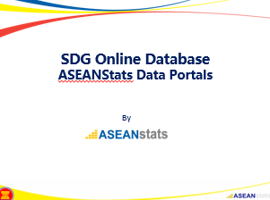
Your Excellencies, distinguished guests, ladies, and gentleman, good morning. Thank you for the opportunity to give live demo on SDG online database.
However, before we move to online database in more detail, I would like to share again a few things related with ASEANStats websites. I believe, some of you may have interacted with these websites but for the others it can be totally new.

Slide 1:
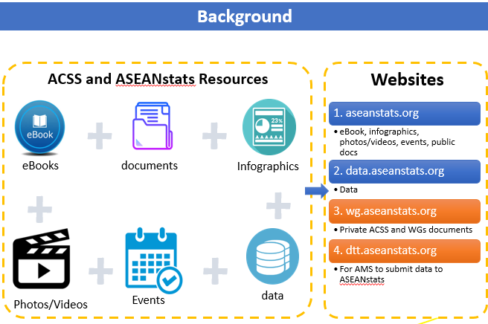
ASEANStats websites is an authorized repository of ASEAN Statistics. Generally, it releases statistical information in summarized level. Dissemination of statistical data can be found in various format, like e-book, leaflet, yearbook, infographic, video and also online database. The websites do not only disseminate statistical data but also share about events and related documents that associated with ASEANStats.
Let start with first website of ASEANStats. Aseanstats.org is the main website, this is the portal where visitor can start to explore and where most of materials can be found. Its simple layout and menu should give visitors clear options to find what material they want to find. One of the menu in this website is Database which will redirect visitors to second website.
The second website is data.aseanstats.org. This is the place where visitor can find complete list of available statistical indicators in ASEANStats. Visitor can click desired indicator and will be navigated to actual page that presenting the data. Some indicators only provide static table in excel format, while the other indicators will redirect visitor to dynamic database where give a chances to visitor to query data with specific criteria.
Third website is wg.aseanstats.org. It is an online private ASEAN statistical forums for the member of ACSS, ACSS-SCPC, WGDSA, WGSNA, IMTS and WGSITS. This site contains related documents which are produced from ACSS/SCPC/WG meetings. Visitors must be registered by ASEANStats admin in order to access its contents.
Fourth website is dtt.aseanstats.org. It is not dissemination website but as a channel for AMS to transmit statistical data to ASEANStats. ACSS WGs regularly transmit the data to ASEANStats in yearly, quarterly or monthly basis. This website provide transparency about data submission.
Slide 2:
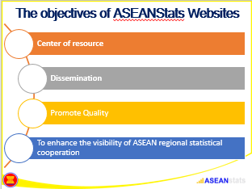
In the following slide, I would like to present the objectives of ASEANStats Website.
- Center of resource. ASEANStats website is an authorized and central repository for ACSS and ASEAN Statistic. It houses statistical data, publications and other documents.
- Dissemination. Website offers multi format dissemination that available all the time and accessible from worldwide. It also provides interactive and user-friendly interface.
- Another functionality of website is as a centralized channel to transmit data. We are in the process to enhance this functionality so it can promote quality of data by providing harmonised template, monitoring of data submission and early phase validation.
- Another information about ACSS, events and documents give an opportunity to public to know about ACSS and ASEAN statistical cooperation.

Slide 3
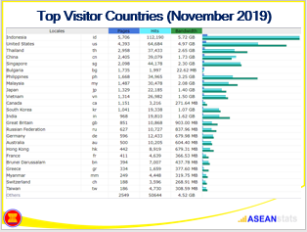
In this slide, I want to share that ASEANStats websites have been acknowledged by public. The visitor come from various countries. As shown in table, the visitors came from worldwide and based on emails were received by ASEANStats, visitors also come from various practitioners – not only from statistical community.
In the future with more and more indicators published in the website, I believe it will attract more visitors to come to visit and acknowledge the statistical data and cooperation in ASEAN community.

