MINISTRY OF PLANNING AND INVESTMENT  GENERAL STATISTICS OFFICE  No: 27/BC-TCTK | SOCIALIST REPUBLIC OF VIET NAM  Independence-Freedom-Happiness  Ha Noi, 28th January 2022

Socio-economic situation report in January 2022

1. Agriculture, forestry and fishery
Agricultural production in the month focused mainly on cultivating and tending winter-spring rice, planting crops across the country, and harvesting winter crops in the North. Pig husbandry continued to recover; poultry developed well. Forestry production focused on activities to respond to the movement "Tet planting trees forever grateful to Uncle Ho" on the occasion of the Lunar New Year, as well as strengthening the protection and prevention of forest fires in the dry season 2022. Fishermen actively cling to the sea to serve the consumption demand of the Lunar New Year. Aquaculture farmers in the coastal provinces of the Mekong River Delta have just finished harvesting the rice-shrimp crop, focusing on improving ponds to start the new crop year.
a) Agriculture
As of January 15, 2022, the country cultivated 1,909.8 thousand hectares of spring paddy, an equal to 104.9% compared with the same period last year, of which Northern provinces reached 132.1 thousand hectares, an equaling 201.5 % due to favorable weather, rainy, humidity and moderate cold, the progress of rice cultivation has been accelerated Southern provinces reached 1,777.7 thousand hectares, an equal to 101.3%. In particular, the Mekong River Delta reached 1,436.6 thousand hectares, equaling 100.6%.
To increase production efficiency, farmers need to adhere to the seasonal schedule, implement intensive technical measures, prevent pests and diseases, and closely monitor weather changes to ensure the growth and development of rice. In the North, localities need to use water-saving irrigation measures, and at the same time follow the schedule of water discharge from reservoirs to take advantage of enough water storage for production to ensure the planting progress of the remaining spring rice. In the southern localities, farmers are recommended to promote the application of the "one must - five reduction" technical package to help reduce the cost of irrigation, fertilizers, plant protection drugs and increase the yield and quality of rice.
The area of some spring crops decreased compared to the same period last year, in which sweet potatoes and soybeans decreased sharply mainly due to low economic efficiency and difficulties in product consumption.

Figure 1: Cultivation of main annual crops
(As of 15/01/2022)
Cattle husbandry was in the month of stable development. Pig husbandry has been gradually prospering due to an increase in live-hog prices this month compared to the previous month. Poultry farming was well developed. Livestock establishments kept their scale stable, ensuring supply for the Lunar New Year. However, the weather forecast in the coming time is that there will be severe cold spells, especially in the North, so farmers need to prepare measures actively to combat colds for their livestock.
Figure 2. Livestock population
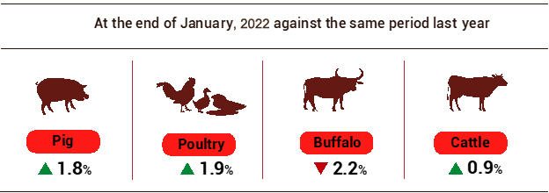

As of January 23, 2022, the whole country has no longer blue-ear disease and avian flu; foot-and-mouth disease was still only in Ha Tinh; African swine fever was reported in 35 localities and LSD was still in Ben Tre for less than 21 days.
b) Forestry
In January 2022, the newly concentrated planted forest area nationwide was estimated at 7.3 thousand hectares, up 5.6% over the same period last year; the number of scattered forest trees reached 3.8 million trees, an increase of 1%. The area of ​​the newly concentrated planted forest increased mainly in Phu Tho, Quang Ninh, and the Central provinces. Timber production in January was estimated at 940.5 thousand m³, up 4.5% over the same period last year; firewood production was 1.5 million ste, down 0.4 %. Provinces with high timber production such as Quang Ngai 113.4 m³, an increase of 7.1%; Quang Tri 72.5 m³, up 6.8%; Nghe An 39.9 m³, up 12.3%.
Damaged forest area in January 2022 was 55.7 ha, decreased by 51.4% over the same period last year (in the same period in 2021, the damaged forest area was 114.8 ha) mainly due to a reduction in the burnt forest area which was estimated at 1.8 ha, a decrease 97.1%; the deforested forest area was 53.9 ha, an increase of 3%.
c) Fishery
Fishery output in January 2022 was estimated at 589.9 thousand tons, up 1.6% over the same period last year, including Fish đạt 433,1 thousand tons, up 1,2%; shrimp đạt 57,5 thousand tons, up 2,3%; other aquatic products đạt 99,3 thousand tons, up 3,1%.
Aquaculture production in the month was estimated at 321.3 thousand tons, up 2.5% over the same period last year, of which: Fish reached 233 thousand tons, up 2%; shrimp reached 47.3 thousand tons, up 2.6%.
Pangasius prices have shown signs of recovery after more than two consecutive years at a low level. Raw pangasius of 0.8 - 1.1 kg/fish in the Mekong Delta ranges from 23,000-24,000 VND/kg, up 4,000 - 5,000 VND/kg over the same period last year. Pangasius processing enterprises have gradually adapted to production in the Covid-19 epidemic prevention situation. Pangasius production in January 2022 was estimated at 107 thousand tons, down 0.3% over the same period last year.
As of the middle of January 2022, the price of vannamei shrimp decreased slightly by 2,000 - 3,000 VND compared to the previous month, 100 shrimp/kg fluctuated at 90,000 - 100,000 VND/kg; size 80 fish/kg fluctuated at 110,000 - 120,000 VND/kg; The price of black tiger shrimp was similar to last month, 20 shrimp/kg ranged from 240,000-260,000 VND/kg. Localities have developed intensive shrimp farming and super-intensive farming applying high technology, improved extensive farming, ecological shrimp farming, shrimp - rice farming; step by step to develop coastal culture and areas with environmental conditions for shrimp farming. Production of vannamei shrimp in January 2022 was estimated at 27.4 thousand tons, up 4.2% over the same period last year; tiger shrimp reached 15.7 thousand tons, down 0.6%.
Figure 3. Aquaculture and catch fishery production
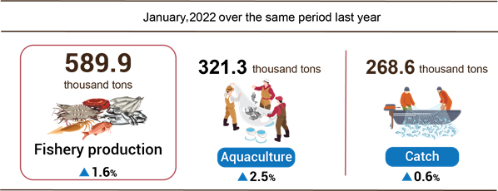

Catch Fishery production in January 2022 was estimated at 268.6 thousand tons, up 0.6% over the same period last year, including fish reached 200.1 thousand tons, up 0.3%; shrimp reached 10.2 thousand tons, up 1%; other aquatic products reached 58.3 thousand tons, up 1.6%. The weather in the fishing grounds in January was generally favorable. This is the month near Lunar New Year 2022, so fishermen actively clinging to the sea. The output of marine fishing was estimated at 255.1 thousand tons, up 0.6%, of which: Fish 191.2 thousand tons, up 0.3%; shrimp reached 9.3 thousand tons, up 1.1%.
2. Industrial production
January is the time to promote the consumption of industrial products, so the index of industrial production in January 2022 was estimated to decrease by 3.1% compared to the previous month and increased by 2.4% over the same period last year, of which the manufacturing industry increased by 2.8%.
The index of industrial production (IIP) of 01/2022 was estimated to decrease by 3.1% over the previous last month and increased by 2.4% over the same period last year. Of which, the manufacturing rose by 2.8%, contributing 2.6 percentage points to the general growth; electricity production and distribution went up by 5.1%, contributing 0.5 percentage points; water supply, waste and wastewater management, and treatment peaked up 1.2%, contributing 0.02 percentage points; the mining industry alone shrank by 4.6%, making the general growth down 0.7 percentage points.
The index of production in 01/2022 belonging to 2-digit key industrial activities significantly increased compared to the same period last year: Mining of metal ores (21.9%); Manufacture of fabricated metal products, except machinery and equipment (16.8%); Manufacture of leather and related products (12.3%); Manufacture of electrical equipment (11.5%); Manufacture of wearing apparel (11.4%); Manufacture of textiles (8.8%); Printing and reproduction of recorded media (8.4%). In the opposite direction, the IIP index of the number of industries decreased: Manufacture of beverages (-2.7%); Manufacture of pharmaceuticals, medicinal chemical and botanical products (-3.6%); Manufacture of computer, electronic and optical products (-5%); Manufacture of wood and products of wood and cork (-5.1%); Extraction of crude petroleum and natural gas (-9.7%).

Table 1. The increase/decrease growth rate of every January IIP
in 2018-2022 some key industries
%

 | 2018 | 2019 | 2020 | 2021 | 2022
Mining of metal ores | 48.5 | -13.0 | 26.8 | 23.3 | 21.9
Manufacture of fabricated metal products  (except machinery and equipment) | 29.5 | -0.2 | -4.2 | 24.5 | 16.8
Manufacture of leather and related products | 20.9 | 10.1 | -9.9 | 24.1 | 12.3
Manufacture of electrical equipment | 36.7 | 8.0 | -19.4 | 41.2 | 11.5
Manufacture of wearing apparel | 15.6 | 11.1 | -14.5 | 15.8 | 11.4
Manufacture of textiles | 21.4 | 13.2 | -8.6 | 19.1 | 8.8
Printing and reproduction of recorded media | 18.4 | 10.8 | 14.8 | 2.0 | 8.4
Manufacture of rubber and plastics products | 17.1 | 10.4 | -8.0 | 25.0 | 8.1
Manufacture of beverages | 11.8 | 8.6 | -10.2 | 19.6 | -2.7
Manufacture of pharmaceuticals, medicinal chemicals, and botanical products | 7.0 | -9.7 | 8.5 | 22.6 | -3.6
Manufacture of computer, electronic and optical products | 39.7 | 1.2 | -5.4 | 39.7 | -5.0
Manufacture of wood and products of wood and cork | 16.7 | 10.5 | -17.8 | 26.4 | -5.1
Extraction of crude petroleum and natural gas | 8.0 | -7.1 | -15.5 | 2.2 | -9.7

The index of industrial production in 01/2022 over the same period last year increased in 52 localities and decreased in 11 localities across the country.

Figure 4: The IIP growth rate of some provinces in January 2022
over the same period last year
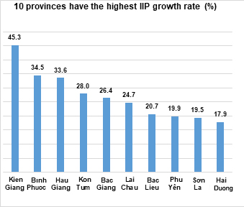 | 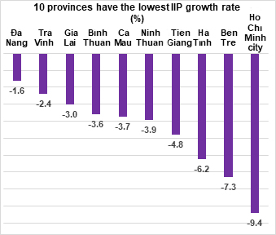

Some major industrial products in 01/2022 increased sharply over the same period last year: Alumin (35.7%); Steel bars and corners (20.3%); powder milk (16.2%); N.P.K mixed fertilizer (15.6%); Monosodium glutamate (15.4%); Processed fishery products (13.8%); Automobile (11.7%); Textile fabric from natural yarn (8.7%). In the opposite side, a number of products decreased compared to the same period last year: Television (-33.5%); Refined sugar (-29.4%); Natural gas (in the form of air) (-11.7%); Phone accessories (-9.3%); Extracted crude oil (-7.5%); Liquidized gas (LPG) (-6.2%); beer (-3.6%).
The number of employees working in industrial enterprises as of 01/01/2022 up 0.7% over the same period last month and down 0.3% over the same period last year, of which the number of working employees in the state-owned enterprise sector went up 0.1% and decreased by 2.8%; non-state enterprises rose by 0.4% and declined by 1.2%; enterprises of foreign direct investment peaked by 0.9% and surged by 0.6%. By industry, the number of employees working in mining and quarrying up 0.2% over the same period last month and went down by 0.9% over the same period last year; manufacturing up 0.7% and down 0.2%; the production and distribution of electricity up 0.2% and down 2%; the water supply, sewerage, waste management, and remediation activities down by 0.6% and peaked up by 0.7%.
3. Enterprise registration status
The business registration situation in January was much improved when the number of newly-established enterprises increased in both quantity and registered capital compared to the same period in 2021. The number of enterprises returning to operation also increased high in all activities. This is a positive signal for business development in 2022.
In January 2022, the whole country had 13,000 newly established enterprises with a registered capital of more than 192.3 trillion VND and the number of registered employees was nearly 77.1 thousand employees, an increase of 15.9% in the number of enterprises. industry, increased by 22.6% in registered capital and 10.5% in the number of employees over the previous month. Compared to the same period last year, an increase of 28.9% in the number of enterprises, an increase of 24% in the registered capital, and a decrease of 33.5% in the number of employees. The average registered capital of a newly established enterprise in the month reached 14.8 billion VND, up 5.8% over the previous month and down 3.7% compared to the same period in 2021. If including 343.8 trillion VND of the additionally registered capital of 5.6 thousand enterprises increased capital, the total amount of additionally registered capital into the economy in January was VND 536.1 trillion, up 35.7% over the same period last year. In addition, 19.1 thousand enterprises returned to operation (increased 352.8% compared to December 2021 and increased 194% compared to January 2021), bringing the total number of newly-established enterprises and enterprises returned to operation in January 2022 to 32.1 thousand enterprises, an increase of 93.6% over the same period last year.
In January 2022, the whole country had 13,000 newly established enterprises with a registered capital of more than 192.3 trillion VND and the number of registered employees was nearly 77.1 thousand employees, an increase of 15.9% in the number of enterprises. industry, increased by 22.6% in registered capital and 10.5% in the number of employees over the previous month. Compared to the same period last year, an increase of 28.9% in the number of enterprises, an increase of 24% in the registered capital, and a decrease of 33.5% in the number of employees. The average registered capital of a newly established enterprise in the month reached 14.8 billion VND, up 5.8% over the previous month and down 3.7% compared to the same period in 2021. If including 343.8 trillion VND of the additionally registered capital of 5.6 thousand enterprises increased capital, the total amount of additionally registered capital in the economy in January was 536.1 trillion VND, up 35.7% over the same period last year. In addition, there were 19.1 thousand re-operated enterprises (increased by 352.8% compared to December 2021 and increased by 94% compared to January 2021), bringing the total number of newly-established enterprises and re-operated enterprises in January 2022 to 32.1 thousand enterprises, an increase of 93.6% over the same period last year.
By economic sector, tháng 01/2022 there were 223 newly-established enterprises in the agriculture, forestry, and fishery sector, up 28,2% over the same period last year; 3.295 enterprises in the industry and construction sector, up 19,9%; 9.486 enterprises in the service sector, up 32,3%.
Figure 5. Enterprise registration status

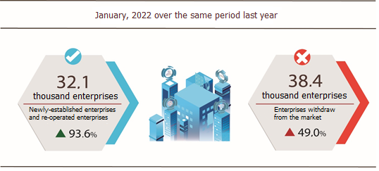

In January 2022, nearly 29.3 thousand enterprises ceased for a certain time, an increase of 62% compared to the same period 2021, due to the short-term shutdown of the business before the Lunar New Year to wait and find the right direction and partners to implement the business plan soon; 7,084 enterprises temporarily ceased and awaited dissolution procedures, up 26.5%; 2,025 enterprises completed dissolution procedures, down 3.3%, of which 1,735 enterprises with the capital size of less than 10 billion VND, down 7.9%; 32 enterprises with the capital size over 100 billion VND and more, up 52.4%.

Table 2. Number of newly registered enterprises and completed dissolution procedures in January 2022 by kinds of some activity

 | Number of enterprises (Enterprise) |  | Growth rate  over the same period last year (%)
 | Newly registered | Dissolution | Newly registered | Dissolution
Wholesale and retail trade; repair of motor vehicles and motorcycles | 4,652 | 743 | 38.2 | -6.5
Manufacturing | 1,663 | 212 | 31.5 | -12.5
Construction | 1,459 | 177 | 19.6 | -7.8
Real estate business | 967 | 130 | 61.2 | 30.0
Transportation and storage | 704 | 94 | 53.4 | -2.1
Accommodation and catering service | 547 | 111 | 38.1 | 5.7
Production and distribution of electricity, water, gas | 102 | 53 | -50.0 | 3.9

4. Investment
Investment activities in January 2022 focus mainly on the allocation of capital plan in 2022, new projects would be allocated capital in 2022 have been preparing to complete investment procedures and file documents, the volume of implementation was mainly at the transition works. The proportion of realized investment capital from the State budget reached 4.8% of the year plan and increased by 8.6% over the same period in 2021. Realized foreign direct investment (FDI) capital in Vietnam in January 2022 was at a good point (1.61 billion USD), up 6.8% over the same period last year.
Investment capital realized under the State budget in January 2022 was estimated at 25.3 trillion VND, equaling 4.8% of the year plan and up 8.6% against the same period last year (the same period last year 2021 equaled to 4.6% and increased by 24.9%), including:
- The capital under central management was 3.4 trillion VND, equaling 3.4% of the yearly plan and increasing 9.2% against the same period last year.

Figure 6. Realized investment capital from the State budget
in January 2022 by Ministry and sector

Bill. VND

- The capital under local management reached 21.9 trillion VND, equaling 5.2% of the yearly plan and climbing up 8.5% over the same period in 2021, of which:
The State budget capital under provincial-level reached 14.5 trillion VND, equaling 4.9% and growing up 6.9%;
The State budget capital at the district level gained 6.3 trillion VND, equaling 5.7% and increasing by 14.4%;
The State budget capital at the commune level was 1.1 trillion VND, equaling 7.1% and decreasing by 0.8%.
- The realized investment capital under the State budget in January of some provinces and cities directly under the Central Government was as follows:

Figure 7. Realized investment capital from the State budget
in January 2022 by locality

Bill. VND
The foreign direct investment from the beginning of the year to 20/01/2022 included newly registered capital, adjusted registered capital, and the total value of capital contribution and share purchases of foreign investors reached 2.1 billion USD, increased by 4.2% compared to the same period in 2021.

Figure 8. The registered capital of foreign investment in Vietnam
as of January 20, in 2018-2022 (Billion USD)
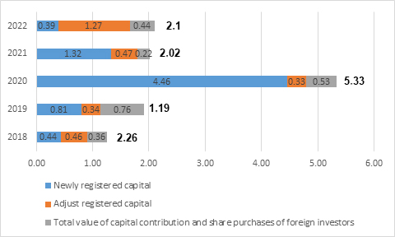

- Newly registered capital included 103 licensed projects with a registered capital of 388 million USD, an increase of 119.1% in the number of projects, and a decrease of 70.7% of registered capital compared to the same period last year. Of which, processing and manufacturing industry attracted the most foreign direct investor with the registered capital of newly licensed projects reaching 233 million USD, accounting for 60.1% of the total newly registered capital; real estate business reached 111.5 million USD, accounting for 28.7%, the remaining industries reached 43.5 million USD, accounting for 11.2%.
Among 23 countries and territories having newly licensed investment projects in 01/2022, Singapore was the largest investor with 198.1 million USD, accounting for 51.1% of total newly registered capital; Hong Kong Special Administrative Region (China) 103.3 million USD, accounting for 26.6%; France 25 million USD, accounting for 6.4%; China 13.7 million USD, accounting for 3.5%; Seychelles 10.3 million USD, accounting for 2.7%.
- Adjust registered capital included 71 turns of projects which were licensed in the previous years registered to adjust investment capital with the additional capital of 1.27 billion USD, increased by 169% compared to same previous of last year.
If including additionally newly registered capital and adjust registered capital of licensed projects in previous years, FDI capital in the processing and manufacturing industry reached 1.19 billion USD, accounting for 72% of the total newly registered capital and additional capital; real estate business reached nearly 124.7 million USD, accounting for 7.5%; the remaining industries reached 339.2 million USD, accounting for 20.5%.
- Capital contribution and share purchases of foreign investors included 206 turns with a total value of the capital contribution of 443.5 million USD, an increase of 100.9% compared to the same period last year. Of which 95 turns of capital contribution, share purchase caused the rise of charter capital of the enterprise with the value of contributed capital of 51.9 million USD, and 111 turns of foreign investors repurchased domestic shares without increasing the charter capital with a value of 391.6 million USD. About the form of capital contribution and share purchase by foreign investors, the investment capital in real estate business reached 347.4 million USD, accounting for 78.3% of the total capital contribution; the processing and manufacturing industry reached 43.8 million USD, accounting for 9.9%; the remaining industries reached 52.3 million USD, accounting for 11.8%.
Foreign direct investment capital that implemented in 01/2022 reached 1.61 billion USD, an increase of 6.8% over the same period last year, of which the processing and manufacturing industry reached 1.21 billion USD, accounting for 75.4% of total realized foreign direct investment capital; real estate business activities gained 182.8 billion USD, making up 11.3%; electricity, gas, steam, and air conditioning supply recorded 141.3 million USD, comprising of 8.8%.
Figure 9. Implemented foreign direct investment
in January of the years 2018-2022 (Billion USD)

Vietnam's investment abroad in 01/2022, there were 15 projects newly granted investment certificates with a total investment capital of 44.2 million USD, 13.97 times higher over the same period last year; 02 turns of projects adjusted capital with adjust capital down 7.2 million USD.
Generally, the total investment capital of Vietnam abroad (newly and additionally licensed capital) reached 36.9 million USD, 11.7 times higher over the same period last year, in which the mining activity reached 33.5 million USD; the financial, banking insurance activities reached 9.2 million USD; the wholesale and retail sector, repair of cars, motorcycles, motorbikes, and other motor vehicles reached 8.5 million USD; the processing and manufacturing industry adjusted capital with adjusted capital down 16.4 million USD.
In 01/2022, 07 countries and territories received investment from Vietnam, of which Laos was the leading country with 48.2 million USD; United States 2.9 million USD; China 1.3 million USD; South Korea 475 thousand USD; Myanmar adjust capital down 16.4 million USD.
5. State budget revenue and expenditure
In January 2022, the State budget revenue was estimated to reach 13% of the yearly estimate. State budget expenditures met the needs of socio-economic development, national defense and security, state management, and payment of due debts support people facing difficulties due to the Covid-19 epidemic and restore the production in areas affected by natural disasters and epidemics.

Figure 10. The state budget in January 2022
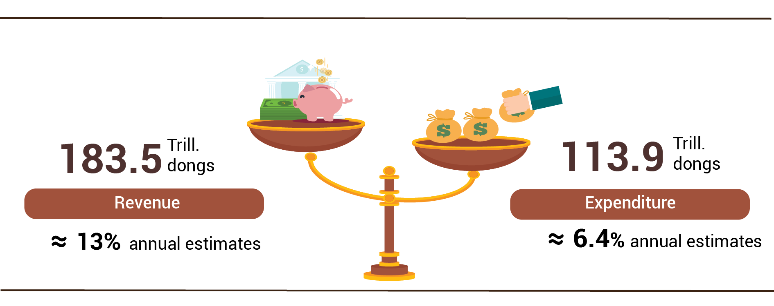

State budget revenue:
Total state budget revenue in January 2022 was estimated at 183.5 trillion VND, equaling 13% of the yearly estimate. Specifically, some of the main revenues were as follows:
- Domestic revenue reached 151.3 trillion VND, equaling 12.9% of the yearly estimate, of which: revenue from state-owned enterprises reached 17.2 trillion VND, equaling 11.1%; revenue from foreign-invested enterprises (excluding crude oil) 30.6 trillion VND, equaling 14.9%; revenue from the non-state economic sector 37.7 trillion VND, equaling 14.9%; personal income tax collection was 15 trillion VND, equaling 12.7%; environmental protection tax collection was 4.6 trillion VND, equaling 7.7%; income from house and land is 21.7 trillion VND, equaling 13.3%.
- Revenue from crude oil reached 3.9 trillion VND, equaling 13.8% of the yearly estimate;
- Balanced budget revenue from import and export activities reached 28.3 trillion VND, equaling 14.2% of the yearly estimate.
State budget expenditure:
Total state budget expenditure in January 2022 was estimated at 113.9 trillion VND, equaling 6.4% of the yearly estimate, of which: Recurring expenditures reached 85.3 trillion VND, equaling 7.7%; development investment expenditure 12.9 trillion VND, equaling 2.5%; debt payment interest 15.6 trillion VND, equal to 15%.
6. Trade, prices, transport, and tourism
a) Retail sales of consumer goods and services
January is the month that is close to the Lunar New Year, so people's demand for consumption and shopping increased high. Enterprises were ready to adapt safely to the Covid-19 pandemic and flexible in operations for production and business.
Total retail sales of consumer goods and services in January 2022 was estimated at 470.7 trillion VND, an increase of 6.7% compared to the previous month and 1.3% compared to the same period last year. If excluding the price factor, it decreased by 0.3% (in the same period in 2021, it increased by 3.6%).

Table 3. Retail sales of consumer goods and services

Trill. VND
 | Performance  December  in 2021 | Estimate  January  in 2022 | Growth rate  01/2022 compared to the previous month (%) | Growth rate  01/2022 compare to  the same period last year (%)
Total | 441.2 | 470.7 | 6.7 | 1.3
Retail sale | 358.3 | 383.5 | 7.0 | 4.3
Accommodation and catering service | 38.2 | 41.3 | 8.0 | -11.9
Traveling service | 1.0 | 1.0 | 2.7 | -35.6
Other services | 43.7 | 44.9 | 2.7 | -8.1

By economic activities in retail sales of goods in January 2022: Food and foodstuffs up 12.8%; vehicles increased by 4.3%; garments down 14.2%; household appliances, tools, and equipment decreased by 8.4%; cultural and educational products decreased by 7.2%. Retail sales of goods in January compared with the same period last year of some localities: Khanh Hoa increased by 1.4%; Hai Phong increased by 7.8%; Binh Duong increased by 8.6%; Hanoi increased by 10%; Can Tho increased by 10.4%; Ba Ria - Vung Tau increased by 12.6%; Quang Ninh increased by 13.9%; Ho Chi Minh city decreased by 13.8%; Da Nang fell 7.8%.
Revenue from accommodation and catering services in January of this year compared to the same period last year of some localities: Ho Chi Minh city decreased by 66.8%; Quang Ninh down 43.3%; Thua Thien - Hue down 39.3%; Hai Phong down 37.5%; Da Nang down 34.5%; Binh Duong down 19.4%; Hanoi decreased by 1.3%.
Revenue from tourism and travel services in January 2022 of some localities decreased sharply compared to the same period last year: Ba Ria - Vung Tau declined by 95.2%; Binh Dinh down 77.5%; Da Nang down 76%; Ho Chi Minh city decreased by 74.3%; Quang Ninh down 66.7%; Can Tho down 50.7%; Kien Giang down 50.6%; Hanoi fell 7.2%.
Revenue from other services in January 2022 compared to the same period last year of Can Tho increased by 3.9%; Binh Dinh increased by 4.9%; Ho Chi Minh city down 39.2%; Da Nang down 34.5%; Hai Phong down 13.1%; Hanoi decreased by 1.7%; Dong Nai fell 1.2%.
b) Export and import of goods
In January 2022, the total import and export turnover of goods was estimated at 58.5 billion USD, down 11.7% compared to the previous month. Compared with the same period last year, total export and import turnover increased by 6.3%, of which exports increased by 1.6%; imports increased by 11.5%.
Figure 11. Import and export of goods in January 2022

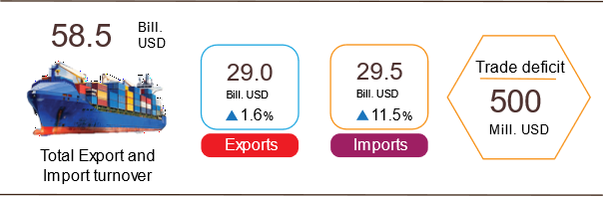

Export of goods
Export turnover in December 2021 reached 34.59 billion USD, 75 million USD higher than the estimated figure.
Export turnover in January 2022 was estimated at 29 billion USD, decreased by 16.2% over the previous month, of which the domestic economic sector gained 8.2 billion USD, decreased by 16.9%; the FDI sector (including crude oil) reached 20.8 billion USD, decreased by 15.9%. Compared to the same period last year, export turnover of goods in January increased by 1.6%, of which the domestic economic sector slightly rose by 20.1%, the FDI sector (including crude oil) decreased by 4.2%.
In January 2022, there were 7 items with an export turnover of over 1 billion USD, contributing 63.3% to the total export turnover.

Table 4. Value of some export items in January 2022
 |  | Estimate | Growth rate of
 |  | January 2022 | January 2022 compare to
 |  | (Mill. USD) | the same period last year (%)
Items with a value of over 1 billion USD
 | Phones all of the kinds and their parts | 4,000 | -34.4
 | Electronic goods, computers, and their parts | 3,500 | -10.2
 | Textiles and garments | 3,300 | 24.2
 | Other machinery, instrument, accessory | 3,000 | -7.8
 | Footwear | 2,000 | 7.2
 | Wood and products | 1,500 | 10.7
 | Means of transport and components | 1,050 | 14.0

Regarding the structure of export commodity groups in January 2022, the group of processing industry accounted for 88.5%, down 1.5 percentage points over the same period last year; agricultural and forestry products accounted for 7.7%, up 0.7 percentage points; aquatic products accounted for 2.9%, up 0.8 percentage points; fuel and mineral products accounted for 0.9%, equaled to the same period last year.
Figure 12. Structure of exports of goods
in January 2022 by commodity group
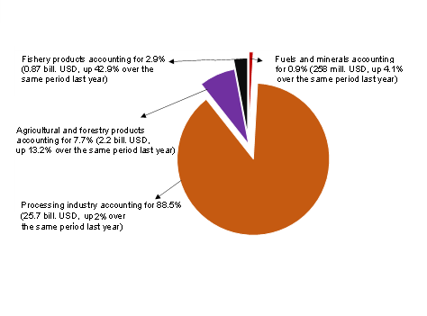

Import of goods
Import turnover of goods in December 2021 reached 31.62 billion USD, 353 million USD lower than the estimated figure.
Import turnover of goods in January 2022 was estimated at 29.5 billion USD, down 6.7% over the previous month, of which the domestic economic sector gained 10 billion USD, down 4.3%; FDI sector reached 19.5 billion USD, down 7.9%. Compared to the same period last year, the import turnover of goods in January increased by 11.5%, of which the domestic economic sector increased by 12.8%; the foreign direct investment sector increased by 10.8%.
In January 2022, there were 4 items with an import turnover of over 1 billion USD, accounting for 46.8% of total import turnover.

Table 5. Value of some imported goods in January 2022
 |  | Estimate | Growth rate of
 |  | January 2022 | January 2022 compare to
 |  | (Mill. USD) | the same period last year (%)
Items with a value of over 1 billion USD
 | Electronic devices, computers, and their parts | 6,800 | 20.2
 | Other machinery, Instrument, accessory | 3,800 | -2.8
 | Phones all of the kinds and their parts | 2,000 | -12.6
 | Fabrics | 1,200 | 8.4

Figure 13. Structure of imports of goods
in January 2022 by commodity group

Regarding the structure of import of goods in January 2022, the group of input materials accounted for 93.7%, a rise of 0.2 percentage points over last year, in which machinery, equipment, accessory, means of transport and components accounted for 46.3%, down 2.2 percentage points; fuel and row materials accounting for 47.3%, up 2.4 percentage point. The consumer goods group accounted for 6.3%, a drop of 0.2 percentage points.
Regarding the export and import market of goods in January 2022, the United States was the largest export market of Viet Nam with an estimated turnover of 9 billion USD. China was Viet Nam's largest import market with an estimated turnover of 10.2 billion USD. January 2022, the trade surplus to the EU was estimated at 2.1 billion USD, down 6.4% over the same period last year; trade deficit from China was 5 billion USD, up 11.7%; trade deficit from Korea was 3.8 billion USD, up 28.9%; trade deficit from ASEAN was 1.2 billion USD, up 69.2%; trade deficit from Japan was 600 million USD (same period in 2021, trade surplus was 58.2 million USD).

Figure 14. Exports and imports of goods in January 2022 by market

 |  | Exports of goods | Imports of goods
The balance of trade in goods in December 2021 had a trade surplus of 3 billion USD; in 2021, trade surplus was 4.08 billion USD; January 2022 was estimated to have a trade deficit of 500 million USD. In which, the domestic economic sector had a trade deficit of 1.8 billion USD; FDI sector (including crude oil) had a trade surplus of 1.3 billion USD.
c) Consumer price index, gold price index, and US dollar
January 2022 is the month adjacent to the Lunar New Year, so people's shopping needs up. The prices of essential consumer goods and services increased according to the consumption rules on the Tet holiday; the increase in domestic gasoline prices was in line with world fuel prices were the factors that made the consumer price index (CPI) in January 2022 increase by 0.19% over the previous month. Compared to the same period in 2021, CPI in January increased by 1.94%; core inflation increased by 0.66%.

Figure 15. CPI growth/decrease rate in January of each year
in the 2018-2022 period (%)

- In the 0.19% increase of CPI in January 2022 compared to the previous month, there were 9 groups of goods and services with an increase in the price index, 1 group of goods with a decrease in the price index, and 1 group of goods that kept prices stable.
Nine groups of goods and services with an increase in price index:
- Transport group had the highest increase with 1.18% (making the general CPI increase by 0.11 percentage points) due to the influence of petrol and oil price adjustments on December 25th, 2021; January 11st, 2022, and January 21st, 2022 made the gasoline price index increased by 2.65%, diesel oil by 2.81%. Besides, the spare parts price index increased by 0.13%; other services for personal means of transport increased by 0.11%; public transport services increased by 2.51%.
- Beverage and cigarettes increased by 0.57% due to demand consumption and used as gifts during Tet, causing alcohol prices to increase by 0.76%; non-alcoholic beverages by 0.27%; smoking increased by 0.47%.
- Garments, hats, and shoes increased by 0.26% due to the increased demand for clothes to prepare for the Lunar New Year.
- Household appliances increased by 0.18%.
- Culture, entertainment, and tourism groups increased by 0.16%.
- Housing and building materials group increased by 0.07%, of which kerosene price increased by 2.9%; the price of domestic water increased by 1% due to the high demand for water at the end of the year; the price of housing maintenance materials increased by 0.25% (making CPI increased by 0.01 percentage points), the price of house repair services increased by 0.53% due to the increase in iron and steel prices, cement and demand to repair, decorate the house to welcome the Lunar New Year.
- Medicine and medical service group and the education group had the same increase of 0.03%.
- Other goods and services increased by 0.39% because the price of jewelry group increased by 0.93% according to the domestic gold price; hair cutting and shampooing services increased by 1.22%; the price of wedding supplies and services increased by 0.29% because it was the wedding season; the demand for worship items at the end of the year increased, so the prices of these items increased by 0.28%.
(2) Postal services and telecommunications decreased by 0,03%.
(3) Food and catering services kept prices stable, in which: Food increased by 0.08%; foodstuff decreased by 0.09% because China tightened control of Covid-19 epidemic prevention at some border gates, causing traffic jams for Vietnamese agricultural products, traders stopped buying; outdoor eating and drinking increased by 0.18% due to the increase in the price of gasoline, fresh food, milk, and cooking oil, which made foodservice shops outside the family increase their selling prices.
Core inflation in January 2022 increased by 0.26% over the previous month, by 0.66% over the same period last year.
The domestic gold price fluctuated in the same direction as the world gold price. The average world gold price as of January 25th, 2022 increased by 1.46% compared to December 2021 due to the US dollar and bond yields falling as the US inflation data increased. Besides, investors fear that prices will continue to rise and geopolitical tensions in Eastern Europe make safe assets like gold rise the price. Domestically, the gold price index in January 2022 increased by 1.08% compared to the previous month; down 0.07% over the same period in 2021.
The US dollar in the world market fell in the context that US inflation in December 2021 increased by 7% over the same period last year. Domestically, due to the guaranteed supply, the US dollar price index in January 2022 decreased by 0.32% compared to the previous month; down 0.73% over the same period in 2021.
b) Transport
Transport activities in January were busier than previous months because this is the month adjacent to the Lunar New Year, the demand for transporting passengers and goods has increased. However, compared to the same period last year, passenger transport decreased by 54% in passengers carried, decreased by 61.4% in passengers traffic, and cargo transport decreased by 8.9% in freight carried, a slight increase of 1.6% in freight traffic.
Passengers carried in January 2022 were estimated at 165.3 million persons, increased by 15% compared to the previous month, and a decrease of 54% over the same period last year (the same period of 2021 down 27.4%), the passenger traffic gained 6 billion passengers-km, increased by 20.3% and down 61.4% (the same period of 2021 decreased by 34.4 %), in which domestic transport accounted for nearly 100%, foreign transport accounted for a negligible proportion.
By types of transport, all types in this month decreased compared to the same period last year.
Table 6. Carriage of passengers in January 2022 by types of transport
 | Number of passengers |  |  | The growth rate  compared to the same period last year (%)
 | Carried  (Thous. passengers) | Traffic  (Mill. passengers-km) |  | Carried | Traffic
Total | 165,271.5 | 5,993.8 |  | -54.0 | -61.4
Railway | 87.2 | 42.1 |  | -67.5 | -49.6
Seaway | 346.2 | 20.8 |  | -53.0 | -55.4
Inland waterway | 12.095.1 | 199.3 |  | -44.3 | -47.2
Road | 152.438.5 | 5,331.3 |  | -54.4 | -57.5
Airway | 304.5 | 400.3 |  | -88.3 | -83.9
Freight carried in January 2022 was estimated at 157.9 million tons, increased by 3% compared to the previous month, and down 8.9% against the similar period last year (the same period in 2021 increased by 11.8%), freight traffic gained 32.3 billion tons-km, increased by 1.1% and increased by 1.6% (the same period of 2021 increased by 7.8%). Of which, domestic freight carried recorded 155.6 million tons, a decrease of 8.9% and 20.2 billion tons-km, up 2.1%; oversea freight reached 2.4 million tons, decreasing by 11% and 12.1 billion tons-km, increased by 0.8%.
Table 7. Carriage of freight in January 2022 by types of transport

 | Quantity of goods |  |  | The growth rate  compared to the same period last year (%)
 | Carried  (Mill. tons) | Traffic  (Bill. tons-km) |  | Carried | Traffic
Total | 157.9 | 32.3 |  | -8.9 | 1.6
Railway | 0.5 | 0.4 |  | 1.6 | 15.0
Seaway | 8.7 | 16.5 |  | 8.2 | 8.0
Inland waterway | 27.0 | 5.8 |  | -9.8 | -7.9
Road | 121.7 | 9.0 |  | -9.7 | -6.5
Airway | 0.03 | 0.6 |  | -67.8 | 137.1

c) International visitors to Viet Nam
International visitors to our country in January increased by 14.9% compared to the previous month and increased by 11.2% over the same period last year because Viet Nam has implemented a pilot route to welcome international tourists from November 2021, and some regular international routes have been restored starting from January 2022.
International visitors to Viet Nam in January were estimated at 19.7 thousand arrivals, up 14.9% compared to the previous month and increased by 11.2% compared to the same period last year. Of which, visitors coming by airway gained 17.4 thousand persons, accounting for 88% of the total international visitors to Viet Nam, increased by 56.2%; by roadway achieved 2.3 thousand arrivals, accounted for 11.9% and went down by 64.2%; by seaway were 10 arrivals, accounted for 0.1% and decreased by 76.7%.

Figure 16. International visitors to Vietnam
in January 2022 by territory
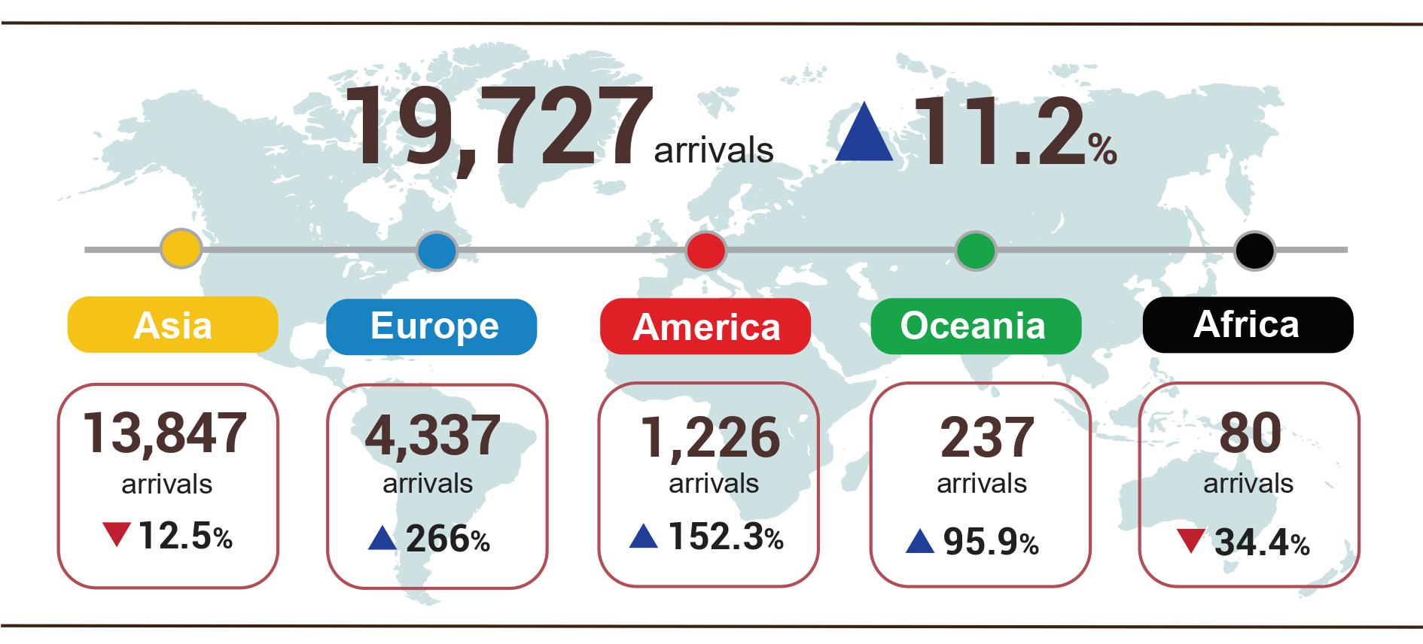
7. Some social situation
a) Residential life and social security
In January 2022, the people of the country prepared to welcome the Lunar New Year in the context of the complicated development of the Covid-19 epidemic. To ensure that people can enjoy the Spring Festival safely and healthily, the Party and Government have made drastic directions in disease prevention and control, and at the same time implemented supportive policies to ensure people's lives. people during the Lunar New Year. On December 8, 2021, the Secretariat issued Directive No. 11/CT-TW on the organization of the Year of the Lunar New Year 2022; The Prime Minister issued Directive No. 35/CT-TTg dated December 31, 2021, on strengthening measures to ensure the Lunar New Year in 2022.
Social security work has received much attention on the occasion of the Lunar New Year, supporting poverty in early 2022 and families affected by rains and floods. The Prime Minister has signed Decisions on free rice supply from the national reserve. Specifically, Decision No. 123/QD-TTg dated January 21, 2022, to supply 9,877.9 tons of rice, of which: 6,902.2 tons in the case of the Lunar New Year 2022 for the following provinces: Tay Ninh 825.5 tons; Cao Bang 624.7 tons; Phu Yen 1,008.1 tons; Ninh Thuan 1,508.8 tons; Nghe An 1,140.7 tons; Gia Lai 692.2 tons; Quang Binh 1,102.2 tons; and 2,975.7 tons of rice to support hunger and poverty for 56.3 thousand hungry households with 198.4 thousand people in 3 provinces: Cao Bang (1,093.4 tons), Gia Lai (697,9 tons), Quang Binh (1,184.4 tons); Decision No. 122/QD-TTg dated 21/01/2022 issued 3,738.5 tons of rice to support people affected by floods.
The package to support people affected by the Covid-19 epidemic continues to be implemented. According to the report of the Ministry of Labor, War Invalids and Social Affairs on the implementation of Resolution No. 68/NQ-CP dated July 01, 2021, of the Government and Resolution No. 126/NQ-CP dated October 8 2021 of the Government amending and supplementing Resolution No. 68/NQ-CP dated July 01, 2021, of the Government on policies to support employees and employers facing difficulties due to the Covid-19 pandemic, as of January 21, 2022, there was 36.3 trillion VND supported for 31.3 million people and 378.3 thousand employers/business households.
b) Epidemic diseases and food poisoning
According to the report of the Ministry of Health, in the month (December 19, 2021, to January 18, 2022), there were 1,188 cases of hemorrhagic fever; 41 cases of hand, foot, and mouth disease; 04 cases of virus encephalitis and 03 cases of scarlet fever suspected for measles.
The epidemic of Covid-19 in the world continues to be complicated. In Vietnam, the prevention and control of the Covid-19 epidemic continue to be implemented drastically, synchronously, and effectively, promptly changing the status to "Safely adapting, flexibly, effectively controlling the Covid-19 epidemic" while preventing and fighting the epidemic, while recovering and developing socio-economically. As of 16:00 on January 25, 2022, in Viet Nam had 2,187.5 thousand cases were reported, of which 1,924.6 thousand were cured and 37,165 deaths.
Vietnam's Covid-19 vaccine campaign continues to be deployed quickly, safely, scientifically, and effectively. As of January 25, 2022, The total number of doses of Covid-19 vaccine administered was 178,818.6 thousand doses, of which the injection was a nasal injection the first was 78,945.7 thousand doses; the second dose was 73,967.1 thousand doses; 3rd dose injection (additional injection, booster injection and basic 3-dose injection) was 25,905.8 thousand doses.
The total number of people living with HIV nationwide as of January 18, 2022, was 214,281 persons and the number of deaths by HIV/AIDS as of the above time-point was 111.076 persons.
In January 2022, there were 01 cases of food poisoning with 04 persons poisoned.
c) Traffic accident
In January (from December 15, 2021, to January 14, 2022), there were 963 traffic accidents nationwide, including 687 traffic accidents less serious or more serious, 276 traffic collisions, causing 565 deaths, 336 injuries, and 263 minor injuries. Compared to the same period last year, the number of traffic accidents in January this year decreased by 21.9% (the number of traffic accidents of less serious or more serious decreased by 8.8%, and the number of traffic collisions decreased by 42.5%); the number of deaths decreased by 7.1%; the number of injured people decreased by 8.2%, and the number of minor injuries decreased by 50.3%. On average a day per month, there are 31 traffic accidents nationwide, including 22 traffic accidents less serious or more serious, and 9 traffic collisions, causing 18 deaths, 11 people were injured, and 8 people were slightly injured.
d) Damage caused by natural disasters, environmental protection and fire, and explosion prevention
Natural disasters that occurred in the month were mainly heavy rain; landslides and storms damaged made 33.6 thousand hectares of rice and crops were damaged; 892 houses flooded, the damage was estimated at 561.2 billion VND, 14.5 times higher over the same period last year, mainly damage caused by storms and heavy rain in some provinces such as Khanh Hoa 395.6 billion VND; Quang Ngai 66.5 billion VND; Binh Dinh 36.8 billion VND; Quang Nam 31.7 billion VND; Phu Yen 21.8 billion VND…
In January 2022, authorities discovered 3,155 cases of environmental violations, of which 2,443 cases were handled with a total fine of 26.4 billion VND. During the month, there were 153 fires and explosions in the whole country, killing 9 people and injuring 9 others, with 24 billion VND estimated damage./.

GENERAL STATISTICS OFFICE

One must: Use certified rice varieties - Five of reduction: reduce the amount of seed sown, reduce fertilizers, reduce irrigation water through alternate flooding-dry techniques, reduce the times of pesticide applications and reduce post losses harvest.
Ha Noi, Bac Ninh, Ha Nam, Thai Binh, Ninh Binh, Cao Bang, Lao Cai, Bac Kan, Lang Son, Tuyen Quang, Thai Nguyen, Thai Nguyen, Dien Bien, Son La, Hoa Binh, Ha Tinh, Quang Binh, Quang Tri, Quang Nam, Quang Ngai, Phu Yen, Khanh Hoa, Kon Tum, Đak Lak, Đak Nong, Tay Ninh, Ba Ria - Vung Tau, Đong Thap, Tien Giang, Vinh Long, Ben Tre, Kien Giang, Tra Vinh, Soc Trang, Bac Lieu and Ca Mau.
Because there was a land bank for logging in the previous period, which was set up in the early spring crop this year, the newly concentrated planted forest area of ​​Phu Tho increased by 348 hectares compared to 2021, Quang Ninh increased by 93 hectares.
Due to the favorable weather in the month for afforestation.
According to data from the Ministry of Agriculture and Rural Development, from December 16, 2021, to January 15, 2022.
Due to the stocking of fingerling pangasius, there was a sharp decrease in the social distancing time (third quarter of 2021) and cold weather (fourth quarter of 2021).
Source: http://agromonitor.vn/group/47/272/giam-sat-gia
The IIP index in 01/2022 compared with the previous month of the number of localities with huge industrial-scale decreased sharply: Hai Phong decreased by 8.4%; Hanoi decreased by 8.3%; Ba Ria - Vung Tau decreased by 6.8%; Bac Ninh decreased by 6.6%; Ho Chi Minh City decreased by 6.2%; Thai Nguyen decreased by 5.4%; Quang Ninh fell by 2.3%.
Source: National Enterprise Registration Information System, Business Registration Management Agency, Ministry of Planning and Investment (Received the report on January 24, 2022)
According to the report of the Foreign Investment Department, Ministry of Planning and Investment, received on January 22, 2022
The total investment capital of Vietnam abroad in January 2022 increased sharply because, in January 2021, only 01 new granted investment project with an investment capital of 3.16 million USD.
According to the report on the implementation of Resolution No. 01/NQ-CP of the Government in Finance - state budget field in January 2022 by the Ministry of Finance.
Data for January 2022 provided by the General Department of Customs on January 26, 2022.
Total import and export turnover of goods in January 2021 reached 55 billion USD, up 48.2% over the same period last year, of which export reached 28.5 billion USD, up 55.1%; imports reached 26.5 billion USD, up 41.4%.
The trade surplus in December 2021 was estimated at 2.54 billion USD
Due to increased shopping demand in preparation for the Lunar New Year, mainly in the following items: Price of color television increased by 0.27%; photography and printing services increased by 0.12%; plants, flowers, and ornamental plants rose from 0.21% to 3.68%.
Rice prices increased 0.04% as export prices remained stable at high levels and consumer demand for delicious rice and sticky rice increased during the Lunar New Year holiday. Besides, the price of other processed food items such as vermicelli increased by 0.51%; instant noodles, noodles, pho, instant porridge increased by 0.34%.
In which, the price of fresh, dried and processed vegetables decreased by 6.05%; prices of fresh and processed fruit decreased by 0.59%, mainly in dragon fruit and watermelon. In the opposite direction, the price of pork increased by 1.79% (making the general CPI increased by 0.06 percentage points) due to the high demand for meat consumption to prepare for Tet; egg prices of all kinds increased by 0.91%; the price of fresh poultry meat increased by 0.57%; price of canned meat and other processed meat increased by 0.26% and 0.31%, respectively; prices of edible fats and other fats increased by 1.63%; cakes, jams and candies up 0.61%; tea, coffee, cacao increased by 0.51%... due to increased consumer demand during the festival of Mr. Cong, Mr. Tao and the preparation of Tet; the price of fresh seafood increased by 0.58% and the price of processed seafood increased by 0.54% because fishing activities are affected by weather and seasonal factors, so the catch and farming output is not high, while consumer demand increases.
According to the report of the Border Gate Department, the Border Guard Command, the Ministry of National Defense and the Immigration Department, the Ministry of Public Security.
The reporting period was from December 21, 2021 to January 20, 2022.
As of 16: 00 on January 25, 2022, in the world, there were 359,661.2 thousand cases of Covid-19 (5,636.1 thousand deaths).
According to a quick report from the Office of the Ministry of Public Security and the Maritime Administration (Ministry of Transport) from December 15 to January 14, 2022.
According to a quick report from the Ministry of Public Security on January 23, 2022.

