MINISTRY OF PLANNING AND INVESTMENT  GENERAL STATISTICS OFFICE  No: 36/BC-TCTK | SOCIALIST REPUBLIC OF VIET NAM  Independence-Freedom-Happiness  Ha Noi, 28th February 2022

Socio-economic situation report in February 2022

1. Agriculture, forestry, and fishery
Agricultural production in February 2022 took place in severe cold weather conditions in the northern provinces, which affected the growth and development of plants and animals. Livestock production faced difficulties due to rising feed prices and the risk of a re-emergence of African swine fever. Forestry production focused on implementing the movement of planting trees and planting forests in the Spring crop; taking care and protecting forests, fight forest fires in the dry season in the southern region. Aquaculture has grown steadily, pangasius prices were at a high level due to a strong increase in export demand after the Lunar New Year while the supply of raw materials for export was scarce; Farmed shrimp grew stably and had few diseases.
a) Agriculture
As of mid-February, the whole country cultivated 2,638.7 thousand hectares of spring rice, equaling 101.2% the same period last year, of which: Northern localities planted 740.5 thousand hectares, equaling 105, 6%; the southern localities planted 1,898.1 thousand hectares, equaling 99.6%; particularly the Mekong Delta provinces alone planted 1,501.8 thousand hectares, equaling 98.8%.
In the Northern provinces, the progress of spring rice planting this year was higher than that of the same period last year mainly due to the rain at the beginning of the crop, and the localities have actively collected and stored enough water for planting. Some localities have had high progress in planting spring rice such as Thai Binh reached 21.5 thousand hectares, equaling 303.3% the same period last year; Hanoi reached 34.3 thousand hectares, equaling 172.7%; Hai Phong reached 17 thousand hectares, equaling 154.5%; Ninh Binh reached 34.8 thousand hectares, equaling 133.4%. To ensure the good growth and development of rice plants, it is necessary to closely monitor the weather and disease situation, promptly handle arising disease outbreaks so as not to affect the growth of rice.
The southern localities have completed the planting of spring rice and started harvesting some early rice. The area of ​​spring rice decreased by 8.4 thousand hectares compared to the same period last year, the Mekong River Delta decreased by 17.8 thousand hectares because some localities actively reduced the area for sowing or converted other areas inefficient rice to dry crops, using less water.
Currently, spring rice is developing well, the main rice crops are in the tillering stage, some are in the milking stage, preparing to flower, of which the Mekong Delta with 300.2 thousand hectares of spring rice for harvest, accounting for 20% of the region's cultivated area and equaling 109.5% the same period last year.
Along with planting spring rice, localities across the country are planting other crops. The area of ​​sweet potatoes, soybeans, and peanuts decreased compared to the same period last year, mainly due to low economic efficiency and difficulties in consumption, so farmers tend to switch to growing maize and vegetable, legumes type.

Figure 1: Cultivation of main annual crops
(As of 15/02/2022)

Buffaloes and cows' husbandry during the month was affected by severe and harmful colds. Pig farming is gradually stabilizing because businesses, farms, and raising households were proactive in breeding stock, linking consumption of output products, and ensuring hygiene and biosecurity. However, the livestock industry is still facing difficulties due to high feed prices, the high risk of African swine fever reoccurrence, and pig farmers, as well as local authorities, still have to take preventive measures against the epidemic for livestock.

Figure 2. Livestock population
As of February 24, 2022, the whole country has no longer blue-ear disease and foot-and-mouth disease; avian flu was still only in Ha Noi, Quang Binh, Quang Nam, Dong Nai; LSD was still in Quang Binh, Quang Ngai, Tien Giang, and African swine fever were reported in 29 localities for less than 21 days.
b) Forestry
The newly concentrated planted forest area nationwide in February 2022 was estimated at 9.5 thousand hectares, up 6.7% over the same period last year. The weather in the month was favorable, so localities actively planted spring forests, some localities had high afforestation like Quang Ngai 2,863 ha, an increase of 47.7% over the same period last year, Yen Bai 1,680 ha, up 76.8%, Phu Tho 995 ha, 2.5 times higher. The number of scattered forest trees in February was estimated at 9.7 million trees, up 5.4% over the same period last year; timber production reached 982.8 thousand m³, an increase of 4%; firewood production reached 1.5 million ste, equaling the same period last year. Localities with high timber output in the month such as Quang Ngai 88.2 thousand m³, up 3.4% over the same period last year, Thanh Hoa 66.5 thousand m³, up 6.6%, Quang Ninh 32.2 thousand m³, an increase of 20%.
Generally, in the first two months of 2022, the newly concentrated planted forest area was estimated at 16.8 thousand hectares, up 6.3% over the same period last year; the number of scattered forestry trees reached 13.6 million trees, up 4.6%; timber production gained 1,923.3 thousand m³, up 4.2%; firewood production was 3 million ste, down 0.3% over the same period last year.
The estimated damaged forest area in February was 68 hectares, down 48.7% over the same period last year, of which: The burnt forest area was 0.7 hectares, down 97.3%; the deforested forest area was 67.3 ha, down 36.8%. Provinces with high areas of deforestation in the month: Dien Bien 15.1 ha, Lang Son 14.2 ha, Phu Yen 5.4 ha, Ha Giang 4.9 ha. Generally, in the first two months of 2022, the whole country has 137.6 hectares of damaged forest, a decrease of 47.8% over the same period last year, of which: Burnt forest area was 1.6 hectares, a decrease of 98 .3%; the deforested forest area was 136 ha, down 19.5%.
c) Fishery
Fishery output in February was estimated at 578.5 thousand tons, up 2.3% over the same period last year, including Fish reaching 434.7 thousand tons, up 2.1%; shrimp 53.8 thousand tons, up 3.3%; other aquatic products 90 thousand tons, up 2.6%.
Aquaculture production in the month was estimated at 297.9 thousand tons, up 4.5% over the same period last year, of which: Fish reached 215.1 thousand tons, up 4.4%; shrimp reached 43.8 thousand tons, up 4.0%.
The price of raw pangasius in the Mekong Delta increased sharply after a long time at a low level due to increased export demand while the supply of raw pangasius for export was scarce. Specifically, the price of 0.8 - 1.1 kg/head ranged from 27,500 to 29,000 VND/kg, an increase of 7,500 - 9,000 VND/kg over the same period last year and an increase of more than 4,000 VND/kg compared to the previous time of the Lunar New Year. With the current price of pangasius, farmers will have high profits. Pangasius production in February 2022 was estimated at 94.9 thousand tons, up 4.9% over the same period last year.
Farmed shrimp has developed quite well and has few diseases, and the price of raw shrimp has been stable. Localities continue to develop high-tech, semi-intensive vannamei shrimp in parallel with new farming processes and lined ponds, taking the initiative in controlling the environment better and better. Vannamei shrimp production in February 2022 was estimated at 25.5 thousand tons, up 6.3% over the same period last year; Black tiger shrimp reached 14.2 thousand tons, equal to the same period last year.
Catch Fishery production in February 2022 was estimated at 280.6 thousand tons, up 0.1% over the same period last year, including fish 219.6 thousand tons, shrimp 10 thousand tons (both fish and shrimp equaled to the same period in 2021); other aquatic products reached 51 thousand tons, up 0.6%. In the early days of February, although the weather in the fishing ground was favorable for fishing and fishing, the increase in gasoline and oil prices directly affected fishermen, causing the number of fishing trips to decrease. The output of marine fisheries in February was estimated at 266.7 thousand tons, equaling the same period in 2021.
Figure 3. Aquaculture and catch fishery production
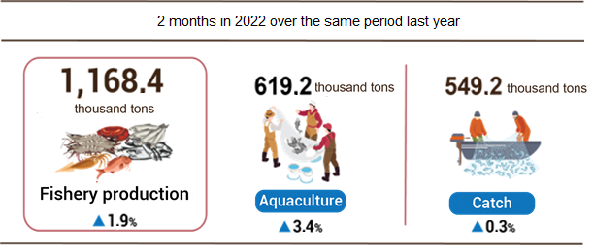
Generally, in the first two months of 2022, fishery output was estimated at 1,168.4 thousand tons, up 1.9% over the same period last year, including Aquaculture production reached 619.2 thousand tons, up 3 .4%; Catch Fishery production reached 549.2 thousand tons, up 0.3% (the output of marine fishing reached 521.8 thousand tons, up 0.3%).
2. Industrial production
Industrial production in February 2022 was estimated to decrease by 12.4% compared to the previous month because the Lunar New Year holiday was mostly concentrated in this month. However, compared to the same period last year, industrial production in February 2022 continued to prosper with an increase of 8.5%; In general, in the first 02 months of 2022, the industrial production index increased by 5.4% compared to the first 02 months last year.
The index of industrial production (IIP) of 02/2022 was estimated to decrease by 12.4% over the previous last month and increased by 8.5% over the same period last year. Of which, compared to the same period last year, the mining and quarrying declined by 4.1%; the manufacturing rose by 10%; electricity production and distribution went up by 8%; water supply, waste and wastewater management, and treatment peaked up 0.8%.
Overall, in the first 02 months of 2021, the IIP was estimated to increase by 5.4% over the same period last year (the same period in 2021 was 6.8%). Of which, the manufacturing rose by 6.1% (the same period last year up 9.4%), contributing 5.2 percentage points to the general growth; electricity production and distribution went up by 6.5%, contributing 0.6 percentage points; water supply, waste and wastewater management, and treatment peaked up by 2.5%, contributing 0.04 percentage points; the mining industry alone shrank by 2.8%, down by 0.44 percentage points in the general growth rate.
The index of production in the first 02 months of 2022 belonging to 2-digit industrial activities significantly increased compared to the same period last year: Manufacture of electrical equipment (27.9%); Manufacture of machinery and equipment n.e.c (21.2%); Manufacture of wearing apparel (20.1%); Manufacture of pharmaceuticals, medicinal chemical and botanical products (15%); Printing and reproduction of recorded media (11%); Manufacture of motor vehicles; trailers and semi-trailers (10.8%); Manufacture of leather and related products (10.6%); Manufacture of other transport equipment (10.2%); Manufacture of chemicals and chemical products (9.7%). On the opposite side, the IIP of some industries decreased: Manufacture of rubber and plastics products (-11.8%); Repair and installation of machinery and equipment (-11.4%); Manufacture of coke and refined petroleum products (-10.8%); Mining of metal ores (-9.6%); Extraction of crude petroleum and natural gas (-8.6%).
Table 1. The increase/decrease growth rate of every 2-month IIP
in 2018-2022 by some key industries

%
 | 2018 | 2019 | 2020 | 2021 | 2022
Manufacture of electrical equipment | 18.3 | 5.7 | -2.7 | 14.3 | 27.9
Manufacture of machinery and equipment n.e.c | 9.3 | 11.5 | -16.1 | 6.0 | 21.2
Manufacture of wearing apparel | 6.9 | 10.6 | -2.4 | 2.1 | 20.1
Manufacture of pharmaceuticals, medicinal chemical  and botanical products | 11.1 | -5.6 | 19.8 | 4.9 | 15.0
Printing and reproduction of recorded media | 6.7 | 11.2 | 14.5 | -14.4 | 11.0
Manufacture of motor vehicles; trailers and semi-trailers | 7.3 | 20.2 | -5.6 | 7.2 | 10.8
Manufacture of leather and related products | 8.0 | 8.9 | 9.5 | 2.3 | 10.6
Manufacture of other transport equipment | 6.3 | 6.8 | -1.2 | -4.2 | 10.2
Manufacture of chemicals and chemical products | 4.1 | 12.6 | 4.1 | 5.1 | 9.7
Extraction of crude petroleum and natural gas | 2.3 | -7.9 | -7.8 | -9.9 | -8.6
Mining of metal ores | 11.7 | 3.2 | 28.0 | 13.5 | -9.6
Manufacture of coke and refined petroleum products | 3.6 | 95.1 | 10.8 | -3.7 | -10.8
Repair and installation of machinery and equipment | 9.7 | -5.1 | -4.1 | 8.8 | -11.4

The index of industrial production in the first 02 months of 2022 over the same period last year increased in 56 localities and decreased in 7 localities across the country.

Figure 4: The IIP growth rate of some provinces in the first 2 months of 2022
over the same period last year
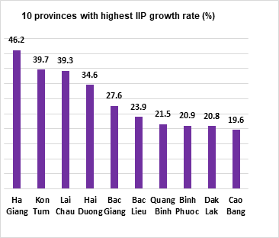 | 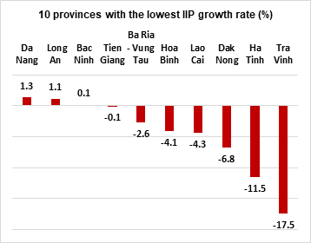
Some major industrial products in the first 2 months of 2022 increased sharply over the same period last year: Alumin (20.3%); Monosodium glutamate (17.6%); Processed fishery products (15%); Clothes (14.1%); Automobile (12.2%); Textile fabric from natural yarn (11.8%); Fresh milk (11.5%); Cement (11%); Phone accessories and motorbike (both by 10.7%); Laminated steel (10.5%); Animal feed (10.4%). In the opposite side, a number of products decreased compared to the same period last year: Television (-32.4%); Natural gas (in the form of air) (-13.4%); Petroleum (-12.8%); Mobile phone (-12.6%); Textile fabric from polyester or artificial yarn (-6.6%); Aquatic feed (-4.4%).
The number of employees working in industrial enterprises as of 01/02/2022 up 1.2% over the same period last month and rose by 1.3% over the same period last year, of which the number of working employees in the state-owned enterprise sector went up 0.1% and decreased by 3%; non-state enterprises rose by 0.8% and declined by 3.4%; enterprises of foreign direct investment peaked by 1.6% and surged by 3.4%. By activity, the number of employees working in mining and quarrying up 0.2% over the same period last month and went down by 1.6% over the same period last year; manufacturing up 1.3% and 1.5%; the production and distribution of electricity up 0.5% and peaked up by 0.1%; the water supply, sewerage, waste management, and remediation activities increased by 0.2% and rosed by 0.7%.
3. Enterprise registration status
In February 2022, business start-up activity was quite quiet compared to the previous month because February was closed for the Lunar New Year. However, the drastic and timely solutions and the direction of the Government and the Prime Minister have created peace of mind and confidence for the business community. Generally, in the 02 months of 2022, newly established and re-operated enterprises increased by 46.2% compared to the same period in last year; businesses withdrawn from the market increased 33.6%.
In February 2022, the whole country had 7,284 newly established enterprises with registered capital were 85.2 trillion VND and a total number of registered employees of nearly 72.6 thousand employees, a decrease of 44% in the number of enterprises, a decline of 55.7% in the registered capital and down 5.8% in the number of employees compared to last month. Compared to the same period 2021, down 9.4% in the number of enterprises, a decrease of 52.6% in the registered capital, and up 27.4% in the number of employees. The average registered capital of a newly established enterprise in the month reached 11.7 billion VND, a decrease of 20.9% compared to last month, and down 47.7% compared to the same period in 2021. In February, there were 4,071 re-operated enterprises in the whole country, down 78.7% compared to the previous month and down 11.6% compared to the same period in 2021.
Generally, in the 2 months of this year, the whole country had nearly 20.3 thousand newly registered enterprises with a total registered capital of 277.6 trillion VND and a total number of registered employees nearly 149.7 thousand employees, up 11.9% in the number of enterprises, a decrease of 17.1% in number the registered capital, and a decrease of 13.4% in the number of employees compared to the same period last year. The average registered capital of a newly established enterprise in 2 months achieved 13.7 billion VND, down 25.9% compared to the same period last year. If including 173.6 trillion VND of the additionally registered capital of 2,332 enterprises that recorded an upward adjustment of capital, the total additional registered capital in the economy in 2 months of this year was 451.2 trillion VND, down 37.4% compared to the same period last year. Besides, there were 22.3 thousand re-operated enterprises (an increase of 102.5% over the same period last year), bringing the total number of newly registered enterprises and re-operated enterprises in 2 months this year to 42.6 thousand enterprises, an increase of 46.2%. The average every month had 21.3 thousand newly established and re-operated enterprises.
By economic sector in 2 months, there were 316 newly-established enterprises in the agriculture, forestry, and fishery sector, equaling the same period in 2021; 5.2 thousand enterprises in the industry and construction sector, increased by 5.9%; 14.7 thousand enterprises in the service sector, increased by 14.5%.

Figure 5. Enterprise registration status

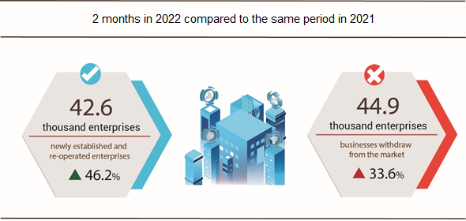

In February 2022, 3,466 enterprises ceased for a certain time, a decrease of 88.2% compared to last month and a decline of 3.5% compared to the same period 2021; 1,917 enterprises temporarily ceased and awaited dissolution procedures, a decrease of 72.9% and a decrease of 26.4%; 1,233 enterprises completed dissolution procedures, down 39.1% and a decrease of 17.8%.
In 2 months this year, there were: 32.7 thousand enterprises temporarily ceased for a certain time, an increase of 51.3% compared to the same period last year; 8.9 thousand enterprises temporarily ceased and awaited dissolution procedures, a climb up 6.3%; nearly 3.3 thousand enterprises completed dissolution procedures, a decrease of 9.4%, of which 2.8 thousand enterprises with the capital size of less than 10 billion VND, down 12.8%; 49 enterprises with the capital size over 100 billion VND and more, an increase of 32.4%. On average, 22.4 thousand enterprises withdraw from the market each month.

Table 2: Number of newly registered enterprises and completed dissolution procedures in 2 months, 2022 by kinds of some activity
 | Number of enterprises (Enterprise) |  | The growth rate over the same period last year (%)
 | Newly registered | Dissolution | Newly registered | Dissolution
1. Wholesale and retail trade; repair of motor vehicles and motorcycles | 7,213 | 1,187 | 19.9 | -11.1
2. Manufacturing | 2,631 | 335 | 13.8 | -23.5
3. Construction | 2,327 | 291 | 4.3 | -4.6
4. Real estate business | 1,463 | 196 | 38.4 | 17.4
5. Transportation and storage | 1,085 | 138 | 33.0 | -17.4
6. Accommodation and catering service | 805 | 165 | 10.3 | -17.1
7. Production and distribution of electricity, water, gas | 156 | 83 | -46.9 | 3.8

4. Investment
The Lunar New Year holiday was in February in 2022, at the same time, investors and contractors mainly focused mainly on the allocation of capital plan in 2022. New projects to be allocated capital in 2022 are in the process of complete procedures and investment preparation documents, so the volume of implementation was mainly at transition works. The rate of investment capital implemented from the State budget in the first 2 months of the year compared to the 2022 plan was 8.8% and increased by 10.4% venus the same period in 2021. Realized foreign direct investment capital in Vietnam in the first two months of 2022 was estimated at 2.68 billion USD, up 7.2% over the same period last year.
Investment capital from the State budget in February was estimated at 20.5 trillion VND, increasing by 9.9% over the same period last year, including Central capital 3 trillion VND, up 10.7%; local capital 17.5 trillion VND, up 9.8%. Generally, in the first 2 months of this year, realized investment capital from the State budget reached 46.3 trillion VND, equaling 8.8% of the year plan and up 10.4% against the same period last year (the same period last year 2021 equaled 8% and increased by 13.6%), including:
- The capital under central management was 6.4 trillion VND, equaling 6.4% of the yearly plan and increasing by 10.1% against the same period last year.

Figure 6. Realized investment capital from the State budget
in first 2 months of 2022 by ministries and sectors

Billion VND

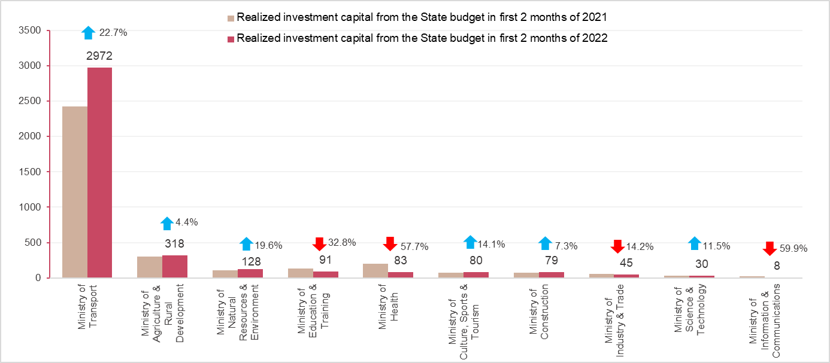
- The capital under local management reached 39.9 trillion VND, equaling 9.3% of the yearly plan and climbing up 10.4% over the same period in 2021.
The State budget capital under provincial-level reached 26.5 trillion VND, equaling 8.9% and growing up 8%;
The State budget capital at the district level gained 11.5 trillion VND, equaling 10.1% and increasing by 18.5%;
The State budget capital at the commune level was 1.9 trillion VND, equaling 11.8% and expanding by 0.1%.
The realized investment capital of the state budget in the first 2 months of 2022 of some provinces and cities directly under the Central Government was as follows:
Figure 7. Realized investment capital from the State budget
- in the first 2 months of 2022 in some localities
Billion VND
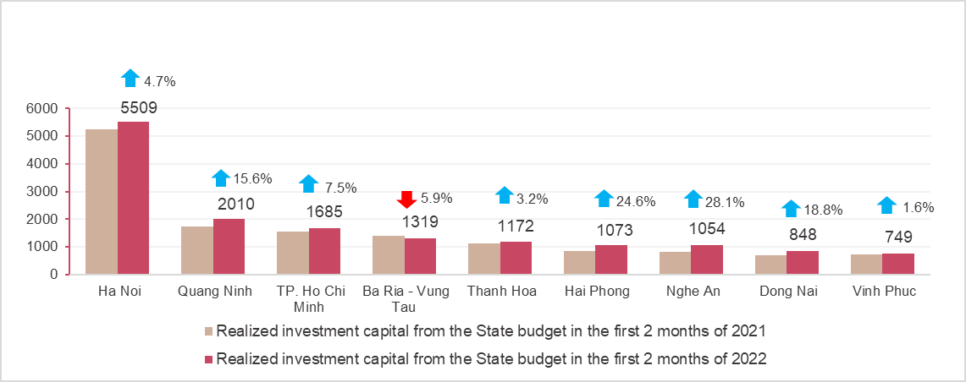
The foreign direct investment capital from the beginning of the year to 20th February 2022 including newly registered capital, adjust registered capital, and the total value of capital contribution and share purchases of foreign investors reached nearly 5 billion USD, decreased by 8.5% compared to the same period in 2021.

Figure 8. The registered capital of foreign investment in Vietnam
as of February 20th in 2018 - 2022 (Billion USD)

- Newly registered capital included 183 newly licensed projects with a registered capital of 631,8 million USD, an increase of 45.2% in the number of projects and a decrease of 80.9% of registered capital compared to the same period last year; of which, processing and manufacturing industry attracted the 1st foreign direct investor with the registered capital of newly licensed projects reaching 346,8 million USD, accounting for 54.9% of the total newly registered capital; real estate business reached 186.9 million USD, accounting for 29.6%, the remaining industries reached 98.1 million USD, accounting for 15.5%.
Among 28 countries and territories having newly licensed investment projects in Vietnam in the first 02 months in 2022, Singapore was the largest investor with 222.8 million USD, accounting for 35.3% of total newly registered capital; Hong Kong Special Administrative Region (China) 112.7 million USD, accounting for 17.8%; China 78.9 million USD, accounting for 12.5%; South Korea 63.4 million USD, accounting for 10%; Taiwan 43.9 million USD, accounting for 7%.
- Adjust registered capital included 142 turns of projects which were licensed in the previous years registered to adjust investment capital with the additional capital of 3.59 billion USD, increased by 123.8% compared to same previous of last year.
If including additionally newly registered capital and adjust registered capital of licensed projects in previous years, foreign direct investment capital in the processing and manufacturing industry reached 2.9 billion USD, accounting for 68.7% of the total newly registered capital and additional capital; real estate business reached 1.16 million USD, accounting for 27.5%; the remaining industries reached 160.4 million USD, accounting for 3.8%.
- Capital contribution and share purchases of foreign investors included 400 turns with a total value of the capital contribution of 769.6 million USD, an increase of 41.7% compared to the same period last year. Of which 174 turns of capital contribution, share purchase caused the increase of charter capital of the enterprise with the value of contributed capital of 91.5 million USD, and 226 turns of foreign investors repurchased domestic shares without increasing the charter capital with a value of 678.1 million USD. About the form of capital contribution and share purchase by foreign investors, the investment capital in real estate business reached 357.8 million USD, accounting for 46.5% of the total capital contribution; the processing and manufacturing industry reached 228.7 million USD, accounting for 29.7%; the remaining industries reached 183 million USD, accounting for 23.8%.
Foreign direct investment capital that implemented in the first 2 months of 2022 reached 2.68 billion USD, an increase of 7.2% over the same period last year, of which the processing and manufacturing industry reached 2.02 billion USD, accounting for 75.4% of total realized foreign direct investment capital; real estate business activities gained 324.3 billion USD, making up 12.1%; electricity, gas, steam, and air conditioning supply recorded 210 million USD, comprising of 7.8%.

Figure 9. Implemented FDI capital in
the first 2 months of the years 2018-2022 (Billion USD)

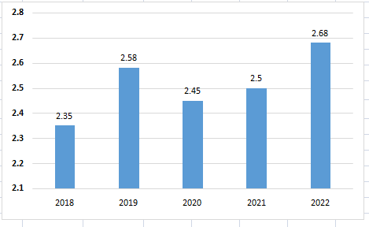

Vietnam's investment abroad in the first 2 months of 2022, there were 21 projects newly granted investment certificates with a total investment capital of 51.7 million USD, 2.4 times higher over the same period of last year; 02 turns of projects adjusted capital with adjust capital down 7.2 million USD.
Generally, the total investment capital of Vietnam abroad (newly and additionally licensed capital) reached 44.5 million USD, 2.1 times higher over the same period last year, in which the mining activities reached 33.5 million USD; the wholesale and retail sector, repair of cars, motorcycles, motorbikes, and other motor vehicles reached 15.1 million USD; the financial, banking insurance activities reached 9.2 million USD; the processing and manufacturing industry adjusted capital with adjusting capital down 16.4 million USD.
In the first 2 months of 2022, 08 countries and territories received investment from Vietnam, of which Laos was the leading country with 48.2 million USD; Singapore 7.4 million USD; United States 2.9 million USD; China 1.3 million USD; South Korea 575 thousand USD; Myanmar adjusted the capital down 16.4 million USD.

5. State budget revenue and expenditure
State budget revenue in the first two months of 2022 increased by 10.8% over the same period last year. State budget expenditures meet the needs of socio-economic development, national defense, and security, state management, payment of due debts, spending on the Covid-19 pandemic prevention, and implementation of social security policies.

Figure 10. State budget revenue and expenditure
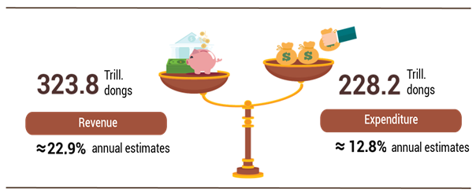

State budget revenue:
Total state budget revenue in February 2022 was estimated at 138.5 trillion VND. The accumulated total state budget revenue in the first two months of the year reached 323.8 trillion VND, equaling 22.9% of the annual estimate and increasing by 10.8% over the same period last year. Of which, some of the main revenues are as follows:
- Domestic revenue in February 2022 was estimated at 114.6 trillion VND. Accumulated in the first 2 months of the year reached 270.8 trillion VND, equaling 23% of the annual estimate, and increasing by 7.6% over the same period last year.
- Revenue from crude oil in February 2022 was estimated at 4,900 billion VND; accumulated in the first 2 months of the year reached 8,060 billion VND, equaling 28.6% of the annual estimate, and increasing by 57.2% over the same period last year.
- Balanced budget revenue from import and export activities in February 2022 was estimated at 19 trillion VND; accumulated in the first 2 months of the year reached 45 trillion VND, equaling 22.6% of the annual estimate, and increasing by 29.4% over the same period last year.
State budget expenditure:
Total state budget expenditure in February 2022 was estimated at 106.3 trillion VND; accumulated in the first 2 months of the year was estimated at 228.2 trillion VND, equaling 12.8% of the annual estimate, and increasing by 10.5% over the same period last year. In which, recurrent expenditure in the first 2 months of the year reached 163.3 trillion VND, equaling 14.7% of the annual estimate and increasing by 0.9%; development investment expenditure reached 44.6 trillion VND, equaling 8.5%, and increasing by 89.9%; debt payment interest is 20.3 trillion VND, equaling 19.6%, and decreasing by 4.3%.
6. Trade, prices, transport, and tourism
a) Retail sales of consumer goods and services
February was the month of the Lunar New Year holiday with many activities to start the spring and festivals, so the total retail sales of consumer goods and services increased by 3.1% over the same period last year; in which revenue from accommodation and food services increased by 12.6% and from travel and tourism increased by 39.4%. Generally, for the first two months of 2022, the total retail sales of consumer goods and services increased by 1.7% over the same period last year.
Total retail sales of consumer goods and services in February 2022 was estimated at 421.8 trillion VND, down 7.1% from the previous month and up 3.1% over the same period last year. Generally, in the first two months of 2022, the total retail sales of consumer goods and services were estimated at more than 876 trillion VND, up 1.7% over the same period last year, if excluding the price factor it was a reduction of 0, 3% (in the same period in 2021, up 0.7%).

Table 4. Retail sales of consumer goods and services
 | Estimate  February  2022 | Estimate  2 months  2022 | The growth rate  compared to the same period last year (%)
 | Estimate  February  2022 | Estimate  2 months  2022 | February  2022 |  | 2 months  2022
Total | 421.8 | 876.0 | 3.1 | 1.7
Retail sale | 338.9 | 707.4 | 2.4 | 3.1
Accommodation and catering service | 41.5 | 82.3 | 12.6 | -1.8
Traveling service | 1.0 | 2.0 | 39.4 | -10.9
Other services | 40.4 | 84.3 | -0.7 | -5.9

Retail sales of goods in the first two months of 2022 increased by 3.1% over the same period last year, of which the group of cultural and educational products increased by 12.7%; food and foodstuffs increased by 9.0%; vehicles increased by 4.3%; garments down 8.1%; household appliances, tools, and equipment decreased by 9.1%. Retail sales of goods in the first two months of the year compared with the same period last year of some localities: Binh Duong increased by 15.2%; Quang Ninh increased by 13.1%; Hanoi increased by 9.3%; Dong Nai increased by 9.1%; Hai Phong increased by 8.9%; Khanh Hoa increased by 3.6%; Ho Chi Minh city increased by 3.4%; Can Tho increased by 3.0%; Da Nang decreased by 21.9%.
Revenue from accommodation and food services in the first 2 months of this year compared to the same period last year of some localities: Bac Ninh increased by 39.6%; Khanh Hoa increased by 22.1%; Binh Dinh increased by 20.1%; Phu Yen increased by 17.5%; Hanoi increased by 12.7%; Quang Ninh increased by 7.5%; Ho Chi Minh city fell 29.1%.
Traveling and tourism revenue in the first 2 months of this year compared with the same period last year of some localities: Khanh Hoa increased by 466.2%; Lang Son increased by 16.3%; Can Tho increased by 4.8%; Hanoi increased by 3.5%; Da Nang decreased by 2.8%; Ho Chi Minh city fell 19.6%.
Revenue from other services in the first 2 months of this year compared with the same period last year of some localities: Can Tho increased by 2.7%; Hanoi increased by 2.6%; Da Nang decreased by 21.2%; Hai Phong down 6.8%; Thua Thien - Hue decreased by 8.9%; Ho Chi Minh City decreased by 18.9%.
b) Export and import of goods
February 2022 had fewer working days than January 2022, so the total import and export turnover in February 2022 decreased by 20% compared to the previous month, estimated at 48.2 billion USD. However, compared to the same period last year, the total export and import turnover of goods in February 2022 still increased by 17.6%. Generally, in the first two months of this year, the total import and export turnover of goods was estimated at 108.52 billion USD, up 13% over the same period last year, of which exports increased by 10.2%; imports increased by 15.9%

Figure 11. Import and export of goods in the first 2 months of 2022
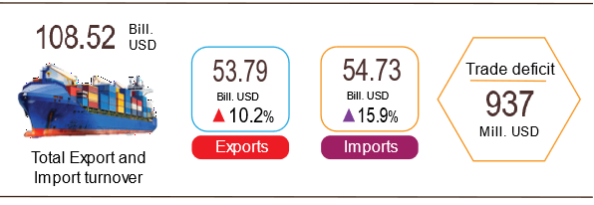
Export of goods
Export turnover in January 2022 reached 30.84 billion USD, 1.84 billion USD higher than the estimated figure.
Export turnover in February 2022 was estimated at 22.95 billion USD, decreased by 25.6% over the previous month, of which the domestic economic sector gained 5.65 billion USD, decreased by 34.6%; the FDI sector (including crude oil) reached 17.3 billion USD, decreased by 22.1%. Compared to the same period last year, export turnover of goods in February increased by 13.2%, of which the domestic economic sector slightly rose by 20.3%, the FDI sector (including crude oil) increased by 11.1%.
Generally, in the first two months of 2022, export turnover of goods was estimated at 53.79 billion USD, up 10.2% over the same period last year, of which the domestic economic sector reached 14.29 billion USD, an increase of 24.1%, accounting for 26.6% of total export turnover; FDI sector (including crude oil) reached 39.5 billion USD, up 5.9%, accounting for 73.4%.
In the first 2 months of 2022, there were nine items with export turnover of over 1 billion USD, accounting for 71.6% of total export turnover (there are 4 export items with over 5 billion USD, accounting for 52%).

Table 5. Value of some export products in the first 2 months of 2022
Mill. USD
 | Estimate  2 months  2022 | Growth rate of  2 months in 2022 over  the same period last year (%)
Items with a value of over 5 billion USD
Phones all of the kinds and their parts | 8,303 | -15.1
Electronic goods, computers, and their parts | 7,810 | 7.4
Other Machinery, instrument, accessory | 6,000 | 6.9
Textiles and garments | 5,871 | 30.9
Figure 12. Structure of exports of goods
in 2 months of 2022 by commodity group

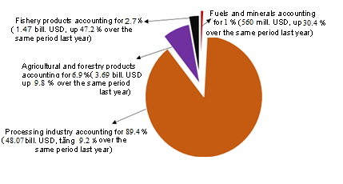

Regarding the structure of export commodity groups in 2 months of 2022, the group of fuel and mineral products accounted for 1%, up 0.1 percentage point over the same period last year; processing industry accounted for 89.4%, down 0.8 percentage points; aquatic products accounted for 2.7%, up 0.7 percentage points; agricultural and forestry products accounted for 6.9%, equaling the same period last year.
Import of goods
Import turnover of goods in January 2022 reached 29.45 billion USD, 51 million USD lower than the estimated figure.
Import turnover of goods in February 2022 was estimated at 25.28 billion USD, down 14.2% over the previous month, of which the domestic economic sector gained 8.28 billion USD, down 17%; FDI sector reached 17 billion USD, down 12.7%. Compared to the same period last year, the import turnover of goods in February increased by 21.9%, of which the domestic economic sector increased by 22.8%; the foreign direct investment sector increased by 21.4%.
Generally, in the first two months of 2022, the import turnover of goods was estimated at 54.73 billion USD, up 15.9% over the same period last year, of which the domestic economic sector reached 18.25 billion USD, up 16.9%; the FDI sector reached 36.48 billion USD, up 15.4%.
In the first two months of 2022, there were 13 imported items worth over 1 billion USD, accounting for 71.6% of the total import turnover.
Table 6. Value of some imported goods in the first 2 months of 2022
Mill. USD
 | Estimate  2 months  2022 | Growth rate of  2 months of 2022 over  the same period last year (%)
Items with a value of over 5 billion USD
Electronic devices, computers, and their parts | 13,421 | 26.4
Other machinery, Instrument, accessory | 6,777 | -0.8
Figure 13. Structure of imports of goods
in 2 months of 2022 by commodity group
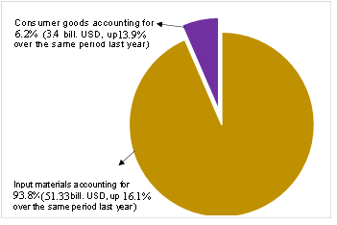
Regarding the structure of imported goods in 2 months of 2022, the group of input materials accounted for 93.8%, a rise of 0.1 percentage points over last year, in which machinery, equipment, accessory, means of transport and components accounted for 46.6%, down 1.6 percentage points; fuel and row materials accounting for 47.2%, up 1.7 percentage point. The consumer goods group accounted for 6.2%, a drop of 0.1 percentage points.
Regarding the export and import market of goods in the 2 months of 2022, the United States was the largest export market of Viet Nam with an estimated turnover of 18.3 billion USD. China was Viet Nam's largest import market with an estimated turnover of 20.8 billion USD. The trade surplus to the EU was estimated at 5.5 billion USD, up 56.6% over the same period last year; the trade surplus to Japan was 566 million USD (at the same period of 2021, the trade deficit was 237 million USD); the trade deficit from China was 13.4 billion USD, up 78,8%; the trade deficit from South Korea was 6.5 billion USD, up 24.4%; the trade deficit from ASEAN was 1.5 billion USD, down 18.1%.

Figure 14. Exports and imports of goods in the first 2 months of 2022 by market
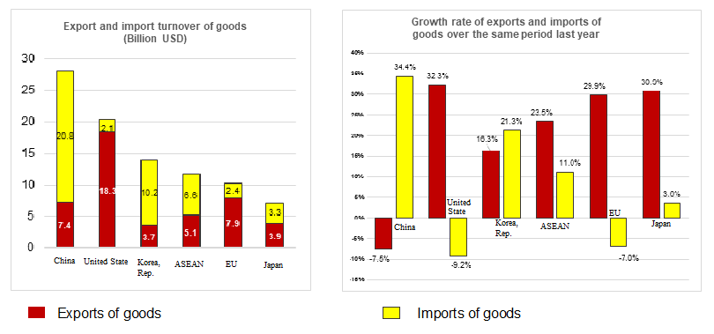

The balance of trade in goods in January 2022 had a trade surplus of 1.4 billion USD; in February 2022, the trade deficit was estimated at 2.34 billion USD. Generally, in the first 2 months of 2022, the trade balance of goods was estimated to have a trade deficit of 937 million USD (the same period last year, the trade surplus was 1.6 billion USD). In which, the domestic economic sector had a trade deficit of 3.96 billion USD; FDI sector (including crude oil) had a trade surplus of 3.02 billion USD.
c) Consumer price index, gold price index, and US dollar
Petrol prices increased according to world fuel prices; the increase in food, foodstuff, outdoor eating and drinking, and public transport prices during the Nham Dan Lunar New Year were the main reasons that make the consumer price index (CPI) in February 2022 increase by 1% compared to the previous month; up 1.42% over the same period last year and up 1.2% compared to December 2021. On average, in the first 2 months of 2022, CPI increased by 1.68% over the same period last year; core inflation increased by 0.67%.
Figure 15. CPI growth/decrease rate of
February and 2 months in the period of 2018-2022 (%)

In the 1% increase of CPI in February 2022 compared to the previous month, there were 10 groups of goods and services with an increase in the price index and 1 group of goods with a decrease in the price index.
- Ten groups of goods and services with increasing price index include:
- The transport group had the highest increase with 2.35% due to the influence of petrol and oil price adjustments on January 21st, 2022, February 11th, 2022, and February 21st, 2022, the petrol price index increased by 5.8% (the impact of making the general CPI increase by 0.21 percentage points). In addition, the price of passenger transport by road increased by 3.92% because some transport businesses declared an increase in surcharge prices when the price of gasoline increased and the impact of the epidemic limited the number of passengers; train fares increased by 7.95% due to the increase in ticket prices by the Vietnam Railways Corporation; vehicle maintenance service prices increased by 0.91%, car wash, and pump services increased by 1.34% due to the increased demand for travel, repair, and maintenance.
- Food and catering services increased by 1.54% (making the general CPI increase by 0.52 percentage points), of which: Food increased by 0.35% (making the general CPI increase by 0.01 percentage points); foodstuff increased by 1.69% (making the general CPI increase by 0.36 percentage points); outdoor eating and drinking increased by 1.68% (making the general CPI increase by 0.15 percentage points).
- Housing and construction materials increased by 0.92% due to an 8.32% increase in kerosene price; gas price increased by 3.5%; electricity and water prices increased by 1.01% and 4.73% respectively due to high demand for electricity and water during the Lunar New Year.
- The education group and Culture, entertainment, and tourism groups with an increase of 0.51%, of which culture, entertainment, and tourism groups increased due to increased demand for tourism and entertainment during the Lunar New Year and Valentine's Day on February 14th.
- Beverage and cigarettes increased by 0.37% due to consumer demand during Tet, so the prices of beverages and cigarettes of all kinds increased.
- Household appliances increased by 0.19%.
- Garments, hats, and shoes increased by 0.07% due to higher prices of laundry, clothes rental, and shoe repair.
- Medicine and medical service group increased by 0.03%.
- Other goods and services increased by 0.22% because the price of jewelry group increased by 2.6% according to the domestic gold price; hair cutting and shampooing services increased by 0.2%; wedding services increased by 0.35%; the demand for worship items on the occasion of the full moon in January increased, so the prices of these items increased by 0.24%.
(2) The group of goods and services with a decrease in price index are: Postal services and telecommunications decreased by 0.04%.
Core inflation in February 2022 increased by 0.49% over the previous month, by 0.68% over the same period last year. The average core inflation in the first two months of this year increased by 0.67% over the same period in 2021.
The domestic gold price fluctuated in the same direction as the world gold price when inflation in many countries increased and was concerned about the impact of the war between Russia and Ukraine. The average world gold price as of February 24th, 2022 increased by 2.4% compared to January 2022. Domestically, the demand for gold shopping on the Day of God of Wealth and Valentine's Day on February 14th made the gold price index in February 2022 increase by 1.85% compared to the previous month; increased by 2.95% compared to December 2021; increased by 1.53% over the same period last year and an average increase of 0.72% in the first 2 months of 2022.
The US dollar in the world market was quite stable. Domestically, due to the guaranteed supply, the US dollar price index in February 2022 decreased by 0.28% compared to the previous month; down 0.59% compared to December 2021; down 0.84% ​​over the same period last year and the average in the first 2 months of 2022 decreased by 0.79%.
d) Transport
Passenger transport in February increased month-on-month as people's travel demand increased during the Lunar New Year, but freight transport decreased because the transportation of goods for the Tet holiday took place in January. Compared to the same period last year, passenger transport decreased by 13.1% in passengers carried, decreased by 18.8% in passengers traffic, and cargo transport increased by 14.3% in freight carried, increased by 18.6% in freight traffic.
Generally, in the first 2 months of 2022, passenger carried decreased by 21.8% compared to the same period last year, passenger traffic decreased by 27.2%, freight carried increased by 6.9%, and freight traffic increased by 9.9%.
Passengers carried in February 2022 were estimated at 285.7 million persons, increased by 13.1% compared to the previous month, and passenger traffic was 11.1 billion passengers-km, increased by 10%. Generally, in the first 2 months of 2022, passenger carried reached 538.5 million passengers, a decrease of 21.8% over the same period last year (the same period of 2021 down 21.1%), the passenger traffic gained 21.3 billion passengers-km, down 27.2% (the same period of 2021 decreased by 28.8%). Of which, domestic passengers carriage gained nearly 538.5 million passengers, down 21.8% and 21.3 billion passengers-km, down 26.6%; overseas passengers carriage achieved 11.6 thousand passengers, decreasing by 81.2% and 21.6 million passengers-km, went down by 91.9%.
By types of transport, all types in the first 2 months of this year decreased compared to the same period last year because the number of Covid-19 cases in localities increased rapidly, so people also restricted their movement.

Table 6. Carriage of passengers in the first 2 months of 2022
by types of transport

 | Number of passengers |  |  | The growth rate  compared to the same period last year (%)
 | Carried  (Mill. passengers) | Traffic  (Bill. passengers-km) |  | Carried | Traffic
Total | 538.5 | 21.3 |  | -21.8 | -27.2
Railway | 0.4 | 0.2 |  | -16.2 | -26.9
Seaway | 0.9 | 0.06 |  | -24.5 | -28.6
Inland waterway | 38.4 | 0.6 |  | -12.1 | -23.5
Road | 496.9 | 18.5 |  | -22.2 | -22.9
Airway | 1.9 | 2.0 |  | -53.9 | -43.3
Freight carried in February 2022 was estimated at 166.7 million tons, decreased by 4.4% compared to the previous month, and freight traffic 31 billion tons- km, down 4.9%. Generally, in the first 2 months, freight carried reached 341.1 million tons, up 6.9% against the similar period last year (the same period in 2021 increased by 8.7%), freight traffic gained 63.6 billion tons-km, up 9.9% (the same period of 2021 increased by 4.2%), of which domestic freight carried recorded 335.8 million tons, an increase of 7% and 39.7 billion tons-km, up 12%; oversea freight reached 5.3 million tons, increasing by 1.5% and 23.9 billion tons-km, up 6.5%.

Table 7. Carriage of freight in the first 2 months of 2022
by types of transport

 | Quantity of goods |  |  | The growth rate  compared to the same period last year (%)
 | Carried  (Mill. tons) | Traffic  (Bill. tons-km) |  | Carried | Traffic
Total | 341.1 | 63.6 |  | 6.9 | 9.9
Railway | 0.8 | 0.7 |  | 10.8 | 38.8
Seaway | 14.9 | 31.0 |  | 8.5 | 12.2
Inland waterway | 50.8 | 11.3 |  | -3.6 | -0.2
Road | 274.6 | 19.4 |  | 9.0 | 8.0
Airway | 0.06 | 1.2 |  | 64.2 | 170.9

đ) International visitors to Viet Nam
International visitors to our country in February increased by 49.6% compared to the previous month and increased by 169.6% over the same period last year because Viet Nam has implemented a pilot route to welcome international tourists and many international routes have been restored.
International visitors to Viet Nam in February were estimated at 29.5 thousand arrivals, up 49.6% compared to the previous month and increased by 169.6% compared to the same period last year. Generally, in 2 months of 2022, international visitors to Viet Nam was estimated at 49.2 thousand arrivals, up 71.7% compared to the same period last year, of which visitors coming by airway gained 43.2 thousand persons, accounting for 87.8% of the number of international visitors to Viet Nam, increased by 135.4%; by roadway achieved 6 thousand arrivals, accounted for 12.1% and went down by 41.7%; by seaway achieved 28 arrivals, accounted for 0.1% and decreased by 53.3%.

Figure 16. International visitors to Viet Nam
in the first 2 months of 2022 by territories

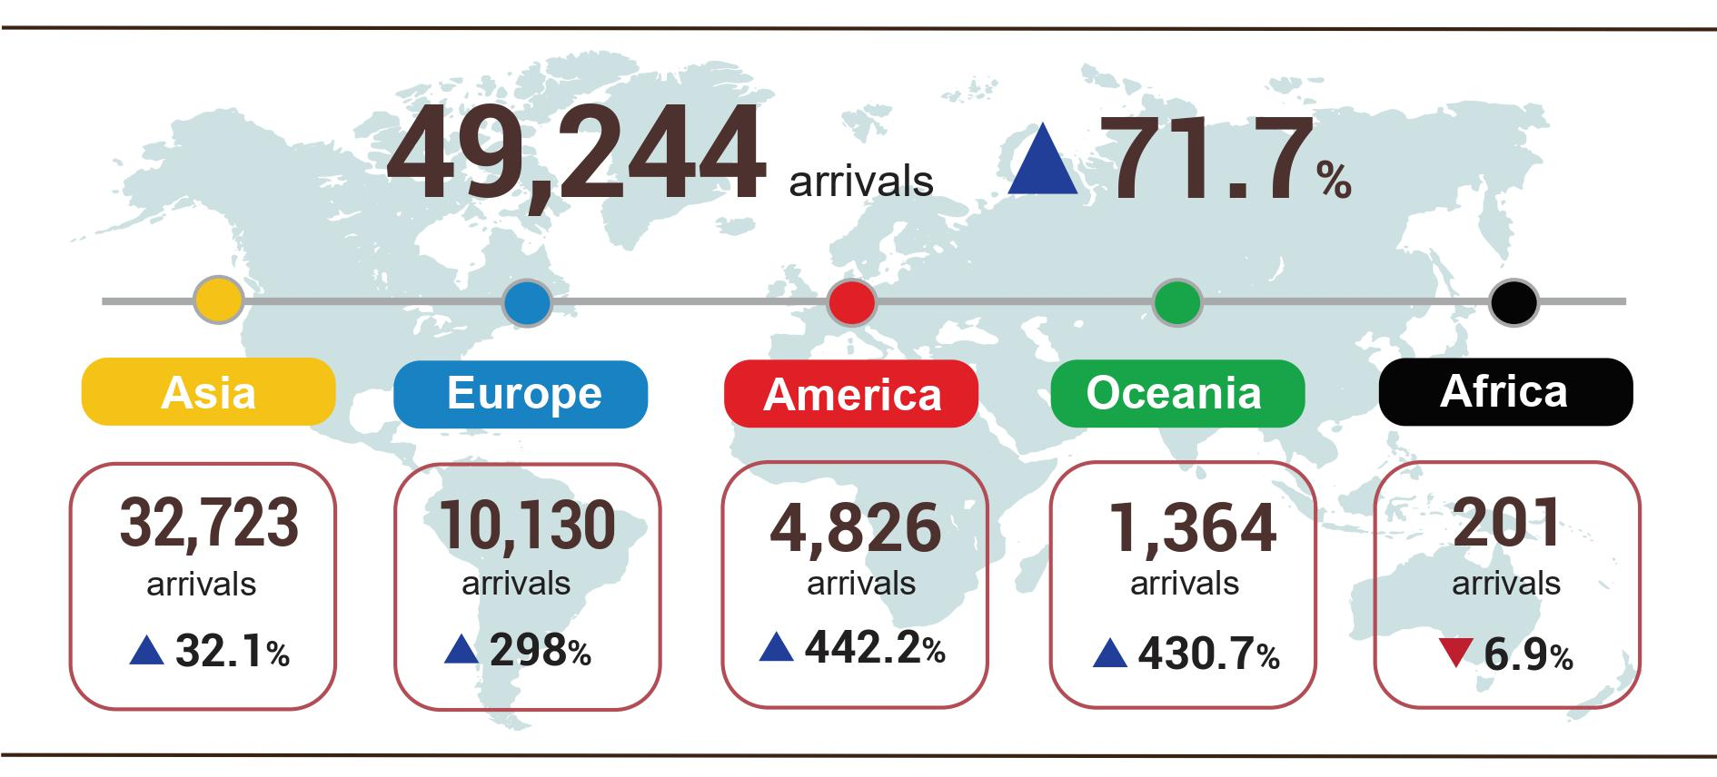
7. Some social situation
a) Residential life and social security
Social security work was concerned by all levels from the central to local ones, especially in the context of the prolonged and complicated Covid-19 epidemic, which has significantly affected economic development and social life, especially on the occasion of welcoming the Lunar New Year. According to a report by the Ministry of Labor, War Invalids and Social Affairs, as of February 5, 2022, the money taking care of the policy beneficiaries and employees’ lives during the last Lunar New Year was nearly 9.3 trillion VND for over 57.81 million people. Of which, gifts from the President by funding sources to people with meritorious services and to celebrate the elderly's life were 3.6 trillion VND; the provincial budget was 2.7 trillion VND; district budget was 1.2 trillion VND; the commune budget was 1.1 trillion VND; socialization expenditure was 621 billion VND. According to beneficiaries, the budget for giving Tet gifts to people with meritorious services to the revolution and their relatives was 3.5 trillion VND; poor households were 1.7 trillionVND; social protection objects were 1.4 trillion VND; for the elderly was 623 billion VND; for children was 232 billion VND; for other subjects was 1.8 trillion VND.
According to the report of the Ministry of Labor, War Invalids and Social Affairs, to ensure that people do not suffer from food shortages during the Lunar New Year and the between-crop period at the beginning of 2022, as of February 23, 2022, the Prime Minister decided to support nearly 18.7 thousand tons of rice for more than 379.8 thousand households with more than 1.2 million people at risk of starvation. Specifically: Support about 14 thousand tons of rice to save hunger during the Lunar New Year for more than 291.7 thousand households with more than 930.6 thousand people at risk of hunger; Supporting more than 4.7 thousand tons of rice to help fight hunger in the between-crop period at the beginning of 2022 for nearly 88.1 thousand households with more than 315.2 thousand people at risk of starvation.
b) Epidemic diseases and food poisoning
According to the report of the Ministry of Health, in the month (January 19, 2022 - February 18, 2022), the whole country had 4,444 cases of hemorrhagic fever; 163 cases of hand, foot, and mouth disease; 16 cases of virus encephalitis and 1 case of meningococcal disease. In the first 2 months of 2022, the whole country has 5,632 cases of hemorrhagic fever; 204 cases of hand, foot, and mouth disease; 20 cases of virus encephalitis; 1 case of meningococcal meningitis, and 3 cases of scarlet fever suspected for measles.
The epidemic of Covid-19 in the world continues to be complicated. In Vietnam, the number of cases included the number of severe and critical cases tends to increase. As of 16:00 on February 24, 2022, in Viet Nam had 3,123.3 thousand cases were reported, of which 2,355.6 thousand were cured and 39,962 deaths.
The rapid vaccination campaign in Spring 2022, launched by the Prime Minister, has been strongly deployed, in addition, localities have prepared resources to vaccinate against Covid-19 for children from 5-11 years old. As of February 22, 2022, the total number of doses of Covid-19 vaccine that have been administered was 191,993.4 thousand doses, of which the first dose injection was 79,492.7 thousand doses; the second dose injection was 76,901.3 thousand doses; the 3rd dose injection (additional injection, booster injection and basic 3-dose injection) was 35,599.4 thousand doses.
The total number of people living with HIV nationwide as of February 18, 2022, was 214,640 people, and the number of deaths by HIV/AIDS as of the above time-point was 111,171 people.
In February, there was 1 case of food poisoning with 06 people poisoned. Generally, in the first 2 months of 2022, there were 2 cases of poisoning with 10 people poisoned in the whole country.
c) Traffic accident
In February (from January 15 to February 14, 2022), there were 1,011 traffic accidents nationwide, including 723 traffic accidents from less serious and over, 288 traffic collisions, causing 620 deaths, 359 injuries, and 302 minor injuries. Compared with the previous month, traffic accident cases increased by 5%; the number of dead increased by 9.7%, and the number of injured people increased by 6.8%. Compared with the same period last year, traffic accident cases in February decreased by 9.9% (the number of traffic accidents from less serious and above decreased by 3.6% and the number of traffic collisions decreased by 22.6%); the number of deaths decreased by 0.3%; the number of injured people decreased by 13.3% and the number of minor injuries decreased by 31.2%. During the 9 days of the Tet holiday, 216 traffic accidents occurred, causing 121 deaths and 138 injuries; On average, there were 24 traffic accidents per day during the Tet holiday, killing 13 people and injuring 15 others.
Generally, in the first two months of 2022, there were 1,974 traffic accidents nationwide, including 1,410 traffic accidents from less serious and over, 564 traffic collisions, killing 1,185 people, 695 injuries, and 565 minor injuries. Compared with the same period last year, traffic accident cases in the first 2 months of this year decreased by 6.1% (the number of traffic accidents from less serious and over decreased by 1.5%; the number of traffic collisions decreased by 4.6%); the number of deaths decreased by 0.7%; the number of injured people decreased by 1.4% and the number of minor injuries decreased by 6.5%. On average per day in the first 2 months this year, there were 32 traffic accidents nationwide, including 23 traffic accidents from less serious and over, 9 traffic collisions, causing 19 deaths, 11 injuries, and 9 minor injuries.
d) Damage caused by natural disasters
Damages from natural disasters in the month (from January 19 to February 18, 2022) were mainly due to landslides and land subsidence. Generally, in the first 2 months of this year, natural disasters made 1 person missing; 591 houses collapsed and were damaged; 33.7 thousand hectares of rice and 3.7 thousand hectares of crops were damaged. The estimated property damage value was 645.3 billion VND, 23.7 times higher than the same period in 2021, of which some localities suffered heavy damage like Khanh Hoa lost 395.6 billion VND; Tien Giang 86.3 billion VND; Quang Ngai 66.5 billion VND; Binh Dinh 36.8 billion VND; Quang Nam 31.7 billion VND...
đ) Environmental protection and fire, and explosion prevention
In February 2022, authorities discovered 1,979 cases of environmental violations, of which 1,851 cases were handled with a total fine of more than 26.3 billion VND. Generally, in the first 2 months of this year, 5,165 cases of environmental violations were detected, of which 4,446 cases were handled with a total fine of 52.2 billion VND.
During the month, there were 162 fires and explosions in the whole country, killing 7 people and injuring 7 others, with estimated damage of 22.1 billion VND. Generally, in the first two months of 2022, there were 315 fires and explosions in the whole country, killing 16 people and injuring 16 others, with estimated damage of VND 46.1 billion./.

GENERAL STATISTICS OFFICE

Severe and harmful cold in the Northern and North Central provinces killed 6,389 cattle, including 5,311 buffaloes and cows; 1,078 goats and other livestock.
According to data from the Ministry of Agriculture and Rural Development, from January 16, 2022, to February 15, 2022.
Source: http://agromonitor.vn/group/48/280/giam-sat-gia
As of mid-February, the price of vannamei shrimp of 100 shrimp/kg ranged from 95,000 to 100,000 VND/kg; size 80 heads/kg fluctuated at 110,000 - 120,000 VND/kg; The price of black tiger shrimp 20 heads/kg ranged from 240,000 to 260,000 VND/kg. Source: http://agromonitor.vn/group/47/274/ban-tin-tuan
The 02/2021 IIP over the same period last year decreased by 8.3%.
The IIP index in 02/2022 compared with the previous month of the number of localities with huge industrial-scale decreased sharply: Vinh Phuc (-24.8%); Ba Ria - Vung Tau (-20%); Bac Giang (-19.8%); Long An (-18.3%); Hai Duong (-18%); Binh Duong (-16.2%); Thai Nguyen (-14.6%); Ha Noi (-14.2%); Hai Phong (-14%); Quang Ninh (-11.1%); Hung Yen (-9.2%); Bac Ninh (-7.3%).
Source: National Enterprise Registration Information System, Business Registration Management Agency, Ministry of Planning and Investment (Received the report on 24th February 2022)
According to the report of the Foreign Investment Department, Ministry of Planning and Investment, received on Fenuary 22, 2022
According to the Report on the implementation of Resolution No. 01/NQ-CP and No. 11/NQ-CP of the Government in the field of finance - state budget in February 2022.
Data for February 2022 was provided by the General Department of Customs on February 25, 2022.
Total import and export turnover of goods in the first 2 months in 2021 reached 96.02 billion USD, up 21.9% over the same period last year, of which export reached 48.81 billion USD, up 23.9%; imports reached 47.21 billion USD, up 19.9%.
The trade deficit in January 2022 was estimated at 500 million USD
For the Ho Chi Minh City - Hanoi route on the days before the Lunar New Year and for the Hanoi - Ho Chi Minh City route from the 4th day of the Lunar New Year.
Rice prices increased by 0.2% as export prices remained high when Vietnam's rice consuming markets such as the Philippines, Malaysia, China... increased imports and in the domestic, consumer demand for delicious rice and sticky rice increased during the Lunar New Year and the Full Moon in January. Besides, other processed food products also increased such as the price of vermicelli, fresh Pho, dry rice paper increased by 1.44%; vermicelli increased by 0.71%; instant noodles, Pho, and instant porridge increased by 0.53%.
Pork price increased by 5.25% due to increased consumer demand during the Lunar New Year and the Full Moon of January; prices of processed pork products increased (prices of roast meat, spring rolls increased by 2.69%; canned meat increased by 1.46%; other processed meat increased by 0.61%); egg prices of all kinds increased by 1.05%; poultry meat increased by 1.31%; edible fats and other fats increased by 1.69%; cakes, jams and sweets by 0.29%; tea, coffee, cocoa by 0.16%; fresh fruit increased by 4.33%; price of fresh seafood increased by 1.87% and processed seafood increased by 0.19% due to strong consumer demand in the month of Tet, while fuel prices continued to rise, along with severe cold weather, which affected fishing activities. On the other hand, vegetable prices decreased by 2.03% due to abundant supply, so vegetable prices in the central and southern provinces dropped sharply.
Package tour prices increased by 1.1%; hotel rental increased by 1%; plants, flowers, and ornamental plants increased from 0.06% to 7.04%.
CPI after excluding fresh food, foodstuff, energy and goods managed by the State including health services and education services.
According to the report of the Border Gate Department, the Border Guard Command, the Ministry of National Defense and the Immigration Department, the Ministry of Public Security.
The reporting period was from January 21, 2022, to February 20, 2022.
As of 4:00 p.m. on February 24, 2022, there were 432,206.1 thousand cases of Covid-19 (5,949.3 thousand deaths).
According to a quick report from the Office of the Ministry of Public Security and the Vietnam Maritime Administration (Ministry of Transport) from January 15, 2022 to February 14, 2022.
On average, there are 26 traffic accidents per day during the Tan Suu Lunar New Year, killing 16 people and injuring 18 others..
Tổng hợp Báo cáo từ 63 Sở Nông nghiệp và Phát triển nông thôn, kỳ báo cáo từ ngày 19/01-18/02/2022.
According to a quick report from the Ministry of Public Security on February 23, 2022.

