MINISTRY OF PLANNING AND INVESTMENT  GENERAL STATISTICS OFFICE  No: 52/BC-TCTK | SOCIALIST REPUBLIC OF VIET NAM  Independence-Freedom-Happiness  Ha Noi, 29th March 2022

Socio-economic situation report in the first quarter and 2022

The socio-economic of our country in the first three months of 2022 took place in the context that the world economy still maintains its recovery momentum, promoted production activities, and the global supply chain has been gradually opened. However, the conflict between Russia and Ukraine has created a major humanitarian crisis that affects millions of people and is a shock to global growth. The high price of commodities on the world market, especially the price of crude oil, natural gas, and liquefied natural gas, increased the most since 2011, putting great pressure on global inflation. Recent forecasts for global growth in 2022 by international organizations are all lower than previous forecasts. The Organization for Economic Cooperation and Development predicts that global growth could fall by more than 1 percentage point in 2022, compared with a forecast of 4.5% made in December 2021. Fitch Rating has revised down 0.7 percentage points, forecasting world GDP growth in 2022 to 3.5%. The World Bank forecasts global economic growth will be 4.1% in 2022 while the figure of the International Monetary Fund by 4.4%.
Domestically, with the determination to recover and develop the economy so as not to miss the pace with the recovery of the world economy, and at the same time achieve the goal of the Resolution of the 13th National Party Congress, the Government has issued Resolution 11/NQ-CP dated January 30, 2022, on the program of socio-economic recovery and development and the implementation of Resolution No. 43/2022/QH15 of the National Assembly on fiscal and monetary policies to support program. Ministries, branches, and localities have focused on developing action plans to synchronously implement solutions. Along with that, with the support of the people of the country and the faith of the business community, the Government's socio-economic recovery and development program has brought into play its impact, effectiveness, and created an impetus to restore the economy rapidly and sustainable. In the first three months of 2022, our country's socio-economy has achieved many positive results, most industries and fields tend to recover and grow again.
Achievements of industries and fields in the first quarter of 2022 are as follows:
I. ECONOMIC GROWTH
1. Gross domestic product growth rate
Gross domestic product (GDP) in the first quarter of 2022 was estimated to increase by 5.03% over the same period last year, higher than the growth rate of 4.72% in the first quarter of 2021 and 3.66% in the first quarter of 2020 but still lower than the growth rate of 6.85% in the first quarter of 2019. Of which, the agriculture, forestry, and fishery sector increased by 2.45%, contributing 5.76% to the overall growth; the industry and construction sector increased by 6.38%, contributing 51.08%; the service sector increased by 4.58%, contributing 43.16%.
In the area of ​​agriculture, forestry, and fishery, the yield of winter rice in the Mekong Delta increased significantly (by 7.4 quintals/ha) compared to the previous year's crop; the livestock industry is gradually recovering, the output of live meat for slaughter in the first quarter of 2022 has increased compared to the same period last year; wood processing and exporting has many positive signals; Aquaculture has developed stably, the prices of farmed pangasius and shrimp are at a high level due to a strong increase in export demand. The added value of the agricultural sector in the first quarter of 2022 increased by 2.35% over the same period last year, contributing 0.22 percentage points to the increase in the total added value of the whole economy; forestry increased by 3.86% but accounted for a low proportion, so it contributed only 0.02 percentage points; the fishery sector increased by 2.54%, contributing 0.05 percentage points.
In the industry and construction sector, the industry in the first quarter of 2022 increased by 7.07% over the same period last year, higher than the increase of 6.44% in the first quarter of 2021, contributing 2.42 percentage points to the growth rate of total value added of the whole economy. The processing and manufacturing industry continued to play a leading role in the growth of the economy with an increase of 7.79%, contributing 2.05 percentage points. The mining industry grew positively by 1.23% (coal mining increased by 3.2% and metal ore increased by 5%), increasing by 0.04 percentage points the increase in the total added value of the whole economy. The construction grew by 2.57%, lower than the 6.53% growth rate of the first quarter of 2021, contributing 0.16 percentage points.
The service sector in the first quarter of 2022 prospered when many service activities were active again. Contributions of some market service industries with a large proportion to the increase in the total added value of the first quarter of this year were as follows: Financial, banking, and insurance activities increased by 9.75% over the same period last year in advance, contributing 0.54 percentage points; transportation and warehousing increased by 7.06%, contributing 0.43 percentage points; wholesale and retail increased by 2.98%, contributing 0.31 percentage points; accommodation and catering services decreased by 1.79%, down 0.04 percentage points.
Regarding the structure of the economy in the first quarter of 2022, the agriculture, forestry, and fishery sector accounted for 10.94%; industry and construction accounted for 37.97%; service sector accounted for 41.70%; product tax minus product subsidies accounted for 9.39% (corresponding structure of the same period in 2021 was 11.61%; 36.61%; 42.38%; 9.40%).
Regarding GDP by use method in the first quarter of 2022, final consumption increased by 4.28% over the same period last year; accumulated assets increased by 3.22%; exports of goods and services increased by 5.08%; imports of goods and services increased by 4.20%.
2. Agriculture, forestry, and fishery
Agricultural production in the first quarter of 2022 took place in relatively favorable weather conditions for spring rice to grow and develop, but due to the complicated developments of the Covid-19 pandemic, it has greatly affected agricultural production and consumption. Livestock production has been in recovery but faced difficulties due to the high price of animal feed. The development of forestry production, wood processing, and export in the first months of 2022 had many positive signs. Aquaculture and seafood processing activities recovered strongly, the price of pangasius increased to a record level in 2018 after more than two consecutive years at a low level. Shrimp prices also tended to increase. Fishing output decreased due to high gasoline prices, many fishing boats lay ashore.
- Agriculture
Spring paddy
As of the middle of March, the country cultivated 2,959.7 thousand hectares of spring paddy, equaling 99.5% compared with the same period last year, of which: Northern provinces reached 1,048.8 thousand hectares, equaling 99.1%; Southern provinces reached 1,910.9 thousand hectares, equaling 99.6%, particularly the Mekong River Delta region reached 1,507 thousand hectares, equaling 99.2%. The area of spring rice cultivation decreased mainly due to conversion of land use purposes to non-agricultural land, to growing crops and fruit trees for higher economic value, or to aquaculture. Some localities with a much-reduced area were: Ben Tre reduced by 10.2 thousand ha; Dong Thap decreased by 6.8 thousand hectares.
In Northern provinces, many localities have completed the first rice tending phase and are proceeding with the second rice tending phase. Currently, rice is in the stage of branching, good growth, and development. Currently, the rice is in the tillering stage, especially the early rice is standing - making a pole, growing and developing well. In the southern provinces, the Mekong Delta has harvested 785 thousand hectares, accounting for 52.1% of the cultivated area and equaling 114.8% of the same period last year, with an estimated yield of 71.8 quintals/ha, down 0.5 quintals/ha compared to the previous year; production reached 10.8 million tons, fell 165.2 thousand tons.
Winter paddy
As of mid-March, Mekong River Delta provinces basically completed harvesting winter paddy 2021-2022. The total cultivated area of the whole region reached 171.2 thousand hectares, equaling 113.6% compared with the previous winter paddy season. Due to less saline intrusion in the dry season this year, along with an effective irrigation system to prevent saline intrusion and perform well in field sanitation; deploying the planting of new high-quality rice varieties, the yield of winter rice in the whole region was quite good at 51.6 quintals/ha, an increase of 7.4 quintals/ha compared to the yield of the previous year's crop, the production reached 881.1 thousand tons, an increase of 215.8 thousand tons.
As of mid-March, the progress of planting many winter-spring crops in general decreased compared to the same period last year mainly due to low economic efficiency and difficulties in product consumption.

Figure 1: Cultivation area of some annual crops
(As of mid-March)

Perennial trees
In the 1st quarter of 2022, some perennial industrial crops were harvested, of which: tea-shoot production was estimated at 171.3 thousand tons, growing up 2.6% compared with the same period last year; pepper reached 166.1 thousand tons, rising by 3.8%; rubber reached 127 thousand tons, grew up 2.4%; cashew reached 210.7 thousand tons, fell 16.6%. Production of some fruit increased quite well compared with the same period last year: banana reached 654.3 thousand tons, grew up 3.3%; orange reached 263 thousand tons, grew up 2.1%; pine-apple reached 211.2 thousand tons, grew up 3,4%; mango reached 180.9 thousand tons, grew up 2.4%; pomelo reached 158.2 thousand tons, grew up 3.2%. Particularly, dragon fruit reached 349.7 thousand tons, down 3.2% due to facing difficult export.
Livestock
Buffaloes and cows’ husbandry in the first quarter was affected by severe and harmful colds in February. Pig and poultry farming is gradually stabilizing because businesses, farms, and households were proactive in breeding stock, linking consumption of output products, and ensuring hygiene and biosecurity.
Figure 2. The growth rate of the population of livestock at the
end of March 2022 compared to the same time last year
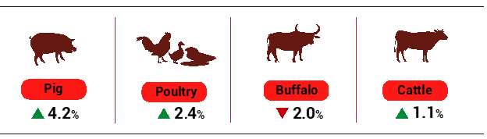
The livestock industry is still facing difficulties due to high feed prices while livestock product prices tend to decrease . The risk of recurrence of African swine fever is great, avian influenza still sporadically occurs in some localities, and farmers need to take effective measures to prevent and handle epidemics to reduce the risk of outbreaks on a large scale.
Table 1. Main productions of livestock
 | The first | Estimate | The first quarter of
 | quarter | the first quarter | 2022 compared with
 | of 2021 | of 2022 | the same period last year (%)
Living-weight (Thous. tons)
Buffalo | 33.5 | 33.9 |  | 101.1
Cattle | 124.7 | 128.9 |  | 103.4
Pig | 998.5 | 1,041.1 |  | 104.3
Poultry | 481.7 | 507.3 |  | 105.3
Other production of livestock
Eggs (Mill. pieces) | 4,403.8 | 4,601.6 |  | 104.5
Milk (Thous. tons) | 275.5 | 304.4 |  | 110.5

As of March 21, 2022, the whole country has no longer blue-ear disease and foot-and-mouth disease; avian flu was still only in Ha Noi; LSD was still in Quang Nam, Quang Ngai, Binh Dinh, Khanh Hoa, Dak Lak, and African swine fever were reported in 24 localities for less than 21 days.
b) Forestry
In March 2022, the newly concentrated planted forest area of ​​the whole country was estimated at 17.4 thousand hectares, up 5.3% over the same period last year; the number of scattered planted trees reached 13.5 million trees, an increase of 12%; timber production reached 1,216.5 thousand m³, up 4.5%; firewood production reached 1.7 million ste, up 3.1%. The situation of wood consumption in the first months of 2022 has many positive signs, the demand for wood and wood products, especially wooden furniture in the world market, has increased rapidly. Therefore, Vietnam's wood processing enterprises have many opportunities to increase the export market share of wood and wood products in the coming time, contributing to promoting the exploitation and consumption of wood in the country. It was estimated that in the first quarter of 2022, the newly concentrated planted forest area of ​​the whole country reached 35.4 thousand hectares, up 5.1% over the same period last year; the number of scattered planted trees reached 27 million trees, up 8.2%; timber production reached more than 3.1 million m³, an increase of 3.6%; firewood production reached 4.7 million ste, up 0.9%.
Damaged forest area in March was 76.4 ha, down 19.7% over the same period last year, including burnt forest area was 6.9 ha, down 66.1%; the deforested forest area was 69.5 ha, a decrease of 7%. It was estimated that in the first quarter of 2022, the damaged forest area was 216.5 hectares, down 40.4% over the same period last year, including the burnt forest area was 7.8 hectares, down 93.2% (in the first quarter of 2021, the burnt forest area was 115.1 ha); the deforested forest area was 208.7 ha, down 15.9%.
c) Fishery
Fishery production in March was estimated at 694.2 thousand tons, up 2% over the same period last year, including Fish reaching 517.4 thousand tons, up 1.9%; shrimp reached 68.2 thousand tons, up 9.1%; other aquatic products reached 108.6 thousand tons, down 1.6%. Generally, in the first quarter of 2022, fishery production was estimated at 1,863.6 thousand tons, up 2% over the same period last year, including Fish reached 1,385.2 thousand tons, up 1.7%; shrimp reached 180.5 thousand tons, up 5.7%; other aquatic products reached 297.9 thousand tons, up 1.2%.
Aquaculture production in March was estimated at 367.8 thousand tons, up 7.7% over the same period last year, of which: Fish reached 268.4 thousand tons, up 7.1%; shrimp reached 56 thousand tons, up 11.8%. Generally, in the first quarter of 2022, aquaculture production was estimated at 988 thousand tons, up 5.1% over the same period last year, of which: Fish reached 716.5 thousand tons, up 4.6%; shrimp reached 148.1 thousand tons, up 7.1%.
Pangasius prices increased sharply due to low domestic and global pangasius supplies. The price of raw pangasius in the Mekong Delta increased sharply after more than two consecutive years at a low level. In January 2022, the price of raw pangasius 0.9 kg/head in Dong Thap, An Giang, and Can Tho provinces fluctuated at 23.5-24 thousand VND/kg, up 3.5-4.0 thousand VND compared to the same period last year. This price was maintained until the beginning of February. In the middle of February, the price of pangasius increased to 26-28 thousand VND/kg and the first week of March reached 32,000 VND/kg. The output of pangasius in March was estimated at 140.7 thousand tons, up 13.5% over the same period last year. In the first quarter of 2022, pangasius production reached 342.6 thousand tons, up 6.5% over the same period last year.
Shrimp prices tend to increase, localities continue to develop high-tech, semi-intensive vannamei shrimp in parallel with new farming processes, bottom-lined ponds, and proactive environmental control increasingly better. Black tiger shrimp production in March 2022 was estimated at 17.1 thousand tons, down 1.7% over the same period last year; vannamei shrimp production reached 35.2 thousand tons, up 23.1%. In the first quarter of 2022, the output of black tiger shrimp was 47 thousand tons, down 0.8% over the same period last year; vannamei shrimp production reached 89.1 thousand tons, up 12.9%.
Catch Fishery output in March was estimated at 326.4 thousand tons, down 3.7% over the same period last year, of which: Fish reached 249 thousand tons, down 3.1%; shrimp reached 12.2 thousand tons, down 1.6%. Marine fishing output in the month was estimated at 313.6 thousand tons, down 3.9% because the number of boats tended to decrease towards sustainable fishing; The high price of gasoline caused the input costs to increase while the price of exploited seafood tends to decrease, so fishermen limited going to the sea.

Figure 3. Aquaculture and catch fishery production 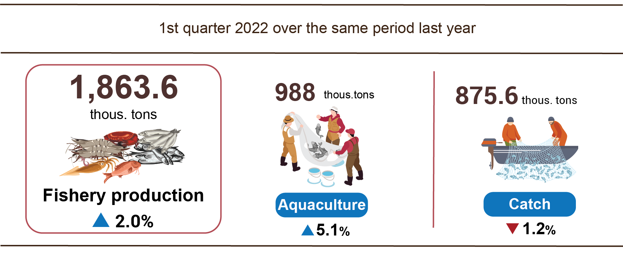
In general, in the first quarter of 2022, catch fishery production was estimated at 875.6 thousand tons, down 1.2% over the same period last year, of which: Fish reached 668.7 thousand tons, down 1.1%; shrimp was 32.4 thousand tons, down 0.3%. The output of marine fishing in the first quarter of 2022 was estimated at 835.3 thousand tons, down 1.3%.
3. Industrial production
Industrial production in the first quarter of 2022 continued to prosper with the value-added of the whole industry increasing by 7.07% over the same period last year, of which the manufacturing increased by 7.79%; electricity production and distribution grew steadily; the mining and quarrying increased positively due to an increase in coal and metal ore
The added value of the whole industry in the first quarter of 2022 was estimated to increase by 7.07% over the same period last year. In which, manufacturing increased by 7.79%, contributing 2.05 percentage points to the general growth of the whole economy; electricity production and distribution increased by 7.42%, contributing 0.29 percentage points; Water supply; sewerage, waste management, and remediation activities increased by 6.54%, contributed 0.04 percentage points; the mining and quarrying increased by 1.23% (due to an increase in coal by 3.2%; metal ore by 5%), contributing the overall growth rate by 0.04 percentage points.
The index of production in the quarter I/2022 of some key activities significantly increased compared to the same period last year: Manufacture of wearing apparel (24.1%); Manufacture of machinery and equipment n.e.c (16.2%); Manufacture of electrical equipment (12.2%); Manufacture of leather and related products (10.4%); Manufacture of fabricated metal products, except machinery and equipment (10.1%); Manufacture of computer, electronic and optical products (9.4%); Manufacture of other non-metallic mineral products (8%). On the opposite side, some industry’s IIP decreased: Manufacture of rubber and plastics products (-15.5%); Repair and installation of machinery and equipment (-11.9%); Manufacture of coke and refined petroleum products (-11.7%); Other mining and quarrying (-3.3%); Extraction of crude petroleum and natural gas (-2.2%).
Table 2. The IIP growth rate of every 3 months in 2018-2022
of some key industries
%
 | 2018 | 2019 | 2020 | 2021 | 2022
Manufacture of wearing apparel | 8.1 | 7.7 | -2.2 | 3.5 | 24.1
Manufacture of machinery and equipment n.e.c | 5.6 | 16.8 | -13.0 | 9.8 | 16.2
Manufacture of electrical equipment | 15.6 | 7.8 | -2.6 | 11.8 | 12.2
Manufacture of leather and related products | 9.0 | 8.3 | 5.6 | 5.4 | 10.4
Manufacture of fabricated metal products, except machinery and equipment | 14.3 | 4.4 | 5.0 | 8.3 | 10.1
Manufacture of computer, electronic and optical products | 34.6 | 3.0 | 14.3 | 9.1 | 9.4
Manufacture of other non-metallic mineral products | 12.9 | 5.5 | 0.5 | 6.5 | 8.0
Extraction of crude petroleum and natural gas | -1.6 | -5.0 | -10.5 | -12.3 | -2.2
Other mining and quarrying | 0.4 | -1.0 | -0.5 | 2.1 | -3.3
Manufacture of coke and refined petroleum products | 4.4 | 72.7 | 21.7 | -2.1 | -11.7
Repair and installation of machinery and equipment | 0.0 | -3.0 | -5.9 | 3.7 | -11.9
Manufacture of rubber and plastics products | 2.3 | 13.0 | 2.5 | 10.1 | -15.5

The 1st quarter of 2022’s IIP over the same period last year increased in 61 provinces and decreased in 02 provinces across the country.

Figure 4. The IIP growth rate of some provinces in the first 3 months of 2022
over the same period last year (%)
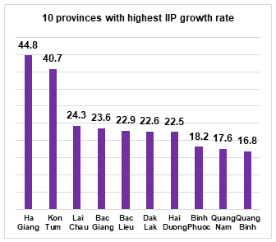 | 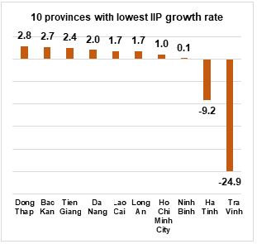
Some key industrial products in the 1st quarter 2022 highly increased over same previous last year: Phone accessories (19%); Monosodium glutamate (15.7%); Automobile (13.4%); Aluminium (12.6%); Clothes (12.4%); Steel bars and corners (11%); Fresh milk (9.2%); Processed fishery products (8.9%); Textile fabric from natural yarn (8.7%). In the opposite side, some products decreased over the same period last year: Television (-23.3%); Petroleum (-12.5%); Textile fabric from polyester or artificial yarn (-12.3%); Aquatic feed (-11.7%); Mobile phone (-9.3%); N.P.K mixed fertilizer (-6.6%); Chemical paint (-5.7%).
The consumption index of the manufacturing industry in 3/2022 increased by 19.1% over the previous month and up 7.6% over the same period last year. Generally, in the first quarter of 2022, the consumption index of the whole manufacturing industry increased by 6.6% over the same period last year (the same period last year went up by 5.8%).
The inventory index of the manufacturing industry was estimated as of 31/3/2022 increased by 4.8% over the period month and increased by 17.7 over the same period last year (in the same period of 2022 increased by 22.5%). The average inventory rate of the whole processing and manufacturing industry in the first quarter of 2022 was 79.9% (the same period last year was 75.1%).
The number of employees working in industrial enterprises as of March 1st, 2022 increased by 1.9% over the same period last month and up 2.7% over the same period last year, of which the number of working employees in the state-owned enterprise sector increased by 0.3% and decreased by 3.3%; non-state enterprises increased by 1.4% and decreased by 2.8%; enterprises of foreign direct investment rose by 2.3% and went up by 4.3%. By industry, the number of employees working in mining and quarrying increased by 0.3% over the same period last month and fell by 1.9% against the same period last year; manufacturing peaked up by 2.1% and up 2.9%; the production and distribution of electricity rose by 0.1% and surged by 0.4%; the water supply, sewerage, waste management and remediation activities went up by 0.1% and increased by 2.1%.
4. Enterprise activities
The situation of business registration in the first quarter of 2022 has many improvements, the number of newly-established enterprises and re-operated enterprises in the first quarter of 2022 increased by 36.7% compared to the same period last year; the total capital registered to the economy increased by 21%, of which the additional registered capital of active enterprises increased by 34.5%. In addition, the results of the survey of business trends of enterprises in the processing and manufacturing industry showed that enterprises are optimistic about the production and business situation in the second quarter of 2022 with 82.3% of enterprises assessing that it will be stable and better than the first quarter of 2022. This is the result of the determination of the National Assembly and the Government to recover and develop the economy in recent years, creating trust and motivation for the business community to develop production and business activities.
a) Enterprise registration status
In March, the whole country had 14.3 thousand newly established enterprises with registered capital was 193.6 trillion VND and a total number of registered employees of 93.8 thousand employees, an increase of 96.3% in the number of enterprises, an increase of 127.3% in registered capital and an increase of 29.2% in the number of employees compared to February 2022. Compared to the same period last year, an increase of 28% in the number of enterprises, 71.3% in registered capital, and 28.8% in the number of employees. The average registered capital of a newly established enterprise in the month reached 13.5 billion VND, an increase of 15.8% compared to the previous month and an increase of 33.8% over the same period last year. In addition, the country also had 4.3 thousand enterprises re-operated, up 5.6% compared to the previous month and down 5.1% compared to the same period in 2021.
In the first 3 months of 2022, the country had nearly 34.6 thousand newly registered enterprises with a total registered capital of 471.2 trillion VND and the total number of registered employees was nearly 243.5 thousand employees, an increase of 18.1% in the number of enterprises, an increase of 5.2% in registered capital and a decrease of 0.9% in the number of employees compared to the same period last year. The average registered capital of a newly established enterprise in the first 3 months of 2022 reached 13.6 billion VND, down 10.9% compared to the same period in 2021. If including 706.7 trillion VND of the additionally registered capital of 11.8 thousand enterprises that recorded an upward adjustment of capital, the total additional registered capital in the economy in the first three months of 2022 was 1,177.9 trillion VND, an increase of 21% compared to the same period last year. In addition, 25.6 thousand re-operated enterprises (up 73.6% compared to the same period in 2021), bringing the total number of newly-established enterprises and re-operated enterprises in the first 3 months of 2022 to 60.2 thousand enterprises, up 36.7% compared to the same period last year. The average every month had 20 thousand newly established and re-operated enterprises.
By economic sector in 3 months, there were 519 newly-established enterprises in the agricultural, forestry, and fishery sectors, an increase of 10% compared to the same period last year; more than 9 thousand enterprises in the industrial and construction sectors, an increase of 10.7%; nearly 25.1 thousand enterprises in the service sector, an increase of 21.1%.

Figure 5. Enterprise registration situation
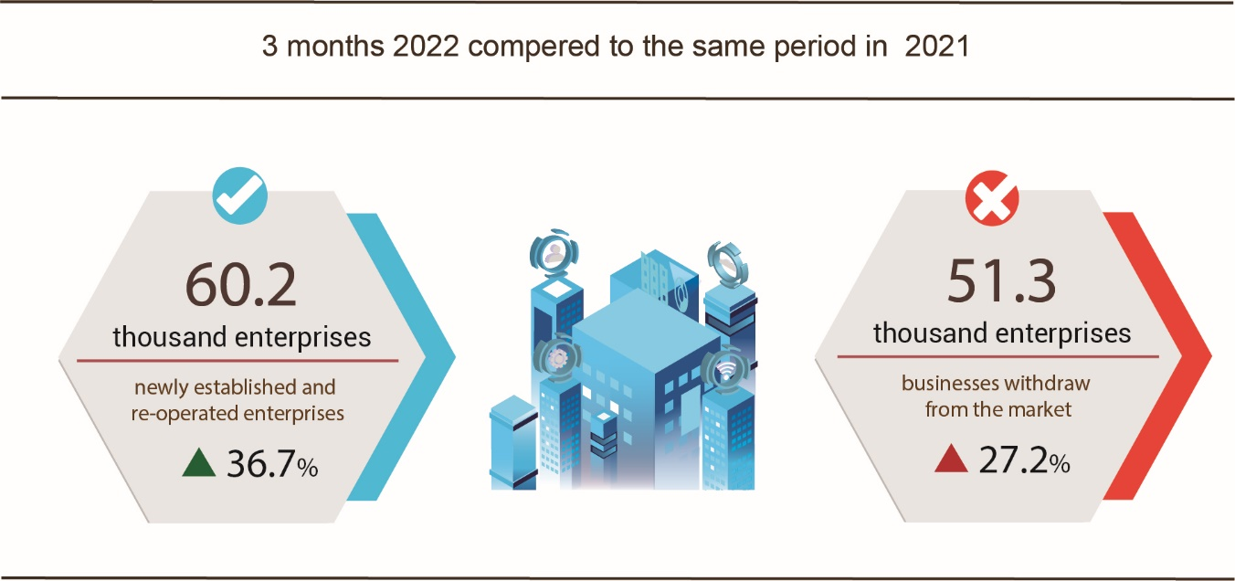
Also in March, 2,976 enterprises ceased for a certain time, down 14.1% compared to the previous month and up 34.5% over the same period in 2021; 2,474 enterprises temporarily ceased and awaited dissolution procedures, an increase of 29.1% and a decrease of 28.5%; 1,077 enterprises completed dissolution procedures, down 12.7% and down 33%.
In the first 3 months of 2022, there were 35.7 thousand enterprises temporarily ceased for a certain time, an increase of 49.7% compared to the same period last year; 11.3 thousand enterprises temporarily ceased and awaited dissolution procedures, an increase of 0.1%; more than 4.3 thousand enterprises completed dissolution procedures, down 16.7%, of which 3.8 thousand enterprises with a capital size of less than 10 billion VND, down 19.7%; 63 enterprises had a capital size of over 100 billion VND, an increase of 28.6%. On average, 17.1 thousand enterprises withdraw from the market each month.

Table 3: Number of newly registered enterprises and completed dissolution procedures in 3 months, 2022 by kinds of activity

 | Number of enterprises (Enterprise) |  | Growth rate  over the same period last year (%)
 | Newly registered | Dissolution | Newly registered | Dissolution
1. Wholesale and retail trade; repair of motor vehicles and motorcycles | 12,285 | 1,592 | 25.1 | -18.2
2. Manufacturing | 4,534 | 453 | 20.1 | -26.5
3. Construction | 4,028 | 375 | 5.4 | -18.8
4. Real estate business | 2,551 | 262 | 47.2 | 7.8
5. Transportation and storage | 1,810 | 181 | 32.5 | -26.7
6. Accommodation and catering service | 1,289 | 226 | 22.6 | -21.8
7. Production and distribution of electricity, water, gas | 275 | 106 | -30.7 | -1.9

b) Business trends of the enterprises
Results of the business tendency survey of manufacturing enterprises in the first quarter of 2022 showed that: 28,4% of enterprises assessed that the business production situation was better than in the fourth quarter of 2021; 35.8% of enterprises said that the business production situation was stable and 35.8% of enterprises faced difficulties. For the expected outcome of the second quarter of 2022, 50% of enterprises presented that the tendency would get better than the first quarter of 2022; 17.7% of enterprises predicted that it would be more difficult and 32.3% of enterprises said that business production situation would be stable. In which, the foreign direct investment sector was the most optimistic, 84.7% of enterprises forecasted a better business production situation in the first quarter of 2022 and expected to remain stable; these rates in the State-owned enterprises and the non-state enterprises were 83.6%, and 81.2% respectively.

Figure 6. The main factors affecting the business production situation
in the first quarter of 2022

Regarding production volume, 30.3% of enterprises pointed out the production volume in the first quarter of 2022 increased compared to the fourth quarter of 2021; 35% of enterprises reported that the production volume reduced and 34.7% of enterprises considered it stable. For the trend in the second quarter of 2022, 50.3% of enterprises forecasted an increase in the production volume; 15.6% of enterprises forecasted a decrease and 34.1% of enterprises predicted stability.
Regarding orders for goods, 26.8% of enterprises had more orders in the first quarter of 2022 than in the fourth quarter of 2021; 39.8% of enterprises had stable orders and 33.4% of enterprises recorded a decrease in orders. About trend in the second quarter, 2022 over the first quarter, 2022, 46.6% of enterprises expected an increase in orders; 16.3% of enterprises expected a decrease in orders, and 37.1% of enterprises expected to have stable orders.
Regarding export orders, 24.7% of enterprises confirmed more export orders in the first quarter of 2022 than the fourth quarter of 2021; 40.9% of enterprises experienced stable export orders and 34.4% of enterprises had decreased export orders. About trend in the second quarter of 2022, over the first quarter, 2022, 40.3% of enterprises expected to have an increase in export orders; 14.6% of enterprises expected to decrease, and 45.1% of enterprises expected to be stable.
5. Service activities
a) Retail sales of consumer goods and services
Trade and service activities in March were quite active with the total retail sales of consumer goods and services increased by 2.9% over the previous month and up 9.4% over the same period last year. Generally, for the first quarter of 2022, the total retail sales of consumer goods and services increased by 4.4% over the same period last year.
Total retail sales of consumer goods and services in March 2022 was estimated at 438 trillion VND, up 2.9% from the previous month and up 9.4% over the same period last year. Generally, in the first quarter of 2022, the total retail sales of consumer goods and services were estimated at 1.318 trillion VND, up 4.4% over the same period last year, if excluding the price factor it was an increase of 1.6% (in the same period in 2021, up 2%).

Table 4. Retail sales of consumer goods and services
Trillion VND
 | Estimate  March  2022 | Estimate  1st quarter  2022 | The growth rate compared to the same period last year (%)
 | Estimate  March  2022 | Estimate  1st quarter  2022 | March  2022 |  | 1st Quarter  2022
Total | 438.0 | 1,318.0 | 9.4 | 4.4
Retail sales | 352.0 | 1,062.2 | 10.7 | 5.8
Accommodation and catering service | 41.5 | 124.4 | 5.9 | 1.2
Traveling service | 1.1 | 3.1 | 29.9 | 1.9
Other services | 43.4 | 128.3 | 3.2 | -2.5

Trade and service activities are gradually recovering with total retail sales of consumer goods and services in the first quarter of 2022 higher than in the same period of previous years.

Figure 7. Total retail sales of consumer goods and services
in the first quarter from 2018-2022
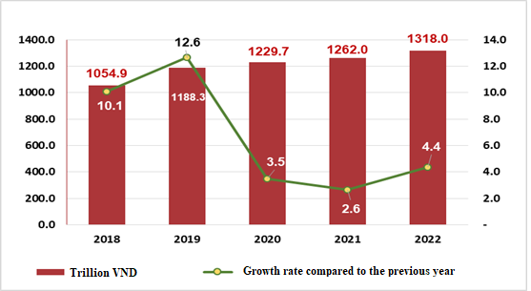
Retail sales of goods in the first quarter of 2022 increased by 5.8% over the same period last year, of which the group of food and foodstuffs increased by 11%; cultural and educational products increased by 10.1%; vehicles increased by 5.4%; garments down 3.6%; household appliances, tools, and equipment decreased by 4.9%. However, these groups of industries increased mainly due to the increase in prices when fuel prices were increased. Retail sales of goods in the first quarter of the year compared with the same period last year of some localities: Quang Ninh increased by 11.7%; Binh Duong increased by 10.8%; Hai Phong increased by 9.5%; Ba Ria - Vung Tau increased by 9.4%; Dong Nai increased by 8.7%; Can Tho increased by 7.5%; Ha Noi increased by 7.2%; Da Nang increased by 3%; Khanh Hoa increased by 2.8%; Ho Chi Minh city increased by 1%.
Revenue from accommodation and food services in the first quarter of 2022 increased by 1.2% over the same period last year, of which the revenue of some localities increased/decreased as follows: Bac Ninh increased by 24%; Can Tho increased by 18.3%; Phu Yen increased by 18.1%; Lam Dong increased by 17.4%; Dong Nai increased by 16.2%; Quang Ninh increased by 7.5%; Hanoi increased by 1.1%; Ho Chi Minh city decreased by 5.6%, Tien Giang decreased by 26.9%; Bac Lieu decreased by 15.3%.
Traveling and tourism revenue in the first quarter of 2022 increased by 1.9% over the same period last year as Vietnam began to open up tourism, of which the revenue of some localities increased/decreased as follows: Khanh Hoa increased by 279.1%; Quang Nam increased by 71.1%; Can Tho increased by 50.1%; Ha Giang increased by 17.6%; Hanoi increased by 10.6%; Ho Chi Minh city decreased by 26.8%; Da Nang fell 51.1%.
Revenue from other services in the first quarter of 2022 decreased by 2.5% compared to the same period last year, specifically the increase/decrease in some localities was as follows: Dong Nai increased by 15.3%; Quang Ninh increased by 13.5%; Can Tho increased by 9%; Khanh Hoa increased by 7.9%; Binh Duong increased by 6.8%; Hanoi increased by 3.1%; Hai Phong down 0.9%; Ho Chi Minh City down 15.5%; Da Nang fell 17%.
- Transport
In March, people's travel demand decreased compared to the Lunar New Year. Besides, the Covid-19 epidemic continues to spread strongly, so passenger transport activities faced many difficulties with the number of passengers carried decreasing by 14% and passengers traffic increasing only slightly by 0.6% over the same period last year. Meanwhile, freight transportation recorded a positive increase of 15.7% in carried and 9.7% in traffic.
Generally, in the first quarter of 2022, passenger carried decreased by 23.6% compared to the same period last year, passenger traffic decreased by 15.8%, freight carried increased by 8.2%, and freight traffic increased by 8.8%.
Passengers carried in March 2022 were estimated at 241.5 million persons, decreased by 1.7% compared to the previous month, and passenger traffic was 12.1 billion passengers-km, increased by 4.7%. Generally, in the first quarter of 2022, passenger carried reached 740.8 million passengers, a decrease of 23.6% over the same period last year (the same period of 2021 down 15.5%), the passenger traffic gained 34.8 billion passengers-km, down 15.8% (the same period of 2021 decreased by 22.5%). Of which, domestic passengers carriage gained nearly 740.6 million passengers, down 23.6% and 34.2 billion passengers-km, down 17.1%; overseas passengers carriage achieved 146.7 thousand passengers, increasing by 703.1% and 593.9 million passengers-km, went up 918.9%.
By types of transport, most of types in the first quarter of this year decreased compared to the same period last year because the number of Covid-19 cases in localities increased rapidly, so people also restricted their movement.

Table 5. Carriage of passengers in the first quarter of 2022
by types of transport

 | Number of passengers |  |  | The growth rate compared to the same period last year (%)
 | Carried  (Mill. passengers) | Traffic  (Bill. passengers-km) |  | Carried | Traffic
Total | 740.8 | 34.8 |  | -23.6 | -15.8
Railway | 0.5 | 0.2 |  | -23.1 | -33.3
Seaway | 1.3 | 0.09 |  | -19.0 | -17.5
Inland waterway | 55.5 | 0.9 |  | -10.5 | -14.3
Road | 674.6 | 25.2 |  | -24.8 | -24.2
Airway | 8.9 | 8.4 |  | 18.8 | 27.4

Freight carried in March 2022 was estimated at 167.5 million tons, increased by 4.8% compared to the previous month, and freight traffic was at 31.5 billion tons-km, up 3.6%. Generally, in the first quarter, freight carried reached 501,8 million tons, up 8.2% against the similar period last year (the same period in 2021 increased by 8.2%), freight traffic gained 94.3 billion tons-km, up 8.8% (the same period of 2021 increased by 5.1%), of which domestic freight carried recorded 492.7 million tons, an increase of 8.6% and 56.8 billion tons-km, up 9.5%; oversea freight reached 9.1 million tons, decreasing by 10% and 37.4 billion tons-km, up 7.6%.
Table 6. Carriage of freight in the first quarter of 2022
by types of transport
 | Quantity of goods |  |  | The growth rate compared to the same period last year (%)
 | Carried  (Mill. tons) | Traffic  (Bill. tons-km) |  | Carried | Traffic
Total | 501.8 | 94.3 |  | 8.2 | 8.8
Railway | 1.5 | 1.2 |  | 18.1 | 34.6
Seaway | 22.6 | 44.0 |  | 10.6 | 6.5
Inland waterway | 82.0 | 18.8 |  | 3.9 | 8.0
Road | 395.6 | 29.3 |  | 8.9 | 11.2
Airway | 0.07 | 1.0 |  | 7.8 | 39.1

c) Telecommunications
Telecommunications activities in the first quarter of 2022 were generally stable with estimated revenue of 83.8 trillion VND, an increase of 5.1% compared to the same period last year (if excluding the price factor, an increase of 4.6%). The total number of telephone subscribers by the end of March 2022 was estimated at 127.2 million subscribers, a decrease of 0.8% compared to the same period last year, of which mobile phone subscribers reached 124.1 million subscribers, down 0.6%. The number of fixed broadband internet subscribers by the end of March 2022 recorded 19.8 million subscribers, up 13.2% compared to the same period last year, of which subscribers accessing via Fiber to The Home (FTTH) and hiring private channels increased rapidly, subscribers accessing through Cable Television (CATV) system and xDSL continued to decrease.
d) International visitors to Viet Nam
International visitors to our country in March increased by 41.4% compared to the previous month and 2.2 times higher than the same period last year because Viet Nam has implemented a pilot route to welcome international tourists and many international routes have been restored. Generally, in the first quarter of 2022, international visitors to Viet Nam was estimated at 91 thousand arrivals, up 89.1% compared to the same period last year
International visitors to Viet Nam in March were estimated at 41.7 thousand arrivals, up 41.4% compared to the previous month and 2.2 times higher than the same period last year. Generally, in the first quarter of 2022, international visitors to Viet Nam was estimated at 91 thousand arrivals, up 89.1% compared to the same period last year, of which visitors coming by airway gained 82.3 thousand persons, accounting for 90.5% of the number of international visitors to Viet Nam, increased by 165.2%; by roadway achieved 8.6 thousand arrivals, accounted for 9.5% and went down by 49.1%; by seaway achieved 36 arrivals, accounted for 0.04% and decreased by 72.1%.

Figure 8. International visitors to Viet Nam
in the first quarter of 2022 by territories
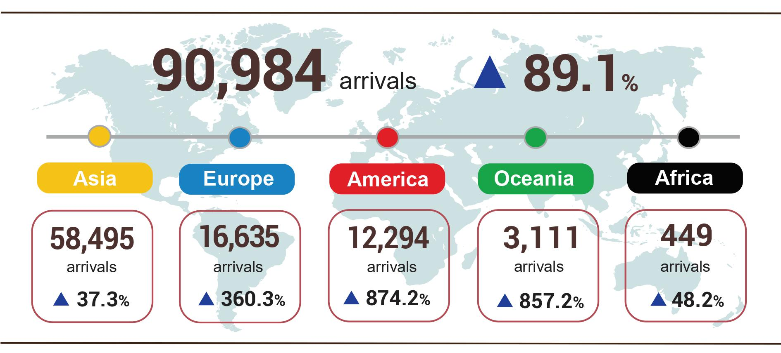

II. MACROECONOMIC STABILITY, INFLATION CONTROL
1. Banking, insurance, and securities activities
In the first quarter of 2022, in the context of the economy facing many difficulties due to the impact of the Covid-19 pandemic, the State Bank of Vietnam continued to maintain the operating interest rate, creating favorable conditions for credit institutions to continue to operate. continue to reduce lending interest rates, and support the recovery of the economy. The insurance business grew steadily; The stock market has many positive prospects with the stock market capitalization estimated to increase by 28% over the same period of last year.
As of March 21, 2022, the total means of payment increased by 2.49% compared to the end of 2021 (the same period in 2021 increased by 1.49%); capital mobilization by credit institutions increased by 2.15% (in the same period in 2021, it increased by 0.54%); credit growth of the economy reached 4.03% (in the same period of 2021, it increased by 1.47%).
In the first quarter of 2022, interest rates will be managed in line with the macro balance, inflation, and monetary policy objectives. The State Bank of Vietnam continues to maintain the operating interest rate unchanged, maintaining low-cost capital sources so that credit institutions can have conditions to reduce lending interest rates; reduce operating costs, and focus all resources to support and accompany businesses and people to overcome difficulties caused by the epidemic. The average deposit interest rate in VND of domestic commercial banks is 0.1%-0.2%/year for demand deposits with terms of less than 1 month; 3.3%-3.5%/year for term deposits from 1 month to less than 6 months; 4.2%-5.7%/year for deposits with a term from 6 months to 12 months; 5.3%-6.5%/year for deposits with terms from over 12 months to 24 months and 6.1%-6.9% for terms over 24 months. The average short-term lending interest rate in VND for priority sectors is about 4.3%/year, lower than the maximum short-term lending interest rate as prescribed by the State Bank of Vietnam (4.5%/year).
The central exchange rate continues to be managed flexibly, closely following market movements and monetary policy objectives. As a result, the exchange rate and foreign currency market are generally stable, contributing to stabilizing the macroeconomy, creating conditions for businesses to be proactive in building and implementing production and business, and hedging against exchange rate risks. Payment activities in the economy take place safely, efficiently, and smoothly; The legal framework for payment activities continues to be improved, and non-cash payments are promoted.
In the first months of 2022, amid the complicated developments of the Covid-19 epidemic, the insurance market still maintained a stable growth rate. Premium revenue of the entire insurance market in the first quarter of 2022 was estimated to increase by 13% over the same period last year, of which premium revenue from the life sector increased by 15%, and the non-life insurance sector increased by 9%.
In the life insurance market, customers continue to choose suitable products for financial protection and future payback plans; The increased demand for products for children and retirement has led to many changes in insurance policies, contributing to the development of life insurance. In the non-life insurance market, life insurance products, property insurance, travel insurance ... are increasingly diversified, attracting the attention of many customers.
In the first months of 2022, all sectors of the economy tend to recover and grow, positively affecting the operation of the stock market.
On the stock market, as of March 25, 2022, the VNIndex reached 1,498.5 points, an increase of 0.5% compared to the time of December 31, 2021. As of March 14, 2022, the market capitalization reached 7,628.6 trillion VND, up 28% compared to the same period in 2021.
In March 2022, the average trading value reached 34,994 billion VND/session, up 27% compared to the previous month. Generally, in the first quarter of 2022, the average transaction value reached 31,409 billion VND/session, up 18.1% compared to the previous year's average.
The stock market currently has 768 listed stocks and fund certificates; 882 shares registered for trading on UPCoM with the total value of listing and registered trading reaching VND 1,777 trillion, up 2.2% compared to the end of 2021.
In the bond market, the average trading value in March 2022 reached 11,217 billion VND/session, down 20.2% from the previous month. Since the beginning of the year, the average transaction value has reached 13,149 billion VND/session, up 15.3% compared to the average in 2021.
The bond market currently has 424 listed bond codes with a listed value of more than 1,606 trillion VND, up 2% compared to the end of 2021.
On the derivatives market, the average trading volume of futures products on the VN30 index in March 2022 reached 137,205 contracts/session, down 0.1% compared to the previous month's average; The average trading value of covered warrants reached VND 35.81 billion/session, down 9%. From the beginning of the year until now, the average trading volume of futures products on the VN30 index reached 139,076 contracts/session, down 26% compared to the average of the previous year; The average trading value of secured securities reached 38.42 billion VND/session, down 46%.
2. Development investment
Realized social investment capital in the first quarter of 2022 grew positively, in which foreign direct investment capital realized in Vietnam reached the highest level compared to the first quarter of the years 2018-2022, showing that the Positive effect of mobilizing and using investment capital, this is a great driving force contributing to economic growth in 2022.
The realized investment in the first quarter of 2022 at current prices was estimated at 562.2 trillion VND, a growth of 8.9% over the same period last year, of which: The investment capital of the State sector reached 136.5 trillion VND, representing 24.3% of the total capital and increasing by 9.3% compared to the same period last year; the non-state sector gained 323.1 trillion VND, accounting for 57.5% and rising by 9.1%; the foreign direct investment recorded 102.6 trillion VND, accounting for 18.2% and decreasing by 7.9%.
Figure 9. Total investment by economic types at current prices
in the 1st quarter of the years 2018-2022 (trillion VND)
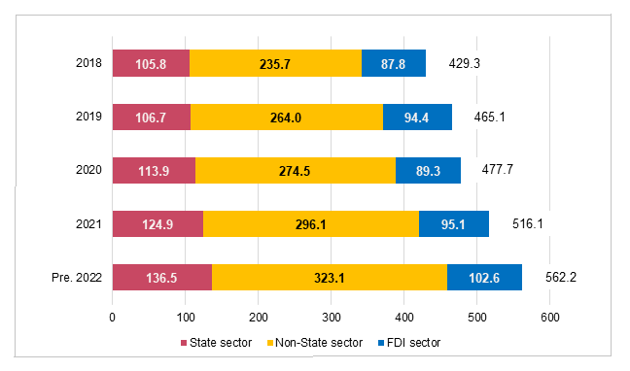

Figure 10. The investment‘s growth rate at current prices
in the 1st quarter of the years 2018-2022 (%)

In the investment capital of the State sector, the realized capital from the State budget in the first quarter of 2022 was estimated at 76.3 trillion VND, equaling 14.4% of the yearly plan and a growth of 10.6% against the same period last year (the corresponding figures of same the period in 2021 was 13.7% and 14.5%, respectively), including the capital under central management reached 12.2 trillion VND, equaling 12% of the yearly plan and increasing by 17.8% over the same period last year; the capital under local management achieved 64.1 trillion VND, equaling 14.9% and increasing by 9.3%, of which: the State budget capital at the provincial level reached 43 trillion VND, equaling 14.4% of the yearly plan and increasing by 6.6%; the State budget capital at district level gained 18.3 trillion VND, equaling 15.8% and jumping up 17.4%; State budget capital at commune level was 2.9 trillion VND, equaling 18.5% and decreasing by 3.4%.
The foreign direct investment from the beginning of the year as of 20th March 2022 including newly registered capital, adjust registered capital, and the total value of capital contribution and share purchases of foreign investors reached 8.91 billion USD, decreased by 12.1% compared to the same period in 2021.
Figure 11. The registered capital of foreign investment in Vietnam as of 20th March
in the years from 2018 to 2022 (Billion USD)

- Newly registered capital included 322 newly licensed projects with a registered capital of 3.21 billion USD, an increase of 37.6% in the number of projects and a decrease of 55.5% of registered capital compared to the same period last year; of which, processing and manufacturing industry attracted the 1st foreign direct investor with the registered capital of newly licensed projects reaching 2.19 billion USD, accounting for 68.2% of the total newly registered capital; real estate business reached 599.9 million USD, accounting for 18.7%, the remaining industries reached 422.7 million USD, accounting for 13.1%.
Among 35 countries and territories having newly licensed investment projects in 03/2022, Denmark was the largest investor with 1.32 billion USD, accounting for 41.1% of total newly registered capital; Singapore 626.6 million USD, accounting for 19.5%; China 379.5 million USD, accounting for 11.8%; Taiwan 219.9 million USD, accounting for 6.8%; Special Administration Hong Kong (China) 191.7 million USD, accounting for 6%.
- Adjust registered capital included 228 turns of projects (which were licensed in the previous years) registered to adjust investment capital with the additional capital of 4.07 billion USD, increased by 93.3% compared to the same previous last year.
If including additionally newly registered capital and adjust registered capital of licensed projects in previous years, foreign direct investment capital in the processing and manufacturing industry reached nearly 5 billion USD, accounting for 68.7% of the total newly registered capital and additional capital; the real estate business reached 1.71 billion USD, accounting for 23.5%; the remaining industries reached 569.6 million USD, accounting for 7.8%.
- Capital contribution and share purchases of foreign investors included 734 turns with a total value of the capital contribution of 1.63 billion USD, an increase of 102.6% compared to the same period last year. Of which, 341 turns of capital contribution, share purchase caused the increase of charter capital of the enterprise with the value of contributed capital of 819.7 million USD, and 393 turns of foreign investors repurchased domestic shares without increasing the charter capital with a value of 811.4 million USD. About the form of capital contribution and share purchase by foreign investors, the investment capital in the real estate business reached 992.9 million USD, accounting for 60.9% of the total capital contribution; the processing and manufacturing industry reached 300.6 million USD, accounting for 18.4%; the remaining industries reached 337,7 million USD, accounting for 20.7%.
Foreign direct investment capital that was implemented in 3 months of 2022 reached 4.42 billion USD, an increase of 7.8% over the same period last year, this is the highest level of foreign direct investment made in the past 5 years, of which the processing and manufacturing industry reached 3.44 billion USD, accounting for 77.8% of total realized foreign direct investment capital; electricity, gas, steam, and air conditioning supply recorded 379.8 million USD, making up 8.6%; real estate business activities gained 350.3 million USD, comprising of 7.9%.
Figure 12. Implemented foreign direct investment
in the first quarter of the years 2018-2022 (Billion USD)
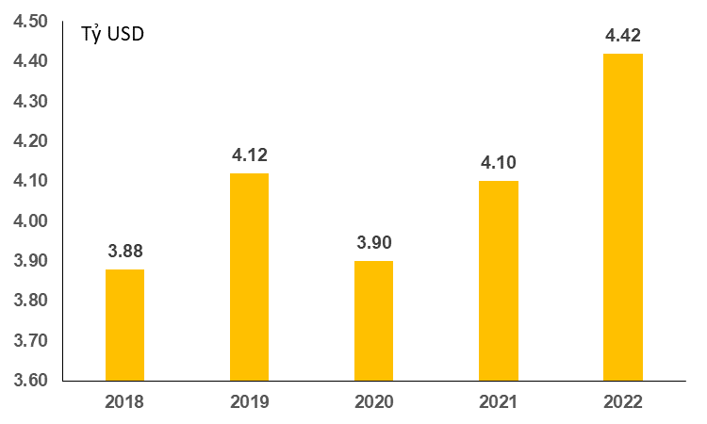
Vietnam's investment abroad in 3 months of 2022, there were 24 projects newly granted investment certificates with a total investment capital of 180.2 million USD, up 28.5% over the same period of last year; 03 turns of projects adjusted capital with adjusted capital up 31.2 million USD, down 92.8%.
Generally, the total investment capital of Vietnam abroad (newly and additionally licensed capital) reached 211.5 million USD, down 63% over the same period last year, in which the processing and manufacturing industry adjusted capital reached 96.8 million USD, making up 45.8%; the mining activities reached 33.5 million USD; making up 15,9%; the financial, banking insurance activities reached 30.8 million USD; making up 14,6%; the remaining industries reached 50,4 million USD, accounting for 23.8%.
In the first 3 months of 2022, 12 countries and territories received investment from Vietnam, of which Laos was the leading country with 64.3 million USD; making up 30.4%; United States with 34.5 million USD, making up 16.3%; Canada with 34 million USD, making up 16.1%; Singapore 29.9 million USD; making up 14.1%; Indonesia 22.7 million USD, making up 10.8%.
3. State budget revenues and expenditures
State budget revenue from the beginning of the year to 15/3/2022 reached 25.5% of the annual estimate. State budget expenditure reached 15.6% of the annual estimate, ensuring needs of socio-economic development, defense, security, state management, payment of due debts as well as timely payment for specified objects.

Figure 13. State budget revenue and expenditure
(As of 15/3/2022)
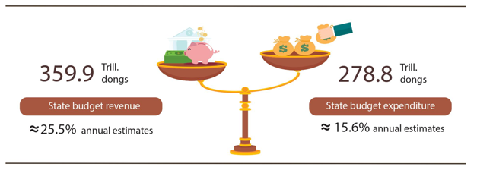
State budget revenue:
Total state budget revenue in the first 15 days of March 2022 was estimated at 31.9 trillion dongs. The accumulated total state budget revenue from the beginning of the year to March 15, 2022, reached 359.9 trillion VND, equaling 25.5% of the annual estimate. Specifically, some of the main revenues were as follows:
- Domestic state budget revenue in the first 15 days of March 2022 reached 18.7 trillion VND. Accumulated to March 15, 2022 reached nearly 289 trillion VND, equaling 24.6% of the year estimate, of which: revenue from state-owned enterprises reached 31.7 trillion VNDs, equaling 20.6%; revenue from foreign-invested enterprises (excluding crude oil) 47.5 trillion VND, equaling 23.1%; public tax, trade and non-state services 70.2 trillion VND, equaling 27.8%; personal income tax collection was 38.6 trillion VND, equaling 32.7%; environmental protection tax collection was 11.7 trillion VND, equaling 19.7%; land use levy 41.2 trillion VND, equaling 30.5%;
- Revenue from crude oil in the first 15 days of March 2022 reached 1,110 billion VND; accumulated to 15/3/2022 reached 10.7 trillion VND, equaling 37.8% of the annual estimate;
- Balanced budget revenue from import and export activities in the first 15 days of March 2022 reached 12.1 trillion VND; accumulated to 15/3/2022 reached 60.3 trillion VND, equaling 30.3% of the annual estimate.
State budget expenditure:
Total state budget expenditure in the first 15 days of March 2022 was estimated at 56.8 trillion VND; accumulated from the beginning of the year to March 15, 2022, reached 278.8 trillion VND, equaling 15.6% of the year estimate, of which: Recurring expenses reached 205 trillion VND, equaling 18.4%; development investment spending 47.4 trillion VND, equaling 9%; debt payment interest was 26.2 trillion VND, equaling 25.3%.
4. Export and import of goods and services
a) Export and import of goods
In March 2022, the activities of export and import of goods recovered strongly with the total export and import turnover estimated at 66.73 billion USD, up 36.8% over the previous month and up 14.7 % compared to the same period last year. Generally, in the first quarter of 2022, the total export and import turnover of goods reached 176.35 billion USD, up 14.4% over the same period last year, of which exports increased by 12.9%; imports increased by 15.9%.

Figure 15. Import and export of goods in the first quarter of 2022
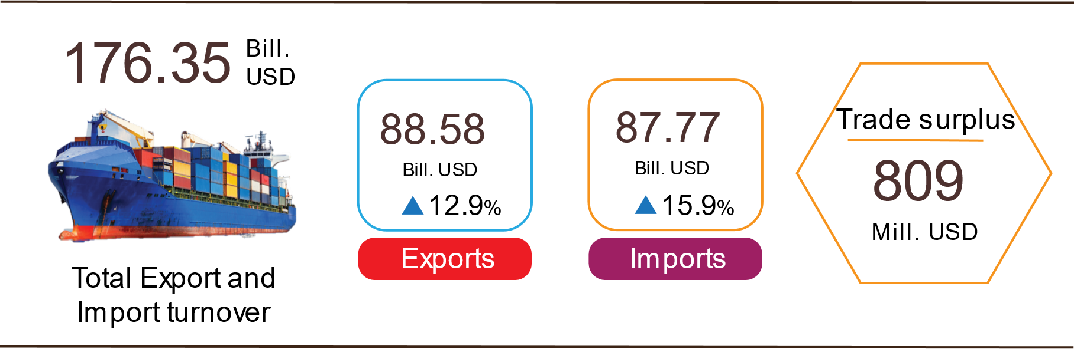

Export of goods
The export turnover of goods in February 2022 reached 23.42 billion USD, 470 million USD higher than the estimated figure.
Export turnover of goods in March 2022 was estimated at 34.06 billion USD, up 45.5% over the previous month. The domestic economic sector reached 8.68 billion USD, up 50.5%; the FDI sector (including crude oil) reached 25.38 billion USD, up 43.8%. Compared to the same period last year, the export turnover of goods in March increased by 14.8%, of which the domestic economic sector increased by 14.7%, the FDI sector (including crude oil) increased by 14.9%.
Generally in the first quarter of 2022, export turnover of goods was estimated at 88.58 billion USD, up 12.9% over the same period last year. In which, the domestic economic sector reached 23.27 billion USD, up 22%, accounting for 26.3% of total export turnover; FDI sector (including crude oil) reached 65.31 billion USD, up 10%, accounting for 73.7%.
In the first quarter of 2022, there were 15 items with export turnover of over 1 billion USD, accounting for 80% of total export turnover (there were 5 export products with over 5 billion USD, accounting for 58%).
Table 7. Value of some export products in the first quarter of 2022
 | Estimate  first quarter 2022  (Mill. USD) | Growth rate of  first quarter 2022 compare to  the same period last year (%)
Items with a value of over 5 billion USD
Phones all of kinds and their parts | 14,239 | -0.9
Electronic goods, computers and their parts | 13,055 | 9.2
Machinery, instrument, accessory | 9,919 | 8.8
Textiles and garments | 8,837 | 22.5
Footwear | 5,288 | 10.1

Regarding the structure of export products in the first quarter of 2022, fuel and mineral products accounted for 1.4%, up 0.5 percentage points over the same period last year; processing industrial products accounted for 89%, down 0.9 percentage points; agricultural and forestry products accounted for 6.9%, down 0.1 percentage point; aquatic products accounted for 2.7%, up 0.5 percentage points.
Figure 16. Structure of export groups
in the first quarter of 2022 by commodity group

Import of goods
Import turnover of goods in February 2022 reached 25.38 billion USD, 101 million USD higher than the estimate figure.
Import turnover of goods in March 2022 was estimated at 32.67 billion USD, up 28.7% over the previous month. In which, the domestic economic sector reached 11.07 billion USD, up 33.3%; the FDI sector reached 21.6 billion USD, up 26.5%. Compared with the same period last year, the import turnover of goods in March increased by 14.6%, of which the domestic economic sector increased by 7.8%; the FDI sector increased by 18.5%.
Generally in the first quarter of 2022, the import turnover of goods was estimated at 87.77 billion USD, up 15.9% over the same period last year, of which the domestic economic sector reached 29.43 billion USD, up 13.7%; FDI sector reached 58.34 billion USD, up 17.1%.
In the first quarter of 2022, there are 16 imported products with a value of over 1 billion USD, accounting for 76.1% of the total import turnover.
Table 8. Value of some imported goods in the first quarter of 2022
 |  | Estimate | Growth rate of
 |  | first quarter of 2022 | first quarter 2022 compare to
 |  | (Mill. USD) | the same period last year (%)
Items with a value of over 5 billion USD
 | Electronic goods, computers and their parts | 21,725 | 31.1
 | Machinery, instrument, accessory | 10,565 | -2.6
 | Phones all of kinds and their parts | 5,545 | 15.2

Regarding the structure of imported goods in the first quarter of 2022, the group of production materials accounted for 93.8%, up 0.1 percentage point over the same period last year, in which the group of machinery, equipment, tools spare parts accounted for 46.2%, down 0.2 percentage points; raw materials, fuel and materials accounted for 47.6%, up 0.3 percentage points. The group of consumer products accounted for 6.2%, down 0.1 percentage point.
Figure 17. Structure of import groups
in the first quarter of 2022 by commodity group
Regarding the export and import market of goods in the first quarter of 2022, the United States was the largest export market of Viet Nam with an estimated turnover of 25.2 billion USD. China was Viet Nam's largest import market with an estimated turnover of 27.6 billion USD. In the first quarter of 2022, the trade surplus to the EU was estimated at 7 billion USD, up 24.5% over the same period last year; trade deficit from China was 14.3 billion USD, up 21%; trade deficit from Korea was 10.4 billion USD, up 39.1%; trade deficit from ASEAN was 3.3 billion USD, down 6.6%; trade deficit from Japan was 434 million USD, up 23.1%.
Figure 17. Major commodity import and export markets in the first quarter of 2022
 |  | Imports of goods | Exports of goods
The trade balance of goods in February had a trade deficit of 1.96 billion USD; 2 months had a trade deficit of 581 million USD; March was estimated to have a trade surplus of 1.39 billion USD. Generally, in the first quarter of 2022, the trade balance of goods was estimated to have a trade surplus of 809 million USD (in the same period last year, the trade surplus of 2.76 billion USD). In which, the domestic economic sector had a trade deficit of 6.16 billion USD; the FDI sector (including crude oil) had a trade surplus of 6.97 billion USD.
b) Export and import of services
In the first quarter of 2022, service export turnover was estimated at 1.05 billion USD, up 19.6% over the same period last year, of which tourism services gained 77 million USD (accounting for 7.3% of total turnover), an increase of 75%; transportation services reached 140 million USD (accounting for 13.4%), up 97.2%.
Service import turnover in the first quarter of this year was estimated at 5.18 billion USD, up 10% over the same period last year, of which transportation services gained 2.6 billion USD (accounting for 49.4% of total turnover), up 11.3%; tourism services reached 1.1 billion USD (accounting for 20.3%), up 16.7%.
Trade deficit of service in the first quarter of 2022 was 4.1 billion USD (of which transportation and insurance service fees for imported goods were 2.1 billion USD).
5. Price index
a) Consumer price index
Petrol and gas prices increase according to world fuel prices; rental housing prices increased again after the Covid-19 epidemic was controlled; the increase in the price of essential consumer goods and services in line with the price of input materials and the price of petrol was the main reason why the consumer price index (CPI) in March 2022 increased by 0.7% compared to the previous month, up 1.91% compared to December 2021 and up 2.41% over the same period in 2021.
In the first quarter of 2022, CPI increased by 1.92% over the same period last year, and core inflation increased by 0.81%.

Figure 18. CPI increase/decrease rate in March and first quarter
years for the period 2018-2022 (%)

The consumer price index (CPI) in March 2022 increased by 0.7% compared to the previous month. Among 11 main groups of consumer goods and services, 10 groups of goods increased in price compared to the previous month; separate groups of food and foodstuff at a discount.
- Ten groups of goods and services with increasing price index include:
- Transport group had the highest increase with 4.8% due to the impact of price adjustments on March 1st, 2022, March 11th, 2022, and March 21st, 2022, the petrol price index increased by 13.44% (the impact of making the general CPI increase by 0.48 percentage points). In addition, the price of passenger transport by road increased by 0.8% compared to the previous month, the price of passenger transport by taxi increased by 1.26%, passenger transportation by bus increased by 2.22%, and the cost of passenger transport by bus increased by 2.22%. delivery and delivery of checked baggage increased by 1.32% because some transport businesses declared price increases when gasoline prices increased. Vehicle maintenance service prices increased by 1.03%; self-driving car and motorbike rental fees increased by 0.53%; driving license fees increased by 0.44%.
- Housing and construction materials group increased by 1.49% due to the increase in oil price by 18.18%; gas price increased by 9.33%; house rent increased by 3.26%; housing maintenance materials prices increased by 1.56%; electricity and water prices increased by 1.51% and 0.12% respectively due to high demand for electricity and water in the month.
- Other goods and services increased by 0.46% mainly because the price of jewelry group increased by 5.17% according to the domestic gold price; hair cutting and shampooing services increased by 0.98%; wedding supplies and services increased by 0.79%; Worship items and services increased by 0.25%.
- Culture, entertainment, and tourism groups increased by 0.21% as activities across the country are returning to the "new normal situation" after months of being affected by the Covid-19 epidemic, the price of package tours increased by 0.61%; tickets for sports venues increased by 0.31%; hotels and guest houses increased by 0.29%; watching movies, listening to music increased by 0.27%; equipment and sports equipment increased by 0.06%.
- Household equipment and goods group increased by 0.19%.
- Garment, hat and footwear group increased by 0.12% due to an increase in petrol prices and production costs. In which, the price of all kinds of fabrics increased by 0.32% compared to the previous month; hats increased by 0.2%; footwear by 0.11%; garment services increased by 0.4%; shoe repair service increased by 0.58%.
- Education group increased by 0.1% (in which Educational services increased by 0.09%).
- Beverages and cigarettes increased by 0.06% due to increased transportation costs, of which non-alcoholic beverages increased by 0.1%; alcohol by 0.07%; smoking increased by 0.02%.
- Medicine and medical service group increased by 0.06%.
- Postal services and telecommunications group increased by 0.02%.
(2) The group of goods and services with a decrease in price index are: Food and foodstuff group decreased by 0.27% (making the general CPI decrease by 0.09 percentage points), of which Food increased by 0.17% (making the general CPI impact increased by 0.01 percentage points); food decreased by 0.48% (the impact of reducing the overall CPI by 0.1 percentage point); outdoor eating and drinking increased by 0.08% (the impact of increasing the overall CPI by 0.01 percentage points).
Average CPI in the first quarter of 2022 compared to the same period in 2021 increased by 1.92%; CPI in March 2022 increased by 1.91% compared to December 2021 and by 2.41% over the same period in 2021. CPI in the first quarter of this year increased compared to the same period last year due to a number of main reasons:
(i) Domestic gasoline prices increased by 48.81% over the same period last year (the impact of increasing the overall CPI by 1.76 percentage points); gas prices increased by 21.04% (the impact of increasing the overall CPI by 0.31 percentage points);
(ii) The price of housing maintenance materials increased by 8.08% over the same period last year due to the increase in the price of cement, iron, steel, and sand in line with the price of input materials (the impact of increasing the overall CPI by 0.16 percent points);
(iii) Rice prices increased by 1.1% compared to previous last year (the impact of increasing the overall CPI by 0.03 percentage points) due to the increase in domestic rice prices in line with export prices and consumer demand for sticky rice and rice delicious food on the occasion of the Lunar New Year and the full moon in January increases.
In addition, some reasons for the decrease in CPI in the first quarter of 2022:
(i) Prices of food items decreased by 1.2% over the same period last year (making CPI decrease by 0.26 percentage points), of which the price of pork decreased by 21.55%, fat decreased by 22.6%; accordingly, the price of processed meat decreased by 4.63%;
(ii) The price of educational services decreased by 4.24% (making the CPI decrease by 0.23 percentage points) because some provinces and centrally-run cities exempted and reduced tuition fees from the first semester of the 2021-2022 school year due to the effects of the Covid-19 pandemic;
(iii) Housing rent decreased by 15.14% over the same period last year (making CPI decrease by 0.07 percentage points) because many households reduced prices to support tenants during the complicated pandemic situation.
Core inflation in March 2022 increased by 0.29% over the previous month, up by 1.09% over the same period last year. In the first quarter of 2022, the average core inflation increased by 0.81% compared to the same period in 2021, lower than the general average CPI (up 1.92%), this reflects fluctuations in consumer prices mainly due to rising food, gasoline, oil, and gas prices.
b) Gold price index and US dollar
Domestic gold prices fluctuated in the same direction as world gold prices when inflation in countries increased and the impact of the war between Russia and Ukraine. As of March 25, 2022, the average world gold price was at 1,956.07 USD/ounce, up 4.95% compared to February 2022. Domestically, the demand for gold increased, making the gold price index in March 2022 increase by 4.51% compared to the previous month; increased by 9.36% over the same period last year; on average, in the first quarter of 2022, the domestic gold price index increased by 3.52%.
On March 16, 2022, the US Federal Reserve (Fed) raised the basic interest rate for the first time in more than 3 years to 0.25%-0.5% in response to increasing inflationary pressure. The US dollar index in March 2022 on the international market reached 98.47 points, up 2.58% over the previous month. Domestically, the average US dollar price on the free market was around 23,000 VND/USD. US dollar price index in March 2022 increased by 0.64% over the previous month; down 0.43% over the same period last year; on average, in the first quarter of 2022, the domestic US dollar price index decreased by 0.67%.
c) Producer price index
In the first quarter of 2022, the prices of all kinds of goods on the world market increased sharply due to the impact of economic, social, and political factors of other countries and the Russia - Ukraine war, along with the economic recovery momentum in many countries caused the demand for raw materials to increase sharply while the supply was interrupted. Domestically, the economy grew again, and the demand for production and consumption increased, causing the prices of goods and services to increase accordingly. Producer price index, price index of raw materials for production, export, and import price index in the first quarter of 2022 all increased compared to the same period in 2021.

Figure 19. Producer price index in the first quarter of 2018-2022
compared to the same period last year (%)
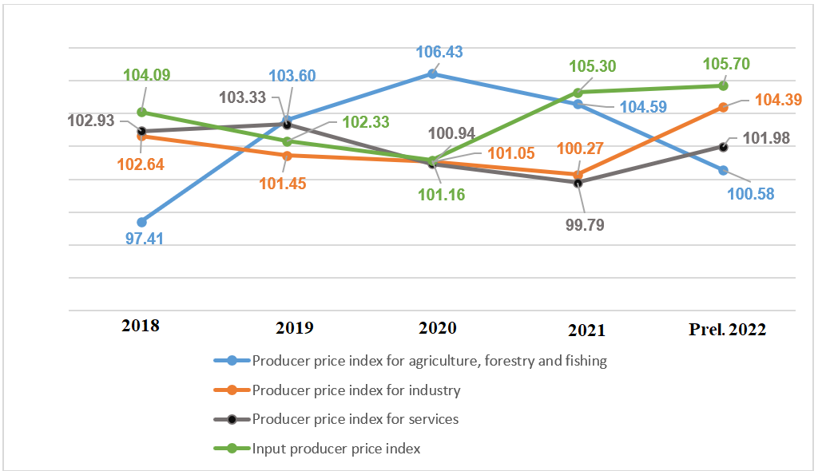
The producer price index (PPI) of agricultural, forestry, and fishery in the first quarter of 2022 increased by 1.89% compared to the previous quarter and by 0.58% over the same period last year, of which: the PPI of agriculture products and related services increased by 1.04% and decreased by 0.59%; forestry and related services increased by 0.57% and by 1.36%; exploited and farming aquatic products increased by 4.69% and 4.22%.
The producer price index of industrial in the first quarter of 2022 increased by 1.09% compared to the previous quarter and by 4.39% over the same period last year, which was the highest first-quarter increase compared to the same period last year from 2015 onwards. In which, the producer price index of mining products increased by 4.86% and 18.69%; processing and manufacturing industrial products increased by 0.87% and 3.84%; production and distribution of electricity, gas, hot water, steam, and air-conditioning by 1.89%, and 4.92%; water supply, management and treatment of waste and wastewater increased by 0.93% and 1.91%.
The producer price index for services in the first quarter of 2022 increased by 0.79% compared to the previous quarter and by 1.98% over the same period last year. Specifically, the service price index of a number of industries was as follows: Transportation and warehousing services increased by 2.79% and 3.08%; accommodation and food services increased by 2.01% and 3.38%; information and communication increased by 0.08% and 0.56%; education and training increased by 0.11% and by 0.6%; health care and social assistance activities increased by 0.08% and by 0.76%; entertainment and entertainment increased by 0.11% and 0.39%.
Input producer price index in the first quarter of 2022 increased by 1.49% compared to the previous quarter and by 5.7% over the same period last year. In which: Price index of raw materials for agricultural, forestry and fishery production increased by 2.21% and 9.1%; used for industrial production, processing, and manufacturing increased by 1.47% and 5.52%; used for construction increased by 1.67%, and 8.26%.
d) Merchandise import and export price index
Figure 20. Commodity import-export price index and commodity trade
rate in the first quarter of 2018-2022 compared to
the same period last year (%)
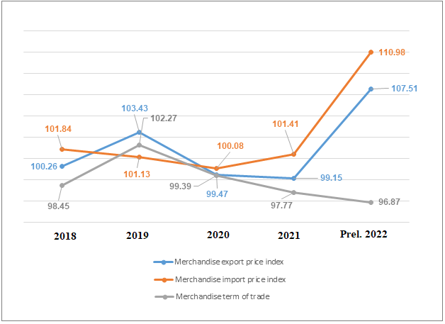
The commodity export price index in the first quarter of 2022 increased by 2.47% compared to the previous quarter and by 7.51% over the same period last year. Specifically, the price index of agricultural products and foodstuffs increased by 2.13% and 9.32%; the fuel group increased by 16.12% and 55.7%; the group of other processed and manufactured goods increased by 2.02% and by 5.73%. Export price index in the first quarter of 2022 compared with the previous quarter and the same period last year of some commodities were as follows: Crude oil increased by 18.78% and 60.39%; petrol and oil of all kinds increased by 9.87% and 51.01%; iron and steel increased by 1.5% and 20.24%; pepper by 2.69% and 32.33%; coal increased by 13.01% and 29.1%; fertilizers increased by 18.14% and 46.33%.
The import price index of goods in the first quarter of this year increased by 2.7% compared to the previous quarter and increased by 10.98% over the same period last year. Specifically, the import price index of agricultural products and foodstuffs increased by 4.11% and 10.95%; the fuel group increased by 5.7% and 37.43%; the group of other processed and manufactured goods increased by 2.48% and 9.84%. Import price index in the first quarter of 2022 of a number of commodities: Liquefied natural gas increased 8.12% compared to the previous quarter and increased by 44.95% over the same period last year; petrol and oil of all kinds increased by 5.25% and 40.44%; animal feed and raw materials increased by 0.77% and 27.73%; iron and steel increased by 12.88% and 43.87%; fertilizers of all kinds increased by 11.32% and 42.68%; wheat increased by 3.83% and by 25.57%.
The commodity trade rate (TOT) in the first quarter of 2022 decreased by 0.23% compared to the previous quarter and by 3.13% compared to the same period last year. Compared to the previous quarter and the same period last year, the TOT in the first quarter of 2022 both decreased because the increase in the export price index was lower than the increase in the import price index, reflecting that Vietnam has been in an unfavorable position. Commodity exchange rates of some commodity groups were as follows: Iron and steel decreased by 10.08% and 16.43%; wood and wood products decreased by 0.08% and 9.11%; vegetables and fruits decreased by 1.2% and 1.12%; rubber increased by 0.99% and decreased by 4.6%; aquatic products increased by 0.48% and 2.71%; petrol and oil of all kinds increased by 4.38% and 7.52%; computers, electronic products, and components increased by 3.95% and 3.07%.
III. SOME SOCIAL ISSUES
1. Labour and employment
The policy of safe, flexible adaptation and effective control of the Covid-19 epidemic made the labor market in the first quarter of 2022 had many signs of prosperity. Labor force, the number of employed people and average monthly income of employees increased compared to the previous quarter and to the same period last year. The unemployment rate and underemployment rate in working-age both decreased compared to the previous quarter, although still higher than the same period last year, but gradually decreasing.
The labor force participation rate in the first quarter of 2022 was 68.1%, up 0.4 percentage points from the previous quarter and down 0.6 percentage points from the same period last year.

Table 9. The labor force in the first quarter in 2022
Mill. people

 | 1st Quarter  2022 | The growth rate of 1st quarter compared to
 | 1st Quarter  2022 | 1st quarter I  2021 | 4th Quarter IV  2021
Labour force aged 15 years and above | 51.2 | 0.16 | 0.44
By gender
Male | 27.3 | 0.21 | 0.28
Female | 23.9 | -0.05 | 0.16
By area
Urban | 19.1 | 0.82 | 0.22
Rural | 32.1 | -0.66 | 0.22
The labor force of working age | 45.2 | 0.05 | 0.24
By gender
Male | 25.0 | 0.04 | 0.20
Female | 20.2 | 0.01 | 0.04
By area
Urban | 17.4 | 0.69 | 0.13
Rural | 27.8 | -0.64 | 0.11

The number of employed workers aged 15 and above in the first quarter of 2022 was estimated at 50 million people, an increase of 132.2 thousand people over the same period last year, including 13.9 million people working in agriculture, forestry, and fishery, accounting for 27.8% of the total; industry and construction sector 16.7 million people, accounting for 33.5%; service sector 19.4 million people, accounting for 38.7%.

Table 10. Unemployment rate and the Under-employment rate
in the first quarter in 2022
 |  | %
 | Total | Of which:
 | Total | Urban | Rural
The unemployment rate of the labor force at the working age | 2.46 | 2.88 | 2.19
The unemployment rate of the youth aged 15-24 | 7.93 | 9.30 | 7.20
The under-employment rate of the labor force at the working age | 3.01 | 2.39 | 3.40

The rate of workers with informal employment outside of agricultural, forestry, and fishery households in the first quarter of 2022 was estimated at 56.2%, of which 48.1% in urban areas; the rural area was 62.9% (in the first quarter of 2021 respectively was 57.1%; 48.4%; 64.3%).
The average monthly income of salaried workers in the first quarter of 2022 was estimated at 7.3 million VND/month, an increase of 1.2 million VND compared to the previous quarter and an increase of 119 thousand VND compared to the same period last year, in which the income of male employees was 7.7 million VND/month, female employees' income was 6.8 million VND/month.
2. Residential life and social security assurance
In the first quarter of this year, people's lives were still facing many difficulties due to the strong outbreak of the Covid-19 epidemic, especially in some northern localities. According to preliminary results of the Household Living Standard Survey, in the first quarter of this year, the percentage of households with a decrease in income compared to the same period last year was 26.9% (86.7% of households assessed a decrease in income compared to the same period last year due to the impact of the Covid-19 epidemic); the percentage of households with unchanged income was 43.4% and the percentage of households with increased income was 29.7%. Besides, the Covid-19 epidemic has largely affected people's lives: 76.1% of households were suffered from negative impacts of the Covid-19 pandemic; Only 2.3% of households were negatively affected by other diseases and 2.2% of households were affected by diseases on livestock and plants.
Social security work was concerned and implemented at all levels from the central to local. According to local reports, the value of gifts for social protection beneficiaries from the budget and socialization was nearly 1 trillion VND; the value of money, gifts and supports for poor and near-poor households was nearly 1.3 trillion VND; the value of money and gifts for preferential subjects who with meritorious services and relatives of people with meritorious services to the revolution was nearly 2.1 trillion VND; supporting sudden and unusual situations (natural disasters, storms, floods...) arising in the locality with nearly 1.9 trillion VND. In addition, more than 25.5 million health insurance cards/books/cards for free medical examination and treatment were distributed and donated to policy beneficiaries nationwide.
In addition, support packages due to the impact of the Covid-19 epidemic continue to be implemented. As of March 22, 2022, the support package under Resolution No. 68/NQ-CP dated July 01, 2021 and Resolution No. 126/NQ-CP dated October 8, 2021 of the Government reached nearly 40.6 trillion VND to support 35.6 million turns of employees and 378.9 thousand employers/business households; The support package under Resolution No. 116/NQ-CP dated September 24, 2021 of the Government reached nearly 38.6 trillion VND, supporting over 13 million labors and 363.6 thousand business units/households. employment. In addition, to ensure that people were not affected by grain shortages, on March 15, 2022, the Government issued Decision No. 340/QĐ-TTg to export 1,006.6 tons of rice from national reserves to Son La and Dien Bien provinces.
The program on building a new countryside in recent years has had a positive impact, contributing to improving people's lives in rural areas, promoting the development of socio-economic infrastructure systems in rural areas. As of February 28, 2022, the whole country has 5,650/8,233 communes (68.6%) reaching new rural standards; there were 561 communes meeting the newly enhanced rural standards; there are 221/664 district-level units in 54 provinces and centrally-run cities that have been recognized by the Prime Minister to complete new rural tasks; 14 provinces reaching 100% of the new rural standard communes.
3. Education and training
Facing the complicated developments of the Covid-19 epidemic, the Education sector has implemented many solutions to guide localities to organize flexible teaching in accordance with the actual situation with the motto "Pause going to school but not stop studying". Up to now, many localities that are eligible for epidemic prevention have welcomed pupils back to school to study directly and have organized two teaching sessions per day.
According to the Ministry of Labor, Invalids and Social Affairs, the plan for vocational education enrollment in 2022 was 2,086,000 people. In which, college and intermediate level reached 530 thousand people; elementary level and other vocational training programs reached 1,556 thousand people. Estimated enrollment in the first 3 months of 2022 was more than 11,000 people. The review and arrangement of public vocational education institutions under ministries, branches and localities continues to be carried out. Estimated in 2022, there were 1,877 vocational education institutions, of which 409 colleges; 438 intermediate schools; 1,030 vocational education centers. The total number of public vocational education institutions was 1,184, down 4% compared to 2021.
4. Epidemic diseases and food poisoning
According to the report of the Ministry of Health, in the month (February 19th to March 18th, 2022 there were 4,287 cases of hemorrhagic fever (02 cases died); 202 cases of hand, foot and mouth disease; 08 cases of virus encephalitis and 04 cases of scarlet fever suspected for measles. In the first 3 months in 2022, there were 9,919 cases of hemorrhagic fever (02 cases died); 406 cases of hand, foot and mouth disease; 28 cases of virus encephalitis; 01 case of meningococcal disease and 07 cases of scarlet fever suspected for measles.
The epidemic of Covid-19 in the world continues to be complicated. In Vietnam, the number of covid-19 cases continues to increase rapidly in localities mainly because the BA.2 variant of the Omicron variant spreads faster, however with a high rate of vaccine coverage, especially taking care of high-risk subjects, the number of severe cases decreased and the death rate per number of cases decreased deeply. As of 16:00 pm on March 27th 2022, there were 9,011.5 thousand cases have been reported, of which 5,352 thousand cases have been cured and 42.3 thousand cases died.
Vietnam is currently one of the six countries with the highest Covid-19 vaccine coverage in the world. As of March 25th, 2022, The total number of doses of Covid-19 vaccine that have been administered was 204,566 thousand doses, of which the first time was 79,974.2 thousand doses; the second time was 76,301 thousand doses; the 3rd time (Additional injections, booster injections and basic 3-dose injections) was 48,290.8 thousand doses.
The total number of alive HIV-infected persons over the country as of March 18, 2022 was 215,062 persons and the number of deaths by HIV/AIDS as of the above time-point was 111,300 persons.
In March 2022, there were 02 cases of food poisoning with 81 persons poisoned. In the first 3 months of 2022, there were 04 cases of food poisoning with 91 poisoned.
5. Cultural and sports activities
According to a report of the Ministry of Culture, Sports and Tourism, the protection and promotion of cultural heritage values is concerned and implemented. Some outstanding activities must be mentioned such as: The program of cooperation between the Ministry of Culture, Sports and Tourism and the Ministry of Education and Training in the work of traditional education for pupils and students through cultural heritage for the period of 2021-2026; Decision on registration of intangible cultural heritage Tu Luong Sam Festival (Hai Phong) on the list of national intangible cultural heritage; complete the national dossier of the Ba Chua Xu Festival of Sam Mountain (An Giang) and submit it to UNESCO for inscription on the List of Intangible Cultural Heritage of Humanity.
Developing physical training and sports in general and mass sports in particular has always been a major policy and social policy of our Party and State in order to contribute to promoting the human factor and building social resources. Exercise and sports movements were widely organized, many mass sports movements were launched, of which the Danang International Marathon 2022 (DNIM 2022) took place on 20th March 2022 with the participation of nearly 5,000 athletes, people, domestic and international tourists; The running tournament for students, S-RACE 2022 has launched and will be held at the end of March 2022 with about 20,000 participating athletes.
Regarding Vietnam's high-achieving sports, mainly focused on preparing forces to attend the 31st SEA Games in Vietnam, and the 19th ASIAD in China. The preparation for the 31st SEA Games has basically been completed from registration, logistics and other works related to the Games.
6. Traffic accident
In the month (from February 15 to March 14), there were 788 traffic accidents nationwide, including 556 traffic accidents of less serious or more serious and 232 traffic collision cases, causing 491 deaths, 252 injuries and 229 minor injuries. Compared to the previous month, the number of traffic accidents in March decreased by 22.1% (the number of traffic accidents of less serious or more serious decreased by 23.1% and and the number of traffic collisions decreased by 19.4%); the number of deaths decreased by 20.8%; the number of injured people decreased by 29.8% and the number of minor injuries decreased by 24.2%. Compared to the same period last year, the number of traffic accidents in March decreased by 7.4% (the number of traffic accidents of less serious or more serious decreased by 2.6% and the number of traffic collisions decreased by 17.1%); the number of deaths increased by 11.1%; the number of injured people decreased by 26.3% and the number of minor injuries decreased by 22.6%.
Generally, in the first quarter of 2022, there were 2,762 traffic accidents nationwide, including 1,966 traffic accidents of less serious or more serious and 796 traffic collisions, causing 1,676 deaths, 947 people injured and 794 people slightly injured. Compared to the same period last year, the number of traffic accidents in the first 3 months of 2022 decreased by 13.8% (traffic accidents of less serious or more serious decreased by 5.2%; the number of traffic collisions decreased by 29.7%); the number of deaths increased by 0.2%; the number of injured people decreased by 15.6% and the number of people with minor injuries decreased by 37.2%. On average, 1 day in the first 3 months of the year, there were 31 traffic accidents nationwide, including 22 traffic accidents of less serious or more serious and 09 traffic collisions, causing 19 deaths, 11 people injured and 9 people slightly injured.
7. Damage caused by natural disasters
Damage caused by natural disasters in March was mainly due to the effects of frost, fog, cold weather, landslides, causing 02 deaths and 01 injury; 5.4 thousand ha of rice and crops were damaged; 1.2 thousand houses collapsed, swept away and damaged; the total value of property damage caused by natural disasters in the month was 187.3 billion VND, nearly 45 times higher than the same period last year. Generally, in the first 3 months of the year, natural disasters caused 03 deaths and missing; 01 person was injured; 38.6 thousand hectares of rice and 4.1 thousand hectares of crops were damaged; nearly 12.2 thousand cattle and poultry died; nearly 1.5 thousand houses collapsed, washed away and damaged. The total value of property damage caused by natural disasters in the first quarter of 2022 was estimated at more than 832.5 billion VND, 19.6 times higher than the same period last year.
8. Environmental protection and fire, explosion prevention
In March, across the country, authorities detected 903 cases of environmental violations, of which 695 cases were handled with a total fine of 13.5 billion VND. Generally, in the first 3 months of the year, 6,068 cases of environmental violations were detected, of which 5,139 cases were handled with a total fine of 65.8 billion VND.
During the month , there were 131 fires and explosions in the whole country, killing 7 people and injuring 14 others. Property damage was estimated at 10.7 billion VND. Generally, in the first three months of the year, there were 446 fires and explosions in the whole country, killing 23 people and injuring 30 people, and property damage was estimated at 56.7 billion VND.
Generally, in the context of the Covid-19 epidemic still developing complicatedly, spreading rapidly in the community, the world economic and political situation fluctuated unpredictably, the socio-economic picture of Vietnam in the first quarter of 2022 achieved good growth in all fields due to the participation of the whole political system, the timely, drastic and close direction and management of the Government, the Prime Minister and the efforts of the Prime Minister efforts of all levels, branches, localities, the business community, and the people of the country. Agencies, both central and local, have adapted safely and flexibly to effectively prevent and control the Covid-19 epidemic, with a high rate of vaccine for the people to be determined to have a quick and sustainable socio-economic recovery. The economy achieved a growth rate of 5.03%, which is quite a growth rate compared to other countries in the region and the world, the macro-economy is stable, inflation is controlled at an appropriate level. The supply and demand of domestic goods were guaranteed, and goods procurement, consumption, and export activities increased. The area of ​​agriculture, forestry, and fishery had a relatively high growth rate, confirming that the restructuring of the industry has brought into play effectively, ensuring the supply of food, foodstuffs, and essential goods. The processing and manufacturing industry played an important role in promoting economic growth in the first quarter of 2022. The progress of disbursement of public investment capital has improved markedly, the growth rate of realized investment capital under the State budget reached a high level, and social security was paid attention to care.
However, entering the second quarter, our country's economy and society still have to face many difficulties and challenges, especially Vietnam's economy has a remarkable openness, so it is affected in many ways by the political situation. The world economy has been complicated and unpredictable, world economic recovery is slowing down, the prices of essential goods are high, and there is a risk of high inflation around the world. Although Vietnam controlled the Covid-19 epidemic, there are still complicated developments of the disease in the world. Therefore, Vietnam's economy in 2022 still has to face many difficulties. Reaching the target of 6.5% growth is a big challenge, requiring the joint effort and consensus of the Government, businesses, and people. Sectors and all levels in the country should strengthen their forecasts, proactively operate flexibly, in line with new situations, promptly respond to arising situations, focus on effectively implementing synchronous recovery support and socio-economic development policies. At the same time, focus on some of the following key contents:
Firstly, continue to effectively implement Resolution No. 128/NQ-CP on the provisional provision "Safely adapting, flexibly, effectively controlling the Covid-19 epidemic"; implementing synchronously, drastically, and effectively the tasks in Resolution No. 11/NQ-CP on the program to support economic recovery and development in 2022-2023; especially to ensure 100% disbursement of public investment capital, creating an economic impetus.
Secondly, persistently maintain macroeconomic stability; control prices, markets; ensure supply, circulation of goods, and major balances of the economy. Continuously update forecast scenarios on growth and inflation to proactively manage and respond to arising situations. Closely monitor the price movements of the most essential commodities, especially petroleum products, develop plans to regulate supply, limit sudden price increases in order to minimize the impact on inflation and people's lives.
Thirdly, promote domestic production towards self-reliance in domestic raw materials supply. At the same time, speed up electricity projects to meet demand when production increases as well as people's demand, especially in the coming summer months.
Fourthly, strengthen the domestic market, promote sustainable export, remove barriers, and create favorable conditions for domestic consumption and export of agricultural, forestry, and fishery products. Building the value chain of each agricultural product is associated with the development of agricultural and rural logistics infrastructure, ensuring the supply chain of the domestic market.
Fifthly, urgently restore the tourism market, facilitate international and domestic passenger traffic, and appropriately support tourism businesses associated with disease safety to welcome the upcoming tourist season.
Sixthly, promote administrative reform, and remove bottlenecks, barriers, and obstacles hindering production and business activities. Actively and faster supporting digital transformation for Vietnamese businesses in all fields, building a practical and effective digital economy and digital society, creating maximum favorable conditions for businesses.
Seventhly, closely monitor the weather situation, proactively plan for disaster prevention, warn of floods, landslides, the impact of drought, and saline intrusion in order to minimize damage to production and people's lives. Effectively implement policies on social security, labor, and employment. Implement well the work of unexpected assistance, ensure that people in danger or disaster receive timely support, overcome difficulties, and stabilize their lives. Strengthen the work of ensuring traffic order and safety, environmental protection, and fire and explosion prevention./.

GENERAL STATISTICS OFFICE

Forecasts of the World Bank and the International Monetary Fund on January 2022.
The value-added of the agriculture, forestry, and fishery in the first quarter of 2021 compared to the same period last year was respectively: 3.55%; 3.82%; 3.25%.
The price of living-weight pork in the last days of March 2022 fluctuated in the range of 52,000 - 57,000 VND/kg, down 2,000 -3,000 VND/kg compared to the end of January 2022.
According to the Report of the Ministry of Agriculture and Rural Development
Source: http://agromonitor.vn/group/48/280/giam-sat-gia.
The price of vannamei shrimp of 100 shrimps/kg and 70 shrimps/kg tended to increase from mid-January to early March but still not as high as the price in the first two weeks of the year. As of early March 2021, the price of vannamei shrimp in the Southwest region, of 100 shrimps/kg was at 95.5 thousand VND/kg, 70 shrimps/kg was at 117.5 thousand VND/kg (Source: http://agromonitor.vn/group/47/272/giam-sat-gia).
Source: National Enterprise Registration Information System, Business Registration Management Agency, Ministry of Planning and Investment on March 24th, 2022
The number of newly established and returning to operations on average a month in the first quarter of 2017-2021 was: 11.9 thousand enterprises; 11.7 thousand enterprises; 14.5 thousand enterprises; 14.8 thousand enterprises; 14.7 thousand enterprises.
Enterprises withdrew from the market on average a month in the first quarter of 2017-2021 were: 8 thousand enterprises; 7.9 thousand enterprises; 11.4 thousand enterprises; 11.6 thousand enterprises; 13.4 thousand enterprises, respectively
Corresponding index of the fourth quarter of 2021: 44% of enterprises rated their business and production situation better joint; 31.1% of enterprises said that the business and production situation was stable and 24.9% of enterprises rated that it was difficult compared to the previous quarter.
Corresponding indexes of the fourth quarter of 2021: 45.7% of enterprises rated that their production volume increased compared to the previous quarter; 30.5% of businesses thought it was stable and 23.8% assessed that production volume would decrease.
Corresponding indexes of the fourth quarter of 2021: 39.3% of enterprises had orders increasing compared to the previous quarter; 37.3% of businesses had stable orders and 23.4% of businesses had reduced orders.
According to the report of the Foreign Investment Department, Ministry of Planning and Investment, received on March 22, 2022
According to the Ministry of Finance’s report as of 15/3/2022.
Estimated total export and import value in March 2022 provided by the General Department of Customs on March 28, 2022. The General Statistics Office estimated the import and export value of key commodities in March 2022 based on preliminary data provided by the General Department of Customs by March 15, 2022.
Total import and export turnover of goods in the first quarter of 2021 reached 154.18 billion USD, up 25.4% over the same period last year, of which export reached 78.47 billion USD, up 23.8%; imports reached 75.71 billion USD, up 27.1%.
Estimated trade deficit in February was 2.34 billion USD.
The domestic electricity price index in March 2022 is calculated based on the revenue and consumption of electricity from the date February 1-28, 2022, thus reflecting movements one month late compared to other commodities.
The price of rice increased by 0.08% according to the price of export rice and the price of fertilizer materials, domestic enterprises boosted purchasing to reserve. In addition, the increase in input material prices and transportation costs affected the prices of other processed food products (the price of noodles, noodles, pho, instant porridge increased by 0.95; flour by 0.65%; cornmeal by 0.56%; instant cereal by 0.25%; bread by 0.23%).
Pork price decreased by 2.72% (general CPI impact decreased by 0.09 percentage points) due to the consumption rule after the Lunar New Year, the price returned to normal level when the supply was guaranteed (the price of roast meat, pork belly, pork belly, sausage reduced by 0.81%; animal fat decreased by 0.43%); poultry meat price down 0.31%; price of fresh seafood decreased by 0.43%; prices of fresh and processed fruit decreased by 0.4%. On the other hand, vegetable oil prices increased by 2.1%; biliary tract increased by 0.34%; cakes, jams, and candies by 0.31%; milk, butter, cheese by 0.24%; condiments increased by 0.21%; the average price of fresh, dried and processed vegetables increased by 0.99%.
The growth rate of the producer price index of industrial products in the first quarter compared to the same period last year in the years 2015-2022 was: 0.15% increase; 1.01% decrease; 2.7% increase; 2.64% increase; 1.45% increase; 1.05% increase; 0.27% increase;4.39% increase.
Commodity export price index compared to commodity import price index..
Informal employed labor in the non-agricultural sector includes those who are not working in the agriculture, forestry, and fishery sectors and belong to one of the following three groups: (i) labor in the formal sector doesn't have a labor contract or has a definite-term contract but not be paid compulsory social insurance premiums by the employer; family labor in the formal sector is the member of cooperatives that do not have compulsory social insurance; (ii) establishment owners, self-employed workers, salaried workers, and family workers at establishments in the informal sector; (iii) self-employed workers serving the household's self-consumption needs and hired laborers in households.
As of 16:00 pm on March 27th 2022, in the world, there were 481,364.2 thousand cases of Covid-19 (6,146.5 thousand deaths).
According to a quick report from the Office of the Ministry of Public Security and the Vietnam Maritime Administration (Ministry of Transport) from February 15, 2022 to March 14, 2022.
Summary of reports from 63 Departments of Agriculture and Rural Development, reporting period from February 19 to March 18, 2022.
According to a quick report from the Ministry of Public Security on March 23, 2022.

