MINISTRY OF PLANNING AND INVESTMENT  GENERAL STATISTICS OFFICE  No: 108/BC-TCTK | SOCIALIST REPUBLIC OF VIET NAM  Independence-Freedom-Happiness  Ha Noi, 29th May 2022

Socio-economic situation report
in May and the first 5 months of 2022

1. Agriculture, forestry, and fishery
Agricultural production in the month focused mainly on caring for spring paddy, preventing pests and diseases of plants in Northern provinces; tending, harvested paddy and vegetables in spring crops, and sowing summer-autumn paddy in Southern localities. Forestry production was stable, localities have continued to plant new concentrated forests as planned; The weather during the month is favorable for logging activities. Core aquatic products such as pangasius and white leg shrimp have impressive growth thanks to high market demand and high export prices. Marine exploitation continues to face difficulties due to high fuel prices.
a) Agriculture
In the spring rice crop in 2022, the whole country cultivated 2,991.8 thousand hectares, equaling 99.5% of the previous year's spring crop, of which the Northern provinces reached 1,077.6 thousand hectares, equaling 99.2%; the Southern provinces reached 1,914.2 thousand hectares, equaling 99.7%. The area of ​​spring rice this year decreased by 15 thousand hectares compared to the spring crop last year, of which: Northern localities decreased by 9.2 thousand hectares, Southern localities decreased by 5.8 thousand hectares mainly due to conversion to non-agricultural land to serve the process of urbanization and to change crop structure, to switch to growing annual and perennial crops or to aquaculture for higher economic efficiency. Some localities where the area of ​​spring rice has decreased significantly is Hanoi, which has decreased by 1.4 thousand hectares; Hung Yen, Thai Binh, Bac Ninh, and Nam Dinh each decreased by nearly 1,000 hectares.
In the North, the yield of spring rice is estimated at 62.6 quintals/ha, down by 1.8 quintals/ha compared to last year's spring crop due to erratic weather in this year's crop. The decrease in yield along with the decrease in the cultivated area, the spring rice production is estimated at 6.74 million tons, down by 258.6 thousand tons.
In the South, by mid-May, spring rice has been basically harvested. According to reports from localities, this year's spring rice yield of the region is estimated at 69.3 quintals/ha, down by 1.7 quintals/ha compared to last year's spring crop, mainly due to high fertilizer prices, so farmers limited investment along with the impact of unseasonal rain on a large scale from last month; production was estimated at 13.3 million tons, down by 358.9 thousand tons. In which, the Mekong River Delta has finished the spring rice crop in 2022 with the cultivated area reached 1,506.9 thousand hectares, down by 12.7 thousand hectares; yield reached 70.8 quintals/ha, down by 1.5 quintals/ha; production reached 10.67 million tons, down by 314.7 thousand tons.
Autumn paddy
Along with the spring rice harvest, by mid-May, the southern localities had planted 1,154.3 thousand hectares of autumn rice, equalling 105.3% of the same period last year, of which the Mekong River Delta region reached 1,062.7 thousand hectares, equalling 103.8%. The progress of autumn rice planting this year was faster than the same period last year because the spring rice crop was planted and harvested according to the earlier time frame than last year. Currently, autumn rice is in the stage of tillering until it is firm, growing and developing well. This year's rainy season comes earlier than usual, so localities focus on producing summer-autumn rice, taking advantage of the soil to sow seeds to avoid drought that may occur at the end of the season. For the safe water sources areas for irrigation and production should focus on cultivating according to the seasonal schedule; in areas at risk of drought, where there is not enough water for crops at the end of the crop, it is necessary to switch from a production structure of 3 crops to 2 rice crops/year, or re-arrange suitable production seasons and apply farming techniques to prevent drought damage to rice crops.
Anual crops
Along with planting rice, localities across the country are planting other crops. The area of growing vegetables and beans of all kinds increased to meet the diverse needs of the people. However, the area of sweet potato, soybean and peanut continued to decrease over the same period last year mainly due to low economic efficiency. If in the coming time, the area of this crops group continues to decrease, it will affect the initiative in domestic raw materials to produce animal feed.

Figure 1: Cultivation of main annual crops
(As of 15/5/2022)

Livestock
Buffaloes and cows' husbandry in the month had a stable development. Pig and poultry production recovered due to the well-controlled disease, breeders were proactive in breeding stock and the market demand increased. However, the livestock industry still faces difficulties due to high feed prices, especially for small-scale farmers.
Figure 2. The growth rate of the population of livestock
at the end of May 2022 compared to the same time last year

As of May 23, 2022, the whole country has no longer blue-ear disease and foot-and-mouth disease; avian flu was still in Tien Giang; LSD was still in 7 localities and African swine fever was reported in 23 localities for less than 21 days.
b) Forestry
In May 2022, there was rain on a large scale in many localities, especially the provinces in the North Central region, forest owners actively planted new forests. The area of ​​newly concentrated planted forests nationwide in May was estimated at 27.5 thousand ha, up 3.1% over the same period last year; the number of scattered forest trees reached 7.7 million trees, an increase of 6.4%. The wood has reached the age of harvest, and the weather in the month was favorable for exploitation and transportation, so the increased volume of wood harvested in the month serves well the increasing wood processing demand of processing facilities in different regions. direction. Timber production in May reached 1,885.8 thousand m³, up 7% over the same period last year; firewood production reached 1.6 million steres, down 2.4%. Some localities have high logging output in the month such as Quang Nam 225.7 thousand m³, an increase of 6% over the same period last year; Quang Ngai 189.4 thousand m³, up 6.1%; Nghe An 180.2 thousand m3, up 8.9%; Quang Tri 132.0 thousand m³, up 11.2%; Phu Tho 101.1 m³, up 9.3%
In the first 5 months of this year, with favorable weather conditions, the forestry sector achieved many positive results: The area of ​​newly planted forests nationwide reached 93.5 thousand hectares, up 3.8% over the same period last year; the number of scattered forest trees reached 42.4 million trees, up 6.7%; timber production reached 6.3 million m³, up 5.3%; firewood production reached 7.9 million steres, up 1.3%.
In May, the whole country had 134.8 hectares of damaged forests, up 2.3% over the same period last year, including Burned forest area was 9.5 hectares, down 81.2%; the area of deforested forest area was 125.3 ha, an increase of 54%. The provinces with high deforested forest area in the month were Bac Kan 21.3 ha, Kon Tum 14.6 ha, Gia Lai 9.3 ha, Dien Bien 8.1 ha, Cao Bang 5.3 ha. Generally, in the first 5 months of 2022, the damaged forest area was 496.7 ha, down 17.8% over the same period last year, including Burned forest area was 23.2 ha, down 86.6 %; the area of ​​ deforested forest area was 473.5 ha, an increase of 9.6%.
c) Fishery
Fishery production in May was estimated at 756.9 thousand tons, up 2.9% over the same period last year, including: Fish reached 544 thousand tons, up 2.2%; shrimp reached 98.3 thousand tons, up 8.6%; other aquatic products reached 114.6 thousand tons, up 1.3%.
It was estimated that in May 2022, aquaculture production will reach 400.9 thousand tons, up 6.3% over the same period last year, including: Fish 268.2 thousand tons, up 5.4%; shrimp reached 85.7 thousand tons, up 10.2%; other aquatic products reached 47 thousand tons, up 4.2%.
As of the middle of May, the raw pangasius price in the Mekong Delta provinces kept a stable price compared to before the National Reunification Day. Pangasius exports to major markets such as the US, EU, and China... have been positive because the export price of pangasius from domestic processing enterprises is competitive and pangasius is an alternative source for pangasius. Some white fish segments are in short supply from Russia. Domestic processing enterprises took advantage of the opportunity to increase export orders when the average export price of frozen pangasius fillet to most markets increased sharply. The weather in the month is favorable for rearing and stocking. Besides, the price of pangasius fingerlings tends to decrease after a period of strong increase. The weather in the month was favorable for rearing and stocking. Besides, the price of pangasius fingerlings tends to decrease after a period of high increase. Pangasius production in the month was estimated at 134.1 thousand tons, up 9.6% over the same period last year. The price of raw shrimp for the month in the Mekong Delta provinces was stable compared to the previous month. Vannamei shrimp is entering the harvest season, the model of intensive farming, super-intensive farming in two stages, active development of high technology, has brought about high economic efficiency. The output of whiteleg shrimp in May was estimated at 57.5 thousand tons, up 15.9% over the same period last year; Black tiger shrimp production reached 22.2 thousand tons, down 0.4%.
The Catch fishery output in May 2022 was estimated at 356,000 tons, down 0.7% over the same period last year, of which: Fish reached 275.8 thousand tons, down 0.7%; shrimp was 12.6 thousand tons, down 0.8%; other aquatic products 67.6 thousand tons, down 0.6%. May is the beginning of the southern fishing season, however, fishermen continue to face difficulties due to high fuel prices, which increases the cost of fishing trips, especially for offshore fishing vessels. Marine fishing output in the month was estimated at 341.3 thousand tons, down 0.7% over the same period last year.

Figure 3. Aquaculture and catch fishery production 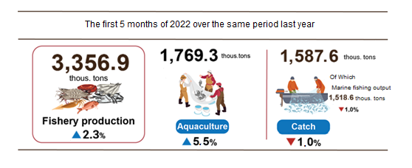
2. Industrial production
Industrial production in May continued the recovery trend, estimated to increase by 4% month-on-month and by 10.4% year-on-year due to the control of the Covid-19 epidemic, businesses have adapted to new context, overcome difficulties to recover and expand production and business. Generally, in the first 5 months of 2022, the industrial production index increased by 8.3% over the same period last year.
The Index of Industrial Production (IIP) in May 2022 was estimated to increase by 4% over the previous month and by 10.4% over the same period last year. In which, compared with the same period last year, the processing and manufacturing industry increased by 12.1%; water supply, waste and wastewater management, and treatment activities increased by 5.5%; mining industry increased by 4.2%; electricity production and distribution increased by 2.4%.
Overall, in the first 4 months of 2021, the IIP was estimated to increase by 7.5% over the same period last year (the same period in 2021 was 9.5%). Of which, the manufacturing rose by 8.3% (the same period last year up 12.1%), contributing 6.5 percentage points to the general growth; electricity production and distribution went up by 6.6%, contributing 0.6 percentage points; the mining and quarrying peaked up by 2.6%, contributing 0.4 percentage point; water supply, waste and wastewater management, and treatment peaked up by 1.1%, contributing 0.02 percentage points to the general growth rate.
The index of production in the first 5 months of 2022 belonging to 2-digit industrial activities significantly increased compared to the same period last year: Wearing apparel production increased by 22%; Manufacture of electrical equipment increased by 20.4%; Manufacture of pharmaceuticals, medicinal chemical and botanical products increased by 16.8%; Other mining and quarrying (stone, sand, and clay), Manufacture of leather and related products increased together by 13.5%; Manufacture of computer, electronic and optical products increased by 11.6%; Manufacture of fabricated metal products, except machinery and equipment increased by 11.5%; Manufacture of machinery and equipment n.e.c increased by 11.2%. In the opposite direction, the IIP index of some industries decreased: Manufacture of rubber and plastics products decreased by 13.8%; Repair and installation of machinery and equipment decreased by 9.8%; drainage and wastewater treatmen Sewerage and sewer treatment activities decreased by 3%; Manufacture of coke and refined petroleum products decreased by 2.6%; Extraction of crude petroleum and natural gas decreased by 1.7%.

Table 1. The increase/decrease growth rate of every 5-month IIP
in 2018-2022 of some key industries
%
 | 2018 | 2019 | 2020 | 2021 | 2022
Manufacture of wearing apparel | 10.5 | 7.2 | -6.8 | 9.1 | 22.0
Manufacture of electrical equipment | 11.4 | 10.6 | -6.0 | 13.5 | 20.4
Manufacture of chemicals and chemical products | 14.7 | -0.7 | 26.0 | -0.1 | 16.8
Mining of coal and lignite | 9.3 | 12.5 | 4.5 | -4.5 | 13.5
Manufacture of leather and related products | 9.8 | 7.7 | -2.9 | 11.5 | 13.5
Manufacture of computer, electronic and optical products | 18.3 | 3.1 | 7.4 | 15.4 | 11.6
Manufacture of fabricated metal products,  except for machinery and equipment | 17.2 | 4.1 | 2.6 | 9.9 | 11.5
Manufacture of machinery and equipment n.e.c | 5.8 | 11.7 | -7.6 | 11.5 | 11.2
Manufacture of leather and related products | -3.1 | -3.3 | -11.1 | -10.2 | -1.7
Other mining and quarrying  (stone, sand and clay) | -1.0 | -0.4 | -2.0 | 3.1 | -1.7
Manufacture of coke and refined petroleum products | 6.6 | 82.9 | 11.4 | 0.8 | -2.6
Repair and installation of machinery and equipment | 11.0 | 5.3 | 0.4 | -2.2 | -3.0
Repair and installation of machinery and equipment | -2.5 | 9.5 | -13.0 | -0.2 | -9.8
Manufacture of rubber and plastics products | 2.3 | 13.8 | 1.3 | 10.8 | -13.8

The industrial production index in the first 5 months of 2022 compared to the same period last year increased in 61 localities and decreased in 02 localities across the country. Some localities have a high IIP index due to the strong recovery of the processing and manufacturing industries when the epidemic is under control. On the other hand, some localities have low or low IIP index increase or decrease because business activities are still facing many difficulties due to the impact of the Covid-19 epidemic, and the processing and manufacturing industry has not regained momentum growth as high as before the epidemic.

Figure 4. The IIP growth rate of some provinces in the first 5 months of 2022
over the same period last year (%)
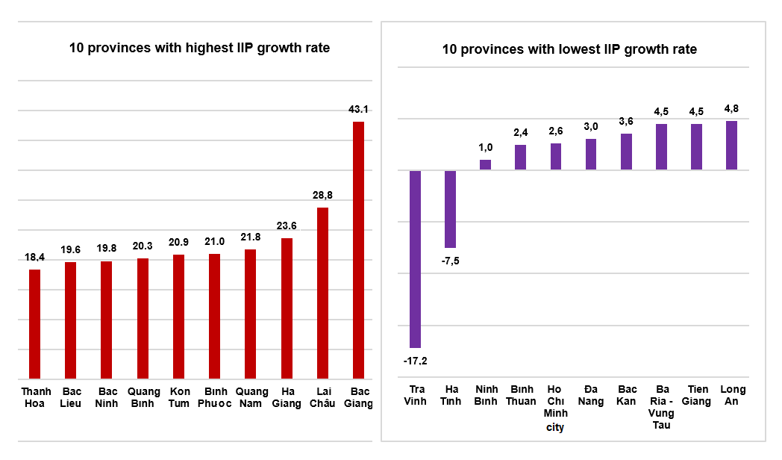
Some major industrial products in the first 5 months of 2022 increased sharply over the same period last year: Phone accessories (21.6%); Urea fertilizer (17.9%); Textile fabric from natural yarn (14.5%); Coal (pure) (13.4%); Processed fishery products (11.4%); Beer (10.5); Automobile (10.3%); Monosodium glutamate (9.5%). In the opposite side, a number of products decreased compared to the same period last year: Television (-18.2%); Textile fabric from polyester or artificial yarn (-9.8%); Mobile phone (-7.1%); Aquatic feed (-7.0%); Petroleum (-3.7%); Crude steel, iron (-3.5%); Extracted crude oil (-2.0%); Natural gas (in the form of air) (-1.4%).
The number of employees working in industrial enterprises as of 01/5/2022 was up 1.4% over the same period last month and rose by 4.4% over the same period last year. Of which the number of working employees in the state-owned enterprise sector was up 0.1% and decreased by 4.5%; non-state enterprises rose by 1.1% and declined by 1.3%; enterprises of foreign direct investment peaked by 1.8% and surged by 1.6%. By industry, the number of employees working in mining and quarrying was up 0.2% over the same period last month and went down by 2.2% over the same period last year; manufacturing was up 1.5% and increased by 4.8%; the production and distribution of electricity kept unchanged and peaked up by 1.2%; the water supply, sewerage, waste management, and remediation activities were constant and rosed by 2.4%.

3. Enterprise registration status
Consistently implementing the motto "Living safely with Covid-19", while promoting the implementation of the program of socio-economic recovery and development, Vietnam's economy is recovering quite quickly and flourishing in many fields. In the first 5 months of 2022, the number of newly established enterprises increased by 12.9% compared to the same period in 2021; the number of enterprises returning to operation increased by 57.8% and the number of enterprises completing dissolution procedures decreased by 14%.
In May, the whole country had 13.4 thousand newly established enterprises with registered capital of nearly 125.8 trillion VND and the number of registered workers 89.5 thousand workers, down 10.9% in the number of enterprises, a decrease of 23.4% in registered capital and a decrease of 14.6% in the number of employees compared to April 2022. Compared to the same period last year, an increase of 15.2% in the number of enterprises, a decrease of 16.5% in registered capital and a 24% increase in the number of employees. The average registered capital of a newly established enterprise in the month reached 9.4 billion VND, down 14% compared to the previous month and down 27.5% compared to the same period last year. In addition, the country also had 5,207 enterprises returning to operation, down 26% compared to the previous month and up 6.4% over the same period in 2021.
In the first 5 months of 2022, the country had 63 thousans newly registered enterprises with a total registered capital of 761 trillion VND and the total number of registered employees was 437.7 thousand employees, an increase of 12.9% in the number of enterprises, a decrease of 2.2% in registered capital and an increase of 6.1% in the number of employees compared to the same period last year. The average registered capital of a newly established enterprise in the first 5 months of 2022 reached 12.1 billion VND, down 13.4% compared to the same period in 2021. If including 1,684.3 trillion VND of the additionally registered capital of 22.1 thousand active enterprises, the total additional registered capital in the economy in the first 5 months of 2022 was 2,445.3 trillion VND, an increase of 39.5% over the same period last year. In addition, 35.6 thousand re-operated enterprises (up 57.8% compared to the same period in 2021), bringing the total number of newly established enterprises and re-operated enterprises in the first 5 months of 2022 to 98.6 thousand enterprises, an increase of 25.8% over the same period last year. On average every month had 19.7 thousand newly established and re-operated enterprises.
According to the economic sector, in the first 5 months, there were 913 newly established enterprises in the agricultural, forestry and fishery sectors, an increase of 2.4% compared to the same period last year; nearly 16.2 thousand enterprises in the industrial and construction sectors, an increase of 5.9%; 45.9 thousand enterprises in the service sector, an increase of 15.8%.

Figure 5. Enterprise registration situation
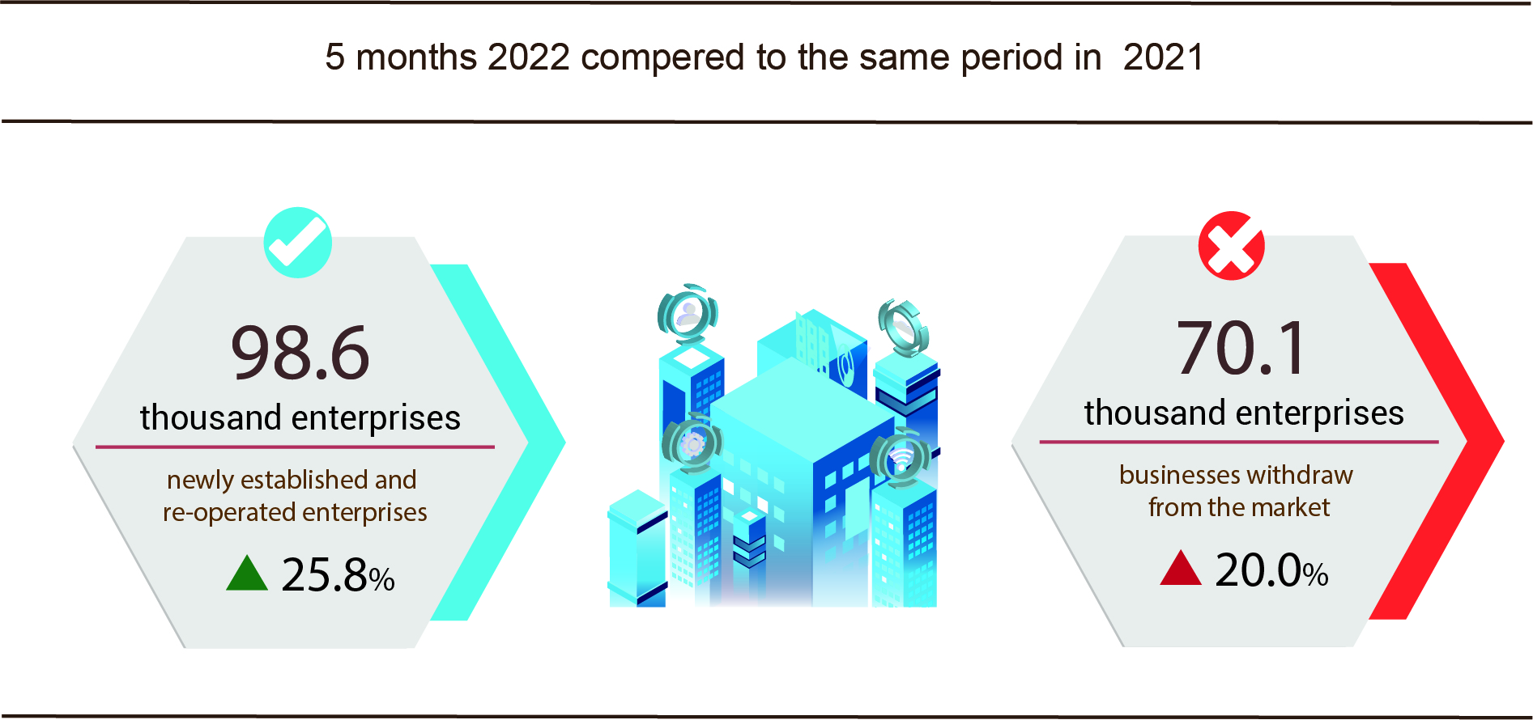

Also in May, there were 4,964 enterprises ceased for a certain time, down 7.9% compared to the previous month and up 46% compared to the same period in 2021; 4,186 enterprises temporarily ceased and awaited dissolution procedures, an increase of 11.3% and a decrease of 1.1%; 1,339 enterprises completed dissolution procedures, an increase of 9.1% and an increase of 4.7%.
In the first 5 months of 2022, there were 45.9 thousand enterprises temporarily ceased for a certain time, up 44.2% compared to the same period last year; 19 thoursansd enterprises temporarily ceased and awaited dissolution procedures, down 4.8%; 6.9 thousand enterprises completed dissolution procedures, down 14%. On average, 14.4 thousand businesses withdraw from the market every month.

Table 2: Number of newly registered enterprises and completed dissolution procedures in the first 5 months, 2022 by kinds of activity

 | Number of enterprises (Enterprise) |  | Growth rate  over the same period last year (%)
 | Newly registered | Dissolution | Newly registered | Dissolution
1. Wholesale and retail trade; repair of motor vehicles and motorcycles | 22,146 | 2,508 | 19.5 | -14.7
2. Manufacturing | 8,190 | 760 | 13.8 | -17.5
3. Construction | 7.156 | 565 | 0.5 | -22.0
4. Real estate business | 4,520 | 425 | 29.0 | 3.2
5. Transportation and storage | 3,212 | 265 | 22.3 | -28.4
6. Accommodation and catering service | 2,458 | 352 | 22.4 | -22.6
7. Production and distribution of electricity, water, gas | 493 | 174 | -25.0 | 3.0

4. Investment
In May, ministries, branches and localities focused on promoting investment capital from the State budget. Generally, in the first five months of 2022, investment capital realized from the state budget was estimated to increase by 9.5% over the same period.
Investment capital from the State budget in May was estimated at 38.1 trillion VND, increasing of 10.3% over the same period last year, including: Central capital 7 trillion VND, up 14.8%; local capital 31.1 trillion VND, up 9.4%. Generally, in first 5 months of this year, realized investment capital from the State budget reached 147.8 trillion VND, equaling 27.7% of the year plan and up 9.5% against the same period last year (the same period last year 2021 equals 26.9% and increases by 15.6%), including:
- The capital under central management was 25.3 trillion VND, equaling 24.9% of the yearly plan and increasing 15.1% against the same period last year.

Figure 6. Realized investment capital from the State budget
in first 5 months of 2022 by ministries and sectors
Billion VND
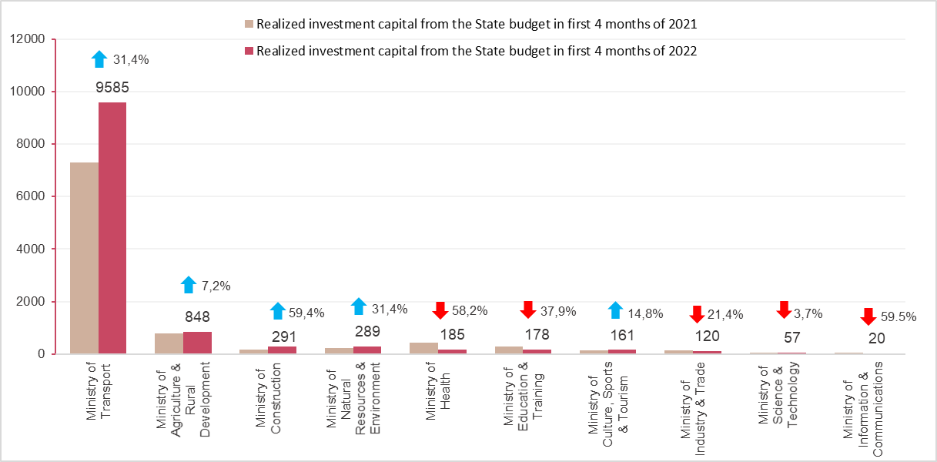
- The capital under local management reached 122.5 trillion VND, equaling 28.4% of the yearly plan and climbing up 8.4% over the same period in 2021.
The State budget capital under provincial level reached 80.5 trillion VND, equaling 26.9% and growing up 4.1%;
The State budget capital at district level gained 36.1 trillion VND, equaling 31.1% and increasing by 19.6%;
The State budget capital at commune level was 5.9 trillion VND, equaling 37.3% and expanding by 8.1%.
The realized investment capital of the state budget in first 5 months of 2022 of some provinces and cities directly under the Central Government was as follows:

Figure 7. Realized investment capital from the State budget
- in first 5 months of 2022 in some localities
Billion VND
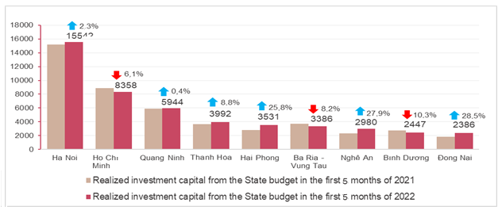

The foreign direct investment from the beginning of the year to 20th April 2022 including newly registered capital, adjust registered capital, and the total value of capital contribution and share purchases of foreign investors reached nearly 10.81 billion USD, decreased by 11.7% compared to the same period in 2021.

Figure 8. The registered capital of foreign investment in Vietnam from as of May 20th, in 2018-2022 (Billion USD)

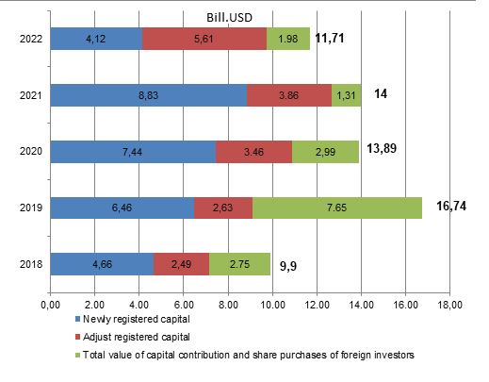

- Newly registered capital included 578 newly licensed projects with a registered capital of 4.12 billion USD, down 5.7% in the number of projects and a decrease of 53.4% of registered capital compared to the same period last year; of which, processing and manufacturing industry attracted the 1st foreign direct investor with the registered capital of newly licensed projects reaching 2.68 billion USD, accounting for 66.5% of the total newly registered capital; real estate business reached 834.7 million USD, accounting for 20.3%, the remaining industries reached 604.9 million USD, accounting for 14.7%.
Among 47 countries and territories having newly licensed investment projects in 5 months of 2022, Denmark was the largest investor with 1.32 billion USD, accounting for 32.1% of total newly registered capital; Singapore was 798.4 million USD, accounting for 19.4%; China 505.3 million USD, accounting for 12.3%; Japan 428.7 million USD, accounting for 10.4%; Taiwan 296.5 million USD, accounting for 7.2%.
- Adjust registered capital included 395 turns of projects which were licensed from the previous years registered to adjust investment capital with the additional capital of 5.61 billion USD, increased by 45.4% compared to the same previous last year.
If including additionally newly registered capital and adjust registered capital of licensed projects in previous years, foreign direct investment capital in the processing and manufacturing industry reached 56.39 billion USD, accounting for 65.7% of the total newly registered capital and additional capital; real estate business reached 1.94 billion USD, accounting for 20%; the remaining industries reached 1.4 billion USD, accounting for 14.3%.
- Capital contribution and share purchases of foreign investors included 1,339 turns with a total value of the capital contribution of 1.98 billion USD, an increase of 51.6% compared to the same period last year. Of which 630 turns of capital contribution, share purchase caused the increase of charter capital of the enterprise with the value of contributed capital of 973.5 million USD, and 709 turns of foreign investors repurchased domestic shares without increasing the charter capital with a value of 1,009.1 million USD. About the form of capital contribution and share purchase by foreign investors, the investment capital in the real estate business reached 1.05 billion USD, accounting for 53.1% of the total capital contribution; the processing and manufacturing industry reached 427.3 million USD, accounting for 21.6%; the remaining industries reached 502.4 million USD, accounting for 25.3%.
Foreign direct investment capital that implemented in 5 months of 2022 reached 7.71 billion USD, an increase of 7.8% over the same period last year, of which the processing and manufacturing industry reached 5.86 billion USD, accounting for 76.1% of total realized foreign direct investment capital; real estate business activities gained 686.1 million USD, making up 8.9%; electricity, gas, steam, and air conditioning supply recorded 639.8 million USD, comprising of 8.3%.

Figure 9. Implemented foreign direct investment
in the first 5 months of the years 2018-2022 (Billion USD)

Vietnam's investment abroad in 5 months of 2022, there were 43 projects newly granted investment certificates with a total investment capital of 293.4 million USD, 2 times higher over the same period of last year; 14 turns of projects adjusted capital with adjust capital up 44.9 million USD, a decrease of 88.9%.
Generally, the total investment capital of Vietnam abroad (newly and additionally licensed capital) reached 338.3 million USD, a decrease of 38.1% over the same period last year, in which the processing and manufacturing industry 204.4 million USD, making up 60.4%; the financial, banking insurance activities reached 33.5 million USD, making up 9.9%.
In the first 5 months of 2022, 22 countries and territories received investment from Vietnam, of which Laos was the leading country with 64.5 million USD, making up 19.1%; Singapore with 38.9 million USD, making up 11,5%; United States with 37.3 million USD, making up 11%; Germany, Netherland, France both reached 34.7 million USD, also making up 10.3%.
5. State budget revenue and expenditure
State budget revenue in the first 5 months of 2022 increased by 18.7% over the same period last year. State budget expenditure increased by 3.7% over the same period in 2021, ensuring the needs of socio-economic development, defense, security, state management, payment of due debts as well as timely payment to subjects as prescribed.

Figure 10. State budget revenue and expenditure of the first 5 months 2022
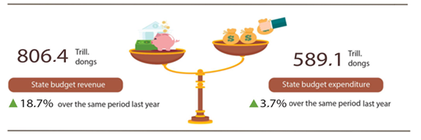
State budget revenue:
Total state budget revenue in May 2022 was estimated at 126.7 trillion VND. The accumulated total state budget revenue in the first 5 months of 2022 reached 806.4 trillion VND, equaling 57.1% of the yearly estimate and increasing by 18.7% over the same period last year. Some of the main revenues were as follows:
- Domestic revenue in May 2022 was estimated at 96.3 trillion VND. Accumulation in the first 5 months of 2022 reached 646 trillion VND, equaling 54.9% of the year estimate and up 14.9% over the same period last year.
- Revenue from crude oil in May 2022 is estimated at 5.2 trillion VND; accumulated in the first 5 months of 2022 reached 29.4 trillion VND, equaling 104.4% of the year estimate and increasing by 90.9% over the same period last year.
- Budget balance revenue from import and export activities in May 2022 was estimated at 25.1 trillion VND; accumulated in the first 5 months of 2022 reached 130.8 trillion VND, equaling 65.7% of the yearly estimate and up 29.7% over the same period last year.
State budget expenditure:
Total state budget expenditure in May 2022 was estimated at 128.1 trillion VND; accumulated in the first 5 months of 2022 was at 589.1 trillion VND, equal to 33% of the year estimate and up 3.7% over the same period last year. In which, recurrent expenditure in the first 5 months of 2022 reached 428.4 trillion VND, equaling 38.6% of the yearly estimate and increasing by 2.5% over the same period last year; development investment expenditure reached 115.9 trillion VND, equaling 22% and increasing by 13.6%; debt payment interest 43.6 trillion VND, equal to 42% and down 8.3%.
6. Trade, prices, transport and tourism
a) Retail sales of consumer goods and services
People's daily life has returned to the normal state of the years before the Covid-19 epidemic, tourism demand has increased sharply along with the SEA Games 31 event just held in Viet Nam, making commercial and service activities in May become bustling and vibrant. Total retail sales of consumer goods and services in May increased by 4.2% over the previous month and by 22.6% over the same period last year. In which, accommodation, catering and traveling services recovered strongly with revenue increasing by 69.3% and 324.3% respectively over the same period last year. In the first 5 months of 2022, the total retail sales of consumer goods and services increased by 9.7% over the same period last year.
Total retail sales of consumer goods and services in May 2022 were estimated at 477.3 trillion VND, up 4.2% from the previous month and up 22.6% over the same period last year, achieving a higher scale and growth rate compared to the same period in the years before the Covid-19 epidemic. Generally, in the first 5 months of 2022, the total retail sales of consumer goods and services were estimated at 2,257.1 trillion VND, up 9.7% over the same period last year, if excluding the price factor it was an increase of 6.3% (in the same period in 2021 down 1%).
Table 3. Retail sales of consumer goods and services
Trillion VND
 | Estimate  May  2022 | Estimate  5 months  2022 | The growth ratecompared to the same period last year (%)
 | Estimate  May  2022 | Estimate  5 months  2022 | May  2022 |  | 5 months  2022
Total | 477.3 | 2,257.1 | 22.6 | 9.7
Retail sale | 375.4 | 1,806.7 | 18.3 | 9.8
Accommodation and catering service | 55.1 | 225.8 | 69.3 | 15.7
Traveling service | 1.5 | 5.8 | 324.3 | 34.7
Other services | 45.3 | 218.8 | 15.1 | 2.5

Total retail sales of consumer goods and services in the first 5 months of 2022 are higher in scale and are gradually catching up with the growth rate of the same period in the years before the epidemic.

Figure 11. Total retail sales of consumer goods and services
in the first 5 months from 2018-2022

Retail sales of goods in the first 5 months of 2022 increased by 9.8% over the same period last year, of which the group of food and foodstuffs increased by 13.1%; cultural and educational products increased by 12.8%; vehicles decreased by 3.1%; garments up 0.2%; household appliances, tools, and equipment decreased by 1.6%. Retail sales of goods in the first 5 months of the year compared with the same period last year in some localities: Da Nang increased by 19.4%; Can Tho increased by 17.3%; Quang Ninh increased by 15.4%; Hai Phong increased by 12.6%; Ba Ria - Vung Tau increased by 11.2%; Dong Nai increased by 10.6%; Hanoi increased by 10.4%; Ho Chi Minh City increased by 7.7%.
Revenue from accommodation and food services in the first 5 months of 2022 increased by 15.7% over the same period last year as people's demand increased along with the 31st SEA Games series of events, which helped the revenue in May increased by 69.3% over the same period last year. In which, the revenue of some localities increased/decreased as follows: Can Tho increased by 39.7%; Hanoi increased by 34.2%; Dong Nai increased by 22.6%; Quang Ninh increased by 17.3%; Hai Phong increased by 10.5%; Binh Duong increased by 11.4%, Da Nang increased by 11.2%; Ho Chi Minh City increased by 2.2%; Vinh Long down 8.3%; Bac Giang decreased by 8.9%; Quang Ngai down 9.8%; Long An down 13%; Tien Giang fell 24.4%.
Traveling and tourism revenue in the first 5 months of 2022 increased by 34.7% over the same period last year due to the strong recovery of tourism activities and the 31st SEA Games event has attracted many international delegations to Viet Nam. The revenue of some localities increased/decreased as follows: Khanh Hoa increased by 347.6%; Can Tho increased by 88.2%; Phu Tho increased by 80.6%; Quang Nam increased by 67.8%; Hanoi increased by 61.1%; Quang Binh increased by 29.6%; Ho Chi Minh City increased by 0.9%; Da Nang decreased by 6.5%; Phu Yen down 16.2%, Quang Ngai down 24.7%; Ninh Thuan down 35.2%; Ha Tinh decreased by 90.4%.
Revenue from other services in the first 5 months of 2022 increased by 2.5% compared to the same period last year, specifically, the increase/decrease in some localities was as follows: Dong Nai increased by 21.7%; Khanh Hoa increased by 20.0%; Da Nang increased by 18.3%; Quang Ninh increased by 17.1%; Ca Mau increased by 13.2%; Thai Nguyen increased 12.1%; Can Tho increased by 11.0%; Hai Phong increased by 8.4%; Hanoi increased by 7.6%; Binh Duong increased by 7.5%; Bac Kan decreased by 1.1%; Dak Nong decreased by 1.2%; Nghe An down 3.1%; Ho Chi Minh City fell 11.4%.
b) Export and import of goods
In May 2022, the total export and import turnover estimated at 62.69 billion USD, down 4.7% over the previous month and up 14.5 % compared to the same period last year. Generally, in 5 months of 2022, the total export and import turnover of goods reached 305.1 billion USD, up 15.6% over the same period last year, of which exports increased by 16.3%; imports increased by 14.9%. The trade balance of goods in five months of the year was estimated to have a trade surplus of 516 million USD.
Figure 12. Import and export of goods in 5 months of 2022
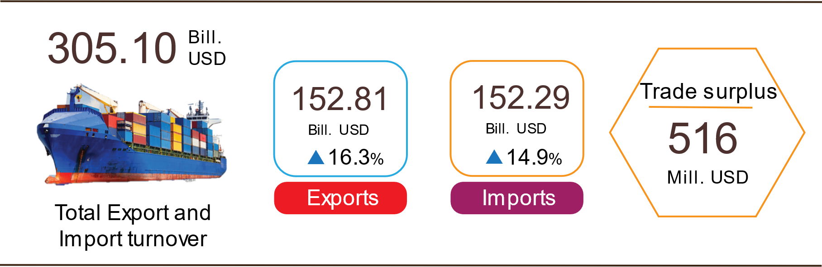

Export of goods
The preliminary export turnover of goods in April 2022 reached 33.32 billion USD, 59 million USD higher than the estimated figure.
Export turnover of goods in May 2022 was estimated at 30.48 billion USD, down 8.5% over the previous month. The domestic economic sector reached USD 8.25 billion, down 7%; the FDI sector (including crude oil) reached 22.23 billion USD, down 9.1%. Compared to the same period last year, the export turnover of goods in May increased by 16.4%, of which the domestic economic sector increased by 14.5%, the FDI sector (including crude oil) increased by 17.1%.
Generally, in 5 months of 2022, export turnover of goods was estimated at 152.81 billion USD, up 16.3% over the same period last year. In which, the domestic economic sector reached 40.25 billion USD, up 20.8%, accounting for 26.3% of total export turnover; FDI sector (including crude oil) reached 112.56 billion USD, up 14.8%, accounting for 73.7%.
In 5 months of 2022, there are 26 items with export turnover of over 1 billion USD, accounting for 89.6% of total export turnover (there are 6 export products with over 5 billion USD, accounting for 62.3%).
Table 4. Value of some export products in 5 months of 2022
 | Estimate  5 months of 2022  (Mill. USD) | Growth rate of  5 months of 2022 compared to  the same period last year (%)
Items with a value of over 5 billion USD
Phones all of kinds and their parts | 24,864 | 14.3
Electronic goods, computers, and their parts | 21,908 | 10.6
Machinery, instrument, accessory | 17,181 | 16.4
Textiles and garments | 14,932 | 21.7
Footwear | 9,367 | 11.4
Wood and products | 6,995 | 4.7

Regarding the structure of export products in 5 months of 2022, fuel and mineral products accounted for 1.4%, up 0.4 percentage points over the same period last year; processed industrial products accounted for 88.6%, down 0.5 percentage points; agricultural and forestry products accounted for 6.9%, down 0.5 percentage point; aquatic products accounted for 3.4%, up 0.6 percentage points.
Figure 13. Structure of export groups
in 5 months of 2022 by commodity group

Import of goods
The preliminary import turnover of goods in April 2022 reached 32.47 billion USD, 259 million USD lower than the estimate figure.
Import turnover of goods in May 2022 was estimated at 32.21 billion USD, down 0.8% over the previous month. In which, the domestic economic sector reached 12.03 billion USD, up 6.8%; the FDI sector reached 20.18 billion USD, down 4.8%. Compared with the same period last year, the import turnover of goods in May increased by 12.9%, of which the domestic economic sector increased by 15.4%; the FDI sector increased by 11.4%.
Generally, in 5 months of 2022, the import turnover of goods was estimated at 152.29 billion USD, up 14.9% over the same period last year, of which the domestic economic sector reached 53.36 billion USD, up 14.7%; FDI sector reached 98.93 billion USD, up 14.9%.
In 5 months of 2022, there are 28 imported products with a value of over 1 billion USD, accounting for 85.7% of the total import turnover.
Table 5. Value of some imported goods in 5 months of 2022
 |  | Estimate | Growth rate of
 |  | 5 months of 2022 | 5 months of 2022 compared to
 |  | (Mill. USD) | the same period last year (%)
Items with a value of over 5 billion USD
 | Electronic goods, computers, and their parts | 36,018 | 28.6
 | Machinery, instrument, accessory | 18,153 | -4.0
 | Phones all of kinds and their parts | 9,076 | 19.3
 | Fabrics | 6,548 | 10.9
 | Plastic | 5,543 | 9.7
 | Iron, steel | 5,444 | 17.1

Regarding the structure of imported goods in 5 months of 2022, the group of production materials accounted for 93.9%, up 0.1 percentage point over the same period last year, in which the group of machinery, equipment, tools spare parts accounted for 44.8%, down 0.3 percentage points; raw materials, fuel and materials accounted for 49.1%, up 0.4 percentage points. The group of consumer products accounted for 6.1%, down 0.1 percentage point.
Figure 14. Structure of import groups
in 5 months of 2022 by commodity group

Regarding the export and import market of goods in 5 months of 2022, the United States is the largest export market of Viet Nam with an estimated turnover of 46.7 billion USD. China is Viet Nam's largest import market with an estimated turnover of 49.6 billion USD. In 5 months of 2022, the trade surplus to the EU was estimated at 13.4 billion USD, up 43.6% over the same period last year; trade deficit from China is 27.1 billion USD, up 15.5%; trade deficit from Korea was 17.9 billion USD, up 46.6%; trade deficit from ASEAN is 6.5 billion USD, up by 6.4%; trade deficit from Japan was 742 million USD, up 18.2%.
Figure 15. Major commodities import and export markets in 5 months of 2022
 |  | Export of goods | Import of goods
The premilinary trade balance of goods in April had a trade surplus of 849 million USD; 4 months of 2022 had a trade surplus of 2.25 million USD; May was estimated to have a trade dificit of 1.73 billion USD. Generally, in 5 months of 2022, the trade balance of goods is estimated to have a trade surplus of 516 million USD (in the same period last year, the trade dificit of 1.24 billion USD). In which, the domestic economic sector has a trade deficit of 13.11 billion USD; the FDI sector (including crude oil) had a trade surplus of 13.63 billion USD.
c) Consumer price index, gold price index and US dollar price index
The consumer price index (CPI) in May 2022 increased by 0.38% compared to the previous month; increased by 2.48% compared to December 2021 and increased by 2.86% over the same period last year. Domestic gasoline prices increase according to world prices; prices of food, foodstuffs, prices of essential consumer goods and services increased in line with input prices of raw materials, which were the main reasons for the increase in CPI in May.
On average, in the first 5 months of 2022, CPI increased by 2.25% over the same period last year, higher than the increase of 1.29% in the first 5 months of 2021, but lower than the increase of the first 5 months of 2017-2020; Core inflation increased by 1.1%.
Figure 16. CPI growth rate in May and 5 months
of the period of 2018-2022 (%)

In the 0.38% increase of CPI in May 2022 compared to the previous month, there were 10 groups of goods and services with an increase in price index and 1 group of goods with a decrease in price index.
(1) Ten groups of goods and services with increasing price index include:
- The transport group had the highest increase with 2.34% (making the general CPI increase by 0.23 percentage points) due to the influence of the petrol price adjustment on May 4, 2022, May 11, 2022 and May 23, 2022 makes gasoline price increase by 5.93%; diesel oil price increased by 3.99%. Besides, the price of public transport service increased by 1.06% due to the increase in fuel price; vehicle maintenance service prices increased by 0.05%; self-driving car and motorbike rental increased by 0.22%; spare parts increased by 0.17%.
- Culture, entertainment and tourism group increased by 0.74% due to an increase in the price of package tours by 3.15% and hotels and guest houses by 0.94% when tourism demand increased again. Besides, cultural equipment in the month increased by 0.19% compared to the previous month; As the weather turns to summer, people's demand for exercise increases, leading to an increase of 0.33% in sports services.
- Beverage and cigarettes group increased by 0.33% due to the increase in input material prices and transportation costs, specifically: The price of carbonated soft drinks increased by 0.2% compared to the previous month; juices increased by 0.1%; alcohol increased by 0.45% and smoking by 0.28%.
- Food and foodsuff group increased by 0.27% (making the general CPI increasing 0.09 percentage points), of which: Food increased by 0.28% (making the general CPI increased by 0.01 percentage points); food increased by 0.22% (making the general CPI increased by 0.05 percentage points); eating out of the family increased by 0.4% (making the general CPI increased by 0.03 percentage points).
- The group of appliances and household appliances increased by 0.22%, mainly due to the high consumption demand in the summer: The price of air conditioners increased by 0.43% compared to the previous month; electric fan price increased by 0.21%; the price of refrigerators increased by 0.41%... In the opposite direction, the price of water heaters decreased by 0.27% compared to the previous month and the price of gas stoves decreased by 0.28%.
- The group of other goods and services increased by 0.19%, mainly focusing on personal goods such as electric personal care machines, which increased by 0.07%; personal service increased by 0.15%; hospitality services increased by 0.3%; environmental cleaning services 0.47%.
- The group of garments, hats and footwear increased by 0.18% due to the increase in the price of production materials due to the influence of the wars in Russia and Ukraine; zero Covid strategy from China. Accordingly, the price of ready-made clothes increased by 0.25%; hats increased by 0.2%; garment services increased by 0.25%; shoe and footwear services increased by 0.4%.
- The education group increased by 0.17% (making the general CPI increase by 0.01 percentage points) because some localities increased tuition fees for the 2021-2022 school year again after the exemption or reduction period due to the impact of the Covid-19 epidemic. making the group of educational services increase by 0.17% compared to the previous month.
- Medicines and medical services increased by 0.03%.
- Post and telecommunications group increased by 0.01%.
(2) The group of goods and services had a decrease in price index: Housing and construction materials decreased by 0.13% due to a decrease in gas prices by 5.38%. Besides, a number of commodities in the month had an increase in price compared to the previous month: The price of housing maintenance materials increased by 0.66%; kerosene price increased by 3.95%; electricity price in May increased by 0.7%; the price of domestic water increased by 1.03%.
Core inflation in May 2022 increased by 0.29% over the previous month, up by 1.61% over the same period last year. On average, in the first 5 months of 2022, core inflation increased by 1.1% over the same period in 2021, lower than the general average CPI (up by 2.25%), this reflects mainly consumer price fluctuations. due to food prices and gasoline prices.
The domestic gold price fluctuates in the same direction as the world gold price. As of May 25, 2022, the average world gold price stood at $1,845 per ounce, down 4.6% compared to April 2022 due to a stronger dollar and rising bond yields, reducing the attractiveness of gold. lead of gold. Domestically, the gold price index in May 2022 decreased by 0.52% compared to the previous month; an increase of 9.86% over the same period in 2021; average growth in the first 5 months of 2022 increased by 6.48%.
The domestic gold price fluctuates in the same direction as the world gold price. As of May 25, 2022, the average world gold price stood at $1,845 per ounce, down 4.6% compared to April 2022 due to a stronger dollar and rising bond yields, reducing the attractiveness of gold. lead of gold. Domestically, the gold price index in May 2022 decreased by 0.52% compared to the previous month; an increase of 9.86% over the same period in 2021; average growth in the first 5 months of 2022 increased by 6.48%.
d) Transport
Passenger transport in May recovered strongly with the number of passengers carried increasing by 34% and passengers traffic increasing by 45.7% over the same period last year due to the effectiveness of Viet Nam's tourism opening policy from March 15, 2022, and the series of 31 SEA Games events held in Ha Noi and some localities. Freight transport continued to develop positively with an increase of 22.8% in terms of carried and 22.4% in terms of traffic.
Generally, in the first 5 months of 2022, passenger carried decreased by 0.3% compared to the same period last year, passenger traffic increased by 4.2% and freight carried increased by 11.3%, and freight traffic increased by 16.4%.
Passengers carried in May 2022 were estimated at 361.6 millions persons, increased by 4.6% compared to the previous month, and passenger traffic was 16 billion passengers-km, decreased by 0.1% mainly due to a sharp drop in air freight 17.2% in terms of carried and 15% in terms of traffic compared to April - a month with many major public holidays. Generally, in the first 5 months of 2022, passenger carried reached 1,572.3 millions passengers, a decrease of 0.3% over the same period last year (the same period of 2021 up 4.2%), due to a sharp increase in the number of Covid-19 infections in the first 2 months of this year, people have limited travel, the passenger traffic gained 70.2 billion passengers-km, up 4.2% (the same period of 2021 increased by 0.1%). Overseas transport had a positive recovery from the effectiveness of the tourism opening policy and the 31st SEA Games event taking place in Viet Nam, gained 262.1 thousand passengers, increasing by 414.6% and 1,067.5 million passengers-km, went up 477.7%.

Table 6. Carriage of passengers in the first 5 monthsof 2022
by types of transport
 | Number of passengers |  | The growth ratecompared to the same period last year (%)
 | Carried  (Mill. passengers) | Traffic  (Bill. passengers-km) | Carried | Traffic
Total | 1,572.3 | 70.2 | -0.3 | 4.2
Railway | 1.2 | 0.4 | 5.7 | -12.0
Seaway | 4.1 | 0.2 | 32.8 | 17.6
Inland waterway | 112.3 | 2.1 | 12.6 | 13.5
Road | 1,439.0 | 51.8 | -1.4 | -3.1
Airway | 15.7 | 15.7 | 21.7 | 37.9

Freight carried in May 2022 was estimated at 184.5 millions tons, increased by 4.4% compared to the previous month, and freight traffic 37.5 billion tons-km, up 1.7%. Generally, in the first 5 months, freight carried reached 834.2 million tons, up 11.3% against the similar period last year (the same period in 2021 increased by 10.5%), freight traffic gained 170.7 billion tons-km, up 16.4% (the same period of 2021 increased by 11.2%). Of which, domestic freight carried recorded 816.8 million tons, an increase of 11.3% and 102.1 billion tons-km, up 21.6%; oversea freight reached 17.4 million tons, increasing by 8.4% and 68.7 billion tons-km, up 9.5%. Enterprises went into stable operation, import and export continued to prosper along with the 31st SEA Games event held in Viet Nam, so the demand for domestic and foreign freight transportation increased compared to the same period in 2021.

Table 7. Carriage of freight in the first 5 months of 2022
by types of transport
 | Quantity of goods |  |  | The growth rate compared to the same period last year (%)
 | Carried  (Mill. tons) | Traffic  (Bill. tons-km) |  | Carried | Traffic
Total | 834.2 | 170.7 |  | 11.3 | 16.4
Railway | 2.5 | 1.9 |  | 9.3 | 25.0
Seaway | 41.7 | 84.1 |  | 19.9 | 19.3
Inland waterway | 154.7 | 37.8 |  | 13.2 | 19.0
Road | 635.2 | 45.2 |  | 10.3 | 8.6
Airway | 0.1 | 1.7 |  | 11.3 | 37.0

đ) International visitors to Viet Nam
International visitors to our country in May were estimated at 172.9 thousand arrivals, increased 70.6% compared to the previous month and 12.8 times higher than the same period last year because Viet Nam has opened up to tourism, international routes have been restored and many international delegations came to Viet Nam to attend the 31st SEA Games. Generally, in the first 5 months of 2022, international visitors to Viet Nam were estimated at 365.3 thousand arrivals, 4.5 times higher than the same period last year but still down 95% compared to the same period in 2019, the year no Covid-19 epidemic.
Out of a total of nearly 365.3 thousand international visitors to Viet Nam in the first 5 months of the year, visitors coming by airway gained 320.7 thousand persons, accounting for 87.8% of the number of international visitors to Viet Nam, 6.3 times higher than the same period last year; by roadway achieved 44.5 thousand arrivals, accounted for 12.2% and went up 47%; by seaway achieved 95 arrivals, accounted for 0.03% and decreased by 50.8%.

Figure 17. International visitors to Viet Nam
in the first 5 months of 2022 by territories
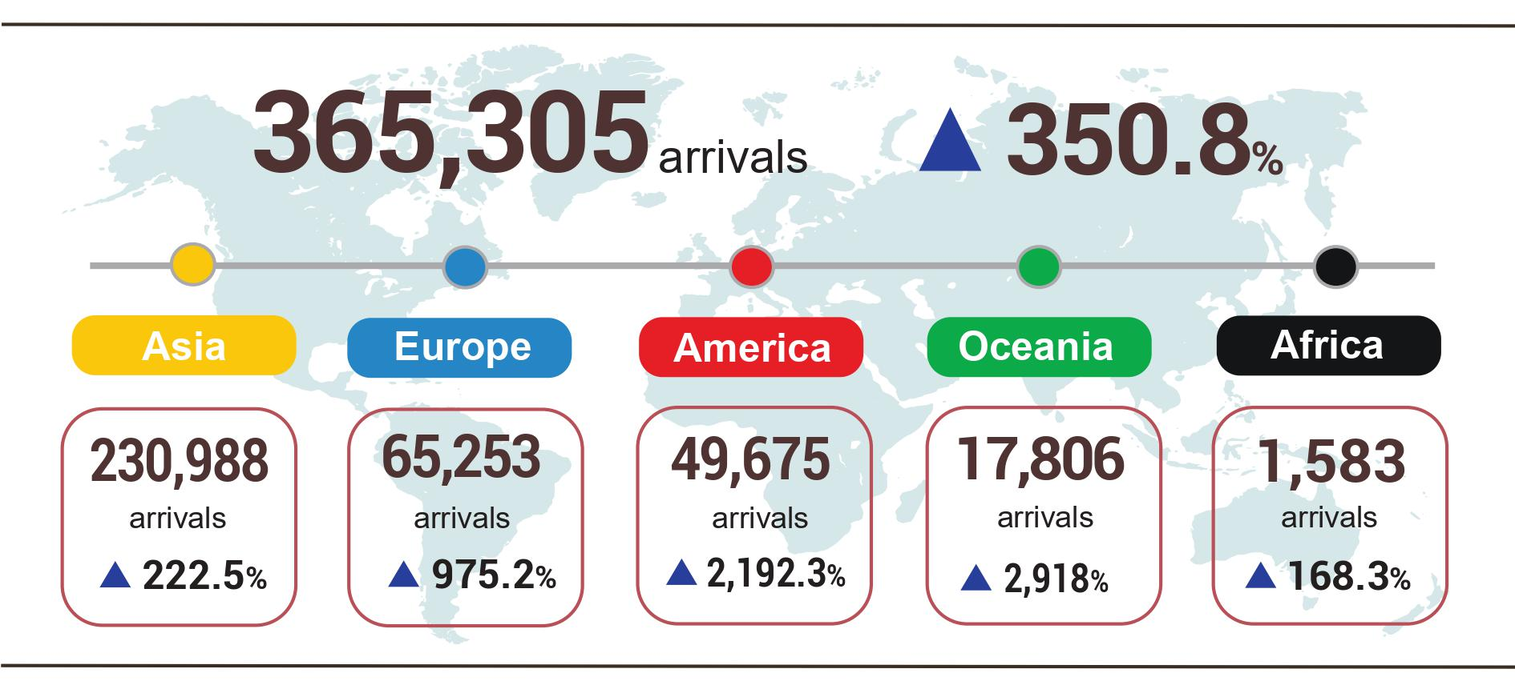

7. Some social issues
a) Residential life and social security
According to preliminary results from the Household Living Standard Survey in the first 5 months of 2022, the living situation of households has improved. The percentage of households with an increase in income compared to the same period last year was 34.7%, 12.6 percentage points higher than the proportion of households with a decrease in income (the percentage of households with a decrease in income was 22, first%); the percentage of households with unchanged income was 43.3%. Among the reasons for reducing household income, up to 83.7% of households assessed that their income decreased due to the impact of the Covid-19 pandemic; 17.9% of households assessed the decrease in income as a result of members of the household losing their job/retiring from work and 13.8% of households assessing the decrease in income as a result of increased input costs for business and production activities of the household. Besides, the Covid-19 epidemic has affected people's lives heavily when 72.6% of households are suffering from negative impacts from the Covid-19 pandemic; households that are negatively affected by other diseases and households that are affected by diseases on livestock and crops have the same rate of 2.1%.
In the first 5 months of 2022, 28.2% of households received assistance from different sources of support. Specifically, the percentage of households receiving assistance from general national programs and policies is 13.1%; from relatives was 12.7%; from local programs and policies was 11.1%; from charitable activities of other organizations and individuals was 6.9% and from other sources was nearly 0.2%.
Support packages due to the impact of the Covid-19 epidemic according to Resolution No. 68/NQ-CP dated July 1, 2021; Resolution No. 126/NQ-CP dated October 8, 2021; and Resolution No. 116/NQ-CP dated September 24, 2021, of the Government, have been implemented effectively. The support package under Resolution 11/NQ-CP, as of May 20, 2022, has supported rent for 2,431 people with the amount of 1.7 billion VND. To ensure that people do not suffer from food shortages during the harvest season, 1,396.1 tons of rice from the national reserve were distributed without charge to Tuyen Quang province (310.8 tons of rice) and Quang Tri (1,085.3 tons of rice).
b) Epidemic diseases and food poisoning
According to the report of the Ministry of Health, in the month (April 19th to May 18th, 2022) there were 11,157 cases of hemorrhagic fever (07 cases died); 4,488 cases of hand, foot and mouth disease (01 cases died); 19 cases of virus encephalitis; 01 case of meningococcal disease and 14 cases of scarlet fever suspected for measles. In the first 5 months of 2022, there were 25,861 cases of hemorrhagic fever (13 cases died); 5,554 cases of hand, foot and mouth disease; 61 cases of virus encephalitis; 03 cases of meningococcal disease and 35 cases of scarlet fever suspected for measles.
The number of new cases and deaths from the Covid-19 epidemic in most regions of the world has decreased. In Vietnam, localities continue to actively implement measures to prevent and control the Covid-19 epidemic under the new situation and protect people's health. As of 4:00 pm on May 27th 2022, there were 10,715.2 thousand cases have been reported in Vietnam, of which 9,431.5 thousand cases have been cured and 43,1 thousand cases died.
The progress of vaccination against Covid-19 for children from 5 to under 12 years old, injection of 3rd and 4th doses for people over 18 years old has been accelerated. As of May 26th, 2022, The total number of doses of Covid-19 vaccine that have been administered was 220,141.2 thousand doses, of which the first time was 84,207.5 thousand doses; the second time was 77,409.5 thousand doses; the 3rd time (Additional injections, booster injections and basic 3-dose injections) was 1,507 thousand doses.
The total number of alive HIV-infected persons in the country as of May 18, 2021 was 216,331 persons and the number of deaths by HIV/AIDS as of the above time-point was 111,573 persons.
In May 2022, there were 04 cases of food poisoning with 15 persons poisoned (01 case died). In the first 5 months of 2022, there were 11 cases of food poisoning with 263 poisoned (02 case died).
c) Cultural and sports activities
The protection and promotion of the value of tangible and intangible cultural heritage are always concerned and invested by localities, to promote heritage values ​​and create unique tourism products. The movement "All people unite to build a cultural life" continues to be widely deployed across the country, creating a healthy cultural environment, and helping people have conditions to improve their quality of life.
The mass sports movement continued to be promoted in association with the movement "All people exercise their body following the great Uncle Ho's example"; Youth sports movement in schools, cultural houses, children's houses, and residential areas is increasingly vibrant, diverse and rich, attracting a large number of children to participate.
In terms of high-performance sports, at the 31st SEA Games, the Vietnamese sports delegation achieved impressive results, ranking first in the group with 446 medals, including 205 gold medals, 125 silver medals, and 116 copper medals.
d) Traffic accident
In the month (from April 15 to May 14), there were 925 traffic accidents nationwide, including 616 traffic accidents of less serious or more serious and 309 traffic collision cases, causing 485 deaths, 322 injuries and 325 minor injuries. Compared to the previous month, the number of traffic accidents in May decreased by 11.6% (the number of traffic accidents less serious or more serious increased by 16.4%, and the number of traffic collisions equaled the previous month); the number of deaths decreased by 19.2%; the number of injured people decreased by 15.3% and the number of minor injuries increased by 4.8%. Compared to the same period last year, the number of traffic accidents in May decreased by 1.6% (the number of traffic accidents less serious or more serious decreased by 1.6%, and the number of traffic collisions decreased by 8%); the number of deaths decreased by 1.2%; the number of injured people increased by 1.3% and the number of minor injuries decreased by 9%.
Generally, in the first 5 months of 2022, there were 4,733 traffic accidents nationwide, including 3,319 traffic accidents less serious or more serious and 1,414 traffic collisions, causing 2,761 deaths, and 1,649 people injured and 1,429 people slightly injured. Compared to the same period last year, the number of traffic accidents in the first 5 months of 2022 decreased by 8.7% (traffic accidents of less serious or more serious decreased by 0.9%; the number of traffic collisions decreased by 22.9%); the number of deaths increased by 4%; the number of injured people decreased by 7.3% and the number of people with minor injuries decreased by 28.9%. On average, 1 day in the first 5 months of the year, there were 31 traffic accidents nationwide, including 22 traffic accidents of less serious or more serious and 09 traffic collisions, causing 18 deaths, 11 injuries, and 9 people with minor injuries.
đ) Damage caused by natural disasters
The damage caused by natural disasters in April was mainly due to the influence of heavy rain, flooding, landslides, killing 24 people, 20 people being injured; 2.4 thousand houses collapsed, washed away and damaged; 15.9 thousand hectares of paddy and 8.7 thousand crops were damaged; the total value of property damage caused by natural disasters in the month was 605.8 billion VND (of which Lang Son province suffered a loss of 390.6 billion VND, accounting for 64.5% of the total damage value), 2.7 times higher than the same period last year. Generally, in the first 5 months of this year, natural disasters made 43 people dead and missing, 31 people were injured; 5.2 thousand houses collapsed; 135.9 thousand hectares of paddy and 25.1 thousand hectares of crops were damaged; total value of property damage was estimated at 4,213.7 billion VND, 13.5 times higher than the same period in 2021.
e) Environmental protection and fire, explosion prevention
In May, across the country, authorities detected 1,813 cases of environmental violations, of which 1,529 cases were handled with a total fine of 19.3 billion VND. Generally, in the first 5 months of the year, 9,072 cases of environmental violations were detected, of which 7,615 cases were handled with a total fine of 102.7 billion VND, up 6.6% over the same period last year.
During the month, there were 154 fires and explosions in the whole country, killing 10 people and injuring 3 others. Property damage was estimated at 32.2 billion VND, up 47.5% over the same period last year. Generally, in the first 5 months of the year, there were 734 fires and explosions in the whole country, killing 44 people and injuring 38 people, and property damage was estimated at 112.5 billion VND, down 57.8% over the period last year./.
GENERAL STATISTICS OFFICE

According to the Ministry of Agriculture and Rural Development, from April 16, 2022, to May 15, 2022.
The price of pangasius 0.8-1.1 kg/fish fluctuated in the range of 31,500-33,000 VND/kg, an increase of more than 10,000 VND/kg over the same period last year. Source: http://agromonitor.vn/group/48/280/giam-sat-gia Source: https://vasep.com.vn/san-pham-xuat-khau/ca-tra/xuat-nhap-khau/gia-ca-tra-xuat-di-my-cao-hon-ca-muc- Dinh-nam-2019-24446.html
The price of pangasius fingerlings in the month of 28-35 fish/kg is at 30,000-32,000 VND/kg, down 8,000 VND/kg compared to April 2022. Source: http://agromonitor.vn/group/48/280/giam-sat-gia
The price of vannamei shrimp in the Mekong Delta was 100 pieces/kg, from 88,000-94,000 VND/kg, up 3,000-4,000 VND/kg, 80 shrimps/kg, from 98,000-104,000 VND/kg, up 4,000 -5,000 VND/kg over the same period last year. The price of frozen black tiger shrimp in the Mekong Delta of 20 shrimps/kg stably ranges from 220,000-250,000 VND/kg. Source: https://thuysanvietnam.com.vn/gia-tom-nguyen-lieu-tuan-09-14-05-2022/
The growth rate of industrial production index in the first 5 months of the year 2018-2022 compared to the same period last year were: 10.3%; 9.5%; 1.7%; 10%; 8.3% respectively.
Some localities with high production index of the processing and manufacturing industry in the first 5 months of 2022 compared with the same period last year were Bac Lieu up 7.8%; Quang Binh increased by 10.9%; Lai Chau increased 13%; Thanh Hoa increased by 17.3%; Bac Ninh increased by 19.9%; Quang Nam increased by 22.4%; Binh Phuoc increased 22.6%; Ha Giang increased by 25.8%; Bac Giang increased by 45.7%
Some localities where the production index of the processing and manufacturing industry in the first 5 months of 2022 decreased or increased slightly compared to the same period last year: Tra Vinh decreased by 1.3%; Ha Tinh down 0.1%; Ninh Binh increased by 1.3%; Ho Chi Minh City increased by 2.1%; Dak Nong increased by 3.8%; Bac Kan increased by 4.1%; Tien Giang increased by 4.5%; Long An increased by 5%.
Source: National Enterprise Registration Information System, Business Registration Management Agency, Ministry of Planning and Investment (Received the report on 22th April 2022)
Although, the number of newly established enterprises in May 2022 decreased compared to April 2022 (which is the month with the highest number of registered enterprises in the year), it was still recorded as the month with the highest number of newly established enterprises compared to the same period of 2016-2021. (the number of newly established enterprises in May 2016-2022 is: 10,019 enterprises; 10,954 enterprises; 11,027 enterprises; 10,693 enterprises; 10,728 enterprises; 11,601 enterprises; 13,370 enterprises).
According to the report of the Foreign Investment Department, Ministry of Planning and Investment, received on April 22, 2022
Newly granted overseas investment capital in the first 5 months of 2022 increased sharply compared to the same period last year because in the first 5 months of 2022, there were 05 major projects newly granted the IRC, which is the project of Vines Energy Solutions Joint Stock Company to the United States and Ca. Canada, France, Germany, the Netherlands with total investment capital of each project is over 34.7 million USD.
Adjusted investment capital decreased sharply because, in the first 5 months of 2021, there were many large projects adjusted to increase capital: Vingroup's project in the US was adjusted to increase by 300 million USD; Indochina Rubber Investment and Development Co., Ltd. project in Cambodia increased by 76 million USD and 01 project of Vinfast in Germany increased by 32 million USD.
As of 27/5/2022.
Total retail sales of consumer goods and services in 5/2018 reached 362.9 trillion VND, up 12.1% over the same period last year; in 5/2019 reached 400.6 trillion VND, up 10.4%.
Estimated total export and import value in May 2022 provided by the General Department of Customs on May 27, 2022. The General Statistics Office estimated the import and export value of key commodities in May 2022 based on preliminary data provided by the General Department of Customs by April 26, 2022.
Total import and export turnover of goods in 5 months of 2021 reached 264 billion USD, up 34.4% over the same period last year, of which export reached 131.4 billion USD, up 31.1%; imports reached 132.6 billion USD, up 37.7%.
Estimated trade surplus in April is 1.07 billion USD.
The growth rate of consumer price index in the first 5 months of 2017-2020 compared to the same period last year is: 4.47% increase; an increase of 3.01%; up 2.74%, up 4.39%.
Price index of rice group increased by 0.25% (Delicious rice increased by 0.35%; ordinary rice increased by 0.25%) according to the high price of export rice and the high prices of fertilizer and input materials for production. In addition, the increase in input material prices and transportation costs affected the prices of other processed food products (the price of noodles, noodles, and pho increased by 0.85% over the previous month; flour increased by 0. 8%; bread by 0.53%; vermicelli, noodle soup, and rice paper by 0.33%; vermicelli by 0.32%; instant cereal by 0.31%).
The increase in the price of animal feed and transportation caused the price of poultry meat to increase by 1.03% (the price of chicken increased by 1.12%; other poultry meat increased by 0.69%; frozen poultry meat increased by 2.16). %); the price of fresh seafood increased by 0.18% (the price of fish increased by 0.13%; the price of shrimp increased by 0.24%; the price of other fresh seafood increased by 0.25%); price of pork increased by 0.02% (processed meat increased by 0.3%; roast meat, pork sausage increased by 0.31%; canned meat increased by 0.25%; other processed meat increased by 0.24%); the price of cooking and processing fats and oils increased by 1.47% (the price of fish sauce and dipping sauce increased by 0.8%; sugar and honey by 0.27%; milk, butter, and cheese by 0.33%; cakes, jams, candy increased by 0.47%; tea, coffee, cocoa increased by 0.16%). On the other hand, the group of fresh, dried, and processed vegetables decreased by 0.39%, mainly because the price of water spinach dropped by 4.25%; fresh fruit and vegetables decreased by 1.38%; Vegetables and fruits decreased by 1.62% because in the main season, the supply was high.
The price of gasoline along with the price of raw materials is high. In which, the food price index outside the family increased by 0.46%; Out-of-home drinks increased by 0.28% and fast food take away increased by 0.14%.
The growth rate of the price index of educational services in May 2022 compared with the previous month of some localities: Soc Trang increased by 14.16%; Ca Mau increased by 12.99%; Hanoi increased by 0.33%; Phu Yen increased 0.14%; Nam Dinh and Lai Chau both increased by 0.08%; An Giang increased by 0.06%; Dong Thap increased 0.05%.
From May 1, 2022, the domestic gas price is adjusted down by 29,000 VND/bottle of 12 kg after the world gas price dropped by 95 USD/ton (from 950 USD/ton to 855 USD/ton).
Steel price increased when the price of raw materials from iron ore, scrap steel… increased; prices of input materials in cement production such as gasoline and coal increased. In addition, the prices of a number of other building material products also increased, such as stone, sand, and construction bricks.
Effects of price adjustments on May 4, 2022, May 11, 2022, and May 23, 2022.
The domestic electricity price index in May 2022 is calculated based on the revenue and output of electricity consumption from date April 1-30, 2022, thus reflecting movements one month late compared to other commodities.
CPI after excluding food, fresh food, energy and goods managed by the State including health services and education.
According to the report of the Border Gate Department, the Border Guard Command, the Ministry of National Defense and the Immigration Department.
The reporting period is from April 21, 2022 to May 20, 2022.
As of 4:00 pm on May 27th 2022, in the world, there were 530,468.2 thousand cases of Covid-19 (6,308.1 thousand deaths).
With this achievement, Vietnam far surpassed the Indonesia record set at the 19th SEA Games with 410 medals, of which 194 gold medals, 101 silver medals, and 115 bronze medals. Followed by delegations from Thailand, Indonesia, Philippines, Singapore, Malaysia, Myanmar, Cambodia, Laos, Brunei, and Timor Leste.
According to a quick report from the Office of the Ministry of Public Security and the Vietnam Maritime Administration (Ministry of Transport) from April 15, 2022 to May14, 2022.
Summary of reports from 63 Departments of Agriculture and Rural Development, reporting period from March 15 to April 14, 2022.
According to a quick report from the Ministry of Public Security on 23/5/2022.

