MINISTRY OF PLANNING AND INVESTMENT  GENERAL STATISTICS OFFICE  No: 165/BC-TCTK | SOCIALIST REPUBLIC OF VIET NAM  Independence-Freedom-Happiness  Ha Noi, 29th July 2022

Socio-economic situation report
in July and the 7 months of 2022

1. Agriculture, forestry, and fishery
In July, localities across the country focused on speeding up the planting of winter rice, caring for and harvesting early summer-autumn rice, and ensuring planting and harvesting in the best time frame. The livestock industry has been facing difficulties due to the high price of animal feed, which makes farmers not assured to re-herd and expand production scale. Forestry production took place relatively smoothly, logging was actively deployed. Aquaculture grew positively due to the increase in demand and a rise in export prices of key aquatic products such as pangasius and farmed shrimp; marine fishing faces many difficulties due to high gasoline prices.
a) Agriculture
Winter rice
As of July 15, the whole country cultivated 1,021.6 thousand hectares of winter rice, equaling 92.3% of the same period last year. Of which, the Northern provinces cultivated 671.9 thousand hectares, equaling 85.9%; provinces in the South cultivated 349.7 thousand hectares, equaling 107.6%. The progress of summer rice planting this year was slower than that of the same period last year due to the impact of the prolonged La-Nina phenomenon leading to slow growth of spring rice and late harvest in the northern provinces. In the southern provinces, the cultivated area increased mainly in the Mekong Delta because it was not affected by drought and salinity like last year. Currently, rice is developing relatively well, the area of early rice is in the stage of greening and tillering.
Summer-autumn rice
By mid-July, the whole country had planted 1,915.9 thousand hectares of summer-autumn rice, equaling 98.3% of the same period last year. In which, the northern provinces reached 177 thousand hectares, equaling 99.2%; the southern provinces reached 1,738.9 thousand ha, equaling 98.2%, and the Mekong Delta reached 1,474.3 thousand ha, equaling 97.7%. The area of ​​summer-autumn rice cultivation decreased compared to the same period last year mainly because farmers converted the inefficient rice area to other purposes such as: planting fruit trees, vegetable crops, and aquaculture for higher efficiency economic. Up to now, most of the summer-autumn rice is in the stage of ripening, the early rice in the southern provinces has been harvested with an area of ​​414.7 thousand hectares, in the southern provinces, equaling 97% of the same period last year, of which the Mekong Delta reached 401.3 thousand hectares, equaling 96.3%.
Autumn-winter rice
As of July 15, the Mekong Delta had sown 279.1 thousand hectares of autumn-winter rice, equaling 98.4% of the same period last year. The sowing area decreased because this year's autumn-winter rice crop was affected by adverse weather, in addition, the price of fertilizer and input materials for production increased. In this year's autumn-winter rice crop, the Agriculture sector has directed localities to have the appropriate time frame to ensure safety and efficiency; synchronously apply advanced technical and farming processes to reduce production costs, improve product quality, and at the same time support and encourage farmers to produce high-quality rice varieties. At present, autumn-winter rice is in the stage of seedling and tillering to grow and develop well.
Annual crops
Along with planting rice, localities across the country are planting other crops. The planted area of all kinds of crops decreased compared to the same period last year, especially soybean and sweet potato. The area planted for sweet potatoes decreased significantly in the Mekong Delta due to unstable selling prices and high fertilizer costs, leading to low economic efficiency, so farmers switched to growing fruit and other crops.
Figure 1: Cultivation of some annual crops
(As of 15/7/2022)
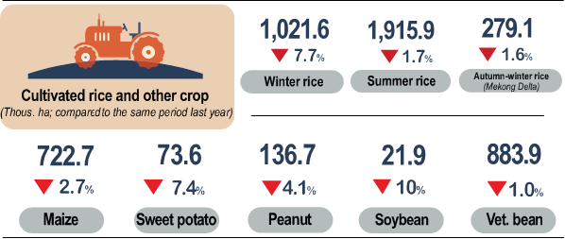

Livestock
Cattle and buffalo husbandry in July 2022 has developed stably, pig raising has been facing difficulties because the price of animal feed is still high, although the price of live hogs has increased compared to the previous month, farmers have not assured to re-herd and expand production. As of July 26, the live hog price was at 63,000-71,000 VND/kg (an increase of 8,000-15,000 VND/kg compared to the previous month). Poultry breeding has developed stably, and diseases are well controlled, but due to the high cost of input materials, especially the price of animal feed, farmers do not expand the scale. As of the end of July 2022, the total poultry increased by 1.6% over the same period last year, this is the lowest increase in the period 2018-2022.
Figure 2. The growth rate of the population of livestock
at the end of July 2022 compared to the same time last year
As of July 24, 2022, the whole country has no longer blue-ear disease and foot-and-mouth disease; avian flu was still in Ha Noi, Lao Cai, Ha Tinh; LSD was still in Ha Tinh, Dak Lak, Gia Lai, and African swine fever were reported in 14 localities for less than 21 days.
b) Forestry
The area of ​​concentrated newly planted forest in the whole country in July was estimated at 15.5 thousand ha, up 19.3% over the same period last year because some localities have accelerated the afforestation progress. Specifically, Tuyen Quang increased by 779 hectares over the same period last year, Son La increased by 1,391 hectares, Kon Tum increased by 372 hectares. The number of scattered forest trees in the month was estimated at 6.7 million trees, down 1.5% over the same period last year. Logging activities continue to take place smoothly and positively due to the sunny weather, the timber has reached the age of exploitation, the price of wood tends to increase, the buyer carried out the exploitation according to the signed contracts. Timber production in July was estimated at 1,676.9 thousand m³, up 5.6% over the same period last year; firewood production reached 1.6 million ste, down 0.6%. Some localities have high timber output in the month such as: Quang Tri reached 124.9 thousand m³, an increase of 18.4% over the same period last year; Nghe An reached 140.2 thousand m³, up 8.2%; Quang Ngai reached 197.6 thousand m³, up 4.5%.
Generally, in the 7 months of 2022, The area of ​​concentrated newly planted forest nationwide was estimated at 134.9 thousand ha, up 4.7% over the same period last year; the number of scattered forest trees reached 53.7 million trees, up 5%; timber production reached 10.2 million m³, up 5.9%; firewood production reached 11.1 million ste, up 0.5%.
In July, the whole country had 100.2 ha of forest damaged, down 76.1% over the same period last year, including: The burned forest area was 1.1 ha, down 99.7%; the area of forest cleared was 99.1 ha, an increase of 12.7%. In the 7 months of 2022, the damaged forest area was 706 ha, down 49.5% over the same period last year, including: The burnt forest area was 25.2 ha, down 96%; the area of forest cleared was 680.8 ha, down 11.5%.
c) Fishery
Fishery output in July was estimated at 805.4 thousand tons, up 1.5% over the same period last year, including Fish reached 566.7 thousand tons, up 0.9%; shrimp reached 130 thousand tons, up 7%; other aquatic products reached 108.7 thousand tons, down 1.3%.
It was estimated that in July 2022, aquaculture output reached 462.9 thousand tons, up 6.1% over the same period last year, including Fish reached 293 thousand tons, up 5.5%; shrimp reached 118.8 thousand tons, up 7.9%; other products reached 51.1 thousand tons, up 5.1%.
Processing and exporting pangasius have many favorable conditions and continue to achieve positive results. As of mid-July, the price of raw pangasius in the Mekong Delta provinces increased over the same period last year. Pangasius production in the month was estimated at 129.3 thousand tons, up 9% over the same period last year. The high and stable price of shrimp helps farmers achieve profits, promoting the expansion of high-tech shrimp raising models. Vannamei shrimp production in July was estimated at 85.5 thousand tons, up 10.2% over the same period last year; black tiger shrimp production reached 28,000 tons, up 2.2%.
Specifically, fish reached 273.7 thousand tons, down 3.6%; shrimp reached 11.2 thousand tons, down 1.8%; other products reached 57.6 thousand tons, down 6.3%. Fishermen continue to face difficulties because fuel prices have still been high compared to last year, leading to an increase in the cost of fishing trips. In addition, during the month, due to the influence of the circulation of storm No.01 with the international name CHABA on the East Sea area, it weakened into a tropical depression that affected marine fishing activities. Marine fishing output in the month was estimated at 327.9 thousand tons, down 4.2% over the same period last year.

Figure 3: Fishery production in 7 months of 2022

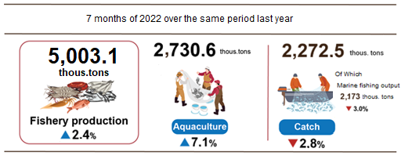

Generally, for the 7 months of 2022, fishery output was estimated at 5,003.1 thousand tons, up 2.4% over the same period last year, of which: Fish reached 3,612 thousand tons, up 1.6%; shrimp reached 650 thousand tons, up 8.9%; other products reached 741.1 thousand tons, up 0.9%.
2. Industrial production
Industrial production in July continued to recover, estimated to increase by 1.6% compared to the previous month and up 11.2% over the same period last year as businesses tried to expand production to offset the 2-year period. affected by the Covid-19 pandemic. Generally for the first 7 months of 2022, the industrial production index is estimated to increase by 8.8 % over the same period last year.
The index of industrial production (IIP) in July 2022 is estimated to increase by 1.6% over the previous month and up by 11.2% over the same period last year. In which, compared to the same period last year, the manufacturing industry increased by 12.8%; water supply; sewerage, waste management and remediation activities by 9.2%; Electricity, gas, steam and air conditioning supply increased by 8.7%; the mining sector alone decreased by 1.5%.
Generally, for 7 months of 2021, IIP was estimated to increase by 8.8% over the same period last year (in the same period in 2021 by 7.6 %). In which, the manufacturing industry increased by 9.7% (the same period in 2021 increased by 9.7%), contributing 7.6 percentage points to the overall growth; electricity production and distribution increased by 6.4%, contributing 0.5 percentage points; Water supply; sewerage, waste management, and remediation activities increased by 4.5%, contributing 0.1 percentage points; the mining increased by 3.6%, contributing 0.6 percentage points to the overall increase.
The 2-digit industry production index of 7 months in 2022 increased sharply compared to the same period last year: The manufacture of wearing apparel increased by 23.1%; the Manufacture of electrical equipment increased by 21%; Manufacture of pharmaceuticals, medicinal chemicals, and botanical products increased by 20.1%; Manufacture of beverages increased by 19.5%; production of leather and related products increased by 15.1%; Manufacture of electronic products, computers, and optical products by 11%; wood processing and production of wood, bamboo and cork products by 10.3%; Manufacture of paper and paper products increased by 10.2%; Manufacture of prefabricated metal products (except for machinery and equipment) increased by 10%. In the opposite direction, the IIP index of some industries decreased: Manufacture of rubber and plastic products decreased by 8.4 %; repair, maintenance, and installation of machinery and equipment reduced by 3.5 %; Sewerage and sewer treatment activities reduced by 2.5%; Extraction of crude petroleum and natural gas decreased by 2.4%; Manufacture of other transport equipment decreased by 1.4%; Manufacture of coke, refined petroleum products decreased by 1%.

Table 1. The growth rate of IIP index in the 7 months of 2018-2022
compared to the same period last year of some key industries
%
 | 2018 | 2019 | 2020 | 2021 | 2022
Manufacture of wearing apparel | 10.3 | 7.7 | -5.5 | 7.2 | 23.1
Manufacture of electrical equipment | 9.0 | 10.7 | -2.0 | 7.1 | 21.0
Manufacture of pharmaceuticals, medicinal chemical and botanical products | 16.1 | -0.3 | 23.1 | -8.6 | 20.1
Manufacture of beverages | 8.7 | 10.0 | -6.6 | 5.4 | 19.5
Manufacture of leather and related products | 10.5 | 8.1 | -4.4 | 13.8 | 15.1
Manufacture of electronic products, computers and optical products | 17.0 | 3.6 | 9.2 | 10.7 | 11.0
Manufacture of wood and of products of wood and cork | 2.8 | 12.3 | -4.2 | 4.9 | 10.3
Manufacture of paper and paper products | 10.2 | 10.5 | 9.0 | 7.7 | 10.2
Manufacture of prefabricated metal products  (except machinery and equipment) | 16.3 | 5.2 | 2.3 | 8.7 | 10.0
Manufacture of coke and refined petroleum products | 57.8 | 46.0 | 14.4 | 5.6 | -1.0
Manufacture of other transport equipment | 6.1 | -4.5 | -10.1 | 6.7 | -1.4
Extraction of crude petroleum and natural gas | -4.9 | -2.7 | -11.0 | -10.9 | -2.4
Sewerage and sewer treatment activities | 5.7 | 4.6 | -1.5 | -2.2 | -2.5
Repair and installation of machinery and equipment | 4.4 | 0.0 | -8.9 | -2.9 | -3.5
Manufacture of rubber and plastics products | 3.8 | 15.2 | 2.2 | 3.1 | -8.4

The industrial production index for 7 months in 2022 compared with the same period last year increased in 61 localities and decreased in 02 localities across the country. Some localities with IIP index achieved a high increase due to the strong recovery of the manufacturing industry; Electricity, gas, steam, and air conditioning supply. On the other hand, some localities have low or low IIP index when production and business activities are still facing many difficulties due to the impact of the Covid-19 pandemic, the manufacturing industries have not regained them as before the pandemic; Mining industry and electricity production and distribution industry slightly increase or decrease.
Figure 4. IIP growth rate in 7 months 2022
compared to the same period last year of some localities (%)

Some key industrial products in 7 months of 2022 witness a high increase compared to the same period last year: Beer (22.1%); phone components (21.3%); Processed fishery products (13.6%); Clothes (13.1%); urea fertilizer (11.8%); Leather footwear (11.4%); Textile fabric from natural yarn (10.6%); Coal (pure) (9.2%); Automobile (9%). In the opposite direction, a number of products decreased compared to the same period last year: Television (-15.9%); Crude steel, iron and Textile fabric from polyester or artificial yarn (- 9.4%); N.P.K mixed fertilizer (-7.1%); aquatic feed (-5.8%); motorbikes (-4.7%); mobile phones (-3.2%); gaseous natural gas (-3.1%); Liquidized gas (LPG) (-1.7%); Extracted crude oil (-1.5%).
The number of employees working in industrial enterprises as of July 1, 2022, an increase of 1.2 % compared to the same period last month and an increase of 11.3 % compared to the same period last year. Of which, Labor in State-owned enterprises remained unchanged and decreased by 5.1%; non-state enterprises increased by 0.7% and 6.6%; foreign-invested enterprises increased by 1.5 % and 14.1%. By industry, the number of employees working in mining enterprises remained unchanged from the same period last month and increased by 0.9% over the same period last year; the manufacturing industry increased by 1.3 % and 12.1 %; Electricity, gas, steam, and air conditioning supply remained unchanged and increased by 1.6%; Water supply; sewerage, waste management, and remediation activities increased by 0.2% and up 4.5%.
3. Enterprise registration status
The high price of input materials and high transportation costs have affected the business activities of the enterprise. The number of newly established enterprises in July decreased slightly (0.7%) compared to June 2022. However, in the first 7 months of 2022, the number of enterprises entering and returning to operation increased by 26.8% over the same period last year; the number of enterprises that completed dissolution procedures decreased by 9%.
In July, the whole country had nearly 13.2 thousand newly established enterprises with registered capital were 123.9 trillion VND and a total number of registered employees of 106.2 thousand employees, a decrease of 0.7% in the number of enterprises, an increase of 2.4% in registered capital and an increase of 37.6% in the number of employees compared to June 2022. Compared to the same period last year, an increase of 50.7% in the number of enterprises, an increase of 1% in registered capital, and an increase of 49% in the number of employees. The average registered capital of a newly established enterprise in the month reached 9.4 billion VND, an increase of 3.1% compared to the previous month and a decrease of 33% over the same period last year. In addition, the country also had 2.3 thousand enterprises re-operated, up 3.2% compared to the previous month and down 53% compared to the same period in 2021.
In the 7 months of 2022, the country had 89.4 thousand newly registered enterprises with a total registered capital of 1,006.1 trillion VND and the total number of registered employees was 621 thousand employees, an increase of 17.9% in the number of enterprises, a decrease of 5.6% in registered capital and an increase of 11.8% in the number of employees compared to the same period last year. The average registered capital of a newly established enterprise in the 7 months of 2022 reached 11.3 billion VND, down 19.9% compared to the same period in 2021. If including 2,329.7 trillion VND of the additionally registered capital of 31.2 thousand passengers’ enterprises that recorded an upward adjustment of capital, the total additional registered capital in the economy in the 7 months of 2022 was 3,335.8 trillion VND, an increase of 37.2% compared to the same period last year. In addition, nearly 44.3 thousand re-operated enterprises (up 49.7% compared to the same period in 2021), bringing the total number of newly established enterprises and re-operated enterprises in the 7 months of 2022 to 133.7 thousand enterprises, up 26.8% compared to the same period last year. The average every month had 19.1 thousand newly established and re-operated enterprises.
By economic sector in 7 months, there were 1,239 newly established enterprises in the agricultural, forestry, and fishery sectors, a decrease of 1.9% compared to the same period last year; nearly 22.5 thousand enterprises in the industrial and construction sectors, an increase of 9.3%; 65.7 thousand enterprises in the service sector, an increase of 21.7%.

Figure 5. Enterprise registration situation
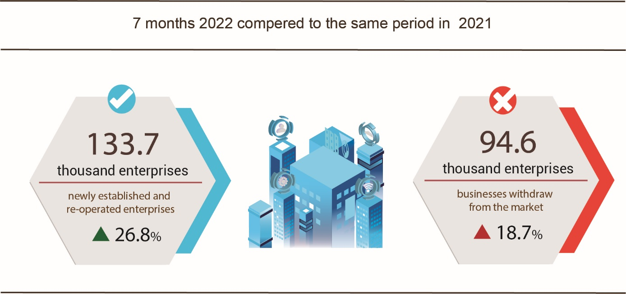
Also in July, 5,285 enterprises ceased for a certain time, up 3% compared to the previous month and up 16.7% over the same period in 2021; 4,416 enterprises temporarily ceased and awaited dissolution procedures, a decrease of 14.2% and an increase of 12.3%; 1,767 enterprises completed dissolution procedures, up 4.7% and 22.5%.
In the 7 months of 2022, there were 56 thousand enterprises temporarily ceased for a certain time, an increase of 39.2% compared to the same period last year; nearly 28.2 thousand enterprises temporarily ceased and awaited dissolution procedures, an increase of 0.6%; nearly 10.4 thousand enterprises completed dissolution procedures, down 9%. On average, 13.5 thousand enterprises withdraw from the market each month.

Table 2: Number of newly registered enterprises and completed dissolution procedures in 7 months, 2022 by kinds of activity
 | Number of enterprises (Enterprise) |  | Growth rate  over the same period last year (%)
 | Newly registered | Dissolution | Newly registered | Dissolution
1. Wholesale and retail trade; repair of motor vehicles and motorcycles | 31,475 | 3,658 | 24.0 | -13.3
2. Manufacturing | 11,530 | 1,195 | 17.4 | -9.8
3. Construction | 9,817 | 929 | 3.4 | -7.7
4. Real estate business | 5,990 | 646 | 23.7 | 12.3
5. Transportation and storage | 4,449 | 389 | 22.4 | -22.4
6. Accommodation and catering service | 3,672 | 496 | 38.6 | -23.2
7. Production and distribution of electricity, water, gas | 669 | 267 | -21.2 | 14.1

4. Investment
In July, investment capital from the State budget continued to be deployed by ministries, branches, and localities, and disbursement of public investment capital was promoted in the context of production and business activities recovery quickly. In the seven months of 2022, investment capital realized from the State budget is estimated at 43.3% of the plan, up 11.9% over the same period last year. The realized foreign direct investment (FDI) capital in Vietnam in the first seven months of 2022 is estimated at 11.6 billion USD, up 10.2% over the same period last year, this is the highest increase in the years 2018-2022.
Realized investment capital from the State budget in July 2022 was estimated at VND 46.2 trillion, up 22.5% over the same period last year, including Centrally managed capital of VND 8.5 trillion VND, up 21.9%; local capital under management is 37.7 trillion VND, up 22.6%. In the 7 months of 2022, investment capital realized from the State budget is estimated at 237.6 trillion VND, equaling 43.3% of the year plan and up 11.9% over the same period last year (the same period last year was 42.3% and increasing by 6.3%). Specifically:
- Realized investment capital under central management was estimated at 41.7 trillion VND, equaling 40.1% of the year plan and increasing by 15.3% over the same period last year.

Figure 6. Realized investment capital from the State budget
7 months of 2022 by Ministries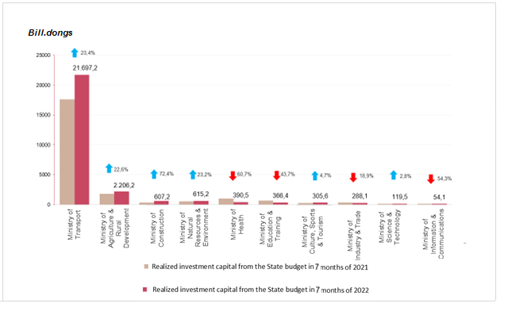

- Realized investment capital under local management was estimated at 195.9 trillion VND, equaling 44.1% of the year plan and increasing by 11.2% over the same period last year, of which:
Provincial state budget capital reached 128.5 trillion VND, equaling 42% and increasing 7.7% over the same period in 2021;
State budget capital at the district level reached 57.9 trillion VND, equaling 47.9% and increasing by 20.8%;
State budget capital at the commune level reached 9.4 trillion VND, equaling 55.1% and increasing by 7.4%.
Realized investment capital from the State budget for the seven months of 2022 of some provinces and centrally-run cities was as follows:
Figure 7. Realized investment capital from the State budget
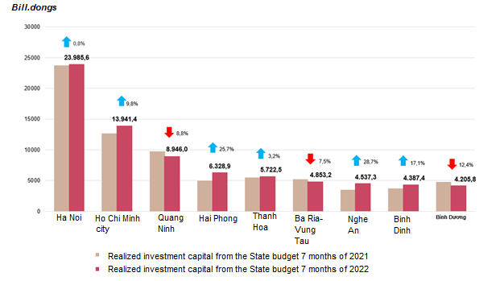
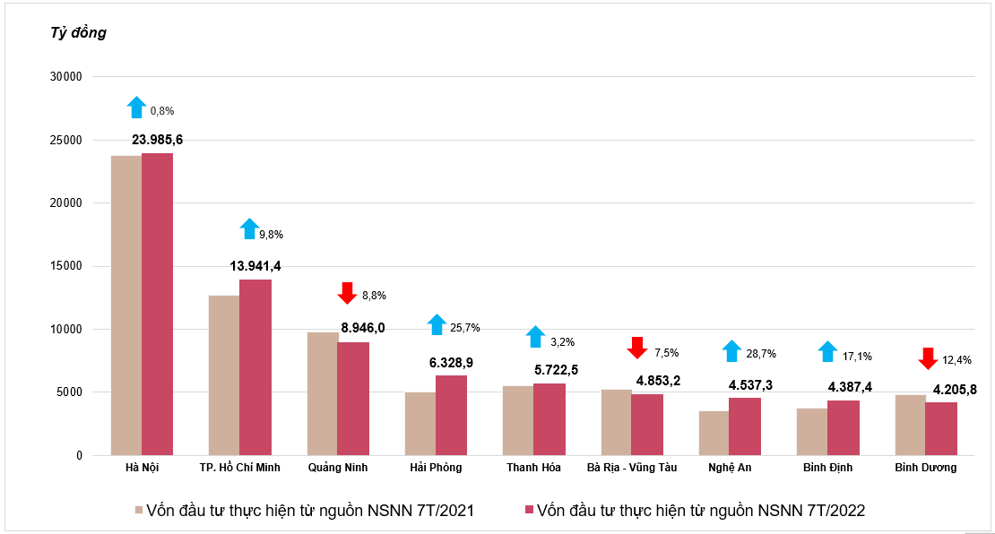
7 months of 2022 by some provinces

The foreign direct investment from the beginning of the year to 20th July 2022 including newly registered capital, adjust registered capital, and the total value of capital contribution and share purchases of foreign investors reached nearly 15.54 billion USD, decreased by 7.1% compared to the same period in 2021.

Figure 8. The registered capital of foreign investment in Vietnam from date 20/07, in 2018-2022 (Billion USD)

- Newly registered capital included 927 newly licensed projects with a registered capital of 5.72 billion USD, a decrease of 7.9% in the number of projects and a decrease of 43.5% of registered capital compared to the same period last year; of which, processing and manufacturing industry attracted the 1st foreign direct investor with the registered capital of newly licensed projects reaching 3.98 billion USD, accounting for 69.5% of the total newly registered capital; real estate business reached 998.2 million USD, accounting for 17.4%, the remaining industries reached 750.3 million USD, accounting for 13.1%.
Among 78 countries and territories having newly licensed investment projects to Vietnam in 7 months in 2022, Denmark was the largest investor with 1.32 billion USD, accounting for 23.1% of total newly registered capital; Singapore 1.22 billion USD, accounting for 21.3%; China 651.4 million USD, accounting for 11.4%; South Korea 567.8 million USD, accounting for 9.9%; Japan 534.8 million USD, accounting for 9.3%; Hong Kong 495.4 million USD, accounting for 8.7%.
- Adjust registered capital included 579 turns of projects which were licensed in the previous years registered to adjust investment capital with the additional capital of 7.24 billion USD, increased by 59.3% compared to same previous of last year.
If including additionally newly registered capital and adjust registered capital of licensed projects in previous years, foreign direct investment capital in the processing and manufacturing industry reached 9.37 billion USD, accounting for 72.3% of the total newly registered capital and additional capital; real estate business reached 2.06 billion USD, accounting for 15.9%; the remaining industries reached 1.53 billion USD, accounting for 11.8%.
- Capital contribution and share purchases of foreign investors included 2,072 turns with a total value of the capital contribution of 2.58 billion USD, an increase of 25.7% compared to the same period last year. Of which 932 turns of capital contribution, share purchase caused the increase of charter capital of the enterprise with the value of contributed capital of 1.32 billion USD, and 1,140 turns of foreign investors repurchased domestic shares without increasing the charter capital with a value of 1.26 billion USD. About the form of capital contribution and share purchase by foreign investors, the investment capital in the real estate business reached 1.15 billion USD, accounting for 44.7% of the total capital contribution; the processing and manufacturing industry reached 625.9 million USD, accounting for 24.3%; the remaining industries reached 799.9 million USD, accounting for 31%.
Foreign direct investment capital that was implemented in 7 months of 2022 reached 11.57 billion USD, an increase of 10.2% over the same period last year, this is the highest increase of the first 7 months of the year in the past 5 years; of which the processing and manufacturing industry reached 8.87 billion USD, accounting for 76.7% of total realized foreign direct investment capital; real estate business activities gained 1,004.8 million USD, making up 8.7%; electricity, gas, steam, and air conditioning supply recorded 912.9 million USD, comprising of 7.9%.
Figure 9. Implemented foreign direct investment
7 months of the years 2018-2022 (Billion USD)

Vietnam's investment abroad in 7 months of 2022, there were 67 projects newly granted investment certificates with a total investment capital of 313.8 million USD, 2.2 times higher over the same period of last year; 14 turns of projects adjusted capital with adjusting capital up 44.9 million USD, a decrease of 89.4%.
Generally, the total investment capital of Vietnam abroad (newly and additionally licensed capital) reached 358.8 million USD, a decrease of 37.1% over the same period last year, in which the processing and manufacturing industry 218.4 million USD, making up 60.9%; the financial, banking insurance activities reached 35.3 million USD, making up 9.8%; mining activities 34.4 million USD, making up 9.6%.
In 7 months of 2022, 23 countries and territories received investment from Vietnam, of which Laos was the top country with 65.9 million USD, making up 18.4%; Singapore with 41.5 million USD, making up 11.6%; United States with 37.8 million USD, making up 10.5%; Germany, Netherland, France also reached 34.7 million USD, also making up 9.7%.
5. State budget revenue and expenditure
State budget revenue in the seven months of 2022 increased by 18.1% over the same period last year. State budget expenditure increased by 3.7% over the same period in 2021, ensuring the needs of socio-economic development, defense, security, state management, payment of due debts as well as timely payment to subjects as prescribed.
Figure 10. State budget revenues and expenditures
in the seven months of 2022
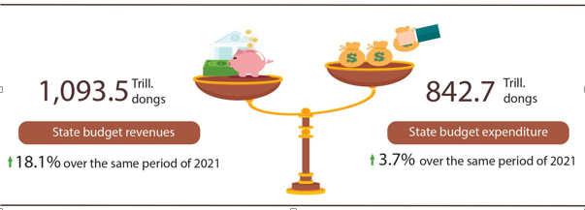
State budget revenue:
Total state budget revenue in July 2022 was estimated at 143.8 trillion VND. Accumulated total state budget revenue in 7 months of 2022 reached 1,093.5 trillion VND, equaling 77.5% of the yearly estimate and increasing by 18.1% over the same period last year. Some of the main revenues are as follows:
- Domestic revenue in July 2022 was estimated at 116.1 trillion VND. Accumulated 7 months of 2022 reached 870.4 trillion VND, equaling 74% of the year estimate and increasing 15% over the same period last year.
- Revenue from crude oil in July 2022 was estimated at 7 trillion VND; accumulated 7 months of 2022 reached 43 trillion VND, equaling 152.5 % of the year estimate and increasing 91.6% over the same period last year.
- Balanced budget revenue from import and export activities in July 2022 was estimated at 20.6 trillion VND; accumulated 7 months of 2022 reached 179.8 trillion VND, equaling 90.3 % of the yearly estimate and increasing by 23.6% over the same period last year.
State budget expenditure:
Total state budget expenditure in July 2022 was estimated at 131.3 trillion VND; accumulated 7 months of 2022 was estimated at 842.7 trillion VND, equaling 47.2% of the yearly estimate and increasing by 3.7 % over the same period last year. Of which, regular expenditures in 7 months in 2022 reached 594.8 trillion VND, equaling 53.5% of the yearly estimate and increasing by 3.9% over the same period last year; development investment expenditure reached 186.8 trillion VND, equaling 35.5% and increasing by 10.3%; debt payment interest was 59.5 trillion VND, equaling 57.4% and down 11.3%.
6. Trade, prices, transport and tourism
a) Retail sales of consumer goods and services
Trade and service activities in July were vibrant, recovering quickly in all industries, especially accommodation, catering, and travel services. Total retail sales of consumer goods and services in July increased by 2.4% over the previous month and by 42.6% over the same period last year. In which accommodation services are 2.3 times higher than the same period last year, catering and travel services are 35.5 times higher. In 7 months of 2022, the total retail sales of consumer goods and services increased by 16% over the same period last year.
Total retail sales of consumer goods and services in July 2022 were estimated at 486 trillion VND, up 2.4% from the previous month and up 42.6% over the same period last year, achieving a larger scale and growth rate compared to the same period in the years before the Covid-19 epidemic. Generally, in 7 months of 2022, the total retail sales of consumer goods and services were estimated at 3,205.8 trillion VND, up 16% over the same period last year (in the same period in 2021 down 0.3%), if excluding the price factor it was an increase of 11.9% (in the same period in 2021 down 1.8%).
Table 3. Retail sales of consumer goods and services
Trillion VND
 | Estimate  July 2022 | Estimate  7 months  2022 | The growth rate compared to the same period last year (%)
 | Estimate  July 2022 | Estimate  7 months  2022 | July  2022 |  | 7 months  2022
Total | 486.0 | 3,205.8 | 42.6 | 16.0
Retail sale | 381.5 | 2,556.4 | 29.4 | 13.7
Accommodation and catering service | 53.9 | 324.9 | 134.7 | 37.5
Traveling service | 3.2 | 11.9 | 3,450.6 | 166.1
Other services | 47.4 | 312.6 | 107.6 | 13.9

Total retail sales of consumer goods and services in the 7 months of 2022 were higher in scale and are gradually catching up with the growth rate of the same period in the years before the epidemic.

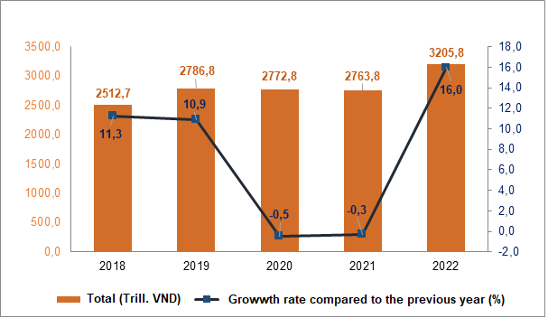
Figure11. Total retail sales of consumer goods and services
in 7 months from 2018-2022

Retail sales of goods in 7 months of 2022 were estimated at 2,556.4 trillion VND, an increase of 13.7% over the same period last year (if excluding the price factor, it was an increase of 9.5%), mainly due to the low revenue of the same period last year nd the increase in the selling price of goods when fuel prices increased. Of which, the group of petroleum products increased by 24.7%; cultural and educational products increased by 21.4%; food and foodstuffs increased by 13.8%; vehicles (Except except for cars) increased by 9.7%; garments up by 9.6%; household appliances, tools, and equipment up 3.7%. Retail sales of goods in 7 months of the year compared with the same period last year in some localities: Khanh Hoa increased by 18.2%; Binh Duong increased by 18.1%; Ho Chi Minh City increased by 16.8%; Can Tho increased by 16.1%; Quang Ninh increased by 15.0%; Hai Phong increased by 11.8%; Hanoi increased by 10.7%; Da Nang increased by 9.7%.
Revenue from accommodation and food services in 7 months of 2022 was estimated at 324.9 trillion VND, up 37.5% over the same period last due to the high demand for entertainment and tourism of the people in the summer after more than 2 years of restricting travel and eating outside the family. (Revenue in July increased by 134.7% over the same period last year). In which, the revenue of some localities was as follows: Ha Noi increased by 80.4%; Can Tho increased by 56.2%; Ho Chi Minh City increased by 38.8%; Da Nang increased by 37.2%; Dong Nai increased by 37%; Binh Duong increased by 25%; Quang Ninh increased by 19.2%; Hai Phong increased 12.6%.
Traveling and tourism revenue in the 7 months of 2022 was estimated at 11.9 trillion VND, 2.7 times higher than the same period last year due to the strong recovery of tourism activities. The revenue in 7 months of some localities was as follows: Khanh Hoa increased by 858.4%; Can Tho increased by 328.3%; Da Nang increased by 284.8%; Ha Noi increased by 216.8%; Ho Chi Minh City increased by 111.4%.
Revenue from other services in 7 months of 2022 was estimated at 312.7 trillion VND, up 13.9% compared to the same period last year (Revenue in July was 2.1 times higher over the same period last year). Specifically, the increase in 7 months compared to the same period last year of some localities was as follows: Da Nang increased by 42.1%; Can Tho increased by 28.4%; Quang Ninh increased by 19.7%; Hai Phong increased by 14.4%; Ha Noi increased by 13.5%; Binh Duong increased 12.7%; Ho Chi Minh City increased by 5.0%.
b) Export and import of goods
In July 2022, the total export and import turnover were estimated at 60.63 billion USD, down 6.8% over the previous month and up 6.1% compared to the same period last year. Generally, in 7 months of 2022, the total export and import turnover of goods reached 431.94 billion USD, up 14.8% over the same period last year, of which exports increased by 16.1%; imports increased by 13.6%. The trade balance of goods in seven months of the year was estimated to have a trade surplus of 764 million USD.
Figure 12. Import and export of goods in 7 months of 2022
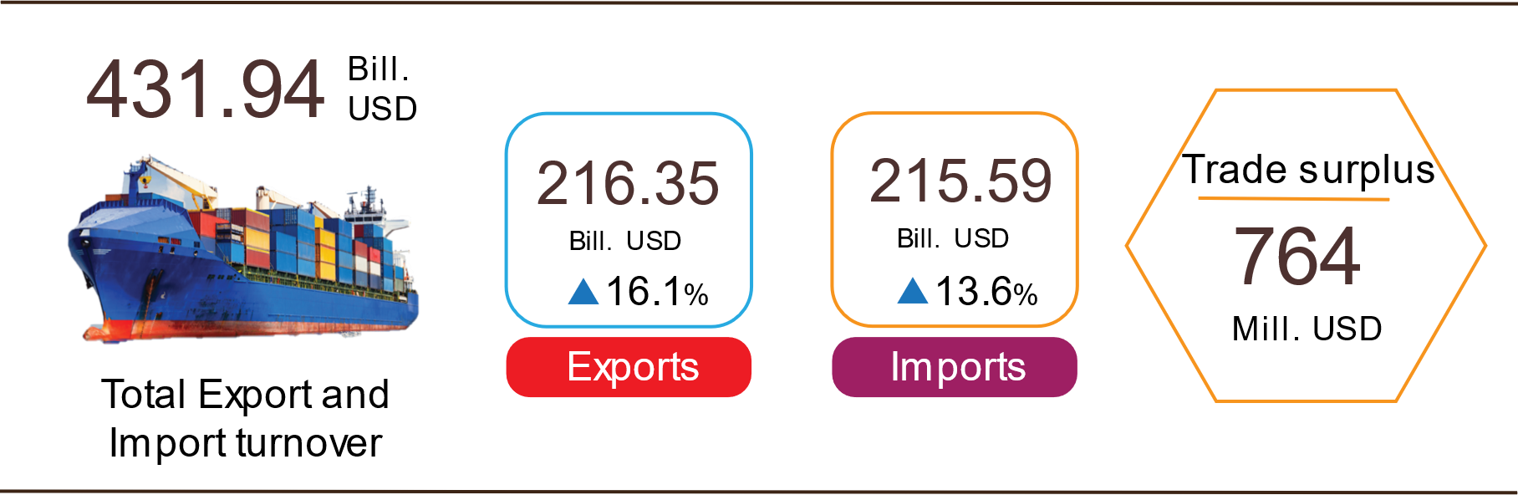

Export of goods
The preliminary export turnover of goods in June 2022 reached 32.84 billion USD, 197 million USD higher than the estimated figure.
Export turnover of goods in July 2022 was estimated at 30.32 billion USD, down 7.7% over the previous month. Of which the domestic economic sector gained 7.93 billion USD, which decreased by 8.5%; the FDI sector (including crude oil) reached 22.39 billion USD, which decreased by 7.4%. Compared to the same period last year, export turnover of goods in July rose by 8.9%, of which the domestic economic sector increased by 3.7%, and the FDI sector (including crude oil) increased by 10.8%.
Generally, in seven months of 2022, the export turnover was estimated at 216.35 billion USD, which rose by 16.1% over the same period in 2021, of which, the domestic economic sector was 56.99 billion USD, went up 17%, accounting for 26.3% of total export turnover; the FDI sector (including crude oil) attained 159.36 billion USD, increased by 15.7%, sharing 73.7%.
In seven months of 2022, there were 30 products with an export turnover of over 1 billion USD, contributing 91.9% to the total export turnover (5 products with export turnover of over 10 billion USD, accounting for 58.5%).
Table 4. Value of some export products in 7 months of 2022
 | Estimate  7 months of 2022  (Mill. USD) | Growth rate of  7 months of 2022 compare to  the same period last year (%)
Items with a value of over 10 billion USD
Phones all of kinds and their parts | 33,671 | 13.1
Electronic goods, computers and their parts | 31,681 | 14.7
Machinery, instrument, accessory | 24,909 | 24.1
Textiles and garments | 22,131 | 19.8
Footwear | 14,096 | 19.6

Regarding the structure of export products in 7 months of 2022, fuel and mineral products accounted for 1.5%, up 0.4 percentage points over the same period last year; processed industrial products accounted for 88.7%, down 0.1 percentage points; agricultural and forestry products accounted for 6.7%, down 0.7 percentage point; aquatic products accounted for 3.1%, up 0.4 percentage points.
Figure 13. Structure of export groups
in 7 months of 2022 by commodity group

Import of goods
Import turnover of goods in June 2022 reached 32.23 billion USD, 138 million USD lower than the estimated figure.
Import turnover in July 2022 was estimated at 30.3 billion USD, decreased by 6% over the previous month, of which the domestic economic sector gained 10.7 billion USD, decreased by 9.4%; the FDI sector reached 19.6 billion USD, decreased by 4%. Compared to the same period in 2021, the import turnover of goods in July increased by 3.4%, of which the domestic economic sector increased by 2.5%; the FDI sector rose by 3.9%.
Generally, in seven months of 2022, the import turnover was estimated at 215.59 billion USD, increased by 13.6% over the same period in 2021, of which the domestic economic sector reached 76.06 billion USD, went up by 13.5%; the FDI sector gained 139.53 billion USD, edged up by 13.7%.
In seven months of 2022, there were 33 imported products with a turnover of over 1 billion USD, accounting for 88.6% of the total import turnover (3 products with import turnover of over 10 billion USD, accounting for 40.8%).

Table 5. Value of some imported goods in 7 months of 2022
 |  | Estimate | Growth rate of
 |  | 7 months of 2022 | 7 months of 2022 compared to
 |  | (Mill. USD) | the same period last year (%)
Items with a value of over 10 billion USD
 | Electronic goods, computers and their parts | 49,905 | 24.7
 | Machinery, instrument, accessory | 26,264 | -3.2
 | Phones all of kinds and their parts | 11,828 | 10.0

Regarding the structure of imported goods in the seven months of 2022, the group of production materials accounted for 94%, up 0.2 percentage points over the same period last year, in which the group of machinery, equipment, tools spare parts accounted for 44%, down 0.8 percentage points; raw materials, fuel, and materials accounted for 50%, up 1 percentage points. The group of consumer products accounted for 6%, down 0.2 percentage points.
Figure 14. Structure of import groups
in 7 months of 2022 by commodity group
Regarding the export and import market of goods in 7 months of 2022, the United States was the largest export market of Viet Nam with an estimated turnover of 67.1 billion USD. China was Viet Nam's largest import market with an estimated turnover of 72.6 billion USD. In 7 months of 2022, the trade surplus to the EU was estimated at 18.7 billion USD, up 41.5% over the same period last year; the trade deficit from China was 42.2 billion USD, up 21.6%; the trade deficit from Korea was 23.5 billion USD, up 30.3%; trade deficit from ASEAN was 7.9 billion USD, down 8.9%; trade deficit from Japan was 769 million USD, down 13.9%.percentage point.

Figure 15. Major commodity import and export markets
in 7 months of 2022
 |  | Exports of goods | Imports of goods

The trade balance of goods in June had a trade surplus of 611 million USD; 6 months had a trade surplus of 743 million USD; July was estimated to have a trade surplus of 21 million USD. Generally, in 7 months of 2022, the trade balance of goods is estimated to have a trade surplus of 764 million USD (in the same period last year, the trade deficit of 3.31 billion USD). In which, the domestic economic sector has a trade deficit of 19.07 billion USD; the FDI sector (including crude oil) had a trade surplus of 19.83 billion USD.
c) Consumer price index, gold price index and US dollar price index
The consumer price index (CPI) in July 2022 increased by 0.4% compared to the previous month; increased by 3.59% compared to December 2021 and increased by 3.14% over the same period last year. Rising pork prices, increased demand for electricity and domestic water due to hot weather, rising prices of essential consumer goods and services in line with input prices, and transportation costs are the main reasons for making the July CPI increase.
On average in the 7 months of 2022, CPI increased by 2.54% over the same period last year; core inflation increased by 1.44%.

Figure 16. CPI growth rates in July and 7 months
In the period of 2018-2022 (%)

In the increase of 0.4% of CPI in July 2022 compared to the previous month, there were 10 groups of goods and services with an increase in price index and 1 group of goods with a decrease in price index.
- Ten groups of goods and services with an increasing price index include:
- Food and foodstuff group increased the most with 1.37% (making the general CPI increase by 0.46 percentage points), in which: Food increased by 0.31% (making the general CPI increased by 0.01 percentage points); food increased by 1.6% (making the general CPI increased 0.34 percentage points); eating out of the family increased by 1.28% (making the general CPI increased by 0.11 percentage points).
- The group of culture, entertainment and tourism increased by 0.79% because the price of domestic tourism services increased by 1.99%; Outbound tourism increased by 0.32% and hotels and guest houses increased by 0.76% when domestic tourism demand increased sharply in the summer. At the same time, the price of cultural equipment in the month increased by 0.06% compared to the previous month; sports services increased by 0.89%, sports equipment increased by 0.11% due to increased demand in the summer.
- Housing and construction materials increased by 0.49% due to the increase in electricity price in July by 1.86% compared to the previous month; the price of domestic water increased by 0.84% ​​due to increased demand in summer; housing repair service prices increased by 1.09%; housing maintenance materials prices increased by 0.63%. In the opposite direction, gas price decreased by 1.54%; kerosene price fell by 1.38% .
- The group of other goods and services increased by 0.43%, mainly focusing on body care products such as lotion, lipstick and perfume, increasing by 0.56%; razors, toothbrushes and sunglasses by 0.23%; personal service increased by 0.88%; hospitality services increased by 0.51%; environmental cleaning services increased by 0.21%.
- Beverage and cigarettes group increased by 0.39% due to increased consumer demand in the summer, at the same time the price of input materials and transportation prices increased.
- Garment, hats and footwear group increased by 0.32% due to the increase in prices of production materials, transportation costs and shopping demand in the summer.
- Household equipment and goods group increased by 0.32%, mainly focusing on items such as: Plastic and rubber products increased by 0.99%; tissue paper increased by 0.46%; metal utensils increased by 0.43%; soaps and detergents by 0.38%; prices of beds, cabinets, tables and chairs increased by 0.28%... In the opposite direction, the price of gas stoves decreased by 0.72% compared to the previous month; electric irons down 0.53%; rice cookers decreased by 0.34%.
- Post and telecommunications group increased by 0.26%.
- Education group increased by 0.20%.
- Medicines and medical services increased by 0.05%.
(2) Group of goods and services with price index decreased: The transportation group decreased by 2.85% (making the overall CPI decrease by 0.28 percentage points) due to the influence of domestic petroleum price adjustments on 1/7/2022, 11/7/2022, and 21/7/2022 make gasoline price decreased by 8.68%; diesel oil price down 4.03%. In the opposite direction, the price of public transport services increased by 2.16% due to the peak tourist season; prices of new motorbikes, bicycles and cars increased by 0.98%, 0.47% and 0.36% respectively due to the lack of supply of components and spare parts mainly from China.
Core inflation in July 2022 increased by 0.58% over the previous month, up 2.63% over the same period last year. On average, in the first 7 months of 2022, core inflation increased by 1.44% over the same period in 2021, lower than the general average CPI (up 2.54%), which reflects the fluctuations in consumer prices mainly due to food prices and gasoline prices.
The domestic gold price fluctuates in the same direction as the world gold price. As of July 25, 2022, the average world gold price was at 1,737.43 USD per ounce, down 5.52% compared to June 2022 due to a stronger dollar and the US Federal Reserve (FED) announced tightening monetary policy. Domestically, the gold price index in July 2022 decreased by 2.39% compared to the previous month; an increase of 6.31% over the same period in 2021; an average increase of 6.58% in 7 months of 2022.
The US dollar in world markets rose after the US Federal Reserve (FED) raised interest rates more strongly than other central banks, with the goal of cooling down inflation. As of July 25, 2022, the US dollar index on the international market reached 106.9 points, up 3.04 points from the previous month. Domestically, the average US dollar price on the free market was around 23,500 VND/USD. The US dollar price index in July 2022 increased by 0.62% over the previous month and by 1.77% over the same period in 2021; an average increase of 0.08% in 7 months of 2022.
d) Transport
Transport activities in July were bustling with positive results in both passengers and freight transport. In which, passengers carried was 3.9 times higher and passengers’ traffic was 5.9 times higher than the same period last year due to the high increase in travel and tourism demand of the people in the summer; freight transportation increased by 79% in freight carried and 64.3% in freight traffic over the same period last year.
Generally, for the seven months of 2022, passenger carried increased by 20.5% over the same period last year, passenger traffic increased by 37.1% and freight carried increased by 16.1%, freight traffic increased by 22, 9%.
Passenger transport in July 2022 was estimated at 368.2 million passengers, an increase of 5.6% compared to the previous month, and 19.2 billion passengers-kilometers, an increase of 7.4%. Generally, in 7 months of 2022, passengers carried an estimated 2,248 million passengers, up 20.5% over the same period last year (decreased by 12% in the same period in 2021) and passenger traffic reached 107.1 billion passengers. km, an increase of 37.1% (in the same period last year, a decrease of 20.1%). In which, domestic transport reached 2,246.9 million passengers, up 20.4% over the same period last year, and 103 billion passengers-kilometers, up 32.2%; Overseas transport recovered positively with 1.1 million passengers, 16.2 times higher than the same period last year and 4.1 billion passengers-kilometers, 16.9 times higher. Although passenger transport has made a positive recovery, it was only equal to 77.5% of carried and 74.6% of traffic compared to the same period in 2019.
Table 6. Carriage of passengers in 7 months of 2022
by types of transport
 | Number of passengers |  | The growth rate compared to the same period last year (%)
 | Carried  (Mill. passengers) | Traffic  (Bill. passengers-km) | Carried | Traffic
Total | 2,248.0 | 107.1 | 20.5 | 37.1
Railway | 2.4 | 0.9 | 99.7 | 81.3
Seaway | 5.3 | 0.3 | 42.8 | 56.6
Inland waterway | 155.0 | 2.9 | 28.0 | 31.7
Road | 2,058.8 | 73.5 | 19.2 | 16.5
Airway | 26.5 | 29.5 | 98.5 | 143.0

Freight transport in July 2022 was estimated at 172.3 million tons of freight carried, up 2.5% over the previous month and 37.7 billion tons-km, up 1.2%. Generally, in 7 months of 2022, freight transport is estimated at 1.129 million tons of freight carried, up 16.1% over the same period last year (in the same period in 2021, increasing by 1.5%) and 240 billion tons. km of freight traffic, an increase of 22.9% (in the same period last year, an increase of 4.1%). In which, domestic transport reached 1,104.2 million tons of freight carried, up 16.2%, and 142.2 billion tons-kilometers of freight traffic, up 32.5%; Overseas transport reached 24.8 million tons freight carried, up 13.3%, and 97.8 billion tons-kilometers of freight traffic, up 11.3%. Enterprises went into stable operation, imports and export continued to prosper, so the demand for domestic and foreign freight transportation in the first seven months of 2022 increased sharply compared to the same period last year.
Table 7. Carriage of freight in 7 months of 2022
by types of transport
 | Quantity of goods |  | The growth rate compared to the same period last year (%)
 | Carried  (Mill. tons) | Traffic  (Bill. tons-km) | Carried | Traffic
Total | 1,129.0 | 240.0 | 16.1 | 22.9
Railway | 3.4 | 2.7 | 4.7 | 22.5
Seaway | 59.6 | 129.9 | 23.3 | 32.0
Inland waterway | 212.2 | 47.1 | 14.1 | 15.2
Road | 853.6 | 57.1 | 16.2 | 11.0
Airway | 0.2 | 3.2 | 8.6 | 41.2

d) International visitors to Viet Nam
International visitors to our country in July were estimated at 352.6 thousand arrivals, increased 49% compared to the previous month and 47.2 times higher than the same period last year because Viet Nam has opened up to tourism, international routes have been restored. Generally, in 7 months of 2022, international visitors to Viet Nam were estimated at 954.6 thousand arrivals, 10 times higher than the same period last year but still down 90.3% compared to the same period in 2019.
Out of a total of nearly 954.6 thousand international visitors to Viet Nam in 7 months of the year, visitors coming by airway gained 831 thousand persons, accounting for 87.1% of the number of international visitors to Viet Nam, 13.5 times higher than the same period last year; by roadway achieved 123.3 thousand arrivals, accounted for 12.9% and 3.6 times higher; by seaway achieved 257 arrivals, accounted for 0.03% and increased by 8.9%.
Figure 17. International visitors to Viet Nam
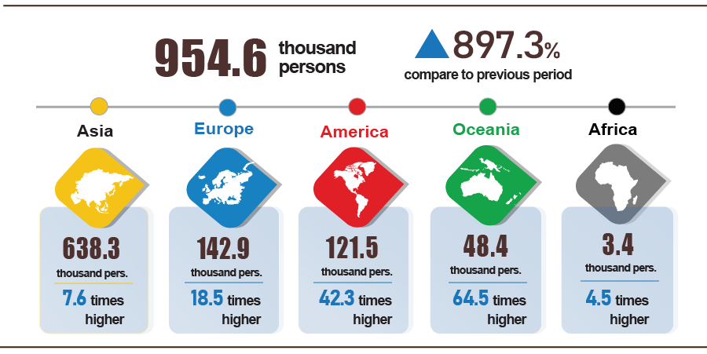
in 7 months of 2022 by territories

7. Some social issues
a) Residential life and social security
According to preliminary results from the Household Living Standard Survey in the first seven months of 2022, the living situation of households has improved. The percentage of households assessed that their income in the month remained unchanged and increased compared to the same period in 2021 was 81.6%; the percentage of households with income reduced compared to the same period in 2021 was 18.4%. Among the reasons for the decrease in household income, 78.4% of households rated it due to the impact of the Covid-19 pandemic; 18.5% of households rated it because members of the household lost their jobs/temporarily quit their jobs, and 15.5% of households assessed it because input costs for household products and business activities increased. Regarding the impact of negative events on life in the 7 months of 2022, 66.4% of households are suffering from negative impacts of the Covid-19 pandemic; 2.3% of households are negatively affected by diseases on livestock and crops, and 1.9% of households are affected by other diseases.
In 7 months of 2022, 26.2% of households received help from different sources of support. Specifically, the percentage of households receiving assistance from general national programs and policies was 11.5%; from relatives was 12.2%; from local programs and policies was 10.2%; from charitable activities of other organizations and individuals was 5.9% and from other sources was nearly 0.2%.
According to a report by the Ministry of Labor and Social Affairs, as of July 22, 2022, the support package under Resolution 11/NQ-CP has disbursed about 196.7 billion VND to support 344,070 employees at 3,936 enterprises. Specifically, support 191.6 billion VND for 339,117 employees working in 3,341 employers; support 5.1 billion VND for 4,953 workers returning to the labor market at 595 enterprises. In July 2022, to support rice for people who lost their crops, on July 9, 2022, the Prime Minister issued Decision No. 806/QD-TTg on the issuance of rice from the national reserve of 432.8 tons to Binh Phuoc province to support people due to crop failure.
b) Epidemic diseases and food poisoning
According to the report of the Ministry of Health, in the month (June 19 to July 18, 2022), the whole country had 49,807 cases of dengue fever (08 deaths); 14,933 cases of hand, foot, and mouth disease (01 death); 29 cases of viral encephalitis; 01 case of meningococcal meningitis; 43 cases of typhus suspected measles. In the first 7 months of 2022, the whole country has 103,433 cases of dengue fever (37 deaths); 36,792 cases of hand, foot, and mouth disease (02 deaths); 139 cases of viral encephalitis (03 deaths); 09 cases of meningococcal disease; 118 cases of typhus suspected measles.
Around the world, the European region has faced a new wave of Covid-19, increasing the number of cases and hospitalizations. In Vietnam, the Covid-19 epidemic situation has complicated new developments, increasing the number of cases, including many new cases of BA.4, BA.5. From the first case of Covid-19 in Vietnam on January 23, 2020, to July 28, 2022, Vietnam has 10,773 thousand cases, of which 9,881.6 thousand cured and 43 thousand cases of deaths.
The rate of vaccination against Covid-19 for children aged 5-11 years old, 3 doses for children aged 12-17 years old, and 3 doses, 4 doses for people over 18 years old was still low. From March 8, 2021, to July 21, 2022, the total number of doses of Covid-19 vaccine administered was 241,480.8 thousand doses, of which the first injection was 87,717.3 thousand doses; the second injection was 81,040.6 thousand doses; injection 3 was 1,515.1 thousand doses; the additional dose was 14,048.8 thousand doses; 1st booster dose was 49,571.2 thousand doses; the second booster dose was 7,587.8 thousand doses.
The total number of people living with HIV in the country as of July 18, 2022, was 217,704 people and the number of people who have died from HIV/AIDS in the whole country up to this point was 111,796 people.
Regarding food poisoning, in July 2022, there were 13 cases with 85 people poisoned. Generally, in the 7 months of 2022, there were 27 cases of poisoning in the whole country with 357 people poisoned (02 people died).
c) Traffic accident
In July (from June 15 to July 14, 2022), there were 833 traffic accidents in the whole country, including 585 traffic accidents from less serious or more and 248 traffic collisions, causing 471 deaths, and 320 injuries, and 246 minor injuries. Compared to the previous month, the number of traffic accidents decreased by 12.4% (the number of traffic accidents from less serious and more decreased by 8.2%, and the number of traffic collisions decreased by 21%) the number of deaths decreased by 10 .3%; the number of injured people increased by 4.2%, and the number of minor injuries decreased by 20.9%. Compared to the same period last year, the number of traffic accidents in July increased by 5.2% (the number of traffic accidents from less serious and more increased by 10.2%, and the number of traffic collisions decreased by 5%); the number of deaths increased by 8.3%; the number of injured people increased by 17.2% and the number of minor injuries increased by 4.2%.
Generally, in the seven months of this year, there were 6,536 traffic accidents nationwide, including 4,578 traffic accidents of less serious or more and 1,958 traffic collisions, killing 3,785 people, 2,284 people injured, and 1,972 people with minor injuries. Compared to the same period last year, the number of traffic accidents in the 7 months of this year decreased by 8.4% (the number of traffic accidents from less serious or more increased by 0.2%; the number of traffic collisions decreased by 23 .9%); the number of deaths increased by 4.1%; the number of injured people decreased by 3.3% and the number of minor injuries decreased by 24.8%. On average, in 7 months, there are 31 traffic accidents per day in the whole country, including 22 traffic accidents of less serious or more and 9 traffic collisions, causing 19 deaths, 11 injured and 9 people slightly injured.
d) Damage caused by natural disasters
Damage caused by natural disasters in July was mainly caused by heavy rains, floods, and landslides, causing 21 deaths and missing, 17 injured; 3.9 thousand houses collapsed, washed away, and damaged; 5 thousand ha of paddy and 762.1 ha of crops were damaged; total value of property damage caused by natural disasters in the month was 167.4 billion VND, down 36.4% over the same period last year. Generally, for the 7 months of this year, natural disasters made 97 people dead and missing, 68 people injured; 12.1 thousand houses collapsed and were damaged; 164.2 thousand hectares of paddy and 32.5 thousand hectares of crops were damaged; the total value of property damage was estimated at 5,624.5 billion VND, 7.3 times higher than the same period in 2021.
đ) Environmental protection and fire, explosion prevention
In July 2022, the authorities detected 1,594 cases of environmental violations, of which 1,615 cases were handled with a total fine of 21.3 billion VND, down 23.4% from the previous month and down 37. 6% over the same period last year. Generally, in the 7 months of this year, 13,079 cases of environmental violations were detected, of which 11,319 cases were handled with a total fine of 151.8 billion VND, down 3.6% over the same period last year.
In the month, the whole country had 154 fires and explosions, killing 6 people and injuring 3 people, with estimated damage of 77.1 billion VND, down 75.3% compared to the previous month and 2.6 times higher than the same period last year. Generally, in the seven months of this year, 1,010 fires and explosions occurred nationwide, killing 55 people and injuring 55 people, causing estimated damage of 491.9 billion VND, an increase of 54.5% over the same period last year./.

GENERAL STATISTICS OFFICE

The growth rate of the total poultry at the end of July of the following years: reached 5.4% in 2018; 7.9% in 2019; 5.3% in 2020 and 7.3% in 2021.
According to the Ministry of Agriculture and Rural Development, from June 16, 2022, to July 15, 2022.
As of mid-July, the price of pangasius 0.8-1.0 kg/fish fluctuated between 27,000-28,500 VND/kg, down 2,000-3,000 VND compared to the previous month, up 5,000-7,000 VND/kg compared to the same period last year and increased by about 20% compared to the end of 2021. Source: http://www.agromonitor.vn/group/48/280/giam-sat-gia.
The growth rate of the industrial production index in the seven months of 2018-2022 compared to the same period last year were respectively 10.7%, 9.4%; 2.6%; 7.6%; 8.8%.
The growth rate of the IIP index in July 2022 compared with the previous month of some large-scale industrial localities were: Thai Nguyen increased by 9.6%; Quang Ninh and Hai Phong both increased by 7.8%; Bac Ninh increased by 6.7%; Binh Duong increased by 4.7%; Long An increased by 3.6%; Hai Duong increased by 2.7%; Ho Chi Minh City increased by 0.9%; Vinh Long down 2.5%; Vinh Phuc down 5.1%.
The localities with high production index of the processing and manufacturing industry in the first 7 months of 2022 compared to the same period last year are: Bac Giang with an increase of 53.4%; Ha Giang increased by 27.7%; Binh Phuoc increased by 25%; Khanh Hoa increased by 23.2%; Quang Nam increased by 21.7%; Son La increased by 15.7%; Dak Lak increased 14.5%. Localities with high index of electricity production and distribution: Dien Bien up 59.8%; Cao Bang increased by 57.2%; Lai Chau increased by 56.3% due to increased hydroelectricity .
Localities with low increase in the production index of the processing and manufacturing industry in the first 7 months of 2022 compared to the same period last year are: Binh Dinh up 6.5%; Bac Kan increased by 4.5%; Quang Ngai increased by 4.9%; Da Nang increased by 4.1%; Ninh Binh increased by 2.6%. Localities with low or low increase or decrease in the index of electricity production and distribution industry in the first 7 months of 2022 compared to the same period last year: Ninh Thuan increased by 5.9% (due to a decrease in solar power); Binh Thuan down 1.8%; Ha Tinh decreased by 38.3%; Tra Vinh fell by 39.5% due to the decrease in thermal power. Localities where the mining industry decreased: Ba Ria - Vung Tau decreased by 0.6% (the output of oil and gas decreased); Ninh Thuan decreased by 7.3% (sand mining decreased).
Source: National Enterprise Registration Information System, Business Registration Management Agency, Ministry of Planning and Investment (Received the report on 26th July 2022) .
According to the Report of the Foreign Investment Department, Ministry of Planning and Investment, received on July 22, 2022
Newly granted overseas investment capital in 7 months of 2022 increased sharply compared to the same period last year because there were 5 major projects newly granted investment certificates, namely the project of Vines Energy Solutions Joint Stock Company to the US, Canada, France, Germany, Netherlands with total investment capital of each project is over 34.7 million USD.
Adjusted investment capital decreased sharply in 7 months, 2022 because in 7 months in 2021 there were many large projects adjusted to increase capital: Vingroup's project in the US was adjusted to increase by 300 million USD; Indochina Rubber Investment and Development Co., Ltd. project in Cambodia increased by 76 million USD and 1 project of Vinfast in Germany increased by 32 million USD.
According to the report on the implementation of the State Budget for the 7 months of 2022 of the Ministry of Finance.
Total retail sales of consumer goods and services in 7/2018 reached 369 trillion VND, up 12.2% over the same period last year; in 7/2019 reached 411.4 trillion VND, up 11.5%.
The total retail sales of consumer goods and services in 7 months of 2022 increased by 15% over the same period in 2019.
July 2021 was the time of strong outbreak of the fourth wave of Covid-19 epidemic in Ho Chi Minh City and southern provinces, so retail sales of goods at current prices in the 7 months of 2021 only increased by 2.2 % over the same period last year (if excluding the price factor, it increased by 0.6%).
Estimated total export and import value in July 2022 provided by the General Department of Customs on July 27, 2022. The General Statistics Office estimated the import and export value of key commodities in July 2022 based on preliminary data provided by the General Department of Customs by July 25, 2022.
Total import and export turnover of goods in 7 months of 2021 reached 376.15 billion USD, up 31.2% over the same period last year, of which export reached 186.42 billion USD, up 26.2%; imports reached 189.73 billion USD, up 36.5%.
Estimated trade surplus in June was 276 million USD.
The price index of rice group increased by 0.24% (Delicious rice decreased by 0.14%; ordinary rice increased by 0.34%) according to the high price of export rice and the price of fertilizer and input materials for production at high levels. . In addition, the increase in input material prices and transportation costs affected the prices of other processed food products (Bread increased by 0.96%; instant noodles, noodles, pho, and instant porridge increased by 0.9%; wheat flour up 0.67%; vermicelli 0.45%; instant cereals up 0.43%).
Pork price increased by 4.29%, making the overall CPI increase by 0.15 percentage points (Price of processed meat increased by 1.73% compared to the previous month, of which roast meat, spring rolls increased by 1.81%; canned meat increased by 1.02%; other processed meat increased by 0.49%); The price of animal feed and transportation increased, causing the price of poultry meat to increase by 1.92% (Chicken price increased by 1.75%; other poultry meat increased by 2.61%; frozen poultry meat increased by 0.02 %); price of fresh seafood increased by 0.69% (Price of fish increased by 0.89%; price of other fresh seafood increased by 0.74%); the price of cooking oil and other fats continued to increase by 2.11% (Price of fish sauce and dipping sauce increased by 0.59% over the previous month; sugar and honey increased by 0.98%; milk, butter, cheese increased by 0. 57%; cakes, jams and candies by 0.62%; tea, coffee, cocoa by 0.22%); price of fresh, dried and processed vegetables increased by 1.79% (Price of tomatoes increased by 16.31%; spice vegetables increased by 3.81%; kohlrabi increased by 3.57%; fresh fruit and vegetables increased by 1.35%; potatoes western vegetables by 1.22%; cabbage by 0.85%; frozen vegetables by 0.18%).
Prices of processed materials are high and July is the peak tourist month. In which, the price index for meals outside the family increased by 1.37% compared to the previous month; Out-of-home drinks increased by 0.66% and fast food take away increased by 1.24%.
The domestic electricity price index in July 2022 is calculated based on the revenue and consumption of electricity from the date June 1-30, 2022, thus reflecting movements one month late compared to other commodities.
Wall painting, bricklaying, wall construction and unskilled labor increased from 10% to 20% when the regional minimum wage increased from July 1, 2022, and construction demand increased.
From July 1, 2022, the domestic gas price is adjusted down by 7,000 VND/bottle of 12 kg after the world gas price decreased by 25 USD/ton (from 750 USD/ton to 725 USD/ton).
Effects of price adjustments on July 1, 2022, July 11, 2022, and July 21, 2022.
The price of mineral water increased by 0.58% compared to the previous month; carbonated beverage prices increased by 0.57%; juice increased by 0.76%; bottled energy drinks increased by 0.45%; alcohol increased by 0.42% and smoking increased by 0.24%.
The price of ready-made clothes increased by 0.37%; hats increased by 0.26%; footwear by 0.19%; garment services increased by 0.28%.
The price of passenger transport by air increased by 2.64%; road increased by 2.73%; taxi increased by 1.22%; railway by 0.32%; bus increased by 2.29%.
CPI after excluding food, fresh food, energy and goods managed by the State including health services and education.
According to the report of the Border Gate Department, the Border Guard Command, the Ministry of National Defense and the Immigration Department.
The reporting period is from June 21, 2022 to July 20, 2022.
According to a quick report from the Office of the Ministry of Public Security and the Vietnam Maritime Administration (Ministry of Transport) from June 15 to July 14, 2022.
Summary of reports from 63 Departments of Agriculture and Rural Development, from June 19 to July 18, 2022.
According to a quick report from the Ministry of Public Security on July 23, 2022.

