MINISTRY OF PLANNING AND INVESTMENT  GENERAL STATISTICS OFFICE  No: 268/BC-TCTK | SOCIALIST REPUBLIC OF VIET NAM  Independence-Freedom-Happiness  Ha Noi, 28th October, 2022

Socio-economic situation in October and ten months of 2022

1. Agriculture, forestry and fishery
Agricultural production in the month focused on tending and harvesting winter and winter-autumn paddy in the country and planting winter crops in the North. Livestock production developed stably; logging activities were actively implemented. Aquaculture has developed quite well due to the increase in demand and export prices of key aquatic products such as pangasius and shrimp; however, marine fishing faces difficulties due to unfavorable weather for offshore fishing.
a) Agriculture
Winter paddy
In the winter rice crop in 2022, the whole country planted 1,557 thousand hectares, equaling 99.9% of the previous year's crop, of which: Northern localities reached 1,023.2 thousand hectares, equaling 98.2%; the southern localities reached 533.8 thousand hectares, equaling 103.2%.
As of mid-October, the whole country harvested 893.1 thousand hectares of winter paddy, accounting for 57.4% of the cultivated area and equaling 87.9% of the same period last year, of which: Northern localities harvested 614.1 thousand hectares, accounting for 60% and 79.6%; Southern localities harvested 279 thousand ha, accounting for 52.3% and equaling 114.3 %. The progress of this year's winter rice harvest in the Northern provinces was slower than the same period last year due to the impact of La Nina phenomenon - cooler weather prolongs the growth period of winter-spring rice crops so affect the progress of sowing and harvesting of winter rice. It was estimated yield of winter rice reached 52.66 quintals/ha, an increase of 1 quintal/ha compared to the 2021 crop; outputs reached 8.2 million tons, up 144 thousand tons.

Summer-autumn paddy
Along with taking care of and harvesting winter rice, localities across the country completed summer-autumn paddy production with a planted area of ​​1,915.6 thousand hectares, down 38.6 thousand hectares compared to the summer-autumn crop in 2021. Cultivated area for summer-autumn crop this year decreased due to high input costs, so famer reduced sowing area to convert inefficient, low-yielding rice land to fruit trees, grass, other crops or aquaculture for higher economic efficiency. According to preliminary reports, the summer-autumn rice yield reached 56.4 quintals/ha, down 0.6 quintals/ha compared to the summer-autumn crop last year output reached 10.8 million tons, down 340 thousand tons. Particularly in the Mekong River Delta, the cultivated area reached 1,476.1 thousand hectares, a decrease of 32.9 thousand hectares compared to the summer-autumn crop in 2021; yield reached 56.5 quintals/ha, down 1.4 quintals/ha; output reached 8.34 million tons, down 314 thousand tons.
Autumn-winter paddy
As of mid-October, localities in the Mekong River Delta cultivated 637.5 thousand hectares of autumn-winter paddy, equal to 90.7% of the same period last year. So far, the region harvested 279.2 thousand hectares of winter-autumn paddy, made up 43.8% of the total cultivated area and equaled to 95.7% in comparison with that of over the same period last year. The remaining paddy area at present is mainly in the green to the ripe stage, growing and developing quite well.
Other annual crops
The progress of winter crop planting in the northern provinces is lower than the same period last year due to unfavorable weather, made some areas were inundation along with economic efficiency from maize, sweet potato, and peanut crops was no high, so farmers reduce production.

Figure 1. Cultivation of main annual crops
(As of mid-October, 2022)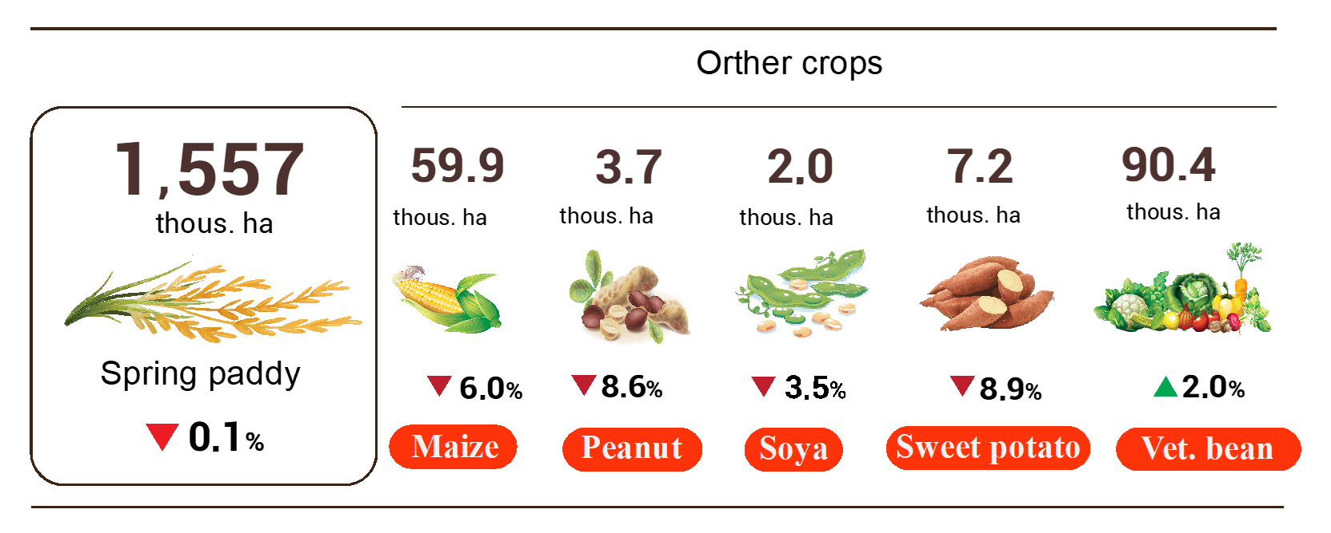
Livestock
Cattle and buffalo husbandry has developed stably, ependemic was gradually controlled. Currently, farmers have begun to focus on re-herding, creating a supply of meat for the market in the last months of the year and the upcoming holidays. In order to stabilize the domestic meat production and consumption market, it was necessary to implement drastic and simultaneous measures and policies against speculation and price manipulation, ensuring the interests of farmers and consumers.
Figure 2. The growth rate of the population of livestock
at the end of October 2022 compared to the same time last year
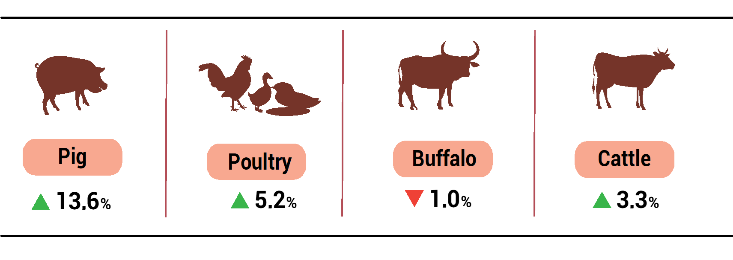
As of October 24, 2022, the whole country has no longer blue-ear disease; avian flu remained in Nghe An; foot-and-mouth disease was still Ha Tinh, Gia Lai; LSD was still in Quang Ngai, Dak Lak, Tien Giang, Ben Tre and African swine fever was reported in 18 localities for less than 21 days.
b) Forestry
The area of ​​newly concentrated planted forests in October 2022 was estimated at 33.3 thousand hectares, up 5.3% over the same period last year; the number of scattered forest trees reached 7.8 million trees, up 2%; firewood production was estimated at 1.5 million steres, up 0.7%; timber production reached 1,876.3 thousand m³, an increase of 6%. Timber production increased sharply compared to the same period last year due to the significant increase in processing and export of wood products, an increase in demand for raw materials for processing factories, and a high price of acacia wood compared to the same period last year. Some localities have high timber production in the month compared to the same period last year, such as Quang Tri up 64.9%; Thanh Hoa an increase of 16.6%; Nghe An up 13.5%.
In the 10 months of 2022, the area of ​​newly concentrated planted forest was estimated at 227 thousand ha, up 5.4% over the same period last year; the number of scattered forest trees was estimated at 78.3 million trees, up 5%; timber production was estimated at 15.4 mill. ste, up 0.3%; firewood production was estimated at 15.6 mill. m³, up 6.2%.
Forest protection was seriously implemented by the forest ranger, along with, localities have well implemented propaganda and awareness raising, so the area of damaged forest in October and 10 months of 2022 was greatly reduced compared to the same period in 2021. The damaged forest area in the month was 88.7 hectares, down 28% over the same period last year, in which mainly the forest was destroyed with 88.2 hectares, down 0,8%; the burned forest area was 0.5 hectares, down 98.6%. In the 10 months of 2022, the damaged forest area was 989.4 hectares, down 59.2% over the same period last year, including the burned forest area was 26.5 hectares, down 98.2%; the destroyed forest area was 963 ha, down 0.2%.
c) Fishery
Fishery output in October was estimated at 815.9 thousand tons, up 2.5% over the same period last year, including fish reached 583.5 thousand tons, up 2.4%; shrimp reached 123.2 thousand tons, up 3.7%; other aquatic products reached 109.2 thousand tons, up 2.1%.
It was estimated that in month, aquaculture output reached 517.5 thousand tons, up 4.5% over the same period last year, of which fish reached 352.8 thousand tons, up 4.4%; shrimp reached 109.6 thousand tons, up 4.3%.
The output of pangasius in the month continued to increase compared to the same period last year because pangasius was an advantageous commodity that was suitable for the spending ability of consumers around the world in the case high inflation. The price of pangasius was stable to help farmers make a profit. Pangasius production in the month was estimated at 168.2 thousand tons, up 7.2% over the same period last year.
The price of farmed shrimp has been high and maintained at a stable level since the first months of 2022, along with the development of high-tech intensive shrimp farming models, and super-intensive shrimp farming to increase farmed shrimp production. Vannamei shrimp production in October was estimated at 75.9 thousand tons, up 5.4% over the same period last year; black tiger shrimp production reached 25.3 thousand tons, up 0.8%.
The caught fishery output in the month was estimated at 298.4 thousand tons, down 0.6% over the same period last year including: Fish production reached 230.7 thousand tons, down 0.6%; shrimp reached 13.6 thousand tons, down 0.7%; other aquatic products reached 54.1 thousand tons, down 0.9%. Marine fishing output in October was estimated at 279.9 thousand tons, down 0.7% over the same period last year due to unfavorable weather for offshore fishing.

Figure 3. Fishery production in 10 months of 2022
over the same period last year

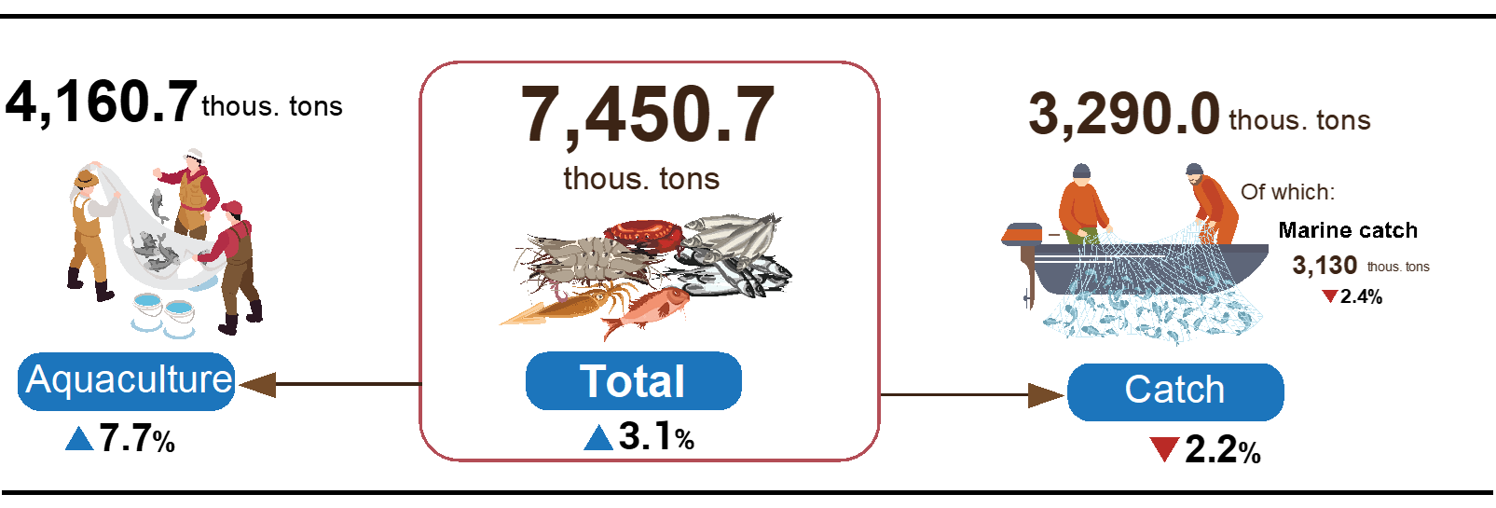
Generally, in the 10 months of 2022, fishery output was estimated at 7,450.7 thousand tons, up 3.1% over the same period last year, including fish reached 5,366.7 thousand tons, up 2.6%; shrimp reached 1,009.8 thousand tons, up 8.2%; other fishery products reached 1,074.2 thousand tons, up 1.2%.
2. Industrial production
Industrial production in October August continued the trend of rapid recovery, estimated to increase by 3% over the previous month and by 6.3% over the same period last year as businesses were more proactive in terms of labor and production and business plans to overcome difficulties to recover and expand production. In the 10 months of 2022, the production index of the whole industry was estimated to increase by 9% over the same period last year .
The index of industrial production (IIP) in October was estimated to increase by 3% over the previous month and up 6.3% over the same period last year. Of which, compared to the same period last year, the manufacturing increased by 5.7%; mining and quarrying increased by 6.3%; Electricity, gas, steam and air conditioning supply by 10.5%; Water supply; sewerage, waste management and remediation activities up 15.7%.
In general, in the 10 months of 2022 IIP was estimated to increase by 9% over the same period last year (in the same period in 2021 by 3.8%). Of which, the manufacturing increased by 9.6% (the same period in 2021 by 5.1%), contributing 7.4 percentage points to the overall growth; Electricity, gas, steam and air conditioning supply by 7.8%, contributing 0.7 percentage points; Water supply; sewerage, waste management and remediation activities increased by 6.6%, contributing 0.1 percentage points; the mining and quarrying increased by 5%, contributing 0.8 percentage points to the overall growth rate.
Production index for 10 months in 2022 of some 2 digit key industries increased sharply compared to the same period last year: Manufacture of beverage (31.5%); Manufacture of wearing apparel (19.2%); manufacture of leather and related products increased by (17.7%); Manufacture of pharmaceuticals, medicinal chemical and botanical products (17.5%); Manufacture of wood and of products of wood and cork (17.3%); Manufacture of machinery and equipment n.e.c (16.3%); Manufacture of electrical equipment (12.8%); Manufacture of other transport equipment (11%); manufature of paper and paper products (10.8%); Waste collection, treatment and disposal activities; materials recovery (10.2%); Manufacture of food products (9.7%). In the opposite direction, the IIP index of some industries decreased: Manufacture of basic metals (-1.5%); Manufacture of rubber and plastics products (-5.4%).

Table 1. Growth rate of IIP index in the 10 months in the years of 2018-2022
compared to the same period last year of some key industries
%
 | 2018 | 2019 | 2020 | 2021 | 2022
Manufacture of beverages | 8.0 | 10.7 | -5.9 | -4.3 | 31.5
Manufacture of wearing apparel | 11.4 | 8.3 | -5.3 | 5.5 | 19.2
Manufacture of leather and related products | 10.5 | 9.3 | -2.8 | 4.1 | 17.7
Manufacture of pharmaceuticals, medicinal chemical and botanical products | 21.2 | -3.4 | 30.8 | -19.3 | 17.5
Manufacture of wood and of products of wood and cork | 3.1 | 9.1 | -6.8 | 4.1 | 17.3
Manufacture of machinery and equipment n.e.c | 2.8 | 11.2 | 0.0 | 2.4 | 16.3
Manufacture of electrical equipment | 7.0 | 10.1 | 1.5 | -1.7 | 12.8
Manufacture of other transport equipment | 6.0 | -6.3 | -9.9 | -3.2 | 11.0
Manufacture of paper and paper products | 13.3 | 11.4 | 7.3 | 3.0 | 10.8
Waste collection, treatment and disposal activities; materials recovery | 3.6 | 6.4 | 4.5 | 5.0 | 10.2
Manufacture of food products | 7.8 | 9.2 | 4.3 | 0.7 | 9.7
Manufacture of basic metals | 22.0 | 34.3 | 10.9 | 25.1 | -1.5
Manufacture of rubber and plastics products | 3.0 | 14.3 | 4.3 | -2.0 | -5.4

Industrial production index for 10 months in 2022 compared with the same period last year increased in 61 localities and decreased in 02 localities across the country. Some localities with IIP index achieved a relatively high increase due to the manufacturing; electricity production and distribution increased. On the other hand, some localities have low or decrease IIP index because the manufacturing has not regained the high growth momentum as before the pandemic; Mining and quarrying and electricity production and distribution increase slowly or decrease.

Figure 4. Growth rate of 10 - month IIP of 2022
compared to the same period last year in some localities

Some key industrial products in the 10 months of 2022 highly increase compared to the same period last year : Beer (34.7%); Processed fishery products (19.1%); phone accessories (16.5%); automobiles (16.4%); Steel bars and corners (15.2%); chemical paint (11.1%); Clothes (10.7%). In the opposite direction, a number of products decreased compared to the same period last year: Extracted crude oil (-1.2%); television (-1.4%); liquefied gas (LPG) (-1.5%); Textile fabric from polyester or artificial yarn (-2.3%); aquatic feed (-3.8%); mobile phones
(-5.1%); N.P.K mixed fertilizer (-5.9%); Crude steel, iron (-15.3%).
The number of employees working in industrial enterprises as of October 1st, 2022 increased by 0.8% over the same period last month and by 10.2% over the same period last year. Of which, Labor in State-owned enterprises increased by 0.1% and decreased by 6.9%; non-state enterprises increased by 0.5% and 4.8%; foreign-invested enterprises increased by 1.1% and by 13.2%. By industry, the number of employees working in mining and quarrying increased by 0.1% over the same period last month and went up by 0.5% over the same period last year; manufacturing rose by 0.9% and by 10.9%; Electricity, gas, steam and air conditioning supply remained unchanged and increased by 1%; Water supply; sewerage, waste management and remediation activities increased by 0.1% and increased by 3.6%.

3. Business registration status
Production and business activities continued to recover in October, especially the service sector, which is forecasted to be more active in the last months of the year, so the number of newly registered businesses in the trade and service sector increased. There were more than 13,000 newly established enterprises in October 2022, up 58.3% over the same period last year. In ten months of 2022, the total number of new and re-open registered enterprises reached 178.5 thousand enterprises, an increase of 38.3% over the same period last year, of which the number of newly established enterprises increased by 34.3% and the number of businesses returning to operation increased by 49%.
In October 2022, the whole country had more than 13 thousand newly established enterprises with registered capital were 106.9 trillion VND and a total number of registered employees of 76.9 thousand employees, an increase of 13.6% in the number of enterprises, a decrease of 21.4% in the registered capital and an increase of 24.1% in the number of employees compared to last month; up 58.3% in the number of enterprises, a decrease of 1.5% in the registered capital and up 30.7% in the number of employees compared to the same period last year. The average registered capital of a newly established enterprise in the month reached 8.2 billion VND, down 30.8% compared to last month, and a decrease of 37.8% compared to the same period last year. In October, there were 3.9 thousand re-operated enterprises in the whole country, which decreased by 23.7% compared to the previous month and down 9.3% compared to the same period last year.
Generally, in the 10 months of this year, the whole country had 125.8 thousand newly registered enterprises with a total registered capital of 1,379.2 trillion VND and a total number of 835 thousand registered employees, up 34.3% in the number of enterprises, an increase of 5.7% in number the registered capital and 18% increase in the number of employees compared to the same period last year. The average registered capital of a newly established enterprise in 10 months achieved 11 billion VND, down 21.2% compared to the same period last year. If including 2,794.1 trillion VND of the additionally registered capital of nearly 42.6 thousand enterprises that recorded an upward adjustment of capital, the total additional registered capital in the economy in 10 months of this year was 4,173.3 trillion VND, up 31.1% compared to the same period last year. Besides, there were 52.7 thousand re-operated enterprises, an increase of 49% over the same period last year, bringing the total number of newly registered enterprises and re-operated enterprises in 10 months this year to 178.5 thousand enterprises, an increase of 38.3% The average every month had 17.8 thousand newly established and re-operated enterprises.
By economic sector in 10 months, there were 1,684 newly-established enterprises in the agriculture, forestry, and fishery sector, up 5.1% compared to the same period last year; more than 31 thousand enterprises in the industry and construction sector, up 23.3%; nearly 93.1 thousand enterprises in the service sector, increased by 39.1%.
Figure 5. Business Registration 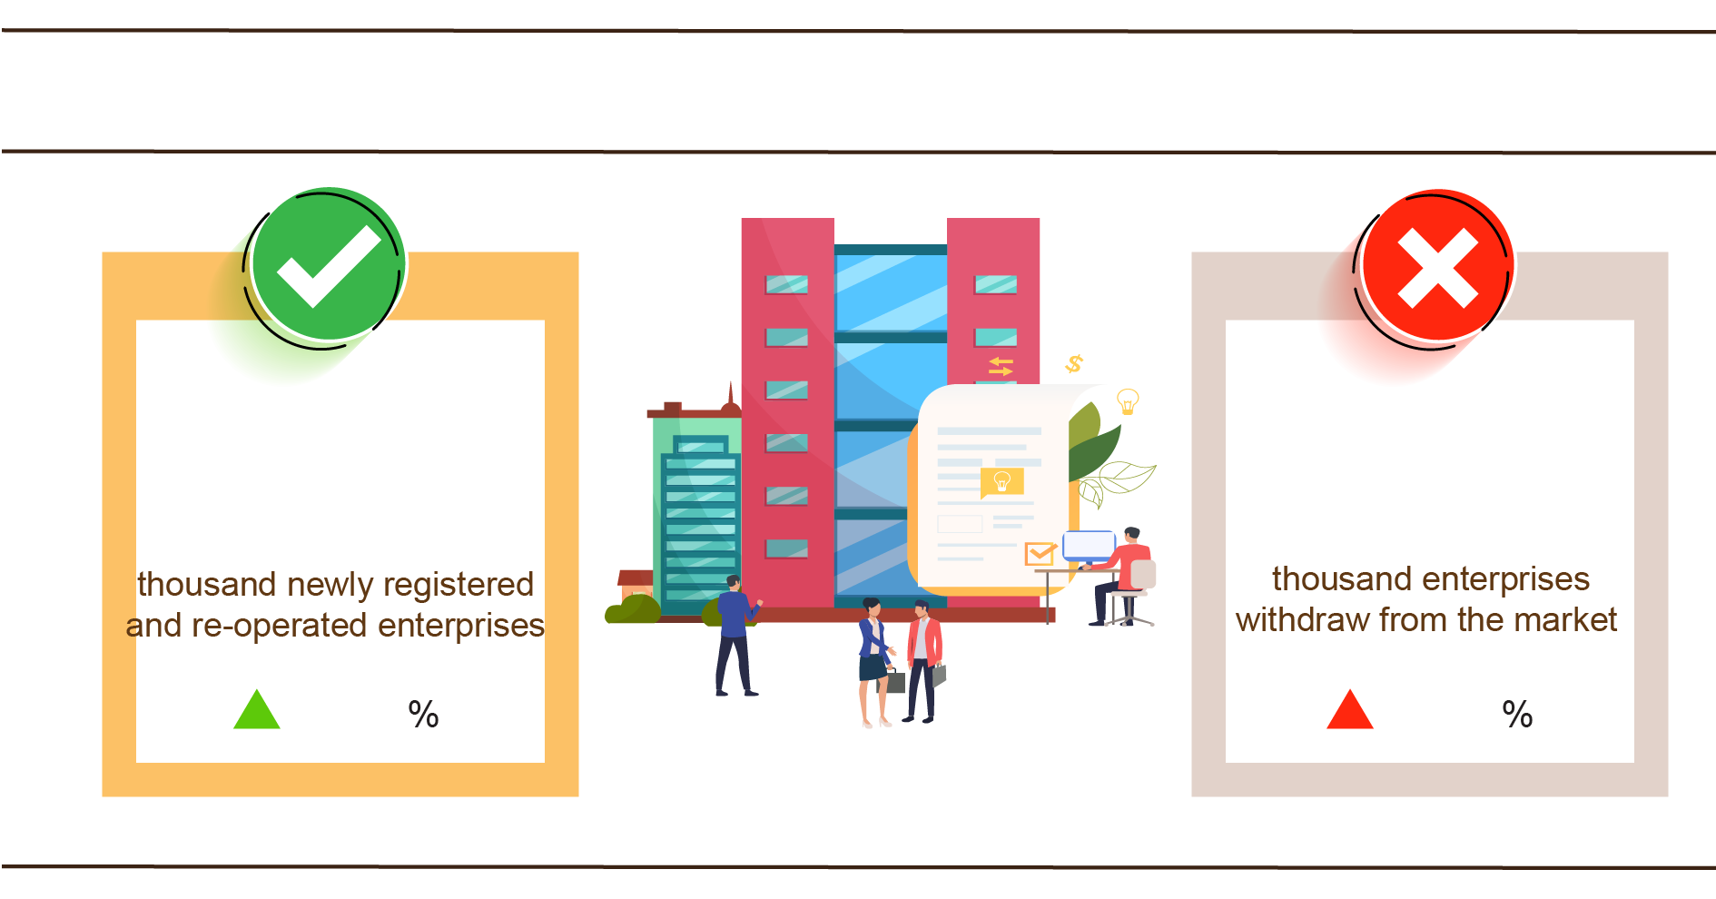
10 months, 2022 compared to the same period last year
178.5
122.1
38.3
25.8
In October 2022, 4,058 enterprises ceased for a certain time, an increase of 38.3% compared to last month and an increase of 16.2% compared to the same period in 2021; 4,200 enterprises temporarily ceased and awaited dissolution procedures, an increase of 0.3% and up 37.8%; 1,602 enterprises completed dissolution procedures, an increase of 5.7% and up 98.8%.
In 10 months this year, there were 66.4 thousand enterprises temporarily ceased for a certain time, an increase of 36.9% compared to the same period last year; 40.3 thousand enterprises temporarily ceased and awaited dissolution procedures, a climb up 15.2%; 15.4 thousand enterprises completed dissolution procedures, an increase of 13.4%. On average, 12.2 thousand enterprises withdraw from the market each month.

Table 2. Number of newly registered enterprises and completed dissolution
procedures 10 months 2022 by kinds of activity

 | Number of enterprises (Enterprise) |  | Growth rate  over the same period  last year (%)
 | Newly registered | Dissolution | Newly registered | Dissolution
Wholesale and retail trade; repair of motor vehicles and motorcycles | 44,413 | 5,436 | 39.2 | 9.0
Manufacturing | 15,936 | 1,814 | 31.8 | 15.6
Construction | 13,596 | 1,413 | 17.6 | 12.1
Real estate business | 7,725 | 974 | 30.9 | 42.0
Transportation and storage | 6,055 | 572 | 26.2 | -3.7
Accommodation and catering service | 5,426 | 751 | 75.2 | -1.6
Production and distribution of electricity, water, gas | 904 | 378 | -11.5 | 25.2

4. Investment
Investment capital from the State budget in October was focused efforts by ministries, branches, and localities to deploy, implement and disburse under the drastic direction of the Government and the Prime Minister. In the ten months of 2022, investment capital realized from the State budget was estimated at 67.1% of the plan, up 20.1% over the same period last year. The implemented foreign direct investment capital in Vietnam in 10 months of 2022 was estimated at 17.45 billion USD, up 15.2% over the same period last year.
Realized investment capital from the State budget in October was estimated at 53.6 trillion VND, up 24.2% over the same period last year, including Centrally managed capital reached nearly 10 trillion VND, up 37.1%; local capital under management was 43.6 trillion VND, up 21.6%. In the ten months of 2022, investment capital realized from the State budget was estimated at 387.7 trillion VND, equaling 67.1% of the year plan and increasing 20.1% over the same period last year (the same period last year in 2021 equaling 64.3% and down by 7%). Specifically:
- Realized investment capital under central management was estimated at 69.4 trillion VND, equaling 62.3% of the year plan and increasing by 21.8% over the same period last year.

Figure 6. Realized investment capital from the State budget
10 months of 2022 by Ministries
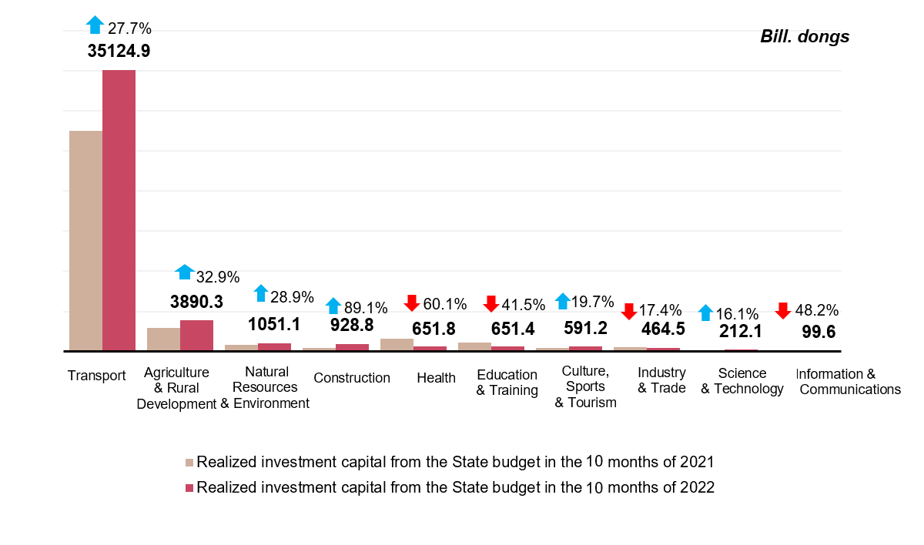
- Realized investment capital under local management was estimated at 318.3 trillion VND, equaling 68.2% of the year plan and increasing by 19.7% over the same period last year, of which:
Provincial state budget capital reached 209.8 trillion VND, equaling 64.4% and increasing 17.3% over the same period in 2021;
State budget capital at the district level reached 93.4 trillion VND, equaling 75.6% and increasing by 27.8%;
State budget capital at the commune level reached 15.1 trillion VND, equaling 86.2% and increasing by 8.1%.
Realized investment capital from the State budget for the ten months of 2022 of some provinces and centrally-run cities was as follows:

Figure 7. Realized investment capital from the State budget
10 months of 2022 by some provinces 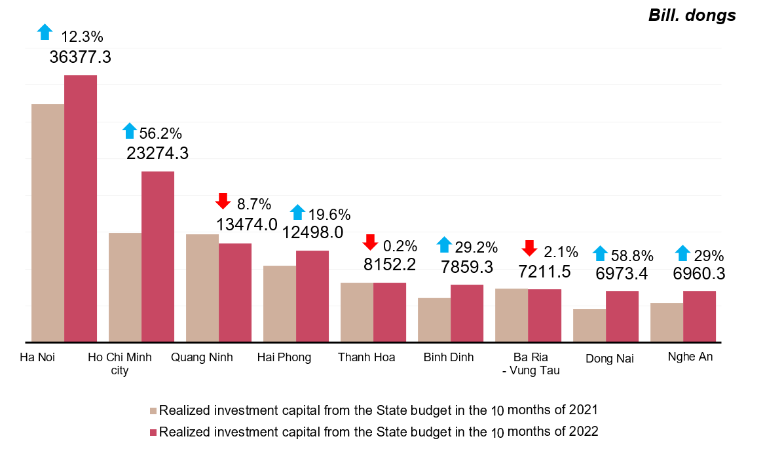
The foreign direct investment from the beginning of the year to 20th October 2022 including newly registered capital, adjust registered capital, and the total value of capital contribution and share purchases of foreign investors reached nearly 22.46 billion USD, decreased by 5.4% compared to the same period in 2021.

Figure 8. The registered capital of foreign investment in Vietnam
from date October 20 in years of 2018-2022 (Billion USD)
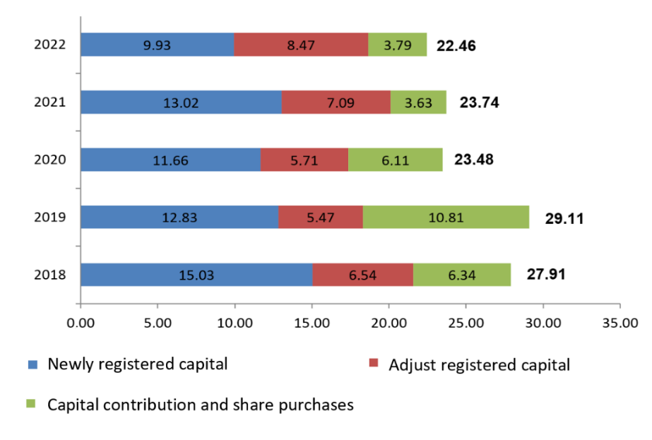
- Newly registered capital included 1,570 newly licensed projects with a registered capital of 9.93 billion USD, up 14.2% over the same period last year in the number of projects and a decrease of 23.7% in the registered capital. of which, processing and manufacturing industry attracted the 1st foreign direct investor with the registered capital of newly licensed projects reaching 5.37 billion USD, accounting for 54% of the total newly registered capital; production and distribution of electricity, gas, hot water, steam, and air conditioning reached 2.1 tỷ USD, accounting for 21.1%; the remaining industries reached 2.46 billion USD, accounting for 24.8%.
Among 67 countries and territories having newly licensed investment projects to Vietnam in 10 months in 2022, Japan was the largest investor with 2.95 billion USD, accounting for 29.7% of total newly registered capital; following was Singapore 1.65 billion USD, accounting for 16.6%; Denmark 1.32 billion USD, accounting for 13.3%; China 804.4 million USD, accounting for 8.1%; Hàn Quốc 779.5 million USD, accounting for 7.9%; Hong Kong 752.2 million USD, accounting for 7.6%.
- Adjust registered capital included 880 turns of projects which were licensed in the previous years registered to adjust investment capital with the additional capital of 8.74 billion USD, increased by 23.3% compared to same previous of last year.
If including additionally newly registered capital and adjust registered capital of licensed projects in previous years, foreign direct investment capital in the processing and manufacturing industry reached 12.14 billion USD, accounting for 65% of the total newly registered capital and additional capital; real estate business reached 2.45 billion USD, accounting for 13.1%; the remaining industries reached 4.08 billion USD, accounting for 21.9%.
- Capital contribution and share purchases of foreign investors included 2,997 turns with a total value of the capital contribution of 3.79 billion USD, an increase of 4.5% compared to the same period last year. Of which 1,356 turns of capital contribution, share purchase caused the increase of charter capital of the enterprise with the value of contributed capital of 2.04 billion USD and 1,641 turns of foreign investors repurchased domestic shares without increasing the charter capital with a value of 1.75 billion USD. About the form of capital contribution and share purchase by foreign investors, the investment capital in the real estate business reached 1.42 billion USD, accounting for 37.5% of the total capital contribution; the processing and manufacturing industry reached 780,8 million USD, accounting for 20,6%; the remaining industries reached 1.59 billion USD, accounting for 41.9%.
Foreign direct investment capital that was implemented in ten months of 2022 reached 17.45 billion USD, an increase of 15.2% over the same period last year. This is the highest increase of the 10 months of the year in the past 5 years. Of which the processing and manufacturing industry reached 13.68 billion USD, accounting for 78.4% of total realized foreign direct investment capital; real estate business activities gained 1.34 billion USD, making up 7.7%; production and distribution of electricity, gas, hot water, steam, and air conditioning recorded 1.29 billion USD, comprising of 7.4%.

Figure 9. Implemented foreign direct investment
10 months of the years 2018-2022 (Billion USD)

Vietnam's investment abroad in 10 months of 2022, there were 90 projects newly granted investment certificates with a total investment capital of 390.1 million USD, 1.8 times higher over the same period of last year; 19 turns of projects adjusted capital with adjust capital up 61.9 million USD, a decrease of 85.5%.
Generally, the total investment capital of Vietnam abroad (newly and additionally licensed capital) reached 452.1 million USD, a decrease of 30% over the same period last year, in which the processing and manufacturing industry 224 million USD, making up 49.6% of the total investment capital; real estate business activities gained 42.8 million USD, making up 9.5%; mining activities 39.8 million USD, comprising of 8.8%.
In 10 months of 2022, 25 countries and territories received investment from Vietnam, of which: Singapore was the leading country with 75.3 million USD, making up 16.7% of the total investment capital; Laos 70 million USD, making up 15.5%; United States 38.2 million USD, making up 8.5%; Germany, Netherland, France reached 34.7 million USD at the same time, also making up 7.7%.
5. State budget revenues and expenditures
State budget revenue in the 10 months of 2022 increased by 16.2% over the same period last year. State budget expenditure increased by 6.3% over the same period in 2021, meeting the needs of socio-economic development, defense, security, state management, payment of due debts as well as expenditures and timely payment to the subjects as prescribed.

Figure 10. State budget revenues and expenditures
in the 10 months of 2022
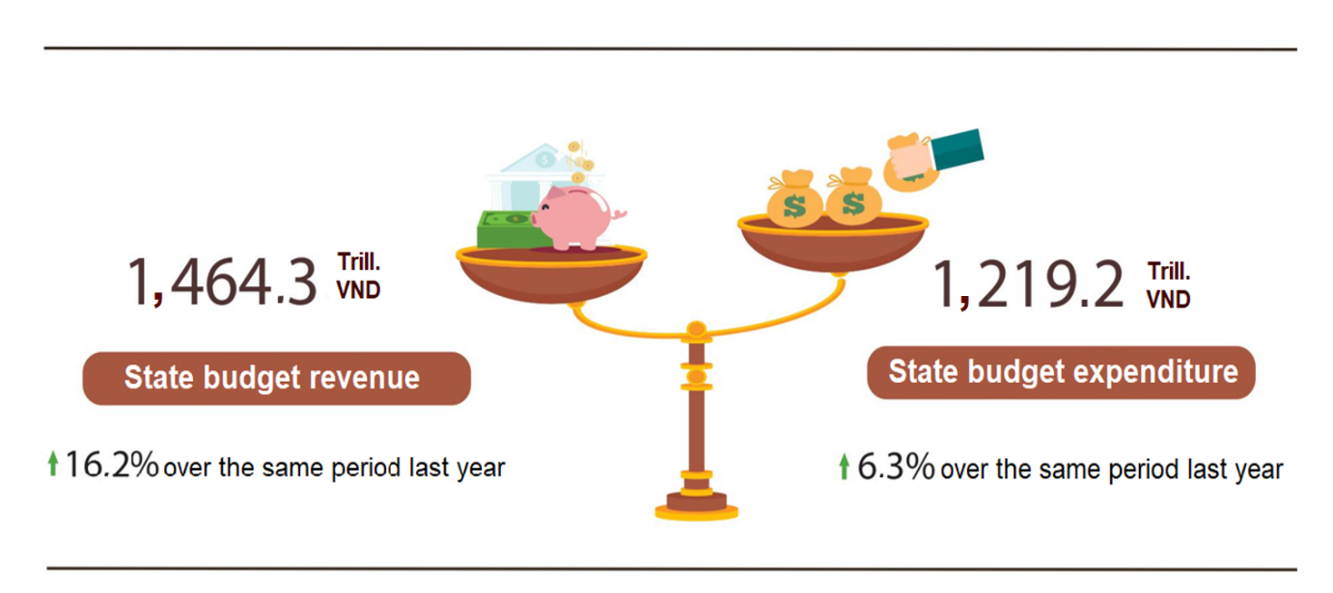
State budget revenue:
Total state budget revenue in October 2022 was estimated at 130.3 trillion VND. Accumulated total state budget revenue in 10 months of 2022 reached 1,464.3 trillion VND, equaling 103,7% of the yearly estimate and up 16,2% over the same period last year. Some of the main revenues are as follows:
- Domestic revenue in October 2022 was estimated at 110,1 trillion VND. Accumulated 10 months of 2022 reached 1,157.7 trillion VND, equaling 98,4 % of the year estimate and increasing by 12.1% over the same period last year.
- Revenue from crude oil in October 2022 was estimated at 6.2 trillion VND; accumulated 10 months of 2022 reached 65.5 trillion VND, equaling 232.4% % of the year estimate and increasing 95% over the same period last year.
- Balanced budget revenue from import and export activities in October 2022 was estimated at 14 trillion VND; accumulated 10 months of 2022 reached 236.1 trillion VND, equaling 118.6% of the year estimate and increasing 21.9% over the same period last year.
State budget expenditure:
Total state budget expenditure in October 2022 was estimated at 136.9 nghìn trillion VND; accumulated 10 months of 2022 was estimated at 1,219.2 trillion VND, equaling 68,3% of the yearly estimate and up 6,3% over the same period last year. Of which, the regular expenditure in 10 months of 2022 reached 841.3 trillion VND, equaling 75,7% of the yearly estimate and increasing by 5.4% over the same period last year; development investment expenditure reached 297.8 trillion VND, equaling 56.6% and increasing by 16,8%; debt payment interest was 78.3 trillion VND, equaling 75.5% and decreasing by 9.1%.
6. Trade, prices, transport and tourism
a) Retail sales of consumer goods and services
Consumer demand for goods and services continues to recover and increase with the total retail sales of consumer goods and services in October estimated to increase by 1.5% over the previous month and up 17.1% compared to the previous month. in the same period last year. In the 10 months of 2022, the total retail sales of consumer goods and services was estimated to increase by 20.2% over the same period last year.
Retail sales of consumer goods and services in October was estimated at 486.4 trillion VND, up 486.4 over the previous month and 1.5% so với tháng trước và tăng 17,1% so với cùng kỳ năm trước. 17.1% over the same period last year. In the 10 months of 2022, the total retail sales of consumer goods and services was estimated at up 20.2% over the same period last year (down 5.1% in the same period in 2021), if excluding the price factor, the increase will be 16.1% (in the same period in 2021, it will decrease by 6.8%).

Table 3. Retail sales of consumer goods and services

Trill. dongs
 | Estimate October  in 2022 | Estimate  10 months  in 2022 | Growth rate  compared to same period  last year (%)
 | Estimate October  in 2022 | Estimate  10 months  in 2022 | October  in 2022 | 10 months  in 2022
Total | 486,4 | 4.643,6 | 17,1 | 20,2
Retail sale | 379,3 | 3.675,4 | 9,6 | 15,0
Accommodation and catering service | 44,5 | 467,1 | 52,4 | 51,8
Traveling service | 2,1 | 19,7 | 424,0 | 291,6
Other services | 60,5 | 481,4 | 52,5 | 36,5

Retail sales of consumer goods and services in 10 months of 2022 increased by 13.9% compared to 10 months of 2019 - the year before the Covid-19 pandemic. However, the scale of the total retail sales of consumer goods and services in the 10 months of 2022 reached only about 83.2% of the scale of this indicator if it is estimated that in normal conditions there will be no Covid-19 pandemic from 2020 to present.

Figure 11. Retail sales of consumer goods and services
10 months of the years in the 2018-2022 period
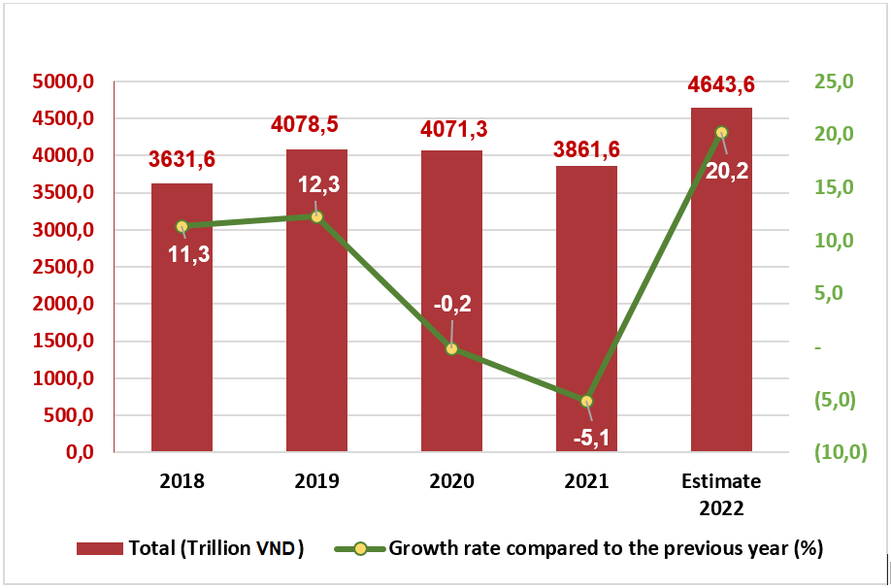
Retail sales of goods in the 2022 10 months of 2022 were estimated at 3,675.4 trillion VND, up 15% over the same period last year (excluding the 11 increase in price factor). In which, the group of cultural and educational products increased by 24.7%; garment increased by 17.3%; means of transport (except for cars) increased by 16%; food, food increased by 9.8%; Household appliances, tools and equipment increased by 6.9%. Retail sales of goods in the 10 months of 2022 compared to the same period last year of some localities are as follows: Khanh Hoa increased by 30.2%; Ho Chi Minh City increased by 26.7%; Binh Duong increased by 16.7%; Can Tho increased by 16.6%; Da Nang increased by 14.6%; Hanoi increased by 12.5%; Quảng Ninh Quang Ninh increased by 11.2%; Hai Phong increased by 9.5%.
Revenue from accommodation and catering services in the 10 months of 2022 was estimated at 467.1 trillion VND, up 51,8% over the same period last year. Revenue in 10 months of 2022 compared to the same period last year of some localities as follows: Can Tho increased by 126.1%; Ho Chi Minh City increased by 110.8%; Dong Nai and Da Nang both increased by 78%; Hanoi increased by 55.3%; Quang Ninh increased by 48.2%.
Revenue from tourism and travel services in 10 months of 2022 was estimated at 19.7 trillion VND, 3.9 times higher than the same period last year. Revenue in the 10 months of 2022 of some localities compared to the same period last year are as follows: Da Nang increased by 741.4%; Can Tho increased by 647.4%; Hanoi increased by 365%; Hai Phong increased by 236%; Ho Chi Minh City increased by 173.6%; Quang Ninh increased by 47.7%.
Revenue from other services in months of 2022 was estimated at 481.4 trillion VND, up 36.5% over the same period last year. Specifically, the 10-month increase over the same period last year of some localities was as follows: Da Nang increased by 90.6%; Khanh Hoa increased by 70.6%; Can Tho increased by 58.3%; Dong Nai increased by 54.7%; Ho Chi Minh City increased by 31.4%; Hanoi increased by 28.7%; Quang Ninh increased by 23.8%; Binh Duong increased by 19.1%; Hai Phong up 11.9%.
b) Export and import of goods
In October 2022, the total export and import turnover estimated at 58.27 billion USD, up 0.1% over the previous month and up 5.7% compared to the same period last year. Generally, in 10 months of 2022, the total export and import turnover of goods reached 616.24 billion USD, up 14.1% over the same period last year, of which exports increased by 15.9%; imports increased by 12.2%. The trade balance of goods in 10 months of the year was estimated to have a trade surplus of 9.4 billion USD.

Figure 12. Import and export of goods in 10 months of 2022

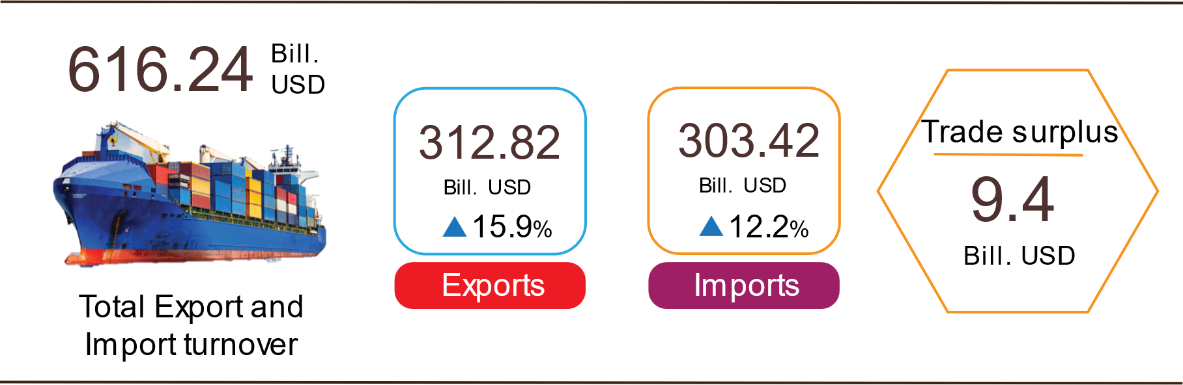

Export of goods
The preliminary export turnover of goods in September 2022 reached 29.82 billion USD, 123 million USD lower than the estimated figure.
Export turnover of goods in October 2022 was estimated at 30.27 billion USD, up 1.5% over the previous month. Of which the domestic economic sector gained 7.55 billion USD, increased by 8.7%; the FDI sector (including crude oil) reached 22.72 billion USD, giảm 0.7%. Compared to the same period last year, export turnover of goods in October rose by 4.5%, of which the domestic economic sector decreased by 4.9%, the FDI sector (including crude oil) increased by 8.1%.
Generally, in 10 months of 2022, the export turnover was estimated at 312.82 billion USD, up 15.9% over the same period in 2021, of which, the domestic economic sector was 80.36 billion USD, went up 13.4%, accounting for 25.7% of total export turnover; the FDI sector (including crude oil) attained 232.46 billion USD, increased by 17%, sharing 74.3%.
In 10 months of 2022, there were 32 products with an export turnover of over 1 billion USD, contributing 92,8% to the total export turnover (6 products with export turnover of over 10 billion USD, accounting for 64,1%).
Table 4. Value of some export products in 10 months of 2022
 | Estimate  10 months of 2022  (Million USD) | Growth rate of  10 months of 2022 compared to  the same period last year (%)
Items with a value of over 10 billion USD
Phones all of kinds and their parts | 50.136 | 7,6
Electronic goods, computers and their parts | 46.595 | 14,0
Machinery, instrument, accessory | 38.305 | 28,1
Textiles and garments | 31.814 | 21,9
Footwear | 20.057 | 40,9
Wood and products | 13.475 | 11,4

Regarding the structure of export products in 10 months of 2022 fuel and mineral products accounted for 1.3%, up 0.1 percentage points over the same period last year; processed industrial products accounted for 89.1%, up 0.1 percentage points; agricultural and forestry products accounted for 6.6%, down 0.6 percentage points; aquatic products accounted for 3%, up 0.4 percentage points.
Figure 13. Structure of export groups
in 10 months of 2022 by commodity group
Import of goods
Import turnover of goods in September 2022 reached 28.39 billion USD, million USD lower than the estimated figure.
Import turnover of goods in October 2022 was estimated at 28 billion USD, decreased by 1.4% over the previous month, of which the domestic economic sector gained 9.5 billion USD, decreased by 1.7%; the FDI sector reached 18.5 tỷ USD, down 1.2%. Compared to the same period in 2021, the import turnover of goods in October increased by 7.1%, of which the domestic economic sector increased by 6.2%; the FDI sector rose by 7.5%.
Generally, in 10 months of 2022, the import turnover was estimated at 303.42 billion USD, increased by 12.2% over the same period in 2021, of which the domestic economic sector reached 105.28 billion USD, went up by 12.5%; the FDI sector gained 198.14 tỷ USD, up 12%.
In 10 months of 2022, there were 44 imported products with a turnover of over 1 billion USD, accounting for 93% of the total import turnover (4 products with import turnover of over 10 billion USD, accounting for 52.7%).

Table 5. Value of some imported goods in 10 months of 2022
 | Estimate  10 months of 2022  (Mill. USD) | Growth rate of  10 months of 2022 compare to  the same period last year (%)
Items with a value of over 10 billion USD
Electronic goods, computers and their parts | 70,468 | 16.7
Machinery, instrument, accessory | 38,162 | -0.5
Phones all of kinds and their parts | 17,739 | 5.2
Fabrics | 12,543 | 8.0
Plastic | 10,722 | 10.8
Iron, steel | 10,282 | 6.7

Figure 14. Structure of import groups
in 10 months of 2022 by commodity group

Regarding the structure of imported goods in 10 months of 2022, the group of production materials accounted for 93.7%, up 0.1 percentage point over the same period last year, in which the group of machinery, equipment, tools spare parts accounted for 45%, down 1.2 percentage points; raw materials, fuel and materials accounted for 48.7%, up 1.3 percentage points. The group of consumer products accounted for 6.3%, down 0.1 percentage point.
Regarding the export and import market of goods in 10 months of 2022, the United States is the largest export market of Viet Nam with an estimated turnover of 93.4 billion USD. China is Viet Nam's largest import market with an estimated turnover of 100.7 tỷ USD. billion USD. In 10 months of 2022, the trade surplus to the EU was estimated at 26.7 billion USD, up 45.6% over the same period last year; trade deficit from China was 53.7 billion USD, up 18.8%; trade deficit from Korea was 32.1 billion USD, up 17.9%; trade deficit from ASEAN was 10.1 billion USD, up 0.8%.

Figure 15. Major commodity import and export markets in 10 months of 2022
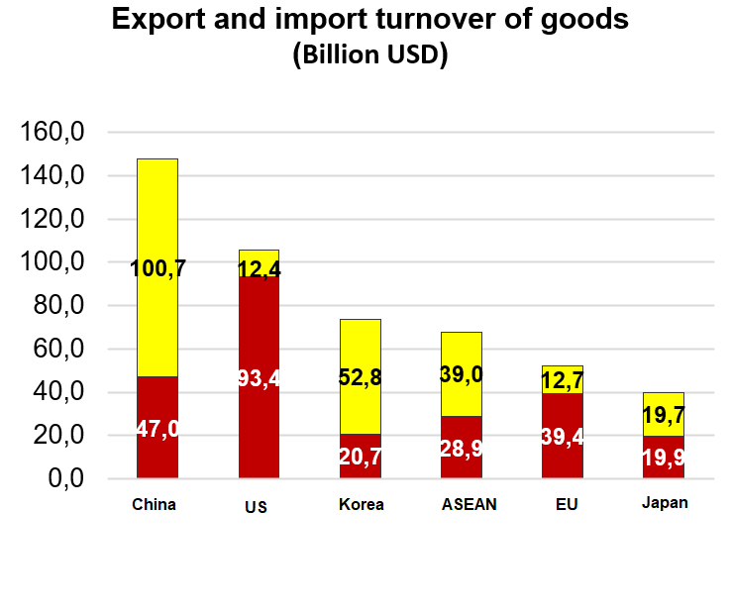 |  |  | 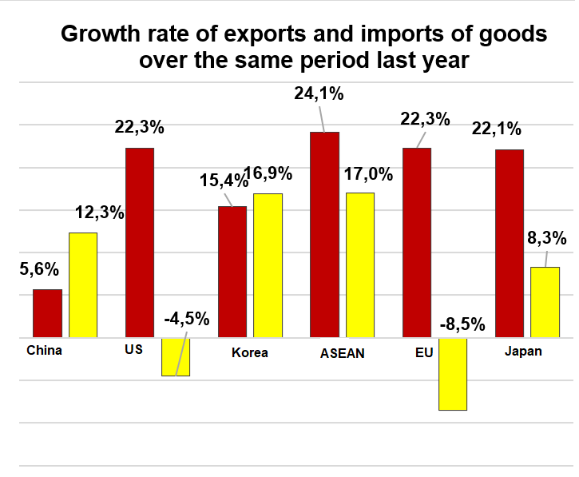
 |  | Exports of goods | Imports of goods
The trade balance of goods in September had a trade surplus of 1.43 billion USD ; 9 months had a trade surplus of 7.13 billion USD; October was estimated to have a trade surplus of 2.27 billion USD. Generally in 10 months of 2022, the trade balance of goods is estimated to have a trade surplus of 9.4 billion USD (in the same period last year, the trade deficit of 0.63 billion USD). In which, the domestic economic sector has a trade deficit of 24.9 billion USD; the FDI sector (including crude oil) had a trade surplus of 34.3 billion USD.
c) Consumer price index, gold price index and US dollar
Rent increased again due to the high demand of the people, some localities increased tuition fees for the 2022-2023 new school year, making the consumer price index (CPI) in October 2022 increase 0.15% compared to the previous month. CPI in October 2022 increased by 4.16% and over the same period last year by 4.3% compared to December 2021.
On average in 10 months of 2022, CPI increased by 2.89% over the same period last year; core inflation increased by 2.14%.

Figure 16. CPI growth rate of October and 10 months
the years for the period 2018-2022 (%)

In the increase of 0.15% of CPI in October 2022 compared to the previous month, there were 9 groups of goods and services with an increase in price index and 2 groups of goods with a decrease in price index.
- Nine groups of goods and services with increasing price index include:
- The education group had the highest increase with 2.35%, of which the education service price index increased by 2.64% compared to the previous month because some provinces and centrally-run cities increased tuition fees for the new school year 2022-2023 for public preschools, high schools and continuing education in the area. In addition, some non-public educational institutions must be self-sufficient in funding to adjust the increase in tuition fees in accordance with regulations. In addition, in the new school year, the demand for books and school supplies increases. Textbook prices increased by 0.29%; the price of notebooks and writing papers of all kinds increased by 0.09%; pens of all kinds increased 0.18% over the previous month.
- Housing and construction materials increased by 0.69% (making the overall CPI increase by 0.13 percentage points) because students started going to school, so the demand for rental housing increased, causing housing rent to increase by 8.85 %; housing repair service prices increased by 0.49% due to the increase in wall painting, bricklaying, wall construction, unskilled labor and high construction demand; price of housing maintenance materials increased by 0.08% because the price of cement, bricks, concrete bricks, roofing sheets, wall paint increased according to the price of input materials for production. In the opposite direction, the price of electricity and water for daily life decreased by 0.4% and 0.11% respectively due to reduced demand; gas price decreased by 3.95% compared to the previous month because from October 1st, 2022, the domestic gas price was adjusted down by 18,000 VND/12 kg cylinder after the world gas price decreased by 65 USD/ton (from 640 USD/ton to 575 USD/ton); kerosene price decreased by 5.07% over the previous month due to the impact of price adjustments on October 3rd, 2022, October 11st, 2022 and October 21st, 2022.
- Beverage and cigarettes increased by 0.34% due to high price of beverage production materials and USD exchange rate .
- Garments, hats, and shoes increased by 0.2% due to the increase in the price of production materials, labor costs and the demand for winter clothes.
- Food and catering services increased by 0.13% (making CPI increase by 0.04 percentage points), of which: Food increased by 0.13% (making CPI increase by 0.005 percentage points); foodstuff increased by 0.1% (making CPI increase by 0.02 percentage points); outdoor eating and drinkingincreased by 0.21% (making the overall CPI increase by 0.02 percentage points) due to high prices of processed materials.
- Household appliances increased by 0.12%, mainly focusing on items such as: The price of electric lights for lighting and metal utensils both increased by 0.34%; egg beaters increased by 0.28%; computers and accessories by 0.25%; soap and detergent increased by 0.2%; beds, cabinets, tables and chairs increased by 0.18%; gas stove increased 0.13%... In the opposite direction, the price of blender and juicer decreased by 1.09%; electric irons down 1.74%; kitchen equipment decreased by 1.86%.
- Medicine and medical service group and Culture, entertainment, and tourism groups both increased by 0.06%.
- Other goods and services increased by 0.23%, mainly focusing on jewelry, which increased by 0.46%; hair cutting and shampooing increased by 0.61%; elderly care services increased by 0.69%; electric appliances for personal care increased by 0.32%.
(2) Two groups of goods and services have decreased price index:
- Transport group decreased by 2.17% (making the general CPI decrease by 0.21 percentage points) due to the influence of domestic petrol price adjustments on October 3rd, 2022, and October 11st, 2022; October 21st, 2022 and also the influence from the downward adjustment in September 2022, making gasoline price decrease by 5.99%; diesel prices fell 0.6%. In the opposite direction, the price of motorbikes; automotive parts; tires and tubes of motorcycles; bicycle tires and tubes continued to increase by 0.31%; 0.15%; 0.28%; 0.73% respectively due to increased demand and limited supply.
- Postal services and telecommunications decreased by 0.06%.
Core inflation in October 2022 increased by 0.45% over the previous month, by 4.47% over the same period last year. On average, in 10 months of 2022, core inflation increased by 2.14% compared to the same period in 2021, lower than the general average CPI (up 2.89%), this reflects consumer price fluctuations mainly due to food prices and gasoline prices.
Domestic gold price fluctuated opposite to world gold price. As of October 25th, 2022, the average world gold price stood at 1,766.26 USDper ounce, down 0.66% compared to September 2022 due to investors' concerns that the US Federal Reserve (FED) will raise interest rates by 75 basis points at two meetings in November and December this year, causing the USD to appreciate strongly against other currencies, leading to an increase in US bond yields and world gold prices may be at a disadvantage. Domestically, the gold price index in October 2022 increased by 0.5% over the previous month; an increase of 4.8% over the same period in 2021; 10 months of 2022 average increase of 6.08%.
The US dollar in the world market increased after the FED raised interest rates and it is likely that the FED will continue to tighten monetary policy for a long time. As of October 25th, 2022, the US dollar index on the international market reached 112.24 points, an increase of 1.35 points compared to the previous month. Domestically, the average US dollar price on the free market is around 24,080 VND/USD. US dollar price index in October 2022 increased by 1.84% over the previous month and by 5.42% over the same period in 2021; 10 months of 2022 average increase of 1.17%.
d) Transport
Transport activities in October had positive growth in both passenger and freight transport compared to the same period last year, in which passengers carried increased by 2.7 times and passenger traffic increased by 3.8 times; freight carried increased by 32.9% and freight traffic increased by 40.1%.
Generally, for the 10 months of 2022, passengers carried increased by 44.9% over the same period last year, passengers traffic increased by 68.8% and freight carried increased by 23.7%, freight traffic increased by 32.6%.
Passengers transport in October 2022 was estimated at 296.4 million passengers, decrease of 0.5% compared to the previous month and 14.4 billion passengers-kilometers, an increase of 0.3%. Generally, in 10 months of 2022, passenger carried estimated at 3,086.7 million passengers, up 44.9% over the same period last year (decreased by 27.4% in the same period in 2021) and passenger traffic reached 146.1 billion passengers.km, an increase of 68.8% (in the same period last year, a decrease of 34.7%). In which, domestic transport reached 3,083.2 million passengers carried, up 44.7% over the same period last year and 134.5 billion passengers-kilometers, up 56%; Overseas transport got 3.5 million passengers, 33.1 times higher than the same period last year and 11.6 billion passengers-kilometers, 30.1 times higher. Although passenger transport has made a positive recovery, it was only equal to 73.8% of passenger carried and 71.2% of passenger traffic compared to the same period in 2019, the year there was no Covid-19 epidemic.

Table 5. Carriage of passengers in 10 months of 2022
by types of transport

 | Number of passengers |  | The growth rate  compared to the same period  last year (%)
 | Carried  (Mill. passengers) | Traffic  (Bill. passengers-km) | Carried | Traffic
Total | 3,086.7 | 146.1 | 44.9 | 68.8
Railway | 3.7 | 1.4 | 187.1 | 140.2
Seaway | 6.9 | 0.3 | 61.7 | 79.5
Inland waterway | 200.0 | 2.9 | 41.6 | 19.3
Road | 2,833.2 | 93.2 | 43.8 | 31.4
Airway | 42.9 | 48.3 | 215.6 | 288.7
Freight transport in October 2022 was estimated at 172.4 million tons of freight carried, up 0.8% over the previous month and 39.7 billion tons-km of freight traffic, down 1.8%. Generally, in 10 months of 2022, freight transport was estimated at 1,644.1 million tons of freight carried, up 23.7% over the same period last year (in the same period in 2021, decreasing by 7.1%) and 359.6 billion tons.km of freight traffic, an increase of 32,6% (in the same period last year, a decrease of 0.8%). In which, domestic transport reached 1,608.4 million tons of freight carried, up 23.5% and 219.3 billion tons-kilometers of freight traffic, up 50.7%; Overseas transport reached 35.7 million tons freight carried, up 33.6% and 140.3 billion tons-kilometers of freight traffic, up 11.6Enterprises went into stable operation, import and export continued to prosper, so the demand for domestic and foreign freight transportation in the 10 months of 2022 increased sharply compared to the same period last year.

Table 6. Carriage of freight in 10 months of 2022
by types of transport
 | Quantity of goods |  | The growth rate  compared to the same period  last year (%)
 | Carried  (Mill. tons) | Traffic  (Bill. tons-km) | Carried | Traffic
Total | 1,644.1 | 359.6 | 23.7 | 32.6
Railway | 4.8 | 3.8 | 4.9 | 19.6
Seaway | 87.8 | 192.1 | 28.2 | 37.9
Inland waterway | 332.5 | 77.3 | 26.9 | 38.4
Road | 1,218.8 | 81.3 | 22.6 | 18.9
Airway | 0.2 | 5.1 | 6.2 | 11.4

đ) International visitors to Viet Nam
International visitors to our country in October were estimated at 484.4 thousand arrivals, increased 12.1% compared to the previous month and 45.9 times higher than the same period last year because Viet Nam has opened up to tourism, international routes have been restored. Generally, in 10 months of 2022, international visitors to Viet Nam were estimated at 2,357.2 thousand arrivals, 18.8 times higher than the same period last year but still down 83.7% compared to the same period in 2019, the year no Covid-19 epidemic.
Out of a total of nearly 2,357.2 thousand international visitors to Viet Nam in 10 months of this year, visitors coming by airway gained 2,093.7 thousand persons, accounting for 88.8% of the number of international visitors to Viet Nam, 24.9 times higher than the same period last year; by roadway achieved 262.8 thousand arrivals, accounted for 11.2% and 6.5 times higher; by seaway achieved 745 arrivals, accounted for 0.03% and increased by 49.3%.

Figure 17. International visitors to Viet Nam
in 10 months of 2022 by territories
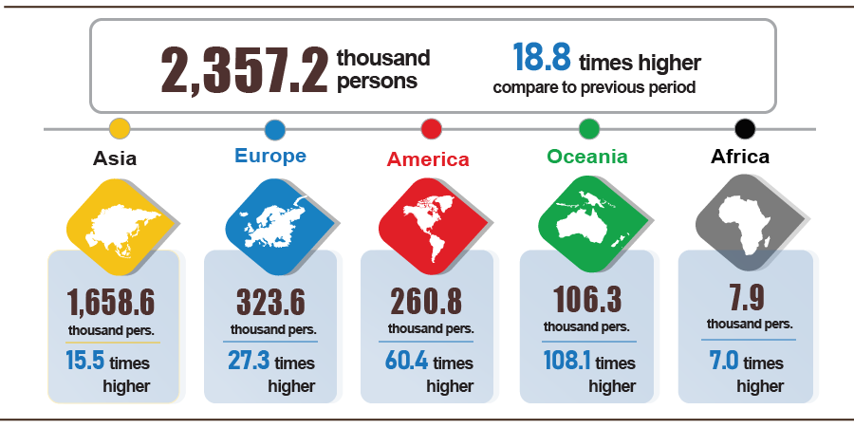

7. Some social situation
a) Residential life
According to preliminary results from the Household Living Standards Survey in the 10 months of 2022, the living situation continues to be better. The percentage of households assessed that their income in the month remained unchanged and increased compared to October 2021 was 84.1%; assessed that has decreased was 15.9%. Among the reasons for reducing household income, 71.8% rated it due to the impact of the Covid-19 pandemic; 20.0% assessed that members of the household lost their jobs/temporarily quit their jobs, and 16.3% of households assessed that input costs for production and business activities of the household increased. Regarding the negative impacts on life in the 10 months of 2022, 57.4% are suffering from negative impacts of the Covid-19 pandemic; 2.3% are from diseases on livestock and crops, and similarly, 1.9% are affected by other diseases.
In 10 months of 2022, 24.5% of households received help from different sources of support. Specifically, the percentage of households receiving support from general national programs and policies was 10.3%; from relatives, relatives was 11.9%; from local programs and policies was 9.2%; from charitable activities of other organizations and individuals was 5.2% and from other sources was nearly 0.2%.
According to a report of the Ministry of Labor, War Invalids and Social Affairs, as of October 24, 2022, the support package under Resolution No. 11/NQ-CP has disbursed about 3,723.8 billion VND to support nearly 5 million employees in 122,253 enterprises. Specifically, support 3,196.6 billion VND for 4.8 million employees working in 93,286 enterprises; supporting 527.2 billion VND for 450 thousand employees returning to the labor market at 28.967 enterprises.
In addition, to prevent people from suffering from hunger, the Government has issued 1,380.3 tons of rice to the people in the pre-seed season in 2022, specifically: 208.5 tons for Soc Trang province; Nghe An 693.5 tons; Gia Lai 478.3 tons.
b) Epidemic diseases and food poisoning
According to the report of the Ministry of Health, in the month (September 19- October 18, 2022), there were 59,191 cases of hemorrhagic fever (24 cases died); 6,605 cases of hand, foot and mouth disease; 24 cases of virus encephalitis (01 case died); 01 cases of meningococcal disease; 34 cases of scarlet fever suspected for measles. Generally, in 10 months of 2022, there were 258,709 cases of hemorrhagic fever (102 cases died); 55,444 cases of hand, foot and mouth disease (03 cases died); 239 cases of hand, foot and mouth disease (05 cases died); 11 cases of meningococcal disease; 239 cases of scarlet fever suspected for measles.
In the world, the Covid-19 epidemic is on an increasing trend in the number of cases. In Vietnam, in recent days, the number of new cases of Covid-19 has continuously decreased, and the number of critically ill patients requiring oxygen has also decreased. From the first case of Covid-19 in Vietnam on January 23, 2020 to October 27, 2022, there were 11,499.4 thousand cases have been reported, of which 10,602.3 thousand have been cured and 43.2 thousand cases died.
The rate of 3rd and 4th vaccination dose against Covid-19 for children aged 5-11 years old in some localities is still low. From March 8, 2021 to October 26, 2022, the total number of doses of Covid-19 vaccine that have been administered 261,608.5 thousand doses, of which the first time 90.059,5 thousand doses; the second time 84,433.8 thousand doses; additional dose 14,501.4 thousand doses; the first booster dose 56,500 thousand doses; the second booster dose 16,113.8 thousand doses.
The total number of people living with HIV nationwide as of October 18, 2022, was 220,580 persons and the number of deaths by HIV/AIDS as of the above time-point was 112,368 persons.
In October 2022, there were 04 cases of food poisoning with 37 persons poisoned. Generally, in 10 months of 2022, there were 43 cases of food poisoning with 581 persons poisoned (11 cases died).
c) Cultural and sports activities
The conservation and promotion of the value of the cultural heritage of Vietnam have achieved many positive achievements. In addition, ​​everyone has gradually improved their awareness of cultural heritage, and the role of conservation and promotion of cultural heritage values. Many cultural heritages have been included in the National Intangible Cultural Heritage List, the highlight of October was the Ceremony to receive National Intangible Cultural Heritage, Traditional Festival Kieu Mai - Phu My.
Movements of mass exercise and sports have been promoted and organized widely in all localities, many movements have been launched such as: Sports congress in Ninh Binh, Son La, Ha Nam, Nam Dinh, Quang Ninh, Lam Dong.
In terms of high-performance sports, in October 2022 a number of outstanding events will take place such as: At the Asian Youth Chess Championship, 2022 took place from October 14-21, 2022 in Indonesia, the Vietnamese team won the first team with 39 gold medals, 21 silver medals, and 9 bronze medals; Successfully organized the National Athletics Championships in relay events in 2022 took place on October 13, 2022, in Hanoi; The 2022 National Strong Team Table Tennis Tournament from October 17 to 23, 2022 in Dak Lak; The 3rd National Movement Bike Festival 2022 on October 23, 2022, in Binh Thuan.
d) Traffic accident
In October (from September 15 to October 14, 2022), there were 899 traffic accidents in the whole country, including 645 from less serious or more and 254 traffic collisions, causing 507 deaths, 349 injuries and 245 minor injuries. Compared to the previous month, the number of traffic accidents increased by 9% (the number of traffic accidents from less serious or more increased by 15.2% and the number of traffic collisions decreased by 4.2%) the number of deaths increased by 15.8%; the number of injured people increased by 13.7% and the number of minor injuries decreased by 13,1%. Compared to the same period last year, the number of traffic accidents in October up 12.7% (the number of traffic accidents from less serious or more increased by 23.1% and the number of traffic collisions decreased by 7.3%); the number of deaths increased by 34.5%; the number of injured people increased by 14.8% and the number of people with minor injuries decreased by 8.9%.
Generally, in the 10 months of this year, there were 9.212 traffic accidents nationwide, including 6.430 traffic accidents of less serious or more and 2.782 traffic collisions, killing 5.221 people, 3.312 people injured and 2.828 minor injuries. Compared to the same period last year, the number of traffic accidents in the ten months of this year increased by 3.1% (the number of traffic accidents from less serious or more increased by 11.6%; the number of traffic collisions decreased by 12.3%); the number of deaths increased by 15.4%; the number of injured people increased by 10.4% and the number of minor injuries decreased by 11.7%. On average, 1 day in 10 months, there were 30 traffic accidents in the whole country, including 21 traffic accidents of less serious or more and 9 traffic collisions, causing 17 deaths, 11 injured and 9 people with minor injuries.
đ) Damage caused by natural disaster
Damage caused by natural disasters in October 2022 was mainly caused by heavy rains, floods, and landslides, causing 26 deaths and missing, 193 injured; 18.1 thousand houses collapsed, washed away, and damaged; 495.5 thousand cattle and poultry died; 10.4 thousand ha of paddy and 17.9 thousand ha of crops were damaged; total value of property damage caused by natural disasters in the month was 7.41 trillion VND (of which because of storms, heavy rains, floods was 7.38 trillion VND, accounting for 99.7% of the total value damage), nearly 7 times higher over the same period last year. Some localities suffered heavy losses: Quang Nam 3,395.3 billion VND; Da Nang 1,519.2 billion VND; Nghe An 947.7 billion VND; Quang Ngai 415.2 billion VND; Thanh Hoa 376.1 billion VND; Thua Thien - Hue 238.9 billion VND.
Generally, for the 10 months of this year, natural disasters made 160 people dead and missing, 279 people injured; 37.3 thousand houses collapsed, and were damaged; 748.7 thousand cattle and poultry died; 212.5 thousand hectares of paddy and 62.7 thousand hectares of crops were damaged; the total value of property damage was estimated at 14,025.3 billion VND, 5.8 times higher than the same period in 2021.
e) Environmental protection and fire prevention
In October 2022, according to reports from the Statistical Offices of provinces and centrally run cities, the authorities detected 1,870 cases of environmental violations, of which 1,618 cases were handled with a total fine of 27 billion VND, up 17,7% from the previous month and up 59,9% over the same period last year. Generally, in the 10 months of this year, 18,522 cases of environmental violations were detected, of which 16,133 cases were handled with a total fine of 222.5 billion VND, up 5,7% over the same period last year.
In the month, the whole country had 106 fires and explosions, killing 3 people and injuring 8 people, with an estimated damage of 31.1 billion VND, up 108,5% compared to the previous month and up 141,4% over the same period last year. Generally, in the ten months of this year, 1,391 fires and explosions occurred nationwide, killing 107 people and injuring 93 people, causing estimated damage of 567.6 billion VND, an increase of 59.1% over the same period last year./.

GENERAL STATISTICS OFFICE

Some provinces have reduced the area much: An Giang reduced by 7.9 thousand hectares; Long An decreased by 4.1 thousand ha; Vinh Long reduced 3.5 thousand ha; Tra Vinh decreased by 2.8 thousand hectares.
Cao Bang, Lang Son, Tuyen Quang, Dien Bien, Hoa Binh, Quang Binh, Quang Ngai, Gia Lai, Dak Lak, Dak Nong, Binh Phuoc, Tien Giang, Vinh Long, Ben Tre, Kien Giang, Tra Vinh, Soc Trang and Bac Lieu.
In October, the price of peeled acacia wood in Quang Tri sold to the factory for 1,400 thousand VND/ton, an increase of 350,000 VND/ton compared to the same period in 2021.
According to the Ministry of Agriculture and Rural Development, as of 15/10/ 2022.
http://agromonitor.vn/group/48/280/giam-sat-gia: In the provinces of the Mekong River Delta, the price of raw pangasius kinds of 0.8-1.0 kg/head ranges from 28,000-31,500 VND/kg lead to farmers have made a profit of 4,000-6,000 VND/kg.
http://agromonitor.vn/group/47/272/giam-sat-gia: The price of vannamei shrimp with 100 pieces/kg ranges from 88,000-94,000 VND/kg; 80 pcs/kg, ranging from 100,000-106,000 VND/kg; the price of black tiger shrimp 20 heads/kg fluctuated at 300,000 VND/kg, an increase of 20,000 VND/kg over the same period last year.
The growth rate of index of industrial production in the 10 months of 2018-2022 compared to the same period last year are:10.3%; 9.5%; 2.6%; 3.8%; 9.0%.
The growth rate of the IIP index in October 2022 compared to the previous month of some large-scale industrial regions are: Ha Tinh increased 24.2%; Phu Tho increased by 18.4%; Hai Phong increased by 9.2%; Vinh Phuc increased by 6.4%; Long An increased by 5.8%; Bac Giang increased by 5.4%; Thai Nguyen increased by 5%; Quang Ninh increased by 3.3%; Hung Yen increased 3%; Tien Giang increased by 2.4%; Binh Duong increased by 1,4%; Dong Nai increased by 1.3%.
Orders dropped, world steel prices fluctuated , input material prices were high, and the impact of typhoon No. 6 disrupted industrial production in some central provinces, leading to only The number of production in the processing and manufacturing industry in October 2022 increased only by 5.7% over the same period last year. The electricity industry IIP index in October 2022 increased sharply because the production index of the electricity industry used in the fields of commerce, hotels and restaurants increased by 65.9% (in the same period last year, the electricity production and distribution industry low increase of 3.1%). The IIP index of water supply industry, waste and wastewater treatment and management activities increased by 15.7% due to the increase of 22.7%; in the drainage and wastewater treatment industry; waste collection, treatment and destruction, and scrap recycling increased by 29.3% (in the same period last year, it decreased by 1.7% and 3.5%, respectively).
Localities have high production index of the processing and manufacturing industry in the 10 months of 2022 compared to the same period last year: Bac Giang increased by 41.8%; Can Tho increased by 38.4%; Vinh Long increased by 30.8%; Kien Giang increased by 27%; Quang Nam increased by 25.2%; Khanh Hoa increased by 24.9%; Binh Phuoc increased by 22.9%; Son La increased by 11.5%. Localities with high index of electricity production and distribution: Dak Lak increased by 38.8%; Lai Chau increased by 29.8%; Son La increased by 27.8% due to high increase in hydropower..
Localities with minor increase or decrease in the production index of the processing and manufacturing industry in the 10 months of 2022 compared with the same period last year: Binh Dinh increased by 6.7%; Bac Kan increased by 6.8%; Ninh Binh increased by 4%; Dak Nong increased by 0.6%; Ha Tinh fell 12.3%. Localities with the index of electricity production and distribution industry in 10 months of 2022 decreased compared to the same period last year: Quang Ninh decreased by 4.5%; Binh Thuan down 1.1%; Ha Tinh decreased by 32.2%; Tra Vinh fell 36%. Localities with mining industry in 10 months of 2022 compared to the same period last year increased or decreased: Ba Ria - Vung Tau increased by 2.6%; Ha Tinh decreased by 3.8%; decreased by 17.4%; Binh Dinh decreased by 20.6%.
Source: National Enterprise Registration Information System, Business Registration Management Agency, Ministry of Planning and Investment (Received the report on 26th October 2022)
According to Ministry of Finance’s report as of 28/10/2022.
Data in October 2022 meeting by an interdisciplinary team consisting of the Ministry of Industry and Trade, the Ministry of Planning and Investment, the State Bank of Viet Nam, the General Department of Customs and the General Statistics Office meeting estimates based on export turnover figures, import as of October 26, 2022 of the General Department of Customs combined with market information, the proportion and trend of export and import of goods. The General Statistics Office received and updated the report on the afternoon of October 28, 2022.
Total import and export turnover of goods in 10 months of 2021 reached 540.3 billion USD, up 22.8% over the same period last year, of which export reached 269.8 billion USD, up 17.4%; imports reached 270.5 billion USD, up 28.7%.
Estimated trade surplus in September was 1.14 billion USD.
The growth rate of the price index of educational services in October compared to the previous month of some localities: Khanh Hoa increased by 83.56%; Lai Chau increased by 56.18%; Nam Dinh increased by 51.72%; Ninh Thuan increased by 47.49%; Binh Thuan increased 45.47%; Phu Yen increased by 39.48%; Thai Binh increased by 37.19%; Dong Thap increased by 25.18%; Thanh Hoa increased by 18.4%; Bac Lieu increased by 10.31%; Ha Giang increased by 9.37%; Tien Giang increased by 8.28%.
The price of mineral water increased by 0.44% compared to the previous month; carbonated beverage prices increased by 0.48%; bottled energy drinks increased by 0.25%; alcohol increased by 0.44% and smoking increased by 0.2%.
Price index of instant noodles, noodles, pho and porridge increased by 0.34%; flour by 0.26%; corn flour by 0.88%; corn by 1.01%; vermicelli increased by 0.2%; bread increased by 0.74%; instant cereals increased by 0.32% due to the increase in input prices. Particularly, the rice price index decreased by 0.02% because the localities had finished harvesting the summer-autumn paddy crop, so the supply was abundant.
Due to the influence of the circulation of storm No. 5, tropical depression combined with cold air caused heavy rain in many localities, inundating many crop areas and causing difficulties for marine fishing activities, making some items increase in price: The price of fresh seafood increased by 0.31%; prices of fresh, dried and processed vegetables increased by 2.22%. In addition, the price of fish sauce and dipping sauce increased by 0.32%; milk, butter, cheese by 0.32%; sugar, bile by 0.26%; cakes, jams and sweets by 0.12%; tea, coffee, cocoa increased by 0.26% due to increase in raw material prices. On the other hand, pork price decreased by 1.41% due to abundant supply (caused the overall CPI to decrease by 0.05 percentage points); poultry meat price decreased by 0.21%; prices of edible fats and oils decreased by 0.26%.
CPI after excluding fresh food, foodstuff, energy and goods managed by the State including health services and education services.
Freight transport in 10 months of 2022 increased by 6.2% in freight carried and 19.8% in freight traffic over the same period in 2019.
According to the report of the Border Gate Department, the Border Guard Command, the Ministry of National Defense and the Immigration Department, the Ministry of Public Security
The reporting period is from September 21, 2022 to October 20, 2022.
From the end of December 2019 to October 27, 2022, in the world, there are 634,321.4 thousand cases of Covid-19 (6,588.1 thousand deaths).
According to a quick report from the Office of the Ministry of Public Security, and the Department of Maritime Affairs (the Ministry of Transport) on Octocber 23, 2022
Summary reports from 63 Departments of Agriculture and Rural Development, from September 19 to October 18, 2022.
According to a quick report from the Ministry of Public Security on October 23, 2022.

