MINISTRY OF PLANNING AND INVESTMENT  GENERAL STATISTICS OFFICE  No: 302/BC-TCTK | SOCIALIST REPUBLIC OF VIET NAM  Independence-Freedom-Happiness  Ha Noi, 29th November, 2022

Socio-economic situation in November and 11 months of 2022

1. Agriculture, forestry and fishery
Agricultural production in November focused mainly on completing the harvest of winter paddy in the country, planting winter crops in the Northern localities and harvesting autumn-winter rice in the Mekong Delta provinces. The livestock was stable, the disease was well controlled. Logging activitie was actively implemented. Aquaculture fishery continues to increase in farming area and harvested output of key aquatic products to meet the needs of domestic and foreign markets at the end of the year.
a) Agriculture
Winter paddy
As of mid-November, the whole country harvested 1,326. thousand hectares of winter rice, accounting for 85.4% of the cultivated area and equaling 101.2% of the same period last year, of which: Northern localities planning 980.4 thousand ha, accounting for 95.8% and equaling 98.2%; Southern localities harvested 346.3 thousand hectares, accounting for 65.1% and 111.1%. The southern localities harvested earlier than the same period last year due to favorable weather conditions, localities actively responded to climate change to limit saltwater intrusion, so farmer expanded the planting area.
This year's winter crop, despite the large amount of rain, the localities have actively developed scenarios for water regulation; To best prepare the conditions for anti-flooding work, minimize damage caused by adverse weather factors, so the winter paddy production achieved good results, the yield increased compared to the previous year. According to preliminary reports, this year's crop yield of the whole country was estimated at 52.9 quintals/ha, an increase of 1.3 quintals/ha compared to the previous year's crop; output reached estimated at 8.21 million tons, up 152 thousand tons. It was estimated in the northern provinces, yield reached 53.1 quintals/ha, an increase of 0.5 output reached at 5.43 million tons, equivalent to last year's crop. Especially in the Red River Delta, the yield reached at 57.5 quintals/ha, up 0.3 quintals/ha; the output reached 2.7 million tons, down 43 thousand tons because the cultivated area decreased by 9.6 thousand hectares. It was estimated in the southern provinces, the yield reached 52.4 quintals/ha, an increase of 2.4 quintals/ha compared to the previous year's crop; output reached 2.77 million tons, up 191 thousand tons.
Autumn-winter paddy
The area of autumn-winter rice cultivation in 2022 in the Mekong Delta was estimated at 648.7 thousand hectares, down 70.6 thousand hectares compared to the previous year's autumn-winter crop due to unstable production and no initiative water resources, besides this year's autumn-winter rice crop was also affected by the high price of fertilizer and input materials, so famer limit their investment or switch to growing perennial crops for higher economic efficiency.
As of November 15, 2022, the whole region has harvested 323 thousand hectares of autumn-winter rice, accounting for 49.8% of the cultivated area and equaling 99.8% of the same period last year. According to the preliminary report, the whole crop's yield was estimated at 56 quintals/ha, down 0.1 quintal/ha compared to the autumn-winter crop last year; due to a decrease in the cultivated area, the total output of the whole crop was estimated at 3.63 million tons, down 390 thousand tons.
Winter-spring rice
As of November 15, 2022, the southern localities had sown 308.1 thousand hectares of early winter-spring rice, equaling 86% of the same period last year, mainly in the Mekong Delta. The progress of planting winter-spring rice is slower than the same period last year because some localities direct the sowing timetable later to avoid drought and salinity.
Other annual crops
This year's winter crop focuses on crops of high economic value, implements intensive farming and spreads crops, improves quality to increase selling prices, especially, focuses on producing crops for fodder to implement circular agricultural economy such as biomass corn, soybean.

Figure 1. Cultivation of main annual crops
(As of mid-November, 2022)
Livestock
Livestock in the month has developed stably, epidemics have been basically controlled. Currently, it was the time for farmers to focus on re-herding and increasing their cattle and poultry to supply to the market on holidays and New Year's Eve at the end of the year and at the beginning of the new year. In order to stabilize the domestic cattle and poultry production and consumption market, it is necessary to take drastic and synchronous measures against speculation and price manipulation, ensuring the interests of farmers and consumers.

Figure 2. The growth rate of the population of livestock
at the end of November 2022 compared to the same time last year

As of November 23, 2022, the whole country has no longer blue-ear disease; foot-and-mouth disease was still Gia Lai; avian flu remained in Nghe An, Quang Ngai, Đak Lak, Tien Giang; LSD was still in Dak Lak, Ben Tre and African swine fever was reported in 19 localities for less than 21 days.
b) Forestry
The area of ​​newly concentrated planted forests in November 2022 was estimated at 33.6 thousand hectares, up 1.4% over the same period last year; the number of scattered forest trees reached 18.3 million trees, up 6.4%; firewood production was estimated at 1.6 million steres, up 7.9%; timber production reached 2,019.8 thousand m³, an increase of 9%. The production of timber increased sharply compared to the same period last year due to it was the age for the forest to be exploited, an increase in demand for raw materials for processing factories. Some localities have high timber production in the month compared to the same period last year, such as Tuyen Quang reached 132.8 thousand m³, up 71.7%; Thanh Hoa reached 70.9 thousand m³, up 17.2%; Nghe An reached 179.5 thousand m³, up 12%; Quang Ngai reached 276.6 m³, up 11.3%.
In the 11 months of 2022, the area of ​​newly concentrated planted forest was estimated at 260.6 thousand ha, up 4.9% over the same period last year; the number of scattered forest trees was estimated at 96.5 million trees, up 5.3%; firewood production was estimated at 17 mill. ste, up 1%; timber production was estimated at 17.6 mill. m³, up 6.6%.
The damaged forest area in the month was 58.2 hectares, down 9.6% over the same period last year, in which mainly the forest was destroyed with 46.8 hectares, up 26.8%; the burned forest area was 11.4 hectares, down 58.5%. In the 11 months of 2022, the damaged forest area was 1,047.6 hectares, down 58.4% over the same period last year, including the burned forest area was 37.9 hectares, down 97.5%; the destroyed forest area was 1,009.7 ha, down 1.6%.
c) Fishery
Fishery output in November was estimated at 802.3 thousand tons, up 3.1% over the same period last year, including fish reached 577.2 thousand tons, up 3.2%; shrimp reached 115 thousand tons, up 3.7%; other aquatic products reached 110.1 thousand tons, up 2%.
It was estimated that in month, aquaculture output reached 521.6 thousand tons, up 5.1% over the same period last year, of which fish reached 363.5 thousand tons, up 5.5%; shrimp reached 101.3 thousand tons, up 4.2%.
The output of pangasius in the month continued to increase compared to the same period last year because pangasius was an advantageous commodity that was suitable for the spending ability of consumers around the world in the case high inflation, along with that, the price of raw pangasius remained stable at a high level. Pangasius production in the month was estimated at 167.8 thousand tons, up 9.2% over the same period last year.
The development of high-tech intensive shrimp farming models, and super-intensive shrimp farming to increase farmed shrimp production. Vannamei shrimp production in November was estimated at 70.5 thousand tons, up 5.9% over the same period last year; black tiger shrimp production reached 23.2 thousand tons, up 0.9%.
The caught fishery output in the month was estimated at 280.7 thousand tons, down 0.4% over the same period last year including: Fish production reached 213.7 thousand tons, down 0.4%; shrimp reached 13.7 thousand tons, equal the same period last year; other aquatic products reached 53.3 thousand tons, down 0.6%. Marine fishing output in November was estimated at 261.8 thousand tons, down 0.6% over the same period last year due to the high price of petrol and the shortage of labours, it makes it difficult for offshore fishing.
Figure 3. Fishery production in 11 months of 2022
over the same period last year
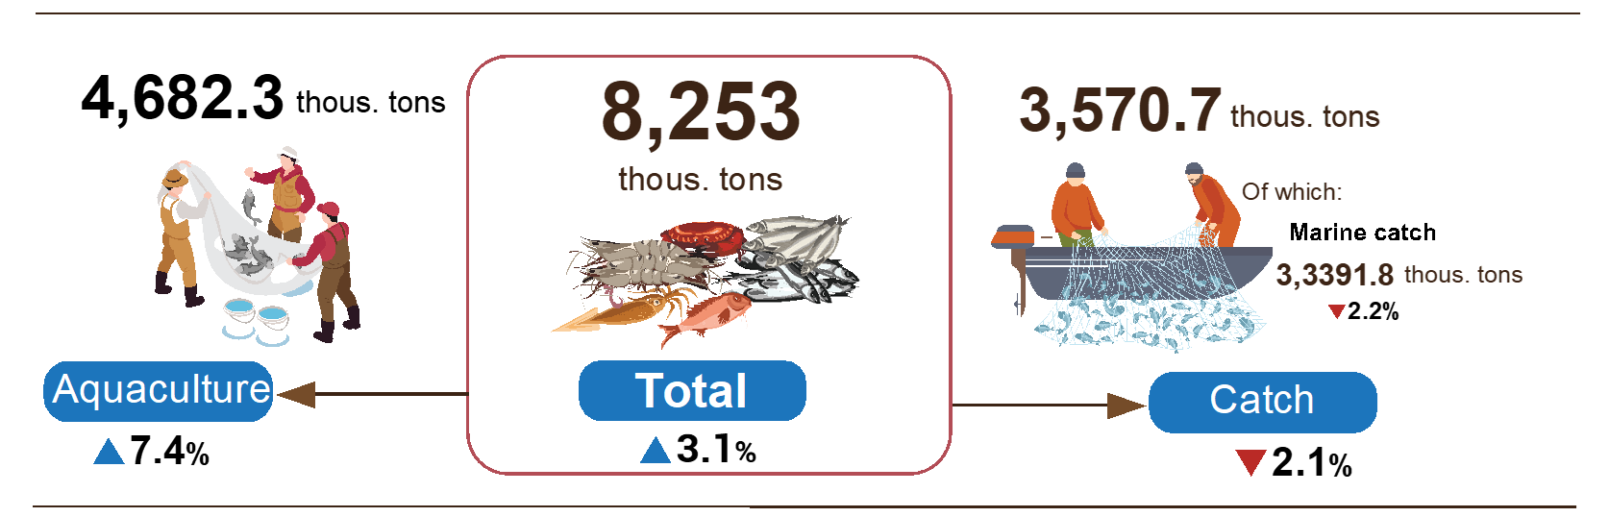
Generally, in the 11 months of 2022, fishery output was estimated at 8,253 thousand tons, up 3.1% over the same period last year, including fish reached 5,943.9 thousand tons, up 2.6%; shrimp reached 1,124.8 thousand tons, up 7.7%; other fishery products reached 1,184.3 thousand tons, up 1.2%.
2. Industrial production
Industrial production in November was estimated to increase by 0.3 % over the previous month and by 5.3% over the same period last year. The growth rate tends to slow down due to declining orders, high input costs and shortage of raw material supply. In the 11 months of the year , the whole index of industry production is estimated to increase by 8.6% over the same period last year.
The index of industrial production (IIP) in November was estimated to increase by 0.3% over the last month and by 5.3% over the same period last year. Of which, compared to the same period last year, the manufacturing increased by 4.4%; Electricity, gas, steam and air conditioning supply by 4.6%; Water supply; sewerage, waste management and remediation activities increased by 13.2%; mining increased by 16%.
Generally for 11 months of 2022 , IIP is estimated to increase by 8.6% over the same period last year (the same period of 2021 increased by 4.2%). Of which, the processing and manufacturing industry increased by 8.9% (the same period in 2021, by 5.4%), contributing 6.8 percentage points to the overall increase; electricity production and distribution increased by 7.7%, contributing 0.7 percentage points; Water supply; sewerage, waste management and remediation activities increased by 7.1%, contributing 0.1 percentage points; the mining industry increased by 6.5%, contributing 1 percentage point to the overall increase.
Production index for 11 months of 2022 of some 2 digit industries increased sharply compared to the same period last year: Manufacture of beverages (31%); Manufacture of pharmaceuticals, medicinal chemical and botanical products (18.8%); Manufacture of wood and of products of wood and cork (18.4%); manufature of leather and related products (16.7%); Manufacture of wearing apparel (16.4%); production of machinery and equipment n.c.e (16.2%); Manufacture of other transport equipment (12.7%); Waste collection, treatment and disposal activities; materials recovery (11.3%); Manufacture of electrical equipment (10.4%); Manufacture of paper and paper products (10.3%). In the opposite direction, the IIP index of some industries decreased: Manufacture of basic metals (-2.6%); Manufacture of rubber and plastics products (-7%).

Table 1. Growth rate of some key industries’s IIP index in the 11 months of 2018-2022 compared to the same period last year

%
 | 2018 | 2019 | 2020 | 2021 | 2022
Manufacture of beverages | 7.8 | 10.9 | -5.6 | -4.1 | 31.0
Manufacture of pharmaceuticals, medicinal chemical and botanical products | 19.5 | -3.0 | 29.2 | -18.3 | 18.8
Manufacture of wood and of products of wood and cork | 3.7 | 8.9 | -5.4 | 2.8 | 18.4
Manufacture of leather and related products | 10.3 | 9.8 | -2.5 | 4.2 | 16.7
Manufacture of wearing apparel | 11.2 | 7.9 | -4.8 | 6.3 | 16.4
Manufacture of machinery and equipment n.e.c | 2.7 | 10.7 | 0.2 | 1.4 | 16.2
Manufacture of other transport equipment | 5.3 | -5.5 | -9.8 | -2.3 | 12.7
Waste collection, treatment and disposal activities; materials recovery | 3.3 | 6.3 | 5.0 | 4.3 | 11.3
Manufacture of electrical equipment | 6.5 | 9.8 | 2.2 | -2.1 | 10.4
Manufacture of paper and paper products | 13.5 | 12.1 | 7.4 | 3.1 | 10.3
Manufacture of basic metals | 23.8 | 31.7 | 12.9 | 23.4 | -2.6
Manufacture of rubber and plastics products | 2.6 | 14.4 | 4.6 | 0.3 | -7.0

Industrial production index for 11 months of 2022 compared with the same period last year increased in 61 localities and decreased in 02 localities across the country. Some localities with IIP index achieved a relatively high increase due to the manufacturing industries; Electricity, gas, steam and air conditioning supply. On the other hand, some localities have low or low increase in IIP index due to the manufacturing industry; Mining industry and electricity production and distribution industry increase slightly or decrease.

Figure 4. IIP’s growth rate in 11 months of 2022
compared to the same period last year of some localities
Some key industrial products in 11 months of 2022, a high increase compared to the same period last year: Beer increased by 34.9%; Processed fishery products and automobiles together increased by 17.3%; Phone accessories by 16.9%; Petroleum by 12.9%; Chemical paint by 12%; Steel bars and corners by 11.8%; motorbikes by 10.8%; Leather footwear by 9.7%; cigarettes and Natural gas (in the form of air) both by 9.1%. In the opposite direction, a number of products decreased compared to the same period last year: Television decreased by 0.6%; liquefied petroleum gas (LPG) decreased by 1.1%; Textile fabric from polyester or artificial yarn decreased by 1.7%; aquatic feed decreased by 4.1%; mobile phones down 6.1%; mixed fertilizer NPK decreased by 6.6%; Crude steel, iron decreased by 16.6%.
The number of employees working in industrial enterprises as of November 1, 2022 increased by 0.4% over the same period last month and by 5.9% over the same period last year. Of which, Labor in State-owned enterprises increased by 0.1% and decreased 7.2%; non-state enterprises decreased by 0.1% and increased by 2.9%; foreign direct invested enterprises increased by 0.6% and 7.9%. By industry, the number of employees working in mining and quarrying enterprises increased by 0.1% over the same period last month and decreased by 0.1% over the same period last year; manufacturing increased by 0.4% and 6.3%; Electricity, gas, steam and air conditioning supply remained unchanged and increased by 0.2%; Water supply; sewerage, waste management and remediation activities increased by 0.2% and up 4.3%.

3. Business registration status
In November, the whole country had nearly 12 thousand newly established enterprises, up 0.3% over the same period last year; nearly 6.3 thousand re-open registered enterprises, up 26.4%. In the 11 months of 2022, the total number of enterprises participating in the market (including newly established enterprises and re-open registered enterprises) reached 194.7 thousand enterprises, an increase of 33.2% over the same period last year, 1.3 times higher than the 11-month average in the period 2017-2021 (153.7 thousand enterprises).
In November 2022, the whole country had 11,943 newly established enterprises with registered capital were 104.5 trillion VND and a total number of registered employees of 74 thousand employees, a decrease of 8.3% in the number of enterprises, a decrease of 2.3% in the registered capital and a decrease of 3.7% in the number of employees compared to last month; up 0.3% in the number of enterprises, a decrease of 30.3% in the registered capital and a decrease of 3.4% in the number of employees compared to the same period last year. The average registered capital of a newly established enterprise in the month reached 8.7 billion VND, up 6.6% compared to last month, and a decrease of 30.5% compared to the same period last year. In November, there were 6,267 re-operated enterprises in the whole country, which up 60.6% compared to the previous month and up 26.4% compared to the same period last year.
Generally, in the 11 months of this year, the whole country had 137.8 thousand newly registered enterprises with a total registered capital of 1,483.7 trillion VND and a total number of 909 thousand registered employees, up 30.4% in the number of enterprises, an increase of 2% in number the registered capital and 15.9% increase in the number of employees compared to the same period last year. The average registered capital of a newly established enterprise in 11 months achieved 10.8 billion VND, down 21.8% compared to the same period last year. If including 2,981.2 trillion VND of the additionally registered capital of 46.5 thousand enterprises that recorded an upward adjustment of capital, the total additional registered capital in the economy in 11 months of this year was 4,464.9 trillion VND, up 21.5% compared to the same period last year. Besides, there were 56.9 thousand re-operated enterprises, an increase of 40.5% over the same period last year, bringing the total number of newly registered enterprises and re-operated enterprises in 11 months this year to 194.7 thousand enterprises, an increase of 33.2%. The average every month had 17.7 thousand newly established and re-operated enterprises.
By economic sector in 11 months, there were 1,831 newly-established enterprises in the agriculture, forestry, and fishery sector, up 0.3% compared to the same period last year; 33.9 thousand enterprises in the industry and construction sector, up 19.6%; 102.1 thousand enterprises in the service sector, increased by 35.2%.

Figure 5. Business Registration 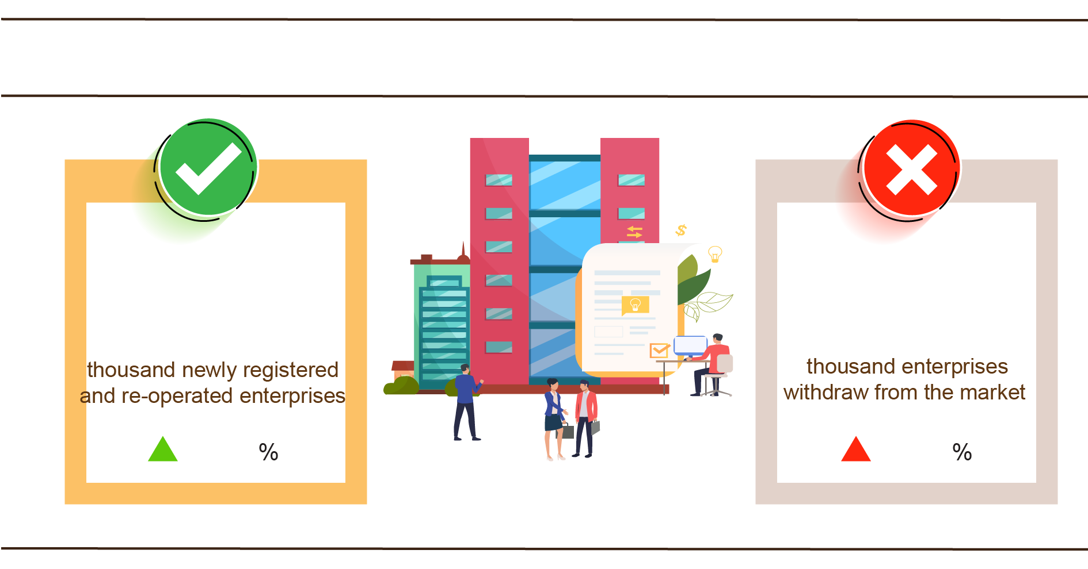
11 months, 2022 compared to the same period last year
194.7
132.3
33.2
24.3
In November 2022, 4,006 enterprises ceased for a certain time, a decrease of 1.3% compared to last month and an increase of 13.7% compared to the same period in 2021; 5,095 enterprises temporarily ceased and awaited dissolution procedures, an increase of 21.3% and up 9.8%; 1,422 enterprises completed dissolution procedures, a decrease of 11.2% and up 13.2%.
In 11 months this year, there were 70.2 thousand enterprises temporarily ceased for a certain time, an increase of 34.8% compared to the same period last year; 45.3 thousand enterprises temporarily ceased and awaited dissolution procedures, a climb up 14.7%; 16.8 thousand enterprises completed dissolution procedures, an increase of 13.3%. On average, 12 thousand enterprises withdraw from the market each month.

Table 2. Number of newly registered enterprises and completed dissolution
procedures 11 months 2022 by kinds of activity

 | Number of enterprises (Enterprise) |  | Growth rate  over the same period  last year (%)
 | Newly registered | Dissolution | Newly registered | Dissolution
Wholesale and retail trade; repair of motor vehicles and motorcycles | 48,907 | 5,948 | 35.1 | 9.1
Manufacturing | 17,323 | 1,990 | 27.0 | 17.1
Construction | 14,861 | 1,516 | 14.7 | 10.5
Real estate business | 8,202 | 1,081 | 22.2 | 43.9
Transportation and storage | 6,570 | 631 | 20.7 | -2.2
Accommodation and catering service | 5,973 | 814 | 71.4 | -1.5
Production and distribution of electricity, water, gas | 997 | 426 | -11.2 | 21.4

4. Investment
Investment capital from the State budget in November was focused efforts by ministries, branches, and localities to deploy, and implement projects, in order to achieve the maximum amount of positive support for economic growth for the whole year. In the eleven months of 2022, investment capital realized from the State budget was estimated at 74.9% of the year plan, up 19.9% over the same period last year. The implemented foreign direct investment capital in Vietnam in 11 months of 2022 was estimated at 19.68 billion USD, up 15.1% over the same period last year.
Realized investment capital from the State budget in November was estimated at 58.5 trillion VND, up 19.7% over the same period last year, including Centrally managed capital reached nearly 10.8 trillion VND, up 35.3%; local capital under management was 47.7 trillion VND, up 16.6%. In the eleven months of 2022, investment capital realized from the State budget was estimated at 445.9 trillion VND, equaling 74.9% of the year plan and increasing 19.9% over the same period last year (the same period last year in 2021 equaling 74% and down 7.7%). Specifically:
- Realized investment capital under central management was estimated at 80 trillion VND, equaling 68.8% of the year plan and increasing by 23.2% over the same period last year.

Figure 6. Realized investment capital from the State budget
In the 11 months of 2022 by Ministries
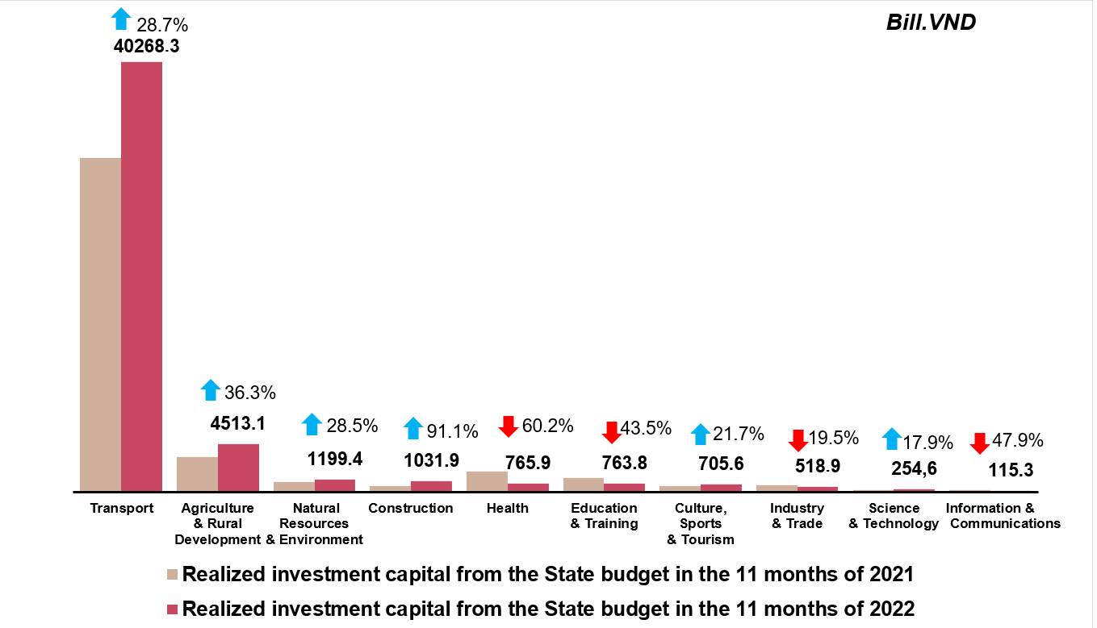
- Realized investment capital under local management was estimated at 365.9 trillion VND, equaling 76.4% of the year plan and increasing by 19.2% so over the same period last year, of which:
Provincial state budget capital reached 242 trillion VND, equaling 72.6% and increasing by 17.6% over the same period in 2021;
State budget capital at the district level reached 106.5 trillion VND, equaling 83.5% and increasing by 25,4%;
State budget capital at the commune level reached 17.4 trillion VND, equaling 95.6% and increasing by 7.8%.
Realized investment capital from the State budget for the eleven months of 2022 of some provinces and centrally-run cities was as follows:

Figure 7. Realized investment capital from the State budget
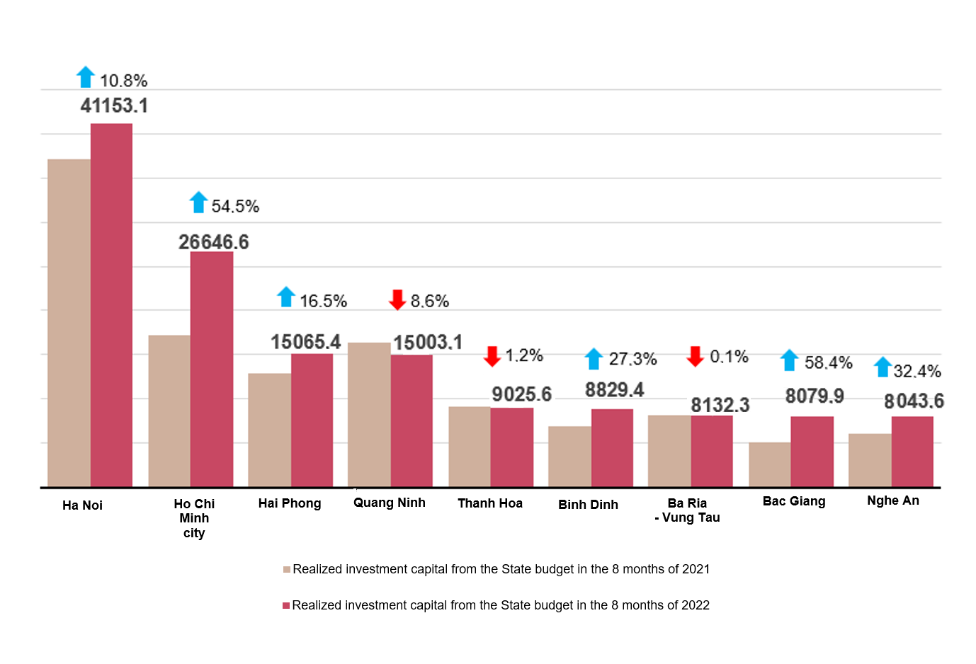
In the 11 months of 2022 by some provinces
Bill. VND
The foreign direct investment from the beginning of the year to 20th November 2022 including newly registered capital, adjust registered capital, and the total value of capital contribution and share purchases of foreign investors reached nearly 25.14 billion USD, decreased by 5% compared to the same period in 2021.

Figure 8. The registered capital of foreign investment in Vietnam
from date November 20 in years of 2018-2022 (Billion USD)
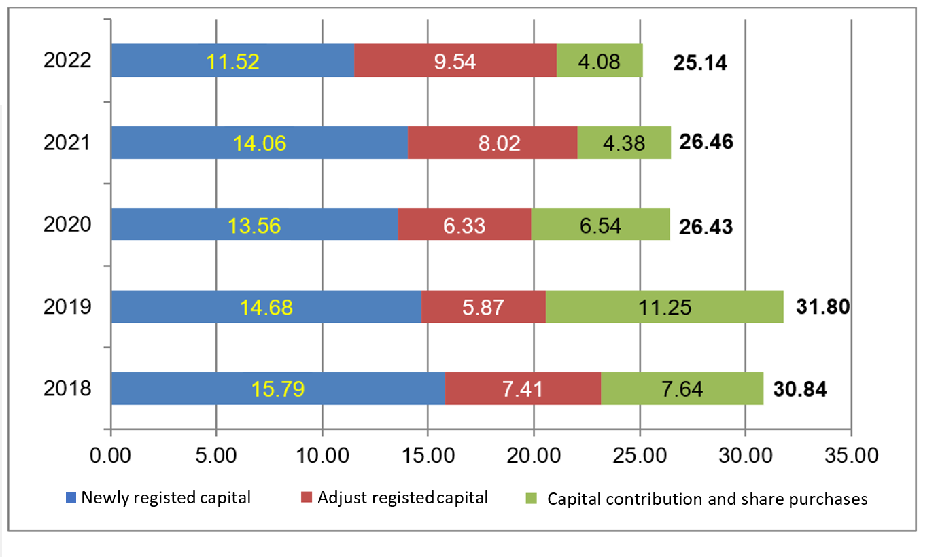
- Newly registered capital included 1,812 newly licensed projects with a registered capital of 11.52 billion USD, up 14.9% over the same period last year in the number of projects and a decrease of 18% in the registered capital. Of which, processing and manufacturing industry attracted the 1st foreign direct investor with the registered capital of newly licensed projects reaching 6.52 billion USD, accounting for 56.6% of the total newly registered capital; production and distribution of electricity, gas, hot water, steam, and air conditioning reached 2.1 billion USD, accounting for 18.2%; the remaining industries reached 2.9 billion USD, accounting for 25.2%.
Among 72 countries and territories having newly licensed investment projects to Vietnam in 11 months in 2022, Japan was the largest investor with 3.23 billion USD, accounting for 28.1% of total newly registered capital; following was Singapore with 1.97 billion USD, accounting for 17.1%; Denmark 1.32 billion USD, accounting for 11.5%; China 1.29 billion USD, accounting for 11.2%; Korea 930.8 million USD, accounting for 8.1%; Hong Kong (China) million USD, accounting for 8%.
- Adjust registered capital included 994 turns of projects which were licensed in the previous years registered to adjust investment capital with the additional capital of 9.54 billion USD, increased by 18.9% compared to same previous of last year.
If including additionally newly registered capital and adjust registered capital of licensed projects in previous years, foreign direct investment capital in the processing and manufacturing industry reached 14 billion USD, accounting for 66.5% of the total newly registered capital and additional capital; real estate business reached 2.76 billion USD, accounting for 13.1%; the remaining industries reached 4.29 billion USD, accounting for 20.4%.
- Capital contribution and share purchases of foreign investors included 3,298 turns with a total value of the capital contribution of 4.08 billion USD, a decrease of 7% compared to the same period last year. Of which 1,481 turns of capital contribution, share purchase caused the increase of charter capital of the enterprise with the value of contributed capital of 2.12 billion USD and 1,817 turns of foreign investors repurchased domestic shares without increasing the charter capital with a value of 2 billion USD. About the form of capital contribution and share purchase by foreign investors, the investment capital in the real estate business reached 1.43 billion USD, accounting for 35.1% of the total capital contribution; the processing and manufacturing industry reached 955.9 million USD, accounting for 23.4%; the remaining industries reached 1.69 billion USD, accounting for 41.5%.
Foreign direct investment capital that was implemented in eleven months of 2022 reached 19.68 billion USD, an increase of 15.1% over the same period last year. This is the highest increase of the 11months of the year in the past 5 years. Of which the processing and manufacturing industry reached 15.52 billion USD, accounting for 78.8% of total realized foreign direct investment capital; real estate business activities gained 1.44 billion USD, making up 7.3%; production and distribution of electricity, gas, hot water, steam, and air conditioning recorded 1.43 billion USD, comprising of 7.3%.

Figure 9. Implemented foreign direct investment
11 months of the years 2018-2022 (Billion USD)
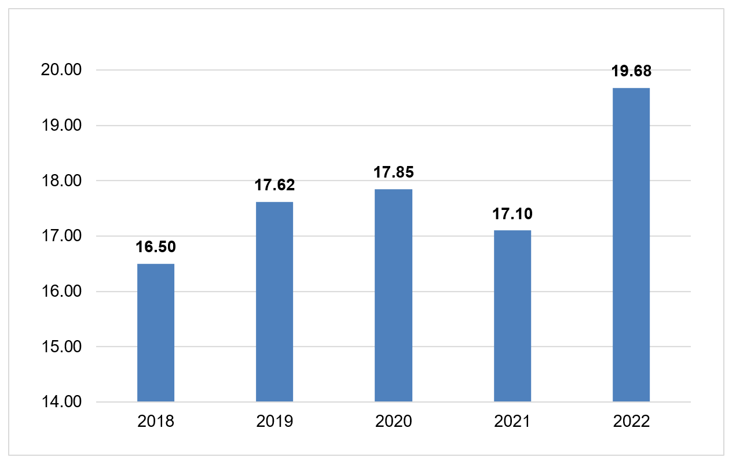

Vietnam's investment abroad in 11 months of 2022, there were 101 projects newly granted investment certificates with a total investment capital of 395.8 million USD, a increase of 61.9% over the same period of last year; 22 turns of projects adjusted capital with adjust capital up 78.3 million USD, a decrease of 81.9%.
Generally, the total investment capital of Vietnam abroad (newly and additionally licensed capital) reached 474.1 million USD, a decrease of 30% over the same period last year, in which the processing and manufacturing industry 236.4 million USD, making up 49.9% of the total investment capital; real estate business activities reached 42.8 million USD, making up 9%; wholesale, retail, repair of automobiles, motorcycles, motorbikes and other motor vehicles gained 41.1 million USD, comprising of 8.7%.
In 11 months of 2022, 27 countries and territories received investment from Vietnam, of which: Singapore was the leading country with 79.5 million USD, making up 16.8% of the total investment capital; Laos 70 million USD, making up 14.8%; United States 38.2 million USD, making up 8.1%; Germany, Netherland, France reached 34,7 million USD at the same time, also making up 7.3%.
5. State budget revenue and expenditure
State budget revenue in the 11 months of 2022 was estimated to increase by 17.4% State budget expenditure was estimated to increase by 7.1% over the same period in 2021, meeting the needs of socio-economic development, defense, security, state management, payment of due debts, supporting people facing difficulties due to the Covid-19 epidemic and restoring production in areas damaged by natural disasters and epidemics.

Figure 10. State budget revenue and expenditure in 11 months of 2022
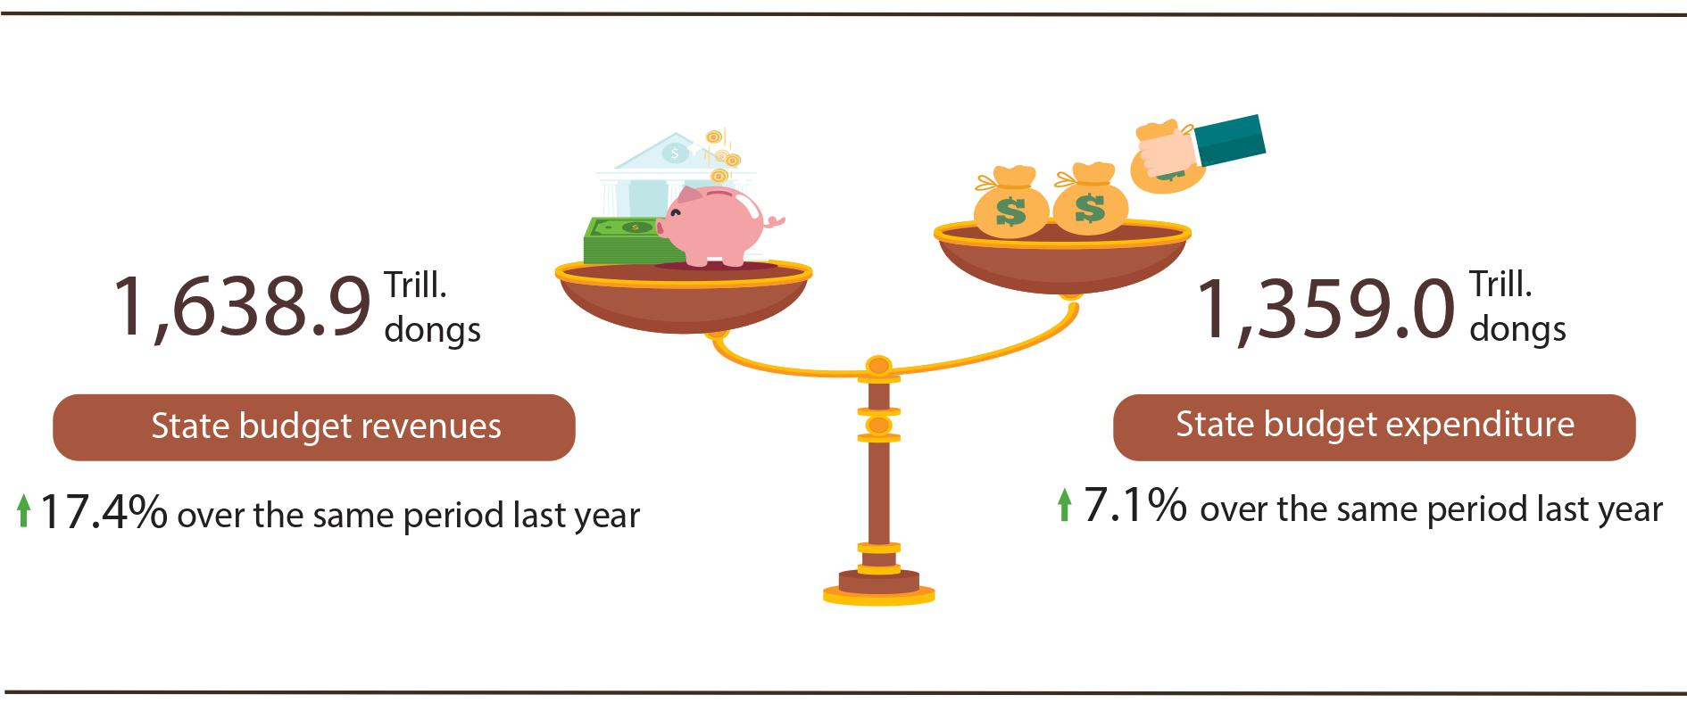
State budget revenue:
Total state budget revenue in November 2022 was estimated at 134.1 trillion VND. Accumulated total state budget revenue in 11 months of 2022 reached 1,638.9 trillion VND, equaling 116.1% of the yearly estimate and increasing by 17.4% over the same period last year . Some of the main revenues are as follows:
- Domestic revenue in November 2022 was estimated at 105.9 trillion VND. Accumulated 11 months of 2022 reached 1,300.7 trillion VND, equaling 110.5% of the yearly estimate and up 13.5% over the same period last year.
- Revenue from crude oil in November 2022 was estimated at 5.5 trillion VND; accumulated 11 months of 2022 reached 69 trillion VND, equaling 244.6% of the year estimate and increasing by 77.6% over the same period last year.
- Balanced budget revenue from import and export activities in November 2022 was estimated at 21.9 trillion VND; accumulated 11 months of 2022 reached 263.5 trillion VND, equaling 132.4% of the year estimate and increasing by 25.1% over the same period last year.
State budget expenditure:
Total state budget expenditure in November 2022 was estimated at 154.5 trillion VND; accumulated 11 months of 2022 was estimated at 1,359.0 trillion VND, equaling 76.2% of the year estimate and increasing by 7.1% over the same period last year. Of which, regular expenditures in 11 months of 2022 reached 935.7 trillion VND, equaling 84.2% of the yearly estimate and increasing by 7% over the same period last year; development investment expenditure reached 338.3 trillion VND, equaling 64.3% and increasing by 14.8%; debt payment interest 82.8 trillion VND, equaling 79.8% and down 8.2%.
6. Trade, prices, transport and tourism
a) Retail sales of consumer goods and services
Trade and consumer services activities were more active in the last month of the year, so the total retail sales of consumer goods and services in November 2022 increased by 2.6% compared to the previous month and by 17.5% compared to the same period last year, in which accommodation and catering service were 1.5 times higher than the same period last year and travel and tourism services were 4.1 times higher. In the 11 months of 2022, the retail sales of consumer goods and services increased by 20.5% over the same period last year.
Retail sales of consumer goods and services in November was estimated at 514.1 trillion VND, up 2.6% from the previous month and up 17.5% over the same period last year. In the 11 months of 2022, the retail sales of consumer goods and services was estimated at 5,180.5 trillion VND, up 20.5% over the same period last year (down 5% in the same period in 2021). If excluding the price factor, the increase would be 16.9% (in the same period in 2021, decreased by 6.8%).

Table 3. Retail sales of consumer goods and services

Trill. VND
 | Estimate November  2022 | Estimate 11  11 months  2022 | Growth rate  compared to same period  last year (%)
 | Estimate November  2022 | Estimate 11  11 months  2022 | November  2022 | 11 months  2022
Total | 514.1 | 5.180.5 | 17.5 | 20.5
Retail sale of consumer goods | 397.1 | 4,079.4 | 10.7 | 14.8
Accommodation and catering service | 53.4 | 536.3 | 51.9 | 56.5
Traveling service | 2.4 | 22.9 | 308.7 | 306.5
Other services | 61.2 | 541.9 | 41.5 | 36.8

Retail sales of consumer goods and services in the 11 months of 2022 increased by 14.9% compared to the 11 months of 2019 - the year before the Covid-19 pandemic. However, the retail sales of consumer goods and services in the 11 months of 2022 only equaled 82.5% of this indicator in terms of scale if it was estimated in the normal condition without the Covid-19 epidemic in the assumption from 2020 to the present.

Figure 11. Retail sales of consumer goods and services
11 months of the years in the 2018-2022 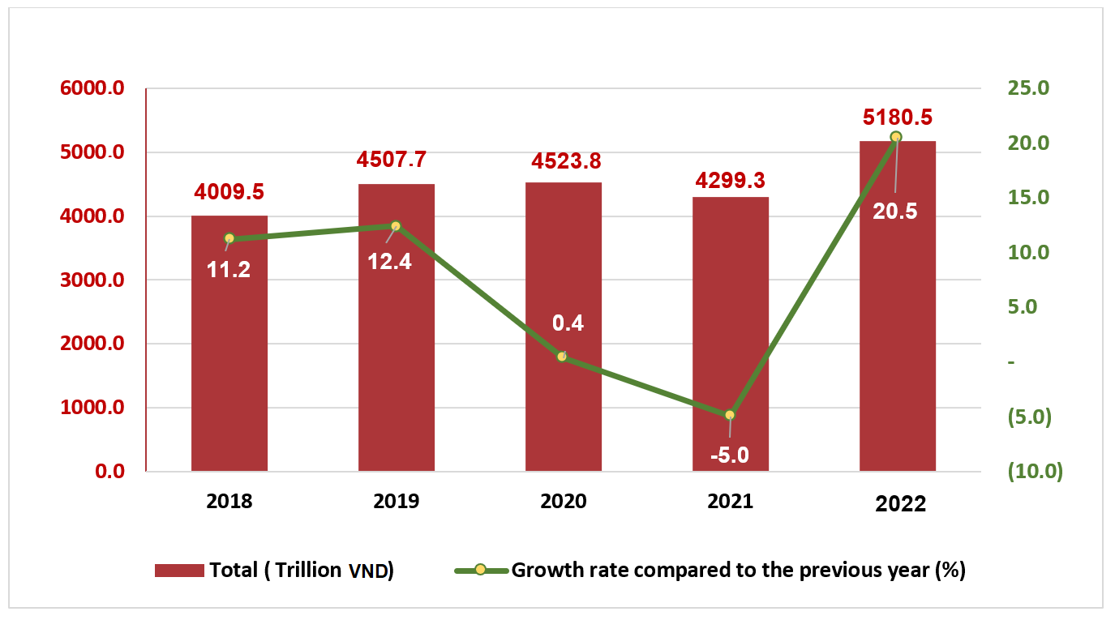

Retail sales of goods in the 11 months of 2022 were estimated at 4,079.4 trillion VND, up 14.8% over the same period last year (excluding the price factor, increased by 11.4%). In which, the group of cultural and educational products increased by 22.9%; garment increased by 17.6%; means of transport (except for cars) increased by 13.8%; food and foodsuff increased by 10.2%; household appliances, tools and equipment increased by 6.6%. Retail sales of goods in 11 months of 2022 compared to the same period last year of some localities were as follows: Khanh Hoa increased by 30%; Ho Chi Minh City increased by 26.8%; Binh Duong increased by 16.2%; Can Tho increased by 14.9%. Da Nang increased by 14.3%; Quang Ninh increased by 11.2%; Hanoi increased by 11%; Hai Phong increased by 9.4%.
Revenue from accommodation and food services in the 11 months of 2022 was estimated at 536.3 trillion VND, up 56.5% over the same period last year. Revenue in 11 months of 2022 compared to the same period last year of some localities were as follows: Ho Chi Minh City increased by 121.7%; Can Tho increased by 122.8%; Hanoi increased by 89.1%; Da Nang increased by 81.3%; Dong Nai increased 62.1%; Quang Ninh increased by 58.2%; Binh Duong increased by 36.8%.
Revenue from tourism and travel services in 11 months of 2022 was estimated at 22.9 trillion VND, 4.1 times higher than the same period last year. Revenue in 11 months of 2022 of some localities compared to the same period last year were as follows: Da Nang increased by 867.1%; Can Tho increased by 647.3%; Hanoi increased by 322.8%; Hai Phong increased by 261.3%; Ho Chi Minh City increased by 191.6%; Quang Ninh increased by 52.1%.
Revenue from other services in 11 months of 2022 was estimated at 541.9 trillion VND, up 36.8% over the same period last year. Specifically, the 11-month increase over the same period last year of some localities were as follows: Da Nang increased by 90.3%; Can Tho increased by 57.5%; Dong Nai increased by 53.4%; Ninh Binh increased by 49.8%; Ho Chi Minh City increased by 33.5%; Hanoi increased by 30.4%; Hai Phong increased by 9.8%.
b) Export and import of goods
In November, total export and import turnover of goods was estimated at 57.58 billion USD, down 1.2% over previous month and down 7.8% over the same period last year. Generally in 11 months, total import-export turnover was estimated at 673.82 billion USD, rose by 11.8% over the same period last year, of which export turnover increased by 13.4%; import turnover increased by 10.1%. The trade balance of goods in 11 months of 2022 was estimated to have a trade surplus of 10.6 billion USD.

Figure 12. Export and import of goods in 11 months of 2022
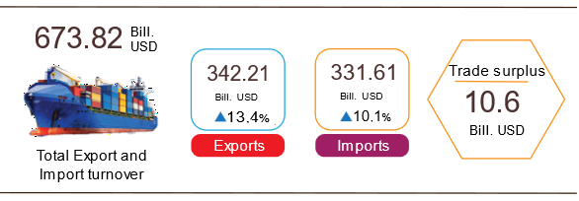

Export of goods
Export turnover in October 2022 reached 30.37 billion USD, 99 million USD higher than the estimated figure.
Export turnover in November 2022 was estimated at 29.18 billion USD, decreased by 3.9% over the previous month, of which the domestic economic sector gained 7.38 billion USD, increased by 0.8%; the FDI sector (including crude oil) reached 21.8 tỷ billion USD, decreased by 5.4%. Compared to the same period last year, export turnover of goods in November decreased by 8.4%, of which the domestic economic sector decreased by 14.2%, the FDI sector (including crude oil) decreased by 6.3%.
Generally, in 11 months of 2022, the export turnover was estimated at 342.21 billion USD, rose by 13.4% over the same period in 2021, of which, the domestic economic sector was 87.46 billion USD, went up 10.1%, accounting for 25.6% of total export turnover; the FDI sector (including crude oil) attained 254.75 billion USD, increased by 14.6%, sharing 74.4%.
In 11 months of 2022, there were 35 products with an export turnover of over 1 billion USD, contributing 93.7% to the total export turnover (08 products with export turnover of over 10 billion USD, accounting for 70.1%).
Table 4. Value of some export products in 11 months of 2022

 | Estimate  11 months of 2022  (Mill. USD) | Growth rate of  11 months of 2022 compare to  the same period last year (%)
Items with a value of over 10 billion USD
Phones all of kinds and their parts | 55,370 | 6.6
Electronic goods, computers and their parts | 50,522 | 11.0
Machinery, instrument, accessory | 41,968 | 23.3
Textiles and garments | 34,530 | 18.5
Footwear | 22,125 | 39.9
Wood and products | 14,587 | 9.0
Means of transport and components | 10,791 | 13.1
Aquatic products | 10,136 | 27.0

Regarding the structure of export products in 11 months of 2022, fuel and mineral products accounted for 1.4%, up 0.2 percentage points over the same period last year; processed industrial products accounted for 89%, equal to the same period last year; agricultural and forestry products accounted for 6.6%, down 0.5 percentage point; aquatic products accounted for 3%, up 0.3 percentage points.
Figure 13. Structure of export groups
in 11 months of 2022 by commodity group
Import of goods
Import turnover of goods in October 2022 reached 27.9 billion USD, 97 million USD lower than the estimated figure.
Import turnover in November 2022 was estimated at 28.4 billion USD, increased by 1.8% over the previous month, of which the domestic economic sector gained 10.16 billion USD, increased by 6.4%; the FDI sector reached 18.24 billion USD, decreased by 0.6%. Compared to the same period in 2021, the import turnover of goods in November decreased by 7.3%, of which the domestic economic sector increased by 0.2%; the FDI sector down 10.8%.
Generally, in 11 months of 2022, the import turnover was estimated at 331.61 billion USD, increased by 10.1% over the same period in 2021, of which the domestic economic sector reached 115.42 billion USD, went up by 11.2%; the FDI sector gained 216.19 billion USD, edged up by 9.6%.
In 11 months of 2022, there were 45 imported products with a turnover of over 1 billion USD, accounting for 93.2% of the total import turnover (06 mặt hàng nhập khẩu trên 10 tỷ USD, chiếm products with export turnover of over 10 billion USD, accounting for 52.3%).

Table 5. Value of some imported goods in 11 months of 2022

 | Estimate  11 months of 2022  (Mill. USD) | Growth rate of  11 months of 2022 compared to  the same period last year (%)
Items with a value of over 10 billion USD
Electronic goods, computers and their parts | 75,746 | 11.1
Machinery, instrument, accessory | 41,481 | -2.0
Phones all of kinds and their parts | 19,777 | 3.0
Fabrics | 13,606 | 5.1
Plastic | 11,667 | 9.6
Iron, steel | 11,159 | 5.8

Figure 14. Structure of import groups
in 11 months of 2022 by commodity group

Regarding the structure of imported goods in 11 months of 2022, the group of production materials accounted for 93.6%, equal to the same period last year, in which the group of machinery, equipment, tools spare parts accounted for 44.7%, down 1.8 percentage points; raw materials, fuel and materials accounted for 48.9%, up 1.8 percentage points. The group of consumer products accounted for 6.4%, equal to the same period last year.

Regarding the export and import market of goods in 11 months of 2022, the United States is the largest export market of Viet Nam with an estimated turnover of 101.5 billion USD. China is Viet Nam's largest import market with an estimated turnover of 109.9 billion USD. In 11 months of 2022, the trade surplus to the EU was estimated at 29.4 billion USD, up 42.4% over the same period last year; trade deficit from China is 56.9 billion USD, up 14.1%; trade deficit from Korea was 35.7 billion USD, up 16.1%; trade deficit from ASEAN is 12.2 billion USD, up 9.4%; trade deficit from Japan is 139 million USD, (the same period had a trade deficit of 2.3 billion USD).

Figure 15. Major commodity import and export markets in 11 months of 2022
 |  | Exports of goods | Imports of goods
The trade balance of goods in October had a trade surplus of 2.47 billion USD; 10 months had a trade surplus of 9.82 billion USD; November was estimated to have a trade surplus of 0.78 billion USD. Generally in 11 months of 2022, the trade balance of goods is estimated to have a trade surplus of 10.6 billion USD (in the same period last year, the trade surplus of 0.6 billion USD). In which, the domestic economic sector has a trade deficit of 27.97 billion USD; the FDI sector (including crude oil) had a trade surplus of 38.57 billion USD.
c) Consumer price index, gold price index and US dollar
Domestic petrol and oil prices adjusted to world prices, rising rents due to high demand from the people were the main reasons for the increase of the consumer price index (CPI) in November 2022 by 0.39% compared to the previous month. Compared to December 2021, CPI in November increased by 4.56% and over the same period last year by 4.37%.
On average in 11 months of 2022, CPI increased by 3.02% over the same period last year; core inflation increased by 2.38%.

Figure 16. CPI growth rate in November and 11 months
Of the years from 2018-2022 (%)
In the 0.39% increase of CPI in November 2022 compared to the previous month, there were 08 groups of goods and services with an increase in price index and 03 groups of goods with a decrease in price index.
(1) Eight groups of goods and services with an increase in the price index include:
- Transport group increased the highest with 2.23% (making the general CPI increase by 0.22 percentage points) due to the influence of domestic petrol price adjustments on November 1st, 2022, and November 11st, 2022 and November 21st, 2022, causing gasoline prices to increase by 5.83% (gasoline increased by 5.84%; diesel oil increased by 5.25%). Besides, the vehicle price index increased by 0.15%; spare parts by 0.16%; other services with personal means of transport increased by 0.15%; public transport services increased by 0.14%.
- Housing and construction materials increased by 0.97% (making the general CPI increase by 0.18 percentage points) due to the high demand for housing, causing housing rent to increase by 1.54%; housing repair service prices increased by 0.45% due to the increase in painting and wall construction, bricklaying, unskilled labor, increased demand for home repair and construction at the end of the year; the price of housing maintenance materials increased by 0.28% because the price of cement, bricks, concrete bricks, roofing sheets, wall paint increased according to the price of input materials for production; gas price increased by 5% because from November 1st, 2022, the domestic gas price was adjusted to increase by 20,000 VND/bottle kind of 12 kg kg after the world gas price increased by 35 USD/ton (from 575 USD/ton to 610 USD/ton); kerosene oil price increased by 7.02% due to the impact of price adjustments on November 1st, 2022, November 11st, 2022 and November 21st, 2022. In the opposite direction, the price of water and electricity for daily life decreased by 0.09% and 1.79% respectively due to the cool weather, so the demand for electricity and water decreased.
- Beverage and cigarettes increased by 0.26% due to high consumer demand and USD exchange rate.
- Garments, hats, and shoes increased by 0.22% due to the increase in the price of production materials, transportation costs and the increased demand for winter clothes.
- Other goods and services with the same increase of 0.22% mainly focusing on jewelry, increasing by 1.08%; hair cutting and shampooing increased by 0.23%; personal care services increased by 0.1%; wristwatches increased by 0.56%.
- Household appliances increased by 0.21% mainly focusing on items such as: Refrigerator prices increased by 0.16%; vacuum cleaners increased by 0.25%; hot and cold tanks increased by 0.14%; printers, projectors and scanners by 0.13%; blender, fruit juicer increased 0.18%; soap and detergent by 0.26%; beds, cabinets, tables and chairs increased by 0.26%; gas stoves increased by 0.1%... In the opposite direction, the price of air conditioners decreased by 0.22%; computers and desktop accessories 0.05% off.
- Culture, entertainment, and tourism groups had the same increase of 0.21% because cultural services increased by 0.28%; in the month with Vietnamese Teachers' Day on November 20th, the demand for flowers increased, causing the price index of flowers, ornamental plants and ornamental plants to increase by 1.91%; movie and music ticket prices increased by 0.82%; toys increased by 0.29%.
- Medicine and medical service group increased by 0.06%.
(2) Three groups of goods and services have decreased price index:

- The education group decreased by 0.63% (making the general CPI decrease by 0.04 percentage points), of which the educational service price index decreased by 0.71% mainly because Hanoi city provided tuition support for preschool, general education, vocational-educational centers according to Resolution No. 17/2022/NQ-HDND dated September 12nd, 2022, according to which the price index of educational services in Hanoi decreased by 9.54 reducing the price index of educational services in the whole country.
- Food and catering services decreased by 0.07% (making CPI decrease by 0.02 percentage points), of which: Food increased by 0.59% (general CPI impact increased by 0.02 percentage pointsmainly because exporters increased rice purchases from farmers to fulfill signed contracts, and at the same time, the increase in the USD exchange rate caused the price of exported rice to rise, which has encouraged exporters to boost sales abroad; foodstuff decreased by 0.3% (general CPI impact decreased by 0.06 percentage points) due to stable husbandry situation, well controlled epidemics, an increase in the total herd of livestock and poultry compared to the same period in 2021, warm weather is favorable for harvesting green vegetables, so the price of some items decreases; outdoor eating and drinking increased by 0.22% (the overall CPI impact increased by 0.02 percentage points).
- Postal services and telecommunications decreased by 0,02%.
Core inflation in November 2022 increased by 0.43% over the previous month, up 4.81% over the same period last year. On average, in the 11 months of 2022, core inflation increased by 2.38% over the same period in 2021, lower than the general average CPI (up 3.02%), which reflects consumer price fluctuations mainly due to food prices and gasoline prices.
The domestic gold price fluctuates in the same direction as the world gold price. As of November 25th, 2022, the average world gold price stood at 1,727.52 USD/ounce, up 3.33% compared to October 2022. Gold prices rose sharply because the US inflation in October cooled down, leading to the expectation that the US Federal Reserve (FED) could slow down the rate hike. Domestically, the gold price index in November 2022 increased by 1.82% compared to the previous month; an increase of 3.95% over the same period in 2021; average increase of 5.88% in 11 months of 2022.
The US dollar in the world market fluctuated up and down. In the policy meeting on November 2nd, 2022, the FED decided to raise interest rates by 0.75 percentage points, bringing the federal funds rate to 3.75-4%. This is the fourth consecutive 0. percentage point increase offered by the FED and the sixth rate hike since March 2022. However, after the US inflation in October was lower than expected, the US dollar fell sharply. As of November 25th, 2022, the average US dollar index in November 2022 on the international market reached 108.16 points, down 3.4 points from the previous month. Domestically, the average US dollar price on the free market is around 24,855 VND/USD. US dollar price index in November 2022 increased by 2.91% over the previous month and by 8.71% over the same period in 2021; average increase in 11 months of 2022 by 1.83%.
d) Transport
Transport activities in November had positive growth in both passenger and freight transport compared to the same period last year, in which passengers carried increased by 2.3 times and passenger traffic increased by 3.1 times; freight carried increased by 28.7% % and freight traffic increased by 29.8%.
Generally, for the 11 months of 2022, passengers carried increased by 48.7% over the same period last year, passengers traffic increased by 71.4% and freight carried increased by 24.6%, freight traffic increased by 32.8% .
Passengers transport in November 2022 was estimated at 283.6 million passengers, increase of 2.2% compared to the previous month and 12.5 billion passengers-kilometers, an increase of 3.2%. Generally, in 11 months of 2022, passenger carried estimated at 3,350.4 million passengers, up 48.7% over the same period last year (decreased by 30.6% in the same period in 2021) and passenger traffic reached 155.4 billion passengers.km, an increase of 71.4% (in the same period last year, a decrease of 38.5%). In which, domestic transport reached 3,346.2 million passengers carried, up 48.5% over the same period last year and 142.2 billion passengers-kilometers, up 57.7%; Overseas transport got 4.2 million passengers, 32.4 times higher than the same period last year and 13.2 billion passengers-kilometers, 27.8 times higher. Although passenger transport has made a positive recovery, it is only equal to 72.6% of passenger carried and 68.4% of passenger traffic compared to the same period in 2019, the year there was no Covid-19 epidemic.

Table 6. Carriage of passengers in 11 months of 2022
by types of transport

 | Number of passengers |  | The growth rate  compared to the same period last year (%)
 | Carried  (Mill. passengers) | Traffic  (Bill. passengers-km) | Carried | Traffic
Total | 3,350.4 | 155.4 | 48.7 | 71.4
Railway | 4.1 | 1.5 | 198.1 | 146.5
Seaway | 7.2 | 0.4 | 57.7 | 75.8
Inland waterway | 213.4 | 3.1 | 43.5 | 20.7
Road | 3,080.6 | 99.0 | 47.8 | 33.2
Airway | 45.1 | 51.4 | 218.2 | 297.1

Freight transport in November 2022 was estimated at 182.5 million tons of freight carried, up 2.2% over the previous month and 41 billion tons-km of freight traffic, down 0.5%. Generally, in 11 months of 2022, freight transport was estimated at 1,832.9 million tons of freight carried, up 24.6% over the same period last year (in the same period in 2021, increasing by 8%) and 402 billion tons.km of freight traffic, an increase of 32,8% (in the same period last year, a decrease of 1%). In which, domestic transport reached 1,793.3 3 million tons of freight carried, up 24.3% and 245,9 billion tons-kilometers of freight traffic, up 50.7%; Overseas transport reached 39.6 million tons freight carried, up 39.6% and 156.1 billion tons-kilometers of freight traffic, up 11.8%. Enterprises went into stable operation, import and export continued to prosper, so the demand for domestic and foreign freight transportation in the 11 months of 2022 increased sharply compared to the same period last year. Freight transport in 11 months of 2022 increased by 7.4% in freight carried and 21% in freight traffic over the same period in 2019.

Table 7. Carriage of freight in 11 months of 2022
by types of transport

 | Quantity of goods |  | The growth rate  compared to the same period last year (%)
 | Carried  (Mill. tons) | Traffic  (Bill. tons-km) | Carried | Traffic
Total | 1,832.9 | 402.0 | 24.6 | 32.8
Railway | 5.3 | 4.3 | 3.6 | 18.4
Seaway | 98.9 | 215.0 | 29.2 | 38.9
Inland waterway | 371.5 | 86.8 | 28.9 | 40.4
Road | 1,356.9 | 90.4 | 23.2 | 19.8
Airway | 0.3 | 5.5 | 2.9 | -23.3

đ) International visitors to Viet Nam
International visitors to our country in November were estimated at 596.9 thousand arrivals, increased by 23.2% compared to the previous month and 39.7 times higher than the same period last year because Viet Nam has opened up to tourism, international routes have been restored. Generally, in 11 months of 2022, international visitors to Viet Nam were estimated at 2,954.2 thousand arrivals, 21.1 times higher than the same period last year but still down 81.9% compared to the same period in 2019, the year no Covid-19 epidemic.
Out of a total of nearly 2,954.2 thousand international visitors to Viet Nam in 11 months of this year, visitors coming by airway gained 2,627.2 thousand persons, accounting for 88.9% of the number of international visitors to Viet Nam, 27.2 times higher than the same period last year; by roadway achieved 326.1 thousand arrivals, accounted for 11.1% and 7.6 times higher; by seaway achieved 855 arrivals, accounted for 0.03% and 1.7 l times higher.

Figure 17. International visitors to Viet Nam
in 11 months of 2022 by territories
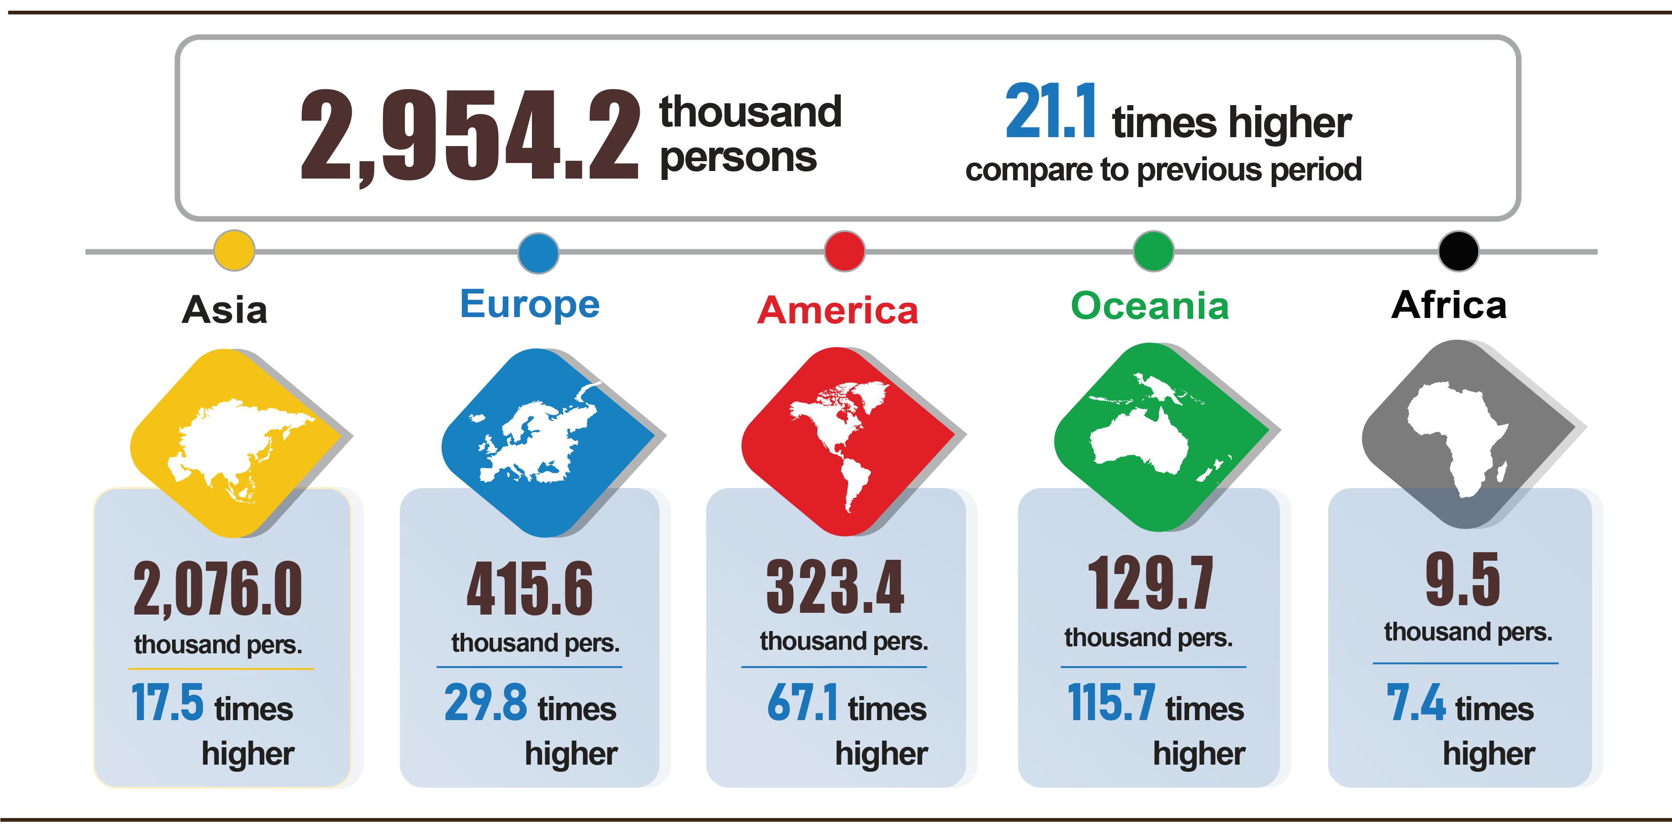

7. Some social situation
a) Residential life
According to preliminary results from the Household Living Standards Survey in the 11 months of 2022, the living situation continues to be better. The percentage of households assessed that their income in the month remained unchanged and increased compared to November 2021 was 84.9% (of which 43.4% of households assessed their income increasing, 41.5% assessed their income was unchanged); assessed that has decreased was 15.1%. Among the reasons for reducing household income, 69.8% rated it due to the impact of the Covid-19 pandemic; 20.6% assessed that members of the household lost their jobs/temporarily quit their jobs, and 16.1% of households assessed that input costs for production and business activities of the household increased. Regarding the negative impacts on life in the 11 months of 2022, 54.4% are suffering from negative impacts of the Covid-19 pandemic; 2.2% are from diseases on livestock and crops, and similarly, 2% are affected by other diseases.
In 11 months of 2022, 24% of households received help from different sources of support. Specifically, the percentage of households receiving support from general national programs and policies was 9.8%; from relatives, relatives was 11.9%; from local programs and policies was 8.9%; from charitable activities of other organizations and individuals was 5.1% and from other sources was nearly 0.2%.
According to a report of the Ministry of Labor, War Invalids and Social Affairs, as of November 23, 2022, the support package under Resolution No. 11/NQ-CP dated January 30, 2022 has disbursed about 3.7 billion VND to support nearly 123 thousand enterprises with 5.3 million employees. Specifically, support 3.2 trillion VND for 4.82 million employees working in more than 94 thousand enterprises; supporting 527.2 billion VND for 450.9 thousand employees returning to the labor market at 29 thousand enterprises.
In addition, to prevent people from suffering from hunger, from the beginning of the year, the Government has issued 25 tons of rice to 492.5 thousand households with more than 1.6 million people, of which: Nearly 14 thousand tons of rice to 292 thousand households with more than 930 thousand people on the occasion of Tet; 10.3 thousand tons of rice to 192 thousand households with more than 691 thousand people in the pre-seed season; 432.8 tons of rice to support disaster recovery for 8.4 thousand households with 28.8 thousand people.
b) Epidemic diseases and food poisoning
According to the report of the Ministry of Health, in the month (October 19 – November 18, 2022), there were 45 thousand cases of hemorrhagic fever (10 cases died); 7,006 cases of hand, foot and mouth disease; 30 cases of virus encephalitis; 01 cases of meningococcal disease (01 case died); 61 cases of scarlet fever suspected for measles. Generally, in the 11 months of 2022, there were 303.6 thousand cases of hemorrhagic fever (112 cases died); 62.4 thousand cases of hand, foot and mouth disease (03 cases died); 269 cases of virus encephalitis (05 cases died); 12 cases of meningococcal disease (01 case died); 300 cases of scarlet fever suspected for measles.
The world's Covid-19 epidemic continues to be complicated, warning that there are new variants of SARS-CoV-2 that increase the number of new cases. In Vietnam, the number of severe and critical Covid-19 cases continues to decrease. From the first case of Covid-19 in Vietnam on January 23, 2020 to November 27, 2022, there were 11.5 million cases have been reported, of which 10.6 million have been cured and 43.2 thousand cases died.
The progress of fully injecting 2 basic doses of Covid-19 vaccine for children aged 5-11 and 3 injections for ages 12-18 is being accelerated to achieve the set target. From March 8, 2021 to November 26, 2022, the total number of doses of Covid-19 vaccine that have been administered 264.1 million doses, of which the first time was 90.3 million does; the second time was 85.1 million doses; additional dose 14.5 million doses; the first booster dose was 57.2 million doses; the second booster dose 17 million doses.
The total number of people living with HIV nationwide as of November 18, 2022 was 221.5 thousand persons and the number of deaths by HIV/AIDS as of the above time-point was 112.5 thousans persons.
In November 2022, there were 03 cases of food poisoning with 20 persons poisoned (03 cases died). Generally, in 11 months of 2022, there were 46 cases of food poisoning with 601 persons poisoned (14 cases died).
c) Cultural and sports activities
The protection and promotion of the value of tangible and intangible cultural heritage are always concerned and invested by localities, in order to promote heritage values and create unique tourism products. The movement "All people unite to build a cultural life" continues to be widely deployed across the country, creating a healthy cultural environment, helping people have conditions to improve their quality of life.
The mass sports movement continued to be promoted in association with the movement "All people exercise their body following the example of the great Uncle Ho" and "Olympic running day for the whole people's health", physical exercise movements. Sports are widely held, some outstanding activities take place in the month such as: People's Teacher Sports Festival 2022 in Nghe An; The Hanoi Open Club Table Tennis Tournament, the IX New Hanoi Newspaper Cup in 2022 in Hanoi; organizing the Olympic Running Day for the people's health and the "Bai Bang Paper Cup" in 2022 in Phu Tho; The Vietnam Journalists Association Cup 2022 in Hanoi.
In terms of high-performance sports, in November 2022, a number of outstanding events will take place such as: Preparation for the 9th National Sports Festival to take place from December 9 to December 21/2022 is being actively deployed by localities and related units; The National Futsal HDBank Cup 2022 will take place from November 21 to November 29, 2022 in Ho Chi Minh city; On November 23, 2022, in Hanoi, the Organizing Committee announced that the International Muay Championship VIETNAM CHAMPIONSHIP 2023 will officially return in Ho Chi Minh City in March 2023.
d) Traffic accident
In November (from October 15 to November 14, 2022), there were 1,111 accidents in the whole country, including 747 from less serious or more and 364 traffic collisions, causing 579 deaths, 440 injuries and 393 minor injuries. Compared to the previous month, the number of traffic accidents increased by 23.6% (the number of traffic accidents from less serious or more increased by 15.8% and the number of traffic collisions decreased by 43.3%) the number of deaths increased by 14.2%; the number of injured people increased by 26.1% and the number of minor injuries decreased by 60.4%. Compared to the same period last year, the number of traffic accidents in November down 5.7% (the number of traffic accidents from less serious or more increased by 0.5% and the number of traffic collisions decreased by 16.3%); the number of deaths increased by 3.6%; the number of injured people increased by 7.3% and the number of people with minor injuries decreased by 8.8%.
Generally, in the 11 months of this year, there were 10,323 traffic accidents nationwide, including 7,177 traffic accidents of less serious or more and 3,146 traffic collisions, killing 5.800 people, 3,752 people injured and 3,221 minor injuries. Compared to the same period last year, the number of traffic accidents in the 11 months of this year increased by 2.1% (the number of traffic accidents from less serious or more increased by 10.3%; the number of traffic collisions decreased by 12.8%); the number of deaths increased by 14.1%; the number of injured people increased by 10.1% and the number of minor injuries decreased by 11.3%. On average, 1 day in 11 months, there were 31 traffic accidents in the whole country, including 22 traffic accidents of less serious or more and 9 traffic collisions, causing 17 deaths, 11 injured and 10 people with minor injuries.
đ) Damage caused by natural disaster
Damage caused by natural disasters in November 2022 was mainly caused by heavy rains, floods, and landslides, causing 01 deaths and 02 injured; 647 houses collapsed, washed away, and damaged; 5.1 thousand ha of paddy and 705 ha of crops were damaged; total value of property damage caused by natural disasters in the month was 44.7 billion VND, down 96.2% over the same period last year.
Generally, for the 11 months of this year, natural disasters made 162 people dead and missing, 281 people injured; 37.9 thousand houses collapsed, and were damaged; 749.2 thousand cattle and poultry died; 217.6 thousand hectares of paddy 63.4 thousand hectares of crops were damaged; the total value of property damage was estimated at 14,077.5 billion VND, 3.9 times higher than the same period in 2021.

e) Environmental protection and fire prevention
In November 2022, according to reports from the Statistical Offices of provinces and centrally run cities, the authorities detected 1,167 870 cases of environmental violations, of which 1,027 cases were handled with a total fine of 21.5 billion VND, down 20.5% from the previous month and up 42.2% over the same period last year. Generally, in the 11 months of this year, 19,689 cases of environmental violations were detected, of which 17,160 cases were handled with a total fine of 243.9 billion VND, up 8.1% over the same period last year.
In the month , the whole country had 199 fires and explosions, killing 7 people and injuring 4 people, with an estimated damage of 13.6 billion VND, down 56.1% compared to the previous month and up 173.3% over the same period last year. Generally, in the eleven months of this year, 1,590 fires and explosions occurred nationwide, killing 114 people and injuring 97 people, causing estimated damage 581.2 billion VND, an increase of 60.6% over the same period last year./.

GENERAL STATISTICS OFFICE

Biomass maize is a short-term crop, that needs warm temperatures to grow, a large stem, tripod roots, resistance falling, and windbreak, grown for leaves, and young corn as forage for the family cattle.
According to the Ministry of Agriculture and Rural Development, as of 15/11/ 2022.
http://agromonitor.vn/group/48/280/giam-sat-gia: In the provinces of the Mekong River Delta, the price of raw pangasius kinds of 0.8-1.0 kg/head ranges from 28,000-30,000 VND/kg, up 7,000 VND/kg over the same period last year.
Industrial production index in August 2022 increased by 13.3% over the same period last year; September 2022 increased by 10.3%; October 2022 increased by 5.5%; estimated increase in November 2022 by 5.3%.
The growth rate of industrial production index in 11 months of 2018-2022 compared to the same period last year respectively was: 10%; 9.3%; 3%; 4.2%; 8.6%.
The growth rate of IIP index in November 2022 compared to the previous month of some large-scale industrial localities are: Long An by 11%; Vinh Phuc increased by 10.7%; Quang Ninh increased by 7.9%; Hai Phong increased by 6%; Bac Giang and Ba Ria - Vung Tau at the same time increased by 3.3%; Binh Duong increased by 2.5%; Thai Nguyen increased by 2.3%; Ho Chi Minh City up 1.6%; Dong Nai increased by 1.4%; Ha Tinh increased by 0.8%; Bac Ninh decreased by 0.5%; Hai Duong down 0.8%; Vinh Long fell 6.7%.
The industry of water supply, management and treatment of waste and waste water in the 11 months of 2021 only increased by 0.4% over the same period last year due to the impact of the Covid-19 epidemic.
Localities have had high production index of the processing and manufacturing industry in the 11 months of 2022 compared to the same period last year: Bac Giang increased by 38.3%; Can Tho increased by 37.8%; Vinh Long increased by 28.8%; Quang Nam increased by 23.9%; Khanh Hoa increased by 23%; Kien Giang increased by 22%. Localities with high index of electricity production and distribution: Lai Chau increased by 23%; Son La increased by 26%; Dak Lak increased by 34.2%; Dien Bien increased by 51.4%.
Localities with low or low growth in the production index of the processing and manufacturing industry in the 11 months of 2022 compared with the same period last year: Binh Dinh increased by 6.8%; Ba Ria - Vung Tau increased by 5%; Dak Nong decreased by 0.4%; Ha Tinh fell 14.1%. Localities with a low or low increase in the index of electricity production and distribution: Binh Thuan down 3.2%; Quang Ninh down 3.4%; Ha Tinh down 31.7%; Tra Vinh down 35%; Lang Son increased by 5.7%. Localities with mining industry decreased: Binh Dinh decreased by 20.1%; Ca Mau decreased by 13.6%; Dak Nong decreased by 1.7%; Ninh Binh down 8.5%; Ha Tinh decreased by 3%.
Due to the high cost of input production, gasoline, and declining orders, businesses producing aqua feed products only operate in moderation.
Source: National Enterprise Registration Information System, Business Registration Management Agency, Ministry of Planning and Investment (Received the report on 26th November, 2022)
Report on the implementation of Resolution No. 01/NQ-CP of the Government in the field of finance - state budget for 11 months and the whole year 2022.
Estimated total export and import value in November 2022 provided by the General Department of Customs on November 28, 2022. The General Statistics Office estimated the import and export value of key commodities in November 2022 based on preliminary data provided by the General Department of Customs by November 25, 2022.
Total export and import turnover in 11 months of 2021 reached 602.8 billion USD, went up 23.1% over the same period last year, of which exports reached 301.7 billion USD, increased by 18.3%; import reached 301.1 billion USD, went up 28.2%.
Estimated trade surplus in October was 2.27 billion USD.
Price of mineral water increased by 0.22%; carbonated beverage prices increased by 0.16%; bottled energy drinks increased by 0.2%; alcohol by 0.33% and smoking by 0.22%.
In which, the price of ordinary rice increased by 0.46%; delicious glutinous rice and glutinous rice both increased by 0.31%. Besides, the price of sweet potato increased by 3.66%; corn by 1.75%; instant noodles, noodles, pho, instant porridge increased by 1.25%; flour by 0.74%; corn flour by 1.02%; vermicelli increased by 0.48%; bread increased 0.44%; instant cereals up 0.24%.
The price of cattle meat decreased by 1.23%, of which pork decreased by 1.67% (making the overall CPI decrease by 0.06 percentage points); beef prices fell by 0.25%; animal organs decreased by 0.84%; frozen cattle meat decreased by 0.12%; poultry meat price decreased by 0.13%; the price of fresh, dried and processed vegetables decreased by 0.83% due to favorable weather that made vegetables grow quickly, winter vegetables such as cabbage and kohlrabi were already in the harvest season, and high output made the prices of vegetables to fall. In the opposite direction, the price of fresh seafood increased by 0.07% due to the increase in oil price, which resulted in high cost of marine fishing while domestic and foreign consumption demand increased; price of fish sauce, dipping sauce increased by 0.4%; milk, butter, cheese by 0.34%; sugar, bile increased by 0.41%; cakes, jams and candies by 0.37%; tea, coffee, cocoa increased by 0.39% due to increase in raw material prices; egg prices of all kinds increased by 0.63%.
CPI after excluding fresh food, foodstuff, energy and goods managed by the State including health services and education services.
According to the report of the Border Gate Department, the Border Guard Command, the Ministry of National Defense and the Immigration Department.
The reporting period is from October 21, 2022 to November 20, 2022.
From the end of December 2019 to November 27, 2022, in the world, there were 645,654.6 thousand cases of the Covid-19 (6,635.4 thousand deaths).
According to a quick report from the Office of the Ministry of Public Security, and the Department of Maritime Affairs (the Ministry of Transport) on November 23, 2022
According to a quick report from the Ministry of Public Security on October 23, 2022, report from 19/10-18/11/2022.
According to a quick report from the Ministry of Public Security on November 23, 2022.

