MINISTRY OF PLANNING AND INVESTMENT  GENERAL STATISTICS OFFICE  No: 330/BC-TCTK | SOCIALIST REPUBLIC OF VIET NAM  Independence-Freedom-Happiness  Ha Noi, 29th August 2023
Socio-economic situation report
in August and the 8 months of 2023

- Agriculture, forestry, and fishery
Agricultural production in the month focuses mainly on planting and taking care of winter rice; harvesting rice and others in the summer-autumn crop and at the same time sowing rice for the autumn-winter crop. Livestock development was stable. Forestry production was at a disadvantage due to the rapid change of weather from hot to rainy, landslides affected the progress of new afforestation in many localities. Aquaculture production in the month increased quite because it is the time to harvest some brackish water aquatic products.
- Agriculture
Winter rice
As of August 15, 2023 the whole country cultivated 1,387.3 thousand ha of winter rice, equaling 98.6% of the same period last year, of which: Northern localities cultivated 1.001 thousand ha, equaling 97.8%; the southern localities planted 386.3 thousand ha, equaling 100.5%. The area of winter rice cultivation in the country decreased mainly due to the change of land use purposes, of which the Red River Delta region decreased by 10.1 thousand hectares due to the conversion to non-agricultural land for urbanization, road construction and expand industrial parks or switch to land for perennial crops (Ha Noi decreased by 2.4 thousand ha, Hung Yen decreased by 1.4 thousand ha); the North Central region decreased by 5.3 thousand hectares due to the hot weather from the beginning of the crop, so it did not plant on the land that has not been active in water sources (Thanh Hoa decreased by nearly 3 thousand hectares, Nghe An decreased by 2.1 thousand hectares).
Summer-autumn rice
By mid-July, the whole country had planted 1,905.3 thousand hectares of summer-autumn rice, equaling 99.9% of the same period last year. In which, the northern provinces reached 172.9 thousand hectares, equaling 98.7%; the southern provinces reached 1,732.4 thousand ha,
The sowing area of the summer-autumn crop in 2023 was estimated at 1,912.5 thousand hectares, down 0.2% compared to the previous year's summer-autumn crop. As of mid-August, the whole country harvested 1,071.6 thousand hectares of summer-autumn rice, accounting for 56% of the cultivated area and equaling 96.6% of the same period last year, mainly in the Mekong River Delta with 892.7 thousand hectares, accounting for 60.6% and equaling 96.1%. The yield of summer-autumn rice was estimated at 57.5 quintals/ha, an increase of 0.9 quintals/ha compared to the previous year's summer-autumn crop because localities actively apply scientific and technical advances to production as the program " one must, five redution", the program "three reductions, three increases", using machines for tillage, planting to ensure seasonality, boosting investment, crop intensification, inspection and strict management of resources water from irrigation works…; output was estimated at 11 million tons, an increase of 157 thousand tons compared to the summer-autumn crop in 2022.
Autumn-winter paddy
After harvesting early summer-autumn rice, the Mekong River Delta continued to sow autumn-winter rice. By mid-August, 391.4 thousand hectares of autumn-winter rice had been sown, equaling 103.2% of the same period of the previous year. The progress of planting autumn-winter rice this year has increased compared to the same period last year due to favorable weather and water sources, high rice prices so it was profitable farmers. Some localities where the area of autumn-winter rice has increased significantly was Tra Vinh with an increase of 6.5 thousand hectares; Vinh Long increased by 10.5 thousand ha; Dong Thap increased by 5.2 thousand ha. Currently, autumn-winter rice was growing and developing quite well, although the situation of pests and diseases has arisen, farmers have prevented and treated it in time, so the damage was not significant.
Other annual crops
Along with rice cultivation, localities across the country are planting other annual crops. The planted area of maize decreased due to the high price of fertilizer and maize seed; the area of sweet potatoes, soybeans and peanuts decreased because the farmer switched to growing fruit and vegetable crops for higher economic efficiency.
Figure 1: Cultivation of main annual crops
(As of 15/8/2023)
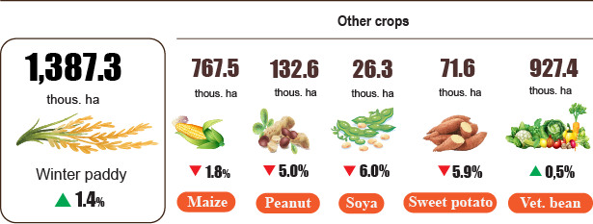

Livestock
Buffalo and cattle breeding in the month developed stably. Pig and poultry raising ensures supply for the market, some broiler farms have connected with enterprise, forming a closed chain from farm to table contributing to promote livestock development. Local authorities and specialized agencies need to implement solutions for disease prevention and control, and effectively organize vaccination; monitor, detect and promptly handle newly arising outbreaks; strictly handle cases of illegal trading and transportation of pigs of unknown origin, increasing the risk of infection and spread of dangerous diseases on domestic pigs.
Figure 2. The growth rate of the population of livestock
at the end of August, 2023 compared to the same time last year

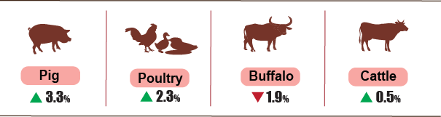

As of August 24, 2023, the whole country has no longer blue-ear disease and foot-and-mouth disease; avian flu was still in Tien Giang; LSD was reported in Thai Nguyen, Dak Lak, Tien Giang and African swine fever was reported in 15 localities for less than 21 days.
b) Forestry
The area of concentrated newly planted forests nationwide in August 2023 was estimated at 22.1 thousand hectares, down 6.4% over the same period last year due to the hot weather that lasted for the first 2 weeks of the month and quickly changed to rain and flood causing landslides affected the progress of new afforestation in many localities; the number of scattered forest trees reached 6.4 million trees, up 3.4%; timber production reached 1,838.8 thousand m³, up 2.1% due to timber production of some localities increased high such as Nghe An up 7.4%, Quang Nam up 7.8%, Hoa Binh up 5%, Bac Giang up 3.5%. Generally, in 8 months of 2023, the area of newly concentrated planted forest was estimated at 160.6 thousand hectares, down 1.2% over the same period last year due to the impact of extreme weather, the progress of new afforestation has decreased, and some newly planted forests have died; the number of scattered forest trees reached 58.5 million trees, up 4.8%; timber production reached 12.4 million m³, up 2.9% due to timber production of some localities increased high.
The damaged forest area in the month was 108.4 hectares, up 41.6% over the same period last year, of which the forest was destroyed with 99.9 hectares, up 30.8%; the burned forest area was 8.5 hectares, 38.8 times higher. In the 8 months of 2023, the damaged forest area was 1,484.9 hectares, up 90% over the same period last year, of which, the destroyed forest area was 857.6 hectares, up 13.3%; the burned forest area was 627.3 hectares, 25.6 times higher due to prolonged hot weather this year.
c) Fishery
Fishery output in July, 2023 was estimated at 837.4 thousand tons, up 2% over the same period last year, including fishes reached 584.7 thousand tons, up 1.4%; shrimp reached 139.3 thousand tons, up 4.1%; other aquatic products reached 113.4 thousand tons, up 2.2%.
It was estimated that in month, aquaculture output reached 485.8 thousand tons, up 3.8% over the same period last year, of which fishes reached 304.9 thousand tons, up 3.3%; shrimp reached 128.4 thousand tons, up 4.6%.
Pangasius harvest in the month increased compared to the same period last year because it was the harvest time, the price of raw pangasius remained stable, exports to some markets increased. Pangasius production in the 8/2023 was estimated at 156.8 thousand tons, up 2.7% over the same period last year.
Shrimp output in the month increased compared to the same period last year because the shrimp export market was showing signs of recovery in some markets such as Japan, Korea and domestic consumption demand increased. The output of whiteleg shrimp was estimated at 93.5 thousand tons, up 5.4% over the same period last year; black tiger shrimp output reached 28.5 thousand tons, up 1.4%.
The caught fishery output in the month was estimated at 351.6 thousand tons, down 0.5% over the same period last year due to the onset of the rainy and stormy season, boats are limited to fishing, included: Fishes reached 279.8 thousand tons, down 0.5%; shrimp reached 10.9 thousand tons, down 0.9%; other aquatic products reached 60.9 thousand tons, down 0.2%. Marine fishing output was estimated at 330.5 thousand tons, down 0.6% over the same period last year.
Figure 3. Fishery production in 8 months of 2023
compared to the same period in 2022
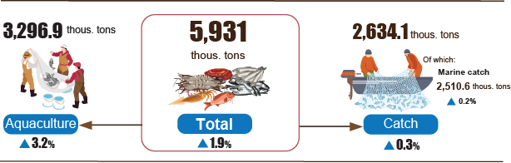
In general, in 8 months of 2023, fishery output was estimated at 5,931 thousand tons, up 1.9% over the same period last year, including: Fishes reached 4,254.3 thousand tons, up 1.7%; shrimp reached 812.2 thousand tons, up 3.6%; other fishery products reached 864.5 thousand tons, up 1.5%.
2. Industrial production
Industrial production in August continued to have a more positive trend than the previous month. It was estimated that the industrial production index in August 2023 increased by 2.9% compared to the previous month and increased by 2.6% over the same period last year. However, the world economic situation in the first months of 2023 faced many difficulties, which affected the results of domestic industrial production. Generally for the 8 months of 2023, the production index of the whole industry was estimated to decrease by 0.4% over the same period last year .
The index of industrial production (IIP) in August 2023 was estimated to increase by 2.9% over the previous month and by 2.6% over the same period last year. In which, compared to the same period last year, the manufacturing industry increased by 3.5%; electricity production and distribution increased by 3.7%; water supply; sewerage, waste management and remediation activities increased by 1.8%; the mining and quarying decreased by 6.2%.
Generally for the 8 months of 2023, IIP was estimated to decrease by 0.4% compared to the same period last year (in the same period in 2022, IIP increased by 9.2%). In which, the manufacturing sector decreased by 0.6% (in the same period in 2022 increased by 10.1%), reducing 0.3 percentage points in the general increase; electricity production and distribution increased by 1.7%, contributing 0.2 percentage points; by 3.7%; water increased by 4.8%, contributing 0.1 percentage points; mining industry decreased by 2.5%, reducing 0.4 percentage points.
Production index for the 8 months of 2023 of some key industries Grade II increased sharply compared to the same period last year: Production of coke, refined petroleum products increased by 9.9%; manufacture of tobacco products increased by 8.6%; manufacture of rubber and plastics products increased by 8.4%; manufacture of fabricated metal products, except machinery and equipment increased by 7%; mining of metal ores increased by 6.5%; manufacture of chemicals and chemical products increased by 5.6%; manufacture of food products increased by 5.4%. In the opposite direction, the IIP index of some industries decreased: Manufacture of computer, electronic and optical products decreased by 3.9%; manufacture of machinery and equipment n.e.c decreased by 4.1%; manufacture of other non-metallic mineral products decreased by 4.4%; manufacture of wood and of products of wood and manufacture of paper and paper products decreased by 4.8%; manufacture of wearing apparel decreased by 5.1%; manufacture of other transport equipment decreased by 6%; manufacture of motor vehicles; trailers and semi-trailers decreased by 6.5%.
Table 1. Growth/decrease rate of IIP index in the 8 months of 2019-2023
compared to the same period last year of some key industries
%
 | 2019 | 2020 | 2021 | 2022 | Estimated 2023
Manufacture of coke and refined petroleum products | 40.9 | 9.8 | 7.7 | 1.3 | 9.9
Manufacture of tobacco products | 3.1 | 8.6 | -1.9 | 10.3 | 8.6
Manufacture of rubber and plastics products | 15.2 | 3.3 | -0.1 | -6.6 | 8.4
Manufacture of fabricated metal products, except machinery and equipment | 6.0 | 2.9 | 5.7 | 9.8 | 7.0
Mining of metal ores | 19.3 | 13.4 | 3.5 | 6.4 | 6.5
Manufacture of chemicals and chemical products | 7.2 | 7.4 | 0.1 | 4.8 | 5.6
Manufacture of food products | 9.7 | 3.6 | 1.5 | 9.0 | 5.4
Manufacture of computer, electronic and optical products | 3.8 | 8.7 | 8.5 | 11.0 | -3.9
Manufacture of machinery and equipment n.e.c | 11.7 | -4,3 | 7.6 | 14.4 | -4.1
Manufacture of other non-metallic mineral products | 5.8 | 1.1 | 3.3 | 7.2 | -4.4
Manufacture of wood and of products of wood and cork | 11.1 | -5.4 | 4,3 | 13.5 | -4.8
Manufacture of paper and paper products | 9.8 | 8.8 | 4.5 | 9.7 | -4.8
Manufacture of wearing apparel | 8.4 | -5.7 | 5.8 | 22.3 | -5.1
Manufacture of other transport equipment | -5.1 | -9.5 | 1.1 | 3.7 | -6.0
Manufacture of motor vehicles; trailers and semi-trailers | 10.0 | -14.1 | 21.4 | 3.9 | -6.5
Industrial production index for 8 months of 2023 compared with the same period last year increased in 49 localities and decreased in 14 localities across the country. Some localities with IIP index achieved a relatively high increase due to the manufacturing industries; electricity generation and distribution industry increased . On the other hand, some localities had a decrease in the IIP index due to the manufacturing industries; mining and electricity production and distribution decreased .
Figure 4. IIP growth/decrease rate in 8 months of 2023
compared to the same period last year of some localities (%)

10 localities with the highest IIP growth rate | 10 localities with the most reduction in IIP
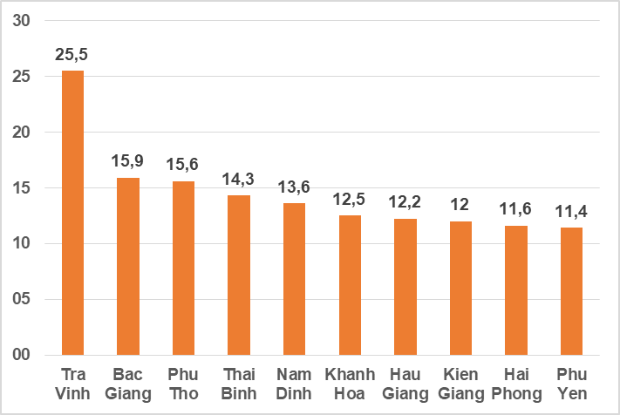 | 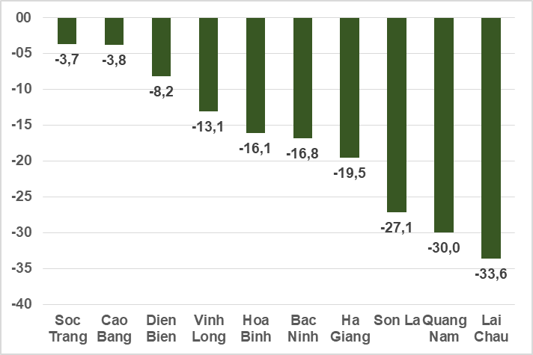
Some key industrial products in the 8 months of 2023 increased sharply compared to the same period last year: Refined sugar increased by 34.9%; N.P.K mixed fertilizer increased by 14.2%; petroleum increased by 10.1%; television increased by 10%; chemical paint increased by 9.5%; cigarettes and textile fabric from polyester or artificial yarn both increased by 8.6%; laminated steel increased by 6.5%. In the opposite direction, a number of products decreased compared to the same period last year: Automobile decreased by 20.4%; mobile phones fell 17.7%; steel bars and corners down 15.5%; motorbikes decreased by 7.4%; clothes down 5.8%; cement down 5.6%; phone accessories down 4.7%.
Number of employees working in industrial enterprises as of August 1, 2023 increased by 0.9% compared to the same period last month and decreased by 2.9% compared to the same period last year. In which, the number of employees in the state-owned enterprise sector was similar to last month and decreased by 1.9% compared to the same period last year; non-state enterprises increased by 0.4% and decreased by 2.9%; foreign-invested enterprises increased by 1.3 % and decreased by 3%. By industry, the number of employees working in mining and quarying enterprises remained unchanged from the same period last month and increased by 0.1% over the same period last year; the manufacturing increased by 1% and decreased by 3.1%; production and distribution of electricity remained unchanged compared to the same period last month and decreased by 1.4 % over the same period last year; water supply, waste and wastewater treatment and management activities increased by 0.1% and up 1.4%.
3. Enterprise registration status
In August, the whole country had more than 14 thousand newly established enterprises with registered capital were 135.3 trillion VND and a total number of registered employees of 79.9 thousand employees, an increase of 2.3% in the number of enterprises, an increase of 6.6% in registered capital and an increase of 1.2% in the number of employees compared to July 2023. Compared to the same period last year, an increase of 17.9% in the number of enterprises, an increase of 3.9% in registered capital, and an increase of 6.3% in the number of employees. The average registered capital of a newly established enterprise in the month reached 9.6 billion VND, an increase of 4.3% compared to the previous month and a decrease of 11.8% over the same period last year. In addition, the country also had more than 6.3 thousand enterprises re-operated, down 10.9% compared to the previous month and down 3.1% compared to the same period in 2022.
In the 8 months of 2023, the country had 103.7 thousand newly registered enterprises with a total registered capital of 969.6 trillion VND and the total number of registered employees was 668.8 thousand employees, an increase of 2.3% in the number of enterprises, a decrease of 14.7% in registered capital and a decrease of 3,9% in the number of employees compared to the same period last year. The average registered capital of a newly established enterprise in the 8 months of 2023 reached 9.4 billion VND, down 16.6% compared to the same period in 2022. If including 1,273.6 trillion VND of the additionally registered capital of 32.3 thousand enterprises that recorded an upward adjustment of capital, the total additional registered capital in the economy in the 8 months of 2023 was 2,243.2 trillion VND, a decrease of 38.3% compared to the same period last year. In addition, 45.7 thousand re-operated enterprises (down 5% compared to the same period in 2022), bringing the total number of newly established enterprises and re-operated enterprises in the 8 months of 2023 to 149.4 thousand enterprises, down 0.03% compared to the same period last year. The average every month had 18.7 thousand newly established and re-operated enterprises.
By economic sector in 8 months, there were 1,107 newly established enterprises in the agricultural, forestry, and fishery sectors, a decrease of 20.2% compared to the same period last year; 24.8 thousand enterprises in the industrial and construction sectors, a decrease of 2%; 77.8 thousand enterprises in the service sector, an increase of 4.2%.
Figure 5. Enterprise registration situation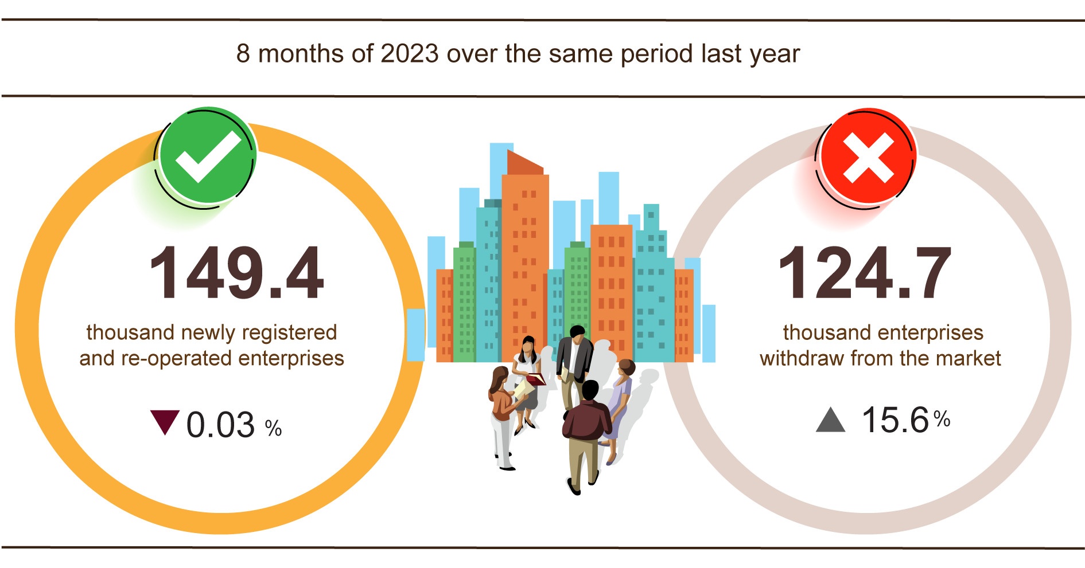
Also in August, 5,178 enterprises ceased for a certain time, down 24.8% compared to the previous month and up 37.9% over the same period in 2022; 5,216 enterprises temporarily ceased and awaited dissolution procedures, a decrease of 0.8% and an increase of 17.1%; 1,375 enterprises completed dissolution procedures, down 13% and down 29.6%.
In the 8 months of 2022, there were 71.8 thousand enterprises temporarily ceased for a certain time, an increase of 20.5% compared to the same period last year; 41.1 thousand enterprises temporarily ceased and awaited dissolution procedures, an increase of 26.7%; 11.8 thousand enterprises completed dissolution procedures, down 4.2%. On average, 15.6 thousand enterprises withdraw from the market each month.
Table 2: Number of newly registered enterprises and completed dissolution procedures in 8 months, 2023 by kinds of activity

 | Number of enterprises (Enterprise) |  | Growth rate  over the same period last year (%)
 | Newly registered | Dissolution | Newly registered | Dissolution
Wholesale and retail trade; repair of motor vehicles and motorcycles | 39,515 | 4,428 | 10.9 | 3.3
Manufacturing | 12,344 | 1,312 | -5.4 | -10.6
Construction | 11,207 | 860 | 2.1 | -25.7
Real estate business | 3,066 | 855 | -53.4 | 10.8
Transportation and storage | 4,945 | 452 | -0.7 | -2.0
Accommodation and catering service | 4,531 | 611 | 6.4 | 3.9
Production and distribution of electricity, water, gas | 716 | 225 | -3.5 | -28.8
4. Investment
With the drastic direction of the Government, the Prime Minister, ministries, branches and localities strive to accelerate the implementation of investment capital from the State budget, supporting economic growth. In the eight months, investment capital realized from the State budget was estimated at 49.4% of the plan, up 23.1 % over the same period in 2022. Foreign direct investment (FDI) registered new registrations as of August 20, 2023 were estimated at 8.87 billion USD, up 39.7% over the same period last year.
Realized investment capital from the State budget in August was estimated at 61.3 trillion VND, up 29.1% over the same period last year, including: Centrally managed capital of 11.4 trillion VND, up 31.7%; local capital under management was 49.9 trillion VND, up 28.5%. In the first eight months of 2023, investment capital realized from the State budget is estimated at 352.1 trillion VND, equaling 49.4% of the year plan and increasing by 23.1% over the same period last year (the same period 2022 by 47.6% and increasing by 17.1%). Specifically:
- Realized investment capital under the central management was estimated at 65.3 trillion VND, equaling 49.1% of the year plan and increasing by 29.5% over the same period last year.

Figure 6. Realized investment capital from the State budget
8 months of 2023 classified by ministries and branches (Billion VND)

- Realized investment capital under local management was estimated at 286.7 trillion VND, equaling 49.5% of the year plan and increasing by 21.8% over the same period last year, of which:
Provincial state budget capital reached 197.6 trillion VND, equaling 47.3% and increasing by 27.5% over the same period in 2022;
State budget capital at district level reached 77.1 trillion VND, equaling 53.9% and increasing by 11.3%;
State budget capital at commune level reached 12 trillion VND, equaling 63.5% and increasing by 7%.
Investment capital made from the State budget for the eight months of 2023 of a number of provinces and centrally-run cities is as follows:
Figure 7. Realized investment capital from the State budget
8 months of 2023 of some localities (Billion VND)

Total foreign investment capital registered in Vietnam As of August 20, 2023, including: newly registered capital, adjusted registered capital and value of capital contribution and share purchase by foreign investors reached nearly 18.15 billion USD, up 8.2% compared to the same period last year.
Figure 8. Foreign investment capital registered in Vietnam
as of August 20, years 2019-2023 (Billion USD)

- Newly registered capital has 1,924 licensed projects with a registered capital of 8.87 billion USD, an increase of 69.5% over the same period last year in terms of the number of projects and an increase of 39.7% in the registered capital. In which, the processing and manufacturing industry that was newly licensed for foreign direct investment was the largest with a registered capital of 7.55 billion USD, accounting for 85.1% of the total newly registered capital; real estate business reached 472.4 million USD, accounting for 5.3%; the remaining industries reached 851.8 million USD, accounting for 9.6%.
Among 63 countries and territories with newly licensed investment projects in Vietnam in the eight months of 2023, Singapore was the largest investor with 2.45 billion USD, accounting for 27.6% total newly registered capital; followed by China with 1.88 billion USD, accounting for 21.2%; Hong Kong Special Administrative Region (China) 1.15 billion USD, accounting for 13%; Taiwan 700.4 million USD, accounting for 7.9%; Japan 555.4 million USD, accounting for 6.3%; South Korea 459.2 million USD, accounting for 5.2%.
- Adjusted registered capital has 830 turns of projects licensed from previous years registered to adjust investment capital, increasing by 4.54 billion USD , down 39.7% over the same period last year.
If including newly registered capital and adjusted registered capital of licensed projects from previous years, the registered foreign direct investment capital in the processing and manufacturing industry reached 11.08 billion USD. accounting for 82.7% of total newly and additionally registered capital; real estate business reached 685.7 million USD, accounting for 5.1%; the remaining industries reached 1.63 billion USD, accounting for 12.2%.
- Registered capital for capital contribution and share purchase by foreign investors had 2,268 turns with a total value of capital contribution of 4.74 billion USD, up 62.8% over the same period last year . In which, there were 903 capital contribution, share purchase increases the charter capital of the enterprise with the capital contribution value of 1.7 billion USD and 1.365 the number of foreign investors buying back domestic shares without increasing charter capital with the value of 3.04 billion USD. For the form of capital contribution or share purchase by foreign investors, investment capital in financial, banking and insurance activities reached 1.53 billion USD, accounting for 32.4% of the value of capital contribution; processing and manufacturing industry reached 1.21 billion USD, accounting for 25.6%; the remaining industry 1.99 billion USD, accounting for 42%.
Realized foreign direct investment capital in Vietnam in the eight months of the year 202 3 was estimated at 13.1 billion USD, up 1.3 % over the same period last year. This is the highest amount of foreign direct investment capital realized in 8 months in the past 5 years. In which: Processing and manufacturing industry reached 10.75 billion USD, accounting for 82.1% of total realized foreign direct investment capital; production and distribution of electricity, gas, hot water, steam and air conditioners reached 863.5 million USD, accounting for 6.6%; real estate business reached 625.9 million USD, accounting for 4.8 % .
Figure 9. Realized foreign direct investment capital
8 months of the year 2019 -2023 ( Billion USD)

Vietnam's investment abroad in the eight months of the year 2023 , there were 79 projects newly granted investment certificates with the total capital of the Vietnamese side of 244.4 million USD, down 29.1% compared to the same period last year; there were 18 times of projects adjusted capital with adjusted capital increased by 172 million USD, 3.4 times higher.
In general, Vietnam's total investment abroad (newly and adjusted capital) reached 416.3 million USD, up 5.2% over the same period last year. In which: Wholesale and retail, repair of automobiles, motorcycles, motorbikes and other motor vehicles reached 150,3 million USD, accounting for 36.1% of total investment capital; information and communication reached 114.3 million USD, accounting for 27.5%; production and distribution of electricity, gas, hot water, steam and air conditioners reached 84.4 million USD; accounted for 20,3%.
In 8 months of 2023, there were 23 countries and territories receiving investment from Vietnam, in which: Canada is the leading country with 150,2 million USD, accounting for 36.1% of total investment capital. Singapore 115,1 million USD, accounting for 27,6%; Laos 113.9 million USD, accounting for 27.4 % ; Cuba reached 11.8 million USD, accounting for 2.8 % ; Israel 6.1 million USD, accounting for 1.5%.

5. State budget revenue and expenditure
State budget revenue in eight months of 2023 was estimated to decrease by 8% over the same period last year. State budget expenditure was estimated to increase by 13% over the same period in 2022, ensuring the needs of socio-economic development, defense, security, state management, payment of due debts as well as timely payment for specified objects.
Figure 10. State budget revenue and expenditure in the 8 months of 2023
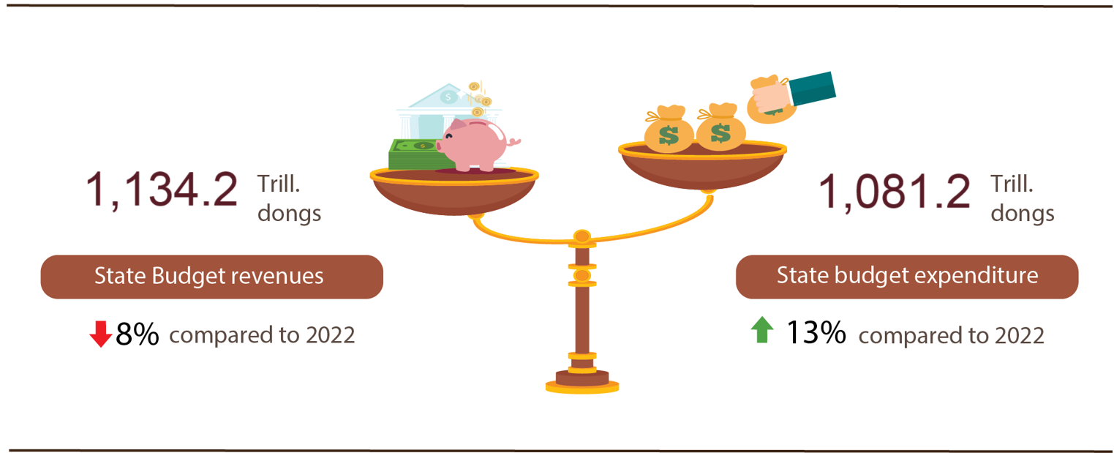
State budget revenue:
Total state budget revenue in August 2023 was estimated at 97.8 trillion VND. The accumulated total state budget revenue in eight months of 2023 was estimated at 1,134.2 trillion VND, equaling 70% of the yearly estimate and down 8% over the same period last year. Some of the main revenues are as follows:
- Domestic revenue in August 2023 was estimated at 80.7 trillion VND; accumulated 8 months of 2023 was estimated at nearly 939.8 trillion VND, equaling 70.4% of the year estimate and down 3.6% over the same period last year.
- Revenue from crude oil in August 2023 was estimated at 5.1 trillion VND; Accumulated 8 months of 2023 was estimated at 40.4 trillion VND, equaling 96.2% of the year estimate and down 23.9% over the same period last year.
- Balanced budget revenue from import and export activities in August 2023 was estimated at 11.9 trillion VND; accumulated 8 months of 2023 was estimated at 153.8 trillion VND, equaling 64.3% of the year estimate and down 23.1% over the same period last year.
State budget expenditure:
Total state budget expenditure in August 2023 was estimated at 139 trillion VND; accumulated 8 months of 2023 was estimated at 1,081.2 trillion VND, equaling 52.1% of the year estimate and increasing 13% over the same period last year. In which, recurrent expenditure in 8 months of 2023 was estimated at 715.9 trillion VND, equaling 61.1% of the yearly estimate and increasing by 5.7% over the same period last year; development investment expenditure reached 297.7 trillion VND, equaling 41% and increasing by 40.3%; debt payment interest was 65.9 trillion VND, equaling 64.1% and increasing by 0.9%.
6. Trade, prices, transport and tourism
a) Retail sales of consumer goods and services
Trade and service activities in August were quite vibrant. Total retail sales of consumer goods and services estimated to increase by 0.9% over the previous month and by 7.6 % over the same period last year. In 8 months of 2023, the total retail sales of consumer goods and services was estimated to increase by 10% over the same period last year, of which revenue from tourism increased by 47%.
Total retail sales of consumer goods and services in August was estimated at 515,4 trillion VND, up 0.9% over the previous month and up 7.6% over the same period last year due to consumer demand for essential goods, especially, the items for the new school year are on the rise. August is the last summer month of the year, which is also the end of the summer vacation for students, therefore, travel activities as well as outdoor fun were more animated. Generally for 8 months of 2023, the total retail sales of consumer goods and services at current prices was estimated at 4.043,9 trillion VND, up 10% over the same period last year (up 19.2% in the same period in 2022), if excluding the price factor, up 7.7% (the same period in 2022 increased by 15.1%).
Table 3. Retail sales of consumer goods and services

Trillion VND

 | Estimate August  in 2023 | Estimate  8 months  in 2023 | Growth rate compared to same period last year (%)
 | Estimate August  in 2023 | Estimate  8 months  in 2023 | August  in 2023 | 8 months  in 2023
Total | 515,4 | 4.043,9 | 7,6 | 10,0
Retail sale of goods | 400,0 | 3.175,5 | 7,5 | 8,7
Accommodation and catering service | 58,7 | 436,3 | 10,8 | 15,6
Traveling service | 3,8 | 22,4 | 21,3 | 47,0
Other services | 52,9 | 409,7 | 4,2 | 12,6

Figure 11. Total retail sales of consumer goods and services
in 8 months from 2019-2023

Retail sales of goods in 8 months of 2023 were estimated at 3.175,5 trillion VND, accounting for 78.5% of the total retail sales of consumer goods and services and up 8.7% over the same period last year (if excluding the price factor, up 7.4%). In which, the group of food and foodstuffs increased by 12.1%; cultural and educational products increased by 11%; garment increased by 8.7%; household appliances, tools and equipment increased by 4.4%; means of transport (except for cars) increased by 0.5%. Retail sales of goods in 8 months of this year compared to the same period last year of some localities were as follows: Quang Ninh increased by 11.8%; Hai Phong and Can Tho both increased by 9.5%; Binh Duong increased by 9.4%; Dong Nai increased by 8.2%;Ha Noi increased by 6%; Ho Chi Minh City increased by 4.8%; Da Nang increased by 3.1%;
Revenue from accommodation and food services in 8 months of 2023 was estimated at 436.3 trillion VND, accounting for 10.8% and up 15.6% over the same period last year. The revenue of 8 months in 2023 compared to the same period last year of some localities was as follows: Da Nang increased by 40.3%; Can Tho increased by 27.2%; Dong Nai increased by 23.6%; Ho Chi Minh City increased by 23.4%; Quang Ninh increased by 21.8%; Hai Phong increased by 14.4%; Ha Noi increased by 11.9%.
Tourism revenue in 8 months of 2023 was estimated at 22.4 trillion VND, accounting for 0,6% and up 47% over the same period last year due to high tourism demand during the peak season and localities have also actively implemented many activities to stimulate tourism demand after a long time being affected by the Covid-19 epidemic.The revenue of some localities in 8 months of 2023 compared to the same period last year was as follows: Da Nang increased by 97.5%; Khanh Hoa increased by 93.4%; Ho Chi Minh City and Quang Ninh both increased by 57.6%; Hai Phong rose 57%; Ha Noi increased by 45.9%; Binh Thuan increased by 40.2%; Can Tho increased by 15.6%; Lam Dong increased by 11.5%.
Other service revenue in 8 months of 2023 was estimated at 409,7 trillion VND, accounting for 10.1% and up 12.6% over the same period last year. Specifically, the revenue in 8 months over the same period last year of some localities was as follows: Da Nang increased by 19.8%; Bac Giang increased by 17,5%; Ba Ria - Vung Tau increased by 11.8%; Can Tho increased by 9.4%; Ha Noi increased by 8.7%; Hai Phong increased by 6.2%; Ho Chi Minh City decreased by 2.7%; Quang Binh down 0.6%.
a) Export and import of goods
Total export and import turnover of goods in August was estimated at 60.92 billion USD, up 6.7% over the previous month and down 7.9% over the same period last year. Generally, in 8 months of 2023, the total export and import turnover of goods reached 435.23 billion USD, down 13.1% over the same period last year, of which exports decreased by 10%; imports decreased by 16.2%. The trade balance of goods in 8 months of 2023 is estimated to have a trade surplus of 20.19 billion USD.
Figure 14. Import and export of goods in 8 months of 2023
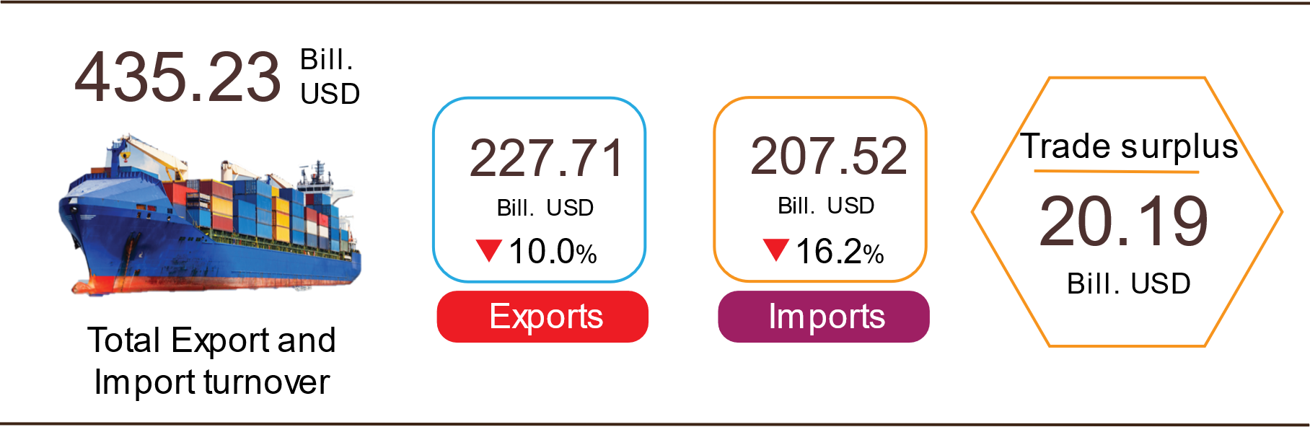

Export of goods
Preliminary export turnover of goods in July 2023 reached USD 30.07 billion, 388 million USD higher than the estimated figure.
Export turnover of goods in August 2023 was estimated at 32.37 billion USD, up 7.7% over the previous month. Of which, the domestic economic sector gained 8.43 billion USD, increased by 8.7%; the FDI sector (including crude oil) reached 23.94 billion USD, increased by 7.3%. Compared to the same period last year, export turnover of goods in August went down 7.6%, of which the domestic economic sector decreased by 2.5%, the FDI sector (including crude oil) decreased by 9.3%.
Generally in 8 months of 2023, the export turnover was estimated at 227.71 billion USD, decreased by 10% over the same period last year. Of which, the domestic economic sector was 59.92 billion USD, went down 9.2%, accounting for 26.3% of total export turnover; the FDI sector (including crude oil) attained 167.79 billion USD, decreased by 10.3%, sharing 73.7%.
In 8 months of 2023, there were 30 products with export turnover of over 1 billion USD, contributing 91.8% to the total export turnover (05 products with export turnover of over 10 billion USD, accounting for 58.4%).
Table 4. Value of some export products in 8 months of 2023
 | Estimate  (Mill. USD) | Growth rate compared to  the same period last year (%)
Items with a value of over 10 billion USD
Electronic goods, computers and their parts | 36,150 | -1.5
Phones all of kinds and their parts | 33,937 | -15.4
Machinery, instrument, accessory | 26.960 | -10.3
Textiles and garments | 22,348 | -15.0
Footwear | 13,487 | -17.6

Regarding the structure of exported groups in 8 months of 2023, the group of fuels and minerals was estimated at 2.82 billion USD, accounting for 1.2%; the group of processing industry was estimated at 201.31 billion USD, accounting for 88.4%; agricultural and forestry products was estimated at 17.87 billion USD, accounting for 7.9%; the group of fishery products was estimated at 5.71 billion USD, accounting for 2.5%.
Figure 13. Structure of export of goods
in 8 months of 2023 by commodity group

Import of goods
Preliminary import turnover of goods in July 2023 reached 27 billion USD, 523 million USD lower than the estimate figure.
Import turnover in August 2023 was estimated at 28.55 billion USD, increased by 5.7% over the previous month. Of which the domestic economic sector gained 10.25 billion USD, decreased by 1.4%; the FDI sector reached 18.3 billion USD, increased by 10.2%. Compared to the same period last year, the import turnover of goods in August decreased by 8.3%, of which the domestic economic sector decreased by 1.7%; the FDI sector decreased by 11.6%.
Generally in 8 months of 2023, the import turnover was estimated at 207.52 billion USD, decreased by 16.2% over the same period last year. Of which the domestic economic sector reached 73.95 billion USD, went down 14.8%; the FDI sector gained 133.57 billion USD, down 17%.
In 8 months of 2023, there are 37 imported products with a turnover of over 1 billion USD, accounting for 89.9% of total import turnover (02 products with import turnover of over 10 billion USD, accounting for 38.8%).
Table 5. Value of some imported goods in 8 months of 2023
 |  | Estimate | Growth rate compare to
 |  | (Mill. USD) | the same period last year (%)
Items with a value of over 10 billion USD
 | Electronic goods, computers and their parts | 53,832 | -6,0
 | Machinery, instrument, accessory | 26,682 | -13.0

Regarding the structure of imported groups in 8 months of 2023, the group of production materials was estimated at 194.65 billion USD, accounted for 93.8%, in which the group of machinery, equipment, tools spare parts accounted for 44.8%; raw materials, fuel and materials accounted for 49%. The group of consumer products was estimated at 12.87 billion USD, accounted for 6.2%.
Figure 14. Structure of import of goods
in 8 months of 2023 by commodity group
Regarding the export and import market of goods in 8 months of 2023, the United States was Viet Nam's largest export market with a turnover of 62.3 billion USD. China remained the largest import market of Viet Nam with a turnover of 68.1 billion USD. In 8 months of 2023, the trade surplus to the United States reached 53 billion USD, down 21% over the same period last year; the trade surplus to the EU reached 19.6 billion USD, down 9.7%; trade surplus to Japan was 1.5 billion USD (the same period last year saw a trade deficit of 146 million USD); trade deficit from China was 32.3 billion USD, went down 30.2%; trade deficit from Korea was 17.3 billion USD, going down 34.5%; trade deficit from ASEAN was 5.2 billion USD, decreased by 38.4%.
Figure 15. Major commodity import and export markets in 8 months of 2023
 |  | Export of goods | Import of goods
The trade balance of goods in July had a trade surplus of 3.07 billion USD; 7 months had a trade surplus of 16.37 billion USD; August was estimated to have a trade surplus of 3.82 billion USD. Generally in 8 months of 2023, the trade balance of goods was estimated to have a trade surplus of 20.19 billion USD (in the same period last year, the trade surplus of 5.26 billion USD). In which, the domestic economic sector had a trade deficit of 14.02 billion USD; the FDI sector (including crude oil) had a trade surplus of 34.21 billion USD.
c) Consumer price index, gold price index and US dollar price index
Petrol prices, domestic rice prices increasing in line with world prices, and rental housing prices increasing according to demand are the main reasons for the consumer price index (CPI) in August 2023 to increase by 0.88% compared to the previous month. Compared to December 2022, CPI in August increased by 2.02% and over the same period last year by 2.96%.
On average in 8 months of 2023, CPI increased by 3.1% over the same period last year; core inflation increased by 4.57%.
Figure 16. CPI growt rate in August and 8 months
the years 2019-2023 (%)
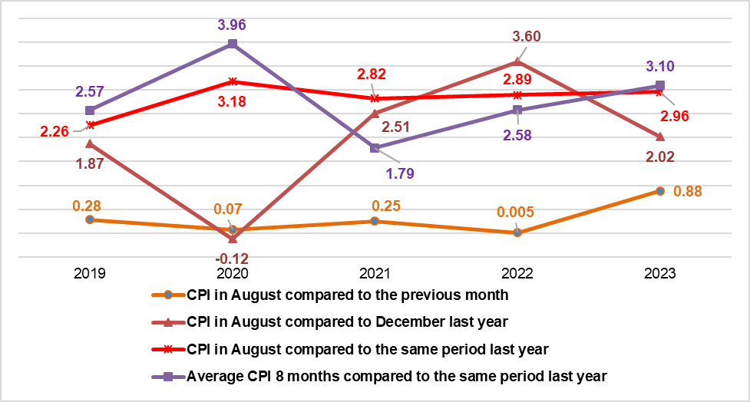
In the 0.88% increase of CPI in August 2023 compared to the previous month, there were 10 groups of goods and services with an increase in price index, and 1 group of goods with a decrease in price index.
(1) Ten groups of goods and services with increasing price index include:
- Transport group increased the highest with 3.85% (making the general CPI increase by 0.37 percentage points) mainly due to: Gasoline price increased by 9.85%; diesel oil price increased by 15.9% due to the influence of domestic price adjustments on August 1, 2023, August 11, 2023 and August 21, 2023; public transport service prices increased by 3.79%; prices of new bicycles, motorbikes and cars continued to increase by 0.42%, respectively; 0.12% and 0.16%.
- Education group increased by 0.96% mainly because the school year 2023-2024 students of grades 4, 8, 11 started learning new textbooks. Accordingly, the price of textbooks increased by 3.37% compared to the previous month; the price of notebooks and writing papers of all kinds increased by 1.17%; the price of writing pens of all kinds increased by 1.03%. Besides, the price index of educational services increased by 0.82% due to a number of people-founded and private schools increasing tuition fees for the 2023-2024 school year.
- Housing and construction materials group increased by 0.85% (making the general CPI increase by 0.16 percentage points) due to a 0.8% increase in rental house prices; kerosene price increased by 15.94%; the price of domestic water increased by 0.93%; gas price increased by 7% because from August 1, 2023, the domestic gas price was adjusted to increase by 26,000 VND/bottle of 12 kg after the world gas price increased by 77.5 USD/ton (from 387.5 USD/ton to 465 USD/ton). In the opposite direction, the price of housing maintenance materials decreased by 0.15% due to the decrease in steel price; the price of electricity for daily life decreased by 0.89% due to the decrease in consumer demand in the rainy season and cool weather.
- The group of food and foodstuff services increased by 0.78% (making the general CPI increase by 0.26 percentage points), of which: Food increased by 3.28% (making the general CPI increase by 0.12 percentage points); foodstuff increased by 0.48% (making the general CPI increase by 0.1 percentage points); eating out of the family increased by 0.47% (making the general CPI increase by 0.04 percentage points).
- Beverage and cigarette group increased by 0.28% due to high demand during the tourist season. Specifically, the price of juice increased by 0.49%; carbonated soft drinks by 0.31%; alcohol of all kinds increased by 0.23% and smoking by 0.37%.
- The group of other goods and services increased by 0.22%, mainly focusing on jewelry, increasing by 0.52%; hair cutting and shampooing services increased by 0.57%; hospitality supplies and services increased by 0.18%.
- Garment, hat and footwear group increased by 0.19% due to increased demand for shopping to prepare for the new school year. In which, the price of all kinds of fabrics increased by 0.38%; hats increased by 0.26%; footwear by 0.22%; ready-made clothes by 0.16%; garment services increased by 0.32%; footwear repair services increased by 0.5%.
- Equipment and household appliances increased by 0.10%, mainly focusing on items such as: Price of kitchen equipment increased by 1.16%; electric irons increased by 0.6%; microwave oven, oven, induction cooker increased 0.11%. In the opposite direction, the price of gas stoves decreased by 0.46% compared to the previous month; bathroom hot water tank down 0.42%; electric fan decreased by 0.36%.
- The group of culture, entertainment and tourism increased by 0.09%, mainly focusing on the following groups: The price of foreign tourism services increased by 0.13% compared to the previous month; domestic tourism increased by 0.09%; hotels, guest houses by 0.05%; musical instruments by 0.12%; equipment and sports equipment increased by 0.45%. In the opposite direction, cultural equipment decreased by 0.18% as the price of color television decreased by 0.19% and DVD player decreased by 0.03%.
- Medicines and health care services increased by 0.03% because the price of medical equipment increased by 0.23%; drug prices increased by 0.1%, of which the increase was mainly in the group of pain relievers, antipyretics, non-steroidal anti-inflammatory drugs (increased by 0.25%) and drugs acting on the respiratory tract (increased by 0.22%) due to the erratic influence of the changing seasons, leading to an increase in respiratory diseases.
(2) The post and communications group alone decreased by 0.17% due to the decrease in the price of mobile phones and landlines.
Core inflation in August 2023 increased by 0.32% over the previous month, by 4.02% over the same period last year. On average, in the eight months of 2023, core inflation increased by 4.57% over the same period in 2022, higher than the overall average CPI growth (up by 3.1%). The main reason is that the average price of gasoline and oil in the country in the eight months of 2023 decreased by 17.56% compared to the same period last year, the decrease in gas price by 11.3% is a factor that restrains the growth rate of CPI but belongs to the group of commodities. excluded from the core inflation calculation.
The domestic gold price fluctuates in the same direction as the world gold price. As of August 25, 2023, the average world gold price was at 1,956.24 USD per ounce, up 0.51% compared to July 2023 after the periodic meeting of the US Federal Reserve (FED) took place in 2 days July 25-26, 2023 decided to raise the basic interest rate by 0.25 percentage points to 5.25%-5.5%, the highest level in the past 22 years. Domestically, the gold price index in August 2023 increased by 0.64% over the previous month; increased by 3.93% compared to December 2022; an increase of 5% over the same period last year; the average increase in 8 months of 2023 increased by 1.54%.
Around the world, the price of the US dollar tends to increase when investors are concerned about the health of the global economy, especially the Chinese economy. As of August 25, 2023, the US dollar index on the international market reached 102.53 points, up 1.12% over the previous month. Domestically, the average US dollar price on the free market is around 23,907 VND/USD. US dollar price index in August 2023 increased by 0.57% compared to the previous month; down 1.16% compared to December 2022; increased by 1.43% over the same period last year; average increase in 8 months of 2023 increased by 2.27%.
d) Transport
Transport activity in August maintained a positive growth rate compared to the same period last year, of which passenger carried increased by 5.9% and passenger traffic increased by 18.6% due to the high number of international visitors to Viet Nam and domestic tourists during this year's tourist peak season compared to the same period last year; freight transport increased by 13.6% in terms of carried and 10.7% in traffic to serve the consumer demand of people during the upcoming Vu Lan and Mid-Autumn Festival.
In 8 months of 2023, passenger carried increased by 14.4% and passenger traffic increased by 28.2% over the same period last year; freight carried increased by 15.1% and passenger traffic increased by 13.4% over the same period last year.
Passenger carried in August was estimated at 396.2 million passengers, decreased 1.0% over the previous month and passenger traffic was 21.6 billion passengers-kilometers, up 2.5%. In 8 months of 2023, passenger carried was estimated at 3,013 million passengers, up 14.4% over the same period last year and passenger traffic was 161.9 billion passengers.km, increased by 28.2%. In which, domestic transport reached 3,003.6 million passengers, up 14.2% over the same period last year and 134.3 billion passengers-kilometers, up 12.7%; overseas transport reached 9.4 million passengers, 4.2 times higher and 27.6 billion passengers-kilometers, 3.9 times higher than the same period last year.
In terms of transportation, all sugar industries in 8 months of 2023 increased sharply compared to the same period last year.
Table 6 : Passengers transport in 8 months of 2023
by types of transport
 | Number of passenger |  | Growth rate compared to the same period last year (%)
 | Carried  (Mill. passengers) | Traffic  (Bill. passengers-km) | Carried | Traffic
Total | 3,013.0 | 161.9 | 14.4 | 28.2
Rail way | 4.5 | 1.7 | 46.8 | 47.2
Sea way | 8.4 | 0.5 | 43.3 | 42.2
Inland water way | 221.9 | 4.4 | 26.6 | 28.1
Road | 2,738.0 | 101.8 | 13.3 | 19.6
Airway | 40.2 | 53.5 | 23.1 | 47.7

Freight transport in August was estimated at 193.1 million tons of freight carried, up 0.9% from the previous month and 43.6 billion tons.km of freight traffic, up 2.9%. Generally for 8 months of 2023, freight transport was estimated at 1,497 million tons of freight carried, up 15.1% over the same period last year and 316.9 billion tons.km of freight traffic, an increase of 13.4%. In which, domestic transport reached 1,467.7 million tons of freight carried, up 15.4% and 200 billion tons.km of freight traffic, up 18.8%; overseas transport reached 29.3 million tons of freight carried, up 2.3% and 116.9 billion tons.km of freight traffic, up 5.1%. In terms of transportation, most of transport in 8 months of 2023 had a positive growth rate compared to the same period last year. Particularly, rail way dropped sharply due to reduced import and export orders and had to compete with water transport when costs were higher.
Table 7. Carriage of freight in 8 months of 2023 by types of transport
 | Quantity of goods |  | Growth rate compared to the same period last year (%)
 | Carried  (Mill. tons) | Traffic  (Bill. tons-km) | Carried | Traffic
Total | 1,497.0 | 316.9 | 15.1 | 13.4
Rail way | 3.0 | 2.4 | -24.1 | -22.5
Sea way | 78.2 | 167.5 | 13.7 | 11.8
Inland water way | 323.1 | 70.2 | 25.7 | 21.7
Road | 1,092.5 | 71.5 | 12.5 | 9.9
Airway | 0.2 | 5.3 | 3.9 | 37.2

đ) International visitors to Viet Nam
International visitors to Viet Nam in August reached over 1.2 million arrivals, up 17.2 % compared to the previous month and 2.5 times higher than the same period last year. In 8 months of 2023, international visitors to our country reached 7.8 million arrivals, 5.4 times higher than the same period last year but still equal to 69.2% compared to the same period in 2019 - the year without the Covid-19.
Out of a total of more than 7.8 million international arrivals to Viet Nam in 8 months of this year, arrivals by air reached 6.9 million arrivals, accounting for 87.6% of international arrivals to Viet Nam and 5.4 times higher than the same period last year; by road reached 909.7 thousand arrivals, accounting for 11.6% and 5.4 times higher; by sea reached 59.7 thousand arrivals, accounting for 0.8% and 154.2 times higher.
Figure 17. International visitors to Viet Nam
in 8 months of 2023 by territories

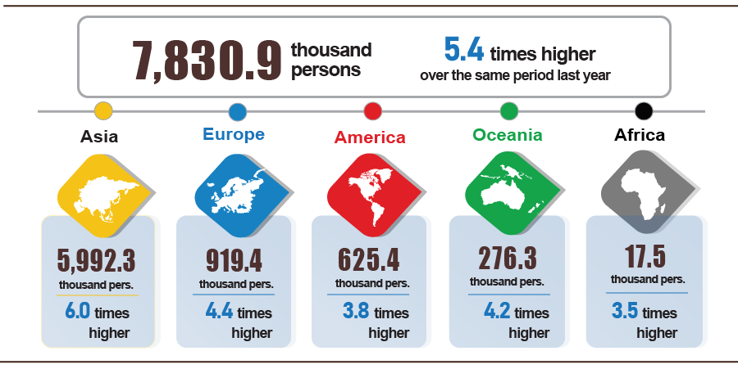

7. Certain social situations
a) Residential life
According to the survey, the life situation of households in August was quite stable. The proportion of households whose income during the month was assessed to be unchanged and increased compared to the same period last year was 94.2% (a slight decrease of 0.3 percentage points compared to the July 2023 reporting period); The proportion of households assessed to have reduced income and not knowing was 5.8%.

Figure 18. Percentage of households reporting
increased and unchanged income months of 2023
compared to the same period last year
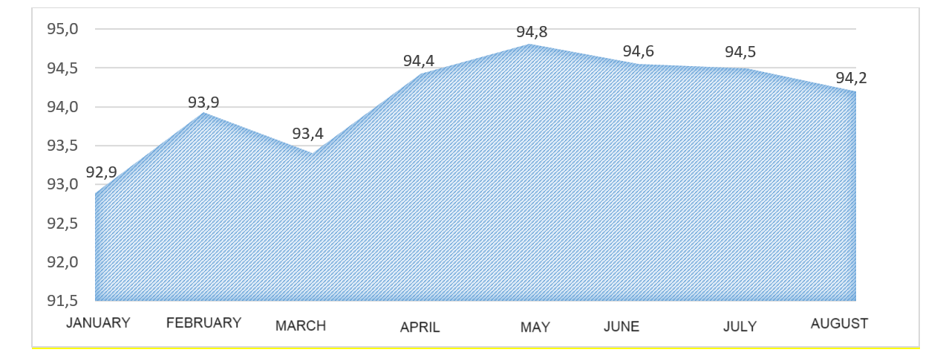

The main reasons for reduced income assessed by households were: 37.8% of households with a member who lost their job/temporarily quit their job; 22.9% of households assessed that input costs for their production and business activities increased, and 21.9% of households assessed that the selling price of products from their production and business activities decreased.
Regarding the impact of negative events on life in the 8 months of 2023, households assess that: 30.1% of households were suffering from the effects of rising prices of goods and services; 5.3% of households were negatively affected by epidemics on humans and 2% of households were negatively affected by epidemics on livestock and crops.
In the 8 months of 2023, 9.9% of interviewed households received help from various support sources. Of which, the proportion of households receiving assistance from relatives was 6.5%; from local programs and policies was 3.4%; from general national programs and policies was 3.1%; from charitable activities of other organizations and individuals was 1.6% and 0.02% from other sources.
Social security work is always paid attention to by all levels and sectors from central to local levels. The Government issued Decree No. 55/2023/ND-CP dated July 21, 2023, amending and supplementing several articles of Decree No. 75/2021/ND-CP dated July 24, 2021 regulating subsidy levels grants, allowances and preferential regimes for people with meritorious services to the revolution, adjusting the standard level of benefits for people with meritorious services from 1,624 thousand VND/month to 2,055 thousand VND/month, corresponding to an increase of 26.54%. The Ministry of Labor, War Invalids and Social Affairs issued Official Dispatch No. 3001/LDTBXH-TE dated August 3, 2023, directing provinces and centrally-run cities to organize the 2023 Mid-Autumn Festival using the State budget and other agencies. resources of organizations and individuals to visit and give gifts to children, especially children in special circumstances, children from poor households, near-poor households, children from ethnic minority areas, remote areas, Borders, islands, orphans, and children affected by natural disasters and epidemics, ensuring safety, health, practicality, and savings according to the conditions of each locality.
b) Epidemic situation, food poisoning
According to a report from the Ministry of Health, in the month (of July 19-August 18, 2023), the whole country had 15,933 cases of dengue fever; 62 cases of viral encephalitis; 19,185 cases of hand, foot, and mouth disease; 43 cases of typhus suspected of measles and 2 cases of meningococcal meningitis. In the eight months of 2023, the whole country has nearly 57.7 thousand cases of dengue fever; 309 cases of viral encephalitis; 52.2 thousand cases of hand, foot, and mouth disease; 209 cases of typhus suspected of measles and 11 cases of meningococcal meningitis.

COVID-19 epidemic, From the end of December 2019 to August 28, 2023, there were 694.2 million cases of COVID-19 in the world (more than 6.9 million deaths), and the US was the country with the highest cases and deaths in the world. In Vietnam, localities continue to strengthen epidemic prevention, control, and control, especially at border areas to detect suspected cases of COVID-19, especially those entering the country from abroad, in epidemic areas, or where new variants appear. In August (from July 27 to August 27), the whole country had 969 cases of Covid-19, with no deaths. Since the first case of COVID-19 in Vietnam on January 23, 2020, to August 27, 2023, Vietnam has had more than 11.6 million cases, of which 10.6 million cases have been cured and 43.2 thousand deaths.
Vaccination against the COVID-19 epidemic continues to be carried out according to the instructions of the Ministry of Health to ensure the requirements of the Government, the Prime Minister, and the National Steering Committee for COVID-19 epidemic prevention and control. From March 8, 2021, to August 28, 2023, the total number of COVID-19 vaccine doses administered was 266.5 million doses, of which 90.3 million doses were for the first dose; 2nd injection was 85.9 million doses; Additional doses were 14.3 million doses; 1st booster dose was 57.9 million doses; The second booster dose was 17.9 million doses.
The total number of people living with HIV in the country as of August 18, 2023, was 230.3 thousand people, and the number of people dying from HIV/AIDS in the country as of the above time was 113.6 thousand people.
Regarding food poisoning, in August 2023, there were 12 cases with 115 people poisoned. In the eight months of 2023, there were 72 cases nationwide with 975 people being poisoned (12 people died).
c) Cultural and sports activities

In August, cultural activities and traditional festivals were held widely in localities across the country, especially cultural exchanges with countries around the world, to promote Vietnamese culture and tourism around the world, creating impressive highlights such as The 19th "Hoi An - Japan Cultural Exchange" in Hoi An city, Quang Nam province on August 6; "Vietnam - India Art Exchange" program in 2023 in Lao Cai on August 12; The 20th Festival of Culture, Sports and Tourism in mountainous districts of Quang Nam province held from August 15-21, 2023.

The mass sports movement continues to be promoted, fitness and sports movements are widely organized, and some outstanding activities took place during the month such as the National Family badminton and table tennis tournament in 2023 held on August 5 in Da Lat City, Lam Dong province with the participation of more than 500 athletes; Vovinam Youth Tournament and Youth Club Championship of Da Nang City 2023 took place from August 7-9 in Da Nang City with the participation of 154 athletes; The final of the 2023 summer primary and secondary school swimming tournament in Hanoi on August 9, 2023, 130 athletes participating; running a tournament for students "S-Race 2023" in Lam Dong on August 12, 2023, with the participation of more than 4,800 athletes; "VnExpress Marathon Marvelous Nha Trang" in Khanh Hoa took place from August 11-13, 2023 with the participation of more than 11,000 domestic and international athletes participating...

Regarding high-performance sports, in August 2023, a number of outstanding events will take place such as Vietnam participating in the 2023 world archery championship in Germany from August 1 to August 6, 2023, with 56 participating teams; World shooting championship takes place from August 14 to September 19, 2023, in Baku, Azerbaijan, the excellent Vietnamese shooting team won a ticket to the 2024 Olympics; Vietnam U23 team won the championship of the 2023 Southeast Asian U23 Football Championship in Rayong city of Thailand from August 17 to August 26, 2023; The international women's volleyball tournament VTV Cup Ferroli 2023 at Lao Cai Provincial Multipurpose Stadium takes place from August 19 to August 26, 2023.

d) Traffic accident
During the month (from July 15 to August 14, 2023), there were 1,179 traffic accidents nationwide, including 877 traffic accidents of less serious or more, and 302 traffic collisions, killing 696 people, injuring 472 people, and 336 people with minor injuries. Compared to the previous month, the number of traffic accidents increased by 23.1% (the number of traffic accidents from less serious or more increased by 24.8% and the number of traffic collisions increased by 18.4%); The number of deaths increased by 23.6%; The number of injured people increased by 28.3% and the number of people with minor injuries increased by 20.9%. Compared to the same period last year, the number of traffic accidents in August increased by 23.8% (the number of traffic accidents from less serious or more increased by 35.5% and the number of traffic collisions decreased by 1%); The number of deaths increased by 41.8%; The number of injured people increased by 26.9% and the number of people with minor injuries increased by 2.1%.
Overall, in the eight months of this year, there were 7,107 traffic accidents nationwide, including 5,183 less serious traffic accidents and 1,924 traffic collisions, killing 4,124 people, 2,849 people injured, and 2,076 people suffered minor injuries. Compared to the same period last year, the number of traffic accidents in the eighth month of this year decreased by 5.1% (the number of traffic accidents from less serious or more decreased by 0.8%; the number of traffic collisions decreased by 15%. %); the number of deaths decreased by 3.6%; The number of injured people increased by 7.3%, and the number of people with minor injuries decreased by 9.8%. On average, every day in 8 months of this year, there were 29 traffic accidents nationwide, including 21 traffic accidents of less serious or more, and 8 traffic collisions, killing 17 people, 12 people were injured and 9 people suffered minor injuries.
d) Damage caused by natural disasters
Damage caused by natural disasters in August was mainly due to the impact of heavy rains, floods, and landslides, leaving 28 people dead or missing, 39 people injured; 4.2 thousand houses collapsed, swept away and damaged; 49 thousand hectares of rice and 10.6 thousand hectares of crops were damaged; The total value of property damage caused by natural disasters in the month was 1,134.3 billion VND, 6.6 times higher than the same period last year. In total, in the eight months of this year, natural disasters left 79 people dead or missing, and 91 people injured; more than 16.2 thousand houses collapsed and damaged; 16.3 thousand cattle and poultry died; 81.1 thousand hectares of rice and nearly 25 thousand crops were damaged. The total value of property damage was estimated at 2,039.9 billion VND, down 64.8% over the same period in 2022.
e) Environmental protection and fire and explosion prevention
In August 2023 (from July 17 to August 16, 2023), according to reports from the Department of Natural Resources and Environment, Police of provinces and centrally run cities compiled by the Departments of Statistics, Authorities discovered 970 cases of environmental violations, of which 897 cases were handled with a total fine of more than 21.6 billion VND, down 25% over the previous month and up 4.1% over the same period last year. In the eight months of this year, 12,040 cases of environmental violations were detected, of which 10,704 cases were handled with a total fine of 198.4 billion VND, an increase of 15% over the same period last year.
During the month, there were 220 fires and explosions nationwide, killing 9 people and injuring 4 people, with an estimated loss of 91.9 billion VND, 4.2 times higher than last month and 3.1 times higher than the same period last year. In the eight months of this year, there were 1,286 fires and explosions nationwide, killing 69 people and injuring 64 people, with estimated damage of nearly 200.7 billion VND, down 61.5% over the same period last year./.

GENERAL STATISTICS OFFICE

One must: must use certified rice varieties and implement the five reduction: Reduce the amount of seed sown, reduce fertilizer, reduce irrigation water through alternate flooding - dry techniques, reduce the number of times of pesticide use, reduce post-harvest losses.
Reduce the amount of seeds, reduce pesticides and reduce fertilizers but still increase productivity, increase economic efficiency and increase product quality.
According to the Ministry of Agriculture and Rural Development, as of 15/8/2023.
The rate of increase/decrease of the industrial production index in the 8 months of 2019-2023 compared to the same period last year is: 9.5%, 2.2%; 5.5%; 9.2% and -0.4%.
The growth rate of the IIP index in August 2023 compared to the previous month of some large-scale industrial regions are: Hai Phong by 26.4%; Bac Ninh increased by 8.2%; Thai Nguyen increased by 6%; Bac Giang increased by 5.4%; Vinh Phuc increased by 5.3%; Ho Chi Minh City increased by 3.4%; Vinh Long increased by 2.2%; Hai Duong increased by 2.1%; Long An increased by 1.5%; Binh Duong increased 1.1%.
The localities with high production index of the processing and manufacturing industry in the first 8 months of 2023 compared with the same period last year are: Bac Giang increased by 16.4%; Phu Tho increased by 15.7%; Nam Dinh increased by 13.8%; Kien Giang increased 13%; Hai Phong increased by 12.1%; Phu Yen increased by 11.8%. Localities with a high index of electricity production and distribution: Hau Giang increased by 183.8%; Thai Binh increased by 91%; Tra Vinh increased by 34.7%.
The localities with decreased production index of the processing and manufacturing industry in the first 8 months of 2023 compared with the same period last year are: Quang Nam down 32.2%; Bac Ninh decreased by 16.9%; Vinh Long down 14.4%; Soc Trang fell 4.8%. Localities have the index of electricity production and distribution industry in the first 8 months of 203 compared with the same period last year: Lai Chau decreased by 35.2%; Son La decreased by 34.7%; Cao Bang down 33.8%; Dien Bien decreased by 30.4%; Hoa Binh decreased by 26.2%. Localities with reduced mining industry: Vinh Long down 79.9%; Ha Giang down 42.2%; Dien Bien decreased by 9.5%; Quang Nam down 4.9%.
Source: National Enterprise Registration Information System, Business Registration Management Agency, Ministry of Planning and Investment (Received the report on 24th August 2023)
According to the report of the Foreign Investment Department, Ministry of Planning and Investment, received on August 22, 2023.
Report on the implementation of Resolution No. 01/NQ-CP of the Government in the field of finance - state budget in August and 8 months of 2023 of the Ministry of Finance sent on September 7th, 2023.
The value of export turnover is calculated at F.O.B price and import turnover is calculated at C.I.F price (including transportation and insurance costs of imported goods). When calculating the economy's trade balance, import and export turnover is calculated according to the F.O.B price.
Estimated total export and import value in August 2023 provided by the General Department of Customs on August 28, 2023. The General Statistics Office estimated the import and export value of key commodities in August 2023 based on preliminary data provided by the General Department of Customs by August 25, 2023.
Total import and export turnover of goods in 8 months of 2022 reached 500.7 billion USD, up 16.2% over the same period last year, of which export reached 253 billion USD, up 18.3%; imports reached 247.7 billion USD, up 14%.
July was estimated to have a trade surplus of 2.15 billion USD.
Index of rice group increased by 4.41% (Common rice increased by 4.94%; delicious rice increased by 3.09% and sticky rice increased by 1.24%). Domestic rice prices have risen in line with export prices due to rice export bans imposed by India, Russia, the United Arab Emirates, political conflicts and the impact of El Nino phenomenon that has made the global rice market complex developments. Besides, prices of processed food and other cereals increased such as potato prices up 4.37%; corn increased by 1.81%; vermicelli, rice noodle, rice paper increased by 1.17%; flour by 0.66%; vermicelli increased by 0.65%; instant noodles, noodles, pho, instant porridge increased by 0.31%; cornmeal increased 0.16%.
Pork price increased by 0.96% (making the overall CPI increase by 0.03 percentage points); poultry meat price increased by 1.23%; price of fresh seafood increased by 0.04%; price of fish sauce and dipping sauce increased by 0.35%; prices of tea, coffee and cocoa increased by 0.33%; milk, butter, cheese by 0.22%; sugar, honey increased by 0.54%; prices of fresh, dried and processed vegetables increased by 1.52%.
Food price index for out-of-home meals increased by 0.54% over the previous month; out-of-home drinks increased by 0.24% and fast food to take away increased by 0.21%.
CPI after excluding fresh food, foodstuff, energy and goods managed by the State including health services and education services.
According to the report of the Border Gate Department, the Border Guard Command, the Ministry of National Defense and the Immigration Department.
The reporting period was from July 21, 2023 to August 20, 2023.
According to a quick report from the Office of the Ministry of Public Security and the Vietnam Maritime Administration (Ministry of Transport) on August 23, 2023.
Summary of reports from 63 Departments of Agriculture and Rural Development, reporting period from July 19 to August 18, 2023.
According to a quick report from the Ministry of Public Security on August 23, 2023.

