 |  | General  Statistics  Office | 
VIETNAM: IMPROVEMENT OF THE NATIONAL STATISTICAL SYSTEM
Project financed by the Italian Agency for Development Cooperation

Component 3
ENVIRONMENT AND CLIMATE CHANGE

PILOT REPORT

Urban Environment, Sustainability
and Climate Change-related Indicators
for Vietnam

2023

STEERING COMMITTEE
- Ms. Nguyễn Thị Hương, Director General, General Statistics Office
- Mr. Nguyễn Trung Tiến, Deputy Director General, General Statistics Office
- Mr. Nguyễn Thanh Dương, Deputy Director General, General Statistics Office

IMPLEMENTATION TEAM
- Ms. Phạm Thị Quỳnh Lợi, Director, Social and Environmental Statistics Department, General Statistics Office
- Ms. Đỗ Thị Hồng, Deputy Director, Social and Environmental Statistics Department, General Statistics Office
- Ms. Nguyễn Thanh Tú, Senior Statisitician, Social and Environmental Statistics Department, General Statistics Office
- Mr. Phạm Xuân Lượng, Senior Statisitician, Social and Environmental Statistics Department, General Statistics Office
- Ms. Vũ Thị Bích Thảo, Statisitician, Social and Environmental Statistics Department, General Statistics Office
- Ms. Nguyễn Đức Hạnh, Statisitician, Social and Environmental Statistics Department, General Statistics Office

TECHNICAL ADVISORS
- Ms. Angela Ferruzza, Head of Division for Environment, Territory and Register of Geographic and Territorial Units/ Italian National Institute of Statistics
- Mr. Luigi Costanzo, Expert on urban environmental statistics, Italian National Institute of Statistics
- Mr. Domenico Adamo, Expert on urban environmental statistics, Italian National Institute of Statistics
- Ms. Giovanna Tagliacozzo, Expert on climate change statistics, Italian National Institute of Statistics

SUPPORTED BY: Italian Agency for Development Cooperation.

Index
Chapter 1. 7
The 2030 Agenda: international frameworks and national policies 7
1.1. The global process of implementation of the 2030 Agenda and the indicators defined by the United Nations in the IAEG-SDGs 8
1.1.1. The 2030 Agenda for Sustainable Development 8
1.1.2. The Sendai Framework for Disaster Risk Reduction 2015-2030 9
1.1.3. The UNECE Set of Core Climate Change-related Indicators and Statistics 10
1.1.4. The UNSD Global Set of Climate Change Statistics and Indicators 11
1.2. Vietnam’s Sustainable Development Goals (VSDGs) 13
1.2.1. Legal basis 13
1.2.2. Implementation of VSDGs indicators related to urban environment 14
1.2.3. Implementation of VSDGs indicators related to climate change, extreme weather events and the Sendai framework 17
1.3. Directory of the statistical measures presented 18
Chapter 2. 25
Sustainable development indicators on urban environment 25
2.1. Classification of territorial units by urban intensity 26
2.1.1. Aim of the classification 26
2.1.2. Methodology 26
2.1.3. Identification of major urban areas 27
2.1.4. Environmental drivers in major urban areas 31
2.2. SDG targets, available proxies and international comparisons 33
TARGET 6.1 – ACCESS TO SAFE AND AFFORDABLE DRINKING WATER 33
TARGET 6.2 – ACCESS TO ADEQUATE AND EQUITABLE SANITATION AND HYGIENE 34
TARGET 7.1 – ACCESS TO AFFORDABLE, RELIABLE AND MODERN ENERGY SERVICES 35
TARGET 11.1 – ACCESS TO ADEQUATE, SAFE AND AFFORDABLE HOUSING 36
TARGET 11.2 – SAFE, AFFORDABLE, ACCESSIBLE AND SUSTAINABLE TRANSPORT SYSTEMS 37
TARGET 11.3 – ENHANCE INCLUSIVE AND SUSTAINABLE URBANIZATION 38
TARGET 11.6 – REDUCE ADVERSE IMPACT OF CITIES, IMPROVE AIR QUALITY AND WASTE MANAGEMENT 39
2.3. Urban environment indicators cards 43
6.1.1: Urban population provided with clean water by centralized water supply system 44
6.2.1: Households using improved sanitation facilities 48
7.1.1: Households with access to electricity 52
11.1.1: Proportion of population living in poorly built housing 56
11.1.1a: Households not living in permanent/semi-permanent houses 56
11.1.1: Proportion of population living in poorly built housing 60
11.1.1b: Households living in less than 10 m2 per capita 60
11.2.1: Growth rate of the number of passengers using public transport 64
11.2.1a: Growth rate of public transport passengers by road 64
11.2.1: Growth rate of the number of passengers using public transport 68
11.2.1b: Demand for road public transport 68
11.3.1: Land consumption (proposed for inclusion in the VSDG framework) 72
11.3.1a: Ratio of land consumption rate to population growth rate 72
11.3.1: Land consumption (proposed for inclusion in the VSDG framework) 76
11.3.1b: Land consumption as a proportion of total land area 76
11.6.1: Proportion of urban domestic solid waste that is collected, transported and treated according to technical standards and regulations 80
11.6.1a: Urban domestic solid waste collected, transported and treated according to technical standards and regulations 80
11.6.1: Proportion of urban domestic solid waste that is collected, transported, and treated according to technical standards and regulations 84
11.6.1b: Urban domestic solid waste collected per capita 84
11.6.3: Concentration of substances in the air environment 88
11.6.3a: Annual mean concentration of pollutants in cities: maximum values (PM10 and NO2) 88
11.6.3: Concentration of substances in the air environment 94
11.6.3b: Annual mean concentration of pollutants in cities: values above the WHO reference values for avoidable mortality (PM10 and NO2) 94
Climate Change, Extreme Events and Disasters related statistics and indicators 98
Total greenhouse gas emissions per year 100
Greenhouse gas emissions from land use, land use change and forestry 102
Greenhouse gas emissions per capita 104
Total primary energy supply from fossil fuels 106
Share of fossil fuels in total primary energy supply 107
Final energy consumption per capita 109
Population growth 111
Urban population as a proportion of total population 113
Direct agricultural loss attributed to disasters 115
Direct economic loss to all damaged or other destroyed productive assets caused by the disaster 119
Number of deaths, missing persons and directly affected persons attributed to disasters per 100,000 population 122
Number of cases of climate-related infectious diseases 125
Temperature records 129
Rate of invasive alien species spread 131
Proportion of population with access to heating/cooling 133
Proportion of the population living below the international poverty line by sex, age, employment status and geographic location (urban/rural) 137
Increase in forest area 140
Chapter 4. 142
Main findings, current issues and development prospects for urban environment, sustainability and climate change-related indicators in Vietnam 142
4.1. Main findings on urban environment 143
4.1.1. Assessment criteria 143
4.1.2. Summary of main findings 145
4.2. Main findings on climate change related statistics 153
4.3. Current issues and development prospects for Urban Environment and Climate Change-related Indicators in Vietnam 159
4.3.1. Information on the environment (Clause 1, Article 114, Law on Environmental Protection 2020) 159
4.3.2. Information and database on climate change (Article 94, Law on Environmental Protection 2020) 159
4.3.3. The main contents about the collection, publication and storage of information on environment and climate change in Vietnam 159
4.3.4. Analysis of indicators conducted within the Istat cooperation project 163
4.3.5. Prospects for the development of environmental and climate change-related statistics in Vietnam 164
Appendix 166
List of National Statistical Indicators 166
(Promulgated together with Law No. 01/2021/QH15 amending and supplementing a number of articles and Appendix List of national statistical indicators of the Law on Statistics) 166
REFERENCES 173

Chapter 1.

The 2030 Agenda: international frameworks and national policies

1.1. The global process of implementation of the 2030 Agenda and the indicators defined by the United Nations in the IAEG-SDGs

1.1.1. The 2030 Agenda for Sustainable Development
The 2030 Agenda for Sustainable Development represents the United Nations (UN) global plan of action for achieving sustainable transformation by 2030. The 2030 Agenda set up 17 Sustainable Development Goals (SDGs), 169 specific targets, orientation for implementation, global partnerships and actions to implement international commitments. The Agenda has a revolutionary character because the four dimensions of sustainable development - social, economic, environmental and institutional - need to be considered in an integrated manner, pointing to the interconnections between sustainability, climate change, hazardous events and disasters (Sendai Framework), inclusion and well-being of people.
Human well-being is intrinsically connected to the health of natural ecosystems: their failure to be protected is in turn a threat to the long-term prosperity of development. Moreover, addressing inequalities in the distribution of development benefits is fundamental to global sustainable development.
The High-level Political Forum on Sustainable Development (HLPF) is the body deputed to monitor the implementation of the 2030 Agenda and the impact of the policies. HLPF in 2021 and 2022 emphasized the need for a constant review of national sustainable development plans and financing frameworks, to ensure the necessary resources for the change required by the Agenda. Ensuring that “no one is left behind” and building sustainable social, economic and environmental infrastructures is necessary to achieve the SDGs. Countries are required to submit Voluntary National Reviews (VNRs), which devote a substantial portion to monitoring and measurement. The focus of the 2022 HLPF was on an in-depth analysis of the objectives dedicated to education and youth (Goal 4), women (Goal 5), protection of marine (Goal 14) terrestrial ecosystems (Goal 15) and Partnerships (Goal 17). In 2023 the focus will be on the objectives dedicated to water resources (Goal 6), energy resources (Goal 7), enterprises, innovation and infrastructure (Goal 9), sustainable cities (Goal11) and Goal 17, which deals with the creation of partnerships. The pandemic has increased inequalities within and between countries and the climate crisis persists globally.
Such action plans also depend on the availability of high quality data and standardized statistical information including geo-statistical aspects, which are essential for sustainability issues. Indeed, the 2030 Agenda presents a constant call for concreteness and statistical measures. The Inter Agency Expert Group on SDGs (UN-IAEG-SDGs), established by the UN Statistical Commission, has identified a shared framework of statistical information as a tool to monitor and assess on progress towards the Agenda's Goals.
After the 2016 version, the UN-IAEG-SDGs set up two revisions scheduled in 2020 and 2025, to ensure the update of indicators, the necessary advancements in their classification into Tiers and the preparation of necessary metadata. The 2022 UN-IAEG-SDGs revision made available 231 indicators, although the total number considered is 248. They are currently classified according to two Tiers: more than half, 136, are in Tier I, 91 are in Tier II. The activities for the revision of indicators and metadata have been initiated and will be concentrated in the forthcoming months. Particular attention is devoted to the increasingly intensive use of administrative data for the definition and production of SDGs statistical measures and to the need to implement data disaggregation, especially with reference to territory and gender.
The use of geo-statistical information and GIS for the production, visualization and dissemination of SDGs statistical measures has also led to the identification by UN-IAEG of a sub-set of indicators that should be disaggregated by geographic location, or for which geospatial information for the SDGs can be used for the production of the indicators themselves.
The actions to implement to achieve one Goal may be reinforced or, conversely, counteracted by those to implement for another Goal. For this reason, UN requested an integrated approach based on the analysis of the interconnections between Goals, targets and indicators.
In July 2022, the UN released a report based on available data on global dynamics. The Global SDG Indicators Database is available as well. It provides statistical information and is updated at least on a six-month basis.

1.1.2. The Sendai Framework for Disaster Risk Reduction 2015-2030
The Sendai Framework for Disaster Risk Reduction 2015-2030 was adopted at the Third UN World Conference in Sendai, Japan, on March 18, 2015. It is the outcome of stakeholder consultations initiated in March 2012 and inter-governmental negotiations from July 2014 to March 2015, supported by the United Nations Office for Disaster Risk Reduction at the request of the UN General Assembly.
The Sendai Framework is the successor instrument to the Hyogo Framework for Action (HFA) 2005-2015: Building the Resilience of Nations and Communities to Disasters. The HFA was conceived to give further impetus to the global work under the International Framework for Action for the International Decade for Natural Disaster Reduction of 1989, and the Yokohama Strategy for a Safer World: Guidelines for Natural Disaster Prevention, Preparedness and Mitigation and its Plan of Action, adopted in 1994 and the International Strategy for Disaster Reduction of 1999.
To support the assessment of global progress in achieving the outcome and goal of the present Framework, seven global targets have been agreed. These targets should be measured at the global level and should be complemented by work to develop appropriate indicators. National targets and indicators should contribute to the achievement of the outcome and goal of the present Framework.
The seven global targets are:
- Substantially reduce global disaster mortality by 2030, aiming to lower the average per 100,000 global mortality rate in the decade 2020–2030 compared to the period 2005– 2015;
- Substantially reduce the number of affected people globally by 2030, aiming to lower the average global figure per 100,000 in the decade 2020–2030 compared to the period 2005–2015;9
- Reduce direct disaster economic loss in relation to global gross domestic product (GDP) by 2030;
- Substantially reduce disaster damage to critical infrastructure and disruption of basic services, among them health and educational facilities, including through developing their resilience by 2030;
- Substantially increase the number of countries with national and local disaster risk reduction strategies by 2020;
- Substantially enhance international cooperation to developing countries through adequate and sustainable support to complement their national actions for implementation of the present Framework by 2030;
- Substantially increase the availability of and access to multi-hazard early warning systems and disaster risk information and assessments to people by 2030.
Taking into account the experience gained through the implementation of the Hyogo Framework for Action, and in pursuance of the expected outcome and goal, there is a need for focused action within and across sectors by States at local, national, regional and global levels in the following four priority areas:
- Priority 1: Understanding disaster risk.
- Priority 2: Strengthening disaster risk governance to manage disaster risk.
- Priority 3: Investing in disaster risk reduction for resilience.
- Priority 4: Enhancing disaster preparedness for effective response and to “Build Back Better” in recovery, rehabilitation and reconstruction.
Both the Sendai Framework and the Sustainable Development Goals (SDGs) outcomes are a product of interconnected social and economic processes. As such, there is a lot of synergy between the two policy instruments. In fact, Sendai Framework monitoring is intended to complement monitoring of 11 SDG indicators.
Figure 1.1 - Sendai targets and the Sustainable Development Goals
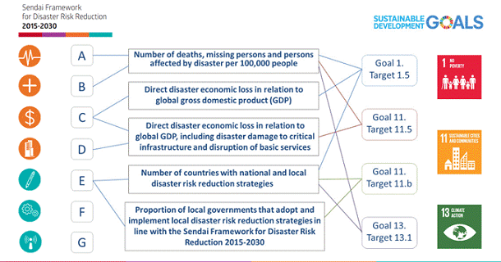
Source: https://www.undrr.org/implementing-sendai-framework/sf-and-sdgs

1.1.3. The UNECE Set of Core Climate Change-related Indicators and Statistics
Climate change is an existential threat and provides an immense challenge for humanity. A better understanding of all its aspects, through monitoring, modelling, analysis and reporting, is crucial to decide on the best course of action. A dedicated United Nations Economic Commission for Europe (UNECE) Task Force established by the Conference of European Statisticians (CES) developed a set of core internationally comparable climate change-related indicators and statistics.
This indicator set (the CES Indicator Set) was endorsed in 2020 by the Heads of national statistical offices of more than 60 CES member countries. The CES Indicator Set provides the foundation for developing national sets of climate change-related indicators intended to show the big picture of climate change-related issues, address the most relevant current policy questions and help meet upcoming information needs. It includes 44 indicators covering climate change drivers, emissions, climate change impacts, mitigation and adaptation.
Figure 1.2 - Scope of climate change-related statistics
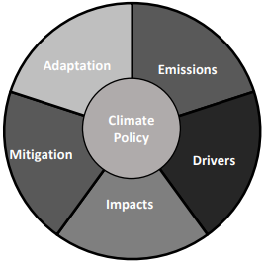
Source: https://unece.org/DAM/stats/documents/ece/ces/2017/A5-leaflet_on_climate_change_EN_New.pdf
It also proposes corresponding contextual and operational indicators, helping interpret the core set in the national and global context, and provide more details according to national circumstances and priorities. The selection of indicators followed a careful vetting process based on the criteria of policy relevance, methodological soundness and data availability described in the present document.

1.1.4. The UNSD Global Set of Climate Change Statistics and Indicators
Following the United Nations Statistical Commission's decisions at its 47th and 49th sessions (2016 and 2018, respectively), the United Nations Statistical Division (UNSD) developed the Global Set of Climate Change Statistics and Indicators (Global Set), in collaboration with UNFCCC and the Expert Group of Environment Statistics to promote the policy and statistics interface. The Global Set thus provides the statistical framework with suitable indicators to serve as guidance for countries to prepare their own sets.
This statistical framework links the reporting requirements stemming from the Paris Agreement and the agreed reporting modalities known as the 'Katowice package' to the indicators necessary to support climate policy action. It is structured in three tiers which follow the internationally accepted frameworks, standards and guidelines with relevance to climate change e.g. IPCC, SDGs, Sendai Framework, Framework of Development of Environment Statistics (FDES), System of Environment and Economic Accounts (SEEA) and UNECE core set of climate change-related indicators. This is expected to assist NSOs to efficiently coordinate the collaboration between specialized national agencies and authorities responsible for reporting to UNFCCC.
Table 1.1 - UNSD Global set of Climate Change Statistics and Indicators
Areas and Topics | Indicators
Areas and Topics | Codes | Number
Drivers | 1-26 | 26
Total greenhouse gas emissions | 1-8 | 8
Atmospheric concentration of greenhouse gases | 9 | 1
Energy production, supply and consumption | 10-14 | 5
Fossil fuels | 15-16 | 2
Population | 17-18 | 2
Transport | 19-20 | 2
Land and agriculture | 21-26 | 6
Impacts | 27-80 | 54
Agricultural production affected by climate change | 27-30 | 4
Areas affected by climate change | 31-35 | 5
Freshwater resources | 36-38 | 3
Hazardous events and disasters | 39-43 | 5
Climate change and human health | 44-46 | 3
Climate change evidence | 47-60 | 14
Soil condition | 61 | 1
Distribution and status of species | 62-65 | 4
Distribution and status of ecosystems | 66-73 | 8
Production and consumption of materials | 74 | 1
Climate change impacts on transport and critical infrastructure | 75-77 | 3
Climate change impacts on tourism | 78-80 | 3
Vulnerability | 81-108 | 28
Water security, food security and agriculture | 81-86 | 6
Vulnerable species, ecosystems and their services | 87-90 | 4
Buildings and infrastructure vulnerable to climate change | 91-92 | 2
Vulnerable population | 93-105 | 13
Area of country vulnerable to climate change | 106-108 | 3
Mitigation | 109-126 | 18
Renewable energy | 109-113 | 5
Climate change mitigation policies, strategies and plans | 114-119 | 6
Climate change mitigation technology and practice | 120-126 | 7
Adaptation | 127-158 | 32
Climate change adaptation policies, strategies and plans | 127-132 | 6
Risk management, disaster forecasting and early warning systems | 133-137 | 5
Public awareness of and education on climate change | 138-141 | 4
Area-based adaptation to climate change | 142-149 | 8
Climate change monitoring | 150-154 | 5
Water management | 155 | 1
Waste management | 156-158 | 3
Source: Processing on UNSD data
The Global Set of Climate Change Statistics and Indicators is a comprehensive statistical framework, with statistics, indicators and metadata, designed to support countries in preparing their own sets of climate change statistics and indicators according to their individual concerns, priorities and resources (Table 1.1). It will assist countries embarking on the development of climate change statistics by providing the scope and coverage as to what may be considered relevant to climate change. It can also assist countries already involved in this area of statistics by providing a check list to see what may be already covered or added to national sets. It is flexible enough, with a tiering system, to be applied based on regions’, as well as countries’, priorities and data availability. It is recommended to promote complementarity among global, regional and national sets of climate indicators, to encourage harmonization across all levels.
A tiering system was set up in a way that distinguishes the most commonly applied indicators (Tier 1) from those that are less applied (Tier 2) and those that require substantial methodological development to become operational (Tier 3). The Global Set of Climate Change Statistics and Indicators takes into consideration the diversity of all Member States of the United Nations at varying stages of development and with different geographical characteristics. To make sure that the countries with least developed and developing statistical systems are not left behind, the Global Set includes both the indicators addressing climate change and the underlying statistics needed for their compilation, whenever distinct guidance for these statistics was identified.

1.2. Vietnam’s Sustainable Development Goals (VSDGs)

1.2.1. Legal basis
The 2030 Agenda for Sustainable Development, adopted by all UN member-countries in 2015, calls for action to reduce poverty, protect the planet and ensure that by 2030 all people enjoy peace and prosperity. The 2030 Agenda set up 17 Sustainable Development Goals (SDGs), 169 specific targets, orientation for implementation, global partnerships and actions to implement international commitments. To implement the 2030 Agenda for Sustainable Development, Vietnam’s Government has promulgated the Decision on the National Action Plan (NAP) for the implementation of the 2030 Sustainable Development Agenda with 17 goals and 115 specific targets, which are suitable with Vietnam's development conditions, and the Decision on the Roadmap for VSDGs implementation by 2030. In order to produce statistical information on VSDGs completely, accurately and timely and to meet international comparison requirements as well as to build a statistical database on VSDGs, the Minister of Planning and Investment has issued a set of statistical indicators on VSDGs with 158 indicators. In addition, the revised and supplemented Statistical Law 2021 also added some basic indicators on VSDGs to the National Statistical Indicator System.
To successfully implement VSDGs on urban environment, climate change and natural disaster reduction, Vietnam has issued many important policies, specifically:
On urban environment
Regarding state management of the environment in general and urban environment in particular, Vietnam has promulgated the Law on Environmental Protection in 2014 (amended and supplemented in 2020, effective in 2022) and sub-law documents. Accordingly, Vietnam has promulgated specific regulations on environmental protection activities: rights, obligations and responsibilities of agencies, organizations, communities, households and individuals in environmental protection activities. The Law on Environmental Protection of 2020 has also specifically stipulated that urban areas and concentrated residential areas must meet environmental protection requirements.
Besides, many important programs and actions related to environmental and urban environment protection have been issued: National action plan on air quality management up to 2020, vision to 2025 (2016); Adopting the adjustment of the national strategy on integrated solid waste management to 2025, with a vision to 2050 (2018); Adopting the task of making water resource planning for the period of 2021-2030, with a vision to 2050 (2019); Adopting the National plan on air quality management for the period 2021-2025 (2021).
On Climate change and Sendai framework
As a developing country with limited resources while suffering many impacts of climate change, Vietnam is still determined to join the international community in responding to global climate change. At the 26th United Nations Climate Change Conference of the Parties (COP26), the Prime Minister of Vietnam proposed that climate change response and the restoration of nature must become the highest priority in all development decisions, and they must form the highest ethical standards for all levels, sectors, businesses and citizens. Implementing international commitments, from 2007 to now, Vietnam has issued many important policies on adaptation and mitigation of climate change impacts. Following are the key policies:
- Promulgating a number of Laws, specifically: Law on Economical and efficient use of energy (2011); Law on Water Resources (2012); Law on natural disaster prevention and control (2013); Land Law (2013); Law on Hydrometeorology (2015); Law on Forestry (2017); Law on Fisheries (2017); Law on Cultivation (2018); Law on Livestock (2018); Law on Biodiversity (2018); and Law on Sea and Islands Natural Resources and Environment (2018).
- Strategies related to climate change and green growth include: Vietnam forestry development strategy for the period 2006-2020 (2007); National energy development strategy to 2020, vision to 2050 (2007); National Strategy on Climate Change (2011); TTX Strategy (2012); Transport development strategy to 2020, vision to 2030 (2013); and the Renewable Energy Development Strategy to 2030, vision to 2050 (2015).
- Programs, plans and schemes directly related to climate change adaptation and greenhouse gas emission reduction include: National program on economical and efficient use of energy (2006 and expanded in 2019); The national target program to respond to climate change for the period 2009-2015 and the target program to respond to climate change and green growth for the period 2016-2020 (2017); National Action Plan on Climate Change for the period 2012-2020 (2012); National project on development of urban areas in Vietnam to respond to climate change in the period of 2013-2020 (2013); National program on greenhouse gas emission reduction through limiting forest loss and degradation; conservation, enhancement of carbon stocks and sustainable management of forest resources (REDD+) to 2030 (approved in 2012 for the period 2011-2020; extended in 2017); National Action Plan on Green Growth for the period 2014-2020 (2014); National electricity development planning for the period 2011-2020, with a vision to 2030 (adjusted in 2016); Plan for the implementation of the Paris Agreement (2016); Support Program to Respond to Climate Change (SP-RCC) (started in 2009, final commitment made in 2020_World Bank); Science and technology program to respond to climate change, natural resources and environment management 2016-2020 (2016); National Action Plan for Implementation of the 2030 Agenda for Sustainable Development (2017); Science and technology program on natural disaster prevention and control and environmental protection 2016-2020 (2018).
- Based on the above national policies, Ministries and Agencies, Provinces and Cities have issued policies and plans of sectors and localities related to climate change such as: Action plan on climate change; Action Plan on Green Growth and the implementation plan of the Paris Agreement; they have integrated the content of climate change mitigation and adaptation in sector development strategies.
In March 2015, in Sendai, Japan, 187 countries around the world, including Vietnam, approved the Sendai Framework on Disaster Risk Reduction; in which, there are 7 global goals, 4 priority action groups to show the commitment of countries to give priority to disaster risk reduction.
The four priority action groups for national implementation in Vietnam are:
- Increasing understanding of disaster risk;
- Strengthen governance to manage disaster risks;
- Invest in risk reduction to build resilience to disasters and
- Improve preparedness for effective response and “Build Better” in recovery and reconstruction.
To well implement disaster risk reduction, even before adopting the Sendai Framework, since 2007 Vietnam has issued a Strategy for Natural Disaster Prevention, Control and Mitigation up to 2020; in 2021, Vietnam continued to approve the National Strategy for Natural Disaster Prevention and Control to 2030, with a vision to 2050. These strategies show that disaster risk management in Vietnam has a close relationship with climate change adaptation.

1.2.2. Implementation of VSDGs indicators related to urban environment
With the socio-economic development, Vietnam's urban areas have significantly changed in quantity, size and quality. The rapid urbanization process has led to many consequences, in which the quality of the urban environment is seriously affected. Besides urban areas with relatively good environmental quality, there are still many urban areas, especially large cities, concentrated in delta areas where socio-economic activities have strongly developed, environmental pollution is still an outstanding issue, posing challenges to the management.
Table 1.2 - VSDGs indicators on urban environment
No. | Goal/Indicator | Indicator code |  |  | Agency in charge, status of data
No. | Goal/Indicator | SDG | VSDG | NSIS | Agency in charge, status of data
 | Goal 6: Ensure availability and sustainable management of water and sanitation for all
1 | Proportion of urban population provided with drinking water through the centralized water supply system | 6.1.1 | 6.1.1 | 1804 | Ministry of Construction, all data available
2 | Percentage of households using improved water resources (*) | 6.1.1 | 6.1.2 | 1805 | GSO, all data available
3 | Percentage of households using improved sanitation facilities | 6.2.1 | 6.2.1 | 1806 | GSO, all data available
4 | Proportion of urban waste-water collected and treated up to standards and technical regulations | 6.3.1 | 6.3.1 |  | Ministry of Construction, available data not suitable for territorial analysis
 | Goal 7: Ensure access to sustainable, reliable, and affordable energy for all
5 | Proportion of households with access to electricity | 7.1.1 | 7.1.1 |  | GSO, all data available
6 | Proportion of households using clean fuel | 7.1.2 | 7.1.2 |  | GSO, no data available (tier B indicator)
 | Goal 11: Promote sustainable, resilient urban and rural development; ensure safe living and working environments; ensure reasonable distribution of population and work force by region
7 | Proportion of population living in poorly built housing | 11.1.1 | 11.1.1 |  | GSO, data partly available
8 | Growth rate of the number of passengers using public transport (**) | 11.2.1 | 11.2.1 |  | Ministry of Construction, all data available
9 | Proportion of urban domestic solid waste that is collected, transported, and treated according to technical standards and regulations (***) | 11.6.1 | 11.6.1 |  | Ministry of Construction, all data available
10 | Proportion of urban construction solid waste collected for reuse or recycling |  | 11.6.2 |  | Ministry of Construction, data partly available
11 | Concentration of substances in the air environment | 11.6.2 | 11.6.3 |  | Ministry of Natural Resources and Environment, data partly available
12 | Public green area per capita in urban areas |  | 11.7.1 |  | Ministry of Construction, data partly available
(*) Not included in the selection as largely overlapping indicator 1, which provides more specific information about urban population.
(**) Complemented by an indicator on the Demand for road public transport.
(***) Complemented by an indicator on Urban domestic solid waste collected per capita.
Source: GSO
Among 158 VSDGs indicators, 12 were identified as most relevant to urban environment (Table 1.2), of which 7 were selected for inclusion in this report (no. 1, 3, 5, 7, 8, 9 and 11), plus one about land consumption (not present in the VSDG list). The selection was driven essentially by the availability of data, and includes indicators sourced both by the GSO and by other Agencies of the National statistical reporting system. As some of these indicators refer to complex phenomena, whose monitoring requires to consider more sub-indicators, the set of urban environment indicators presented in this report actually consists of 13 statistical measures, referring to 3 SDGs (Table 1.3).
Table 1.3 - Set of urban environment indicators
SDG indicators | VSDG indicators | Statistical measures available (unit of measure) | Source | Time series
Goal 6 - Ensure availability and sustainable management of water and sanitation for all
6.1.1 - Proportion of population using safely managed drinking water services, by urban/rural | 6.1.1 - Proportion of urban population provided with drinking water by centralized water supply system | 6.1.1 - Urban population provided with clean water by centralized water supply system (percentage share) | National statistical reporting system (MOC) | 2016-2021
6.2.1 - Proportion of population using (a) safely managed sanitation services and (b) a hand-washing facility with soap and water | 6.2.1 - Households using improved sanitation facilities | 6.2.1 - Households using improved toilet facilities (percentage share) | GSO, Vietnam Household Living Standards Survey | 2014-2020
Goal 7 - Ensure access to affordable, reliable, sustainable and modern energy for all (VSDG: Ensure access to sustainable, reliable, and affordable energy for all)
7.1.1 - Proportion of population with access to electricity | 7.1.1 - Proportion of households with access to electricity | 7.1.1 - Households with access to electricity (percentage share) | GSO, Vietnam Household Living Standards Survey | 2010-2020
Goal 11 - Make cities and human settlements inclusive, safe, resilient and sustainable (VSDG: Promote sustainable, resilient urban and rural development; ensure safe living and working environments; ensure reasonable distribution of population and work force by region)
11.1.1 - Proportion of urban population living in slums, informal settlements or inadequate housing | 11.1.1 - Proportion of population living in poorly built housing | 11.1.1a - Households not living in permanent/semi-permanent houses (percentage share) | GSO, Vietnam Household Living Standards Survey | 2014-2020
 |  | 11.1.1b - Households living in less than 10 m² per capita (percentage share) | GSO, Population Census | 2009, 2019
11.2.1 - Proportion of population that has convenient access to public transport, by sex, age and persons with disabilities | 11.2.1 - Growth rate of the number of passengers using public transport | 11.2.1a - Growth rate of public transport passengers by road (percentage change) | National statistical reporting system (MOIT) | 2012-2021
 |  | 11.2.1b - Demand for road public transport (passengers per capita) | National statistical reporting system (MOIT) | 2011-2021
11.3.1 - Ratio of land consumption rate to population growth rate | Land consumption (indicator recommended for inclusion in the VSDGs) | 11.3.1a - Ratio of land consumption rate to population growth rate (index) | National statistical reporting system (MONRE) | 2016-2020
 |  | 11.3.1b - Land consumption as a proportion of total land area (percentage share) | National statistical reporting system (MONRE) | 2015-2020
11.6.1 - Proportion of municipal solid waste collected and managed in controlled facilities out of total municipal waste generated, by cities | 11.6.1 - Proportion of urban domestic solid waste that is collected, transported and treated according to technical standards and regulations | 11.6.1a - Urban domestic solid waste collected, transported and treated according to technical standards and regulations (percentage share) | National statistical reporting system (MOC) (*) | 2015-2019
 |  | 11.6.1b - Urban domestic solid waste collected per capita (kg per capita) | National statistical reporting system (MOC) (*) | 2015-2019
11.6.2 - Annual mean levels of fine particulate matter (e.g. PM_{2.5} and PM₁₀) in cities (population weighted) | 11.6.3 - Concentration of substances in the air environment | 11.6.3a - Annual mean concentration of pollutants in cities: maximum values (PM₁₀ and NO₂) (g per m³) | National statistical reporting system (MONRE) | 2014-2019 (PM₁₀),  2013-2021 (NO₂)
 | 11.6.3 - Concentration of substances in the air environment | 11.6.3b - Annual mean concentration of pollutants in cities: values above the WHO reference values for avoidable mortality (PM₁₀ and NO₂) (percentage share) | National statistical reporting system (MONRE) | 2014-2019 (PM₁₀),  2013-2021 (NO₂)
(*) To be replaced by MONRE from 2020 on.
Source: GSO and Istat

1.2.3. Implementation of VSDGs indicators related to climate change, extreme weather events and the Sendai framework
Vietnam, with more than 3,000 km of coastline, located in the Asian monsoon region, annually faces the activity of storms, tropical depressions as well as the impact of many types of extreme weather. Climate change affects all regions, areas of natural resources, environment and socio-economic. Climate change in Vietnam is complicated process, happening faster than expected. Compared with studies on damage caused by climate change in the world, Vietnam is a country heavily affected by climate change.
Regarding GHG emissions
As one of the main factors causing climate change. In the period 1994-2016, the total amount of GHG generated in Vietnam increased about three times, from 103.8 million tons to 316.7 million tons of CO2 equivalent. In particular, the amount of emissions in the energy sector has increased significantly, about 8 times higher than in 1994 due to the rapidly increasing demand for energy. Noted that the field of land use, land use change and forestry (LULUCF) has begun to gradually shift from GHG emissions to GHG sequestration since 2010. This is the result of forest protection programmes, and effective afforestation was carried out in previous years.
Regarding extreme weather events
According to the Global Climate Change Risk Index Report 2018, Vietnam ranked 5th in the Global Climate Risk Index in 2018 and 8th in the long term Climate Risk Index (CRI). In the past, extreme weather events occurred with a seasonal pattern; however, in recent years, extreme weather events occur all year round. Extreme weather events spread across all regions of the country, of which, typically extreme drought and extreme rain in the Central region, severe cold and damaging cold in the Northern mountainous region, and saltwater intrusion in the South⁴.
Among 158 VSDGs indicators, there are 5 indicators basically related to climate change:
- Indicator 11.5.1_VSDGs (Goal 11 SDGs): Number of deaths and missing persons attributed to hydro meteorological disaster, per 100.000 population;
- Indicator 11.6.4_VSDGs (Goal 11 SDGs): Greenhouse gas emissions per capita;
- Indicator 13.2.1_SDGs (Goal 13 SDGs): Percentage of ministries, branches and provinces and cities directly under the Central Government that have promulgated the Green Growth Action Plan;
- Indicator 13.3.1_VSDGs (Goal 13 SDGs): Proportion of the population who are disseminated knowledge about flood and storm prevention and disaster risk reduction
- Indicator 15.2.2_VSDGs (Goal 15 SDGs): Forest area.
In order to assess the situation of climate change in Vietnam, within this report, 17 indicators of the Global set of climate change statistics and indicators of UNSD were selected for specific analysis (of which 3 VSDGs indicators, see Table 2.3).
There are 3 indicators of the Sendai framework that are presented in this publication: Indicator 11.5.1_VSDGs: Number of deaths and missing persons attributed to hydro meteorological disaster, per 100.000 population, and indicators with code 27, 40, 42 (Table 1.4) of the UNSD Global set of climate change statistics and indicators.
Although Vietnam has issued a National Action Plan for the implementation of the 2030 Sustainable Development Agenda, Roadmap for VSDGs implementation by 2030, promulgating VSDGs Indicators, regulations on collecting information for VSDGs indicators, in fact certain difficulties, in terms of resources and technical issues, remain. This made the data collection for some indicators unsuccessful, while for some others data are still available only in part.
Table 1.4 - Climate change indicators
No | Goal/Indicator | Indicator code |  |  |  | Agency in charge, status of data
No | Goal/Indicator | SDGs | VSDGs | NSIS | UNSD | Agency in charge, status of data
1 | Total greenhouse gas emissions per year | 13.2.2 |  |  | 1 | Ministry of Natural Resources and Environment, a part data available (when calculation implemented)
2 | Greenhouse gas emissions from land use, land use change and forestry |  |  |  | 3 | Ministry of Natural Resources and Environment, a part data available (when calculation implemented)
3 | Greenhouse gas emissions per capita | 11 | 11.6.4 | 2110 | 5 | Ministry of Natural Resources and Environment, a part data available (when calculation implemented)
4 | Total primary energy supply from fossil fuels |  |  |  | 11 | Ministry of Industry and Trade, all data available
5 | Share of fossil fuels in total primary energy supply |  |  |  | 12 | Ministry of Industry and Trade, all data available
6 | Final energy consumption per capita |  |  |  | 13 | GSO, all data available
7 | Population growth |  |  | 0107 | 17 | GSO, all data available
8 | Urban population as a proportion of total population |  |  |  | 18 | GSO, all data available
9 | Direct agricultural loss attributed to disasters |  |  | 2103 | 27 | GSO, all data available
10 | Direct economic loss to all damaged or other destroyed productive assets caused by the disaster |  |  | 2103 | 40 | GSO, all data available
11 | Number of deaths, missing persons and directly affected persons attributed to disasters per 100,000 population | 11 | 11.5.1 | 2103 | 42 | Ministry of Agriculture and Rural Development and GSO, all data available
12 | Number of cases of climate-related infectious diseases |  |  |  | 44 | Ministry of Health, a part of data available
13 | Temperature records |  |  |  | 53 | Ministry of Natural Resources and Environment, a part of data available
14 | Rate of invasive alien species spread | 15.8.1 |  |  | 65 | The Ministry of Natural Resources and Environment, all data available
15 | Proportion of population with access to heating/cooling |  |  |  | 99 | GSO, all data available
16 | Proportion of the population living below the international poverty line by sex, age, employment status and geographic location (urban/rural) | 1.1.1 |  |  | 101 | GSO, all data available
17 | Increase in forest area |  | 15.2.2 | 2102 | 125 | Ministry of Agriculture and Rural Development, all data available

Source: GSO

1.3. Directory of the statistical measures presented
To sum up, this Report includes 30 statistical measures, relevant to the SDG indicators on urban environment, and/or the UNSD indicators on climate change, extreme events and disasters. The measures are presented by cards, in the following Chapters 2 and 3. In particular, Chapter 2 includes 13 cards (for the measures relevant to SDG indicators on urban environment, including the eight relevant to both frameworks), while Chapter 3 includes the other 17 cards, for the measures relevant only to UNSD indicators on climate change, extreme events and disasters (Figure 1.3). Given this complexity, a directory of the statistical measures presented is provided below, reporting for each item the corresponding card and the reference to the relevant frameworks (Table 1.5).
Figure 1.3 - Statistical measures presented, by relevant framework and Chapter
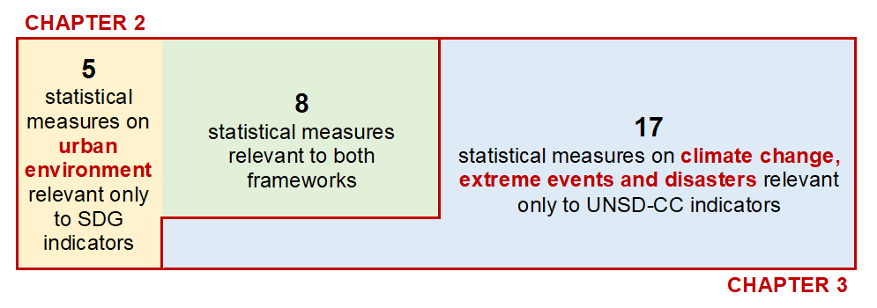

Table 1.5 - Directory of the statistical measures included in the Report
STATISTICAL MEASURES  (in alphabetical order) | RELEVANCE TO SDGs GLOBAL FRAMEWORK  (P = proxy or partial) |  |  | RELEVANCE TO CLIMATE CHANGE STATISTICS AND INDICATORS  (P = proxy or partial) |  |  |  |  | REFERENCE TO INDICATOR CARDS (Chapters 2 and 3)
STATISTICAL MEASURES  (in alphabetical order) | Goal | Target  (definitions abridged) | Indicator | UNSD GLOBAL SET |  |  | SENDAI | FDES | 2. Urban environment indicators | 3. Climate change indicators
 |  |  |  | Area | Topic | Indicator
Agricultural damage directly caused by natural disasters | 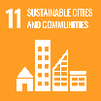 | 11.5 - Reduce direct economic losses caused by disasters | 11.5.2 (P) |  | Agricultural production affected by climate change | 27 (P) | C-2 | - |  | 27
Annual mean concentrations of pollutants in cities: maximum values |  | 11.6 - Reduce adverse impact of cities, improve air quality and waste management | 11.6.2 (P) |  | Climate change and human health | 46 (P) | - | - | 11.6.3a
Annual mean concentrations of pollutants in cities: values above the WHO reference values for avoidable mortality |  | 11.6 - Reduce adverse impact of cities, improve air quality and waste management | 11.6.2 (P) | - | - | - | - | - | 11.6.3b
Demand for road public transport |  | 11.2 - Safe, affordable, accessible and sustainable transport systems | 11.2.1 (P) | - | - | - | - | - | 11.2.1b
Energy consumption per capita | - | - | - |  | Energy production, supply and consumption | 13 (P) | - | - |  | 13
Estimated damage in cash directly caused by the disaster | 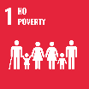 | 1.5 - Reduce exposure and vulnerability to climate-related extreme events and disasters | 1.5.2 (P) |  | Hazardous events and disasters | 40 (P) | C-3 | - |  | 40
Estimated damage in cash directly caused by the disaster |  | 11.5 - Reduce direct economic losses caused by disasters | 11.5.2 (P)
Forest area |  | 15.1 - Conservation, restoration and sustainable use of terrestrial ecosystems | 15.1.1 (P) |  | Climate change mitigation technology and practice | 125 | - | - |  | 125
Greenhouse gas emissions by LULUCF | - | - | - |  | Total greenhouse gas emissions | 3 (P) | - | 3.1.1a |  | 3
Greenhouse gas emissions per capita | - | - | - |  | Total greenhouse gas emissions | 5 | - | 3.1.1a |  | 5
Growth rate of public transport passengers by road |  | 11.2 - Safe, affordable, accessible and sustainable transport systems | 11.2.1 (P) | - | - | - | - | - | 11.2.1a
Households living in less than 10 m² per capita |  | 11.1 - Access to adequate, safe and affordable housing | 11.1.1 (P) | - | - | - | - | - | 11.1.1b
Households not living in permanent/semi-permanent houses |  | 11.1 - Access to adequate, safe and affordable housing | 11.1.1 (P) |  | Vulnerable population | 103 (P) | - | - | 11.1.1a
Households using improved sanitation facilities |  | 6.2 - Access to adequate and equitable sanitation and hygiene | 6.2.1 (P) |  | Vulnerable population | 97 (P) | - | - | 6.2.1
Households with access to electricity |  | 7.1 - Access to affordable, reliable and modern energy services | 7.1.1 |  | Vulnerable population | 95 | - | - | 7.1.1
Invasive alien flora and fauna species |  | 15.8 - Prevent introduction and reduce impact of invasive alien species | 15.8.1 (P) |  | Distribution and status of species | 65 (P) | - | - |  | 65
Land consumption as a proportion of total land area |  | 11.3 - Enhance inclusive and sustainable urbanization | 11.3.1 (P) |  | Land and agriculture | 26 (P) | - | - | 11.3.1b
Multi-dimensional poverty household rate |  | 1.1 - Eradicate extreme poverty | 1.1.1 (P) |  | Vulnerable population | 101 (P) | - | - |  | 101
Number of cases of climate-related infectious diseases | - | - | - |  | Climate change and human health | 44 (P) | - | - |  | 44
Number of people dead and missing due to natural disasters |  | 1.5 - Reduce exposure and vulnerability to climate-related extreme events and disasters | 1.5.1 (P) |  | Hazardous events and disasters | 42 (P) | A-1 (P) | - |  | 42
Number of people dead and missing due to natural disasters |  | 11.5 - Reduce direct economic losses caused by disasters | 11.5.1 (P)
Number of people dead and missing due to natural disasters |  | 13.1 - Strengthen resilience and adaptive capacity to climate-related hazards and natural disasters | 13.1.1 (P)
Population growth | - | - | - |  | Population | 17 | - | - |  | 17
Proportion of population living in dwellings with air conditioners | - | - | - |  | Vulnerable population | 99 (P) | - | - |  | 99
Ratio of land consumption rate to population growth rate |  | 11.3 - Enhance inclusive and sustainable urbanization | 11.3.1 | - | - | - | - | - | 11.3.1a
Recorded daily average temperature | - | - | - |  | Climate change evidence | 53 (P) | - | - |  | 53
Share of fossil fuels in total primary energy supply |  | 7.2 - Increase the share of renewable energies | 7.2.1 (P) |  | Energy production, supply and consumption | 12 | - | - |  | 12
Total emissions of greenhouse gases |  | 13.2 - Integrate climate change measures into national policies | 13.2.2 |  | Total greenhouse gas emissions | 1 | - | - |  | 1
Total primary energy supply |  | 7.2 - Increase the share of renewable energies | 7.2.1 (P) |  | Energy production, supply and consumption | 11 (P) | - | - |  | 11
Urban domestic solid waste collected per capita |  | 11.6 - Reduce adverse impact of cities, improve air quality and waste management | 11.6.1 (P) |  | Waste management | 156 | - | - | 11.6.1b
Urban domestic solid waste collected, transported and treated according to technical standards and regulations |  | 11.6 - Reduce adverse impact of cities, improve air quality and waste management | 11.6.1 (P) |  | Waste management | 157 | - | - | 11.6.1a
Urban population as a proportion of total population | - | - | - |  | Population | 18 | - | - |  | 18
Urban population provided with clean water by centralized water supply system |  | 6.1 - Access to safe and affordable drinking water | 6.1.1 |  | Vulnerable population | 98 | - | - | 6.1.1

Chapter 2.

Sustainable development indicators on urban environment

2.1. Classification of territorial units by urban intensity

2.1.1. Aim of the classification
In this Report, for the purpose of the analysis of urban environment indicators, the Provinces of Vietnam (63 territorial units, including the five under the central government) have been classified by urban intensity degree. The aim is twofold: on one hand, such classification makes possible to bypass some limits currently imposed to the assessment of urban environment indicators by the unavailability of data referred to individual cities. On the other hand, it allows the disaggregation of all indicators by urban and rural areas, which is particularly relevant to Vietnam, and fully meets the SDG recommendation to monitor inequality and the trends of social and territorial divides, so to “leave no one behind”.
By identifying, on a statistical basis, the territorial units that are more intensely urbanized, these have been assumed as proxies of “urban areas”, and the values of indicators have been calculated with reference to them. This enabled to make comparisons, for the topics covered, among homogeneous areas, and, for each area, to the national averages, as well as to compare the average values of urban and rural areas (having identified the latter, via the same procedure, as the less urbanized territorial units).

2.1.2. Methodology
A simple method has been implemented, based on the combination of three indicators of urban intensity, all sourced by the GSO or the National statistical reporting system, and referred to 2020:
- Population density (inhabitants per km²);
- Proportion of urban population (people living in urban areas per 1,000 people living in rural areas);
- Urbanization rate (percentage of land occupied by urban residential areas and by activities other than agriculture and forestry over the total land area).
Population density: In 2020, it is 295 inhabitants per km² nationwide, ranging from 52 (Province of Lai Chau) to 4,404 (Province of Ho Chi Minh City).
Proportion of urban population: In 2020, there were 583 people living in urban areas every 1,000 living in rural areas, ranging from 109 (Province of Ben Tre) to 6,847 (Province of Da Nang).
Urbanization rate: In 2020, according to MONRE data on land use, the total land area of Vietnam was composed as follows:
- 35.4%: Agricultural production land
- 50.4%: Forestry land
- 2.2%: Homestead land (of which: 0.6% urban + 1.6% rural)
- 6.1%: Specially used land
- 5.9%: Unused land
The urbanization rate can be calculated as the percentage of total land area that is covered by urban homestead land and specially used land, which is 6.6% for the whole Country, ranging from 1.0% (Province of Lai Chau) to 38.2% (Province of Da Nang).
For each of the above indicators, the Provinces have been grouped into three classes, based on their placement in the distributions of the three indicators (Table 2.1).
Table 2.1 - Cut-offs for urban intensity indicators
Classes | Population density (inhabitants per km²) | Urban population (per 1,000 people living in rural areas) | Urbanization rate (%)
A (upper 33.3%) | > 472.8 | > 465.4 | > 8.3
B (middle 33.3%) | 175.9 - 472.8 | 286.0 - 465.4 | 5.3 - 8.3
C (lower 33.3%) | < 175.9 | < 286.0 | < 5.3
Source: Processing on GSO population data and MONRE land use data.
Then, the Provinces have been classified at High, Medium, or Low urban intensity, according to the following criteria (Table 2.2).
Table 2.2 - Criteria for the classification of territorial units by urban intensity
Urban intensity degree | Criterion | Number of territorial units (Provinces)
HIGH | At least two A ratings out of three | 18
LOW | At least two C ratings out of three | 20
MEDIUM | All others | 25
 |  | Total = 63

2.1.3. Identification of major urban areas
Finally, the Provinces at high urban intensity have been aggregated in order to identify the major urban areas, based on a contiguity principle. As the five Provinces under the central government resulted all at high urban intensity, it was assumed that they were the centers of the major urban areas (central units), and the other adjoining high-intensity units were forming their peripheries (peripheral units).
Table 2.3 - Number of territorial units (Provinces), average population, population density, proportion of urban population and percentage of urbanized land by urban intensity degree. Year 2020
Urban intensity degree | No. of territorial units | Average population |  | Population density (inhabitants/km²) | Urban population (per 1,000 people living in rural areas) | Urbanization rate (%)
Urban intensity degree | No. of territorial units | (thousands) | (%) | Population density (inhabitants/km²) | Urban population (per 1,000 people living in rural areas) | Urbanization rate (%)
HIGH | 18 | 42,791.8 | 43.9 | 1,065 | 1,106 | 17.2
of which: Central | 5 | 21,937.9 | 22.5 | 2,260 | 1,863 | 24.6
of which: Peripheral | 13 | 20,853.9 | 21.4 | 685 | 647 | 14.8
MEDIUM | 25 | 33,923.6 | 34.8 | 295 | 360 | 7.5
LOW | 20 | 20,867.2 | 21.4 | 118 | 273 | 3.7
TOTAL | 63 | 97,582.7 | 100.0 | 295 | 583 | 6.6
Source: Processing on GSO population data and MONRE land use data.
By applying the above criteria, the major urban areas have been defined as follows:
- Ha Noi urban area, including the Province of Ha Noi as central unit, and seven peripheral units (the Provinces of Vinh Phuc, Bac Ninh, Hai Duong, Hung Yen, Ha Nam, Ninh Binh, and Thai Nguyen) – in total, 17.2 million inhabitants
- Hai Phong urban area, including the Province of Hai Phong as central unit, and three peripheral units (the Provinces of Quang Ninh, Thai Binh, and Nam Dinh) – in total, 7.0 million inhabitants.
- Da Nang urban area, formed by the sole Province of Da Nang – 1.3 million inhabitants.
- Ho Chi Minh City urban area, including the Province of Ho Chi Minh City as central unit, and three peripheral units (the Provinces of Binh Duong, Dong Nai, and Ba Ria-Vung Tau) – in total, 16.2 million inhabitants.
- Can Tho urban area, formed by the sole Province of Can Tho – in total, 1.2 million inhabitants.
The adjoining urban areas of Ha Noi and Hai Phong were kept separate, and their boundaries defined empirically, so to take account of the differences between the coastal area and the hinterland of Ha Noi (Figure 2.1, Table 2.4).
Figure 2.1 - Provinces of Vietnam by urban intensity degree. Year 2020
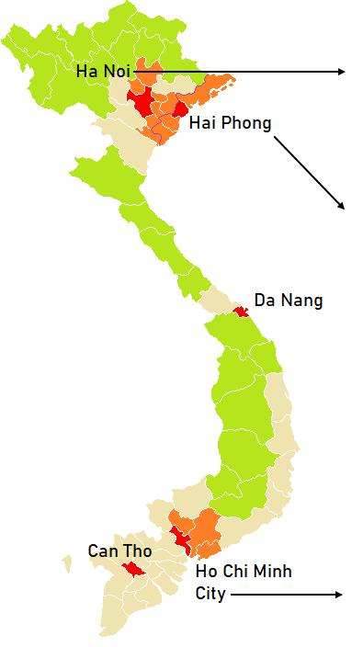 |  | HA NOI URBAN AREA  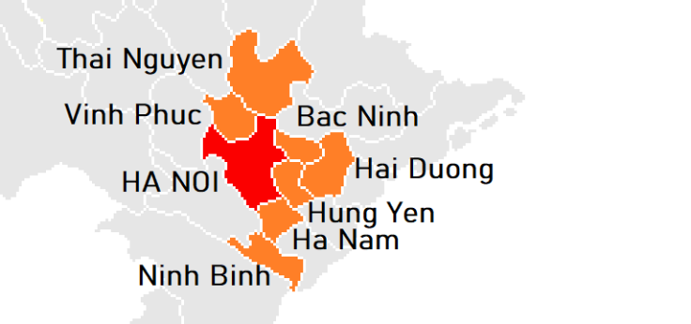  HAI PHONG URBAN AREA  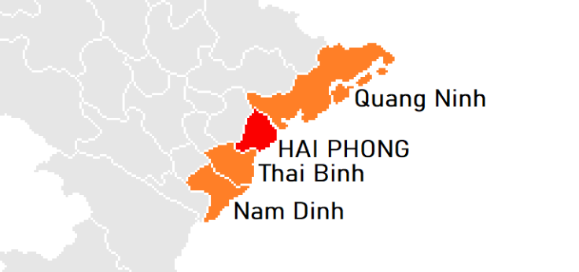  HO CHI MINH CITY URBAN AREA  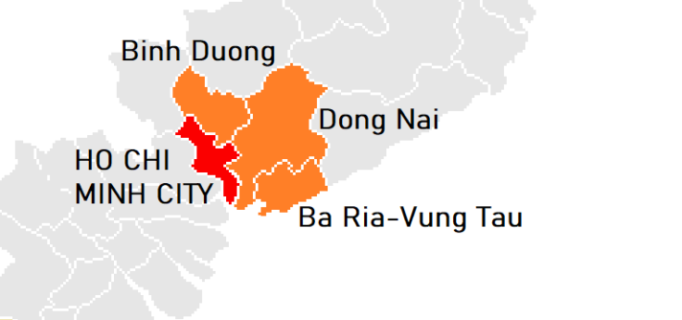
URBAN INTENSITY DEGREE
High (Central units) | High (Peripheral units) |  | Medium | Low
Source: Processing on GSO population data and MONRE land use data.

Table 2.4 - Classification of Provinces by urban intensity degree. Year 2020
Socio-economic Regions | Provinces  (provinces under central govt. in bold) | Ratings |  |  | Urban intensity degree | Major urban area
Socio-economic Regions | Provinces  (provinces under central govt. in bold) | Population density | Urban population | Urbanization rate | Urban intensity degree | Major urban area
Red River Delta | Ha Noi | A | A | A | High (central) | Ha Noi
Red River Delta | Vinh Phuc | A | B | A | High (peripheral) | Ha Noi
Red River Delta | Bac Ninh | A | B | A | High (peripheral) | Ha Noi
Red River Delta | Quang Ninh | B | A | A | High (peripheral) | Hai Phong
Red River Delta | Hai Duong | A | A | A | High (peripheral) | Ha Noi
Red River Delta | Hai Phong | A | A | A | High (central) | Hai Phong
Red River Delta | Hung Yen | A | C | A | High (peripheral) | Ha Noi
Red River Delta | Thai Binh | A | C | A | High (peripheral) | Hai Phong
Red River Delta | Ha Nam | A | B | A | High (peripheral) | Ha Noi
Red River Delta | Nam Dinh | A | C | A | High (peripheral) | Hai Phong
Red River Delta | Ninh Binh | A | C | A | High (peripheral) | Ha Noi
Northern Midlands and Mountains | Ha Giang | C | C | C | Low | -
Northern Midlands and Mountains | Cao Bang | C | B | C | Low | -
Northern Midlands and Mountains | Bac Kan | C | B | C | Low | -
Northern Midlands and Mountains | Tuyen Quang | C | C | C | Low | -
Northern Midlands and Mountains | Lao Cai | C | B | C | Low | -
Northern Midlands and Mountains | Yen Bai | C | C | C | Low | -
Northern Midlands and Mountains | Thai Nguyen | B | A | A | High (peripheral) | Ha Noi
Northern Midlands and Mountains | Lang Son | C | B | C | Low | -
Northern Midlands and Mountains | Bac Giang | B | C | A | Medium | -
Northern Midlands and Mountains | Phu Tho | B | C | B | Medium | -
Northern Midlands and Mountains | Dien Bien | C | C | C | Low | -
Northern Midlands and Mountains | Lai Chau | C | C | C | Low | -
Northern Midlands and Mountains | Son La | C | C | C | Low | -
Northern Midlands and Mountains | Hoa Binh | B | B | B | Medium | -
North-central and Central Coast | Thanh Hoa | B | B | B | Medium | -
North-central and Central Coast | Nghe An | B | C | C | Low | -
North-central and Central Coast | Ha Tinh | B | C | B | Medium | -
North-central and Central Coast | Quang Binh | C | B | C | Low | -
North-central and Central Coast | Quang Tri | C | B | C | Low | -
North-central and Central Coast | Thua Thien-Hue | B | A | B | Medium | -
North-central and Central Coast | Da Nang | A | A | A | High (central) | Da Nang
North-central and Central Coast | Quang Nam | C | B | C | Low | -
North-central and Central Coast | Quang Ngai | B | C | B | Medium | -
North-central and Central Coast | Binh Dinh | B | A | B | Medium | -
North-central and Central Coast | Phu Yen | C | A | B | Medium | -
North-central and Central Coast | Khanh Hoa | B | A | B | Medium | -
North-central and Central Coast | Ninh Thuan | B | A | B | Medium | -
North-central and Central Coast | Binh Thuan | C | A | B | Medium | -
Central Highlands | Kon Tum | C | A | C | Low | -
Central Highlands | Gia Lai | C | B | C | Low | -
Central Highlands | Dak Lak | C | B | C | Low | -
Central Highlands | Dak Nong | C | C | C | Low | -
Central Highlands | Lam Dong | C | A | C | Low | -
Socio-economic Regions | Provinces  (provinces under central govt. in bold) | Ratings |  |  | Urban intensity degree | Major urban area
Socio-economic Regions | Provinces  (provinces under central govt. in bold) | Population density | Urban population | Urbanization rate | Urban intensity degree | Major urban area
South East | Binh Phuoc | C | B | B | Medium | -
South East | Tay Ninh | B | A | B | Medium | -
South East | Binh Duong | A | A | A | High (peripheral) | Ho Chi Minh City
South East | Dong Nai | A | A | A | High (peripheral) | Ho Chi Minh City
South East | Ba Ria-Vung Tau | A | A | A | High (peripheral) | Ho Chi Minh City
South East | Ho Chi Minh City | A | A | A | High (central) | Ho Chi Minh City
Mekong River Delta | Long An | B | C | A | Medium | -
Mekong River Delta | Tien Giang | A | C | B | Medium | -
Mekong River Delta | Ben Tre | A | C | C | Low | -
Mekong River Delta | Tra Vinh | B | C | B | Medium | -
Mekong River Delta | Vinh Long | A | B | B | Medium | -
Mekong River Delta | Dong Thap | A | C | B | Medium | -
Mekong River Delta | An Giang | A | B | B | Medium | -
Mekong River Delta | Kien Giang | B | B | B | Medium | -
Mekong River Delta | Can Tho | A | A | A | High (central) | Can Tho
Mekong River Delta | Hau Giang | B | B | A | Medium | -
Mekong River Delta | Soc Trang | B | A | B | Medium | -
Mekong River Delta | Bac Lieu | B | B | B | Medium | -
Mekong River Delta | Ca Mau | B | B | C | Medium | -
Source: Processing on GSO population data and MONRE land use data.
Table 2.5 - Number of territorial units (Provinces), average population, population density, proportion of urban population and percentage of urbanized land by major urban areas. Year 2020
Major urban areas | No. of territorial units | Average population |  | Population density (inhabitants/km²) | Urban population (per 1,000 people living in rural areas) | Urbanization rate (%)
Major urban areas | No. of territorial units | (thousands) | (%) | Population density (inhabitants/km²) | Urban population (per 1,000 people living in rural areas) | Urbanization rate (%)
HA NOI | 8 | 17,186.4 | 40.2 | 1,244.2 | 617 | 18.4
of which: Central | 1 | 8,246.5 | 19.3 | 2,454.5 | 970 | 23.5
of which: Peripheral | 7 | 8,939.8 | 20.9 | 855.2 | 388 | 16.7
HAI PHONG | 4 | 7,041.7 | 16.5 | 640.9 | 509 | 14.6
of which: Central | 1 | 2,053.5 | 4.8 | 1,345.2 | 832 | 24.9
of which: Peripheral | 3 | 4,988.2 | 11.7 | 527.2 | 406 | 12.9
DA NANG | 1 | 1,169.5 | 2.7 | 910.3 | 6,847 | 38.2
HO CHI MINH CITY | 4 | 16,153.5 | 37.7 | 1,278.4 | 2,586 | 16.5
of which: Central | 1 | 9,227.6 | 21.6 | 4,403.8 | 4,025 | 26.4
of which: Peripheral | 3 | 6,925.9 | 16.2 | 657.1 | 1,595 | 14.6
CAN THO | 1 | 1,240.7 | 2.9 | 861.4 | 2,336 | 12.1
High urban intensity units | 18 | 42,791.8 | 100.0 | 1,065 | 1,106 | 17.2
Source: Processing on GSO population data and MONRE land use data.

2.1.4. Environmental drivers in major urban areas
The pressure exerted by human activities on urban environment tends to concentrate in major urban areas, as the result of several processes of a social and economic nature. A basic driver is the population dynamics itself, mostly in terms of growth and spatial concentration. In this regard, the major urban areas of Vietnam experienced, in the 2012-2021 decade, a population growth much faster than the national average (Figure 2.2), although with significant differences among them: over 2% a year in Da Nang and Ho Chi Minh City, 1.7% in Ha Noi, below 1% in Hai Phong and Can Tho (Figure 2.3).
Figure 2.2 - Population growth by urban intensity degree. Years 2012-2021 (index, 2012=100)
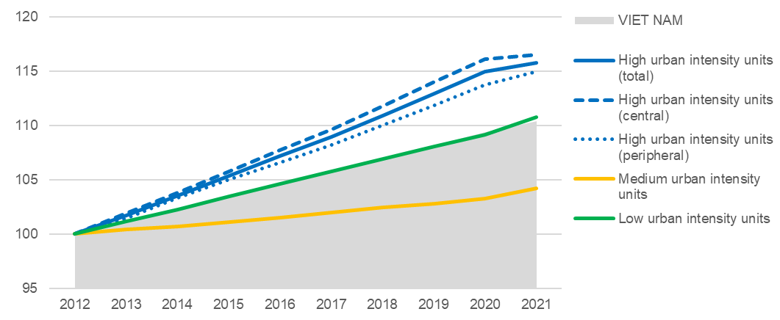
Source: Processing on GSO data.

Figure 2.3 - Population growth rates by urban intensity degree and by major urban areas. Years 2012-2021 (yearly averages, percentage values)
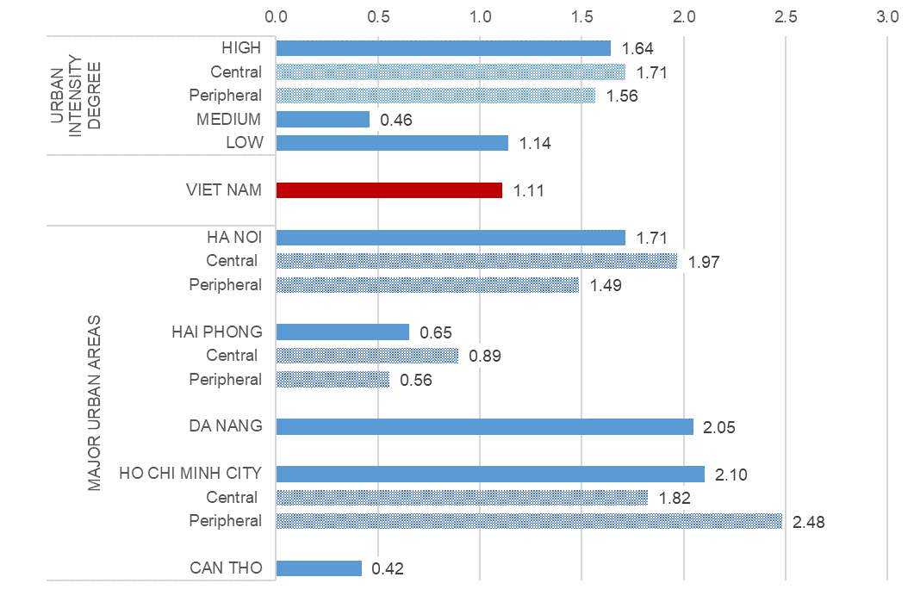
Source: Processing on GSO data.
Demographic growth in major urban areas received a significant contribution from internal migration, since the high-urban intensity units show net migration rates that remain constantly positive all over the period, and steadily increasing since 2017, following a resumption of outmigration from medium- and low-urban intensity units (Figure 2.4).
Figure 2.4 - Net migration rates by urban intensity degree. Years 2012-2021 (per thousand inhabitants)
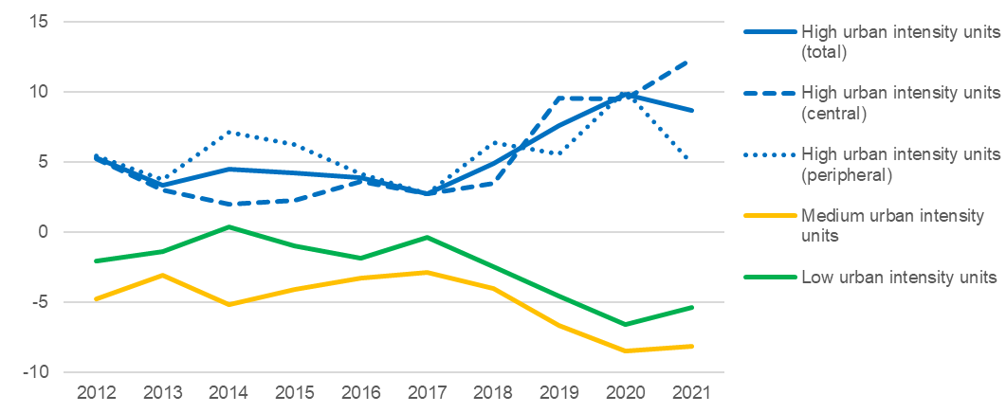
Source: Processing on GSO data.
In addition, population growth was accompanied by a nearly linear increase of the average income per capita, which is a welcomed signal of enhancement of living standards but, at the same time, a driver of environmental pressure – as it normally entails more consumption of natural resources, and increasing generation of pollution and waste. From 2012 to 2020, the average income per capita has about doubled at all levels of urban intensity, and in all the major urban areas. Consequently, the growth did not reduce the gap between urban and rural areas, as in 2020 the monthly income per capita ranges from 2.7 million VND in low-urban intensity units to 5.5 in high-urban intensity units (and 6.1 in the central ones), compared to a national average of 4.2. Significant differences can be observed also among the major urban areas, where the monthly income per capita ranges from 2.7 4.5 million VND in Hai Phong to 6.3 in Ho Chi Minh City (Figure 2.5).
Figure 2.5 - Monthly average income per capita. Years 2012-2020 (million VND, current prices)
BY URBAN INTENSITY DEGREE  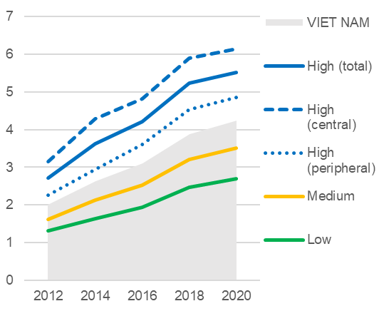 | BY MAJOR URBAN AREAS  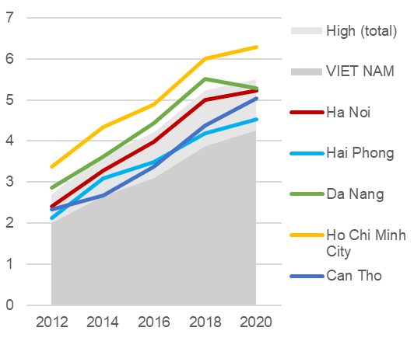
Source: Processing on GSO data.
The overall picture describes a phase of robust urban expansion, bringing obvious risks of increasing environmental pressure and widening of the economic gap between urban and rural areas. Both issues directly concern the sustainability of urban development, and urge for the implementation and monitoring of sustainability policies targeted to urban areas, in order to conciliate the economic growth and the rising of living standards with the protection of environment and human health.

2.2. SDG targets, available proxies and international comparisons
This section presents the indicators selected in relation to the SDG targets of reference, as defined by the global 2030 Agenda and by the Vietnam National action plan for its implementation (VSDGs), giving an account of the preparatory analysis carried out in order to identify the indicators to be implemented. Where possible, a comparison of the national values to the world and regional estimates published on the UN Global SDG Database is also presented.

TARGET 6.1 – ACCESS TO SAFE AND AFFORDABLE DRINKING WATER
Target 6.1 of the VSDGs – By 2030, ensure full and equitable access to safe and affordable water for all citizens – is substantially identical to the corresponding Global target.
For SDG indicator 6.1.1 – Proportion of population using safely managed drinking water services, by urban/rural, the key concept is that of safely managed drinking water service, defined as an improved drinking water source that is accessible on premises, available when needed, and free from faecal and priority chemical contamination. Improved drinking water sources include: piped supplies, boreholes and tubewells, protected dug wells, protected springs, rainwater, water kiosks, and packaged and delivered water.
The available proxy (VSDG 6.1.1 – Urban population provided with clean water by centralized water supply system) is sourced by the Ministry of Construction (MOC), within the National statistical reporting system. Unlike the indicator described in the global SDG metadata, the proxy is currently available only for urban population. Within this limitation, the comparability to the global indicator published on the UN Global SDG Database can be considered good, as far as the water supplied by centralized system has to meet quality standards specified by law.
Figure 2.6 - SDG indicator 6.1.1: Proportion of population using safely managed drinking water services, by urban/rural. Years 2016-2021 (percentage of urban population)
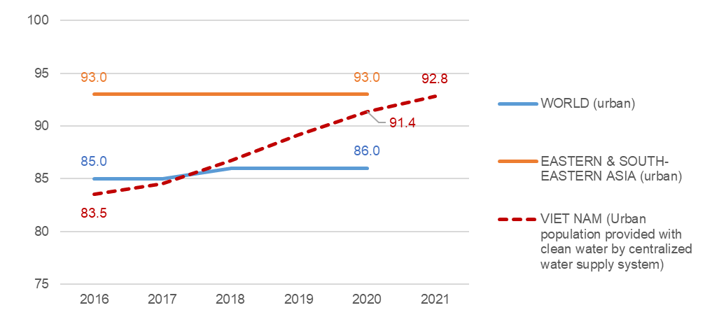
Source: WHO-UNICEF Joint Monitoring Programme for Water Supply, Sanitation and Hygiene (World, Eastern & South-Eastern Asia); National statistical reporting system, Ministry of Construction (Viet Nam).
National estimates for Vietnam, compared to the estimates for the East and South-East Asia region and the whole world, show a full recovery of the gap from the regional average, performed between 2016 and 2021 (Figure 2.6).

TARGET 6.2 – ACCESS TO ADEQUATE AND EQUITABLE SANITATION AND HYGIENE
Target 6.2 of the VSDGs – By 2030, ensure access to adequate and equitable sanitation facilities and conditions for all citizens, with particular attention paid to the needs of women, girls, persons with disabilities and other vulnerable groups; end open-air defecation practices; 100% of households have hygienic toilets – largely follows the formulation of the corresponding Global target, adding to it a specific reference to hygienic toilets.

SDG indicator 6.2.1 – Proportion of population using (a) safely managed sanitation services and (b) a hand washing facility with soap and water actually consists of two sub-indicators. Sub-indicator (a) about sanitation services can be considered more relevant to urban environment as a proxy for the spreading of sewerage networks and other safe systems for wastewater disposal, while sub-indicator (b) about hand washing facilities, being more characterized as a public health indicator, was considered out of scope. The key concept is that of safely managed sanitation service, defined as an improved sanitation facility that is not shared with other households and where excreta are safely disposed on site or removed and treated off-site. Improved sanitation facilities include wet sanitation technologies (flush or pour flush toilets connected to sewer systems, septic tanks or pit latrines); and dry sanitation technologies (dry pit latrines with slabs, ventilated improved pit latrines, pit latrines with a slab, composting toilets and container based sanitation).
Figure 2.7 - SDG indicator 6.2.1: Proportion of population using safely managed sanitation services. Years 2014-2020 (percentage values) | Figure 2.8 - VSDG indicator 6.2.1: Households using improved sanitation facilities. Years 2014-2021 (percentage values)
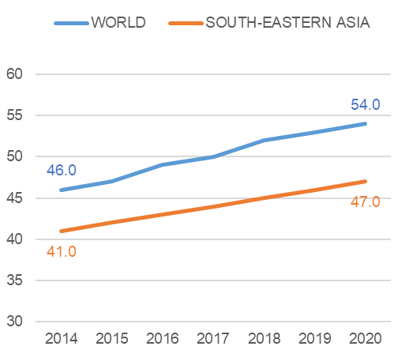 | 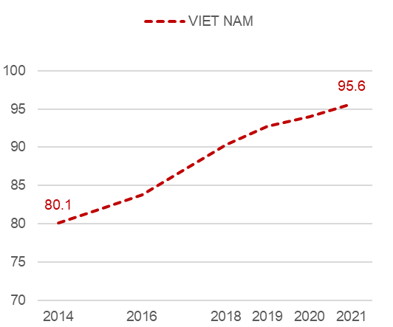
Source: WHO-UNICEF Joint Monitoring Programme for Water Supply, Sanitation and Hygiene | Source: GSO, Vietnam Household Living Standards Survey
The available proxy (VSDG 6.2.1 – Households using improved sanitation facilities) is sourced by the Vietnam Household Living Standards Survey (VHLSS) of the GSO and is fully relevant to the objective set by the VSDGs about hygienic toilets. It presents, however, several differences compared to the global SDG indicator, as estimates are available by households (not by population), and the definition of improved sanitation facilities does not match exactly that of safely managed sanitation services, because it considers only the type of facility and not whether the facility is used by one or more households.
Therefore, national estimates are not comparable to those published on the UN Global SDG Database. Anyway, VHLSS data describe a steadily improving trend, concordant with those estimated by WHO and UNICEF for the South-East Asia region and the whole World (Figures 2.7 and 2.8).

TARGET 7.1 – ACCESS TO AFFORDABLE, RELIABLE AND MODERN ENERGY SERVICES
Target 7.1 of the VSDGs – By 2025, fully 100% households have access to electricity; by 2030, ensure universal access to affordable, reliable and modern energy services – differs from the corresponding global target as it anticipates to 2025 the objective of universal access to electricity grid.

Under the target of equal access to energy, SDG indicator 7.1.1 – Proportion of population with access to electricity refers to the people that have access to consistent sources of electricity, which are considered such only if the primary source of lighting is the local electricity provider, solar energy systems, mini-grids and stand-alone systems. Sources such as generators, batteries, etc., are not considered due to their limited working capacities and since they are usually kept as backup sources for lighting.
The available proxy (VSDG 7.1.1 – Households with access to electricity) is sourced by the VHLSS and substantially matches the global indicator, as the difference between the estimates by households (available) and by population (required) can be considered negligible, given the proximity to 100%.
Therefore, in this case, national estimates are comparable to those published on the UN Global SDG Database, and show a regular improving trend over the last decade, that led to substantially achieve the target as early as 2020 (Figure 2.9).
Figure 2.9 - SDG indicator 7.1.1: Proportion of population with access to electricity. Years 2010-2020 (percentage values)
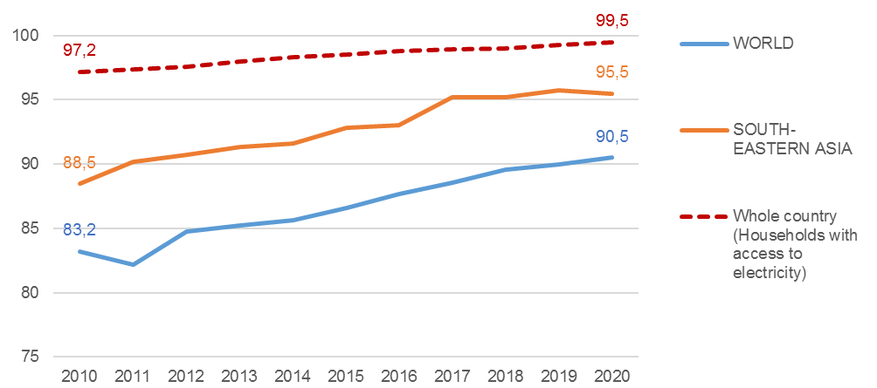
Source: World Bank (World, South-Eastern Asia); GSO, Vietnam Household Living Standards Survey (Viet Nam)

TARGET 11.1 – ACCESS TO ADEQUATE, SAFE AND AFFORDABLE HOUSING
Target 11.1 of the VSDGs – By 2030, ensure access for all citizens to adequate, safe and affordable basic services and housing; abolish slums; build, upgrade, improve sub-standard housing areas – largely follows the formulation of the corresponding global target, adding to it specific references to urban redevelopment and the improvement of housing standards.

SDG indicator 11.1.1 – Proportion of urban population living in slums, informal settlements or inadequate housing is a complex one, considering several different aspects of housing conditions. The concepts of “slums” and “informal settlements” largely overlap, as they refer to aspects regarding material living conditions that are closely connected each other, while the concept of “inadequate housing” is a most comprehensive one (Table 2.6).
Table 2.6 - Criteria defining slums, informal settlements and inadequate housing
 | Informal settlements | Slums | Inadequate housing
Access to water | X | X | X
Access to sanitation | X | X | X
Security of tenure | X | X | X
Structural quality, durability and location | X | X | X
Sufficient living area, overcrowding |  | X | X
Affordability |  |  | X
Accessibility |  |  | X
Cultural adequacy |  |  | X
Source: UNSD-IAEG, SDG Indicators metadata.
The corresponding VSDG indicator 11.1.1 – Proportion of population living in poorly built housing substantially matches the criteria for defining “slums”, and does not consider the criteria of affordability (housing costs), accessibility (specific needs of disadvantaged and marginalized groups) and cultural adequacy (special needs related to cultural traditions). The key concepts are the following:
- Access to water and to sanitation follow the same criteria of indicators 6.1.1 and 6.2.1;
- Security of tenure is granted when the ownership rights of house dwellers are established or recognized by law, protecting people from the risk of unlawful evictions.
- Structural quality, durability and location refer to (a) permanency of structural elements, (b) adequate protection from rain, heat, cold, humidity, (c) non-hazardous location, i.e. not in contaminated sites, flood plains, steep slopes, dangerous proximity to railways, highways, airports, power lines;
- Sufficient living area, overcrowding: according to the metadata of SDG indicator 11.1.1, a dwelling unit provides sufficient living area for the household members if not more than three people share the same habitable room. For converting this definition into square meters, the UN-Habitat Programme recommends to adopt a minimum value of 9 m² per capita, below which houses are considered overcrowded.
Both the SDG and the VSDG indicator require the processing of microdata (not feasible at this stage), being based on a multi-criteria classification of individuals or households. In particular, according to the VSDG metadata, people living in poorly built housing are those who live in a household that lacks one or more of the following attributes: (a) Access to improved water source, (b) Access to improved sanitation facilities, (c) Sufficient living area, (d) Housing durability, (e) Security of ownership.
The proposed proxy, based on the available data, consists of two sub-indicators that focus on building conditions (structural quality/durability and sufficient living area), and do not cover the access to water and sanitation (already covered by indicators 6.1.1 and 6.2.1), nor the security of tenure (which appears not to be relevant to Vietnam):
- VSDG indicator 11.1.1a – Households not living in permanent/semi-permanent houses is sourced by the VHLSS and covers the criterion of structural quality and durability (not the location);
- VSDG indicator 11.1.1b – Households living in less than 10 m² per capita is sourced by the Population Census and covers the criterion of sufficient living area.
Both sub-indicators describe an improving trend, and appear consistent (although not comparable) with the estimates produced within the UN-Habitat Programme, published on the UN Global SDG Database, according to which the proportion of population living in slums reduced from 20.6 to 5.8% between 2010 and 2016 (Figures 2.10 and 2.11).
Figure 2.10 - SDG indicator 11.1.1: Proportion of population living in slums. Years 2010-2020 (percentage values) | Figure 2.11 - VSDG sub-indicators 11.1.1a, 11.1.1b: Households (a) not living in permanent/semi-permanent houses, (b) living in less than 10 m² per capita. Years 2009-2020 (percentage values)
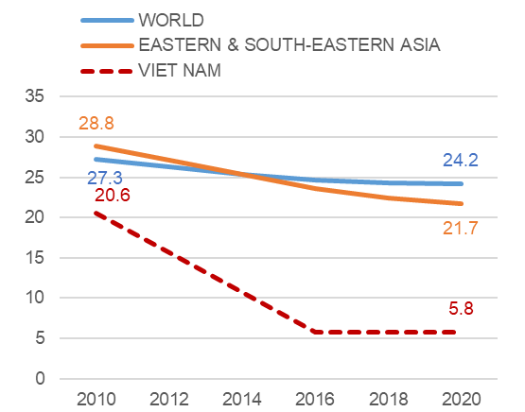 | 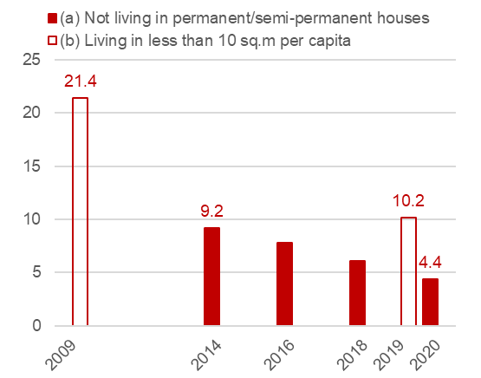
Source: United Nations Human Settlements Programme (UN-Habitat) | Source: GSO, Vietnam Household Living Standards Survey (a), Population Census (b)

TARGET 11.2 – SAFE, AFFORDABLE, ACCESSIBLE AND SUSTAINABLE TRANSPORT SYSTEMS
Target 11.2 of the VSDGs – By 2030, ensure access for all citizens to safe, affordable, convenient and sustainable transport systems; improve traffic safety, notably by expanding public transport with special attention paid to the needs of women, children, persons with disabilities and elderly people – is substantially identical to the corresponding global target.

SDG indicator 11.2.1 – Proportion of population that has convenient access to public transport, by sex, age and persons with disabilities focuses on the right to access to public transport. Access to public transport is considered convenient when a stop is accessible within a walking distance from home/school/workplace (500 m for bus and other low-capacity systems, 1 km for rail, metro and other high-capacity systems). Additional criteria include: (a) Accessibility to all special-needs customers (persons with disabilities, elderly people, children and other people in vulnerable situations), (b) Frequent service during peak travel times, (c) Stations/stops safe and comfortable to all passengers.
The corresponding VSDG indicator 11.2.1 – Growth rate of the number of passengers using public transport is a completely different measure, even though probably more relevant to the Vietnamese context, as increasing the share of public transport in urban mobility is for sure a priority, in order to reduce pressure on urban environment. Relevant data for this indicator is provided by the Ministry of Infrastructures and Transport (MOIT), and currently disseminated by the GSO (Number of passengers carried by province). As the passengers carried exclude those using their own private vehicles, they can be identified as users of public transport services (regardless of the public or private ownership of transport companies), and the subset of the road passengers can be used to calculate an indicator more specific to urban environment. On this basis, it was implemented the VSDG indicator 11.2.1a – Growth rate of public transport passengers by road, in the form of a percentage change, calculated on an annual basis.
However, in order to assess whether the growth of public transport is actually mitigating to some extent the pressure on environment exerted by the expansion of the whole transport system, a relative measure is needed, that compares the public transport growth to the population growth. Such mitigation, in fact, can take place only if public transport grows faster than the population it serves. Therefore it was proposed to complement the indicator on public transport growth with the average number of passengers carried per capita per year, referred to as VSDG indicator 11.2.1b – Demand for road public transport.
The combination of these sub-indicators can provide relevant information about sustainability of current trends in urban mobility. International comparisons, however, are not possible, as the SDG indicator is not included in the VSDG framework and cannot be implemented due to the lack of relevant data.

TARGET 11.3 – ENHANCE INCLUSIVE AND SUSTAINABLE URBANIZATION

Target 11.3 of the VSDGs – By 2030, enhance national capacity for inclusive, sustainable urban planning and development with the participation of communities – is substantially identical to the corresponding global target, but no statistical indicator was identified for its monitoring within the VSDG framework. However, since relevant data are available within the National statistical reporting system, and the topic is extremely important in a fast growing country like Vietnam, it was proposed to implement SDG indicator 11.3.1 – Ratio of land consumption rate to population growth rate, which is meant to monitor one of the major factors of pressure on environment, generated by urban growth. As recommended by the SDG metadata, this indicator is complemented by another land consumption measure, independent from population trends. Therefore, also in this case, the indicator actually consists of a couple of sub-indicators:
- VSDG 11.3.1a (identical to SDG 11.3.1);
- VSDG 11.3.1b – Land consumption as a proportion of total land area.
Land consumption is defined as the taking of land by urban land uses, which often involves conversion of land from non-urban to urban functions (including any kind of built-up area, regardless of its use). The physical growth of urban areas may be disproportionate to population growth, which results in less efficient land use and increasing impact on environment. However, a land consumption rate lower than the population growth rate is not necessarily a sign of sustainability of urban growth, as it may indicate on one hand efficiency in land use but also, on the other hand, increasing congestion of urban areas, overcrowding and poor living environments. Therefore, to help explain this indicator, it is recommended to pair it with other statistical measures, which account for the intensity of the phenomenon in itself, separated from demographic evolution.
Land consumption estimates were calculated based on the land use data produced by the Ministry of Natural Resources and Environment (MONRE), currently disseminated by the GSO. As a form of pressure exerted by the economic system over the environment, land consumption encompasses not only urban areas but every area occupied by buildings, infrastructures and non-agricultural activities. Therefore, as a proxy of land consumption, it was considered the sum of Homestead land (both urban and rural) and Specially used land. Although the two sub-indicators proposed match exactly the global SDG indicator, international comparisons are not possible, because this indicator is not yet covered by the UN Global SDG Database.
Time series of land use data shows a rapidly changing picture over the decade 2010-2020, and a quite intense land consumption (from 7.5% to 8.3% of total land area). Such process, mostly due to the expansion of homestead land, does not seem, however, to threaten agricultural land and forest areas (Figure 2.12).
Figure 2.12 - Land use. Years 2010-2020 (percentage of total land area)
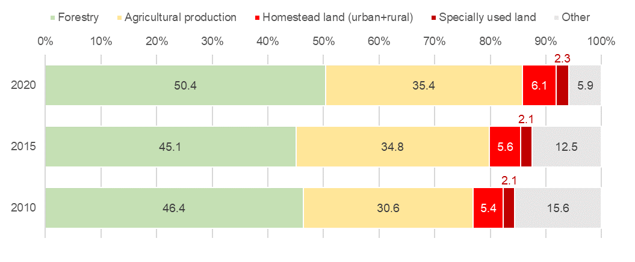
Source: National statistical reporting system, Ministry of Natural Resources and Environment.

TARGET 11.6 – REDUCE ADVERSE IMPACT OF CITIES, IMPROVE AIR QUALITY AND WASTE MANAGEMENT

Target 11.6 of the VSDGs – Reduce adverse environmental impacts on people in urban areas, including by strengthening the management of air quality, urban waste and other sources of waste – is substantially identical to the corresponding global target. Interestingly, the shift in the formulation, from “impact of cities” to a more explicit “impact on people in urban areas”, adopted in the VSDGs, correctly emphasizes the public health implications of urban environment issues. Under this target, two SDG indicators were implemented: 11.6.1 on waste management and 11.6.2 (corresponding to VSDG 11.6.3) on air quality.

Waste management
The generation of municipal solid waste (MSW) is a major pressure factor for urban environment. The key concepts for SDG indicator 11.6.1 – Proportion of MSW collected and managed in controlled facilities out of total municipal waste generated, by cities are the following:
- Municipal solid waste includes waste from households, commerce and trade, small businesses, office buildings and institutions. It also includes bulky waste (except demolition waste) and waste from selected municipal services (e.g. from park and garden maintenance, street and market cleaning services).
- Waste generation is defined as the sum of MSW collected plus the estimated amount of MSW from areas not covered by municipal waste collection service.
- Waste collection indicates the MSW collected by or on behalf of municipalities, as well as by the private sector. It includes mixed waste, and fractions collected separately for recovery operations (door-to-door collection and/or voluntary deposits).
The SDG indicator focuses on the response to the pressure from waste generation, by measuring the basic capacity of the waste management systems to collect, treat, and safely dispose the MSW. However, a direct measure of the pressure itself is a necessary complement to the monitoring of urban waste. To this end, it was proposed to implement SDG indicator 11.6.1 by developing two sub-indicators, both sourced by the MOC, within the National statistical reporting system:
- VSDG 11.6.1a – Urban domestic solid waste collected, transported and treated according to technical standards and regulations, as a proxy of SDG 11.6.1 (then, a response indicator);
- VSDG 11.6.1b – Urban domestic solid waste collected per capita, as a pressure indicator (although not referred to the whole of waste generation but only to the fraction that is collected).
Assuming that “urban domestic solid waste” corresponds to MSW, the main difference between the available proxies and the global indicator is due to the unavailability of estimates for the total amount of generated waste. As the proxies refer to collected waste (the fraction of collected waste that is treated etc., and the amount of collected waste per capita), they do provide information about the trends of environmental pressure from waste, but not about the actual intensity of such pressure, which is supposedly higher. However, this does not undermine the relevance and usefulness of the measures proposed to the monitoring of waste management, since these let know whether the pressure from waste generation is rising or falling, and at what pace. International comparisons are not possible anyway, as world and regional estimates for SDG indicator 11.6.1 are not yet available on the UN Global SDG Database.

Air quality
The pollution caused by human activities is a degradation factor for air quality, and is considered the main environmental health risk by the World Health Organization (WHO), being linked to increased mortality from respiratory infections and diseases, lung cancer, and several cardiovascular diseases. Air pollution depends in a complex way on multiple factors, which can be observed more effectively at a micro scale than at a local or regional scale. Normally, the focus is posed on the pollutants for which a link between exposure and short- and long-term health effects is recognized. Among these substances, particulate matter (PM_{2.5} and PM₁₀), Nitrogen Dioxide (NO₂) and ground-level Ozone (O₃) are the most commonly considered for monitoring air quality. The WHO considers the particulate matter PM_{2.5} to be the air pollutant most harmful to human health, as these particles are able to penetrate deeply into the respiratory tract. Morerover, air concentrations of these substances reflect, at least in part, the levels and the variability over time of the concentrations of other pollutants. Therefore, according to the SDG metadata, the annual mean concentration of PM_{2.5} (or PM₁₀) represents the preferable option for monitoring air quality by a single indicator.
SDG indicator 11.6.2 - Annual mean levels of fine particulate matter in cities is based on average concentration values, weighted by urban population, to be calculated using all types of monitoring stations, stratified by the main source of pollution (traffic, background and industrial) and by location (urban, suburban and rural). Values shall be compared to the reference values set for each substance, defined at the global level by the WHO, which are stricter than the limits set by the Vietnam national regulation in 2013 (Table 2.7). The reference values set by the WHO Global air quality guidelines in 2005 were upgraded in 2021. The old values, however, remain valid as “interim targets”, being aware that any lowering of the reference values adopted leads to further benefits in terms of reduced mortality.
Table 2.7 - WHO reference values and Vietnam national limit values for some substances in ambient air (Annual mean concentrations, µg/m³)
 | WHO Global air quality guidelines |  | Vietnam national technical regulation on ambient air quality (2013)
 | (2005) | (2021 upgrade)
Particulate matter (PM_{2.5}) | 10 | 5 | 25
Particulate matter (PM₁₀) | 20 | 15 | 50
Nitrogen Dioxide (NO₂) | 40 | 10 | 40
Source: World Health Organization; Ministry of Natural Resources and Environment.
An international comparison on SDG indicator 11.6.2 can be made using the estimates produced by the WHO, and published on the UN Global SDG Database. These are world, regional and national averages, weighted by the urban population and disaggregated by type of location (cities, towns and semi-dense areas, rural areas). Considering the period 2010-2019, the levels of PM_{2.5} pollution in Vietnam (all areas) remain constantly below the world and regional averages, but always close to the national limit of 25 µg/m³, trespassed only in 2013 (Figure 2.13).
The overall trend is moderately improving, but values have been increasing since 2017. Concentrations of PM_{2.5} are obviously higher in the cities, where values are estimated above the national limit for most of the period. Even in the rural areas, however, estimates keep far higher than the WHO reference values all over the period, which indicates the exposure of the entire population to significant health risk.
Figure 2.13 - SDG indicator 11.6.2: Annual mean levels of PM_{2.5} (population weighted), by location. Years 2010-2019 (µg/m³)
VIET NAM  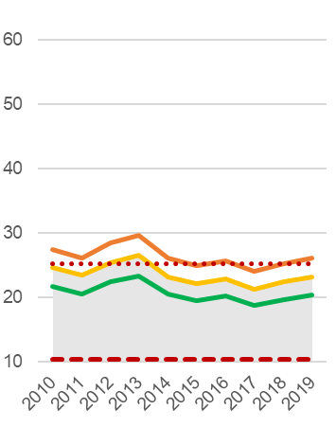 | EASTERN AND SOUTH-EASTERN ASIA  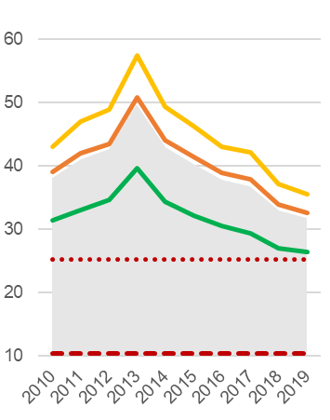 | WORLD  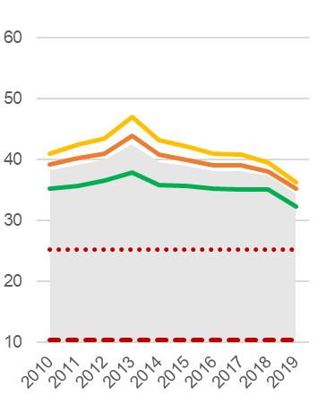
Source: World Health Organization
The corresponding VSDG indicator 11.6.3 – Concentration of substances in the air environment considers various pollutants to be monitored, apart from PM_{2.5} and PM₁₀: Total suspended particles (TSP), Carbon Oxide (CO), Sulphur Dioxide (SO₂), Nitrogen Dioxide (NO₂), Ozone (O₃) and Lead (Pb), defining also specific monitoring periods for each substance.
The available data, however, allowed only a partial implementation of statistical measures related to PM₁₀ and NO₂, due to the limited number of observations and the lack of information about their representativeness and validity. If considered together, and in lack of PM_{2.5} data (which would be the best option for a synthetic indicator), PM₁₀ and NO₂ may provide a viable alternative, because PM_{2.5} is closely correlated with PM₁₀ (being a fraction of it), and moderately so with NO₂. Moreover, the pollution patterns of these two substances are largely complementary, so to cover various aspects of such a complex phenomenon. High concentrations of PM₁₀ are more frequent in the cold months and result in immediate health risk, while the concentrations of NO₂ – a less volatile gas, with a longer permanence in atmosphere – are associated with a higher risk in the medium term for the exposed population. Both pollutants are released into the atmosphere from the use of fossil fuels (vehicular traffic, domestic heating, manufacturing activities), but their concentration at harmful levels also depends on meteoclimatic and geomorphologic factors, which can mitigate or exacerbate the effects of primary pollution, playing also a role in the high variability of concentrations over time and space.
The proposed proxies are:
- VSDG 11.6.3a – Annual mean concentration of pollutants in cities: maximum values (PM₁₀ and NO₂), providing a direct measure of pollution intensity for the two substances;
- VSDG 11.6.3b – Annual mean concentration of pollutants in cities: values above the WHO reference values for avoidable mortality (PM₁₀ and NO₂), i.e. the percentage of valid observations exceeding the 2005 WHO limits, giving account for the population exposure to harmful pollution levels.

2.3. Urban environment indicators cards
This section is a collection of 13 cards, each presenting in detail one of the statistical measures proposed as proxies for the selected SDG indicators related to urban environment.
These measures refer to two targets and indicators of Goal 6 about Clean water and sanitation, one target an indicator of Goal 7 about Affordable and clean energy, and five targets and indicators of Goal 11 about Sustainable cities and communities.
Four statistical measures are sourced directly by the GSO, in particular three by the Vietnam Household Standard Survey and one by the Population and Housing Census. Nine measures are sourced by other agencies of the National statistical reporting system, namely:
- Four by the Ministry of Natural Resources and Environment,
- Three by the Ministry of Construction,
- Two by the Ministry of Infrastructure and Transport.
Each card contains essential metadata (including a glossary of relevant terms, and general information about data sources and the main data features), statistical tables and charts, and a short commentary about the present state and trends of the phenomena described, paying special attention to the progress towards the reference targets and the evolution of the urban-rural divide.
All statistical measures were implemented based on provincial data. However, the primary data needed for the calculation of values referred to aggregations of provinces (by urban intensity degree, and by the urban areas of Ha Noi, Hai Phong and Ho Chi Minh City, formed by more provinces) were available only for the statistical measures on land consumption (VSDG indicator 11.3.1) and air quality (VSDG indicator 11.6.3). In all other cases, the values referred to such aggregations were estimated as population-weighted averages of the known provincial values, according to the following formula:
$$V=\sum_{i=1}^{n}{\frac{v_{i}×p_{i}}{P}}$$
where i indicates a single territorial unit (province), belonging to a group of n units (for example, those classified at a given degree of urban intensity, or those belonging to a given urban area), v_{i} is the (known) value of a given measure in i, p_{i} is the population of i, and P is the population of the whole group of n units.
VSDG Target 6.1: By 2030, ensure full and equitable access to safe and affordable water for all citizens

6.1.1: Urban population provided with clean water by centralized water supply system
Global SDGs |  | Target 6.1: By 2030, achieve universal and equitable access to safe and affordable drinking water for all  Indicator 6.1.1: Proportion of population using safely managed drinking water services
UNSD-CC |  | Topic: Vulnerable population  Indicator 98 = SDG 6.1.1
Metadata card
Definition |  |  | Proportion of the population supplied with clean water through a centralized water supply system to the total urban population.
Glossary |  |  | Centralized water supply system: a system that includes exploitation and water treatment facilities, a network of pipes to supply clean water to water users and related ancillary works.  Clean water: Tap water produced by factories, and supplied to people, that meets the standards set by the Ministry of Construction, and the National technical standards QCVN 02:2009/BYT.  Urban population: Population living in urban centres of grade 5 or special category.
Unit of measure |  |  | %
Breakdown |  |  | 63 Provinces
Data source |  |  | National statistical reporting system, Ministry of Construction (MOC)
Time series |  |  | 2016-2021
Frequency of updates |  |  | 1 year
Main data
Table 2.8 - Urban population provided with clean water by centralized water supply system, by major urban areas and by urban intensity degree. Years 2016-2021 (estimates, percentage values)
TERRITORY | 2016 | 2017 | 2018 | 2019 | 2020 | 2021
WHOLE COUTRY | 83.5 | 84.5 | 86.7 | 89.2 | 91.4 | 92.8
Ha Noi urban area | 79.1 | 85.6 | 92.1 | 96.1 | 96.7 | 97.9
Central unit | 80.0 | 88.0 | 96.0 | 100.0 | 100.0 | 100.0
Peripheral units | 77.2 | 81.0 | 84.5 | 89.1 | 91.4 | 94.5
Hai Phong urban area | 93.3 | 94.2 | 95.1 | 95.8 | 97.2 | 98.6
Central unit | 97.0 | 97.0 | 97.0 | 97.0 | 97.0 | 100.0
Peripheral units | 90.6 | 92.3 | 93.7 | 95.1 | 97.3 | 97.7
Da Nang urban area | 97.5 | 95.0 | 97.8 | 99.0 | 99.0 | 100.0
Ho Chi Minh City urban area | 94.5 | 96.0 | 96.1 | 98.0 | 98.1 | 99.0
Central unit | 92.4 | 96.8 | 96.8 | 100.0 | 100.0 | 100.0
Peripheral units | 98.8 | 94.4 | 94.5 | 94.4 | 94.8 | 97.3
Can Tho urban area | 70.2 | 87.0 | 87.2 | 87.3 | 87.3 | 95.0
High urban intensity (total) | 89.0 | 92.4 | 94.5 | 96.8 | 97.2 | 98.5
High urban intensity (central units) | 88.2 | 93.6 | 96.1 | 98.9 | 99.0 | 99.7
High urban intensity (peripheral units) | 90.8 | 90.0 | 91.4 | 93.0 | 94.2 | 96.5
Medium urban intensity | 82.0 | 84.0 | 86.2 | 88.0 | 89.8 | 91.0
Low urban intensity | 65.1 | 71.1 | 73.6 | 76.3 | 80.2 | 82.1
DISTANCE FROM TARGET in pct. points | 16.5 | 15.5 | 13.3 | 10.9 | 8.6 | 7.2
URBAN-RURAL DIVIDE in pct. points | 24.0 | 21.3 | 21.0 | 20.5 | 17.0 | 16.4
Source: Processing on MOC data
In 2021, 92.8% of the urban population is provided with clean water through the centralized water supply system (+9.3 percentage points since 2016: at this rate, target could be achieved by 2024). The proportion is considerably higher (98.5%) in the high urban intensity areas, but the gap between urban and rural areas is reducing (Figures 2.14 and 2.15).
Figure 2.14 - Urban population provided with clean water by centralized water supply system, by urban intensity degree. Years 2016-2020 (estimates, percentage values)
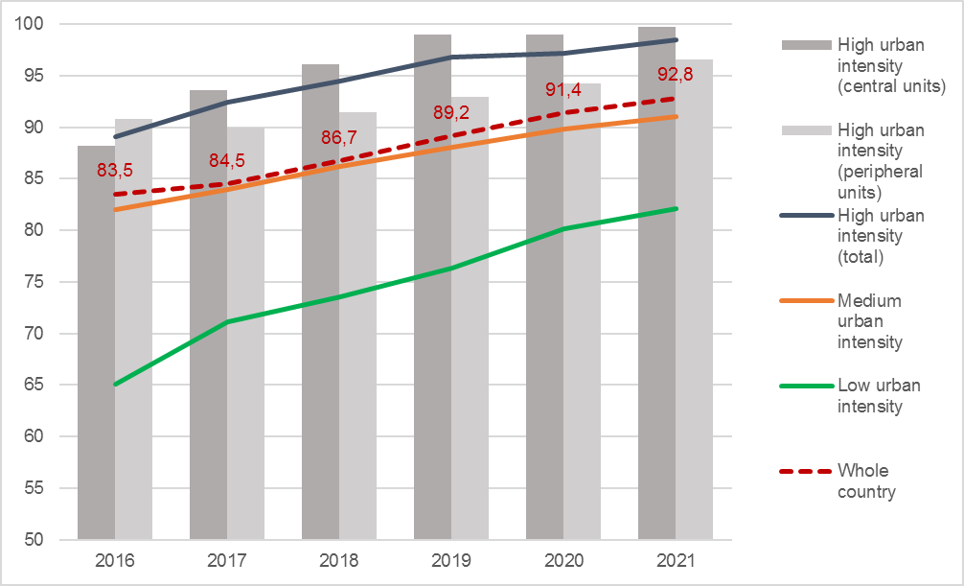
Source: Processing on MOC data

Figure 2.15 - Urban population provided with clean water by centralized water supply system: distance from target and urban-rural divide. Years 2016-2021 (estimates, percentage points)
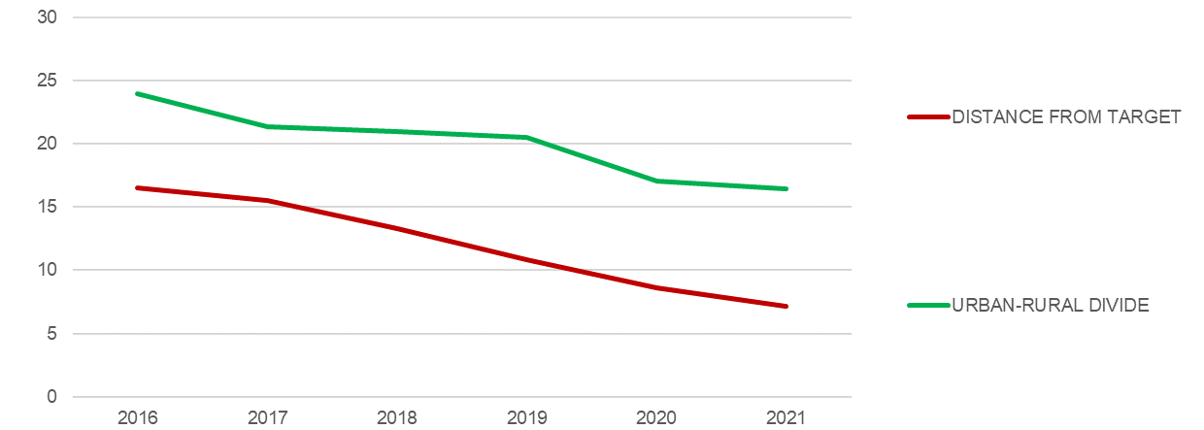
Source: Processing on MOC data
The trend is positive for all the major urban areas, and the progress is particularly remarkable in Ha Noi (+20 pct. points from 2016 to 2019) and Can Tho (+25 points from 2016 to 2020). The target of 100% is already reached in Ha Noi, Hai Phong, Da Nang and Ho Chi Minh City, while Can Tho is very close to it (Figure 2.16).
Figure 2.9 - Urban population provided with clean water by centralized water supply system, by major urban areas. Years 2016-2021 (estimates, percentage values)
HA NOI  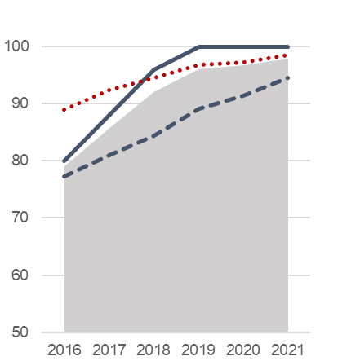 | HAI PHONG  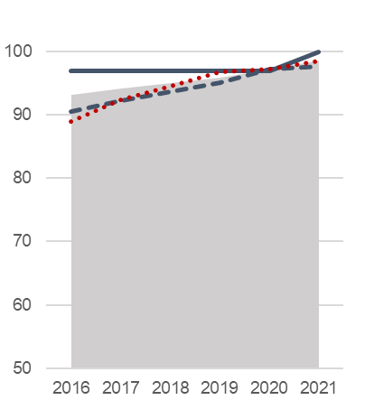 | DA NANG  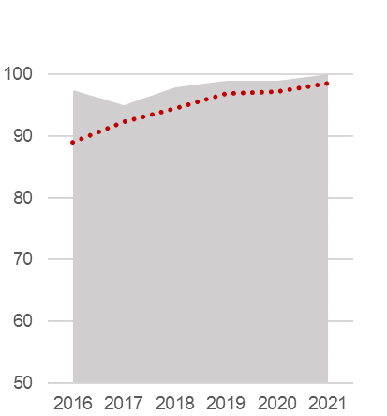
HO CHI MINH CITY  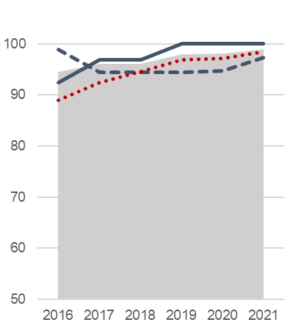 | CAN THO  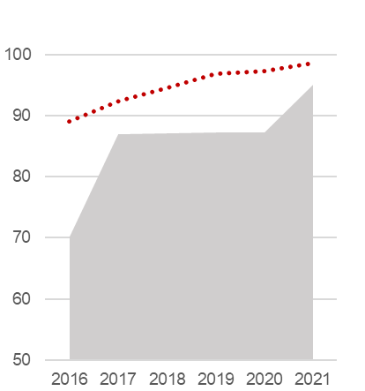 | 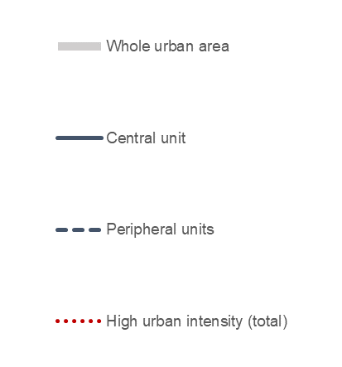
Source: Processing on MOC data

The national standards for water quality
Clean water used for domestic purposes is treated water of guaranteed quality, meeting the requirements for human consumption and hygiene (abbreviated as clean water), as specified in the Circular of the Ministry of Health no. 41/2018/TT-BYT dated December 14, 2018 promulgating national technical regulation and regulations on inspection and monitoring of domestic water quality.
Source: Ministry of Health

Table 2.9 - Urban population provided with clean water by centralized water supply system, by province and socio-economic region. Years 2017-2021 (percentage values)
Regions  Provinces | 2017 | 2018 | 2019 | 2020 | 2021 |  | Regions  Provinces | 2017 | 2018 | 2019 | 2020 | 2021
Red River Delta | 90.0 | 92.4 | 94.9 | 96.4 | 97.3 |  | Central
Ha Noi | 88.0 | 96.0 | 100.0 | 100.0 | 100.0 |  | Highlands | 62.4 | 64.1 | 66.6 | 69.7 | 72.6
Vinh Phuc | 77.0 | 77.0 | 78.1 | 81.4 | 82.0 |  | Kon Tum | 45.0 | 47.7 | 51.4 | 51.4 | 55.0
Bac Ninh | 86.5 | 86.7 | 87.5 | 90.5 | 97.5 |  | Gia Lai | 45.0 | 48.0 | 48.0 | 52.0 | 60.0
Quang Ninh | 92.3 | 94.2 | 95.9 | 98.0 | 98.6 |  | Dak Lak | 78.3 | 78.3 | 86.0 | 90.7 | 90.5
Hai Duong | 89.4 | 89.6 | 97.8 | 100.0 | 100.0 |  | Dak Nong | 86.3 | 86.6 | 86.6 | 86.6 | 87.0
Hai Phong | 97.0 | 97.0 | 97.0 | 97.0 | 100.0 |  | Lam Dong | 68.9 | 69.1 | 69.4 | 71.3 | 72.0
Hung Yen | 65.0 | 69.3 | 69.8 | 80.0 | 82.0
Thai Binh | 97.7 | 97.7 | 97.8 | 100.0 | 100.0 |  | South East | 90.0 | 93.0 | 94.8 | 94.1 | 95.9
Ha Nam | 90.0 | 90.3 | 91.0 | 92.0 | 96.5 |  | Binh Phuoc | 34.0 | 55.2 | 57.8 | 60.0 | 63.0
Nam Dinh | 89.0 | 90.1 | 91.3 | 94.0 | 94.0 |  | Tay Ninh | 45.0 | 51.3 | 51.8 | 52.0 | 53.0
Ninh Binh | 83.4 | 83.4 | 83.4 | 84.0 | 96.2 |  | Binh Duong | 94.4 | 94.4 | 94.5 | 95.0 | 99.6
 |  |  |  |  |  |  | Dong Nai | 92.0 | 92.2 | 92.4 | 92.4 | 93.0
Northern |  |  |  |  |  |  | Ba Ria-Vung Tau | 98.0 | 98.3 | 98.3 | 98.9 | 98.9
Midlands and |  |  |  |  |  |  | Ho Chi Minh City | 96.8 | 96.8 | 100.0 | 100.0 | 100.0
Mountains | 78.0 | 85.0 | 89.9 | 92.5 | 93.1
Ha Giang | 72.5 | 76.0 | 79.0 | 79.0 | 92.8 |  | Mekong River
Cao Bang | 77.2 | 77.3 | 77.7 | 78.5 | 85.0 |  | Delta | 85.0 | 89.8 | 91.4 | 92.0 | 94.2
Bac Kan | 80.0 | 81.9 | 83.1 | 85.0 | 85.0 |  | Long An | 97.0 | 98.2 | 98.2 | 98.0 | 100.0
Tuyen Quang | 80.0 | 83.1 | 86.4 | 87.0 | 92.5 |  | Tien Giang | 99.0 | 99.4 | 99.5 | 99.7 | 99.7
Lao Cai | 90.0 | 90.9 | 91.2 | 92.0 | 90.0 |  | Ben Tre | 87.1 | 87.1 | 92.0 | 93.0 | 95.0
Yen Bai | 68.0 | 78.2 | 80.5 | 87.4 | 87.4 |  | Tra Vinh | 82.0 | 86.9 | 90.3 | 91.0 | 95.0
Thai Nguyen | 71.0 | 86.1 | 97.8 | 97.8 | 97.8 |  | Vinh Long | 90.0 | 91.6 | 92.6 | 92.6 | 98.9
Lang Son | 87.0 | 92.3 | 99.7 | 99.7 | 99.0 |  | Dong Thap | 97.0 | 98.6 | 98.8 | 99.0 | 99.0
Bac Giang | 82.0 | 82.9 | 83.9 | 97.3 | 92.0 |  | An Giang | 93.0 | 93.6 | 93.8 | 97.1 | 98.0
Phu Tho | 89.0 | 89.0 | 91.9 | 92.1 | 92.1 |  | Kien Giang | 85.0 | 85.5 | 86.2 | 86.2 | 88.4
Dien Bien | 67.0 | 73.2 | 73.2 | 80.0 | 90.0 |  | Can Tho | 87.0 | 87.2 | 87.3 | 87.3 | 95.0
Lai Chau | 70.0 | 84.9 | 90.1 | 95.5 | 96.0 |  | Hau Giang | 80.6 | 80.6 | 95.0 | 95.0 | 88.8
Son La | 80.3 | 92.7 | 93.0 | 93.2 | 94.0 |  | Soc Trang | 81.0 | 81.2 | 81.7 | 81.7 | 96.8
Hoa Binh | 85.0 | 88.9 | 92.0 | 93.0 | 93.5 |  | Bac Lieu | 90.0 | 90.1 | 90.6 | 96.8 | 90.0
 |  |  |  |  |  |  | Ca Mau | 90.0 | 95.3 | 95.6 | 90.0 | 91.5
North-central
and Central
Coast | 76.0 | 83.1 | 86.2 | 90.9 | 91.1
Thanh Hoa | 70.0 | 80.4 | 87.2 | 95.6 | 96.0
Nghe An | 73.0 | 73.1 | 75.4 | 76.0 | 78.0
Ha Tinh | 74.0 | 74.1 | 76.1 | 82.8 | 83.0
Quang Binh | 41.0 | 41.9 | 51.5 | 85.0 | 86.0
Quang Tri | 94.0 | 94.0 | 94.9 | 95.0 | 95.3
Thua Thien-Hue | 98.0 | 98.2 | 98.3 | 99.0 | 99.0
Da Nang | 95.0 | 97.8 | 99.0 | 99.0 | 100.0
Quang Nam | 75.0 | 75.7 | 79.4 | 80.0 | 81.0
Quang Ngai | 82.0 | 87.4 | 89.3 | 94.5 | 89.0
Binh Dinh | 82.0 | 82.2 | 83.4 | 84.0 | 85.0
Phu Yen | 76.0 | 80.8 | 84.4 | 84.4 | 85.0
Khanh Hoa | 87.7 | 87.7 | 89.3 | 89.3 | 90.0
Ninh Thuan | 94.0 | 96.3 | 97.5 | 98.0 | 98.5
Binh Thuan | 82.0 | 82.1 | 82.2 | 94.0 | 95.0
High-urban intensity areas (central units)
High-urban intensity areas (peripheral units)
Source: Ministry of Construction.

VSDG Target 6.2: By 2030, ensure access to adequate and equitable sanitation facilities and conditions for all citizens, with particular attention paid to the needs of women, girls, people with disabilities and other vulnerable groups; end open-air defecation practices; 100% of households have hygienic toilets

6.2.1: Households using improved sanitation facilities
Global SDGs |  | Target 6.2: By 2030, achieve access to adequate and equitable sanitation and hygiene for all and end open defecation, paying special attention to the needs of women and girls and those in vulnerable situations  Indicator 6.2.1: Proportion of population using (a) safely managed sanitation services and (b) a hand-washing facility with soap and water
UNSD-CC |  | Topic: Vulnerable population  Indicator 97 = SDG 6.2.1
Metadata card
Definition |  |  | Proportion of households using improved sanitation facilities to the total number of households.
Glossary |  |  | Improved sanitation facilities include: hygienic latrines, septic latrines, absorbent flushing; dig latrines (improved with vent pipe; with seat); composting latrines.
Unit of measure |  |  | %
Breakdown |  |  | 63 Provinces
Data source |  |  | GSO, Vietnam Household Living Standards Survey (VHLSS)
Time series |  |  | 2014-2020
Frequency of updates |  |  | 2 years
Main data
Table 2.10 - Households using improved sanitation facilities, by major urban areas and by urban intensity degree. Years 2014-2020 (estimates, percentage values)
TERRITORY | 2014 | 2016 | 2018 | 2020
WHOLE COUTRY | 80.1 | 83.8 | 90.3 | 94.0
Ha Noi urban area | 95.7 | 97.5 | 99.4 | 99.8
Central unit | 98.9 | 99.4 | 99.8 | 100.0
Peripheral units | 92.8 | 95.8 | 99.1 | 99.5
Hai Phong urban area | 95.6 | 97.1 | 99.2 | 99.8
Central unit | 99.0 | 98.7 | 99.4 | 99.9
Peripheral units | 94.3 | 96.5 | 99.2 | 99.7
Da Nang urban area | 99.4 | 99.8 | 99.2 | 100.0
Ho Chi Minh City urban area | 97.7 | 98.9 | 99.3 | 99.8
Central unit | 99.2 | 99.3 | 99.2 | 99.9
Peripheral units | 95.7 | 98.4 | 99.4 | 99.7
Can Tho urban area | 74.7 | 80.5 | 90.2 | 93.1
High urban intensity (total) | 95.8 | 97.5 | 99.0 | 99.6
High urban intensity (central units) | 97.5 | 98.1 | 98.9 | 99.6
High urban intensity (peripheral units) | 94.1 | 96.8 | 99.2 | 99.6
Medium urban intensity | 71.1 | 76.6 | 84.6 | 90.5
Low urban intensity | 61.4 | 67.0 | 81.0 | 86.3
DISTANCE FROM TARGET in pct. points | 19.9 | 16.2 | 9.7 | 6.1
URBAN-RURAL DIVIDE in pct. points | 34.4 | 30.5 | 18.0 | 13.3
Source: Processing on VHLSS data
The percentage of households using improved sanitation facilities differs between urban and rural areas. In whole country, the percentage of households using improved sanitation facilities increased from 80.1% in 2014 to 94.0% in 2020. There is a difference also in the distance from reaching the target of 100% of households using improved sanitation facilities, but this gap is increasingly being closed narrow. (Figures 2.17 and 2.18).
Figure 2.17 - Households using improved sanitation facilities, by urban intensity degree. Years 2014-2020 (estimates, percentage values)
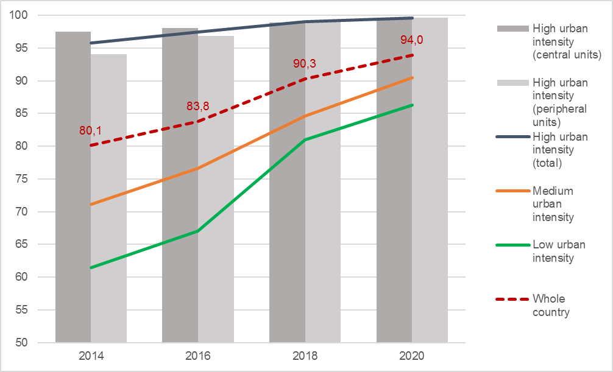
Source: Processing on VHLSS data

Figure 2.18 - Households using improved sanitation facilities: distance from target and urban-rural divide. Years 2014-2020 (estimates, percentage points)
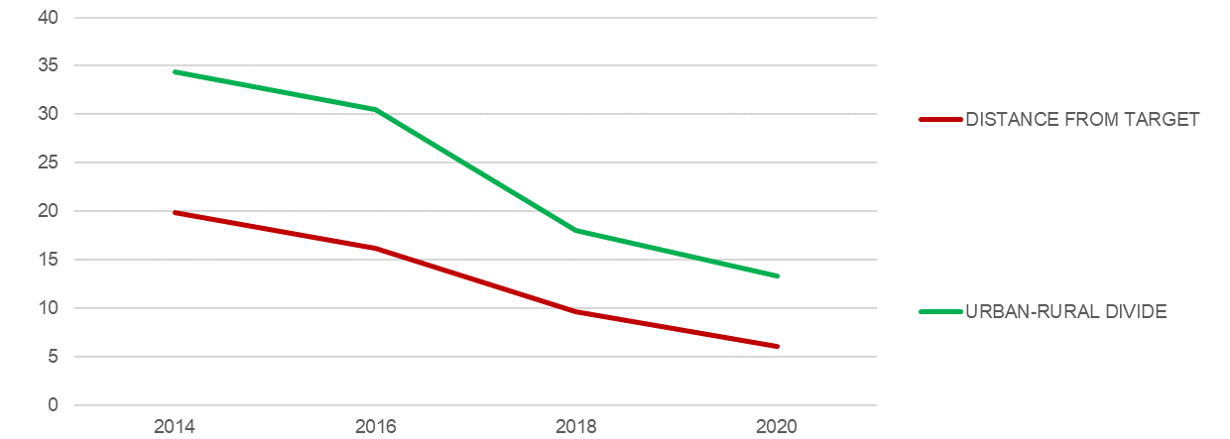
Source: Processing on VHLSS data
The proportion of households using improved sanitation facilities in Hanoi, Hai Phong, Ho Chi Minh City, and Da Nang does not differ significantly between urban areas and the general urban area of the country. The situation is different in the urban area of Can Tho, which still shows lower values compared to the national average (Figure 2.19).
Figure 2.19 - Households using improved sanitation facilities, by major urban areas. Years 2014-2020 (estimates, percentage values)
HA NOI  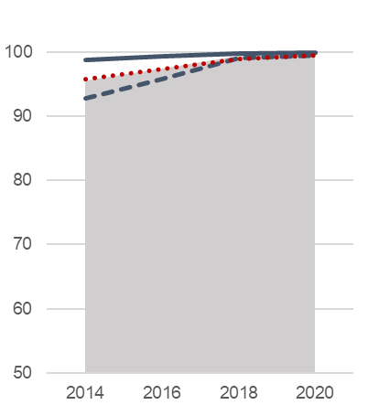 | HAI PHONG  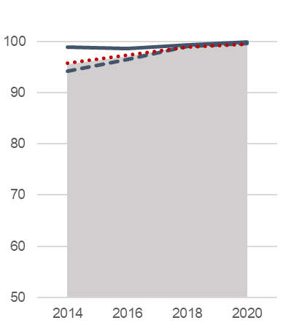 | DA NANG  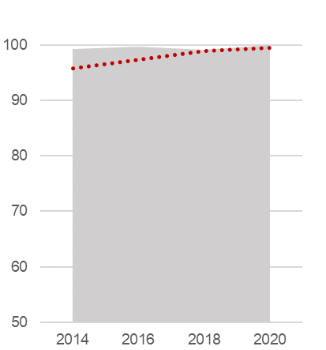
HO CHI MINH CITY  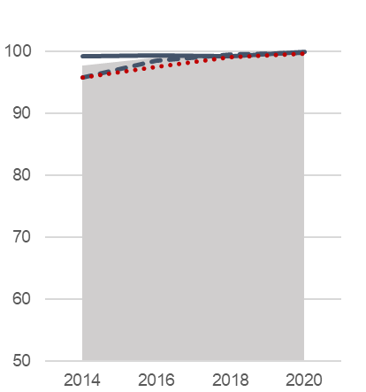 | CAN THO  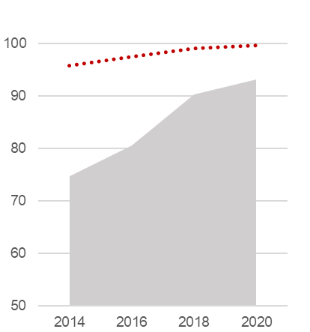
Source: Processing on VHLSS data

Table 2.11 - Households using improved sanitation facilities, by province and socio-economic region. Years 2014-2020 (percentage values)
Regions  Provinces |  | 2014 | 2016 | 2018 | 2020 |  | Regions  Provinces |  | 2014 | 2016 | 2018 | 2020
Red River Delta |  | 96.4 | 97.8 | 99.4 | 99.8 |  | Central Highlands |  | 61.9 | 66.1 | 82.7 | 87.1
Ha Noi |  | 98.9 | 99.4 | 99.8 | 100.0 |  | Kon Tum |  | 56.9 | 49.5 | 58.1 | 79.2
Vinh Phuc |  | 96.0 | 98.1 | 99.9 | 99.8 |  | Gia Lai |  | 53.3 | 51.5 | 73.9 | 77.9
Bac Ninh |  | 98.5 | 99.2 | 99.5 | 100.0 |  | Dak Lak |  | 51.2 | 66.8 | 86.1 | 91.1
Quang Ninh |  | 90.0 | 94.2 | 98.3 | 99.4 |  | Dak Nong |  | 63.8 | 68.4 | 92.5 | 92.1
Hai Duong |  | 99.5 | 99.7 | 99.6 | 99.8 |  | Lam Dong |  | 84.8 | 82.2 | 89.9 | 92.5
Hai Phong |  | 99.0 | 98.7 | 99.4 | 99.9
Hung Yen |  | 97.9 | 98.5 | 99.6 | 100.0 |  | South East |  | 95.5 | 97.1 | 98.6 | 99.4
Thai Binh |  | 96.2 | 96.4 | 99.7 | 99.9 |  | Binh Phuoc |  | 81.1 | 83.0 | 91.8 | 94.3
Ha Nam |  | 89.5 | 92.2 | 97.5 | 99.5 |  | Tay Ninh |  | 79.8 | 85.8 | 95.0 | 97.4
Nam Dinh |  | 95.3 | 98.1 | 99.3 | 99.8 |  | Binh Duong |  | 97.4 | 98.7 | 99.7 | 100.0
Ninh Binh |  | 80.9 | 89.5 | 98.0 | 98.6 |  | Dong Nai |  | 93.5 | 97.8 | 99.2 | 99.5
 |  |  |  |  |  |  | Ba Ria-Vung Tau |  | 98.6 | 99.6 | 99.4 | 99.7
Northern Midlands and |  |  |  |  |  |  | Ho Chi Minh City |  | 99.2 | 99.3 | 99.2 | 99.9
Mountains |  | 61.8 | 69.6 | 84.2 | 89.1
Ha Giang |  | 30.6 | 53.5 | 66.5 | 67.9 |  | Mekong River Delta |  | 60.4 | 67.9 | 77.7 | 85.1
Cao Bang |  | 31.8 | 38.0 | 57.8 | 70.7 |  | Long An |  | 67.5 | 76.7 | 85.0 | 93.4
Bac Kan |  | 57.3 | 68.1 | 88.8 | 87.7 |  | Tien Giang |  | 72.0 | 75.3 | 83.9 | 90.1
Tuyen Quang |  | 56.2 | 60.1 | 84.5 | 94.8 |  | Ben Tre |  | 57.8 | 60.0 | 77.2 | 86.7
Lao Cai |  | 58.6 | 70.3 | 83.3 | 82.7 |  | Tra Vinh |  | 40.5 | 51.5 | 61.0 | 75.8
Yen Bai |  | 56.9 | 64.1 | 88.0 | 91.5 |  | Vinh Long |  | 53.9 | 58.8 | 68.3 | 81.1
Thai Nguyen |  | 80.9 | 89.8 | 98.7 | 98.8 |  | Dong Thap |  | 63.5 | 75.1 | 82.5 | 90.7
Lang Son |  | 37.1 | 51.7 | 82.3 | 89.3 |  | An Giang |  | 83.6 | 87.8 | 94.8 | 96.2
Bac Giang |  | 91.3 | 98.0 | 98.4 | 99.5 |  | Kien Giang |  | 44.8 | 53.6 | 65.0 | 74.5
Phu Tho |  | 88.3 | 92.4 | 92.6 | 97.3 |  | Can Tho |  | 74.7 | 80.5 | 90.2 | 93.1
Dien Bien |  | 34.7 | 33.6 | 56.8 | 70.7 |  | Hau Giang |  | 40.9 | 49.6 | 58.2 | 68.0
Lai Chau |  | 29.6 | 41.6 | 58.8 | 75.2 |  | Soc Trang |  | 45.2 | 56.8 | 60.6 | 66.3
Son La |  | 37.8 | 45.4 | 74.6 | 78.2 |  | Bac Lieu |  | 53.8 | 58.6 | 77.3 | 88.1
Hoa Binh |  | 57.9 | 70.5 | 86.4 | 97.0 |  | Ca Mau |  | 51.6 | 64.7 | 78.1 | 79.4
North-central and Central
Coast |  | 82.1 | 84.7 | 90.0 | 93.9
Thanh Hoa |  | 79.2 | 81.5 | 95.0 | 97.5
Nghe An |  | 79.2 | 82.5 | 82.8 | 92.4
Ha Tinh |  | 91.7 | 94.9 | 95.5 | 97.4
Quang Binh |  | 75.7 | 81.7 | 87.5 | 90.5
Quang Tri |  | 81.7 | 79.6 | 86.6 | 85.5
Thua Thien-Hue |  | 85.9 | 92.0 | 92.7 | 95.8
Da Nang |  | 99.4 | 99.8 | 99.2 | 100.0
Quang Nam |  | 83.7 | 85.1 | 92.0 | 93.6
Quang Ngai |  | 72.6 | 78.3 | 85.7 | 85.9
Binh Dinh |  | 76.5 | 80.3 | 84.9 | 95.8
Phu Yen |  | 73.0 | 73.7 | 79.6 | 85.4
Khanh Hoa |  | 90.3 | 89.9 | 94.6 | 96.4
Ninh Thuan |  | 85.4 | 83.3 | 82.8 | 89.3
Binh Thuan |  | 89.8 | 88.3 | 95.1 | 96.6
High-urban intensity areas (central units)
High-urban intensity areas (peripheral units)
Source: Vietnam Household Living Standards Survey.

VSDG Target 7.1: By 2030, fundamentally 100% households have access to electricity; by 2025, fully 100% households have access to electricity; by 2030, ensure universal access to affordable, reliable and modern energy services

7.1.1: Households with access to electricity
Global SDGs | 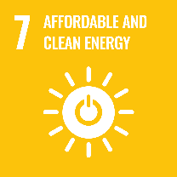 | Target 7.1: By 2030, ensure universal access to affordable, reliable and modern energy services  Indicator 7.1.1: Proportion of population with access to electricity
UNSD-CC |  | Topic: Vulnerable population  Indicator 95 = SDG 7.1.1
Metadata card
Definition |  |  | Proportion of households using electricity to the total number of households.
Glossary |  |  | Access to electricity: connection to the national grid.
Unit of measure |  |  | %
Breakdown |  |  | 63 Provinces
Data source |  |  | GSO, Vietnam Household Living Standards Survey (VHLSS)
Time series |  |  | 2010-2020
Frequency of updates |  |  | 2 years
Main data
Table 2.12 - Households with access to electricity, by major urban areas and by urban intensity degree. Years 2010-2020 (estimates, percentage values)
TERRITORY | 2010 | 2012 | 2014 | 2016 | 2018 | 2020
WHOLE COUTRY | 97.2 | 97.6 | 98.3 | 98.8 | 99.0 | 99.5
Ha Noi urban area | 99.8 | 99.9 | 99.9 | 99.9 | 99.9 | 99.9
Central unit | 99.9 | 100.0 | 99.9 | 99.9 | 99.8 | 99.9
Peripheral units | 99.7 | 99.9 | 99.9 | 100.0 | 99.9 | 100.0
Hai Phong urban area | 99.7 | 99.9 | 99.9 | 99.9 | 99.9 | 99.9
Central unit | 99.9 | 99.9 | 99.8 | 99.8 | 100.0 | 99.8
Peripheral units | 99.7 | 99.9 | 99.9 | 100.0 | 99.9 | 100.0
Da Nang urban area | 100.0 | 100.0 | 99.8 | 100.0 | 100.0 | 100.0
Ho Chi Minh City urban area | 99.2 | 99.6 | 99.3 | 99.8 | 99.9 | 99.9
Central unit | 99.8 | 99.9 | 99.6 | 99.8 | 99.9 | 99.8
Peripheral units | 98.5 | 99.1 | 99.0 | 99.7 | 100.0 | 99.9
Can Tho urban area | 99.7 | 99.7 | 99.6 | 99.7 | 99.7 | 100.0
High urban intensity (total) | 99.6 | 99.8 | 99.7 | 99.9 | 99.9 | 99.9
High urban intensity (central units) | 99.9 | 99.9 | 99.7 | 99.8 | 99.9 | 99.9
High urban intensity (peripheral units) | 99.3 | 99.7 | 99.6 | 99.9 | 99.9 | 100.0
Medium urban intensity | 97.4 | 98.2 | 98.8 | 99.4 | 99.5 | 99.7
Low urban intensity | 91.6 | 91.5 | 94.3 | 95.5 | 96.6 | 98.3
DISTANCE FROM TARGET in pct. points | 2.8 | 2.4 | 1.7 | 1.2 | 1.0 | 0.5
URBAN-RURAL DIVIDE in pct. points | 8.0 | 8.3 | 5.4 | 4.4 | 3.3 | 1.6
Source: Processing on VHLSS data
All over the country, the percentage of households with access to electricity gradually increases from 97.2% in 2010 to 99.5% in 2020, so approaching to the target of 100%, to be reached by 2025. In 2010, the percentage was already above 95% in the high-urban intensity areas (8 percentage points more than in rural areas), but this gap reduced to 0.5 points in 2020 (Figures 2.21 and 2.22).
Figure 2.21 - Households with access to electricity, by urban intensity degree. Years 2010-2020 (estimates, percentage values)
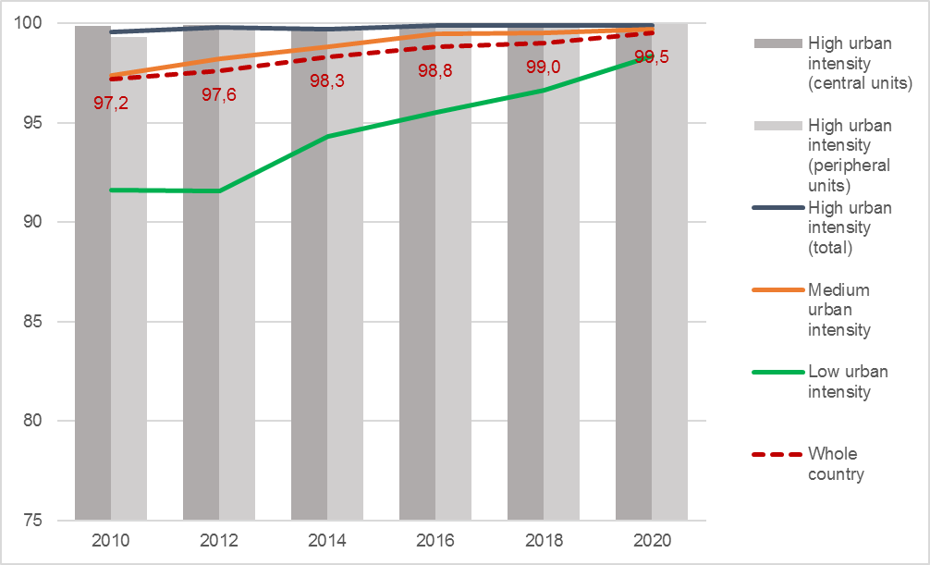
Source: Processing on VHLSS data

Figure 2.22 - Households with access to electricity: distance from target and urban-rural divide. Years 2010-2020 (estimates, percentage points)
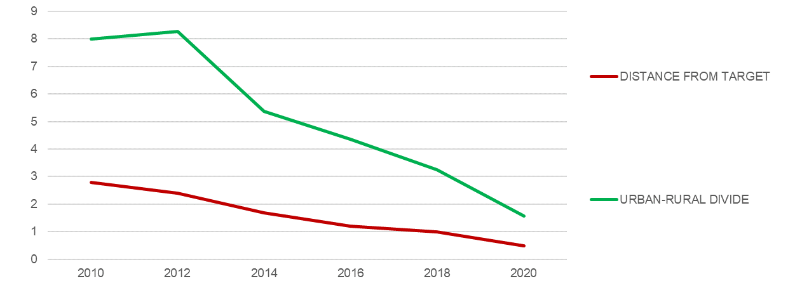
Source: Processing on VHLSS data
In the major urban areas, which include the five big cities directly under the central government and their surroundings, the percentage of households with access to electricity in 2020 is not significantly different between the central city and the peripheral areas. In all of these areas, the target of 100% can be considered substantially reached in 2020. (Figure 2.23).
Figure 2.23 - Households with access to electricity, by major urban areas. Years 2010-2020 (estimates, percentage values)
HA NOI  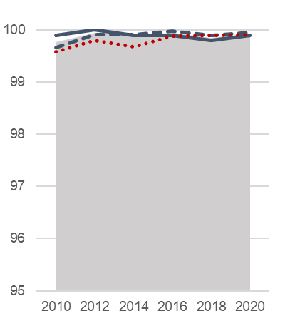 | HAI PHONG  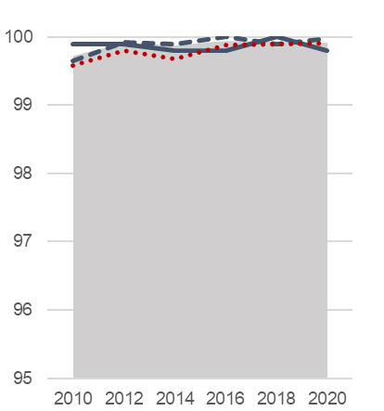 | DA NANG  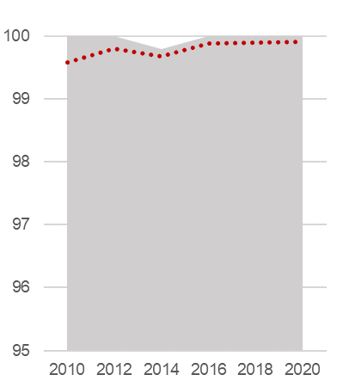
HO CHI MINH CITY  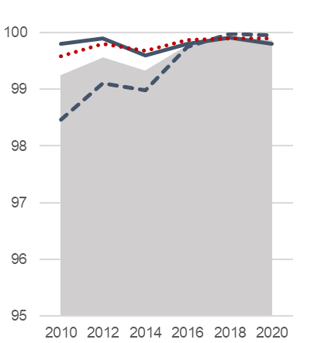 | CAN THO  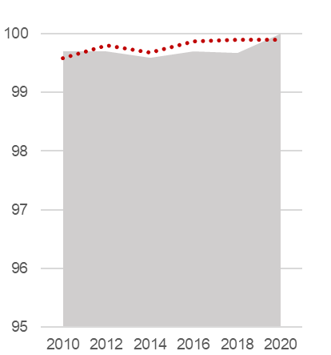
Source: Processing on VHLSS data

Table 2.13 - Households with access to electricity, by province and socio-economic region. Years 2012-2020 (percentage values)
Regions  Provinces | 2012 | 2014 | 2016 | 2018 | 2020 |  | Regions  Provinces | 2012 | 2014 | 2016 | 2018 | 2020
Red River Delta | 99.9 | 99.9 | 99.9 | 99.8 | 99.9 |  | Central
Ha Noi | 100.0 | 99.9 | 99.9 | 99.8 | 99.9 |  | Highlands | 97.5 | 98.2 | 98.9 | 99.5 | 98.9
Vinh Phuc | 100.0 | 100.0 | 100.0 | 99.6 | 100.0 |  | Kon Tum | 99.8 | 98.8 | 98.5 | 99.3 | 99.8
Bac Ninh | 99.9 | 100.0 | 100.0 | 100.0 | 100.0 |  | Gia Lai | 99.3 | 99.3 | 98.3 | 99.7 | 99.4
Quang Ninh | 100.0 | 99.9 | 100.0 | 100.0 | 99.9 |  | Dak Lak | 95.0 | 96.5 | 99.3 | 99.7 | 98.3
Hai Duong | 99.9 | 99.7 | 100.0 | 99.8 | 100.0 |  | Dak Nong | 96.5 | 99.3 | 98.2 | 98.9 | 96.1
Hai Phong | 99.9 | 99.8 | 99.8 | 100.0 | 99.8 |  | Lam Dong | 98.5 | 98.9 | 99.3 | 99.6 | 99.9
Hung Yen | 99.7 | 99.9 | 100.0 | 100.0 | 100.0
Thai Binh | 99.9 | 100.0 | 100.0 | 99.7 | 100.0 |  | South East | 99.3 | 99.3 | 99.7 | 99.9 | 99.8
Ha Nam | 100.0 | 99.9 | 100.0 | 100.0 | 100.0 |  | Binh Phuoc | 96.3 | 98.4 | 99.0 | 99.4 | 97.6
Nam Dinh | 99.9 | 99.8 | 100.0 | 100.0 | 100.0 |  | Tay Ninh | 99.7 | 99.9 | 99.8 | 100.0 | 99.9
Ninh Binh | 100.0 | 100.0 | 100.0 | 100.0 | 99.7 |  | Binh Duong | 99.9 | 99.6 | 99.9 | 100.0 | 100.0
 |  |  |  |  |  |  | Dong Nai | 98.3 | 98.3 | 99.7 | 100.0 | 100.0
Northern |  |  |  |  |  |  | Ba Ria-Vung Tau | 99.9 | 99.7 | 99.6 | 99.9 | 99.7
Midlands and |  |  |  |  |  |  | Ho Chi Minh City | 99.9 | 99.6 | 99.8 | 99.9 | 99.8
Mountains | 90.7 | 93.0 | 94.8 | 96.4 | 98.2
Ha Giang | 78.3 | 77.7 | 90.8 | 85.5 | 96.0 |  | Mekong River
Cao Bang | 81.7 | 82.3 | 82.2 | 89.9 | 91.7 |  | Delta | 97.8 | 99.1 | 99.6 | 99.5 | 99.8
Bac Kan | 90.2 | 88.4 | 95.3 | 97.0 | 97.3 |  | Long An | 99.3 | 99.6 | 99.7 | 99.2 | 99.8
Tuyen Quang | 97.0 | 96.1 | 96.5 | 96.5 | 99.7 |  | Tien Giang | 100.0 | 100.0 | 100.0 | 99.5 | 100.0
Lao Cai | 91.2 | 89.2 | 93.4 | 93.2 | 98.8 |  | Ben Tre | 98.9 | 99.8 | 99.6 | 99.6 | 99.7
Yen Bai | 91.7 | 93.2 | 92.8 | 95.0 | 98.7 |  | Tra Vinh | 95.3 | 97.5 | 99.3 | 98.8 | 99.8
Thai Nguyen | 99.9 | 100.0 | 99.9 | 100.0 | 99.9 |  | Vinh Long | 99.4 | 99.2 | 99.6 | 99.6 | 100.0
Lang Son | 86.3 | 89.0 | 96.0 | 99.0 | 96.7 |  | Dong Thap | 99.1 | 99.4 | 99.8 | 99.9 | 100.0
Bac Giang | 99.2 | 100.0 | 99.9 | 100.0 | 99.9 |  | An Giang | 96.1 | 99.3 | 99.5 | 99.1 | 99.2
Phu Tho | 97.4 | 99.0 | 99.8 | 99.9 | 99.7 |  | Kien Giang | 92.5 | 95.7 | 99.2 | 99.7 | 99.8
Dien Bien | 75.5 | 84.5 | 80.5 | 94.0 | 88.7 |  | Can Tho | 99.7 | 99.6 | 99.7 | 99.7 | 100.0
Lai Chau | 55.8 | 72.6 | 89.1 | 89.8 | 97.3 |  | Hau Giang | 98.9 | 99.8 | 99.1 | 99.8 | 99.8
Son La | 73.8 | 90.2 | 88.0 | 93.6 | 98.7 |  | Soc Trang | 96.2 | 98.3 | 99.3 | 99.4 | 99.6
Hoa Binh | 99.6 | 97.1 | 99.8 | 99.7 | 99.8 |  | Bac Lieu | 99.7 | 99.8 | 100.0 | 100.0 | 99.8
 |  |  |  |  |  |  | Ca Mau | 99.0 | 99.7 | 99.7 | 99.9 | 99.3
North-central
and Central
Coast | 97.6 | 98.3 | 98.6 | 98.6 | 99.7
Thanh Hoa | 98.2 | 97.1 | 98.7 | 98.3 | 99.8
Nghe An | 92.6 | 97.0 | 94.5 | 94.6 | 99.8
Ha Tinh | 99.9 | 100.0 | 100.0 | 99.7 | 99.5
Quang Binh | 99.5 | 100.0 | 99.9 | 99.9 | 97.3
Quang Tri | 95.7 | 99.1 | 99.6 | 99.6 | 100.0
Thua Thien-Hue | 99.3 | 98.8 | 100.0 | 99.5 | 100.0
Da Nang | 100.0 | 99.8 | 100.0 | 100.0 | 100.0
Quang Nam | 95.6 | 100.0 | 99.7 | 99.3 | 99.7
Quang Ngai | 98.1 | 95.2 | 99.7 | 100.0 | 99.4
Binh Dinh | 99.7 | 99.5 | 99.6 | 100.0 | 99.9
Phu Yen | 99.3 | 99.8 | 99.1 | 99.7 | 99.8
Khanh Hoa | 99.7 | 99.9 | 99.7 | 99.9 | 99.9
Ninh Thuan | 99.0 | 98.8 | 99.6 | 99.8 | 99.8
Binh Thuan | 97.4 | 96.7 | 97.3 | 99.7 | 100.0
High-urban intensity areas (central units)
High-urban intensity areas (peripheral units)
Source: Vietnam Household Living Standards Survey.

VSDG Target 11.1: By 2030, ensure access for all citizens to adequate, safe and affordable basic services and housing; abolish slums; build, upgrade, improve sub-standard housing areas

11.1.1: Proportion of population living in poorly built housing

11.1.1a: Households not living in permanent/semi-permanent houses
Global SDGs | 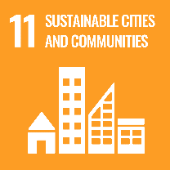 | Target 11.1: By 2030, ensure access for all to adequate, safe and affordable housing and basic services and upgrade slums  Indicator 11.1.1: Proportion of urban population living in slums, informal settlements or inadequate housing
UNSD-CC |  | Topic: Vulnerable population  Indicator 103 = SDG 11.1.1
Metadata card
Definition |  |  | Proportion of households not living in permanent or semi-permanent houses to the total number of households.
Glossary |  |  | Permanent and semi-permanent houses: considering the three main elements of a house (pillars/load-bearing walls, roof, outer walls), houses are classified permanent if all these elements are made of durable materials, and semi-permanent if at least two elements out of three are made of durable materials.
Unit of measure |  |  | %
Breakdown |  |  | 63 Provinces
Data source |  |  | GSO, Vietnam Household Living Standards Survey (VHLSS)
Time series |  |  | 2014-2020
Frequency of updates |  |  | 2 years
Main data
Table 2.14 - Households not living in permanent/semi-permanent houses, by major urban areas and by urban intensity degree. Years 2014-2020 (estimates, percentage values)
TERRITORY | 2014 | 2016 | 2018 | 2020
WHOLE COUTRY | 9.2 | 7.8 | 6.1 | 4.4
Ha Noi urban area | 0.8 | 0.6 | 0.4 | 0.2
Central unit | 0.1 | 0.1 | 0.1 | 0.1
Peripheral units | 1.4 | 1.0 | 0.6 | 0.4
Hai Phong urban area | 0.7 | 0.5 | 0.4 | 0.1
Central unit | 0.3 | 0.0 | 0.2 | 0.0
Peripheral units | 0.8 | 0.7 | 0.5 | 0.2
Da Nang urban area | 0.2 | 0.2 | 0.2 | 0.0
Ho Chi Minh City urban area | 1.7 | 1.3 | 0.9 | 0.6
Central unit | 0.8 | 1.0 | 0.9 | 0.7
Peripheral units | 3.0 | 1.6 | 0.8 | 0.5
Can Tho urban area | 18.1 | 14.1 | 11.5 | 8.9
High urban intensity (total) | 1.7 | 1.2 | 0.9 | 0.6
High urban intensity (central units) | 1.6 | 1.4 | 1.2 | 0.8
High urban intensity (peripheral units) | 1.7 | 1.1 | 0.6 | 0.4
Medium urban intensity | 16.6 | 13.5 | 10.0 | 7.6
Low urban intensity | 13.5 | 12.6 | 11.1 | 8.6
DISTANCE FROM TARGET in pct. points | 9.2 | 7.8 | 6.1 | 4.4
URBAN-RURAL DIVIDE in pct. points | 11.8 | 11.4 | 10.2 | 8.0
Source: Processing on VHLSS data
In high-urban intensity areas, the percentage of households not living in permanent/semi-permanent houses is lower than the national average (0.6% vs. 4.4% in 2020), while it is higher both in medium- and low-urban intensity areas than the national average (7.6% and 8.6%, respectively). The overall trend is positive, and the gap between urban and rural areas is reducing (from 11.8 percentage points in 2014 to 8 points in 2020), but remains quite wide (Figures 2.24 and 2.25).
Figure 2.24 - Households not living in permanent/semi-permanent houses, by urban intensity degree. Years 2014-2020 (estimates, percentage values)
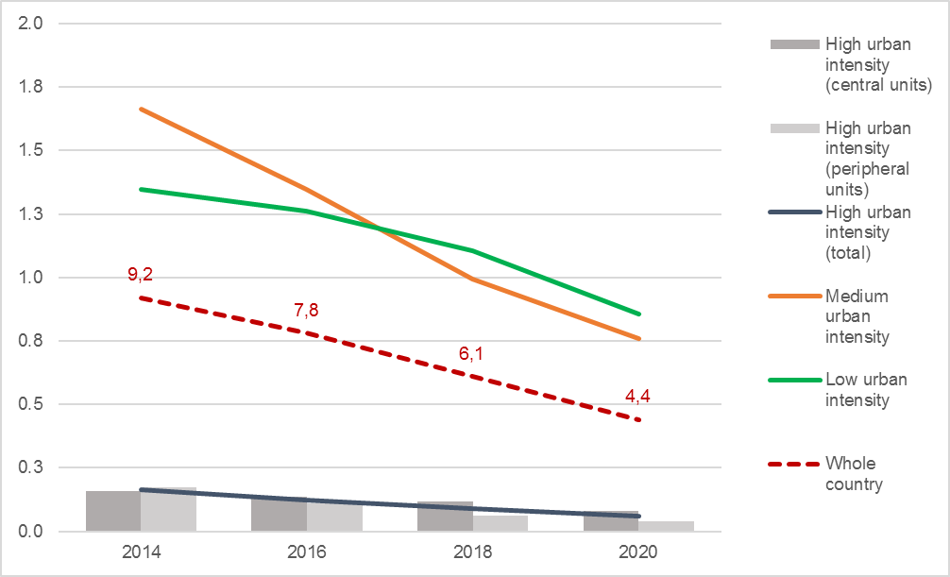
Source: Processing on VHLSS data

Figure 2.25 - Households not living in permanent/semi-permanent houses: distance from target and urban-rural divide. Years 2014-2020 (estimates, percentage points)
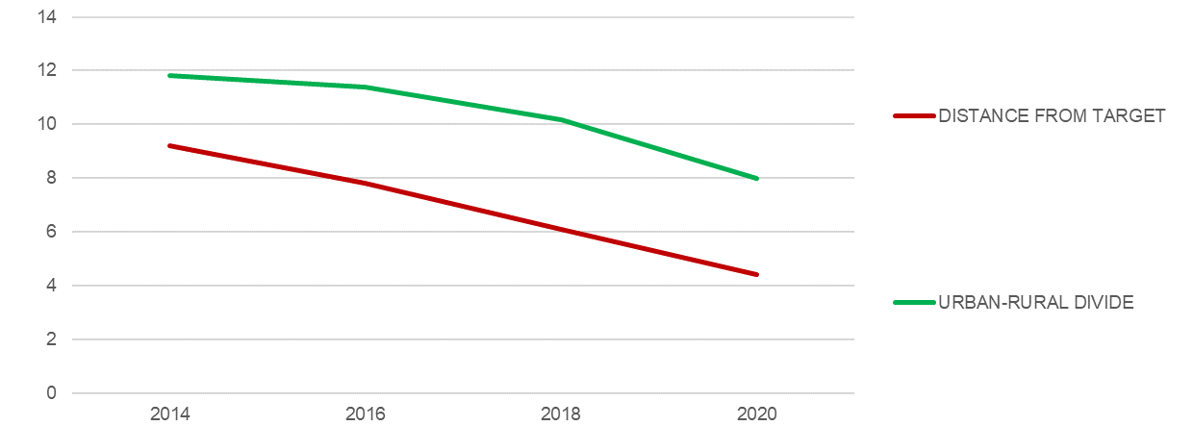
Source: Processing on VHLSS data
In 2020, the urban area of Da Nang has reached the goal of zero households living in dwellings mostly or entirely built of non-durable materials, while other three major urban areas (Hanoi, Hai Phong and Ho Chi Minh City) are very close to it. The urban area of Can Tho, instead, despite a steady positive trend, is still far from the goal, with 8.9% households not living in permanent or semi-permanent houses – nearly double the national average of 4.4% (Figure 2.26).
Figure 2.26 - Households not living in permanent/semi-permanent houses, by major urban areas. Years 2014-2020 (estimates, percentage values)
HA NOI  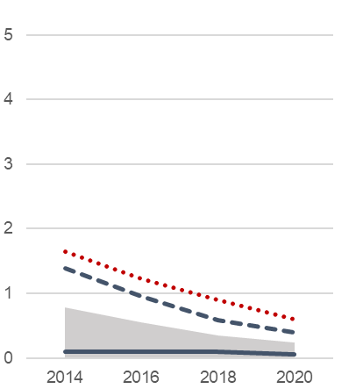 | HAI PHONG  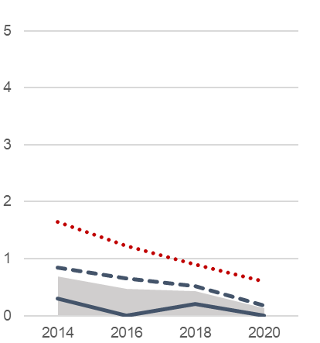 | DA NANG  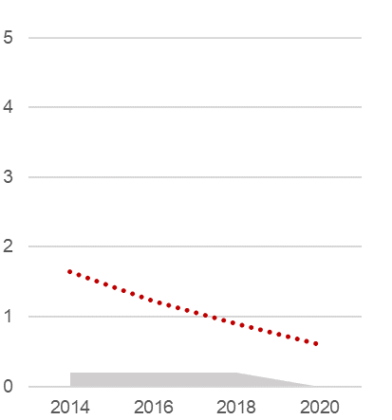
HO CHI MINH CITY  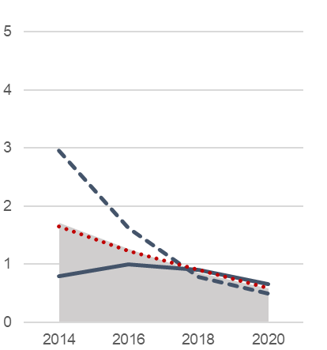 | CAN THO (*)  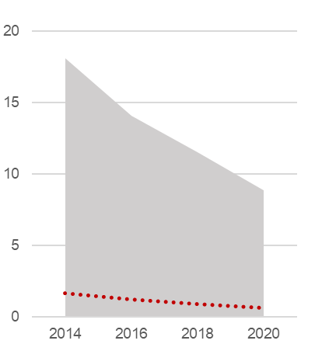
(*) Scale not comparable with that of the other charts.
Source: Processing on VHLSS data

Table 2.15 - Households not living in permanent/semi-permanent houses, by province and socio-economic region. Years 2014-2020 (percentage values)
Regions  Provinces |  | 2014 | 2016 | 2018 | 2020 |  | Regions  Provinces |  | 2014 | 2016 | 2018 | 2020
Red River Delta |  | 0.3 | 0.2 | 0.3 | 0.1 |  | Central Highlands |  | 7.1 | 6.0 | 5.3 | 4.8
Ha Noi |  | 0.1 | 0.1 | 0.1 | 0.1 |  | Kon Tum |  | 5.8 | 7.3 | 9.7 | 6.3
Vinh Phuc |  | 0.1 | 0.1 | 0.4 | 0.3 |  | Gia Lai |  | 9.7 | 4.9 | 5.1 | 5.0
Bac Ninh |  | .. | 0.1 | .. | .. |  | Dak Lak |  | 3.2 | 3.7 | 4.3 | 4.6
Quang Ninh |  | 2.8 | 2.3 | 1.7 | 0.7 |  | Dak Nong |  | 15.5 | 11.7 | 6.0 | 9.3
Hai Duong |  | .. | .. | .. | 0.3 |  | Lam Dong |  | 7.0 | 7.3 | 4.7 | 2.4
Hai Phong |  | 0.3 | .. | 0.2 | ..
Hung Yen |  | 0.1 | .. | .. | 0.1 |  | South East |  | 2.8 | 2.1 | 1.6 | 1.2
Thai Binh |  | 0.1 | 0.1 | .. | .. |  | Binh Phuoc |  | 12.0 | 8.0 | 6.4 | 6.7
Ha Nam |  | 0.5 | 0.3 | 0.3 | .. |  | Tay Ninh |  | 10.3 | 8.0 | 6.6 | 4.8
Nam Dinh |  | 0.3 | 0.1 | 0.2 | .. |  | Binh Duong |  | 1.8 | 0.4 | 0.3 | ..
Ninh Binh |  | .. | .. | .. | 0.2 |  | Dong Nai |  | 4.2 | 2.7 | 1.3 | 0.9
 |  |  |  |  |  |  | Ba Ria-Vung Tau |  | 1.7 | 0.9 | 0.3 | 0.4
Northern Midlands and |  |  |  |  |  |  | Ho Chi Minh City |  | 0.8 | 1.0 | 0.9 | 0.7
Mountains |  | 19.0 | 16.7 | 13.8 | 10.8
Ha Giang |  | 48.0 | 35.0 | 37.7 | 33.4 |  | Mekong River Delta |  | 26.4 | 21.5 | 16.4 | 12.8
Cao Bang |  | 13.0 | 10.8 | 14.8 | 10.1 |  | Long An |  | 14.1 | 9.6 | 9.0 | 5.9
Bac Kan |  | 28.0 | 21.5 | 20.7 | 20.6 |  | Tien Giang |  | 13.6 | 8.4 | 6.5 | 4.0
Tuyen Quang |  | 33.5 | 32.7 | 32.2 | 18.6 |  | Ben Tre |  | 18.2 | 19.3 | 11.6 | 8.4
Lao Cai |  | 35.5 | 32.0 | 26.3 | 20.4 |  | Tra Vinh |  | 37.9 | 36.2 | 26.6 | 21.1
Yen Bai |  | 37.8 | 34.6 | 25.7 | 23.0 |  | Vinh Long |  | 15.9 | 12.5 | 9.8 | 4.9
Thai Nguyen |  | 8.9 | 6.0 | 3.3 | 1.8 |  | Dong Thap |  | 25.8 | 20.3 | 17.0 | 11.6
Lang Son |  | 16.4 | 15.5 | 12.2 | 10.0 |  | An Giang |  | 31.2 | 27.4 | 26.7 | 18.4
Bac Giang |  | 5.1 | 1.7 | 0.4 | 0.2 |  | Kien Giang |  | 42.5 | 34.5 | 23.3 | 23.7
Phu Tho |  | 10.9 | 7.9 | 3.1 | 4.9 |  | Can Tho |  | 18.1 | 14.1 | 11.5 | 8.9
Dien Bien |  | 17.1 | 22.3 | 16.2 | 11.9 |  | Hau Giang |  | 32.1 | 21.6 | 17.4 | 12.5
Lai Chau |  | 29.2 | 26.6 | 17.0 | 14.3 |  | Soc Trang |  | 34.8 | 24.9 | 16.7 | 16.0
Son La |  | 18.8 | 20.7 | 18.7 | 13.4 |  | Bac Lieu |  | 34.1 | 22.3 | 14.1 | 10.1
Hoa Binh |  | 9.9 | 7.5 | 7.7 | 3.7 |  | Ca Mau |  | 38.5 | 35.9 | 24.7 | 25.1
North-central and Central
Coast |  | 4.4 | 4.5 | 3.2 | 2.0
Thanh Hoa |  | 7.9 | 7.8 | 4.5 | 2.5
Nghe An |  | 7.9 | 8.8 | 6.5 | 1.5
Ha Tinh |  | 6.8 | 5.1 | 4.2 | 1.4
Quang Binh |  | 2.2 | 1.4 | 4.0 | 5.4
Quang Tri |  | 4.6 | 4.8 | 4.9 | 3.8
Thua Thien-Hue |  | 1.8 | 1.9 | 0.8 | 1.1
Da Nang |  | 0.2 | 0.2 | 0.2 | ..
Quang Nam |  | 3.2 | 3.5 | 2.0 | 3.9
Quang Ngai |  | 1.3 | 3.3 | 2.7 | 2.0
Binh Dinh |  | 0.6 | 1.1 | 0.1 | ..
Phu Yen |  | 1.6 | 1.2 | 1.3 | 1.4
Khanh Hoa |  | 1.8 | 1.4 | 0.7 | 1.2
Ninh Thuan |  | 4.8 | 4.0 | 3.3 | 1.9
Binh Thuan |  | 1.8 | 2.9 | 1.9 | 1.7
High-urban intensity areas (central units)
High-urban intensity areas (peripheral units)
Source: Vietnam Household Living Standards Survey.

VSDG Target 11.1: By 2030, ensure access for all citizens to adequate, safe and affordable basic services and housing; abolish slums; build, upgrade, improve sub-standard housing areas

11.1.1: Proportion of population living in poorly built housing

11.1.1b: Households living in less than 10 m2 per capita
Global SDGs |  | Target 11.1: By 2030, ensure access for all to adequate, safe and affordable housing and basic services and upgrade slums  Indicator 11.1.1: Proportion of urban population living in slums, informal settlements or inadequate housing
UNSD-CC |  | Topic: Vulnerable population  Indicator 103 = SDG 11.1.1
Metadata card
Definition |  |  | Proportion of households living in less than 10 m² of floor space per capita to the total number of households.
Glossary |  |  | Floor space per capita: Total floor area of inhabited dwellings or flats, divided by the number of components of the households living in.
Unit of measure |  |  | %
Breakdown |  |  | 63 Provinces
Data source |  |  | GSO, Population and Housing Census
Time series |  |  | 2009-2019
Frequency of updates |  |  | 10 years
Main data
Table 2.16 - Households living in less than 10 m² per capita, by major urban areas and by urban intensity degree. Years 2009 and 2019 (estimates, percentage values)
TERRITORY | 2009 | 2019
WHOLE COUTRY | 21.4 | 10.2
Ha Noi urban area | 21.5 | 7.3
Central unit | 25.6 | 9.4
Peripheral units | 18.2 | 5.6
Hai Phong urban area | 21.8 | 6.1
Central unit | 29.7 | 10.8
Peripheral units | 18.8 | 4.2
Da Nang urban area | 14.7 | 9.9
Ho Chi Minh City urban area | 32.3 | 23.1
Central unit | 34.4 | 22.3
Peripheral units | 29.6 | 24.1
Can Tho urban area | 20.1 | 11.1
High urban intensity (total) | 25.0 | 13.2
High urban intensity (central units) | 28.7 | 15.1
High urban intensity (peripheral units) | 21.5 | 11.3
Medium urban intensity | 18.5 | 6.9
Low urban intensity | 19.4 | 9.6
DISTANCE FROM TARGET in pct. points | 21.4 | 10.2
URBAN-RURAL DIVIDE in pct. points | 5.5 | 3.6
Source: Processing on Population and Housing Census data
The proportion of households living in less than 10 m² per capita decreased from 21.4% in 2009 to 10.2% in 2019; as well as the gap between urban and rural areas, which reduced from 5.5 to 3.6 percentage points over the same period. Overcrowding seems to affect most the central cities of the high-urban intensity areas (15.1% in 2019), and less the medium-intensity areas than the rural ones (6.9 pct. points vs. 9.6 – Figures 2.27 and 2.28).
Figure 2.27 - Households living in less than 10 m² per capita, by urban intensity degree. Years 2009 and 2019 (estimates, percentage values)
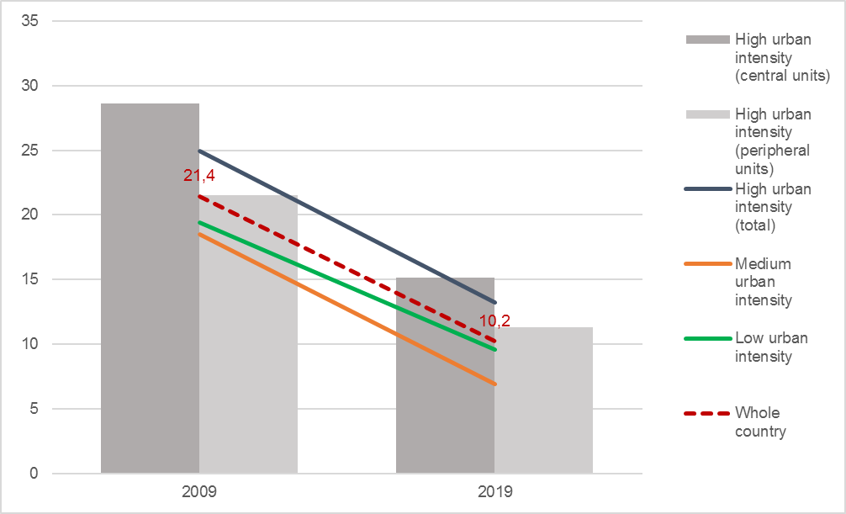
Source: Processing on Population and Housing Census data

Figure 2.28 - Households living in less than 10 m² per capita: distance from target and urban-rural divide. Years 2009 and 2019 (estimates, percentage points)
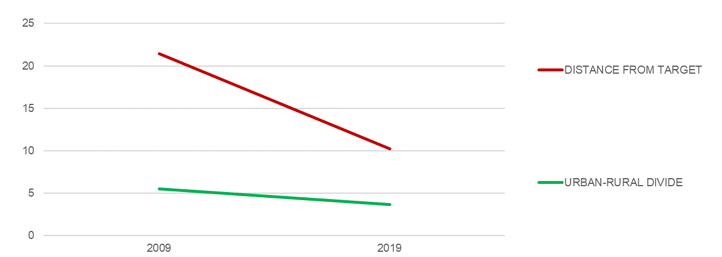
Source: Processing on Population and Housing Census data
The detail of the major urban areas, which include the five cities under the central government, shows how overcrowding issues actually concentrate in the area of Ho Chi Minh City (22.3% in the central unit, corresponding to the province of HCMC, and 24.1% in the peripheral units), while in all other high-urban intensity areas the rates are lower than the national average (around 10% in Da Nang and Can Tho, between 5 and 10% in Ha Noi and Hai Phong). The trends are positive, however, in all major urban areas, for both the central and the peripheral units (Figure 2.29).
Figure 2.29 - Households living in less than 10 m² per capita, by major urban areas. Years 2009 and 2019 (estimates, percentage values)
HA NOI  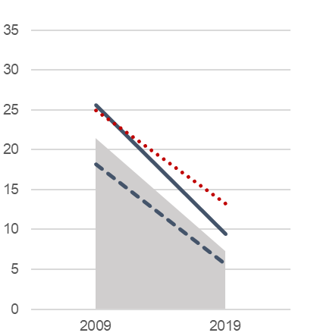 | HAI PHONG  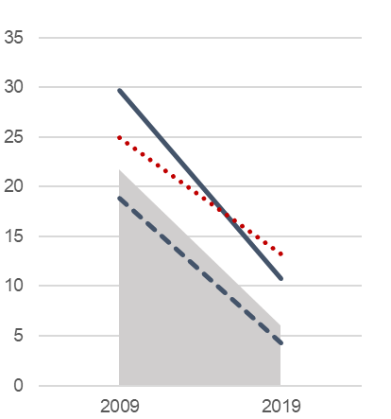 | DA NANG  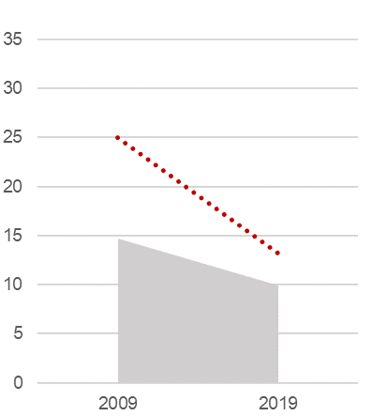
HO CHI MINH CITY  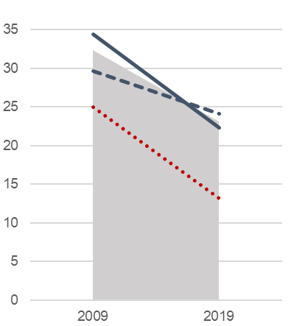 | CAN THO  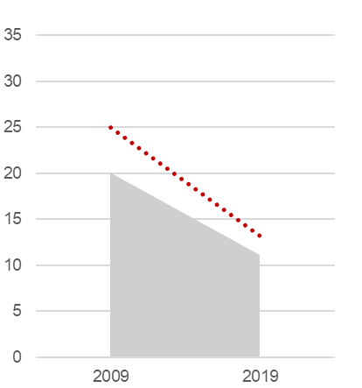
Source: Processing on Population and Housing Census data

Table 2.17 - Households living in less than 10 m² per capita, by province and socio-economic region. Years 2009 and 2019 (percentage values)
Regions  Provinces |  |  |  | 2009 | 2019 |  | Regions  Provinces |  |  |  | 2009 | 2019
Red River Delta |  |  |  | 22.0 | 7.0 |  | Central Highlands |  |  |  | 28.9 | 14.4
Ha Noi |  |  |  | 25.6 | 9.4 |  | Kon Tum |  |  |  | 34.8 | 19.6
Vinh Phuc |  |  |  | 13.2 | 3.4 |  | Gia Lai |  |  |  | 32.9 | 18.3
Bac Ninh |  |  |  | 18.1 | 9.7 |  | Dak Lak |  |  |  | 27.3 | 12.8
Quang Ninh |  |  |  | 19.4 | 6.5 |  | Dak Nong |  |  |  | 28.9 | 14.6
Hai Duong |  |  |  | 19.1 | 4.3 |  | Lam Dong |  |  |  | 25.1 | 10.5
Hai Phong |  |  |  | 29.7 | 10.8
Hung Yen |  |  |  | 23.3 | 6.6 |  | South East |  |  |  | 30.3 | 21.1
Thai Binh |  |  |  | 18.1 | 3.4 |  | Binh Phuoc |  |  |  | 19.8 | 7.5
Ha Nam |  |  |  | 14.9 | 4.4 |  | Tay Ninh |  |  |  | 14.9 | 5.5
Nam Dinh |  |  |  | 19.1 | 3.7 |  | Binh Duong |  |  |  | 42.9 | 38.7
Ninh Binh |  |  |  | 23.7 | 4.4 |  | Dong Nai |  |  |  | 24.6 | 16.0
 |  |  |  |  |  |  | Ba Ria-Vung Tau |  |  |  | 18.0 | 8.5
Northern Midlands and Mountains |  |  |  | 16.2 | 8.0 |  | Ho Chi Minh City |  |  |  | 34.4 | 22.3
Ha Giang |  |  |  | 14.6 | 9.7
Cao Bang |  |  |  | 8.4 | 5.1 |  | Mekong River Delta |  |  |  | 18.3 | 7.9
Bac Kan |  |  |  | 9.4 | 5.8 |  | Long An |  |  |  | 9.6 | 7.6
Tuyen Quang |  |  |  | 14.0 | 6.6 |  | Tien Giang |  |  |  | 9.6 | 4.3
Lao Cai |  |  |  | 18.4 | 7.4 |  | Ben Tre |  |  |  | 6.5 | 3.1
Yen Bai |  |  |  | 13.5 | 6.5 |  | Tra Vinh |  |  |  | 15.2 | 6.4
Thai Nguyen |  |  |  | 14.0 | 5.4 |  | Vinh Long |  |  |  | 11.8 | 5.9
Lang Son |  |  |  | 10.5 | 5.6 |  | Dong Thap |  |  |  | 22.9 | 7.7
Bac Giang |  |  |  | 17.0 | 5.2 |  | An Giang |  |  |  | 30.1 | 11.6
Phu Tho |  |  |  | 11.5 | 3.4 |  | Kien Giang |  |  |  | 24.2 | 10.9
Dien Bien |  |  |  | 28.3 | 21.1 |  | Can Tho |  |  |  | 20.1 | 11.1
Lai Chau |  |  |  | 27.5 | 18.2 |  | Hau Giang |  |  |  | 16.6 | 5.3
Son La |  |  |  | 20.8 | 13.5 |  | Soc Trang |  |  |  | 21.9 | 9.2
Hoa Binh |  |  |  | 27.0 | 12.4 |  | Bac Lieu |  |  |  | 21.5 | 9.6
 |  |  |  |  |  |  | Ca Mau |  |  |  | 23.2 | 8.3
North-central and Central Coast |  |  |  | 18.1 | 6.3
Thanh Hoa |  |  |  | 21.0 | 5.6
Nghe An |  |  |  | 16.9 | 5.4
Ha Tinh |  |  |  | 11.9 | 3.0
Quang Binh |  |  |  | 12.5 | 4.5
Quang Tri |  |  |  | 20.9 | 11.6
Thua Thien-Hue |  |  |  | 18.9 | 7.4
Da Nang |  |  |  | 14.7 | 9.9
Quang Nam |  |  |  | 14.6 | 4.6
Quang Ngai |  |  |  | 14.4 | 6.4
Binh Dinh |  |  |  | 13.4 | 4.5
Phu Yen |  |  |  | 20.7 | 6.4
Khanh Hoa |  |  |  | 22.9 | 8.5
Ninh Thuan |  |  |  | 37.5 | 14.6
Binh Thuan |  |  |  | 23.4 | 7.1
High-urban intensity areas (central units)
High-urban intensity areas (peripheral units)
Source: Population and Housing Census.

VSDG Target 11.2: By 2030, ensure access for all citizens to safe, affordable, convenient and sustainable transport systems; improve traffic safety, notably by expanding public transport with special attention paid to the needs of women, children, persons with disabilities and elderly people

11.2.1: Growth rate of the number of passengers using public transport

11.2.1a: Growth rate of public transport passengers by road
Global SDGs |  | Target 11.2: By 2030, provide access to safe, affordable, accessible and sustainable transport systems for all, improving road safety, notably by expanding public transport, with special attention to the needs of those in vulnerable situations, women, children, persons with disabilities and older persons  Indicator 11.2.1: Proportion of population that has convenient access to public transport, by sex, age and persons with disabilities
Metadata card
Definition |  |  | Variation in the total number of passengers carried by road, observed in year t compared to t-1.
Glossary |  |  | Passengers carried by road: total passengers travelling by road, carried by transportation establishments and other business activities operating a public transportation service (both of public and private ownership), regardless of travel distance. The number does not include the passengers of personal vehicles.
Unit of measure |  |  | %
Breakdown |  |  | 63 Provinces
Data source |  |  | National statistical reporting system, Ministry of Transportation (MOT)
Time series |  |  | 2012-2021
Frequency of updates |  |  | 1 year
Main data
Table 2.18 - Growth rate of public transport passengers by road (*), by major urban areas and by urban intensity degree. Years 2012-2021 (estimates, percentage values)
TERRITORY | 2012 | 2013 | 2014 | 2015 | 2016 | 2017 | 2018 | 2019 | 2020 | 2021
WHOLE COUTRY | 8.6 | 6.3 | 7.6 | 8.4 | 8.2 | 9.6 | 9.1 | 10.6 | -26.8 | -27.1
Ha Noi urban area | 10.2 | 8.0 | 10.1 | 7.3 | 9.4 | 9.5 | 7.7 | 10.8 | -13.2 | -19.3
Central unit | 10.5 | 8.0 | 10.2 | 7.2 | 9.3 | 9.7 | 7.4 | 10.9 | -13.2 | -20.2
Peripheral units | 7.5 | 7.6 | 9.2 | 8.3 | 10.2 | 7.5 | 11.6 | 9.4 | -13.1 | -9.6
Hai Phong urban area | 4.2 | 3.4 | 9.0 | 8.0 | 9.0 | 10.6 | 11.9 | 12.8 | 2.3 | -0.5
Central unit | 1.0 | -0.3 | 13.1 | 9.6 | 11.1 | 10.7 | 15.3 | 12.7 | 3.5 | 8.4
Peripheral units | 7.3 | 6.8 | 5.6 | 6.5 | 7.1 | 10.5 | 8.6 | 12.9 | 1.1 | -9.6
Da Nang urban area | 7.8 | -6.1 | 11.2 | -15.9 | 7.0 | 7.7 | -12.9 | 15.6 | -58.9 | -12.9
Ho Chi Minh City urban area | 10.7 | 8.6 | 7.6 | 13.0 | 8.9 | 10.9 | 13.1 | 12.7 | -45.2 | -42.2
Central unit | 10.2 | 8.8 | 8.6 | 14.2 | 9.5 | 11.5 | 13.9 | 13.9 | -49.4 | -46.2
Peripheral units | 13.3 | 7.9 | 2.3 | 6.5 | 5.5 | 7.2 | 7.7 | 4.8 | -14.5 | -24.6
Can Tho urban area | 6.7 | 7.2 | 0.4 | -11.4 | 1.5 | 9.8 | 8.0 | 3.2 | -9.3 | -32.7
High urban intensity (total) | 10.0 | 7.8 | 8.4 | 8.7 | 8.8 | 10.2 | 10.2 | 11.6 | -28.5 | -27.4
High urban intensity (central units) | 9.9 | 7.9 | 9.0 | 8.9 | 9.1 | 10.5 | 10.3 | 12.1 | -30.7 | -29.0
High urban intensity (peripheral units) | 10.6 | 7.7 | 4.7 | 7.1 | 7.2 | 7.8 | 9.1 | 7.6 | -11.5 | -17.1
Medium urban intensity | 4.9 | 1.8 | 5.2 | 6.9 | 6.1 | 7.8 | 7.4 | 7.0 | -23.2 | -27.5
Low urban intensity | 7.6 | 5.7 | 6.4 | 10.4 | 7.8 | 9.2 | 1.6 | 9.9 | -17.0 | -22.5
(*) For this statistical measure there is no target set, neither is relevant the monitoring of urban-rural divide.
Source: Processing on MOIT data
Over the period 2012-2019, the public transport passengers travelling by road have been increasing by an average of 8,6% a year, witnessing a huge expansion of the public transport services all over the country. Such progress was suddenly interrupted by the Covid-19 pandemic in 2020, when a negative growth rate of 26,8% was first recorded, followed by a similar value in 2021 (Figure 2.30).
Figure 2.30 - Growth rate of public transport passengers by road, by urban intensity degree. Years 2012-2021 (estimates, percentage values)
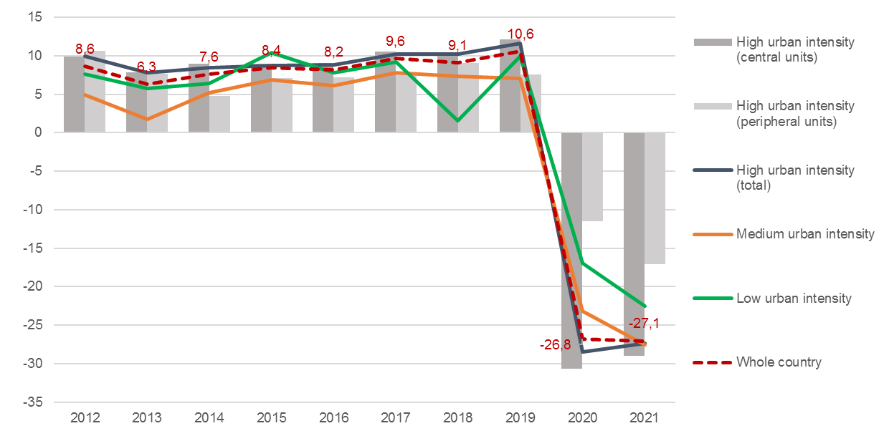
Source: Processing on MOT data
Considering the five major urban areas, the latest data show signs of recovery in Da Nang and Hai Phong (where the growth rate went slightly negative only in 2021). The urban areas of the South, instead, appear to be the furthest from a restoration of the pre-pandemic scenario, as in 2021 losses by over 30% in the area of Can Tho and over 40% in the area of Ho Chi Minh City were still recorded in terms of public transport passengers carried by road (Figure 2.31).
Figure 2.31 - Growth rate of public transport passengers by road, by major urban areas. Years 2012-2021 (estimates, percentage values)
HA NOI  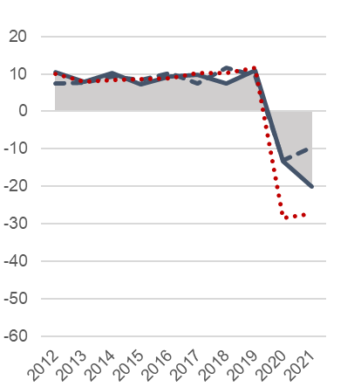 | HAI PHONG  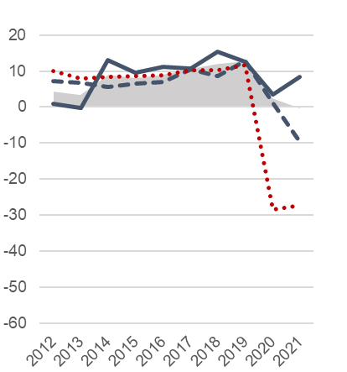 | DA NANG  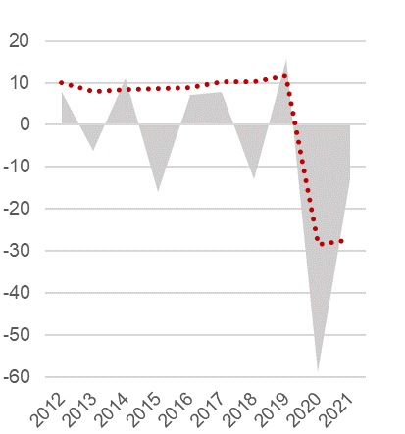
HO CHI MINH CITY  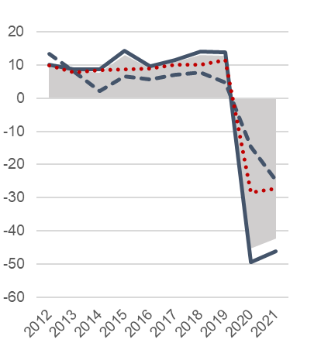 | CAN THO  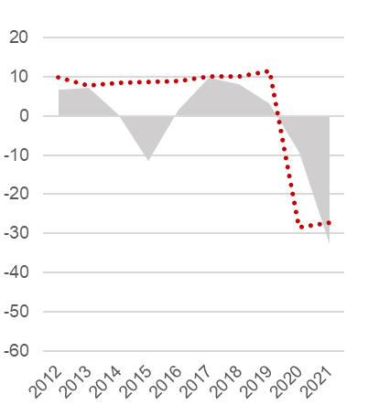
Source: Processing on MOT data

Table 2.19 - Growth rate of public transport passengers by road, by province and socio-economic region. Years 2017-2021 (percentage values)
Regions  Provinces | 2017 | 2018 | 2019 | 2020 | 2021 |  | Regions  Provinces | 2017 | 2018 | 2019 | 2020 | 2021
Red River Delta | 9.6 | 8.0 | 10.9 | -12.0 | -17.8 |  | Central
Ha Noi | 9.7 | 7.4 | 10.9 | -13.2 | -20.2 |  | Highlands | 8.8 | 11.2 | 6.1 | -22.1 | -35.3
Vinh Phuc | 3.3 | 25.2 | 4.1 | -34.2 | -34.6 |  | Kon Tum | 10.8 | 9.4 | 9.1 | -5.8 | -32.1
Bac Ninh | 11.3 | 17.5 | 11.9 | -37.3 | -42.7 |  | Gia Lai | 7.0 | 7.0 | 12.5 | 2.2 | -21.9
Quang Ninh | 11.7 | 17.3 | 15.5 | 8.1 | -16.8 |  | Dak Lak | 10.2 | 12.3 | 7.7 | -2.4 | -50.0
Hai Duong | 10.4 | 9.3 | 9.8 | -7.5 | -6.0 |  | Dak Nong | 6.7 | 8.7 | 6.3 | -21.6 | -51.7
Hai Phong | 10.7 | 15.3 | 12.7 | 3.5 | 8.4 |  | Lam Dong | 8.6 | 12.7 | 2.5 | -45.1 | -30.4
Hung Yen | 9.2 | 11.5 | 17.1 | 2.4 | -10.2
Thai Binh | 8.1 | -4.0 | 13.5 | -1.9 | -1.9 |  | South East | 10.8 | 13.1 | 12.7 | -44.6 | -42.2
Ha Nam | 10.3 | 11.2 | 5.5 | -4.5 | -8.3 |  | Binh Phuoc | 3.0 | 20.2 | 13.1 | -32.9 | -41.5
Nam Dinh | 11.4 | 8.2 | 7.9 | -8.8 | -2.1 |  | Tay Ninh | 7.2 | 8.2 | 9.9 | -3.6 | -43.1
Ninh Binh | 2.4 | 1.8 | 8.7 | 1.6 | 5.3 |  | Binh Duong | 6.7 | 6.6 | 4.6 | -25.3 | -28.3
 |  |  |  |  |  |  | Dong Nai | 7.7 | 6.1 | 5.7 | -8.9 | -29.6
Northern |  |  |  |  |  |  | Ba Ria-Vung Tau | 6.4 | 12.4 | 3.1 | -17.6 | -9.4
Midlands and |  |  |  |  |  |  | Ho Chi Minh City | 11.5 | 13.9 | 13.9 | -49.4 | -46.2
Mountains | 7.1 | 6.5 | 3.9 | -22.8 | -6.5
Ha Giang | 8.3 | 11.2 | 17.6 | -11.8 | -13.3 |  | Mekong River
Cao Bang | 5.3 | 10.0 | 4.5 | -47.8 | .. |  | Delta | 8.4 | 5.4 | 6.0 | -17.6 | -27.3
Bac Kan | .. | -2.2 | 13.6 | .. | -6.7 |  | Long An | 9.4 | 6.7 | 5.9 | -37.8 | -41.9
Tuyen Quang | 4.5 | 0.3 | 6.8 | -26.7 | 10.9 |  | Tien Giang | 10.0 | 2.9 | 2.3 | -53.3 | -35.8
Lao Cai | 10.2 | 12.3 | 15.1 | -59.5 | -2.9 |  | Ben Tre | 9.8 | 10.2 | 5.4 | -7.4 | -27.5
Yen Bai | 6.6 | 6.2 | 2.3 | -6.8 | -23.2 |  | Tra Vinh | 4.2 | 6.5 | 12.9 | -18.0 | -58.9
Thai Nguyen | 8.5 | 7.3 | 11.8 | -9.4 | 9.6 |  | Vinh Long | 6.6 | -10.5 | 0.8 | -36.3 | -35.4
Lang Son | 11.1 | 7.5 | 1.6 | -42.0 | 5.3 |  | Dong Thap | 4.2 | 8.5 | 12.3 | -6.6 | -23.9
Bac Giang | 6.1 | 7.8 | 14.5 | -33.3 | -17.2 |  | An Giang | 8.1 | 11.2 | 11.2 | -23.5 | -21.9
Phu Tho | 1.4 | -4.2 | 10.1 | 3.9 | -5.1 |  | Kien Giang | 9.8 | 4.6 | 5.1 | -3.3 | -36.9
Dien Bien | 8.3 | 20.0 | 2.6 | -18.8 | -23.1 |  | Can Tho | 9.8 | 8.0 | 3.2 | -9.3 | -32.7
Lai Chau | 8.3 | 10.0 | 18.9 | -17.6 | -21.4 |  | Hau Giang | 4.9 | -1.9 | 0.6 | -21.3 | -26.6
Son La | 16.7 | 15.1 | 9.2 | -27.3 | -18.8 |  | Soc Trang | 10.2 | 4.9 | 8.2 | -10.5 | -39.3
Hoa Binh | 6.1 | 6.2 | -98.2 | …. | -3.2 |  | Bac Lieu | 10.1 | 7.6 | 7.6 | -4.3 | -1.0
 |  |  |  |  |  |  | Ca Mau | 8.5 | 10.0 | 11.1 | -0.6 | -19.6
North-central
and Central
Coast | 8.6 | 3.8 | 11.9 | -28.4 | -25.6
Thanh Hoa | 9.0 | -4.9 | 16.4 | -26.9 | -36.7
Nghe An | 11.6 | -15.7 | 19.3 | 4.8 | -20.6
Ha Tinh | 5.1 | 21.6 | 5.5 | -16.3 | -42.8
Quang Binh | 8.8 | 10.0 | 10.1 | 0.7 | 1.3
Quang Tri | 3.1 | 11.8 | 8.1 | -13.6 | -8.6
Thua Thien-Hue | 6.0 | 10.5 | 10.0 | -24.9 | -5.1
Da Nang | 7.7 | -12.9 | 15.6 | -58.9 | -12.9
Quang Nam | 7.0 | -21.7 | 11.1 | -53.3 | -42.0
Quang Ngai | 10.8 | 37.1 | 6.8 | -35.0 | -35.9
Binh Dinh | 5.4 | 16.2 | 12.6 | -33.8 | -29.4
Phu Yen | 8.4 | 0.4 | 3.5 | -19.9 | -45.0
Khanh Hoa | 10.8 | 18.7 | 9.0 | -67.4 | -35.1
Ninh Thuan | 7.9 | 5.6 | 10.0 | -29.1 | -39.3
Binh Thuan | 9.7 | 29.5 | 9.0 | -15.9 | -30.3
High-urban intensity areas (central units)
High-urban intensity areas (peripheral units)
Source: Processing on MOT data.

VSDG Target 11.2: By 2030, ensure access for all citizens to safe, affordable, convenient and sustainable transport systems; improve traffic safety, notably by expanding public transport with special attention paid to the needs of women, children, persons with disabilities and elderly people

11.2.1: Growth rate of the number of passengers using public transport

11.2.1b: Demand for road public transport
Global SDGs |  | Target 11.2: By 2030, provide access to safe, affordable, accessible and sustainable transport systems for all, improving road safety, notably by expanding public transport, with special attention to the needs of those in vulnerable situations, women, children, persons with disabilities and older persons  Indicator 11.2.1: Proportion of population that has convenient access to public transport, by sex, age and persons with disabilities
Metadata card
Definition |  |  | Ratio of the number of public transport passengers carried by road in one year to the resident population.
Glossary |  |  | Passengers carried by road: total passengers travelling by road, carried by transportation establishments and other business activities operating a public transportation service (both of public and private ownership), regardless of travel distance. The number does not include the passengers of personal vehicles.
Unit of measure |  |  | Passengers per capita
Breakdown |  |  | 63 Provinces
Data source |  |  | National statistical reporting system, Ministry of Infrastructure and Transport (MOIT)
Time series |  |  | 2012-2021
Frequency of updates |  |  | 1 year
Main data
Table 2.20 - Demand for road public transport (*), by major urban areas and by urban intensity degree. Years 2012-2021 (estimates, passengers per capita)
TERRITORY | 2012 | 2013 | 2014 | 2015 | 2016 | 2017 | 2018 | 2019 | 2020 | 2021
WHOLE COUTRY | 28.1 | 29.6 | 31.5 | 33.8 | 36.1 | 39.2 | 42.3 | 45.9 | 33.2 | 24.0
Ha Noi urban area | 53.2 | 56.8 | 61.7 | 65.3 | 70.5 | 76.2 | 81.1 | 84.5 | 72.1 | 57.4
Central unit | 104.8 | 111.3 | 120.6 | 127.1 | 136.8 | 148.3 | 157.0 | 161.8 | 137.8 | 108.9
Peripheral units | 8.2 | 8.7 | 9.5 | 10.1 | 11.0 | 11.7 | 12.9 | 13.5 | 11.5 | 10.3
Hai Phong urban area | 10.0 | 10.3 | 11.1 | 11.9 | 12.9 | 14.2 | 15.8 | 17.7 | 18.0 | 17.7
Central unit | 16.5 | 16.3 | 18.2 | 19.8 | 21.8 | 23.9 | 27.3 | 30.5 | 31.3 | 33.6
Peripheral units | 7.4 | 7.8 | 8.3 | 8.8 | 9.3 | 10.3 | 11.1 | 12.4 | 12.5 | 11.1
Da Nang urban area | 28.7 | 26.3 | 28.7 | 23.6 | 24.9 | 26.3 | 22.6 | 24.7 | 9.9 | 8.4
Ho Chi Minh City urban area | 60.1 | 63.8 | 67.1 | 74.1 | 79.2 | 86.0 | 95.2 | 101.9 | 54.5 | 31.6
Central unit | 86.4 | 92.1 | 98.0 | 109.6 | 117.9 | 129.1 | 144.5 | 156.6 | 77.7 | 42.1
Peripheral units | 23.3 | 24.4 | 24.3 | 25.3 | 26.1 | 27.3 | 28.7 | 28.4 | 23.6 | 17.7
Can Tho urban area | 73.0 | 77.6 | 77.3 | 67.9 | 68.4 | 74.2 | 79.6 | 85.3 | 77.1 | 51.6
High urban intensity (total) | 47.8 | 50.8 | 54.2 | 58.0 | 62.3 | 67.7 | 73.5 | 78.3 | 55.0 | 39.7
High urban intensity (central units) | 82.2 | 87.1 | 93.3 | 99.9 | 107.3 | 116.9 | 127.1 | 135.6 | 92.3 | 65.3
High urban intensity (peripheral units) | 12.5 | 13.3 | 13.8 | 14.5 | 15.4 | 16.3 | 17.6 | 18.1 | 15.8 | 12.9
Medium urban intensity | 17.5 | 17.8 | 18.6 | 19.8 | 20.9 | 22.4 | 23.9 | 25.8 | 19.7 | 14.2
Low urban intensity | 8.5 | 8.8 | 9.3 | 10.2 | 10.8 | 11.7 | 11.7 | 12.8 | 10.5 | 8.0
URBAN-RURAL DIVIDE (**) | 565 | 574 | 583 | 571 | 576 | 580 | 627 | 614 | 524 | 495
CENTRE-PERIPHERY DIVIDE WITHIN HIGH-URBAN INTENSITY AREAS (***) | 656 | 654 | 678 | 687 | 697 | 715 | 723 | 748 | 585 | 505
(*) For this statistical measure there is no target set.
(**) Passengers in high-urban intensity areas per 100 passengers in low-urban intensity areas.
(***) Passengers in central units of high-urban intensity areas per 100 passengers in peripheral units of same areas.
Source: Processing on MOIT data
The demand for public transport by road was constantly growing before the onset of the Covid-19 pandemic, having arisen from 28.1 passengers per capita in 2012 up to 45.9 in 2019 nationwide. Then, it underwent a sharp reduction for two years in a row, landing to 24 passengers per capita in 2021. Spatial distribution is concentrated in the high-urban intensity areas (78.3 passengers per capita in 2019, nearly two times the national average), with a wide imbalance between central and peripheral units. The latter appear to be poorly served, as the demand does not differ significantly from the medium- and low-urban intensity areas, much less densely populated. In 2021, the demand for road transport in the whole of high-urban intensity areas was about five times that of rural areas, and an equal gap can be observed within the major urban areas, between central and peripheral units. The reduction of these gaps in 2020-2021 shall not be considered positive, as it just reflects the greater losses in the demand of public transport experienced by the high urban intensity areas compared to the rural areas, and by the central units of the major urban areas compared to the peripheral ones. (Figures 2.32 and 2.33).
Figure 2.32 - Demand for road public transport, by urban intensity degree. Years 2012-2021 (estimates, passengers per capita)
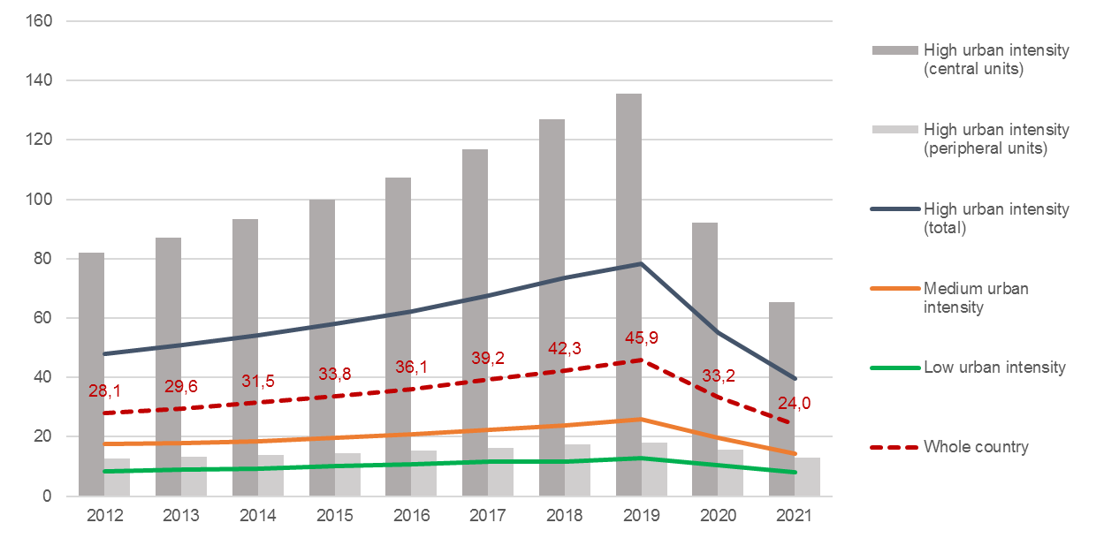
Source: Processing on MOT data
Figure 2.33 - Demand for road public transport: urban-rural divide and centre-periphery divide within the high-urban intensity areas. Years 2012-2021 (estimates, passengers in high-urban intensity areas per 100 passengers in low-urban intensity areas; passengers in central units of high-urban intensity areas per 100 passengers in peripheral units of same areas)
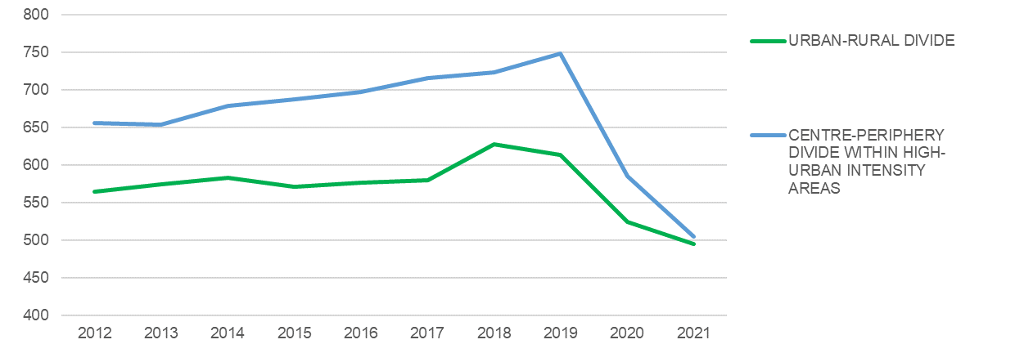
Source: Processing on MOT data
Before 2020, the demand for public transport was most high and steadily increasing in the two largest urban areas of Ha Noi and Ho Chi Minh City. The impact of the pandemic on public transport was most felt in Ho Chi Minh City and, to a lesser extent, in Can Tho, where in 2021 the demand dropped far below the levels of 2012; while in Ha Noi it came back to the level of ten years before. In the other major urban areas, the demand for public transport is much lower: apparently, the pandemic impact did not affect the public transport in Hai Phong, and accelerated a declining trend in Da Nang (Figure 2.34).
Figure 2.34 - Demand for road public transport, by major urban areas. Years 2012-2021 (estimates, passengers per capita)
HA NOI  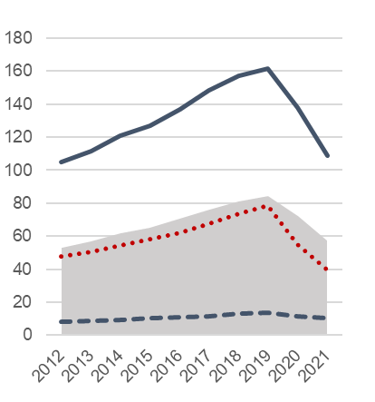 | HAI PHONG  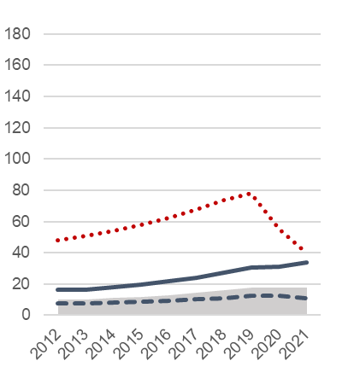 | DA NANG  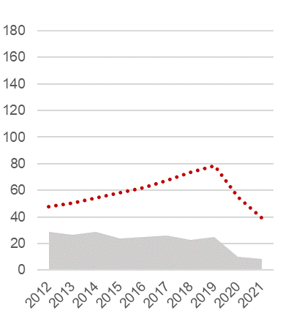
HO CHI MINH CITY  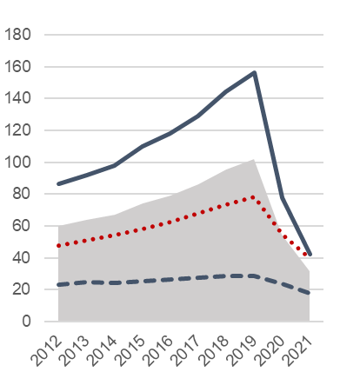 | CAN THO  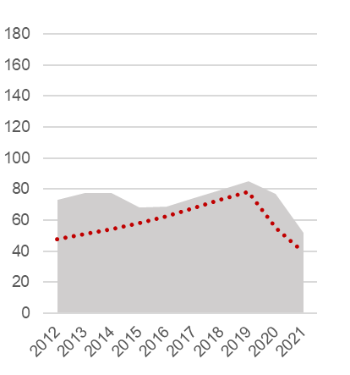
Source: Processing on MOT data

Table 2.21 - Demand for road public transport, by province and socio-economic region. Years 2017-2021 (passengers per capita)
Regions  Provinces | 2017 | 2018 | 2019 | 2020 | 2021 |  | Regions  Provinces | 2017 | 2018 | 2019 | 2020 | 2021
Red River Delta | 60.2 | 64.3 | 68.0 | 59.0 | 47.9 |  | Central
Ha Noi | 148.3 | 157.0 | 161.8 | 137.8 | 108.9 |  | Highlands | 15.0 | 16.4 | 17.4 | 13.4 | 8.5
Vinh Phuc | 14.4 | 17.8 | 17.5 | 11.4 | 7.3 |  | Kon Tum | 13.8 | 14.7 | 15.8 | 14.6 | 9.7
Bac Ninh | 8.9 | 10.2 | 10.3 | 6.3 | 3.5 |  | Gia Lai | 10.6 | 11.1 | 12.0 | 12.1 | 9.3
Quang Ninh | 17.7 | 20.4 | 22.5 | 24.1 | 19.8 |  | Dak Lak | 10.8 | 12.0 | 13.2 | 12.8 | 6.3
Hai Duong | 14.2 | 15.4 | 16.1 | 14.8 | 13.7 |  | Dak Nong | 5.1 | 5.4 | 5.9 | 4.5 | 2.1
Hai Phong | 23.9 | 27.3 | 30.5 | 31.3 | 33.6 |  | Lam Dong | 31.2 | 34.8 | 36.0 | 19.6 | 13.5
Hung Yen | 8.1 | 8.9 | 9.9 | 10.0 | 8.9
Thai Binh | 8.1 | 7.8 | 8.5 | 8.3 | 8.2 |  | South East | 76.9 | 85.2 | 91.5 | 49.5 | 28.7
Ha Nam | 9.3 | 10.3 | 10.3 | 9.7 | 8.8 |  | Binh Phuoc | 10.6 | 12.6 | 14.0 | 9.3 | 5.4
Nam Dinh | 7.4 | 8.0 | 9.0 | 8.2 | 7.8 |  | Tay Ninh | 14.6 | 15.7 | 16.6 | 16.0 | 9.1
Ninh Binh | 17.6 | 17.7 | 19.0 | 19.1 | 19.8 |  | Binh Duong | 17.6 | 18.0 | 16.6 | 11.8 | 8.4
 |  |  |  |  |  |  | Dong Nai | 30.6 | 31.9 | 33.4 | 29.8 | 21.0
Northern |  |  |  |  |  |  | Ba Ria-Vung Tau | 36.4 | 40.5 | 40.4 | 32.8 | 29.5
Midlands and |  |  |  |  |  |  | Ho Chi Minh City | 129.1 | 144.5 | 156.6 | 77.7 | 42.1
Mountains | 7.7 | 8.1 | 8.2 | 6.3 | 5.8
Ha Giang | 3.1 | 3.4 | 4.0 | 3.4 | 2.9 |  | Mekong River
Cao Bang | 3.7 | 4.1 | 4.3 | 2.3 | 2.2 |  | Delta | 76.9 | 85.2 | 91.5 | 49.5 | 28.7
Bac Kan | 8.4 | 8.1 | 9.5 | 9.5 | 8.6 |  | Long An | 10.6 | 12.6 | 14.0 | 9.3 | 5.4
Tuyen Quang | 9.0 | 9.0 | 9.5 | 6.9 | 7.6 |  | Tien Giang | 14.6 | 15.7 | 16.6 | 16.0 | 9.1
Lao Cai | 9.4 | 10.3 | 11.5 | 4.6 | 4.3 |  | Ben Tre | 17.6 | 18.0 | 16.6 | 11.8 | 8.4
Yen Bai | 10.0 | 10.5 | 10.7 | 9.9 | 7.5 |  | Tra Vinh | 30.6 | 31.9 | 33.4 | 29.8 | 21.0
Thai Nguyen | 9.2 | 9.7 | 10.7 | 9.6 | 10.4 |  | Vinh Long | 36.4 | 40.5 | 40.4 | 32.8 | 29.5
Lang Son | 15.4 | 16.3 | 16.7 | 9.6 | 10.0 |  | Dong Thap | 129.1 | 144.5 | 156.6 | 77.7 | 42.1
Bac Giang | 13.5 | 14.4 | 15.4 | 10.1 | 8.2 |  | An Giang | 76.9 | 85.2 | 91.5 | 49.5 | 28.7
Phu Tho | 5.2 | 4.9 | 5.2 | 5.3 | 5.0 |  | Kien Giang | 10.6 | 12.6 | 14.0 | 9.3 | 5.4
Dien Bien | 2.3 | 2.7 | 2.7 | 2.1 | 1.6 |  | Can Tho | 14.6 | 15.7 | 16.6 | 16.0 | 9.1
Lai Chau | 2.9 | 3.1 | 3.7 | 3.0 | 2.3 |  | Hau Giang | 17.6 | 18.0 | 16.6 | 11.8 | 8.4
Son La | 2.8 | 3.2 | 3.5 | 2.5 | 2.0 |  | Soc Trang | 30.6 | 31.9 | 33.4 | 29.8 | 21.0
Hoa Binh | 6.2 | 6.5 | 0.1 | 3.6 | 3.4 |  | Bac Lieu | 36.4 | 40.5 | 40.4 | 32.8 | 29.5
 |  |  |  |  |  |  | Ca Mau | 129.1 | 144.5 | 156.6 | 77.7 | 42.1
North-central
and Central
Coast | 15.5 | 15.9 | 17.7 | 12.6 | 9.3
Thanh Hoa | 5.8 | 5.5 | 6.2 | 4.5 | 2.8
Nghe An | 21.2 | 17.7 | 20.0 | 20.8 | 16.3
Ha Tinh | 14.7 | 17.8 | 18.6 | 15.5 | 8.8
Quang Binh | 13.9 | 15.2 | 16.6 | 16.6 | 16.7
Quang Tri | 10.7 | 11.9 | 12.8 | 11.0 | 9.9
Thua Thien-Hue | 16.9 | 18.5 | 21.0 | 15.7 | 14.6
Da Nang | 26.3 | 22.6 | 24.7 | 9.9 | 8.4
Quang Nam | 8.2 | 6.4 | 7.1 | 3.3 | 1.9
Quang Ngai | 3.2 | 4.4 | 4.9 | 3.2 | 2.0
Binh Dinh | 21.6 | 25.0 | 29.0 | 19.2 | 13.4
Phu Yen | 17.1 | 17.1 | 18.4 | 14.8 | 8.1
Khanh Hoa | 37.0 | 43.5 | 47.5 | 15.4 | 9.9
Ninh Thuan | 11.2 | 11.7 | 13.4 | 9.4 | 5.7
Binh Thuan | 15.6 | 20.1 | 22.0 | 18.4 | 12.8
High-urban intensity areas (central units)
High-urban intensity areas (peripheral units)
Source: Processing on MOT data.
VSDG Target 11.3: By 2030, enhance national capacity for inclusive, sustainable urban planning and development with the participation of communities

11.3.1: Land consumption (proposed for inclusion in the VSDG framework)

11.3.1a: Ratio of land consumption rate to population growth rate
Global SDGs |  | Target 11.3: By 2030, enhance inclusive and sustainable urbanization and capacity for participatory, integrated and sustainable human settlement planning and management in all countries  Indicator 11.3.1: Ratio of land consumption rate to population growth rate
Metadata card
Definition |  |  | Ratio of the land consumption rate to the population growth rate, in a given year.
 |  |  | $$R=\frac{{\left(H+S\right)}_{t}/{(H+S)}_{t-1}}{P_{t}/P_{t-1}}$$ | where H and S are the areas covered respectively by Homestead land and Specially used land, according to the national land use statistics (see below); P is the population and t is the reference year.
Glossary |  |  | Land consumption is the taking of land due to human activities other than agriculture and forestry in a given year, over a given territory. With reference to the categories adopted by national land use statistics, a proxy of land consumption is provided by the sum of homestead land and specially used land.  Population growth expresses the change of population size in a given year, over a given territory. Population change is determined by the sum of two differences: births less deaths plus in-migration less out-migration.  Homestead land is the land used for housing and other work constructions for living activities, both in urban and rural areas.  Specially used land is the land used by government offices; public service facilities; security and national defense land; land for non-agricultural production and business and public land.
Unit of measure |  |  | Index
Breakdown |  |  | 63 Provinces
Data source |  |  | National statistical reporting system, Ministry of Natural Resources and Environment (MONRE)
Time series |  |  | 2016-2020
Frequency of updates |  |  | 1 year
Main data
Table 2.22 - Ratio of land consumption rate to population growth rate (*), by major urban areas and by urban intensity degree. Years 2016-2020 (estimates, index numbers: population growth=1)
TERRITORY | 2016 | 2017 | 2018 | 2019 | 2020
WHOLE COUTRY | 1.000 | 0.999 | 0.999 | 1.031 | 0.995
Ha Noi urban area | 0.995 | 0.998 | 0.993 | 0.982 | 0.992
Central unit | 0.990 | 0.999 | 0.991 | 0.948 | 0.984
Peripheral units | 0.997 | 0.997 | 0.994 | 1.004 | 0.997
Hai Phong urban area | 1.005 | 1.006 | 1.007 | 1.055 | 1.003
Central unit | 1.015 | 1.001 | 1.006 | 1.087 | 0.996
Peripheral units | 1.003 | 1.007 | 1.008 | 1.044 | 1.006
Da Nang urban area | 0.985 | 0.993 | 0.983 | 0.956 | 0.976
Ho Chi Minh City urban area | 1.008 | 0.987 | 0.989 | 1.016 | 0.978
Central unit | 0.990 | 0.994 | 0.995 | 0.965 | 0.980
Peripheral units | 1.015 | 0.982 | 0.984 | 1.034 | 0.973
Can Tho urban area | 0.997 | 0.983 | 0.998 | 1.066 | 0.999
High urban intensity (total) | 0.999 | 0.995 | 0.994 | 1.006 | 0.989
High urban intensity (central units) | 0.993 | 0.995 | 0.992 | 0.979 | 0.984
High urban intensity (peripheral units) | 1.004 | 0.995 | 0.994 | 1.023 | 0.991
Medium urban intensity | 1.002 | 1.002 | 1.005 | 1.059 | 1.003
Low urban intensity | 0.999 | 1.001 | 0.999 | 1.038 | 0.995
(*) For this statistical measure there is no target set, neither is relevant the monitoring of urban-rural divide.
Source: Processing on MONRE data
From 2016 to 2020, the ratio of the land consumption rate to the population growth rate has been homogeneous all over the country, and constantly close to 1 (except in 2019, when above-average values were recorded in medium- and low-urban intensity areas). Therefore, in the observed period, the land consumption progress was substantially proportional to population growth.
Higher values would indicate unsustainability of the urbanization process. However, the current balance is not a proof of sustainability in itself: it rather indicates how urbanization is still fundamentally powered by population dynamics, as it normally occurs in a phase of economic growth and raising of living standards. In the coming years, monitoring the ratio of the land consumption to the population growth will tell whether the slight imbalance recorded in 2019 was just an occasional fluctuation, or the beginning of a new phase, suddenly interrupted in 2020 and potentially set to resume after the pandemic (Figure 2.35).
Figure 2.35 - Ratio of land consumption rate to population growth rate, by urban intensity degree. Years 2016-2020 (estimates, index numbers: population growth=1)
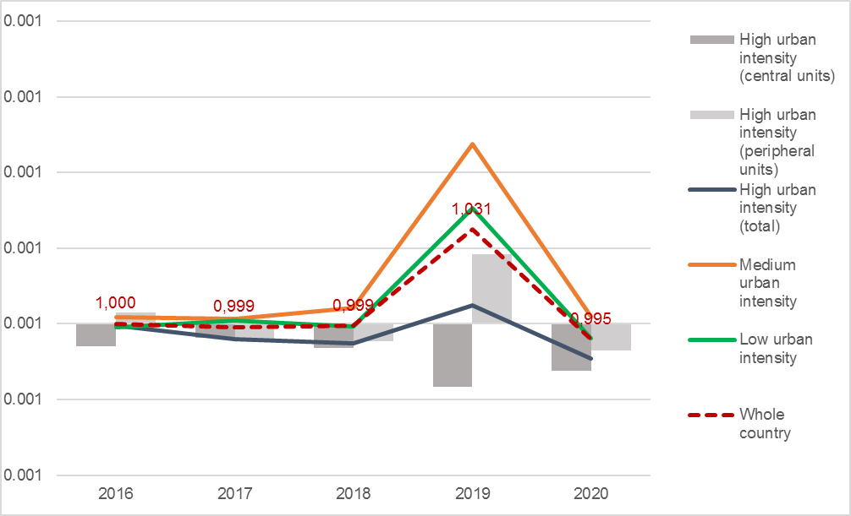
Source: Processing on MONRE data
The differences among the five major urban areas appear not very significant, as in the observed period most of the values lie within a narrow range around the balance point (0.95-1.05). Values above 1.05 were recorded only in 2019, in the urban areas of Hai Phong (central) and Can Tho (Figure 2.36).
Figure 2.36 - Ratio of land consumption rate to population growth rate, by major urban areas. Years 2016-2020 (estimates, index numbers: population growth=1)
HA NOI  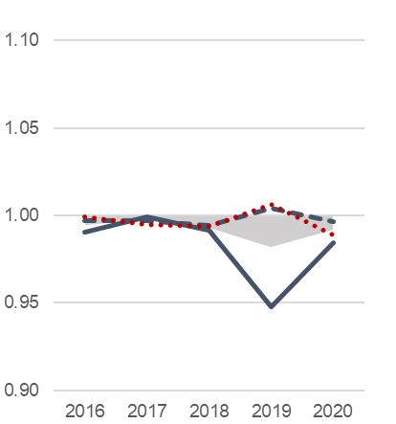 | HAI PHONG  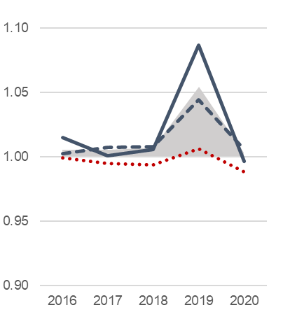 | DA NANG  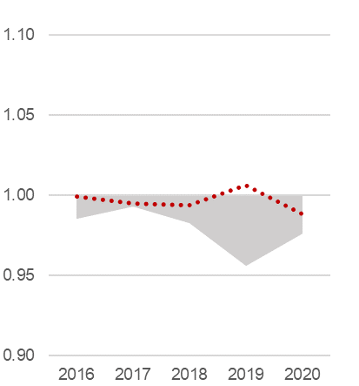
HO CHI MINH CITY  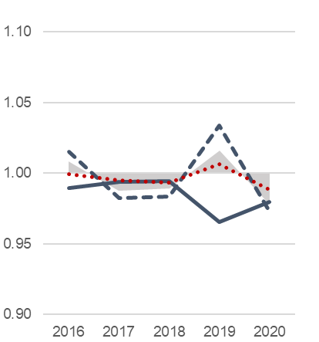 | CAN THO  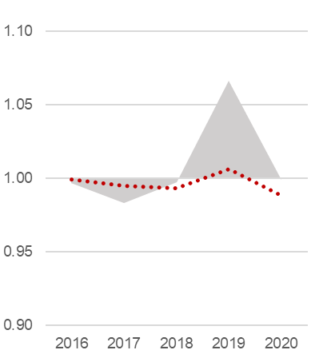
Source: Processing on MONRE data

Table 2.23 - Ratio of land consumption rate to population growth rate, by province and socio-economic region. Years 2016-2020 (index numbers: population growth=1)
Regions  Provinces | 2016 | 2017 | 2018 | 2019 | 2020 |  | Regions  Provinces | 2016 | 2017 | 2018 | 2019 | 2020
Red River Delta | 0.999 | 1.001 | 1.000 | 0.997 | 0.995 |  | Central
Ha Noi | 0.990 | 0.999 | 0.991 | 0.948 | 0.984 |  | Highlands | 0.987 | 0.998 | 0.991 | 1.078 | 0.992
Vinh Phuc | 0.993 | 1.011 | 0.988 | 1.007 | 0.989 |  | Kon Tum | 0.981 | 1.021 | 0.981 | 1.071 | 0.986
Bac Ninh | 0.987 | 0.984 | 0.999 | 0.932 | 0.996 |  | Gia Lai | 0.983 | 0.997 | 0.984 | 1.060 | 0.990
Quang Ninh | 0.997 | 1.009 | 0.995 | 1.077 | 1.008 |  | Dak Lak | 0.993 | 0.994 | 1.000 | 1.077 | 0.996
Hai Duong | 0.998 | 0.996 | 1.001 | 0.981 | 0.994 |  | Dak Nong | 0.974 | 0.977 | 0.975 | 1.089 | 0.986
Hai Phong | 1.015 | 1.001 | 1.006 | 1.087 | 0.996 |  | Lam Dong | 0.991 | 0.989 | 0.999 | 1.083 | 0.995
Hung Yen | 0.999 | 0.999 | 1.004 | 0.989 | 0.994
Thai Binh | 1.004 | 1.008 | 1.006 | 0.975 | 1.000 |  | South East | 1.004 | 0.989 | 0.990 | 1.021 | 0.982
Ha Nam | 1.019 | 1.013 | 1.009 | 0.992 | 1.010 |  | Binh Phuoc | 0.986 | 0.993 | 0.991 | 1.042 | 1.002
Nam Dinh | 1.004 | 0.997 | 1.019 | 1.052 | 1.005 |  | Tay Ninh | 1.015 | 1.002 | 1.014 | 1.067 | 0.997
Ninh Binh | 1.009 | 0.995 | 0.996 | 1.024 | 0.993 |  | Binh Duong | 1.081 | 0.969 | 0.972 | 0.993 | 0.956
 |  |  |  |  |  |  | Dong Nai | 0.986 | 0.986 | 0.987 | 1.045 | 0.980
Northern |  |  |  |  |  |  | Ba Ria-Vung Tau | 0.987 | 0.996 | 0.997 | 1.072 | 0.991
Midlands and |  |  |  |  |  |  | Ho Chi Minh City | 0.990 | 0.994 | 0.995 | 0.965 | 0.980
Mountains | 0.996 | 0.996 | 0.993 | 1.026 | 0.994
Ha Giang | 0.991 | 0.994 | 0.978 | 1.241 | 0.989 |  | Mekong River
Cao Bang | 0.995 | 0.990 | 0.986 | 1.091 | 0.997 |  | Delta | 0.999 | 0.998 | 1.006 | 1.071 | 1.003
Bac Kan | 0.989 | 0.987 | 1.007 | 1.084 | 1.000 |  | Long An | 1.002 | 1.002 | 1.011 | 0.893 | 0.996
Tuyen Quang | 0.995 | 1.000 | 0.994 | 1.021 | 0.997 |  | Tien Giang | 0.998 | 1.014 | 0.994 | 1.056 | 1.002
Lao Cai | 1.003 | 1.019 | 0.992 | 1.067 | 0.987 |  | Ben Tre | 1.004 | 1.004 | 1.004 | 1.051 | 1.001
Yen Bai | 1.009 | 1.000 | 1.025 | 1.060 | 0.994 |  | Tra Vinh | 0.994 | 0.995 | 1.007 | 1.133 | 1.003
Thai Nguyen | 0.981 | 0.989 | 0.970 | 1.118 | 1.005 |  | Vinh Long | 1.003 | 0.998 | 1.011 | 1.077 | 1.031
Lang Son | 0.999 | 0.996 | 1.001 | 1.035 | 0.996 |  | Dong Thap | 0.996 | 1.001 | 1.001 | 1.071 | 1.001
Bac Giang | 0.996 | 0.996 | 0.997 | 0.990 | 0.991 |  | An Giang | 0.999 | 0.999 | 1.001 | 1.174 | 1.004
Phu Tho | 0.994 | 0.997 | 0.995 | 1.007 | 0.996 |  | Kien Giang | 0.993 | 0.989 | 0.995 | 1.142 | 0.997
Dien Bien | 1.017 | 1.003 | 1.028 | 0.944 | 1.004 |  | Can Tho | 0.997 | 0.983 | 0.998 | 1.066 | 0.999
Lai Chau | 0.986 | 0.988 | 0.999 | 0.689 | 0.982 |  | Hau Giang | 1.004 | 1.004 | 0.997 | 1.149 | 1.005
Son La | 0.997 | 0.997 | 0.979 | 0.996 | 0.990 |  | Soc Trang | 0.999 | 1.010 | 1.003 | 1.129 | 1.007
Hoa Binh | 0.998 | 0.995 | 0.991 | 1.043 | 0.995 |  | Bac Lieu | 0.995 | 0.985 | 1.086 | 1.299 | 0.995
 |  |  |  |  |  |  | Ca Mau | 1.000 | 0.981 | 1.004 | 0.875 | 1.006
North-central
and Central
Coast | 1.007 | 1.006 | 1.007 | 1.035 | 1.001
Thanh Hoa | 1.016 | 1.008 | 1.009 | 1.003 | 0.993
Nghe An | 1.016 | 1.013 | 1.024 | 0.967 | 0.996
Ha Tinh | 1.003 | 1.003 | 1.005 | 0.982 | 1.012
Quang Binh | 1.025 | 1.000 | 1.005 | 1.008 | 1.011
Quang Tri | 0.994 | 1.007 | 1.013 | 1.072 | 1.006
Thua Thien-Hue | 0.999 | 1.001 | 0.999 | 1.099 | 1.005
Da Nang | 0.985 | 0.993 | 0.983 | 0.956 | 0.976
Quang Nam | 1.003 | 1.001 | 0.998 | 1.035 | 0.996
Quang Ngai | 1.008 | 1.015 | 1.000 | 1.110 | 1.004
Binh Dinh | 1.006 | 1.011 | 1.001 | 1.085 | 1.006
Phu Yen | 1.005 | 0.992 | 1.008 | 1.099 | 0.999
Khanh Hoa | 1.005 | 1.014 | 0.994 | 1.081 | 1.004
Ninh Thuan | 0.999 | 1.031 | 1.039 | 1.072 | 1.074
Binh Thuan | 1.002 | 0.995 | 1.013 | 1.148 | 0.996
High-urban intensity areas (central units)
High-urban intensity areas (peripheral units)
Source: Processing on MONRE data.

VSDG Target 11.3: By 2030, enhance national capacity for inclusive, sustainable urban planning and development with the participation of communities

11.3.1: Land consumption (proposed for inclusion in the VSDG framework)

11.3.1b: Land consumption as a proportion of total land area
Global SDGs |  | Target 11.3: By 2030, enhance inclusive and sustainable urbanization and capacity for participatory, integrated and sustainable human settlement planning and management in all countries  Indicator 11.3.1: Ratio of land consumption rate to population growth rate
UNSD-CC |  | Topic: Land and agriculture  Indicator 26: Growth in built-up area
Metadata card
Definition |  |  | Ratio of the area affected by land consumption to the total land area, at a given year.
Glossary |  |  | Land consumption is the taking of land due to human activities other than agriculture and forestry in a given year, over a given territory. With reference to the categories adopted by national land use statistics, a proxy of land consumption is provided by the sum of homestead land and specially used land.  Homestead land is the land used for housing and other work constructions for living activities, both in urban and rural areas.  Specially used land is the land used by government offices; public service facilities; security and national defense land; land for non-agricultural production and business and public land.
Unit of measure |  |  | %
Breakdown |  |  | 63 Provinces
Data source |  |  | National statistical reporting system, Ministry of Natural Resources and Environment (MONRE)
Time series |  |  | 2015-2020
Frequency of updates |  |  | 1 year
Main data
Table 2.24 - Land consumption as a proportion of total land area (*), by major urban areas and by urban intensity degree. Years 2015-2020 (estimates, percentage values)
TERRITORY | 2015 | 2016 | 2017 | 2018 | 2019 | 2020
WHOLE COUTRY | 7.66 | 7.74 | 7.82 | 7.89 | 8.29 | 8.35
Ha Noi urban area | 22.80 | 22.99 | 23.25 | 23.36 | 24.38 | 24.54
Central unit | 30.63 | 30.81 | 31.16 | 31.30 | 31.93 | 32.03
Peripheral units | 20.28 | 20.48 | 20.69 | 20.80 | 21.95 | 22.14
Hai Phong urban area | 16.11 | 16.27 | 16.45 | 16.67 | 17.78 | 17.94
Central unit | 26.82 | 27.46 | 27.74 | 28.10 | 31.56 | 31.76
Peripheral units | 14.33 | 14.42 | 14.58 | 14.77 | 15.56 | 15.71
Da Nang urban area | 39.30 | 39.38 | 39.74 | 39.69 | 40.06 | 40.07
Ho Chi Minh City urban area | 16.82 | 17.29 | 17.43 | 17.61 | 18.79 | 18.83
Central unit | 29.79 | 30.03 | 30.36 | 30.75 | 30.70 | 30.71
Peripheral units | 14.28 | 14.80 | 14.90 | 15.04 | 16.43 | 16.47
Can Tho urban area | 13.97 | 14.04 | 13.97 | 14.04 | 14.41 | 14.45
High urban intensity (total) | 19.30 | 19.56 | 19.75 | 19.91 | 20.96 | 21.07
High urban intensity (central units) | 28.52 | 28.76 | 29.03 | 29.22 | 30.08 | 30.16
High urban intensity (peripheral units) | 16.36 | 16.63 | 16.79 | 16.93 | 18.05 | 18.18
Medium urban intensity | 9.01 | 9.08 | 9.14 | 9.24 | 9.69 | 9.76
Low urban intensity | 4.22 | 4.27 | 4.33 | 4.38 | 4.58 | 4.61
(*) For this statistical measure there is no target set, neither is relevant the monitoring of urban-rural divide.
Source: Processing on MONRE data
The percentage of total land area occupied by urbanization is a basic measure of land consumption, although not an indicator of sustainability in itself. In five years (2015-2020), the sum of the land covered by urban and rural settlements (homestead land) plus the specially used land grew up from 7.66% to 8.35% of the national territory, equal to an average consumption of 124.5 hectares per day all over the country. In 2020, land consumption reached 21.07% of territory in high-urban intensity areas (and over 30% in the central units), 9.76% in medium-intensity areas and 4.61% in low-intensity areas (Figure 2.37).
Figure 2.37 - Land consumption as a proportion of total land area, by urban intensity degree. Years 2015-2020 (estimates, percentage values)
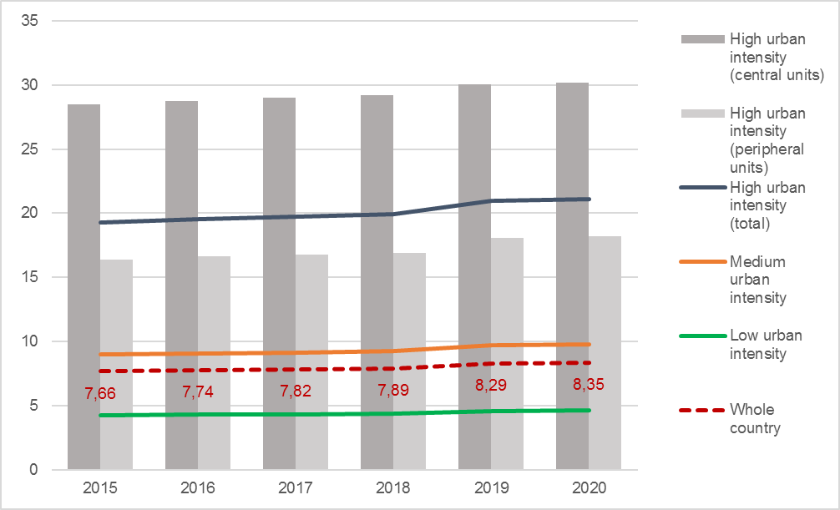
Source: Processing on MONRE data
Over the observed period (i.e. from the end of 2015 to the end of 2020), the speed of land consumption varied significantly: after keeping rather stable from 2016 to 2018 around an average of 70 hectares per day, it had an intense acceleration in 2019 (365 ha/day), followed by a sharp slowdown in 2020 (below 50 ha/day), probably due to the economic impact of the pandemic (Table 2.25).
Table 2.25 - Average land consumption (*) by urban intensity degree. Years 2016-2020 (hectares per day)
 | 2016 | 2017 | 2018 | 2019 | 2020
WHOLE COUTRY | 74.1 | 66.6 | 70.4 | 365.0 | 46.5
High-urban intensity areas | 29.0 | 20.3 | 17.5 | 117.2 | 13.9
Central units | 6.3 | 7.4 | 5.2 | 22.8 | 2.0
Peripheral units | 22.7 | 12.9 | 12.3 | 94.4 | 11.9
Medium-urban intensity areas | 20.8 | 18.9 | 29.3 | 144.2 | 21.0
Low-urban intensity areas | 24.4 | 27.4 | 23.5 | 103.9 | 11.6
(*) Annual net increase of Homestead land+Specially used land. As data refer to December 31st of each year, the increase of 2016 is calculated on the difference between 2016 and 2015 data.
Source: Processing on MONRE data.
Among the major urban areas, the highest land consumption as a proportion of total land area is found in Da Nang (40.07% in 2020), followed by the central units of Ha Noi, Hai Phong and Ho Chi Minh City, all with shares slightly above 30% (Figure 2.38).
Figure 2.38 - Land consumption as a proportion of total land area, by major urban areas. Years 2015-2020 (estimates, percentage values)
HA NOI  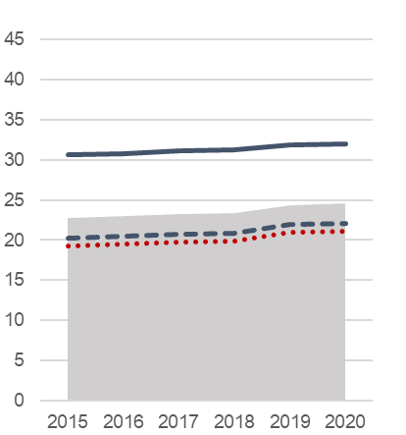 | HAI PHONG  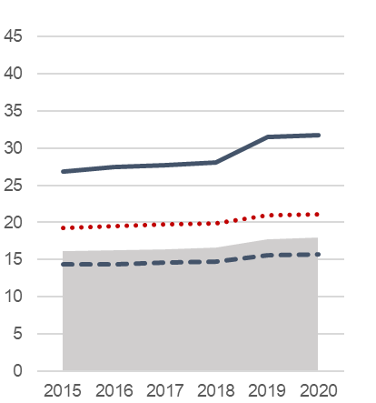 | DA NANG  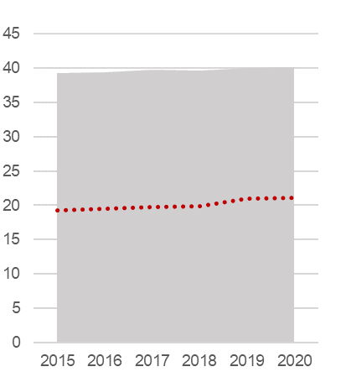
HO CHI MINH CITY  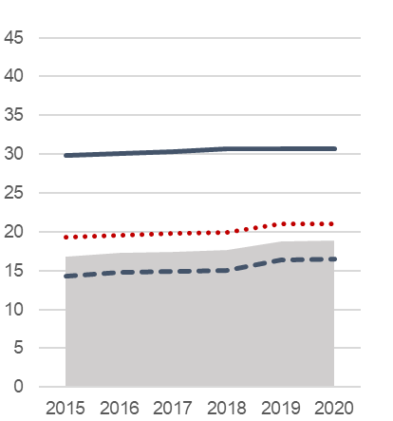 | CAN THO  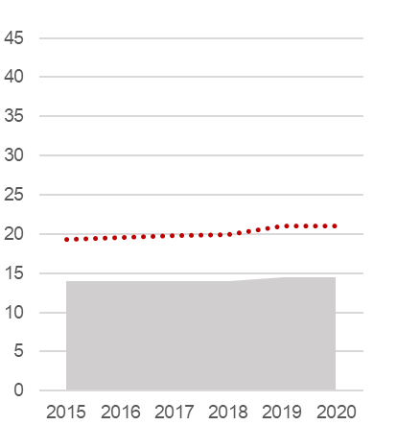
Source: Processing on MONRE data

Table 2.26 - Land consumption as a proportion of total land area, by province and socio-economic region. Years 2016-2020 (percentage values)
Regions  Provinces | 2016 | 2017 | 2018 | 2019 | 2020 |  | Regions  Provinces | 2016 | 2017 | 2018 | 2019 | 2020
Red River Delta | 21.72 | 21.95 | 22.17 | 23.19 | 23.34 |  | Central
Ha Noi | 30.81 | 31.16 | 31.30 | 31.93 | 32.03 |  | Highlands | 4.61 | 4.67 | 4.70 | 5.06 | 5.08
Vinh Phuc | 20.16 | 20.61 | 20.66 | 21.95 | 22.03 |  | Kon Tum | 4.12 | 4.31 | 4.35 | 4.74 | 4.77
Bac Ninh | 33.17 | 33.70 | 34.55 | 35.55 | 36.45 |  | Gia Lai | 4.53 | 4.58 | 4.58 | 5.06 | 5.08
Quang Ninh | 8.37 | 8.58 | 8.69 | 9.75 | 9.92 |  | Dak Lak | 5.24 | 5.27 | 5.33 | 5.59 | 5.61
Hai Duong | 28.72 | 28.81 | 28.96 | 29.81 | 29.95 |  | Dak Nong | 4.95 | 4.99 | 5.02 | 5.30 | 5.33
Hai Phong | 27.46 | 27.74 | 28.10 | 31.56 | 31.76 |  | Lam Dong | 4.16 | 4.15 | 4.19 | 4.49 | 4.51
Hung Yen | 28.92 | 29.06 | 29.43 | 30.76 | 30.89
Thai Binh | 27.11 | 27.33 | 27.52 | 27.93 | 28.05 |  | South East | 12.92 | 13.02 | 13.15 | 14.08 | 14.14
Ha Nam | 29.23 | 29.80 | 30.12 | 31.50 | 32.09 |  | Binh Phuoc | 7.66 | 7.71 | 7.72 | 8.20 | 8.32
Nam Dinh | 24.75 | 24.69 | 25.16 | 25.42 | 25.53 |  | Tay Ninh | 8.24 | 8.31 | 8.49 | 9.36 | 9.38
Ninh Binh | 19.54 | 19.64 | 19.77 | 20.45 | 20.14 |  | Binh Duong | 18.70 | 18.81 | 19.11 | 21.56 | 21.66
 |  |  |  |  |  |  | Dong Nai | 11.19 | 11.27 | 11.34 | 11.96 | 11.95
Northern |  |  |  |  |  |  | Ba Ria-Vung Tau | 20.19 | 20.31 | 20.45 | 22.67 | 22.77
Midlands and |  |  |  |  |  |  | Ho Chi Minh City | 30.03 | 30.36 | 30.75 | 30.70 | 30.71
Mountains | 4.59 | 4.64 | 4.66 | 4.89 | 4.92
Ha Giang | 3.00 | 3.05 | 3.03 | 3.81 | 3.82 |  | Mekong River
Cao Bang | 3.39 | 3.39 | 3.37 | 3.62 | 3.62 |  | Delta | 9.11 | 9.13 | 9.22 | 9.56 | 9.60
Bac Kan | 2.90 | 2.90 | 2.96 | 3.08 | 3.10 |  | Long An | 14.44 | 14.52 | 14.75 | 14.86 | 14.96
Tuyen Quang | 4.98 | 5.02 | 5.03 | 5.18 | 5.21 |  | Tien Giang | 9.48 | 9.67 | 9.68 | 10.06 | 10.12
Lao Cai | 3.72 | 3.85 | 3.88 | 4.31 | 4.32 |  | Ben Tre | 7.93 | 7.97 | 8.01 | 8.62 | 8.65
Yen Bai | 3.25 | 3.28 | 3.40 | 3.63 | 3.64 |  | Tra Vinh | 7.85 | 7.85 | 7.93 | 8.52 | 8.55
Thai Nguyen | 9.72 | 9.84 | 9.65 | 10.98 | 11.18 |  | Vinh Long | 10.55 | 10.56 | 10.70 | 11.18 | 11.53
Lang Son | 4.44 | 4.48 | 4.55 | 4.66 | 4.68 |  | Dong Thap | 11.85 | 11.88 | 11.91 | 12.05 | 12.07
Bac Giang | 16.94 | 17.05 | 17.17 | 18.19 | 18.33 |  | An Giang | 10.66 | 10.66 | 10.69 | 11.06 | 11.09
Phu Tho | 10.24 | 10.30 | 10.33 | 10.86 | 10.93 |  | Kien Giang | 6.85 | 6.84 | 6.87 | 7.46 | 7.47
Dien Bien | 1.57 | 1.60 | 1.68 | 1.65 | 1.69 |  | Can Tho | 14.04 | 13.97 | 14.04 | 14.41 | 14.45
Lai Chau | 1.95 | 1.97 | 2.02 | 1.41 | 1.41 |  | Hau Giang | 9.68 | 9.74 | 9.75 | 10.55 | 10.57
Son La | 3.56 | 3.61 | 3.58 | 3.59 | 3.61 |  | Soc Trang | 7.91 | 8.00 | 8.03 | 8.30 | 8.33
Hoa Binh | 9.78 | 9.82 | 9.83 | 10.37 | 10.38 |  | Bac Lieu | 5.92 | 5.88 | 6.40 | 8.43 | 8.44
 |  |  |  |  |  |  | Ca Mau | 5.82 | 5.73 | 5.76 | 4.85 | 4.88
North-central
and Central
Coast | 7.72 | 7.82 | 7.92 | 8.25 | 8.31
Thanh Hoa | 11.66 | 11.80 | 11.96 | 12.29 | 12.26
Nghe An | 6.09 | 6.22 | 6.42 | 6.56 | 6.59
Ha Tinh | 9.00 | 9.07 | 9.15 | 9.06 | 9.21
Quang Binh | 4.64 | 4.66 | 4.71 | 4.80 | 4.88
Quang Tri | 4.76 | 4.82 | 4.91 | 5.20 | 5.26
Thua Thien-Hue | 8.71 | 8.75 | 8.81 | 9.32 | 9.39
Da Nang | 39.38 | 39.74 | 39.69 | 40.06 | 40.07
Quang Nam | 6.04 | 6.07 | 6.09 | 6.29 | 6.29
Quang Ngai | 6.60 | 6.75 | 6.81 | 7.32 | 7.35
Binh Dinh | 7.29 | 7.39 | 7.42 | 7.80 | 7.85
Phu Yen | 7.05 | 7.03 | 7.13 | 7.52 | 7.52
Khanh Hoa | 8.17 | 8.35 | 8.37 | 8.94 | 9.03
Ninh Thuan | 7.27 | 7.57 | 7.93 | 8.21 | 8.86
Binh Thuan | 7.36 | 7.37 | 7.53 | 8.59 | 8.61
High-urban intensity areas (central units)
High-urban intensity areas (peripheral units)
Source: Processing on MONRE data.

VSDG Target 11.6: Reduce adverse environmental impacts on people in urban areas, including by strengthening the management of air quality, urban waste and other sources of waste

11.6.1: Proportion of urban domestic solid waste that is collected, transported and treated according to technical standards and regulations

11.6.1a: Urban domestic solid waste collected, transported and treated according to technical standards and regulations
Global SDGs |  | Target 11.6: By 2030, reduce the adverse per capita environmental impact of cities, including by paying special attention to air quality and municipal and other waste management  Indicator 11.6.1: Proportion of municipal solid waste collected and managed in controlled facilities out of total municipal waste generated, by cities
UNSD-CC |  | Topic: Waste management  Indicator 157: Proportion of municipal waste treated
Metadata card
Definition |  |  | Proportion of urban domestic solid waste that is treated according to standards and regulations to the total volume of urban domestic solid waste collected.
Glossary |  |  | Urban domestic solid waste includes waste from households, commerce and trade, small businesses, office buildings and institutions. It also includes bulky waste (except demolition waste) and waste from selected municipal services (e.g. from park and garden maintenance, street and market cleaning services). Collection is operated by or on behalf of municipalities.
Unit of measure |  |  | %
Breakdown |  |  | 63 Provinces
Data source |  |  | National statistical reporting system, Ministry of Construction (MOC)
Time series |  |  | 2015-2019
Frequency of updates |  |  | 1 year
Main data
Table 2.27 - Urban domestic solid waste collected, transported and treated according to technical standards and regulations, by major urban areas and by urban intensity degree. Years 2015-2019 (estimates, pct. values)
Territory | 2015 | 2016 | 2017 | 2018 | 2019
WHOLE COUTRY | 75.0 | 81.6 | 83.6 | 84.3 | 85.3
Ha Noi urban area | 89.0 | 89.8 | 94.9 | 93.5 | 86.9
Central unit | 98.1 | 98.3 | 98.5 | 98.5 | 100.0
Peripheral units | 57.7 | 64.5 | 81.8 | 76.0 | 56.9
Hai Phong urban area | 71.4 | 78.6 | 86.4 | 88.4 | 89.0
Central unit | 70.9 | 92.4 | 92.4 | 97.5 | 96.5
Peripheral units | 72.0 | 68.6 | 82.8 | 82.7 | 82.0
Da Nang urban area | 100.0 | 100.0 | 100.0 | 100.0 | 100.0
Ho Chi Minh City urban area | 95.9 | 100.0 | 99.1 | 92.6 | 92.6
Central unit | 100.0 | 100.0 | 100.0 | 100.0 | 100.0
Peripheral units | 85.7 | 100.0 | 97.0 | 77.3 | 73.4
Can Tho urban area | 43.2 | 92.7 | 100.0 | 94.2 | 94.2
High urban intensity (total) | 89.2 | 93.8 | 96.3 | 92.7 | 90.5
High urban intensity (central units) | 94.4 | 98.6 | 99.0 | 99.1 | 99.5
High urban intensity (peripheral units) | 75.3 | 82.1 | 89.7 | 78.2 | 69.7
Medium urban intensity | 44.5 | 59.4 | 59.5 | 65.8 | 72.2
Low urban intensity | 51.0 | 50.5 | 58.1 | 76.8 | 82.7
DISTANCE FROM TARGET in pct.points | 25.0 | 18.4 | 16.4 | 15.7 | 14.7
URBAN-RURAL DIVIDE in pct. points | 38.2 | 43.3 | 38.2 | 15.9 | 7.8
CENTRE-PERIPHERY DIVIDE WITHIN HIGH-URBAN INTENSITY AREAS in pct. points | 19.1 | 16.5 | 9.3 | 20.9 | 29.8
Source: Processing on MOC data
Between 2015 and 2019, the percentage of urban solid waste that is safely transported and treated, according to the national standards and technical regulations, increased by 10.3 percentage points (from 75% to 85.3%). The rate is higher in the major urban areas, where, however, it is declining in the latest years (from 96.3% in 2017 to 90.5% in 2019). Most of the progress, then, is due to the advances made in the medium- and low-urban intensity areas (by 27.7 and 31.7 points, respectively). Therefore, the gap between urban and rural areas has been substantially reduced (from 38.2 to 7.8 points over the observed period). The distance to the target of 100%, however, is reducing at a slower pace (by about 10 points, over the same period), mostly because of the poor progress realised in the peripheral units of the high-urban intensity areas, where the rate of safely managed waste in 2019 was lower than 2015 (69.7% vs. 75.3%). As a consequence, while the urban-rural divide is about to be closed, another gap, between the centres and the peripheries of the major urban areas, is widening (Figures 2.39 and 2.40).
Figure 2.39 - Urban domestic solid waste collected, transported and treated according to technical standards and regulations, by urban intensity degree. Years 2015-2019 (estimates, percentage values)
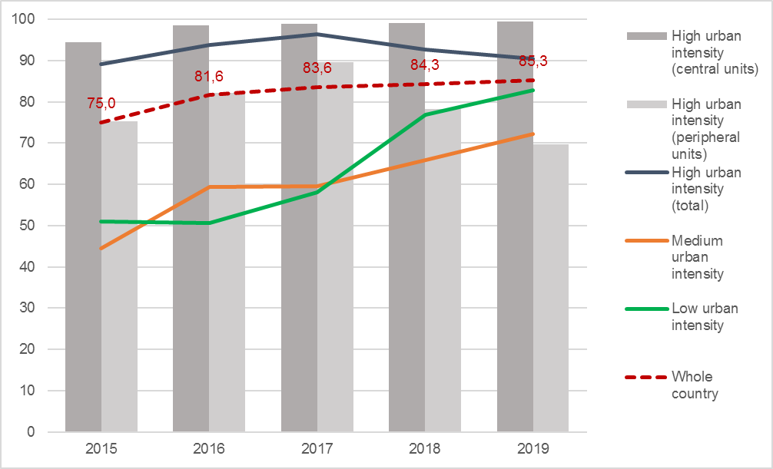
Source: Processing on MOC data

Figure 2.40 - Urban domestic solid waste collected, transported and treated according to technical standards and regulations: distance from target, urban-rural divide and centre-periphery divide within the high-urban intensity areas. Years 2015-2019 (estimates, percentage points)
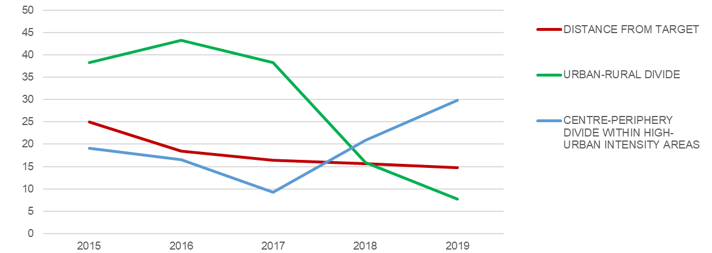
Source: Processing on MOC data
The widening of the gap between central and peripheral units can be observed in the urban areas of Ha Noi, Hai Phong and Ho Chi Minh City. In 2019, the target of 100% was reached in the urban area of Da Nang, and in the central units of Ha Noi and Ho Chi Minh City (Figure 2.41).
Figure 2.41 - Urban domestic solid waste collected, transported and treated according to technical standards and regulations, by major urban areas. Years 2015-2019 (estimates, percentage values)
HA NOI  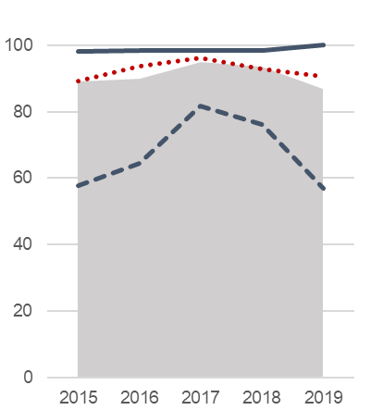 | HAI PHONG  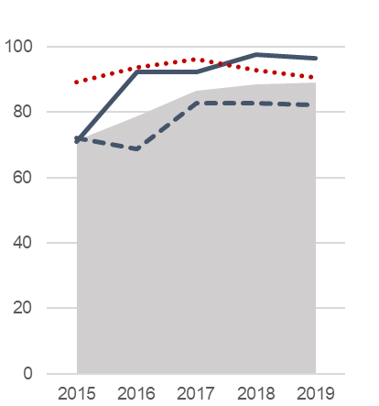 | DA NANG  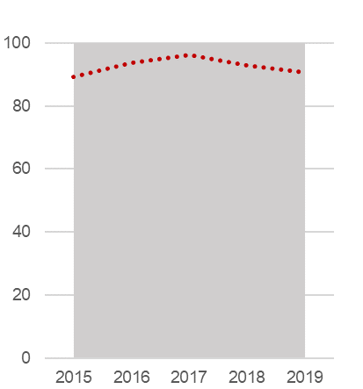
HO CHI MINH CITY  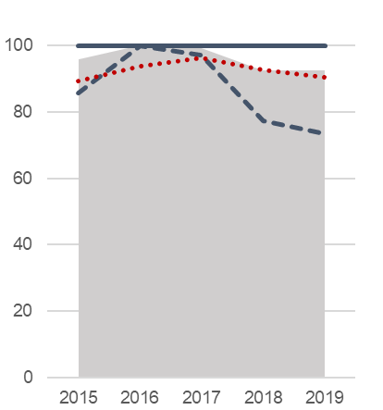 | CAN THO  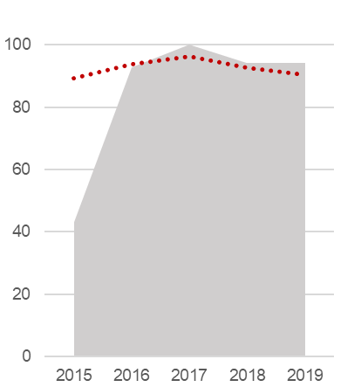
Source: Processing on MOC data

Table 2.28 - Urban domestic solid waste collected, transported and treated according to technical standards and regulations, by province and socio-economic region. Years 2015-2019 (percentage values)
Regions  Provinces | 2015 | 2016 | 2017 | 2018 | 2019 |  | Regions  Provinces | 2015 | 2016 | 2017 | 2018 | 2019
Red River Delta | 84.3 | 88.9 | 94.6 | 94.0 | 89.3 |  | Central
Ha Noi | 98.1 | 98.3 | 98.5 | 98.5 | 100.0 |  | Highlands | 59.0 | 57.4 | 67.3 | 61.0 | 66.7
Vinh Phuc | 100.0 | 76.6 | 100.0 | 100.0 | 100.0 |  | Kon Tum | 71.7 | 58.7 | 65.6 | 74.1 | 80.7
Bac Ninh | .. | 39.1 | 87.8 | 74.4 | 36.8 |  | Gia Lai | 62.5 | 48.8 | 60.6 | 67.1 | 71.2
Quang Ninh | 79.6 | 81.3 | 74.7 | 74.7 | 78.5 |  | Dak Lak | 53.2 | 66.0 | 81.8 | 84.5 | 66.1
Hai Duong | 74.1 | 79.7 | 100.0 | 100.0 | 100.0 |  | Dak Nong | 33.0 | 71.4 | 86.7 | 100.0 | 98.0
Hai Phong | 70.9 | 92.4 | 92.4 | 97.5 | 96.5 |  | Lam Dong | 66.0 | 52.8 | 52.8 | 52.8 | 45.5
Hung Yen | 30.0 | 68.0 | 100.0 | 60.9 | 83.3
Thai Binh | 35.8 | 35.1 | 92.6 | 92.7 | 92.7 |  | South East | 93.7 | 99.4 | 98.1 | 92.5 | 92.9
Ha Nam | 95.2 | 96.6 | 100.0 | 100.0 | 74.0 |  | Binh Phuoc | 34.0 | 64.0 | 34.0 | 80.0 | 100.0
Nam Dinh | 96.8 | 99.0 | 99.5 | 98.9 | 75.3 |  | Tay Ninh | 11.5 | 100.0 | 100.0 | 100.0 | 100.0
Ninh Binh | 57.0 | 85.5 | 69.2 | 85.5 | 23.7 |  | Binh Duong | 100.0 | 100.0 | 100.0 | 100.0 | 100.0
 |  |  |  |  |  |  | Dong Nai | 74.7 | 100.0 | 100.0 | 50.0 | 50.0
Northern |  |  |  |  |  |  | Ba Ria-Vung Tau | 85.4 | 100.0 | 84.2 | 90.2 | 100.0
Midlands and |  |  |  |  |  |  | Ho Chi Minh City | 100.0 | 100.0 | 100.0 | 100.0 | 100.0
Mountains | 45.4 | 56.4 | 56.6 | 69.0 | 77.5
Ha Giang | 47.6 | 77.0 | 90.8 | 67.6 | 88.5 |  | Mekong River
Cao Bang | 63.5 | 88.5 | 92.7 | 77.8 | 5.6 |  | Delta | 41.6 | 59.1 | 58.3 | 66.0 | 72.8
Bac Kan | 48.5 | .. | .. | 66.7 | 12.2 |  | Long An | 42.7 | 100.0 | 43.3 | 43.3 | 43.3
Tuyen Quang | 67.9 | 85.4 | 73.2 | 73.2 | 73.2 |  | Tien Giang | 21.1 | .. | .. | 3.3 | 100.0
Lao Cai | .. | 72.3 | 72.3 | 98.5 | 93.5 |  | Ben Tre | 74.8 | 89.0 | 89.0 | 90.8 | 91.5
Yen Bai | 50.0 | 77.2 | 78.8 | 89.2 | 89.0 |  | Tra Vinh | 10.1 | 32.4 | .. | 11.0 | 12.2
Thai Nguyen | 74.7 | 46.5 | 47.5 | 47.5 | 53.2 |  | Vinh Long | 63.4 | 84.7 | 100.0 | 54.0 | 100.0
Lang Son | 50.0 | .. | .. | 13.4 | 96.4 |  | Dong Thap | 44.8 | 65.5 | 65.5 | 100.0 | 50.0
Bac Giang | 58.0 | 67.5 | 73.8 | 73.8 | 73.8 |  | An Giang | 28.4 | 3.9 | 71.6 | 75.3 | 82.3
Phu Tho | 59.1 | 95.6 | 88.1 | 90.8 | 91.0 |  | Kien Giang | 63.1 | 79.7 | 72.0 | 87.8 | 87.8
Dien Bien | 53.8 | 32.7 | 27.6 | 100.0 | 100.0 |  | Can Tho | 43.2 | 92.7 | 100.0 | 94.2 | 94.2
Lai Chau | .. | 100.0 | 100.0 | 100.0 | 100.0 |  | Hau Giang | 52.4 | 71.7 | 71.7 | 100.0 | 100.0
Son La | 28.9 | 28.9 | 34.0 | 34.0 | 100.0 |  | Soc Trang | .. | 25.7 | 25.7 | 25.7 | 42.4
Hoa Binh | 7.3 | 62.9 | 30.2 | 77.2 | 91.3 |  | Bac Lieu | 68.1 | 74.6 | 48.3 | 100.0 | 58.8
 |  |  |  |  |  |  | Ca Mau | 72.1 | 100.0 | 96.9 | 83.3 | 100.0
North-central
and Central
Coast | 58.7 | 61.9 | 66.7 | 75.9 | 82.5
Thanh Hoa | 16.7 | 21.9 | 66.3 | 61.7 | 72.2
Nghe An | 62.0 | 71.4 | 72.8 | 92.0 | 98.0
Ha Tinh | 90.6 | 88.8 | 88.8 | 90.3 | 100.0
Quang Binh | 45.1 | 100.0 | 100.0 | 89.6 | 89.8
Quang Tri | 35.3 | 58.6 | 74.1 | 8.9 | 81.6
Thua Thien-Hue | 84.4 | 99.0 | 94.4 | 41.3 | 41.2
Da Nang | 100.0 | 100.0 | 100.0 | 100.0 | 100.0
Quang Nam | 52.7 | 10.6 | 10.6 | 100.0 | 100.0
Quang Ngai | 76.0 | 42.7 | 42.7 | 85.0 | 91.9
Binh Dinh | 94.4 | 70.0 | 76.4 | 85.5 | 85.4
Phu Yen | 71.8 | 71.8 | 66.8 | 84.6 | 65.2
Khanh Hoa | 60.0 | 67.4 | 67.4 | 86.6 | 86.6
Ninh Thuan | 100.0 | 100.0 | 100.0 | 100.0 | 100.0
Binh Thuan | 9.0 | 26.6 | 16.9 | 26.9 | 26.9
High-urban intensity areas (central units)
High-urban intensity areas (peripheral units)
Source: Ministry of Construction

VSDG Target 11.6: Reduce adverse environmental impacts on people in urban areas, including by strengthening the management of air quality, urban waste and other sources of waste

11.6.1: Proportion of urban domestic solid waste that is collected, transported, and treated according to technical standards and regulations

11.6.1b: Urban domestic solid waste collected per capita
Global SDGs |  | Target 11.6: By 2030, reduce the adverse per capita environmental impact of cities, including by paying special attention to air quality and municipal and other waste management  Indicator 11.6.1: Proportion of municipal solid waste collected and managed in controlled facilities out of total municipal waste generated, by cities
UNSD-CC |  | Topic: Waste management  Indicator 156: Municipal waste collected per capita
Metadata card
Definition |  |  | Average quantity of urban domestic solid waste per inhabitant, collected in the reference year
Glossary |  |  | Urban domestic solid waste includes waste from households, commerce and trade, small businesses, office buildings and institutions. It also includes bulky waste (except demolition waste) and waste from selected municipal services (e.g. from park and garden maintenance, street and market cleaning services). Collection is operated by or on behalf of municipalities.
Unit of measure |  |  | Kg per inhabitant
Breakdown |  |  | 63 Provinces
Data source |  |  | National statistical reporting system, Ministry of Construction (MOC)
Time series |  |  | 2015-2019
Frequency of updates |  |  | 1 year
Main data
Table 2.29 - Urban domestic solid waste collected per capita (*), by major urban areas and by urban intensity degree. Years 2015-2019 (estimates, kg per inhabitant)
Territory | 2015 | 2016 | 2017 | 2018 | 2019
WHOLE COUTRY | 129.0 | 130.6 | 147.3 | 156.0 | 163.2
Ha Noi urban area | 166.2 | 185.6 | 192.0 | 192.0 | 201.7
Central unit | 273.1 | 294.2 | 319.7 | 315.5 | 293.1
Peripheral units | 70.7 | 88.4 | 77.7 | 81.2 | 117.7
Hai Phong urban area | 143.1 | 137.6 | 152.9 | 152.2 | 191.4
Central unit | 261.8 | 200.1 | 198.4 | 199.4 | 318.8
Peripheral units | 95.0 | 112.1 | 134.3 | 132.9 | 139.3
Da Nang urban area | 259.0 | 262.0 | 257.6 | 323.9 | 335.9
Ho Chi Minh City urban area | 273.4 | 272.7 | 311.0 | 322.3 | 288.3
Central unit | 336.0 | 336.5 | 384.7 | 377.8 | 363.4
Peripheral units | 187.3 | 185.3 | 210.6 | 247.3 | 187.3
Can Tho urban area | 190.1 | 150.3 | 162.6 | 172.2 | 178.7
High urban intensity (total) | 204.6 | 210.1 | 230.1 | 236.6 | 235.4
High urban intensity (central units) | 292.1 | 291.7 | 321.7 | 321.7 | 320.7
High urban intensity (peripheral units) | 113.6 | 125.1 | 134.5 | 147.9 | 145.7
Medium urban intensity | 72.9 | 72.4 | 85.0 | 94.5 | 102.3
Low urban intensity | 77.0 | 73.6 | 89.9 | 100.1 | 116.0
(*) For this statistical measure there is no target set, neither is relevant the monitoring of urban-rural divide.
Source: Processing on MOC data
According to the latest data released by the Ministry of Construction, the amount of municipal solid waste collected was 163.2 kg per capita in 2019, increasing by 26.5% compared to 2015, when it was 129. This trend is consistent with the economic growth and, in particular, with the growth of the average income (+37.2% at current prices, from 2016 to 2020). The amount of waste generated and collected in urban areas also depends on the population size and the speed of the urbanization and industrialization process, as shown by the significant disparity between high- and low-urban intensity areas. The average of high-intensity areas (235.4 kg per capita in 2019) is in fact double that of the low-intensity areas (116 kg per capita), and 2.3 times the average of medium-intensity areas). Even within the major urban areas, a remarkable difference can be observed between central and peripheral units (320.7 vs. 145.7 kg per capita), which is likely to reflect a lesser coverage of urban peripheries by the waste collection services (Figure 2.42).
Figure 2.42 - Urban domestic solid waste collected per capita, by urban intensity degree. Years 2015-2019 (estimates, kg per inhabitant)
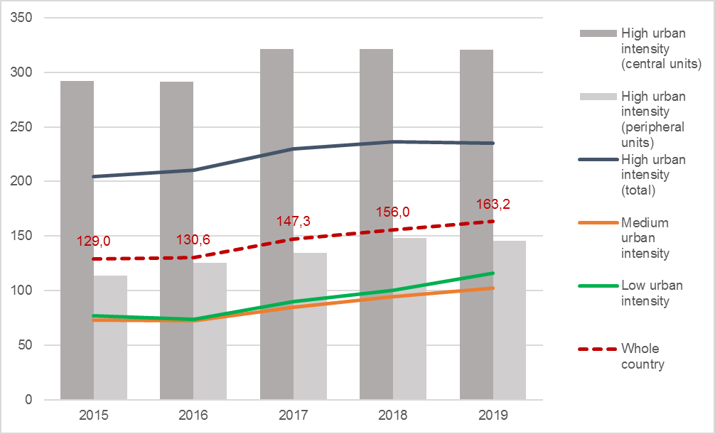
Source: Processing on MOC data
Over the period 2015-2019, the amount per capita of urban solid waste collected increased in all major urban areas, except Can Tho (substantially stable around an average of 170 kg per capita). The highest growth rates (about +30%) are observed in Hai Phong and Da Nang. Da Nang is also the urban area that recorded the highest value in 2019 (335.9 kg per capita), followed by Ho Chi Minh City and Ha Noi (288.3 and 201.7, respectively). Considering the central units, both Ha Noi and Ho Chi Minh City show a slight reduction in the collected amount per capita after 2017 (Figure 2.43).
Figure 2.43 - Urban domestic solid waste collected per capita, by major urban areas. Years 2015-2019 (estimates, kg per inhabitant)
HA NOI  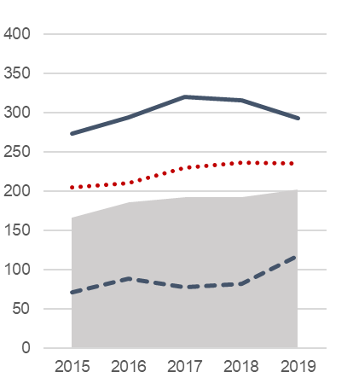 | HAI PHONG  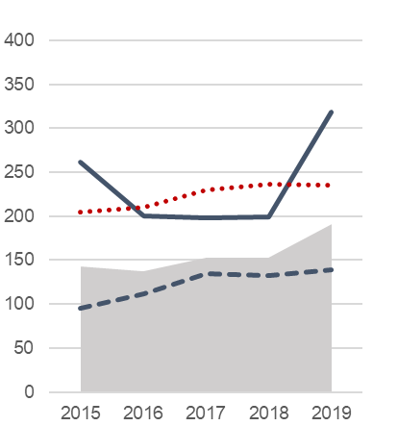 | DA NANG  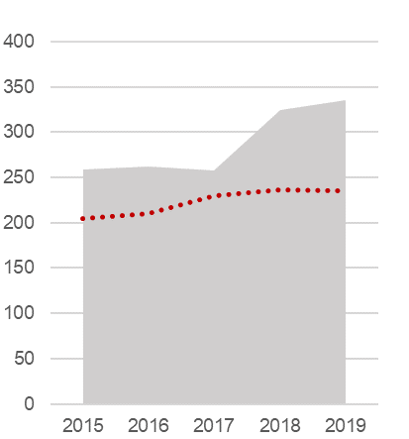
HO CHI MINH CITY  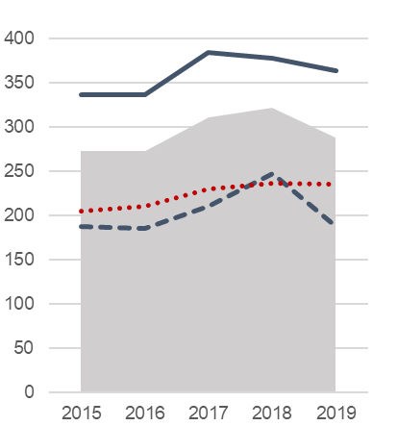 | CAN THO  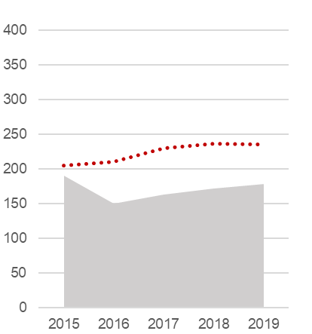
Source: Processing on MOC data

Table 2.30 - Urban domestic solid waste collected per capita, by province and socio-economic region. Years 2015-2019 (kg per inhabitant)
Regions  Provinces | 2015 | 2016 | 2017 | 2018 | 2019 |  | Regions  Provinces | 2015 | 2016 | 2017 | 2018 | 2019
Red River Delta | 164.0 | 173.0 | 183.1 | 183.0 | 199.5 |  | Central
Ha Noi | 273.1 | 294.2 | 319.7 | 315.5 | 293.1 |  | Highlands | 69.1 | 72.2 | 81.9 | 79.5 | 137.3
Vinh Phuc | 102.5 | 80.5 | 100.1 | 98.6 | 93.2 |  | Kon Tum | 106.7 | 66.1 | 136.9 | 107.8 | 71.3
Bac Ninh | 94.8 | 103.7 | 123.1 | 125.8 | 230.3 |  | Gia Lai | 41.8 | 64.9 | 76.7 | 82.1 | 269.2
Quang Ninh | 222.1 | 242.9 | 309.4 | 303.8 | 276.2 |  | Dak Lak | 71.5 | 67.6 | 71.0 | 65.0 | 85.2
Hai Duong | 50.0 | 73.6 | 56.3 | 55.9 | 69.7 |  | Dak Nong | 56.5 | 33.8 | 35.0 | 40.2 | 58.5
Hai Phong | 261.8 | 200.1 | 198.4 | 199.4 | 318.8 |  | Lam Dong | 86.9 | 107.4 | 106.5 | 105.4 | 123.6
Hung Yen | 80.6 | 105.4 | 41.0 | 69.1 | 40.9
Thai Binh | 62.6 | 99.3 | 112.3 | 112.0 | 107.8 |  | South East | 246.2 | 244.3 | 279.4 | 292.5 | 262.7
Ha Nam | 47.7 | 65.9 | 35.3 | 36.1 | 44.5 |  | Binh Phuoc | 79.6 | 66.8 | 77.6 | 96.9 | 77.7
Nam Dinh | 43.2 | 38.0 | 38.2 | 36.4 | 70.3 |  | Tay Ninh | 43.0 | 32.0 | 42.5 | 67.6 | 75.1
Ninh Binh | 49.5 | 44.8 | 49.3 | 43.9 | 156.4 |  | Binh Duong | 201.3 | 223.3 | 257.3 | 313.1 | 106.1
 |  |  |  |  |  |  | Dong Nai | 171.5 | 177.6 | 173.9 | 217.0 | 215.1
Northern |  |  |  |  |  |  | Ba Ria-Vung Tau | 204.9 | 136.7 | 224.0 | 203.3 | 285.1
Midlands and |  |  |  |  |  |  | Ho Chi Minh City | 336.0 | 336.5 | 384.7 | 377.8 | 363.4
Mountains | 70.4 | 74.8 | 75.6 | 78.9 | 86.1
Ha Giang | 66.9 | 62.2 | 66.6 | 63.8 | 62.7 |  | Mekong River
Cao Bang | 44.0 | 35.8 | 37.5 | 12.2 | 91.4 |  | Delta | 75.8 | 75.7 | 87.8 | 89.2 | 105.2
Bac Kan | 79.3 | 77.8 | 76.8 | 13.4 | 76.6 |  | Long An | 47.2 | 73.5 | 102.4 | 102.0 | 90.4
Tuyen Quang | 64.3 | 49.0 | 65.1 | 64.6 | 64.1 |  | Tien Giang | 70.1 | 61.0 | 63.3 | 63.0 | 74.6
Lao Cai | 98.5 | 88.5 | 87.3 | 105.0 | 106.5 |  | Ben Tre | 42.5 | 47.0 | 44.7 | 44.0 | 43.3
Yen Bai | 90.2 | 76.2 | 83.2 | 91.3 | 66.3 |  | Tra Vinh | 104.8 | 38.9 | 139.6 | 139.1 | 130.6
Thai Nguyen | 72.7 | 134.4 | 128.5 | 127.2 | 183.5 |  | Vinh Long | 49.6 | 41.1 | 35.5 | 65.6 | 69.6
Lang Son | 96.3 | 119.2 | 118.6 | 116.8 | 104.4 |  | Dong Thap | 79.7 | 89.6 | 89.4 | 51.3 | 114.1
Bac Giang | 51.4 | 44.0 | 39.9 | 39.5 | 36.9 |  | An Giang | 59.0 | 91.6 | 70.1 | 92.3 | 139.7
Phu Tho | 68.5 | 77.7 | 81.2 | 76.4 | 74.7 |  | Kien Giang | 82.1 | 89.0 | 126.4 | 125.8 | 132.1
Dien Bien | 62.0 | 64.2 | 63.1 | 69.0 | 66.1 |  | Can Tho | 190.1 | 150.3 | 162.6 | 172.2 | 178.7
Lai Chau | 58.4 | 85.4 | 85.9 | 237.6 | 237.7 |  | Hau Giang | 100.4 | 100.2 | 99.9 | 99.6 | 119.1
Son La | 85.5 | 83.7 | 69.8 | 69.0 | 63.8 |  | Soc Trang | 65.7 | 80.1 | 80.0 | 79.9 | 87.6
Hoa Binh | 54.5 | 39.1 | 54.8 | 53.1 | 56.0 |  | Bac Lieu | 77.8 | 55.2 | 84.5 | 77.3 | 129.8
 |  |  |  |  |  |  | Ca Mau | 44.0 | 42.1 | 47.9 | 53.4 | 55.8
North-central
and Central
Coast | 95.5 | 90.5 | 113.7 | 139.8 | 139.5
Thanh Hoa | 79.1 | 79.4 | 91.7 | 128.0 | 82.1
Nghe An | 76.2 | 46.1 | 114.1 | 152.0 | 135.7
Ha Tinh | 43.1 | 61.7 | 61.4 | 50.0 | 146.2
Quang Binh | 85.3 | 55.3 | 50.5 | 91.3 | 90.2
Quang Tri | 110.1 | 115.9 | 211.2 | 162.1 | 154.7
Thua Thien-Hue | 92.5 | 98.4 | 108.1 | 139.9 | 144.0
Da Nang | 259.0 | 262.0 | 257.6 | 323.9 | 335.9
Quang Nam | 112.2 | 127.6 | 127.1 | 147.4 | 147.8
Quang Ngai | 50.1 | 65.6 | 65.1 | 80.3 | 90.9
Binh Dinh | 51.9 | 71.8 | 83.1 | 83.7 | 107.5
Phu Yen | 85.4 | 84.8 | 90.0 | 83.5 | 112.9
Khanh Hoa | 143.8 | 142.8 | 141.9 | 185.4 | 185.3
Ninh Thuan | 108.4 | 124.4 | 123.3 | 167.6 | 144.5
Binh Thuan | 143.9 | 61.8 | 163.2 | 201.2 | 202.3
High-urban intensity areas (central units)
High-urban intensity areas (peripheral units)
Source: Ministry of Construction

VSDG Target 11.6: Reduce adverse environmental impacts on people in urban areas, including by strengthening the management of air quality, urban waste and other sources of waste

11.6.3: Concentration of substances in the air environment

11.6.3a: Annual mean concentration of pollutants in cities: maximum values (PM10 and NO2)
Global SDGs |  | Target 11.6: By 2030, reduce the adverse per capita environmental impact of cities, including by paying special attention to air quality and municipal and other waste management  Indicator 11.6.2: Annual mean levels of fine particulate matter (e.g. PM_{2.5} and PM₁₀) in cities (population weighted)
UNSD-CC |  | Topic: Climate change and human health  Indicator 46: Climate induced air pollution
Metadata card
Definition |  |  | Maximum values of the mean concentration in atmosphere of PM₁₀ particulate matter and Nitrogen dioxide (NO₂), recorded by monitoring stations in the reference year
Glossary |  |  | Environmental monitoring stations: network systems that check the evolution of the air environment in each locality in order to report specific parameters of air quality.  Particulate matter PM₁₀: material present in the atmosphere in the form of microscopic particles, whose diameter is equal to or less than 10 µm, consisting of dust, smoke, and droplets of liquid substances.  Nitrogen dioxide (NO₂): the product of the oxidation of Nitrogen monoxide (NO) in the atmosphere. It is mostly a secondary pollutant, as it is released directly into the atmosphere only in small proportion.
Unit of measure |  |  | µg per m³
Breakdown |  |  | By monitoring station
Data source |  |  | National statistical reporting system, Ministry of Natural Resources and Environment (MONRE)
Time series |  |  | 2014-2019 (PM₁₀), 2013-2021 (NO₂)
Frequency of updates |  |  | 1 year
Main data
Table 2.31 - Annual mean concentration of pollutants in cities: maximum values for PM₁₀ and NO₂, by major urban areas and by urban intensity degree. Years 2014-2019 (PM₁₀) and 2014-2021 (NO₂) (estimates, µg/m³)
Territory | PM₁₀ |  |  |  |  |  |  | NO₂
Territory | 2014 | 2015 | 2016 | 2017 | 2018 | 2019 |  | 2013 | 2014 | 2015 | 2016 | 2017 | 2018 | 2019 | 2020 | 2021
Ha Noi urban area | 683 | …. | 182 | 112 | 139 | 147 |  | 40 | 15 | 60 | 53 | 193 | 23 | 35 | 32 | 33
Central unit | 683 | …. | 182 | 112 | 114 | 147 |  | 30 | 14 | 48 | 40 | 23 | 19 | 34 | 23 | 27
Peripheral units | 165 | …. | 73 | …. | 139 | 138 |  | 40 | 15 | 60 | 53 | 193 | 23 | 35 | 32 | 33
Hai Phong urban area | …. | …. | 82 | …. | …. | …. |  | 42 | 12 | 44 | 28 | 21 | 19 | 29 | 24 | 33
Central unit | …. | …. | 80 | …. | …. | …. |  | 42 | 10 | 37 | 20 | …. | 17 | 29 | 24 | 33
Peripheral units | …. | …. | 82 | …. | …. | …. |  | 41 | 12 | 44 | 28 | 21 | 19 | 21 | 21 | 29
Da Nang urban area | …. | …. | 148 | …. | …. | …. |  | 36 | 60 | 70 | 51 | 83 | 61 | 27 | 19 | 24
Ho Chi Minh City urban area | 521 | 258 | 128 | …. | …. | …. |  | 895 | 120 | 49 | 73 | 42 | 50 | 70 | 72 | 55
Central unit | 129 | 163 | 18 | …. | …. | …. |  | 348 | 48 | 43 | 56 | 36 | 49 | 65 | 71 | 40
Peripheral units | 521 | 258 | 128 | …. | …. | …. |  | 895 | 120 | 49 | 73 | 42 | 50 | 70 | 72 | 55
Can Tho urban area | …. | …. | …. | …. | …. | …. |  | …. | …. | …. | …. | …. | 17 | 33 | 24 | 20
### = values above WHO 2005 reference value of 20 µg/m³ and National limit value of 50 µg/m³ for PM₁₀
### = values above WHO 2005 reference value/National limit value of 40 µg/m³ for NO₂;
### = values above WHO 2021 reference value of 10 µg/m³ for NO₂.
Four dots (….) = values not available/not sufficient
Source: Processing on MONRE data.
Where a sufficient number of valid observations is available, it is possible to identify situations of significant risk for human health caused by exposure to PM₁₀ or NO₂ concentrations above the WHO reference values.
As for PM₁₀, except for the case of central Ho Chi Minh City in 2016, all values estimated for the major urban areas exceed both the WHO reference value of 20 µg/m³ and the national limit value of 50 µg/m³ over the entire observation period. The risk associated to pollution from NO₂ appears also critical, although less severe, as the 2005 WHO reference values (coinciding, in this case, with the national limit values) are exceeded only in the urban areas of Ha Noi (2015-2017), Da Nang (2014-2018) and Ho Chi Minh City (for the entire period 2014-2021). Almost all other values, however, exceed the upgraded WHO reference values of 2021 (Table 2.18).
During the observed period (2015-2019), pollution from particulate matter appears to be a prominent problem in the high-urban intensity areas (both for central and peripheral units), as the maximum concentrations of PM₁₀ are many times higher than the WHO reference value of 2005. Maximum values of PM₁₀ decreased from 2015 to 2017, then tended to increase again in 2018-2019 (Figure 2.44).
Figure 2.44 - Maximum values for PM₁₀ concentrations (annual mean) recorded in the high-urban intensity areas. Years 2015-2019 (estimates, µ/m³)
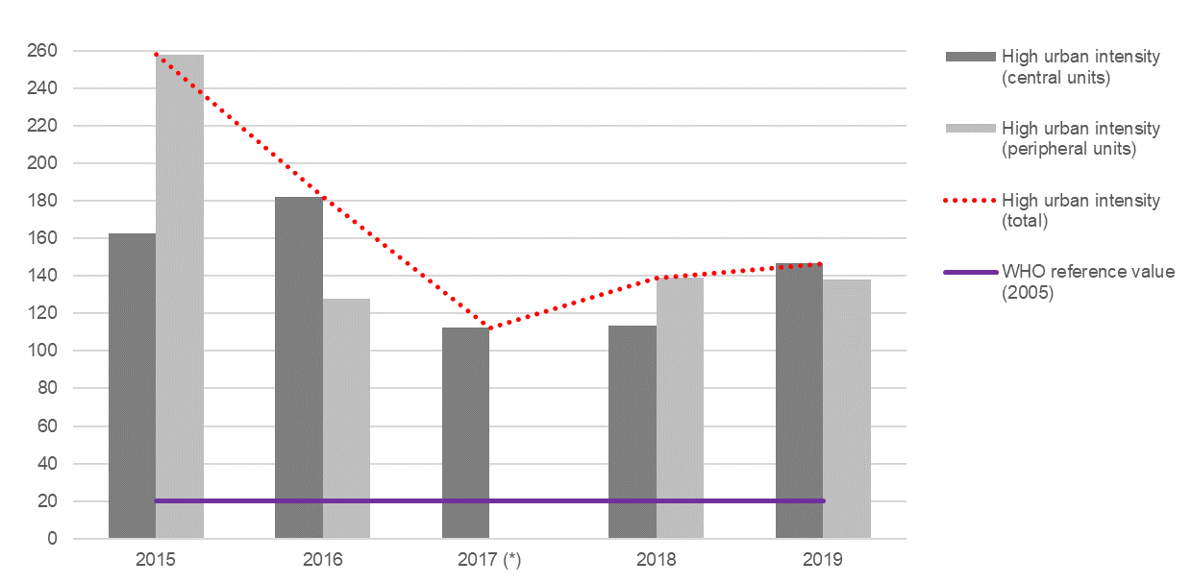
(*) Data not available/not sufficient for peripheral units.
Source: Processing on MONRE data
Available data on PM₁₀ allow comparison among the major urban areas only to a limited extent. In fact, estimates are available only for Ha Noi (2014 and 2016-2019) and Ho Chi Minh City (2014-2016). Central Ha Noi recorded a peak of 683 µ/m³ in 2014, followed by far lower values from 2016 to 2019 (always well above the WHO reference value, however, also in the peripheral units). In the urban area of Ho Chi Minh City, maximum concentrations are constantly higher in the peripheral units. However, both the centre and the periphery were showing, from 2014 to 2016, an improving trend, having reached a value of 18 µ/m³ (within the WHO reference value) in central Ho Chi Minh City in 2016 (Figure 2.45).
Figure 2.45 - Maximum values for PM₁₀ concentrations (annual mean) recorded in the high-urban intensity areas (*). Years 2014-2019 (estimates, µ/m³)
HA NOI  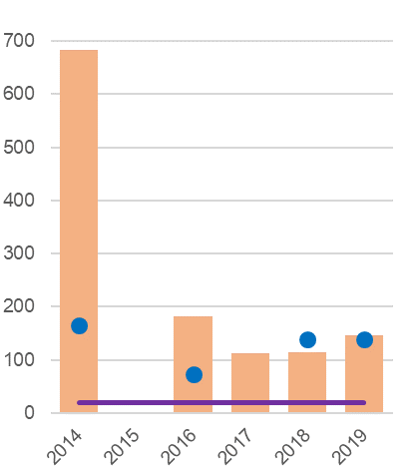 | HO CHI MINH CITY  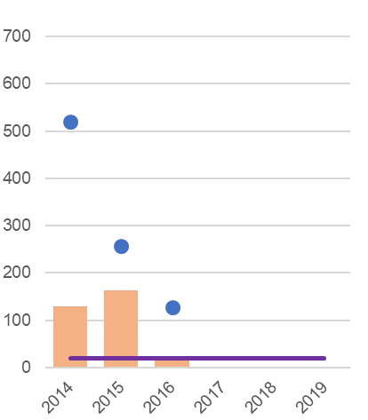 | 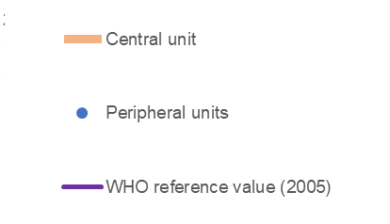
(*) Data not available/not sufficient for Da Nang, Hai Phong central and peripheral units, Can Tho (2014-2019); Ha Noi central and peripheral units (2015), Ha Noi peripheral units (2017), Ho Chi Minh City central and peripheral units (2017-2019).
Source: Processing on MONRE data
Pollution from NO₂ is generated mainly by the traffic of motor vehicles. According to the monitoring results for 2014-2021, most of the maximum values recorded in the single urban areas do not exceed the WHO reference value (coinciding with the national limit set by the QCVN 05:2013/BTNMT standard). However, the maximum values recorded among the high-urban intensity areas remain constantly above the threshold, except in 2021, when none of the five central units – i.e. the municipalities of Ha Noi, Hai Phong, Da Nang, Ho Chi Minh City and Can Tho – exceeded the reference value (2005) of 40 µ/m³ (Figure 2.46).
Figure 2.46 - Maximum values for NO₂ concentrations (annual mean) recorded in the high-urban intensity areas. Years 2014-2021 (estimates, µ/m³)
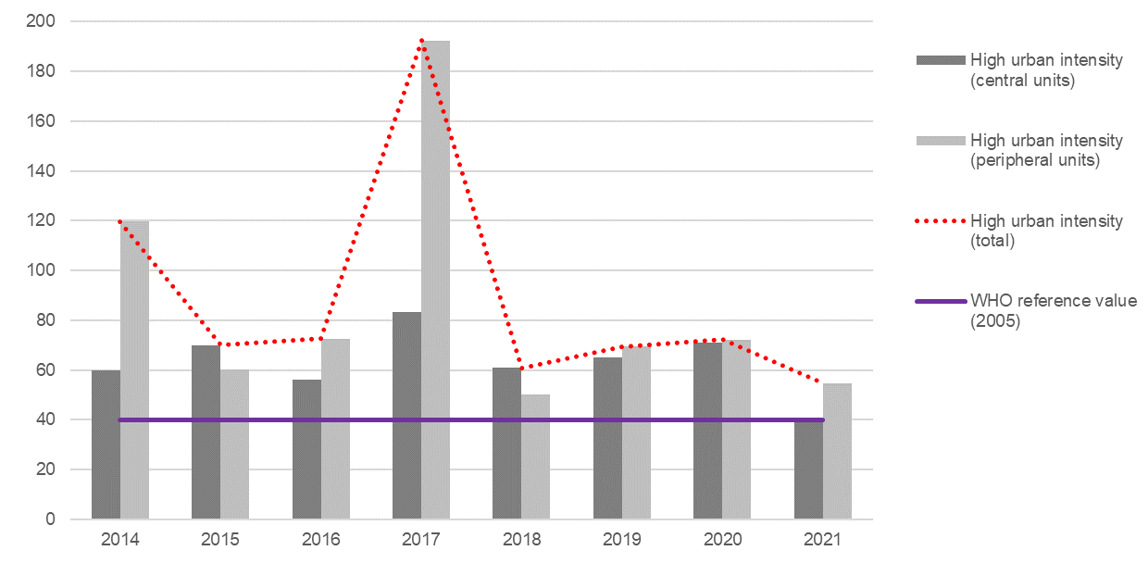
Source: Processing on MONRE data
As for the single urban areas, the maximum values of NO₂ concentrations meet the WHO reference value in Can Tho from 2018 to 2021, in Hanoi and Hai Phong throughout the period 2014-2021 (except 2015), in Da Nang from 2019 to 2021 (with a significant improvement compared to 2014-2018). The worst situation is observed in Ho Chi Minh City, where the maximum NO₂ values keep always above the WHO reference, except in 2017 and 2021 (Figure 2.47).
Figure 2.47 - Maximum values for NO₂ concentrations (annual mean) recorded in the high-urban intensity areas (*). Years 2014-2021 (estimates, µ/m³)
HA NOI  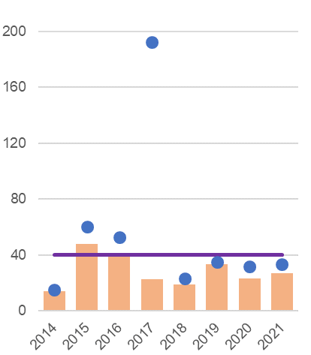 | HAI PHONG  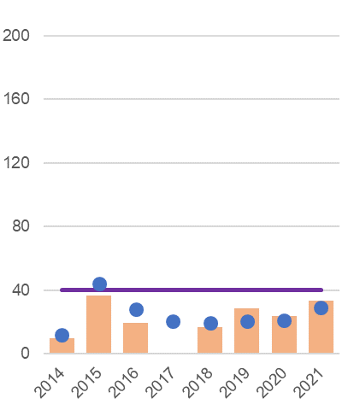 | DA NANG  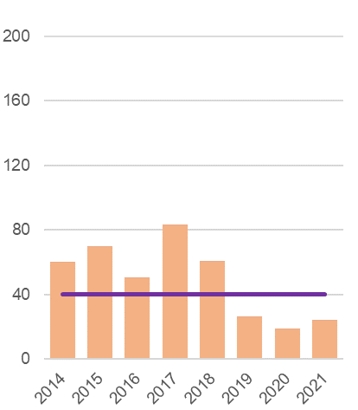
HO CHI MINH CITY  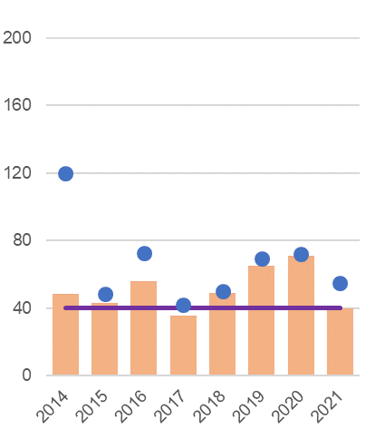 | CAN THO  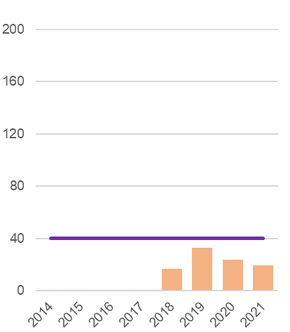
(*) Data not sufficient for Hai Phong central unit (2017) and Can Tho (2014-2017).
Source: Processing on MONRE data

Table 2.32 - Annual mean concentration of pollutants in cities: maximum values for PM₁₀, by province. Years 2015-2019 (µg/m³)
Regions  Provinces | 2015 | 2016 | 2017 | 2018 | 2019 |  | Regions  Provinces | 2015 | 2016 | 2017 | 2018 | 2019
Red River Delta |  |  |  |  |  |  | Central Highlands
Ha Noi | …. | 182 | 112 | 114 | 147 |  | Kon Tum | …. | …. | …. | …. | ….
Vinh Phuc | …. | …. | …. | 106 | …. |  | Gia Lai | …. | …. | …. | …. | ….
Bac Ninh | …. | 65 | …. | 139 | 138 |  | Dak Lak | …. | …. | …. | …. | ….
Quang Ninh | …. | 82 | …. | …. | …. |  | Dak Nong | …. | …. | …. | …. | ….
Hai Duong | …. | …. | …. | 98 | 116 |  | Lam Dong | …. | …. | …. | …. | ….
Hai Phong | …. | 80 | …. | …. | ….
Hung Yen | …. | 73 | …. | …. | …. |  | South East
Thai Binh | …. | …. | …. | …. | …. |  | Binh Phuoc | 123 | …. | …. | …. | ….
Ha Nam | …. | …. | …. | …. | …. |  | Tay Ninh | 59 | …. | …. | …. | ….
Nam Dinh | …. | …. | …. | …. | …. |  | Binh Duong | 258 | 54 | …. | …. | ….
Ninh Binh | …. | …. | …. | …. | …. |  | Dong Nai | 217 | 128 | …. | …. | ….
 |  |  |  |  |  |  | Ba Ria-Vung Tau | 80 | 61 | …. | …. | ….
Northern Midlands and Mountains |  |  |  |  |  |  | Ho Chi Minh City | 163 | 18 | …. | …. | ….
Ha Giang | …. | …. | …. | …. | ….
Cao Bang | …. | …. | …. | …. | …. |  | Mekong River Delta
Bac Kan | …. | …. | …. | …. | …. |  | Long An | 153 | 103 | …. | …. | ….
Tuyen Quang | …. | …. | …. | …. | …. |  | Tien Giang | …. | …. | …. | …. | ….
Lao Cai | …. | …. | …. | …. | …. |  | Ben Tre | …. | …. | …. | …. | ….
Yen Bai | …. | …. | …. | …. | …. |  | Tra Vinh | …. | …. | …. | …. | ….
Thai Nguyen | …. | …. | …. | …. | …. |  | Vinh Long | …. | …. | …. | …. | ….
Lang Son | …. | …. | …. | …. | …. |  | Dong Thap | …. | …. | …. | …. | ….
Bac Giang | …. | …. | …. | …. | …. |  | An Giang | …. | …. | …. | …. | ….
Phu Tho | …. | …. | …. | …. | …. |  | Kien Giang | …. | …. | …. | …. | ….
Dien Bien | …. | …. | …. | …. | …. |  | Can Tho | …. | …. | …. | …. | ….
Lai Chau | …. | …. | …. | …. | …. |  | Hau Giang | …. | …. | …. | …. | ….
Son La | …. | …. | …. | …. | …. |  | Soc Trang | …. | …. | …. | …. | ….
Hoa Binh | …. | …. | …. | …. | …. |  | Bac Lieu | …. | …. | …. | …. | ….
 |  |  |  |  |  |  | Ca Mau | …. | …. | …. | …. | ….
North-central and Central Coast
Thanh Hoa | …. | …. | …. | …. | ….
Nghe An | …. | …. | …. | …. | ….
Ha Tinh | …. | …. | …. | …. | ….
Quang Binh | …. | …. | …. | …. | ….
Quang Tri | …. | …. | …. | …. | ….
Thua Thien-Hue | …. | 97 | …. | …. | ….
Da Nang | …. | 148 | …. | …. | ….
Quang Nam | …. | 110 | …. | …. | ….
Quang Ngai | …. | 86 | …. | …. | ….
Binh Dinh | …. | 51 | …. | …. | ….
Phu Yen | …. | …. | …. | …. | ….
Khanh Hoa | …. | …. | …. | …. | ….
Ninh Thuan | …. | …. | …. | …. | ….
Binh Thuan | …. | …. | …. | …. | ….
High-urban intensity areas (central units)
High-urban intensity areas (peripheral units)
### = values above WHO 2005 reference value of 20 µg/m³ and National limit value of 50 µg/m³ for PM₁₀
Four dots (….) = values not available/not sufficient
Source: Processing on MONRE data.

Table 2.33 - Annual mean concentration of pollutants in cities: maximum values for NO₂, by province. Years 2017-2021 (µg/m³)
Regions  Provinces | 2017 | 2018 | 2019 | 2020 | 2021 |  | Regions  Provinces | 2017 | 2018 | 2019 | 2020 | 2021
Red River Delta |  |  |  |  |  |  | Central Highlands
Ha Noi | 23 | 19 | 34 | 23 | 27 |  | Kon Tum | …. | …. | …. | …. | ….
Vinh Phuc | 16 | 19 | 33 | 23 | 27 |  | Gia Lai | …. | …. | …. | …. | ….
Bac Ninh | 19 | 20 | 21 | 32 | 19 |  | Dak Lak | …. | …. | …. | …. | ….
Quang Ninh | 21 | 19 | 21 | 21 | 29 |  | Dak Nong | 14 | …. | …. | …. | ….
Hai Duong | 31 | 23 | 28 | 27 | 33 |  | Lam Dong | 15 | …. | …. | …. | ….
Hai Phong | …. | 17 | 29 | 24 | 33
Hung Yen | …. | 23 | 35 | 24 | 24 |  | South East
Thai Binh | …. | …. | …. | …. | …. |  | Binh Phuoc | …. | 26 | 41 | 35 | 26
Ha Nam | …. | …. | …. | …. | …. |  | Tay Ninh | 20 | 37 | 31 | 33 | 34
Nam Dinh | …. | …. | …. | …. | …. |  | Binh Duong | 42 | 50 | 53 | 61 | 43
Ninh Binh | …. | …. | …. | …. | …. |  | Dong Nai | 41 | 33 | 70 | 72 | 55
 |  |  |  |  |  |  | Ba Ria-Vung Tau | 34 | 28 | 55 | 55 | 38
Northern Midlands and Mountains |  |  |  |  |  |  | Ho Chi Minh City | 36 | 49 | 65 | 71 | 40
Ha Giang | …. | …. | …. | …. | ….
Cao Bang | …. | …. | …. | …. | …. |  | Mekong River Delta
Bac Kan | …. | …. | …. | …. | …. |  | Long An | 29 | 30 | 52 | 46 | 32
Tuyen Quang | …. | …. | …. | …. | …. |  | Tien Giang | …. | …. | …. | …. | ….
Lao Cai | …. | …. | …. | …. | …. |  | Ben Tre | …. | …. | …. | …. | ….
Yen Bai | …. | …. | …. | …. | …. |  | Tra Vinh | …. | …. | …. | …. | ….
Thai Nguyen | …. | …. | …. | …. | …. |  | Vinh Long | …. | …. | …. | …. | ….
Lang Son | …. | …. | …. | …. | …. |  | Dong Thap | …. | …. | …. | …. | ….
Bac Giang | …. | …. | …. | …. | …. |  | An Giang | …. | …. | …. | 25 | 23
Phu Tho | …. | …. | …. | …. | …. |  | Kien Giang | …. | 24 | 31 | 34 | 59
Dien Bien | …. | …. | …. | …. | …. |  | Can Tho | …. | 17 | 33 | 24 | 20
Lai Chau | …. | …. | …. | …. | …. |  | Hau Giang | …. | …. | …. | …. | ….
Son La | …. | …. | …. | …. | …. |  | Soc Trang | …. | …. | …. | …. | ….
Hoa Binh | …. | …. | …. | …. | …. |  | Bac Lieu | …. | …. | …. | …. | ….
 |  |  |  |  |  |  | Ca Mau | …. | 36 | 41 | 30 | 20
North-central and Central Coast
Thanh Hoa | 17 | …. | …. | …. | ….
Nghe An | 16 | …. | …. | …. | ….
Ha Tinh | 15 | 16 | 20 | 15 | 22
Quang Binh | …. | …. | …. | …. | ….
Quang Tri | …. | …. | …. | …. | ….
Thua Thien-Hue | 75 | 53 | 24 | 17 | 27
Da Nang | 83 | 61 | 27 | 19 | 24
Quang Nam | 68 | 55 | 19 | 16 | 33
Quang Ngai | 79 | 54 | 22 | 18 | 23
Binh Dinh | 76 | 55 | 20 | 17 | 21
Phu Yen | …. | …. | …. | …. | ….
Khanh Hoa | …. | …. | …. | …. | ….
Ninh Thuan | …. | …. | …. | …. | ….
Binh Thuan | …. | …. | …. | …. | ….
High-urban intensity areas (central units)
High-urban intensity areas (peripheral units)
### = values above WHO 2005 reference value/National limit value of 40 µg/m³ for NO₂;
### = values above WHO 2021 reference value of 10 µg/m³ for NO₂.
Four dots (….) = values not available/not sufficient
Source: Processing on MONRE data.

VSDG Target 11.6: Reduce adverse environmental impacts on people in urban areas, including by strengthening the management of air quality, urban waste and other sources of waste

11.6.3: Concentration of substances in the air environment

11.6.3b: Annual mean concentration of pollutants in cities: values above the WHO reference values for avoidable mortality (PM10 and NO2)
Global SDGs |  | Target 11.6: By 2030, reduce the adverse per capita environmental impact of cities, including by paying special attention to air quality and municipal and other waste management  Indicator 11.6.2: Annual mean levels of fine particulate matter (e.g. PM_{2.5} and PM₁₀) in cities (population weighted)
UNSD-CC |  | Topic: Climate change and human health  Indicator 46: Climate induced air pollution
Metadata card
Definition |  |  | Proportion of monitoring stations that report values of the mean concentration in atmosphere of PM₁₀ particulate matter and Nitrogen dioxide (NO₂) above the WHO reference values for avoidable mortality (2005), recorded in a given territory in the reference year
Glossary |  |  | Environmental monitoring stations: network systems that check the evolution of the air environment in each locality in order to report specific parameters of air quality.  Particulate matter PM₁₀: material present in the atmosphere in the form of microscopic particles, whose diameter is equal to or less than 10 µm, consisting of dust, smoke, and droplets of liquid substances.  Nitrogen dioxide (NO₂): the product of the oxidation of Nitrogen monoxide (NO) in the atmosphere. It is mostly a secondary pollutant, as it is released directly into the atmosphere only in small proportion.  WHO reference values for avoidable mortality (according to 2005 guidelines): 20 µ/m³ for PM₁₀, 40 µ/m³ for NO₂ (the WHO guidelines have been upgraded in 2021: the new reference values are 10 µ/m³ both for PM₁₀ and NO₂).
Unit of measure |  |  | %
Breakdown |  |  | By monitoring station
Data source |  |  | National statistical reporting system, Ministry of Natural Resources and Environment (MONRE)
Time series |  |  | 2014-2019 (PM₁₀), 2013-2021 (NO₂)
Frequency of updates |  |  | 1 year

Regarding the pollution from PM₁₀ particulate matter, since all observed values exceed the WHO reference value of 2005 (20 µg/m³), the result of this measure is always 100%. Given the limited number of observations available, a general assessment can be hardly provided. However, it is worth noting how, in recent years, relatively lower concentrations (up to 4 times the reference values, i.e. between 20 and 80 µg/m³) have become less frequent. The evolution is even more worrying in the peripheries of the major urban areas, where 100% of monitoring stations recorded values above 80 µg/m³ in 2017-2019. In the urban area of Ha Noi (the only one with sufficient data for a local estimate), the percentage of monitoring stations that report values above 80 µg/m³ reached 77.1% in 2017-2019 (Figure 2.48).
Even considering the National limit value of 50 µg/m³, in 2017-2019 over 80% of monitoring stations in high-urban intensity areas reported values above threshold, and 100% in the peripheral units (Table 2.34).
Figure 2.48 - Monitoring stations reporting annual mean concentrations of PM₁₀ above the WHO reference value of 20 µg/m³ in the high-urban intensity areas and in the urban area of Ha Noi. Years 2015-2019 (percentage values, 3-year moving averages. No station reported concentrations below the reference value)
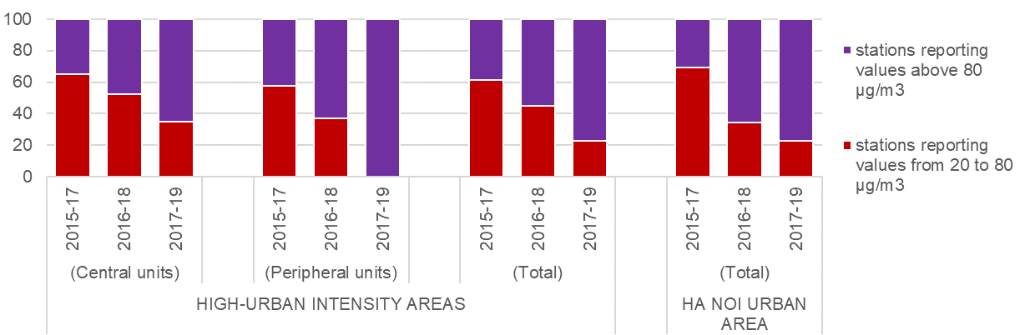
Source: Processing on MONRE data

Table 2.34 - Monitoring stations reporting annual mean concentrations of PM₁₀ above the National limit value of 50 µg/m³ in the high-urban intensity areas and in the urban area of Ha Noi. Years 2015-2019 (percentage values, 3-year moving averages)
 | 2015-2017 | 2016-2018 | 2017-2019
High-urban intensity areas | 65.0 | 78.3 | 82.6
Central units | 94.7 | 94.7 | 100.0
Peripheral units | 79.5 | 85.7 | 88.6
Ha Noi urban area (total) | 69.2 | 86.2 | 88.6
Source: Processing on MONRE data.
As regards the pollution from Nitrogen Dioxide (NO₂), an improving trend can be observed in the centres of the major urban areas, counterbalanced in the latest years by a deterioration in the peripheral areas. Considering the 2005 WHO reference value of 40 µg/m³ (identical to the National limit value), the percentages of monitoring stations located in the central units of the high-urban intensity areas, that report values of the NO₂ parameter above threshold have gradually decreased from 2013-2015 to 2019-2021. Percentages tend to increase, instead, in the peripheral units, from 2017-2019 to 2019-2021, which indicates – also in relation to this pollutant – an increasing health risk for the population living in the outskirts of the big cities (Figure 2.49).
Figure 2.49 - Monitoring stations reporting annual mean concentrations of NO₂ above the WHO reference and National limit value of 40 µg/m³ in the high-urban intensity areas. Years 2013-2021 (percentage values, 3-year moving averages)
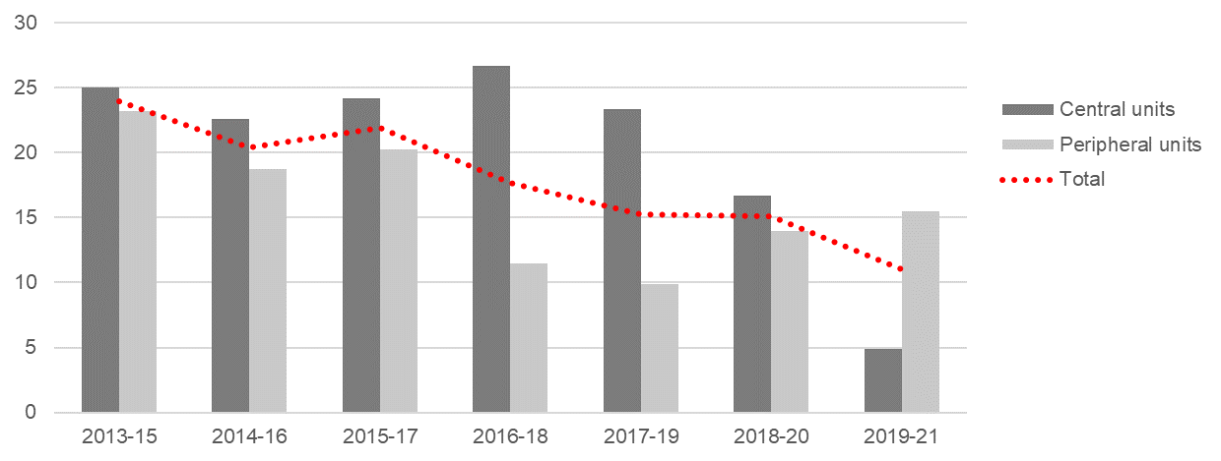
Source: Processing on MONRE data
The percentage of monitoring stations reporting annual mean values of NO₂ above threshold varies significantly among the urban areas of Ha Noi, Da Nang and Ho Chi Minh City over the observed period. The share is particularly low in Ha Noi, compared to the two other urban areas. In Da Nang, the share tends to increase from 2013 to 2017, then gradually decreases in the latest years; while in the Ho Chi Minh City area, the trend is opposite (decreasing from 2013 to 2017, then gradually increasing). According to the most recent available data, the parameter for NO₂ was reported to exceed the limit value by 1.4% of monitoring stations in Ha Noi (2017-2019), 39% in Ho Chi Minh City (2019-2021) and 27.8% in Da Nang (2018-2020) (Figure 2.50).
Figure 2.50 - Monitoring stations reporting annual mean concentrations of NO₂ above the WHO reference and National limit value of 40 µg/m³, by major urban areas (*). Years 2013-2021 (percentage values, 3-year moving averages)
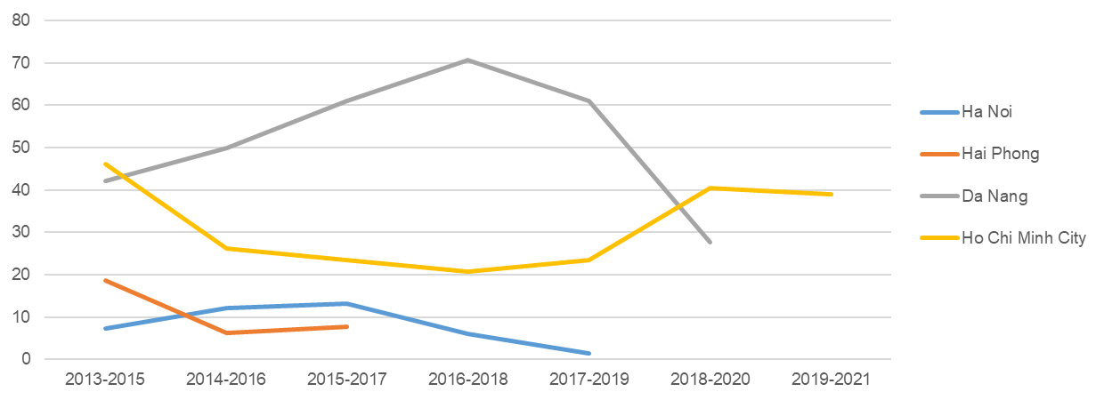
(*) Values not available/not sufficient for Can Tho, Ha Noi (from 2018-20), Hai Phong (from 2016-18) and Da Nang (2019-21).
Source: Processing on MONRE data
However, if considering the upgraded WHO reference value for NO₂ (10 µg/m³, according to the 2021 guidelines), over 90% of monitoring stations in high-urban intensity areas would be found reporting values above the new threshold set for the protection of human health (Table 2.35).
Table 2.35 - Monitoring stations reporting annual mean concentrations of NO₂ above the WHO reference values of 2005 and 2021 in the high-urban intensity areas. Years 2013-2021 (percentage values, 3-year moving averages)
 | 2013-15 | 2014-16 | 2015-17 | 2016-18 | 2017-19 | 2018-20 | 2019-21
 | 2005 GUIDELINES (40 µg/m³)
High-urban intensity areas | 23.9 | 20.4 | 21.9 | 17.7 | 15.2 | 15.1 | 11.0
Central units | 25.0 | 22.6 | 24.2 | 26.7 | 23.3 | 16.7 | 4.9
Peripheral units | 23.2 | 18.8 | 20.2 | 11.5 | 9.9 | 14.0 | 15.5
 | 2021 GUIDELINES (10 µg/m³)
High-urban intensity areas | 85.2 | 85.2 | 97.3 | 98.6 | 98.0 | 99.3 | 99.3
Central units | 81.7 | 82.3 | 95.2 | 98.3 | 96.7 | 98.3 | 98.4
Peripheral units | 87.8 | 87.5 | 98.8 | 98.9 | 98.9 | 100.0 | 100.0
Source: Processing on MONRE data.

Chapter 3.

Climate Change, Extreme Events and Disasters related statistics and indicators

This chapter is a collection of 17 cards, each presenting one of the statistical measures proposed as identical, partial or proxies for the selected UNSD Global Set of Climate Change Statistics and Indicators.
These measures, selected on criteria of availability and feasibility, refer to four of the five areas in which the Global Set of Climate Change Statistics and Indicators is organized: drivers, impacts, vulnerability, mitigation and adaptation.
Three topics are covered under the area of drivers: Total greenhouse gas emissions (with 3 indicators), Energy production, supply and consumption (3 indicators), Population (2 indicators). Five topics are covered under the area of impacts: Agricultural production affected by climate change (1 indicator), Hazardous events and disasters (2 indicators), Climate change and human health (1 indicator), Climate change evidence (1 indicator), Distribution and status of species (1 indicator). One topic is covered under the area of vulnerability: Vulnerable population (2 indicators) and one topic is covered under the area of mitigation: Climate change mitigation policies, strategies and plans (1 indicator).
Eight statistical measures are sourced directly by the GSO, in particular two by the Vietnam Household Standard Survey and one by the Population and Housing Census. Nine measures are sourced by other agencies of the National statistical reporting system, namely:
- Five by the Ministry of Natural Resources and Environment
- Two by the Ministry of Industry and Trade
- One by the Ministry of Agriculture and Rural Development
- One by the Ministry of Health.

Comparing to UNSD metadata, five indicators are Identical and twelve are Partial or Proxy. Two indicators are disaggregated by sectors, six by Socio economic regions or Provinces, one is classified by urban or rural.
Each card contains essential metadata (including a glossary of relevant terms, and general information about data sources and the main data features), statistical tables and charts, disaggregations available, and a short commentary about the present state and trends of the phenomena described.

Area | Topic | N. indicators
DRIVERS
 | Total greenhouse gas emissions | 3
 | Energy production, supply and consumption | 3
 | Population | 2
IMPACTS
 | Agricultural production affected by climate change | 1
 | Hazardous events and disasters | 2
 | Climate change and human health | 1
 | Climate change evidence | 1
 | Distribution and status of species | 1
VULNERABILITY
 | Vulnerable population | 2
MITIGATION
 | Climate change mitigation policies, strategies and plans | 1
ADAPTATION
DRIVERS | Topic:  Total greenhouse gas emissions
DRIVERS | Total greenhouse gas emissions per year  UNSD indicator 1  SDG indicator 13.2.2
METADATA CARD
Definition | Total greenhouse gas emissions per year  Greenhouse gases (GHG) are those gaseous constituents of the atmosphere, both natural and anthropogenic, that absorb and emit radiation at specific wavelengths within the spectrum of thermal infrared radiation emitted by the Earth’s surface, the atmosphere itself, and by clouds,  Emissions are the release of GHGs and/or their precursors into the atmosphere over a specified area and period of time. Removals conversely are the absorption of atmospheric GHGs by a sink. CO₂ is the only gas for which removals are estimated in the national GHG inventory.
Compare to UNSD Identical
Unit of measure | Millions tons of CO₂ equivalent
Breakdown | By sectors
Data source | The Ministry of Natural Resources and Environment - MONRE  Report on the state of the national environment for the period 2016 -2020.  National statistical reporting system
Entity in charge of data collection and aggregation | - Principal investigator: The Ministry of Natural Resources and Environment;  - Collaborator: The Ministry of Planning and Investment, the Ministry of Agriculture and Rural Development, the Ministry of Construction, the Ministry of Industry and Trade, the Ministry of Transport, People’s Committees of centrally-affiliated cities and provinces.
Time series | 1994, 2000, 2010, 2014, 2016
Frequency of updates Inventory period

Figure 1. Total greenhouse gas emissions. Years 1994, 2000, 2010, 2014 and 2016 (millions tons of CO₂ equivalent)

Source: Report on the state of the national environment for the period 2016 -2020.
During the period 1994 - 2016, the total amount of greenhouse gases in Vietnam increased by about three times, from 103.8 million to 316.7 million tons of CO₂ equivalent. In the measurement, emissions in the energy sector have increased significantly. About 8 times higher than in 1994 due to rapidly increasing energy demand. It is noteworthy that the land use, land use change and forestry (LULUCF) sector has been gradually transitioning from greenhouse gas emissions to greenhouse gas sequestration since 2010. This is the result of the programmes effective forest protection and afforestation programs were implemented in previous years.
In this period we can see that, the trends of GHG and GDP are very different. GDP increased sharply while GHG increase slightly. It shows that Vietnam has well and synchronously implemented solutions to protect the environment in the process of socio-economic development.
Table 1. Total greenhouse gas emissions. Years 1994, 2000, 2010, 2014 and 2016 (millions tons of CO₂ equivalent)
Year | Energy | Industry and construction | Agriculture | LULUCF | Waste | Total
1994 | 25.6 | 3.8 | 52.0 | 19.4 | 2.6 | 103.8
2000 | 52.2 | 10.0 | 65.1 | 15.1 | 7.9 | 150.9
2010 | 146.2 | 21.7 | 87.6 | -20.7 | 17.9 | 252.7
2014 | 171.6 | 38.6 | 89.7 | -37.5 | 21.5 | 283.9
2016 | 205.8 | 46.1 | 44.1* |  | 20.7 | 316.7
(*) According to Vietnam's 3rd biennial update report (BUR 3) submitted to the UNFCCC in 2021, greenhouse gas emissions from the agricultural sector and the LULUCF sector (land use, land use change) and forestry) are merged into the AFOLU (agriculture, forestry and land use) sector.
Source: MONRE - Report on the state of the national environment for the period 2016 -2020.

DRIVERS | Topic:  Total greenhouse gas emissions
DRIVERS | Greenhouse gas emissions from land use, land use change and forestry  UNSD indicator 3  FDES indicator 3.1.1.a
METADATA CARD
Definition | Greenhouse gas emissions from land use, land use change and forestry  GHG emissions and removals produced in land use, land use change and forestry (LULUCF), as defined by the relevant IPCC Guidelines for National Greenhouse Gas Inventories.
Compare to UNSD Partial
Unit of measure | Millions tons of CO₂ equivalent
Data source | The Ministry of Natural Resources and Environment - MONRE  National statistical reporting system
Entity in charge of data collection and aggregation | - Principal investigator: The Ministry of Natural Resources and Environment;  - Collaborator: The Ministry of Planning and Investment, the Ministry of Agriculture and Rural Development, the Ministry of Construction, the Ministry of Industry and Trade, the Ministry of Transport, People’s Committees of centrally-affiliated cities and provinces.
Time series | 1994, 2000, 2010, 2014, 2016
Frequency of updates Inventory period

Figure 1. Total greenhouse gas emissions by agriculture, LULUCF, and AFOLU. Years 1994, 2000, 2010, 2014 and 2016 (millions tons of CO₂ equivalent)

Source: MONRE - Report on the state of the national environment for the period 2016 -2020.
(2016): According to Vietnam's 3rd biennial update report (BUR 3) submitted to the UNFCCC in 2021, greenhouse gas emissions from the agricultural sector and the LULUCF sector (land use, land use change) and forestry) are merged into the AFOLU (agriculture, forestry and land use) sector.
It is noteworthy that the land use, land use change, and forestry (LULUCF) sector has been gradually transitioning from greenhouse gas emissions to greenhouse gas sequestration since 2010. In 1994, greenhouse gas emissions from LULUCF were 19.4 million tons of CO₂ equivalent, and in 2014, this area absorbed 37.5 million tons of CO₂ equivalent. This is the result of the programs effective forest protection and afforestation programs that were implemented in previous years.
DRIVERS | Topic:  Total greenhouse gas emissions
DRIVERS | Greenhouse gas emissions per capita  UNSD indicator 5
METADATA CARD
Definition | Greenhouse gas emissions per capita  The indicator measures the total direct greenhouse gas (GHG) emissions (excluding LULUCF) divided by the population of the country.
Compared to UNSD Identical
Unit of measure | Tons of CO₂ equivalent/capita
Data source | GSO - General Statistics Office processing on The Ministry of Natural Resources and Environment (MONRE).  National statistical reporting system.
Entity in charge of data collection and aggregation | - Principal investigator: The Ministry of Natural Resources and Environment;  - Collaborator: The Ministry of Planning and Investment, the Ministry of Agriculture and Rural Development, the Ministry of Construction, the Ministry of Industry and Trade, the Ministry of Transport, People’s Committees of centrally-affiliated cities and provinces.
Time series | 1994, 2000, 2010, 2014, 2016
Frequency of updates Inventory period

Figure 1: Total greenhouse gas emissions per capita. Years 1994, 2000, 2010, 2014 and 2016 (tons of CO₂ equivalent/capita)

Source: GSO processing on The Ministry of Natural Resources and Environment (MONRE).
From 1994 to 2016, total greenhouse gas emission per capita increased from 1.2 to 3.4 tons of CO₂ equivalent/capita.
Vietnam is a country with low total greenhouse gas emissions, classified as a country with no obligation to reduce greenhouse gas. According to statistics from countries greenhouse gas emission reports to the United Nations Framework Convention on Climate Change (UNFCCC) secretariat and the United States World Resources Institute (WRI), total emissions Vietnam's greenhouse gas currently accounts for about 0.5% of the total global emissions, ranking 33rd out of 195 countries participating in the Convention. However, in terms of emissions per capita, Vietnam ranks 125th in the world with 3.4 tons of CO₂ equivalent/person in 2016.
.

Table 1: Total greenhouse gas emissions per capita. Years 1994, 2000, 2010, 2014 and 2016 (thousand tons of CO₂ equivalent/capita).
Year | Population (thousand of people) | GHG (thousand tons of CO₂ equivalent) | Total greenhouse gas emissions per capita (tons of CO₂ equivalent/capita)
1994 | 70,824.5 | 84,4593 | 1.2
2000 | 77,635.4 | 135,795.1 | 1.7
2005 | 82,392.1 | 185,496.3 | 2.3
2010 | 87,067.3 | 264,210.7 | 3,0
2013 | 90,191.4 | 293,263.9 | 3.3
2014 | 91,203.8 | 278,660.7 | 3.1
2016 | 93,250.7 | 316,735.0 | 3.4
Source: - GHG: Report on the state of the national environment for the period 2016 -2020.
- Population: GSO .
- GSO processing on The Ministry of Natural Resources and Environment (MONRE).

Topic:
Energy production, supply and consumption

Total primary energy supply from fossil fuels
UNSD indicator 11
METADATA CARD
Definition | Total primary energy supply  Sum of production and imports minus exports and changes in storage
Compared to UNSD | Partial
Unit of measure | Petajoule (PJ)
Data source | Statistics report of Ministry of Industry and Trade
Time series | 2010-2020
Frequency of updates | Annual
Glossary | Energy is a special form of material and material, which exists in many different forms (physical form such as coal, firewood, charcoal, oil, gas and intangible form such as electricity, wind power) ...), when consumed, it will generate a certain heat energy or the ability to generate work through the power transmission system
 | Primary energy is energy contained in natural resources, such as oil, natural gas, coal...
Figure 1 – Total primary energy supply. Years 2010-2020 (PJ)

Source: Statistics report of Ministry of Industry and Trade
During the period 2010 – 2020, the total primary energy supply in Vietnam increased rapid, nearly two time: from 634.3 PJ in year 2010 to 1,194.8 PJ in year 2020.
In the period 2010-2019, the growth rate of total primary energy supply in 2018/2017 was the highest (11.4%), in 2020/2019 the lowest (2.8%). This shows that the greening in energy use in recent years tends to increase.

Topic:
Energy production, supply and consumption

Share of fossil fuels in total primary energy supply
UNSD indicator 12

METADATA CARD
Definition | Share of fossil fuels in total primary energy supply
Compared to UNSD | Identical
Unit of measure | %
Data source | Ministry of Industry and Trade
Time series | 2010-2020
Frequency of updates | Annual
Figure 1. Share of fossil fuels in total primary energy supply. Years 2010-2020 (%)

Source: Ministry of Industry and Trade

The share of fossil fuels in the total primary energy supply tends to decrease over the years. In 2010, the proportion of fossil fuels in the total primary energy supply was 43.2%, by 2020 this proportion decreased to 25.3%. This shows that the trend of using “clean” energy tends to increase.
Overall, in the period 2010-2020, the share of fossil fuels in the total primary energy supply decreased by 17.9 percentage points.
Glossary | Energy is a special form of matter and matter, existing in many different forms (physical form such as coal, firewood, charcoal, oil, gas and intangible form such as electricity, wind power) ...), when consumed, it will generate a certain heat energy or the ability to generate work through the power transmission system.
Glossary | Primary energy is the energy contained in natural resources, such as oil, natural gas, coal...

Topic:
Energy production, supply and consumption

Final energy consumption per capita
UNSD indicator 13

METADATA CARD
Definition | Energy consumption per capita  Value of energy used for production and daily life needs in 1 year per capita of households.
Calculation formula:
Energy consumption by households per capita = (Total value of energy consumed by households in 1 year)/(Total population)
Compared to UNSD | Proxy
Unit of measure | 1000 VND
Data source | GSO - General Statistics Office  Vietnam household living standard survey
Time series | 2016, 2018, 2020
Frequency of updates | 2 years

Figure 1 - Energy consumption per capita. Years 2016, 2018, 2020 (1000 VND)

Source: GSO - Vietnam household living standard survey
According to calculations from the results of the Vietnam Household Living Standards Survey, Vietnam's energy consumption per capita tends to increase. Energy consumption per capita increased from 4,020 thousand VND in 2016 to 6,468 thousand VND in 2020.
The energy consumption per capita through the data of 2016, 2018, 2020 shows that the increase in energy consumption per capita gradually decreases over the years: in 2018 compared to 2016 it increased by 1,352 thousand VND; in 2020 compared to 2018 increased by 1,097 thousand VND.
The growth rate of energy consumption per capita in 2018 compared to 2016 was 33.6%; in 2020 compared to 2018 is 20.4%, down 13.2 percentage points compared to the previous year.
Glossary | Energy is a special form of material, which exists in many different forms (physical form such as coal, firewood, charcoal, oil, gas and intangible form such as electricity, wind power ...), when consumed, it will generate a certain heat energy or the ability to generate work through the power transmission system.
Glossary | Energy sources include:  - Electricity;  - Coal (also known as hard coal;  - Briquette/honeycomb;  - Gasoline;  - Kerosene;  - Diesel oil (DO;  - Fuel oil (FO);  - Liquefied petroleum gas (LPG);  - Natural gas;  - Firewood.

DRIVERS | Topic:  Population
DRIVERS | Population growth  UNSD indicator 17
METADATA CARD
Definition | Population  Population refers to the collection of people living in the same country, region, geographically economic region or administrative subdivision.
Compare to UNSD | Identical
Unit of measure | Thousands of people
Data source | GSO - General Statistics Office
Time series | 1994, 2000, 2005 2013 2014, 2016 – 2021
Frequency of updates Annual

Figure 1. Population. Years 1994, 2000, 2005, 2013, 2014, 2016 – 2021 (thousands of people)

Source: GSO
Vietnam's population increased by 1.3 times from 70,824.5 thousand people in 1994 to 93,250.7 thousand people in 2016. After 2016, from 2017 to 2021, the population of Vietnam increases steadily, approximately 1 million people per year. From 94,29 million people in 2017 to 98,51 million in 2021. In 2021, out of 10 asian countries, Vietnam is the third most populous country, behind Indonesia (275 million people) and the Philippines (110.2 million people).

Table 1. Population. Years 1994, 2000, 2005, 2010, 2014, 2016 - 2021 (thousands of people)
Year | Population (thousands of people)
1994 | 70,824.5
2000 | 77,635.4
2005 | 82,392.1
2010 | 87,067.3
2013 | 90,191.4
2014 | 91,203.8
2016 | 93,250.7
2017 | 94,286.0
2018 | 95,385.2
2019 | 96,484.0
2020 | 97,582.7
2021 | 98,506.2

Source: GSO – Years book
DRIVERS | Topic:  Population
DRIVERS | Urban population as a proportion of total population  UNSD indicator 18
METADATA CARD
Definition | Urban population as a proportion of total population  City-dwelling population refers to all inhabitants living in 5-class through special-class cities.
Compare to UNSD | Identical
Unit of measure | %
Data source | GSO - General Statistics Office
Time series | 1994, 2000, 2010 – 2021
Frequency of updates Annual

Figure 1. Urban population as a proportion of total population (%)

Source: GSO – Years book

The growth of the urban population as a proportion of total population from 1994 to 2020 is 1.78 times and it is faster than the growth of the population in the same period, 1.37 times. Up to 2021, the propotion of urban population increased to 37.1%. This means the growth of the urban population as a proportion of the total population from 1994 to 2021 is nearly 1.82 times.

Table 1: Urban population as a proportion of total population in years 1994, 2000 and from 2010 to 2021 (%)
 | Popolation (thousands of people) | Urban population (thousands of people) | Urban population as a proportion of total population (%)
1994 | 70.825 | 14.426 | 20,4%
2000 | 77.635 | 18.772 | 24,2%
2010 | 86.748 | 25.924 | 29,9%
2011 | 87.611 | 26.780 | 30,6%
2012 | 88.527 | 28.569 | 32,3%
2013 | 89.479 | 28.859 | 32,3%
2014 | 90.493 | 29.939 | 33,1%
2015 | 91.710 | 31.068 | 33,9%
2016 | 92.696 | 31.926 | 34,4%
2017 | 93.678 | 32.823 | 35,0%
2018 | 95.385 | 33.830 | 35,5%
2019 | 96.484 | 33.817 | 35,0%
2020 | 97.583 | 35.867 | 36,8%
2021 | 98.506 | 36.565 | 37,1%

Source: GSO - Years book

IMPACTS | Topic:  Dangerous events and disasters
IMPACTS | Direct agricultural loss attributed to disasters  UNSD indicator 27  SDG: 11.5.2  Sendai: C-2
METADATA CARD
Definition | Agricultural damage directly caused by natural disasters  A natural disaster is a natural disaster such as hurricane, hurricane, flood, tornado, earthquake, gypsum, force, monopoly, tsunami, volcano, lightning, rain, frost, volcano, lightning, rain, hot frost, drought.  Agricultural damage directly caused by natural disasters is that the area of damaged rice and flowers that cannot be harvested is directly caused by natural disasters.
Compare to UNSD | Proxy
Unit of measure | Ha
Breakdown | Rice and Crops, socio economic regions
Data source | GSO - General Statistics Office  Statistical reporting regime of provincial/city Statistical Offices
Time series | 2015-2021
Frequency of updates | Annual

Figure 1. Agricultural damage directly caused by natural disasters, by rice and crops. Years 2015-2021 (Ha)

Source: GSO

Figure 2. Area of rice damaged by natural disasters by socio economic regions. Years 2015-2021 (Ha)

Source: GSO

From 2015 to 2021, natural disasters damaged 1,230 thousand hectares of rice. The river delta and the long river delta suffer the most damage to rice, and these are also the two regions with the largest rice production in the country.

Figure 3. Area of crops damaged by natural disasters by socio economic regions. Years 2015-2021 (Ha)

Source: GSO

From 2015 to 2021 natural disasters damage 558.5 thousand hectares of crops. The North Central Coast and Central Coast are the most affected areas.
In 2020, natural disasters occurred unusually, abnormally, fiercely, especially, from mid-September to mid-November 2020, storms and floods continuously occurred in the Central region with very strong intensity, on a large scale, causing a lot of damage to agriculture, severely affecting the lives and production of millions of people in the area.

Table 1. Area of rice damaged by natural disasters by socio economic regions. Years 2015-2021 (Ha)

 | 2015 | 2016 | 2017 | 2018 | 2019 | 2020 | 2021
Whole country | 56,894.1 | 264,390.1 | 233,957.3 | 203,580.4 | 72,630.4 | 268,984.0 | 130,337.0
Red River Delta | 7,147.1 | 167,530.3 | 158,578.9 | 76,556.8 | 20.0 | 12,583.6 | 21,935.6
Northern midlands and Mountain areas | 24,385.3 | 20,197.6 | 14,927.2 | 18,804.5 | 4,750.9 | 10,507.2 | 4,257.1
Northern Central area and Central coastal area | 24,959.9 | 63,396.0 | 47,273.5 | 85,322.0 | 38,731.1 | 44,564.7 | 75,933.5
Central Highlands | - | 7,844.5 | 4,998.7 | 2,231.8 | 14,034.5 | 20,073.5 | 15,882.1
South East | - | 1,522.4 | 90.0 | 4,179.6 | 2,897.9 | 296.2 | 1,682.9
Mekong River Delta | 401.8 | 3,899.2 | 8,089.0 | 16,485.7 | 12,196.1 | 180,958.8 | 10,645.8
Source: GSO

Table 2. Area of crops damaged by natural disasters by socio economic regions. Years 2015-2021 (Ha)

 | 2015 | 2016 | 2017 | 2018 | 2019 | 2020 | 2021
Whole country | 26,753.2 | 105,551.3 | 130,553.2 | 56,748.2 | 25,493.4 | 134,932.6 | 78,466.0
Red River Delta | 5,952.8 | 29,011.9 | 36,007.5 | 8,651.9 | 10.8 | 11,754.2 | 7,835.6
Northern midlands and Mountain areas | 11,787.0 | 14,613.8 | 12,647.0 | 10,193.1 | 6,154.6 | 13,231.5 | 3,185.9
Northern Central area and Central coastal area | 8,518.0 | 45,140.2 | 61,398.0 | 34,718.2 | 12,324.4 | 39,946.0 | 27,003.9
Central Highlands | 260.0 | 16,221.1 | 19,799.6 | 813.6 | 6,249.5 | 47,687.9 | 33,738.0
South East | 90.0 | 511.0 | 637.3 | 1,681.7 | 322.6 | 114.2 | 161.8
Mekong River Delta | 145.4 | 53.3 | 63.8 | 689.7 | 431.5 | 22,198.8 | 6,540.9
Source: GSO
IMPACTS | Topic:  Dangerous events and disasters
IMPACTS | Direct economic loss to all damaged or other destroyed productive assets caused by the disaster  UNSD indicator 40  SDG: 11.5.2  Sendai: C-3
METADATA CARD
Definition | Estimated damage in cash directly caused by the disaster  A natural disaster is a disaster caused by nature such as storm, flood, flood, whirlwind, earthquake, landslide, storm surge, saltwater intrusion, tsunami, volcano, lightning strike, hail, frost, heat, drought,...  Estimated cash loss caused by a direct disaster is the sum of all estimated losses in Vietnam dong due to a direct disaster in a specified year.
Compare to UNSD | Proxy
Unit of measure | Billion.VND
Breakdown | Socio economic regions
Data sources | GSO - General Statistics Office  Statistical reporting regime of provincial/city Statistical Offices
Time series | 2015-2021
Frequency of updates | Annual

Figure 1. Estimated cash loss. Years 2015-2021 (Billion VND)

Source: GSO
In 7 years from 2015 to 2021 , the estimated cash value caused by natural disasters is up to VND 150.2 trillion. 2017 was the year with the largest loss of natural disasters, with a total cash value of up to VND 60 trillion, accounting for 1.2% of the country's GDP in 2017.
Figure 2. Estimated cash loss by socio economic regions. Years 2015-2021 (Billion VND)

Source: GSO

North Central and Central Coast regions are the most estimated total losses in cash in the whole country.
In 2017, natural disasters occurred seriously, with complicated developments, many large natural disasters of historical level, anomalous nature, difficult to forecast and warn, causing damage of more than 60,000 billion VND. This is a record year when 16 storms and 6 tropical depressions entered the East Sea. In which, two particularly serious storms are typhoon No. 10 (Doksuri) that hit the North Central Coast and No. 12 (Damrey) in the South Central provinces. 2017 was the year with many natural disasters causing the most property loss in years, especially in the central coastal region, the total damage was estimated at nearly 1% of the country's GDP. Physical damage is mainly caused by natural disasters such as floods and storms. The floods that cause these disasters mainly occur in the northern mountainous areas and the Central Coast.
In 2020, natural disasters occurred irregularly, abnormally, fiercely. Especially, from mid-September to mid-November 2020, storms and floods occurred consecutively in the central region with very strong intensity, on a large scale, causing damage of about 30,4 trillion VND, severely affecting the lives and production of millions of people in the area.

Table 1. Estimated value of damage in cash by socio economic regions. Years 2015 - 2021 (Billion.VND)

Year | 2015 | 2016 | 2017 | 2018 | 2019 | 2020 | 2021
Whole country | 5,362.3 | 18,912.8 | 60,070.0 | 15,765.8 | 6,206.8 | 39,066.9 | 4,876.9
Red River Delta | 2,948.0 | 7,366.0 | 5,648.0 | 1,894.0 | 25.0 | 213.0 | 253.0
Northern midlands and Mountain areas | 1,249.0 | 1,391.0 | 7,545.0 | 5,683.0 | 566.0 | 1,170.0 | 259.0
Northern Central area and Central coastal area | 1,042.0 | 9,788.0 | 45,142.0 | 7,659.0 | 4,235.0 | 30,432.0 | 3,387.0
Central Highlands | 38.0 | 235.0 | 1,585.0 | 125.0 | 960.0 | 2,668.0 | 359.0
South East | 21.0 | 104.0 | 42.0 | 52.0 | 172.0 | 41.0 | 278.0
Mekong River Delta | 64.0 | 28.0 | 109.0 | 352.0 | 248.0 | 4,543.0 | 341.0
Source: GSO

IMPACTS | Topic:  Dangerous events and disasters
IMPACTS | Number of deaths, missing persons and directly affected persons attributed to disasters per 100,000 population  UNSD indicator 42  SDG: 11.5.1  Sendai: A-1
METADATA CARD
Definition | Number of people dead and missing due to natural disasters  Number of people dead, missing due to a natural disaster is the total number of people killed, missing due to a natural disaster in a specified year.
Compare to UNSD Partial
Unit of measure | Number of persons
Breakdown | Socio economic regions
Data source | GSO - General Statistics Office  Statistical reporting regime of provincial/city Statistical Offices
Time series | 2015-2021
Frequency of updates | Annual
Glossary | A natural disaster is a disaster caused by nature such as storm, flood, flood, whirlwind, earthquake, landslide, storm surge, saltwater intrusion, tsunami, volcano, lightning strike, hail, frost, heat, drought.  Dead people are those who died directly from natural disasters, excluding those who died from other causes during the time the natural disaster occurred in the locality.  Missing person is a person who cannot be found after a natural disaster, may have died but has not found the body or has no information. After one year, the missing person is considered dead.

Figure 1- Number of people dead and missing due to natural disasters. Years 2015-2021 (Number of Persons)

Source: GSO

From 2015 to 2021 natural disasters made 1,664 people dead and missing. In year 2017 and 2020 were the years with the highest number of dead and missing people, respectively are 389 people and 377 people.

Figure 2. Number of people dead and missing due to natural disasters by socio economic regions. Years 2015-2021 (Number of Persons)

Source: GSO

The Northern Midlands and Mountains areas and the North Central Region and Central Coastal areas are the regions with the highest number of dead and missing people in the whole country. The number of dead and missing people in these two regions from 2015 to 2021 accounts for 85% of the total number of dead and missing people in the country. The number of missing people is mainly due to natural disasters such as lightning storms, floods and storms, which mainly occur in the northern mountainous areas and the Central Coast.
In 2017, Vietnam suffered from a series of natural disasters that left 389 people dead or missing. This is a record year when 16 storms and 6 tropical depressions entered the East Sea. In which, two particularly serious storms are typhoon No. 10 (Doksuri) that hit the North Central Coast and No. 12 (Damrey) in the South Central provinces.
In 2020, natural disasters occurred irregularly, abnormally, fiercely… Storms and floods occurred consecutively in the central region with very strong intensity. on a large scale, caused great damage to people (377 dead and missing) and property, severely affecting the lives and production of millions of people.

Table 1. Number of people dead and missing due to natural disasters, by socio economic regions. Years 2015-2021 (Number of Persons)
 | 2015 | 2016 | 2017 | 2018 | 2019 | 2020 | 2021
Whole country | 157 | 252 | 389 | 218 | 132 | 377 | 139
Red River Delta | 26 | 10 | 5 | 2 | 5 | 11 | 11
Northern midlands and Mountain areas | 62 | 77 | 174 | 111 | 54 | 54 | 34
Northern Central area and Central coastal area | 55 | 144 | 197 | 86 | 52 | 272 | 57
Central Highlands | 7 | 6 | 6 | 11 | 5 | 16 | 13
South East | 2 | 10 | 4 | 3 | 5 | 7 | 4
Mekong River Delta | 5 | 5 | 3 | 5 | 11 | 17 | 20
Source: GSO

IMPACTS | Topic:  Climate change and human health
IMPACTS | Number of cases of climate-related infectious diseases  UNSD indicator 44
METADATA CARD
Definition | Number of case of infectious diseases  Infectious Disease: A disease that is transmitted directly or indirectly from person to person or from animals to humans by an infectious agent.
Definition | Calculation method: record the number of infectious cases nationwide by type of infectious disease.
Compared to UNSD | Proxy
Unit of measure | Number of cases and deaths
Breakdown | Total, infectious disease
Data source | Ministry of Health - Report
Entity in charge of data collection and aggregation | GSO - General Statistics Office processing on Ministry of Health
Time series | 2015 - 2021
Frequency of updates | Annual
Figure 1. Number of cases and deaths of infectious, Dengue fever.Years 2015-2021 (Number)

Source: GSO processing on Report of Ministry of Health

In the period 2015-2021, year 2019 recorded the highest number of dengue fever cases with 320,702 infections and 53 deaths due to dengue. The year 2015 had the lowest number of infections (81,441 cases), but the number of deaths recorded ranked second in the whole period (52 deaths).

Figure 2. Number of cases and deaths of infectious hand, foot and mouth disease. Years 2015-2021 (Number )

Source: GSO processing on Report of Ministry of Health

In the period 2015-2021, 2018 recorded the highest number of hand, foot and mouth infections with 127401 cases and 6 deaths. In 2021, although the number of cases is the lowest in the whole period (38413 cases), the number of deaths due to hand, foot and mouth disease is the highest (11 deaths).

Figure 3. Number of cases and deaths of infectious measles-like rash. Years 2015-2021 (Number)

Source: GSO processing on Report of Ministry of Health

In the period 2015-2021, 2019 recorded the highest number of cases of typhus suspected of measles with 42,986 cases with 3 deaths. Followed by 2018 recorded 7,417 cases with 1 death.
In the period 2015-2021, dengue fever caused 1,007,691 case of and 240 deaths.

Glossary | Infectious agent: A virus, bacteria, parasites and fungi capable of causing infectious diseases
Glossary | Usually each infectious disease is caused by a pathogen. In isolated cases, it can be caused by two or more pathogens (Malaria caused by P.falciparum + P.vivax combination…).
Glossary | Disease vectors: Insects, animal, environment, food and other objects that carry pathogens that are infectious and capable of transmitting disease.
 | A person can have an infectious disease more than once. each case is counted as a case of infectious disease.

Among climate-related infectious diseases in the years 2015-2021, the most common was the number of dengue fever cases, followed by the number of hand, foot and mouth disease cases, the number of viral encephalitis cases, the number of cases of typhoid, the number of cases of meningococcal meningitis. In particular, in 2018 there was an outbreak of influenza (H1N1) and B cases; 2017 and 2018 outbreaks of whooping cough and swine streptococcus.
The year 2018 recorded the highest number of deaths from influenza A (H1N1) and B in the period 2015 - 2021. In addition to the number of deaths due to influenza mentioned above, among the remaining infectious diseases in the period 2015 -2021, dengue fever and viral encephalitis are two diseases with higher death toll than other diseases. Cholera, influenza A (H5N1), typhoid, zika virus disease did not record any deaths due to the disease

Table 1. Number of cases and deaths of infectious diseases. Years 2015-2021 (number)
 | Disease | 2015 | 2016 | 2017 | 2018 | 2019 | 2020 | 2021
1 | Number of cases of cholera | 0 | 1 | 0 | 0 | 0 | 0 | 0
1.1 | Number of people who died from cholera | 0 | 0 | 0 | 0 | 0 | 0 | 0
2 | Number of people infected with diphtheria | 0 | 0 | 0 | 0 | 0 | 242 | 0
2.1 | Number of people who died from diphtheria | 0 | 0 | 0 | 0 | 0 | 5 | 0
3 | Number of cases of influenza A (H5N1) | 0 | 0 | 0 | 0 | 0 | 0 | 0
3.1 | Number of deaths from influenza A (H5N1) | 0 | 0 | 0 | 0 | 0 | 0 | 0
4 | Dengue fever cases | 81,441 | 106,256 | 175,795 | 125,173 | 320,702 | 128,970 | 69,354
4.1 | Number of deaths due to dengue fever | 52 | 36 | 38 | 16 | 53 | 23 | 22
5 | Number of cases of meningococcal meningitis | 131 | 59 | 53 | 33 | 27 | 11 | 14
5.1 | Number of deaths from meningococcal meningitis | 5 | 5 | 3 | 2 | 1 | 0 | 2
6 | Number of cases of viral encephalitis | 924 | 962 | 720 | 760 | 578 | 622 | 536
6.1 | Number of deaths due to viral encephalitis | 26 | 34 | 26 | 21 | 14 | 11 | 10
7 | Number of cases of hand, foot and mouth disease | 57,039 | 47,457 | 102,719 | 127,401 | 103,942 | 78,063 | 38,413
7.1 | Number of deaths due to hand, foot and mouth disease | 6 | 1 | 0 | 6 | 1 | 1 | 11
8 | Number of cases of typhoid | 376 | 469 | 630 | 628 | 0 | 0 | 0
8.1 | Number of deaths due to typhoid | 0 | 0 | 0 | 0 | 0 | 0 | 0
9 | Measles-like rash | 0 | 0 | 0 | 7,417 | 42,986 | 3,311 | 509
9.1 | Number of positive cases | 0 | 0 | 0 | 1,552 | 8,313 | 307 | 77
9.2 | Number of people who died from typhus suspected of measles | 0 | 0 | 0 | 1 | 3 | 0 | 0
10 | Zika virus disease | 0 | 0 | 39 | 2 | 0 | 0 | 0
10.1 | Number of deaths due to zika virus | 0 | 0 | 0 | 0 | 0 | 0 | 0
11 | Whooping cough disease | 0 | 0 | 653 | 673 | 0 | 0 | 0
11.1 | Number of people who died from whooping cough | 0 | 0 | 5 | 2 | 0 | 0 | 0
12 | Swine Streptococcal Disease | 0 | 0 | 164 | 77 | 0 | 0 | 0
12.1 | Number of deaths due to swine streptococcus | 0 | 0 | 14 | 6 | 0 | 0 | 0
13 | Number of cases of influenza A (H1N1) and B | 0 | 0 | 0 | 7,876 | 0 | 0 | 0
13.1 | Number of people who died from flu | 0 | 0 | 0 | 3,040 | 0 | 0 | 0
Source: GSO processing on Report of Ministry of Health

IMPACTS | Topic:  Climate change evidence
IMPACTS | Temperature records  UNSD indicator 53

METADATA CARD
Definition | Temperature records  Recorded daily average temperature
Compare to UNSD | Partial
Unit of measure | ºC
Breakdown | 11 monitoring stations ((limited coverage)
Data source | GSO - General Statistics Office processing on The Ministry of Natural Resources and Environment
Time series | 1971 - 2001 and 2002 - 2020
Frequency of updates Annual

Figure 1. Mean temperatures. Years 1971-2001 and years 2002-2020 (ºC)

Source: General Statistics Office processing on The Ministry of Natural Resources and Environment (MONRE).
Note: We calculated the mean temperatures of each period for and compare the difference among them.

For the selected meteorological monitoring stations in Viet Nam, mean temperatures have been analyzed by comparing the two periods 1971 - 2001 and 2002 - 2020. The analysis shows an increase in average temperature in almost all monitoring stations, excluding Lai Chau and Quy Nhon in which a decrease of about 1⁰C can be observed. The highest increase in temperature is in HaNoi (Lang), 1⁰C. Follow it by Vinh, 0.9⁰C. The temperature in Hue is unchanged during this time.
Table 1. Mean temperatures. Years 1971-2001 and 2000-2020 (ºC)
Monitoring station | Mean temperature |  | Difference
Monitoring station | 1971 - 2001 | 2002 - 2020 | Difference
Lai Chau | 23.0 | 21.9 | -1.0
Son La | 21.1 | 21.7 | 0.6
Tuyen Quang | 23.3 | 24.0 | 0.7
Ha Noi (Lang) | 23.7 | 24.7 | 1.0
Bai Chay | 23.1 | 23.8 | 0.7
Vinh | 24.0 | 24.8 | 0.9
Hue | 25.1 | 25.1 | 0.0
Đa Nang | 25.7 | 26.2 | 0.5
Quy Nhon | 27.1 | 25.9 | -1.2
Pleiku | 21.7 | 22.4 | 0.7
Ca Mau | 27.0 | 27.7 | 0.7
Source: General Statistics Office processing on The Ministry of Natural Resources and Environment

IMPACTS | Topic  Distribution and status of species
IMPACTS | Rate of invasive alien species spread  UNSD indicator 65  SDG indicator 15.8.1
METADATA CARD
Definition | Rate of invasive alien species spread  Invasive alien flora and fauna species:  - Encroaching on habitats, competing for food or harming native organisms, spreading widely or causing ecological imbalance where they appear and develop in Vietnam.  - Assessed as having a high risk of harm to biodiversity and recorded as invasive in an area with a climate similar to that of Vietnam or through testing and testing showing signs of invasiveness.
Compare to UNSD Proxy
Unit of measure | Number of species
Data source | The Ministry of Natural Resources and Environment
Entity in charge of data collection and aggregation | - Principal investigator: The Ministry of Natural Resources and Environment.  - Collaborator: The Ministry of Agriculture and Rural Development.
Time series | 2011, 2013, 2018
Frequency of updates Occasionaly

Figure 1. Invasive alien species. Years 2011, 2013, 2018 (number)

Source: MONRE
In Vietnam, the number of invasive alien species has decreased very rapidly, from 33 species in 2011 to 19 species in 2018 (14 species reduction), this is a remarkable effort in protecting the need by the ecosystem of Vietnam.

Glossary:
The Law on Biodiversity No. 20/2008/QH12 was approved by the National Assembly on November 13rd, 2008.
The Law on Biodiversity No. 32/VBHN-VPQH was approved by the National Assembly on December 10th, 2018
Law on Veterinary Medicine 2015.
Law on Plant Protection and Quarantine Law 2013.
Breakdown
- Article 3 of the Veterinary Law 2015 stipulates: Animals include:
a) Terrestrial animals are livestock, poultry, wild animals, reptiles, bees, silkworms and some other species of terrestrial animals;
b) Aquatic animals are fishes, crustaceans, molluscs, amphibians, mammals and some other animals living in water.
- Article 3 of the Law on Plant Protection and Quarantine 2013 stipulates: Plants are plants and their products.

Table 1. Invasive alien species. List of typologies
No. | Science name |  | No. | Science name
A. Microorganism |  |  | D. Amphibian - Reptile
1 | Banana bunchy top virus |  | 1 | Trachemys scripta subsp. elegans
2 | Yersinia pestis |  | 2 | Crocodylus rhombifer
3 | Phytophthora cinnamomi |  | E. Birds - Animals
4 | Avian influenza virus |  | 1 | Myocastor coypus
B. Invertebrates |  |  | F. Plants
1 | Pomacea canaliculata |  | 1 | Eichhornia crassipes
2 | Pomacea bridgesii |  | 2 | Ageratum conyzoides
3 | Achatina fulica |  | 3 | Chromolaena odorata
4 | Cherax quadricarinatus |  | 4 | Eupatorium adenophorum
5 | Brontispa longissima |  | 5 | Parthenum hysterophorus
6 | Dendrolimus punctatus |  | 6 | Mikania micrantha
C. Fishes |  |  | 7 | Mimosa diplotricha
1 | Oreochromis mossambicus |  | 8 | Mimosa pigra
2 | Pterygoplichthys pardalis |  | 9 | Leucaena leucocephala
3 | Hypostomus punctatus |  | 10 | Lantana camara
4 | Clarias gariepinus |  | 11 | Melaleuca quinquenervia
5 | Gambusia affinis
6 | Micropterus dolomieu
7 | Micropterus salmoides
8 | Pygocentrus nattereri
9 | Siniperca chuatsi
Source: MONRE
VULNERABILITY | Topic:  Vulnerable population
VULNERABILITY | Proportion of population with access to heating/cooling  UNSD indicator 99
METADATA CARD
Definition | Proportion of population living in dwellings with air conditioners or air conditioning  The percentage of households with air conditioning out of the total number of households  Calculation formula:  Proportion of population living in dwellings with air conditioners or air conditioning (%) = (Number of households with air conditioning/Total number of households ) x 100
Compared to UNSD | Partial
Unit of measure | %
Breakdown | All country, urban/rural, Socio economic regions, Provinces
Data source | GSO - General Statistics Office, Census of the population
Time series | 2009, 2019
Frequency of updates | 10 years
Figure 1. Percentage of households using air conditioners, by urban/rural areas. Years 2009, 2019 (%)
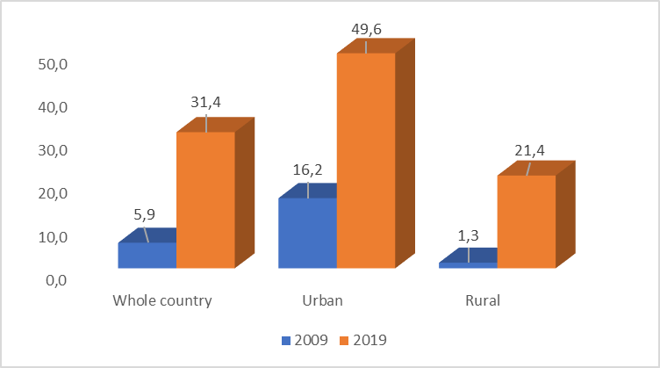
Source: GSO - Population and Housing Census
In general, percentage of households using air conditioners rapid growth from 5,9% in 2009 to 31,4% in 2019 (more than 5,3 time). Percentage of households using air conditioners in urban greater than in rural. In urban areas, in 2019 the proportion of households using air conditioning increased more 3 times compared to 2009 (49,6% compared to 21,4%). In rural areas, the proportion of households using air conditioners increased by more than 16,4 times in 2019 compared to 2009 (21,4% versus 1,3%).
Figure 2. Percentage of households using air conditioners, by Socio economic regions. Years 2009, 2019 (%)
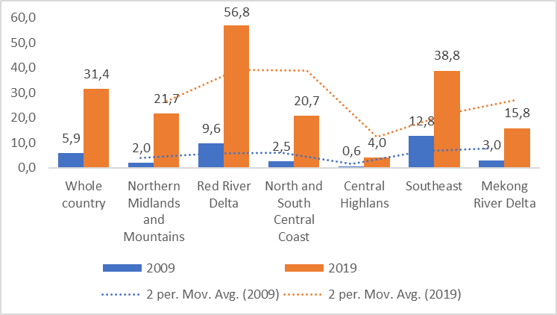
Source: GSO - Population and Housing Census
Among the 6 socio-economic regions, in 2019 the highest percentage of households using air conditioning was in the Red River Delta (56.8%), the lowest was in the Central Highlands (4%).
Figure 3. Percentage of households using air conditioners by 5 provinces/cities under central authority. Years 2009, 2019 (%)

Source: GSO - Population and Housing Census

Among the 5 provinces/cities directly under the central government, in 2019 Hanoi and Can Tho are the provinces with the highest percentage of households using air conditioners (75.1%) and the lowest (24.7%), respectively.
Percentage of households living in houses with air conditioning in the whole country increased from 5.9% in 2009 to 31.4% in 2019; Urban areas have a higher percentage of households living in houses with air conditioning than rural areas. In 2019, the highest percentage of households living in houses with air conditioning was in Hanoi (75.1%) and Hai Phong (60.9%), the lowest was in Dak Nong and Lam Dong (both 2.3%).
Glossary | Residential households include one or a group of people living together and eating together. For households with 2 or more people, they may or may not have a common revenue and expenditure fund; they may or may not be related by blood; or a combination of both.
Glossary | The head of the household is the representative of the household recognized by the members of the household

Table 1. Percentage of households living in houses with air conditioning, by urban/rural areas, Socio economic regions, Provinces. Years 2009, 2019 (%)
 | 2009 | 2019
ALL COUNTRY | 5.9 | 31.4
Urban | 16.2 | 49.6
Rural | 1.3 | 21.4
Socio-economic region
Northern Midlands and Mountains | 2.0 | 21.7
Red River Delta | 9.6 | 56.8
North and South Central Coast | 2.5 | 20.7
Central Highlans | 0.6 | 4.0
Southeast | 12.8 | 38.8
Mekong River Delta | 3.0 | 15.8
Province/City
Ha Noi | 21.7 | 75.1
Ha Giang | 1.6 | 9.8
Cao Bang | 1.1 | 8.5
Bac Kan | 1.2 | 9.4
Tuyen Quang | 2.3 | 20.4
Lao Cai | 2.8 | 20.4
Dien Bien | 0.4 | 5.5
Lai Chau | 0.2 | 4.0
Son La | 0.5 | 6.6
Yen Bai | 1.6 | 17.6
Hoa Binh | 1.8 | 20.5
Thai Nguyen | 3.4 | 32.1
Lang Son | 1.9 | 13.2
Quang Ninh | 10.0 | 54.1
Bac Giang | 1.6 | 36.3
Phu Tho | 3.3 | 36.6
Vinh Phuc | 2.8 | 49.7
Bac Ninh | 4.3 | 50.3
Hai Duong | 3.2 | 55.9
Hai Phong | 8.8 | 60.9
Hung Yen | 2.2 | 47.6
Thai Binh | 2.1 | 36.5
Ha Nam | 1.6 | 40.1
Nam Dinh | 1.9 | 34.4
Ninh Binh | 2.8 | 44.9
Thanh Hoa | 1.8 | 24.3
Nghe An | 2.9 | 29.3
Ha Tinh | 2.1 | 27.1
Quang Binh | 1.4 | 16.8
Quang Tri | 1.4 | 13.6
Hue | 2.4 | 17.4
Da Nang | 10.2 | 45.0
Quang Nam | 0.9 | 10.1
Quang Ngai | 1.2 | 9.5
Binh Dinh | 2.2 | 13.0
Phu Yen | 1.3 | 9.0
Khanh Hoa | 5.0 | 23.6
Ninh Thuan | 2.2 | 14.3
Binh Thuan | 2.3 | 14.0
Kon Tum | 0.5 | 4.1
Gia Lai | 0.4 | 4.1
Dak Lak | 1.0 | 5.7
Dak Nong | 0.4 | 2.3
Lam Dong | 0.2 | 2.3
Binh Phuoc | 2.4 | 15.2
Tay Ninh | 3.9 | 20.5
Binh Duong | 4.2 | 20.5
Dong Nai | 5.3 | 30.4
Ba Ria Vung Tau | 8.2 | 35.6
Ho Chi Minh City | 20.8 | 52.9
Long An | 2.4 | 18.6
Tien Giang | 3.0 | 16.7
Ben Tre | 1.8 | 11.6
Tra Vinh | 2.1 | 11.8
Vinh Long | 3.2 | 16.6
Dong Thap | 2.1 | 13.5
An Giang | 3.7 | 14.3
Kien Giang | 3.3 | 17.2
Can Tho | 7.0 | 24.7
Hau Giang | 1.6 | 12.5
Soc Trang | 3.0 | 12.8
Bac Lieu | 2.8 | 15.0
Ca Mau | 3.2 | 17.0
Source: GSO - Population and Housing Census

VULNERABILITY | Topic:  Vulnerable population
VULNERABILITY | Proportion of the population living below the international poverty line by sex, age, employment status and geographic location (urban/rural)  UNSD indicator 101  SDG indicator 1.1.1

METADATA CARD
Definition |  | Multi-dimensional poverty household rate  The percentage of the population living on less than $1,90 a day at 2011 international prices.
 |  | Proportion of the population below the international poverty line” is defined as the percentage of the population living on less than $2,15 a day at 2017 international prices.
Compared to UNSD |  | Proxy
Unit of measure |  | %
Breakdown |  | All country, Socio economic regions, Provinces
Data source |  | GSO - General Statistics Office,  Vietnam household living standard survey
Time series |  | 2016, 2018-2021
Frequency of updates |  | Annual
Figure 1. Multi - poverty rate by socio economic regions. Years 2016, 2018-2021 (%)

Source: GSO - Vietnam household living standards survey
The rate of multidimensionally poor households in the whole country decrease from 9.2% in 2016 to 4.4% in 2021.
Among the 6 socio-economic regions, the Northern Midlands and Mountains region and the Southeast region have the highest and lowest rates of multidimensional poverty, respectively. In the 2016-2021 period, the multidimensional poverty rate will gradually decrease from 9.2% in 2016 to 4.4% in 2021.

In 2021, Ho Chi Minh City and Binh Duong are the two provinces with the lowest multidimensional poverty rate in the whole country (0%); Dien Bien (34.5%) and Son La (28.6%) are the two provinces with the highest proportion of multidimensionally poor households in the country.
Glossary | (*) Multi-dimensional poverty household is defined as follows:  - For rural area: Monthly average income per capita as 700 thousand dongs and below or between over 700 thousand dongs and 1.000 thousand dongs in 2016; monthly average income per capita as 725 thousand dongs and below or between over 725 thousand dongs and 1,035 thousand dongs in 2017; monthly average income per capita as 755 thousand dongs and below or between over 755 thousand dongs and 1,080 thousand dongs in 2018 and is deprived of at least 3 indicators measuring deprivation of access to basic social services.  - For urban area: Monthly average income per capita as 900 thousand dongs and below or between over 900 thousand dongs and 1,300 thousand dongs in 2016; monthly average income per capita as 935 thousand dongs and below or between over 935 thousand dongs and 1,350 thousand dongs in 2017; monthly average income per capita as 975 thousand dongs and below or between over 975 thousand dongs and 1,400 thousand dongs in 2018 and is deprived of at least 3 indicators measuring deprivation of access to basic social services.
Table 1. Multi - Poverty rate by Provinces. Years 2016, 2018-2021 (%)
 | 2016 | 2018 | 2019 | 2020 | Prel. 2021
WHOLE COUNTRY | 9.2 | 6.8 | 5.7 | 4.8 | 4.4
Red River Delta | 3.1 | 1.9 | 1.6 | 1.3 | 1.2
Ha Noi | 1.4 | 0.9 | 0.7 | 0.5 | 0.4
Vinh Phuc | 5.1 | 3.4 | 2.9 | 2.5 | 2.3
Bac Ninh | 1.9 | 1.1 | 0.8 | 0.7 | 0.6
Quang Ninh | 4.3 | 2.5 | 2.2 | 2.1 | 1.8
Hai Duong | 3.6 | 2.3 | 2.0 | 1.8 | 1.7
Hai Phong | 2.1 | 1.4 | 1.2 | 0.9 | 0.8
Hung Yen | 4.2 | 2.8 | 2.3 | 1.9 | 1.8
Thai Binh | 4.7 | 2.9 | 2.4 | 2.1 | 1.9
Ha Nam | 4.9 | 2.8 | 2.3 | 2.1 | 2
Nam Dinh | 4.2 | 2.8 | 2.3 | 2.0 | 1.8
Ninh Binh | 4.5 | 2.8 | 2.2 | 2.1 | 2.0
Northern midlands and mountain areas | 23.0 | 18.4 | 16.4 | 14.4 | 13.4
Ha Giang | 39.8 | 32.6 | 29.1 | 27 | 25
Cao Bang | 37.3 | 31.5 | 28.5 | 26 | 24.5
Bac Kan | 29.7 | 25.1 | 22.5 | 21.5 | 20.6
Tuyen Quang | 22.0 | 17.5 | 15.1 | 12.9 | 11.9
Lao Cai | 26.4 | 20.5 | 17.2 | 15.4 | 14.8
Yen Bai | 26.1 | 20.3 | 17.5 | 15.1 | 14
Thai Nguyen | 7.8 | 6.0 | 5.1 | 4.1 | 3.7
Lang Son | 23.5 | 18.4 | 15.9 | 12.3 | 10.7
Bac Giang | 6.4 | 3.8 | 3.3 | 2.8 | 2.6
Phu Tho | 10.3 | 7.5 | 6.5 | 5.8 | 5.6
Dien Bien | 53.9 | 44.5 | 39.9 | 36.7 | 34.5
Lai Chau | 44.3 | 37.1 | 33.0 | 30.8 | 27.9
Son La | 42.8 | 36.3 | 33.0 | 30.5 | 28.6
Hoa Binh | 17.8 | 12.7 | 10.5 | 9.1 | 8.2
North Central and Central coastal areas | 11.6 | 8.7 | 7.4 | 6.5 | 5.7
Thanh Hoa | 11.9 | 8.8 | 8.0 | 7.0 | 6.3
Nghe An | 17.7 | 13.5 | 12.1 | 10.9 | 9.5
Ha Tinh | 12.5 | 8.8 | 7.2 | 6.5 | 5.9
Quang Binh | 13.7 | 10.8 | 9.3 | 8.8 | 7.7
Quang Tri | 16.1 | 12.6 | 10.9 | 9.2 | 8.1
Hue | 7.3 | 4.7 | 4.0 | 3.5 | 3.0
Da Nang | 1.5 | 0.9 | 0.7 | 0.5 | 0.4
Quang Nam | 13.7 | 10.3 | 9.1 | 8.1 | 7.0
Quang Ngai | 13.7 | 10.1 | 8.4 | 7.5 | 6.8
Binh Dinh | 8.0 | 5.5 | 4.6 | 4.1 | 3.6
Phu Yen | 9.9 | 7.5 | 6.3 | 5.5 | 5.0
Khanh Hoa | 5.9 | 3.7 | 3.0 | 2.5 | 2.2
Ninh Thuan | 13.4 | 11.0 | 9.8 | 9.0 | 8.4
Binh Thuan | 4.4 | 2.6 | 2.1 | 1.6 | 1.3
Central Highlands | 18.5 | 13.9 | 12.4 | 11.0 | 10.1
Kon Tum | 34.0 | 27.5 | 24.1 | 22.0 | 20.6
Gia Lai | 30.2 | 23.4 | 20.2 | 18.4 | 16.9
Dak Lak | 15.4 | 10.9 | 9.1 | 7.8 | 7.0
Dak Nong | 17.1 | 12.1 | 10.1 | 9.0 | 8.2
Lam Dong | 8.1 | 5.8 | 4.8 | 4.0 | 3.3
South East | 1.0 | 0.6 | 0.5 | 0.3 | 0.2
Binh Phuoc | 6.7 | 4.4 | 3.7 | 3.0 | 2.7
Tay Ninh | 2.5 | 1.7 | 1.2 | 1.1 | 0.8
Binh Duong | 1.1 | 0.7 | 0.6 | 0.1 | 0.0
Dong Nai | 0.8 | 0.5 | 0.3 | 0.3 | 0.3
Ba Ria Vung Tau | 1.3 | 0.9 | 0.7 | 0.5 | 0.2
Ho Chi Minh City | 0.2 | 0.1 | 0.1 | 0.0 | 0.0
Mekong River Delta | 8.6 | 5.8 | 4.8 | 4.2 | 3.8
Long An | 4.8 | 2.9 | 2.5 | 2.0 | 1.7
Tien Giang | 5.7 | 3.2 | 2.6 | 2.0 | 1.7
Ben tre | 10.1 | 6.7 | 5.6 | 5.0 | 4.6
Tra Vinh | 13.9 | 9.9 | 8.4 | 7.4 | 6.6
Vinh Long | 9.3 | 6.5 | 5.8 | 5.1 | 4.6
Dong Thap | 8.0 | 5.6 | 4.7 | 4.0 | 3.7
An Giang | 7.6 | 5.7 | 4.9 | 4.0 | 3.5
Kien Giang | 8.2 | 5.8 | 4.8 | 4.1 | 3.6
Can Tho | 4.6 | 2.7 | 2.2 | 2.0 | 1.8
Hau Giang | 10.7 | 7.3 | 6.2 | 5.6 | 5.2
Soc Trang | 10.2 | 6.7 | 5.6 | 5.0 | 4.7
Bac Lieu | 13.3 | 9.4 | 7.9 | 6.7 | 5.8
Ca Mau | 11.9 | 8.3 | 6.9 | 5.9 | 5.2
Source: GSO - Vietnam household living standards survey.

MITIGATION | Topic:  Climate change mitigation technology and practice
MITIGATION | Increase in forest area  UNSD indicator 125
METADATA CARD
Definition | Total forest area by locality
Compare to UNSD | Partial
Unit of measure | Thousand ha
Breakdown | Natural forest/Plantation forest, socio economic regios
Data source | Ministry of Agriculture and Rural Development  National level statistical reporting mode
Time series | 2010-2021
Frequency of updates | Annual

Figure 1. Total forest area by Natural forest/Plantation forest. Years 2010-2021 (Thousand Ha)

Source: GSO – Years book
From 2010 to 2021, Vietnam's total forest area increased by about 1,357 thousand hectares, however, the natural forest area was reduced by 133 thousand hectares.
In recent years, the government has made many policies to pay attention to the current forest problem such as afforestation, reforestation, tightening in the management of loggers. However, although the area of planted forest is increasing, the illegal activities of loggers are also becoming more and more blatant and bold, so the area of natural forest is still significantly reduced.
Figure 2. Total forest area by socio economic regions. Years 2010, 2015, 2021 (Thousand Ha)

Source: GSO - Years book
Forest areas are concentrated mainly in the Northern Midlands and Mountains, the North Central Coast and the Central Coast and the Central Highlands. In the past 10 years, the forest area in all regions has increased. However, in the Central Highlands, the forest area has decreased significantly. From 2010 to 2021, the forest area in the Central Highlands will decrease by 300 thousand ha.
Due to the influence of climate change, abnormal weather and dry weather occurred in most localities in the Central Highlands, leading to an increase in the number of forest fires in recent years, both in terms of the number of cases and the number of forest fires, and extent of damage. However, the biggest reason for the reduction of forest area in the Central Highlands is human destruction.

Glossary:
Forest is an ecosystem consisting of forest plants, animals, fungi, microorganisms, forest soil and other environmental factors, in which the main component is one or several species of woody plants, bamboo. , cork, areca tree whose height is determined according to the flora on the soil mountain, rocky mountain, wetland, sandy soil or other typical flora; the adjacent area is from 0.3 ha or more; shade from 0.1 or more.
- Based on the origin of formation, forests are divided into natural forests and planted forests:
+ Natural forest is a forest available in nature or restored by zoning for natural regeneration or zoning for regeneration with additional planting.
+ Planted forest is a forest formed by new planting by humans on unforested land; reclamation of natural forests; replanting or regeneration after exploitation of planted forests.
- Based on the main use purposes, natural forests and planted forests are classified into 3 types as follows: special-use forests, protection forests, and production forests.

Chapter 4.

Main findings, current issues and development prospects for urban environment, sustainability and climate change-related indicators in Vietnam

4.1. Main findings on urban environment

4.1.1. Assessment criteria
To provide a summary of urban environment indicators, a comprehensive assessment of their results was carried out, for the whole Country and the high-urban intensity areas, considering the following aspects:
- Current position, in terms of distance of the latest available values from the reference targets;
- Direction and speed of the current trends, with respect to the set targets and to the gap between urban and rural areas.
Such exercise is just meant to highlight at a glance the points of strength and weakness that emerged from the analysis of indicators – keeping in mind that this Report provides only a partial picture, and not a representative one, of the state of urban environment in Vietnam, as the selection of indicators was fundamentally driven by the availability of data.
As for the position with respect to the target, taking into account the direction of each indicator (positive if an increase in observed values is desirable, negative otherwise), the assessment is:
- Positive, if the latest available value is less than 5 percentage points away from the target;
- Neutral, if the distance is between 5 and 10 points;
- Negative, if the distance is greater than 10 points.
In lack of a formally set target implicit targets were considered where possible. Values of indicators for which there is no target set or applicable were not classified.
The assessment of current trends was made considering a time span of 5 or 6 years (in most cases, 2016-2021 or 2014-2020), depending on the availability of time series. Over that period, an annual change rate was calculated, based on the following formula:
$$R=d×100×{\left(\frac{y_{t}}{y_{t-x}}\right)}^{\frac{1}{x}}-1$$
where x is the length of the period in years, t is the last year of the period, y is the value of the indicator, and d is its direction (1 if positive, -1 if negative). Then, it was assumed that:
- R between 1 and -1 indicates stability (i.e. an average change by less than 1% a year over the period, for better or for worse);
- R >1 indicates a significant improvement (by more than 1% a year),
- R <-1 indicates a significant deterioration (by more than 1% a year).
Using the same formula, the urban-rural divide (i.e. the difference between the average values of high- and low-urban intensity areas) is considered stable for values of R between 5 and -5, while higher values (R >5) are assumed to indicate a significant reduction of the gap (positive assessment), and lower values (R <-5) a significant increase of it (negative assessment).
Table 4.1 - Statistical measures on urban environment, latest available values and assessment of current trends, for the whole Country and the high-urban intensity areas
GOAL | STATISTICAL MEASURES |  | TARGET or reference value | LATEST AVAILABLE VALUES |  | ASSESSMENT OF CURRENT TRENDS
GOAL |  |  | TARGET or reference value | Whole Country | High urban intensity areas | Period | Whole Country | High urban intensity areas | Urban-rural divide
 | 6.1.1: Urban population provided with clean water by centralized water supply system (pct. share) |  | 100 | 92.8  (2021) | 98.5  (2021) | 2016-2021
 | 6.2.1: Households using improved sanitation facilities (pct. share) |  | 100 | 94.0  (2020) | 99.6  (2020) | 2014-2020
 | 7.1.1: Households with access to electricity (pct. share) |  | 100 | 99.5  (2020) | 99.9  (2020) | 2014-2020
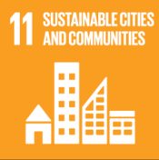 | 11.1.1a: Households not living in permanent/semi-permanent houses (pct. share) |  | 0 | 4.4  (2020) | 0.6  (2020) | 2014-2020
 | 11.1.1b: Households living in less than 10 m² per capita (pct. share) |  | 0 | 10.2  (2019) | 13.2  (2019) | 2009-2019 |  |  | =
 | 11.2.1a: Growth rate of public transport passengers by road (pct. change) |  | - | -27.1  (2021) | -27.4  (2021) | -
 | 11.2.1b: Demand for road public transport (passengers per capita) |  | - | 24.0  (2021) | 39.7  (2021) | 2016-2021 |  |  | =
 | 11.3.1a: Ratio of land consumption rate to population growth rate (index) |  | Balance point=1 | 0.995  (2020) | 0.989  (2020) | 2016-2020
 | 11.3.1b: Land consumption as a proportion of total land area (pct. share) |  | - | 8.35  (2020) | 21.07  (2020) | 2015-2020
 | 11.6.1a: Urban domestic solid waste collected, transported and treated according to technical standards and regulations (pct. share) |  | 100 | 85.3  (2019) | 90.5  (2019) | 2015-2019
 | 11.6.1b: Urban domestic solid waste collected per capita (kg per inhabitant) |  | - | 163.2  (2019) | 235.4  (2019) | 2015-2019
 | 11.6.3a: Annual mean concentrations of pollutants in cities: maximum values (g per m³) | PM₁₀ | National limit=50 | …. | 146.5  (2019) | 2014-2019 | …. |  | ….
 |  | NO₂ | National limit=40 | …. | 54.8  (2021) | 2016-2021 | …. |  | ….
 | 11.6.3b: Annual mean concentrations of pollutants in cities: values above the WHO reference values for avoidable mortality (pct. share, 3-year moving averages) | PM₁₀ | 0 | …. | 100.0  (2017-19) | 2014-2019 | …. |  | ….
 |  | NO₂ | 0 | …. | 11.0  (2019-21) | 2014-2021 | …. |  | ….
Latest available values: ### POSITIVE / ### NEUTRAL / ### NEGATIVE / ### ASSESSMENT NOT APPLICABLE
Assessment of current trends: SIGNIFICANT IMPROVEMENT / STABILITY / SIGNIFICANT DETERIORATION / NOT APPLICABLE
(Urban-rural divide): SIGNIFICANT REDUCTION (positive) / = STABLE (negative) / SIGNIFICANT INCREASE (very negative) / NOT APPLICABLE
Four dots (….) : INSUFFICIENT DATA

4.1.2. Summary of main findings
The set of urban environment indicators provides a mixed picture, as it shows several positive achievements and trends (especially with regard to the narrowing of the urban-rural divide), but also important criticalities.
Data witness remarkable progress made in the access to clean water and sanitation, as the targets of 100% of urban population provided with clean water through centralized supply system, and 100% of households using improved sanitation facilities have been substantially achieved in the high-urban intensity areas, while the rest of the Country is well on track to close the gap. A combined representation of both indicators shows the progress made (and the path ahead) to achieving the first two targets of Goal 6, that 100% of the population have access to safe water and sanitation (Figure 4.1).
Figure 4.1 - Progress towards targets on access to clean water from centralized supply (VSDG 6.1.1) and use of improved sanitation facilities (VSDG 6.2.1), by urban intensity degree. Years 2016-2020 (estimates, percentage values)
VIET NAM  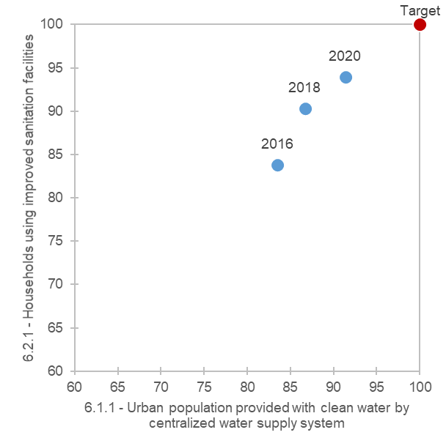 | HIGH URBAN INTENSITY AREAS  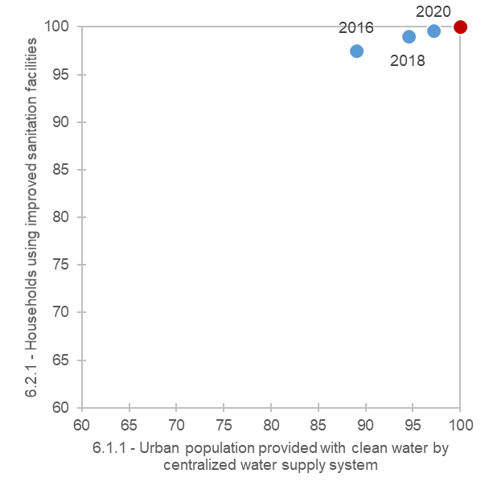
MEDIUM URBAN INTENSITY AREAS  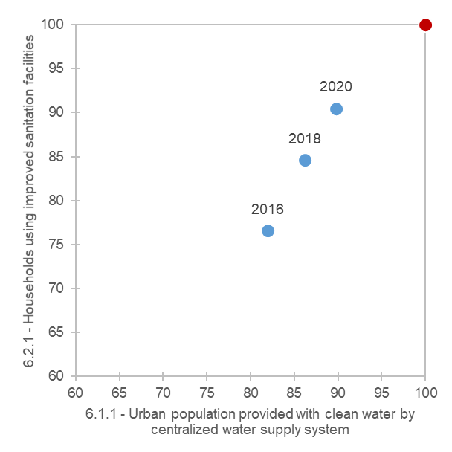 | LOW URBAN INTENSITY AREAS  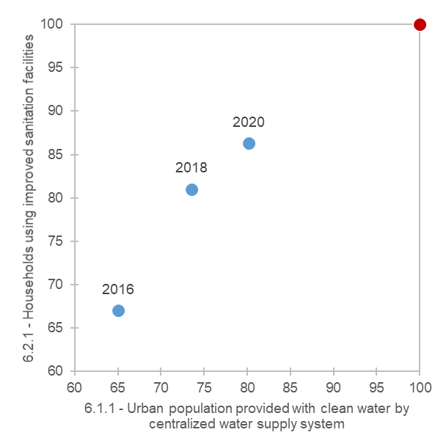
Source: Processing on MOC and GSO data
At the national level, the distance to the target of 100% of urban population with access to clean water through centralized supply has been reduced by 9.3 percentage points from 2016 to 2021, with substantial progress made, in particular, in the urban areas of Ha Noi and Can Tho, and the whole of medium- and low-urban intensity areas (Figure 4.2). An even greater advancement (by 13.8 pct. points, nationwide) is observed from 2014 to 2020 in the use of improved sanitation facilities, especially in the urban area of Can Tho and the whole of medium- and low-urban intensity areas (Figure 4.3).
Figure 4.2 - Urban population provided with clean water by centralized water supply system: distance from target by major urban areas and by urban intensity degree. Years 2016 and 2021 (estimates, percentage points)
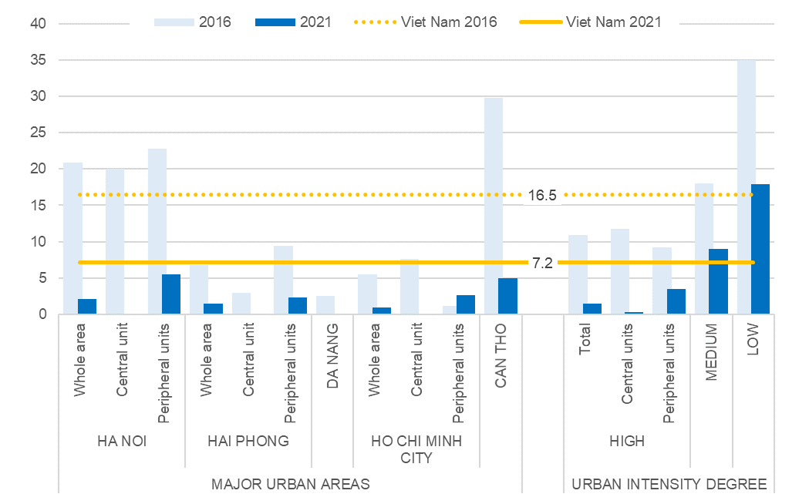
Source: Processing on MOC data
Figure 4.3 - Households using improved sanitation facilities: distance from target by major urban areas and by urban intensity degree. Years 2014 and 2020 (estimates, percentage points)
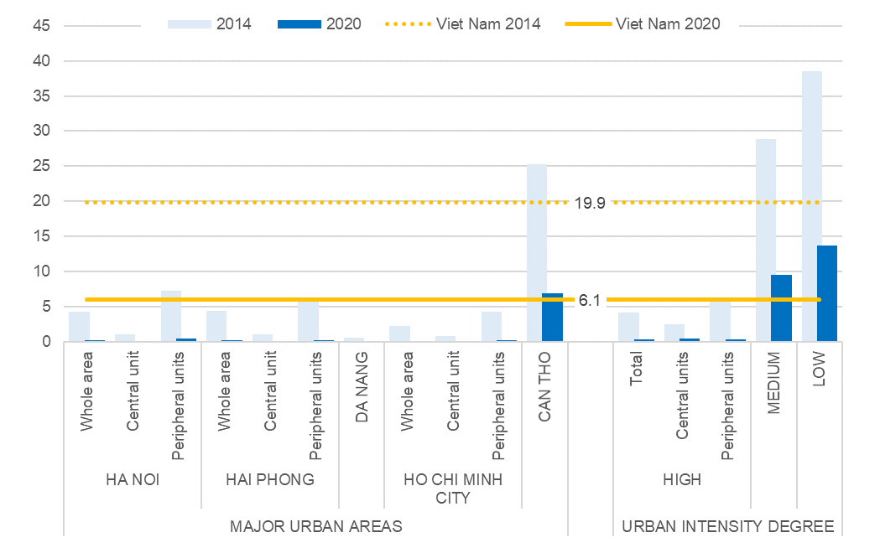
Source: Processing on VHLSS data
The goal of 100% of households having access to the electricity grid was far closer already in 2010, except in low-urban intensity areas. The progress made toward this target consisted essentially in filling this gap, which was almost completely closed in 2020 (Figure 4.4).
Figure 4.4 - Households with access to electricity: distance from target by major urban areas and by urban intensity degree. Years 2010 and 2020 (estimates, percentage points)
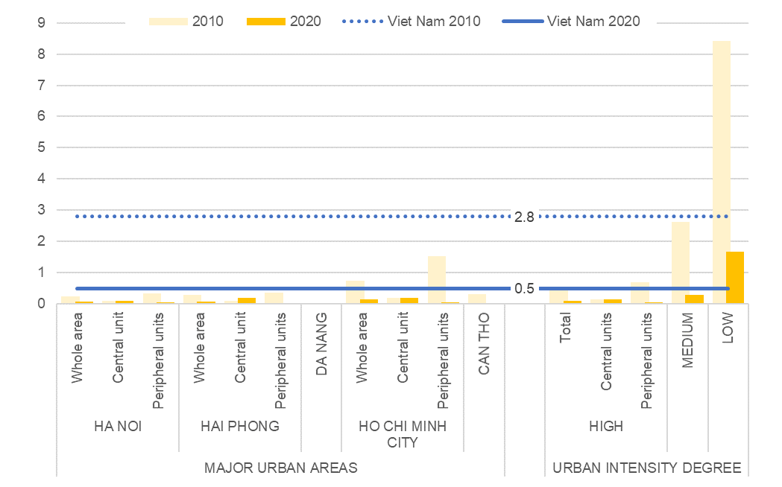
Source: Processing on VHLSS data
Figure 4.5 - Households not living in permanent/semi-permanent houses: distance from target by major urban areas and by urban intensity degree. Years 2014 and 2020 (estimates, percentage points)
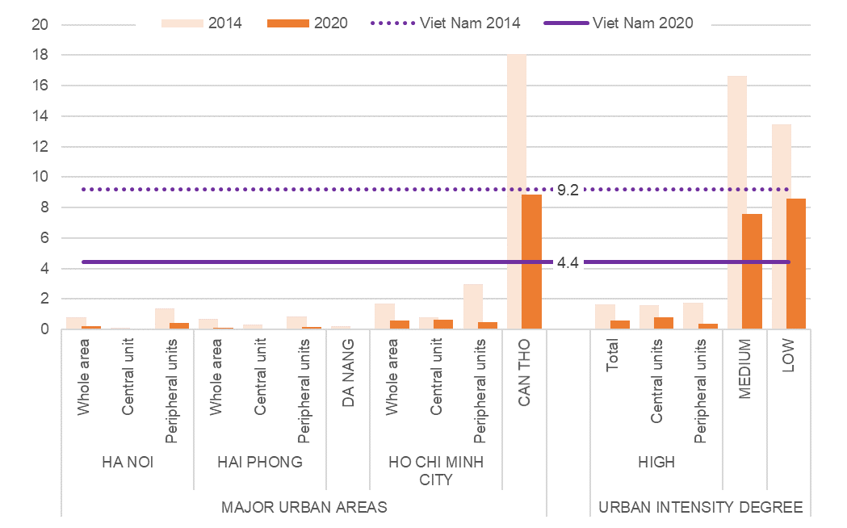
Source: Processing on VHLSS data
Regarding housing conditions, the percentage of households living in poorly built houses (i.e. entirely or mostly made of non-durable materials) has greatly reduced all over the Country (from 9.2% in 2014 to 4.4% in 2020), and fell below 1% in the high-urban intensity areas as a whole. Despite the progress, and a significant reduction of the urban-rural divide, the shares of households not living in permanent or semi-permanent houses remain quite high in the medium- and low-urban intensity areas, as well as in the major urban area of Can Tho (Figure 4.5).
Important progress is also observed in the reduction of overcrowding, as the percentage of households living in less than 10 m² per capita has more than halved from 2009 to 2019 (from 21.4 to 10.2%), while the urban-rural divide remained substantially unchanged over the decade. Although the highest values are found in the great urban area of Ho Chi Minh City (more than double the national average), overcrowding is widespread all over the country, as the percentage estimated for the low-urban intensity areas (9.6% in 2019) is very close to the national average (Figure 4.6).
Figure 4.6 - Households living in less than 10 m² per capita: distance from target by major urban areas and by urban intensity degree. Years 2009 and 2019 (estimates, percentage points)
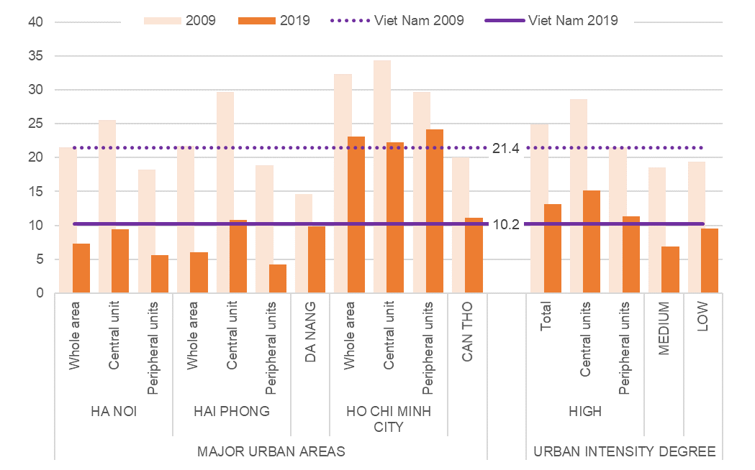
Source: Processing on Population and Housing Census data
Although the development of public transport services is considered a key factor in reducing the pressure of road traffic on urban environment, there are no quantitative targets set in this field. Considering the 2012-2021 decade, the growth of public transport show a severe setback in the last two years, clearly due to the impact of the Covid-19 pandemic. Between 2012 and 2019, time series show a steady growth of public transport in terms of road passengers carried, whose number was increasing, on average, by 8.5% a year, and by 9.5% in high-urban intensity areas. In the following two years, however, this progress was completely averted, so that in 2021 the demand for road public transport dropped to 24 passengers carried per capita nationwide, and to 39.7 in high-urban intensity areas, below the values of 2012 (Figure 4.7).
Also for limiting land consumption, a major pressure on environment generated by urban development, no target has been set. Over the 2015-2020 period, land consumption was intense, as urbanized areas grew by 9.0% overall. Such expansion, however, was proportionate to population growth, and did not occur at the expense of agricultural and forestry land. The intensity of the process was substantially homogeneous all over the country: also in low-urban intensity areas, in fact, the average growth in urbanized areas was in line with the national average. Besides, it is worth remarking how, within the high-urban intensity areas, land consumption growth was much higher in the peripheral units than in the central ones (Figure 4.8). However, there are significant differences among the major urban areas. In particular, higher land consumption rates are observed in central Hai Phong (+15.7%), and in the peripheral units of Ho Chi Minh City (+15.3%), while the lowest value is found in Da Nang (1.9%).
Figure 4.7 - Demand for road public transport by urban intensity degree. Years 2012-2021 (estimates, fixed base index numbers: 2012=100) | Figure 4.8 - Land consumption by urban intensity degree. Years 2015-2020 (estimates, percentage change in Homestead land + Specially used land)
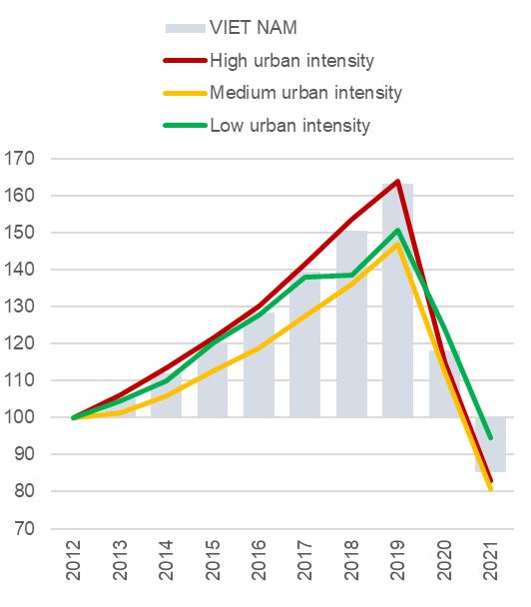 | 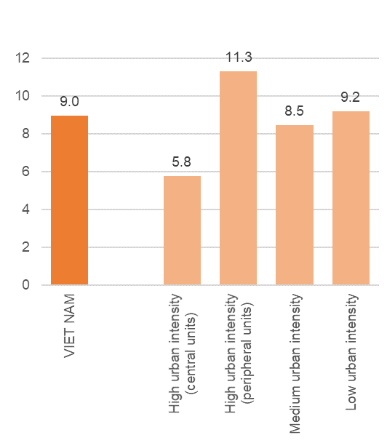
Source: Processing on MOIT data | Source: Processing on MONRE data
About waste management, an implicit target of 100% of urban waste collected and treated according to standards and regulations (sub-indicator 11.6.1a) can be considered, while no target is applicable to the amount of collected waste per capita (sub-indicator 11.6.1b).
Over the entire 2015-2019 period, a significant progress to the target is observed at the national level, as the percentage of urban waste managed by the law increased by about 10 pct. points. Most of this progress, however, has been made in medium- and low-urban intensity areas, both of which were starting from very low shares in 2015. In the whole of high-intensity areas, on the other hand, no significant improvement can be observed, such that in 2019 more than 10% of collected waste was still not managed in accordance with national standards and regulations.
Also in this case, however, the picture changes from one major urban area to another. By 2015, the target had been already achieved in Da Nang and central Ho Chi Minh City, and nearly achieved in central Ha Noi, while the whole urban area of Hai Phong, as well as the peripheral units of Ha Noi and Ho Chi Minh City, and most of all the urban area of Can Tho, were very far from it. In 2019, Can Tho and Hai Phong have recovered much of their disadvantage, while a worsening can be observed in the peripheral units of Ha Noi, and especially Ho Chi Minh City (Figure 4.9).
Safety and accountability issues in urban waste management call for special attention in view of the increase observed in the amount of collected waste: from 129 to 163 kg per capita between 2015 and 2019 nationwide, and from 205 to 236 kg per capita in high-urban intensity areas.
Figure 4.9 - Urban domestic solid waste collected, transported and treated according to technical standards and regulations: distance from target by major urban areas and by urban intensity degree. Years 2009 and 2019 (estimates, percentage points)
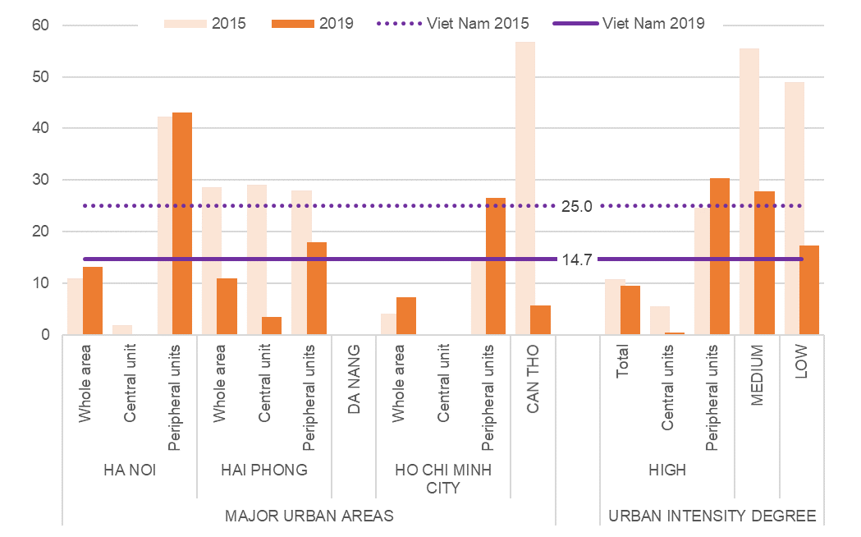
Source: Processing on MOC data
Regarding air quality, the implicit target assumed for sub-indicator 11.6.3a (Annual mean concentration of pollutants in cities: maximum values) is that the highest observed value do not exceed the limits set by the national regulations for the annual mean concentrations of PM₁₀ and NO₂ (50 µ/m³ and 40 µ/m³, respectively), bearing in mind that – in any event – these limits do not correspond to an optimal situation, and are supposed to be upgraded in order to comply with the WHO guidelines of 2005 (which follow, in fact, the state of the art in scientific knowledge on avoidable mortality from air pollution). Despite progress, PM₁₀ values are still a long way from complying with the national limits. NO₂ values, on the other hand, are significantly closer to the limits (except in 2017), but still indicate a situation of significant health risk (Figure 4.10).
For sub-indicator 11.6.3.b (Annual mean concentration of pollutants in cities: values above the WHO reference values for avoidable mortality), the target is reached when no monitoring stations (0%) detect values above the WHO reference values (according to the 2005 guidelines). Also in this case, considering the three-year moving averages of the available measurements for both pollutants, the situation appears to be critical, despite some progress observed for NO₂ (Figure 4.11).
As recalled several times, findings on air pollution based on the available data cannot be considered fully representative of the phenomenon, due to the lack of comprehensive data by single years and to large gaps in time series, especially with regard to PM₁₀. There is sufficient evidence, anyway, for raising serious concerns about air pollution in Vietnamese cities, and its fallouts on public health.
Figure 4.10 - Sub-indicator 11.6.3a: progress toward compliance with the national limits for maximum annual mean concentrations of PM₁₀ and NO₂, in high-urban intensity units. Years 2015-2019 (µ/m³) | Figure 4.11 - Sub-indicator 11.6.3b: progress toward zero exceedances of WHO reference values in annual mean concentrations of PM₁₀ and NO₂, in high-urban intensity units. Years 2015-2019 (percentage values, 3-year moving averages)
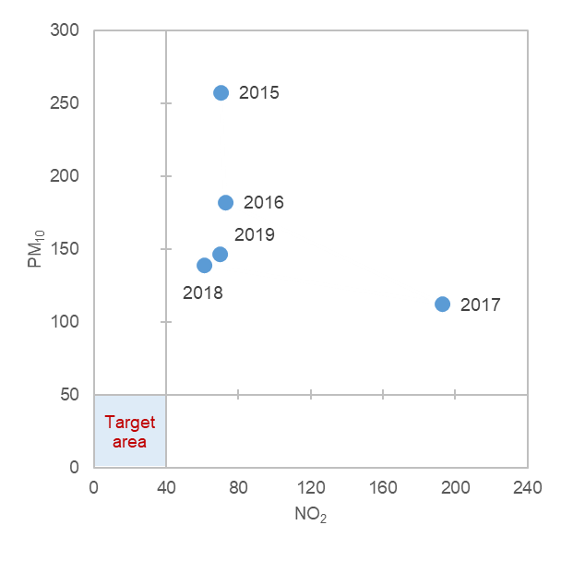 | 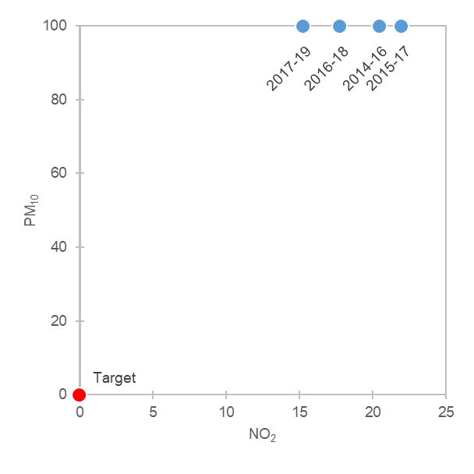
Source: Processing on MONRE data | Source: Processing on MONRE data

4.2. Main findings on climate change related statistics
The set of available statistical indicators related to climate change from the UNSD Global set, highlights the challenge of reconciling the development of a country with the protection of the environment, to ensure prosperity and welfare for current and future people, leaving no one behind, according to the ‘one health’ paradigm and the principles of sustainable development. The growing pressure of different factors insisting on the causes of climate change and the climate change impacts on vulnerable territories, ecosystems and on the more disadvantaged segments of the population, represent issue that need to be addressed. Combating climate change and its consequences is crucial to embarking on a sustainable development path for the country and in the international context. The subset of 17 indicators presented, already clearly represents the challenge, that need to be deepened and monitored over time and supplemented with additional information as it becomes available, analyzing specific geographies and specific population segments (gender, age, disability, etc.).
Table 4.2 - Statistical measures on climate change related statistics, latest available values and assessment of current trends
AREA | STATISTICAL MEASURE | PERIOD | INITIAL VALUE | LATEST AVAILABLE VALUE | TREND
 | Total greenhouse gas emissions per year (Millions tons of CO₂ equivalent) | 1994-2016 | 103.8 | 316.7
 | Greenhouse gas emissions from land use, land use change and forestry (Millions tons of CO₂ equivalent) | 1994-2016 | 19.4 | -37.5
 | Greenhouse gas emissions per capita (Tons of CO₂ equivalent/capita) | 1994-2016 | 1.193 | 3.397
 | Total primary energy supply (Petajoule) | 2010-2020 | 643.3 | 1,194.8 | -
 | Share of fossil fuels in total primary energy supply (%) | 2010-2020 | 43.2 | 25.3
 | Energy consumption per capita (1000 VND) | 2016-2020 | 4,020 | 6,468
 | Population growth (Thousands of people) | 1994-2021 | 70,824 | 98,506 | -
 | Urban population as a proportion of total population (%) | 1994-2021 | 20.4 | 37.1 | -
 | Agricultural damage directly caused by natural disasters- rice and crops (Ha) | 2015-2021 | 83,647 | 208,803
 | Estimated damage in cash directly caused by the disaster (Billion VND) | 2015-2021 | 5,362 | 4,877
 | Number of people dead and missing due to natural disasters (Number) | 2015-2021 | 157 | 159
 | Number of case of infectious diseases - dengue fever (Number) | 2015-2019 | 81,441 | 69,354
 | Temperature records in some meteorological stations (average ºC) | 1971 to 2001, 2002 to 2020 | 24.1 | 24.4
 | Invasive alien species (Number) | 2011-2018 | 33 | 19
 | Population living in dwellings with air conditioners or air conditioning (%) | 2009-2019 | 5.9 | 31.4 | -
 | Multi-dimensional poverty household rate (%) | 2016-2021 | 9.2 | 4.4
 | Increase in forest area (Thousand ha) | 2010-2021 | 13,388 | 14,746
Trends: SIGNIFICANT IMPROVEMENT / STABILITY / SIGNIFICANT DETERIORATION / - NOT APPLICABLE

Under the area of drivers, three topics are covered: Total greenhouse gas emissions (with 3 indicators), Energy production, supply and consumption (3 indicators), Population (2 indicators).
- During the period 1994-2016, the Total greenhouse gas emissions in Viet Nam increased by about three times, from 103.8 million to 316.7 million tons of CO₂ equivalent. In particular, emissions in the energy sector have increased significantly. Energy sector contributed to 24.7% of total emissions in 1994 up to 65.0% in 2016. The contribution of the sector related to industry and construction to the total amount of emissions increased from 3.7% to 14.6% and the waste sector from 2.5% to 6.5%. Emission from agriculture increased from 1994 (52 million tons of CO₂ equivalent, 50.1% of the total emissions) to 2014 (89.7 million tons of CO₂ equivalent, 31.6% of the total emissions), where
- Greenhouse gas emissions from land use, land use change and forestry (LULUCF) has been gradually transitioning from greenhouse gas emissions to greenhouse gas sequestration since 2000. Since 2016, greenhouse gas emissions from the agricultural sector and the LULUCF sector (land use, land use change and forestry) are merged into the AFOLU (agriculture, forestry and land use) sector.
- In the same period Total greenhouse gas emissions per capita increased from 1.193 tons of CO₂ equivalent/capita in 1994 to 3.397 tons of CO₂ equivalent/capita in 2016.
- The Total primary energy supply is a key element of energy balances. It represent the sum of production and imports minus exports and changes in storage. In the decade 2010-2020 the Viet Nam total primary energy supply increased rapidly, nearly two time from 634.3 to 1,194.8 PJ.
- In this context of increasing energy demand, the Share of fossil fuels in the total primary energy supply decreased over the years. In 2010, the proportion of fossil fuels in the total primary energy supply was 43.2% and by 2020 this proportion decreased to 25.3%.
- Energy consumption per capita increased from 4,020 thousand VND in 2016 to 5,371 in 2018 and 6,468 thousand VND in 2020.
- Viet Nam Population increased from 70,824.5 thousand people in 1994 to 93,250.7 thousand people in 2016. The rate of growth decreased in the succeeding period 2017 to 2021, with approximately 1 million people per year, up to 98.51 million in 2021.
- Proportion of urban population increased rapidly from 20.4% in 1994 to 37.1% in 2021.
Under the area of vulnerability, two indicators related to vulnerable population are covered:
- Population living in dwellings with air conditioners or air conditioning growth from 5.9% in 2009 to 31.4% in 2019, more than 5.3 times. In urban areas the value is greater than in rural (49.6% and 21.4% respectively).
- Viet Nam Multi-dimensional poverty household rate decreased from 9.2% in 2016 to 4.4% in 2021 in the whole country, despite the evidence of strong differences among the 6 socio-economic regions: in particular the Northern Midlands and Mountains region and the Southeast region show a high divide with the highest (13.4%) and lowest (0.2%) rates, respectively.
Under the area of impacts, five topics are covered: Climate change evidence (1 indicator), Agricultural production affected by climate change (1 indicator), Hazardous events and disasters (2 indicators), Climate change and human health (1 indicator), Distribution and status of species (1 indicator).
- For eleven selected meteorological monitoring stations dislocated in different areas of the country, Temperatures shows an increase in average comparing the two periods 1971 – 2001 and 2002 – 2020 in almost all monitoring stations. The highest increase in temperature is in Ha Noi (Lang), 10^{C}, followed it by Vinh, 0.90^{C}.
- From 2015 to 2021, Agricultural damage directly caused by natural disasters damaged 1,230 hectares of rice and 558.5 thousand hectares of crops.
- In the same period, the Estimated damage in cash directly caused by the disaster is up to VND 150.2 trillion,
- 1,664 is the Number of people dead and missing due to natural disasters,
- The Number of case of infectious diseases for dengue fever amount at 1,007,691 cases and 240 deaths.
- Between 2011 and 2018 the number of Invasive alien species has decreased very rapidly, from 33 species to 19.
Under the area of mitigation, the topic on Climate change mitigation policies, strategies and plans include one indicator. Measures for contrasting climate change consequences include nature based solutions, strengthening the protection and restoring of ecosystems:
- From 2010 to 2021 Viet Nam's Forest area increased by about 1.357 thousand hectares, however, the natural forest area was reduced by 133 thousand hectares.
Eight additional indicators from the set of SDGs urban environment are also relevant in the context of UNSD Global dataset in the areas of drivers (one indicator), vulnerability (4 indicators), adaptation (2 indicators), impacts (one indicator).

- 11.3.1b: Land consumption as a proportion of total land area (UNSD 26, Topic: Land and agriculture)
In five years (2015-2020), the sum of the land covered by urban and rural settlements (homestead land) plus the specially used land, grew up from 7.66% to 8.35% of the national territory, equal to an average consumption of 124.5 hectares per day all over the country.

- 6.1.1: Urban population provided with clean water by centralized water supply system (UNSD 98, Topic: Vulnerable population)
In 2021, 92.8% of the urban population is provided with clean water through the centralized water supply system. The proportion is considerably higher (98.5%) in the high urban intensity areas, but the gap between urban and rural areas is reducing.
- 6.2.1: Households using improved sanitation facilities (UNSD 97, Topic: Vulnerable population)
In whole country, the percentage of households using improved sanitation facilities increased from 80.1% in 2014 to 94.0% in 2020. The percentage of households using improved sanitation facilities differs between urban and rural areas: High urban intensity 99.6%, medium urban intensity 90.5%, low urban intensity 86.3%.
- 7.1.1: Households with access to electricity (UNSD 95, Topic: Vulnerable population)
All over the country, the percentage of households with access to electricity gradually increases from 97.2% in 2010 to 99.5% in 2020

For more details on these indicators refer to the cards in Chapter 2 Sustainable development indicators on urban environment.
- 11.1.1a: Households not living in permanent/semi-permanent houses (UNSD 103, Topic: Vulnerable population)
The percentage of households not living in permanent/semi-permanent houses is 4.4% in 2020. It was 9.2 in 2014. In high-urban intensity areas, the percentage is lower than the national average (0.6%).

- 11.6.1a: Urban domestic solid waste collected, transported and treated according to technical standards and regulations (UNSD 157, Topic: Waste management)
Between 2015 and 2019, the percentage of urban solid waste that is safely transported and treated, according to the national standards and technical regulations, increased by 10.3 percentage points (from 75% to 85.3%). The rate is higher in the major urban areas, where, however, it is declining in the latest years (from 96.3% in 2017 to 90.5% in 2019).
- 11.6.1b: Urban domestic solid waste collected per capita (UNSD 156, Topic: Waste management)
The amount of municipal solid waste collected was 163.2 kg per capita in 2019, increasing by 26.5% compared to 2015, when it was 129.

- 11.6.3a: Annual mean concentration of pollutants in cities: maximum values (PM₁₀ and NO₂) (UNSD 46, Topic: Climate change and human health)
Situations of significant risk for human health caused by exposure to PM₁₀ or NO₂ concentrations above the WHO reference values can be identified in the major urban areas and by urban intensity degree where a sufficient number of valid observations is available.
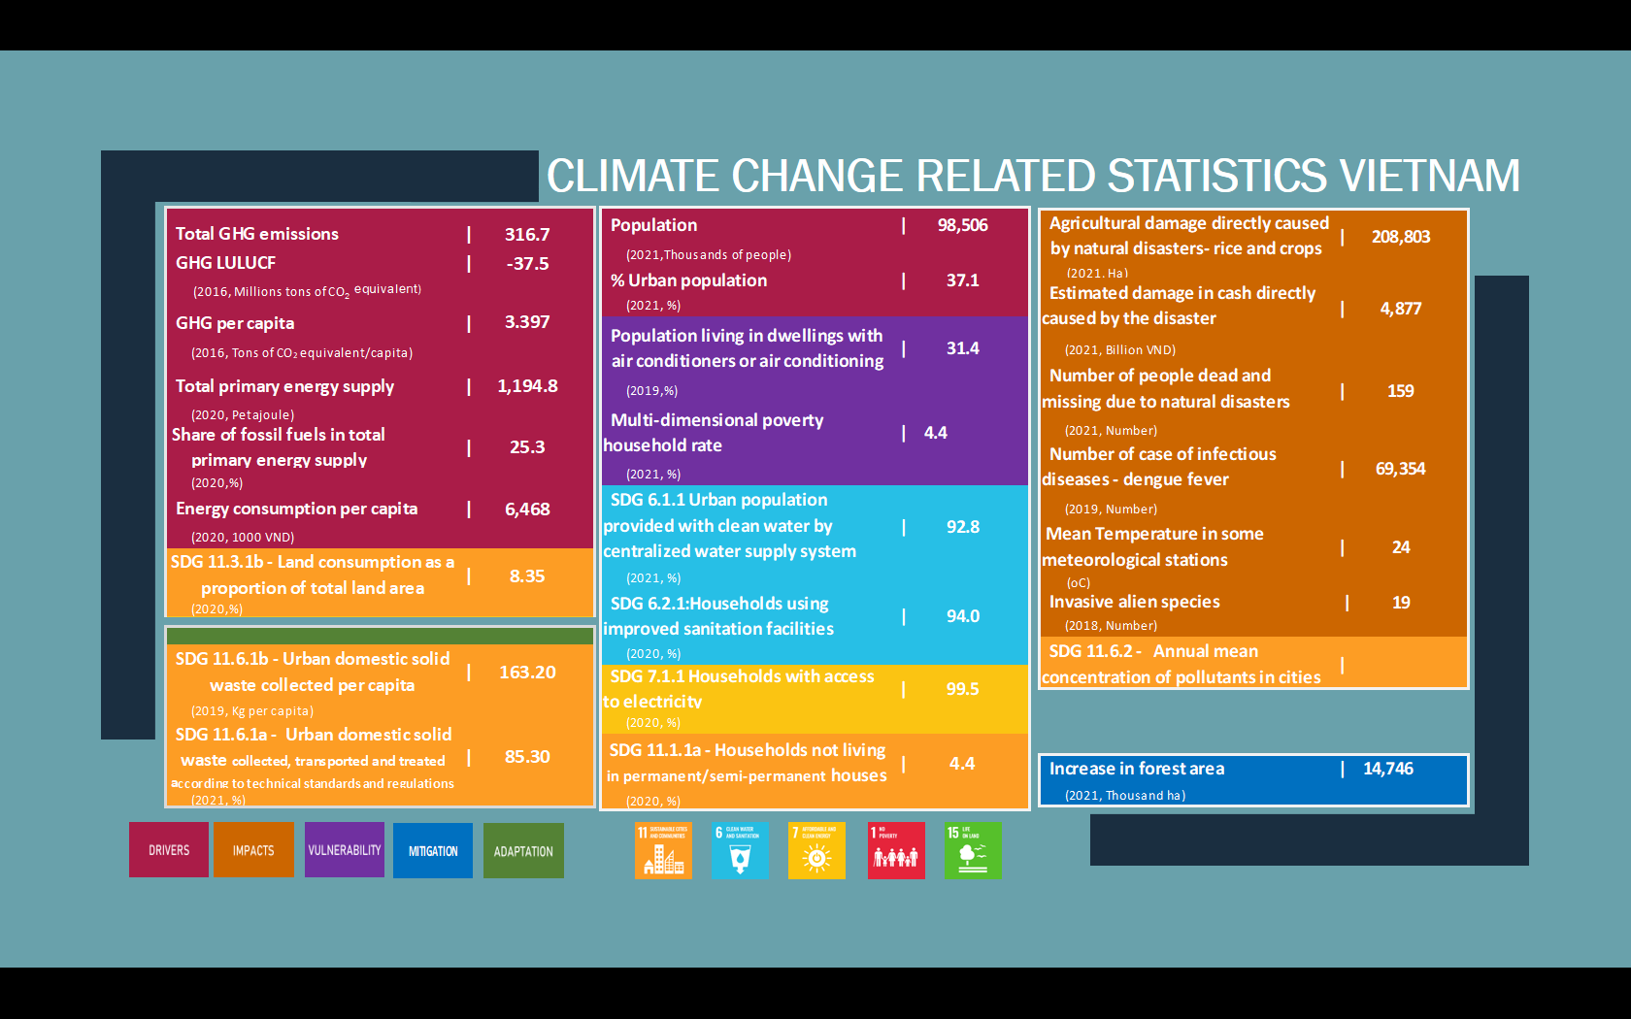
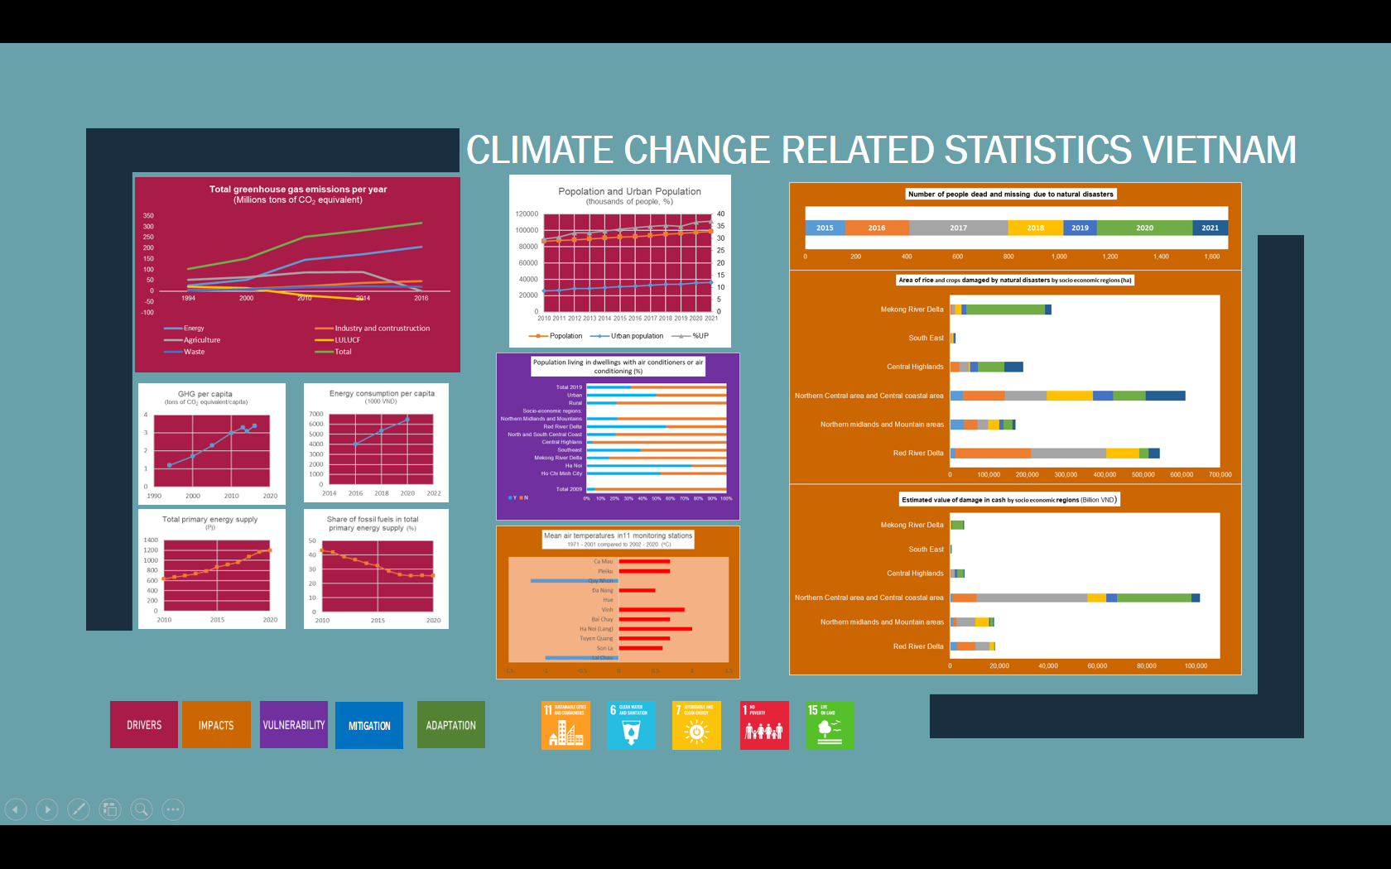

4.3. Current issues and development prospects for Urban Environment and Climate Change-related Indicators in Vietnam
Environmental statistics and CC is a new field in Vietnam. The collection, processing and dissemination of official statistical information on environment and CC is necessary for (i) Assessment, forecasting, strategic planning, policy planning, management, and administration of economic development and society; (ii) inspecting and supervising the implementation of socio-economic development strategies, plans, and policies (in service of direction and administration); (iii) Providing statistical information to domestic users and international agencies, organizations and individuals.

4.3.1. Information on the environment (Clause 1, Article 114, Law on Environmental Protection 2020)
Environmental information includes:
- Information on pollutants, discharge of pollutants into the environment, pollution sources; environmental protection of investment projects, establishments, concentrated production, business, service zones, industrial clusters;
- Information on solid waste, hazardous waste, wastewater, emission, and other types of waste as prescribed by law;
- Information on the decision on approval of appraisal results, environmental impact assessment report, except for trade secrets, business secrets, and information belonging to state secrets; licensing, registration, certification, and certification content; results of inspection and inspection of environmental protection for investment projects, establishments, concentrated production, business and service zones, and industrial clusters according to regulations;
- Information on environmental statistical indicators, environmental quality and environmental pollution;
- Information on natural heritage, natural ecosystems, biological species and genetic resources; nature reserves, and biodiversity conservation facilities; important wetlands.
Statistical indicators on the environment are part of the Vietnam Statistical Indicator System, established in order to measure and evaluate environmental protection activities toward SDGs. On the basis of information and data on the environment, MONRE makes environmental overview reports and thematic reports on the environment.

4.3.2. Information and database on climate change (Article 94, Law on Environmental Protection 2020)
Includes the following main contents:
- Information on impacts of climate change on natural resources, environment, ecosystems, living conditions and socio-economic activities;
- Greenhouse house gas emissions and socio-economic activities related to GHG;
- Activities to reduce GHG emissions and adapt to climate change;
- Protecting the ozone layer and managing ozone-depleting substances;
- National climate assessment results; climate change scenarios of periods;
- International cooperation activities in response to climate change and protection of the ozone layer.
On the basis of information and data on CC, MONRE implements: (i) Develop a national report on CC response and submit it to the Government for reporting to the National assembly; guide ministries, ministerial-level agencies, and provincial-level people's committees to make reports on the response to CC; (ii) Transparency reports every two years and other national reports on CC and ozone layer protection in accordance with the provisions of international treaties to which Vietnam is a signatory and other countries report on CC.

4.3.3. The main contents about the collection, publication and storage of information on environment and climate change in Vietnam
The current system of indicators, the set of statistical indicators to collect statistical indicators on the environment and climate change in Vietnam include:
- The set of indicators synthesizes periodical reports and socio-economic reports in service of the Direction and Administration of the Government, the Prime Minister promulgated under Decision No. 293/QD-TTg dated 24th Feb 2020 (The Government's set of directing and operating indicators). It has 200 indicators; In which, while environmental regulation has 11 indicators.
- The National Statistical Indicator System (NSIS) promulgated in Law No. 01/2021/QH15_Law amends and supplements a number of articles and the Appendix to the List of National Statistical Indicators of the Statistical Law (Statistical Law 2021). It has 230 indicators; In which, while the regulation on environmental protection has 11 indicators.
- System of statistical indicators of ministries and sectors; In which, the statistical indicator system of the Natural Resources and Environment sector has 84 indicators, and the environmental regulations have 14 main indicators, and 52 related indicators.
- VSDG has 158 indicators (GSO is responsible for collecting 62 indicators; 21 ministries and other agencies are responsible for collecting 96 indicators); in which, indicators on the environment and CC mainly belong to Goals No. 6, 7, 11, 13, 14, and 15.
Statistical information on environment and CC in Vietnam is mainly collected through 2 channels: (1) Ministries, sectors and (2) People's Committees at all levels (Article 117, Law on Environmental Protection 2020).
Environment and CC is a field that covers all other socio-economic fields and has indicators that are intertwined with a very large number of indicators. Within the scope of this report, only reviewing the data status of the indicators in the Environment Section of the Government's Directive and Executive Indicators Set (GDEIS); The Environmental Protection section of the NSIS compares with the VSDGs, specifically as reported in Table 4.3.
Review of 18 statistical indicators of environment and environmental protection in GDEIS and the NSIS in Table 4.3 found:
- Out of 11 environmental indicators under GDEIS: (i) Only 7 indicators have data, the remaining 4 have no data; (ii) Only 3 indicators belong to VSDGs.
- Out of 11 environmental indicators under NSIS: (i) Only 8 indicators have data, the remaining 3 have no data; (ii) Only 7 indicators belong to VSDGs.
Development of a National environmental report
MONRE shall assume the prime responsibility for developing a nationwide environmental report to submit to the Government for reporting to the National Assembly at the first session of the year (Article 118 of the Law on Environmental Protection 2020), including the following contents: (i) Present status and changes in the environmental quality of soil, water and air; natural heritage and biodiversity; (ii) General socio-economic context and impacts on the environment; (iii) The results of environmental protection activities include pollution source control; solid waste and hazardous waste management; environmental quality management of land, water and air; pollution treatment, environmental quality improvement; prevention and response to environmental incidents; environmental protection of natural heritage and biodiversity; (iv) Environmental monitoring and warning system; (v) Develop policies and laws, settle administrative procedures, supervise, inspect, inspect, handle law violations, settle complaints and denunciations about the environment; (vi) Conditions and resources for environmental protection; (vii) Results of implementation of statistical indicators on the environment; (viii) Overall assessment; (ix) Directions, tasks and solutions for environmental protection in the next time.

Table 4.3 - Reviewing the Environmental indicators in the Ministry of Information and Communications, directing and administering the Government, the targets of Environmental Protection in the NSIS
No. | GDEIS code (Environ-ment) | NSIS code (Environ-ment Protection) | VSDGs code |  | NAME OF INDICATOR | DEPARTMENT/ MINISTRY IN CHARGE | AVAILABI-LITY OF DATA UP TO 2021 | NOTE
1 | - | 2101 | 15.2.1 |  | Current forest area | MARD | Data available
2 | 159 | 2102 | 15.2.2 |  | Forest cover | MARD | Data available
3 | 160 | - | - |  | Area of fired and destroyed forests | MARD | Data available
4 | 161 | - | - |  | Concentrated area of newly-planted forests | MARD | Data available
5 | 162 | 2103 | 11.5.1 |  | Number of natural hazard events and level of injury | MARD | Data available
6 | - | 2104 | 6.6.1 |  | Number and area of nature reserves | MONRE | Data available
7 | - | 2105 | 15.3.1 |  | Area of degraded land | MONRE | Data not available | Data available by the next Census
8 | 155 | 2106 | - |  | Proportion of hazardous wastes which have been treated | MONRE | Data available
9 | 154 | 2107 | 11.6.1 |  | Proportion of domestic wastes which have been treated | MONRE | Data not available | 2015-2019 data available from MOC
10 | 156 | - | - |  | Proportion of domestic wastes which have been treated in rural | MONRE | Data not available
11 | 157 | - | - |  | Proportion of domestic wastes which have been treated in urban | MONRE | Data not available
12 | 158 | - | - |  | Proportion of medical wastes which have been treated according to regulations | MOH | Data not available
14 | 152 | - | - |  | The number of environmental violations detected and handled | MONRE | Data available
15 | 153 | 2108 | - |  | Percentage of operating industrial parks, processing zones, and high-tech parks with centralized wastewater treatment systems meeting environmental standards | MPI | Data available
16 | - | 2109 | - |  | Percentage of operating industrial clusters with centralized wastewater treatment systems meeting environmental standards | MOIT | Data not available | New time series to start from 2021
17 | - | 2110 | 11.6.4 |  | Greenhouse gas emissions per capita | MONRE | Data available | Latest available data refer to 2016
18 | - | 2111 | - |  | Percentage of days in a year with dust concentrations of PM_{2.5} and PM₁₀ in the atmosphere exceeding the allowable environmental technical regulations in urban centers of grade IV or higher | MONRE | Data available
Total | 11 | 11 | 7
Source: GSO

From 2006 up to now, Vietnam's national environmental report has been carried out as follows: (i) Overview report, once every 5 years, 3 reports have been made for the period 2006-2010, 2010-2015, 2016-2020, reporting on all environmental issues (ii) Thematic report on environment, done every year except the year with the overview report, each year has a different topic together. The overview report on the state of the national environment for the period 2015-2020 is the latest report, built on the model of Drivers - Pressures - Status - Impacts - Responses, including 10 contents; in which, there are 09 contents as prescribed in Article 118 of the Law on Environmental Protection 2020 and 01 content on CC and natural disasters.
Development of Biennial update reports (BURs) to UNFCCC
Implementation of Decision No. 2/CP.17 dated 15th March 2012 of the 17th Conference of the Parties to the United Nations Framework Convention on Climate Change (UNFCCC), the Tokyo Protocol, and the Paris Agreement on Change climate; The Ministry of Natural Resources and Environment shall assume the prime responsibility for, and coordinate with concerned ministries and branches in, compiling Viet Nam's biennial update reports for submission to the UNFCCC: Initial Update Report 2014 (BUR1); The second report updated in 2017 (BUR2) and the third report updated in 2020 (BUR3). The development of the biennial update reports also has certain limitations due to the lack of data (the latest greenhouse gas inventory data of Vietnam is 2016).
Development of Climate change scenarios in Vietnam
The climate change scenario was first announced by MONRE in 2009, the second time in 2012, the third time in 2016 and the fourth time in 2020.
The climate change scenario in the year 2020 is updated on the basis of the 5th assessment report (AR5) of the Intergovernmental Panel on Climate Change in 2013; Special report on global warming beyond 1.5°C (IPCC, 2018); Special Report on CC and Land (IPCC, 2019); Special report on ocean change and cryosphere change (IPCC, 2019). The scenario showed the variation in the 21st century of climate factors such as temperature, precipitation, and some extreme climate events. The sea level rise scenario considers the rising trend of the mean sea level due to climate change. The flood risk map is built based on the average sea level rise due to climate change and the digital elevation model at scale 1:2,000; 1:5000; 1:10000 updated to 2020.
Development of National SDGs reports
The United Nations Summit took place from 25-27 September 2015 in New York, USA. The 2030 Agenda for Sustainable Development was unanimously adopted by UN member states. Senior Vietnamese State leaders attending the Conference affirmed Vietnam's support and commitment to focus all necessary resources, mobilizing all ministries, branches, localities, organizations, communities and people to successfully implement the 2030 Agenda and all Sustainable Development Goals. The 2030 Agenda has broad, universal policy coverage, for the benefit of all people around the world, for today's and future generations. This program has set out a vision for a 15-year development period (2016-2030) on a global scale.
To evaluate the implementation of its commitments, Vietnam compiled the first National SDGs Report in 2018, the second Report in 2020, and the latest Report in 2021, specifically: In 2018, Vietnam participated Participating in the Voluntary Country Review at the High-Level Political Forum on Sustainable Development (HLPF). In 2020, Vietnam has compiled a National SDGs Report on 5-year progress in implementing the sustainable development goals in Vietnam (National SDGs Report 2020). In 2021, Vietnam also completed the National SDGs Report, which is the latest national SDGs Report today. The assessment of the ability to achieve the sustainable development goals is based on data analysis of VSDGs issued in Circular No. 03/2019/TT-BKHĐT and Vietnam's roadmap for the implementation of VSDGs of Vietnam in Decision No. 681/QD-TTg dated June 4, 2019 of the Prime Minister.
Overall, the National SDGs Reports, have basically assessed the results of Vietnam's implementation of 17 general and 115 specific goals (115 of these specific goals reflect 150/169 goals of SDGs). However, the process of compiling the reports still faces difficulties due to the lack of data. Through the review during the preparation of the report, only 114/158 VSDGs indicators have data in the form of national totals. Data in the form of disaggregation is still lacking, especially according to criteria and target groups, especially disadvantaged groups (such as children, people with disabilities, etc.), to be able to consider multi-dimensionally and fully evaluate the implementation of the principle “leaving no one behind” of the 2030 Agenda.
The results of the implementation of the SDGs in Vietnam are ranked as follows by the SDG Reports of 2019, 2020 and 2021:
Table 4.4 - Ranking on the SDGs of Vietnam. Years 2019-2021
 | 2019 | 2020 | 2021
Rank / Countries | 54 / 162 | 49 / 166 | 51 / 165
Score | 71.1 | 73.8 | 72.8*
(*) Vietnam's score in 2021 decreases due to the impact of the Covid-19 pandemic

4.3.4. Analysis of indicators conducted within the Istat cooperation project
Within the Istat Project (see Table 1.5, Chapter I), it is shown that:
For urban environmental indicators:
Through the review of 158 VDSGs, there are 11 statistical measures already feasible, relevant to urban environment, referring to 7 SDG/VSDG indicators; plus 2 statistical measures on Land consumption (based on MONRE Land Use data), referring to SDG indicator 11.3.1 (proposed for inclusion in the VSDG set), available for research and presented in the Report.
For indicators on climate change:
Through a review of 158 indicators belonging to the Global climate change indicators of UNSD, there are 17 indicators (main and minor) with data for research and presentation in the Report.
Thus, the number of statistical indicators on the environment and CC of Vietnam have data in accordance with international standards is very small. The results of the review of the VSDGs related to urban environment and the UNSD on CC and the land use indicator, there are only 30 indicators (main and minor) available with data studied and presented in this Report.
General comment:
The statistics on environment and CC in Vietnam has achieved some results. However, there are still many gaps, such as:
- In Vietnam, there are currently many sets of national statistical indicators, but the number of indicators on environment, urban environment and climate change integrated into the sets of statistical indicators is not much and many indicators do not have data.
- Vietnam has not yet issued a set of national statistical indicators on environment (including urban environment) neither a set of national indicators on CC. The statistical reporting regime has not yet been issued for the VSDG (including in the field of environment and CC). The organization of surveys specialized in the field of environment and CC has not yet been carried out.
- Although the VSDGs statistical information system has been initially formed and operated, it is still facing many challenges. The data collected to reflect the progress of implementing VSDGs goals according to 158 indicators is still limited, since many indicators still cannot be implemented, including very expensive survey-based indicators such as the "Greenhouse gas emissions per capita".
- Data on the environment and CC are diverse and abundant, but scattered among ministries and branches; there is no shared link, no common database to provide users with information in the country and abroad.
The good news is that the Statistical Law 2021 has integrated 52 indicators in VSDGs into the NSIS (the 2015 Statistical Law only integrates 38 indicators), creating a basis to partially improve the lack of data like the present.

4.3.5. Prospects for the development of environmental and climate change-related statistics in Vietnam
In the trend of international integration and rapid socio-economic development, with the maximum effective promotion of available resources and the support of both international organizations and governments of other countries, among which the Italian Government, the work on environmental and CC statistics in Vietnam will be increasingly developed, with many prospects. Strengthening the capacity of environmental statistics (including urban environmental statistics) and CC statistics to serve the management and administration of the Government of Vietnam and provide timely evidence in monitoring, and assessing the implementation of the SDGs is an urgent prospect in Vietnam today with the following main objectives:
- Develop a set of national statistical indicators on the environment (including urban environment) on the basis of integrating all environmental statistical indicators of NSIS and the sets of statistics indicators of ministries, and sectors together with the nationalization of the basic set of environment statistics of UNSD (Basic Set of Environment Statistics). Developing a national indicator system on CC based on the version 2022 Global CC indicator of UNSD. Sets of indicators that must meet the following requirements: (a) Reflect the evolution and actual situation of the environment and CC in Vietnam; consistent with national practice and the regional and international standards; (b) Building on the basis of information needs on environment and CC, to serve management and administration; develop national policies and laws and serve the needs of reporting on international commitments at regional and global levels; (c) Assign responsibilities to Ministries and sectors for collecting, synthesizing and disclosing information for each indicator; Ministries and sectors shall assume the prime responsibility for synthesizing information and announcing all indicators of each set of indicators.
- Develop a manual for the use of the national statistical indicators set on the environment. The set of national indicators on CC aims to provide specific guidance on the implementation of the targets.
- Training on the set of national statistical indicators on the environment, and the set of national indicators on CC for Ministries, sectors and localities, in order to raise awareness for the producers, the providers and the users of statistical information.
- Develop and complete forms of input information collection for the compilation and publication of the national set of statistical indicators on the environment, and the set of national indicators on CC with the following main forms: Statistical survey, statistical reporting regime, and use of administrative data.
- Develop surveys to collect information on the environment and CC, and incorporate these surveys into the National statistical survey program, to allocate resources for regular implementation. The Prime Minister signed Decision No. 03/2023/QD-TTg on 15th February 2023 on promulgating the National statistical survey program including 45 surveys, among which the survey of environmental protection indicators (there is no separate survey on climate change), which has not been available before.
- Training in analysis and processing of microdata of surveys on environment and CC in order to improve the capacity to process, analyze and write reports at both central and provincial levels; including the proficient use of statistical analysis software.
- Applying information technology, promoting digital transformation, and building a national statistical database on the environment and CC in order to store, update, and export information to provide individual users and domestic and international organizations with complete, timely and relevant information. To this end, integrate data from statistical surveys, statistical reports, and administrative data of Ministries and sectors from central to local levels. The Law on Environmental Protection in 2020 stipulates that MONRE assumes the prime responsibility for building and collecting environmental information and data from information and data sources managed by itself. Ministries and sectors assume the prime responsibility for and coordinate with MONRE and relevant ministries and branches in, collecting and updating environmental data under their respective management. The People's committees of the cities/provinces shall assume the prime responsibility and coordinate with MONRE and relevant Ministries and sectors in collecting and updating environmental data under their local management.
- Publicizing and disseminating statistics on the environment and CC with popular forms such as electronic publication, print publication, etc.
- Strengthening international cooperation and sharing the data with international individual users and organizations for information on the environment and CC of Vietnam are important prospects, contributing to promoting environmental statistics and getting better and better and suit to the trend of international integration of developing countries in the world.

Appendix

List of National Statistical Indicators

(Promulgated together with Law No. 01/2021/QH15 amending and supplementing a number of articles and Appendix List of national statistical indicators of the Law on Statistics)
ORDER |  | CODE |  | GROUP, TARGET NAME
01. Land, population
1 | 0101 |  | Area and structure of land
2 | 0102 |  | Population, population density
3 | 0103 |  | Sex ratio at birth
4 | 0104 |  | Crude birth rate
5 | 0105 |  | Total fertility rate
6 | 0106 |  | Crude death rate
7 | 0107 |  | Population growth rate
8 | 0108 |  | Immigration rate, emigration rate, net emigration rate
9 | 0109 |  | Average life expectancy at birth
10 | 0110 |  | Percentage of people with disabilities
11 | 0111 |  | Number of marriages and average age at first marriage
12 | 0112 |  | Number of divorces and average age of divorce
13 | 0113 |  | Percentage of children under 5 years old with birth registration
14 | 0114 |  | Number of deaths registered for death registration
15 | 0115 |  | Urbanization rate
02. Labor, employment and gender equality
16 | 0201 |  | Labor force
17 | 0202 |  | Number of employed workers in the economy
18 | 0203 |  | Percentage of trained workers
19 | 0204 |  | Unemployment rate
20 | 0205 |  | Underemployment rate
21 | 0206 |  | Percentage of workers with informal employment
22 | 0207 |  | Percentage of people from 05-17 years old participating in labor
23 | 0208 |  | Labor productivity
24 | 0209 |  | Average income per working employee
25 | 0210 |  | Percentage of women participating in party committees
26 | 0211 |  | Percentage of women in the National Assembly
27 | 0212 |  | Percentage of women deputies of the People's Council
28 | 0213 |  | Percentage of state management agencies, local authorities at all levels with female key leaders
03. Enterprises, economic, administrative and non-business establishments
29 | 0301 |  | Number of establishments, number of employees in economic establishments
30 | 0302 |  | Number of establishments, number of employees in administrative and non-business establishments
31 | 0303 |  | Number of households, number of individual economic workers engaged in agricultural, forestry and fishery activities
32 | 0304 |  | Number of enterprises, number of employees, capital sources, assets, net revenue, income of employees, profit before tax of the enterprise
33 | 0305 |  | Equip fixed assets on average per employee of the enterprise
34 | 0306 |  | Pre-tax profit ratio of the business
04. Investment and construction
35 | 0401 |  | Investment capital realized in the whole society
36 | 0402 |  | Ratio of realized investment capital of the whole society to gross domestic product
37 | 0403 |  | Investment efficiency (ICOR)
38 | 0404 |  | The main newly increased capacity of the economy
39 | 0405 |  | Floor area of completed housing construction
40 | 0406 |  | Number of houses, total area of existing and used housing
41 | 0407 |  | Housing area per capita
42 | 0408 |  | Total housing area according to the project completed in the year
43 | 0409 |  | Total number of houses and total area of social housing completed in the year
05. National accounts
44 | 0501 |  | Gross Domestic Product (GDP)
45 | 0502 |  | The structure of gross domestic product
46 | 0503 |  | Growth rate of gross domestic product
47 | 0504 |  | Gross domestic product per capita
48 | 0505 |  | Accumulate wealth
49 | 0506 |  | Final consumption
50 | 0507 |  | National Income (GNI)
51 | 0508 |  | Ratio of national income compare with gross domestic product
52 | 0509 |  | National Disposable Income (NDI)
53 | 0510 |  | Savings to gross domestic product
54 | 0511 |  | The ratio of savings to wealth accumulation
55 | 0512 |  | Consumption and increase/decrease in energy consumption for production compared to gross domestic product
56 | 0513 |  | Total factor productivity (TFP) growth rate
57 | 0514 |  | The proportion of contribution of capital, labor, and productivity factors to the overall growth rate
58 | 0515 |  | The proportion of value added of logistics services in the gross domestic product
59 | 0516 |  | Logistics costs compared to gross domestic product
60 | 0517 |  | The proportion of value added of the digital economy in gross domestic product
06. Public Finance
61 | 0601 |  | State budget revenue and tax structure
62 | 0602 |  | Ratio of state budget revenue to gross domestic product
63 | 0603 |  | Ratio of tax and fee revenue to gross domestic product
64 | 0604 |  | State budget expenditure and spending structure
65 | 0605 |  | Ratio of state budget expenditure to gross domestic product
66 | 0606 |  | State budget deficit
67 | 0607 |  | Ratio of state budget deficit to gross domestic product
68 | 0608 |  | Government debt balance
69 | 0609 |  | The country's foreign debt balance
70 | 0610 |  | Public debt balance
07. Currencies, insurance and securities
71 | 0701 |  | Total means of payment
72 | 0702 |  | Ratio of total means of payment to gross domestic product
73 | 0703 |  | Growth rate of total means of payment
74 | 0704 |  | Capital mobilization balance of credit institutions, foreign bank branches
75 | 0705 |  | Credit balance of credit institutions, foreign bank branches
76 | 0706 |  | Growth rate of credit balance of credit institutions, foreign bank branches
77 | 0707 |  | Percentage of people aged 15 and over who have a transaction account at a bank or other authorized organization
78 | 0708 |  | Interest rate
79 | 0709 |  | International balance of payments
80 | 0710 |  | Ratio of current account to gross domestic product
81 | 0711 |  | Exchange rate of Vietnamese Dong (VND) to US Dollars (USD)
82 | 0712 |  | Total fee collection, insurance payment
83 | 0713 |  | Percentage of people participating in social insurance
84 | 0714 |  | Percentage of people participating in health insurance
85 | 0715 |  | Percentage of people participating in unemployment insurance
86 | 0716 |  | Number of people entitled to social insurance, health insurance, unemployment insurance
87 | 0717 |  | Collection and expenditure of social insurance, health insurance and unemployment insurance funds
88 | 0718 |  | Market capitalization of stocks
89 | 0719 |  | Ratio of stock market capitalization to gross domestic product
90 | 0720 |  | Growth rate of stock market capitalization
91 | 0721 |  | Value of capital raised through issuing shares on the stock market
92 | 0722 |  | Bond market size relative to gross domestic product
93 | 0723 |  | The growth rate of the bond market size
94 | 0724 |  | Total value of bond issuance
08. Agriculture, forestry and fisheries
95 | 0801 |  | Area of annual trees
96 | 0802 |  | Area of perennial plants
97 | 0803 |  | Yield of some major crops
98 | 0804 |  | Production of some major crops
99 | 0805 |  | Number of livestock, poultry and other animals in livestock production
100 | 0806 |  | Output of some major livestock products
101 | 0807 |  | Newly concentrated planted forest area
102 | 0808 |  | Production of timber and non-timber forest products
103 | 0809 |  | Aquatic harvest area
104 | 0810 |  | Seafood production
105 | 0811 |  | Number of motorized marine fishing vessels
106 | 0812 |  | Balance some key agricultural products
107 | 0813 |  | Rate of food insecurity
108 | 0814 |  | The ratio of productive and sustainable agricultural land area
09. Industry
109 | 0901 |  | Industrial production index
110 | 0902 |  | Output of some major industrial products
111 | 0903 |  | Proportion of export value of high-tech industry in total value of high-tech industry
112 | 0904 |  | Value added by the processing and manufacturing industry per capita according to purchasing power parity
113 | 0905 |  | Consumption index of products of the processing and manufacturing industry
114 | 0906 |  | Inventory index of products of the processing and manufacturing industry
115 | 0907 |  | Industrial product production capacity
116 | 0908 |  | Balance some key energies
10. Trade, service
117 | 1001 |  | Retail sales of goods
118 | 1002 |  | Revenue from accommodation and food services
119 | 1003 |  | Revenue from real estate business services
120 | 1004 |  | Other service revenue
121 | 1005 |  | Number of markets, supermarkets, trade centers
122 | 1006 |  | Value of exported and imported goods
123 | 1007 |  | Import and export goods
124 | 1008 |  | Commodity trade balance
125 | 1009 |  | Value of export and import services
126 | 1010 |  | Balance of trade in services
11. Price Index
127 | 1101 |  | Consumer Price Index (CPI), Gold Price Index, US Dollar Price Index
128 | 1102 |  | Core Inflation Index
129 | 1103 |  | Spatial cost of living index
130 | 1104 |  | Price index of raw materials, fuel and materials used for production
131 | 1105 |  | Producer price index of agriculture, forestry, fishery, industry, construction and services
132 | 1106 |  | Real estate price index
133 | 1107 |  | Wage price index
134 | 1108 |  | Export and import price index
135 | 1109 |  | Trade rate
12. Transportation
136 | 1201 |  | Revenue from transportation, warehousing and transportation support services
137 | 1202 |  | Number of passengers transported and rotated
138 | 1203 |  | Volume of goods transported and rotated
139 | 1204 |  | Volume of cargo through port
140 | 1205 |  | Number and new and existing loading and unloading capacity of inland waterway ports
141 | 1206 |  | Number, existing and new exploitation capacity of airports
142 | 1207 |  | Number, existing and new loading and unloading capacity of seaports
143 | 1208 |  | Existing railway length and new capacity increase
144 | 1209 |  | Highway length
145 | 1210 |  | Highway length
13. Information technology, postal, telecommunications and communication
146 | 1301 |  | Postal service revenue
147 | 1302 |  | Postal service output
148 | 1303 |  | Telecommunications service revenue
149 | 1304 |  | Number of phone subscribers
150 | 1305 |  | Percentage of mobile phone users
151 | 1306 |  | Percentage of Internet users
152 | 1307 |  | Number of subscribers accessing broadband Internet
153 | 1308 |  | Percentage of households with Internet connection
154 | 1309 |  | Number of merchants with e-commerce transactions
155 | 1310 |  | International Internet bandwidth capacity
156 | 1311 |  | Revenue from information technology services
157 | 1312 |  | Revenue from digital platform services and online business
158 | 1313 |  | Percentage of households with computers
159 | 1314 |  | Percentage of population covered by mobile network
160 | 1315 |  | Broadband Internet traffic
161 | 1316 |  | Total number of active digital certificates
162 | 1317 |  | Percentage of people who know skills in information and communication technology
163 | 1318 |  | Percentage of people using online public services
164 | 1319 |  | Number of public administrative services that generate online records
165 | 1320 |  | Percentage of people participating in social networks
166 | 1321 |  | Spending on digital conversion
14. Science and technology
167 | 1401 |  | Number of science and technology organizations
168 | 1402 |  | Number of people in science and technology organizations
169 | 1403 |  | Number of people engaged in scientific research and technological development
170 | 1404 |  | Number of inventions granted protection titles
171 | 1405 |  | Ratio of technology innovation spending to total fixed capital of the enterprise
172 | 1406 |  | Spending on scientific research and technological development
15. Education
173 | 1501 |  | Average number of high school students per teacher
174 | 1502 |  | Average number of high school students per class
175 | 1503 |  | Percentage of students attending high school
176 | 1504 |  | Percentage of solid classrooms
177 | 1505 |  | Number of schools at all levels
178 | 1506 |  | Streaming rate of students graduating from lower and upper secondary schools into vocational education
179 | 1507 |  | Number of university students per 10,000 population
16. Health and wellness
180 | 1601 |  | Number of doctors per 10,000 people
181 | 1602 |  | Number of hospital beds per 10,000 people
182 | 1603 |  | Maternal mortality rate per 100,000 live births
183 | 1604 |  | Mortality rate of children under 1 year old
184 | 1605 |  | Mortality rate of children under 5 years old
185 | 1606 |  | Percentage of children under 1 year of age who are fully immunized with vaccines
186 | 1607 |  | Percentage of children under 5 years of age who are malnourished
187 | 1608 |  | Number of current HIV infections detected per 100,000 population
188 | 1609 |  | Number of annual reported HIV/AIDS deaths per 100,000 population
189 | 1610 |  | Percentage of medical examination and treatment establishments that implement remote medical examination and treatment consultation
17. Culture, sports and tourism
190 | 1701 |  | Number of cultural heritage at national level
191 | 1702 |  | Number of medals in international competitions
192 | 1703 |  | Revenue from travel services
193 | 1704 |  | Number of foreigners entering Vietnam
194 | 1705 |  | Number of Vietnamese citizens leaving the country
195 | 1706 |  | Number of domestic tourists
196 | 1707 |  | Number of international tourists to Vietnam
197 | 1708 |  | Spending of international visitors to Vietnam
198 | 1709 |  | Spending by domestic tourists
18. Residential living standards
199 | 1801 |  | Human Development Index (HDI)
200 | 1802 |  | Multidimensional poverty rate
201 | 1803 |  | Percentage of children in multidimensional poverty
202 | 1804 |  | Average income per capita 01 month
203 | 1805 |  | The coefficient of inequality in the income distribution (Gini coefficient)
204 | 1806 |  | Percentage of urban population supplied with clean water through a centralized water supply system
205 | 1807 |  | Percentage of rural population using clean water that meets standards
206 | 1808 |  | Percentage of population with access to hygienic water
207 | 1809 |  | Percentage of population using hygienic latrines
208 | 1810 |  | Energy consumption per capita
19. Social order and safety
209 | 1901 |  | Number of traffic accidents; number of people killed and injured in traffic accidents
210 | 1902 |  | Number of fires and explosions; number of deaths, injuries and property damage caused by fire and explosion
211 | 1903 |  | Number of incidents, number of accidents, number of people saved, number of victims' bodies found in activities of fire prevention and fighting forces
212 | 1904 |  | Road traffic safety factor
213 | 1905 |  | Percentage of population experiencing violence
20. Justice
214 | 2001 |  | Number of cases, number of defendants prosecuted
215 | 2002 |  | Number of cases, number of defendants prosecuted
216 | 2003 |  | Number of cases, number of defendants tried at first instance
217 | 2004 |  | Civil judgment enforcement results
218 | 2005 |  | Results of execution of administrative judgments
219 | 2006 |  | Number of people who have received legal aid
21. Environmental protection
220 | 2101 |  | Existing forest area
221 | 2102 |  | Forest cover rate
222 | 2103 |  | Number of natural disasters and extent of damage
223 | 2104 |  | Number of zones and areas of nature reserves
224 | 2105 |  | Degraded land area
225 | 2106 |  | Rate of hazardous waste collected and treated
226 | 2107 |  | Rate of daily-life solid waste collected and treated
227 | 2108 |  | Percentage of operating industrial parks, export processing zones, and high-tech parks with centralized wastewater treatment systems meeting environmental standards
228 | 2109 |  | Percentage of operating industrial clusters with centralized wastewater treatment systems meeting environmental standards
229 | 2110 |  | GHG emissions per capita
230 | 2111 |  | Percentage of days in a year with dust concentrations of PM2,5 and PM10 in the atmosphere exceeding the allowable environmental technical regulations in urban centers of grade IV or higher

REFERENCES

- The 2030 Agenda for Sustainable Development.
- Sustainable Development Goals (SDGs).
- Vietnam’s Sustainable Development Goals (VSDGs).
- The Sendai Framework for Disaster Risk Reduction 2015 - 2030.
- The UNECE Set of Core Climate Change-related Indicators and Statistics.
- The UNSD Global Set of Climate Change Statistics and Indicators.
- Statistics Law 2015, amended and supplemented in 2021.
- National Statistical Indicators System.
- General Statistics Office’s Yearbooks.
- The WHO/UNICEF Joint Monitoring Programme for Water Supply, Sanitation and Hygiene (World, East Asia and Southeast Asia).
- UN-Habitat Programme.
- WHO reference values and and Vietnam's national limit values ​​for some substances in ambient air.
- National Report on Environment 2016 – 2020.
- Vietnam's biennial update reports (BURs) to UNFCCC.
- Climate change scenarios in Vietnam by the Ministry of Natural Resources and Environment.
- Voluntary National Review (VNR) report of Viet Nam.
- Result of Vietnam’s Household Living Standard Survey.
- Results of the Population and Housing Census.
- Data and figures are calculated by the GSO and experts from sources: Ministry of Natural Resources and Environment, Ministry of Agriculture and Rural Development, Ministry of Construction, Ministry of Transport, Ministry of Industry and Trade and Ministry of Health.
- Other relevant documents./.

The Agenda was adopted by the United Nations General Assembly in September 2015: it outlines at the global level the directions of activities for the coming years (UN Resolution A7RES/70/1, New York September 2015). In the same year, in coherence with the 2030 Agenda, the Paris Climate Agreement (UN Decision 1/CP.21, adoption of the Paris Agreement) and the Sendai Framework for Disaster Risk Reduction (adopted at the Third UN World Conference on Disaster Risk Reduction in Sendai, Japan) were also adopted.
The first Tier includes all indicators with consolidated standards and methodologies and regularly produced by countries. The second Tier includes indicators that, despite a consolidated methodology and standards, are not regularly produced. UN-IAEG-SDGs metadata define the proposed monitoring indicators and describe the methodologies for their implementation.
The Global indicator framework was adopted by the General Assembly in resolution 71/313 and proposed for revisions at the 51st session of the Statistical Commission in 2020 and the 56th session in 2025. https://unstats.un.org/sdgs/metadata/ https://unstats.un.org/sdgs/indicators/indicators-list/
See https://unstats.un.org/sdgs/files/Tier%20Classification%20of%20SDG%20Indicators_9%20Jun%202022_web.pdf.
https://unstats.un.org/sdgs/iaeg-sdgs/tier-classification/. Given the heterogeneity of their constituent components, 4 indicators belong to several levels.
https://unstats.un.org/sdgs/report/2022/.
https://unstats.un.org/sdgs/dataportal.
https://www.undrr.org/publication/sendai-framework-disaster-risk-reduction-2015-2030.
https://unece.org/sites/default/files/2021-08/CES_Set_Core_CCR_Indicators-Report.pdf.
United Nations Economic Commission for Europe - UNECE. 2020a. Recommendations on the Role of Official Statistics in Measuring Hazardous Events and Disasters. Geneva, Switzerland: UNECE; United Nations Economic Commission for Europe - UNECE. 2014. Conference of European Statisticians “Recommendations on Climate Change-Related Statistics. Geneva”, Switzerland: UNECE.
https://unstats.un.org/unsd/statcom/53rd-session/side-events/22022022-M-global-set-of-climate-change-statistics-and-indicators.
https://unstats.un.org/unsd/statcom/53rd-session/documents/BG-3m-Globalsetandmetadata-E.pdf; https://unstats.un.org/unsd/envstats/fdes/fdes_eges9.cshtml.
Decision 622/QD-TTg dated May 10, 2017 of the Prime Minister.
Decision 681/QD-TTg dated June 04, 2019 of the Prime Minister.
Circular No. 03/2019/TT-BKHDT dated January 22, 2019 of the Minister of MPI.
Source: National State of Environment Report 2016-2020 of MONRE.
https://unsdg.un.org/2030-agenda/universal-values/leave-no-one-behind.
Land used for house and other work construction for living activities; garden and pond attached to house in a parcel of land in residential area (including garden and pond attached to detached house) which is recognized as homestead land. It includes land in urban and rural areas. Source: GSO (2020), Statistical Yearbook of Vietnam.
Land used by the government offices; public service construction facilities; security and national defense land; land for non-agricultural production and business and public land. Source: GSO (2020), Statistical Yearbook of Vietnam.
Minor islands are not represented on the map.
The national targets related to the 2030 Agenda were set in 2017 by the Decision No. 622/QĐ-TTg of the Prime Minister on the Issuance of the National Action Plan for the Implementation of the 2030 Sustainable Development Agenda. The national framework of statistical indicators for monitoring the implementation of the targets was set in 2019 by the Circular No. 03/2019/TT-BKHDT of the Minister of Planning and Investment on Stipulating the Set of Sustainable Development Statistical Indicators of Vietnam. Within this Report, the VSDG acronym is used with reference to both documents, which define the national framework for the implementation of the 2030 Agenda.
“By 2030, achieve universal and equitable access to safe and affordable drinking water for all”.
https://unstats.un.org/sdgs/metadata/files/Metadata-06-01-01.pdf.
https://unstats.un.org/sdgs/dataportal. National data refer to “clean water used for domestic purposes”, which is defined as treated water of guaranteed quality, meeting the requirements for human consumption and hygiene specified in the Circular 41/2018/TT-BYT (Source: Ministry of Health).
“By 2030, achieve access to adequate and equitable sanitation and hygiene for all and end open defecation, paying special attention to the needs of women and girls and those in vulnerable situations”.
https://unstats.un.org/sdgs/metadata/files/Metadata-06-02-01a.pdf.
Improved sanitation facilities correspond to VHLSS hygienic toilets, which include flush toilet with septic tank, sewage pipe, pour flush toilet, sulabh, double vault compost latrine, and ventilated improved pit latrine (Source: GSO Statistical Yearbook).
“By 2030, ensure universal access to affordable, reliable and modern energy services”.
https://unstats.un.org/sdgs/metadata/files/Metadata-07-01-01.pdf.
“By 2030, ensure access for all to adequate, safe and affordable housing and basic services and upgrade slums”.
https://unstats.un.org/sdgs/metadata/files/Metadata-11-01-01.pdf.
Based on the results of 2019 Census, 88.1% of households own the house they live in, another 11.4% live in rented houses, and 0.3% in cooperative houses. Only 0.2% live in houses with other/unclear ownership.
Within the VHLSS, houses are classified considering three structural elements (pillars or load-bearing walls, roof, outer walls). Houses are considered permanent if all of these elements are made of durable materials, and semi-permanent if at least two elements out of three are made of durable materials. Pillars and load-bearing walls are considered durable if made of concrete, brick or stone, or steel, iron or durable wood. The roof is considered durable if made of concrete or covered with tiles in cement or terra-cotta. Outer walls are considered durable if made of concrete, brick or stone, or wood or metal. Sub-indicator 11.1.1a is the proportion of households that live in all dwellings that do not match the above criteria, being made mostly or entirely of non-durable materials. Considering that not all houses made of durable materials provide a good housing standard, this measure is supposed to capture extreme housing poverty.
“By 2030, provide access to safe, affordable, accessible and sustainable transport systems for all, improving road safety, notably by expanding public transport, with special attention to the needs of those in vulnerable situations, women, children, persons with disabilities and older persons”.
According to the UN-Habitat estimates, published on the UN Global SDG Database, in 2020 the proportion of urban population that has convenient access to public transport was 51.6% worldwide and 40.9% in Eastern and South-Eastern Asia. The Global SDG Database contains also 2020 estimates for two Vietnamese cities: Ho Chi Minh City (68.7%) and Vinh Long (8.3%).
“By 2030, enhance inclusive and sustainable urbanization and capacity for participatory, integrated and sustainable human settlement planning and management in all countries”.
Homestead land is the land used for housing and other work constructions for living activities (…). It includes land in urban and rural areas (Source: GSO Statistical Yearbook).
Specially used land is the land used by government offices; public service facilities; security and national defense land; land for non-agricultural production and business, and public land (Source: GSO Statistical Yearbook).
“By 2030, reduce the adverse per capita environmental impact of cities, including by paying special attention to air quality and municipal and other waste management”.
Time series produced by the MOC were discontinued in 2020, following a transfer of responsibility in matter of waste to the MONRE. Preliminary analysis conducted on 2020 MONRE data showed limited comparability with the previous time series.
According to the UN-Habitat estimates (2017), the coverage of waste collection in the whole of Eastern and South-Eastern Asia was 72% of total waste generated.
QVCN 05:2013/BTNMT – National technical regulation on ambient air quality promulgated together with Circular no. 32/2013/TT-BTNMT dated October 25, 2013 of the Minister of Natural Resources and Environment. On the 2021 upgrade of the WHO guidelines, see WHO Air Quality Guidelines 2021 – Aiming for Healthier Air for All: A Joint Statement by Medical, Public Health, Scientific Societies and Patient Representative Organisations, in “International Journal of Public Health”, 23 September 2021 (https://doi.org/10.3389/ijph.2021.1604465).
The WHO modelled estimates of air quality are based on data from ground measurements and other sources, including satellite remote sensing, population estimates, topography and information on local monitoring networks and measures of specific contributors of air pollution from chemical transport models. Estimates are expressed in terms of median concentrations of PM_{2.5} for all regions of the world, including areas in which PM_{2.5} monitoring is not available (https://www.who.int/data/gho/data/themes/air-pollution).
As the available data do not provide a sufficient basis for robust estimates by single year, sub-indicator 11.6.3b was calculated as a three-year moving average – which clearly limits the accuracy and timeliness of the estimates without affecting, however, their relevance.
For the list of the statistical measures presented, see above (Chapter 1, Table 1.3).
This solution was deemed viable for the implementation of a pilot Report, being aware that a future production of official statistics will require the full availability of primary data for all the statistical measures disseminated.
The time series of MOC data on municipal solid waste was discontinued in 2020, as this matter became responsibility of the Ministry of Natural Resources and Environment (MONRE). Being time series essential to assess progress towards the SDGs, it was preferred here to use the MOC series, which covers a five-year time span, while for MONRE data there was only one year available when drafting this Report.
The monthly average income per capita at current prices raised from 3.1 million VND in 2016 to 4.2 million in 2020 (source: GSO).
The number of monitoring stations is variable (from 10 to 31 for PM₁₀, and from 83 to 107 for NO₂, in the observed period), depending on the availability of valid observations in each reference year.
The number of monitoring stations is variable (from 10 to 31 for PM₁₀, and from 83 to 107 for NO₂, in the observed period), depending on the availability of valid observations in each reference year.
Primary data are made available on a yearly basis. However, as they do not provide a sufficient basis for robust estimates by single year, sub-indicator 11.6.3b is calculated as a three-year moving average.
For the list of the statistical measures presented, see above (Chapter 1, Table 1.3).
https://documents1.worldbank.org/curated/en/477271568122311699/pdf/Volume-1-Pathway-to-Low-Carbon-Transport.pdf
An example of indicator with a positive direction is the share of population provided with clean water (target=100%), while an example of indicator with a negative direction is the share of households living in less than 10 m² per capita (target=0%).
This is the case of sub-indicator 11.6.1a, which compares to the implicit target of 100% of urban waste safely treated; sub-indicator 11.3.1a, which compares to the balance point (1) between land consumption rate and population growth rate; and sub-indicator 11.6.3b, which compares to the implicit target of no (0%) values above the WHO reference values for avoidable mortality. Sub-indicators 11.6.3a (maximum concentrations of pollutants) compare to the National limits currently in force for the concentration of air pollutants.
This is the case of indicators 11.2.1 (growth rate of public transport passengers and demand for road public transport), and sub-indicators 11.3.1b (proportion of land consumption) and 11.6.1b (urban waste collected per capita).
Only in one case (11.1.1b: Households living in less than 10 m² per capita) the assessment was made over a 10-year period, as this measure is sourced by the Population Census. Trend assessment is not applicable to sub-indicators 11.2.1a and 11.3.1a, which are based on annual change rates.
The proxy adopted for land consumption, based on MONRE land use data, is the net increase in urbanized land area, identified with the sum of “Homestead land” (urban+rural) and “Specially used land”.
Over the observed period, the annual ratio of land consumption rate to the population growth rate (sub-indicator 11.3.1a) varied within a very narrow range around the value 1, indicating an expansion of urbanized areas in balance with population growth (min=0.995; max=1.031). During the same period, agricultural land grew by 1.6% (from 115,302 to 117,184 km²), and forestry land by 11.9% (from 149,236 to 166,992 km². Thus, urban growth seems to have occurred mainly on non-used and non-classified land areas, which shrunk by 52.8% between 2015 and 2020 (Source: MONRE, Land use data).
For more details on these indicators refer to the cards in Chapter 2 Sustainable development indicators on urban environment.

