MINISTRY OF PLANNING AND INVESTMENT  GENERAL STATISTICS OFFICE  No: 55/BC-TCTK | SOCIALIST REPUBLIC OF VIET NAM  Independence-Freedom-Happiness  Ha Noi, 29th March 2024

Socio-economic situation report in the first quarter and 2024

The world economy in the first three months of 2024 continues to face many difficulties and challenges. Strategic competition between powerful countries is becoming more intense, increasing geopolitical tensions. The military conflict between Russia and Ukraine has been complicated and protracted, the conflict in the Gaza Strip has escalated, attacks on shipping activities in the Red Sea have affected the global supply chain of goods, crude oil and food, increasing risks to maritime safety, affecting the growth prospects of countries around the world. Natural disasters, droughts, storms, floods, climate change cause serious consequences; risks of energy security, food security, cybersecurity increase... Inflation, although cooling down, is still above target; International organizations have made different assessments of world economic growth in 2024, but they are all 0.2 to 0.3 percentage points lower than the growth of 2023.
The United Nations (UN) and the World Bank (WB) forecast global economic growth in 2024 to reach 2.4%, 0.3 and 0.2 percentage points lower than in 2023, respectively; The Organization for Economic Co-operation and Development (OECD) said that world economic growth reached 2.9%, 0.2 percentage points lower; The European Union (EU) forecasts global economic growth (excluding the EU) to reach 3.3%, 0.2 percentage points lower. respectively compared to the forecast in June 2022; The Philippines and Vietnam reached 5.4% and 6.3%, respectively, down 0.2 percentage points.
In the region, the World Bank forecasts economic growth of Thailand and Malaysia to reach 3.2% and 4.3%, respectively, up 0.7 and 0.4 percentage points compared to 2023; The Philippines and Vietnam reached 5.8% and 5.5%, respectively, up 0.2 and 0.8 percentage points; Indonesia's growth alone reached 4.9%, down 0.1 percentage points.
Domestically, with the determination to create a breakthrough motivation for socio-economic development according to the set goals, the Government and the Prime Minister have drastically instructed ministries, sectors and localities to focus on implementing Resolution No. 01/NQ-CP dated January 05, 2024 on major tasks and solutions to implement the socio-economic development plan and the State budget estimate 2024; Directive No. 06/CT-TTg dated February 15, 2024 of the Prime Minister on key tasks and solutions after the Lunar New Year Ministries, sectors and localities have focused on developing action plans to synchronously implement solutions to achieve growth goals. Our country's socio-economy in the first quarter of 2024 achieved positive results in the context of the world economy still facing many uncertainties, affirming the management and administration policies of the Government, the Prime Minister, ministries, sectors and localities gradually promoting efficiency. The results achieved by industries and sectors in the first quarter of 2024 are as follows:.
I. ECONOMIC GROWTH
1. Gross domestic product growth rate
Gross domestic product (GDP) in the first quarter of 2024 was estimated to increase by 5.66% over the same period last year, higher than the growth rate of the first quarter of 2020-2023. Of which, the agriculture, forestry and fishery sector increased by 2.98%, contributing 6.09% to the overall growth; the industry and construction sector increased by 6.28%, contributing 41.68%; the service sector increased by 6.12%, contributing 52.23%.
In the area of agriculture, forestry and fishery, the output of some perennial crops and the output of a number of main livestock products increased positively compared to the same period last year; aquaculture grew positively. The value added of the agricultural sector in the first quarter of 2024 increased by 2.81% over the same period last year, contributing 0.26 percentage points to the increase in total value added of the whole economy; the forestry sector increased by 4.08% but accounted for a low proportion, so it contributed only 0.02 percentage points; the fisheries sector increased by 3.46%, contributing 0.08 percentage points.
In the industrial and construction sector, industrial production prospered and continued growth momentum from the end of 2023. The value added of industries in the first quarter of 2024 increased by 6.18% compared to the same period last year (same period last year decreased by 0.73%), contributing 2.02 percentage points to the increase in total added value of the whole economy. The processing and manufacturing industry is the growth engine of the whole economy with an increase rate of 6.98%, contributing 1.73 percentage points; electricity production and distribution increased by 11.97 %, contributing 0.45 percentage points; water supply, garbage and wastewater management and treatment increased by 4.99%, contributing 0.03 percentage points; mining industry decreased by 5.84% (coal mining output decreased by 0.3% and crude oil production decreased by 3.2%), reducing 0.2 percentage points. The construction industry increased by 6.83%, much higher than the growth rate of 1.87% of the first quarter of 2023, contributing 0.4 percentage points.
In the service sector, trade activities took place vibrantly, tourism recovered strongly thanks to the effectiveness of favorable visa policies and tourism stimulus policies, export turnover of key products increased. The contribution of some service industries to the increase in total value added in the first quarter of this year is as follows: The transportation and warehousing industry increased by 10.58% over the same period last year, contributing 0.68 percentage points. Accommodation and catering services increased by 8.34% over the same period last year, contributing 0.24 points ; wholesale and retail increased by 6.94%, contributing 0.76 percentage points; financial, banking and insurance activities increased by 5.2%, contributing 0.32 percentage points; The information and communication sector increased by 4.14%, contributing 0.28 percentage points..
Regarding the structure of the economy in the first quarter of 2024, the agriculture, forestry and fishery sector accounts for 11.77%; industry and construction accounted for 35.73%; service sector accounted for 43.48%; product tax minus product subsidies accounted for 9.02%.
Regarding GDP use in the first quarter of 2024, final consumption increased by 4.93% over the same period last year, contributing 56.77% to the overall growth rate; accumulated assets increased by 4.69%, contributed 24.07%; exports of goods and services increased by 18%; import of goods and services increased by 17.08%, the difference between import and export of goods and services contributed 19.16%.
2. Agriculture, forestry, and fishery
Agricultural production in the first quarter of 2024 continued to grow steadily. Pig and poultry farming developed well, diseases were controlled. Forestry production promotes planting, care and protection of forests, and harvesting of wood until harvest time. Aquaculture activities achieved positive results due to the application of an effective high-quality shrimp farming model, and fishery fishing increased over the same period due to favorable weather.
- Agriculture
Spring paddy
As of mid-March, the whole country had planted 2,926.1 thousand hectares of spring rice, down 1.3 thousand hectares compared to the spring crop in 2023. Northern localities reached 1,032 thousand hectares, down 12.5 thousand hectares compared to the previous year's spring crop, mainly due to changing land use purposes to non-agricultural land such as building industrial clusters, constructing highways or switching to growing fruit trees for higher economic value. Of which, the Red River Delta region reached 468.4 thousand hectares, down 8.5 thousand hectares; Northern midlands and mountain region reached 216.1 thousand hectares, down 3.5 thousand hectares; the North Central region reached 347.5 thousand hectares, down 0.5 thousand hectares. Southern localities reached 1,894.1 thousand hectares, an increase of 11.2 thousand hectares compared to the spring crop of 2023. Of which, the Mekong Delta region reached 1,478.6 thousand hectares, an increase of 8.9 thousand hectares. The area of ​​spring rice cultivation in southern localities has increased because rice prices were at a stable high level, so famers could rest assured to take advantage of maximum seeding area and invest in high-quality, high-yield rice varieties.
In northern localities, spring rice care was being taken to ensure that rice plants grow smoothly, achieve optimal tillering rates, and focus on preventing harmful pests and diseases. In southern localities, the Mekong Delta region harvested 868.8 thousand hectares, accounting for 58.8% of the cultivated area and equal to 106.1% of the same period last year, with yield estimated to be approximately the same as the previous crop; production was estimated at 10.7 million tons, an increase of 65 thousand tons.
Winter rice
By mid-March, the Mekong Delta region had completed the rice harvest for the 2023-2024 season. The entire region's winter rice cultivation area reached 183.1 thousand hectares, an increase of 5.2 thousand hectares compared to last year's crop. This year's crop has relatively favorable weather, less affected by saltwater intrusion, famers used rice varieties suitable for soil conditions along with enhanced disease prevention, so yield reached high with 53.7 quintals/ha, an increase of 2.3 quintals/ha compared to last year's crop, production reached 974.4 thousand tons, an increase of 60.3 thousand tons.
Annual crops
As of mid-March, the planting progress of some winter-spring crops such as beans, corn, and sweet potatoes increased compared to the same period last year; The area of peanuts and soybeans decreased mainly due to low economic efficiency.

Figure 1: Cultivation area of some annual crops
(As of 15/3/2024)
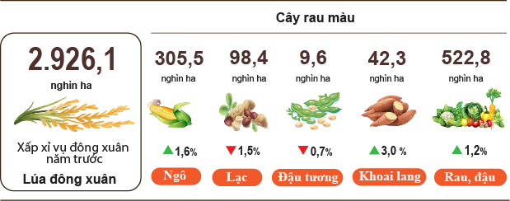
Perennial trees
The output of some perennial crops in the first quarter of 2024 increased compared to the same period last year due to favorable weather and stable product prices. The output of some perennial industrial crops was as follows: Rubber reached 134.1 thousand tons, up 2.7% over the same period last year; cashew nuts reached 230 thousand tons, up 1.7%; tea buds reached 173.3 thousand tons, an increase of 0.5%. For fruit trees, by converting the crop structure, reducing the area of ineffective perennial trees such as pineapple and dragon fruit to planting trees with higher economic efficiency. Compared to the same period last year, the output of some trees increased significantly such as: Durian reached 108.1 thousand tons, an increase of 27.1%; oranges reached 323.3 thousand tons, an increase of 4.1%; banana reached 697 thousand tons, up 3.8%; mango reached 191 thousand tons, an increase of 3.6%; grapefruit reached 167.3 thousand tons, an increase of 3.1%. Dragon fruit output reached 324.1 thousand tons, down 4.7% over the same period last year; pineapple reached 200.7 thousand tons, down 4.1%.
Livestock
Buffalo and cow raising have tended to decrease due to low economic efficiency and shrinking grazing area. Pig and poultry farming were developing well, diseases were under control, pork selling prices increased, production reached higher economic efficiency when reducing the scale of production in small households at the same time increasing livestock enterprises large-scale farming has a closed process with lower production costs.
Figure 2. The growth rate of the population of livestock at the
end of 3/2024 compared to the same time last year
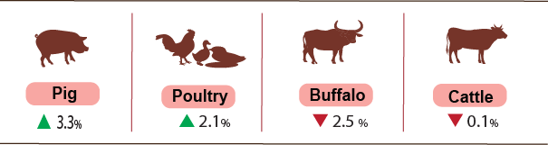
However, livestock farmers still need to closely monitor the market situation, the authorities need to provide timely information, control the local livestock situation, and not massively increase herds leading to a surplus situation with excess supply, selling prices fell sharply, causing losses.
Table 1. Main productions of livestock
 | The first | Estimate | Growth rate of the first quarter of
 | quarter | the first quarter | 2024 compared with
 | of 2023 | of 2024 | the same period last year (%)
Living-weight (Thous. tons)
Pig | 1,237.5 | 1,293.9 |  | 4.6
Poultry | 564.6 | 593.5 |  | 5.1
Buffalo | 32.8 | 32.9 |  | 0.4
Cattle | 130.5 | 132.5 |  | 1.5
Other production of livestock
Eggs (Mill. pieces) | 4,795.4 | 5,025.8 |  | 4.8
Milk (Thous. tons) | 314.9 | 331.3 |  | 5.2
As of 23/3/2024, the whole country has no longer blue-ear disease and avian flu; foot-and-mouth disease was still in Dien Bien, Kon Tum, Gia Lai; LSD was reported in Ha Tinh, Quang Ngai and African swine fever was reported in 18 localities for less than 21 days.

b) Forestry
The area of ​​newly concentrated planted forests in 3/2024 was estimated at 19.2 thousand hectares, up 0.9% over the same period last year; the number of scattered forest trees reached 10.5 million trees, up 10.1%; timber production reached 1,479,8 thousand m³, up 7% due to the increase in the price of raw wood, many localities have accelerated their exploitation progress, such as: Quang Ngai increased by 37.5%; Nghe An increased by 23.8%; Tuyen Quang increased by 21.1%... In the 1st quarter of 2024, the area of ​​newly concentrated planted forest was estimated at 37.3 thousand ha, down 1.4% over the same period last year due to rainy weather, it affected the progress of afforestation in some localities; the number of scattered forest trees reached 23.6 million trees, up 3.6%; timber production was estimated at 3,670.1 thous. m³, up 4.6%.
The damaged forest area in the month was 163.7 hectares, up 7.8% compared to the same period last year, in which the destroyed forest area was 94.3 hectares, up 6.5%; the burned forest area was 69.4 hectares, up 9.5%. In the 1st quarter of 2024, the damaged forest area was 252.3 hectares, up 0.3% over the same period last year, of which the destroyed forest area was 182.2 ha, up 1.1%; the burned forest area was 70.1 hectares, down 1.9%.
c) Fishery
Fishery output in 3/2024 was estimated at 725.4 thousand tons, up 2.4% over the same period last year, including: Fish reached 539.7 thousand tons, up 2.2%; shrimp reached 73.6 thousand tons, up 3.7%; other aquatic products reached 112.1 thousand tons, up 2.8%.
Aquaculture production in the month was estimated at 400.3 thousand tons, up 3.9% over the same period last year, of which fish reached 290.4 thousand tons, up 3.7%; shrimp reached 61.7 thousand tons, up 4.4%.
Pangasius harvest output in the month increased compared to the same period last year due to increased prices of raw pangasius and exports to two main markets which the United States and the European Union were promising. Pangasius output in March 2024 is estimated to reach 149.1 thousand tons, up 3.4% over the same period last year.
Shrimp output in the month increased over the same period due to the application of intensive and semi-intensive white shrimp farming models that were actively developing, bringing high economic efficiency, so farmer and businesses promote their farming activities. Whiteleg shrimp output in the month was estimated at 40.1 thousand tons, up 5% over the same period last year; black tiger shrimp output reached 17.8 thousand tons, an increase of 2.6%.
The caught fishery output in the month was estimated at 325.1 thousand tons, up 0.7% over the same period last year including: Fish production reached 249.3 thousand tons, up 0.5%; shrimp reached 11.9 thousand tons, up 0.2%; other aquatic products reached 63.9 thousand tons, up 1.6%. Marine fishing output was estimated at 310.5 thousand tons, up 0.2% over the same period last year due to favorable fishing weather and abundant aquatic resources which has high economic value.
Figure 3. Fishery production in 1st quarter of 2024
compared to the same period in 2023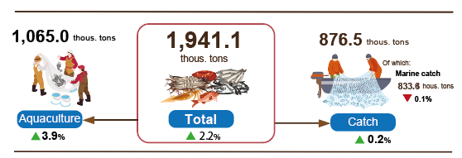
Generally, in the 1st quarter of 2024, fishery output was estimated at 1,941.5 thousand tons, up 2.2% over the same period last year, including fish reached 1,440.8 thousand tons, up 2%; shrimp reached 193 thousand tons, up 3.9%; other fishery products reached 307.7 thousand tons, up 2%.
3. Industrial production
Industrial production in the first quarter of 2024 continues to prosper with the added value of the entire industry estimated to increase by 6.18% over the same period last year, of which the manufacturing increased by 6.98%.
The added value of the entire industry in the first quarter of 2024 is estimated to increase by 6.18% over the same period last year. Of which, the manufacturing increased by 6.98%, contributing 1.73 percentage points to the overall growth of the entire economy; electricity, gas, steam and air conditioning supply increased by 11.97%, contributing 0.45 percentage points; water supply, sewerage, waste management and remediation activities increased by 4.99%, contributing 0.03 percentage points; the mining and quarying decreased by 5.84%, a decrease of 0.20 percentage points.
The index of industrial production (IIP) in the first quarter of 2024 of a number of secondary industries increased compared to the same period last year: Manufacture of chemicals and chemical products increased by 28.4%; Manufacture of rubber and plastics products increased by 25.8%; Manufacture of electrical equipment increased by 24.8%; Manufacture of coke and refined petroleum products increased by 21.7%; Manufacture of furniture increased by 18.1%; Manufacture of basic metals increased by 16.6%; Manufacture of textiles increased by 14.6%; Manufacture of food products increased by 4.5%; Manufacture of computer, electronic and optical products increased by 0.4%. In the opposite direction, the IIP index of some industries decreased: Repair and installation of machinery and equipment decreased by 21.2%; Extraction of crude petroleum and nutural gas decreased by 8.6%; Manufacture of other transport equipment decreased by 6.2%; Manufacture of other non-metallic mineral products decreased by 4.7%; Manufacture of beverages decreased by 2.7%.
Table 2. Growth rate of increase/decrease in IIP index in the first quarter of 2020-2024 compared to the same period last year of some key industries
%
 | 2020 | 2021 | 2022 | 2023 | 2024
Extraction of crude petroleum and nutural gas | -10.5 | -12.3 | -0.2 | -4,3 | -8.6
Manufacture of food products | 4.1 | 5.0 | 5.7 | 3.2 | 4.5
Manufacture of beverages | -10.2 | 12.9 | 5,6 | 11.9 | -2.7
Manufacture of textiles | 4.2 | 4.7 | 6.3 | -7.4 | 14.6
Manufacture of coke and refined petroleum products | 21.7 | -2,1 | -11.6 | 18.7 | 21.7
Manufacture of chemicals and chemical products | 8.3 | 3,4 | 3.3 | 0.6 | 28.4
Manufacture of rubber and plastics products | 2.5 | 10.1 | -13.5 | 10.9 | 25.8
Manufacture of other non-metallic mineral products | 0.5 | 6.5 | 9.1 | -7.2 | -4.7
Manufacture of basic metals | 0.2 | 36.7 | 2.9 | -7.3 | 16.6
Manufacture of computer, electronic and optical products | 14.3 | 9.1 | 7.6 | -5,4 | 0.4
Manufacture of electrical equipment | -2.6 | 11.8 | 16.6 | -5,7 | 24.8
Manufacture of other transport equipment | 0.6 | -1.7 | 6.8 | -10.9 | -6.2
Manufacture of furniture | 4.7 | 12.5 | 3.8 | -8.4 | 18.1
Repair and installation of machinery and equipment | -5.9 | 3.7 | -15.2 | 11.2 | -21.2

Industrial production index for the first quarter of 2024 compared to the same period last year increased in 54 localities and decreased in 9 localities across the country. Some localities have had a fairly high increase in the IIP index due to the manufacturing; the electricity, gas, steam and air conditioning supply increased sharply. On the other hand, some localities have a low increase or decrease in the IIP due to the manufacturing; the mining and quarying and the electricity, gas, steam and air conditioning supply increased slightly or decreased.
Figure 4. IIP increase/decrease rate in the first quarter of 2024
compared to the same period last year in some localities (%)

10 localities with the highest IIP growth rate | 10 localities have low or decreasing IIP
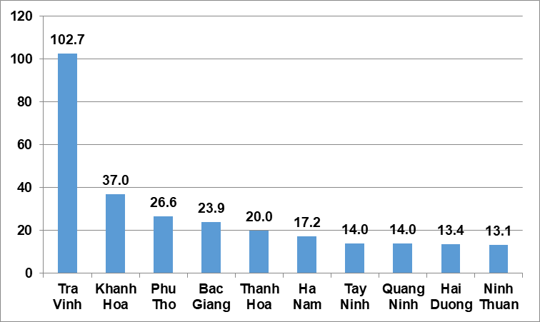 | 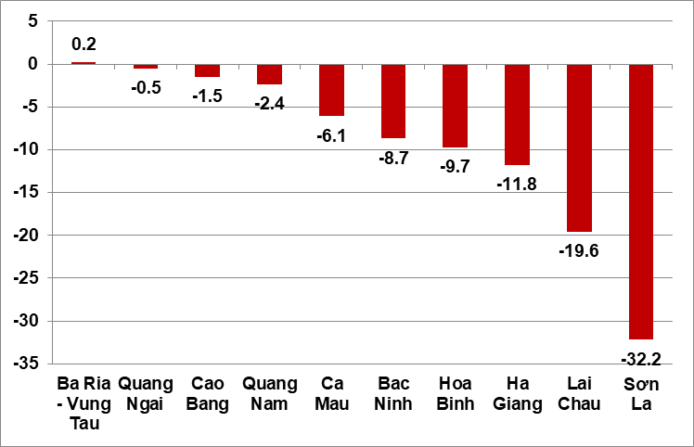
Some main industrial products in the first quarter of 2024 increased compared to the same period last year: Steel bars and corners increased by 29.1%; laminated steel increased by 24.1%; N.P.K mixed fertilizer increased by 23.1%; Textile fabric from natural yarn increased by 21.8%; Petroleum increased by 21.7%; Urea fertilizer increased by 16.9%; refined sugar increased by 14%; chemical paint increased by 13.9%; generated electricity increased by 11.4%. On the oher hand, some products decreased compared to the same period last year: Natural gas (in the form of air) and mobile phones both decreased by 13.3%; automobiles decreased by 11.3%; television decreased by 11.1%; liquidized gas (LPG) decreased by 11.0%; phone accessories decreased by 5.3%; motorbikes decreased by 5.2%.
The consumption index of the manufacturing in 3/2024 increased by 12.7% compared to the previous month and increased 0.2% over the same period last year. General, in the first quarter of 2024, the consumption index of the manufacturing increased by 8.2% compared to the same period in 2023 (the same period in 2023 decreased by 2.9%).
The inventory index of the manufacturing is estimated at March 31,2024 to increase by 9.8% compared to the same time last month and by 14.1% compared to the same time last year (same time as March 31, 2024 last year increased by 19.8%). The average inventory rate of the manufacturing in the first quarter of 2024 is 68.7% (the average in the first quarter of 2023 is 81.1%).
The number of employees working in industrial enterprises as of March 1, 2024 increased by 1.3% compared to the same time last month and increased by 1.1% compared to the same time last year. Of which, the number of employees in the State-owned enterprise sector increased by 0.1% and decreased by 0.5%; Non-state enterprises increased by 1.1% and decreased by 0.6%; enterprises of foreign direct investment increased by 1.5% and 1.7%. By industry, the number of employees working in mining and quarrying increased by 0.2% compared to the same time last month and increased by 0.7% compared to the same time last year; manufacturing increased by 1.4% and 1.1%; electricity, gas, steam and air conditioning supply was equivalent to the same period last month and increased 0.8% compared to the same period last year; the water supply, sewerage, waste management and remediation activities increased by 0.1% and 1.2%.
4. Enterprise activities
a) Enterprise registration status
In March, the whole country had 14.1 thousand newly established enterprises with registered capital was 113.5 trillion VND and a total number of registered employees of 104.4 thousand employees, an increase of 64.3% in the number of enterprises, an increase of 68.7% in registered capital and an increase of 105.2% in the number of employees compared to February 2024. Compared to the same period last year, a decrease of 0.7% in the number of enterprises, down 22.1% in registered capital and up 12.7% in the number of employees. The average registered capital of a newly established enterprise in the month reached 8 billion VND, an increase of 2.7% compared to the last month and down 21.5% compared to the same period of 2023. Besides, there were more than 3 thousand re-operated enterprises in the whole country, a decrease of 43.4% compared to the previous month and down 52% compared to the same period of 2023.
Generally, in the first quarter of 2024, the whole country had over 36.2 thousand newly registered enterprises with a total registered capital of 332.2 trillion VND and a total number of registered employees was nearly 258.8 thousand employees, up 6.9% in the number of enterprises, up 7% in registered capital and up 21.9% in the number of employees compared to the same period last year. The average registered capital of a newly established enterprise in the first 3 months of 2024 achieved 9.2 billion VND, up 0.1% compared to the same period in 2023. If including 392.3 trillion VND of the additionally registered capital of over 9.7 thousand enterprises that recorded an upward adjustment of capital, the total number of captial that added more to the economy in the first 3 of 2024 was 724.5 trillion VND, a decrease of 4.3% compared to the same period last year. Besides, there were over 23.6 thousand re-operated enterprises (up 2.4% compared to the same period of 2023), bringing the total number of newly-established enterprises and re-operated enterprises in the first 3 months of 2024 to nearrly 59,9 thousand enterprises, up 5.1% compared to the same period last year. The average each month had nearly 20 thousand newly established and re-operated enterprises.
By economic sector in 3 months, there were 363 newly-established enterprises in the agricultural, forestry, and fishery sectors, an increase of 10% compared to the same period last year; 8.7 thousand enterprises in the industrial and construction sectors, an increase of 6.8%; 27.2 thousand enterprises in the service sector, an increase of 6.9%.
Figure 6. Enterprise registration situation
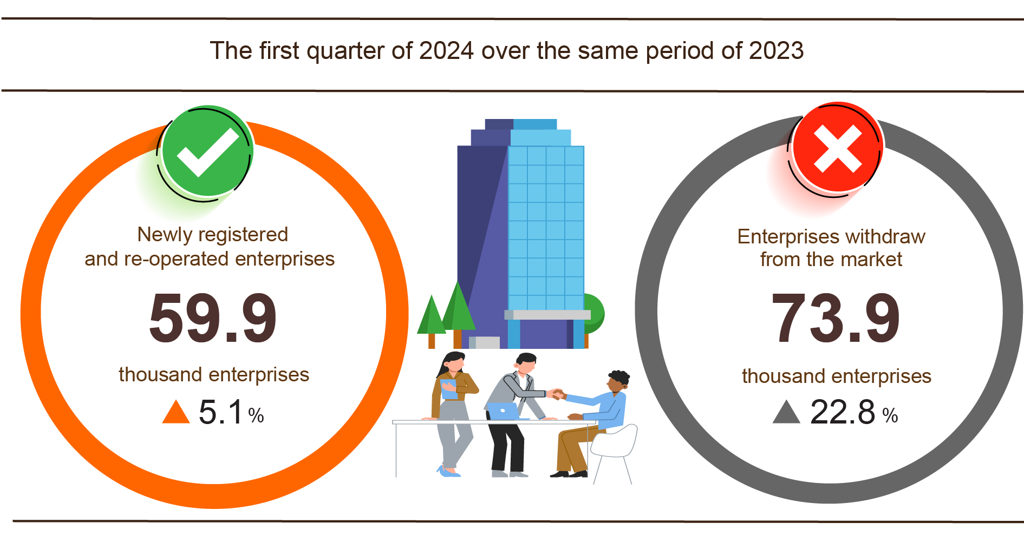
Also in March, 4,139 enterprises ceased for a certain time, down 19.6% compared to the previous month and down 0.2% over the same period in 2023; 4,980 enterprises temporarily ceased and awaited dissolution procedures, an increase of 131.3% and an increase of 44.3%; 1,412 enterprises completed dissolution procedures, down 6.2% over February, 2024 and equal to the the same period last year.
In the first 3 months of 2024, there were 53.4 thousand enterprises temporarily ceased for a certain time, an increase of 24.5% compared to the same period last year; over 15.5 thousand enterprises temporarily ceased and awaited dissolution procedures, an increase of 10.1%; 5.1 thousand enterprises completed dissolution procedures, up 10.1%. On average, nearly 24.7 thousand enterprises withdraw from the market each month.
Thus, comparing the number of newly established and re-operated enterprises with the number of enterprises withdraw from the market, in the first quarter of 2024, the total number of enterprises in our country decreased by 14.1 thousand enterprises, on average, a decrease of 4.7 thousand enterprises each month.
Table 3: Number of newly registered enterprises and completed dissolution procedures in 3 months, 2024 by kinds of activity

 | Number of enterprises (Enterprise) |  | Growth rate  over the same period last year (%)
 | Newly registered | Dissolution | Newly registered | Dissolution
Wholesale and retail trade; repair of motor vehicles and motorcycles | 14,652 | 1,945 | 13 | 21.6
Manufacturing | 4,283 | 550 | 8.8 | 8.3
Construction | 3,997 | 369 | 4.4 | -4.4
Real estate business | 921 | 331 | -2 | -2.9
Transportation and storage | 1,879 | 190 | 24.4 | 5.6
Accommodation and catering service | 1,357 | 229 | -11.7 | -1.3
Production and distribution of electricity, water, gas | 256 | 62 | 5.3 | -37.4

b) Business trends of the enterprises
Results of the business tendency survey of manufacturing enterprises in the first quarter of 2024 showed that: 22.1% of enterprises assessed that the business production situation was better than in the forth quarter of 2023; 42.8% of enterprises said that the business production situation was stable and 35.1% of enterprises faced difficulties. For the expected outcome of the second quarter of 2024, 45.4% of enterprises presented that the tendency would get better than the first quarter of 2024; 36.6% of enterprises said that business production situation would be stable and 18% of enterprises predicted that it would be more difficult. In which, the non-state enterprises sector and the foreign direct investment sector were the most optimistic, 82.2% of enterprises forecasted a better business production situation in the second quarter of 2024 and expected to remain stable compared to the first quarter of 2024; these rates in the State-owned enterprises were 78.1% respectively.
Figure 7. The main factors affecting the business production situation
in the first quarter of 2024

Regarding production volume, 22.3% of enterprises pointed out the production volume in the first quarter of 2024 increased compared to the forth quarter of 2023; 38.9% of enterprises considered it stable and 38.8% of enterprises reported that the production volume reduced. For the trend in the second quarter of 2024 compared to the first quarter, 44.1% of enterprises forecasted an increase in the production volume; 38.2% of enterprises predicted stability and 17.7% of enterprises forecasted a decrease.
Regarding orders for goods, 20.9% of enterprises had more orders in the first quarter of 2024 than in the forth quarter of 2023; 42.6% of enterprises had stable orders and 36.5% of enterprises recorded a decrease in orders. About trend in the second quarter, 2024 over the first quarter, 2024, 42.2% of enterprises expected an increase in orders; 40.7% of enterprises expected to have stable orders and 17.1%% of enterprises expected a decrease in orders.
Regarding export orders, 19.1% of enterprises confirmed more export orders in the first quarter of 2024 than the forth quarter of 2023; 47.3% of enterprises experienced stable export orders and 33.6% of enterprises had decreased export orders. About trend in the second quarter of 2024 over the first quarter of 2024, 36.9% of enterprises expected to have an increase in export orders; 46% of enterprises expected to be stable, and 17.1% of enterprises expected to decrease.
5. Service activities
a) Retail sales of consumer goods and services
After the Lunar New Year, people's consumption needs return to normal, the total retail sales of consumer goods and services in March increased by 0.5% over the previous month and up 9.2% over the same period last year, including a positive contribution from the tourism industry. Overall, in the first quarter of 2024, the total retail sales of consumer goods and services was estimated to increase by 8.2% over the same period last year, of which revenue from accommodation and food services increased by 13.4%, revenue from tourism up to 46.3%.
Total retail sales of consumer goods and services at current prices in 3/2024 was estimated at 509.3 trillion VND, up 0.5% over the previous month and up 9.2% over the same period last year. In which, the group of food and foodstuffs increased by 11.6%; household appliances, tools and equipment increased by 16%; garment increased by 10.1%; accommodation and food services increased by 15.8%; traveling service increased by 66.1% over the same period last year.
Table 3. Retail sales of consumer goods and services at current prices

Trillion VND
 | Estimate  March  2024 | Estimate  1st quarter  of 2024 | Growth rate compared to the same period last year (%)
 | Estimate  March  2024 | Estimate  1st quarter  of 2024 | March  in 2024 | 1st quarter  of 2024
Total | 509,3 | 1.537,6 | 9,2 | 8,2
Retail sale of goods | 392,7 | 1.190,3 | 7,6 | 7,0
Accommodation and catering service | 58,3 | 174,8 | 15,8 | 13,4
Tourism revenue | 5,1 | 14,1 | 66,1 | 46,3
Other services | 53,2 | 158,4 | 10,6 | 9,5
Overall, in the first quarter of 2024, the total retail sales of consumer goods and services at current prices was estimated at 1,537.6 trillion VND, up 8.2% over the same period last year (up 13.9% in the same period in 2023), if excluding the price factor, up 5.1% (the same period in 2023 increased by 10.1%).
Figure 11. Total retail sales of consumer goods and service
in the first quarter of 2020-2024

Retail sales of goods in the first quarter of 2024 were estimated at 1,190.3 trillion VND, accounting for 77.4% of the total retail sales of consumer goods and services and up 7% over the same period last year (if excluding the price factor, up 4.5%). In which, food and foodstuffs increased by 11.8%; household appliances, tools and equipment increased by 15%; garment increased by 8%; cultural and educational products increased by 17.7%; means of transport (except for cars) down 4.9%; automobile products decreased by 27.8%. Retail sales of goods in the first quarter of this year compared to the same period last year of some localities were as follows: Quang Ninh increased by 9.8%; Hai Phong increased by 9.7%; Khanh Hoa and Long An both increased by 9.1%; Binh Duong, Dong Nai, and Can Tho all increased by 7%; Da Nang increased by 5.9%; Ho Chi Minh City increased by 5.8%; Ha Noi increased by 4.7%.
Revenue from accommodation and catering services in the first quarter of 2024 was estimated at 174.8 trillion VND, accounting for 11.4% and up 13.4% over the same period last year. Revenue in the first quarter of 2024 compared to the same period last year of some localities with a high growth rate such as: Quang Ninh increased by 23.2%; Da Nang increased by 19.8%; Hai Phong increased by 13.5%; Ha Noi increased by 12.7%; Ho Chi Minh City increased by 12.2%; Can Tho increased by 9.1%.
Tourism revenue in the first quarter of 2024 was estimated at 14.1 trillion VND, accounting for 0.9% and up 46.3% over the same period last year. The revenue of some localities in the first quarter of 2024 compared to the same period last year was as follows: Da Nang increased by 69%; Ho Chi Minh City increased by 59%; Can Tho increased by 57.7%; Ha Noi increased by 47.6%; Quang Ninh increased by 18.5%; Lam Dong increased by 13.3%.
Other service revenue in the first quarter of 2024 was estimated at 158.4 trillion VND, accounting for 10.3% and up 9.5% over the same period last year. Specifically, the increase/decrease growth rate in the first quarter of 2024 over the same period last year of some localities was as follows: Bac Ninh increased by 23.3%; Lao Cai increased by 17.7%; Khanh Hoa increased by 17.1%; Ho Chi Minh City increased by 15.5%; Dong Nai increased by 12.4%; Vinh Long increased by 9.3%; Hanoi increased by 8.2%; Ha Tinh increased by 6.2%; Kien Giang increased by 4.2%; Can Tho increased by 3.2%; Hai Phong increased by 3.1%.
d) Transport
Transport activities in March decreased in passenger transport output compared to the previous month due to reduced travel demand of people after the Lunar New Year holiday, but freight transport still recorded positive growth when the demand for transporting goods for production increased and March had more working days than last month. Compared to the same period last year, passenger carried in 03/2024 increased by 9.4% and passenger traffic increased by 10.3%; freight carried increased by 13.3% and freight traffic up 5.9%.
Overall, in the first quarter of 2024, passenger carried increased by 8.5% and passenger traffic up 10.7% over the same period last year; freight carried increased by 13% and freight traffic up 11.2%.
Passenger transport in 3/2024 was estimated at 398.1 million passengers, decreased by 3.8% over the previous month and passenger traffic was 21.7 billion passengers-kilometers, down 6.9%. Overall, in the first quarter of 2024, passenger carried was estimated at 1,199.6 million passengers, up 8.5% over the same period last year (up 27.7% in the same period in 2023) and passenger traffic was 66.6 billion passengers.km, increased by 10.7% (up 57% in the same period in 2023). Of which, domestic transport reached 1,195.3 million passengers, up 8.5% over the same period last year and 52.7 billion passengers-kilometers, up 5.7%; overseas transport reached 4.3 million passengers, increased by 27.9% and 13.9 billion passengers-kilometers, up 35%.
In terms of transportation, most transport industries in the first quarter of 2024 increased compared to the same period last year, especially aviation had a decrease in passenger carried output but had an increase in passenger traffic.
Table 6 : Passengers transport in the first quarter of 2024
by types of transport

 | Number of passengers |  | Growth rate compared to the same period last year (%)
 | Carried  (Mill. passengers) | Traffic  (Bill. passengers-km) | Carried | Traffic
Total | 1.199.6 | 66.6 | 8.5 | 10.7
Rail way | 1.7 | 0.7 | 13.4 | 13.5
Sea way | 4.8 | 0.2 | 1.6 | 5.0
Inland water way | 101.7 | 1.8 | 12.8 | 13.6
Road | 1.078.4 | 42.3 | 8.4 | 9.5
Airway | 13.0 | 21.6 | -4.6 | 12.9

Freight transport in 3/2024 was estimated at 208.1 million tons of freight carried, decreased by 3.1% over the previous month and 41.4 billion tons.km of freight traffic, up 0.8%. Overall, in the first quarter of 2024, freight transport was estimated at 620.1 million tons of freight carried, up 13% over the same period last year (up 16% in the same period in 2023) and 129.2 billion tons.km of freight traffic, an increase of 11.2% (up 20.7% in the same period in 2023). Of which, domestic transport reached 608.6 million tons of freight carried, up 13.1% and 79.6 billion tons.km of freight traffic, up 9.6%; overseas transport reached 11.5 million tons of freight carried, up 7.8% and 49.6 billion tons.km of freight traffic, up 13.8%.
Table 6. Carriage of freight in the first quarter of 2024
by types of transport

 | Quantity of goods |  | Growth rate compared to the same period last year (%)
 | Carried  (Mill. tons) | Traffic (Bill. tons-km) | Carried | Traffic
Total | 620,1 | 129,2 | 13,0 | 11,2
Rail way | 1,2 | 0,9 | 15,5 | 4,3
Sea way | 32,6 | 68,3 | 12,8 | 14,4
Inland water way | 131,3 | 27,6 | 14,2 | 5,4
Road | 454,9 | 29,9 | 12,7 | 8,8
Airway | 0,1 | 2,5 | 32,2 | 27,5

c) Telecommunications
Telecommunications activities in the first quarter of 2024 were generally stable with estimated revenue of 89.1 trillion VND, an increase of 3.4% compared to the same period last year (if excluding the price factor, an increase of 3.1%). The total number of telephone subscribers by the end of March 2024 was estimated at 125.9 million subscribers, a decrease of 3.5% compared to the same period last year. Of which, the number of mobile subscribers at the above time was 123.6 million, a decrease of 3.5% because the number of 2G mobile phone subscribers is gradually decreasing according to the roadmap to achieve the goal of the Digital Transformation Program and the information and communications industry have strengthened the management of prepaid mobile subscriptions, controlled, minimized and gradually eliminated junk SIMs, so the number of new mobile subscribers has decreased significantly. The number of fixed broadband internet subscribers by the end of March 2024 recorded 22.9 million subscribers, up 6.4% compared to the same period last year, in which subscribers accessing via fiber optic cable systems (FTTH) and private channel rentals tend to increase rapidly; subscribers through cable television systems (CATV) and through xDSL continue to decrease.
đ) International visitors to Viet Nam
Thanks to favorable visa policies, tourism stimulus programs as well as the efforts of the government and tourism businesses, the number of international visitors to Viet Nam in 3/2024 reached nearly 1.6 million, up 4.4% compared to the previous month and increased by 78.6% compared to the same period last year. In the first quarter of 2024, international visitors to our country reached more than 4.6 million arrivals, up 72% compared to the same period last year and up 3.2% to the same period of 2019 - the year before the Covid-19 pandemic. The number of Vietnamese exits reached 1.2 million, up 11.5% over the same period last year.
Out of a total of 4.6 million international arrivals to Viet Nam in the first quarter of this year, arrivals by air reached nearly 3.9 million arrivals, accounting for 83.6% of international arrivals to Viet Nam and up 60.1% over the same period last year; by road reached 625.3 million arrivals, accounting for 13.5% and 2.6 times higher; by sea reached 136.7 thousand arrivals, accounting for 2.9% and 4.1 times higher.
Figure 17. International visitors to Viet Nam in the first quarter
of 2024 by territories
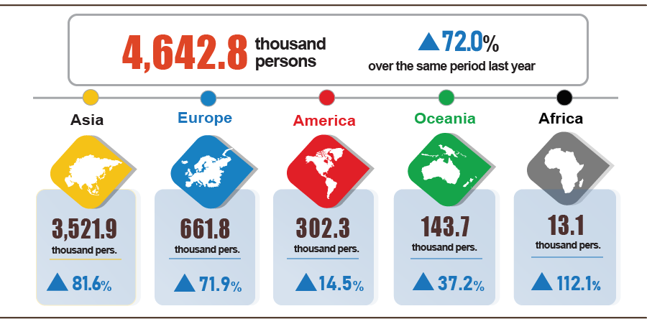
The number of Vietnamese people leaving the country in 3/2024 was 537.4 thousand people, an increase of 42.7% over the same period last year. In the first quarter of 2024, the number of Vietnamese leaving the country reached 1.2 million, up 11.5% over the same period last year.

II. MACROECONOMIC STABILITY, INFLATION CONTROL
1. Banking, insurance, and securities activities
Deposit and lending rates maintained a downward trend, contributing to macroeconomic stability. Stable insurance business; The stock market flourished with its share market capitalization up 12.2%.
As of March 25, 2024, capital mobilization of credit institutions decreased by 0.76% compared to the end of 2023 ( increased by 1.17% at the same time in 2023); credit growth of the economy reached 0.26% ( up 1.99% at the same time in 2023).
Following the decline in interest rates from the end of 2023, the trend of reducing deposit and lending rates continues to be maintained. The average deposit interest rate in Vietnamese dong in February 2024 of domestic commercial banks (commercial banks) is at 0.2%/year for demand deposits with terms of less than 1 month; from 2.2-3.1%/year for term deposits from 1 month to less than 6 months; 5.3-5.6%/year for term deposits from 6 months to 12 months; 6.8-7.5%/year for term deposits from more than 12 months to 24 months and 6.9-7.3%/year for terms over 24 months. The average lending interest rate of domestic commercial banks for new and old loans with outstanding loans is at 7.7-9.9%/year. Credit continues to be oriented to production and business sectors, priority areas and growth drivers, promptly meeting the capital needs of people and enterprises.
The central exchange rate was operated proactively and flexibly in accordance with the domestic and international market situation, macro balances and monetary policy objectives,contributing to stabilizing the foreign currency market, and lawful foreign currency needs are fully met. As of March 25, 2024, the central exchange rate was at 24,015 VND/USD, up 0.62% compared to the end of 2023. The listed buying - selling rate of Joint Stock Commercial Bank for Foreign Trade was at 24,570-24,940 VND/USD, up 2.13-2.16% compared to the end of 2023.
Regarding social policy credit, by March 25, 2024, the total disbursed capital of social policy credit programs reached 26,333 billion VND, with more than 540 thousand loans from poor households, near-poor households and other policy beneficiaries during the year. Total policy credit balance reached 338,642 billion VND, up 2% compared to 2023 with more than 6.8 million poor households, near-poor households and other policy beneficiaries having outstanding loans.
Regarding the insurance market, in the first months of 2024, non-life insurance premium revenue, investment capital back into the economy, total assets of insurance enterprises achieved decent growth. Total premium revenue in the first quarter of 2024 was estimated at 53,295 billion VND, down 4.3% over the same period in 2023, of which: Premium revenue from life insurance was estimated at 33,740 billion VND, down 10.9%; The non-life insurance sector was estimated at 19,555 billion VND, up 9.8%. Insurance benefit payment in the first quarter of 2024 was estimated at 20,988 billion VND, up 20.5% over the same period in 2023; the total amount of investment back into the economy was estimated at 779,116 billion VND, up 10.4%; Total assets of insurance enterprises were estimated at 932,866 billion VND, up 10.2%.
On the stock market, the easing of monetary policy of the State Bank of Vietnam is the driving force for domestic investors to return to the market, in the first quarter of 2024, the VN-Index tends to increase sharply.
In the stock market, as of March 28, 2024, the VNIndex index reached 1,286.11 points, up 2.7% from the end of last month and up 13.8% from the end of 2023; Market capitalization (until March 15, 2024) was estimated at 6,662 trillion VND, up 12.2%.
In March, the average transaction value reached 28,992 billion VND /session, up 24.5% compared to the previous month's average. In the first quarter of 2024, the average transaction value reached 22,529 billion VND /session, up 28.2% compared to the average of 2023.
The stock market as of the end of February 2024 has 736 listed stocks and fund certificates; 870 shares registered for trading on UPCoM with a total listed and registered trading value of 2,138 trillion VND, up 0.5% compared to the end of 2023.
On the bond market, the average transaction value in March reached 11,279 billion VND /session, up 20.5% over the previous month; On average, the first quarter of 2024 reached 9,698 billion VND /session, up 48.8% compared to the average of 2023.
At the end of February 2024, the bond market has 457 listed codes with a listed value of more than 2,040 trillion VND, up 17.1% compared to the end of 2023.
On the derivatives market, the average trading volume of futures products on VN30 index in March reached 235,398 contracts/session, up 42% over the previous month; The average trading volume of secured warrant products reached 65.2 million warrants/session, down 2.3%. Since the beginning of the year, the average trading volume of futures products on VN30 index has reached 191,436 contracts/session, down 19% compared to the average in 2023; secured warrant products reached 63.2 million warrants/session, up 93.1%.
2. Development investment
Realized social investment capital in the first quarter of 2024 at current prices increased by 5.2% over the same period last year, reflecting the recovery trend of domestic production and business in many industries and fields. . This increase will create momentum for continued breakthroughs in the following quarters, supporting economic growth in 2024 in a context where the economy still faces many difficulties and challenges . Realized foreign direct investment capital in Vietnam in the first quarter of 2024 is estimated to reach 4.63 billion USD, up 7.1% over the same period last year, reaching the highest level in the first three months of the years from 2020 to now.
Realized social investment capital in the first quarter of 2024 at current prices is estimated at 613.9 trillion VND, up 5.2% over the same period last year, including: State sector capital estimated at 162.7 trillion VND, accounting for 26.5% of total investment capital and increasing 4.9% over the same period last year; The non-state sector reached 340.7 trillion VND, accounting for 55.5%, an increase of 4.2%; The foreign direct investment sector reached 110.5 trillion VND, accounting for 18% and increasing by 8.9%.
Figure 9. Total investment capital implemented in the whole society
classified by economic type according to current prices in the first quarter of 2020-2024

In the investment capital of the State sector, realized capital from the State budget in the first quarter of 2024 is estimated to reach 97.7 trillion VND, equal to 13.9% of the yearly plan and an increase of 3.7% over the same period last year (first quarter 2023 equal to 12.9% and increase 21.6%). According to management level, central capital reached 15.7 trillion VND, equal to 14.2% of the year's plan and down 8.1 % over the same period last year; Local capital reached 82 trillion VND, equal to 13.8 % and increased by 6.4 %. Among locally managed capital, provincial - level State budget capital reached 54.8 trillion VND, equal to 13% and increased by 5.8 %; State budget capital at district level reached 23.6 trillion VND, equal to 15.6% and increased by 8%; State budget capital at commune level reached 3.6 trillion VND, equal to 17.2% and increased by 5%.
Figure 10. Rate of increase/decrease in realized investment capital of the whole society
at current prices in the first quarter of the years 2020-2024

Total foreign investment capital registered in Vietnam As of March 20, 2024, including: Newly registered capital, adjusted registered capital and value of capital contributions and share purchases by foreign investors reached nearly 6.17 billion USD, an increase of 13.4% compared to the same period last year.
Figure 11. Foreign investment capital registered in Vietnam
as of March 20, 2020-2024 (Billion USD)

- Newly registered capital has 644 licensed projects with a registered capital of 4.77 billion USD, an increase of 23.4% over the same period last year in the number of projects and an increase of 57.9% in registered capital. sign. Among them, the processing and manufacturing industry has the largest newly licensed foreign direct investment with a registered capital of 3.04 billion USD, accounting for 63.7% of the total newly registered capital; Real estate business activities reached 1.49 billion USD, accounting for 31.2%; The remaining industries reached 239.3 million USD, accounting for 5.1%.
Among the 42 countries and territories with new licensed investment projects in Vietnam in the first three months of 2024, Singapore is the largest investor with 2.28 billion USD, accounting for 47.8% of total newly registered capital; followed by Hong Kong Special Administrative Region (China) with 833 million USD, accounting for 17.4%; China 481.3 million USD, accounting for 10.1% ; Japan 456.4 million USD, accounting for 9.6%; Korea 248.6 million USD, accounting for 5.2%; Taiwan 107.7 million USD, accounting for 2.3%.
- Adjusted registered capital: 248 projects licensed from previous years registered to adjust their investment capital by 934.6 million USD, down 22.6% over the same period last year.
If including new registered capital and adjusted registered capital of projects licensed in previous years, registered foreign direct investment capital in the processing and manufacturing industry reached 3.83 billion USD, accounting for 67% of total newly registered and increased capital; Real estate business activities reached 1.53 billion USD, accounting for 26.8%; The remaining industries reached 350.2 million USD, accounting for 6.2%.
- Registered capital for capital contribution and share purchase by foreign investors was 604 times with a total capital contribution value of 466.2 million USD, down 61.7% over the same period last year. Among them, there are 224 capital contributions and share purchases increase the enterprise's charter capital with a capital contribution value of 214.5 million USD and 380 foreign investors bought back domestic shares without increasing charter capital with a value of 251.7 million USD. For the form of capital contribution, share purchase by foreign investors, professional and scientific and technological activities reached 150.7 million USD, accounting for 32.3%; Investment capital in processing and manufacturing industry reached 99.4 million USD, accounting for 21.3% of capital contribution value; The remaining industry has 216 million USD, accounting for 46.4 %.
Foreign direct investment capital realized in Vietnam in the first three months of 2024 is estimated to reach 4.63 billion USD, up 7.1% over the same period last year. This is the highest amount of realized foreign direct investment capital in the first three months of the year in the past 5 years. Of which: Processing and manufacturing industry reached 3.61 billion USD, accounting for 78% of total realized foreign direct investment capital; Real estate business activities reached 460.4 million USD , accounting for 9.9%; Production and distribution of electricity, gas, hot water, steam and air conditioning reached 197.5 million USD, accounting for 4.3 % .
Figure 12. Realized foreign direct investment capital in
3 months head year years 2020-2024

Vietnam's investment abroad in the first three months of 2024 has 22 projects newly granted investment certificates with a total Vietnamese capital of 28.7 million USD, down 74.6% over the same period. last year; There were 2 rounds of capital adjusted projects with the adjusted capital increasing by 220 thousand USD, a decrease of 96.5%.
In general, Vietnam's total investment capital abroad (new and adjusted capital) reached 28.9 million USD, down 75.8% over the same period last year. Of which: Sell trade and sell odd, edit Car and tissue repair​ car, car machine and car Have dynamic muscle another reached 11.5 million USD, accounting for 39.8% of total investment capital; Real estate business activities reached 5.4 million USD, accounting for 18.6%; Construction activities reached 5 million USD; accounting for 17.3%.
In the first three months of 2024, there are 13 countries and territories receiving investment from Vietnam, of which : America is the leading country with 6.7 million USD, accounting for 23% of total investment capital; New Zealand 5.9 million USD, accounting for 20.3%; Germany 5.4 million USD, accounting for 18.6%; Laos reached 4.2 million USD, accounting for 14.6%; Singapore 1.8 million USD, accounting for 6.1%.
3. State budget revenues and expenditures
State budget revenue in the first quarter of 2024 is estimated to increase by 9.8% over the same period last year. State budget expenditure is estimated to increase by 8.3% over the same period in 2023, ensuring the needs of socio-economic development, national defense and security, state management, payment of due debts as well as payment of due debts. such as timely payment to subjects according to regulations.
Figure 14. State budget revenue and expenditure in the first quarter of 2024
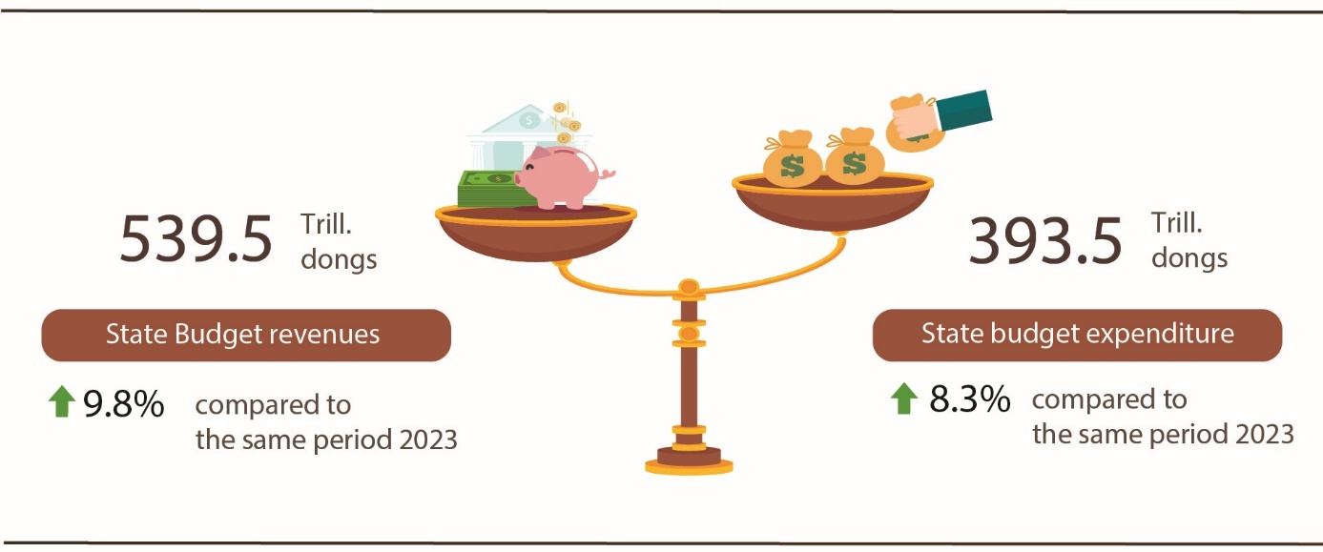

State budget revenue:
Total state budget revenue in March, 2024 was estimated at 141.8 trillion VND. The accumulated total state budget revenue in the first quarter of 2024 was estimated at 539.5 trillion VND, equal to 31.7% of the yearly estimate and increasing by 9.8% over the same period last year. Some of the main revenues are as follows:
- Domestic revenue in March was estimated at 114.6 trillion VND. Accumulation in the first quarter of 2024 is estimated at 467.5 trillion dong, equaling 32,4% of the year estimate and increasing by 13,5% over the same period last year.
- Revenue from crude oil in March was estimated at 6 trillion dong; accumulated in the first quarter of 2024 is estimated at 15.8 trillion dong, equaling 34.4% of the year estimate and up 2.1% over the same period last year.
- Budget balance revenue from import and export activities in March was estimated at 21.2 trillion VND; accumulated in the first quarter of 2024 is estimated at VND 56.2 trillion, equaling 27.5% of the year estimate and down 12.5% over the same period last year.
State budget expenditure:
Total state budget expenditure in March, 2024 was estimated at 140.3 trillion VND; accumulated in the first quarter of 2024 was estimated at 393.5 trillion dong, equaling 18.6% of the year estimate and up 8.3% over the same period last year. In which, recurrent expenditure in the first quarter of 2024 was estimated at 271 trillion dong, equaling 21.5% of the year estimate and increasing by 3.4% over the same period last year; development investment expenditure reached 89.9 trillion dong, equaling 13.3% and increasing by 22.8%; interest payment was 32.5 trillion dong, equal to 29,1% and up 16.6%.
4. Export and import of goods and services
a) Export and import of goods
Total export and import turnover of goods in 3/2024 was estimated at 65.09 billion USD, up 35.6% over the previous month and up 12% over the same period last year. Generally, in the first quarter of 2024, the total export and import turnover of goods reached 178.04 billion USD, up 15.5% over the same period last year, of which exports increased by 17%; imports increased by 13.9%. The trade balance of goods had a surplus of 8.08 billion USD.
Figure 12. Import and export of goods in the first quarter of 2024
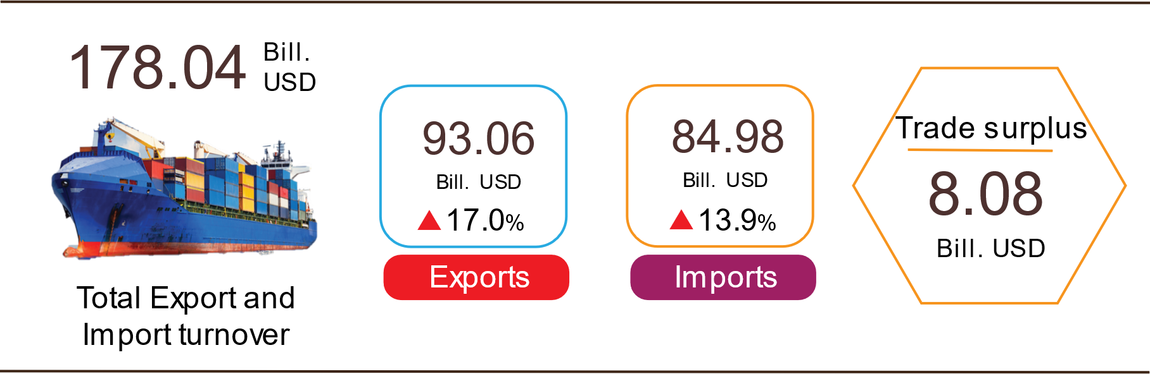

Export of goods
Preliminary export turnover of goods in 02/2024 reached USD 24.69 billion, 135 million USD lower than the estimated figure.
Export turnover of goods in 3/2024 was estimated at 34.01 billion USD, up 37.8% over the previous month. Of which, the domestic economic sector gained 9.54 billion USD, increased by 51.7%; the FDI sector (including crude oil) reached 24.47 billion USD, increased by 33%. Compared to the same period last year, export turnover of goods in March increased by 14.2%, of which the domestic economic sector increased by 21.2%, the FDI sector (including crude oil) increased by 11.7%.
Generally in the first quarter of 2024, the export turnover was estimated at 93.06 billion USD, increased by 17% over the same period last year. Of which, the domestic economic sector was 25.21 billion USD, went up 26.2%, accounting for 27.1% of total export turnover; the FDI sector (including crude oil) attained 67.85 billion USD, increased by 13.9%, sharing 72.9%.
In the first quarter of 2024, there were 16 products with export turnover of over 1 billion USD, contributing 82.1% to the total export turnover (04 products with export turnover of over 5 billion USD, accounting for 52.7%).

Table 4. Value of some export products in the first quarter of 2024
 | Estimate  (Mill. USD) | Growth rate compare to  the same period last year (%)
Items with a value of over 5 billion USD
Electronic goods, computers and their parts | 15,693 | 30,3
Phones all of kinds and their parts | 14,713 | 9,7
Machinery, instrument, accessory | 10,876 | 10,2
Textiles and garments | 7,757 | 7,9

Regarding the structure of exported groups in the first quarter of 2024, the group of fuels and minerals was estimated at 1.18 billion USD, accounting for 1.3%; the group of processing industry was estimated at 82.02 billion USD, accounting for 88.1%; agricultural and forestry products was estimated at 8 billion USD, accounting for 8.6%; the group of fishery products was estimated at 1.86 billion USD, accounting for 2%.
Figure 13. Structure of exported groups
in the first quarter of 2024

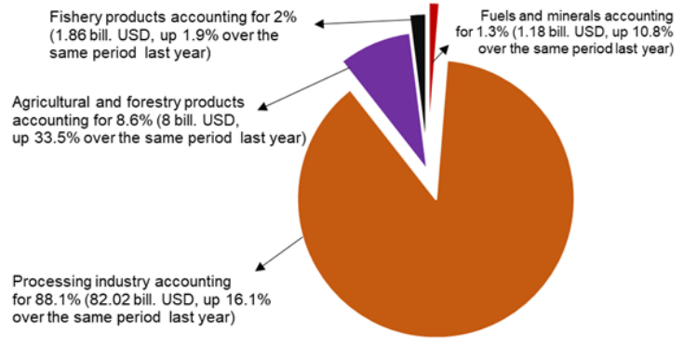
Import of goods
Preliminary import turnover of goods in 02/2024 reached 23.3 billion USD, 416 million USD lower than the estimate figure.
Import turnover in 3/2024 was estimated at 31.08 billion USD, increased by 33.4% over the previous month. Of which, the domestic economic sector gained 10.83 billion USD, increased by 36.8%; the FDI sector reached 20.25 billion USD, increased by 31.6%. Compared to the same period last year, the import turnover of goods in March increased by 9.7%, of which the domestic economic sector increased by 2.9%; the FDI sector increased by 13.7%.
Generally in the first quarter of 2024, the import turnover was estimated at 84.94 billion USD, increased by 13.9% over the same period last year. Of which, the domestic economic sector reached 29.7 billion USD, went up 14.4%; the FDI sector gained 55.28 billion USD, up 13.6%.
In the first quarter of 2024, there are 17 imported products with a turnover of over 1 billion USD, accounting for 76.1% of total import turnover (02 products with import turnover of over 5 billion USD, accounting for 40.3%).
Table 5. Value of some imported goods in the first quarter of 2024
 |  | Estimate | Growth rate compare to
 |  | (Mill. USD) | the same period last year (%)
Items with a value of over 5 billion USD
 | Electronic devices, computers and their parts | 23,941 | 23.6
 | Machinery, instrument, accessory | 10,312 | 12.1
Figure 14. Structure of imported groups
in the first quarter of 2024
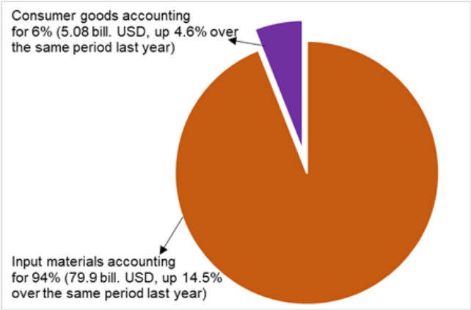
Regarding the structure of imported groups in the first quarter of 2024, the group of production materials was estimated at 79.9 billion USD, accounted for 94%, in which the group of machinery, equipment, tools spare parts accounted for 46.3%; raw materials, fuel and materials accounted for 47.7%. The group of consumer products was estimated at 5.08 billion USD, accounted for 6%.
Regarding the export and import market of goods in the first quarter of 2024, the United States was the Viet Nam's largest export market with a turnover of 26.2 billion USD. China remained the largest import market of Viet Nam with a turnover of 29.4 billion USD. In the first quarter of 2024, the trade surplus to the United States reached 22.7 billion USD, up 27.9% over the same period last year; the trade surplus to the EU reached 8.2 billion USD, up 15.8%; the trade surplus to Japan was 50 million USD, down 27,7%; the trade deficit from China was 16.7 billion USD, went up 44.4%; the trade deficit from Korea was 6.2 billion USD, went down 3.5%; the trade deficit from ASEAN was 2.2 billion USD, increased by 10.9%.

Figure 15. Major commodity import and export markets
in the first quarter of 2024
 |  | Export of goods | Import of goods
The trade balance of goods in February had a trade surplus of 1.38 billion USD; two months had a trade surplus of 5.15 billion USD; March was estimated to have a trade surplus of 2.93 billion USD. Generally in the first quarter of 2024, the trade balance of goods is estimated to have a trade surplus of 8.08 billion USD (in the same period last year, the trade surplus of 4.93 billion USD). Of which, the domestic economic sector has a trade deficit of 4.49 billion USD; the FDI sector (including crude oil) had a trade surplus of 12.57 billion USD.
b) Export and import of services
In the first quarter of 2024, service export turnover was estimated at 5.67 billion USD, up 24.7% over the same period last year, of which tourism services gained 3.15 billion USD (accounting for 55.5% of total turnover), an increase of 45.8%; transportation services reached 1.35 billion USD (accounting for 23.8%), up 3.8%.
Service import turnover in the first quarter of 2024 was estimated at 8 billion USD (of which is included in the transportation and insurance service fee of imported goods is 2.69 billion USD), up 26.8% over the same period last year, of which transportation services gained 3.43 billion USD (accounting for 42.9% of total turnover), up 22.5%; tourism services reached 2.35 billion USD (accounting for 29.4%), up 67.3%.
Trade deficit of service in the first quarter of 2024 is 2.33 billion USD.
5. Price index
a) Consumer price index
According to the law of consumption, people's demand decreases after the Lunar New Year, causing the price of essential goods and services on the market to decrease, especially food. The consumer price index (CPI) in March 2024 decreased by 0.23% compared to the previous month, increased by 1.12% compared to December 2023 and increased by 3.97% compared to the same period last year.
In the first quarter of 2024, CPI increased by 3.77% over the same period last year; Core inflation increased by 2.81%.
In the 0.23% decrease in CPI in March 2024 compared to the previous month, there were 07 groups of goods and services with a decrease in price index and 04 groups of goods with an increase in price index.
Figure 18. CPI growth rate in 3/2024 compared to the previous month
Seven groups of goods and services with falling price indexes include:
- The food and foodstuff service group decreased the most at 0.76% (making the general CPI decreased by 0.25 percentage points), of which: Food decreased
by 0.42%; foodstuff decreased by 1.19% (making the general CPI decreased by 0.25 percentage points); eating out at home increased by 0.19%.
- Education group decreased by 0.29%, of which educational services decreased by 0.34%. The main reason is that on December 31, 2023, the Government issued Decree No. 97/2023/ND-CP amending and supplementing a number of articles of Decree No. 81/2021/ND-CP dated August 27, 2021 of the Government, which requires maintaining a stable tuition fee rate from the 2023-2024 school year equal to the tuition rate of the 2021-2022 school year for preschool education and public general education, accordingly a A number of schools have adjusted their tuition fees after being collected according to Decree No. 81/2021/ND-CP.
- Culture, entertainment and tourism group decreased by 0.12% due to reduced demand for shopping and spring travel after the Lunar New Year, focusing on the following items: Prices for flowers, ornamental plants and decorative objects decreased by 0.84 %; Package travel decreased by 0.45%; hotels and guest houses decreased by 0.36%.
- The beverage and cigarette group decreased by 0.07% according to the rule of reduced consumption after the Lunar New Year, of which alcohol prices decreased by 0.23%; non-alcoholic beverages decreased by 0.05%; The smoking group alone increased by 0.15% due to the increase in US dollar prices.
- The group of garments, hats, and footwear decreased by 0.06% due to the weather in the Northern provinces warming up and people tightening their spending after Tet. Of which, footwear decreased by 0.08% compared to the previous month; ready-made clothes decreased by 0.06%; other garments decreased by 0.12%.
- Transportation group decreased by 0.03%, of which: Public transportation service price index decreased by 5.76%, mainly due to reduced demand after the Lunar New Year; gasoline price index increased by 0.72%; diesel price index decreased by 1.15% due to the impact of domestic gasoline price adjustments; car washing and car pumping services decreased by 0.8%; parking services decreased by 0.09%; vehicle maintenance services increased by 0.36%.
- The post and telecommunications group decreased by 0.01% mainly due to businesses implementing discount promotions for some old cell phone models.
Four groups of goods and services with increased price indexes include:
- Household appliances and equipment group increased slightly by 0.01%. In particular, the prices of some items increased: The price of electric irons increased by 1.01%; electric lighting increased by 0.3%; electric fans increased by 0.25%; cooking utensils increased by 0.2%; metal utensils increased by 0.15%; household appliance repair services increased by 0.12%; soaps and detergents increased by 0.03%.
- The group of medicines and health care services increased by 0.02%, of which the drug price index increased by 0.08%, mainly due to some analgesics, antipyretics, anti-allergic, anti-inflammatory drugs, and drugs used in medicine, respiratory products increase in price when the weather turns humid in some northern localities.
- Other goods and services group increased by 0.06%, mainly increasing prices in some product groups: Jewelry group increased by 4.47%; repair of watches and jewelry increased by 0.12%. During the wedding season, prices of wedding items and services increase by 0.13%.
- Housing and construction materials group increased by 0.29%, of which some items increased in price: Price of housing maintenance materials increased by 0.15% and price of housing repair services increased by 0.33%, mainly due to increased sand prices due to lack of supply; domestic electricity prices increased by 0.47%, domestic water prices increased by 2.1% due to increased consumer demand; gas prices increased by 0.49% because from 01/3/2024, domestic gas prices were adjusted to increase by 2,000 VND/12 kg tank due to USD exchange rate adjustments. On the contrary, kerosene prices in March 2024 decreased by 0.1% compared to February 2024 due to the impact of price adjustments during the month.
The consumer price index in the first quarter of 2024 increased by 3.77% compared to the same period in 2023, of which: Education increased by 9.02%; medicine and medical services increased by 6.51%; other goods and services increased by 6.20%; housing and construction materials increased by 5.40%; food and foodstuff services increased by 3.53%; beverages and cigarette increased by 2.33%; transportation increased by 2.27%; garments, hats, and footwear increased by 1.54%; culture, entertainment and tourism increased by 1.35%; household appliances and equipment increased by 1.21%. Post and telecommunications alone decreased by 1.46%.
CPI in the first quarter of 2024 increased compared to the same period last year due to the following main reasons:
(i) Domestic rice prices increased according to export rice prices and increased demand for delicious sticky rice and regular rice during Ong Cong and Tet holidays and Lunar New Year, causing the rice price index in the first quarter of 2024 to increase by 21 71% over the same period last year, making the general CPI increased by 0.55 percentage points.
(ii) The price index of domestic water group increased by 10.58% due to increased water use demand, and at the same time, some provinces and centrally run cities increased water prices according to the decision of the People's Committee, making the general CPI increase by 0.06 percentage points.
(iii) Domestic electricity price index increased by 9.38% due to increased electricity demand. From May 4, 2023 and November 9, 2023, EVN adjusted the average retail electricity price, making the general CPI increase of 0.31 percentage points.
(iv) The first quarter education price index increased by 9.02% over the same period last year, because in the 2023-2024 school year, some provinces and centrally run cities increased tuition levels, making the general CPI increase by 0.56 percentage points.
(v) The price index of drugs and medical services increased by 6.51%, making the general CPI increase by 0.35 percentage points due to the price of medical services being adjusted according to Circular No. 22/2023/TT-BYT of the Government. Ministry of Health from 17/11/ 2023.
(vi) The price index of the housing and construction materials group increased by 5.4% due to the increase in cement and sand prices along with the price of raw materials and input materials and the increase in house rental prices, making the general CPI increase by 1.02 percentage points. .
(vii) The price index of the culture, entertainment and tourism group increased by 1.35%, making the general CPI increase of 0.06 percentage points.
Besides, factors contributing to curbing CPI growth in the first quarter of 2024:
The price index of the post and telecommunications group in the first quarter of 2024 decreased by 1.46% compared to the same period last year due to a decrease in the price of older generation phones when businesses applied discount programs and stimulated demand for electricity lines. Smartphones have been on the market for some time.
Core inflation March 2024 increased by 0.03% over the previous month and increased by 2.76% over the same period last year. In the first quarter of 2024, average core inflation increased by 2.81% over the same period last year, lower than the general average CPI (increased by 3.77%), mainly due to food, gasoline, and service prices. Health services and educational service prices are factors that impact CPI increases but belong to the group of goods excluded from the list of core inflation calculations.
b) Gold and US dollar price index
Domestic gold prices fluctuate in the same direction as world gold prices. As of March 25, 2024, the average world gold price was at 2,139.64 USD/ounce, an increase of 5.21% compared to February 2024. The reason why world gold prices increased is mainly due to traders' expectations that the US Federal Reserve (FED) will loosen monetary policy after a campaign to increase interest rates to curb inflation; Prolonged geopolitical tensions and slowing Chinese economic growth push investors to seek gold as a safe haven. Domestically, the gold price index in March 2024 increased by 4.59% compared to the previous month; an increase of 9.41% compared to December 2023; increased 22.71% over the same period last year; on average, in the first quarter of 2024, the gold price index increased by 18.23% over the same period last year.
Around the world, the price of the US dollar increased after the FED announced to maintain interest rates within a range of 5.25%-5.5%. As of March 25, 2024, the US dollar index on the international market reached 103.5 points, down 0.35% compared to the previous month. Domestically, the demand for US dollars from businesses importing raw materials and fuels increased, the average US dollar price on the free market was around 24,837 VND/USD. US dollar price index in March 2024 increased by 0.88% compared to the previous month; an increase of 1.81% compared to December 2023; increased 4.32% over the same period last year; the average increase in the first quarter of 2024 is 3.97% over the same period last year.
c) Producer price index
In the first quarter of 2024, the world commodity market will have many fluctuations due to the influence of political, economic and social factors of countries. Strategic competition between major countries continues to be fierce; the prolonged military conflict between Russia and Ukraine and in the Gaza Strip; Unrest escalated in the Red Sea. Many countries maintain tight monetary policies and weak aggregate demand, causing the world economy to grow slowly. Domestically, the production of goods and services fully meets the consumption needs of people and exports. Production prices in the first quarter of 2024 increased and decreased intermittently, the price index of raw materials and fuels used for production, the price index of agricultural, forestry, and fishery production and the service price index increased compared to the same period last year. , while the industrial producer price index decreased slightly and the export and import price index of goods tended to decrease according to the world market.

Figure 19. Producer price index, input producer price index compared to the same period last year in 2020-2024 (%)

The producer price index for agriculture, forestry and fishing in the first quarter of 2024 is estimated to increase by 3.4% compared to the fourth quarter of 2023 and by 5.81% over the same period last year, of which: Producer price index of agricultural products and related services increased by 3,8% and increased 8.23%; forestry and related services increased by 0.37% and decreased by 0.44%; exploited and aquaculture products increased by 2.51% and decreased by 0.78%.
The producer price index for industry in the first quarter of 2024 is estimated to decrease by 0.64% compared to the previous quarter and decrease by 0.56% compared to the same period in 2023, of which: Producer price index of mining products decreased by 3.02% and increased by 3.23%; processing and manufacturing industrial products decreased by 0.55% and 1.01%; electricity, gas, hot water, steam and air conditioning increased by 1.09% and 4.75%; natural water exploitation, waste management and treatment services, and wastewater increased by 0.78% and 2.53%.
The producer price index for services in the first quarter of 2024 is estimated to increase by 1.97% compared to the previous quarter and increase by 7.15% compared to the same period in 2023, of which: Transportation and warehousing services increase by 4.24% and increased by 15.49%; accommodation and food services increased by 1.81% and 4.9%; administrative and support activities increased by 2.57% and 4.25%; other service activities increased by 3.18% and 6.86%; hired work activities in households increased by 1.46% and 3.83%.
The input producer price index in the first quarter of 2024 increased by 1.39% compared to the previous quarter and increased by 1.25% compared to the same period in 2023, of which: Raw material price index materials used for agricultural, forestry and fishery production decreased by 0.57% and 0.34%; the price index of raw materials and fuels used for industrial processing and manufacturing increased by 1.49% and 1.5%; the price index of raw materials and fuels used for construction increased by 0.37% and decreased by 0.94%.
d) Merchandise import and export price index
Figure 20. Merchandise export price index, merchandise import price index
and merchandise term of trade in the first quarter compared to the same period last year years 2020-2024 (%)

Merchandise export price index in the first quarter of 2024 decreased by 1.6% compared to the previous quarter and decreased by 1.75% compared to the same period in 2023, of which: Price index of agricultural products and food groups increased by 2.36 % and 4.63%; fuel group decreased by 6.73% and 6.72%; the group of other processed and manufactured goods decreased by 1.91% and 2.34%.
Merchandise import price index in the first quarter of 2024 decreased by 0.39% compared to the previous quarter and decreased by 1.54% compared to the same period in 2023, of which: Price index of agricultural products and food groups increased by 0.22 % and decreased by 7.83%; fuel group increased by 1.07% and decreased by 20.72%; the group of other processed and manufactured goods decreased by 0.5% and increased by 0.2%.
The merchandise term of trade (TOT) in the first quarter of 2024 decreased by 1.21% compared to the previous quarter and decreased by 0.2% compared to the same period in 2023. Of which, aquatic products decreased by 0.06% and increased by 0.0. 56%; fruit and vegetable products increased by 2.63% and decreased by 1.96%; petroleum of all kinds decreased by 5.52% and decreased by 8.56%; rubber increased 3.22% and 7.28%; wood and wood products decreased by 1.95% and decreased by 3.24%; iron and steel increased by 1.66% and 1.38%; computers, electronic products and components decreased by 2.1% and increased by 4.35%.
TOT in the first quarter of 2024 decreased compared to the same period last year because the export price index had a deeper decrease than the decrease in the import price index, reflecting that Vietnam is in a disadvantageous position when the price of imported goods has an advantage higher than the price of exported goods.
III. SOME SOCIAL ISSUES
1. Labor and employment
The labor and employment situation in the first quarter of 2024 has returned to the normal development trend as before the Covid-19 pandemic, that is, the labor force often decreased slightly compared to the previous quarter but still increased compared to the same period. period last year. The underemployment rate increased compared to the previous quarter and the same period last year, but the unemployment rate decreased, following the usual pattern in the quarter with Lunar New Year.
a) Labor force
The country's labor force aged 15 and over in the first quarter of 2024 is estimated to be 52.4 million people, down 137.4 thousand people compared to the previous quarter and up 175.8 thousand people over the same period last year; the labor force participation rate in the first quarter of 2024 is 68.5%, both down 0.4 percentage points compared to the previous quarter and compared to the same period last year.
Percentage of trained labour force with degrees and certificates in the first quarter of 2024 is 27.8%, an increase of 0.2 percentage points compared to the previous quarter and an increase of 1.4 percentage points compared to the same period last year.
Table 9. Labor force in the first quarter of 2024
Thousands people
 | First quarter  2024 | Compared to same
 | First quarter  2024 | First quarter  2023 | Fourth quarter  2023
Labour force at aged 15 years and above | 52,392.2 | 175.8 | -137.4
By gender
Male | 27,855.7 | 7.7 | -236.9
Female | 24,536.5 | 168.1 | 99.5
By area
Male | 20,077.1 | 660.2 | 443.6
Female | 32,315.1 | -484.4 | -581.0
Labor force in working age | 46,903.6 | 293.1 | -54.8
By gender
Male | 25,707.8 | 106.1 | -192.4
Female | 21,195.8 | 187.0 | 137.6
By area
Male | 18,524.3 | 638.8 | 392.7
Female | 28,379.3 | -345.7 | -447.5

b) Employed persons
Employed persons in the first quarter of 2024 are estimated to be 51.3 million people, a decrease of 127.0 thousand people compared to the previous quarter and an increase of 174.1 thousand people compared to the same period last year. Of which, the urban area has 19.6 million people, an increase of 446 thousand people over the previous quarter and an increase of 647.7 thousand people over the same period last year; rural areas were 31.7 million people, down 573.0 thousand people and down 473.7 thousand people.
By economic sectors, employed persons in the first quarter of 2024 in the agriculture, forestry and fishing sector were 13.8 million people, accounting for 26.9% and down 3.1 thousand people compared to the previous quarter and decreased by 65.4 thousand people compared to the same period last year; the industry and construction sector is 17.0 million people, accounting for 33.1% and decreasing by 196.4 thousand people and decreasing by 336.4 thousand people; the services sector is 20.5 million people, accounting for 40.0% and increasing by 72.4 thousand people and increasing by 575.8 thousand people.
In general, employed persons tend to develop normally as before the Covid-19 pandemic, but informal employment rate (including labours working in the agricultural, forestry, and fishery household sectors) still accounts for a large proportion. The informal employment rate in the first quarter of 2024 was 64.8%, down 0.3 percentage points compared to the previous quarter and up 0.2 percentage points over the same period last year. By region, the informal employment rate in urban areas is 49.3%; rural areas is 74.4%. By gender, the informal employment rate is 67.9% for men and 61.4% for women.
c) Underemployment in working age
The number of underemployed people in the working age in the first quarter of 2024 was 933.0 thousand people, an increase of 26.4 thousand people over the previous quarter and an increase of 47.2 thousand people over the same period last year. The underemployment rate among the working age in the first quarter of 2024 is 2.03%, an increase of 0.05 percentage points compared to the previous quarter and an increase of 0.09 percentage points compared to the same period last year. Of which, the urban area was 1.20%, down 0.41 percentage points over the previous quarter and down 0.11 percentage points over the same period last year; rural areas is 2.58%, an increase of 0.38 percentage points and an increase of 0.24 percentage points.
Figure 21. Number of people and underemployment rate in working age
the quarters of 2021-2024

In the first quarter of 2024, the number of underemployed people of working age in the agriculture, forestry and fishing sector was 459.5 thousand people, accounting for 49.3%, an increase of 64.5 thousand people compared to the previous quarter; the industry and construction sector is 205.5 thousand people, accounting for 22.0%, down 64.1 thousand people; the service sector is 268.0 thousand people, accounting for 28.7%, an increase of 26.0 thousand people.
d) Average income of employees
The average income of employees in the first quarter of 2024 is 7.6 million VND/month, an increase of 301 thousand VND compared to the fourth quarter of 2023 and an increase of 549 thousand VND compared to the same period in 2023. In particular, the average monthly income for male workers is 8.6 million VND/month, for female workers is 6.5 million VND/month; the average income of workers in urban areas is 9.3 million VND/month, and in rural areas is 6.5 million VND/month.
The average monthly income of salaried workers in the first quarter of 2024 is 8.5 million VND/month, an increase of 7.7%, equivalent to an increase of 606 thousand VND compared to the same period last year. Of which, the income of male workers is 9.0 million VND/month, and the income of female workers is 7.9 million VND/month.
đ) Unemployment rate in working age
The unemployment rate in the working age in the first quarter of 2024 was 2.24%, down 0.02 percentage points compared to the previous quarter and down 0.01 percentage points over the same period last year, of which: urban is 2.64%; rural areas is 1.99%.
Figure 22. Number of people and unemployment rate in working age
the quarters of 2021-2024

The unemployment rate for young people (aged 15-24) in the first quarter of 2024 was 7.99%, up 0.37 percentage points compared to the previous quarter and up 0.38 percentage points over the same period last year. The unemployment rate of youth in urban areas is 10.18%; rural areas is 6.87%. The rate of young people without jobs and not participating in study and training in rural areas is 12.8%, in urban areas is 8.3%; young women who are unemployed and do not participate in study or training are 12.5%; male is 9.7%.
e) Percentage of workers not using their full potential
Tỷ lệ lao động không sử dụng hết tiềm năng của Việt Nam thường dao động ở mức 4%. Tỷ lệ lao động không sử dụng hết tiềm năng quý I/2024 là 4,4%. Trong đó, tỷ lệ lao động không sử dụng hết tiềm năng của khu vực thành thị là 3,9%; khu vực nông thôn là 4,7%. Đa số lao động không sử dụng hết tiềm năng là những người từ 15-34 tuổi (49,0%). Điều này cho thấy Việt Nam vẫn còn một bộ phận không nhỏ lực lượng lao động tiềm năng chưa được khai thác, đặc biệt là nhóm lao động trẻ.
The percentage of workers not using their full potential of Vietnam's full potential usually fluctuates at 4%. The percentage of workers not using their full potential in the first quarter of 2024 is 4.4%. Of which, the rate of labor not using the full potential of urban areas is 3.9%; rural areas is 4.7%. The majority of workers who do not use their full potential are people aged 15-34 years old (49.0%). This shows that Vietnam still has a large portion of the potential labor force that has not been exploited, especially the group of young workers.
g) Labor for self-production and self-consumption
The number of labor for self-production and self-consumption in the first quarter of 2024 is 3.9 million people, an increase of 492.4 thousand people compared to the previous quarter and a decrease of 51.3 thousand people compared to the same period last year. The number of labor for self-production and self-consumption work is concentrated mainly in rural areas with 86.6% and is concentrated in women, accounting for 63.7%. In the context of the labor market increasingly demanding skills and skills as well as the economy showing signs of recession and lack of stability, the opportunity for this group of workers to find good jobs is very difficult. towel.
2. Residential life and social security
The situation of residential life in the first quarter of this year improved. According to preliminary results from the 2024 Residential Living Standards Survey, average income per capita in the first quarter of 2024 is estimated to reach 5.2 million VND/month, an increase of about 8% compared to the previous quarter and an increase of 10% over the same period 2023.
According to a survey of the living situation of households, the proportion of households assessed to have income in March remained unchanged and increased compared to the same month last year at 94.1%; The proportion of households assessed to have reduced income and not knowing is 5.9%. In the first quarter of 2024, the proportion of households assessed to have income unchanged and increased compared to the same period in 2023 is 93.6% (the proportion of households assessed to have increased income compared to the fourth quarter of 2023 increased by 1 .9 percentage points; compared to the first quarter of 2023, an increase of 0.1 percentage points); The proportion of households assessed to have reduced income and not knowing is 6.4%.
Figure 23. Households' assessment of the household's life situation
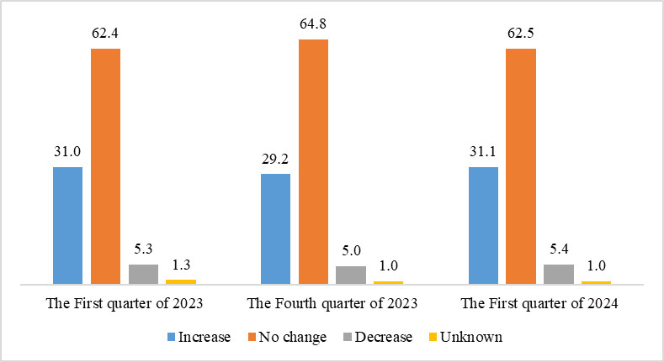
The main reasons for the decrease in income in the first quarter of 2024 are assessed by households as follows: 39.8% of households have a member who lost their job/temporarily quit their job; 22.4% of households assessed that input costs for their production and business activities increased and 19.2% of households assessed that the selling price of products from their production and business activities decreased.
Regarding the impact of negative events on life in the first quarter of 2024, assessed by households: 31.3% of households are being affected by rising prices of goods and services; 2.9% of households are negatively affected by epidemics on humans and 1.7% of households are negatively affected by epidemics on livestock and crops.
In the first quarter of this year, 12.7% of households interviewed received help from various sources of support. Specifically, the proportion of households receiving assistance from relatives is 8.5%; from local programs and policies is 4.5%; from general national programs and policies is 4.2%; from charitable activities of other organizations and individuals is 1.8% and from other sources is 0.02%.
The work of ensuring social security is always carried out promptly and effectively by all levels and sectors. According to reports from the locality, as of March 19, 2024, central and local leaders, departments, branches, unions, and philanthropists have also organized visits, encouragement, and gifts for the victims. Social protection objects according to Decree No. 20/2021/ND-CP dated March 15, 2021 are 8.1 trillion VND; Poor and near-poor households are more than 2.4 trillion VND; People with meritorious services and relatives of people with meritorious services to the revolution are 9.2 trillion VND; Unexpected and unusual support arising locally is nearly 26.8 billion VND. In addition, social insurance has issued more than 27.1 million health insurance cards/books/free medical examination and treatment cards to beneficiaries.
According to information from the Ministry of Labor, War Invalids and Social Affairs, to prevent people from starving, from the beginning of the year until now, the total amount of rice the Government, ministries, branches and localities have supported people with is more than 17 million. 7 thousand tons of rice, of which: Supported 10.4 thousand tons of rice for hunger relief on the occasion of the Lunar New Year Giap Thin for 103.7 thousand households with 693.4 thousand people; The Government supports more than 2.3 thousand tons of rice to relieve hunger in 2024 for more than 33 thousand households with 155.7 thousand people.
According to data from the Ministry of Agriculture and Rural Development, accumulated by the end of February 2024, the whole country has about 6,370/8,167 communes (about 78%) meeting new rural standards; There are 1,737 communes meeting advanced new rural standards; 301 communes meet model new rural standards; There are 280 district-level units in 58 provinces and centrally run cities completing tasks/meeting new rural standards. There are 23 provinces and centrally run cities with 100% of communes meeting new rural standards.
3. Disease and food poisoning situation
According to a report from the Ministry of Health, in the month (February 19 - March 18, 2024), the whole country had 3,644 cases of dengue fever; 1,849 cases of hand, foot and mouth disease; 18 cases of typhus suspected of measles; 02 cases of meningococcal meningitis and 26 cases of viral encephalitis. In the first quarter of 2024, the whole country had nearly 12 thousand cases of dengue fever; 6.7 thousand cases of hand, foot and mouth disease; 50 cases of typhus suspected of measles; 02 cases of meningococcal meningitis and 65 cases of viral encephalitis.
The total number of people living with HIV in the country as of March 18, 2024 is 235.7 thousand people and the number of people dying from HIV/AIDS in the country as of the above time is 114.4 thousand people.
Regarding food poisoning, in March there were 6 cases causing 368 people to be poisoned. Overall, in the first quarter of 2024 (from December 19, 2023 to March 18, 2024), there were 16 food poisoning cases nationwide, poisoning 659 people (03 died).
4. Cultural and sports activities
In the first quarter of 2024, many traditional festivals and cultural and artistic activities will be held all over the country to preserve and promote cultural identity and improve the spiritual life of the people. Typically in Hanoi, in the first quarter there were more than 400 festivals held, along with a number of other outstanding cultural activities such as the 20th Festival of Ethnic Cultures and performances of traditional costumes of ethnic groups. Thanh Hoa province's ethnic festival takes place on March 8 and 9, the Hoa Ban Festival in 2024 with the theme "Returning to the Hoa Ban region" is held on March 16 in Dien Bien province, the Temple of Tranh and Xuan Giap festival opening ceremony. Dragon 2024 takes place over 3 days, March 19 and March 23-24 in Hai Duong province.
The mass sports movement continues to be promoted, fitness and sports movements are widely organized, a number of outstanding activities take place such as: Launching ceremony of the Olympic running day for the health of the entire population to attract more attention. 1,500 people participated on March 3 in Kon Tum; National Ethnic Wrestling Championship takes place from March 12-16 in Bac Giang; Opening the 10th Phu Dong Health Festival on March 15, 2024 with the participation of 5,000 people in Hanoi; The lion, dragon and traditional martial arts tournament held on March 19 attracted 200 athletes from 12 lion, dragon and traditional martial arts clubs in Thai Binh province.
Regarding high-performance sports, in March a number of outstanding events and achievements took place such as: Vietnam won the gold medal in diving at the 2024 Asian Youth Group Championship on March 1 in Africa. li-battery; Vietnam won the runner-up position at the 2024 German Badminton Open on March 3 in Germany; Vietnam won the Bogota Billiards World Cup on March 4 in Colombia; Ciputra Hanoi 2024 International Badminton Tournament takes place from March 12-17 in Hanoi with more than 300 athletes from many countries participating; The 12th national tug-of-war championship in 2024 will be held in Dak Lak from March 20-26 with more than 300 athletes competing; The UIM-ABP Aquabike World Championship from March 22-24 held in Binh Dinh attracted nearly 70 of the world's top riders.
5. Traffic accident
In March (from February 15 to March 14, 2024), there were 1,697 traffic accidents nationwide, including 1,193 traffic accidents of less serious or more severity and 504 traffic collisions. traffic, killing 743 people, injuring 748 people and 519 people with minor injuries. Compared to the previous month, the number of traffic accidents decreased by 29.9% (the number of traffic accidents from less serious or more decreased by 28.3% and the number of traffic collisions decreased by 33.5%); number of deaths decreased by 26.7%; The number of injured people decreased by 32% and the number of people with minor injuries decreased by 38.4%. Compared to the same period last year, the number of traffic accidents in March was nearly 2.4 times higher (the number of traffic accidents from less serious or more was 2.4 times higher and the number of traffic collisions was 2.2 times higher). time); The number of deaths is 1.9 times higher; The number of injured people is 2.7 times higher and the number of people with minor injuries is 2.2 times higher.
In the first quarter of this year, there were 6,552 traffic accidents nationwide, including 4,465 less serious traffic accidents and 2,087 traffic collisions, killing 2,723 people and 2,924 others. injured and 2,322 people suffered minor injuries. Compared to the same period last year, the number of traffic accidents in the first quarter of this year was nearly 2.8 times higher (the number of traffic accidents from less serious or more was 2.6 times higher; the number of traffic collisions was 2.6 times higher). 3.3 times); The number of deaths is 1.9 times higher; The number of injured people is 3.2 times higher and the number of people with minor injuries is 3.5 times higher. On average, every day in the first quarter of this year, there were 72 traffic accidents nationwide, including 49 traffic accidents of less serious severity and 23 traffic collisions, killing 30 people. 32 people were injured and 26 people suffered minor injuries.
6. Damage caused by natural disasters
Damage caused by natural disasters in March was mainly due to the impact of landslides that left one person missing; 111 houses collapsed, swept away and damaged; 87.6 hectares of crops were damaged; The total value of property damage caused by natural disasters in the month was 15.9 billion VND, down 59.2% over the same period last year. In the first quarter of this year, natural disasters left 10 people missing and 1 person injured; 195 houses collapsed and damaged; 1.2 thousand cattle died; 2.1 thousand hectares of rice and crops were damaged; The total value of property damage is estimated at 95 billion VND, an increase of 34.7% over the same period in 2023.
7. Environmental protection and fire and explosion prevention
In March, according to reports from the Department of Natural Resources and Environment, Provincial and Central City Police compiled by the Statistics Department, the authorities discovered 1,169 environmental violations, of which Handled 1,131 cases with a total fine of 27.9 billion VND, down 2.5% over the previous month and up 10.4% over the same period last year. Overall, in the first quarter of this year, 6,978 cases of environmental violations were detected, of which 6,176 cases were handled with a total fine of 82.5 billion VND, an increase of 15.5% over the same period last year.
During the month, there were 354 fires and explosions nationwide, killing 8 people and injuring 5 people, with an estimated loss of 24.2 billion VND, down 11.7% over the previous month and 4.2 times higher than the same period last month. last year. In the first quarter of this year, there were 1,179 fires and explosions nationwide, killing 24 people and injuring 18 people, with an estimated loss of 71.1 billion VND, 3.2 times higher than the same period last year.

Particularly, the International Monetary Fund (IMF) forecasts world economic growth in 2024 to reach 3.1%, unchanged from 2023
UN (January 2024), "World Economic Situation and Outlook 2024", https://www.un.org/development/desa/dpad/wp-content/uploads/sites/45/WESP_2024_Web.pdf, accessed March 18, 2024
World Bank (January 2024), "Global Economic Outlook", https://www.worldbank.org/en/publication/global-economic-prospects, accessed March 18, 2024
OECD (February 2024), "OECD Economic Outlook Preliminary Report", https://www.oecd-ilibrary.org/sites/0fd73462-en/index.html?itemId=/content/publication/0fd73462-en, accessed 2024-03-18
EU (February 2024), "European Economic Forecast Winter 2024: Delaying Growth Recovery Amid Easing Inflation", https://ec.europa.eu/commission/presscorner/detail/en/ip_24_730, accessed March 18, 2024.
The GDP growth rate in the first quarter compared to the same period last year in 2020-2023 was: 3.21%, respectively; 4.85%; 5.12%; 3.41%.
The growth rate of added value of the service sector in the first quarter compared to the same period last year in 2020-2023 was: 3.03%; 4.51%; 4.38%; 6.86%.
The added value of the processing and manufacturing industry in the first quarter of 2023 will decrease by 0.45% over the same period last year.
The corresponding structure of the same period in 2023 is 11.74%; 36,02%; 43,07%; 9,17%.
The purchase price of fresh rice in the field ranges from 8,000 to 8,700 VND/kg.
As of March 23, 2024, the price of live pork nationwide fluctuates between 59,000 - 62,000 VND / kg, an increase of about 10,000 - 11,000 VND / kg over the same period last year. The pig product price index in the first quarter of 2024 will increase by 0.02% over the same period last year, in March 2024 it will increase by 3.37% over the same period last year
According to the livestock survey results as of January 1, 2024, the total number of livestock households across the country will decrease by 1.94% compared to the same period in 2023.
Cao Bang, Bac Kan, Lang Son, Son La, Hoa Binh, Nghe An, Ha Tinh, Quang Binh, Quang Ngai, Gia Lai, Dak Lak, Binh Phuoc, Ba Ria - Vung Tau, Long An, Tien Giang, Kien Giang, Tra Vinh and Ca Mau.
According to the Ministry of Agriculture and Rural Development, as of 15/3/2024.
http://agromonitor.vn/group/48/280/giam-sat-gia: Raw pangasius prices in the middle of March 2024 in the Mekong Delta are fluctuating from 28,000-29,000 VND/kg, an increase of 3,000 VND compared to the previous quarter.
The locality has a high increase in the production index of the processing and manufacturing industry in the first quarter of 2024 compared to the same period last year: Quang Ninh increased by 39.9%; Phu Tho increased by 27.7%; Bac Giang increased by 24%; Thanh Hoa increased by 18.6%; Ha Nam increased by 17.9%; Ninh Thuan increased by 17.4%; Tay Ninh increased by 14.4%; Hai Duong increased by 12.8%. Localities with high production indexes of the electricity production and distribution industry: Khanh Hoa increased by 476.5%; Tra Vinh increased by 164.0%; Thanh Hoa increased by 41.3%; Hai Duong increased by 17.3%; Bac Giang increased by 15.7%; Ninh Thuan increased by 13.5%.
Localities with the production index of the processing and manufacturing industry in the first quarter of 2024 increased slightly or decreased compared to the same period last year: Quang Nam increased by 0.5%. Quang Ngai increased by 0.2%; Ca Mau decreased by 9.5%; Bac Ninh decreased by 8.8%. Localities with production indexes of the electricity production and distribution industry in the first quarter of 2024 decreased compared to the same period last year: Son La decreased by 50.6%; Hoa Binh and Quang Nam both decreased by 28.7%; Quang Ngai decreased by 25.1%; Lai Chau decreased by 23.9%; Cao Bang decreased by 14.5%. The locality's production index of the mining industry in the first quarter of 2024 decreased compared to the same period last year: Ha Giang decreased by 79.4%; Quang Nam decreased by 21.2%; Ba Ria - Vung Tau decreased by 10.6%.
Source: National Enterprise Registration Information System, Business Registration Management Agency, Ministry of Planning and Investment on March 24th, 2024.
The number of newly established and returning to operations on average a month in the first quarter of 2019- 2023 was: 14.5 thousand enterprises; 14.8 thousand enterprises; 14.7 thousand enterprises; 20.1 thousand enterprises; 19 thousand enterprises.
Enterprises withdrew from the market on average a month in the first quarter of 2019-2023 were: 11.4 thousand enterprises; 11.6 thousand enterprises; 13.4 thousand enterprises; 17.1 thousand enterprises; 20.1 thousand enterprises, respectively.
Corresponding indexes of the forth quarter of 2023: 22.3% of enterprises rated that their production volume increased compared to the previous quarter; 38.9% of businesses thought it was stable and 38.8% assessed that production volume would decrease.
Corresponding indexes of the forth quarter of 2023: 32.7% of enterprises had orders increasing compared to the previous quarter; 36.8% of businesses had stable orders and 30.5% of businesses had reduced orders.
Corresponding indexes of the forth quarter of 2023: 29.2% of enterprises had orders increasing compared to the previous quarter; 39.7% of businesses had stable orders and 31.1% of businesses had reduced orders.
According to the Ministry of Information and Communications, Viet Nam will stop 2G mobile technology nationwide from September 2024.
According to the report of the Border Gate Department, the Border Guard Command, the Ministry of National Defense and the Immigration Department.
The reporting period was from February 21, 2024 to March 20, 2024.
Vietnamese citizen leaving Viet Nam's territory by air.
The first quarter of 2023 increased by 3.7% over the same period last year.
According to the newspaper fox belong to Department Head private water outside , Ministry Next plan and Head invest , receive March 22 , 2024.
According to the Report on the implementation of Resolution of the Government of the Ministry of Finance sent on March 27th, 2024.
The value of export turnover is calculated at F.O.B price and import turnover is calculated at C.I.F price (including transportation and insurance costs of imported goods). When calculating the economy's trade balance, import and export turnover is calculated according to the F.O.B price.
Estimated total export and import value in 3/2024 provided by the General Department of Customs on 27/3/2024. The General Statistics Office estimated the import and export value of key commodities in 3/2024 based on preliminary data provided by the General Department of Customs by 24/3/2024.
Total import and export turnover of goods in the first quarter of 2023 reached 154.2 billion USD, down 13.5% over the same period last year, of which exports reached 79.6 billion USD, down 11.6%; imports reached 74.6 billion USD, down 15.4%.
February is estimated to have a trade surplus of 1.1 billion USD.
The price index of the rice group decreased by 0.5% (Regular rice decreased by 0.49%; Delicious ordinary rice decreased by 0.27% and sticky rice decreased by 1.31%). Domestic rice prices decreased along with export rice prices because countries are entering the main harvest season so supplies are abundant. In addition, provinces in the Mekong Delta are harvesting the winter-spring crop, causing domestic rice prices to decrease compared to the time before the Lunar New Year. The decrease in rice prices has affected the price index of other food items such as potato prices in March decreased by 4.46% compared to the previous month; vermicelli decreased by 0.67%; cornstarch decreased by 0.02%; Other cereals decreased by 0.2%.
The pork price index in the month decreased by 2.17%. Accordingly, animal fat decreased by 1.39%; animal organs decreased by 1.24%; roasted meat and sausages decreased by 0.93%. Beef prices decreased by 1.3%; poultry meat prices decreased by 1.7%; egg prices of all kinds decreased by 2.78%; fresh and processed fruit price index decreased by 2.64%; fresh seafood price index decreased by 1.65%; fresh, dried and processed vegetable price index decreased by 0.62%; sugar price index decreased by 0.33%; confectionery and candy decreased by 0.19%; spices and tea, coffee, and cocoa all decreased by 0.04%.
Due to increased labor costs and high electricity prices, in which the price of eating out at home increased by 0.2%; drinking outside the home increased by 0.35%; takeaway fast food increased by 0.03%.
Vinh Phuc's education service price index in March 2024 will decrease by 30.77% compared to the previous month.
The electricity and water price index in March 2024 reflects fluctuations one month later than other items because it is calculated based on revenue and consumption output of February 2024.
CPI after excluding fresh food, foodstuff, energy and goods managed by the State including health services and education services.
Merchandise export price index/Merchandise import price index.
Informal employment (including labours working in the agricultural, forestry, and fishery household sectors) are those who have jobs and fall into one of the following cases: (i) family workers the family does not receive salary or benefits; (ii) the owner of the establishment, self-employed workers in the informal sector (iii) salaried employees who are not allowed to sign a labor contract or are signed with a fixed-term contract but are not paid by the recruiting establishment Compulsory social insurance; (iv) cooperative members do not pay mandatory social insurance; (iv) labor in the agricultural household sector.
Underemployed people of working age include those with jobs who want to work overtime; willing to work overtime; actually working less than 35 hours/week.
An unemployed person is a person aged full 15 years or older who, in the reference period, has all three factors: not currently working, looking for a job and ready to work. The unemployment rate is the percentage of the unemployed compared to the labor force.
Labor with a need for work but not being able to meet enough work (also known as underutilized labor) includes those who are unemployed, underemployed and a group outside the labor force willing to work. job but not looking for a job or looking for a job but not ready to work right away. The rate of underutilized labor is the ratio between the number of laborers who are in need of work but are not fully satisfied with the work to the total number of laborers who have the need to work in the economy.
Accumulated to February 2024, 282 units have been recognized by the Prime Minister for completing tasks/meeting new rural standards, however there are 02 units (Tu Son city, Bac Ninh province; Bien Hoa city). , Dong Nai province) no longer has communes, so these two units are not subject to implementation of the New Rural Program.
Hanoi, Hai Phong, Hung Yen, Vinh Phuc, Bac Ninh, Ha Nam, Nam Dinh, Thai Binh, Hai Duong, Ninh Binh, Quang Ninh, Da Nang, Lam Dong, City. Ho Chi Minh, Ba Ria-Vung Tau, Binh Duong, Dong Nai, Can Tho, Bac Lieu, Tra Vinh, Ha Tinh, Tien Giang, Dong Thap.
According to a quick report from the Office of the Ministry of Public Security and the Vietnam Maritime Administration (Ministry of Transport) on March 23, 2024.
Summary of reports from 63 Departments of Agriculture and Rural Development, reporting period from February 19 to March 18, 2024.
According to a quick report from the Ministry of Public Security on March 23, 2024.

