MINISTRY OF PLANNING AND INVESTMENT  GENERAL STATISTICS OFFICE  No: 71/BC-TCTK | SOCIALIST REPUBLIC OF VIET NAM  Independence-Freedom-Happiness  Ha Noi, 28th May 2024
Socio-economic situation report
April and 5 months of 2024

- Agricultural, forestry and fishery production
Agricultural production in May with the main task of focusing on taking care of spring rice in the northern localities; tending, harvesting rice, spring crops and sowing summer-autumn rice varieties in southern localities. Pig and poultry farming has developed quite well, the disease on livestock and poultry was strictly controlled. Forestry production was stable, localities continue to plant new forests as planned. Aquaculture grew well because the application of advanced and effective farming methods. Marine fisheries exploitation achieved positive results due to relatively favorable weather..
a) Agriculture
Spring paddy
In the spring rice crop of 2024, the country cultivated 2,953.6 thousand hectares, an increase of 0.9 thousand hectares compared to the previous year's spring crop. Northern localities cultivated 1,059.4 thousand hectares, down 8.5 thousand hectares, of which the Red River Delta reached 471.3 thousand hectares, down 5.6 thousand hectares. Southern localities planted 1,894.2 thousand hectares, an increase of 9.4 thousand hectares compared to the spring crop last year, of which the Mekong Delta region reached 1,487.7 thousand hectares, an increase of 9 thousand hectares, the main reason being due to high rice prices, farmers switched from late autumn-winter rice areas to early spring. Some localities had a high increase in planted area compared to last year's spring crop, such as Long An reaching 235.7 thousand hectares, an increase of 10.6 thousand hectares; Bac Lieu reached 45 thousand hectares, an increase of 1.8 thousand hectares.
As of 15/5/2024, southern localities have basically finished harvesting spring rice with an area of ​​1,885.6 thousand hectares, accounting for 99.5% of the cultivated area and equal to 100.5% of the same period last year. Of which, the Mekong Delta region reached 1,487.5 thousand hectares, accounting for nearly 100% of the cultivated area. Spring rice yield was estimated at 72.3 quintal/ha, an increase of 0.1 quintal/ha compared to last year's spring crop. Some localities have increased rice productivity such as Tra Vinh increased by 6.0 quintal/hectare; Soc Trang increased by 2.0 quintal/ha; Vinh Long increased by 1.9 quintal/ha; Kien Giang increased by 0.7 quintal/ha; Tien Giang and Can Tho both increased by 0.4 quintal/ha.
Autumn paddy
Along with the winter-spring rice harvest, by mid-May, southern localities had planted 1,059.4 thousand hectares of summer-autumn rice, equal to 96.1% of the same period last year, of which the Mekong Delta reached 959.7 thousand hectares, equal to 95.1%. This year's summer-autumn rice planting progress was slower than the same period last year mainly due to hot weather, lack of water and late rain. Currently, summer-autumn rice was in the tillering stage until green coagulate stage, the rice plant was growing and developing quite well. Because summer-autumn rice grows in hot conditions and high temperatures can lack water at the beginning of the season, so localities have advised farmers to choose to plant high-quality rice varieties with short growing periods and s trictly comply the sowing schedule and manage water resources well to limit the effects of drought and saltwater intrusion.
Annual crops
Along with rice cultivation, localities across the country are planting annual crops. Of which, the area of maize, soybeans and peanuts continued to decrease over the same period last year mainly due to low economic efficiency.
Figure 1: Cultivation area of some annual crops
(As of mid 5/2024)
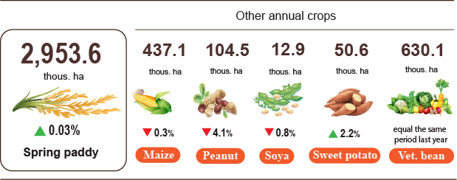

Livestock
Buffalo and cow husbandry during the month tended to decrease. The pig herd tends to increase strongly again due to household farming shifting strongly to semi-industrial production, linking with businesses; farm farming in a chain that combines biosecurity, disease safety and application of advanced technology. At the same time, disease prevention, control were good, pork prices have increased compared to the same period last year, so people promote pig farming. Poultry farming continues to grow due to low input costs, being able to take advantage of available food sources along with stable and increased consumer demand during holidays, bringing high economic efficiency.
Figure 2. The growth rate of the population of livestock at the
end of April, 2024 compared to the same time last year
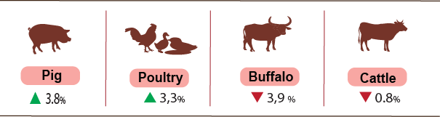
As of 22/5/2024, the whole country has no longer blue-ear disease and avian flu; foot-and-mouth disease was still in Gia Lai; LSD was reported in Quang Binh, Quang Ngai, Lam Dong and African swine fever was reported in 21 localities for less than 21 days.
b) Forestry
The area of concentrated newly planted forests nationwide in May 2024 was estimated at 30.3 thousand hectares, an increase of 8.6% over the same period last year due to favorable weather. Some provinces have high forest planting progress: Quang Ngai doubled; Quang Tri increased by 69.7%; Nghe An increased by 8.1%. The number of scattered forest trees planted reached 6.7 million, down 3.9%; the output of exploited wood reached 2,263.9 thousand m3, up 9.2% due to the increasing trend of raw wood prices, people promoted the exploitation of wood to harvest age. Some localities have high progress in logging compared to the same period last year: Quang Tri increased by 56.6%; Yen Bai increased by 15.3%; Bac Kan increased by 15.1%; Thua Thien - Hue increased by 10.0%; Quang Ninh increased by 9.5%. In the first five months of 2024, the area of ​​newly planted concentrated forests is estimated at 98.2 thousand hectares, up 1.3% over the same period last year; the number of scattered forest trees planted reached 37.8 million trees, up 1.2%; the output of exploited timber reached 7,413.7 thousand m3, up 6.6%.
The damaged forest area in the month was 204.9 hectares, down 38.6% over the same period last year. Of which, 74.3 hectares of forest were cut down and destroyed, down 43.9%; the burnt forest area was 130.6 hectares, down 35.1%. In the first five months of 2024, the whole country had 652.2 hectares of damaged forest, down 24.8% over the same period last year, of which 376.2 hectares were cut down and destroyed, down 24.9%; the burnt forest area was 285.1 hectares, down 24.8%.
c) Fishery
Fishery output in May, 2024 was estimated at 801.3 thousand tons, up 2.8% over the same period last year, including: Fish reached 573.8 thousand tons, up 2.4%; shrimp reached 110.9 thousand tons, up 5.8%; other aquatic products reached 116.6 thousand tons, up 1.7%.
Aquaculture production in May was estimated at 434.8 thousand tons, up 3.5% over the same period last year, of which: Fish reached 288.1 thousand tons, up 2.4%; shrimp reached 97.1 thousand tons, up 6.2%
Pangasius production in the month increased compared to the same period last year because raw pangasius prices remained at a stable high level and pangasius exports were showing signs of recovery, so fish farmers and businesses adjusted farming output accordingly to meet export demand. Pangasius output in the month was estimated at 155,000 tons, up 6.5% over the same period last year.
Shrimp production in the month increased compared to the same period last year due to the application of an effective high-quality shrimp farming model. White-leg shrimp output is estimated at 68 thousand tons, up 8.1% over the same period last year; black tiger shrimp output is estimated at 23 thousand tons, up 3.1%.
The caught fishery production in the month was estimated at 366.5 thousand tons, up 1.9% over the same period last year due to favorable fishing weather, including: Fish reached 285.7 thousand tons, up 2.4%; shrimp reached 13.8 thousand tons, up 2.9%; other aquatic products reached 67 thousand tons, down 0.5%. Marine fishing output wasestimated at 351.3 thousand tons, up 2.0% over the same period last year.
Figure 3. Fishery production in 5 months of 2024
over the same period last year
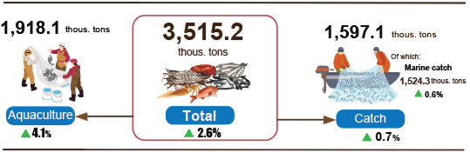
Generally, in 5 months of 2024, fishery output was estimated at 3,515.2 thousand tons, up 2.6% over the same period last year, including: Fish reached 2,570.1 thousand tons, up 2.4%; shrimp reached 408.5 thousand tons, up 4.3%; other aquatic products reached 536.6 thousand tons, up 2.2%.
- Industrial Production
Industrial production in May continued to maintain a more positive growth trend than the previous month. The index of industrial production in May is estimated to increase by 3.9% from the previous month and by 8.9% from the same period last year. In the first five months of 2024, the manufacturing index of the whole industry will increase by 6.8% compared to the same period last year.
The industry-wide manufacturing index (IIP) for May 2024 is estimated to increase by 3.9% month-on-month and 8.9% year-on-year. In which, compared to the same period last year, the processing and manufacturing industry increased by 10.6%; electricity production and distribution increased by 11.4%; water supply, waste and wastewater management and treatment activities increased by 7.4%; The mining sector alone decreased by 9.4%.
In the first five months of 2024, IIP is estimated to increase by 6.8% year-on-year (the same period in 2023 will decrease by 2.0%). In which, the processing and manufacturing industry will increase by 7.3% (the same period in 2023 will decrease by 2.6%), contributing 6.4 percentage points to the overall increase; the electricity production and distribution industry will increase by 12.7% (the same period in 2023 will increase by 1.2%), contributing 1.1 percentage points; water supply, waste and wastewater management and treatment activities will increase by 6.3% (the same period in 2023 will increase by 5.9%), contributing 0.1 percentage points; Particularly, the mining industry will decrease by 5.2% (the same period in 2023 will decrease by 2.4%), reducing 0.8 percentage points in the overall increase.
Production indexes in the first five months of 2024 of some key tier II industries will increase compared to the same period last year: Manufacture of rubber and plastics products increased by 27.4%; Manufacture of electrical equipment increased by 24.0%; manufacture of chemicals and chemical products increased by 20.1%; manufacture of furniture increased by 19.6%; Manufacture of basic metals increased by 13.2%; Manufacture of textiles and water supply; sewerage, waste management and remediation activities increased by 12.7%. In the opposite direction, the IIP index of some industries increased lower than the general average or decreased over the same period last year: Manufacture of computer, electronic and optical productsincreased by 5.8%; manufacture of wearing apparel increased by 5.4%; repair and installation of machinery and equipment decreased by 11.8%; extraction of crude petroleum and natural gas decreased by 11.0%; manufacture of other transport equipment decreased by 5.1%; manufacture of other non-metallic mineral products decreased by 1.7%; mining of coal and lignite decreased by 1.3%.
Table 1. The rate of increase/decrease in IIP index in the first 5 months of 2020-2024 compared to the same period last year of some key industries
%

 | 2020 | 2021 |  | 2022 |  | 2023 | 2024
Mining of coal and lignite | 4.5 | -4.5 | 11.9 |  | -3.0 |  | -1.3
Extraction of crude petroleum and natural gas | -11.1 | -10.2 | -1.1 |  | -2.1 |  | -11.0
Manufacture of food products | 3.4 | 6.2 | 6.4 |  | 3.5 |  | 5.4
Manufacture of textiles | 1.5 | 7.4 | 4.6 |  | -3.8 |  | 12.7
Manufacture of chemicals and chemical products | 7.7 | 4.0 | 3.5 |  | 3.5 |  | 20.1
Manufacture of rubber and plastics products | 1.3 | 10.8 | -12.3 |  | 6.8 |  | 27.4
Manufacture of other non-metallic mineral products | 0.8 | 7.1 | 6.3 |  | -5.0 |  | -1.7
Manufacture of basic metals | -2.3 | 37.7 | 3.1 |  | -6.1 |  | 13.2
Manufacture of computer, electronic and optical products | 7.4 | 15.4 | 11.0 |  | -5.3 |  | 5.8
Manufacture of electrical equipment | -6.0 | 13.5 | 22.3 |  | -1.7 |  | 24.0
Manufacture of other transport equipment | -14.9 | 13.6 | 2.6 |  | -5.6 |  | -5.1
Manufacture of furniture | 0.1 | 17.1 | 4.7 |  | -3.7 |  | 19.6
Repair and installation of machinery and equipment | -13.0 | -0.2 | -10.6 |  | 9.1 |  | -11.8
Water supply; sewerage, waste management and remediation activities | 2.1 | 8.7 | 6.0 |  | 1.2 |  | 12.7

The index of industrial production in the first five months of 2024 compared to the same period last year increased in 55 localities and decreased in 8 localities across the country. Some localities have achieved a relatively high increase in IIP due to the processing and manufacturing industry; electricity production and distribution industry increased. In the opposite direction, some localities have low or decreased IIP due to low or decrease in the processing and manufacturing industry and the electricity production and distribution industry .

Figure 4. IIP increase/decrease rate in the first 5 months of 2024 compared to the same period last year of some localities (%)
10 localities with the highest increase in IIP | 10 localities with the lowest decrease/increase IIP
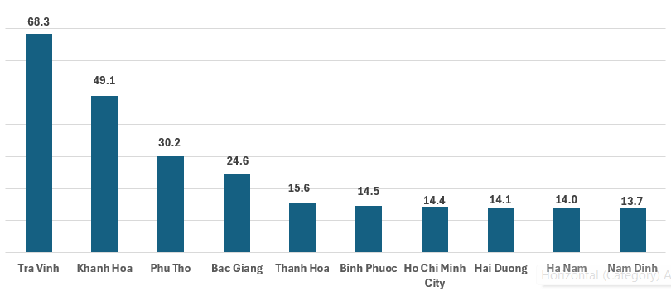 | 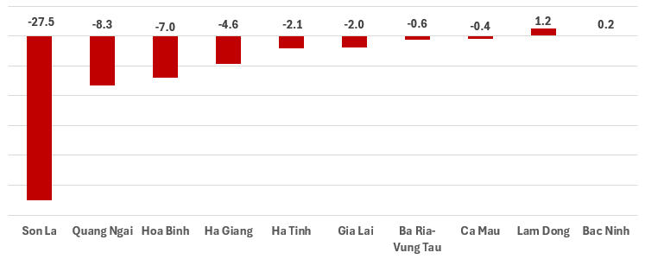

Some key industrial products in the first five months of 2024 will increase compared to the same period last year: Steel bars and corners increased by 33.8%; Textile fabric from natural yarn increased by 20.2%; laminated steel increased by 18.0%; urea fertilizer increased by 14.6%; N.P.K mixed fertilizer increased by 12.6%. In the opposite direction, some products decreased compared to the same period last year: Liquidized gas (LPG) decreased by 21.2%; Natural gas (in the form of air) fell 15.6%; television decreased by 10.4%; extracted crude oil decreased by 5.6%; crude steel, iron fell 5.2%.
The number of employees working in industrial enterprises as of May 1, 2024 will increase by 1.0% compared to the same time last month and increase by 3.2% compared to the same time last year. In which, the labor force of State-owned enterprises increased by 0.1% over the previous month and decreased by 0.3% over the same period last year; non-state enterprises increased by 0.7% and increased by 0.5%; foreign-invested enterprises increased by 1.3% and increased by 4.4%. By sector, the number of employees working in mining enterprises increased by 0.1% over the same period last month and decreased by 0.1% over the same period last year; processing and manufacturing increased by 1.1% and increased by 3.4%; the production and distribution of electricity, gas, hot water, steam and air conditioning remained unchanged and increased by 0.4%; Water supply, waste and wastewater management and treatment activities increased by 0.1% and increased by 1.2%.
3. Enterprise activities
a) Enterprise registration status
In May, the whole country had over 13.2 thousand newly established enterprises with registered capital was 93.2 trillion VND and a total number of registered employees of nearly 72.6 thousand employees, a decrease of 13.7% in the number of enterprises, a decrease of 47% in registered capital and a decrease of 23.6% in the number of employees compared to April 2024. Compared to the same period last year, up of 9.2% in the number of enterprises, down 10.1% in registered capital and down 2.7% in the number of employees. The average registered capital of a newly established enterprise in the month reached 7.1 billion VND, a decrease of 38.5% compared to the last month and down 17.7% compared to the same period last year. Besides, there were 6,749 re-operated enterprises in the whole country, a decrease of 18.8% compared to the previous month and up 13.4% compared to the same period of 2023.
Generally, in the first five months of 2024, the whole country had 64.8 thousand newly registered enterprises with a total registered capital of more than 601.2 trillion VND and a total number of registered employees was 426.4 thousand employees, up 4.5% in the number of enterprises, up 5.7% in registered capital and up 5% in the number of employees compared to the same period last year. The average registered capital of a newly established enterprise in the first five months of 2024 achieved 9.3 billion VND, up 1.2% compared to the same period in 2023. If including 666.9 trillion VND of the additionally registered capital of 18,567 thousand enterprises that recorded an upward adjustment of capital, the total number of captial that added more to the economy in the first five of 2024 was 1,268.1 trillion VND, a decrease of 9% compared to the same period last year. Besides, there were nearly 34.1 thousand re-operated enterprises (up 3.3% compared to the same period of 2023), bringing the total number of newly-established enterprises and re-operated enterprises in the first five months of 2024 to over 98.8 thousand enterprises, up 4.1% compared to the same period last year. The average each month had 19.8 thousand newly established and re-operated enterprises.
By economic sector, in the first five months this year, there were 630 newly-established enterprises in the agricultural, forestry, and fishery sectors, an increase of 1.1% compared to the same period last year; 15.4 thousand enterprises in the industrial and construction sectors, an increase of 4.2%; 48.7 thousand enterprises in the service sector, an increase of 4.6%.
Figure 6. Enterprise registration situation
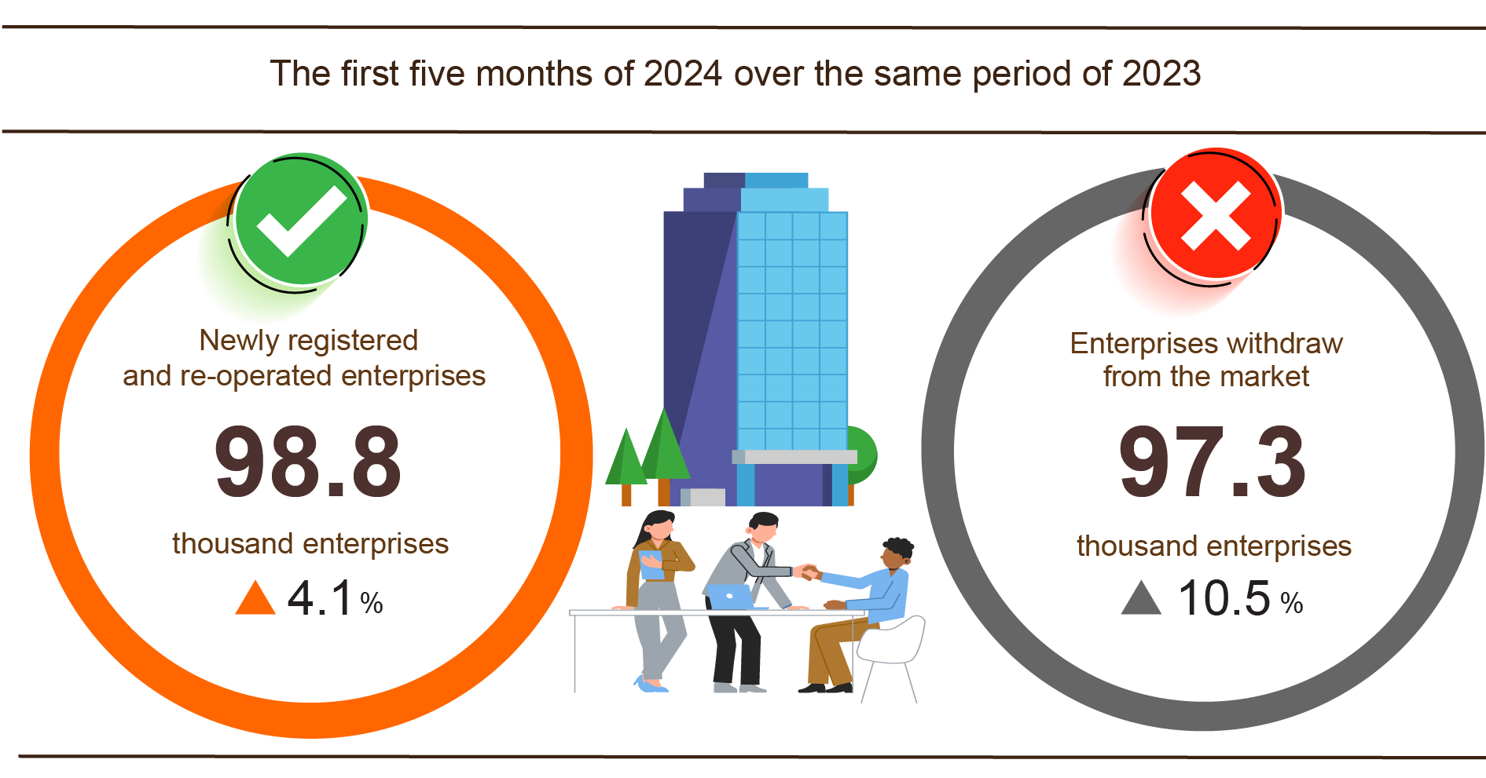
Also in May, 5,303 enterprises ceased for a certain time, down 30.4% compared to the previous month and down 1.1% over the same period in 2023; 4,550 enterprises temporarily ceased and awaited dissolution procedures, a deccrease of 2.3% and a deccrease of 3.5%; 1,538 enterprises completed dissolution procedures, up 14.4% and up 25.8%.
In the first five months of 2024, the number of enterprises temporarily ceased for a certain time was 66.1 thousand enterprises, an increase of 19.7% compared to the same period last year; 23.3 thousand enterprises temporarily ceased and awaited dissolution procedures, down 8.8%; nearly 8 thousand enterprises completed dissolution procedures, up 8.4%. On average, nearly 19.5 thousand enterprises withdraw from the market each month.
Table 3: Number of newly registered enterprises and completed dissolution procedures in the first five months of 2024 by kinds of activity

 | Number of enterprises (Enterprise) |  | Growth rate over the same period last year (%)
 | Newly registered | Dissolution | Newly registered | Dissolution
Wholesale and retail trade; repair of motor vehicles and motorcycles | 26,117 | 3,101 | 11.2 | 44.0
Manufacturing | 7,816 | 861 | 6.2 | 29.5
Construction | 6,887 | 601 | 2.1 | 21.9
Real estate business | 1,782 | 489 | 2.2 | 7.2
Transportation and storage | 3,376 | 302 | 20.8 | 23.8
Accommodation and catering service | 2,426 | 362 | -15.1 | 12.8
Production and distribution of electricity, water, gas | 465 | 91 | 9.4 | -24.8
4. Investment
Investment capital from the State budget in May 2024 is focused on promoting implementation by ministries, branches and localities. Overall, in the first five months of 2024, realized investment capital from the State budget is estimated to reach 26.6% of the year's plan, up 5.0% over the same period last year. Foreign direct investment (FDI) implemented in Vietnam in the first five months of 2024 is estimated to reach 8.25 billion USD, up 7.8% over the same period last year .
Implemented investment capital from the State budget in May 2024 is estimated to reach 48.2 trillion VND, up 3.1% over the same period last year, including: Centrally managed capital reached 8.6 trillion VND, up 0.5%; Locally managed capital reached 39.6 trillion VND, an increase of 3.7%. Overall, in the first five months of 2024, realized investment capital from the State budget is estimated to reach 190.6 trillion VND, equal to 26.6% of the year's plan and up 5.0% over the same period last year (same period in 2023 equals 24.8% and increases by 21.5%). Specifically:
- Implemented investment capital managed by the Central Government is estimated at 32.5 trillion VND, equal to 29.3% of the year's plan and down 2.6% over the same period last year. Of which, the Ministry of Transport reached 20.3 trillion VND, down 19.1%; Ministry of Agriculture and Rural Development reached more than 3.0 trillion VND, an increase of 37%; Ministry of Education and Training reached 287.7 billion VND, down 1.1%; Ministry of Health reached 247.4 billion VND, down 1.5%; Ministry of Natural Resources and Environment reached 193.3 billion VND, down 34.8%; The Ministry of Industry and Trade reached 187.8 billion VND, an increase of 9.3%.
- Locally managed investment capital is estimated at 158.1 trillion VND, equal to 26.1% of the year's plan and up 6.7% over the same period last year, of which:
Provincial state budget capital reaches nearly 106.0 trillion VND, equal to 24.6% and up 6.1% over the same period in 2023;
State budget capital at district level reached 44.9 trillion VND, equal to 29.3% and increased 8%;
State budget capital at commune level reached 7.2 trillion VND, equal to 34.5% and increased by 7.1%.
Investment capital implemented from the State budget in the first five months of 2024 of a number of provinces and centrally run cities is as follows:
Figure 6. Investment capital made from the State budget
of some localities (Billion dong)

Total foreign investment capital registered in Vietnam As of May 20, 2024, including: Newly registered capital, adjusted registered capital and value of capital contributions and share purchases by foreign investors reached nearly 11.07 billion USD, an increase of 2.0%. compared to the same period last year.

Figure 7. Foreign investment capital registered in Vietnam
as of May 20, 2020-2024 (Billion USD)

- Newly registered capital has 1,227 licensed projects with a registered capital of 7.94 billion USD, an increase of 27.5% over the same period last year in the number of projects and an increase of 50.8% in registered capital. sign. Among them, the processing and manufacturing industry has the largest newly licensed foreign direct investment with a registered capital of 5.37 billion USD, accounting for 67.7% of the total newly registered capital; Real estate business activities reached 1.83 billion USD, accounting for 23.1%; The remaining industries reached 730.5 million USD, accounting for 9.2%.
Among the 53 countries and territories with new licensed investment projects in Vietnam in the first five months of 2024, Singapore is the largest investor with 2.92 billion USD, accounting for 36.8% of total newly registered capital; followed by Hong Kong Special Administrative Region (China) with 957.2 million USD, accounting for 12.1%; Japan 947.7 million USD, accounting for 11.9%; China 926.1 million USD, accounting for 11.7%; Türkiye 730.1 million USD, accounting for 9.2%; Taiwan 517.1 million USD, accounting for 6.5%.
- Adjusted registered capital: 440 projects licensed from previous years registered to adjust their investment capital by 2.08 billion USD, down 8.7% over the same period last year.
If including new registered capital and adjusted registered capital of projects licensed in previous years, registered foreign direct investment capital in the processing and manufacturing industry reached 7.2 billion USD, accounting for 71.8% of total newly registered and increased capital; Real estate business activities reached 1.91 billion USD, accounting for 19.0%; The remaining industries reached 916.8 million USD, accounting for 9.2%.
- Registered capital for capital contribution and share purchase by foreign investors was 1,158 times with a total capital contribution value of 1.05 billion USD, down 68.2% over the same period last year. Of these, there were 427 capital contributions and share purchases to increase the enterprise's charter capital with a capital contribution value of 580.7 million USD; 731 times foreign investors bought back domestic shares without increasing charter capital with a value of 472.6 million USD. For the form of capital contribution and share purchase by foreign investors, capital invested in professional activities and science and technology warehouses reached 253.3 million USD, accounting for 24.1%; Warehousing and transportation activities reached 198.4 million USD, accounting for 18.8% of capital contribution value; The remaining industries 601.6 million USD, accounting for 57.1%.
Foreign direct investment capital in Vietnam in the first five months of 2024 is estimated to reach 8.25 billion USD, up 7.8% over the same period last year. This is the highest amount of realized foreign direct investment capital in the first five months of the year in the past 5 years. Of which: Processing and manufacturing industry reached 6.5 billion USD, accounting for 78.9% of total realized foreign direct investment capital; Real estate business activities reached 781.0 million USD, accounting for 9.5%; Production and distribution of electricity, gas, hot water, steam and air conditioning reached 336.2 million USD, accounting for 4.1%.
Figure 8. Realized foreign direct investment capital in
the first 5 months of 2020-2024 (Billion USD)

Vietnam's investment abroad in the first five months of 2024 has 42 projects newly granted investment certificates with a total Vietnamese capital of 103.5 million USD, down 27.5% over the same period. last year; There were 10 projects with capital adjusted with an increase of 32.5 million USD, a decrease of 81.3%.
In the first five months of 2024, Vietnam's total investment capital abroad (new and adjusted capital) reached 136.1 million USD, down 57.0% over the same period last year. Of which: Mining reached 58.6 million USD, accounting for 43.1% of total investment capital; Processing and manufacturing industry reached 32.5 million USD, accounting for 23.9%; wholesale and retail, repair of cars, motorbikes, motorbikes and other motor vehicles reached 11.3 million USD, accounting for 8.3%; Other services reached 10.0 million USD, accounting for 7.4%; Construction activities reached 5.5 million USD, accounting for 4.0%.
In the first five months of 2024, there are 16 countries and territories receiving investment from Vietnam, of which: the Netherlands is the leading country with 54.6 million USD, accounting for 40.1% of total investment capital; Laos 50.0 million USD, accounting for 36.8%; United States 7.7 million USD, accounting for 5.6%; New Zealand 5.9 million USD, accounting for 4.3%; Indonesia 5.5 million USD, accounting for 4.0%.
5. State budget revenue and expenditure
State budget revenue in the first 5 months of 2024 is estimated to increase by 14.8% over the same period last year. State budget expenditure was estimated to increase by 0.5% over the same period in 2023, ensuring the needs of socio-economic development, defense, security, state management, payment of due debts as well as such as making timely payments for specified objects.
Figure 10. State budget revenues and expenditures
in the first 5 months of 2024
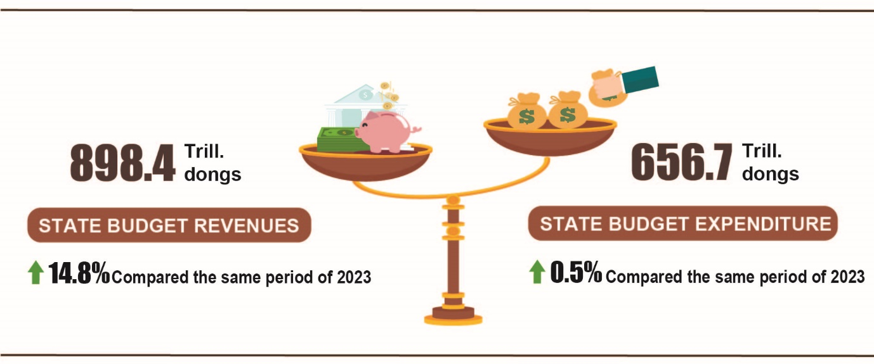

State budget revenue
Total State budget revenue in May 2024 was estimated at 150.9 trillion VND. Accumulated total state budget revenue in the first 5 months of 2024 was estimated at 898.4 trillion VND, equaling to 52.8% of the year estimate and up 14.8% over the same period last year. Some of the main revenues are as follows:
- Domestic revenue in May 2024 was estimated at 118.4 trillion VND. Accumulated for the first 5 months of 2024 was estimated at 757.5 trillion VND, equaling 52.4 % of the year estimate and up 16.8% over the same period last year.
- Revenue from crude oil in May 2024 was estimated at 5 trillion VND; accumulative in the first 5 months of 2024 was estimated at 24.7 trillion VND, equaling 53.6 % of the year estimate and down 5.5% over the same period last year.
- Budget balance revenue from export and import activities in May 2024 was estimated at 27.5 trillion VND; accumulated in the first 5 months of 2024 was estimated at 116.2 trillion VND, equaling to 57 % of the year estimate and up 7.8% over the same period last year.
State budget expenditure
Total State budget expenditure in May 2024 was estimated at 140.1 trillion VND; accumulated in the first 5 months of 2024 was estimated at 656.7 trillion VND, equaling 31% of the yearly estimate and increasing 0.5% over the same period last year. Of which, regular expenditure in the first 5 months of 2024 was estimated at 460.5 trillion VND, equaling to 36.6% of the yearly estimate and increasing 1.8% over the same period last year; development investment expenditure reached 148.3 trillion VND, equaling 21.9% and down 5.6%; debt payments was 47.5 trillion VND, equaling 42.5% and increased by 10.1%.
6. Trade, prices, transport and tourism
a) Retail sales of consumer goods and services
The total retail sales of consumer goods and services in 4/2024 decreased slightly by 0.1% compared to the previous month due to reduced consumption and travel demand of people after last month's long holiday. However, compared to the same period last year, it increased by 9.5% thanks to the positive contribution of the tourism industry. Generally, in the first five months of 2024, the total retail sales of consumer goods and services was estimated to increase by 8.7% over the same period last year, of which revenue from accommodation and food services increased by 15.1%, revenue from tourism up to 45.1%.
Total retail sales of consumer goods and services at current prices in 5/2024 was estimated at 519.8 trillion VND, up 9.5% over the same period last year, of which, the group of food and foodstuffs increased by 9.9%; household appliances, tools and equipment increased by 9.0%; garment increased by 9.3%; accommodation and food services increased by 17.0%; traveling service increased by 34.3%.
Table 3. Retail sales of consumer goods and services at current prices

Trillion VND
 | Estimate  May  2024 | Estimate the  first 5 months  of 2024 | Growth rate compared to the same period last year (%)
 | Estimate  May  2024 | Estimate the  first 5 months  of 2024 | May  in 2024 | The first 5 months  of 2024
Total | 519.8 | 2.580.2 | 9.5 | 8.7
Retail sale of goods | 402.4 | 1.998.2 | 8.2 | 7.4
Accommodation and catering service | 60.5 | 296.3 | 17.0 | 15.1
Tourism revenue | 5.0 | 24.2 | 34.3 | 45.1
Other services | 51.9 | 261.5 | 9.5 | 8.8
Generally for the first five months of 2024, the total retail sales of consumer goods and services at current prices was estimated at 2,580.2 trillion VND, up 8.7% over the same period last year (up 12.3% in the same period in 2023), if excluding the price factor, up 5.2% (the same period in 2023 increased by 9.3%).
Figure 11. Total retail sales of consumer goods and service
in the first five months of 2020-2024

Retail sales of goods in the first five months of 2024 were estimated at 1,998.2 trillion VND, accounting for 77.5% of the total retail sales of consumer goods and services and up 7.4% over the same period last year (if excluding the price factor, up 4.5%). In which, food and foodstuffs increased by 10.5%; household appliances, tools and equipment increased by 13.4%; garment increased by 10.3%; means of transport (except for cars) rose up 1.3%; cultural and educational products increased by 15.5%. Retail sales of goods in the first five months of this year compared to the same period last year of some localities was as follows: Quang Ninh increased by 10.1%; Hai Phong increased by 9.5%; Can Tho increased by 8.4%; Da Nang increased by 8.2%; Ho Chi Minh City increased by 6.8%; Ha Noi increased by 6.7%.
Revenue from accommodation and catering services in the first five months of 2024 was estimated at 296.3 trillion VND, accounting for 11.5% and up 15.1% over the same period last year. Revenue in the first five months of 2024 compared to the same period last year of some localities was as follows: Khanh Hoa increased by 26.4%; Quang Ninh increased by 23.5%; Da Nang increased by 22.2%; Hai Phong increased by 14.9%; Hanoi increased by 12.4%; Can Tho increased by 11.5%; Ho Chi Minh City increased by 8.0%.
Tourism revenue in the first five months of 2024 was estimated at 24.2 trillion VND, accounting for 0.9% and up 45.1% over the same period last year. The revenue of some localities in the first five months of 2024 compared to the same period last year was as follows: Da Nang increased by 52.0%; Ho Chi Minh City increased by 46.0%; Hanoi increased by 44.6%; Quang Ninh increased by 18.0%.
Other service revenue in the first five months of 2024 was estimated at 261.5 trillion VND, accounting for 10.1% and up 8.8% over the same period last year. Revenue in the first five months of 2024 of some localities was as follows: Thua Thien - Hue increased by 23.5%; Binh Dinh increased by 17.5%; Ho Chi Minh City increased by 8.6%; Can Tho increased by 8.4%; Hanoi increased by 7.8%; Da Nang decreased by 19.1%; Quang Ninh decreased by 12.7%; Lang Son decreased by 6.6%.
b) Export and import of goods
Total export and import turnover of goods in 5/2024 was estimated at 66.62 billion USD, up 9.1% over the previous month and up 22.6% over the same period last year. Generally, in the first five months of 2024, the total export and import turnover of goods reached 305.53 billion USD, up 16.6% over the same period last year, of which exports increased by 15.2%; imports increased by 18.2%. The trade balance of goods had a surplus of 8.01 billion USD.
Figure 12. Import and export of goods in the first 5 months of 2024
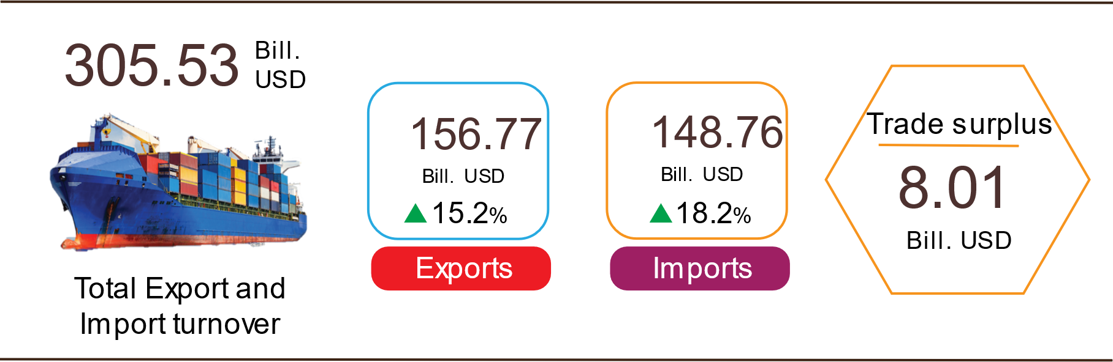

Export of goods
Preliminary export turnover of goods in 4/2024 reached USD 31.1 billion, 113 million USD higher than the estimated figure.
Export turnover of goods in 5/2024 was estimated at 32.81 billion USD, up 5.7% over the previous month. Of which, the domestic economic sector gained 9.37 billion USD, increased by 2.7%; the FDI sector (including crude oil) reached 23.44 billion USD, increased by 6.9%. Compared to the same period last year, export turnover of goods in May increased by 15.8%, of which the domestic economic sector increased by 13.0%, the FDI sector (including crude oil) increased by 17.0%.
Generally in the first five months of 2024, the export turnover was estimated at 156.77 billion USD, increased by 15.2% over the same period last year. Of which, the domestic economic sector was 43.69 billion USD, went up 20.5%, accounting for 27.9% of total export turnover; the FDI sector (including crude oil) attained 113.08 billion USD, increased by 13.3%, sharing 72.1%.
In the first five months of 2024, there were 26 products with export turnover of over 1 billion USD, contributing 90% to the total export turnover (7 products with export turnover of over 5 billion USD, accounting for 65.3%).
Table 4. Value of some export products in the first 5 months of 2024
 | Estimate  (Mill. USD) | Growth rate compare to  the same period last year (%)
Items with a value of over 5 billion USD
Electronic goods, computers and their parts | 27,379 | 33.4
Phones all of kinds and their parts | 22,539 | 11.6
Machinery, instrument, accessory | 18,441 | 11.8
Textiles and garments | 13,116 | 3.3
Footwear | 8,639 | 7.1
Wood and products | 6,144 | 23.5
Means of transport and components | 6,087 | 3.8

Regarding the structure of exported groups in the first five months of 2024, the group of fuels and minerals was estimated at 2.06 billion USD, accounting for 1.3%; the group of processing industry was estimated at 137.39 billion USD, accounting for 87.7%; agricultural and forestry products was estimated at 13.82 billion USD, accounting for 8.8%; the group of fishery products was estimated at 3.5 billion USD, accounting for 2.2%.
Figure 13. Structure of exported groups
in the first 5 months of 2024

Import of goods
Preliminary import turnover of goods in 4/2024 reached 29.99 billion USD, 273 million USD lower than the estimate figure.
Import turnover in 5/2024 was estimated at 33.81 billion USD, increased by 12.8% over the previous month. Of which the domestic economic sector gained 12.81 billion USD, increased by 11.2%; the FDI sector reached 21.0 billion USD, increased by 13.7%. Compared to the same period last year, the import turnover of goods in May increased by 29.9%, of which the domestic economic sector increased by 38.2%; the FDI sector increased by 25.3%.
Generally in the first five months of 2024, the import turnover was estimated at 148.76 billion USD, increased by 18.2% over the same period last year. Of which the domestic economic sector reached 54.95 billion USD, went up 24.2%; the FDI sector gained 93.81 billion USD, up 14.9%.
In the first five months of 2024, there are 27 imported products with a turnover of over 1 billion USD, accounting for 84.5% of total import turnover (4 products with import turnover of over 5 billion USD, accounting for 47.0%).
Table 5. Value of some imported goods in the first 5 months of 2024
 |  | Estimate | Growth rate compare to
 |  | (Mill. USD) | the same period last year (%)
Items with a value of over 5 billion USD
 | Electronic devices, computers and their parts | 40,250 | 27.3
 | Machinery, instrument, accessory | 18,534 | 15.4
 | Fabrics | 6,043 | 13.3
 | Iron, steel | 5,045 | 28.3
Figure 14. Structure of imported groups
in the first 5 months of 2024
Regarding the structure of imported groups in the first five months of 2024, the group of production materials was estimated at 139.89 billion USD, accounted for 94%, in which the group of machinery, equipment, tools spare parts accounted for 45.7%; raw materials, fuel and materials accounted for 48.3%. The group of consumer products was estimated at 8.87 billion USD, accounted for 6%.
Regarding the export and import market of goods in the first five months of 2024, the United States was the Viet Nam's largest export market with a turnover of 44.0 billion USD. China remained the largest import market of Viet Nam with a turnover of 54.9 billion USD. In the first five months of 2024, the trade surplus to the United States reached 38.1 billion USD, up 24.2% over the same period last year; the trade surplus to the EU reached 14.3 billion USD, up 18.4%; the trade surplus to Japan was 290 million USD, down 61.8%; the trade deficit from China was 32.3 billion USD, went up 55.9%; the trade deficit from Korea was 11.1 billion USD, went up 1.3%; the trade deficit from ASEAN was 4.2 billion USD, increased by 39.1%.
Figure 15. Major commodity import and export markets
in the first 5 months of 2024
 |  | Export of goods | Import of goods
The trade balance of goods in April had a trade surplus of 1.07 billion USD; the first four months of 2024 had a trade surplus of 9.01 billion USD; May was estimated to have a trade surplus of 1.0 billion USD. Generally in the first five months of 2024, the trade balance of goods is estimated to have a trade surplus of 8.01 billion USD (in the same period last year, the trade surplus of 10.2 billion USD). Of which, the domestic economic sector has a trade deficit of 11.26 billion USD; the FDI sector (including crude oil) had a trade surplus of 19.27 billion USD.
c) Consumer price index, gold price index and US dollar price index
Pork prices increase due to supply shortages after the African swine fever epidemic at the end of 2023, and increased electricity prices during hot weather are the main reasons for the increase in the consumer price index (CPI) in May 2024 increased by 0.05% compared to last month. Compared to December 2023, CPI in May increased by 1.24% and compared to the same period last year increased by 4.44%.
On average, in the first 5 months of 2024, CPI increased by 4.03% over the same period last year; core inflation increased by 2.78%.
Figure 15. CPI increase/decrease rate in May 2024 compared to the previous month

In the 0.05% increase in CPI in May 2024 compared to the previous month, there were 07 groups of goods and services with increased price indexes; 03 groups of discounted products and 01 group of products with stable prices.
(1) Seven groups of goods and services with increased price index include:
- Food and foodstuff services group increased by 0.38% (making the general CPI increase by 0.13 percentage points), of which: Food decreased 0.26%; foodstuff increased by 0.59% (making the general CPI increase by 0.13 percentage points); meals and drinking out increased by 0.14%.
- Housing and construction materials group increased by 0.38% mainly due to domestic electricity prices increasing by 2.11%; prices of housing maintenance materials increased by 0.28%; house rent increased by 0.23%. Besides the price increasing items, there are a number of price decreasing items: Kerosene price decreased by 5.23% due to the impact of price adjustments during the month; gas prices decreased by 1.6% because from 01/5/2024, domestic gas prices were adjusted to decrease by 7,300 VND/12 kg tank after world gas prices decreased by 35 USD/ton compared to the previous month to 582.5 USD/ton.
- Culture, entertainment and tourism group increased by 0.31%, of which the price of package travel services increased by 1.12%; guest houses and hotels increased by 0.28% due to the extended holiday period from April 30 to May 1, so people's demand for travel increased.
- Other goods and services increased by 0.2%, focusing mainly on personal items, which increased by 0.60%. Of which, jewelry prices increased by 3.3% according to domestic gold prices; administrative and legal services increased by 0.28%; hospitality services increased by 0.12%; personal services increased by 0.09%.
- Beverage and cigarette group increased by 0.14% due to hot and muggy weather, so demand for soft drinks increased, specifically: Mineral water price increased by 0.14%; all kinds of beer increased by 0.11%; fruit juice increased by 0.09% and all kinds of alcohol increased by 0.01%. Cigarette prices increased by 0.27% compared to last month due to increased exchange rates.
- Household equipment and goods group increased by 0.12%, focusing mainly on refrigeration products due to hot weather so consumer demand increased. In particular, refrigerator prices increased by 0.7% compared to the previous month; electric irons increased by 0.56%; electric fans increased by 0.38%; air conditioning increased by 0.3%. On the contrary, the price of blenders and juicers decreased by 0.45%; bathroom water heaters decreased by 0.32% due to promoting promotional programs to stimulate shopping.
- The group of medicine and health care services increased by 0.01%, mainly due to hot weather, the number of cases of measles, chickenpox, hand, foot and mouth disease increased rapidly, so people needed to buy drugs to strengthen the immune system. immunity. In particular, the price of pain relievers, antipyretics, and anti-inflammatory drugs increased by 0.18%; vitamin and mineral medicine group increased by 0.16%; hormone drugs and drugs that affect the endocrine system increased by 0.15%; the group of drugs that act on the respiratory tract increased by 0.11%; anti-infection and anti-parasitic drugs group increased by 0.1%; cardiovascular drugs decreased by 0.08%.
(2) Three groups of goods and services with decreasing price index include:
- The postal and communication group decreased by 0.09% due to businesses implementing promotional programs for some types of old cell phones, smart phone accessories and tablet computers.
- Education group decreased by 0.25% (contribute to reduction decreased by 0.3%). The main reason is that on 31/12/2023, the Government issued Decree No. 97/2023/ND-CP amending and supplementing a number of articles of Decree No. 81/2021/ND-CP dated 27/8/2021, which requires localities to keep tuition fees stable from the 2023-2024 school year equal to the tuition fees of the 2021-2022 school year for preschool education and public general education. Accordingly, some schools have adjusted to reduce tuition fees after being collected according to Decree No. 81/2021/ND-CP.
- Transportation group decreased by 1.73% (contributing to a decrease in overall CPI of 0.17 percentage points), mainly due to a decrease in domestic gasoline prices of 4.72%; Diesel oil prices decreased by 5.08% due to the impact of price adjustments during the month. In the opposite direction, there are some product groups that increased in price as follows: Vehicle group prices increased by 0.11%; passenger transportation prices by taxi increased by 0.94%; combined passenger transport increased by 0.22%; waterway increased by 0.18%; road increased by 0.1% due to increased travel demand during the holidays of April 30 and May 1. Self-driving car and motorbike rental fees increased by 0.22%; driver's license tuition increased by 0.1%; vehicle maintenance service prices increased by 0.33%.
(3) Particularly, the garment, hat and footwear groups keep their prices stable because businesses and business establishments carry out many promotional programs to stimulate shopping in early summer. Of which, the price of ready-made clothes decreased by 0.02%; Scarves, scarves, gloves, belts, socks decreased by 0.08%. In the opposite direction, footwear service prices increased by 0.4%; garment services increased by 0.23% and hats increased by 0.2%.
Core inflation in May 2024 increased by 0.15% over the previous month, up 2.68% over the same period last year.
On average in the first five months of 2024, core inflation increased by 2.78% over the same period in 2023, lower than the general average CPI (up 4.03%), mainly due to food, gasoline, and service prices. Education and health services are factors that increase CPI but belong to the group of goods excluded from the list of core inflation calculations.
Domestic gold prices are in the same direction as world gold prices. As of 24/5/2024, the average world gold price is at 2,352.56 USD/ounce, up 1.3% compared to April 2024. Increasing geopolitical risks in the Middle East region along with the reserve needs of central banks and investors are the main reasons leading to the continuous increase in world gold prices. Domestically, the gold price index in May 2024 increased by 3.81% compared to the previous month; an increase of 21.47% compared to December 2023; increased 32.18% over the same period last year; The average increase in the first five months of 2024 is 22.95%.
As of 24/5/2024, the US dollar index on the international market reached 105.06 points, up 0.1% over the previous month due to US business activities accelerating when the PMI index decreased. The May 2024 case to 54.4 is the highest level since April 2022. Domestically, the demand for foreign currency for import activities of businesses has increased, the average US dollar price on the free market fluctuates around 25,464 VND/USD. The US dollar price index in May 2024 increased by 1.15% compared to the previous month; an increase of 4.21% compared to December 2023; increased 7.85% over the same period last year; the average increase in the first five months of 2024 is 5.24%
d) Transport
Passenger transport in 5/2024 increased by 4.3% of passenger carried and increased by 9.6% of passenger traffic; freight transport increased by 11.4% of freight carried and up 4.8% of freight traffic. Overall, in the first five months of 2024, passenger carried increased by 6.1% and passenger traffic up 12.7% over the same period last year; freight carried increased by 11.4% and freight traffic up 7.9%.
Passenger transport in 5/2024 was estimated at 360.5 million passengers, decreased by 3.9% and passenger traffic was 21.1 billion passengers-kilometers, decreased by 6.8% compared to the previous month because there weren't as many holidays this month as last month, so people's travel and tourism needs decreased. In the first five months of 2024, passenger carried was estimated at 1.935.1 million passengers, up 6.1% over the same period last year and passenger traffic was 111.4 billion passengers.km, increased by 12.7%. Of which, domestic transport reached 1,927.4 million passengers, up 6.0% over the same period last year and 86.3 billion passengers-kilometers, up 5.4%; overseas transport reached 7.7 million passengers, increased by 35.5% and 25.1 billion passengers-kilometers, up 47.8% compared to the same period last year.
Table 6 : Passengers transport in the first five months of 2024
by types of transport
 | Number of passengers |  | Growth rate compared to the same period last year (%)
 | Carried  (Mill. passengers) | Traffic  (Bill. passengers-km) | Carried | Traffic
Total | 1,935.1 | 111.4 | 6.1 | 12.7
Rail way | 2.8 | 1.1 | 14.0 | 16.6
Sea way | 6.4 | 0.3 | -0.5 | -0.4
Inland water way | 158.0 | 2.9 | 8.3 | 9.2
Road | 1,745.6 | 69.3 | 6.1 | 9.1
Airway | 22.3 | 37.8 | -1.5 | 20.3

Freight transport in 5/2024 was estimated at 206.1 million tons of freight carried, increased by 2.2% and 39.9 billion tons.km of freight traffic, decreased by 3.0% over the previous month - Mainly due to a decrease in freight traffic by sea of 7.7% compared to the previous month. Generally for the firsr five months of 2024, freight transport was estimated at 1.028 million tons of freight carried, up 11.4% over the same period last year and 208.4 billion tons.km of freight traffic, an increase of 7.9%. Of which, domestic transport reached 1,008.9 million tons of freight carried, up 11.6% and 126.6 billion tons.km of freight traffic, up 3.6%; overseas transport reached 19.1 million tons of freight carried, up 4.3% and 81.8 billion tons.km of freight traffic, up 15.4%.
Table 7. Carriage of freight in the first five months of 2024
by types of transport

 | Quantity of goods |  |  | Growth rate compared to the same period last year (%)
 | Carried | Traffic |  | Carried | Traffic
 | (Mill. tons) | (Bill. tons-km) |  | Carried | Traffic
Total | 1,028.0 | 208.4 |  | 11.4 | 7.9
Rail way | 2.1 | 1.6 |  | 14.0 | 6.4
Sea way | 53.1 | 108.1 |  | 10.1 | 5.4
Inland water way | 215.4 | 45.5 |  | 11.4 | 10.3
Road | 757.2 | 48.9 |  | 11.5 | 9.5
Airway | 0.2 | 4.3 |  | 47.5 | 35.7

đ) International visitors to Viet Nam
Favorable visa policies and tourism promotion programs in 2024 have been promoted by localities across the country, attracting a high increase in international visitors to Vietnam compared to the same period last year. In 5/2024, the number of international visitors to Viet Nam reached 1.4 million. increased by 51.0% compared to the same period last year. In the first five months of 2024, international visitors to our country reached nearly 7.6 million arrivals, up 64.9% compared to the same period last year and up 3.9% compared to the same period of 2019 - the year before the Covid-19 pandemic.
Out of a total of 7.6 million international arrivals to Viet Nam in the first five months of this year, arrivals by air reached nearly 6.3 million arrivals, accounting for 83.7% of international arrivals to Viet Nam and 1.6 times higher than the same period last year; by road reached 1.1 million arrivals, accounting for 14.2% and 2.1 times higher; by sea reached 162.4 thousand arrivals, accounting for 2.1% and 3.2 times higher.
Figure 17. International visitors to Viet Nam in the first five months
of 2024 by territories
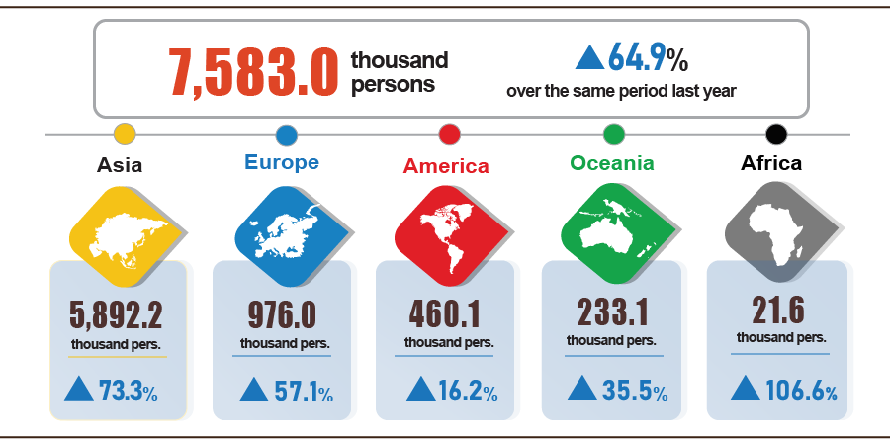
7. Some social situations
a) Residential life
According to the survey on the living situation of households in May 2024, the rate of assessment with income during the month remained unchanged and increased compared to the same period last year at 94.8%; The rate of assessments with reduced and undetermined income is 5.2%. This ratio did not change compared to the previous month's reporting period and the same period last year. However, the income assessment rate in May increased compared to the same month last year by 32.9% (an increase of 2.8 percent compared to the April 2024 reporting period and an increase of 6.4 percentage points). compared to the May 2023 reporting period) found positive changes in household income.
Households whose income in May decreased compared to the same period last year identified the main reasons as: Some household members lost their jobs or temporarily quit their jobs (rate of 43.4%); due to increased input costs for household production and business activities (24.2%); due to the decrease in the scale of household production and business activities (24.7%); due to the decrease in selling prices of products from household production and business activities (20.9%).
In the first five months of 2024, 31% of households reported experiencing at least one event that negatively affected family life, this rate decreased slightly by 0.2 percentage points compared to the April reporting period. /2024 and down 2.3 percentage points compared to the May 2023 reporting period. Among the households negatively affected by the events: 30.3% of households are suffering from the effects of rising prices of goods and services; 2.7% of households are negatively affected by epidemics on humans and 1.7% of households are negatively affected by epidemics on livestock and crops.
In the first five months of 2024, 12.4% of interviewed households received help from various support sources. Of which, the proportion of households receiving assistance from relatives is 8.4%; from local programs and policies is 4.4%; from general national programs and policies is 4.1%; from charitable activities of other organizations and individuals is 1.7% and 0.02% from other sources.
The work of ensuring social security is always carried out promptly and effectively by all levels and sectors. According to a report from the Ministry of Labor, War Invalids and Social Affairs, in the first five months of this year, the Government, ministries, branches and localities supported people with nearly 18.5 thousand tons of rice. Of which, 10.4 thousand tons of rice were supported to relieve hunger on the occasion of the Lunar New Year of the Dragon for 103.7 thousand households with 693.4 thousand people; supporting nearly 3.1 thousand tons of rice to relieve hunger in 2024 for 44.5 thousand households with 205.5 thousand people. Localities proactively allocated budget and socialization resources to support nearly 5 thousand tons of rice for poor, near-poor households and people in difficult circumstances.
b) Disease situation and food poisoning
According to a report from the Ministry of Health, in the month (from April 19 to May 18, 2024), the whole country had 4,446 cases of dengue fever (03 deaths); 9,003 cases of hand, foot and mouth disease; 163 cases of typhus suspected of measles; 05 deaths due to rabies; 60 cases of viral encephalitis (02 deaths); 04 cases of meningococcal meningitis. In the first five months of 2024, the whole country has 19.9 thousand cases of dengue fever (03 deaths); 20.1 thousand cases of hand, foot and mouth disease; 312 cases of typhus suspected of measles; 34 deaths due to rabies; 159 cases of viral encephalitis (06 deaths); 09 cases of meningococcal meningitis; 01 case of influenza A and died.
The total number of people living with HIV in the country as of May 18, 2024 is nearly 237 thousand people; The number of deaths due to HIV/AIDS is 114.7
thousand people.
Regarding food poisoning, in May 2024, there were 11 cases with 1,190 people poisoned. In the first five months of 2024, there were 35 cases nationwide with 2,025 people being poisoned (3 people died).
c) Cultural and sports activities
Regarding cultural activities, during the month a series of activities commemorating the 70th anniversary of the Dien Bien Phu Victory took place: Special art programs, rallies, military parades, parades commemorating the 70th anniversary of the Dien Bien Phu Victory were organized. held on the morning of May 7, 2024 in Dien Bien Phu City. The 134th birthday anniversary of President Ho Chi Minh was organized by many localities across the country.
The mass sports movement in the first months of the year was promoted and took place across the country, a number of outstanding activities took place during the month: Vietnam Public Employees' Trade Union Sports Festival 2024 held from May 4 - May 18 at Cau Giay Gymnasium, attracting more than 1,500 athletes who are officials, civil servants, public employees, and workers working in ministries, departments, branches, unions, and central public service units. The central government has a union affiliated with the Vietnam Public Employees' Union; The mass sports tournament for agencies and businesses in Tuyen Quang province takes place from May 16 to May 18 in Tuyen Quang province; The 2024 Lotus Village Festival sports competition is taking place from May 15 to May 17 in Nghe An province with the participation of nearly 300 athletes from 17 districts, cities and towns in the province; The 10th National Phu Dong Health Festival 2024 takes place on May 23 in Thai Nguyen province...
Regarding high-performance sports, a number of outstanding events took place during the month: The 2024 Asian Taekwondo Tournament took place from May 14 to May 19 at Tien Son Sports Palace - Da Nang with the participation of 1,026 athletes. athletes and coaches from 45 countries and territories; Vietnam karate team won the championship with 21 gold medals, 21 silver medals, 32 bronze medals at the Southeast Asian Karate Championship taking place from April 22 to April 27 in Bangkok - Thailand. ; Hanoi Grandmaster - International Grandmaster Chess Tournament 2024 round 2 opened on May 21 at the Hanoi Old Quarter Cultural Exchange Center; Vietnamese athletics won the Gold medal at the 2024 Asian Championship relay on May 21 in Thailand.
d) Traffic accident
During the month (from April 15 to May 14, 2024), there were 1,879 traffic accidents nationwide, including 1,353 traffic accidents from less serious or more (causing 837 deaths, 840 deaths). injured people) and 526 traffic collisions caused 603 people with minor injuries. Compared to the previous month, the number of traffic accidents decreased by 5.8% (the number of traffic accidents from less serious or more decreased by 6.6% and the number of traffic collisions decreased by 3.8%); number of deaths decreased by 0.9%; The number of injured people decreased by 12.6% and the number of people with minor injuries increased by 4.7%. Compared to the same period last year, the number of traffic accidents in May increased by 12.8% (the number of traffic accidents from less serious or more decreased by 18.8% and the number of traffic collisions increased by 31.5%. ); number of deaths decreased by 6.9%; The number of injured people increased by 12.4% and the number of people with minor injuries increased by 48.5%.
In the first five months of this year, there were 10,427 traffic accidents nationwide, including 7,267 less serious traffic accidents and 3,160 traffic collisions, causing 4,405 deaths and 4,725 deaths. people were injured and 3,501 people suffered minor injuries. Compared to the same period last year, the number of traffic accidents in the first five months of this year increased by 20% (the number of traffic accidents from less serious or more increased by 2.5%; the number of traffic collisions increased by 58, 5%); number of deaths decreased by 12.2%; The number of injured people increased by 28.9% and the number of people with minor injuries increased by 75.8%. On average, every day in the first five months of the year, there were 69 traffic accidents nationwide, including 48 traffic accidents of less serious severity and 21 traffic collisions, killing 29 people. 31 people were injured and 23 people suffered minor injuries.
d) Damage caused by natural disasters
Damage caused by natural disasters in May was mainly due to the effects of tornadoes, lightning, hail, and landslides, causing 29 deaths and missing people, and 45 injuries; 16.4 thousand houses collapsed, swept away and damaged; 25.3 thousand hectares of rice and crops were flooded and damaged; The total value of property damage caused by natural disasters in the month was 772.1 billion VND, nearly 3 times higher than the same period last year. In the first five months of this year, natural disasters left 39 people dead or missing, and 50 injured; More than 25 thousand houses collapsed and damaged; 13.6 thousand cattle and poultry died; 20.8 thousand hectares of crops and 9.9 thousand hectares of rice were flooded and damaged; The total value of property damage is estimated at 996.7 billion VND, nearly 2.3 times higher than the same period in 2023.
e) Environmental protection and fire and explosion prevention
During the month (from April 18 to May 17, 2024) , the authorities discovered 1,993 cases of environmental violations in 56/63 localities, of which 1,754 cases were handled with a total fine of 19.3 billion VND. VND, down 30.4% over the previous month and down 18% over the same period last year. In the first five months of this year, the authorities discovered 9,964 cases of environmental violations, of which 8,834 cases were handled with a total fine of 129.5 billion VND, an increase of 8.8% over the same period last year.
During the month, there were 425 fires and explosions nationwide, killing 8 people and injuring 11 people, with estimated damage of 26.5 billion VND, an increase of 41.8% compared to the previous month and an increase of 46.3% compared to the previous month. in the same period last year. In the first five months of this year, there were 1,980 fires and explosions nationwide, killing 36 people and injuring 37 people, with an estimated loss of 116.3 billion VND, down 31.7% over the same period last year./.
GENERAL STATISTICS OFFICE

Because raising buffaloes and cows for meat is not economically effective, people switch to other livestock. However, the dairy herd was still growing steadily.
As of May 24, 2024, the price of live pork nationwide fluctuates between 64,000-68,000 VND/kg, an increase of 13,000-14,000 VND/kg compared to the same period last year.
The decrease was mainly in Kien Giang, this locality reduced 840 thousand trees due to prolonged heat, late rainy season, lack of fresh water causing drought, at the same time forest fires increased, so this time is not suitable for planting scattered trees, the planting time of scattered trees was postponed to the following months.
According to the Ministry of Agriculture and Rural Development, as of 15/5/2024.
http://agromonitor.vn/category/48/ca-tra: The price of raw pangasius fish in mid-May 2024 in the Mekong Delta fluctuated from 27,500-28,000 VND/kg.
The growth rate of industrial production index in the first five months of 2020-2024 over the same period last year is: 1.7%; 10,0%; 8,1%; -2,0%; 6,8%.
The locality has a high production index of the processing and manufacturing industry in the first five months of 2024 compared to the same period last year: Phu Tho will increase by 31.2%; Bac Giang increased by 24.9%; Binh Phuoc increased by 14.8%; Henan increased by 14.5%; Hai Phong increased by 14.4%. Localities with high production indexes of the electricity production and distribution industry: Khanh Hoa 5.4 times; Tra Vinh increased by 95.9%; Thanh Hoa increased by 33.3%; Hai Duong increased by 21.1%; Hai Phong increased by 17.2%; Phu Tho increased by 15.0%; Bac Giang increased by 14.6%.
Localities with production indexes of the processing and manufacturing industry in the first five months of 2024 increased or decreased compared to the same period last year: Ha Giang increased by 0.4%; Bac Ninh increased by 0.05%; Ha Tinh decreased by 9.0%; Quang Ngai decreased by 8.2%; Ca Mau fell 2.5%. Localities with indexes of the electricity production and distribution industry in the first five months of 2024 decreased compared to the same period last year: Son La decreased by 40.1%; Peace decreased by 27.7%; Quang Ngai decreased by 19.9%; Lam Dong decreased by 9.3%; Lai prices fell 4.1%.
Source: National Enterprise Registration Information System, Business Registration Management Agency, Ministry of Planning and Investment on May 24th, 2024.
According to the report of the Foreign Investment Department, Ministry of Planning and Investment, received on May 22, 2024.
Report on the implementation of Resolution No. 01/NQ-CP of the Government in the field of finance - State budget in May and 5 months of 2024 sent by the Ministry of Finance on May 28, 2024.
The value of export turnover is calculated at F.O.B price and import turnover is calculated at C.I.F price (including transportation and insurance costs of imported goods). When calculating the economy's trade balance, import and export turnover is calculated according to the F.O.B price.
Estimated total export and import value in 5/2024 provided by the General Department of Customs on 28/5/2024. The General Statistics Office estimated the import and export value of key commodities in 5/2024 based on preliminary data provided by the General Department of Customs by 25/5/2024.
Total import and export turnover of goods in the first five months of 2023 reached 261.95 billion USD, down 14.9% over the same period last year, of which exports reached 136.05 billion USD, down 11.7%; imports reached 125.9 billion USD, down 18.2%.
April is estimated to have a trade surplus of 0.68 billion USD.
Domestic rice prices decreased along with export rice prices and localities were in the process of harvesting the winter-spring crop, so rice supply increased. Accordingly , the price index of the rice group decreased by 0.32% (Regular rice decreased by 0.38%; Sticky rice decreased by 0.26%; Delicious non-glutinous rice decreased by 0.11%). Besides, potato prices decreased by 4.61%; cassava decreased by 0.22%; ready-to-eat cereals decreased by 0.02%. On the contrary, some food items increased in price compared to the previous month such as corn increased by 1.31%; Other cereals increased by 0.52%; vermicelli, pho, and rice paper increased by 0.29%; Cornmeal increased 0.27% and bread increased 0.19%.
Prices of fresh, dried and processed vegetables increased by 2.19%; pork prices increased by 1.94%; prices of tea, coffee, and cocoa increased by 0.38%; milk, butter, cheese increased by 0.2%; seasonings increased by 0.18%; fresh seafood prices increased by 0.11%. In addition to the increased prices, some food items during the month had a decrease in price compared to the previous month: Poultry meat prices decreased by 0.12%; fresh and processed fruit prices decreased by 0.28%.
Due to the hot weather and the extended holiday from April 30 to May 1, consumer demand increased. In particular, the price of drinks outside the home increased by 0.39%; takeaway fast food increased by 0.2%; The price of eating out at home increased by 0.1%.
Some localities had a decrease in the educational service price index in May 2024 compared to the previous month: Cao Bang decreased by 28.79%; Gia Lai decreased by 22.32%; Quang Ninh decreased by 5.2%.
CPI after excluding food, fresh food, energy and State-managed goods including health services and education.
Freight traffic by sea in May 2024 decreased compared to the previous month in some localities: Da Nang decreased by 33.8%; Ho Chi Minh City decreased by 23.2%; Nghe An decreased by 20.0%; Khanh Hoa decreased by 6.3%; Ba Ria Vung Tau decreased by 0.2%.
According to the report of the Border Gate Department, the Border Guard Command, the Ministry of National Defense and the Immigration Department.
The reporting period was from April 21, 2024 to May 20, 2024.
A household can choose many reasons to reduce income.
According to a quick report from the Office of the Ministry of Public Security and the Vietnam Maritime Administration (Ministry of Transport) on May 23, 2024.
Summary of reports from 63 Departments of Agriculture and Rural Development, reporting period from April 19 to May 18, 2024.
According to a report from the Department of Natural Resources and Environment, the Police of provinces and centrally run cities Department of General Statistics.
There are 7 localities that did not detect environmental violations in May 2024: Khanh Hoa, Ninh Thuan, Dak Nong, Lam Dong, Tay Ninh, Dong Thap, Hau Giang.
According to a quick report from the Ministry of Public Security on May 23, 2024.

