MINISTRY OF PLANNING AND INVESTMENT  GENERAL STATISTICS OFFICE  No: /BC-TCTK | SOCIALIST REPUBLIC OF VIET NAM  Independence-Freedom-Happiness  Ha Noi, 28th July 2024

Socio-economic situation report
in July and the 7 months of 2024

1. Agriculture, forestry, and fishery
Agricultural production in the month focused on accelerating the progress of planting summer rice, autumn-winter rice, caring for summer-autumn rice and harvesting summer-autumn rice early. Livestock development is stable, livestock and poultry epidemics are controlled. Forestry production has promoted concentrated afforestation and timber exploitation activities due to high wood prices. Aquaculture was growing positively due to the application of advanced and effective farming methods. Marine fisheries exploitation was quite good due to relatively favorable weather.
a) Agriculture
Winter rice
As of July 15, 2024, the whole country has planted 1,206.9 thousand hectares of winter rice, equal to 99.5% of the same period last year, of which: Northern localities have planted 852.5 thousand hectares, equal to 99.5% of the same period last year; Southern localities planted 354.4 thousand hectares, equivalent to the same period last year. Currently, the planted rice plants are in a relatively good stage of development. According to forecasts, in the coming time the weather will be complicated and unpredictable, with the possibility of many unusual storms and tropical depressions in northern localities and severe heat and drought in southern localities. Therefore, the Agriculture sector and localities need to strengthen production direction and guide the farmer on rice care measures; Regularly maintain water levels, proactively prevent waterlogging and local droughts in a timely manner.
Summer-autumn rice
By mid-July, the whole country had planted 1,902.2 thousand hectares of summer-autumn rice, equal to 99.6% of the same period last year. Of which, Northern localities reached 173.6 thousand hectares, equal to 100.6%; Southern localities reached 1,728.6 thousand hectares, equal to 99.5%, the Mekong Delta region alone reached 1,465.9 thousand hectares, equal to 99.5%. This year's summer-autumn rice seeding progress was slower than the same period last year, mainly due to the impact of drought and saltwater intrusion since the beginning of the year. Up to now, most of the summer-autumn rice has been being in the growing, branching, and flowering stage. The area of ​​early summer-autumn rice harvest reached 510.6 thousand hectares, equal to 105.7% of the same period last year, of which the Mekong Delta region harvested 496.6 thousand hectares, equal to 105.6%.Autumn and winter rice.
As of July 15, 2024, the Mekong Delta region has sown 297.1 thousand hectares of autumn-winter rice, equal to 110.7% of the same period last year because some localities have increased the area which harvested early of the summer-autumn crop in 2024. Currently, the autumn-winter rice crop is in the seedling, tillering and tillering stages, growing and developing well. Due to the rainy weather, high humidity and temperature, which was favorable for the development of fungal diseases, the local Agriculture sector needs to advise farmers to regularly visit their fields and implement good prevention and treatment measures pests and diseases to ensure the best autumn-winter rice crop production.
Annual crops
Along with rice cultivation, localities across the country were planting annual crops. However, the area of maize, peanuts and soybeans continued to decrease compared to the same period last year mainly due to low economic efficiency; the area planted with vegetables and beans of all kinds has decreased due to unfavorable weather, prolonged heat in the early summer months and heavy rain recently. Particularly, the area of ​​sweet potatoes increased slightly because recently there have been many good quality sweet potato varieties that bring higher economic efficiency, so farmers increased new planting areas.
Figure 1: Cultivation of main annual crops
(As of 15/7/2024)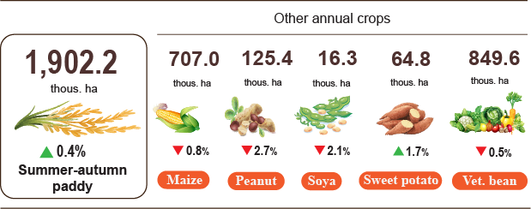
Livestock
Buffalo and cow husbandry during the month tended to decrease. Pig and poultry farming was developing stably because farmers were proactive in breeding sources and pork prices have increased in recent months. However, livestock farmers still need to closely monitor the market situation, and authorities need to provide timely information and well manage the local livestock situation.
Figure 2. The growth rate of the population of livestock
at the end of July, 2024 compared to the same time last year
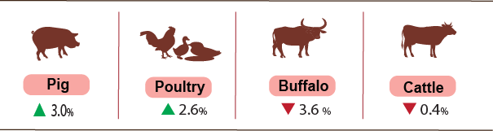
As of July 23, 2024, the whole country has no longer blue-ear disease; foot-and-mouth disease and avian flu disease were still in Tien Giang; LSD was still in 8 localities and African swine fever was reported in 25 localities for less than 21 days.
b) Forestry
The area of concentrated newly planted forests nationwide in July 2024 was estimated at 13,8 thousand hectares, an increase of 6,9% over the same period last year. Some provinces have high forest planting progress: Quang Binh increased by 7.3%, Nghe An increased by 6.4%, especially Yen Bai and Phu Tho increased by 8 times and 43 times respectively (respectively increased by 111 hectares and 593 hectares). The number of scattered forest trees reached 6.5 million trees, up 4% over the same period last year. The output of exploited wood reached 1,945.7 thousand m3, up 7.8% due to the increasing trend of raw wood prices, people have increased the exploitation of wood at harvest age. Some localities have high timber exploitation output compared to the same period last year: Yen Bai increased by 17.4%; Tuyen Quang increased by 12.7%; Nghe An increased by 9.7%; Quang Ngai increased by 7.9%; Quang Ninh increased by 7.7%.
Total seven months of 2024, the area of concentrated newly planted forests was estimated at 143,4 thousand hectares, an increase of 4,6% over the same period last year; the number of scattered forest trees reached 51.1 million trees, up 3%; the output of exploited wood reached 11,943.2 thousand m3, up 7.1%
The damaged forest area in July was 80.5 hectares, down 61.1% over the same period last year. Of which, the forest was destroyed with 49.7 hectares, down 64.1%; the burned forest area was 30.8 hectares, down 55.1%. Generally, in 7 months of 2024, the whole country had 1.303.0 hectares of damaged forest, down 5.3% over the same period last year. Of which the forest was destroyed with 588.0 hectares, down 23.0%; the burned forest area was 715.0 hectares, down 16.8%.
c) Fishery
Fishery output in July 2024 was estimated at 841.3 thousand tons, up 2.2% over the same period last year, including: Fish reached 588.0 thousand tons, up 2.0%; shrimp reached 139.2 thousand tons, up 3.2%; other aquatic products reached 113.9 thousand tons, up 1.9%.
Aquaculture production in July was estimated at 490.7 thousand tons, up 3.4% over the same period last year, of which: Fish reached 307.9 thousand tons, up 3.2%; shrimp reached 127.7 thousand tons, up 3.5%
Pangasius production in July was estimated at 139.0 thousand tons, up 4.5% over the same period last year due the price of raw pangasius remains stable at a high level and pangasius exports are showing signs of recovery, fish farmers and businesses are adjusting farming output accordingly to meet export demand.
Shrimp production in July increased compared to the same period last year due to the harvest season. White-leg shrimp output is estimated at 93.1 thousand tons, up 4.1% over the same period last year; black tiger shrimp output is estimated at 29.1 thousand tons, up 2.4%.
In July, the caught fishery production was estimated at 350.4 thousand tons, up 0.6% over the same period last year, including: Fish reached 280.1 thousand tons, up 0.7%; shrimp reached 11.5 thousand tons same period last year; other aquatic products reached 58.8 thousand tons, up 0.2%. Marine fishing output wasestimated at 336.2 thousand tons, up 0.7% over the same period last year.
Figure 3. Fishery production in 7 months of 2024
over the same period last year
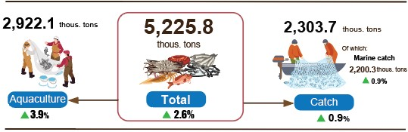
Generally, in 7 months of 2024, fishery output was estimated at 5,225.8 thousand tons, up 2.6% over the same period last year, including: Fish reached 3,760.2 thousand tons, up 2.5%; shrimp reached 699.0 thousand tons, up 3.9%; other aquatic products reached 766.6 thousand tons, up 2.1%.
2. Industrial Production
Industrial production maintained a positive growth momentum, it is estimated that the industrial production index in July increased by 0.7% compared to the previous month and increased by 11.2% over the same period last year. Generally, in the first seven months of 2024, the production index of the whole industry is estimated to increase by 8.5% over the same period last year.
The index of industrial production (IIP) in July 2024 is estimated to increase by 0.7% compared to the previous month and increase by 11.2% over the same period last year. In which, compared to the same period last year, the processing and manufacturing industry increased by 13.3%; the electricity production and distribution industry increased by 9.9%; water supply, waste and wastewater management and treatment activities increased by 12.1%; the mining industry alone decreased by 7.0%.
Generally, in the first seven months of 2024, IIP is estimated to increase by 8.5% over the same period last year (the same period in 2023 decreased by 0.8%). In which, manufacturing industry increased by 9.5% (the same period in 2023 decreased by 1.2%), contributing 8.2 percentage points to the overall increase; electricity, gas, steam and air conditioning supply increased by 12.4% (the same period in 2023 increased by 1.4%), contributing 1.1 percentage points; water supply; sewerage, waste management and remediation activitiesincreased by 7.2% (the same period in 2023 increased by 5.2%), contributing 0.1 percentage points; mining and quarying alone decreased by 6.2% (the same period in 2023 decreased by 2.0%), reducing by 0.9 percentage points.
The production index in the first seven months of 2024 of a number of key industries at level II increased sharply compared to the same period last year: Manufacture of rubber and plastics products increased by 28.7; manufacture of furniture increased by 21.5%; manufacture of chemicals and chemical products increased by 17.3%; mining of metal ores increased by 15.0%; manufacture of fabricated metal products, except machinery and equipment increased by 13.0%; manufacture of basic metalsincreased by 12.8%; manufacture of electrical equipment increased by 12.5%; manufacture of textiles and electricity, gas, steam, air conditioning supply both increased by 12.4%; manufacture of computer, electronic and optical products increased by 11.1%; manufacture of food products increased by 7.4%. In the opposite direction, the IIP index of some industries decreased: Extraction of crude petroleum and natural gas decreased by 12.4%; repair and installation of machinery and equipment decreased by 2.9%; manufacture of other non-metallic mineral products decreased by 1.8%; mining of coal and lignite decreased by 1.3%.
Figure 1. Rate of increase/decrease of IIP index in 7 months of 2020-2024
compared to the same period last year of some key industries

%
 | 2020 | 2021 | 2022 | 2023 | Estimate 2024
Mining of coal and lignite | 4,8 | -3,1 | 7,3 | -2,2 | -1,3
Extraction of crude petroleum and natural gas | -11,0 | -10,9 | -1,6 | -1,0 | -12,4
Mining of metal ores | 14,0 | 5,6 | 8,3 | 7,9 | 15,0
Manufacture of food products | 3,3 | 3,8 | 7,1 | 4,5 | 7,4
Manufacture of textiles | 0,8 | 9,3 | 3,8 | 0,2 | 12,4
Manufacture of chemicals and chemical products | 7,5 | 1,7 | 3,7 | 5,1 | 17,3
Manufacture of rubber and plastics products | 2,2 | 3,1 | -8,0 | 8,1 | 28,7
Manufacture of other non-metallic mineral products | 1,6 | 5,4 | 6,3 | -4,8 | -1,8
Manufacture of basic metals | -2,3 | 33,4 | 0,0 | -1,7 | 12,8
Manufacture of fabricated metal products, except machinery and equipment | 2,3 | 8,7 | 9,8 | 5,5 | 13,0
Manufacture of computer, electronic and optical products | 9,2 | 10,7 | 11,6 | -4,2 | 11,1
Electricity, gas, steam and air conditioning supply | 2,4 | 7,4 | 5,7 | 1,4 | 12,4
The industrial production index in the first seven months of 2024 compared to the same period last year increased in 60 localities and decreased in 03 localities across the country. Some localities have a fairly high increase in the IIP index due to the processing and manufacturing industry; the electricity production and distribution industry has increased. In the opposite direction, some localities have a decrease in IIP index due to the processing and manufacturing industry; mining industry and electricity production and distribution industry increased low or decreased.
Figure 4. IIP increase/decrease rate in the first 7 months of 2024
compared to the same period last year of some localities (%)
10 localities with the highest increase in IIP index | 10 localities with the lowest decrease/increase in IIP
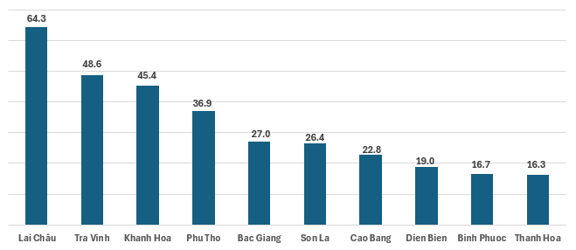 | 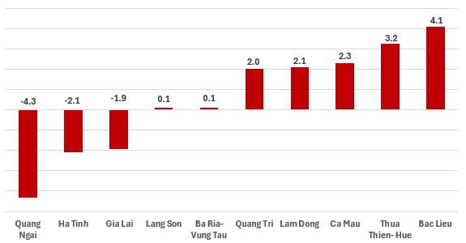

Some key industrial products in the first seven months of 2024 increased significantly compared to the same period last year: Steel bars and corners increased by 31.4%; laminated steel increased by 17.8%; textile fabric from natural yarn increased by 17.0%; N.P.K mixed fertilizer increased by 14.2%; milk powder increased by 12.3%; refined sugar increased by 12.0%; phone accessories increased by 11.7%. In the opposite direction, some products decreased compared to the same period last year: Natural gas and LPG both decreased by 16.9%; extracted crude oil decreased by 7.1%; beer decreased by 3.8%; mobile phones decreased by 3.2%; alumina decreased by 3.1%; crude steel, iron decreased by 1.6%.
The number of employees working in industrial enterprises as of July 1, 2024 increased by 0.9% over the same time last month and increased by 3.3% over the same time last year. In which, labor in the state-owned enterprise sector increased by 0.1% and increased by 1.5%; non-state enterprises increased by 0.5% and increased by 0.7%; foreign-invested enterprises increased by 1.2% and increased by 4.3%. By industry, the number of employees working in mining enterprises increased by 0.1% over the same period last month and increased by 0.4% over the same period last year; the processing and manufacturing industry increased by 1.0% and increased by 3.5%; the production and distribution of electricity, gas, hot water, steam and air conditioning remained unchanged compared to the same time last month and increased by 1.1% over the same period last year. The water supply industry, waste and wastewater management and treatment activities only decreased by 0.1% over the same period last month and increased by 1.2% over the same period last year.
3. Enterprise activities
a) Enterprise registration status
In July, the whole country had 14.7 thousand newly established enterprises with registered capital over 110 trillion VND and a total number of registered employees of over 88.4 thousand employees, a decrease of 6.3% in the number of enterprises, a decrease of 22.8% in registered capital and an increase of 3.3% in the number of employees compared to June 2024. Compared to the same period last year, up 7.3% in the number of enterprises, down 13% in registered capital and up 11.9% in the number of employees. The average registered capital of a newly established enterprise in the month reached 7.5 billion VND, a reduction of 17.6% compared to the last month and down 18.9% compared to the same period of 2023. Besides, there were more than 6.8 thousand enterprises resumed in the whole country, an increase of 26.2% compared to the previous month and down 0.7% compared to the same period of 2023.
Generally, in the seven months of 2024, the whole country had more than 95.2 thousand newly registered enterprises with a total registered capital of 854.6 trillion VND and a total number of registered employees was nearly 600.4 thousand employees, an increase 6.3% in the number of enterprises, 2.4% in registered capital and 2.0% in the number of employees compared to the same period last year. The average registered capital of a newly established enterprise in the seven months of 2024 achieved 9.0 billion VND, a year-on-year reduction of 3.6%. If including 919.2 trillion VND of the additional registered capital of more than 27.1 thousand active enterprises that registered to make upward adjustment of their capital, the total number additional registered captial into the economy in the seven months of 2024 was 1,773.8 trillion VND, a year-on-year reduction of 9.1%. Besides, there were nearly 44.3 thousand enterprises resumed (a year-on-year increase of 4.7%), levering the total number of newly established enterprises and resumed enterprises in the seven months of 2024 to nearly 139.5 thousand enterprises, a year-on-year increase of 5.8%. On average, there were over 19.9 thousand newly established and resumed enterprises per month.
By economic sector in the seven months of 2024, there were 919 newly established enterprises in the agricultural, forestry, and fishery sectors, a year-on-year decrease of 2.8%; 22.4 thousand enterprises in the industrial and construction sectors, an increase of 4.8%; 71.9 thousand enterprises in the service sector, an increase of 6.8%.
Figure 6. Enterprise registration situation
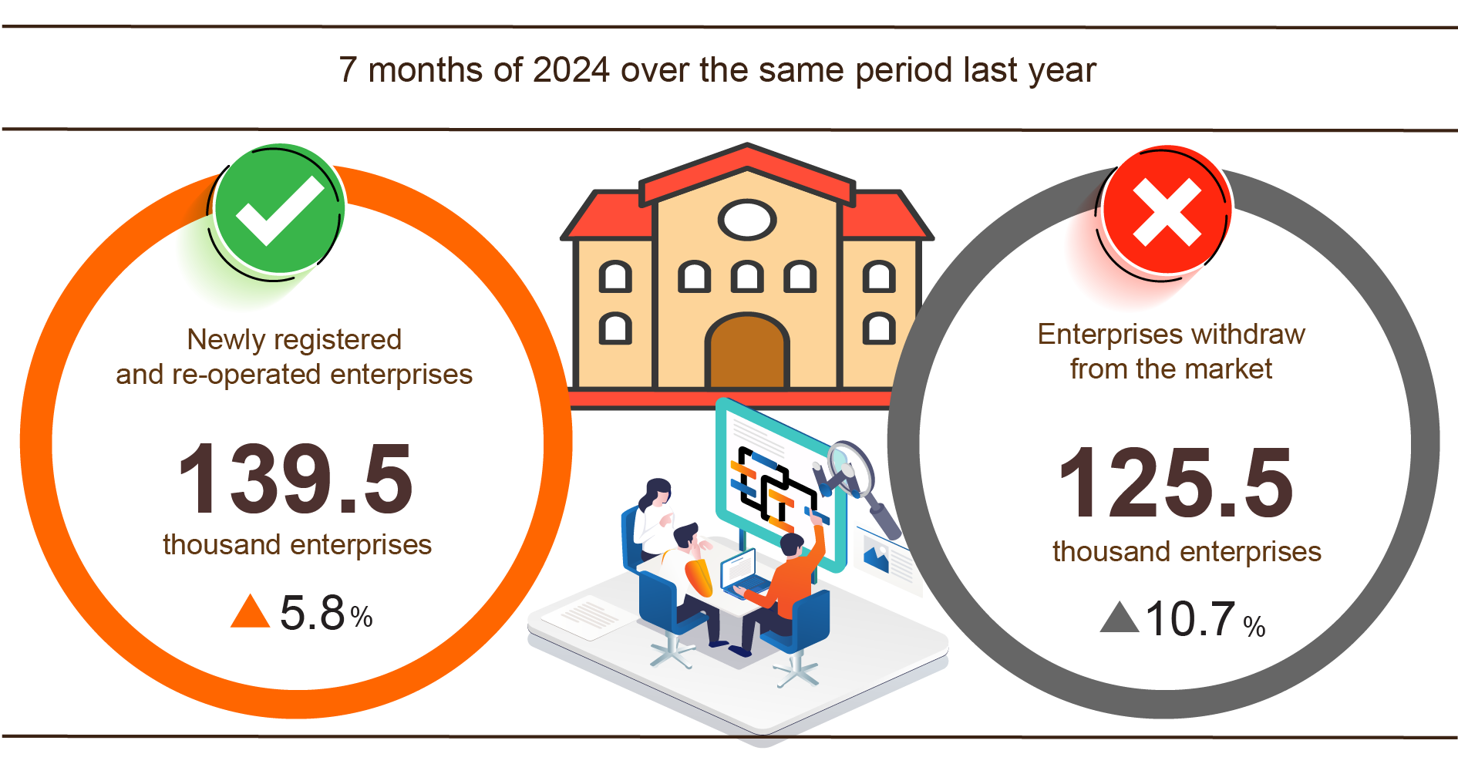
Also in July, 6,837 teamporarily inactive enterprises, up 26.2% compared to the previous month and down 0.7% over the same period in 2023; 7,035 enterprises ceased and awaited dissolution procedures, up 30.2% and up 33.8%; 1,730 enterprises completed dissolution procedures, up 22.4% and up 9.4%.
In the seven months of 2024, the number of teamporarily inactive enterprises was more than 78 thousand ones, a year-on-year increase of 16.7%; over 35.5 thousand enterprises ceased and awaited dissolution procedures, a reduction of 1.5%; 11.9 thousand enterprises completed dissolution procedures, up 14.5%. On average, more than 17.9 thousand enterprises withdrawing from the market per month.
Table 3: Number of newly registered enterprises and completed dissolution procedures in the seven months of 2024 by kinds of activity

 | Number of enterprises (Enterprise) |  | Growth rate  over the same period last year (%)
 | Newly registered | Dissolution | Newly registered | Dissolution
Wholesale and retail trade; repair of motor vehicles and motorcycles | 38,829 | 4,896 | 14.0 | 32.3
Manufacturing | 11,595 | 1,269 | 8.5 | 7.4
Construction | 9,694 | 838 | 1.1 | 2.1
Real estate business | 2,687 | 693 | 2.5 | -8.3
Transportation and storage | 5,076 | 451 | 20.4 | 8.4
Accommodation and catering service | 3,537 | 518 | -10.7 | -7.2
Production and distribution of electricity, water, gas | 692 | 133 | 12.5 | -30.0

b) Business trends of the enterprises
Results of the business tendency survey of manufacturing enterprises in the second quarter of 2024 showed that: 37.4% of enterprises assessed that the business production situation was better than in the first quarter; 41.6% of enterprises said that the business production situation was stable and 21% of enterprises faced difficulties. For the expected outcome of the third quarter of 2024, 40.7% of enterprises presented that the tendency would get better than the second quarter; 42.2% of enterprises said that business production situation would be stable and 17.1% of enterprises predicted that it would be more difficult. In which, the state-owned enterprises sector was the most optimistic with 83.6% of enterprises forecasted a better business production situation in the third quarter of 2024 and expected to remain stable; these rates in the FDI sector and non-state enterprises sector were 83.2 and 82.7% respectively.
Figure 7. The main factors affecting the business production situation
in the first six months of 2024

Regarding production volume, 38.7% of enterprises pointed out the production volume in the second quarter of 2024 increased compared to the first one; 40.5% of enterprises considered it stable and 20.8% of enterprises reported that the production volume reduced. For the trend in the third quarter of 2024 compared to the second one, 39.8% of enterprises forecasted an increase in the production volume; 44% of enterprises predicted stability and 16.2% of enterprises forecasted a decrease.
Regarding orders for goods, 34.6% of enterprises had more orders in the second quarter of 2024 than in the first one; 44.3% of enterprises had stable orders and 21.1% of enterprises recorded a decrease in orders. About trend in the third quarter of 2024 over the second one, 38% of enterprises expected an increase in orders; 45.8% of enterprises expected to have stable orders and 16.2% of enterprises expected a decrease in orders.
Regarding export orders, 28.8% of enterprises confirmed more export orders in the second quarter of 2024 than the first one; 49.6% of enterprises experienced stable export orders and 21.6% of enterprises had decreased export orders. About trend in the third quarter of 2024 over the second one, 33.1% of enterprises expected to have an increase in export orders; 50.6% of enterprises expected to decrease and 16.3% of enterprises expected to be stable.
4. Investment
Investment capital from the State budget continues to be promoted by ministries, branches and localities. Investment capital realized from the State budget in July 2024 is estimated to increase by 8.2% compared to the previous month; Overall , the seven months of 2024 are estimated to reach 40.6% of the yearly plan and increase 2.3% over the same period last year. Foreign direct investment (FDI) implemented in Vietnam in the first seven months of 2024 is estimated to reach 12.55 billion USD, up 8.4% over the same period last year .
Implemented investment capital from the State budget in July 2024 is estimated to reach 57.6 trillion VND, down 1.6% over the same period last year, including: Centrally managed capital reached 10.1 trillion VND copper, down 4.9%; Locally managed capital reached 47.5 trillion VND, down 0.9%. In the seven months of 2024, realized investment capital from the State budget is estimated to reach 301.5 trillion VND, equal to 40.6% of the year's plan and up 2.3% over the same period last year (same period, in 2023 by 40.2% and increase by 23.6%). Specifically:
- Implemented investment capital managed by the Central Government is estimated at 51.9 trillion VND, equal to 44.9% of the year's plan and down 3.7% over the same period last year. Of which, the Ministry of Transport reached 31.8 trillion VND, down 20.9%; Ministry of Agriculture and Rural Development reached 5.1 trillion VND, an increase of 37.6%; Ministry of Education and Training reached 503.3 billion VND, an increase of 6.6%; Ministry of Health reached 483.6 billion VND, an increase of 19.5%; Ministry of Natural Resources and Environment reached 324.5 billion VND, down 38.9%; The Ministry of Industry and Trade reached 302.5 billion VND, an increase of 10.3%.
- Locally managed investment capital is estimated at 249.6 trillion VND, equal to 39.8% of the year's plan and up 3.6% over the same period last year, of which:
Provincial State budget capital reached nearly 166.8 trillion VND, equal to 37.8% and increased 2.3%;
State budget capital at district level reached 71.3 trillion VND, equal to 43.3% and increased 6.7%;
State budget capital at commune level reached 11.5 trillion VND, equal to 54.8% and increased by 5.1%.
Investment capital made from the State budget in the first seven months of 2024 of a number of provinces and centrally run cities is as follows:
Figure 6. Investment capital made from the State budget
of some localities

Total foreign investment capital registered in Vietnam As of July 20, 2024, including: Newly registered capital, adjusted registered capital and value of capital contributions and share purchases by foreign investors reached more than 18 billion USD, an increase of 10.9% compared to in the same period last year.
Figure 7. Foreign investment capital registered in Vietnam
as of July 20, 2020-2024 (Billion USD)

- Newly registered capital has 1,816 licensed projects with a registered capital of 10.76 billion USD, an increase of 11.6% over the same period last year in the number of projects and an increase of 35.6% in registered capital. sign. Among them, the processing and manufacturing industry has the largest newly licensed foreign direct investment with a registered capital of 7.88 billion USD, accounting for 73.2% of the total newly registered capital; Real estate business activities reached 1.94 billion USD, accounting for 18%; The remaining industries reached 939.7 million USD, accounting for 8.8%.
Among the 62 countries and territories with new licensed investment projects in Vietnam in the seven months of 2024, Singapore is the largest investor with 4.55 billion USD, accounting for 42.3%. total newly registered capital; followed by Hong Kong Special Administrative Region (China) with 1.31 billion USD, accounting for 12.1%; China 1.22 billion USD, accounting for 11.3 % ; Japan 991.5 million USD, accounting for 9.2%; Türkiye 731.3 million USD, accounting for 6.8%; Taiwan 588.4 million USD, accounting for 5.5%.
- Adjusted registered capital: 734 projects licensed from previous years registered to adjust their investment capital by 4.97 billion USD, up 19.4% over the same period last year.
If including new registered capital and adjusted registered capital of projects licensed in previous years, registered foreign direct investment capital in the processing and manufacturing industry reached 12.23 billion USD, accounting for 77.8% of total newly registered and increased capital; Real estate business activities reached 2.11 billion USD, accounting for 13.4%; The remaining industries reached 1.39 billion USD, accounting for 8.8%.
- Registered capital for capital contribution and share purchase by foreign investors was 1,795 times with a total capital contribution value of 2.27 billion USD, down 45.2% over the same period last year. Of these, there were 689 capital contributions and share purchases to increase the enterprise's charter capital with a capital contribution value of 1.03 billion USD; 1,106 foreign investors bought back domestic shares without increasing charter capital with a value of 1.24 billion USD. For the form of capital contribution and share purchase by foreign investors, capital invested in real estate business activities reached 759.6 million USD, accounting for 33.5% of the value of capital contribution; Processing and manufacturing industry reached 422.5 million USD, accounting for 18.6%; The remaining industries have 1.09 billion USD, accounting for 47.9%.
Foreign direct investment capital made in Vietnam seven May 2024 is estimated to reach 12.55 billion USD, an increase of 8.4% over the same period last year. This is the highest amount of realized foreign direct investment in seven months in the past 5 years. Of which: Processing and manufacturing industry reached 9.98 billion USD, accounting for 79.5% of total realized foreign direct investment capital; Real estate business activities reached 1.14 billion USD, accounting for 9.1%; Production and distribution of electricity, gas, hot water, steam and air conditioning reached 481.1 million USD, accounting for 3.8%.
Figure 8. Realized foreign direct investment capital in
7 months of 2020-2024 (Billion USD)

Vietnam's investment abroad in the seven months of 2024 has 64 projects newly granted investment certificates with a total Vietnamese capital of 122 million USD, down 18.2% over the same period last year; There were 15 projects with adjusted capital with an increase of 28.6 million USD, a decrease of 83.3%.
In the seven months of 2024, Vietnam's total investment capital abroad (new and adjusted capital) reached 150.7 million USD, down 53% over the same period last year. Of which: Mining reached 58.6 million USD, accounting for 38.9% of total investment capital; Processing and manufacturing industry reached 28.9 million USD, accounting for 19.2%; wholesale and retail, repair of cars, motorbikes, motorbikes and other motor vehicles reached 24.7 million USD, accounting for 16.4%; Other services reached 10.0 million USD, accounting for 6.6%; Production and distribution of electricity, gas, hot water and air conditioning reached 6.8 million USD, accounting for 4.5%.
In the seven months of 2024, there will be 23 countries and territories receiving investment from Vietnam, of which: the Netherlands is the leading country with 54.6 million USD, accounting for 36.2% of total investment capital; Laos 36.7 million USD, accounting for 24.3%; United States 18.7 million USD, accounting for 12.4%; Cambodia 12.4 million USD, accounting for 8.2%; New Zealand 5.9 million USD, accounting for 3.9%.

5. State budget revenue and expenditure
State budget revenue in the seven months of 2024 increased by 14.6% over the same period last year. State budget expenditure increased by 0.6% over the same period in 2023, ensuring the needs of socio-economic development, national defense, security, state management, and payment of due debts. as well as make timely payments to subjects according to regulations.
Figure 9. State budget revenue and expenditure in 7 months of 2024
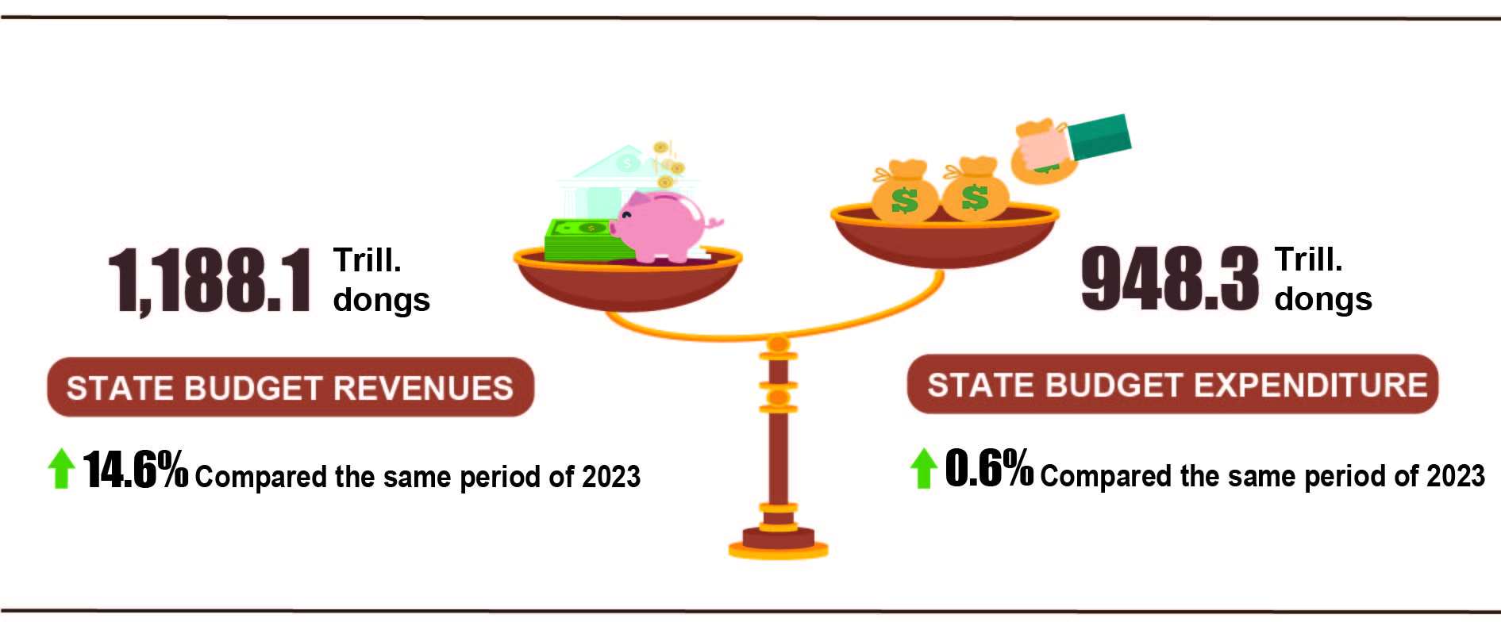
State budget revenue
Total State budget revenue in July 2024 was estimated at nearly 150 trillion VND. The accumulated total state budget revenue in the seven months of 2024 was estimated at 1,188.1 trillion VND, equal to 69.8% of the yearly estimate and increasing by 14.6% over the same period last year. Some main revenues are as follows:
- Domestic revenue in July 2024 was estimated at 126.2 trillion VND; Accumulated in the seven months of 2024 was estimated at 995 trillion VND, equaling 68.9 % of the yearly estimate and increasing by 15.8% over the same period last year .
- Revenue from crude oil in July 2024 was estimated at 4.8 trillion VND; Accumulated in the seven months of 2024 was estimated at 34.4 trillion VND, equaling 74.7% of the year estimate and down 2.7 % over the same period last year.
- Budget balance revenue from export and import activities in July 2024 was estimated at 18.8 trillion VND; accumulative in the seven months of 2024 was estimated at 158.5 trillion VND, equaling 77.7% of the yearly estimate and increasing by 11.7% over the same period last year.
State budget expenditure
Total State budget expenditure in July 2024 was estimated at 152.6 trillion VND, accumulative total State budget expenditure in the seven months of 2024 was estimated at 948.3 trillion VND, equaling 44.7% of the yearly estimate and up 0.6% over the same period last year. Of which, Recurrent expenditure was estimated at 652.5 trillion VND, equaling 51.8% of the yearly estimate and up 3.7% over the same period last year; development investment expenditure reached 232.1 trillion VND, equaling 34.3% and down 8.4%; interest payment was 63.2 trillion VND, equaling 56.5% and increased by 7.7%.
6. Trade, prices, transport and tourism
b) Export and import of goods
Total export and import turnover of goods in 7/2024 was estimated at 69.72 billion USD, up 8.7% over the previous month and up 21.8% over the same period last year. Generally, in seven months of 2024, the total export and import turnover of goods reached 439.88 billion USD, up 17.1% over the same period last year, of which exports increased by 15.7%; imports increased by 18.5%. The trade balance of goods had a surplus of 14.08 billion USD.
Figure 11. Import and export of goods in 7 months of 2024
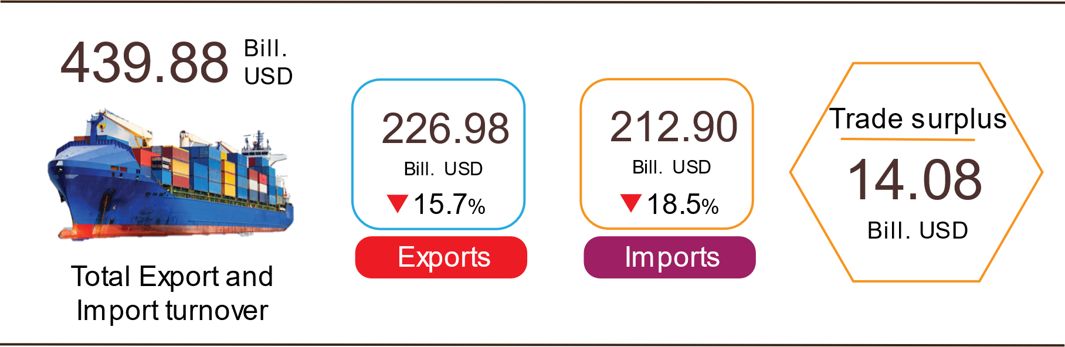

Export of goods
Preliminary export turnover of goods in 6/2024 reached USD 33.66 billion, 568 million USD higher than the estimated figure.
Export turnover of goods in 7/2024 was estimated at 35.92 billion USD, up 6.7% over the previous month. Of which, the domestic economic sector gained 9.87 billion USD, increased by 9.8%; the FDI sector (including crude oil) reached 26.05 billion USD, increased by 5.6%. Compared to the same period last year, export turnover of goods in July increased by 19.1%, of which the domestic economic sector increased by 25.9%, the FDI sector (including crude oil) increased by 16.7%.
Generally in seven months of 2024, the export turnover was estimated at 226.98 billion USD, increased by 15.7% over the same period last year. Of which, the domestic economic sector was 63.08 billion USD, went up 21.1%, accounting for 27.8% of total export turnover; the FDI sector (including crude oil) attained 163.9 billion USD, increased by 13.8%, sharing 72.2%.
In seven months of 2024, there were 30 products with export turnover of over 1 billion USD, contributing 91.9% to the total export turnover (9 products with export turnover of over 5 billion USD, accounting for 70.8%).
Table 4. Value of some export products in 7 months of 2024
 | Estimate  (Mill. USD) | Growth rate compare to  the same period last year (%)
Items with a value of over 5 billion USD
Electronic goods, computers and their parts | 39,867 | 30.0
Phones all of kinds and their parts | 32,446 | 12.3
Machinery, instrument, accessory | 27,656 | 19.0
Textiles and garments | 19,873 | 4.2
Footwear | 12,818 | 10.1
Wood and products | 8,876 | 23.3
Means of transport and components | 8,411 | 2.5
Iron, steel | 5,475 | 9.8
Aquatic products | 5,293 | 7.3

Regarding the structure of exported groups in seven months of 2024, the group of fuels and minerals was estimated at 2.48 billion USD, accounting for 1.1%; the group of processing industry was estimated at 199.94 billion USD, accounting for 88.1%; agricultural and forestry products was estimated at 19.27 billion USD, accounting for 8.5%; the group of fishery products was estimated at 5.29 billion USD, accounting for 2.3%.
Figure 12. Structure of exported groups
in 7 months of 2024

Import of goods
Preliminary import turnover of goods in 6/2024 reached 30.46 billion USD, 307 million USD higher than the estimate figure.
Import turnover in 7/2024 was estimated at 33.8 billion USD, increased by 11% over the previous month. Of which the domestic economic sector gained 12.2 billion USD, increased by 11.3%; the FDI sector reached 21.6 billion USD, increased by 10.8%. Compared to the same period last year, the import turnover of goods in July increased by 24.7%, of which the domestic economic sector increased by 16.5%; the FDI sector increased by 29.9%.
Generally in seven months of 2024, the import turnover was estimated at 212.9 billion USD, increased by 18.5% over the same period last year. Of which the domestic economic sector reached 78 billion USD, went up 21.5%; the FDI sector gained 134.9 billion USD, up 16.9%.
In seven months of 2024, there are 35 imported products with a turnover of over 1 billion USD, accounting for 89.4% of total import turnover (10 products with import turnover of over 5 billion USD, accounting for 62.5%).
Table 5. Value of some imported goods in 7 months of 2024
 |  | Estimate | Growth rate compare to
 |  | (Mill. USD) | the same period last year (%)
Items with a value of over 5 billion USD
 | Electronic devices, computers and their parts | 58,822 | 28.1
 | Machinery, instrument, accessory | 26,404 | 14.6
 | Fabrics | 8,493 | 14.8
 | Iron, steel | 6,917 | 23.4
 | Plastics | 6,405 | 17.5
 | Other basic metals | 5,479 | 27.2
 | Phones all of kinds and their parts | 5,440 | 26.9
 | Petroleum | 5,086 | 4.0
 | Crude oil | 5,045 | 19.1
 | Coal | 5,013 | 15.5
Figure 13. Structure of imported groups
in 7 months of 2024
Regarding the structure of imported groups in seven months of 2024, the group of production materials was estimated at 199.88 billion USD, accounted for 93.9%, in which the group of machinery, equipment, tools spare parts accounted for 46.2%; raw materials, fuel and materials accounted for 47.7%. The group of consumer products was estimated at 13.02 billion USD, accounted for 6.1%.
Regarding the export and import market of goods in seven months of 2024, the United States was the Viet Nam's largest export market with a turnover of 66.1 billion USD. China remained the largest import market of Viet Nam with a turnover of 79.2 billion USD. In seven months of 2024, the trade surplus to the United States reached 57.5 billion USD, up 27.6% over the same period last year; the trade surplus to the EU reached 20.1 billion USD, up 19.4%; the trade surplus to Japan was 1.1 billion USD, down 14%; the trade deficit from China was 45.8 billion USD, went up 65.4%; the trade deficit from Korea was 17.7 billion USD, went up 15.7%; the trade deficit from ASEAN was 5.5 billion USD, increased by 21%.
Figure 14. Major commodity import and export markets
in 7 months of 2024
 |  | Export of goods | Import of goods
The trade balance of goods in June had a trade surplus of 3.2 billion USD; the first six months of 2024 had a trade surplus of 11.96 billion USD; July was estimated to have a trade surplus of 2.12 billion USD. Generally in seven months of 2024, the trade balance of goods is estimated to have a trade surplus of 14.08 billion USD (in the same period last year, the trade surplus of 16.5 billion USD). Of which, the domestic economic sector has a trade deficit of 14.92 billion USD; the FDI sector (including crude oil) had a trade surplus of 29 billion USD.
b) Export and import of goods
Total export and import turnover of goods in 7/2024 was estimated at 69.72 billion USD, up 8.7% over the previous month and up 21.8% over the same period last year. Generally, in seven months of 2024, the total export and import turnover of goods reached 439.88 billion USD, up 17.1% over the same period last year, of which exports increased by 15.7%; imports increased by 18.5%. The trade balance of goods had a surplus of 14.08 billion USD.
Figure 11. Import and export of goods in 7 months of 2024

Export of goods
Preliminary export turnover of goods in 6/2024 reached USD 33.66 billion, 568 million USD higher than the estimated figure.
Export turnover of goods in 7/2024 was estimated at 35.92 billion USD, up 6.7% over the previous month. Of which, the domestic economic sector gained 9.87 billion USD, increased by 9.8%; the FDI sector (including crude oil) reached 26.05 billion USD, increased by 5.6%. Compared to the same period last year, export turnover of goods in July increased by 19.1%, of which the domestic economic sector increased by 25.9%, the FDI sector (including crude oil) increased by 16.7%.
Generally in seven months of 2024, the export turnover was estimated at 226.98 billion USD, increased by 15.7% over the same period last year. Of which, the domestic economic sector was 63.08 billion USD, went up 21.1%, accounting for 27.8% of total export turnover; the FDI sector (including crude oil) attained 163.9 billion USD, increased by 13.8%, sharing 72.2%.
In seven months of 2024, there were 30 products with export turnover of over 1 billion USD, contributing 91.9% to the total export turnover (9 products with export turnover of over 5 billion USD, accounting for 70.8%).
Table 4. Value of some export products in 7 months of 2024
 | Estimate  (Mill. USD) | Growth rate compare to  the same period last year (%)
Items with a value of over 5 billion USD
Electronic goods, computers and their parts | 39,867 | 30.0
Phones all of kinds and their parts | 32,446 | 12.3
Machinery, instrument, accessory | 27,656 | 19.0
Textiles and garments | 19,873 | 4.2
Footwear | 12,818 | 10.1
Wood and products | 8,876 | 23.3
Means of transport and components | 8,411 | 2.5
Iron, steel | 5,475 | 9.8
Aquatic products | 5,293 | 7.3

Regarding the structure of exported groups in seven months of 2024, the group of fuels and minerals was estimated at 2.48 billion USD, accounting for 1.1%; the group of processing industry was estimated at 199.94 billion USD, accounting for 88.1%; agricultural and forestry products was estimated at 19.27 billion USD, accounting for 8.5%; the group of fishery products was estimated at 5.29 billion USD, accounting for 2.3%.
Figure 12. Structure of exported groups
in 7 months of 2024

Import of goods
Preliminary import turnover of goods in 6/2024 reached 30.46 billion USD, 307 million USD higher than the estimate figure.
Import turnover in 7/2024 was estimated at 33.8 billion USD, increased by 11% over the previous month. Of which the domestic economic sector gained 12.2 billion USD, increased by 11.3%; the FDI sector reached 21.6 billion USD, increased by 10.8%. Compared to the same period last year, the import turnover of goods in July increased by 24.7%, of which the domestic economic sector increased by 16.5%; the FDI sector increased by 29.9%.
Generally in seven months of 2024, the import turnover was estimated at 212.9 billion USD, increased by 18.5% over the same period last year. Of which the domestic economic sector reached 78 billion USD, went up 21.5%; the FDI sector gained 134.9 billion USD, up 16.9%.
In seven months of 2024, there are 35 imported products with a turnover of over 1 billion USD, accounting for 89.4% of total import turnover (10 products with import turnover of over 5 billion USD, accounting for 62.5%).
Table 5. Value of some imported goods in 7 months of 2024
 |  | Estimate | Growth rate compare to
 |  | (Mill. USD) | the same period last year (%)
Items with a value of over 5 billion USD
 | Electronic devices, computers and their parts | 58,822 | 28.1
 | Machinery, instrument, accessory | 26,404 | 14.6
 | Fabrics | 8,493 | 14.8
 | Iron, steel | 6,917 | 23.4
 | Plastics | 6,405 | 17.5
 | Other basic metals | 5,479 | 27.2
 | Phones all of kinds and their parts | 5,440 | 26.9
 | Petroleum | 5,086 | 4.0
 | Crude oil | 5,045 | 19.1
 | Coal | 5,013 | 15.5
Figure 13. Structure of imported groups
in 7 months of 2024
Regarding the structure of imported groups in seven months of 2024, the group of production materials was estimated at 199.88 billion USD, accounted for 93.9%, in which the group of machinery, equipment, tools spare parts accounted for 46.2%; raw materials, fuel and materials accounted for 47.7%. The group of consumer products was estimated at 13.02 billion USD, accounted for 6.1%.
Regarding the export and import market of goods in seven months of 2024, the United States was the Viet Nam's largest export market with a turnover of 66.1 billion USD. China remained the largest import market of Viet Nam with a turnover of 79.2 billion USD. In seven months of 2024, the trade surplus to the United States reached 57.5 billion USD, up 27.6% over the same period last year; the trade surplus to the EU reached 20.1 billion USD, up 19.4%; the trade surplus to Japan was 1.1 billion USD, down 14%; the trade deficit from China was 45.8 billion USD, went up 65.4%; the trade deficit from Korea was 17.7 billion USD, went up 15.7%; the trade deficit from ASEAN was 5.5 billion USD, increased by 21%.
Figure 14. Major commodity import and export markets
in 7 months of 2024
 |  | Export of goods | Import of goods
The trade balance of goods in June had a trade surplus of 3.2 billion USD; the first six months of 2024 had a trade surplus of 11.96 billion USD; July was estimated to have a trade surplus of 2.12 billion USD. Generally in seven months of 2024, the trade balance of goods is estimated to have a trade surplus of 14.08 billion USD (in the same period last year, the trade surplus of 16.5 billion USD). Of which, the domestic economic sector has a trade deficit of 14.92 billion USD; the FDI sector (including crude oil) had a trade surplus of 29 billion USD.
c) Consumer price index, gold price index and US dollar price index

Domestic gasoline prices increased according to world prices, domestic electricity demand increased, and health insurance premiums were adjusted according to the new base salary. These are the main reasons for the monthly consumer price index (CPI) July 2024 increase 0.48% compared to last month. Compared to December 2023, CPI in July increased by 1.89% and compared to the same period last year increased by 4.36%.
On average, in the seven months of 2024, CPI increased by 4.12% over the same period last year; core inflation increased by 2.73%.
Figure 15. CPI growth rate in 7/2024 compared to the previous month

In the 0.48% increase in CPI in July 2024 compared to the previous month, there were 10 groups of goods and services with increased price indexes; particularly, postal and communication groups have stable prices.
Ten groups of goods and services with increased price indexes include:
- Other consumer goods and services group increased by 3.77% mainly due to health insurance price increasing by 28.45% when the base salary was adjusted from 1.8 million VND/month to 2.34 million VND/month . Besides, the price of elderly care services increased by 2.5% compared to the previous month; watch and jewelry repair increased by 0.47%; body care products increased by 0.24%; environmental sanitation services increased by 0.3%. In the opposite direction, jewelry prices decreased by 0.44% according to domestic gold prices; electric appliances for personal care decreased by 0.08%.
- Transport group increased by 1.45% (making the general CPI increase by 0.14 percentage points), mainly due to: Diesel oil price increased by 4.07%; domestic gasoline prices increased by 3.55% due to the effects of adjustments price for the month. Passenger transport prices by air increased by 20.44%; railway increased by 4.4%; Passenger transport by road increased by 0.04%; combined passenger transport increased by 0.01% due to increased travel demand during the summer. Auto parts prices increased by 0.15%; bicycle tires and tubes increased by 0.31%; motorcycle tire prices increased by 0.09%. Vehicle maintenance service prices increased by 0.24%; self-driving car and motorbike rental fees increased by 0.15%; driver's license fees increased by 0.17% due to high demand. Particularly, the price of vehicles decreased by 0.18% compared to the previous month, of which the price of new cars decreased by 0.25%; motorbikes decreased by 0.16%; used cars decreased by 0.03% due to automobile manufacturing and assembling businesses applying incentive programs to encourage and support consumers in purchasing cars.
- The group of housing, electricity, water, fuel and construction materials increased by 0.5% mainly due to the following reasons: Domestic electricity prices increased by 1.39%; Domestic water increased by 0.22%. Kerosene prices increased by 4.02% due to the impact of price adjustments during the month; house rent increased by 0.2%; prices of housing maintenance materials increased by 0.08%. Gas prices alone decreased by 0.01% compared to last month because some stores reduced prices to stimulate consumer demand .
- The food and foodstuff service group increased by 0.26% (making the general CPI increase by 0.09 percentage points), of which: Food decreased 0.03%; foodstuff increased by 0.31%( making the general CPI to increase by 0.07 percentage points); Eating out at home increased by 0.25%.
- Culture, entertainment and tourism group increased by 0.14%, of which the price of package travel services increased by 0.23%; guest houses and hotels increased by 0.43% because students had summer vacation in July, so travel demand from agencies, businesses and families increased.
- Medicines and health care services group increased by 0.13%, of which inpatient medical examination and treatment prices increased by 0.19%; outpatient medical examination and treatment services increased by 0.08%. The reason is that in July 2024, there will continue to be localities implementing new medical service prices according to Circular No. 22/2023/TT-BYT dated 17/11/2023 of the Ministry of Health regulating uniform service prices. Medical examination and treatment services covered by health insurance among hospitals of the same class nationwide and instructions on applying prices and payment of medical examination and treatment costs in some cases.
- Beverage and cigarette group increased by 0.11% due to increased consumer demand during hot weather, specifically: Price of carbonated beverages increased by 0.22%; fruit juice increased by 0.16%; all kinds of beer and bottled, canned, and canned energy drinks all increased by 0.08%; wine of all kinds increased slightly by 0.02%. Cigarette prices increased by 0.2% compared to the previous month.
- Household equipment and goods group increased by 0.07% due to increased labor costs. In particular, air conditioning repair services increased by 0.42% compared to the previous month; washing machine repair services increased by 0.31%; motor equipment repair increased by 0.12%; washing machines increased by 0.22%; beds, wardrobes, tables and chairs increased by 0.17%; waiter hiring increased by 0.16%. On the contrary, some items' prices decreased compared to last month because many stores continued to apply shopping stimulus programs such as: Prices of egg beaters and multi-function mixers decreased by 1.28%; gas stove decreased by 0.32%; rice cookers decreased by 0.24%; printers, projectors, and scanners decreased by 0.23%; buffer decreased by 0.22%; bathroom water heater decreased by 0.17%; vacuum cleaners decreased by 0.15%.
- Garment, hat and footwear group increased by 0.03% due to increased transportation and labor costs. In particular, the price of shoe and sandals services increased by 0.37%; garment services increased by 0.21%; fabrics of all kinds increased by 0.19%; hat increased by 0.16%; footwear increased by 0.07%.
- Education group increased by 0.02%, of which paper product prices increased by 0.4%; writing pens of all kinds increased by 0.15%; textbooks increased by 0.05%.
Particularly, the postal and communication groups kept their prices stable because businesses and business establishments continued to carry out promotional programs and stimulate shopping demand. In particular, smart mobile phones and tablets decreased by 0.39% compared to the previous month; phone repair prices increased by 0.19%.
Core inflation in July 2024 increased by 0.36% over the previous month, up 2.61% over the same period last year.
On average in the seven months of 2024, core inflation will increase by 2.73% over the same period in 2023, lower than the general average CPI (increased by 4.12%), mainly due to food and electricity prices. Activities, educational services, medical services and petroleum are factors that increase CPI but are in the group of goods excluded from the list of core inflation calculations.
As of 24/7/2024, the average world gold price is at 2,383.17 USD/ounce, an increase of 1.49% compared to 7/2024. World gold prices increased as investors predicted that the US Federal Reserve (FED) would cut interest rates in 9/2024, along with the risk of geopolitical conflicts in the world also increasing demand hoard gold. Domestically, the gold price index in 7/2024 decreased by 0.12% compared to the previous month; an increase of 18.11% compared to 12/2023; increased 29.39% over the same period last year; on average in the seven months of 2024, the gold price index increased by 24.77%.
As of 24/7/2024, the US dollar index on the international market reached 104.61 points, down 0.24% compared to the previous month. Domestically, the average US dollar price on the free market fluctuates around 25,463 VND/USD. US dollar price index in July 2024 increased by 0.05% compared to the previous month; an increase of 4.22% compared to December 2023; increased 7.14% over the same period last year; the average increase in the seven months of 2024 is 5.85%.

d) Transport
Transport activity in July maintained a positive growth rate compared to the same period last year, of which passenger carried increased by 5.3% and passenger traffic increased by 3.1%; freight transport increased by 9.8% in terms of carried and 5.3% in traffic.
In 7 months of 2023, passenger carried increased by 15.8% and passenger traffic increased by 27.6% over the same period last year; freight carried increased by 15.3% and passenger traffic increased by 12.7% over the same period last year.
Passenger carried in July was estimated at 398.5 million passengers, up 1.3% over the previous month and passenger traffic was 21.1 billion passengers-kilometers, up 2.9%. In 7 months of 2023, passenger carried was estimated at 2,615.1 million passengers, up 15.8% over the same period last year and passenger traffic was 140.3 billion passengers.km, increased by 27.6%. In which, domestic transport reached 2,607 million passengers, up 15.5% over the same period last year and 116.4 billion passengers-kilometers, up 10.8%; overseas transport reached 8.1 million passengers, 5.7 times higher and 23.9 billion passengers-kilometers, 4.9 times higher than the same period last year.
In terms of transportation, all sugar industries in 7 monthsof 2023 increased sharply compared to the same period last year.
Table 6 : Passengers transport in 7 months of 2023
by types of transport
 | Number of passenger |  | Growth rate compared to the same period last year (%)
 | Carried  (Mill. passengers) | Traffic  (Bill. passengers-km) | Carried | Traffic
Total | 2,615.1 | 140.3 | 15.8 | 27.6
Rail way | 3.9 | 1.5 | 55.1 | 56.6
Sea way | 7.6 | 0.4 | 44.7 | 42.7
Inland water way | 196.6 | 3.8 | 28.6 | 31.0
Road | 2,373.2 | 89.0 | 14.6 | 21.3
Airway | 33.8 | 45.6 | 22.2 | 40.7

Freight transport in July was estimated at 191.2 million tons of freight carried, up 0.7% from the previous month and 39.7 billion tons.km of freight traffic, up 4.8%. Generally for 7 months of 2023, freight transport was estimated at 1,303.6 million tons of freight carried, up 15.3% over the same period last year and 270.7 billion tons.km of freight traffic, an increase of 12.7%. In which, domestic transport reached 1,278.2 million tons of freight carried, up 15.6% and 170.7 billion tons.km of freight traffic, up 19.9%; overseas transport reached 25.5 million tons of freight carried, up 2.8% and 100 billion tons.km of freight traffic, up 2.2%. In terms of transportation, road and waterway transport in 7 months of 2023 had a positive growth rate compared to the same period last year; airway increased slightly in terms of carried but increased sharply in traffic compared to the same period last year because from the beginning of this year Vietnamese airlines reopened and opened many new international routes. Particularly, rail way dropped sharply due to reduced import and export orders and had to compete with water transport when costs were higher.
Table 7. Carriage of freight in 7 monthsof 2023 by types of transport
 | Quantity of goods |  | Growth rate compared to the same period last year (%)
 | Carried  (Mill. tons) | Traffic  (Bill. tons-km) | Carried | Traffic
Total | 1,303.6 | 270.7 | 15.3 | 12.7
Rail way | 2.6 | 2.0 | -25.5 | -24.0
Sea way | 66.1 | 142.6 | 11.5 | 10.5
Inland water way | 285.0 | 59.6 | 30.0 | 23.9
Road | 949.7 | 61.9 | 11.9 | 8.5
Airway | 0.2 | 4.6 | 0.7 | 37.3

đ) International visitors to Viet Nam
International visitors to Viet Nam in July reached over 1 million arrivals, up 6.5% compared to the previous month and 2.9 times higher than the same period last year. In 7 months of 2023, international visitors to our country reached 6.6 million arrivals, 6.9 times higher than the same period last year but still equal to 67.5% compared to the same period in 2019 - the year without the Covid-19.
Out of a total of more than 6.6 million international arrivals to Viet Nam in 7 months of this year, arrivals by air reached 5.8 million arrivals, accounting for 87.6% of international arrivals to Viet Nam and 7 times higher than the same period last year; by road reached 765.3 thousand arrivals, accounting for 11.6% and 6.2 times higher; by sea reached 55.1 thousand arrivals, accounting for 0.8% and 214.2 times higher.
Figure 17. International visitors to Viet Nam in 7 months of 2023
by territories
d) Transport
Transport activities in July were vibrant, continuing to maintain a positive growth rate compared to the same period last year, of which passenger transport in 7/2024 increased by 11.9% of passenger carried and increased by 5.5% of passenger traffic; freight transport increased by 14.5% of freight carried and up 12.4% of freight traffic.
Overall, in seven months of 2024, passenger carried increased by 7.2% and passenger traffic up 10.5% over the same period last year; freight carried increased by 13.3% and freight traffic up 11.3%.
Passenger transport in 7/2024 was estimated at 447.7 million passengers, increased by 6.4% and passenger traffic was 22.7 billion passengers-kilometers, increased by 2.9% compared to the previous month due to the increased demand for travel and tourism of people during the peak tourist season. In seven months of 2024, passenger carried was estimated at 2,805.7 million passengers, up 7.2% over the same period last year and passenger traffic was 155.6 billion passengers.km, increased by 10.5%. Of which, domestic transport reached 2,795,4 million passengers, up 7.2% over the same period last year and 123,1 billion passengers-kilometers, up 6.0%; overseas transport reached 10.3 million passengers, increased by 21.6% and 32.5 billion passengers-kilometers, up 31.7% compared to the same period last year.
Table 6 : Passengers transport in 7 months of 2024
by types of transport
 | Number of passengers |  | Growth rate compared to the same period last year (%)
 | Carried  (Mill. passengers) | Traffic  (Bill. passengers-km) | Carried | Traffic
Total | 2,805.7 | 155.6 | 7.2 | 10.5
Rail way | 4.6 | 1.8 | 19.5 | 22.9
Sea way | 7.9 | 0.5 | 1.7 | 8.2
Inland water way | 214.0 | 4.3 | 9.1 | 13.8
Road | 2,549.6 | 99.1 | 7.3 | 11.5
Airway | 29.6 | 49.9 | -12.4 | 7.9

Freight transport in 7/2024 was estimated at 217.9 million tons of freight carried, increased by 1.2% and 45.4 billion tons.km of freight traffic, increased by 1.2% over the previous month. Generally for seven months of 2024, freight transport was estimated at 1.476.8 million tons of freight carried, up 13.3% over the same period last year and 302.2 billion tons.km of freight traffic, an increase of 11.3%. Of which, domestic transport reached 1,449.8 million tons of freight carried, up 13.5% and 183.5 billion tons.km of freight traffic, up 7.2%; overseas transport reached 27.0 million tons of freight carried, up 5.9% and 118.7 billion tons.km of freight traffic, up 18.5%.
Table 7. Carriage of freight in 7 months of 2024
by types of transport

 | Quantity of goods |  |  | Growth rate compared to the same period last year (%)
 | Carried | Traffic |  | Carried | Traffic
 | (Mill. tons) | (Bill. tons-km) |  | Carried | Traffic
Total | 1,476.8 | 302.2 |  | 13.3 | 11.3
Rail way | 2.9 | 2.2 |  | 13.9 | 4.6
Sea way | 77.2 | 156.8 |  | 15.2 | 10.3
Inland water way | 315.7 | 67.8 |  | 12.5 | 12.6
Road | 1,080.7 | 69.7 |  | 13.5 | 11.8
Airway | 0.3 | 5.7 |  | 45.0 | 23.1

đ) International visitors to Viet Nam
Favorable visa policies and tourism promotion programs in 2024 have been promoted by localities across the country, attracting a high increase in international visitors to Vietnam compared to the same period last year.
In 7/2024, the number of international visitors to Viet Nam reached 1.15 million. increased by 10.9% compared to the same period last year. In seven months of 2024, international visitors to our country reached nearly 10 million arrivals, up 51.0% compared to the same period last year and up 1.9% compared to the same period of 2019 - the year before the Covid-19 pandemic.
Out of a total of nearly 10 million international arrivals to Viet Nam in seven months of this year, arrivals by air reached nearly 8.4 million arrivals, accounting for 84.2% of international arrivals to Viet Nam and up 45.1% over the same period last year; by road reached 1.4 million arrivals, accounting for 14.1% and up 84.2% ; by sea reached 165.5 thousand arrivals, accounting for 1.7% and 3.0 times higher.
Figure 17. International visitors to Viet Nam in 7 months
of 2024 by territories

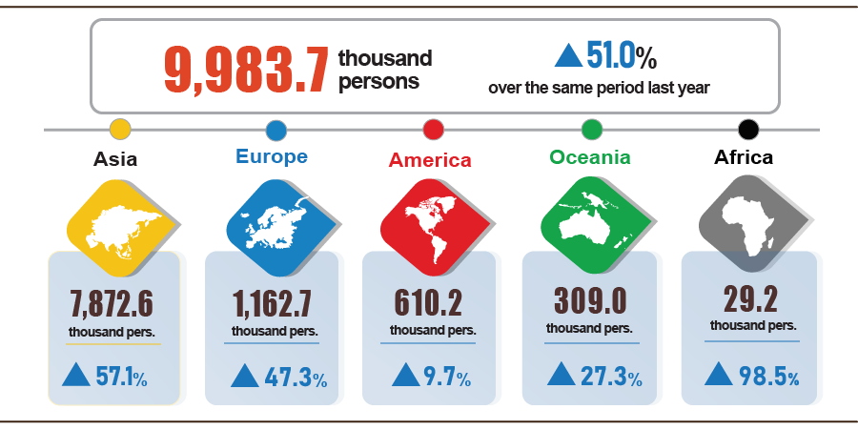
7. Some social situations
a) Residential life
According to the survey on the life situation of households in July 2024, the proportion of households assessed to have income during the month remained unchanged and increased compared to the same period last year was 95.8% (an increase of 0.2 percentage points). percent compared to the June 2024 reporting period and increased by 1.3 percentage points compared to the same period last year); The proportion of households assessed to have reduced income and unknown compared to the same month in 2023 is 4.2%.
Households whose income in July decreased compared to the same period last year identified the main reasons as: Some household members lost their jobs or temporarily quit their jobs (rate of 41%); due to the decrease in the scale of household production and business activities (25.5%); due to increased input costs for household production and business activities (24%); due to the decrease in selling prices of products from household production and business activities (17.9%).
In the seven months of 2024, 30.8% of households reported experiencing at least one event that negatively affected family life, this rate remained unchanged compared to the previous month and decreased by 1.4 percentage points. hundred compared to the same period last year. Among the households negatively affected by the events: 30.1% of households are suffering from the effects of rising prices of goods and services; 2.6% of households are negatively affected by epidemics on humans and 1.8% of households are negatively affected by epidemics on livestock and crops.
In seven months of 2024, 12.4% of interviewed households received help from various support sources. Of which, the proportion of households receiving assistance from relatives is 8.4%; from local programs and policies is 4.5%; from national programs and general policies is 4.0%; from charitable activities of other organizations and individuals is 1.6% and from other sources is 0.02%.
The work of ensuring social security is always implemented promptly and effectively by all levels and sectors, notably the policy of increasing the base salary. The policy of giving gifts of gratitude on the occasion of the 77th anniversary of War Invalids and Martyrs' Day includes two gift levels of 600,000 VND and 300,000 VND depending on each specific object.
Regarding rice support, according to a report from the Ministry of Labor, War Invalids and Social Affairs, in seven months of this year, the Government, ministries, branches and localities have supported people with more than 21.3 thousand tons of rice, in Accordingly: The Government supported 10.4 thousand tons of rice to relieve hunger on the occasion of the Lunar New Year Giap Thin for 693.4 thousand people; supporting more than 5.9 thousand tons of rice to relieve hunger in 2024 for 396.3 thousand people. Localities also developed plans and proactively allocated local budgets and socialization resources to support nearly 5 thousand tons of rice for poor, near-poor households and people in difficult circumstances.
b) Disease situation and food poisoning
According to a report from the Ministry of Health, in the month (from June 19 to July 18, 2024), the whole country had 10,434 cases of dengue fever (01 death); 6,057 cases of hand, foot and mouth disease; 437 cases of typhus suspected of measles; 09 deaths due to rabies; 48 cases of viral encephalitis; 01 case of meningococcal meningitis. In the seven months of 2024, the whole country has 35.3 thousand cases of dengue fever (04 deaths); 34.6 thousand cases of hand, foot and mouth disease; 887 cases of typhus suspected of measles; 53 deaths due to rabies; 256 cases of viral encephalitis (06 deaths); 12 cases of meningococcal meningitis; 01 case of influenza A and died.
The total number of people living with HIV in the country as of July 18, 2024 is more than 240.1 thousand people; The number of deaths due to HIV/AIDS is 115 thousand people.
Regarding food poisoning, in July 2024, there were 07 cases with 264 people being poisoned and 03 people died. In the seven months of 2024 (from December 19, 2023 to July 18, 2024), there were 62 cases nationwide with 2,661 people being poisoned (9 people died).
c) Cultural and sports activities
During the seven months of 2024, cultural activities take place enthusiastically with many festivals after the Lunar New Year 2024, mainly from January to March at the beginning of the year. In addition to the festive activities, there are activities commemorating the 49th anniversary of the Complete Liberation of the South and reunification of the country (April 30, 1975 - April 30, 2024) and a series of activities commemorating the 70th anniversary of Victory. Dien Bien Phu (May 7, 1954-May 7, 2024), Da Nang International Fireworks Festival - DIFF 2024 (June 8-July 13, 2024).
Regarding the mass sports movement, some outstanding activities taking place during the month include: Volleyball tournament for workers and civil servants in Lam Dong province taking place from July 18 to July 20, 2024; Vinh Long Provincial Taekwondo Open Tournament takes place on July 14, 2024; Swimming tournament for age groups in Khanh Hoa province on July 11, 2024; Vovinam - Karate Championship of Yen Bai province takes place from July 12 to July 14, 2024; Badminton tournament for workers, officials, labor and armed forces of Tuyen Quang province takes place from July 11 to July 14, 2024; The third Thanh Hoa Newspaper Cup Children's Football tournament takes place from July 6 to July 12, 2024. Regarding sports, Vietnamese people with disabilities have 8 athletes who won tickets to attend the 2024 Paris Paralympics.
Regarding high-performance sports, in July there are a number of outstanding events such as: Youth Archery Championship taking place from July 8 to July 13, 2024 in Hai Duong province; U20 Vietnam won tickets for the 2025 World U21 Women's Volleyball Championship for the first time; Rowing, Canoeing Youth Championship U19, U23 and Southeast Asia Championship taking place from June 26 to July 7, 2024 in Hai Phong; Vietnam's U16 football team won fourth place overall at the 2024 Southeast Asian U16 Championship from July 11-24, 2024 in Indonesia.
d) Traffic accident
During the month (from June 15 to July 14, 2024), there were 1,889 traffic accidents nationwide, including 1,355 traffic accidents from less serious or more (causing 860 deaths, 837 deaths). injured people) and 534 traffic collisions caused 587 people with minor injuries. Compared to the previous month, the number of traffic accidents decreased by 0.3% (the number of traffic accidents from less serious or more decreased by 1% and the number of traffic collisions increased by 1.7%); number of deaths increased by 1.3%; The number of injured people increased by 2.6% and the number of people with minor injuries increased by 5.4%. Compared to the same period last year, the number of traffic accidents in July increased by 11.2% (the number of traffic accidents from less serious or more increased by 6.3% and the number of traffic collisions increased by 25.9%. ); number of deaths decreased by 8.7%; The number of injured people increased by 18.2% and the number of people with minor injuries increased by 39.1%.
In the seven months of this year, there were 14,242 traffic accidents nationwide, including 10,083 less serious traffic accidents and 4,159 traffic collisions, killing 6,203 people and 6,394 people. injured and 4,582 people suffered minor injuries. Compared to the same period last year, the number of traffic accidents in the seven months of this year increased by 15% (the number of traffic accidents from less serious or more increased by 7.3%; the number of traffic collisions increased by 39%) ; number of deaths decreased by 10.4%; The number of injured people increased by 22.6% and the number of people with minor injuries increased by 50.7%. On average, every day in seven months of this year, there were 67 traffic accidents nationwide, including 47 less serious traffic accidents and 20 traffic collisions, killing 29 people. 30 people were injured and 22 people suffered minor injuries.
d) Damage caused by natural disasters
Damage caused by natural disasters in July was mainly due to the impact of heavy rains, floods, and inundation, killing 23 people and injuring 11 people; 789 houses collapsed, swept away and damaged; 53.2 thousand hectares of rice and crops were flooded and damaged; The total value of property damage caused by natural disasters in the month was 399.6 billion VND, an increase of 89.5% over the same period last year. In the seven months of this year, natural disasters left 91 people dead or missing, and 67 people injured; 28.9 thousand houses collapsed and damaged; 28.4 thousand cattle and poultry died; 25.7 thousand hectares of crops and 64.3 thousand hectares of rice were flooded and damaged; The total value of property damage is estimated at 2,122.9 billion VND, more than 2.3 times higher than the same period in 2023.
e) Environmental protection and fire and explosion prevention
During the month (from June 18 to July 17, 2024) , the authorities discovered 1,513 cases of environmental violations in 53/63 localities, of which 1,486 cases were handled with a total fine of 20.2 billion VND. VND, down 23.4% over the previous month and down 30.1% over the same period last year. In the seven months of this year, the authorities detected 14,163 cases of environmental violations, of which 12,977 cases were handled with a total fine of more than 177 billion VND, an increase of 0.2% over the same period last year.
During the month, there were 308 fires and explosions nationwide, killing 20 people and injuring 13 people, with estimated damage of 11.1 billion VND, up 0.6% over the previous month and down 59.8% over the previous month. in the same period last year. In the seven months of this year, there were 2,539 fires and explosions nationwide, killing 75 people and injuring 65 people, with an estimated loss of 139 billion VND, down 39.3% over the same period last year. /.
GENERAL STATISTICS OFFICE

Raising buffaloes and cows for meat has decreased mainly due to difficult farming conditions, high farming costs, and low profits, leading to a decrease in the number of animals. However, the dairy herd was still growing steadily.
The pork price index in July 2024 increased by 0.53% over the previous month and increased by 6.49% over the same period last year.
Due to the dry weather in July 2023, Yen Bai and Phu Tho provinces proactively reduced the area and did not plant new forests.
Data from the Ministry of Agriculture and Rural Development from June 16, 2024 to July 15, 2024.
http://agromonitor.vn/category/48/ca-tra: The price of raw pangasius in July 2024 fluctuates from 26,200-26,600 VND/kg.
Localities with a high production index of the processing and manufacturing industry in the first seven months of 2024 compared to the same period last year are: Lai Chau increased by 43.1%; Phu Tho increased by 38.4%; Bac Giang increased by 27.5%; Binh Phuoc increased by 17.1%; Thanh Hoa increased by 15.1%; Dien Bien increased by 8.8%. Localities with high indicators of electricity production and distribution: Khanh Hoa increased by 258.5%; Lai Chau increased by 66.4%; Cao Bang increased by 62.1%; Dien Bien increased by 51.8%; Son La increased by 35.2%; Thanh Hoa increased by 33.0%; Phu Tho increased by 15.3%.
Localities with a low or decreased production index of the processing and manufacturing industry in the first seven months of 2024 compared to the same period last year are: Ca Mau increased by 1.5%; Gia Lai increased by 0.3%; Ha Tinh decreased by 8.0%; Quang Ngai decreased by 4.2%. Localities have low or decreased indicators of the electricity production and distribution industry in the first seven months of 2024 compared to the same period last year: Quang Tri increased by 1.7%; Quang Ngai decreased by 16.9%; Thua Thien - Hue decreased by 16.1%; Lang Son decreased by 15.5%; Lam Dong decreased by 5.6%; Gia Lai decreased by 3.6%. Localities with a decrease in the mining industry production index: Ba Ria - Vung Tau decreased by 14.3%; Lam Dong decreased by 8.6%; Quang Tri decreased by 4.7%; Lang Son decreased by 3.0%; Thua Thien - Hue decreased by 1.6%.
Source: National Enterprise Registration Information System, Business Registration Management Agency, Ministry of Planning and Investment on July 25th, 2024.
Corresponding indexes of the first quarter of 2024: 22.1% of enterprises rated that their business production situation was better than that in the previous quarter; 42.8% of businesses thought it was stable and 35.1% faced difficulties.
Corresponding indexes of the first quarter of 2024: 22.3% of enterprises considered the production volume increased compared to the previous quarter; 38.9% of businesses thought that it was stable and 38.8% of businesses assessed that it reduced.
Corresponding indexes of the first quarter of 2024: 20.9% of enterprises had orders increasing compared to the previous quarter; 42.6% of businesses had stable orders and 36.5% of businesses had reduced orders.
According to the report of the Foreign Investment Department, Ministry of Planning and Investment, received on July 22, 2024.
According to the Report on the implementation of Resolution No. 01/NQ-CP of the Government in the field of finance - State budget in July and 7 months of 2024 sent by the Ministry of Finance on July 26 , 2024.
The value of export turnover is calculated at F.O.B price and import turnover is calculated at C.I.F price (including transportation and insurance costs of imported goods).
Estimated total export and import value in July 2024 provided by the General Department of Customs on July 26, 2024. The General Statistics Office estimated the import and export value of key commodities in July 2024 based on preliminary data provided by the General Department of Customs by July 25, 2024.
Total import and export turnover of goods in seven months of 2023 reached 375.8 billion USD, down 13.5% over the same period last year, of which exports reached 196.1 billion USD, down 10%; imports reached 179.7 billion USD, down 17.1%.
June is estimated to have a trade surplus of 2.94 billion USD.
The value of export turnover is calculated at F.O.B price and import turnover is calculated at C.I.F price (including transportation and insurance costs of imported goods).
Estimated total export and import value in July 2024 provided by the General Department of Customs on July 26, 2024. The General Statistics Office estimated the import and export value of key commodities in July 2024 based on preliminary data provided by the General Department of Customs by July 25, 2024.
Total import and export turnover of goods in seven months of 2023 reached 375.8 billion USD, down 13.5% over the same period last year, of which exports reached 196.1 billion USD, down 10%; imports reached 179.7 billion USD, down 17.1%.
June is estimated to have a trade surplus of 2.94 billion USD.
Other products because it is calculated based on revenue and consumption output of June 2024.
The price index of the rice group decreased by 0.27% (Regular rice decreased by 0.27%; Delicious ordinary rice decreased by 0.28%; Sticky rice decreased by 0.12%) . On the contrary, some food items increased in July such as potato prices increased by 2.63%; corn increased by 1.68%; Wheat flour and noodles, noodles, pho, and instant porridge all increased by 0.42%; vermicelli increased by 0.32%; cornstarch increased by 0.27%; ready-to-eat cereals increased by 0.26%.
Pork prices increased by 0.79%, accordingly, animal fat prices increased by 1.45%; Roasted meat and sausage increased by 0.49%; animal organs increased by 0.39%. Prices of fresh, dried and processed vegetables increased by 0.32%; fresh and dried herbs and spices increased by 1.19%; kohlrabi increased by 1.02%; Fresh and processed fruit prices increased by 0.33%; Prices of fresh eggs of all kinds increased by 1.99% and processed eggs increased by 0.31%; Spice prices increased by 0.5%; tea, coffee, cocoa increased by 0.42%; sugar and bile increased by 0.24%; cakes, jams, and candy increased by 0.12%; milk, butter, cheese increased by 0.11%. In addition to price increasing items, the price of fresh seafood in July 2024 decreased by 0.02% compared to the previous month, of which the price of fresh or chilled shrimp decreased by 0.84% due to shrimp being harvested and supply. cornucopia.
Due During the peak tourist month, many localities organize activities and programs to attract tourists, increasing the demand for eating out at home. In particular, the price of drinks outside the home increased by 0.32%; Eating out at home increased by 0.26%; takeaway fast food increased by 0.12%.
CPI after excluding food, fresh food, energy and State-managed goods including health services and education.
According to the report of the Border Gate Department, the Border Guard Command, the Ministry of National Defense and the Immigration Department.
The reporting period was from June 21, 2023 to July 20, 2023.
According to the report of the Border Gate Department, the Border Guard Command, the Ministry of National Defense and the Immigration Department.
The reporting period was from June 21, 2024 to July 20, 2024.
A household can choose many reasons to reduce income.
According to a quick report from the Office of the Ministry of Public Security and the Vietnam Maritime Administration (Ministry of Transport) on July 23, 2024.
Summary of reports from 63 Departments of Agriculture and Rural Development, reporting period from June 19 to July 18, 2024.
According to a report from the Department of Natural Resources and Environment, the Police of provinces and centrally run cities Department of General Statistics.
According to a quick report from the Ministry of Public Security on July 23, 2024.

