MINISTRY OF PLANNING AND INVESTMENT  GENERAL STATISTICS OFFICE  No: 330/BC-TCTK | SOCIALIST REPUBLIC OF VIET NAM  Independence-Freedom-Happiness  Ha Noi, 29th August 2024
Socio-economic situation report
in August and the 8 months of 2024

1. Agriculture, forestry production and fishery
Agricultural production in the month focused on harvesting summer-autumn rice, cultivating and caring for rice, other annual crops. Livestock production is generally stable, localities have well controlled epidemics, pig and poultry herds continue to grow. Localities promote the exploitation of wood and forest products reached harvest age. Aquaculture exploitation has increased significantly, met domestic and export demand.
a) Agriculture
Summer-autumn rice
The nationwide summer-autumn rice cultivation area this year is estimated to reach 1,909.8 thousand hectares, equal to 99.8% of the same period last year. Of which, northern localities reached 173.9 thousand hectares, equal to 100.7%; Southern localities reached 1,735.9 thousand hectares, equal to 99.8%, the Mekong Delta region alone reached 1,470.0 thousand hectares, equal to 99.7%. This year's summer-autumn rice seeding progress is slower than the same period last year, mainly due to the impact of drought and saltwater intrusion since the beginning of the year. As of August 20th, 2024, the whole country harvested 1,170.6 thousand hectares of summer-autumn rice, accounting for 61.3% of the sowing area and equal to 99.2% of the same period last year. Mainly concentrated in the Mekong Delta region with an estimated harvest area of ​​968.0 thousand hectares, accounting for 65.9% of the sowing area and equal to 98.7% of the same period in 2023.
Seasonal rice
As of August 20, 2024, the whole country has planted 1,391.2 thousand hectares of winter rice, equal to 99.7% of the same period last year, of which: Northern localities have planted 994.0 thousand hectares, equal to 99.7% of the same period last year. .5%; Southern localities cultivated 397.2 thousand hectares, equal to 100.5%. Seasonal rice production in the Northern provinces has been affected by heavy rains that have lasted on a large scale recently. Faced with the above situation, localities have promptly directed pumping to drain floods to save rice, and at the same time proactively overcome the consequences of storms such as replanting and replanting rice, quickly stabilizing life and production in the area. affected areas. Currently, the summer rice areas not affected by floods are growing and developing well. However, small leaf rollers, brown planthoppers, white-backed planthoppers... appear sporadically on rice fields, causing slight damage in some localities. The Agriculture sector in localities needs to direct farmers to actively prevent and control the infection so that it does not spread on a large scale, affecting the production results of the entire crop.
Autumn - winter rice
This year's fall-winter rice production in the Mekong Delta has favorable weather and stable rice prices, so farmers are speeding up progress. As of August 20, 2024, the Mekong Delta region has sown 489.1 thousand hectares of autumn-winter rice, equal to 107.4% of the same period last year. Autumn-winter rice is currently growing well, localities need to regularly check the capacity of irrigation works, develop plans to ensure safe operation and promptly detect and handle critical locations, landslides during the rainy season.
Annual crops
Along with rice cultivation, localities across the country are planting cash crops. However, the area of ​​corn, peanuts and soybeans continued to decrease compared to the same period last year, mainly due to low economic efficiency. The area of ​​vegetables and beans increased slightly. The area of ​​sweet potatoes has increased because recently there have been many good quality sweet potato varieties that bring higher economic efficiency, so people have increased new planting areas.
Figure 1. Cultivation of main annual crops
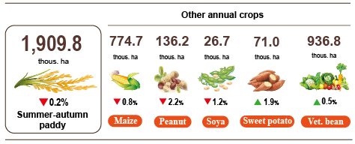
(As of 20/8/2024)

Livestock
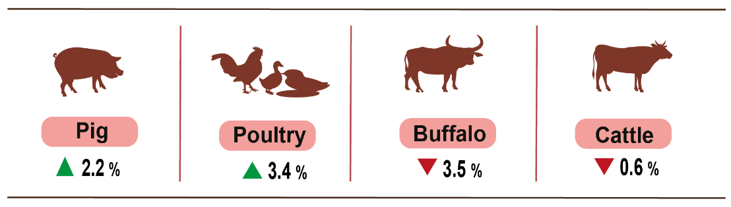
Buffalo and cow husbandry during the month tended to decrease. Pig and poultry farming is developing stably, farmers are proactive in breeding sources and pork prices have increased slightly in recent months. However, livestock farmers still need to closely monitor the market situation, and authorities need to provide timely information and well manage the local livestock situation.
Figure 2. The growth rate of the population of livestock at the end of August, 2024 compared to the same time last year
As of August 26, 2024, the whole country no longer has an outbreak of bird flu; Foot and mouth disease epidemic occurred in 03 localities, lumpy dermatitis epidemic in 07 localities, rabies epidemic in 11 localities and African swine fever epidemic in 29 localities in less than 21 days.
b) Forestry
The area of concentrated newly planted forests nationwide in August 2024 was estimated at 20,8 thousand hectares, down 5,2% over the same period last year. Some provinces have slow forestation progress: Kon Tum by 41.2% over the same period last year; Quang Tri by 71.8%; Nghe An by 95.3%. The number of scattered forest trees planted reached 6.5 million trees, up 3.4% over the same period last year. The output of exploited timber in the month reached 2,086.4 thousand m3, up 7.6% due to people stepping up the exploitation of timber at harvest age. Some localities have high timber exploitation output compared to the same period last year: Bac Kan increased by 28.8%; Yen Bai increased by 15.5%; Thanh Hoa increased by 7.9%; Quang Ninh increased by 7.6%.
Total eight months of 2024, the area of ​​newly planted concentrated forests is estimated at 164.2 thousand hectares, up 3.3% over the same period last year; the number of scattered forest trees planted reached 57.6 million trees, up 3.1%; the output of exploited timber reached 14,033.2 thousand m3, up 7.2%.
The damaged forest area in August was 48.5 hectares, down 55.4% over the same period last year. Of which, the area of ​​forest cut down and destroyed was 43.2 hectares, down 56.8%; the area of ​​forest burned was 5.3 hectares, down 38.2%. In the first eight months of 2024, the whole country had 1,386.2 hectares of damaged forest, down 6.6% over the same period last year. Of which, the area of ​​forest cut down and destroyed was 647.7 hectares, down 24.5%; the area of ​​forest burned was 738.5 hectares, up 17.7%.
c) Fishery
Fishery output in August 2024 was estimated at 862.3 thousand tons, up 2.5% over the same period last year, including: Fish reached 561.0 thousand tons, up 2.4%; shrimp estimated at 176.3 thousand tons, up 2.7%; other aquatic products estimated at 125.0 thousand tons, up 2.6%.
Aquaculture production in August was estimated at 522.4 thousand tons, up 3.8% over the same period last year. Of which: Fish reached 293.0 thousand tons, up 4.5%; shrimp reached 165.7 thousand tons, up 2.8%.
Pangasius production in August was estimated at 148.2 thousand tons, up 3.9% over the same period last year due to the stable price of raw pangasius at a high level so fish farmers and businesses adjusted farming output accordingly to meet processing and export activities.
Shrimp production in August increased compared to the same period last year due to increased export activities and the time to harvest aquatic products, including brackish water shrimp. Whiteleg shrimp output is estimated at 119.6 thousand tons, up 2.7% over the same period last year; black tiger shrimp output is estimated at 30.0 thousand tons, up 1.7%.
The caught fishery production was estimated at 339.9 thousand tons, up 0.5% over the same period last year, including: Fish reached 268.0 thousand tons, up 0.1%; shrimp reached 10.6 thousand tons, up 1.0%; other aquatic products reached 61.3 thousand tons, up 2.5%. The output of exploited marine aquatic products was estimated at 314.6 thousand tons, up 0.4% over the same period last year.
Figure 3. Fishery production in 8 months of 2024
over the same period last year
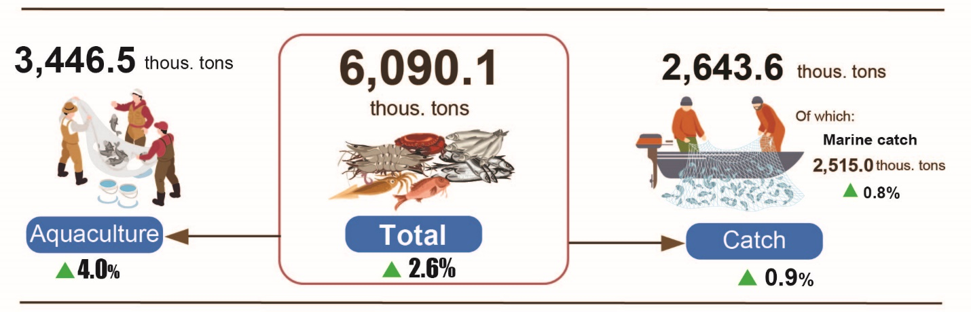
Generally, in 8 months of 2024, fishery output was estimated at 6,090.1 thousand tons, up 2.6% over the same period last year. Including: Fish reached 4,321.3 thousand tons, up 2.5%; shrimp reached 877.2 thousand tons, up 3.9%; other aquatic products 891.6 thousand tons, up 2.2%.
2. Industrial production
Industrial production in August continued the positive growth trend, it is estimated that the industrial production index in August 2024 will increase by 2.0% compared to the previous month and increase by 9.5% over the same period last year. Generally, in the first eight months of 2024, the industrial production index is estimated to increase by 8.6% over the same period last year.
The index of industrial production (IIP) in August 2024 is estimated to increase by 2.0% compared to the previous month and increase by 9.5% over the same period last year. In which, compared to the same period last year, the processing and manufacturing industry increased by 10.6%; the electricity production and distribution industry increased by 8.9%; water supply, waste and wastewater management and treatment activities increased by 12.6%; the mining industry alone decreased by 1.5%.
Generally, in the first eight months of 2024, IIP is estimated to increase by 8.6% over the same period last year (the same period in 2023 decreased by 0.2%). In which, the manufacturing sector increased by 9.7% (the same period in 2023 decreased by 0.4%), contributing 8.4 percentage points in the overall increase; the electricity production and distribution increased by 11.6%, contributing 1.0 percentage points; water supply, waste and wastewater management and treatment activities increased by 7.8%, contributing 0.1 percentage points; the mining industry decreased by 6.0%, decreasing by 0.9 percentage points.
Production index for the 8 months of 2024 of some key industries Grade II increased sharply compared to the same period last year: Manufacture of rubber and plastics products increased by 29.5%; manufacture of furniture increased by 21.6%; mining of metal ores increased by 19%; manufacture of chemicals and chemical products increased by 17.8%; manufacture of textiles increased by 13.4%; manufacture of basic metals increased by 13.2%; manufacture of fabricated metal products, except machinery and equipment increased by 12.6%; manufacture of computer, electronic and optical products increased by 9.8%; manufacture of food products increased by 7.3%. In the opposite direction, the IIP index of some industries increased low or decreased: Manufacture of other transport equipment increased by 4%; manufacture of beverages increased by 0.5%; extraction of crude petroleum and natural gas decreased by 11.2%; repair and installation of machinery and equipment decreased by 3.4%; mining of coal and lignite decreased by 3.3%; manufacture of other non-metallic mineral products decreased by 0.6%.
Table 1. Growth/decrease rate of IIP index in the 8 months of 2020-2024
compared to the same period last year of some key industries
%
 | 2020 | 2021 | 2022 | 2023 | Estimated 2024
Mining of coal and lignite | 4,8 | -0,3 | 6,9 | -1,2 | -3,3
Extraction of crude petroleum and natural gas | -11,6 | -11,1 | -0,6 | -2,6 | -11,2
Mining of metal ores | 13,4 | 3,5 | 6,4 | 6,2 | 19,0
Manufacture of food products | 3,6 | 1,5 | 9,0 | 4,9 | 7,3
Manufacture of beverages | -7,0 | 0,2 | 27,3 | 4,0 | 0,5
Manufacture of textiles | 0,6 | 8,0 | 4,4 | 1,8 | 13,4
Manufacture of chemicals and chemical products | 7,4 | 0,1 | 4,8 | 5,2 | 17,8
Manufacture of rubber and plastics products | 3,3 | -0,1 | -6,6 | 8,5 | 29,5
Manufacture of other non-metallic mineral products | 1,1 | 3,3 | 7,2 | -4,2 | -0,6
Manufacture of basic metals | -1,9 | 30,6 | -1,2 | 0,6 | 13,2
Manufacture of fabricated metal products, except machinery and equipment | 2,9 | 5,7 | 9,8 | 6,7 | 12,6
Manufacture of computer, electronic and optical products | 8,7 | 8,5 | 11,0 | -3,2 | 9,8
Manufacture of other transport equipment | -9,5 | 1,1 | 3,7 | -6,0 | 4,0
Manufacture of furniture | 4,8 | 7,8 | 5,3 | 0,8 | 21,6
Repair and installation of machinery and equipment | -8,0 | -6,6 | 6,8 | 2,0 | -3,4
The industrial production index in the first eight months of 2024 compared to the same period last year increased in 61 localities and decreased in 02 localities across the country. Some localities have a fairly high increase in the IIP index due to the processing and manufacturing industry; the electricity production and distribution industry has increased. In the opposite direction, some localities have a decrease in IIP index due to the processing and manufacturing industry; mining industry and electricity production and distribution industry decreased.
Figure 4. IIP growth/decrease rate in 8 months of 2024
compared to the same period last year of some localities (%)

10 localities with the highest IIP growth rate | 10 localities with the most reduction in IIP
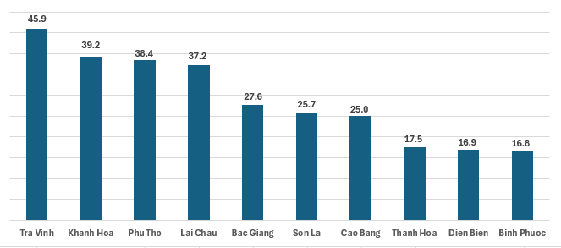 | 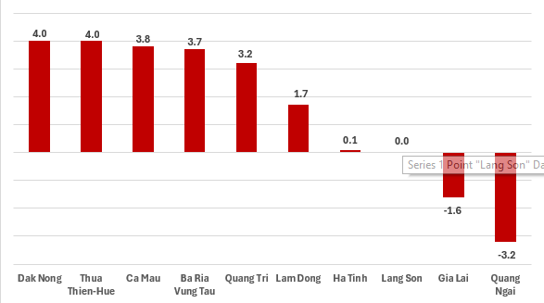
Some key industrial products in the 8 months of 2024 increased sharply compared to the same period last year: Steel bars and corners increased by 31%; laminated steel increased by 17.1%; textile fabric from natural yarnincreased by 15.6%; refined sugar increased by 14.2%; petroleum increased by 12.6%; NPK mixed fertilizer increased by 12.3%; powder milk increased by 11.2%; generated electricity increased by 10.9%; processed fishery products increased by 10.7%. In the opposite direction, some products decreased compared to the same period last year: Liquidized gas (LPG) decreased by 15.3%; natural gas (in the form of air) decreased by 14.9%; extracted crude oil decreased by 7.1%; mobile phones decreased by 5.2%; beer decreased by 3.7%; coal (pure) decreased by 3.4%; alumina decreased by 2.7%.
The number of employees working in industrial enterprises as of August 1, 2024 increased by 0.9% over the same period last month and increased by 4.5% over the same period last year. In which, labor in the state-owned enterprise sector increased by 0.1% and increased by 1.5%; non-state enterprises increased by 0.6% and increased by 1.8%; foreign-invested enterprises increased by 1.1% and increased by 5.7%. By industry, the number of employees working in mining enterprises remained unchanged compared to the same time last month and increased by 0.1% compared to the same time last year; the processing and manufacturing industry increased by 1.0% and increased by 4.8%; the production and distribution of electricity, gas, hot water, steam and air conditioning remained unchanged compared to the same time last month and increased by 1.6% over the same period last year; the water supply industry, waste and wastewater management and treatment activities increased by 0.1% and increased by 0.8%.
3. Enterprise activities
a) Enterprise registration status
In July, the whole country had 13.4 thousand newly established enterprises with registered capital over 124.6 trillion VND and a total number of registered employees of nearly 71.8 thousand employees, a decrease of 15.2% in the number of enterprises, a decrease of 6.2% in registered capital and a decrease of 12.1% in the number of employees compared to July 2024. Compared to the same period last year, down 12.8% in the number of enterprises, down 16.2% in registered capital and down 22.6% in the number of employees. The average registered capital of a newly established enterprise in the month reached 9.3 billion VND, an increase of 24.4% compared to the last month and down 3.9% compared to the same period of 2023. Besides, there were nearly 8.5 thousand enterprises resumed in the whole country, up 12.7% compared to the previous month and up 35.6% compared to the same period of 2023.
Generally, in the eight months of 2024, the whole country had neaaly 110.8 thousand newly registered enterprises with a total registered capital of 994.7 trillion VND and a total number of registered employees was over 672.4 thousand employees, up 4.4% in the number of enterprises, up 0.7% in registered capital and down 1.9% in the number of employees compared to the same period last year. The average registered capital of a newly established enterprise in the eight months of 2024 achieved 9.0 billion VND, a year-on-year reduction of 3.6%. The total number additional registered captial into the economy in the eight months of 2024 was more than 2,041.0 trillion VND, a year-on-year reduction of 5.1%. Besides, there were over 57.3 thousand enterprises resumed (a year-on-year increase of 25.3%), levering the total number of newly established enterprises and resumed enterprises in the eight months of 2024 to nearly 168.1 thousand enterprises, a year-on-year increase of 12.5%. On average, there were over 21 thousand newly established and resumed enterprises per month.
By economic sector in the eight months of 2024, there were 1,090 newly established enterprises in the agricultural, forestry, and fishery sectors, a year-on-year decrease of 3.7%; 25.7 thousand enterprises in the industrial and construction sectors, an increase of 1.4%; nearly 84 thousand enterprises in the service sector, an increase of 5.5%.
Figure 6. Enterprise registration situation
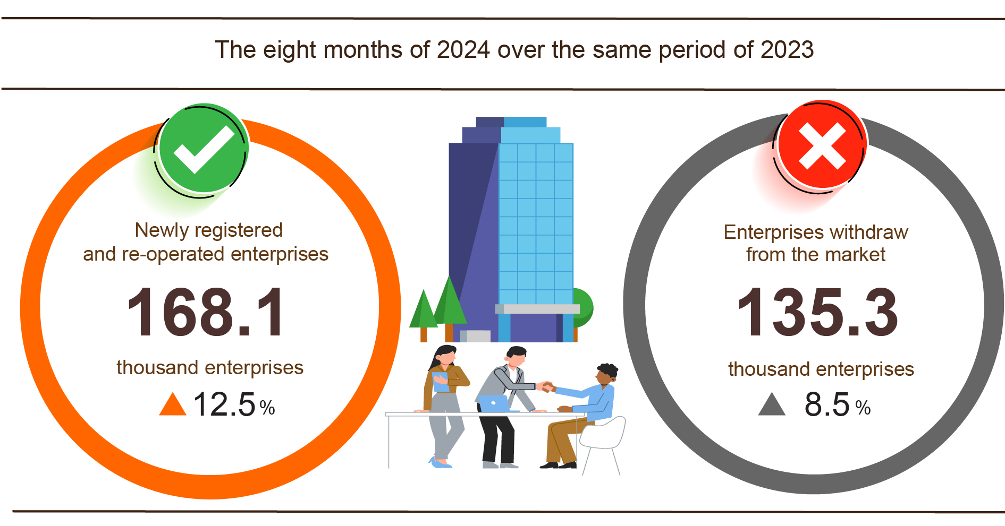
Also in August, 5,334 teamporarily inactive enterprises, down 1.6% compared to the previous month and up 3.0% over the same period in 2023; 5,160 enterprises ceased and awaited dissolution procedures, down 4.5% and down 1.1%; 1,927 enterprises completed dissolution procedures, up 11.4% and up 26.0%.
In the eight months of 2024, the number of teamporarily inactive enterprises was more than 82.8 thousand ones, a year-on-year increase of 15.3%; nearly 38.7 thousand enterprises ceased and awaited dissolution procedures, a reduction of 5.8%; 13.8 thousand enterprises completed dissolution procedures, up 18.0%. On average, more than 16.9 thousand enterprises withdrawing from the market per month.
Table 3: Number of newly registered enterprises and completed dissolution procedures in the eight months of 2024 by kinds of activity

 | Number of enterprises (Enterprise) |  | Growth rate over  the same period last year (%)
 | Newly registered | Dissolution | Newly registered | Dissolution
Wholesale and retail trade; repair of motor vehicles and motorcycles | 45,408 | 5,560 | 12.1 | 26.9
Manufacturing | 13,390 | 1,456 | 5.7 | 14.7
Construction | 11,059 | 980 | -3.2 | 14.2
Real estate business | 3,155 | 814 | 2.2 | -2.0
Transportation and storage | 5,864 | 518 | 15.5 | 16.9
Accommodation and catering service | 4,152 | 631 | -10.0 | 3.8
Production and distribution of electricity, water, gas | 692 | 133 | 12.5 | -30.0

4. Investment
Investment capital from the State budget is being focused on and promoted by the Government, the Prime Minister, ministries, branches and localities . In the first eight months of 2024, investment capital from the State budget is estimated to reach 47.8% of the annual plan, up 2.0% over the same period last year. Foreign direct investment (FDI) implemented in Vietnam in the first eight months of 2024 is estimated at 14.15 billion USD, up 8.0% over the same period last year .
Investment capital implemented from the State budget in August 2024 is estimated at VND 62.1 trillion, up 1.3% over the same period last year, including: Centrally managed capital reached VND 10.9 trillion, down 0.5%; locally managed capital reached VND 51.2 trillion, up 1.7%. In the first eight months of 2024, investment capital implemented from the State budget is estimated at VND 363.1 trillion, equal to 47.8% of the annual plan and up 2.0% over the same period last year (the same period in 2023 was equal to 48.6% and up 24.5%). Specifically:
- The investment capital implemented under the central management is estimated at 62.6 trillion VND, equal to 50.4% of the annual plan and down 3.4% compared to the same period last year. Of which, the Ministry of Transport reached 38.2 trillion VND, down 20.8%; the Ministry of Agriculture and Rural Development reached 6.1 trillion VND, up 34.6%; the Ministry of Health reached 642.1 billion VND, up 29.5%; the Ministry of Education and Training reached 625.4 billion VND, up 8.1%; the Ministry of Natural Resources and Environment reached 397.3 billion VND, down 40.8%; the Ministry of Industry and Trade reached 381.3 billion VND, up 16.9%.
- Investment capital managed by localities is estimated at 300.5 trillion VND, equal to 47.3% of the annual plan and up 3.2% over the same period last year, of which:
Provincial State budget capital reached nearly 201 trillion VND, equal to 44.8% and increased by 1.9% over the same period in 2023;
District-level State budget capital reached 85.7 trillion VND, equal to 51.9% and increased by 6.1%;
State budget capital at commune level reached 13.8 trillion VND, equal to 65.1% and increased by 4.1%.
Investment capital implemented from the State budget in the first eight months of 2024 of a number of provinces and centrally run cities is as follows:
Figure 6. Investment capital implemented from the State budget
of some localities

Total foreign investment registered in Vietnam As of August 31, 2024, including: Newly registered capital, adjusted registered capital and capital contribution and share purchase value of foreign investors reached 20.52 billion USD, up 7% over the same period last year.

Figure 7. Foreign investment capital registered in Vietnam in
8 months of 2020-2024 (Billion USD)

- Newly registered capital has 2,247 licensed projects with registered capital reaching nearly 12 billion USD, up 8.5% over the same period last year in terms of number of projects and 27% in terms of registered capital. Of which, the processing and manufacturing industry is the one with the largest newly licensed foreign direct investment with registered capital reaching 8.53 billion USD, accounting for 71.1% of the total newly registered capital; real estate business activities reached 2.40 billion USD, accounting for 20%; the remaining industries reached 1.07 billion USD, accounting for 8.9%.
Among the 66 countries and territories with newly licensed investment projects in Vietnam in the first eight months of 2024, Singapore was the largest investor with 4.66 billion USD, accounting for 38.8% of the total newly registered capital; followed by China with nearly 1.7 billion USD, accounting for 14.2%; Hong Kong Special Administrative Region (China) with 1.41 billion USD, accounting for 11.7 % ; Japan with 1.24 billion USD, accounting for 10.3%; Turkey with 731.3 million USD, accounting for 6.1%; Taiwan with 660.3 million USD, accounting for 5.5%.
- Adjusted registered capital: 926 licensed projects from previous years registered to adjust investment capital by an additional 5.71 billion USD, up 14.8% over the same period last year.
If including newly registered capital and adjusted registered capital of licensed projects from previous years, foreign direct investment capital registered in the processing and manufacturing industry reached 13.61 billion USD, accounting for 76.8% of the total newly registered and increased capital; real estate business activities reached 2.55 billion USD, accounting for 14.4%; the remaining industries reached 1.56 billion USD, accounting for 8.8%.
- There were 2,196 registered capital contributions and share purchases by foreign investors with a total capital contribution value of 2.81 billion USD, down 40.9% compared to the same period last year. Of which, 838 capital contributions and share purchases increased the charter capital of enterprises with a capital contribution value of 1.27 billion USD; 1,358 foreign investors bought back domestic shares without increasing the charter capital with a value of 1.54 billion USD. Regarding the form of capital contributions and share purchases by foreign investors, the investment capital in real estate business activities reached 811.8 million USD, accounting for 28.9% of the capital contribution value; professional activities, science and technology reached 588.3 million USD, accounting for 20.9%; the remaining sectors reached 1.41 billion USD, accounting for 50.2%.
Foreign direct investment implemented in Vietnam eight The estimated FDI in the first month of 2024 was 14.15 billion USD, an increase of 8.0% over the same period last year. Of which: Processing and manufacturing industry reached 11.28 billion USD, accounting for 79.7% of total realized foreign direct investment; real estate business activities reached 1.27 billion USD, accounting for 9.0%; production and distribution of electricity, gas, hot water, steam and air conditioning reached 542.3 million USD, accounting for 3.8%.
Figure 8. Foreign direct investment realized in
8 months of 2020-2024 (Billion USD)

Vietnam's overseas investment in the first eight months of 2024 had 75 projects newly granted investment certificates with a total capital of Vietnam's side of 148 million USD, down 39.4% over the same period last year; there were 17 projects adjusting capital with the adjusted capital decreasing by 736.7 million USD.
In the first eight months of 2024, Vietnam's total investment capital abroad (newly granted and adjusted capital) reached 147.3 million USD, down 64.6% over the same period last year. Of which: Mining reached 58.6 million USD, accounting for 39.8% of total investment capital; processing and manufacturing industry reached 29.1 million USD, accounting for 19.7%; wholesale and retail, repair of automobiles, motorcycles, motorbikes and other motor vehicles reached 24.7 million USD, accounting for 16.8%; professional scientific and technological activities reached 20 million USD, accounting for 13.6%; other services reached 10.0 million USD, accounting for 6.8%; production and distribution of electricity, gas, hot water and air conditioning reached nearly 8 million USD, accounting for 5.4%.
In the first eight months of 2024, 25 countries and territories received investment from Vietnam, of which: The Netherlands was the leading country with 54.6 million USD, accounting for 37.1% of total investment capital; Laos 37.8 million USD, accounting for 25.7%; the United Kingdom 19.8 million USD, accounting for 13.4%; the United States 18.6 million USD, accounting for 12.7%; Cambodia 16.6 million USD, accounting for 11.3%; New Zealand 5.9 million USD, accounting for 4.0%.
5. State budget revenue and expenditure
State budget revenue in the eight months of 2024 increased by 17.8% over the same period last year. State budget expenditure increased by 1.9% over the same period in 2023, ensuring the needs of socio-economic development, national defense, security, State management, payment of due debts as well as timely payment to subjects according to regulations.
Figure 9. State budget revenue and expenditure for the first 8 months of 2024
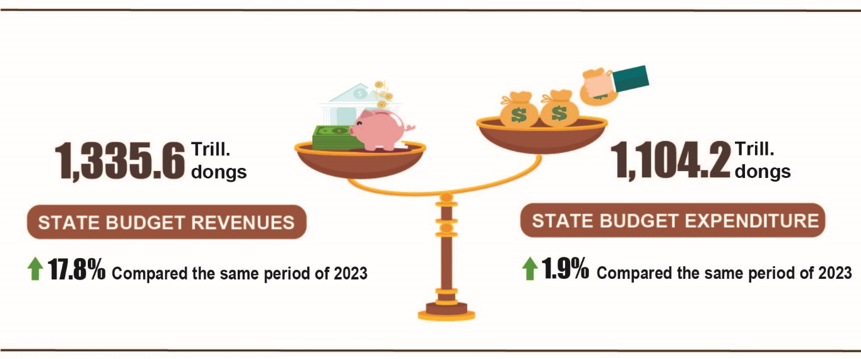
State budget revenue
Total state budget revenue in August 2024 was estimated at 101.3 trillion VND. The accumulated total state budget revenue in the eight months of 2024 was estimated at 1,335.6 trillion VND, equal to 78.5% of the yearly estimate and increasing by 17.8% over the same period last year. Some main revenue items are as follows:
- Domestic revenue in August 2024 was estimated at 81.3 trillion VND; accumulated revenue in the eight months of 2024 was estimated at nearly 1,117.2 trillion VND, equal to 77.3% of the yearly estimate and increaseing by 18.9% over the same period last year.
- Revenue from crude oil in August 2024 was estimated at 5.0 trillion VND; accumulated revenue in the eight months of 2024 was estimated at 39.4 trillion VND, equaling 85.6 % of the yearly estimate and down 2.6 % over the same period last year.
- Budget balance revenue from export and import activities in August 2024 was estimated at 15.0 trillion VND; accumulated revenue in the eight months of 2024 was estimated at 178.7 trillion VND, equaling to 87.6% of the yearly estimate and increasing by 16.2% over the same period last year.
State budget expenditure
Total state budget expenditure in August 2024 was estimated at 158.8 trillion VND; accumulated expenditure in the eight months of 2024 was estimated at 1,104.2 trillion VND, equaling 52.1 % of the yearly estimate and up 1.9% over the same period last year. Of which, recurrent expenditure in the eight months of 2024 was estimated at 758.7 trillion VND, equaling 60.2% of the yearly estimate and up 6.0% over the same period last year; development investment expenditure was estimated at 273.6 trillion VND, equaling 40.4 % and down 8.9%; interest payment was 71.1 trillion VND, equaling 63.7% and increased 8.9%.
6. Trade, prices, transport and tourism
a) Retail sales of consumer goods and services
The recovery of domestic consumption and production demand, along with the strong growth of tourism, has contributed positively to the growth of the trade and service industry since the beginning of the year. The total retail sales of consumer goods and services in 8/2024 increased by 0.4% compared to the previous and increased by 7.9% over the same period last year. Overall, in eight months of 2024, the total retail sales of consumer goods and services was estimated to increase by 8.5% over the same period last year, of which revenue from accommodation and food services increased by 14.3%, revenue from tourism up to 26.2%.
Total retail sales of consumer goods and services at current prices in 8/2024 was estimated at 526.6 trillion VND, up 7.9% over the same period last year, of which, the group of food and foodstuffs increased by 8.2%; household appliances, tools and equipment increased by 6.5%; garment increased by 8.2%; accommodation and food services increased by 9.7%; traveling service increased by 7.1%.
Table 3. Retail sales of consumer goods and services at current prices

Trillion VND
 | Estimate  August  2024 | Estimate  8 months  of 2024 | Growth rate compared to the same period last year (%)
 | Estimate  August  2024 | Estimate  8 months  of 2024 | August  in 2024 | 7 months  of 2024
Total | 526.6 | 4,148.4 | 7.9 | 8.5
Retail sale of goods | 402.3 | 3,199.7 | 7.5 | 7.3
Accommodation and catering service | 62.4 | 481.2 | 9.7 | 14.3
Tourism revenue | 5.6 | 40.9 | 7.1 | 26.2
Other services | 56.3 | 426.6 | 9.1 | 9.4
Generally for eight months of 2024, the total retail sales of consumer goods and services at current prices was estimated at 4,148.4 trillion VND, up 8.5% over the same period last year (up 10.3% in the same period in 2023), if excluding the price factor, up 5.3% (the same period in 2023 increased by 8.0%).
Figure 11. Total retail sales of consumer goods and service
in 8 months of 2020-2024

Retail sales of goods in eight months of 2024 were estimated at 3,199.7 trillion VND, accounting for 77.1% of the total retail sales of consumer goods and services and up 7.3% over the same period last year (if excluding the price factor, up 4.6%). In which, food and foodstuffs increased by 10.2%; household appliances, tools and equipment increased by 10.1%; garment increased by 8.7%; means of transport (except for cars) rose up 4.0%; cultural and educational products increased by 9.6%. Retail sales of goods in the first five months of this year compared to the same period last year of some localities was as follows: Quang Ninh increased by 10.6%; Hai Phong increased by 9.3%; Can Tho increased by 7.7%; Da Nang increased by 7.6%; Ho Chi Minh City increased by 6.8%, Ha Noi increased by 6.3%.
Revenue from accommodation and catering services in eight months of 2024 was estimated at 481.2 trillion VND, accounting for 11.6% and up 4.3% over the same period last year. Revenue in eight months of 2024 compared to the same period last year of some localities was as follows: Quang Ninh increased by 29.1%; Da Nang increased by 23.3%; Thanh Hoa increased by 21.5%; Khanh Hoa increased by 19.1%; Hai Phong increased by 15.1%; Can Tho increased by 11.9%; Ha Noi increased by 11.4%; Ho Chi Minh City increased by 8.9%; Binh Duong increased by 7.9%.
Tourism revenue in eight months of 2024 was estimated at 40.9 trillion VND, accounting for 1.0% and up 26.2% over the same period last year. The revenue of some localities in eight months of 2024 compared to the same period last year was as follows: Ho Chi Minh City increased by 42.2%; Da Nang increased by 38.6%; Can Tho increased by 33.7%; Ha Noi increased by 29.7%; Quang Ninh increased by 21.0%; Binh Duong increased by 18.5%.
Other service revenue in eight months of 2024 was estimated at 426.6 trillion VND, accounting for 10.3% and up 9.4% over the same period last year. Revenue in eight months of 2024 of some localities was as follows: Khanh Hoa increased by 22.8%; Can Tho increased by 10.4%; Ha Noi increased by 8.0%; Ho Chi Minh City increased by 7.0%; Bac Lieu decreased by 1.0%; Quang Ninh decreased by 1.9%.
b) Export and import of goods
Total export and import turnover of goods in 8/2024 was estimated at 70.65 billion USD, up 0.8% over the previous month and up 13.5% over the same period last year. Generally, in eight months of 2024, the total export and import turnover of goods reached 511.11 billion USD, up 16.7% over the same period last year, of which exports increased by 15.8%; imports increased by 17.7%. The trade balance of goods had a surplus of 19.07 billion USD.
Figure 11. Import and export of goods in 8 months of 2024
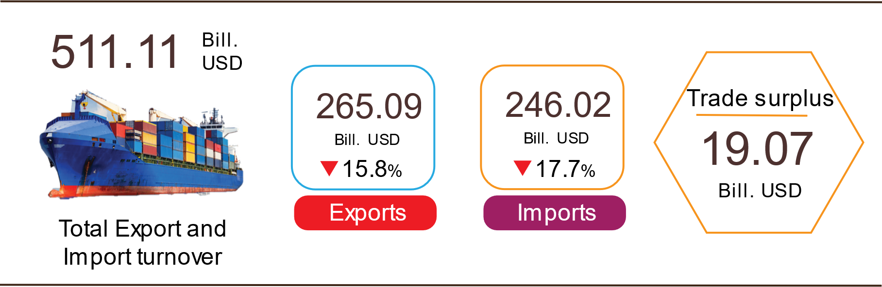

Export of goods
Preliminary export turnover of goods in 7/2024 reached USD 36.24 billion, 316 million USD higher than the estimated figure.
Preliminary export turnover of goods in 8/2024 reached 37.59 billion USD, up 3.7% over the previous month. Of which, the domestic economic sector gained 10.84 billion USD, increased by 9.8%; the FDI sector (including crude oil) reached 26.75 billion USD, increased by 1.5%. Compared to the same period last year, export turnover of goods in August increased by 14.5%, of which the domestic economic sector increased by 21.3%, the FDI sector (including crude oil) increased by 12%.
Generally in eight months of 2024, preliminary export turnover reached 265.09 billion USD, increased by 15.8% over the same period last year. Of which, the domestic economic sector was 73.88 billion USD, went up 21%, accounting for 27.9% of total export turnover; the FDI sector (including crude oil) attained 191.21billion USD, increased by 13.9%, sharing 72.1%.
In eight months of 2024, there were 30 products with export turnover of over 1 billion USD, contributing 92.3% to the total export turnover (6 products with export turnover of over 10 billion USD, accounting for 62.6%).
Table 4. Value of some export products in 8 months of 2024
 | Estimate  (Mill. USD) | Growth rate compare to  the same period last year (%)
Items with a value of over 10 billion USD
Electronic goods, computers and their parts | 46,325 | 28.9
Phones all of kinds and their parts | 37,278 | 9.5
Machinery, instrument, accessory | 32,734 | 21.8
Textiles and garments | 24,319 | 7.9
Footwear | 14,938 | 11.8
Wood and products | 10,388 | 22.3

Regarding the structure of exported groups in eight months of 2024, the group of fuels and minerals was estimated at 2.92 billion USD, accounting for 1.1%; the group of processing industry was estimated at 233.33 billion USD, accounting for 88%; agricultural and forestry products was estimated at 22.53 billion USD, accounting for 8.5%; the group of fishery products was estimated at 6.31 billion USD, accounting for 2.4%.
Figure 12. Structure of exported groups
in 8 months of 2024

Import of goods
Preliminary import turnover of goods in 7/2024 reached 33.88 billion USD, 80 million USD higher than the estimate figure.
Preliminary import turnover of goods in 8/2024 reached 33.06 billion USD, decreased by 2.4% over the previous month. Of which the domestic economic sector gained 12 billion USD, increased by 1.4%; the FDI sector reached 21.06 billion USD, decreased by 4.5%. Compared to the same period last year, the import turnover of goods in August increased by 12.4%, of which the domestic economic sector increased by 13.2%; the FDI sector increased by 11.9%.
Generally in eight months of 2024, preliminary import turnover of goods reached 246.02 billion USD, increased by 17.7% over the same period last year. Of which the domestic economic sector reached 89.58 billion USD, went up 19.7%; the FDI sector gained 156.44 billion USD, up 16.5%.
In eight months of 2024, there are 38 imported products with a turnover of over 1 billion USD, accounting for 90.8% of total import turnover (2 products with import turnover of over 10 billion USD, accounting for 40.7%).
Table 5. Value of some imported goods in 8 months of 2024
 |  | Estimate | Growth rate compare to
 |  | (Mill. USD) | the same period last year (%)
Items with a value of over 10 billion USD
 | Electronic devices, computers and their parts | 68,891 | 26.9
 | Machinery, instrument, accessory | 31,336 | 17.0
Figure 13. Structure of imported groups
in 8 months of 2024
Regarding the structure of imported groups in eight months of 2024, the group of production materials was estimated at 230.95 billion USD, accounted for 93.9%, in which the group of machinery, equipment, tools spare parts accounted for 46.9%; raw materials, fuel and materials accounted for 47%. The group of consumer products was estimated at 15.07 billion USD, accounted for 6.1%.
Regarding the export and import market of goods in eight months of 2024, the United States was the Viet Nam's largest export market with a turnover of 77.9 billion USD. China remained the largest import market of Viet Nam with a turnover of 92.3 billion USD. In eight months of 2024, the trade surplus to the United States reached 68.1 billion USD, up 28.6% over the same period last year; the trade surplus to the EU reached 23.6 billion USD, up 22%; the trade surplus to Japan was 1.7 billion USD, up 30.5%; the trade deficit from China was 54.4 billion USD, went up 69.6%; the trade deficit from Korea was 20 billion USD, went up 12.1%; the trade deficit from ASEAN was 5.8 billion USD, increased by 14.8%.
Figure 14. Major commodity import and export markets
in 8 months of 2024
 |  | Export of goods | Import of goods
The preliminary trade balance of goods in July had a trade surplus of 2.36 billion USD; the seven-month trade surplus was 14.54 billion USD; and the preliminary trade surplus in August was 4.53 billion USD. Generally in eight months of 2024, the preliminary trade balance of goods had a trade surplus of 19.07 billion USD (in the same period last year, the trade surplus of 19.9 billion USD). Of which, the domestic economic sector has a trade deficit of 15.7 billion USD; the FDI sector (including crude oil) had a trade surplus of 34.77 billion USD.
c) Consumer price index, gold price index and US dollar price index
Prices of consumer goods and services in August increased and decreased, in which prices of food, foodstuffs, and rental housing increased compared to July 2024, and domestic gasoline prices decreased following world prices. Overall, in August 2024, the consumer price index (CPI) remained stable compared to the previous month. Compared to December 2023, the CPI in August increased by 1.89% and compared to the same period last year, it increased by 3.45%.
On average, in the first eight months of 2024, CPI increased by 4.04% over the same period last year; core inflation increased by 2.71%.
Figure 15. CPI growth rate in 8/2024 compared to the previous month

The Consumer Price Index (CPI) in August 2024 was stable. Of the 11 main consumer goods and services groups, 10 had a slight increase in price index; only the transport group had a decrease in price compared to the previous month.
Ten groups of goods and services with increasing price indexes include:
- Group housing, electricity, water, fuel and construction materials increased by 0.29% mainly due to the following reasons: House rental prices increased by 0.45% due to increased demand for housing in some localities as the new school year approaches ; gas prices increased by 0.67%, due to the fact that from 01/8/2024, domestic gas prices will be adjusted to increase according to world gas prices. In addition, the prices of some commodities in the month decreased compared to the previous month: Kerosene price decreased by 6.02% due to the impact of price adjustments in the month; household electricity price decreased by 0.76%; household water price decreased by 0.17% due to reduced consumer demand during the rainy season and cool weather.
- The food and foodstuff group increased by 0.27% (making the general CPI increase by 0.09 percentage points), of which: Food increased by 0.19 %; foodstuff increased by 0.28% (making the general CPI increase by 0.06 percentage points); eating out increased by 0.26%.
- The group of other goods and services increased by 0.2%, of which, the price of administrative and legal services increased by 1.91%; jewelry increased by 1.89%; environmental sanitation services increased by 0.52%; watch and jewelry repair increased by 0.28%. On the contrary, the price of handbags, suitcases, wallets decreased by 0.18%; watches decreased by 0.05%.
- The group of medicines and health care services increased by 0.18%, of which the price of inpatient examination and treatment increased by 0.29%; outpatient examination and treatment services increased by 0.11%. The reason is that in August 2024, some localities continued to apply new medical service prices according to Circular No. 22/2023/TT-BYT dated 17/11//2023 of the Ministry of Health regulating the unification of prices of medical examination and treatment services under health insurance between hospitals of the same rank nationwide and guiding the application of prices and payment of medical examination and treatment costs in some cases .
- Post and telecommunications group increased by 0.15%. Of which, the price of regular mobile phones increased by 0.52%; the price of fixed phones increased by 0.25%.
- The beverage and cigarette group increased by 0.15%, mainly due to high consumer demand during Vu Lan Festival and during the tourist season, specifically: Fruit juice prices increased by 0.42%; energy drinks increased by 0.29%; cigarettes increased by 0.25%; bottled beer increased by 0.13%; alcohol of all kinds increased by 0.12%.
- The education group increased by 0.14%, of which the price of writing pens increased by 0.5%; paper products increased by 0.45%; stationery and other school supplies increased by 0.2%. In addition, the price of educational services increased by 0.13% due to some public universities, private high schools, and private kindergartens in some provinces increasing tuition fees for the 2024-2025 school year.
- The culture, entertainment and tourism group increased by 0.12%, mainly concentrated in the following groups: Prices of foreign tourism services increased by 0.72%; sports and fitness equipment increased by 0.38%; hotels and guesthouses increased by 0.24%; movies and music increased by 0.16%. On the contrary, domestic tourism decreased by 0.29% due to companies reducing prices to stimulate demand.
- The group of household equipment and goods increased by 0.09% due to increased labor costs. Of which, refrigerator repair services increased by 0.64% compared to the previous month; air conditioner repair services increased by 0.59%; household appliance rental increased by 0.56%; washing machine repair services increased by 0.48%; motorized equipment repair increased by 0.45%; beds, wardrobes, tables and chairs increased by 0.24%; service staff increased by 0.14%; washing machines increased by 0.11%. On the contrary, some items had lower prices compared to the previous month because many stores continued to apply shopping stimulus programs such as: Gas stove prices decreased by 0.89%; blenders and juicers decreased by 0.47%; mattresses decreased by 0.15%; rice cookers decreased by 0.07%; vacuum cleaners decreased by 0.03%.
- The garment, hat and footwear group increased by 0.05% due to increased shopping demand in preparation for the new school year. Of which, footwear prices increased by 0.53%; footwear services increased by 0.44%; garment services increased by 0.37%; fabrics of all kinds increased by 0.25%; hats increased by 0.22%.
The transport group alone decreased by 1.98% (reducing the overall CPI by 0.19 percentage points), mainly due to: Diesel oil price decreased by 7.05%; domestic gasoline price decreased by 5.83% due to the impact of price adjustments during the month; passenger transport price by rail decreased by 4.09%; used cars decreased by 0.28%. In addition, the groups of goods increased in price: Auto spare parts price increased by 0.4%; vehicle maintenance service price increased by 0.91%; driving license fee increased by 1.7%.
Core inflation in August 2024 increased by 0.24% over the previous month and by 2.53% over the same period last year.
On average, in the first eight months of 2024, core inflation increased by 2.71% over the same period in 2023, lower than the average CPI increase (4.04%), mainly due to the prices of food, foodstuffs, electricity, education services, medical services and gasoline, which are factors affecting the CPI increase but are excluded from the list of core inflation calculations.
Domestic gold prices fluctuate in the same direction as world gold prices. As of August 27, 2024, the average world gold price was at 2,495.53 USD/ounce, up 3.63% compared to July 2024. World gold prices increased as investors believed that the US Federal Reserve (FED) could lower interest rates in September , along with geopolitical conflicts in the world and demand from Central Banks have boosted gold purchases as a safe haven asset. Domestically, the gold price index in August 2024 increased by 1.93% compared to the previous month; increased by 20.4% compared to December 2023; increased by 31.05% compared to the same period last year; on average in the first eight months of 2024, the gold price index increased by 25.54%.
As of August 27, 2024, the US dollar index in the international market reached 102.38 points, down 1.97% compared to the previous month. Domestically, the average US dollar price in the free market is around 25,329 VND/USD. The US dollar price index in August 2024 decreased by 0.64% compared to the previous month; increased by 3.55% compared to December 2023; increased by 5.86% compared to the same period last year; the average increase in the first eight months of 2024 was 5.85%.
d) Transport
Transport activities in August were vibrant, maintaining a positive growth rate compared to the same period last year due to the strong recovery of tourism and high demand for transportation to serve production and import and export of goods, of which passenger transport increased by 13.2% of passenger carried and increased by 16.2% of passenger traffic; freight transport increased by 13.2% of freight carried and up 10.5% of freight traffic.
Overall, in eight months of 2024, passenger carried increased by 7.5% and passenger traffic up 12.7% over the same period last year; freight carried increased by 13.0% and freight traffic up 11.8%.
Passenger transport in 8/2024 was estimated at 442.0 million passengers, increased by 1.9% and passenger traffic was 24.9 billion passengers-kilometers, increased by 2.5%. In eight months of 2024, passenger carried was estimated at 3,234.3 million passengers, up 7.5% over the same period last year and passenger traffic was 183.0 billion passengers.km, increased by 12.7%. Of which, domestic transport reached 3,222.3 million passengers, up 7.5% over the same period last year and 144.6 billion passengers-kilometers, up 8.6%; overseas transport reached 12.0 million passengers, increased by 19.7% and 38.4 billion passengers-kilometers, up 31.5% compared to the same period last year.
Table 6 : Passengers transport in 8 months of 2024
by types of transport
 | Number of passengers |  | Growth rate compared to the same period last year (%)
 | Carried  (Mill. passengers) | Traffic  (Bill. passengers-km) | Carried | Traffic
Total | 3,234.3 | 183.0 | 7.5 | 12.7
Rail way | 5.4 | 2.1 | 19.9 | 23.7
Sea way | 9.1 | 0.6 | 6.6 | 13.7
Inland water way | 239.0 | 5.1 | 8.9 | 17.5
Road | 2,943.9 | 114.7 | 7.6 | 12.5
Airway | 36.9 | 60.5 | -5.8 | 12.3

Freight transport in 8/2024 was estimated at 215.1 million tons of freight carried, increased by 1.3% and 47.1 billion tons.km of freight traffic, decreased by 0.5% over the previous month. Generally for eight months of 2024, freight transport was estimated at 1,686.3 million tons of freight carried, up 13.0% over the same period last year and 351.2 billion tons.km of freight traffic, an increase of 11.8%. Of which, domestic transport reached 1,655.6 million tons of freight carried, up 13.1% and 212.8 billion tons.km of freight traffic, up 7.6%; overseas transport reached 30.7 million tons of freight carried, up 5.0% and 138.4 billion tons.km of freight traffic, up 19.1%.
Table 7. Carriage of freight in 8 months of 2024
by types of transport
 | Quantity of goods |  |  | Growth rate compared to the same period last year (%)
 | Carried | Traffic |  | Carried | Traffic
 | (Mill. tons) | (Bill. tons-km) |  | Carried | Traffic
Total | 1,686.3 | 351.2 |  | 13.0 | 11.8
Rail way | 3.4 | 2.5 |  | 11.8 | 4.3
Sea way | 88.5 | 181.7 |  | 15.2 | 10.7
Inland water way | 363.5 | 80.4 |  | 13.0 | 14.0
Road | 1,230.6 | 79.7 |  | 12.8 | 11.5
Airway | 0.3 | 6.9 |  | 42.7 | 26.6

đ) International visitors to Viet Nam
Favorable visa policies, enhanced tourism promotion programs, and prestigious tourism awards presented by international organizations have attracted an increasing number of international visitors to Vietnam.
In 8/2024, the number of international visitors to Viet Nam reached 1.43 million, increased by 17.7% compared to the same period last year. In eight months of 2024, international visitors to our country reached nearly 11.4 million arrivals, up 45.8% compared to the same period last year and up 1.0% compared to the same period of 2019 - the year before the Covid-19 pandemic.
Out of a total of nearly 11.4 million international arrivals to Viet Nam in eight months of this year, arrivals by air reached nearly 9.7 million arrivals, accounting for 84.7% of international arrivals to Viet Nam and up 41.0% over the same period last year; by road reached 1.6 million arrivals, accounting for 13.8% and up 73.3% ; by sea reached 165.6 thousand arrivals, accounting for 1.5% and 2.8 times higher.
Figure 17. International visitors to Viet Nam in 8 months
of 2024 by territories
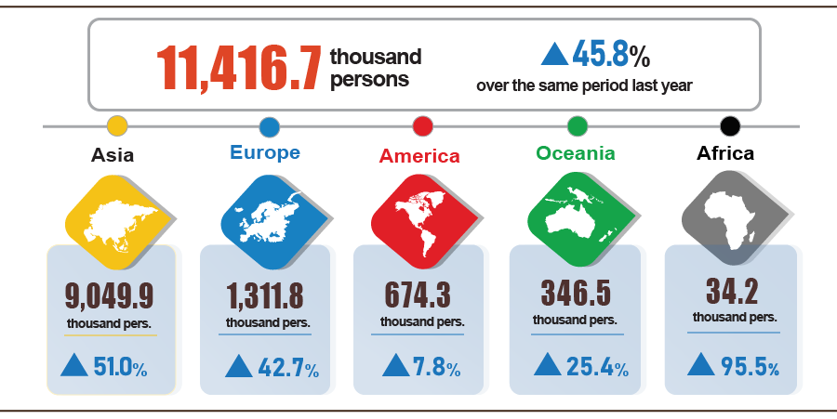
7. Some social situations
a) Residential life
According to the survey on the life situation of households in August 2024, the proportion of households assessed to have income during the month remained unchanged and increased compared to the same period last year was 96.1% (an increase of 0.3 percentage points). percent compared to the July 2024 reporting period and increased by 1.9 percentage points compared to the same period last year); The proportion of households assessed to have reduced income and unknown compared to the same month in 2023 is 3.9%.
Households whose income in August decreased compared to the same period last year identified the main reasons as: Some household members lost their jobs or temporarily quit their jobs (rate of 45.7%); due to the decrease in the scale of household production and business activities (28.8%); due to increased input costs for household production and business activities (26.0%); due to the decrease in selling prices of products from household production and business activities (20.2%).
In the eight months of 2024, 30.8% of households reported experiencing at least one event that negatively affected family life, this rate remained unchanged compared to the previous month and decreased by 1 percentage point compared to the previous month. with the same period last year. Among the households negatively affected by the events: 30.1% of households are suffering from the effects of rising prices of goods and services; 2.5% of households are negatively affected by epidemics on humans and 1.8% of households are negatively affected by epidemics on livestock and crops.
During the eight months of 2024, 12.4% of households interviewed received assistance from various sources of support. Of which, the proportion of households receiving assistance from relatives is 8.4%; from local programs and policies is 4.5%; from general national programs and policies is 4.1%; from charitable activities of other organizations and individuals is 1.6% and from other sources is 0.02%.
The work of ensuring social security is always carried out promptly and effectively by all levels and sectors. According to a report from the Ministry of Labor, War Invalids and Social Affairs, in eight months of this year, the Government, ministries, branches and localities have supported people with more than 21.3 thousand tons of rice, of which: provided 10.4 thousand tons of rice for hunger relief on the occasion of the Lunar New Year Giap Thin for 693.4 thousand people; supporting more than 5.9 thousand tons of rice to relieve hunger in 2024 for 396.3 thousand people; Localities also developed plans and proactively allocated local budgets and socialization resources to support nearly 5 thousand tons of rice for poor, near-poor households and people in difficult circumstances.
b) Disease situation and food poisoning
According to a report from the Ministry of Health, in the month (from July 19 to August 18, 2024), the whole country had 18,636 cases of dengue fever (02 deaths); 7,087 cases of hand, foot and mouth disease; 859 cases of typhus suspected of measles; 07 deaths due to rabies; 51 cases of viral encephalitis; 01 case of meningococcal meningitis. In the eight months of 2024, the whole country has 53.9 thousand cases of dengue fever (06 deaths); 41.7 thousand cases of hand, foot and mouth disease; 1,746 cases of typhus suspected of measles; 60 deaths due to rabies; 307 cases of viral encephalitis (06 deaths); 13 cases of meningococcal meningitis; 09 cases of diphtheria (01 death); 01 case of influenza A and death.
The total number of people living with HIV in the country as of August 18, 2024 is more than 242.3 thousand people; The number of deaths due to HIV/AIDS is 115.2 thousand people.
Regarding food poisoning, in August 2024, there were 15 cases with 503 people being poisoned and 1 person died. In the eight months of 2024 (from December 19, 2023 to August 18, 2024), there were 77 cases nationwide with 3,164 people being poisoned (10 people died).
c) Sports activities
Regarding the mass sports movement, some outstanding activities taking place during the month include: National Youth Aerobic Gymnastics Championship 2024 from August 24-25, 2024 in Hai Duong; Vietnam Chess Prodigy Award 2024 from August 23-24, 2024 in Binh Dinh; GreenUP Marathon 2024 on August 24 in Long An; SeaStar Nha Trang Bay 2024 swimming tournament in Khanh Hoa from August 24-25, 2024; The 2nd National Tug of War Youth and Teen Championship 2024 from August 20-26, 2024 in Bac Kan.
Regarding high-performance sports, in August, a number of outstanding events took place such as: The Vietnamese wushu team won 4 gold medals, ranked 4th at the 2024 world tai chi tournament in Singapore. ; National Women's Futsal Championship 2024 from August 28 to September 2, 2024 in Ha Nam; Vietnam leads the 2024 Asian Shuttlecock Championship and the 2024 Asian Youth Championship with 8 gold medals and 6 silver medals taking place in Thua Thien - Hue; 2024 Asian Short Track Speed ​​Skating Championship in Indonesia; ASEAN Age Group Chess Open 2024 in Laos from August 22-31, 2024; 3x3 Youth Basketball Championship from August 20-30, 2024 in Binh Dinh; National Excellence Chess Championship 2024 from August 9-19, 2024 in Hai Phong; National Youth Shooting Championship 2024 from August 10-20, 2024 in Ho Chi Minh City; The VTV Ferroli Cup 2024 International Women's Volleyball Tournament will be held from August 24-31, 2024 in Ninh Binh.
d) Traffic accident
During the month (from July 15 to August 14, 2024), there were 1,801 traffic accidents nationwide, including 1,333 traffic accidents from less serious or more (causing 873 deaths, 746 deaths). injured people) and 468 traffic collisions caused 526 people with minor injuries. Compared to the previous month, the number of traffic accidents decreased by 4.7% (the number of traffic accidents from less serious or more decreased by 1.6% and the number of traffic collisions decreased by 12.4%); number of deaths increased by 1.5%; The number of injured people decreased by 10.9% and the number of people with minor injuries decreased by 10.4%. Compared to the same period last year, the number of traffic accidents in August decreased by 0.4% (the number of traffic accidents from less serious or more decreased by 2.8% and the number of traffic collisions increased by 7.1%. ); number of deaths decreased by 12%; The number of injured people decreased by 2.7% and the number of people with minor injuries increased by 14.1%.
In eight months of this year, there were 16,052 traffic accidents nationwide, including 11,441 less serious traffic accidents and 4,611 traffic collisions, killing 7,108 people and 7,134 others. injured and 5,090 people suffered minor injuries. Compared to the same period last year, the number of traffic accidents in eight months of this year increased by 13.1% (the number of traffic accidents from less serious or more increased by 6.3%; the number of traffic collisions increased by 34. 4%); number of deaths decreased by 10.2%; The number of injured people increased by 19.2% and the number of people with minor injuries increased by 45.4%. On average, every day in eight months of this year, there were 66 traffic accidents nationwide, including 47 traffic accidents of less serious or more severity and 19 traffic collisions, killing 29 people. 29 people were injured and 21 people suffered minor injuries.
d) Damage caused by natural disasters
Damage caused by natural disasters in August was mainly due to the impact of heavy rains, floods, and inundation, causing 56 people to die or go missing, and 37 people to be injured; 4 thousand houses collapsed, swept away and damaged; 230.9 thousand cattle and poultry died; 25.3 thousand hectares of rice and crops were flooded and damaged; The total value of property damage caused by natural disasters in the month was 1,168 billion VND, down 10.1% over the same period last year. In eight months of this year, natural disasters left 147 people dead or missing, and 104 injured; 32.9 thousand houses collapsed and damaged; 259.3 thousand cattle and poultry died; 30.8 thousand hectares of crops and 84.5 thousand hectares of rice were flooded and damaged; The total value of property damage is estimated at 3,374.6 billion VND, more than 1.5 times higher than the same period in 2023.
e) Environmental protection and fire and explosion prevention
During the month (from July 18 to August 17, 2024), the authorities discovered 1,649 cases of environmental violations in 52/63 localities, of which 1,538 cases were handled with a total fine of 27.3 billion VND. VND, up 35.4% over the previous month and up 26.2% over the same period last year. In eight months of this year, the authorities detected 15,812 cases of environmental violations, of which 14,515 cases were handled with a total fine of more than 204.3 billion VND, an increase of 3.0% over the same period last year.
During the month, there were 317 fires and explosions nationwide, killing 5 people and injuring 16 people, with an estimated loss of 10.7 billion VND, down 3.9% compared to the previous month and down 90.8% compared to the previous month. same period last year. In eight months of this year, there were 2,857 fires and explosions nationwide, killing 80 people and injuring 81 people, with an estimated loss of 149.7 billion VND, down 56.6% over the same period last year./.
GENERAL STATISTICS OFFICE

Raising buffaloes and cows for meat has decreased mainly due to difficult farming conditions, high farming costs, and low profits, leading to a decrease in the number of animals. However, the dairy herd is still growing steadily.
The live pork price index in August 2024 increased by 4.28% over the same period last year.
Due to the province's new forest planting plan this year being reduced compared to last year and due to the severe hot weather.
Data from the Ministry of Agriculture and Rural Development as of August 15, 2024.
http://agromonitor.vn/category/48/ca-tra: As of August 21, 2024, the price of raw pangasius fish of size 800gr-1.1kg purchased at the pond fluctuated from 26-26.5 thousand VND/kg.
The rate of increase/decrease of the industrial production index in the eight months of 2020-2024 compared to the same period last year was: 2.2%; 5,5%; 9,2%; -0.2% and 8.6%.
The rate of increase/decrease in the IIP index in August 2024 compared to the previous month of some localities with large industrial scale is: Hai Phong increased by 17.2%; Binh Duong increased by 5.1%; Long An increased by 4.9%; Vinh Long increased by 2.3%; Ho Chi Minh City increased by 2.2%; Bac Giang increased by 1.7%; Hai Duong increased by 1.4%; Thai Nguyen increased by 0.8%; Vinh Phuc increased by 0.1%; Bac Ninh decreased by 9.6%.
Localities with a high production index of the processing and manufacturing industry in the first eight months of 2024 compared to the same period last year are: Lai Chau increased by 45.4%; Phu Tho increased by 40.0%; Bac Giang increased by 28.1%; Binh Phuoc increased by 17.2%; Thanh Hoa increased by 16.6%. Localities with high indicators of electricity production and distribution: Khanh Hoa increased by 204.3%; Tra Vinh increased by 59.6%; Cao Bang increased by 44.2%; Lai Chau increased by 37.5%; Dien Bien increased by 36.8%; Son La increased by 32.7%; Thanh Hoa increased by 29.7%.
Localities with a decrease in the production index of the processing and manufacturing industry in the first eight months of 2024 compared to the same period last year are: Ha Tinh decreased by 4.4%; Quang Ngai decreased by 3.2%; Gia Lai decreased by 1.6%. Localities have a decrease in the index of the electricity production and distribution industry in the first eight months of 2024 compared to the same period last year: Lang Son decreased by 16.4%; Quang Ngai decreased by 13.1%; Thua Thien - Hue decreased by 7.8%; Lam Dong decreased by 5.7%; Gia Lai decreased by 1.8%. Localities with a decrease in the mining industry production index: Ba Ria - Vung Tau decreased by 12.9%; Lam Dong decreased by 11.1%; Quang Tri decreased by 1.8%.
Source: National Enterprise Registration Information System, Business Registration Management Agency, Ministry of Planning and Investment on September 02nd, 2024. Based on the Decree No. 62/2024/ND-CP dated June 07th, 2024 (effective from August 01st, 2024), the data period on business registration of August 2024 is from 01st-31st August 2024. The data period of the time indicators (enterprises returning to operations, temporarily inactive enterprises, enterprises ceasing and awaiting dissolution procedures) before August 01st, 2024 is from the 21st day of the previous month of the reporting month to the 20th day of the reporting month.
According to the report of the Foreign Investment Agency, Ministry of Planning and Investment, received on August 31 , 2024.
2020-2022 years up to August 20 every year , 2023 and 2024 up to August 31.
According to the Report on the implementation of Resolution No. 01/NQ-CP of the Government in the field of finance - State budget in August and 8 months of 2024 sent by the Ministry of Finance on August 28, 2024.
The value of export turnover is calculated at F.O.B price and import turnover is calculated at C.I.F price (including transportation and insurance costs of imported goods).
Total turnover and value of preliminary export and import goods in August 2024 provided by the General Department of Customs on September 5, 2024.
Total import and export turnover of goods in eight months of 2023 reached 438.03 billion USD, down 12.5% over the same period last year, of which exports reached 228.96 billion USD, down 9.5%; imports reached 209.07 billion USD, down 15.6%.
June is estimated to have a trade surplus of 2.94 billion USD.
1 Other commodities because it is calculated based on revenue and consumption output of July 2024.
Domestic rice prices increased following export rice prices, along with the summer-autumn rice crop coming to an end, which also affected rice supply. The price index of the rice group increased slightly by 0.03% (regular rice decreased by 0.02%; premium rice increased by 0.19%; sticky rice increased by 0.24%). In addition, some food items increased in price in August compared to the previous month, such as potato prices increased by 4.95%; corn increased by 1.27%; vermicelli increased by 0.31%; vermicelli, pho, rice paper increased by 0.26%; corn flour increased by 0.22%; instant cereal increased by 0.13%.
Prices of fresh, dried and processed vegetables increased by 2.02% ; poultry prices increased by 0.21%; spices increased by 0.59%; tea, coffee, cocoa increased by 0.26%; milk, butter, cheese increased by 0.15%; sugar, molasses increased by 0.04%; cakes, jams, candies increased by 0.02%; prices of cooking oil and other fats increased by 0.13%. In addition to the items that increased in price, some food items in August 2024 had prices that decreased compared to the previous month: Fresh seafood prices decreased by 0.15%; pork prices decreased slightly by 0.06% due to the complicated developments of African swine fever in some localities, causing consumers to worry about food safety and origin.
Due to the high demand for eating out during the tourist season. Of which, the price of drinking out increased by 0.45%; eating out increased by 0.25%; and fast food take-away increased by 0.16%.
The price index of the health service group in Nam Dinh province in August 2024 increased by 11.85% compared to the previous month.
Some localities have an increase in the education service price index in August 2024 compared to the previous month: Dak Lak increased by 6.33%; Vinh Phuc increased by 2.91%; Hai Phong increased by 2.5%; Dong Nai increased by 0.76%; Hanoi increased by 0.25%; Ha Tinh increased by 0.18%; Ho Chi Minh City increased by 0.07%. In particular, Hau Giang province decreased by 23.21% according to Resolution No. 12/2024/NQ-HDND dated July 24, 2024.
CPI after excluding food, fresh food, energy and state-managed goods including medical services and education.
According to the report of the Border Gate Department, the Border Guard Command, the Ministry of National Defense and the Immigration Department on August 27, 2024.
The reporting period was from July 26, 2024 to August 25, 2024.
A household can choose many reasons to reduce income.
According to a quick report from the Office of the Ministry of Public Security and the Vietnam Maritime Administration (Ministry of Transport) on August 23, 2024.
Summary of reports from 63 Departments of Agriculture and Rural Development, reporting period from July 19 to August 18, 2024.
According to a report from the Department of Natural Resources and Environment, the Police of provinces and centrally run cities Department of General Statistics.
There are 11 localities that did not detect environmental violations in August 2024: Tuyen Quang, Lao Cai, Thanh Hoa, Khanh Hoa, Ninh Thuan, Dak Nong, Ba Ria-Vung Tau, Dong Thap, An Giang, Can Tho and Hau Giang.
According to a quick report from the Ministry of Public Security on August 23, 2024.

