MINISTRY OF PLANNING AND INVESTMENT  GENERAL STATISTICS OFFICE  No: /BC-TCTK | SOCIALIST REPUBLIC OF VIET NAM  Independence-Freedom-Happiness  Ha Noi, 6th September 2023
Socio-economic situation report
in October and the 10 months of 2024

1. Agriculture, forestry, and fishery
Agricultural production in October focused on tending and harvesting winter rice and autumn-winter rice across the country and planting winter crops in the North. Livestock development was stable, and localities focused on recovering production after the impact of storm No. 3.
a) Agriculture
Winter rice
In the 2024 winter crop, the whole country has cultivated 1,540.9 thousand hectares, equal to 99.9% of the previous winter crop, of which: Northern localities have reached 997.2 thousand hectares, equal to 99.2%; Southern localities have reached 543.7 thousand hectares, equal to 101.1%.
As of October 20, 2024, the whole country has harvested 1,198.8 thousand hectares of winter rice, down 28.3 thousand hectares compared to the same period last year due to the heavy impact of storm No. 3 in early September, causing damage to many rice areas near harvest time, of which about 75 thousand hectares were completely lost. Up to now, the northern localities have harvested 731.1 thousand hectares of winter rice, accounting for 73.3% of the cultivated area and equal to 97.6% of the same period last year; Southern localities harvested 467.7 thousand hectares, accounting for 86.0% and equal to 97.8%. In the last days of October, localities are urgently harvesting ripe rice, and clearing damaged rice areas. This year's crop production result was forecast to be lower than last year's crop due to the impact of storms, floods and inundation.Vụ mùa năm 2024 cả nước gieo cấy được 1.540,9 nghìn ha, bằng 99,9% vụ mùa năm trước, trong đó: Các địa phương phía Bắc đạt 997,2 nghìn ha, bằng 99,2%; các địa phương phía Nam đạt 543,7 nghìn ha, bằng 101,1%.
Summer-autumn rice
This year's summer-autumn crop, the whole country has cultivated 1,909.3 thousand hectares, a decrease of 3.5 thousand hectares compared to the summer-autumn crop in 2023, mainly due to the conversion of land use purposes to non-agricultural land, switching to growing other annual crops, fruit trees or aquaculture for higher economic efficiency. According to the preliminary report, the summer-autumn rice yield reached 58.1 quintals/ha, an increase of 0.5 quintals/ha compared to the summer-autumn crop last year; the output reached 11.1 million tons, an increase of 77.6 thousand tons.
Autumn-winter rice
As of October 20, 2024, the Mekong Delta has sown 710.7 thousand hectares of autumn-winter rice, equal to 102.6% of the same period last year, mainly due to increased sowing area (increased crop) favorable weather, stable rice prices, famers took advantage of planting. Up to now, the whole region has harvested 334.3 thousand hectares, accounting for 47.0% of the sown area, concentrated in Can Tho with 66 thousand hectares; Dong Thap 86 thousand hectares; Kien Giang 78 thousand hectares.
Annual crops
Due to favorable weather this month, northern localities took advantage of the opportunity to plant winter vegetables, so the progress of planting some winter crops this year was faster than the same period last year.
Figure 1: Cultivation of main annual crops
(As of 20/10/2024)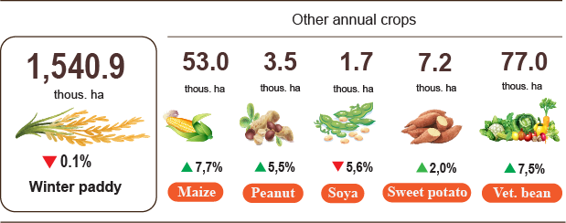

Livestock
Buffalo and cow husbandry in the month tended to decrease, and diseases are basically under control. Currently, it is being the time for farmers to focus on re-herding, increasing herds, and taking care of livestock and poultry to supply meat to the market in the last months of the year and the upcoming holidays. To stabilize the domestic production and consumption market, it is necessary to drastically implement many measures and policies to prevent and control diseases, effectively organize vaccination; monitor, detect and promptly handle new outbreaks of unknown origin to ensure the rights of farmers and consumers.
Figure 2. The growth rate of the population of livestock
at the end of October, 2024 compared to the same time last year
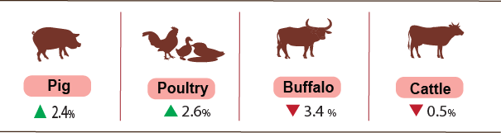

As of October 28, 2024, the whole country has no longer blue-ear disease; foot-and-mouth disease was still in Bac Kan; avian flu disease was still in Nghe An; LSD was still in Cao Bang, Nghe An, Dak Lak and African swine fever was reported in 28 localities for less than 21 days.

Logging activities continued to be boosted due to increased demand for raw wood. Aquaculture strived to maintain growth, raising pangasius and brackish water shrimp to meet domestic consumption and export in the last months of the year, while fishing decreased due to the impact of weather and storms.
b) Forestry
The area of concentrated newly planted forests nationwide in October 2024 was estimated at 33.1 thousand hectares, up 6.2% over the same period last year. Some provinces have a high increase in newly planted forest area: Ca Mau increased by 121.2%; Quang Binh increased by 19.0%; Nghe An increased by 15.2%; Quang Nam 5.5%. The number of scattered forest trees planted reached 7.9 million trees, up 4.2% over the same period last year. The output of exploited timber in the month reached 2,420.8 thousand m³, up 14.7% due to the increased demand for raw wood at processing factories and stable wood prices, people are actively exploiting forests that are at harvest age. Some localities have high increases in exploited wood output such as: Quang Tri increased by 29.5%; Bac Kan increased by 22.8%; Quang Binh increased by 17.6%; Nghe An increased by 15.0%. In addition, in some localities affected by storm No. 3, many areas of forest were broken and eroded and had to be fully exploited, so the exploited wood output increased sharply, such as Quang Ninh increased by 170.0%; Yen Bai increased by 78.7%; Lang Son increased by 32.0%.
Generally,in 10 months of 2024, the area of ​​newly planted concentrated forests was estimated at 233.0 thousand hectares, up 3.7% over the same period last year; the number of scattered forestry trees is estimated at 80.3 million trees, up 4.3%; the output of exploited wood reached 18,489.7 thousand m3, up 7.9%.
The damaged forest area in October, the area of ​​forest damaged was 43.1 hectares, down 37.4% over the same period last year. Of which, the area of ​​forest cut down and destroyed was 42.3 hectares, down 30.7%; the area of ​​forest burned was 0.8 hectares, down 89.5%. In the first ten months of 2024, the whole country had 1,506.3 hectares of damaged forest, down 9.4% over the same period last year. Of which, the area of ​​forest cut down and destroyed was 762.4 hectares, down 22.5%; the area of ​​forest burned was 743.9 hectares, up 9.5%.
c) Fishery
Fishery output in October 2024 was estimated at 870.7 thousand tons, up 2.6% over the same period last year, including: Fish reached 561.0 thousand tons, up 2.4%; shrimp estimated at 176.3 thousand tons, up 2.7%; other aquatic products estimated at 125.0 thousand tons, up 2.6%.
Aquaculture production in October output was estimated at 567.7 thousand tons, up 4.3% over the same period last year. Of which: Fish output reached 379.2 thousand tons, up 3.8%; shrimp output reached 130.9 thousand tons, up 8.6%.
Pangasius production in October is estimated at 180.7 thousand tons, up 5.4% over the same period last year due to increased pangasius exports in both volume and value, increased prices of raw pangasius, so farmers and businesses adjusted farming output accordingly to meet processing and export activities.
Shrimp production in October increased compared to the same period last year due to the increase in prices of black tiger shrimp and whiteleg shrimp, so farmers have increased the harvest. Whiteleg shrimp output was estimated at 97.5 thousand tons, up 9.3% over the same period last year; black tiger shrimp output was estimated at 24.5 thousand tons, up 6.5%.
The caught fishery production in October was estimated at 303.0 thousand tons, down 0.4% over the same period last year, including: Fish reached 230.8 thousand tons, down 0.4%; shrimp reached 13.4 thousand tons, down 0.7%; other aquatic products reached 58.8 thousand tons, down 0.2%. The output of exploited marine aquatic products was estimated at 282.3 thousand tons, down 0.5% over the same period last year.
Figure 3. Fishery production in 10 months of 2024
over the same period last year
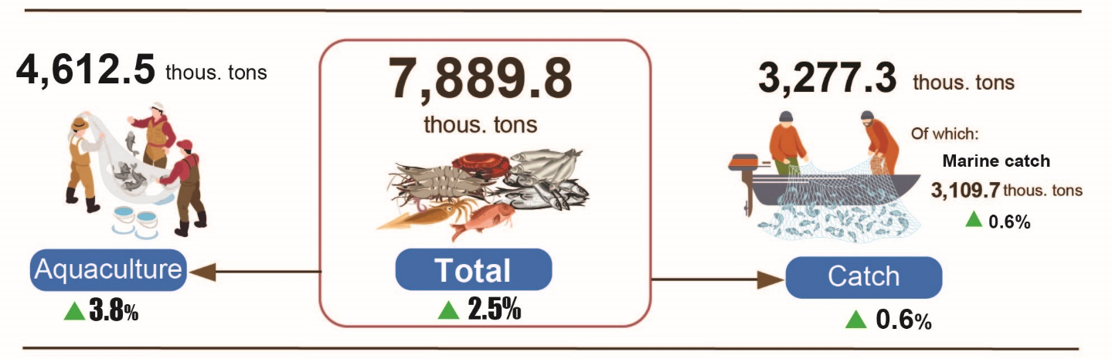
Generally, in 10 months of 2024, fishery output was estimated at 7,889.8 thousand tons, up 2.5% over the same period last year. Including: Fish reached 5,528.3 thousand tons, up 2.3%; shrimp reached 1,226.0 thousand tons, up 4.6%; other aquatic products reached 1,135.5 thousand tons, up 1.0%.
2. Industrial production
Industrial production in October continued the positive trend, it is estimated that the industrial production index in October 2024 will increase by 4.0% compared to the previous month and increase by 7.0% over the same period last year. Generally, in the first ten months of 2024, the production index of the whole industry is estimated to increase by 8.3% over the same period last year.
The index of industrial production (IIP) in October 2024 is estimated to increase by 4.0% compared to the previous month and increase by 7.0% over the same period last year. In which, compared to the same period last year, the manufacturing industry increased by 8.8%; the electricity production and distribution industry increased by 6.0%; water supply; sewerage, waste management and remediation activities increased by 6.9%; mining and quarying industry alone decreased by 10.4%.
Generally, in the first ten months of 2024, IIP is estimated to increase by 8.3% over the same period last year (the same period in 2023 increased by 0.5%). In which, manufacturing industry increased by 9.6% (the same period in 2023 increased by 0.5%), contributing 8.3 percentage points to the overall increase; the electricity production and distribution industry increased by 10.3%, contributing 0.9 percentage points; water supply; sewerage, waste management and remediation activities increased by 9.5%, contributing 0.2 percentage points; mining and quarying industry alone decreased by 7.2%, reducing 1.1 percentage points in the overall increase.
The production index in the first ten months of 2024 of a number of key industries at level 2 increased significantly compared to the same period last year: Manufacture of rubber and plastics products increased by 26.3; manufacture of furniture increased by 24.8%; manufacture of coke and refined petroleum products increased by 16.0%; manufacture of chemicals and chemical products increased by 14.6%; manufacture of motor vehicles; trailers and semi-trailers increased by 14.0%; manufacture of textiles increased by 12.1%; manufacture of fabricated metal products, except machinery and equipment increased by 11.9%; manufacture of leather and related products increased by 11.4%; manufacture of computer, electronic and optical products increased by 8.8%; Manufacture of food products increased by 7.5%. In the opposite direction, the IIP index of some industries increased low or decreased: Manufacture of other transport equipment increased by 3.0%; manufacture of beverages increased by 0.9%; crude oil and natural gas extraction decreased by 11.8%; mining of coal and lignite decreased by 5.9%; Repair and installation of machinery and equipment decreased by 3.9%; manufacture of other non-metallic mineral products decreased by 0.4%.

Table 1. Rate of increase/decrease of IIP index in 10 months of 2020-2024
compared to the same period last year of some key industries
%
 | 2020 | 2021 | 2022 | 2023 | 2024
Mining of coal and lignite | 7.1 | 5.1 | 7.0 | -0.6 | -5.9
Crude oil and natural gas extraction | -11.7 | -13.4 | 2.4 | -3.6 | -11.8
Manufacture of beverages | -5.9 | -4.3 | 32.5 | 3.3 | 0.9
Manufacture of textiles | -0.6 | 8.0 | 4.0 | 4.7 | 12.1
Manufacture of leather and related products | -2.8 | 4.1 | 17.5 | -1.2 | 11.4
Manufacture of coke and refined petroleum products | 4.9 | 8.8 | 7.0 | 1.1 | 16.0
Manufacture of chemicals and chemical products | 7.5 | -1.2 | 4.9 | 8.0 | 14.6
Manufacture of rubber and plastics products | 4.3 | -2.0 | -5.4 | 10.2 | 26.3
Manufacture of other non-metallic mineral products | 3.9 | 3.9 | 8.6 | 8.0 | -0.4
Manufacture of fabricated metal products. except machinery and equipment | 9.5 | 7.7 | 9.1 | -1.8 | 11.9
Manufacture of computer. electronic and optical products | -10.7 | 13.5 | 6.4 | -4.1 | 8.8
Manufacture of motor vehicles; trailers and semi- | -9.9 | -3.3 | 11.0 | -7.9 | 14.0
Manufacture of other transport equipment | 6.6 | 2.3 | 3.1 | 4.9 | 3.0
Manufacture of furniture | -7.9 | -8.5 | 5.9 | 4.2 | 24.8
Repair and installation of machinery and equipment | 7.1 | 5.1 | 7.0 | -0.6 | -3.9

The industrial production index in the first ten months of 2024 compared to the same period last year increased in 59 localities and decreased in 04 localities across the country. Some localities have a fairly high IIP index due to the manufacturing industry ; electricity production and distribution industry; mining industry soars. In the opposite direction. some localities have a low increase or decrease in the IIP index due to the processing industry. manufacturing and manufacturing industry. low or decreased power distribution .
Figure 4. Rate of increase/decrease of IIP in the first 10 months of 2024
compared to the same period last year of some localities
10 localities with the highest increase in IIP index (%)  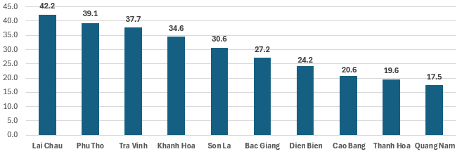 | 10 localities with IIP index  lowest increase/largest decrease (%)  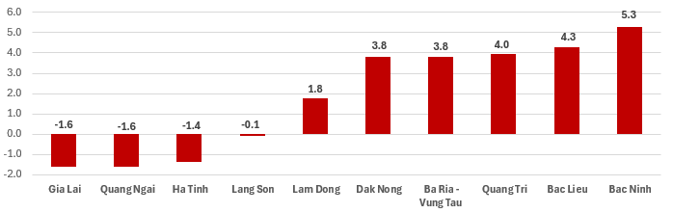

In the first ten months of 2024, several key industrial products showed growth compared to the same period last year. Notable increases include rebar and angle steel (up by 21.8%), gasoline (up by 17.6%), rolled steel (up by 16.4%), automobiles (up by 15.8%), fabrics woven from natural fibers (up by 15.0%), sugar (up by 14.5%), powdered milk (up by 12.8%), and NPK mixed fertilizers (up by 11.5%). However, some products experienced a decline, including natural gas (down by 17.3%), liquefied petroleum gas (LPG) (down by 14.6%), clean coal (down by 5.9%), crude oil extraction (down by 5.8%), mobile phones (down by 5.6%), beer (down by 2.6%), and aluminum (down by 1.9%).
In terms of employment, the number of workers in industrial enterprises as of October 1, 2024, increased by 1.0% compared to the previous month and by 5.7% year-on-year. Specifically, the number of workers in state-owned enterprises rose by 0.2% from the previous month and by 1.1% from the previous year, while private enterprises saw a 0.8% increase from the previous month and 2.9% from the same time last year. Foreign-invested enterprises experienced the most significant growth, with a 1.2% increase compared to the previous month and a 7.1% increase year-on-year. By sector, the mining industry remained stable with no change in the number of workers compared to the previous month but saw a slight decrease of 0.1% year-on-year. In contrast, the manufacturing and processing sector saw a 1.1% increase from the previous month and a 6.1% increase compared to the same period last year. The electricity, gas, hot water, steam, and air conditioning supply sector remained stable month-on-month but grew by 1.1% year-on-year. The water supply, waste management, and wastewater treatment sector saw a slight increase of 0.1% from the previous month and a 1.5% increase from the previous year.
3. Enterprise activities
a) Enterprise registration status
In October, the whole country had nearly 14.2 thousand newly established enterprises with registered capital was over 153.5 trillion VND and a total number of registered employees of nearly 80.5 thousand employees, an increase of 26.5% in the number of enterprises, an increase of 65.4% in registered capital and an increase of 27.8% in the number of employees compared to September 2024. Compared to the same period last year, down 9.8% in the number of enterprises, up 9.5% in registered capital and down 39.2% in the number of employees. The average registered capital of a newly established enterprise in the month reached 10.8 billion VND, an increase of 30.8% compared to the last month and up 21.4% compared to the same period of 2023. Besides, there were nearly 8.7 thousand enterprises resumed in the whole country, up 33.5% compared to the previous month and up 53.7% compared to the same period of 2023.
Generally, in the ten months of 2024, the whole country had neaaly 136.1 thousand newly registered enterprises with a total registered capital of nearly 1,312.1 trillion VND and a total number of registered employees was nearly 815.6 thousand employees, up 1.9% in the number of enterprises, up 4.1% in registered capital and down 8.7% in the number of employees compared to the same period last year. The average registered capital of a newly established enterprise in the ten months of 2024 achieved 9.6 billion VND, up 2.2% to the same period of 2023. The total number additional registered captial into the economy in the ten months of 2024 was nealy 2,613.1 trillion VND, a year-on-year reduction of 4.7%. Besides, there were more than 66.2 thousand enterprises resumed (a year-on-year increase of 27.7%), levering the total number of newly established enterprises and resumed enterprises in the ten months of 2024 to over 202.3 thousand enterprises, a year-on-year increase of 9.1%. On average, there were over 20.2 thousand newly established and resumed enterprises per month.
By economic sector in the ten months of 2024, there were 1,373 newly established enterprises in the agricultural, forestry, and fishery sectors, a year-on-year decrease of 5.2%; nearly 31.6 thousand enterprises in the industrial and construction sectors, a decrease of 0.5%; more than 103.1 thousand enterprises in the service sector, an increase of 2.7%.
Figure 6. Enterprise registration situation
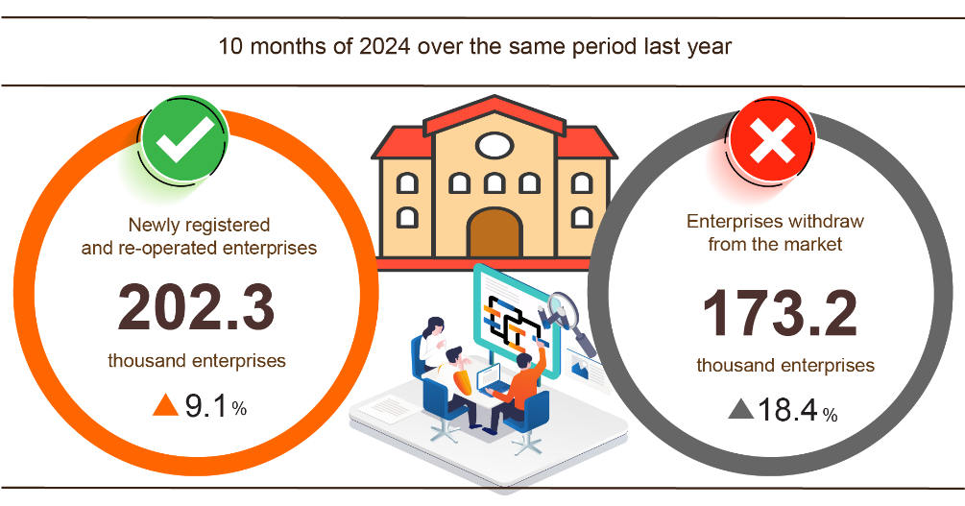
Also in October, 5,454 teamporarily inactive enterprises, up 28.8% compared to the previous month and down 0.9% over the same period in 2023; 5,424 enterprises ceased and awaited dissolution procedures, down 26.8% and up 10.7%; 1,987 enterprises completed dissolution procedures, up 23.8% and up 34.3%.
In the ten months of 2024, the number of teamporarily inactive enterprises was more than 92.1 thousand ones, a year-on-year increase of 13.6%; over 63.7 thousand enterprises ceased and awaited dissolution procedures, an increase of 25.6%; nearly 17.4 thousand enterprises completed dissolution procedures, up 20.5%. On average, there were 17.3 thousand enterprises withdrawing from the market per month.
Table 3: Number of newly registered enterprises and completed dissolution procedures in the ten months of 2024 by kinds of activity

 | Number of enterprises (Enterprise) |  | Growth rate over  the same period last year (%)
 | Newly registered | Dissolution | Newly registered | Dissolution
Wholesale and retail trade; repair of motor vehicles and motorcycles | 55,612 | 6,941 | 7.5 | 28.9
Manufacturing | 16,486 | 1,865 | 3.9 | 19.3
Construction | 13,555 | 1,193 | -5.3 | 14.1
Real estate business | 3,896 | 1,020 | 0.7 | -1.4
Transportation and storage | 7,317 | 651 | 11.3 | 17.1
Accommodation and catering service | 5,024 | 798 | -11.9 | 5.4
Production and distribution of electricity, water, gas | 996 | 213 | 7.6 | -13.4

4. Investment
Investment capital from the State budget is being focused on by ministries, branches and localities. In the first ten months of 2024, the investment capital implemented from the State budget is estimated to reach 64.3% of the annual plan, up 1.8% over the same period last year. Foreign direct investment (FDI) implemented in Vietnam in the first ten months of 2024 is estimated to reach 19.58 billion USD, up 8.8% over the same period last year .
Investment capital implemented from the State budget in October 2024 is estimated at 68.4 trillion VND, up 1.5% over the same period last year, including: Centrally managed capital reached 12.3 trillion VND, up 7.9%; locally managed capital reached 56.1 trillion VND, up 0.2%. In the first ten months of 2024, investment capital implemented from the State budget is estimated at 495.9 trillion VND, equal to 64.3% of the annual plan and up 1.8% over the same period last year (the same period in 2023 was equal to 66.5% and up 24.6%). Specifically:
- The realized investment capital managed by the Central Government is estimated at 87.2 trillion VND, equal to 70.1% of the annual plan and down 0.2% over the same period last year. Of which, the Ministry of Transport reached 54.2 trillion VND, down 15.5%; the Ministry of Agriculture and Rural Development reached 7.6 trillion VND, up 23.8%; the Ministry of Health reached 995.5 billion VND, up 43.4%; the Ministry of Education and Training reached 874.4 billion VND, up 9.0%; the Ministry of Natural Resources and Environment reached 546.1 billion VND, down 43.5%; the Ministry of Industry and Trade reached 526.5 billion VND, up 20.6%.
- Realized investment capital managed by localities is estimated at 408.7 trillion VND, equal to 63.2% of the annual plan and up 2.3% over the same period last year, of which:
Provincial State budget capital reached nearly 274.0 trillion VND, equal to 60.0% and increased by 1.1% over the same period in 2023;
District-level State budget capital reached 115.9 trillion VND, equal to 68.9% and increased by 4.8%;
State budget capital at commune level reached 18.8 trillion VND, equal to 85.8% and increased by 4.7%.
Investment capital implemented from the State budget in the first ten months of 2024 of a number of provinces and centrally run cities is as follows:
Figure 6. Investment capital implemented from the State budget
of some localities

Total foreign investment capital registered in Vietnam As of October 31, 2024, including: Newly registered capital, adjusted registered capital and capital contribution and share purchase value of foreign investors reached 27.26 billion USD, up 1.9% over the same period last year.
Figure 7. Foreign investment capital registered in Vietnam
in 10 months of 2020-2024 (Billion USD)

- Newly registered capital has 2,743 licensed projects with registered capital reaching 15.23 billion USD, up 1.4% over the same period last year in terms of number of projects and down 2.5% in terms of registered capital. Of which, the processing and manufacturing industry is the one with the largest newly licensed foreign direct investment with registered capital reaching 9.79 billion USD, accounting for 64.2% of the total newly registered capital; real estate business activities reached 3.24 billion USD, accounting for 21.3%; the remaining industries reached 2.2 billion USD, accounting for 14.5%.
Among the 76 countries and territories with newly licensed investment projects in Vietnam in the first ten months of 2024, Singapore was the largest investor with 4.98 billion USD, accounting for 32.7% of the total newly registered capital; followed by South Korea with 2.08 billion USD, accounting for 13.7%; China with 2.07 billion USD, accounting for 13.6%; Hong Kong Special Administrative Region (China) with 1.69 billion USD, accounting for 11.1 % .
- Adjusted registered capital: 1,151 licensed projects from previous years registered to adjust investment capital by an additional 8.35 billion USD, up 41.7% over the same period last year.
If including newly registered capital and adjusted registered capital of licensed projects from previous years, foreign direct investment capital registered in the processing and manufacturing industry reached 16.39 billion USD, accounting for 69.5% of the total newly registered and increased capital; real estate business activities reached 4.41 billion USD, accounting for 18.7%; the remaining industries reached 2.78 billion USD, accounting for 11.8%.
- Foreign investors registered to contribute capital and purchase shares with a total value of 3.68 billion USD, down 29.9% over the same period last year. Of which, 966 contributed capital and purchased shares increased the charter capital of enterprises with a capital contribution value of 1.87 billion USD; 1,703 foreign investors bought back domestic shares without increasing the charter capital with a value of 1.81 billion USD. Regarding the form of capital contribution and purchase shares of foreign investors, the investment capital in real estate business activities reached 815.8 million USD, accounting for 22.2% of the contributed capital value; professional activities, science and technology reached 691.2 million USD, accounting for 18.8%; the remaining sectors reached 2.17 billion USD, accounting for 59.0%.
Foreign direct investment implemented in Vietnam in 10 months of 2024 was 19.58 billion USD, an increase of 8.8% over the same period last year. Of which: Processing and manufacturing industry reached 15.8 billion USD, accounting for 80.7% of total realized foreign direct investment; real estate business activities reached 1.56 billion USD, accounting for 8.0%; production and distribution of electricity, gas, hot water, steam and air conditioning reached 801.7 million USD, accounting for 4.1%.

Figure 8. Foreign direct investment realized
in 10 months of 2020-2024 (billion USD)

Vietnam's overseas investment in the ten months of 2024 had 124 projects newly granted investment certificates with a total capital of Vietnam's side of 429.9 million USD, an increase of 71.2% over the same period last year; there were 21 projects with adjusted capital with an increased capital of 43.2 million USD, a decrease of 75.1%.
In the ten months of 2024, Vietnam's total investment capital abroad (newly granted and adjusted capital) reached 473.1 million USD, an increase of 11.5% over the same period last year. Of which: Scientific and technological professional activities reached 200.5 million USD, accounting for 42.4% of total investment capital; processing and manufacturing industry reached 70.8 million USD, accounting for 15.0%; mining reached 58.6 million USD, accounting for 12.4%; wholesale and retail, repair of automobiles, motorcycles, motorbikes and other motor vehicles reached 36.2 million USD, accounting for 7.6%; transportation and warehousing reached 33.2 million USD, accounting for 7.0%; production and distribution of electricity, gas, hot water and air conditioning reached 23.9 million USD, accounting for 5.0%; other services reached 10.2 million USD, accounting for 2.2%.
In the ten months of 2024, 30 countries and territories received investment from Vietnam, of which: Indonesia was the leading country with 127.7 million USD, accounting for 27.0% of total investment capital; India 90.1 million USD, accounting for 19.0%; Laos 77.9 million USD, accounting for 16.5%; Netherlands 54.6 million USD, accounting for 11.5%; United States 42.8 million USD, accounting for 9.0%; Gi-rata 29.4 million USD, accounting for 6.2%; Cambodia 27.2 million USD, accounting for 5.8%; United Kingdom 20.4 million USD, accounting for 4.3%.
5. State budget revenue and expenditure
State budget revenue in ten months of 2024 was estimated to increase by 17.3% over the same period last year. State budget expenditure was estimated to increase by 4.1% over the same period last year, ensuring the needs of socio-economic development, national defense, security, State management, payment of due debts as well as timely payment to subjects according to regulations.

Figure 9. State budget revenue and expenditure for 10 months of 2024
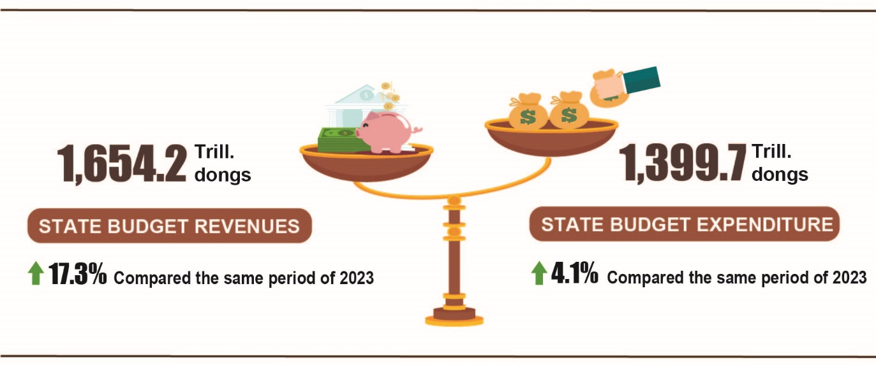

State budget revenue
Total state budget revenue in October 2024 was estimated at 178.5 trillion VND. Cumulative total state budget revenue in ten months of 2024 reached 1,654.2 trillion VND, equal to 97.2% of the annual estimate and an increase of 17.3% over the same period last year. In particular, some main revenue items are as follows:
- Domestic revenue in October 2024 was estimated at 154.1 trillion VND; accumulated revenue in ten months of 2024 reached 1,377.6 trillion VND, equal to 95.4% of the annual estimate and an increase of 18.1% over the same period last year.
- Revenue from crude oil in October 2024 was estimated at 4.8 trillion VND; accumulated revenue in ten months of 2024 reached 48.9 trillion VND, equal to 106.2 % of the annual estimate and down 6.0% over the same period last year.
- Budget revenue from import and export activities in October 2024 was estimated at 19.5 trillion VND; accumulated revenue in ten months of 2024 was 227.2 trillion VND, equal to 111.4 % of the annual estimate and an increase of 18.9% over the same period last year.
State budget expenditure
Total state budget expenditure in October 2024 was estimated at VND 155.4 trillion; the accumulated expenditure in ten months of 2024 is estimated at VND 1,399.7 trillion, equivalent to 66.0% of the annual estimate and up 4.1% over the same period last year. Of which, regular expenditure in ten months of 2024 reached VND 956.3 trillion, equivalent to 75.9% of the annual estimate and up 9.5% over the same period last year; development investment expenditure reached VND 355.6 trillion, equivalent to 52.5% and down 8.7%; debt interest payment was VND 85.8 trillion, equivalent to 76.8% and up 8.1%.
6. Trade, prices, transport and tourism
a) Retail sales of consumer goods and services
Domestic consumption and production demand often increases in the last months of the year, contributing to the growth of the service industry. The total retail sales of consumer goods and services in 10/2024 increased by 2.4% compared to the previous and increased by 7.1% over the same period last year. Overall, in ten months of 2024, the total retail sales of consumer goods and services was estimated to increase by 8.5% over the same period last year, of which revenue from accommodation and food services increased by 12.5%, revenue from tourism up to 14.2%.
Total retail sales of consumer goods and services at current prices in 10/2024 was estimated at 545.7 trillion VND, up 7.1% over the same period last year, of which, the group of food and foodstuffs increased by 12.0%; means of transport (except for cars) rose up 21.4%
Table 3. Retail sales of consumer goods and services at current prices

Trillion VND
 | Estimate  October  2024 | Estimate  10 months  of 2024 | Growth rate compared to the same period last year (%)
 | Estimate  October  2024 | Estimate  10 months  of 2024 | October  in 2024 | 10 months  of 2024
Total | 545,7 | 5.246,2 | 7,1 | 8,5
Retail sale of goods | 419,5 | 4.048,6 | 7,4 | 7,8
Accommodation and catering service | 61,2 | 602,3 | 6,5 | 12,5
Tourism revenue | 4,8 | 50,3 | -1,9 | 14,2
Other services | 60,2 | 545,0 | 6,8 | 9,0
Generally for ten months of 2024, the total retail sales of consumer goods and services at current prices was estimated at 5,246.2 trillion VND, up 8.5% over the same period last year (up 9.8% in the same period in 2023), if excluding the price factor, up 4.6% (the same period in 2023 increased by 7.3%).
Figure 11. Total retail sales of consumer goods and service
in 10 months of 2020-2024

Retail sales of goods in ten months of 2024 were estimated at 4,048.6 trillion VND, accounting for 77.2% of the total retail sales of consumer goods and services and up 7.8% over the same period last year. In which, food and foodstuffs increased by 10.7%; household appliances, tools and equipment increased by 8.0%; garment increased by 8.7%; means of transport (except for cars) rose up 7.5%; cultural and educational products increased by 6.6%. Retail sales of goods in the first five months of this year compared to the same period last year of some localities was as follows: Quang Ninh increased by 9.6%; Hai Phong increased by 9.5%; Thua Thien - Hue increased by 8.1%; Can Tho increased by 7.6%; Da Nang increased by 7.5%.
Revenue from accommodation and catering services in ten months of 2024 was estimated at 602.3 trillion VND, accounting for 11.5% and up 12.5% over the same period last year. Revenue in ten months of 2024 compared to the same period last year of some localities was as follows: Khanh Hoa increased by 17.1%; Hai Phong increased by 13.1%; Can Tho increased by 11.6%; Binh Duong increased by 8.0%.
Tourism revenue in ten months of 2024 was estimated at 50.3 trillion VND, accounting for 0.9% and up 14.2% over the same period last year. The revenue of some localities in ten months of 2024 compared to the same period last year was as follows: Can Tho increased by 31.2%; Ho Chi Minh City increased by 15.9%; Khanh Hoa increased by 15.4%; Binh Dinh increased by 11.9%; Ha Noi increased by 9.8%; Da Nang increased by 6.1%.
Other service revenue in ten months of 2024 was estimated at 545.0 trillion VND, accounting for 10.4% and up 9.0% over the same period last year. Revenue in ten months of 2024 of some localities was as follows: Binh Dinh increased by 20.0%; Vung Tau increased by 13.7%; Can Tho increased by 11.7%; Hung Yen decreased by 9.9%; Da Nang decreased by 0.7%.
b) Export and import of goods
Total export and import turnover of goods in 10/2024 was estimated at 69.19 billion USD, up 5.1% over the previous month and up 11.8% over the same period last year. Generally, in ten months of 2024, the total export and import turnover of goods reached 647.87 billion USD, up 15.8% over the same period last year, of which exports increased by 14.9%; imports increased by 16.8%. The trade balance of goods had a surplus of 23.31 billion USD.
Figure 11. Import and export of goods in 10 months of 2024
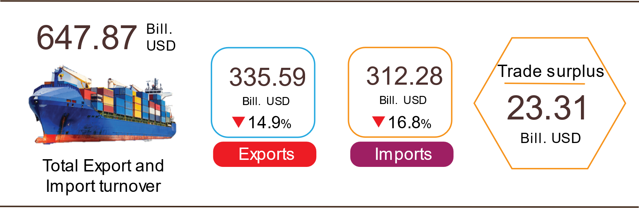

Export of goods
Preliminary export turnover of goods in 9/2024 reached USD 34.1 billion.
Preliminary export turnover of goods in 10/2024 reached 35.59 billion USD, up 4.4% over the previous month. Of which, the domestic economic sector gained 10.3 billion USD, increased by 9.8%; the FDI sector (including crude oil) reached 25.29 billion USD, increased by 2.4%. Compared to the same period last year, export turnover of goods in October increased by 10.1%, of which the domestic economic sector increased by 17.7%, the FDI sector (including crude oil) increased by 17.3%.
Generally in ten months of 2024, preliminary export turnover reached 335.59 billion USD, increased by 14.9% over the same period last year. Of which, the domestic economic sector was 93.97 billion USD, went up 20.7%, accounting for 28.0% of total export turnover; the FDI sector (including crude oil) attained 241.62 billion USD, increased by 12.8%, sharing 72.0%.
In ten months of 2024, there were 31 products with export turnover of over 1 billion USD, contributing 92.6% to the total export turnover (7 products with export turnover of over 10 billion USD, accounting for 66.5%).
Table 4. Value of some export products in 10 months of 2024
 | Estimate  (Mill. USD) | Growth rate compare to  the same period last year (%)
Items with a value of over 10 billion USD
Electronic goods, computers and their parts | 58,666 | 26.1
Phones all of kinds and their parts | 46,467 | 4.9
Machinery, instrument, accessory | 43,049 | 21.5
Textiles and garments | 30,572 | 10.5
Footwear | 18,574 | 12.9
Wood and products | 13,219 | 21.2
Means of transport and components | 12,517 | 5.9

Regarding the structure of exported groups in ten months of 2024, the group of fuels and minerals was estimated at 3.57 billion USD, accounting for 1.1%; the group of processing industry was estimated at 295.23 billion USD, accounting for 88.0%; agricultural and forestry products was estimated at 28.54 billion USD, accounting for 8.5%; the group of fishery products was estimated at 8.25 billion USD, accounting for 2.4%.
Figure 12. Structure of exported groups
in 10 months of 2024

Import of goods
Preliminary import turnover of goods in 9/2024 reached 31.8 billion USD.
Preliminary import turnover of goods in 10/2024 reached 33.6 billion USD, increased by 5.8% over the previous month. Of which the domestic economic sector gained 12.68 billion USD, increased by 15.9%; the FDI sector reached 20.92 billion USD, increased by 0.5%. Compared to the same period last year, the import turnover of goods in October increased by 13.6%, of which the domestic economic sector increased by 18.6%; the FDI sector increased by 10.7%.
Generally, in ten months of 2024, preliminary import turnover of goods reached 312.28 billion USD, increased by 16.8% over the same period last year. Of which the domestic economic sector reached 113.58 billion USD, went up 18.8%; the FDI sector gained 198.7 billion USD, up 15.8%.
In ten months of 2024, there are 42 imported products with a turnover of over 1 billion USD, accounting for 92.1% of total import turnover (4 products with import turnover of over 10 billion USD, accounting for 48.3%).
Table 5. Value of some imported goods in 10 months of 2024
 |  | Estimate | Growth rate compare to
 |  | (Mill. USD) | the same period last year (%)
Items with a value of over 10 billion USD
 | Electronic devices, computers and their parts | 88,253 | 23.7
 | Machinery, instrument, accessory | 39,701 | 17.0
 | Fabrics | 12,273 | 14.7
 | Iron, steel | 10,477 | 23.2
Figure 13. Structure of imported groups
in 10 months of 2024
Regarding the structure of imported groups in ten months of 2024, the group of production materials was estimated at 292.57 billion USD, accounted for 93.7%, in which the group of machinery, equipment, tools spare parts accounted for 47.3%; raw materials, fuel and materials accounted for 46.4%. The group of consumer products was estimated at 19.71 billion USD, accounted for 6.3%.
Regarding the export and import market of goods in ten months of 2024, the United States was the Viet Nam's largest export market with a turnover of 98.4 billion USD. China remained the largest import market of Viet Nam with a turnover of 117.7 billion USD. In ten months of 2024, the trade surplus to the United States reached 86.1 billion USD, up 26.9% over the same period last year; the trade surplus to the EU 28.5 billion USD, up 18.6%; the trade surplus to Japan was 2.4 billion USD, up 56.9%; the trade deficit from China was 66.9 billion USD, went up 68.5%; the trade deficit from Korea was 25.3 billion USD, went up 8.1%; the trade deficit from ASEAN was 7.3 billion USD, increased by 6.4%.
Figure 14. Major commodities import and export markets
in 10 months of 2024
 |  | Export of goods | Import of goods
The preliminary trade balance of goods in September had a trade surplus of 2.32 billion USD; the nine-month trade surplus was 21.32 billion USD; and the preliminary trade surplus in October was 1.99 billion USD. Generally in ten months of 2024, the preliminary trade balance of goods had a trade surplus of 23.31 billion USD (in the same period last year, the trade surplus of 24.8 billion USD). Of which, the domestic economic sector has a trade deficit of 19.61 billion USD; the FDI sector (including crude oil) had a trade surplus of 42.92 billion USD.
c) Consumer price index, gold price index and US dollar price index
Food prices continue to increase due to the impact of storms, domestic gasoline prices increase according to world prices, and housing rental prices increase are the main causes of the consumer price index (CPI) in October 2024 increased 0.33% compared to the previous month. CPI in October increased by 2.52% compared to December 2023 and increased by 2.89% over the same period last year.
On average in the ten months of 2024, CPI increased by 3.78% over the same period last year; Core inflation increased by 2.69%.
In the 0.33% increase in CPI in October 2024 compared to the previous month, there were 10 groups of goods and services with increased price indexes and 01 group of goods with decreased price indexes.
Figure 15. CPI growth rate in 10/2024 compared to the previous month

Ten groups of goods and services with increased price indexes include:
- The transport group increased the most with 0.66% (making the general CPI increase of 0.06 percentage points), mainly due to: Diesel oil price increased by 2.27%; domestic gasoline prices increased by 0.98% due to the impact of price adjustments during the month. Passenger transport prices by air increased by 32.75% due to increased consumer demand; prices of other bicycle parts increased by 0.48%; motorbike repair increased by 0.45%; bicycle repair increased by 0.27%; Other motorbike spare parts increased by 0.25%; bicycle tires and tubes increased by 0.21%; motorcycle tires and tubes increased by 0.19%. In addition, there are a number of discounted items: New car prices and passenger transport prices by road both decreased by 0.1%; used cars decreased by 0.23%.
- Food and foodstuff group increased by 0.55% (making the general CPI increase by 0.18 percentage points). Of which, food increased by 0.77%; foodstuff increased by 0.66% (impact increased by 0.14 percentage points); eating out at home increased by 0.19%.
- The education group increased by 0.48%, of which the price of educational services increased by 0.53% due to some private preschools, colleges, vocational schools, intermediate schools, universities, and postgraduate schools increasing tuition. In addition, some localities also have tuition exemption and reduction policies to support people affected by storms and floods such as Quang Ninh, Ha Giang, Yen Bai... In addition, the price of pens increased by 0, 13%; prices of stationery and other school supplies increased by 0.09%; prices of paper products and textbooks both increased by 0.07%.
- Other goods and services group increased by 0.26%. Of which, jewelry prices increased by 4.67% according to domestic gold prices; elderly care services increased by 0.69%; watch repair increased by 0.51%; personal care services increased by 0.46%; environmental sanitation services increased by 0.4%.
- Household appliances and equipment group increased by 0.2% due to increased consumer demand and many promotional programs in some localities have ended. Of which, the price of electric irons increased by 1.27%; vacuum cleaners increased by 0.68%; bathroom water heater increased by 0.67%; beds, wardrobes, tables and chairs increased by 0.58%; plastic and rubber products increased by 0.42%; home appliance repair services increased by 0.25%; rent of household appliances increased by 0.24%; soaps, detergents and other consumer goods increased by 0.22%; waiter hiring increased by 0.19%; wall clocks, desk clocks, and mirrors increased by 0.14%; home textiles increased by 0.12%; electrical appliances increased by 0.08%; glass, porcelain, and porcelain products increased by 0.05%.
- Beverage and cigarette group increased by 0.11% due to increased labor costs and exchange rates. Specifically: Mineral water prices increased by 0.27%; smoking increased by 0.23%; fruit juice increased by 0.15%; bottled beer increased by 0.13%; wine of all kinds increased by 0.06%.
- The group of housing, electricity and water, fuel and construction materials increased by 0.11% mainly due to the following reasons: Gas prices increased by 1.17%, the reason is that from October 1, 2024, gas prices in water adjusted to increase according to world gas prices; kerosene prices increased by 1% due to the impact of price adjustments during the month; house rent increased by 0.73%; domestic water increased by 0.24%. In the opposite direction, household electricity prices decreased by 2.02% due to cool weather, so consumer demand decreased.
- The garment, hat and footwear group increased by 0.09% due to increased shopping demand when the weather changes. In particular, the price of shoe and sandals services increased by 0.32%; garment services increased by 0.25%; other garments increased by 0.18%; fabrics of all kinds increased by 0.12%; ready-made clothes increased by 0.1%; headwear increased by 0.06%.
- The culture, entertainment and tourism group increased by 0.09% because the month had Vietnamese Women's Day, so the demand for buying flowers increased, the price of plants and ornamental flowers increased by 1.27%; watching movies and music increased by 0.38%. Besides, newspaper prices of all types increased by 1.48%; children's toy prices increased by 0.07%.
- The group of medicines and medical services increased by 0.02% due to the transition between the two seasons, flu and respiratory diseases increased, so the demand for pain relief, fever reduction, respiratory medicine, etc. vitamins and minerals increased. Of which, gastrointestinal drugs increased by 0.25%; cardiovascular drugs increased by 0.09%; pain relievers and antipyretics increased by 0.07%; vitamin and mineral drugs increased by 0.01%.
Particularly, the post and telecommunications group decreased by 0.05%. Of which, smartphone and tablet accessories decreased by 0.46%; prices of smart mobile phones and tablets decreased by 0.28%; the price of regular mobile phones decreased by 0.17%. In contrast, phone repair prices increased by 0.4% due to increased labor costs.
Core inflation in October 2024 increased by 0.23% over the previous month, up 2.68% over the same period last year.
On average in the ten months of 2024, core inflation will increase by 2.69% over the same period in 2023, lower than the general average CPI increase (3.78%), mainly due to food and electricity prices. Activities, educational services, medical services and petroleum are factors that increase CPI but are in the group of goods excluded from the list of core inflation calculations.
Domestic gold prices fluctuate in the same direction as world gold prices. As of October 27, 2024, the average world gold price is at 2,693.44 USD/ounce, up 4.0% compared to September 2024 due to increasingly serious geopolitical tensions in the Middle East. In addition, the prolonged conflict between Russia and Ukraine and fluctuations in the Korean Peninsula have increased concerns about global political instability. Along with that, the fact that major central banks such as the European Central Bank (ECB) and the US Federal Reserve (FED) continue to implement loosening monetary policies has contributed to promoting the increase in economic growth. gold price. Domestically, the gold price index in October 2024 increased by 5.96% compared to the previous month; an increase of 29.97% compared to December 2023; increased 38.88% over the same period last year. On average, in the ten months of 2024, the gold price index increased by 27.48%.
As of October 27, 2024, the US dollar price index on the international market reached 102.88 points, up 1.91% over the previous month due to better-than-expected US economic data, along with Escalating geopolitical risks in global hot spots are also factors driving the rise of the USD. Domestically, the average US dollar price on the free market is around 25,050 VND/USD. The US dollar price index in October 2024 increased by 0.7% compared to the previous month; an increase of 2.41% compared to December 2023; increased 1.89% over the same period last year. On average in the ten months of 2024, the US dollar price index increased by 5.1%.
d) Transport
Transport activity in October maintained a positive growth rate compared to the same period last year. Passenger carried in 10/2023 increased by 6.5% and passenger traffic increased by 25.7% due to the high number of international visitors to Viet Nam and the increase in demand for air transport compared to the same period last year. Freight carried in 10/2023 increased by 11.9% and freight carried up 7.3% in traffic compared to the same period last year.
In 10 months of 2023, passenger carried increased by 12.5% and passenger traffic increased by 27.6% over the same period last year; freight transport increased by 14.4% and freight traffic increased by 11.4% over the same period last year.
Passenger carried in October was estimated at 399.7 million passengers, decreased by 0.3% over the previous month and passenger traffic was 22.3 billion passengers-kilometers, up 2.2%. In 10 months of 2023, passenger carried was estimated at 3,807.8 million passengers, up 12.5% over the same period last year and passenger traffic was 206.2 billion passengers.km, increased by 27.6%. In which, domestic transport reached 3,794.6 million passengers, up 12.2% over the same period last year and 168.1 billion passengers-kilometers, up 11.9%; overseas transport reached 13.2 million passengers, 3.6 times higher and 38.1 billion passengers-kilometers, 3.4 times higher than the same period last year.
In terms of transportation, all types of transport in 10 months of 2023 increased sharply compared to the same period last year.
Table 6 : Passengers transport in 10 months of 2023
by types of transport
 | Number of passenger |  | Growth rate compared to the same period last year (%)
 | Carried  (Mill. passengers) | Traffic  (Bill. passengers-km) | Carried | Traffic
Total | 3,807.8 | 206.2 | 12.5 | 27.6
Railway | 5.2 | 1.9 | 40.0 | 41.4
Sea way | 9.8 | 0.6 | 41.6 | 38.4
Inland water way | 268.0 | 5.6 | 22.4 | 23.4
Road | 3,474.1 | 127.9 | 11.5 | 17.5
Airway | 50.7 | 70.2 | 24.4 | 51.4

Freight transport in October was estimated at 200.1 million tons of freight carried, up 3% from the previous month and 44 billion tons.km of freight traffic, up 4.8%. Generally for 10 months of 2023, freight transport was estimated at 1,888.3 million tons of freight carried, up 14.4% over the same period last year and 402 billion tons.km of freight traffic, an increase of 11.4%. In which, domestic transport reached 1,851.3 million tons of freight carried, up 14.7% and 253 billion tons.km of freight traffic, up 15%; overseas transport reached 37 million tons of freight carried, up 3.3% and 149 billion tons.km of freight traffic, up 5.9%.
In terms of transportation, most of transport in 10 months of 2023 had a positive growth rate compared to the same period last year due to increased transportation of goods to serve domestic production and consumption demands. Particularly, rail way dropped sharply due to reduced import and export orders and had to compete with water transport when costs were higher.
Table 7. Carriage of freight in 10 months of 2023 by types of transport
 | Quantity of goods |  | Growth rate compared to the same period last year (%)
 | Carried  (Mill. tons) | Traffic  (Bill. tons-km) | Carried | Traffic
Total | 1,888.3 | 402.0 | 14.4 | 11.4
Rail way | 3.8 | 3.0 | -21.7 | -21.3
Sea way | 98.7 | 211.5 | 11.3 | 9.3
Inland water way | 394.9 | 87.9 | 19.8 | 15.6
Road | 1,390.6 | 92.6 | 13.3 | 12.2
Airway | 0.3 | 7.0 | 9.9 | 43.1

đ) International visitors to Viet Nam
International visitors to Viet Nam in October reached over 1.1 million arrivals, up 5.5 % compared to the previous month and 2.3 times higher than the same period last year. In 10 months of 2023, international visitors to our country reached nearly 10 million arrivals, 4.2 times higher than the same period last year but still equal to 69% compared to the same period in 2019 - the year without the Covid-19.
Out of a total of 10 million international arrivals to Viet Nam in 10 months of this year, arrivals by air haven’t reached more than 8.7 million arrivals, accounting for 87.5% of international arrivals to Viet Nam and 4.2 times higher than the same period last year; by road reached nearly 1.2 million arrivals, accounting for 11.8% and 4.5 times higher; by sea reached 69.5 thousand arrivals, accounting for 0.7% and 93.2 times higher.
Figure 17. International visitors to Viet Nam
in 10 months of 2023 by territories
d) Transport
Transportation activities in October maintained high growth, meeting people's travel needs and transporting goods for production, domestic consumption and export. Compared to the same period last year, passenger transport increased by 8.8% of passenger carried and increased by 8.5% of passenger traffic; freight transport increased by 13.2% of freight carried and up 10.2% of freight traffic.
Overall, in ten months of 2024, passenger carried increased by 8.1% and passenger traffic up 11.6% over the same period last year; freight carried increased by 14.3% and freight traffic up 11.0%.
Passenger transport in 10/2024 was estimated at 457.9 million passengers, increased by 0.9% and passenger traffic was 23.0 billion passengers-kilometers, increased by 1.6% over the previous month. In ten months of 2024, passenger carried was estimated at 4,136.6 million passengers, up 8.1% over the same period last year and passenger traffic was 227.0 billion passengers.km, increased by 11.6%. Of which, domestic transport reached 4,122.0 million passengers, up 8.1% over the same period last year and 179.9 billion passengers-kilometers, up 8.3%; overseas transport reached 14.6 million passengers, increased by 15.2% and 47.1 billion passengers-kilometers, up 25.9% compared to the same period last year.
Table 6 : Passengers transport in 10 months of 2024
by types of transport
 | Number of passengers |  | Growth rate compared to the same period last year (%)
 | Carried  (Mill. passengers) | Traffic  (Bill. passengers-km) | Carried | Traffic
Total | 4.136,6 | 227,0 | 8,1 | 11,6
Rail way | 6,2 | 2,4 | 18,0 | 22,4
Sea way | 10,5 | 0,7 | 6,4 | 13,5
Inland water way | 294,4 | 6,5 | 9,8 | 17,4
Road | 3.782,0 | 144,8 | 8,2 | 12,7
Airway | 43,5 | 72,6 | -8,2 | 8,5

Freight transport in 10/2024 was estimated at 245.6 million tons of freight carried, increased by 2.7% and 47.7 billion tons.km of freight traffic, increased by 4.5% over the previous month. Generally for ten months of 2024, freight transport was estimated at 2,176.2 million tons of freight carried, up 14.3% over the same period last year and 443.3 billion tons.km of freight traffic, an increase of 11.0%. Of which, domestic transport reached 2,137.4 million tons of freight carried, up 14.5% and 270.0 billion tons.km of freight traffic, up 7.5%; overseas transport reached 38.8 million tons of freight carried, up 4.7% and 173.3 billion tons.km of freight traffic, up 17.1%.
Table 7. Carriage of freight in 10 months of 2024
by types of transport
 | Quantity of goods |  | Growth rate compared to the  same period last year (%)
 | Carried | Traffic | Carried | Traffic
 | (Mill. tons) | (Bill. tons-km) | Carried | Traffic
Total | 2.176,2 | 443,3 | 14,3 | 11,0
Rail way | 4,2 | 3,1 | 9,8 | 3,5
Sea way | 110,9 | 224,6 | 15,1 | 8,7
Inland water way | 440,8 | 99,0 | 11,2 | 11,6
Road | 1.619,9 | 108,6 | 15,1 | 15,4
Airway | 0,4 | 8,0 | 37,4 | 18,3

đ) International visitors to Viet Nam
Favorable visa policies, enhanced tourism promotion programs, and prestigious tourism awards presented by international organizations have attracted an increasing number of international visitors to Vietnam.
In 10/2024, the number of international visitors to Viet Nam reached 1.42 million, increased by 27.6% compared to the same period last year. In ten months of 2024, international visitors to our country reached nearly 14.1 million arrivals, up 41.3% compared to the same period last year.
Out of a total of nearly 14.1 million international arrivals to Viet Nam in ten months of this year, arrivals by air reached nearly 12 million arrivals, accounting for 84.8% of international arrivals to Viet Nam and up 36.9% over the same period last year; by road reached 2 million arrivals, accounting for 13.9% and up 65.7%; by sea reached 189.1 thousand arrivals, accounting for 1.3% and up 172.3% .
Figure 17. International visitors to Viet Nam in 10 months
of 2024 by territories
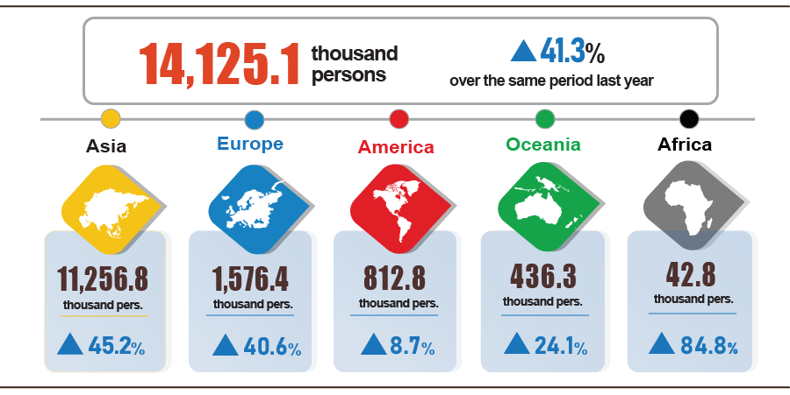
7. Some social situations
a) Residential life
According to the survey on the living situation of households in October 2024, the proportion of households assessed to have income during the month remained unchanged and increased compared to the same period last year was 95.4% (down 0.8 percentage points). percent compared to the September 2024 reporting period and increased by 1.6 percentage points compared to the same period last year); The proportion of households assessed to have reduced income and unknown compared to the same month in 2023 is 4.6%.
Households whose income in October decreased compared to the same period last year identified the main reasons as: Some household members lost their jobs or temporarily quit their jobs (rate of 34.6%); due to the impact of natural disasters (23.4%); due to increased input costs for household production and business activities (22.2%); due to the decrease in the scale of household production and business activities (19.9%); due to the decrease in selling prices of products from household production and business activities (17.4%).
In the ten months of 2024, 31.1% of households reported experiencing at least one event that negatively affected family life, an increase of 0.3 percentage points compared to the September 2024 reporting period and down 0.8 percentage points compared to the October 2023 reporting period. Among the households negatively affected by the events: 30.1% of households are suffering from the effects of rising prices of goods and services; 2.5% of households are negatively affected by human diseases; 2.1% of households are negatively affected by natural disasters and 1.9% of households are negatively affected by epidemics of livestock and crops.
During the ten months of 2024, 12.7% of interviewed households received assistance from various support sources. Of which, the proportion of households receiving assistance from relatives is 8.6%; from local programs and policies is 4.6%; from general national programs and policies is 4.2%; from charitable activities of other organizations and individuals is 1.6% and from other sources is 0.02%.
The work of ensuring social security is always carried out promptly and effectively by all levels and sectors. According to a report from the Ministry of Labor, War Invalids and Social Affairs, in ten months of this year, the Government, ministries, branches and localities have supported people with nearly 21.8 thousand tons of rice, of which: provided 10.4 thousand tons of rice for hunger relief on the occasion of the Lunar New Year Giap Thin for 693.4 thousand people; supporting more than 5.9 thousand tons of rice to relieve hunger in 2024 for 396.3 thousand people; Localities also developed plans and proactively allocated local budgets and socialization resources to support nearly 5 thousand tons of rice for poor, near-poor households and people in difficult circumstances.
b) Disease situation and food poisoning
According to a report from the Ministry of Health, in the month (from September 19th to October 18th, 2024), the whole country had 19,744 cases of dengue fever (03 deaths); 9,682 cases of hand, foot and mouth disease; 3,415 cases of typhus suspected of measles (02 deaths); 02 deaths due to rabies; 46 cases of viral encephalitis; 01 case of meningococcal meningitis. In the ten months of 2024, the whole country has 94.6 thousand cases of dengue fever (15 deaths); 56.6 thousand cases of hand, foot and mouth disease; 7,128 cases of typhus suspected of measles (03 deaths); 70 deaths due to rabies; 393 cases of viral encephalitis (06 deaths); 15 cases of meningococcal meningitis; 10 cases of diphtheria (01 death); 01 case of influenza A and death.
The total number of people living with HIV in the country as of October 18th, 2024 was more than 245 thousand people; the number of deaths due to HIV/AIDS was 115.7 thousand people.
Regarding food poisoning, in October 2024, there were 10 cases with 183 people being poisoned and 1 person died. In the ten months of 2024 (from December 19th, 2023 to October 18th, 2024), there were 99 cases nationwide with 3,561 people being poisoned (12 people died).

c) Sports activities
Regarding the mass sports movement, some outstanding activities took place during the month include: Longbien Marathon 2024 on October 27, 2024 in Hanoi with the participation of 15,000 athletes; national 7-a-side Football Cup - Hyundai Thanh Cong Cup 2024 in the Northern region from October 13-17, 2024 in Hanoi; Hanoi Dragon Boat Swimming Open 2024 to celebrate the 70th anniversary of the Capital's Liberation Day on October 13, 2024 in Hanoi; youth Badminton tournament competing for Capital Youth Newspaper Cup 2024 from October 6-8, 2024 in Hanoi...
Regarding high-performance sports, in October there will be a number of outstanding events such as: The 2024 Southeast Asian Women's Futsal Championship kicks off from November 16-21, 2024 in the Philippines; national 5x5 Basketball Championship 2024 from October 17-25, 2024 in Khanh Hoa; the 30th Asia-Pacific Golf Team Championship 2024 from October 15-18, 2024 in Hai Phong; the Vietnamese kickboxing team won 11 gold medals, 11 silver medals and 11 bronze medals, ranking 3rd overall at the 2024 Asian Kickboxing Championship from October 4-14, 2024 in Cambodia. divide; national swimming and diving championship 2024 from October 10-20, 2024 in Da Nang; the 7th National Crossbow Shooting Championship from October 11-18, 2024 in Thai Nguyen.

d) Traffic accident
In October (from September 26 to October 25, 2024), there were 1,850 traffic accidents nationwide, killing 896 people and injuring 1,347 people. Compared to September 2024, the number of traffic accidents increased by 5.1%; number of deaths decreased by 1.1%; The number of injured people increased by 7.6%. Compared to the same period in 2023, the number of traffic accidents will decrease by 7.5%; number of deaths decreased by 1.6%; The number of injured people decreased by 11.3%.
In the ten months of 2024, there were 19,513 traffic accidents nationwide, killing 8,990 people and injuring 14,505 people. Compared to the same period last year, the number of traffic accidents increased by 5.7%; number of deaths decreased by 8.4%; The number of injured people increased by 13.9%. On average, every day in the ten months of 2024, there will be 64 traffic accidents nationwide, killing 30 people and injuring 48 people.
d) Damage caused by natural disasters
Damage caused by natural disasters in October was mainly due to the impact of heavy rains, floods, and inundation, killing 14 people and injuring 33 people; 777 houses collapsed, swept away and damaged; 9.6 thousand cattle and poultry died; 2.8 thousand hectares of rice and crops were flooded and damaged; The total value of property damage caused by natural disasters in the month was 235.4 billion VND, down 77.2% over the same period last year. In total, in the ten months of this year, natural disasters left 525 people dead or missing, and 2,136 people injured; 26.2 thousand houses collapsed and damaged; 5.1 million cattle and poultry died; 90.3 thousand hectares of crops and 334.2 thousand hectares of rice were flooded and damaged; The total value of property damage is estimated at 78,082.4 billion VND, more than 21.2 times higher than the same period in 2023.
e) Environmental protection and fire and explosion prevention
During the month (from September 18 to October 17, 2024) , the authorities discovered 1,940 cases of environmental violations in 51/63 localities, of which 1,831 cases were handled with a total fine of 29.8 billion VND. VND, up 46.0% over the previous month and up 12.8% over the same period last year. In the ten months of this year, the authorities detected 19,282 cases of environmental violations, of which 17,683 cases were handled with a total fine of 254.5 billion VND, an increase of 4.4% over the same period last year.
During the month, there were 282 fires and explosions nationwide, killing 4 people and injuring 8 people, with an estimated loss of 150.7 billion VND, 2.2 times higher than last month and nearly 8 times higher than the same period last year. In the ten months of this year, there were 3,475 fires and explosions nationwide, killing 89 people and injuring 95 people, with an estimated loss of 368.1 billion VND, down 3.1% over the same period last year. /.
GENNERAL STATISTICS OFFICE

According to the forecast of the National Center for Hydro-Meteorological Forecasting, in the coming time, the weather is likely to continue to have moderate and heavy rains, negatively affecting agricultural production activities. In order to overcome the impact of storms and rains, effectively implement the 2024 crop production plan, and at the same time focus on implementing the 2024-2025 winter-spring vegetable production plan, the Department of Agriculture has directed localities to closely monitor weather developments and proactively implement measures to prepare for natural disasters in the next time.
Of which, Tien Giang decreased by 5,423 hectares; Vinh Long decreased by 922 hectares; Kien Giang decreased by 884 hectares; Dong Nai decreased by 325 hectares; Tra Vinh decreased by 276 hectares.
Raising buffaloes and cows for meat has decreased mainly due to difficult farming conditions, high farming costs, and low profits, leading to a decrease in the number of animals. However, the dairy herd was still growing steadily.
Data from the Ministry of Agriculture and Rural Development as of October 15, 2024.
http://agromonitor.vn/category/48/ca-tra: As of October 16, 2024, the price of raw pangasius fish fluctuated from 27,500 - 28,000 VND/kg, an increase of about 500 VND/kg compared to the same period.
According to https://agromonitor.vn/group/47/272/giam-sat-gia: In the Mekong Delta provinces, the price of raw black tiger shrimp: 20 pieces/kg 210-215 thousand VND/kg; 30 pieces/kg 155-160 thousand VND/kg; 40 pieces/kg 125-130 thousand VND/kg. The price of white-leg shrimp 60-70 pieces/kg fluctuates around 160-170 thousand VND/kg, 80 pieces/kg fluctuates around 125 thousand VND/kg.
The decrease in fishery output due to the large number of damaged boats requiring repair and maintenance after storm No. 3 in the northern coastal areas has significantly affected fishing activities.
The growth rate of the industrial production index in the first ten months of 2020-2024 compared to the same period last year was: 2.6%; 3,8%; 8,9%; 0,5%; 8,3%.
Localities have a high production index of the manufacturing industry in the first ten months of 2024 compared to the same period last year: Lai Chau increased by 43.9%; Phu Tho increased by 40.7%; Bac Giang increased by 27.7%; Thanh Hoa increased by 19.5%; Quang Nam increased by 19.3%; Tra Vinh increased by 6.6%; Dien Bien increased by 5.7%. Localities with high indices of electricity production and distribution industry: Khanh Hoa increased by 175.2%; Dien Bien increased by 57.1%; Cao Bang increased by 48.5%; Tra Vinh increased by 48.3%; Lai Chau increased by 42.7%; Son La increased by 39.6%; Thanh Hoa increased by 21.9%. Localities with high mining industry indexes: Cao Bang increased by 30.0%; Thanh Hoa increased by 14.0%; Tra Vinh increased by 6.0%.
Localities with a low increase or decrease in the production index of the manufacturing industry in the first ten months of 2024 compared to the same period last year are: Bac Lieu increased by 4.9%; Dak Nong increased by 2.8%; Ha Tinh decreased by 5.3%; Gia Lai decreased by 1.8%; Quang Ngai decreased by 1.6%. Localities with low or decreased indicators of the electricity production and distribution industry: Quang Tri increased by 2.3%; Bac Lieu increased by 0.7%; Lang Son decreased by 16.7%; Quang Ngai decreased by 8.6%; Lam Dong decreased by 5.0%; Gia Lai fell 1.5%.
Source: National Business Registration Information System, Department of Business Registration Management, Ministry of Planning and Investment, received November 02nd, 2024. Implementing Decree No. 62/2024/ND-CP dated June 07th, 2024 of the Government (effective from August 01st, 2024), the data period on business registration in the month is calculated from the 1st to the last day of the reporting month. Particularly for time indicators (enterprises returning to operations, enterprises temporarily suspending business for a limited period of time, enterprises temporarily suspending operations awaiting dissolution procedures), the data period is the months before the time. August 01st, 2024 is calculated from the 21st of the month preceding the reporting month to the 20th of the reporting month.
According to the report of the Foreign Investment Agency, Ministry of Planning and Investment, received on November 3 , 2024.
2020-2022 years up to August 20 every year , 2023 and 2024 up to August 31.
According to Report No. 287/BC-BTC dated October 31, 2024 of the Ministry of Finance.
The value of export turnover is calculated at F.O.B price and import turnover is calculated at C.I.F price (including transportation and insurance costs of imported goods).
Total turnover and value of preliminary export and import goods in October 2024 provided by the General Department of Customs on November 3, 2024.
Total import and export turnover of goods in ten months of 2023 reached 559.3 billion USD, down 10.8% over the same period last year, of which exports reached 292 billion USD, down 6.8%; imports reached 267.3 billion USD, down 14.8%.
28 million USD higher than the figure sent by the General Department of Customs to the General Statistics Office on October 3, 2024
The same as the figure sent by the General Department of Customs to the General Statistics Office on October 3, 2024.
Preliminary trade surplus in September report was 2.29 billion USD.
Domestic rice prices increased due to the impact of prolonged rains and thunderstorms, affecting rice output. The price index of the rice group increased by 0.79% (Delicious ordinary rice increased by 0.92%; regular ordinary rice increased by 0.76%; sticky rice increased by 0.75%). Besides, some food items increased in price in October such as potato price increased by 3.52%; corn increased by 2.46%; cassava increased by 1.46%; corn flour increased by 1.04%; ready-to-eat cereals increased by 1%.
Prices of fresh, dried and processed vegetables increased by 3%; pork prices increased by 0.25%; poultry meat prices increased by 0.2%; fresh seafood prices increased by 0.36%; fresh and processed fruit prices increased by 1.45%; spice prices increased by 0.36%; tea, coffee, cocoa increased by 0.32%; cakes, jams, and candy increased by 0.23%; milk, butter, and cheese increased by 0.21%.
Food prices have increased and in the month of October 20, Vietnamese Women's Day has increased the demand for food outside the home. In particular, the price of takeout fast food increased by 0.42% compared to the previous month; The price of eating out at home and the price of drinking out at home both increased by 0.15%.
In particular, the electricity and water price index in October 2024 reflects fluctuations one month later than other items because it is calculated based on revenue and consumption output of September 2024.
CPI after excluding food, fresh food, energy and state-managed goods including medical services and education.
According to the report of the Border Gate Department, the Border Guard Command, the Ministry of National Defense and the Immigration Department.
The reporting period was from September 21, 2023 to October 20, 2023.
According to the report of the Border Gate Department, the Border Guard Command, the Ministry of National Defense and the Immigration Department on October 27, 2024.
The reporting period was from September 26, 2024 to October 25, 2024.
A household can choose many reasons to reduce income.
According to a quick report from the Office of the Ministry of Public Security and the Vietnam Maritime Administration (Ministry of Transport) on October 29, 2024.
Summary of reports from 63 Departments of Agriculture and Rural Development, reporting period from September 19 to October 18, 2024.
According to a report from the Department of Natural Resources and Environment, the Police of provinces and centrally run cities Department of General Statistics.
According to a quick report from the Ministry of Public Security on October 23, 2024.

