MINISTRY OF FINANCE  NATIONAL STATISTICS OFFICE  ________________  No: 292/BC-CTK | SOCIALIST REPUBLIC OF VIET NAM  Independence-Freedom-Happiness  ______________________________________  Ha Noi, 5th September 2025

REPORT
SOCIO-ECONOMIC SITUATION
IN AUGUST AND 8 MONTHS OF 2025

1. Agriculture, forestry, and fishing
In August, agricultural production focused on cultivating and tending Winter-Spring rice, harvesting Summer-Autumn rice, and sowing Autumn-Winter rice in the Mekong Delta. Poultry farming witnessed a stable growth; pig farming faced challenges due to the complicated situation of African swine fever. Forestry production primarily focused on afforestation and wood harvesting as planned. Aquaculture saw a stability; aquaculture establishments strengthened application of high technology, and developed super-intensive, intensive farming models that brought high economic efficiency. However, unfavorable weather caused negative impacts to marine capture fisheries.
a) Agriculture
Summer-Autumn rice
As of August 20th, 2025, the national rice cultivation area reached 1,899.4 thousand hectares of Summer-Autumn rice, a year-on-year decrease of 8.7 thousand hectares, of which, Northern localities reached 172.6 thousand hectares, a decrease of 1.4 thousand hectares; Southern localities reached 1,726.8 thousand hectares, a decrease of 7.3 thousand hectares. The Summer-Autumn rice area recorded a year-on-year drop due to the fact that some localities converted a part of their rice areas to other crops for higher economic efficiency. Up to now, Southern localities harvested 1,140.9 thousand hectares of early Summer-Autumn rice, equal to 102.0% of the same period in 2024, of which, some localities were recorded of faster harvesting progress compared to the same period last year, including Ca Mau 230.0%; Vinh Long 136.0%; and An Giang 104.6%.
Winter-Spring rice
As of August 20th, 2025, the national rice cultivation area reached 1,375.6 thousand hectares of Winter-Spring rice, a year-on-year decline of 6.4 thousand hectares. Northern localities reached 978.3 thousand hectares, decreasing by 15.6 thousand hectares. Of which, the Red River Delta basically cultivated with an area of ​​471.3 thousand hectares, a reduction of 10.5 thousand hectares; Southern localities reached 397.3 thousand hectares, showed a surge of 9.2 thousand hectares. Currently, the Winter-Spring rice was in the main growing period, localities focused on top dressing, weeding and pests control.
Autumn-Winter rice
As of August 20th, 2025, the Mekong Delta region sown 449.3 hectares of Autumn-Winter rice, equal to 96.4% compared to the same period last year, mainly due to the fact that localities proactively nourished the soil according to the recommendations of the agricultural authority; in addition, long-lasting rainy weather affected the progress of sowing. Some localities recorded with a slow sowing progress compared to the same period last year, including Vinh Long 90.3%; Dong Thap 91.7%; Can Tho 95.2%. Currently, Autumn-Winter rice was growing well, localities must conduct regular inspections and develop plans to ensure the safety of irrigation and drainage systems during the flooding season.
Annual crops
Along with rice cultivation, localities were planting other crops across the country. However, the area of some primary annual crops witnessed a year-on-year reduction due to low economic efficiency.
Figure 1. Cultivation area of key annual crops
(As of August, 20th 2025)
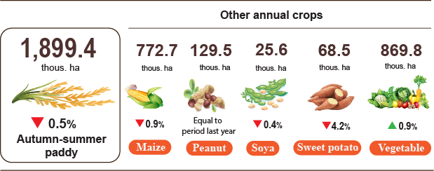
Livestock
Cattle and buffalo farming showed a downward trend, mainly due to shrinking grazing areas and low economic efficiency. Pig farming faced challenges owing to the complicated situation of African swine fever. The outbreaks mainly occurred in households, small-scale livestock farms that did not ensure biosafety conditions, disinfection, isolation, and control of entry and exit from barns, along with the changing seasons, heavy rain, and high humidity that diminished the effect of disinfection and created a favorable environment for the virus to spread. Some localities experienced a year-on-year sharp decrease in the total pig numbers, including Quang Tri (down 13.6%); Phu Tho (down 12.8%); Cao Bang (down 10.3%); Da Nang (down 7.2%); Quang Ngai (down 5.8%); Ha Noi (down 3.2%); Ha Tinh (down 2.6%); Ninh Binh (down 2.2%). However, in large-scale enterprises and farms, the pig numbers were protected thanks to strict application of biosecurity measures. Poultry farming witnessed a positive growth due to favorable production conditions, well control of diseases, and no major outbreaks.
Figure 2. The growth rate of livestock and poultry number
at the end of August, 2025 (Y-o-Y)
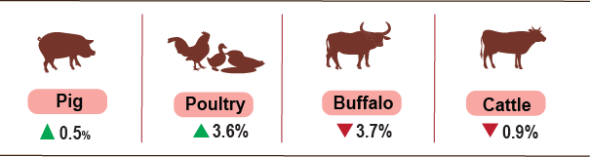
As of August 29th, 2025, the country was no longer recorded with blue ear and foot-and-mouth disease; however, several diseases were reported in localities such as avian influenza in Nghe An, Quang Ngai; lumpy skin disease in Lang Son, Thai Nguyen, Son La, Nghe An, Dong Nai; and African swine fever in 33 out of 34 localities was not over 21 days.
b) Forestry
The area of newly concentrated planted forest in August was estimated at 22,4 thousand hectares nationwide, a year-on-year increase of 5,9%; the number of scattered forest trees reached 6.5 million, an increase of 6.8%; wood production reached 2,284.8 thousand m³, an increase of 6.6% due to stable raw wood prices and promotion of wood harvesting in many localities. In eight months of 2025, the area of ​​newly planted concentrated forests was estimated at 186.8 thousand hectares, a year-on-year rise of 13.9%; the number of scattered forest trees reached 60.4 million, an increase of 2.7%; wood production reached 15,463.2 thousand m³, a growth of 7.4%.
The damaged forest area in the month was estimated at 31.5 hectares, a year-on-year decline of 35.0%, of which the deforested area was estimated at 22,7 hectares, a decline of 47.5%; the burnt forest area reached 8.8 hectares, a surge of 66,7%. Generally, in eight months of 2025, the total damaged forest area was 960.3 hectares, a year-on-year crash of 30.7%, of which the deforested area was 654.5 hectares, a rise of 1.0%; the burnt forest area was 305.8 hectares, a decline of 58.6%.
c) Fishing
Fishery production in August was estimated at 916.4 thousand tons, of which fish production reached 629.3 thousand tons, a rise of 1.6%; shrimp production reached 160.8 thousand tons, a spread of 5.3%; other aquatic production reached 126.3 thousand tons, an increase of 3.5%.
Aquaculture production in the month was estimated at 592.5 thousand tons, a year-on-year upturn of 4.6%, of which, fish production reached 380.7 thousand tons, a rise of 3.5%; shrimp production reached 150.3 thousand tons, a growth of 5.8%.
Pangasius production in the month show a year-on-year increase due to the rise in raw pangasius prices, the harvested pangasius production ensured the source of raw materials for export processing. Pangasius production in the month was estimated at 168.9 thousand tons, a year-on-year growth of 3.5%.
Shrimp production in the month witnessed a year-on-year upward trend because farmers applied an intensive and super-intensive farming model and advance technology to raise the farming yield. Production of white leg shrimp in August was estimated at 111,000 tons, a year-on-year upturn of 5.9%; production of black tiger shrimp reached 29,100 tons, a surge of 3.9%.
Capture fisheries in the month was estimated at 323.9 thousand tons, a year-on-year decline of 1.1%, of which fish production reached 248.6 thousand tons, a drop of 1.0%; shrimp production reached 10.5 thousand tons, a reduction of 0.9%; other aquatic production reached 64.8 thousand tons, a fall of 1.5% due to unfavorable weather caused by rainstorms, fishing vessels returned to shore to take shelter and avoid storms. Production of marine capture fisheries was estimated at 306.0 thousand tons, a year-on-year downturn of 1.2%, of which fish production reached 236.3 thousand tons, a decline of 1.0%; shrimp production reached 9.2 thousand tons, a decrease of 2.1%; other aquatic produciton reached 60.5 thousand tons, a reduction of 1.5%.

Figure 3. Capture fisheries and aquaculture production
in 8 months of 2025 (Y-o-Y)
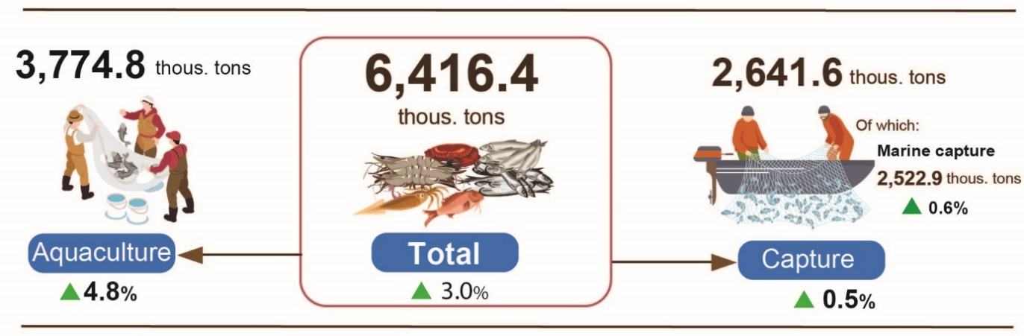
Generally for 8 months of 2025, the total fishery production was estimated at 6,416.4 thousand tons, a year-on-year growth of 3.0%, of which, fish production reached 4,555.0 thousand tons, an increase of 2.7%; shrimp production reached 954.2 thousand tons, a rise of 5.6%; other aquatic production reached 907.2 thousand tons, a growth of 2.2%.
2. Industrial production
Industrial production in Augsust continuously sustained its upward trajectory. In August, the Index of Industrial Production (IIP) was estimated at a growth rate of 2.2% month-on-month and 8.9% year-on-year. Generally for 8 months of 2025, the IIP grew by 8.5% over that in the same period last year.
In August, the IIP was estimated at a growth rate of 2.2% month-on-month and 8.9% year-on-year. Specifically, the manufacturing saw a year-on-year growth of 9.5%; the mining increased by 9.1%; the electricity supply increased by 6.1%; the water supply, sewerage, waste management, and remediation activities increased by 2.4%.
Generally for 8 months of 2025, the IIP was estimated to grow by 8.5% over that in the same period last year (the corresponding figure in 2024 was 8.4%). Specifically, the manufacturing grew by 10.0% (an increase of 9.5% in 2024), contributing 8.1 percentage points to the overall growth; the water supply, sewerage, waste management, and remediation activities rose by 9.1% (versus 9.2% in 2024), contributing 0.1 percentage points; the electricity supply increased by 4.9% (versus 11.7% in 2024), contributing 0.5 percentage points; while the mining declined by 1.1% (a decline of 6.5% in 2024), reducing the overall growth by 0.2 percentage points.
In seven months of 2025, the IIP of several key 2-digit activities experienced a year-on-year increase as follows: Manufacture of motor vehicles (27.4%); manufacture of rubber and plastics products (17.5%); manufacture of other non-metallic mineral products (15.0%); manufacture of wearing apparel (13.9%); manufacture of leather and related products (13.4%); fabricated metal products (excluding machinery and equipment) (12.0%); manufacture of furniture (11.8%); manufacture of basic metals (10.5%); manufacture of food products (10.1%); manufacture of wood and products of wood, bamboo, and schizostachyum aciculare (9.6%); manufacture of paper and paper products (9.5%); manufacture of computer, electronic and optical products (7.5%). Conversely, the IIP of some activities nudged up or decreased as follows: mining of hard coal and lignite (up 3.9%); manufacture of beverages (up 2.6%); extraction of crude petroleum and natural gas (down 5.5%).Table 1. Year-on-year IIP growth rate for 8 months in the period 2021 - 2025
for some key industrial activities
%
 | 2021 | 2022 | 2023 | 2024 | 2025
Mining of hard coal and lignite | -0.3 | 6.9 | -1.2 | -3.5 | 3.9
Extraction of crude petroleum and natural | -11.1 | -0.6 | -2.6 | -11.9 | -5.5
Manufacture of food products | 1.5 | 9.0 | 4.9 | 7.3 | 10.1
Manufacture of beverages | 0.2 | 27.3 | 4,0 | 0.2 | 2.6
Manufacture of wearing apparel | 5.8 | 22.3 | -3.4 | 8.8 | 13.9
Manufacture of leather and related products | 8.2 | 18.0 | -2.4 | 10.8 | 13.4
Manufacture of wood and products of wood, bamboo, and schizostachyum aciculare (except furniture); manufacture of articles of straw and plaiting material | 4.3 | 13.5 | -4.6 | 9.8 | 9.6
Manufacture of paper and paper products | 4.5 | 9.7 | -4.8 | 9.6 | 9.5
Manufacture of rubber and plastics products | -0.1 | -6.6 | 8.5 | 29.3 | 17.5
Manufacture of other non-metallic mineral products | 3.3 | 7.2 | -4.3 | -1.0 | 15.0
Manufacture of basic metals | 30.6 | -1.2 | 0.6 | 12.3 | 10.5
Manufacture of fabricated metal products (except machinery and equipment) | 5.7 | 9.8 | 6.7 | 11.9 | 12.0
Manufacture of computer, electronic and optical products | 8.5 | 11.0 | -3.2 | 9.5 | 7.5
Manufacture of motor vehicles | 21.4 | 3.9 | -6.6 | 11.2 | 27.4
Manufacture of furniture | 7.8 | 5.3 | 0.8 | 22.9 | 11.8
The IIP in 8 months of 2025 experienced a year-on-year increase in all 34 provinces and municipalities. Several provinces saw a fairly high IIP growth rate thanks to the acceleration in the manufacturing and the electricity supply. Conversely, the IIP growth rate in several provinces and municipalities nudged up because the manufacturing, mining and electricity supply in these provinces gained a modest growth or even decrease.

Figure 4. Year-on-year IIP growth rate
for some localities (8-month period, 2025) (%)
Top 10 localities by IIP growth rate | Bottom 10 localities by IIP growth rate
Some key industrial products in 8 months in 2025 witnessed a year-on-year increase as follows: automobiles (59.6%); television (21.4%); NPK fertilizer (17.9%); clothes (14.7%); cement (14.6%); leather shoes and sandals (13.9%); aquatic feed (12.5%); rolled steel (11.9%); refined sugar (11.8%); fabrics from natural yarn (9.6%); chemical paint (9.3%). Conversely, some industrial products experienced a year-on-year reduction, including: natural gas (9.4%); fabrics from synthetic yarn (4.4%); crude oil (1.6%).
The number of employees in industrial enterprises as of August 01st, 2025 saw a month-on-month growth of 0.9% and a year-on-year increase of 4.7%. Particularly, the number of employees in the state-owned enterprises saw the increase of 0.1% month-on-month and 2.3% year-on-year; the foreign investment enterprises increased by 1.1% and 5.4%, respectively; while the non-state enterprises rose by 0.7% and 3.0%, respectively. By economic activity, the number of employees in the mining remained unchanged month-on-month and saw a 2.0% year-on-year increase. The manufacturing saw an increase of 1.0% and 4.9%, respectively. The electricity, gas, hot water, steam, and air conditioning supply saw an increase of 0.1% and 2.8%; meanwhile the water supply, sewerage, waste management, and remediation activities recorded a slight increase of 0.4% month-on-month and 2.0% year-on-year.
3. Enterprise registration status
In August, the country had 20.5 thousand newly established enterprises with a registered capital of 326.1 trillion VND and 106.9 thousand registered employees , gaining an increase of 23.9% in number of enterprises, nearly 2.8 times higher in registered capital and a rise of 35.4% in number of employees, month-on-month. Compared to that in the same period last year, the number of enterprises increased by 52.9%, 2.6 times higher in registered capital and up 49.0% in number of employees. The average registered capital of a newly established enterprise in the month reached 15.9 billion VND, a month-on-month rise of over 2.2 times and a year-on-year increase of 71.2%. In addition, the whole country had 12.4 thousand enterprises resumed, a reduction of 15.0% month-on-month and a rise of 46.4% year-on-year.
In 8 months of 2025, the whole country had 128.2 thousand newly registered enterprises with a total registered capital of 1,254.5 trillion VND and a total number of nearly 777 thousand registered employees, an increase of 15.7% in the number of enterprises, 26.1% in the registered capital and 15.5% in the number of employees, year-on-year. The average registered capital of a newly established enterprise in eight months of 2025 reached 9.8 billion VND, a year-on-year increase of 9.0%. The total additional registered capital in the economy in eight months of 2025 reached nearly 4,135.7 trillion VND, an increase of 105.3% over that in the same period in 2024. In addition, the whole country had 81.1 thousand enterprises resumed operations (a year-on-year increase of 41.4%), bringing the total number of newly established and resumed enterprises in eight months of 2025 to 209.2 thousand enterprises, a year-on-year increase of 24.5%. On average, there were 26.2 thousand newly established and resumed enterprises a month.
By economic sector, in eight months of 2025, there were 1,167 newly registered enterprises in the agriculture, forestry and fishery sector, a year-on-year increase of 7.1%; 28.4 thousand enterprises in the industry and construction sector, up 10.7%; 98.6 thousand enterprises in the service sector, up 17.4%.
Also in August, 6.5 thousand enterprises registered to temporarily shut down for a specific period, a month-on-month decline of 11.0% and a year-on-year increase of 22.5%; 6.9 thousand enterprises temporarily suspended awaiting dissolution procedures, an increase of 56.8% month-on-month and 33.2% year-on-year; 3.8 thousand enterprises completed dissolution procedures, a month-on-month increase of 96.7% and a year-on-year rise of 99.0%.
Figure 5. Enterprise registration status
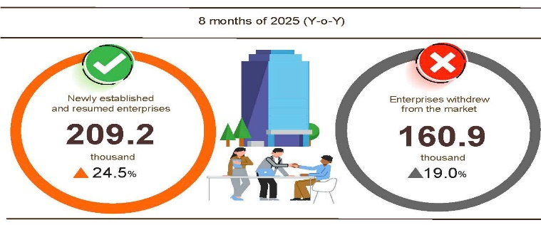
Generally, in eight months of this year, the number of enterprises temporarily shut down for a specific period was 95.0 thousand, a year-on-year increase of 14.7%; 47.8 thousand enterprises temporarily suspended awaiting for dissolution procedures, up 23.7%; 18.1 thousand enterprises completed dissolution procedures, up 31.5%. On average, 20.1 thousand enterprises withdrew from the market a month.
Table 2. Newly established and completely dissolved enterprises in 8 months of 2025 by economic activity
 | Number of enterprises (Enterprise) |  | Y-o-Y growth rate (%)
 | Newly established | Completely dissolved | Newly established | Completely dissolved
Wholesale and retail, repair of motor vehicle and motorcycle | 55,067 | 6,628 | 21.3 | 19.2
Manufacturing | 17,213 | 1,969 | 28.6 | 35.2
Construction | 9,813 | 1,281 | -11.3 | 30.7
Real estate business | 3,543 | 1,014 | 12.3 | 24.6
Transportation and storage | 7,269 | 692 | 24.0 | 33.6
Accommodation and food services | 4,681 | 922 | 12.7 | 46.1
Electricity, water and gas supply | 965 | 219 | 20.6 | 28.8

4. Investment
The disbursement of State budget investment in August was accelerated by ministries, line-ministries and local authorities to create momentum for economic growth. In eight months of 2025, the disbursed State budget investment was estimated to reach 48.3% over the plan, while the foreign direct investment (FDI) disbursed in Viet Nam was estimated at 15.40 billion USD, gained a year-on-year increase of 26.9% and 8.8%, respectively.
The disbursed State budget investment in August was estimated at 83.8 trillion VND, a year-on-year increase of 32.6%, of which 12.1 trillion VND from central investment, up 8.1% and 71.7 trillion VND from local investment, up 37.9%. Generally, for eight months of 2025, the total disbursed State budget investment was estimated at 463.2 trillion VND, gaining 48.3% over the annual plan and increasing by 26.9% year-on-year (the same rates in 2024 were 46.7% and 2.5%). Specifically:
- The disbursed central investment was estimated at 66.4 trillion VND, equal to 45.2% over the annual plan and up 6.4% over that in the same period last year. Of which, Ministry of Construction reached 40.7 trillion VND, up 2.2%; Ministry of Agriculture and Environment reached 10.3 trillion VND, up 60.7%; Ministry of Health reached 1.7 trillion VND, increasing by 2.7 times; Ministry of Education and Training reached 1.0 trillion VND, up 67.8%; Ministry of Culture, Sports and Tourism reached 535.6 billion VND, up 39.7%; Ministry of Science and Technology reached 271.5 billion VND, down 12.1%; Ministry of Industry and Trade reached 135.9 billion VND, down 59.5%.
- The disbursed local investment was estimated at 396.8 trillion VND, equal to 48.8% over the annual plan and up 31.2% over that in the same period last year, of which:
319.4 trillion VND was disbursed at the provincial level, equal to 47.7% over the annual plan and up 36.1% over that in the same period in 2024;
77.4 trillion VND was disbursed at commune level, equal to 54.0% over the annual plan and up 14.2% over that in the same period in 2024.
The disbursed State budget investment in eight months of 2025 in some provinces and municipalities was as follows:
Figure 6. Disbursed State budget investment in 8 months of 2024 and 2025 in selected localities

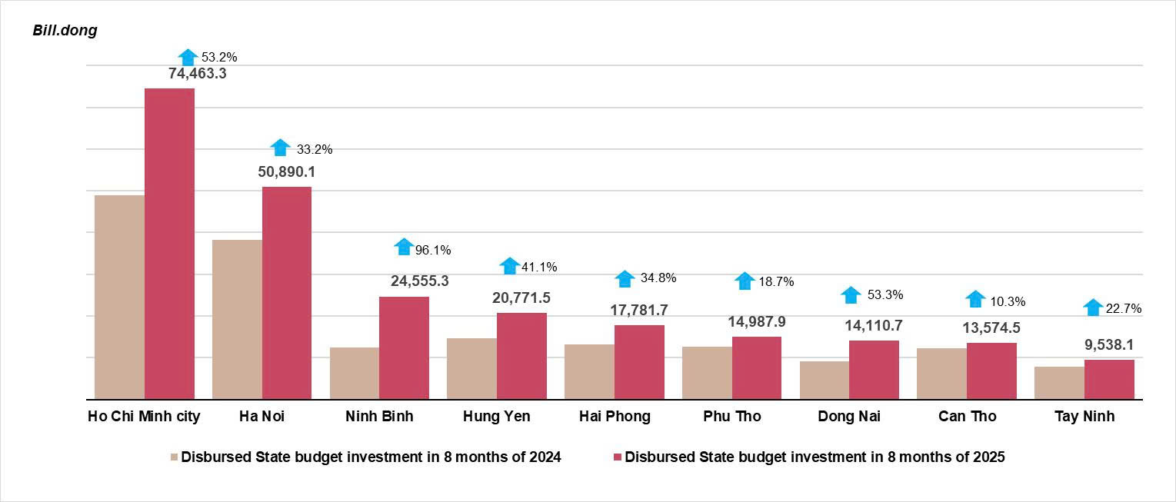

Total inward foreign investment in Viet Nam as of August 31, 2025, including newly registered capital, adjusting registered capital and capital contribution and purchasing shares by foreign investors reached 26.14 billion USD, year-on-year increase of 27.3%.
Figure 7. Inward foreign investment in Viet Nam in 8 months in the period 2021-2025 (Billion USD)

- In terms of newly registered capital: 2,534 projects were licensed with a registered capital of 11.03 billion USD, a year-on-year increase of 12.6% in the number of projects and a decrease of 8.1% in registered capital. Of which, the manufacturing was the largest newly licensed FDI with a registered capital of 6.53 billion USD, accounting for 59.2% of the total newly registered capital; the real estate business reached 2.37 billion USD, accounting for 21.5%; the other activities reached 2.13 billion USD, accounting for 19.3%.
Singapore was the largest investor out of 78 countries and territories with newly licensed projects in Viet Nam in eight months of 2025, with 3.06 billion USD, accounting for 27.8% of the total newly registered capital; followed by China with 2.65 billion USD, accounting for 24.0%; Sweden with 1.0 billion USD, accounting for 9.1%; Japan with 877.9 million USD, accounting for 8.0%; Hong Kong SAR (China) with 786.4 million USD, accounting for 7.1%; Taiwan (China) with 745.6 million USD, accounting for 6.8%; and the United States with 433.7 million USD, accounting for 3.9%.
- Adjusting registered capital: 996 turns of projects were licensed from the previous years, registered to adjust investment capital to increase by 10.65 billion USD, up 85.9% over that in the same period last year.
If including newly registered capital and adjusting registered capital of licensed projects from the previous years, the registered FDI in the manufacturing reached 13.64 billion USD, accounting for 62.9% of the total newly registered and additional capital; the real estate business reached 4.98 billion USD, accounting for 23.0%; the other activities reached 3.06 billion USD, accounting for 14.1%.
- There were 2,245 turns of registered capital contribution and purchasing shares by the foreign investors with a total value of 4.46 billion USD, a year-on-year increase of 58.8%. Of which, 882 turns of capital contribution and purchasing shares increased the charter capital of enterprises with a capital contribution value of 1.61 billion USD and 1,363 foreign investors re-bought domestic shares without making the charter capital increase with a value of 2.85 billion USD. Among capital contribution and purchasing shares by foreign investors, the manufacturing reached 1.65 billion USD, accounting for 37.0% of the capital contribution value; the professional, scientific and technical activities reached 981.7 million USD, accounting for 22.0%; the other activities reached 1.83 billion USD, accounting for 41.0%.
Figure 8. Disbursed FDI in 8 months
in the period 2021-2025 (Billion USD)
The disbursed FDI in Viet Nam in eight months of 2025 was 15.40 billion USD, a year-on-year increase of 8.8%. This was the highest figure in the disbursed FDI in eight months of the last 5-year period. Of which: the manufacturing reached 12.57 billion USD, accounting for 81.6% of total disbursed FDI; the real estate business reached 1.24 billion USD, accounting for 8.0%; the electricity, gas, steam and air conditioning supply reached 563.6 million USD, accounting for 3.7%.
Viet Nam's outward investment in eight months of 2025 witnessed 108 projects granted with new investment certificates and a total capital of 426.5 million USD, 2.9 times higher than that in the same period last year; 21 turns of projects adjusted their capital with an addition of 129.7 million USD.
Generally, the total Viet Nam's outward FDI (newly granted and adjusted capital) in eight months of 2025 reached 556.2 million USD, 3.8 times higher than that in the same period last year. Of which: the electricity, gas, steam and air conditioning supply reached 111.2 million USD, accounting for 20.0% of total investment; the transportation and storage reached 109.1 million USD; accounting for 19.6%; the wholesale and retail trade, repair of motor vehicles and motorcycles reached 78.6 million USD; accounting for 14.1%.
In eight months of 2025, Viet Nam invested in 33 countries and territories, of which: Laos was at the top with 150.3 million USD, accounting for 27.0% of total investment; the following countries were Philippines with 61.8 million USD, accounting for 11.1%; Indonesia with 60.5 million USD, accounting for 10.9%; Germany with 50.6 million USD, accounting for 9.1%; United States with 31.6 million USD, accounting for 5.7%.
5. State budget revenue and expenditure
State budget revenue in 8 months of 2025 was estimated to increase by 28.5% over that in the same period last year. State budget expenditure was estimated to increase by 31.5% over that in the same period in 2024, ensuring the needs of socio-economic development, national defense, security, state management, payment of due debts as well as timely payment to intended beneficiaries, science and technology development, digital transformation, and timely compensation for beneficiaries in accordance with the Decree No. 178/2024/ND-CP and Decree No. 67/2025/ND-CP of the Government.
Figure 9. State budget revenue and expenditure in 8 months of 2025
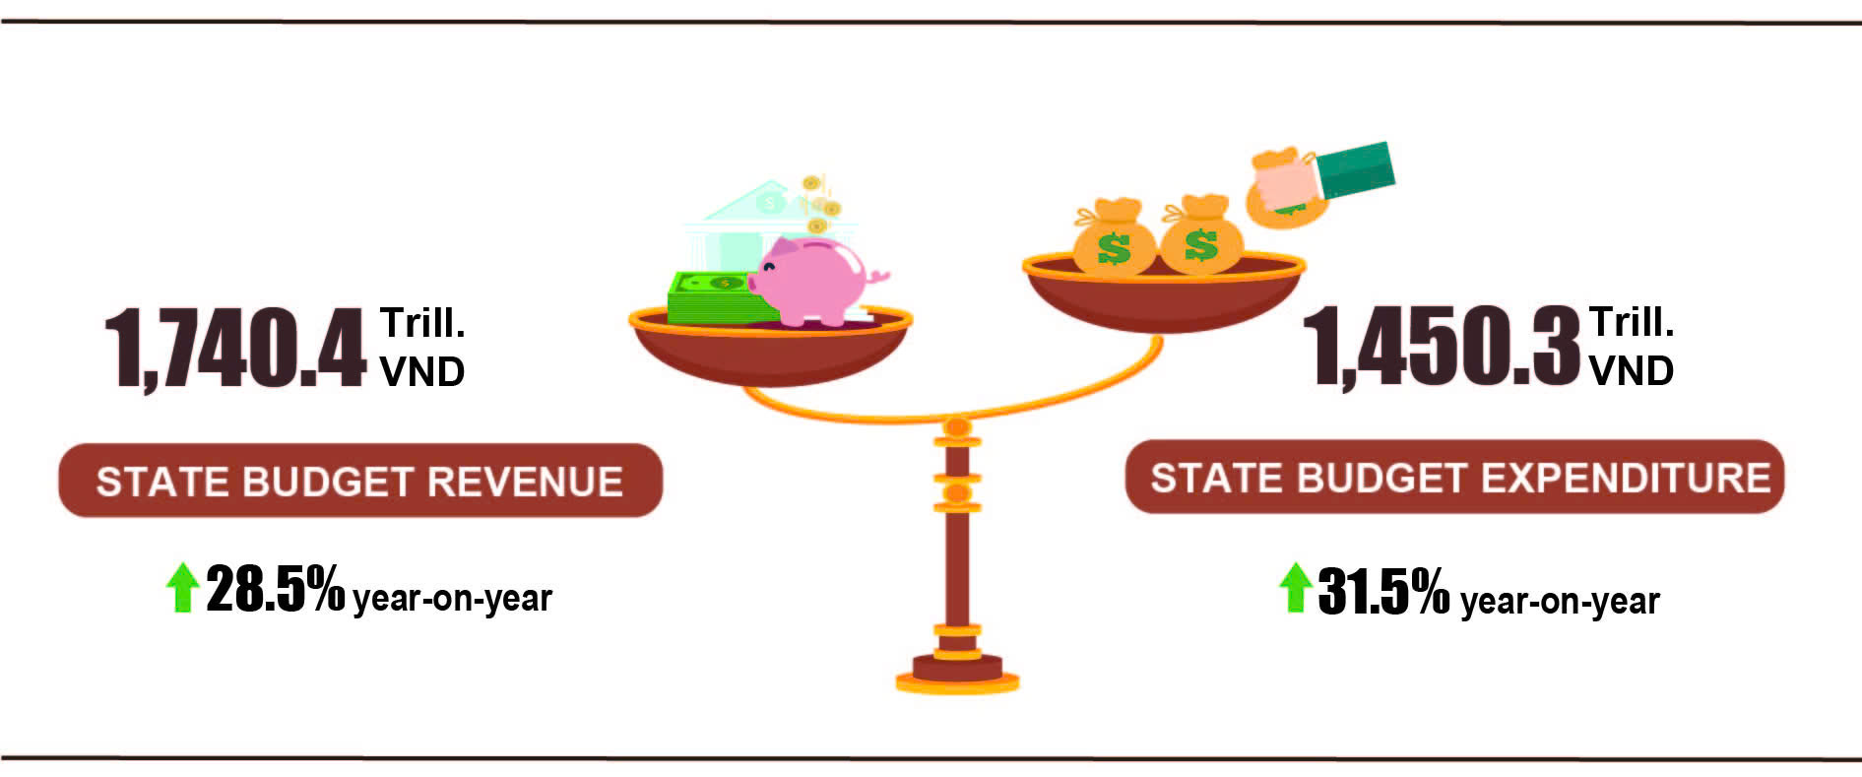
State budget revenue
Total state budget revenue in August 2025 was estimated at 158.8 trillion VND. The total state budget revenue accumulated in eight months of 2025 was estimated at nearly 1,740.0 trillion VND, reaching 88.5% of the annual estimate and going up by 28.5% over the same period last year. In particular, some main revenue items were as follows:
- Domestic revenue in August 2025 was estimated at 130.8 trillion VND; The accumulated revenue in 8 months of 2025 was estimated at 1,498.8 trillion VND, reaching 89.8% of the annual estimate and increasing by 32.7% year-on-year.
- Oil revenue in August 2025 was estimated at 3.9 trillion VND; the accumulated revenue in 8 months of 2025 reached 32.7 trillion VND, reaching 61.4% of the annual estimate and declining by 17.6% year-on-year.
- Net revenue from trade activities in August 2025 was estimated at nearly 24.0 trillion VND; the accumulated revenue in 8 months of 2025 was estimated at 207.6 trillion VND, reaching 88.3% of the annual estimate and increasing by 12.3% year-on-year.
State budget expenditure
Total state budget expenditure in August 2025 was estimated at 183.1 trillion VND. The accumulated expenditure in 8 months of 2025 was estimated at 1,450.3 trillion VND, equivalent to 56.3% of the annual estimate and 31.5% increase year-on-year. Specifically, recurrent expenditure in 8 months of 2025 was estimated at 968.0 trillion VND, equalling to 60.6% of the annual estimate and increasing by 27.6% over the same period last year; development investment expenditure gained 409.2 trillion VND, equivalent to 51.7% and an increase of 49.4%; interest payment was 70.4 trillion VND, reaching 63.7% and increasing by 1.3%.
6. Trade, prices, transport and tourism
a) Retail sales of consumer goods and services
In August, events and activities commemorating the 80th anniversary of the August Revolution and the National Day of the Socialist Republic of Viet Nam were solemnly broadly organized, contributing to a sharp increase in consumption of goods, services, and tourism. The gross retail sales of consumer goods and services in August were estimated to rise by 10.6% compared to that in the same period last year. In eight months of 2025, the gross retail sales of consumer goods and services increased by 9.4% year-on-year, of which turnover from accommodation and food services rose by 14.7%, and turnover from travelling and tourism went up by 20.3%.
Gross retail sales of consumer goods and services at current prices in August were estimated 588.2 trillion VND, went up by 2.6% over the previous month and 10.6% year-on-year. Specifically, turnover from garments rose by 13.7% year-on-year; food and foodstuffs by 12.3%; household appliances, tools and equipment by 10.4%; accommodation and food services by 13.2% and travel and tourism services by 15.2%.
Table 3. Gross retail sales of consumer goods and services at current prices
Trillion VND
 | Estimate  for August  2025 | Estimate for  8 months  of 2025 | Year-on-Year  Growth rate (%)
 | Estimate  for August  2025 | Estimate for  8 months  of 2025 | August 2025 | 8 months  of 2025
Total | 588.2 | 4,579.0 | 10.6 | 9.4
Retail sales of goods | 448.3 | 3,495.8 | 10.2 | 8.1
Accommodation and food services | 71.0 | 552.4 | 13.2 | 14.7
Travelling and tourism | 7.8 | 61.2 | 15.2 | 20.3
Other services | 61.1 | 469.6 | 9.8 | 11.9
Generally, for eight months of 2025, the gross retail sales of consumer goods and services at current prices were estimated at 4,579.0 trillion VND, going up by 9.4% over that in the same period last year (8.9%), increasing by 7.2% year-on-year if excluding the price rising factor ( this figure was 8.0% in the same period of 2024).
Figure 10. Gross retail sales of consumer goods and services at current prices
in eight months in the period 2021-2025

Retail sales of goods in eight months of 2025 were estimated at 3,495.8 trillion VND, accounting for 76.3% of the total retail sales of consumer goods and services and increasing by 8.1% over that in the same period last year. Of which, food and foodstuffs rose by 10.1%; cultural and educational products by 7.4%; garments by 7.3%; and household appliances, tools and equipment by 6.7%. Retail sales of goods in eight months of 2025 compared to the same period last year in some localities saw an increase as follows: Da Nang by 9.4%; Can Tho by 8.6%; Ha Noi by 8.2%; Ho Chi Minh City by 8.1%; and Hai Phong by 8.0%.
Turnover from accommodation and food services in eight months of 2025 was estimated at 552.4 trillion VND, accounting for 12.1% of the total turnover and increasing by 14.7% compared to that in the same period last year. In comparison to the same period last year, the turnover in eight months of 2025 in some localities experienced an expansion as follows: Ho Chi Minh City by 18.6%; Da Nang by 18.2%; Can Tho by 14.2%; Hai Phong by 12.7%; and Ha Noi by 11.4%.
Travelling and tourism turnover in eight months of 2025 was estimated at 61.2 trillion VND, accounting for 1.3% of the total and increasing by 20.3% year-on-year. The turnover of some localities in eight months of 2025 witnessed a rise as follows: Ho Chi Minh City by 24.0%; Ha Noi by 20.9%; Vinh Long by 19.8%; Quang Tri by 18.0%; and Quang Ninh by 17.2%.
Other services turnover in eight months of 2025 was estimated at 469.6 trillion VND, accounting for 10.3% of the total turnover and increasing by 11.9% over that in the same period last year. Specifically, the turnover increase in eight months of 2025 of some localities was as follows: Hue by 17.2%; Bac Ninh by 20.3%; Thanh Hoa by 15.3%; Hai Phong by 12.3%; Ho Chi Minh City by 12.6%; An Giang by 10.8%; and Ha Noi by 8.0%.
b) Export and import of goods
In August, the total export and import turnover of goods reached 83.06 billion USD, gaining a month-on-month rise of 0,9% and a year-on-year increase of 16,0%. Generally, for 8 months, the total export and import turnover of goods reached 597.93 tỷ USD, going up by 16.3% over that in the same period last year, of which export and import increased by 14.8%; and 17,9%, respectively. Trade surplus was 13.99 tỷ USD.
Figure 11. Import and export of goods in 8 months of 2025
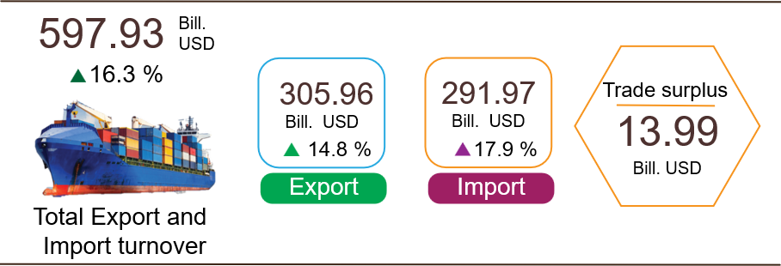
Export of goods
Export turnover of goods in July 2025 preliminarily reached 42.29 billion USD.
Export turnover of goods in August 2025 reached 43.39 billion USD, going up by 2.6% over the previous month. Of this total, the domestic economic sector contributed 9.16 billion USD, increased by 2.4%; the FDI sector (including crude oil) reached 34.22 billion USD, increased by 2.6%. Compared to the same period last year, the export turnover of goods in August increased by 14.5%, particularly the domestic economic sector decreased by 17.1% and the FDI sector (including crude oil) increased by 27.5%.
Generally, export turnover of goods in eight months of 2025 reached 305.96 billion USD, increased by 14.8% compared to that in the same period last year. Of which, the domestic economic sector contributed 76.69 billion USD, went up 3.2% and represented 25.1% of total export turnover; the FDI sector (including crude oil) reached 229.27 billion USD, increased by 19.3% and accounted for 74.9%.
In eight months of 2025, there were 29 commodities with export turnover exceeding 1 billion USD, contributing 92.1% of total export value (including 7 commodities with export turnover of over 10 billion USD, making up 67.8%).
Table 4. Export value of some commodities in 8 months of 2025
 | Value  (Mill. USD) | Growth rate  Year-on-Year (%)
Commodities with export value of over 10 billion USD
Electronic goods, computers and their parts | 66,873 | 43.1
Phones of all kinds and their parts | 38,190 | 2.4
Machinery, instrument, accessories | 37,396 | 13.8
Textiles and sewing products | 26,472 | 8.5
Footwear | 16,083 | 7.2
Transport and equipment | 11,388 | 12.7
Wood and wooden products | 11,123 | 6.5

Regarding the structure of exported commodities in eight months of 2025: the group of manufactured commodities reached 271.06 billion USD, accounting for 88.6%; the group of agricultural and forestry commodities reached 25.92 billion USD, accounting for 8.5%; the group of fishery commodities reached 7.15 billion USD, accounting for 2.3%; and the group of fuels and minerals reached 1.83 billion USD, accounting for 0.6%.
Figure 12. Structure of exported commodities in 8 months of 2025
Import of goods
Import turnover of goods in July 2025 preliminarily reached 40.0 billion USD.
In August 2025, import turnover of goods were estimated at 39.67 billion USD, decreased by 0.8% over the previous month. Of which, the domestic economic sector gained 10.76 billion USD, fell by 4.6%; the FDI sector reached 28.91 billion USD, increased by 0.7%. Compared to the same period last year, the import turnover of goods in August increased by 17.7%. Of which, the domestic economic sector decreased by 11.3%; the FDI sector went up by 34.0%.
Generally, the import turnover of goods in eight months of 2025 reached 291.97 billion USD, increased by 17.9% over that in the same period last year. Of which, the domestic economic sector reached 94.77 billion USD, went up by 5.3%; the FDI sector reached 197.2 billion USD, rose by 25.1%.
In eight months of 2025, there were 38 imported commodities with import value of over 1 billion USD, accounting for 91.2% of the total import turnover (including 2 commodities with import turnover of over 10 billion USD, making up 46.2%).
Table 5. Import value of some commodities in 8 months of 2025

 | Value  (Mill. USD) |  | Growth rate  Year-on-Year (%)
Commodities with import value of over 10 billion USD
Electronic goods, computers and their parts | 95,953 |  | 38.2
Machinery, instrument, accessory | 38,866 |  | 23.6

Regarding the structure of imported commodities in eight months of 2025, the group of capital goods reached 273.91 billion USD, accounting for 93.8%, of which the group of machinery, instrument, and accessories accounted for 52.2%, the group fuels, raw materials accounted for 41.6%. The consumer goods attained 18.06 billion USD, accounting for 6.2%.
Figure 13. Structure of imported commodities
in 8 months of 2025
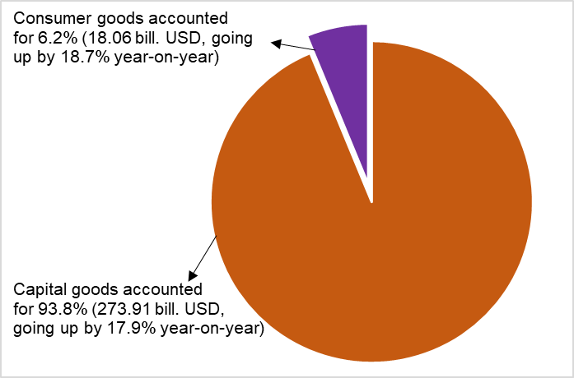
Regarding the export and import market of goods in eight months of 2025, the United States remained Viet Nam’s largest export market with an export turnover of 99.1 billion USD, while China was the largest import market with an import turnover of 117.9 billion USD. In this period, the trade surplus to the United States, EU, and Japan reached 87.0 billion USD, 25.6 billion USD, and 1.5 billion USD, respectively, with the corresponding year-on-year changes of an increase of 26.8%; 10.0%, and a decrease of 9.3%; whereas the trade deficit from China, South Korea, and ASEAN was 75.9 billion USD, a rise of 39.8% (Y-o-Y); 20.1 billion USD, an increase of 0.7% (Y-o-Y); and 9.4 billion USD, a growth of 69.1% (Y-o-Y), respectively.
Figure 14. Major commodity export and import markets in 8 months of 2025
 |  | Xuất khẩu hàng hóa | Nhập khẩu hàng hóa
Trade balance of goods in July preliminarily recorded a trade surplus of 2.29 billion USD; seven-month trade surplus reached 10.27 billion USD; Trade surplus in August recorded 3.72 billion USD. Overall, in eight months of 2025, the trade balance of goods registered a surplus of 13.99 billion USD (this figure was 18.84 billion USD in the same period last year). Of which, the domestic economic sector ran a trade deficit of 18.08 billion USD; the FDI sector (including crude oil) posted a trade surplus of 32.07 billion USD.
c) Consumer price index, Gold price index, and US dollar price index
The consumer price index (CPI) in August increased by 0.05% compared to that in the previous month, mainly due to a rise in prices of rental housing and eating out service. The CPI in August rose by 2.18% and 3.24% compared to that in December 2024 and the same period last year, respectively.
The average CPI in eight months of 2025 witnessed a year-on-year increase of 3.25%, the core inflation possessed a rise of 3.19%.
Figure 15. Consumer price index, Gold price index, and US dollar price index

In the month-on-month increase of 0.05% in the CPI, eight groups of goods and services experienced an increase, while three groups saw a decrease.
(1) Eight groups of goods and services recorded an upturn in CPI:
- Groups of housing, electricity, water, fuel, and construction materials increased by 0.21% mainly due to an expansion of 0.28% in house rental prices caused by rising demand in some areas when pupils and students returned to cities for preparation for a new school year; a rise of 1.01% in prices of household electricity resulitng from higher demand caused by hot weather; and an expansion of 0.49% in the prices of housing maintenance materials as a result of rising prices of bricks, sand, and stone, resulting from scarce supply and increasing costs of production and transportation, and high demand for construction. Conversely, some items witnessed a month-on-month reduction in prices, including: gas price dropped 3.86% as the domestic gas prices were downward adjusted in accordance with the world gas prices since August 1, 2025. Kerosene prises also fell by 0.86% due to the impact of price adjustments during the month.
- The education group added up 0.21%, of which, the price of educational service jumped up 0.21% as the result of the tuition fees adjustment in the 2025-2026 school year in some private universities, secondary schools, and preschools in some provinces. Additionally, prices of paper products climbed up 0.9%, prices of pens of all kinds, stationery and other school supplies went up 0.71%, 0.52%, respectively.
- The group of garments, hats, and footwear accelerated by 0.17% due to rising shopping demand to prepare for new school year. Of which, prices of fabrics of all kinds; garment services; footwear; ready-made clothes and shoe services; hats expanded by 0.28%, 0.27%, 0.18%, 0.16%, 0.07%, respectively.
- The group of beverages and cigarette grew by 0.17% due to higher consumpsion demand during summer and increasing costs of production, of which prices of carbonated soft drinks; mineral water; alcohol of all kinds; bottled and canned energy drinks; beer of all kinds; cigarette edged up 0.41%, 0.3%, 0.2%, 0.17%, 0.12%, and 0.11%, respectively.
- The group of household equipment and goods climbed up 0.11% due to increasing production and labor costs, of which, prices of electric fans up 0.3%; plastic and rubber products up 0.25%; gas stoves up 0.25%; both soap, detergents and air conditioner repair services up 0.23%; both TV repair services and rental of household equipment and goods up 0.21%; water heaters up 0.16%; lighting and furniture (beds, wardrobes, tables and chairs) up 0.11%; and wall mirrors up 0.02%.
- Other goods and services increased by 0.11%, focusing on some items as folows: prices of jewelry surged up 1.46% in line with the trend of gold prices; prices of watch and jewelry repair services up 0.36%; wedding and funeral services up 0.18%; personal care services up 0.05%; haircut and shampoo services up 0.04%; and environmental hygiene services up 0.01%. Conversely, prices of electric appliances for personal care; handbags, luggage, and wallets decreased by 0.38%, and 0.15%, respectively.
- The group of culture, entertainment and tourism jumped up 0.08%, focusing on some groups: prices of hotel and guesthouse; sports venue rental tickets; international tourism services; cinema and concert tickets went up 1.79%; 0.19%; 0.09%; and 0.04%, respectively. In contrast, prices of domestic tourism decreased by 0.15% as travel companies offered promotional discounts to stimulate consumer’s demand.
- The group of medicines and health care services experienced a slight increase of 0.03% due to a rise in exchange rates, causing a high increase in the cost of imported pharmaceuticals and raw materials. Of which, prices of cardiovascular drugs up 0.23%, anti-infective and anti-parasitic drugs up 0.16%, non-steroidal anti-inflammatory pain relievers, fever reducers and medicines for gout and bone diseases up 0.15%, vitamins and minerals up 0.14%, and medical equipment up 0.11%.
(2) Three groups of goods and services experienced an decrease in CPI, including:
- The group of postal service and telecommunications declined by 0.04%, of which prices of smartphones and tablets; landline phones; regular mobile phones fell by 0.63%, 0.23%, and 0.12%, respectively. In contrast, prices of phone repair services; and accessories for smart phones and tablets expanded by 0.6%, 0.55%, respectively.
- The group of food and foodstuff reduced by 0.06%, of which prices of food droped 0.18%, meals and drinking out rose by 0.2%, and prices of foodstuff possessed a slight increase of 0.01%.
- The transport group reduced by 0.11%, of which the CPI of diesel fuel and gasoline fell by 2.06% and 0.2%, respectively due to the impacts of adjustments of domestic gasoline price. Additionally, prices of second hand cars and motorbikes shrank by 0.58% and 0.18%, respectively resulting from enterprises’s preference programs for promoting and supporting consumers in shopping. On the other hand, some groups of goods recorded a month-on-month expansion such as: prices of passenger transport by air way up 0.21%, passenger transport by waterway up 0.08%, and passenger transport by roadway up 0.06% due to increasing demands for travelling during summer. Prices of spare parts jumped up 0.17% due to higher costs of imported parts, and prices of vehicle maintenance services climbed up 0.36% due to rising labor costs.
Core inflation in August saw a month-on-month increase of 0.19% and a year-on-year rise of 3.25%. The average core inflation in eight months of 2025 surged up 3.19% compared to that in the same period last year, lower than the increase of 3.25% in the overall CPI because prices of food, foodstuff, household electricity, healthcare service, education services which were main factors causing an increase in CPI, were excluded from the list of core inflation calculations.
Domestic gold prices fluctuated in line with global gold prices. As of August 30, 2025, the average price of global gold was at 3,418.45 USD/ounce, a month-on-month increase of 1.47% mainly caused by expectations of implementation of interest rate cut of US Federal Reserve (FED) and a weakening USD. Besides, geopolitical instability, gold purchases by central banks, and rising demand for gold in Asian markets also impacted the global gold prices. Domestically, the gold price index in August witnessed a month-on-month increase of 1.2%, a year-on-year surge of 48.62%, and a spike of 36.51% compared to that in December 2024. The average gold prices in eight months of 2025 shot up 40.25% compared to that in the same period last year.
Domestic US dollar prices fluctuated in the opposite direction to the world prices. As of August 30, 2025, the US dollar price index in the international market reached 98.11 points, a month-on-month reduction of 0.14%, mainly due to investors' expectations that the FED would cut its interest rates in September 2025 to support economic growth. Domestically, the US dollar price index in August possessed a month-on-month rise of 0.36%, a year-on-year upturn of 4.43%, and an expansion of 3.67% compared to that in December 2024. The average US dollar prices in eight months of 2025 saw a year-on-year increase of 3.45%.
d) Passengers and cargo transport
Transport activities in August 2025 were continuously dynamic, meeting demands for travel and tourism of domestic and international visitors to Viet Nam during the national holiday on the occasion of the Independence Day on September 2nd, as well as serving production, import and export of goods. In August 2025, passengers carried and passenger traffic saw a year-on-year increase of 25.1% and 19.2%, respectively; freight carried and freight traffic recorded a year-on-year rise of 15.7% and 17.7%, respectively.
Overall, in eight months of 2025, passengers carried and passenger traffic experienced a year-on-year rise of 21.8% and 14.2%, respectively; freight carried and freight traffic recorded a year-on-year increase of 14.6% and 14.1%, respectively.
Passengers carried in August were estimated at 542.6 million turns of passengers, a month-on-month increase of 2.2% and passenger traffic was estimated at 27.8 billion passengers-kilometers, a growth of 2.2%. Generally, for eight months of 2025, passengers carried were estimated at 3,937.2 million turns of passengers, a year-on-year rise of 21.8% and passenger traffic reached 207.3 billion passengers-kilometers, a year-on-year growth of 14.2%. Of which, domestic passengers carried were estimated at 3,924.1 million turns of passengers, a year-on-year increase of 21.8% and domestic passenger traffic was estimated at 165.5 billion passengers-kilometers, a year-on-year upturn of 15.6%; oversea passengers carried were estimated at 13.1 million turns of passengers, a year-on-year expansion of 9.6% and 41.8 billion passengers-kilometers, a year-on-year rise of 9.2%.
Table 6. Passengers transport in eight months of 2025 by type of transport
 | Number of passengers |  | Year-on-year growth rate (%)
 | Carriage  (Mill. persons) | Traffic  (Bill. persons-km) | Carriage | Traffic
Total | 3,937.2 | 207.3 | 21.8 | 14.2
Railway | 26.6 | 2.5 | 108.7 | 15.6
Seaway | 8.5 | 0.7 | -7.0 | 12.9
Inland waterway | 277.9 | 6.3 | 16.2 | 22.8
Roadway | 3,584.9 | 133.2 | 22.1 | 16.6
Airway | 39.3 | 64.6 | 9.7 | 8.9

Freight carried in August was estimated at 254.8 million tons, a month-on-month increase of 1.3% and freight traffic reached 53.8 billion tons-kilometers, a month-on-month upturn of 1.1%. Overall, in eight months of 2025, freight carried was estimated at 1,937.5 million tons, a year-on-year rise of 14.6% and freight traffic reached 399.0 billion tons-kilometers, a year-on-year increase of 14.1%. Of which, domestic transport was estimated at 1,904.1 million tons of freight carried, an upturn of 14.7% and 229.6 billion tons-kilometers of freight traffic, a rise of 8.3%; overseas transport was estimated at 33.4 million tons of freight carried, an increase of 8.5% and 169.4 billion tons-kilometers of freight traffic, a growth of 22.9%.
Table 7. Freight transport in eight months of 2025 by type of transport
 | Volume of freight |  | Year-on-year growth rate (%)
 | Carriage  (Mill. tons) | Traffic  (Bill. tons-km) | Carriage  (Mill. tons) | Traffic  (Bill. tons-km)
Total | 1,937.5 | 399.0 | 14.6 | 14.1
Railway | 3.6 | 2.7 | 7.3 | 7.8
Seaway | 102.8 | 212.6 | 15.7 | 17.4
Inland waterway | 396.2 | 86.8 | 10.9 | 10.6
Roadway | 1,434.6 | 90.3 | 15.5 | 11.2
Airway | 0.3 | 6.6 | 6.9 | 0.7

đ) International visitors to Viet Nam
More and more international visitors came to Viet Nam thanks to favorable visa policies, enhanced tourism advocacy and promotion programs, together with charming celebration activities of great national holidays.
In August, the number of international visitors to Viet Nam reached 1.68 million, a month-on-month increase of 7.8% and a year-on-year rise of 16.5%. Generally, for eight months of 2025, the international visitors to Viet Nam reached 13.9 million, a year-on-year increase of 21.7%. Of which, visitors by airway reached 11.9 million, accounted for 85.2% of international arrivals and experienced a year-on-year growth of 22.6%; visitors by roadway reached 1.9 million, comprised 13.4%, a spread of 17.5%; visitors by seaway reached 187.8 thousand, made up1.4% and an expansion of 13.4%.
Figure 16. International visitors to Viet Nam in eight months of 2025 by territories
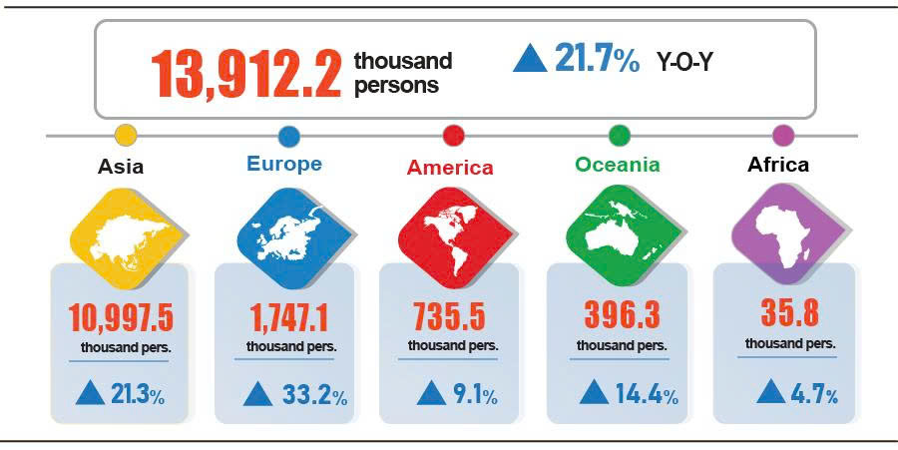
7. Social situation
a) People's life
According to preliminary results of the Labor Force Survey, 96.6% of surveyed households reported that their income in August remained unchanged and increased compared to that in the same period last year (this rate was a month-on-month increase of 0.4 percentage points and a year-on-year growth of 0.5 percentage points); 3.4% of households said that their income decreased.
Households experiencing downward income in August pointed out main reasons as follows: Household members lost their job or temporarily quitted jobs (accounting for 36.6%); the size of household production and business activities reduced (27.2%); selling prices of products made from household production and business activities went down (20.8%); and input costs for household production and business activities increased (19.5%).
In eight months of 2025, 29.4% of households reported experiencing at least one negatively affected event. Particularly, 28.7% out of negatively affected households, suffered from the effects of rising prices of goods and services; 2.4% of households were negatively affected by human epidemics; 1.6% of households were negatively affected by natural disasters, and 1.8% suffered from epidemics in livestock and crops.
In eight months of this year, 13.3% of surveyed households received assistance from different sources. Of which, 9.1% households received assistance from relatives and family; 4.7% households were supported by local programs and policies; 4.6% households were assisted by national programs and policies; 1.6% households received assistance from charity activities of other organizations and individuals; and 0.02% from other sources.
Social security work was always implemented promptly and practically by all levels and sectors. In August, as of August 28, 2025, the Government had provided 990.3 tons of rice to Đien Bien and Son La provinces to support people in overcoming the consequences of natural disasters and floods. From the beginning of the year to the end of August 28, 2025, the Government provided 11.3 thousand tons of rice to the people, of which: 6.0 thousand tons were provided for 402.6 thousand persons for hunger relief during the Lunar New Year; 4.3 thousand tons were provided for 284.5 thousand persons during the 2025 pre-harvest season; and 990.3 tons of rice were provided for 66.0 thousand persons for overcoming the consequences of natural disasters and floods.
According to the Ministry of Ethnic and Religious Affairs’s data, the program "The whole country joins hands to eliminate temporary and dilapidated houses" basically achieved its goal, 5 years and 4 months ahead of schedule as set by Resolution No. 42-NQ/TW dated November 24, 2023, by the Central Committee on continuing to innovate and improve the quality of social policies to meet the requirements of national construction and defense in the new period. The program supported the new construction and repair of 334,234 houses (of which, 255,310 new houses and 78,924 repaired houses), including: 39,981 houses for national devotees and martyrs' relatives; 62,230 houses under two National Target Programs; and 232,023 houses for poor and near-poor households under the Program to support other disadvantaged people.
b) Epidemic, food poisoning
According to the Ministry of Health's report, during the month (from July 18 to August 17, 2025), the country recorded nearly 21.6 thousand cases of dengue fever (06 deaths ); nearly 5.7 thousand cases of hand, foot and mouth disease; 1,584 cases of rash fever suspected of measles; 39 cases of viral encephalitis; 46 cases of meningococcal meningitis; 05 deaths of rabies. Generally, for eight months of 2025, the country had 111.7 thousand cases of rash fever suspected of measles (11 deaths); 65.1 thousand cases of dengue fever (11 deaths); nearly 39.6 thousand cases of hand, foot and mouth disease; 224 cases of viral encephalitis (01 death); 79 cases of meningococcal meningitis; 52 deaths of rabies.
The total number of people living with HIV nationwide as of August 17, 2025 was 251.5 thousand persons; the number of deaths from HIV/AIDS was 116.9 thousand persons.
Regarding food poisoning, in August, there were 06 cases of food poisoning, poisoning 101 people (01 death). In eight months of 2025 (from December 18, 2024 to August 17, 2025), there were 47 cases nationwide, with 585 people poisoned (14 deaths).

c) Culture and sports
Regarding culture, in August, a series of commemorative activities took place nationwide to celebrate the 80th anniversary of the August Revolution (August 19, 1945 - August 19, 2025), the National Day (September 2, 1945 - September 2, 2025), the 80th anniversary of the Traditional Day of the People's Public Security and the 20th anniversary of the festive day All People Protecting National Security. In preparation for the parade and march celebrating the 80th Anniversary of the August Revolution and the National Day, parade rehearsals were held on August 21 and 24; a state-level preliminary rehearsal was staged on August 27; a state-level full-dress rehearsal was conducted on August 30 and the official parade and march took place on September 2 with the participation of about 16,000 persons and international delegations at Ba Dinh Square, Ha Noi.
A series of art programs were also held in August, notably: the political-artistic program “Under the Glorious Flag”, organized and broadcasted live from Ba Dinh Square (Ha Noi), with two additional live venues at Ngo Mon Square (Hue) and Thu Thiem Creative Park (Ho Chi Minh City); the program “The Homeland in our Hearts”, organized at My Dinh National Stadium (Ha Noi) with the participation of more than 50,000 spectators; the special art program “Proud to be Vietnamese”, staged at the My Dinh National Stadium (Ha Noi), connecting over 30,000 live spectators with millions of Vietnamese compatriots at home and abroad through television and digital platforms; and the special art program “Echoes of Heroic Songs”, held at Ho Guom Theatre (Ha Noi)....
Regarding sports, in August, the Vietnamese sports delegations participated in a number of international tournaments and achieved remarkable results as follows: the 2025 Asian Shooting Championship in Kazakhstan from 16 to 30 August, with the participation of 750 shooters from 28 countries and territories; the 2025 Asian Youth Karate Championship held in China from 12 to 16 August, winning 01 gold medal and 02 silver medals; the Southeast Asian Bodybuilding Championship held in Thailand on 21 August, which gathered more than 100 athletes from 8 countries in the region, ranking the first overall with 06 gold, 04 silver, and 04 bronze medals; the Asian Bodybuilding and Fitness Championship held in Thailand from 22 to 24 August, ranking the second overall with 9 gold, 5 silver, and 06 bronze medals; the Southeast Asian Taekwondo Championship hosted in Khanh Hoa Province from 18 to 21 August, ranking the first overall; the 2025 Asian Kurash Championship held in the Republic of Korea from 2 to 4 August, wining the second place overall with 3 gold, 2 silver, and 3 bronze medals; the 2025 AFF Women’s Championship held from 6 to 19 August with the third place recorded by Vietnamese women’s football team; the 2025 World Championship in Thailand, ranked the 31st by Vietnamese women’s volleyball team; and the 2025 World Championship in Indonesia, held the 19th place by U21 women’s volleyball team.
d) Traffic accident
In August (from July 26 to August 25, 2025 ), there were 1,386 cases of traffic accident nationwide, causing 775 deaths and 931 injuries. Compared to the figures of July 2025, the number of traffic accidents decreased by 1.6 %; the number of deaths declined by 3.6 %; the number of injuries reduced by 2.9 %. Compared to the figures of the same period in 2024, the number of traffic accidents, deaths, and injuries dropped 23.7 %, 13.2 %, 26.4 %, respectively.
Generally, in eight months of 2025, there were 12,195 cases of traffic accident nationwide, resulting in 6,876 deaths and 8,136 injuries. Compared to the figures of the same period last year, the number of traffic accident cases, deaths, and injuries decreased by 23.8%, 4.9 %, and 32.4 %, respectively. On average, in eight months of 2025, there were 50 traffic accidents, causing 28 deaths and 33 injuries a day.
đ) Damage caused by natural disaster
In August, damage caused by natural disasters was attributed to rain-induced floods and inundations, resulting in 31 people died and missing, 85 others injured, more than 111.4 thousand hectares of rice and other crops submerged and damaged, 78.7 thousand heads of livestock and poultry killed, more than 36.3 thousand houses collapsed, swept away and damaged. The total value of property loss caused by natural disasters during the month was 3,867.0 billion VND, 3.3 times higher than the figure of the same period last year. In eight months of this year, natural disasters caused 175 people died and missing, 188 others injured; damaged 221,200 hectares of rice and 29,100 hectares of other crops; killed 498,500 heads of livestock and poultry; collapsed, swept away and damaged nearly 52,400 houses. The total value of property damage was estimated at 9,865.8 billion VND, 2.9 times higher than the figure of the same period in 2024.
e) Environmental protection, fire and explosion prevention
In August (from July 18 to August 17, 2025), functional authorities detected 948 cases of environmental violations in 30 out of 34 localities, of which, 775 cases were addressed with a total fine of 14.8 billion VND, gaining a month-on-month increase of 22.0% and a year-on-year decrease of 45.9%. In eight months of this year, the functional authorities detected 9,512 cases of environmental violations, of which, 8,443 cases were addressed with a total fine of 142.4 billion VND, a year-on-year reduction of 30.3%.
In August (from July 15 to August 14, 2025), 272 cases of fire and explosion occurred nationwide, causing 6 deaths and 10 injuries with an estimated loss of 32.6 billion VND, a month-on-month increase of 75.7%, 3.1 times higher than the figure of the same period last year. In eight months of this year, there were 2,211 cases of fire and explosion nationwide, causing 76 deaths and 89 injuries with an estimated loss of 212.1 billion VND, a year-on-year rise of 25.9%./.

Main reason of land acquisition for industrial zone projects, conversion to other crops for higher economic efficiency, of which: localities showed a reduction as follow Ninh Binh 4.2 thousand hectares; Hung Yen 2.4 thousand hectares; Hanoi 1.7 thousand hectares, respectively.
No African swine fever was recorded in Hai Phong.
Some localities were recorded with a year-on-year bounce of newly planted forest area, including Gia Lai (up 80.8%); Da Nang (up 12.2%); Quang Ngai (up 11.0%).
Some localities were recorded with a year-on-year jump in wood production, of which Ca Mau 68.7%; Khanh Hoa 37.4%; Da Nang 8.8%; Hue 8.3%; Thanh Hoa 7.0%.
Figure released by the Ministry of Agriculture and Environment as of August 15, 2025.
Source: http://vasep.com.vn/gia-thuy-san and compiled by reports of localities: The price of raw pangasius in the Mekong Delta, type 0.7-1.0 kg/fish,which showed a stability at 28,000 VND/kg - 29,000 VND/kg, an increase of 2,000 VND/kg - 3,000 VND/kg compared to the same period in 2024. With this price, farmers made profit of 4,000 VND/kg - 5,000 VND/kg.
The IIP in August 2024 saw a year-on-year increase of 8.4%.
The month-on-month IIP growth rate in August of some provinces and municipalities with large-shared industrial activities were as follows: Vinh Long up 10.1%; Hai Phong up 7.8%; Ho Chi Minh city up 5.4%; Quang Ngai up 2.4%; Quang Ninh up 2.1%; Dong Nai up 1.9%; Da Nang down 1.7%; Bac Ninh down 1.2%.
Some localities experienced a y-o-y high increase in IIP in 8 months of 2025 as follows: Quang Ninh (32.1%); Phu Tho (27.3%); Ninh Binh (23.7%); Hue (17.7%); Hai Phong (16.4%); Thanh Hoa (16.3%). Localities saw an IIP surge in the electricity production and distribution as follows: Hue (39.5%); Nghe An (27.6%); Phu Tho (14.0%).
Some provinces and municipalities saw a year-on-year modest increase or even decrease in IIP of the manufacturing in 8 months as follows: Lang Son (+4.4%); Son La (+1.4%); Ha Tinh (-0.2%); Cao Bang (-7,.0%). Some provinces and municipalities experienced a year-on-year modest increase or even decrease in IIP of the electricity production and distribution in 8 months as follows: Lam Dong (+1.5%); Cao Bang (+ 0.5%); Can Tho (-0.5%); Ho Chi Minh city (-36.6%). Some localities saw a y-o-y modest increase or even reduction in the IIP of the mining in 8 months of 2025 as follows: Tuyen Quang (+2.2%); Ha Noi (-4.2%); Ho Chi Minh city (-4.9%); Can Tho (-8.2%).
Of which, the additional registered capital of the active enterprises in eight months of 2025 reached 2,881.2 trillion VND (a year-on-year increase of 182.7%).
According to the report of the Foreign Investment Department, Ministry of Finance, received on September 3, 2025.
Data received from the State Budget Department, Ministry of Finance on September 4, 2025
The value of export turnover is calculated at F.O.B price and import turnover is calculated at C.I.F price (including transportation and insurance costs of imported goods).
The preliminary data of export and import of goods in August 2025 were provided by the Viet Nam Customs on September 4th, 2025.
Total import and export turnover of goods in eight months of 2024 reached 514.04 billion USD, a year-on-year increase of 17.4%, of which export and import reached 266.44 billion USD, rising by 16.4% and 247.6 billion USD, growing by 18.4%, respectively.
22 million USD higher than the data sent by the Viet Nam Customs to the National Statistics Office on August 1st, 2025.
The same as the data sent by the Viet Nam Customs to the National Statistics Office on August 1st, 2025.
The reporting period in July preliminarily recorded a trade surplus of 2.27 billion USD.
The electricity price index in August reflected one-month-latency fluctuations compared to other items, as it was calculated basing on the revenue and consumption output in July 2025.
Pork prices decreased by 2.42% due to complication of African Swine Fever in some provinces, causing consumer’s concern about food safety and origination. Consequently, animal fat prices down 1.72%; prices of organs down 1.66%; prices of frozen livestock down 0.84%; and prices of processed meat down 0.42%. Prices fresh and processed fruit also down 1.51%. In contrast, some food items in August saw a month-on-month increase in price: prices of poultry meat up 0.89%; fresh seafood prices up 0.42%; processed seafood prices up 0.37%; prices of eggs of all kinds up 3.22%; prices of fresh, dried, and processed vegetables up 1.0%; confection up 0.44%; tea, coffee, and cocoa by 0.29%; spices up 0.2%; milk, butter, and cheese up 0.1%; and sugar and syrup up 0.08%.
Due to increased demand for eating out during the peak summer tourism season. Of which, prices of drinking out up 0.26%, eating out up 0.25%, while takeaway fast food down 0.1%.
Due to rise in price of some foodstuff items, such as prices of corn up 0.96%, potatoes up 0.95%, both instant cereals and flour up 0.32%, bread up 0.24%, vermicelli up 0.23%, corn flour up 0.15%, and rice noodles up 0.05%. In contrast, prices of domestic rice fell in line with the prices of export rice due to abundant global supply. Consequently, the price index if rice group dropped 0.1% (regular rice down 0.17%, while premium rice and sticky rice up 0.06%; 0.41%, respectively).
The CPI after excluding prices of fresh food, energy, and State-managed goods, which include healthcare and education services.
The number of passengers carried by highway railway in Ha Noi and Metro in Ho Chi Minh City was added.
The number of passengers carried by seaway in eight months of 2025 saw a year-on-year decrease, mainly due to unfavorable weather conditions, which led to a reduction in the number of seaway passengers and caused many shipping routes to temporarily suspend or to reduce frequency.
According to the reports from the Department of Border Gate, the Border Guard Command, the Ministry of National Defense, and the Immigration Department, the Ministry of Public Security.
The reporting period was from July 26, 2025 to August 25, 2025.
A household could select multiple causes leading to decreased income.
On August 15 2025, the Ho Chi Minh Relic Site at the Presidential Palace held the opening ceremony of a series of six events, including: the exhibition “Viet Nam – Ho Chi Minh – Milestones in the Nation’s History”; the thematic display “Journey for Peace”; the exhibition “Continuing the Story of Peace”; the launch of the books “President Ho Chi Minh and General Nguyen Chi Thanh” and “The Former Indochina Governor-General’s Palace and the Presidential Palace Today”; and the premiere of “Red Rain”, a feature film on the revolutionary war produced by the People’s Army Cinema, which vividly recalled the heroic memory of the 81 days and nights defending Quang Tri Citadel. On August 19 2025, groundbreaking and inauguration ceremonies for 250 projects were simultaneously organized at 80 locations nationwide. On August 28 2025, the opening ceremony of the national exhibition of achievements “80 Years of Independence – Freedom – Happiness” was held at the Viet Nam Exhibition Center, lasting from August 28 to September 5 2025.
According to a quick report from the Office of the Ministry of Public Security and the Viet Nam Maritime and Waterways Administration (Ministry of Construction ) dated August 28, 2025.
Report integrated from 34 Departments of Agriculture and Environment, the reporting period from July 19 to August 18, 2025.
According to data compiled by Provincial Statistics Offices from the reports of Provincial Departments of Agriculture and Environment and Provincial, Municipal Police Departments.
Four localities (Gia Lai, Khanh Hoa, Lam Dong and Tay Ninh) did not detect any cases of environmental violation in August 2025.
According to a quick report from the Ministry of Public Security dated August 23, 2025.

