MINISTRY OF FINANCE  NATIONAL STATISTICS OFFICE  ________________  No: 451/BC-CTK | SOCIALIST REPUBLIC OF VIET NAM  Independence-Freedom-Happiness  ______________________________________  Ha Noi, 6th December 2025

REPORT
SOCIO-ECONOMIC SITUATION
IN NOVEMBER AND THE 11 MONTHS OF 2025

1. Agriculture, forestry, and fishing
In November, agricultural production focused on harvesting winter-spring rice, cultivating other winter crops, caring for and restoring production and livestock affected by natural disasters and floods, especially in the coastal provinces of the South Central Coast and the Central Highlands. Wood exploitation and aquaculture witnessed a stability, ensuring raw material supply for processing and export. However, due to the severe weather, some localities were recorded with a slow progress of afforestation, and a decrease of marine capture fisheries.
a) Agriculture
Winter-spring rice
As of November 20, 2025, the nationwide harvested area reached 1,283.2 hectares of the winter-spring rice, making up 83.3% of the cultivated area, and equal to 100.2% of the same period last year. Of which the Northern localities harvested 940.3 thousand hectares, accounting for 95.70%, and equal to 99.2%; the Southern localities harvested 342.9 thousand hectares, accounting for 61.3%, and equal to 103.0%. The winter-spring rice this year was recorded with favorable weather conditions at the beginning of the crop for rice growth and development. However, at harvesting period, heavy rains due to storms flooded some localities, and affected the national harvesting progress. Some localities were recorded with a year-on-year slow of harvesting progress including Thanh Hoa (93.8%), Ninh Binh (94.7%), and Hai Phong (96.7%).
According to reports of localities, the national winter-spring rice yield this year was estimated at 52.4 quintals/hectare, showing a year-on-year increase of 2.2 quintals/hectare, of which the Northern localities were estimated at 50.7 quintals/hectare, rising by 3.2 quintals/hectare (the Red River Delta reached 55.5 quintals/hectare, growing by 8.0 quintals/hectare). The yield of the winter-spring rice in the Southern localities was estimated at 55.3 quintals/hectare, showing a year-on-year growth of 0.3 quintals/hectare. The national production of the winter-spring rice was estimated at 8.07 million tons, a year-on-year expansion of 314.7 tons, of which the North was estimated at 4.98 million tons, an increase of 243.3 thousand tons (the Red River Delta reached 2.6 million tons, a growth of 319.1 thousand tons); the South reached 3.09 million tons, a rise of 71.5 thousand tons.
Autumn-winter rice
In 2025, the cultivation area of autumn-winter rice in the Mekong River Delta and Tay Ninh province was estimated at 716.6 thousand hectares, a year-on-year drop of 1,300 hectares because some localities converted partly the rice cultivation land area to fruit trees and vegetables for higher economic efficiency. In addition, some localities were recorded not ready to cultivate new crops yet, proactively flooding fields to deposit nutrient-rich silt preparing for the 2025-2026 winter-spring crop. Some localities witnessed a year-on-year decrease in cultivation area, including Vinh Long (down 1,700 hectares); Can Tho (down 2,600 hectares); Kien Giang (down 6,700 hectares); Ca Mau (down 7,100 hectares).
As of November 20, 2025, the localities in the country harvested 435.7 thousand hectares of autumn-winter rice, accounting for 60.8% of the cultivated area, and equal to 95.9% of the same period last year, due to late sowing, especially in An Giang, which was recorded the largest autumn-winter rice area in the region. The harvested area of ​​An Giang reached 155.7 thousand hectares, accounting for 62.9% of the cultivated area, and equal to 84.9% of the same period last year.
Annual crops
Due to the impact of natural disasters and floods, the area of ​​most vegetables and crops witnessed a year-on-year decrease. Generally, the cultivation progress witnessed a fall in most crops; however, the Northern localities quickly restored production when the weather conditions got stable. Specialized vegetable growing areas in Ha Noi, Hai Duong, and Vinh Phuc saw an expansion in cultivated area to meet the demand at the end of the year and during the traditional Lunar New Year.
Figure 1. Cultivated areas of annual crops
(As of November 20, 2025)
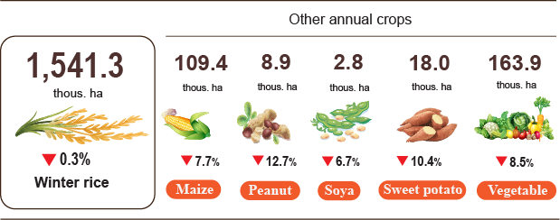
Livestock
Buffalo farming showed a downtrend, mainly due to the narrowing of natural grazing areas, high input costs, long maturation periods, and low profits. Some localities saw a sharp decrease in buffalo numbers including Thanh Hoa (down 13.2%); Lai Chau (down 3.1%); Tuyen Quang (down 2.6%); Phu Tho (down 2.5%). The cattle numbers showed a slight decrease, mainly due to lack of green roughage sources, high input costs and ineffective small-scale farming. However, some localities recorded a growth in cattle numbers thanks to stable consumption markets and developed high-tech farm systems, of which Nghe An and Lam Dong witnessed an increase of 2.4%, and 2.1%, respectively.
Pig farming witnessed a recovery after impact of African swine fever; however, in the Central provinces, due to the severe impact of floods, the repopulation process was interrupted, the scale of farming was shrunk, and the recovery of production faced uncertainties. Some localities experienced a year-on-year decrease of the pig numbers, including Da Nang (down 2.2%); Ha Tinh (down 2.8%); Thanh Hoa (down 3.2%); Quang Ngai (down 4.8%); Quang Tri (down 5.5%), and Khanh Hoa (down 21.0%). Poultry farming in the South Central Coast and Central Highlands localities were affected by floods and rains caused a decline in local production, however, the national number of poultry maintained an upward trend thanks to the stability and expansion of farming scale of other localities. Some localities witnessed a year-on-year sharp increase in poultry numbers, including Nghe An (up 7.0%); Thanh Hoa (up 6.3%); Phu Tho up (3.8%); Dong Nai (up 2.9%), and Ha Noi (up 1.2%).
Figure 2. Year-on-year growth rate of livestock and poultry number
at the end of November 2025
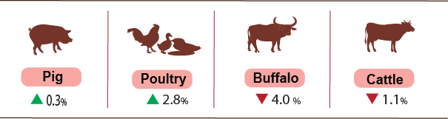
As of November 30, 2025, the country was no longer the recorded blue ear. However, the avian influenza was still reported in localities such as Ha Noi, Ninh Binh, Quang Ngai, Dong Thap, Ca Mau; the foot-and-mouth disease was reported in Tuyen Quang and Son La; the lumpy skin disease was occurred in Nghe An; and the African swine fever remained in 31 localities where the outbreak has not yet passed 21 days.
b) Forestry
The area of newly concentrated planted forest in November was estimated at 29.9 thousand hectares nationwide, a year-on-year decline of 4.8%; the number of scattered forest trees reached 8.3 million, a fall of 1.0%; wood production reached 2,478.5 thousand m³, a rise of 1.9% due to stability of raw wood, and promotion of wood harvesting as the trees reached harvesting period in several localities. In general, in eleven months of 2025, the area of ​​newly planted forests was estimated at 281.1 thousand hectares, a year-on-year growth of 6.5%; the number of scattered trees reached 83.0 million trees, an increase of 1.0%; and production of harvested wood reached 22,881.5 thousand m³, a build-up of 6.8%.
The damaged forest area in the month was estimated at 18.8 hectares, a year-on-year drop of 76.0%, of which the deforested area was estimated at 18.7 hectares, declining by 75.1%; the burnt forest area reached 0.1 hectares, dropping by 96.9%. Generally, in the 11months of 2025, the total damaged forest area was estimated at 1,059.6 hectares, a year-on-year drop of 33.1%, of which the deforested area was 744.1 hectares, dropping by 11.3%; the burnt forest area was 315.5 hectares, decreasing by 57.8%.
c) Fishing
Capture fisheries and aquaculture production in November were estimated at 904.5 thousand tons, a year-on-year increase of 2.6%, of which fish reached 633.5 thousand tons, growing by 2.4%; shrimp reached 157.8 thousand tons, going up 4.5%; other aquatic products reached 113.2 thousand tons, rising by 0.9%.
Aquaculture production in the month was estimated at 625.7 thousand tons, a year-on-year upturn of 5.4%, of which, fish reached 423.7 thousand tons, rising by 5.3%; shrimp reached 144.8 thousand tons, growing by 5.2%.
Pangasius production in the month showed a year-on-year increase, thanks to the rise in raw pangasius prices, and the harvested pangasius production ensured the source of raw materials for export processing. Pangasius production in the month was estimated at 213.5 thousand tons, which showed a year-on-year growth of 6.4%.
Shrimp production in the month witnessed a year-on-year upward trend thanks to a slight increase in raw shrimp prices and export demand to major markets for the year-end demand. White leg shrimp production in November was estimated at 104.8 thousand tons, a year-on-year growth of 5.9%; black tiger shrimp production reached 32.1 thousand tons, a rise of 3.2%.
The capture fisheries in the month were estimated at 278.8 thousand tons, a year-on-year decline of 3.2%, due to severe weather caused by the Typhoon No. 13 and its aftermath, fishing vessels were forced ashore to avoid the storm, directly impacted to marine capture fisheries. Of which, fish production reached 209.8 thousand tons, falling by 2.9%; shrimp production reached 13.0 thousand tons, decreasing by 2.3%; other aquatic products reached 56.0 thousand tons, dropping by 4.3%. The total marine fisheries production was estimated at 259.5 thousand tons, a year-on-year decrease of 2.8%. Of which, fish reached 198.0 thousand tons (up 2.6%); shrimp reached 12.5 thousand tons (up 1.6%); other aquatic products reached 49.0 thousand tons (up 3.9%).

Figure 3. Capture fisheries and aquaculture production
in the 11 months of 2025 (Y-o-Y)
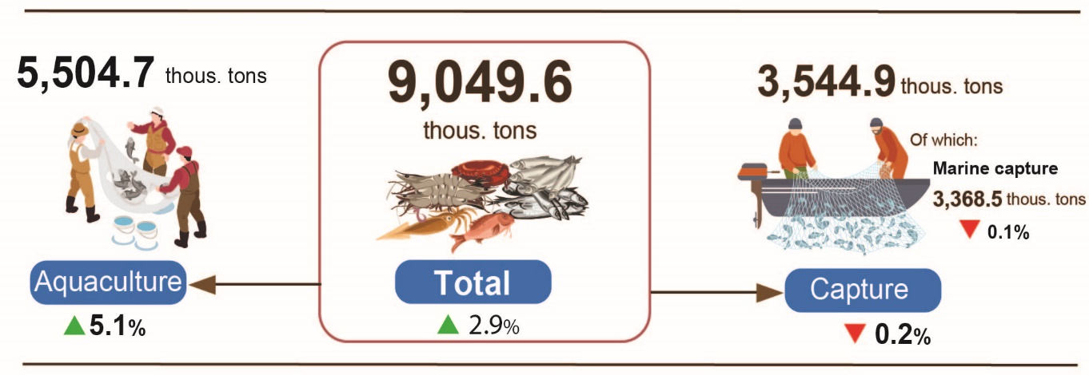
Generally, in the 11 months of 2025, the total capture fisheries and aquaculture production were estimated at 9,049.6 thousand tons, a year-on-year growth of 2.9%, of which, fish reached 6,362.4 thousand tons, increasing by 2.6%; shrimp reached 1,413.9 thousand tons, rising by 5.5%; other aquatic products reached 1,273.3 thousand tons, growing by 1.9%.
2. Industrial production
November's industrial production continued its upward trend, as businesses accelerated production to meet year-end demand for both domestic sales and exports. In November, the Index of Industrial Production (IIP) was estimated to grow by 2.3% month-on-month and 10.8% year-on-year. Generally, for the 11 months of 2025, the IIP grew by 9.3% over the same period last year.
In November, the IIP was estimated to grow by 2.3% month-on-month and 10.8% year-on-year. Specifically, the manufacturing recorded a year-on-year increase of 11.8%; the mining and quarrying rose by 7.0%; the water supply, sewerage, waste management and remediation activities grew by 6.5%; and the electricity supply increased by 5.8%.
Generally, for 11 months of 2025, the IIP was estimated to grow by 9.3% over the same period last year (the corresponding figure in 2024 was 8.3%). Specifically, the manufacturing grew by 10.6% (the corresponding figure in 2024 was 9.6%), contributing 8.5 percentage points to the overall growth; the water supply, sewerage, waste management and remediation activities increased by 8.4% (versus 10.2% in 2024), contributing 0.1 percentage points; the electricity supply rose by 6.5% (versus 9.8% in 2024), contributing 0.6 percentage points; the mining and quarrying grew by 0.9% (6.7% decline in the same period of 2024), contributing 0.1 percentage points.
In the 11 months of 2025, the IIP of several key 2-digit activities experienced a year-on-year increase as follows: manufacture of motor vehicles 22.0%; manufacture of other non-metallic mineral products 16.5%; manufacture of rubber and plastic products 16.4%; manufacture of basic metals 15.5%; manufacture of wearing apparel 13.5%; manufacture of fabricated metal products (except machinery and equipment) 12.6%; manufacture of paper and paper products 11.6%; manufacture of leather and related products 11.2%; manufacture of chemicals and chemical products 11.2%; manufacture of coke, refined petroleum products 10.6%; manufacture of food products 10.5%; manufacture of furniture 10.1%; manufacture of computer, electronic and optical products 8.5%. Conversely, the IIP for some activities nudged up or decreased as follows: mining of hard coal and lignite nudged up 3.7%; extraction of crude petroleum and natural gas reduced by 2.7%.
Table 1. Year-on-year IIP growth rate for 11 months in the period of 2021 - 2025 for several key industrial activities
%
 | 2021 | 2022 | 2023 | 2024 | 2025
Mining of hard coal and lignite | 7.5 | 5.8 | -0.8 | -5.8 | 3.7
Extraction of crude petroleum and natural | -12.6 | 4.7 | -4.4 | -11.2 | -2.7
Manufacture of food products | 1.9 | 9.2 | 5.8 | 7.1 | 10.5
Manufacture of wearing apparel | 6.3 | 16.6 | -1.2 | 10.9 | 13.5
Manufacture of leather and related products | 4.2 | 16.5 | -0.3 | 12.7 | 11.2
Manufacture of paper and paper products | 3.1 | 10.5 | -0.7 | 9.5 | 11.6
Manufacture of coke, refined petroleum products | 7.5 | 8.9 | 1.3 | 14.5 | 10.6
Manufacture of chemicals and chemical products | -0.8 | 4.0 | 8.8 | 13.5 | 11.2
Manufacture of rubber and plastics products | 0.3 | -6.5 | 12.1 | 25.4 | 16.4
Manufacture of other non-metallic mineral products | 1.7 | 6.0 | -4.0 | 0.6 | 16.5
Manufacture of basic metals | 23.4 | -2.4 | 4.4 | 9.8 | 15.5
Manufacture of fabricated metal products (except machinery and equipment) | 4.5 | 7.7 | 8.3 | 11.3 | 12.6
Manufacture of computer, electronic and optical products | 8.6 | 8.6 | -1.4 | 8.3 | 8.5
Manufacture of motor vehicles | 11.5 | 6.5 | -3.7 | 19.7 | 22.0
Manufacture of furniture | 0.8 | 1.9 | 7.8 | 25.0 | 10.1
The IIP in the 11 months of 2025 experienced a year-on-year increase in all 34 provinces and municipalities. Several provinces saw a fairly high growth rate in the IIP thanks to the manufacturing and the surge in the electricity supply. Conversely, the IIP in several provinces and municipalities nudged up due to low growth or decrease in the manufacturing, the mining and quarrying, and the electricity supply.
Figure 4. Year-on-year IIP growth rate for some localities
(11-month period, 2025) (%)

Top 10 localities by IIP growth rate | Bottom 10 localities by IIP growth rate
Several key industrial products in the 11 months in 2025 witnessed year-on-year increases were as follows: automobiles with 37.4%; TV with 19.0%; laminated steel with 18.5%; aquatic feed with 14.8%; regular clothes with 14.2%; manufacture of cement with 14.1%; leather shoes and sandals with 12.8%; refined sugar with 12.3%; NPK fertilizer with 11.9%; chemical paint with 10.9%. Conversely, some industrial products experienced a year-on-year reduction, including natural gas (5.9%); fabrics from synthetic yarn (1.8%).
The number of employees in industrial enterprises as of November 1, 2025 saw a month-on-month growth of 1.0% and year-on-year increase of 3.7%. Among them, the number of employees in the state-owned enterprises saw a 0.1% month-on-month increase and 1.5% year-over-year increase; the FDI enterprises increased by 1.3% and 4.5%, respectively; while the non-state enterprises rose by 0.7% and 1.9%, respectively. By kind of economic activity, the number of employees in the mining was unchanged over previous month and saw a year-on-year increase of 1.6%. The manufacturing saw an increase of 1.1% and 3.9%, respectively. The electricity, gas, steam and air conditioning supply was unchanged over previous month and saw a year-on-year increase of 1.9%. Meanwhile water supply, sewerage, waste management, and remediation activities recorded a slight increase of 0.3% month-on-month and 1.9% year-on-year.
3. Business registration status
In November, the country had 15.1 thousand newly registered enterprises with registered capital of 160.5 trillion VND and registered employees of 83.3 thousand employees, a month-on-month decrease of 16.1%, 6.9%, and 11.0% in the number of enterprises, in the registered capital and in the number of employees, respectively. In comparison with the same period last year, the number of enterprises increased by 34.9%, the registered capital increased by 15.8% and the number of employees decreased by 7.6%. In November, the average registered capital of a newly registered enterprise reached 10.7 billion VND, a month-on-month increase of 10.9% and a year-on-year decrease of 14.1%. In addition, the country also had 9.7 thousand resumed operation enterprises, a month-on-month decrease of 16.4% and a year-on-year increase of 25.6%.
In November, there were 4,859 enterprises registered to temporarily suspending for a definite time, a month-on-month decrease of 19.9% and a year-on-year growth of 14.5%; 6,668 enterprises ceased and awaited for dissolution procedures, a month-on-month decrease of 1.5% and a year-on-year decrease of 11.7%; 4,022 enterprises completed procedures for dissolution, a month-on-month decrease of 11.3% and a year-on-year growth of 110.6%.
In the 11 months of 2025, the whole country had nearly 178,0 thousand newly registered enterprises with a total registered capital of 1,753.2 trillion VND and a total number of registered employees of 1,050.8 thousand employees, a year-on-year increase of 20.9%, 20.9%, 16.0% in the number of enterprises, in the registered capital and in the number of employees, respectively. The average registered capital of a newly registered enterprise in the 11 months of 2025 reached 9.8 billion VND, equal to the same period last year. The total registered capital added to the economy in the 11 months of 2025 was 5.6 quadrillion VND, a year-on-year increase of 104.3%. In addition, the whole country has 97.6 thousand resumed operation enterprises (a year-on-year increase of 36.9%), bringing the total number of newly registered and resumed enterprises in the 11 months of 2025 to 275.6 thousand enterprises, a year-on-year increase of 26.1%. On average, there were 25.1 thousand newly registered and resumed enterprises per month.
By economic sector, in the 11 months of 2025, the number of newly registered enterprises in the agriculture, forestry and fishery sector; the industry and construction sector, the service sector reached 1,682 enterprises, (a year-on-year increase of 12.5%); 40.1 thousand enterprises (a year-on-year increase of 16.6%), and 136.2 thousand enterprises (a year-on-year increase of 22.3%), respectively.
Figure 5. Business registration status
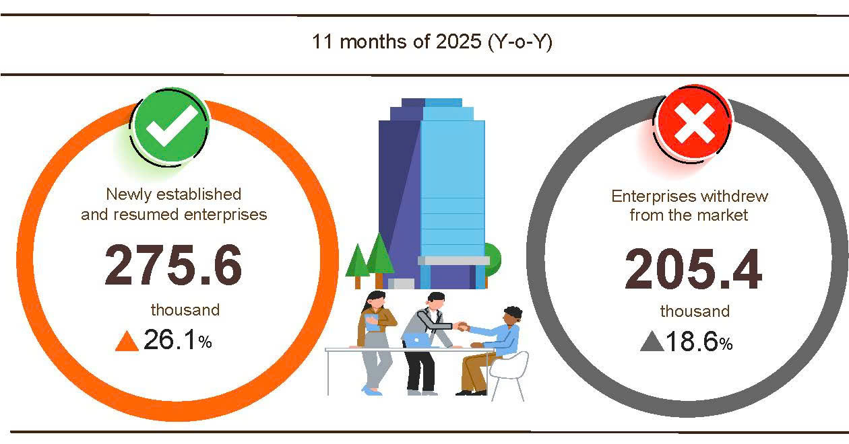
In the 11 months of 2025, the number of enterprises temporarily suspending for a definite time was 110,1 thousand enterprises, a year-on-year increase of 14.4%; 64,5 thousand enterprises suspended operation waiting for dissolution procedures, an increase of 11.7%; 30,8 thousand enterprises completed procedures for dissolution, an increase of 60.1%. On average, 18.7 thousand enterprises withdrew from the market per month.
Table 2. Newly registered and completely dissolved enterprises
in the 11 months of 2025 by kind of economic activity

 | Number of enterprises (Enterprises) |  | Y-o-Y growth rate (%)
 | Newly established | Completely dissolved | Newly established | Completely dissolved
Wholesale and retail, repair of motor vehicle and motorcycle | 75,606 | 11,296 | 26.1 | 44.3
Manufacturing | 23,737 | 3,390 | 32.9 | 64.7
Construction | 14,294 | 2,262 | -3.7 | 77.0
Real estate business | 5,183 | 1,778 | 22.2 | 56.4
Transportation and storage | 10,269 | 1,182 | 29.3 | 61.5
Accommodation and food services | 7,042 | 1,569 | 29.7 | 81.0
Electricity, water and gas supply | 1,422 | 365 | 30.2 | 60.1
4. Investment
State budget investment in November was strongly promoted by ministries, branches, and localities, reaching its highest growth rate ever, creating a momentum to boost economic growth. In the 11 months of 2025, the State budget investment was estimated to reach 72.2% of the plan, a year-on-year increase of 26.8%. The foreign direct investment (FDI) in Viet Nam in the 11 months of 2025 was estimated at 23.6 billion USD, a year-on-year increase of 8.9%.
The State budget investment in November was estimated at 97.5 trillion VND, up 21.5% over the same period last year, of which the Centrally- managed investment reached 13.2 trillion VND (up 8.1%); locally- managed investment was 84.3 trillion (up 23.9%). In the 11 months of 2025, the total State budget investment was estimated at 736.4 trillion VND, equal to 72.2% of the annual plan and increasing by 26.8% over that in the same period last year (the same rates in 2024 were 74.3% and up 3.9%, respectively). Specifically:
- The Centrally- managed investment was estimated at 102.6 trillion VND, equal to 69.7% of the annual plan and increasing by 5.1% year-on-year. Of which, Ministry of Construction reached nearly 62.0 trillion VND (down 0.5%); Ministry of Agriculture and Environment was nearly 15 trillion VND, (up 58.9%); Ministry of Health reached 3.1 trillion VND, (2.9 times higher); Ministry of Education and Training 1.7 trillion VND (up 73.3%); Ministry of Culture, Sports and Tourism reached 1.0 trillion VND (up 64.5%); Ministry of Science and Technology reached 390.9 billion VND (down 24.0%); and Ministry of Industry and Trade reached 229.4 billion VND (down 55.8%).
- The locally- managed investment was estimated at 633.8 trillion VND, equal to 72.6% of the annual plan and rising by 31.1% year-on-year, of which:
519.1 trillion VND was disbursed at the provincial level, equal to 72.0% of the annual plan and growing by 36.9% over that in the same period in 2024.
Nearly 114.7 trillion VND was disbursed at the commune level, equal to 75.5% of the annual plan and going up 10.3% over that in the same period of 2024.
The State budget investment in eleven months of 2025 of some provinces and municipalities was as follows:
Figure 6. State budget investment in the 11 months of 2024-2025
in selected localities

Total inward foreign investment in Viet Nam as of November 30, 2025, including newly registered capital, adjusting registered capital, and capital contribution and purchasing shares by foreign investors, reached 33.69 billion USD, year-on-year increase of 7.4%.
Figure 7. Inward foreign investment in Viet Nam
in the 11 months of 2021-2025 (Billion USD)

- In terms of newly registered capital: 3,695 projects were licensed with a registered capital of 15.96 billion USD, a year-on-year increase of 21.7% in the number of projects and a decrease of 8.2% in registered capital. Of which, the largest newly licensed FDI was the manufacturing with a registered capital of 9.17 billion USD, accounting for 57.5% of the total newly registered capital; the real estate activities reached 3.14 billion USD, accounting for 19.7%; and other economic activities accounted for 3.65 billion USD, accounting for 22.8%.
Among the 88 countries and territories with newly licensed projects in Viet Nam during eleven months of 2025, Singapore was the largest investor with 4.29 billion USD, accounting for 26.9% of the total newly registered capital; followed by China with 3.40 billion USD, accounting for 21.3%; Hong Kong Special Administrative Region (China) with 1.66 billion USD, accounting for 10.4%; Japan with 1.56 billion USD, accounting for 9.8%; Sweden with 1.0 billion USD, accounting for 6.3%; Taiwan with 951.1 million USD, accounting for 6.0%; and South Korea with 659.6 million USD, accounting for 4.1%.
- Adjusted registered capital: 1,318 turns of projects licensed from the previous years registered to adjust investment capital upwards by an additional 11.62 billion USD, increasing by 17.0% over that in the same period last year.
If including newly registered capital and adjusted registered capital of licensed projects in the previous years, the registered FDI in the manufacturing reached 16.52 billion USD, accounting for 59.9% of the total newly registered and increased capital; the real estate activities reached 5.72 billion USD, accounting for 20.7%; and other economic activities reached 5.34 billion USD, accounting for 19.4%.
- There were 3,225 turns of registered capital contributions and purchasing shares by foreign investors with a total value of 6.11 billion USD, a year-on-year increase of 50.7%. Of which, 1,238 turns of capital contributions and purchasing shares increased the charter capital of enterprises with a value of 2.37 billion USD and 1,987 turns of foreign investors rebought domestic shares without increasing the charter capital with a value of 3.74 billion USD. Regarding the form of capital contribution and purchasing shares by foreign investors, the manufacturing reached 2.0 billion USD, accounting for 32.7% of the capital contribution value; the professional, scientific and technical activities reached 1.13 billion USD, accounting for 18.5%; the other economic activities reached 2.99 billion USD, accounting for 48.8%.
The FDI in Viet Nam in eleven months of 2025 was estimated at 23.6 billion USD, a year-on-year increase of 8.9%. This was the highest figure in the FDI in eleven months in the past-5-year period. Of which: the manufacturing reached 19.56 billion USD, accounting for 82.9% of total disbursed FDI; the real estate activities reached 1.67 billion USD, accounting for 7.1%; the electricity, gas, steam and air conditioning supply reached 754.9 million USD, accounting for 3.2%.
Figure 8. Foreign direct investment
In the eleven months of 2021-2025 (billion USD)

Viet Nam's outward investment in the eleven months of 2025 witnessed 148 projects granted with new investment certificates with a total capital of 742.8 million USD, an increase of 33.8% over that in the same period last year; 28 turns of projects adjusted their capital with an additional of 358.2 million USD, 8.2 times higher.
Generally, the total Viet Nam's outward FDI (newly granted and adjusted capital) reached 1.1 billion USD, a year-on-year increase of 83.9%. Of which, the electricity, gas, steam and air conditioning supply reached 342.5 million USD, accounting for 31.1% of total investment; the manufacturing reached 277.6 million USD, accounting for 25.2%; the wholesale and retail trade, repair of motor vehicles and motorcycles reached 129.6 million USD; accounting for 11.8%.
In the eleven months of 2025, Viet Nam invested in 36 countries and territories, of which, Laos was the top with 590.3 million USD of investment capital, accounting for 53.6% of total investment; following countries were Philippines with 92.0 million USD, accounting for 8.4%; Germany with 78.1 million USD, accounting for 7.1%; Indonesia with 69.6 million USD, accounting for 6.3%; the United States with 33.9 million USD, accounting for 3.1%.
5. State budget revenue and expenditure
State budget revenue in the 11 months of 2025 recorded a year-on-year increase of 30.9%. The State budget expenditure increased by 32.5%, effectively meeting the needs for socio-economic development, national defense, security, state management, payment of due debts, and timely payment to beneficiaries according to regulations.
Figure 9. State budget revenue and expenditure in the 11 months of 2025
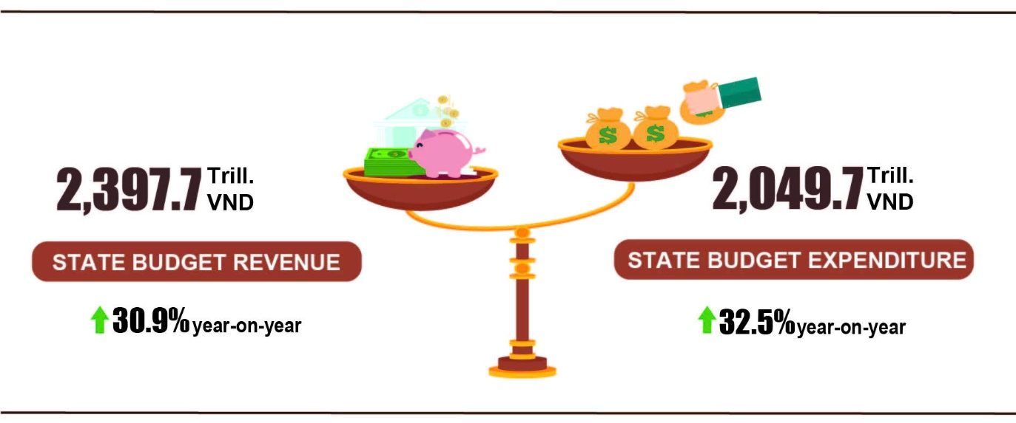
State budget revenue
Total State budget revenue in November 2025 was 201.5 trillion VND. The accrued revenue in the 11 months of 2025 reached 2,397.7 trillion VND, equal to 121.9% of the annual estimate and increasing by 30.9% over the same period last year.. Specifically, some main revenue items were as follows:
- Domestic revenue in November 2025 was 171.6 trillion VND. The accrued revenue in the 11 months of 2025 was 2,059.5 trillion VND, reaching 123.4% of the annual estimate and going up by 35.2% over the same period last year.
- Revenue from crude oil in November 2025 was 3.0 trillion VND; the accrued revenue in the 11 months of 2025 reached nearly 43.7 trillion VND, reaching 82.2% of the annual estimate and down 16.7% over the same period last year.
- Budget revenue balancing from import and export in November 2025 was 26.7 trillion VND; the accrued revenue in the 11 months of 2025 was nearly 293.0 trillion VND, reaching 124.7% of the annual estimate and an increase of 15.1% over the same period last year.
State budget expenditure
Total State budget expenditure in November 2025 was estimated at 213.3 trillion VND. The accrued expenditure in the 11 months of 2025 was 2.049,7 trillion VND, reaching 79.5% of the annual estimate and an increase of 32.5% over the same period last year.. Specifically, recurrent expenditure was 1,398.0 trillion VND, reaching 87.5% of the annual estimate and an increase of 32.4% over the same period last year; development investment expenditure was 553.3 trillion VND, reaching 70.0% and increase of 39.2%; interest payment was 92.2 trillion VND, reaching 83.4% and up 0.8%.
6. Trade, prices, transport and tourism
a) Retail sales of consumer goods and services
Trade and service activities in November remained stable, with gross retail sales of consumer goods and services estimated to be equivalent to the previous month and going up by 7.1% year-on-year. For eleven months of 2025, gross retail sales of consumer goods and services increased by 9.1% over that in the same period last year, of which, turnover from accommodation and food services rose by 14.6%, and turnover from travel and tourism services increased by 19.9%, reflecting the effectiveness of consumption-stimulus measures and strengthened tourism promotion and marketing programs.
The gross retail sales of consumer goods and services at current prices in November were estimated at 601.2 trillion VND, a year-on-year increase of 7.1%. Of which, turnover from household appliances, tools, and equipment rose by 13.6% year-on-year due to increased shopping demand as the weather shifted seasons and the need to replenish or replace items damaged by floods; turnover from garment products increased by 9.2%; food and foodstuff went up 7.0%; accommodation and food services grew by 13.6%; and travel and tourism services rose by 19.1%.
Table 3. Gross retail sales of consumer goods and services at current prices
Trillion VND
 | Estimate  for November  2025 | Estimate for  11 months  of 2025 | Year-on-Year  Growth rate (%)
 | Estimate  for November  2025 | Estimate for  11 months  of 2025 | November 2025 | 11 months  of 2025
Total | 601.2 | 6,377.7 | 7.1 | 9.1
Retail sales of goods | 455.3 | 4,859.0 | 6.0 | 7.9
Accommodation and food services | 72.2 | 767.8 | 13.6 | 14.6
Travelling and tourism | 7.9 | 85.4 | 19.1 | 19.9
Other services | 65.8 | 665.5 | 7.2 | 11.2
Generally, for the eleven months of 2025, the gross retail sales of consumer goods and services at current prices were estimated at 6,377.7 trillion VND, a year-on-year increase of 9.1% (the corresponding increase in 2024 was 8.9%). Excluding the price factors, the growth rate was 6.8% (compared to 5.8% in the same period of 2024).
Figure 10. Gross retail sales of consumer goods and services at current prices
in the eleven months of 2021-2025

The retail sales of goods for the eleven months of 2025 were estimated at 4,859.0 trillion VND, accounting for 76.2% of the gross and increasing by 7.9% over that in the same period last year. Of which, food and foodstuffs increased by 9.6% year-on-year; garments increased by 8.5%; household appliances, tools, and equipment increased by 7.8%; cultural and educational products increased by 5.1%. The retail sales of goods for eleven months of 2025 compared to the same period last year in some localities saw an increase as follows: An Giang increased by 9.9%; Dong Nai increased by 7.9%; Ninh Binh increased by 7.7%; Nghe An increased by 7.4%; Thanh Hoa increased by 7.1%.
The turnover from accommodation and food services for the eleven months of 2025 was estimated at 767.8 trillion VND, accounting for 12.0% of the gross and increasing by 14.6% year-on-year. In comparison to the same period last year, the turnover in the eleven months of 2025 in some localities experienced an expansion as follows: Ho Chi Minh City increased by 17.3%; Da Nang increased by 15.8%; Ha Noi increased by 13.4%; Can Tho increased by 12.2%; Hai Phong increased by 11.6%.
The turnover from travel and tourism services for the eleven months of 2025 was estimated at 85.4 trillion VND, accounting for 1.4% of the gross and increasing by 19.9% over that in the same period last year, as localities effectively implemented various tourism stimulation programs and diversified tourism products to meet consumer demand from the beginning of the year. The turnover of some localities in the eleven months of 2025 witnessed a rise as follows: Ha Noi up 23.4%; Ho Chi Minh City up 22.3%; Quang Ninh up 18.2%; Vinh Long up 14.1%; Da Nang up 13.2%.
The other services turnover in the eleven months of 2025 was estimated at 665.5 trillion VND, accounting for 10.4% of the gross and increasing by 11.2% compared to the same period last year. Specifically, the turnover increase in the eleven months of 2025 of some localities was as follows: Hai Phong up 16.2%; Vinh Long up 14.6%; Quang Ninh up 11.9%; Ca Mau up 11.5%; Ha Tinh up 10.9%; Ho Chi Minh City up 10.7%; Ha Noi up 8.2%.
b) Export and import of goods
In November, the total export and import turnover of goods reached 77.06 billion USD, going down 5.4% from the previous month but going up 15.6% compared to the same period last year. Generally, for the eleven months of 2025, the total export and import turnover of goods reached 839.75 billion USD, an increase of 17.2% year-on-year, of which exports rose by 16.1% and imports increased by 18.4%. The trade balance of goods recorded a surplus of 20.53 billion USD.
Figure 11. Export and import of goods in the 11 months of 2025
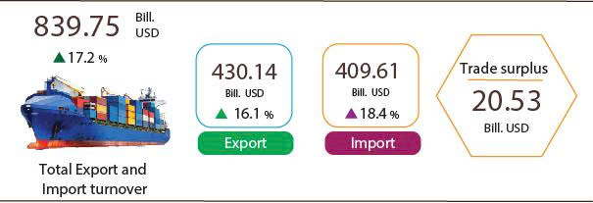
Export of goods
The export turnover of goods in October 2025 preliminarily reached 42.05 billion USD.
The export turnover of goods in November 2025 was estimated at 39.07 billion USD, went down 7.1% from the previous month. Of which, the domestic economic sector contributed 8.23 billion USD, going down 4.2%; and the FDI sector (including crude oil) reached 30.84 billion USD, declining by 7.8%. Compared to the same period last year, the export turnover of goods in November increased by 15.1%, of which, the domestic economic sector decreased by 17.5% and the FDI sector (including crude oil) increased by 28.8%.
For the eleven months of 2025, the export turnover of goods was estimated at 430.14 billion USD, an increase of 16.1% compared to the same period last year. Of which, the domestic economic sector reached 102.41 billion USD, going down 1.7% and accounting for 23.8% of total export turnover; while the FDI sector (including crude oil) reached 327.73 billion USD, increasing by 23.1% and accounting for 76.2%.
In the eleven months of 2025, there were 36 commodities with export turnover exceeding 1 billion USD, accounting for 94.1% of the total export turnover (there were 8 commodities with export turnover over 10 billion USD, accounting for 70.3%).
Table 4. Value of some export commodities in the 11 months of 2025
 | Value  (Mill. USD) | Year-on-year growth rate (%)
Commodities with export value of over 10 billion USD
Electronic goods, computers and their parts | 96,917 | 48.5
Machinery, instrument, accessory | 53,358 | 11.6
Phones all of kinds and their parts | 52,658 | 4.8
Textiles and sewing products | 35,913 | 6.7
Footwear | 21,909 | 5.5
Transport and equipment | 15,811 | 13.4
Wood and wooden products | 15,519 | 5.4
Fishing | 10,317 | 12.6
Regarding the structure of exported commodities in the eleven months of 2025, the group of manufactured products reached 381.72 billion USD, accounting for 88.7%; the group of agricultural and forestry products reached 35.58 billion USD, accounting for 8.3%; the group of fishing products recorded 10.32 billion USD, accounting for 2.4%; and the group of fuel and mineral products reached 2.52 billion USD, accounting for 0.6%.
Figure 12. Structure of exported commodities in the 11 months of 2025
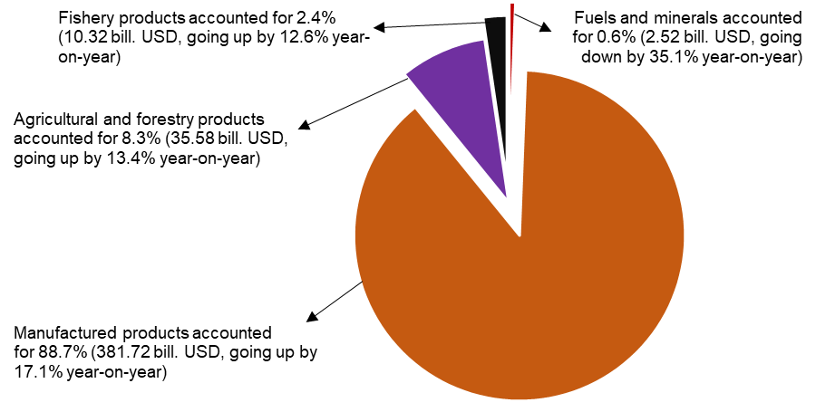
Import of goods
The import turnover of goods in October 2025 preliminarily reached 39.45 billion USD.
The import turnover of goods in November 2025 reached 37.98 billion USD, decreasing by 3.7% compared to the previous month. Of which, the domestic economic sector gained 11.34 billion USD, decreasing by 0.4%; while the FDI sector reached 26.64 billion USD, falling by 5.1%. Compared to the same period last year, the import turnover of goods in November increased by 16.0%, of which the domestic economic sector decreased by 8.8% and the FDI sector increased by 31.2%.
Generally, for the eleven months of 2025, the import turnover of goods was estimated at 409.61 billion USD, an increase of 18.4% year-on-year, of which the domestic economic sector reached 128.40 billion USD, going up 1.7%; and the FDI sector reached 281.21 billion USD, rising by 28.0%.
In the eleven months of 2025, there were 47 imported commodities with a value exceeding 1 billion USD, accounting for 93.9% of total import turnover (there were 6 commodities with import value over 10 billion USD, accounting for 57.7%).
Table 5. Value of some import commodities in the 11 months of 2025
 | Value  (Mill. USD) | Year-on-year growth rate (%)
Commodities with import value of over 10 billion USD
Electronic goods, computers and their parts | 136,167 | 39.2
Machinery, instruments and accessories | 54,752 | 23.8
Fabrics | 13,763 | 1.3
Plastics | 11,385 | 6.7
Phones all of kinds and their parts | 10,256 | 8.8
Other base metals | 10,213 | 17.9

Regarding the structure of imported commodities in the eleven months of 2025, the group of capital goods reached 383.96 billion USD, accounting for 93.7%, of which the group of machinery, equipment, tools, and spare parts accounted for 52.7%, and raw materials, fuels, and supplies accounted for 41.0%. Consumer goods group reached 25.65 billion USD, accounting for 6.3%.
Figure 13. Structure of imported commodities
in the 11 months of 2025
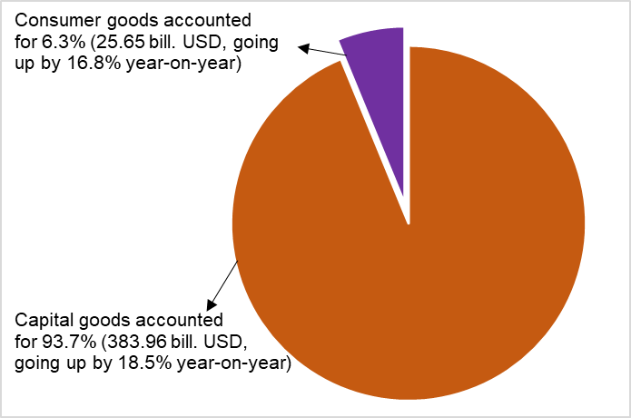
Regarding the export and import markets in the eleven months of 2025, the United States remained Viet Nam’s largest export market with a turnover of 138.6 billion USD, while China was the largest import market with a turnover of 167.5 billion USD. In eleven months of 2025, Viet Nam recorded a trade surplus of 121.6 billion USD with the United States, went up 27.5% year-on-year; a trade surplus of 35.6 billion USD with the EU, going up 10.4%; and a trade surplus of 2.0 billion USD with Japan, going down 29.7%. Viet Nam ran a trade deficit of 104.3 billion USD with China, went up 38.1%; a trade deficit of 28.3 billion USD with the Republic of Korea, going up 1.9%; and a trade deficit of 12.4 billion USD with ASEAN, rose by 46.3%.
Figure 14. Major commodity export and import markets in the 11 months of 2025
 |  | Exports of goods | Imports of goods
According to preliminary data, the trade balance of goods in October recorded a surplus of USD 2.6 billion; a surplus of 19.44 billion USD for ten months; and a surplus of 1.09 billion USD in November. Overall, for the eleven months of 2025, the trade balance of goods showed a surplus of 20.53 billion USD (compared to a surplus of 24.38 billion USD in the same period last year). Of which, the domestic economic sector ran a trade deficit of 25.99 billion USD, while the FDI sector (including crude oil) recorded a trade surplus of 46.52 billion USD.
c) Consumer price index, Gold and US dollar index
The consumer price index (CPI) in November saw a month-on-month increase of 0.45%, mainly due to high rise in food prices in centrally-run provinces and cities which directly impacted by floods after storms; meal and drinking out experienced an expansion due to increasing costs in input material and high prices of fuel. The CPI in November rose by 3.28% and 3.58% compared to that in December 2024 and the same period last year, respectively.
The average CPI in the eleven months of 2025 witnessed a year-on-year increase of 3.29%; a rise of 3.21% in core inflation.
Figure 15. Month-on-month CPI growth rate

In the month-on-month increase of 0.45% in November’s CPI, 9 groups of goods and services witnessed an upturn in CPI; otherwise, 2 groups of goods and services possessed a decrease in CPI.
(1) 9 groups of goods and services recorded a rise in CPI, including:
- The transport group accelerated by 1.07% (contributing to an increase of 0.11 percentage points in the overall CPI), of which the price index of diesel and gasoline soared by 5.23% and 2.41%, respectively due to the effects of adjustments of domestic gasoline and fuel price. Additionally, prices of motorcycle and auto spare parts climbed up 0.03%; and 0.29%, respectively. Prices of passenger transport by airway; combined passenger transport jumped up 3.61%; 0.57%, respectively due to increasing demand for travelling. Prices of spare parts went up 0.31% due to high costs of component import. Prices of vehicle maintenance edged up 0.46%, of which prices of motorcycle and bicycle repair added up 0.46% and 0.22%, respectively due to increasing costs of labor.
On the other hand, some groups of goods experienced a reduction in CPI such as prices of new car fell by 0.40% because businesses reduced prices in order to stimulate demand before switching to new models; prices of bicycles and second hand cars declined by 0.05%; 0.34%, respectively. Taxi fares also shrunk by 0.03%.
- The group of food and foodstuff expanded by 0.95% (contributing to an increase of 0.34 percentage point in the overall CPI), of which: Food accelerated by 1.33% (contributing to a rise of 0.3 percentage point in the overall CPI); eating out and foodstuff went up 0.34%; and 0.30%, respectively.
- The group of other consumer goods and services increased by 0.30%, focusing on some items such as: Jewelry prices rose by 3.22% in accordance with the prices of world gold; non-electric personal appliances up 0.04%; body care products, watch and jewelry repair both expanded by 0.19%; funeral and wedding services; personal care services; haircut and shampooing services added up 0.22%; 0.47%; 0.79%, respectively.
- The group of household equipment and goods climbed up 0.17% due to increasing production expenditures and labor costs. Of which, electric irons, electric pots, wall mirrors, bowls and plates, electric kettles and thermoses; household services; egg beaters; cabinets of all kinds; gas stoves; all lighting, soap, detergents, and beds jumped up 1.26%; 0.76%; 0.72%; 0.42%; 0.33%; 0.27%; 0.26%; 0.24%; 0.18%; 0.23%, respectively.
- The group of garment, hat and footwear edged up 0.12% due to rising shopping demand for clothes and footwear during the transitional seasons and the end of the year. Of which, prices of fabrics of all kinds; ready-made clothes; other garments; garment services; footwear and shoe services accelerated by 0.27%; 0.11%; 0.28%; 0.55%; 0.30%, respectively.
- The group of beverage and cigarette grew by 0.10% due to rising costs of raw material and production, of which the price of bottled, canned, and boxed energy drinks; alcohol and tobacco; canned beer; bottled beer grew by 0.04%; 0.34%; a 0.16%; and 0.10%, respectively.
- The group of medicines and health care services accelerated by 0.06% because hormone and respiratory drugs; non-steroidal anti-inflammatory drugs (NSAIDs) for pain relief and fever reduction; the group of vitamins and minerals; gastrointestinal drugs; anti-allergy, hypersensitivity and anti-infective/antiparasitic drugs added up 0.13%; 0.18%; 0.19%; 0.16%; 0.12%, respectively.
- The education group expanded by 0.05%, of which the price of educational services edged up 0.05% due to upward adjustments of tuition fee for the 2025-2026 school year at some private universities, colleges, secondary schools, vocational schools, upper intermediate schools, and preschools in some provinces, in despite of exemptions, reductions, and support of tuition fees in public schools in accordance with the Decree No. 238/2025/ND-CP issued by the Government on September 3, 2025. Besides, the price of paper products; pens of all kinds; stationery and other school supplies other school supplies rose by 0.06%; 0.23%; and 0.13%, respectively.
- The culture, entertainment, and tourism group soared by 0.01%, mainly due to an expansion of 1.26%; 0.31%; 0.28%; 0.19%; 0.13%; 0.12% in the prices of flowers, ornamental plants, and decorative items; cameras and video cameras; sports venue rentals; cultural services; toys; and musical instruments, respectively. Otherwise, the prices of some services saw a decrease, of which package tours fell by 0.38% as travel companies implemented promotional programs to stimulate consumer demands; concert tickets reduced by 0.16%.
(2) Two groups of goods and services possessed a declining in CPI, including:
- The group of information and communications decreased by 0.06%, of which: accessories for smart phones; smartphones and tablets; printers, projectors, and scanners; computers and accessories shrunk by 0.48%; 0.34%; 0.06%; 0.01%, respectively.
- Group of housing, electricity, water, fuel and construction materials fell by 0.10%, mainly due to main reasons as follows: prices of household electricity; tap water reduced by 1.53%; 0.34%, respectively resulting from decreasing consumer demand caused by cold weather. Service prices of household electricity decelerated by 0.09%. Gas prices dropped 1.15% due to downward adjustments in line with the world gas prices since November 1, 2025. On the other hand, some goods witnessed a rise in CPI: Prices of housing maintenance materials; house rental; kerosene; housing repair service edged up 0.62%; 0.31%; 6.39%; 0.48%, respectively.
Core inflation in November witnessed a month-on-month soar of 0.23% and a year-on-year rise of 3.28%. %. The average core inflation in the eleven months of 2025 saw a year-on-year increase of 3.21%, lower than the rise of 3.29% in the overall CPI mainly due to the increase in prices of food, foodstuff, household electricity, healthcare services, and education services, which were factors contributing to an expansion in CPI, were excluded from the list of core inflation calculations.
Domestic gold prices fluctuated in line with the world gold prices. As of November 28, 2025, the average price of world gold was at 4,109.63USD/ounce, a month-on-month surge of 1.96%. The world gold prices continued to witness a month-on-month rise due to expectations that the US Federal Reserve (FED) continued to ease monetary policy in the end of the year, together with the increasing demand for physical gold consumption in the peak holiday and wedding season in Asia. Besides, strong aversion of risk was caused by escalated geopolitical conflicts in some regions, pushing the demand for precious metals as safe-haven assets to increase. The domestic gold price index in November experienced a month-on-month rise of 1.90%; a year-on-year spike of 64.44%; and a surge of 66.74% compared to that in December 2024. The average domestic gold price index in eleven months of 2025 saw a year-on-year soar of 45.77%.
The domestic US dollar prices in November fluctuated the opposite direction to global prices. As of November 28, 2025, the US dollar price index reached 99.64 points in the international market, a month-on-month increase of 1.20%, mainly due to increasing demand for the US dollar as safe-haven assets in the context of unpredictable geopolitical conflicts. The domestic US dollar price index in November possessed a month-on-month decrease of 0.11%; a year-on-year rise of 3.60%; an expansion of 3.51% compared to that in December 2024; the average US dollar price index in eleven months of 2025 witnessed a year-on-year upturn of 3.94%.
d) Passengers and cargo transport
In November, despite being affected by natural disasters and floods in some localities, transport activities recovered rapidly, maintaining transport capacity, meeting demands for travel and tourism of domestic and international visitors to Viet Nam, as well as serving production, import and export of goods. In November 2025, passengers carried and passenger traffic saw a year-on-year increase of 22.4% and 11.8%, respectively; freight carried and freight traffic recorded a year-on-year rise of 14.2% and 13.1%, respectively.
Overall, in the eleven months of 2025, passengers carried and passenger traffic experienced a year-on-year rise of 22.4% and 13.8%, respectively; freight carried and freight traffic recorded a year-on-year increase of 14.7% and 14.0%, respectively.
Passengers carried in November were estimated at 565.7 million turns of passengers, a month-on-month increase of 1.9% and passenger traffic was estimated at 26.4 billion passengers-kilometers, a growth of 2.4%. Generally, for the eleven months of 2025, passengers carried were estimated at 5,635.0 million turns of passengers, a year-on-year rise of 22.4% and passenger traffic reached 285.5 billion passengers-kilometers, a year-on-year growth of 13.8%. Of which, domestic passengers carried were estimated at 5,617.3 million turns of passengers, a year-on-year increase of 22.4% and domestic passenger traffic was estimated at 229.2 billion passengers-kilometers, a year-on-year upturn of 15.5%; oversea passengers carried were estimated at 17.7 million turns of passengers, a year-on-year expansion of 8.8% and 56.3 billion passengers-kilometers, a year-on-year rise of 7.6%.
Table 6. Passengers transport in the eleven months of 2025 by type of transport
 | Number of passengers |  | Year-on-year growth rate (%)
 | Carriage  (Mill. persons) | Traffic  (Bill. persons-km) | Carriage | Traffic
Total | 5,635.0 | 285.5 | 22.4 | 13.8
Railway | 37.0 | 3.1 | 106.5 | 13.4
Seaway | 10.4 | 0.8 | -6.4 | 8.3
Inland waterway | 371.6 | 8.9 | 15.4 | 23.1
Roadway | 5,164.5 | 187.0 | 22.8 | 17.1
Airway | 51.5 | 85.7 | 8.1 | 6.7

Freight carried in November was estimated at 278.6 million tons, a month-on-month increase of 4.3% and freight traffic reached 56.2 billion tons-kilometers, a month-on-month upturn of 2.8%. Overall, in the eleven months of 2025, freight carried was estimated at 2,773.9 million tons, a year-on-year rise of 14.7% and freight traffic reached 562.9 billion tons-kilometers, a year-on-year increase of 14.0%. Of which, domestic transport was estimated at 2,726.0 million tons of freight carried, an upturn of 14.8% and 335.4 billion tons-kilometers of freight traffic, a rise of 10.3%; overseas transport was estimated at 47.9 million tons of freight carried, an increase of 9.6% and 227.5 billion tons-kilometers of freight traffic, a growth of 20.0%.
Table 7. Freight transport in the eleven months of 2025 by type of transport
 | Volume of freight |  | Year-on-year growth rate (%)
 | Carriage  (Mill. tons) | Traffic  (Bill. tons-km) | Carriage  (Mill. tons) | Traffic  (Bill. tons-km)
Total | 2,773.9 | 562.9 | 14.7 | 14.0
Railway | 5.0 | 3.7 | 9.4 | 7.8
Seaway | 137.4 | 291.2 | 12.9 | 16.5
Inland waterway | 538.2 | 122.3 | 11.7 | 11.8
Roadway | 2,092.9 | 136.8 | 15.7 | 12.1
Airway | 0.4 | 8.9 | 4.6 | 0.7
đ) International visitors to Viet Nam
More and more international visitors came to Viet Nam thanks to favorable visa policies, enhanced tourism advocacy and promotion programs, together with large-scale events in many localities.
In November, the number of international visitors to Viet Nam reached nearly 1.98 million, a month-on-month increase of 14.2% and a year-on-year rise of 15.6%. Generally, for the eleven months of 2025, the international visitors to Viet Nam reached 19.15 million, a year-on-year increase of 20.9%. Of which, visitors by airway reached 16.2 million, accounted for 84.5% of international arrivals and experienced a year-on-year growth of 21.0%; visitors by roadway reached 2.7 million, comprised 14.3%, a spread of 22.2%; visitors by seaway reached 228.8 thousand, made up 1.2%, an expansion of 3.4%.
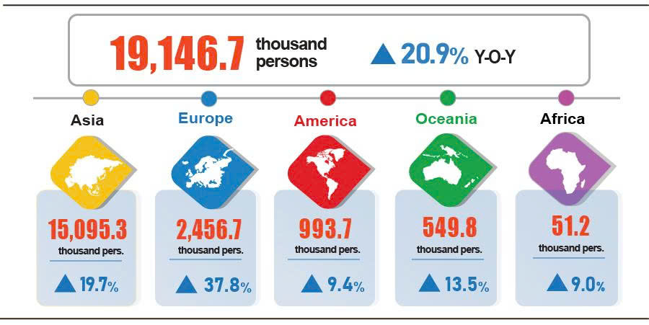
Figure 16. International visitors to Viet Nam in the eleven months of 2025 by territories

7. Social situation
a) People's life
According to preliminary results of the Labor Force Survey, 96.4% households reported their income in November remained unchanged or increased compared to the same month last year (a rise of 0.3 percentage points compared to the previous month's reporting period and a growth of 0.2 percentage points year-on-year); 3.6% households said that their income decreased or undetermined.
Households with year-on-year decreased income in November identified the main reasons as follows: Household member(s) lost its/their jobs or temporarily quitted jobs (36.8%); impact of natural disasters (26.6%); the size of household production and business activities reduced (21.0%); input costs for household production and business activities increased (16.8%); and selling prices of products made from household production and business activities reduced (15.3%).
In the eleven months of 2025, 30.0% of interviewed households reported experiencing at least one negatively affected event. Among the households affected by negative events, 28.6% households suffered from the effects of rising prices of goods and services; 2.4% households were negatively impacted by human epidemics; 3.2% households were negatively affected by natural disasters; and 2.3% households suffered from epidemics in livestock and crops.
In the eleven months of this year, 15.3% of surveyed households received assistance from various sources. Specifically, 9.0% households received assistance from relatives and family; 4.9% households were supported by local programs and policies; 7.2% households were assisted by the national programs and policies; 1.7% households received assistance from charity activities of other organizations and individuals; and 0.1% households received assistance from other sources.
Social security work was implemented promptly and effectively by all level authorities and agencies. In November, as of November 27th, 2025, the Government allocated 25.9 thousand tons of rice to support the people in overcoming the consequences of natural disasters and floods. Cumulatively from the beginning of the year to November 27, 2025, the Government supported the people with approximately 38.2 thousand tons of rice, particularly: 6.0 thousand tons of rice for hunger relief during the Lunar New Year for 402.6 thousand persons; nearly 4.3 thousand tons of rice for hunger relief during the 2025 pre-harvest season for 284.5 thousand persons; and over 27.9 thousand tons of rice to overcome the consequences of natural disasters and floods for more than 1.86 million persons. Cumulatively from the beginning of the year to November 23, 2025, the Central State budget supported localities in overcoming disaster damage with a total amount of 6,794.0 billion VND; of which 2,630.0 billion VND was provided to localities affected by the Typhoon No. 13 and floods in the South Central Coast and Central Highlands.
b) Epidemic, food poisoning
According to the Ministry of Health's report, during the month (from October 18 to November 17, 2025), the country recorded 46.1 thousand cases of dengue fever (08 deaths); 19.9 thousand cases of hand, foot and mouth disease (01 death); 1,393 cases of rash fever suspected of measles; 34 cases of viral encephalitis; 11 cases of meningococcal meningitis; 06 deaths of rabies. Generally, for the eleven months of 2025, the country had 156.6 thousand cases of dengue fever (31 deaths); 116.0 thousand cases of rash fever suspected of measles (11 deaths); 78.5 thousand cases of hand, foot and mouth disease; 340 cases of viral encephalitis (01 death); 95 cases of meningococcal meningitis (01 death); 68 deaths of rabies.
The total number of people living with HIV nationwide as of November 17, 2025 was 253.1 thousand persons; the number of deaths from HIV/AIDS was 117.3 thousand persons.
Regarding food poisoning, in November, there were 07 cases of food poisoning, poisoning 301 persons. In the eleven months of 2025 (from December 18, 2024 to November 17, 2025), there were 64 cases nationwide, with 1,255 people poisoned (16 deaths).

c) Culture and sports
Regarding culture, in November, several notable cultural events took place, including: The Great National Solidarity – Vietnamese Cultural Heritage Week 2025 took place from November 18 - 24 in Hanoi; Ho Chi Minh City hosted the Opening Ceremony of the 24th Viet Nam Film Festival from November 21 - 25, and has been recognized by UNESCO as a “Creative City of Film” The 4th Asia - Europe New Music Festival was held from November 27 to December 01 in Hanoi and Phu Tho; The Thang Long – Hanoi Festival 2025, themed “Heritage - Connectivity - Modernity,” took place from November 01 - 16 in Hanoi; The Hanoi Tourism Ao Dai Festival 2025, under the theme “Hanoi Ao Dai – Shining Essence of Heritage,” held from November 6 - 9 in Hanoi; The “Quang Ninh – Heroic Mining Land” Concert organized on November 12 in Quang Ninh, etc.
Regarding sports, in November, the Viet Nam sports delegations participated in several sports events and achieved encouraging results as follows: Viet Nam secured 10 gold medals, 5 silver medals, and 3 bronze medals at the World Bodybuilding and Fitness Championships held in Indonesia from November 14-17; The Vietnamese fin swimming team won 31 gold, 22 silver, and 4 bronze medals, ranking first overall at the 2025 Southeast Asian Championships in Indonesia from November 16-19; The Vietnamese youth athletics team finished second with 13 gold medals at the 2025 Southeast Asian Youth Athletics Championships for the U18 and U20 categories, held in Indonesia from November 15-18; The 2025 Asian Esports Championship took place in Can Tho from November 19-22; the 2025 National Golf Clubs Championship was held in Da Nang from November 28-30; and the 14th National Sports Festival for Ethnic Minorities - Region II (2025) took place in Dong Nai from November 17-24; The Viet Nam U17 football team secured a berth in the AFC U17 Asian Cup 2026 Final Tournament.
d) Traffic accident
In November (from October 26 to November 25, 2025), there were 1,523 cases of traffic accident nationwide, causing 832 deaths and 1,042 injuries. Compared to the figures of October 2025, the number of traffic accidents decreased by 0.8%; the number of deaths decreased by 1.3%; the number of injuries increased by 2.4%. Compared to the figures of the same period in 2024, the number of traffic accidents, deaths, and injuries dropped by 25.8%, 17.5%, 27.4%, respectively.
Generally, in the eleven months of 2025, there were 16,816 cases of traffic accident nationwide, resulting in 9,502 deaths and 11,142 injuries. Compared to the figures of the same period last year, the number of traffic accident cases, deaths, and injuries decreased by 22.3%, 6.6%, and 29.8%, respectively. On average, in the eleven months of 2025, there were 50 traffic accidents, causing 28 deaths and 33 injuries a day.
đ) Damage caused by natural disaster
According to the Ministry of Agriculture and Environment, from the beginning of the year to December 5, 2025, natural disasters across the country resulted in 420 people died and missing; 730 persons injured; 4,193 houses collapsed, swept away; 347,883 damaged or unroofed; 541,204 hectares of rice and other crops submerged and damaged; 73,300 livestock and 5.1 million poultry killed or swept away; 171,763 aquatic cages damaged; 1,032 km of dikes, embankments, and canals damaged; 115 km of river banks and coastlines eroded; 1,258 km of roads damaged with a total volume of eroded soil and rock of 14.5 million m³, etc. The total value of damage was estimated at over 99,469 billion VND.
e) Environmental protection, fire and explosion prevention
In November (from October 18 to November 17, 2025), functional authorities detected 1,640 environmental violations in 34 localities, of which, 1,292 cases were addressed with a total fine of 27.5 billion VND, experiencing a month-on-month decrease of 0.7% and a year-on-year increase of 4.4%. In the eleven months of this year, the functional authorities detected 15,717 cases of environmental violations, of which, 13,862 cases were addressed with a total fine of nearly 220.2 billion VND, a year-on-year reduction of 21.6%.
In November (from October 15 to November 14, 2025), 212 cases of fire and explosion occurred nationwide, causing 4 deaths and 5 injuries with an estimated loss of 30.2 billion VND, experiencing a month-on-month decrease of 39.0% and a year-on-year decrease of 65.0%. In the eleven months of this year, there were 2,894 cases of fire and explosion nationwide, causing 101 deaths and 112 injuries with an estimated loss of 318.7 billion VND, a year-on-year reduction of 32.6 %.

Due to the impact of storms, heavy rains, and flooding in October, causing late harvest of the winter-spring rice from October to November.
The main reason was the low yield of the previous year's rice crop, which was severely affected by the Typhoon Yagi (Typhoon No. 3) before harvesting period.
Several localities recorded the yiels of winter-spring rice was as follows: Hung Yen with 59.2 quintals/hectare (up 15.2 quintals/hectare); Hai Phong with 57.8 quintals/hectare (up 13.1 quintals/hectare); Ha Noi with 55.8 quintals/hectare (up 6.6 quintals/hectare).
Due to heavy rain, some localities were recorded with a slow afforestation progress and a year-on-year drop in afforestation was as follows: Khanh Hoa (64.0%); Gia Lai (29.1%); Quang Ngai (17.5%); and Lang Son (10.5%), respectively.
Localities showed an increase and recorded with high wood production such as Tuyen Quang (6.1%), Thai Nguyen (7.0%), and Thanh Hoa (8.3%), respectively.
Figures released by Ministry of Agriculture and Environment as of November 15, 2025.
Compiled by reports of localities: The price of raw pangasius in the Mekong River Delta maintained from 29,500 VND/kg - 31,000 VND/kg, an increase of 1,000 VND/kg compared to the previous month and a year-on-year increase of 3,000 VND/kg.
The IIP in November 2024 saw a year-on-year increase of 7.9%.
The local month-on-month changes in IIP in November for the large-shared industrial sector provinces and municipalities were as follows: Quang Ninh up 13.2%; Vinh Long up 8.6%; Hai Phong up 4.2%; Can Tho up 4.0%; Bac Ninh up 2.6%; Ho Chi Minh city up 2.0%; Dong Nai up 1.9%, Da Nang up 1.9%; and Quang Ngai down 6.6%.
The provinces and municipalities recorded high year-on-year increase in IIP of the manufacturing for the 11 months of 2025 were as follows: Quang Ninh (33.8%); Phu Tho (28.8%); Ninh Binh (23.4%); Thanh Hoa (17.5%); Bac Ninh (16.9%); and Hai Phong (16.9%). The provinces and municipalities recorded high year-on-year increase in IIP of the electricity generation and distribution were as follows: Hue city (32.0%); Nghe An (25.3%); and Dong Nai (10.2%).
The provinces and municipalities recorded slight year-on-year increase in IIP of the manufacturing for the 11 months of 2025 were as follows: Ha Tinh (5.1%); Lang Son (4.7%); Cao Bang (0.5%). The provinces and municipalities recorded slight increases or even decrease in IIP of the electricity generation and distribution for 11 months of 2025 were as follows: Khanh Hoa (up 2.2%); Lam Dong (up 1.6%); Ho Chi Minh (down 29.7%). The provinces and municipalities recorded a year-on-year decrease in IIP of the manufacturing for 11 months of 2025 were as follows: Quang Tri 10.9%; Tuyen Quang 4.8%; Ho Chi Minh City 1.8%; Hanoi 1.7%.
Of which, the additional registered capital of active enterprises in the 11 months of 2025 reached nearly 3.9 million billion VND (a year-on-year increase of 197.3%).
According to the report of the Foreign Investment Department, Ministry of Finance, received on December 3, 2025.
Data received from the State Budget Department - Ministry of Finance on November 30, 2025.
These results were underpinned by fiscal policies that reduced and extended taxes, fees, charges, and land rental. These measures were designed to help businesses and the public quickly overcome challenges, adapt flexibly, and restore production and business growth. Concurrently, efforts were focused on revenue collection tasks, promoting digital transformation, and applying information technology in tax management.
This strong performance was supported by significant domestic revenue streams, including: revenues from land and housing estimated at 505.6 trillion VND, equaling 172.6% of the annual projection and representing a 108.1% increase over the same period in 2024. This was due to the positive recovery of the real estate market, accelerated public investment, and the decisive implementation of the Prime Minister's Official Dispatch No. 124/CĐ-TTg. Capital recovery, dividends, after-tax profits, and net revenue difference of the State Bank of Vietnam (SBV): Estimated at 145.7 trillion VND, equaling 127.1% of the annual projection and rising 19.3% compared to the same period in 2024, driven by an increase in dividend remittances to the state budget.
The central budget utilized its reserve to fund critical and urgent tasks, and to provide support to local authorities for administrative unit rearrangement, as well as for disaster relief efforts.
These efforts were realized through the synchronized deployment of measures aimed at expediting the disbursement of public investment capital, coupled with a rigorous review to ensure that detailed capital allocation plans matched project implementation timelines.
The value of export turnover was calculated at F.O.B price and import turnover was calculated at C.I.F price (including transportation and insurance costs of imported goods).
The preliminary data of export and import of goods in November 2025 were provided by the Viet Nam Customs on December 3rd, 2025.
Total import and export turnover of goods in eleven months of 2024 reached 716.37 billion USD, a year-on-year increase of 15.5%, of which export and import reached 370.37 billion USD, rising by 14.6% and 345.99 billion USD, growing by 16.5%, respectively.
The same as the data sent by the Viet Nam Customs to the National Statistics Office on November 3rd, 2025.
The same as the data sent by the Viet Nam Customs to the National Statistics Office on November 3rd, 2025.
The same as the data sent by the Viet Nam Customs to the National Statistics Office on November 3rd, 2025.
The CPI of food group in November increased by 3.72%, 3.55%, 3.31%,2.78%, 2.51%, 2.34%, 2.03%, 1.36% and 1.13% in Gia Lai; Da Nang; Khanh Hoa; Quang Ngai; Lam Dong; Hue; Dak Lak; Dong Nai; and Quang Tri, respectively.
Due to the impacts of successive storms and floods causing heavy rains and widespread flooding in many provinces made losses of agricultural products and food supply disruption. Prices of fresh, dried, and processed vegetables; processed seafood; fresh seafood; poultry; eggs of all kinds; tea, coffee, and cocoa; sugar and molasses; milk, butter, and cheese; spice soared by 12.71%; 0.45%; 0.87%; 0.28%; 1.14%; 0.22%; 0.05%; 0.28%; 0.42%, respectively. Besides, some food items saw a drop in price: pork prices fell by 0.42% due to stable prices of cattle feed; prices of organ meat; cakes, jams, and candies; soy and corn milk; butter; chocolate shrunk by 0.25%; 0.17%; 0.39%; 0.29%; 0.38%, respectively.
Due to rising prices of input food and services, of which the price of eating out; drinking out; and takeaway fast food edged up 0.30%; 0.37%; 0.51%, respectively.
The prices of domestic rice increased in line with the prices of export rice due to increased import of rice from major markets such as Africa, China, and the Philippines. Therefore, the CIP of rice group soared by 0.17% (regular white rice, premium white rice, glutinous rice, brown rice expanded by 0.15%, 0.10%, 0.72%, and 0.52%, respectively). In addition, some food items witnessed an increase in price, such as: corn, potatoes, cassava, vermicelli, instant cereals, bread, rice noodles, and other similar products, noodles of all kinds up 2.97%, 2.60%, 1.47%, 0.49%, 0.41%, 0.38%, and 0.25%, respectively. Conversely, the CPI of other cereal groups and wheat flour decreased by 0.33%, 0.04%, respectively.
The electricity and water price index in November reflects one-month-latency fluctuations compared to other items because it was calculated basing on October's revenue and consumption output.
The CPI after excluding prices of food, fresh foodstuff, energy, and State-managed goods, which include healthcare and education services.
The number of passengers carried by high-speed railway in Ha Noi and Metro in Ho Chi Minh City was added.
Due to unfavorable weather conditions, the number of seaway passengers reduced, leading to temporary suspension or reduced frequency of many shipping routes.
According to the reports from the Department of Border Gate, the Border Guard Command, the Ministry of National Defense, and the Immigration Department, the Ministry of Public Security.
The reporting period was from October 26th, 2025 to November 25th.
A household could select multiple causes leading to decreased income.
According to a quick report from the Office of the Ministry of Public Security and the Viet Nam Maritime and Waterways Administration (Ministry of Construction) dated November 28, 2025.
According to data compiled by Provincial Statistics Offices from the reports of Provincial Departments of Agriculture and Environment and Provincial, Municipal Police Departments.
According to a quick report from the Ministry of Public Security dated November 23, 2025.

