MINISTRY OF FINANCE  NATIONAL STATISTICS OFFICE  ________________  No.: 52/BC-CTK | SOCIALIST REPUBLIC OF VIETNAM  Independence - Freedom - Happiness  ______________________________________  Ha Noi, 6th March 2026

REPORT
SOCIO-ECONOMIC PERFORMANCE
IN FEBRUARY AND THE FIRST TWO MONTHS OF 2026

1. Agriculture, forestry, and fishing
Agricultural production in February focused on cultivating and tending the winter-spring rice and other crops nationwide. Pig farming witnessed a recovery, poultry farming saw a stability, ensuring food supply for consumption during the Lunar New Year. The weather in the month was favorable for wood harvesting, forest care and protection; forest management, forest fire prevention and control were strengthened. In February 2026, the prices of pangasius and shrimp remained at a profitable level, encouraging farmers to increase harvesting for domestic consumption and export; fisheries capture saw a downturn tendency due to disruptions caused by the Lunar New Year holiday.
- Agriculture
Spring rice
As of February 20th, 2026, the national planted area of spring rice reached 2,731.4 thousand hectares, a year-on-year decrease of 58.0 thousand hectares. Of which, the Northern localities reached 854.1 thousand hectares, falling by 24.1 thousand hectares; the Southern localities reached 1,877.3 thousand hectares, decreasing by 33.9 thousand hectares (the Mekong River Delta reached 1,234.1 thousand hectares, showing a decrease of 32.2 thousand hectares). The progress of spring rice cultivation in the Northern localities recorded a slower progress, comparing to the same period last year, because localities mainly focused on late spring cultivation to minimize damage to seedlings and newly transplanted rice before the severe cold weather at the beginning of the crop season. In addition, February this year coincided with the Lunar New Year holiday, therefore, some areas were not timely cultivated. Some localities saw a decrease in spring rice area, comparing to the same period last year, including Bac Ninh (a decrease of 19.1 thousand hectares); Ninh Binh (a fall of 5.9 thousand hectares); Hai Phong (a decline of 1.6 thousand hectares). In the Southern localities, the cultivation of spring rice basically completed, with the decrease in cultivation area mainly due to converting a part of inefficient rice fields to other crops for higher economic benefit. Some localities experienced a year-on-year decrease in cultivation area, including Can Tho (a decrease of 14.8 thousand hectares); Dong Thap (a downturn of 8.6 thousand hectares) and An Giang (a reduction of 5.2 thousand hectares).
So far, the Southern localities began harvesting some early paddies with an area of ​​253.1 thousand hectares, showing a year-on-year decrease of 15.6 thousand hectares, mainly due to the impact of heavy rain and delayed crop calendar, resulting in a slower harvest of the spring rice, comparing to the previous year.
Winter rice in the Mekong River Delta
The planted area of winter rice in the Mekong River Delta was estimated at 171.7 thousand hectares, a year-on-year decrease of 20.1 thousand hectares, mainly due to heavy rains at the beginning of the season and restructuring of cropping patterns in the region. Of which Can Tho saw a decrease of 10.6 thousand hectares due to shifting from the winter crop to the autumn-winter and winter-spring rice for higher yields; An Giang fell by 7.4 thousand hectares due to converting to shrimp farming and freshwater reservoirs; and Ca Mau decreased by 4.8 thousand hectares due to heavy rains preventing the cultivation.
As of February 20th, 2026, the provinces in the region basically completed the winter rice harvest with an estimated harvested area of ​​168.1 thousand hectares, a year-on-year decrease of 23.7 thousand hectares. Of which, An Giang reached 73.6 thousand hectares, decreasing by 7.4 thousand hectares; Ca Mau reached 88.6 thousand hectares, decreasing by 2.1 thousand hectares; and Vinh Long reached 5.9 thousand hectares, rising by 0.1 thousand hectares. According to preliminary estimates of the localities, the yield of rice in the region was estimated at 54.1 quintals/hectare, a year-on-year rise of 1.6 quintals/hectare; the production was estimated at 909.6 thousand tons, showing a decrease of 97.7 thousand tons, mainly due to the reduction in cultivation area.
Annual crops
Along with cultivating the spring rice, localities nationwide cultivated other crops. The progress of crops cultivation including maize, sweet potatoes, soybeans, and peanuts was lower than the same period last year.
Figure 1. Cultivation of annual crops
(As of February 20th, 2026)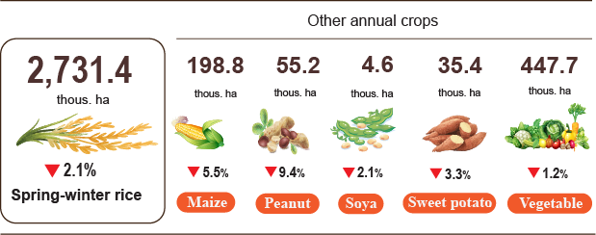
Livestock
Cattle and buffalo farming continued a down trend due to low economic efficiency, unstable selling prices, and high input costs including breeding stock, and labour costs. The trend of restructuring livestock farming in some localities and the livestock repopulation were slow, and mainly maintained in farms with stable consumption links, causing the reduction in livestock population scale.
Pig farming continued its trend of recovering production and repopulation after the Lunar New Year. Pig population in some localities recorded a significant growth thanks to the strong development of farm-based breeding models and effective disease control, including Gia Lai (showing a year-on-year increase of 9.4%); Lam Dong (+7.5%); Lao Cai (+6.8%); Ho Chi Minh City (+3.8%); Dak Lak (+2.8%); and Dong Nai (+2.4%). However, the potential risks of African swine fever outbreaks remained high, especially during the changing weather period. Localities continued implementing comprehensive and effective disease prevention and control measures.
Poultry farming maintained a stable growth thanks to short breeding cycle, quick capital turnover, and high demand for poultry meat and eggs during the Lunar New Year. Large-scale, concentrated farming establishments continued expanding production, ensuring supply for the market. Several localities saw significant increase in poultry numbers, comparing to the same period last year, including Nghe An (+7.4%), Thanh Hoa (+5.8%), Tay Ninh (+3.6%), and Dong Nai (+2.8%).
Figure 2. Year-on-year growth rate of livestock and poultry number
at the end of February 2026
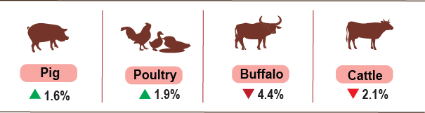
As of February 28th, 2026, the country was no longer recorded with the porcine reproductive and respiratory syndrome and foot-and-mouth disease; the avian influenza was still reported in localities such as in Nghe An, Ha Tinh, Khanh Hoa; the lumpy skin disease still occurred in Da Nang, Quang Ngai; and African swine fever occurred in 15 localities that where the outbreak has not yet passed the 21-day quarantine period.
b) Forestry
The area of ​​newly planted forests nationwide in February 2026 was estimated at 11.8 thousand hectares, showing a year-on-year decrease of 1.4%; the number of scattered forests planted reached 7.0 million trees, showing a year-on-year decrease of 5.8%. Wood production was estimated at 1,381.9 thousand m³, growing by 4.1%. Thanks to dry weather facilitating an increase of harvesting of mature wood, satisfying the raw material needs of wood processing factories. Some localities saw a significant increase in wood harvesting, comparing to the same period in 2025, including Ha Tinh growing by 3.5 times; Gia Lai 76.8%; and Quang Tri 69.0%.
Generally, in the first two months of 2026, the area of ​​newly planted forests nationwide was estimated at 21.7 thousand hectares, showing a year-on-year growth of 4.5%; the number of scattered forest trees planted reached 10.9 million trees, falling by 3.9%; the wood production reached 2,634.3 thousand m3, rising by 0.9%.
In February 2026, the damaged forest area was 31.9 hectares, a year-on-year decrease of 56.4%. Of this, the damaged forest area by forest fire was 0.1 hectares, a decrease of 99.4%; and the area of ​​forest destroyed by logging was 31.8 hectares, falling by 43.2%.
c) Fishing
Capture fisheries and aquaculture production in February 2026 reached 665.4 thousand tons, a year-on-year climb of 2.3%, of which, fish reached 489.3 thousand tons (+2.0%); shrimp reached 73.3 thousand tons, (+5.8%); and other aquatic products reached 102.8 thousand tons (+1.2%).
Aquaculture production in the month was estimated at 381.4 thousand tons, a year-on-year growth of 5.2%, of which fish reached 271.8 thousand tons, rising by 5.1%; shrimp reached at 62.3 thousand tons, rising by 7.4%; and other aquatic products reached 47.3 thousand tons, rising by 3.3%.
Pangasius production in February 2026 was estimated at 128.6 thousand tons, a year-on-year growth of 5.7%, due to rising raw pangasius prices and favorable market conditions encouraging farmers to raise fish.
Shrimp production in the month was estimated at 62.3 thousand tons, showing a year-on-year growth of 7.4% due to higher raw shrimp prices and increased processing and export demand of enterprises during the Lunar New Year. White leg shrimp production was estimated at 39.6 thousand tons, showing a growth of 8.5%; tiger shrimp production reached 17.7 thousand tons, rising by 6.0%.
In February 2026, the capture fisheries production was estimated at 284.0 thousand tons, showing a year-on-year decline of 1.4%, of which fish reached 217.5 thousand tons, falling by 1.5%; shrimp reached 11.0 thousand tons, falling by 2.7%; and other aquatic products reached 55.5 thousand tons, falling by 0.5%. Marine capture fisheries production was estimated at 266.9 thousand tons, falling by 1.3%, of which fish reached 205.2 thousand tons, declining by 1.5%; shrimp reached 9.8 thousand tons, falling by 3.0%; and other aquatic products reached 51.9 thousand tons, falling by 0.4%.
Figure 3. Capture fisheries and aquaculture production
in the first 2 months of 2026 (Y-o-Y)
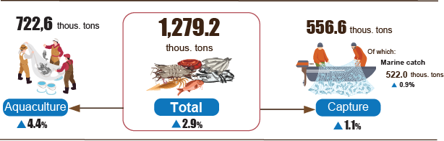

Generally, in the first two months of 2026, fishery production was estimated to reach 1,279.2 thousand tons, showing a year-on-year growth of 2.9%, of which fish reached 946.9 thousand tons, rising by 2.7%; shrimp reached 132.6 thousand tons, rising by 6.0%; and other aquatic products reached 199.7 thousand tons, increasing by 2.1%.
2. Industrial production
The Lunar New Year took place in February 2026, so the number of working days was fewer compared to the previous month and the same period last year, the Index of Industrial Production (IIP) was estimated to decrease by 18.4% month-on-month and grow by 1.0% year-on-year. Generally, for the first 2 months of 2026, the IIP grew by 10.4% over the same period last year.
In February 2026, the IIP of the manufacturing recorded a year-on-year increase of 2.3%; the mining and quarrying decreased by 5.3%; the water supply, sewerage, waste management and remediation activities reduced by 5.6%; and the electricity supply reduced by 4.5%.
Generally, for the first 2 months of 2026, the IIP was estimated to grow by 10.4% over the same period last year (the corresponding figure in 2025 was 7.5%). Specifically, the manufacturing grew by 11.5% (the corresponding figure in 2025 was 9.1%), contributing 8.9 percentage points to the overall growth; the electricity supply rose by 6.3% (versus 4.3% in 2025), contributing 0.6 percentage points; the water supply, sewerage, waste management and remediation activities increased by 2.1% (versus 12.9% in 2025), contributing 0.03 percentage points; the mining and quarrying grew by 5.4% (5.2% decline in the same period of 2025), contributing 0.9 percentage points.
In the first 2 months of 2026, the IIP of several key 2-digit activities experienced a year-on-year increase as follows: manufacture of other non-metallic mineral products (+33.1%); manufacture of basic metals (+27.9%); manufacture of beverages (+20.9%); manufacture of paper and paper products (+20.4%); manufacture of motor vehicles (+20.3%); manufacture of chemicals and chemical products (+20.1%); manufacture of wood and products of wood and cork (+13.4%); manufacture of food products (+13.2%); manufacture of wearing apparels (+11.6%); manufacture of textiles (+10.5%); manufacture of furniture (+10.2%); manufacture of rubber and plastic products (+9.3%); manufacture of computer, electronic and optical products (+8.0%). Conversely, the IIP for some activities decreased as follows: mining of coal and lignite (-3.4%); manufacture of other transport equipment (-2.7%).
Table 1. Year-on-year IIP growth rate for several key industrial activities
in the first 2 months of the years 2022 - 2026
%
 | 2022 | 2023 | 2024 | 2025 | 2026
Mining of coal and lignite | 2,6 | 2,0 | 2,5 | 6,3 | -3,4
Manufacture of food products | 6,2 | 1,2 | 4,2 | 7,7 | 13,2
Manufacture of beverages | 1,5 | 12,7 | -3,5 | -1,1 | 20,9
Manufacture of textiles | 5,3 | -9,9 | 18,0 | 10,2 | 10,5
Manufacture of wearing apparels | 25,7 | -14,0 | 4,1 | 13,3 | 11,6
Manufacture of wood and products of wood and cork, (except furniture); manufacture of articles of straw and plaiting materials | -1,2 | 3,9 | 3,5 | 14,6 | 13,4
Manufacture of paper and paper products | 2,9 | -13,2 | 10,6 | 6,2 | 20,4
Manufacture of chemicals and chemical products | -0,3 | -2,0 | 42,6 | 2,2 | 20,1
Manufacture of rubber and plastic products | -16,5 | 9,6 | 24,0 | 12,8 | 9,3
Manufacture of other non-metallic mineral products | 8,4 | -10,7 | -0,2 | 7,1 | 33,1
Manufacture of basic metals | 2,9 | -8,4 | 19,8 | -0,3 | 27,9
Manufacture of computer, electronic and optical products | 4,9 | -2,1 | -1,8 | 10,1 | 8,0
Manufacture of motor vehicles | 7,0 | -11,8 | 1,6 | 46,3 | 20,3
Manufacture of other transport equipment | 8,3 | -10,0 | -6,9 | 12,9 | -2,7
Manufacture of furniture | 1,5 | -9,1 | 20,4 | 14,7 | 10,2
The IIP in the first 2 months of 2026 experienced a year-on-year increase in all 34 provinces and municipalities. Several provinces saw a fairly high growth rate in the IIP thanks to the manufacturing and the surge in the electricity supply. Conversely, the IIP in several provinces and municipalities nudged up due to slow growth or decrease in the manufacturing, the mining and quarrying, and the electricity supply.
Figure 4. Year-on-year IIP growth rate for some localities
(in the first 2 months, 2026) (%)

Top 10 localities by IIP growth rate  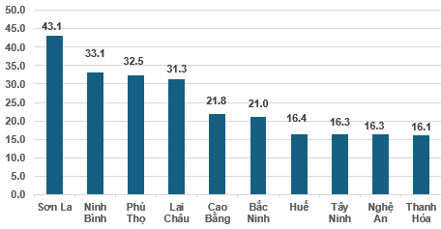 | Bottom 10 localities by IIP growth rate  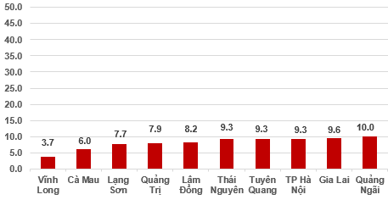
Several key industrial products in the first 2 months in 2026 witnessed year-on-year increase as follows: Cement (+30.5%); chemical paint (+27.5%); steel bar, angle bar (+25.7%); processed seafood (+24.8%); automobiles (+24.0%); motorbike (+22.5%); beer (+18.1%; phone components (+15.4%). Conversely, some industrial products experienced a year-on-year reduction, including urea fertilizer (-16.7%); anthracite (6.1%); mobile phones (-4.4%); fabrics from natural yarn (-4.2%); NPK fertilizers (-3.9%); alumin (-0.5%).
The number of employees in industrial enterprises as of February 1st, 2026 saw a month-on-month growth of 0.2% and year-on-year increase of 4.0%. Among them, the number of employees in the state-owned enterprises saw a 0.1% month-on-month decrease and 3.0% year-over-year decrease; the non-state enterprises increased by 0.2% and decreased by 0.2%, respectively; while the FDI enterprises rose by 0.3% and 5.9%, respectively. By kind of economic activity, the number of employees in the mining was unchanged over previous month and saw a year-on-year increase of 1.0%. The manufacturing saw an increase of 0.2% and 4.1%, respectively. The electricity, gas, steam and air conditioning supply was increased by 0.1% month-on-month and saw a year-on-year increase of 2.6%. Meanwhile water supply, sewerage, waste management, and remediation activities recorded a slight month-on-month decrease of 0.1% and a year-on-year increase of 4.3%.
3. Business registration status
In February, the whole country had 11.3 thousand newly established enterprises with a registered capital of nearly 132.8 trillion VND and registered employees of nearly 59.4 thousand employees, a month-on-month decrease of 53.2%, 26.6%, and 45.1% in the number of enterprises, in the registered capital, and in the number of employees, respectively. In comparison with the same period last year, there were an increase of 11.6% in the number of enterprises, a decrease of 2.6% in registered capital, and an increase of 0.4% in the number of employees. The average registered capital a newly established enterprises in February reached 11.7 billion VND, a month-on-month increase of 56.9%, and a year-on-year decrease of 12.8%. In addition, the country had nearly 6.2 thousand resumed operation enterprises, a month-on-month decrease of 74.9%, and a year-on-year decrease of 12.6%.
In February, there were 4,257 enterprises temporarily suspending for a definite time, a month-on-month decrease of 92.2% and a year-on-year increase of 19.8%; 3,492 enterprises suspended operation waiting for dissolution procedures, a decrease of 52.2% and an increase of 17.5%; and 3,290 enterprises completed procedures for dissolution, a decrease of 28.6% and an increase of 89.4%.
In the first two months of 2026, the whole country had nearly 35.5 thousand newly registered enterprises with a registered capital of nearly 313.7 trillion VND, and a total registered employee of over 167.5 thousand employees, a year-on-year increase of 70.7%, 36.1% 19.1% in the number of enterprises, in the registered capital, and in the number of employees, respectively. The average registered capital of a newly established enterprises in the first two months of 2026 reached 8.8 billion VND, a year-on-year decrease of 20.3%. The total registered capital added to the economy in the two months of 2026 was nearly 851.9 trillion VND, a year-on-year increase of 20.1%. In addition, the country had 29 thousand resumed operation enterprises (a year-on-year decrease of 0.2%), bringing the total number of newly established and resumed operation enterprises in the first two months of 2026 to nearly 64.5 thousand enterprises, a year-on-year increase of 29.4%. On average, there were 32.2 newly established and resumed operation enterprises per month.
By economic sector, in the first two months of 2026, the number of newly registered enterprises in the agriculture, forestry and fishing sector; the industry and construction sector; the service sector reached 440 enterprises, a year-on-year increase of 145.8%; 8,199 thousand enterprises, a year-on-year increase of 71.5%; and over 26.8 thousand enterprises, a year-on-year increase of 69.6%, respectively.
Figure 5. Enterprise registration status in the first two months of 2026 (Y-o-Y)
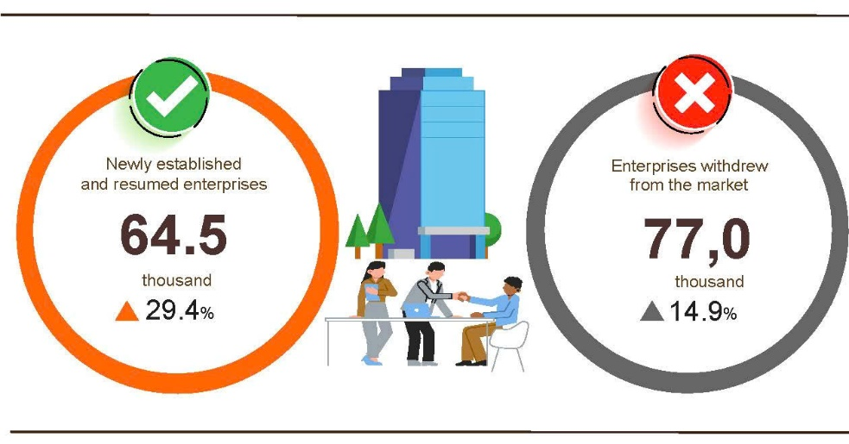

In the first two months of 2026, the number of enterprises temporarily suspending for a definite time was nearly 58.5 thousand enterprises, a year-on-year increase of 2.8%; over 10.6 thousand enterprises suspended operation waiting for dissolution procedures, a year-on-year increase of 66.3%; and nearly 7.9 thousand enterprises completed procedures for dissolution, a year-on-year increase of 110.2%. On average, 38.5 thousand enterprises withdrew from the market per month.
Table 2. Newly registered and completely dissolved enterprises
in the first 2 months 2026 by kind of economic activity

 | Number of enterprises (Enterprises) |  | Y-o-Y growth rate (%)
 | Completely dissolved | Newly established | Completely dissolved | Dissolve
Wholesale and retail, repair of motor vehicle and motorcycle | 16,020 | 2,967 | 124.0 | 113.1
Manufacturing | 4,826 | 867 | 82.7 | 101.6
Construction | 2,930 | 531 | 52.4 | 103.4
Real estate activities | 959 | 480 | 94.9 | 108.7
Transportation and storage | 2,094 | 281 | 99.4 | 92.5
Accommodation and food service activities | 1,591 | 361 | 165.2 | 92.0
Electricity, water and gas supply | 286 | 85 | 95.9 | 102.4

4. Investment
Investment from the State budget in February was actively implemented by ministries, authorities, and localities since the beginning of the month and after the Lunar New Year holiday to accelerate the progress of public investment projects, especially ongoing projects. Overall, in the first two months of 2026, the proportion of disbursed investment from the State budget reached 9.4% of the annual plan and increased by 11.5% compared to that in the same period last year. The disbursed foreign direct investment (FDI) in Viet Nam in the first two months of 2026 was estimated at 3.21 billion USD, a year-on-year increase of 8.8%.
The disbursed investment from the State budget in February was estimated at nearly 38.9 trillion VND, a year-on-year increase of 0.4%, including the Centrally-managed investment reached 5.8 trillion VND, an increase of 5.9%; and locally-managed investment reached 33.1 trillion VND, a decrease of 0.5%. Generally, in the first two months of 2026, the disbursed investment from the State budget was estimated at 83.5 trillion VND, equivalent to 9.4% of the annual plan and a year-on-year increase of 11.5% (the same rates in 2025 were 7.4% and up 24.6%, respectively). Specifically:
- The Centrally-managed investment was estimated to reach 11.7 trillion VND, equivalent to 6.3% of the annual plan, and increasing by 16.9% year-on-year. Of which, the Ministry of Construction reached 8.8 trillion VND, up 43.1%; the Ministry of Agriculture and Environment reached 397.4 billion VND, down 72.5%; the Ministry of Health reached 139.3 billion VND, down 44.8%; the Ministry of Education and Training reached 105.5 billion VND, down 17.4%; the Ministry of Culture, Sports and Tourism reached 81.8 billion VND, up 8.7%; the Ministry of Industry and Trade reached 12.8 billion VND, down 61.1%; and the Ministry of Science and Technology reached 7.3 billion VND, down 72.9%.
- The locally-managed investment was estimated at 71.8 trillion VND, equivalent to 10.2% of the annual plan, and rising by 10.7% year-on-year, of which:
55.8 trillion VND was disbursed at the provincial level, equal to 10.2% of the annual plan, and growing by 8.9% over that in the same period last year;
16.0 trillion VND was disbursed at the commune level, equal to 10.2% of the annual plan, and growing by 17.7% over that in the same period last year.
The disbursed investment from the State budget of the first two months of 2026 in selected provinces and centrally-run municipalities was as follows:
Figure 6. Disbursed investment from the State budget
in the first two months of 2026 in selected localities

Total inward foreign investment in Viet Nam as of February 28th, 2026, including newly registered capital, adjusting registered capital, and capital contribution and purchasing shares by foreign investors, reached 6.03 billion USD, a year-on-year decrease of 12.6%.
Figure 7. Inward foreign investment in Viet Nam as of February 28th of 2022-2026 (Billion USD)

- In terms of newly registered capital: 620 projects were licensed with a registered capital of 3.54 billion USD, a year-on-year increase of 20.2% in the number of projects, and an upturn of 61.5% in registered capital. Of which, the largest newly licensed FDI was in the manufacturing with a registered capital of 2.63 billion USD, accounting for 74.3% of the total newly registered capital; the newly licensed FDI in the wholesale and retail trade, repair of vehicles and motorcycles reached 358.6 million USD, accounting for 10.1%; and in other economic activities was 550.5 million USD, accounting for 15.6%.
Among the 44 countries and territories with newly licensed investment projects in Viet Nam during the first two months of 2026, South Korea was the largest investor with 1.34 billion USD, accounting for 37.8% of the total newly registered capital; followed by Singapore with 1.1 billion USD, accounting for 31.1%; China with 522.8 million USD, accounting for 14.8%; Japan with 171.0 million USD, accounting for 4.8%; Hong Kong Special Administrative Region (China) with 143 million USD, accounting for 4.0%; the United States with 85.6 million USD, accounting for 2.4%; and Samoa with 68.7 million USD, accounting for 1.9%.
- Adjusted registered capital: 180 turns of projects licensed from the previous years registered to adjust investment capital upwards by 1.99 billion USD, a year-on-year decrease of 52.3%.
If including newly registered capital and adjusted registered capital of licensed projects in the previous years, the registered FDI in the manufacturing reached 4.16 billion USD, accounting for 75.2% of the total newly registered and increased capital; in the wholesale and retail trade, repair of vehicles and motorcycles reached 392.7 million USD, accounting for 7.1%; and in other economic activities was 979.7 million USD, accounting for 17.7%.
- There were 492 turns of registered capital contributions and purchasing shares by foreign investors with a total value of 499.5 million USD, a year-on-year decrease of 5.7%. Of which, 128 turns of capital contributions and purchasing shares increased the charter capital of enterprises with a value of 297.8 million USD, and 364 turns of foreign investors repurchased domestic shares without increasing charter capital with a value of 201.7 million USD. Regarding the form of capital contributions and purchasing shares by foreign investors in the manufacturing reached 244.7 million USD, accounting for 49.0% of the capital contribution; in the wholesale and retail trade, repair of vehicles and motorcycles reached 103.7 million USD, accounting for 20.8%; and in other economic activities reached 151.1 million USD, accounting for 30.2%.
The disbursed FDI in Viet Nam in the first two months of 2026 was estimated at 3.21 billion USD, a year-on-year increase of 8.8%. This was the highest figure in the disbursed FDI in the first two months of years in the past-5-year period. Of which, the disbursed FDI in the manufacturing reached 2.65 billion USD, representing 82.7% of total disbursed FDI; in the real estate activities reached 223.5 million USD, accounting for 7.0%; and in the electricity, gas, steam and air conditioning supply reached 119.2 million USD, accounting for 3.7%.
Figure 8. Disbursed foreign direct investment
in the first two months, 2022-2026 (billion USD)

Viet Nam's outward investment in the first two months of 2026 witnessed 36 projects granted with new investment certificates with a total capital of 532.4 million USD, 2.3 times higher than that in the same period last year; there were 3 turns of projects adjusted their capital with an additional amount of 7.8 million USD, 1.5 times higher than that in the same period last year.
Generally, the total Viet Nam's outward FDI (newly granted and adjusted capital) reached 540.2 million USD, 2.3 times higher than that in the same period last year. Of which, the outward FDI in the electricity, gas, steam and air conditioning supply reached 163.8 million USD, accounting for 30.3%; in the construction reached 150.9 million USD, accounting for 27.9%; and in the transportation and storage reached 149.2 million USD, accounting for 27.6%.
In the first two months of 2026, 36 countries and territories received investment from Viet Nam. Laos was the leading destination with 176.7 million USD, accounting for 32.7% of total investment; followed by Kyrgyzstan with 149.9 million USD, accounting for 27.8%; Angola with 30 million USD, accounting for 5.6%; the Netherlands with 29.4 million USD, accounting for 5.5%; and Sweden with 28.5 million USD, accounting for 5.3%.
5. State budget revenue and expenditure
State budget revenue in the first two months of 2026 was estimated to increase by 13.1% over the same period last year. State budget expenditure was estimated to increase by 11.0% over the same period in 2025, ensuring the needs of socio-economic development, national defense, security, state management, payment of due debts as well as timely payment to beneficiaries according to regulations.
Figure 9. State budget revenue and expenditure in the first 2 months of 2026
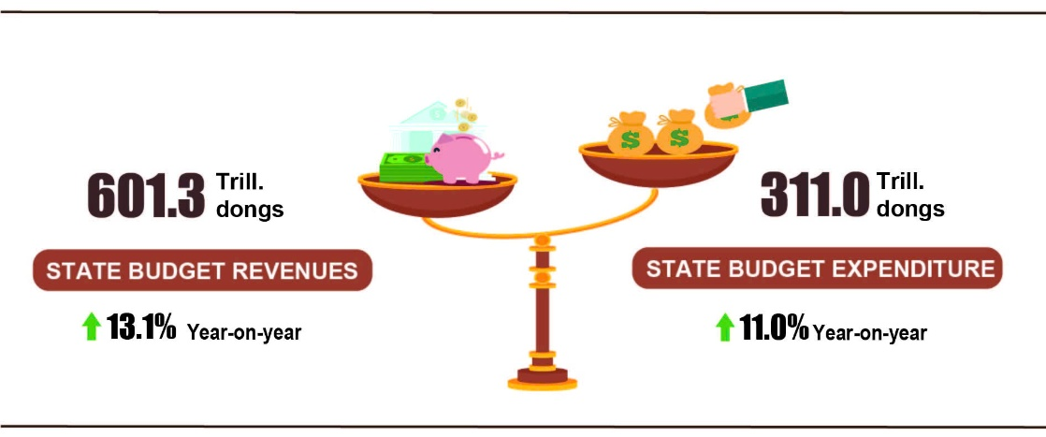
State budget revenue
Total State budget revenue in February 2026 was estimated at 170.5 trillion VND. The total State budget revenue accrued in the first two months of 2026 was estimated at 601.3 trillion VND, reaching 23.8% of the annual estimate, and going up 13.1% over the same period last year. In particular, some main revenue items were as follows:
- Domestic revenue in February 2026 was 159.3 trillion VND. The accrued revenue in the first two months of 2026 was 558.1 trillion VND, reaching 25.4% of the annual estimate and going up by 15.0% over the same period last year.
- Oil revenue in February 2026 was estimated at 1.7 trillion VND. The accrued revenue in the first two months of 2026 was 5.1 trillion VND, reaching 11.9% of the annual estimate, and down 42.2% over the same period last year.
- Revenue from budget balance of import-export activities in February 2026 was estimated at 9.6 trillion VND. The accrued revenue in the first two months of 2026 was 38.0 trillion VND, reaching 13.7% of the annual estimate, and increasing by 1.2% over the same period last year.
State budget expenditure
Total State budget expenditure in February 2026 was estimated at 163.0 trillion VND. The accrued expenditure in the first two months of 2026 was 311.0 trillion VND, reaching 9.8% of the annual estimate and an increase of 11.0% over the same period last year. Specifically, recurrent expenditure in the first two months of 2026 was estimated at 241.0 trillion VND, equal to 13.3% of the annual estimate and an increase of 14.8% over the same period last year; expenditure on development investment gained 42.5 trillion VND, reaching 3.8% and decrease of 5.2%; interest payment was 27.1 trillion VND, reaching 22.3% and increasing 8.1%.
6. Trade, prices, transport and tourism
a) Retail sales of goods and services
Commercial and service activities in February were dynamic, meeting the consumption demand of people during the 2026 Lunar New Year. Retail sales of goods and services were estimated to increase by 8.5% over that in the same period last year. Generally, in the first two months of 2026, the retail sales of goods and services were estimated to increase by 7.9% year-on-year, of which: Accommodation and food service activities increased by 9.1%, turnover of travelling increased by 12.2%.
The retail sales of goods and services at current prices in February were estimated at 613.7 trillion VND, a year-on-year increase of 8.5%. Of which, turnover from garment products increased by 14.3% year-on-year due to increased shopping demand during the Lunar New Year; household appliances, tools and equipment increased by 9.6%; food and foodstuffs increased by 9.0%; accommodation and food service activities increased by 9.7%; and the travelling increased by 13.8%. Meanwhile, other services, accounting for 10.3% of the total, increased by only 4.4% compared with the same period last year.
Table 3. Retail sales of goods and services at current prices
Trillion VND
 | Estimate  for February  2026 | Estimate  2 months of  2026 | Year-on-Year  Growth rate (%)
 | Estimate  for February  2026 | Estimate  2 months of  2026 | February  2026 | 2 months of  2026
Total | 613.7 | 1,236.6 | 8.5 | 7.9
Retail sales of goods | 469.2 | 945.3 | 8.8 | 7.8
Accommodation and food service activities | 74.8 | 149.2 | 9.7 | 9.1
Travelling | 7.5 | 15.0 | 13.8 | 12.2
Other services | 62.2 | 127.1 | 4.4 | 7.3
Generally, in the first two months of 2026, the retail sales of goods and services at current prices are estimated at 1,236.6 trillion VND, going up 7.9% compared with the same period last year (the same period of 2025 increased by 9.3%); excluding the price factor, the increase was 4.5% (compared with an increase of 6.8% in the same period of 2025.
Figure 10. Retail sales of goods and services at current prices
in the first two months of 2022-2026

The retail sales of goods in the first two months of 2026 were estimated at 945.3 trillion VND, accounting for 76.4% of the total and increasing by 7.8% year-on-year. Of which, garments and household appliances, tools and equipment increased significantly compared with the same period last year, by 10.4%, and 8.6%, respectively, due to increased shopping demand and brands’ promoting discount program and consumption stimulus during holidays and the Lunar New Year since the beginning of the year; food and foodstuffs increased by 5.8%; vehicles (excluding automobiles) increased by 5.5%; and cultural and educational goods increased by 1.5%. The retail sales of goods in the first two months of 2026 compared to the same period last year in some localities saw an increase as follows: Hai Phong increased by 8.5%; Da Nang increased by 7.9%; Can Tho increased by 7.8%; Ha Noi increased by 7.7%; and Ho Chi Minh City increased by 7.6%.
The turnover from accommodation and food service activities in the first two months of 2026 was estimated at 149.2 trillion VND, accounting for 12.1% of the total and increasing by 9.1% compared with the same period last year. In comparison to the same period last year, the turnover in the first two months of 2026 in some localities experienced an increase as follows: Da Nang increased by 10.6%; Ho Chi Minh City increased by 7.5%; Hai Phong increased by 7.4%; Can Tho increased by 6.2%; and Ha Noi increased by 4.8%.
The turnover of travelling in the first two months of 2026 was estimated at 15.0 trillion VND, accounting for 1.2% of the total and a year-on-year growth of 12.2% thanks to the surge in domestic and international visitors to Viet Nam in the early months of the New Year. The turnover of some localities in the first two months of 2026 witnessed a rise as follows: Ca Mau increased by 23.2%; Quang Ninh increased by 21.3%; Da Nang increased by 15.9%; Ho Chi Minh City increased by 12.1%; and Ha Noi increased by 7.3%.
The other services turnover in the first two months of 2026 was estimated at 127.1 trillion VND, accounting for 10.3% of the total and a year-on-year rise of 7.3%. Specifically, the turnover increase in the first two months of 2026 in some localities was as follows: Lao Cai increased by 9.0%; Thanh Hoa increased by 8.1%; Ha Noi increased by 6.2%; Can Tho increased by 0.5%; Dong Thap decreased by 2.2%; and Cao Bang decreased by 4.5%.
b) Export and import of goods
In February, the total export and import turnover of goods reached 67.16 billion USD, a month-on-month decrease of 24.1% and a year-on-year increase of 5.1%. Generally, in the first two months of 2026, the total export and import turnover of goods reached 155.7 billion USD, going up 22.2% over that in the same period last year, of which exports increased by 18.3% and imports increased by 26.3%. The trade balance of goods recorded a trade deficit of 2.98 billion USD.
Figure 11. Export and import of goods in two months of 2026
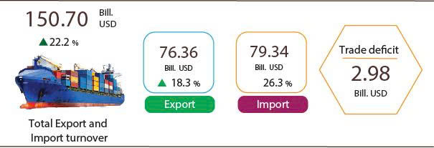
Export of goods
The export turnover of goods in January 2026 preliminarily reached 43.3 billion USD.
The export turnover of goods in February 2026 amounted to 33.06 billion USD, a month-on-month decrease of 23.7%. Of which, the domestic economic sector reached 6.44 billion USD, going down 33.1%; the FDI sector (including crude oil) reached 26.62 billion USD, went down 21.0%. Compared to the same period last year, the export turnover of goods in February increased by 5.7%, of which the domestic economic sector decreased by 24.3% and the FDI sector (including crude oil) increased by 17.0%.
Generally, in the first two months of 2026, the export turnover of goods reached 76.36 billion USD, rising by 18.3% year-on-year. Of which, the domestic economic sector reached 15.96 billion USD, down 12.0%, accounting for 20.9% of total export turnover; the FDI sector (including crude oil) reached 60.4 billion USD, up 30.1%, accounting for 79.1%.
In the first two months of 2026, there were 13 commodities with export turnover exceeding 1 billion USD, accounting for 79.9% of total export turnover (of which 4 commodities recorded export turnover exceeding 5 billion USD, accounting for 57.4%).
Table 4. Value of some export commodities in the first of two months of 2026
 | Value  (Mill. USD) | Year-on-year growth rate (%)
Commodities with export turnover exceeding 5 billion USD
Electronic goods, computers and their parts | 17,690 | 40.9
Phones all of kinds and their parts | 11,147 | 21.0
Machinery, instrument, accessory | 9,286 | 20.6
Textiles and garments | 5,700 | 1.2

Regarding the structure of exported commodities in the first two months of 2026, the group of manufactured products reached 68.55 billion USD, accounting for 89.8%; the group of agricultural and forestry products reached 5.8 billion USD, accounting for 7.6%; the group of fishery products reached 1.72 billion USD, accounting for 2.2%; and the group of fuels and minerals reached 0.29 billion USD, accounting for 0.4%.
Figure 12. Structure of exported commodities in two months of 2026
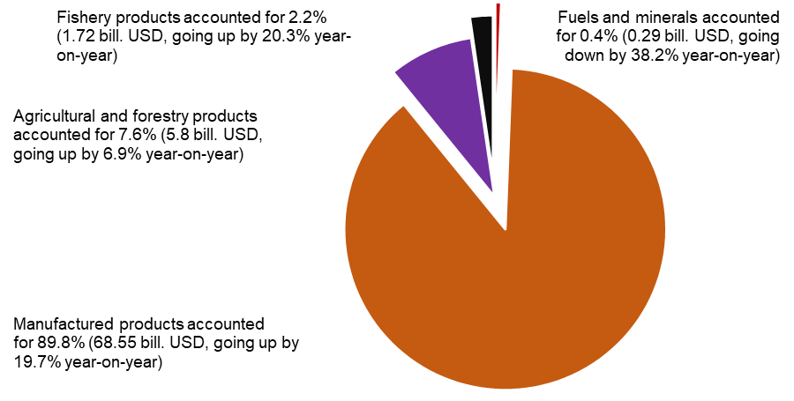
Import of goods
The import turnover of goods in January 2026 preliminarily reached 45.24 billion USD.
The import turnover of goods in February 2026 reached 34.1 billion USD, a month-on-month decrease of 24.6%. Of which, the domestic economic sector reached 9.55 billion USD, down 27.5%, and the FDI sector reached 24.55 billion USD, down 23.4%. Compared with the same period last year, the import turnover of goods in February increased by 4.4%, of which the domestic economic sector decreased by 19.6%, while the FDI sector increased by 18.1%.
Generally, in the first two months of 2026, the import turnover of goods reached 79.34 billion USD, going up 26.3% compared with the same period last year, of which the domestic economic sector reached 22.47 billion USD, down 1.5%, while the FDI sector reached 56.87 billion USD, up 42.2%.
In the first two months of 2026, there were 16 imported commodities with import turnover exceeding 1 billion USD, accounting for 77.8% of the total import turnover (of which two commodities recorded import turnover exceeding 5 billion USD, accounting for 50.2%).
Table 5. Value of some import commodities in the first two months of 2026

 | Value  (Mill. USD) |  | Year-on-year growth rate (%)
Commodities with import turnover exceeding 5 billion USD
Electronic goods, computers and their parts | 29,869 |  | 48.3
Machinery, instruments and accessories | 9,955 |  | 27.9

Regarding the structure of imported commodity in the first two months of 2026, the group of capital goods reached 74.67 billion USD, accounting for 94.1%, of which the group of machinery, equipment, tools and spare parts accounted for 56.0%, the group of raw materials, fuels and materials accounted for 38.1%. Consumer goods group reached 4.67 billion USD, accounting for 5.9%.
Figure 13. Structure of imported commodities
in the first two months of 2026
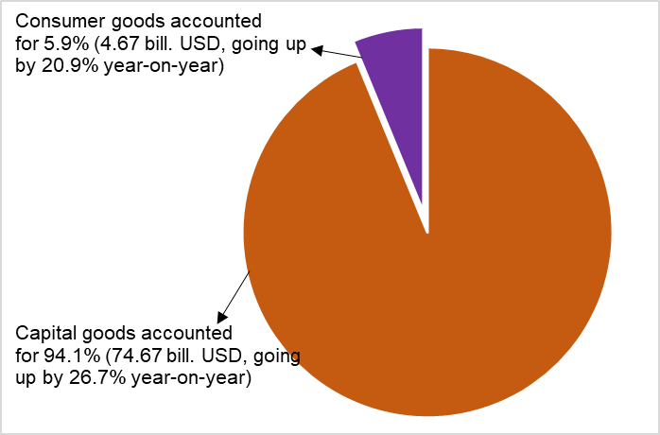
Regarding export and import markets in the first two months of 2026, the United States was Viet Nam’s largest export market with a turnover of 23.8 billion USD, while China was Viet Nam’s largest import market with a turnover of 31.9 billion USD. In the first two months of 2026, Viet Nam recorded a trade surplus of 20.4 billion USD with the United States, up 20.8% compared with the same period last year; a trade surplus of 6.7 billion USD with the EU, up 6.5%; and a trade surplus of 0.3 billion USD with Japan, down 43.1%; meanwhile, Viet Nam recorded a trade deficit of 20.9 billion USD with China, up 35.7%; a trade deficit of 6.5 billion USD with the Republic of Korea, up 41.5%; and a trade deficit of 2.6 billion USD with ASEAN, up 20.7%.
Figure 14. Major commodity export and import markets
in the first two months of 2026
 |  | Exports of goods | Imports of goods
According to preliminary data, the trade balance of goods recorded a deficit of 1.94 billion USD in January and a deficit of 1.04 billion USD in February. Generally, in the first two months of 2026, the trade balance of goods posted a deficit of 2.98 billion USD (the same period last year recorded a surplus of 1.77 billion USD). Of which, the domestic economic sector recorded a trade deficit of 6.5 billion USD, while the FDI sector (including crude oil) posted a trade surplus of 3.52 billion USD.
c) Consumer price index, Gold and US dollar index
Consumer Price Index (CPI) in February 2026 saw a month-on-month increase of 1.14%, mainly due to higher prices of foodstuff, eating out, and transport services resulting from increasing demand for shopping and travelling during the Lunar New Year. The CPI in February rose by 1.19% and 3.35% compared to that in December 2025 and the same period in 2025, respectively.
The average CPI in the first two months of 2026 witnessed a year-on-year expansion of 2.94%; core inflation increased by 3.47%.

Figure 15. Month-on-month CPI growth rate

In the month-on-month increase of 1.14% in the CPI in February 2026, all major groups of consumer goods and services experienced an upturn in price.
- The group of food and foodstuff climbed up 2.02% (contributing to an increase of 0.72 percentage points in the overall CPI), of which: Food; foodstuff jumped up 0.94%; 2.34%, respectively (contributing to an increase of 0.52 percentage points); and eating out edged up 1.71% (contributing to a rise of 0.16 percentage points).
- The group of culture, entertainment, and tourism increased by 1.36%, mainly due to increasing demand for consumption during the Lunar New Year holiday and high costs of related services, focusing on the following items: prices of ornamental plants and flowers; movie and music tickets; decorative items; toys surged up 9.51%; 2.32%; 1.72%; 0.26%, respectively. Package tours added up 1.6% due to high demand for travelling and rising cost of service; hotels and accommodation expanded by 0.63%. In contrast, prices of sports equipment; books, newspapers, and magazines of all kinds decreased by 0.12%; 0.05%, respectively.
- The group of other consumer goods and services increased by 1.30%, focusing on a rise in prices of some items: Jewelry shot up 8.23% in line with the price of domestic gold; haircut and shampooing services soared by 4.27% due to high demand for beauty services at the end of the year; personal care services; wedding related items and services; funeral related items and services; administrative and legal services climbed up 3.36%; 1.23%; 0.83%; 0.27%, respectively.
- The transport group expanded by 1.23%, contributing to an increase of 0.12 percentage points in the overall CPI, of which: The CPI of petroleum; diesel jumped up 1.95%, 6.34%, respectively. The price of passenger transported by airway; roadway; taxi; bus soared by 21.07%; 3.60%; 0.76%; 0.37%, respectively. Baggage handling and checked services jumped up 4.33%. Price of automobile spare parts; motorcycle tires and its tubes; bicycle tires and its tubes; other motorcycle parts; vehicle washing and tire pumping services; vehicle maintenance services; and parking services accelerated by 0.69%; 0.60%; 0.50%; 0.31%; 4.42%; 2.03%; and 1.75%, respectively. In contrast, the price index of new automobile and used automobile declined by 0.07%; and 0.39%, respectively.
- The group of beverage and cigarette climbed up 1.18% due to increasing demand for consumption and usage as gifts during the Lunar New Year, resulting in an increase of 1.69% in the price of alcohol and beer; an upturn of 0.59% in the prices of both cigarettes and non-alcoholic beverages.
- The group of household equipment and goods increased by 0.57% due to increasing demand for shopping during the Lunar New Year. Of which, prices of glassware, ceramics, and porcelain products; metalware; home textiles; furniture; soap and detergents; plastic and rubber products; electric irons; electric cookers; vacuum cleaners edged up 0.91%; 0.74%; 0.63%; 0.62%; 0.55%; 0.54%; 0.44%; 0.21%; and 0.09%, respectively. The prices of household services surged up 5.01% due to increasing demand for house cleaning and family care services during the Lunar New Year holiday; and the prices of household appliance repair climbed up 0.78% due to higher costs of labor and replacement parts.
- The group of housing and construction materials rose by 0.56% (contributing to an increase of 0.13 percentage points in the overall CPI), mainly due to a rise in the price of the following items: Housing maintenance materials; housing repair services; other housing-related services; gas; household electricity; tap water; household electricity service; tap water service; kerosene climbed up 0.67%; 1.02%; 0.44%; 1.40%; 0.52%; 0.72%; 0.80%; 0.73 4.30%, respectively.
- The group of garment, hat and footwear expanded by 0.55% due to rising costs of labor and material and increasing demand for purchase of clothes and footwear during the Lunar New Year. Of which, the price of fabrics of all kinds witnessed a month-on-month increase of 0.78%; ready-made clothes; footwear; other garments; garment services; footwear services edged up 0.55%; 0.49%; 0.68%; 1.34%; 1.33%, respectively. In contrast, hats shrunk by 0.21% because some stores offered promotion to stimulate consumer demand.
- The group of medicine and health care services accelerated by 0.14%, of which the CPI of health care services went up 0.14%, and medicines rose by 0.14% due to the spread of flu, respiratory illnesses, and people’s increasing demand for painkillers, fever reduction, respiratory drugs, vitamins, and minerals. Specifically, the prices of painkillers, fever reduction, non-steroidal anti-inflammatory drugs, and drugs for gout and bone diseases added up 0.16%; respiratory drugs; vitamin and mineral; and gastrointestinal drugs all climbed up 0.08%; and cardiovascular drugs jumped up 0.13%.
- The education group increased by 0.09%, of which educational services went up 0.09%, mainly due to the adjustments of tuition fee in some private schools and tutoring centers. Besides, the price of paper products; pens of all kinds; stationery and other school supplies edged up 0.10%; 0.20%; 0.17%, respectively.
- The group of information and communication increased by 0.01%, of which the prices of fixed-line telephone; feature phones soared by 0.28%; 0.19%, respectively; phone repair service rose by 0.49% due to increasing costs of labor. In contrast, the prices of smart phones and tablets; audio equipment; accessories for smart phone and tablet; color televisions declined by 0.45%; 0.43%; 0.25%; 0.18%, respectively because enterprises continued to downward adjust the sale prices, implemented promotion programs, and clearance sale in the end of the year to stimulate consumer demand.
Core inflation in February 2026 experienced a month-on-month increase of 0.82% and a rise of 3.74% compared to that in the same period last year. The average core inflation in the first two months of 2026 witnessed a year-on-year upturn of 3.47%, higher than a soar of 2.94% in the overall CPI. The main reason was the price of food and energy which contributed to a shrink in the overall CPI but were excluded from the list for calculation of core inflation.
Domestic gold prices fluctuated in line with world gold prices. As of February 28th, 2026, the average price of world gold was 5,023.09 USD/ ounce, a month-on-month increase of 6.12%, stemming from continuously increasing demand of investor in the context of persistent economic and geopolitical uncertainties, particularly trade tensions and concerns about global economic growth. Besides, lower US bond yields increased gold's attractiveness to investors, leading to a rise in the price of gold during the month. Domestically, increasing demand for gold purchase as a lucky charm on the God of Wealth Day after the Lunar New Year contributed to a month-on-month soar of 11.42% in the gold price in February 2026; a year-on-year surge of 88.42%; and a spite 17.01% compared to that in December 2025. The average gold price index in the first two months of 2026 witnessed a period-on-period spite of 82.67%.
As of February 28th, 2026, the US dollar price index in the international market reached 97.31 points, a month-on-month reduction of 0.81%, mainly due to the relatively weak USD but recovery of some key currencies. Besides, more stable market sentiment and the trend of investment capital reallocation toward other sectors decreased the demand for the short-term USD holding, thus leading to a fall in the US dollar index during the month. The domestic US dollar price index in February 2026 saw a month-on-month decline of 0.89%; an increase of 2.31% compared to the same period last year; and a drop of 1.18% compared to that in December 2025. The average US dollar price index in the first two months of 2026 experienced an upturn of 2.74% compared to the same period last year.
d) Passenger and freight transport
As February coincided with the 2026 Lunar New Year holiday, there was a surge in demand for both passenger and freight transport. In February 2026, passengers carried and passenger carried (passenger-kilometers) experienced a year-on-year rise of 23.5% and 20.7%, respectively; freight transported and freight transported (ton-kilometers) recorded a year-on-year increase of 14.4% and 12.0%, respectively.
Overall, in the first two months of 2026, passengers carried and passenger carried (passenger-kilometers) experienced a year-on-year rise of 23.6% and 17.0%, respectively; freight transported and freight transported (ton-kilometers) recorded a year-on-year increase of 14.7% and 6.4%, respectively.
Passenger carried in February 2026 was estimated at 596.3 million persons, a month-on-month increase of 6.7% and passenger carried (passenger-kilometers) reached 31.5 billion persons.km, a rise of 7.5%. Overall, in first two months of 2026, passengers carried was 1.155,2 million passengers, a year-on-year rise of 23.6% and passenger carried (passenger-kilometers) reached 60.8 billion passengers-kilometers, a year-on-year growth of 17.0%. Of which, domestic passengers carried were estimated at 1,151.8 million passengers, a year-on-year increase of 23.6% and 49.7 billion passengers-kilometers, a year-on-year upturn of 19.9%; outbound passengers carried were estimated at 3.4 million passengers, a year-on-year expansion of 5.9% and 11.1 billion passengers-kilometers, a year-on-year rise of 5.6%.
Table 6. Passengers carried in the first two months of 2026
by type of transport
 | Number of passengers |  | Y-o-Y growth rate (%)
 | Carried  (Mill. persons) | Carried (passenger-kilometers)  (Bill. persons-km) | Carried | Carried (passenger-kilometers)
Total | 1,155.2 | 60.8 | 23.6 | 17.0
Railway | 8.1 | 0.6 | 1.2 | 2.7
Seaway | 3.1 | 0.2 | 2.9 | 14.9
Inland waterway | 96.6 | 1.4 | 14.1 | 6.8
Road | 1,037.5 | 42.0 | 25.0 | 23.2
Airway | 9.9 | 16.6 | 6.5 | 5.0

Freight transported in February 2026 was estimated at 270.0 million tons, a month-on-month decrease of 1.2% and freight transported (ton-kilometers) reached 49.1 billion tons.km, a decrease of 1.6%. Overall, in first two months of 2026, freight transported was estimated at 543.3 million tons, a year-on-year rise of 14.7% and freight transported (ton-kilometers) reached 99.1 billion ton-kilometers, a year-on-year growth of 6.4%. Of which, domestic freight transported were estimated at 533.8 million tons, a year-on-year increase of 14.7% and 61.1 billion ton-kilometers, a year-on-year upturn of 7.9%; outbound freight transported were estimated at 9.5 million tons, a year-on-year expansion of 15.7% and 38.0 billion ton-kilometers, a year-on-year rise of 4.0%.
Table 7. Freight transported in the first two months of 2026
by type of transport
 | Volume of freight |  | Y-o-Y growth rate (%)
 | Transported  (Mill. tons) | Transported (ton-kilometers)  (Bill. tons-km) | Transported | Transported (ton-kilometers)
Total | 543.3 | 99.1 | 14.7 | 6.4
Railway | 0.7 | 0.6 | -8.4 | 2.2
Seaway | 29.0 | 51.2 | 10.2 | 0.9
Inland waterway | 113.9 | 21.7 | 14.9 | 13.8
Road | 399.6 | 23.9 | 15.1 | 13.2
Airway | 0.1 | 1.7 | 13.4 | 4.8
đ) International visitors to Viet Nam
The surge in international arrivals was attributed to favorable visa reforms, innovative tourism marketing strategies, and a commitment to broadening tourism products while elevating service standards.
In February, the number of international visitors to Viet Nam reached over 2.2 million, a month-on-month decrease of 9.2% and a year-on-year rise of 17.7%. Overall, for the first two months of 2026, the international visitors to Viet Nam reached nearly 4.7 million, a year-on-year increase of 18.1%. Of which, visitors by airway reached over 3.8 million, accounted for 81.8% of international visitors and experienced a year-on-year growth of 12.8%; visitors by road reached 741,2 thousand, comprised 15.8%, a spread of 58.6%; visitors by seaway reached 109.5 thousand, made up 2.4%, an expansion of 10.2%.
Figure 16. International visitors to Viet Nam
in the first two months of 2026 by territories

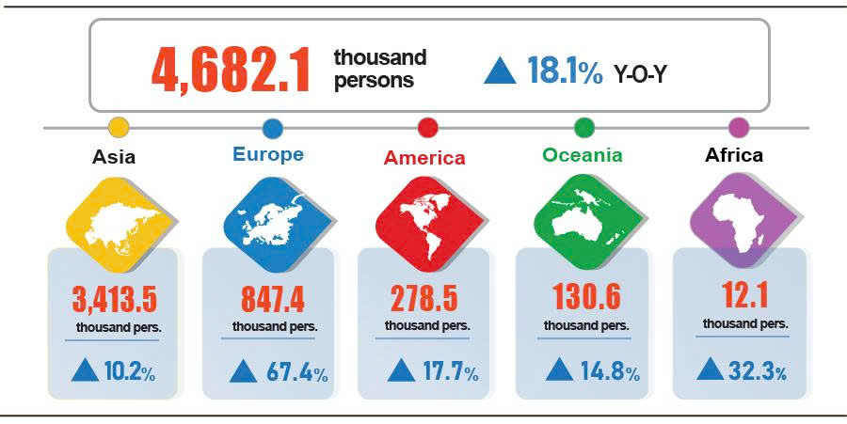
7. Social situation
a) People's living conditions
According to preliminary results of the Labor Force Survey, 95.5% households reported their income in February remained unchanged or increased compared to the same month last year (a rise of 0.2 percentage points compared to the January 2026 reporting period, and a decrease of 1.5 percentage points year-on-year); 4.5% households said that their income decreased or undetermined.
Households with decreased income identified the main reasons as a reduction in household income sources, of which 44.7% of households experienced a reduced income from household members' salaries and wages; 37.9% of households witnessed a declined income from agricultural, forestry, and fishery activities; and 26.2% of households noted a decrease in income from non-agricultural, forestry, and fishery production, business, or service activities.
Additionally, other main reasons for income reduction identified by households include: 29.9% attributed the income decline to reduced selling prices of products made from household production and business (P&B) activities; 26.7% reported that input costs for P&B activities increased; 20.3% reported illness or disease, severe injury and death of household members; 20.1% cited a decline in the size of household’s P&B activities; and 18.6% reported a temporary quit of job of household members.
Regarding the impact of negative events on life in the first two months of 2026, households assessed that: 31.6% were affected by rising prices of goods and services; 9.7% were negatively impacted by natural disasters and climate change; 4.2% suffered from epidemics in livestock and crops; and 3.0% faced adverse conditions due to human epidemics.
In February, 20.1% of surveyed households received assistance from various sources, of which: 10.9% from national programs and policies; 9.8% from relatives and family members; 7.7% from local programs and policies; 3.1% from charitable activities of other organizations and individuals; and 0.1% from other sources.
Social security work was implemented promptly and effectively by authorities at all levels to support the people in overcoming difficulties caused by natural disasters or hunger during holidays and festivals, celebrating the 2026 Lunar New Year in a joyful, healthy, safe, and economical manner. Cumulatively from the beginning of the year to February 27th, 2026, the Government supported the people with 15.3 thousand tons of rice, of which: nearly 9.1 thousand tons of rice for hunger relief during the Lunar New Year for 604.6 thousand persons; 5.6 thousand tons of rice for hunger relief during the pre-harvest season for 372.9 thousand persons; and over 604 tons of rice to overcome the consequences of natural disasters and floods for 40.3 thousand persons.
Regarding the implementation of the "Quang Trung Campaign", after 1.5 months of deployment, the Campaign was two weeks ahead of schedule, 34,759 damaged houses were completely repaired for people to return before December 31st, 2025. All 1,597 houses that collapsed, were destroyed, or swept away by floods were rebuilt and completed before January 15th, 2026, providing the people with sturdy homes to welcome the 14th National Party Congress and prepare for the new spring.
b) Epidemic diseases and food poisoning
According to the Ministry of Health's report, during the month (from January 19th to February 18th, 2026), Viet Nam recorded 12.8 thousand cases of dengue fever; 8,696 cases of hand, foot and mouth disease; 865 cases of rash fever suspected of measles; 34 cases of viral encephalitis; 06 cases of meningococcal meningitis (01 death), and 05 deaths of rabies. Overall, for the first two months of 2026, Viet Nam recorded nearly 33.0 thousand cases of dengue fever (02 deaths); 16.6 thousand cases of hand, foot and mouth disease (02 deaths); 1,854 cases of rash fever suspected of measles; 60 cases of viral encephalitis (01 ca death); 12 cases of meningococcal meningitis (01 death), and 07 deaths of rabies.
As of February 13th, 2026, the total number of people living with HIV nationwide was 255.2 thousand persons and the number of deaths from HIV/AIDS was 117.9 thousand persons.
In February 2026, there were 08 cases of food poisoning, involving 186 victims, with 02 reported deaths. Overall, during the first two months of 2026 (January 19th to February 13th, 2026), Viet Nam recorded 11 food poisoning cases, involving 275 victims, including 3 deaths.

c) Culture and Sports
Cultural events flourished nationwide throughout February, reaching their peak during the Lunar New Year and early spring festivals, including the “Homeland Spring” program series at the Viet Nam National Village for Ethnic Culture and Tourism ran from February 1 to 28, 2026. This was followed by the Spring Calligraphy Festival at the Temple of Literature (Van Mieu - Quoc Tu Giam) from February 11th to March 1st, 2026. Additionally, the “Happy Lunar New Year 2026 – Lunar New Year is happy” experiential space at the Imperial Citadel of Thang Long, held from February 6th to 10th, 2026, featured activities such as Chung cake wrapping, art performances, and displays of ancient Tet customs. These events collectively helped citizens gain a deeper understanding of the nation's cultural heritage. A wide range of festival events continued to unfold across multiple heritage sites, museums, and regions nationwide.

In February, the sports sector remained highly active with several key events: The 2nd Hanoi Open Taekwondo Festival - Thang Long Cup 2026, held from January 31st to February 1st, attracted nearly 2,000 athletes. Meanwhile, the Viet Nam National Futsal Team competed in the 2026 AFC Futsal Asian Cup in Indonesia from January 27th to February 7th. Furthermore, Vietnamese sports were fully focused on preparations for the 20th ASIAD in Japan, aiming for the highest possible achievements on the continental arena and following the recent successes at the 33rd SEA Games.

d) Traffic accidents
In February (from January 26th to February 25th, 2026), there were 1,404 traffic accidents nationwide, resulting in 876 deaths and 854 injuries. In comparison with January 2026, traffic accidents, deaths, and injuries saw decreases of 8.1%, 3.1%, and 9.6%, respectively. Compared with the same period last year, traffic accidents dropped by 5.9%, number of deaths rose by 5.7%, and number of injuries declined by 20.3%.
Overall, in the first two months of 2026, there were 2,932 traffic accidents nationwide, resulting in 1,780 deaths and 1,799 injuries. Compared to the same period last year, the number of traffic accidents, number of deaths, and number of injuries declined by 10.8%, 2.6% and 18.0%, respectively. On average, there were 47 traffic accidents per day nationwide during the first two months of 2026, resulting in 29 deaths and 29 injuries.
đ) Environment protection, fire and explosion prevention
In February (from January 18th to February 17th, 2026), the authorities identified 2,013 environmental violations across 33 out of 34 localities. Of which, 1,691 cases were addressed with total fine of 32.1 billion VND, experiencing a month-on-month decrease of 7.3% and a year-on-year increase of 27.5%. Overall, in the first two months of 2026, 4,695 cases of violating regulations of environment protection were detected, of which 3,899 cases were addressed with total fine of 66.7 billion VND, a year-on-year increase of 19.4%.
During the month (from January 15th to February 14th, 2026), 255 cases of fires and explosions occurred nationwide, resulting in 11 deaths and 15 injuries, with an estimated loss of 29.8 billion VND, experiencing a month-on-month decrease of 84.6% and a year-on-year increase of 21.3%. Overall, for the first 2 months of 2026, there were 515 fires and explosions nationwide, causing 23 deaths and 27 injuries, with an estimated loss of 223.0 billion VND, a 6.1 times higher than the same period last year./.
Recipients:  - General Secretary;  - President;  - Chairperson of the National Assembly;  - Prime Minister;  - Deputy Prime Ministers;  - Leaders of Ministry of Finance;  - Agencies under the Central Committee of the Party;  - Office of the President;  - Agencies under the National Assembly;  - Ministries and line-ministries; Government agencies;  - Supreme People’s Court;  - Supreme People's Procuracy;  - Central mass organizations;  - Provinces and centrally governed cities;  - Viet Nam Chamber of Commerce and Industry (VCCI);  - Units under the Ministry of Finance;  - News agencies and press;  - Units under the National Statistics Office;  Archives: Correspondence Section, Integrated Statistics and Foreign Affairs Department. | DIRECTOR GENERAL  Nguyễn Thị Hương

Cultivated area decreased, comparing to the same period last year, mainly due to unfavorable weather causing long lasting the winter harvest, affecting the land preparation and spring cultivating. In addition, the cultivation period coincided with the Lunar New Year holiday, causing delays in production progress.
February coincided with the Lunar New Year holiday, during which localities and production establishments temporarily cease operations, causing a smaller area of planted forests, comparing to the same period last year.
Figures released by Ministry of Agriculture and Environment, from January 16, 2026 to February 15, 2026
According to the Viet Nam Association of Seafood Processing and Export (VASEP): The price of raw pangasius in the Mekong River Delta was estimated at 33,000-34,000 VND/kg, increasing by 2,000 VND/kg, comparing to the same period last year.
Figures released by provincial and city statistics: office. The price of white leg shrimp remains high, while the price of raw tiger shrimp increased by 10,000-20,000 VND/kg , comparing to the previous month.
The local month-on-month changes in IIP in February for the large-shared industrial sector provinces and municipalities were as follows: Dong Nai is down 6.3%; Da Nang is down 10.0%; Can Tho is down 13.1%; Vinh Long is down 13.8%; Ho Chi Minh City is down 22.6%; Bac Ninh is down 23.6%; Quang Ninh is down 25.4%; Hai Phong is down 31.9%.
The provinces and municipalities recorded high year-on-year increase in IIP of the manufacturing for the first 2 months of 2026 were as follows: Ninh Binh (33.6%); Phu Tho (32.5%); Bac Ninh (21.0%); Hue (20.2%); Tay Ninh (16.7%). The provinces and municipalities recorded high year-on-year increase in IIP of the electricity generation and distribution were as follows: Son La (68.2%); Phu Tho (36.3%); Lai Chau (32.9%).
The provinces and municipalities recorded slight year-on-year increase in IIP of the manufacturing for the first 2 months of 2026 were as follows: Tuyen Quang and Gia Lai (5.8%). The provinces and municipalities recorded decrease in IIP of the electricity generation and distribution for the first 2 months of 2026 were as follows: Lang Son (14.1%); Vinh Long (3.1%); Quang Tri (1.5%). The provinces and municipalities recorded a year-on-year decrease in IIP of the mining and quarrying for the first 2 months of 2026 were as follows: Thai Nguyen (17.9%); Ca Mau (0.2%); Tuyen Quang (10.0%); Gia Lai (8.9%).
Of which, the additional registered capital of active enterprises in the first two months of 2026 reached over 538.2 trillion VND (a year-on-year increase of 12.4%) .
According to the report of the Foreign Investment Agency, Ministry of Finance, received on March 3rd, 2026.
Data received from the State Budget Department - Ministry of Finance on February 28, 2026.
Domestic revenue collection outperformed forecasts and saw a year-on-year increase, driven by robust economic growth in 2025 which bolstered receipts from corporate income tax and value-added tax.
As the Lunar New Year holiday this year fell in February, the number of working days was fewer than in the same period last year (art, entertainment and recreation services increased by 9.7%; health services increased by 8.7%; other services increased by 6.0%; education and training services increased by 5.5%; administrative and support services increased by 4.6%; and real estate services decreased by 1.0%).
The value of export turnover was calculated at F.O.B price and import turnover was calculated at C.I.F price (including transportation and insurance costs of imported goods).
The preliminary data of export and import of goods in February 2026 were provided by the Viet Nam Customs on March 2nd, 2026.
As the Lunar New Year holiday fell in February this year, the number of working days in February this year was five days fewer than in February last year.
The total export and import turnover of goods in the first two months of 2025 amounted to 127.38 billion USD, going up 12.1% year-on-year, of which exports reached 64.57 billion USD, increasing by 8.7%, and imports reached 62.81 billion USD, increasing by 15.9%.
This figure was 23 million USD higher than the data submitted by the Viet Nam Customs to the National Statistics Office on February 3rd 2026.
This figure was 8 million USD higher than the data submitted by the Viet Nam Customs to the National Statistics Office on February 3rd.
Increasing demand for rice and processed food during Binh Ngo Lunar New Year (Tet holiday) in 2026 together with the great need for reserve and preparations for Tet holiday in many localities and rising costs of transport and distribution at the peak of Tet holiday. Of which, the price index of the rice group added up 1.0% (regular rice, premium rice, glutinous rice, brown rice expanded by 0.79%, 1.33%, 3.26%, and 0.82%, respectively). Besides, prices of some food items increased, such as: potatoes up 1.83%; rice noodles and rice paper wrapper up 1.34%; vermicelli up 1.20%; corn flour up 0.96%; other grains up 0.83%; wheat flour up 0.82%; and instant noodles, instant pho, and instant porridge up 0.49%.
The price index of pork; poultry; fresh seafood; fresh and processed fruit; confection, jam; beans and nuts; tea, coffee, and cocoa; spices; fish sauce and condiment; milk, butter, and cheese; sugar and syrup and eggs accelerated by 7.43%; 2.58%; 2.59%; 5.13%; 1.08%; 1.26%; 1.0%; 0.79%; 0.67%; 0.61%; 0.53%; 0.31%, respectively. In contrast, the price index of fresh, dried, and processed vegetables decreased by 7.77% because favorable weather conditions facilitated the stable production of winter vegetable, resulting in an abundant and diverse supply of vegetables.
Due to high prices of raw material and increasing labor costs together with the high demand for celebrations, ending year parties, New Year's parties, and spring outings, the prices of eating out; drinks out; and takeaway fast food soared by 1.84%; 1.17%; 1.47%, respectively.
The CPI of household electricity and tap water in February 2026 reflects a one-month lag than other items based on January 2026 revenue and consumption.
The CPI after excluding food, fresh produce, energy, and State-managed goods which included healthcare and education services.
According to reports from the Department of Border Gate (Border Guard Command, Ministry of National Defence) and the Immigration Department (Ministry of Public Security).
Reporting period: From January 26th, 2026 to February 25th, 2026.
A household could select multiple causes leading to decreased income.
According to Notice No. 36/TB-VPCP dated January 20th, 2026 of the Government Office.
Note: Figures for January 2026 include an additional two deaths.
According to quick reports from the Office of the and the Viet Nam Maritime and Waterway Administration (Ministry of Construction) on February 28, 2026
According to data compiled by Provincial Statistics Offices from the reports from Provincial Departments of Agriculture and Environment and Provincial and Municipal Police Departments.
No environmental violations were identified in Hue City in February 2026.
According to a quick report from the Ministry of Public Security dated February 23rd, 2026.

