MINISTRY OF FINANCE  NATIONAL STATISTICS OFFICE  ________________  Nº: 163/BC-CTK | SOCIALIST REPUBLIC OF VIET NAM  Independence-Freedom-Happiness  ______________________________________  Ha Noi, 3rd May 2026

REPORT
SOCIO-ECONOMIC PERFORMANCE
IN APRIL AND FOUR MONTHS OF 2026

- Agriculture, forestry, and fishing
Agricultural production in April primarily focused on tending winter-spring crops in the northern localities; harvesting winter-spring crops and cultivating autumn rice in the Mekong River Delta. Pig and poultry farming witnessed a stable growth with numbers of large-scale farming models applying biosecurity solutions. Wood harvesting was intensified, forest fire prevention and protection were being paid attention and implemented comprehensively. Aquaculture showed a growing tendency thanks to favorable weather conditions. Marine capture saw a slight increase as it was the start of the southern fishing season and a plummet of oil prices, comparing to the previous month, encouraging fishermen to continue marine capture.
a) Agriculture
Spring rice
As of April 20th, 2026, the national planted area of spring rice reached 2,932.9 thousand hectares, a year-on-year decrease of 36.8 thousand hectares. Of which, the Northern localities reached 1,037.5 thousand hectares, falling by 12.9 thousand hectares; the Southern localities reached 1,895.4 thousand hectares, decreasing by 23.9 thousand hectares. The planted area of spring rice experienced a decrease due to localities converting inefficient rice-land to cultivating annual crops, perennial crops, aquaculture for higher economic efficiency, and for the construction of public works and industrial zones in the area.
So far, the Northern localities completed cultivation, the spring rice was growing and developing well. Early spring rice entered the flowering and milk-ripening stages, while late rice was tillering vigorously and entering the heading stage. Localities were recommended to provide timely irrigation and proactively control pests and diseases to ensure favorable growth and development of the rice for the next stage.
The Southern localities harvested 1,486.0 thousand hectares of spring rice, accounting for 78.4% of the cultivation area, equal to 92.2% of the same period last year. Of which, the Mekong River Delta harvested 1,119.9 thousand hectares, accounting for 90.3% of the cultivation area, equal to 90.7% of the same period last year, mainly due to adjusting the crop calendar to be later of the localities in order to proactively manage water resources for crops.
Autumn rice
Post-harvest of the spring rice, the Southern localities conducted field cleaning, plowing, and tilling the land for cultivation summer-autumn crop. As of April 20th, 2026, the Southern localities sown 355.5 thousand hectares of autumn rice, equal to 50.9%, comparing to the same period last year, of which the Mekong River Delta made up 272.3 thousand hectares, equal to 44.2%. The progress of autumn rice cultivation was slower than the same period last year, mainly due to the prolonged harvest period of the spring rice affecting the crop calendars. In addition, localized heatwaves in several localities, along with the late rainy season due to the impact of El Nino caused further slowed down the cultivating progress. Some localities showed a year-on-year slower cultivating progress, including An Giang reached 74.4 thousand hectares, equal to 26.9%; Can Tho reached 84.9 thousand hectares, equal to 57.4%; Dong Thap reached 93.8 thousand hectares, equal to 55.4%. Given the unfavorable weather conditions, localities proactively cultivated according to the crop calendars, adhering to the recommendations of the agricultural agency to minimize pest and disease risks, prioritizing the use of high-quality, disease-resistant rice and applied advanced farming methods, using pesticides following instruction to improve productivity and efficiency of the summer-autumn crop.
Annual crops
Along with cultivating rice, localities nationwide cultivated other crops. Of which the area of crops cultivation including maize, sweet potatoes showed a year-on-year drop due to low economic efficiency.
Figure 1. Planted area of annual crops
(As of April 20th, 2026)
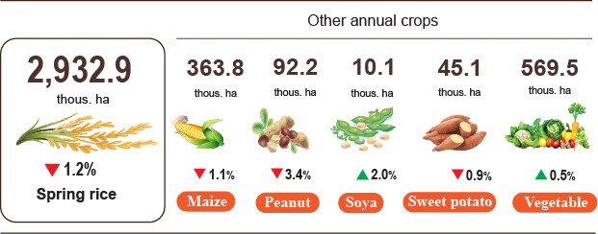
Livestock
Cattle and buffalo farming witnessed a downtrend due to low economic efficiency, long breeding cycles, and large grazing areas, discouraging farmers from the livestock repopulation. Poultry farming showed a stability thanks to short breeding cycles, quick capital turnover, and consistently high selling prices. Large-scale, concentrated farming facilities expanded production, ensuring supply for the market. Pig farming continued its recovery trend. Several localities saw a significant growth of pig numbers due to the strong development of farm-based breeding models and effective disease control such as Gia Lai showed a year-on-year increase of 7.4%; Lam Dong by (+7.2%); Ho Chi Minh City by (+3.4%); Bac Ninh and Phu Tho both by (+3.2%); and Lao Cai (+2.7%). However, small-scale livestock farming faced challenges due to high feed and veterinary medicine costs, while the potential risks of localized outbreaks of African swine fever still remained. Local authorities needed to implement effective disease prevention, control, and management measures.
Figure 2. Year-on-year growth rate of livestock and poultry number
at the end of April 2026
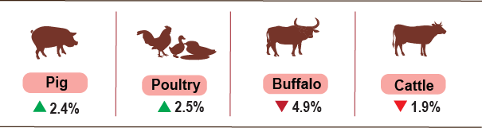
As of April 23rd, 2026, the country no longer recorded with the swine fever nationwide; avian influenza and lumpy skin disease remained in Quang Ngai; the African swine fever occurred in 21 localities not yet passed the 21-day quarantine period.
b) Forestry
Area of ​​new concentrated planted forest nationwide in April 2026 was estimated at 32.3 thousand hectares, showing a year-on-year decrease of 4.2%; the number of scattered trees planted reached 7.1 million trees, showing a year-on-year decrease of 1.8%. Production of exploited wood was estimated at 1,674.8 thousand m³, growing by 1.5%, thanks to dry and favorable weather facilitating people to harvest wood reaching maturity.
Generally, in four months of 2026, the area of ​​newly planted forests nationwide was estimated at 78.5 thousand hectares, showing a year-on-year decrease of 1.0%; the number of scattered trees planted reached 27.6 million trees, showing an increase of 0.9%; the production of exploited wood reached 6,021.9 thousand m³, showing an increase of 2.4%.
Area of ​​forest damaged in April was estimated at 79.9 hectares, showing a year-on-year decrease of 68.3%, of which: the area of burned ​​forest was estimated at 12.8 hectares, a falling by 73.3%; the area of ​​ chopped down forest reached 67.1 hectares, falling by 67.1%. Generally, in four months of 2026, the area of ​​forest damaged was estimated at 142.0 hectares, showing a year-on-year drop of 70.1%, of which​​ the area of burned forest reached 13.7 hectares, showing a decrease of 83.3%; ​​ the area of chopped down forest was estimated at 128.3 hectares, showing a decrease of 67.4%.
c) Fishing
Capture fisheries and aquaculture production in April 2026 reached 831.3 thousand tons, a year-on-year climb of 2.8%, of which fish reached 578.1 thousand tons, rising by 1.8%; shrimp reached 127.0 thousand tons, rising by 7.2%; and other aquatic products reached 126.6 thousand tons, rising by 3.0%.
Aquaculture production in the month was estimated at 471.6 thousand tons, showing a year-on-year growth of 4.8%, of which fish reached 301.5 thousand tons, growing by 3.3%; shrimp reached 114.8 thousand tons, growing by 8.0%; and other aquatic products reached 55.3 thousand tons, showing an increase of 7.0%.
Pangasius production in April was estimated at 156.6 thousand tons, showing a year-on-year growth of 3.8%, due to the rising raw pangasius prices and favorable market encouraging farmers to increase pangasius stocking.
Shrimp production in the month was estimated at 114.8 thousand tons, showing a year-on-year growth of 8.0% due to a rise of raw shrimp prices and domestic demand ahead of the holiday occasion. White leg shrimp production was estimated at 84.7 thousand tons, showing a year-on-year rise of 9.0%; tiger shrimp production reached 25.7 thousand tons, rising by 4.9%.
Production of capture fisheries in April reached 360.1 thousand tons, showing a year-on-year growth of 0.2%, of which fish reached 276.6 thousand tons, rising by 0.3%; shrimp reached 12.2 thousand tons, equal to the same period last year; and other aquatic products reached 71.3 thousand tons, rising by 0.1%. Marine capture entered the southern fishing season a long with a sharp drop in fuel prices, comparing to the end of the previous month, encouraging fishermen to conduct capturing. The production of marine capture fisheries reached 335.3 thousand tons, rising by 0.2%. Of which fish reached 257.4 thousand tons, rising by 0.2%; shrimp reached 11.4 thousand tons, equal to the same period last year; and other aquatic products reached 66.5 thousand tons, showing a growth of 0.2%.
Figure 3. Capture fisheries and aquaculture production
In 4 months of 2026 (Y-o-Y)
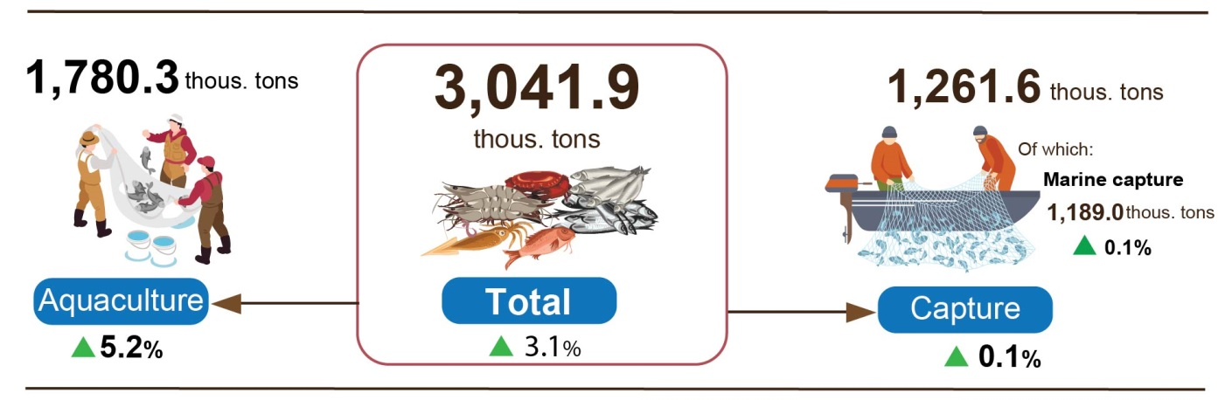
Generally, in four months of 2026, capture fisheries and aquaculture production was estimated to reach 3,041.9 thousand tons, showing a year-on-year growth of 3.1%, of which fish reached 2,214.5 thousand tons, rising by 2.5%; shrimp reached 368.6 thousand tons, rising by 6.6%; and other aquatic products reached 458.8 thousand tons, increasing by 2.9%.
2. Industrial production
Industrial production in April continued its positive trend. The Index of Industrial Production (IIP) was estimated to increase by 3.0% month-on-month and grow by 9.9% year-on-year. Generally, in the first 4 months of 2026, the IIP grew by 9.2% over the same period last year.
In April 2026, the overall IIP was estimated to grow by 3.0% month-on-month and 9.9% year-on-year. Specifically, the manufacturing recorded a year-on-year increase of 10.0%; the mining and quarrying rose by 7.6%; the water supply, sewerage, waste management and remediation activities grew by 7.1%; and the electricity supply increased by 10.9%.
Generally, in the first 4 months of 2026, the IIP was estimated to grow by 9.2% over the same period last year (the corresponding figure in 2025 was 8.6%). Specifically, the manufacturing grew by 9.9% (the corresponding figure in 2025 was 10.6%), contributing 7.8 percentage points to the overall growth; the electricity supply rose by 7.5% (versus 4.5% in 2025), contributing 0.7 percentage points; the mining and quarrying grew by 4.0% (4.6% decline in the same period of 2025), contributing 0.6 percentage points; the water supply, sewerage, waste management and remediation activities increased by 7.4% (versus 9.7% in 2025), contributing 0.1 percentage points.
In the first 4 months of 2026, the IIP of several key 2-digit activities experienced a year-on-year increase as follows: manufacture of chemicals and chemical products (+20.6%); manufacture of basic metals (+18.7%); manufacture of other non-metallic mineral products (+17.9%); manufacture of motor vehicles (+17.0%); manufacture of beverages (+15.9%); manufacture of furniture (+12.5%); manufacture of food products (+11.8%); manufacture of paper and paper products and manufacture of textiles (+9.6%); manufacture of rubber and plastic products (+9.1); manufacture of computer, electronic and optical products (+8.4%). Conversely, the IIP for some activities slightly increased or decreased as follows: manufacture of leather and related products nudged up 4.4%; mining of coal and lignite reduced by 5.3%; manufacture of other transport equipment reduced by 0.9%.
Table 1. Year-on-year IIP growth rate for several key industrial activities
in the first 4 months of the years 2022 - 2026
%
 | 2022 | 2023 | 2024 | 2025 | 2026
Mining of coal and lignite | 11.6 | -4.6 | -0.6 | 6.3 | -5.3
Manufacture of food products | 6.4 | 2.9 | 5.2 | 8.7 | 11.8
Manufacture of beverages | 7.3 | 8.9 | -1.1 | -0.5 | 15.9
Manufacture of textiles | 5.0 | -5.6 | 14.0 | 10.0 | 9.6
Manufacture of leather and related products | 12.2 | -2.9 | 6.7 | 17.6 | 4.4
Manufacture of paper and paper products | 9.9 | -9.2 | 8.9 | 7.7 | 9.6
Manufacture of chemicals and chemical products | 4.5 | 1.8 | 23.9 | 5.5 | 20.6
Manufacture of rubber and plastic products | -14.6 | 6.2 | 28.3 | 15.8 | 9.1
Manufacture of other non-metallic mineral products | 6.9 | -6.2 | -2.5 | 9.0 | 17.9
Manufacture of basic metals | 3.3 | -7.2 | 14.3 | 7.6 | 18.7
Manufacture of computer, electronic and optical products | 10.4 | -5.0 | 3.2 | 9.9 | 8.4
Manufacture of motor vehicles | 2.3 | -9.6 | 2.9 | 36.1 | 17.0
Manufacture of other transport equipment | 5.2 | -9.4 | -5.0 | 8.6 | -0.9
Manufacture of furniture | 5.0 | -4.7 | 19.8 | 8.5 | 12.5
The IIP in the first 4 months of 2026 experienced a year-on-year increase in all 34 provinces and municipalities. Several provinces saw a fairly high growth rate in the IIP thanks to the surge in the manufacturing and the electricity supply. Conversely, the IIP in several provinces and municipalities nudged up due to slow growth or decrease in the manufacturing, the mining and quarrying, and the electricity supply.
Figure 4. Year-on-year IIP growth rate for some localities
(in the first 4 months, 2026) (%)

Top of 10 localities by IIP growth rate  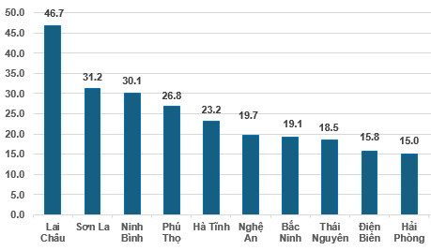 | Bottom of 10 localities by IIP growth rate  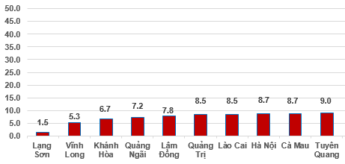
Several key industrial products in the first 4 months in 2026 witnessed year-on-year increase as follows: Motorbike (+33.3%); processed seafood (+22.5%); automobile (+22.4%); rolled steel (+17.0%); steel bar, angle bar (15.8%); beer (+15.5); chemical paint (+14.7%). Conversely, some industrial products experienced a year-on-year reduction, including coal (pure) (-5.4%); sodium glutamate (4.4%); television (-4.3%); leather shoes and sandals (-4.1%); urea fertilizers (-1.1%).
Number of employees in industrial enterprises as of April 1st, 2026 saw a month-on-month growth of 1.1% and year-on-year increase of 3.6%. Among them, the number of employees in the state-owned enterprises increased by 0.2% both month-on-month and year-over-year; the non-state enterprises increased by 1.1% and decreased by 0.1%, respectively; while the FDI enterprises rose by 1.2% and 5.1%, respectively. By kind of economic activity, the number of employees in the mining saw a month-on-month decrease of 0.1% and saw a year-on-year increase of 0.4%. The manufacturing saw an increase of 1.2% and 3.8%, respectively. The electricity, gas, steam and air conditioning supply was increased by 0.1% month-on-month and saw a year-on-year increase of 2.2%. Meanwhile water supply, sewerage, waste management, and remediation activities recorded a slight month-on-month increase of 0.2% and a year-on-year increase of 3.9%.
3. Enterprise registration situation
In April, the whole country had nearly 20.4 thousand newly established enterprises with a registered capital of nearly 246.8 trillion VND and registered employees of nearly 91 thousand employees, a month-on-month decrease of 7.1%, an increase of 9.7% and a decrease of 7.5% in the number of enterprises, the registered capital, and the number of employees, respectively. In comparison with the same period last year, the number of enterprises, the registered capital and the number of employees showed an increase of 33.9%, 84.6%, and a decrease of 28.7%. Average registered capital of a newly established enterprises in April reached 12.1 billion VND, a month-on-month increase of 18.1% and a year-on-year increase of 37.9%. In addition, the country had nearly 9.5 thousand resumed operation enterprises, a month-on-month increase of 19.8% and a year-on-year increase of 5.1%.
In April, there were 8,863 enterprises registered to temporarily suspended for a definite time, a month-on-month increase of 75.2% and a year-on-year increase of 23.4%; 5,388 enterprises suspended operation waiting for dissolution procedures, a month-on-month decrease of 14.5% and a year-on-year decrease of 40.1%; and 3,473 enterprises completed procedures for dissolution, a month-on-month decrease of 9.0% and a year-on-year increase of 98.5%.
Overall, in the four months of 2026, the whole country had 77.8 thousand newly registered enterprises with total registered capital of nearly 785.4 trillion VND and total registered employee of 356.9 thousand employees, a year-on-year increase of 50.7%, 60.1% and 0.3% in number of enterprises, registered capital, and number of employees, respectively. Average registered capital of a newly established enterprises in the four months of 2026 reached 10.1 billion VND, a year-on-year increase of 6.2%. Total registered capital added to the economy in the four months of 2026 was nearly 1.9 quadrillion VND, a year-on-year increase of 4.2%. In addition, the whole country had 41.6 thousand resumed operation enterprises (a year-on-year increase of 8.6%), bringing the total number of newly established and resumed operation enterprises in the four months of 2026 to over 119.4 thousand enterprises, a year-on-year increase of 32.8%. On average, there were 29.9 thousand newly established and resumed operation enterprises per month.
By economic sector, in the four months of 2026, the number of newly registered enterprises in the agriculture, forestry and fishing sector; the industry and construction sector; and the services sector reached 827 enterprises (+66.7% Y-o-Y); 18.9 thousand enterprises (+56.6% Y-o-Y); and nearly 58.1 thousand enterprises (+48.7% Y-o-Y), respectively.
Figure 5. Enterprises registration situation in the four months of 2026
compared to the same period in 2025.
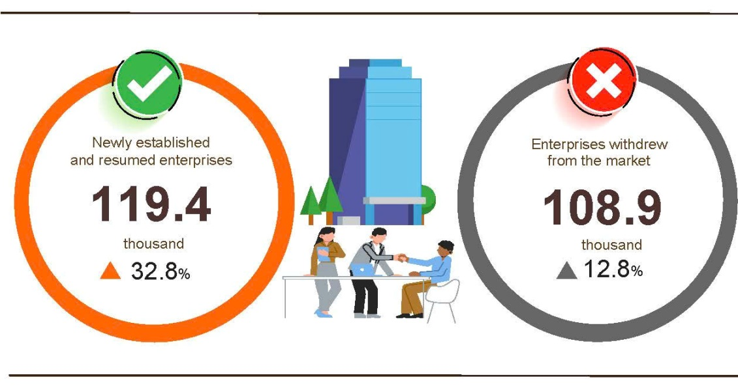
Overall, in the four months of 2026, the number of enterprises temporarily suspended for a definite time was 72.2 thousand enterprises, a year-on-year increase of 5.1%; nearly 21.5 thousand enterprises suspended operation waiting for dissolution procedures, a year-on-year increase of 6.6%; and nearly 15.2 thousand enterprises completed procedures for dissolution, a year-on-year increase of 98.7%. On average, 27.2 thousand enterprises withdrew from the market per month.
Table 2. Newly established and completely dissolved enterprises
in the four months of 2026 by kind of economic activity

 | Number of enterprises (Enterprises) |  | Year-on-year growth rate (%)
 | Newly established | Completely dissolved | Newly established | Completely dissolved
Wholesale and retail, repair of motor vehicle and motorcycle | 33,269 | 5,719 | 81.4 | 102.2
Manufacturing | 10,644 | 1,630 | 60.1 | 99.3
Construction | 7,225 | 1,053 | 49.2 | 91.5
Real estate business | 2,122 | 928 | 34.1 | 110.9
Transportation and storage | 4,837 | 565 | 75.0 | 82.8
Accommodation and food services | 3,516 | 733 | 121.3 | 87.9
Electricity, water and gas supply | 692 | 145 | 74.7 | 40.8

4. Investment
State budget investment in April was implemented by ministries, agencies, and localities, creating a momentum for economic growth. Generally, in the four months of 2026, the State budget investment was estimated to reach 19.7% of the annual plan, a year-on-year increase of 10.4%. Disbursed foreign direct investment (FDI) in Viet Nam in the four months of 2026 was estimated at 7.40 billion USD, a year-on-year increase of 9.8%.
The disbursed investment from the State budget in April was estimated at nearly 54.8 trillion VND, a year-on-year increase of 8.2%, including: the centrally-managed investment was 7.8 trillion VND, an increase of 2.1%; and locally-managed investment was 47.0 trillion VND, an increase of 9.3%. Generally, in the four months of 2026, the disbursed State budget investment was estimated at 187.1 trillion VND, equivalent to 19.7% of the annual plan and a year-on-year increase of 10.4% (these figures in 2025 were 16.7% and 20.5%, respectively). Specifically:
- The Centrally-managed investment was estimated to reach 25.4 trillion VND, equivalent to 12.5% ​​of the annual plan and a year-on-year increase of 4.6%. Of which, the Ministry of Construction accounted for nearly 16 trillion VND, up 5.1%; the Ministry of Agriculture and Environment accounted for 1.3 trillion VND, down 61.8%; the Ministry of Health accounted for 309.7 billion VND, down 49.4%; the Ministry of Culture, Sports and Tourism accounted for 185.5 billion VND, down 7.3%; the Ministry of Education and Training reached 167.6 billion VND, down 48.5%; the Ministry of Industry and Trade reached 22.8 billion VND, down 62.9%; and the Ministry of Science and Technology reached 12.1 billion VND, down 82.7%.
- Locally-managed investment was estimated at 161.7 trillion VND, equal to 21.6% of the annual plan and a year-on-year increase of 11.4%, including:
The State budget investment at provincial level reached 125.3 trillion VND, equivalent to 21.3% and a year-on-year increase of 8.3%;
The State budget investment at commune level reached 36.4 trillion VND, equivalent to 22.7% and a year-on-year increase of 23.5%.
The disbursed State budget investment in the four months of 2026 in some provinces and centrally-run cities was as follows:
Figure 6. Disbursed investment from the State budget
in the four months of 2026 in selected localities

Total inward foreign investment in Viet Nam as of April 27th, 2026, including newly registered capital, adjusting registered capital, and the value of capital contribution and purchasing shares by foreign investors reached 18.24 billion USD, a year-on-year increase of 32.0%.
Figure 7. Inward foreign investment in Viet Nam
in the four months of 2022-2026 (Billion USD)

- In terms of newly registered capital: 1,249 projects were licensed with a registered capital of 12.15 billion USD, a year-on-year increase of 3.7% in the number of projects and an upturn of 2.2 times in registered capital. Of which, the largest newly licensed FDI was the manufacturing with 8.12 billion USD, accounting for 66.8% of the total newly registered capital; the electricity, gas, steam, and air conditioning supply reached 2.31 billion USD, accounting for 19.0%; and other activities was 1.72 billion USD, accounting for 14.2%.
Among the 53 countries and territories with newly licensed investment projects in Viet Nam during the four months of 2026, Singapore was the largest investor with 6.05 billion USD, accounting for 49.8% of the total newly registered capital; followed by South Korea with 4.08 billion USD, accounting for 33.6%; China with 524.1 million USD, accounting for 4.3%; Japan with 462 million USD, accounting for 3.8%; Hong Kong Special Administrative Region (China) with 329.2 million USD, accounting for 2.7%; and the Netherlands with 318.5 million USD, accounting for 2.6%.
- The adjusted registered capital: 316 turns of projects licensed from the previous years registered to adjust investment capital upwards by an additional 3.13 billion USD, a year-on-year decrease of 51.0%.
If including newly registered capital and adjusted registered capital of licensed projects in the previous years, the registered FDI in the manufacturing reached 10.49 billion USD, accounting for 68.6% of the total newly registered and increased capital; the electricity, gas, steam and air conditioning supply reached 2.31 billion USD, accounting for 15.1%; and other activities reached 2.48 billion USD, accounting for 16.3%.
- There were 976 turns of registered capital contributions and purchasing shares by foreign investors with a total value of 2.96 billion USD, a year-on-year increase of 61.9%. Of which, 325 turns of capital contributions and purchasing shares increased the charter capital of enterprises with a value of 445.13 USD million, and 651 turns of foreign investors rebought domestic shares without increasing the charter capital with a value of 2.51 billion USD. The capital contributions and purchasing shares by foreign investors in the wholesale and retail trade and repair of motor vehicles and motorcycles reached 1.89 billion USD, accounting for 63.9% of the total capital contribution; the professional, scientific, and technical activities reached 321 million USD, accounting for 10.9%; and the other economic activities accounted for 747 million USD, accounting for 25.2%.
Disbursed FDI in Viet Nam during the four months of 2026 was estimated at 7.40 billion USD, a year-on-year increase of 9.8%. This was the highest figure in the disbursed FDI in the four months of the year in the past-5-year period. Of which, the disbursed FDI in the manufacturing reached 6.12 billion USD, representing 82.7% of total disbursed FDI; the real estate activities reached 540.5 million USD, accounting for 7.3%; and electricity, gas, steam and air conditioning supply reached 270.6 million USD, accounting for 3.7%.
Figure 8. Disbursed foreign direct investment
in the four months of 2022-2026 period (Billion USD)

Viet Nam's outward investment in the four months of 2026 witnessed 74 projects granted with new investment certificates with a total capital of 691.1 million USD, 2.6 times higher than that in the same period last year; 4 turns of projects with adjusted their capital with the additional amount of 22.8 million USD, a decrease of 43.2%.
Generally, the total Viet Nam’s outward FDI (newly granted and adjusted capital) reached 713.9 million USD, 2.3 times higher than the same period last year. Of which: the electricity, gas, steam and air conditioning supply reached 163.8 million USD, accounting for 22.9%; the construction reached 153.0 million USD, accounting for 21.4%; and transportation and storage reached 149.2 million USD, accounting for 20.9%.
In the four months of 2026, 32 countries and territories received investment from Viet Nam, of which: Laos was the leading destination with 198 million USD, accounting for 27.7% of total investment; Kyrgyzstan with 149.9 million USD, accounting for 21.0%; the United Kingdom with 82.8 million USD, accounting for 11.6%; Kazakhstan with 36.0 million USD, accounting for 5.0%; the British Virgin Islands with 30.1 million USD, accounting for 4.2%; Angola with 30 million USD, accounting for 4.1%; and the Netherlands with 29.4 million USD, accounting for 4.0%.
5. State budget revenue and expenditure
State budget revenue in the four months of 2026 was estimated to increase by 15.2% over the same period last year. State budget expenditure was estimated to increase by 11.6% over the previous year, effectively meeting the needs for socio-economic development, national defense, security, state management, payment of due debts, and timely payment to beneficiaries according to regulations.
Figure 9. State budget revenue and expenditure in the 4 months 2026
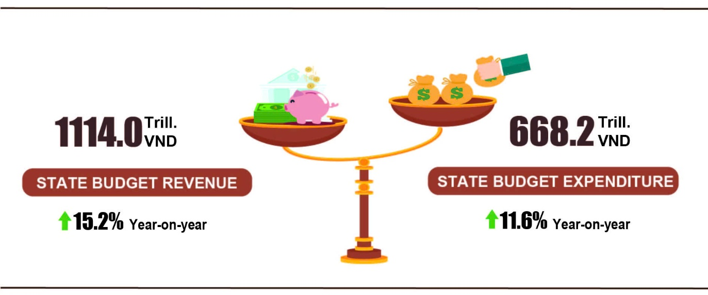
State budget revenue
State budget revenue in April 2026 was estimated at 257.2 trillion VND. The accrued revenue in the 4 months of 2026 reached nearly 1,114.0 trillion VND, reaching 44.0% of the annual estimate (+15.2% YoY). In particular, selected revenue items were as follows:
- Domestic revenue in April 2026 was estimated at 224.0 trillion VND. The accrued revenue in the 4 months of 2026 was estimated at 991.0 trillion VND, reaching 45.0% of the annual estimate and (+17.4% YoY).
- Oil revenue in April 2026 was estimated at 5.5 trillion VND; the accrued revenue in the 4 months of 2026 reached 17.0 trillion VND, reaching 39.5% of the annual estimate and (-4.9% YoY).
- Revenue from budget balance of import-export activities in April 2026 was estimated at 27.6 trillion VND; accrued revenue in the 4 months of 2026 was estimated at 105.4 trillion VND, reaching 37.9% of the annual estimate (+0.4% YoY).
State budget expenditure
State budget expenditure in April 2026 was estimated at nearly 143.9 trillion VND. The accrued expenditure in the 4 months of 2026 was estimated at 668.2 trillion VND, reaching 21.2% of the annual estimate (+11.6% YoY). Specifically, recurrent expenditure in the 4 months of 2026 was estimated at 471.0 trillion VND, equal to 26.0% of the annual estimate (+10.8% YoY); development investment expenditure gained 153.2 trillion VND, reaching 13.7% of the annual estimate (+16.4% YoY); interest payment was 43.0 trillion VND, reaching 35.5% of the annual estimate (+5.4% YoY).
6. Trade, prices, transport and tourism
a) Retail sales of goods and services
Commercial and service activities in April 2026 maintained a solid growth, with retail sales of goods and services estimated to increase by 1.7% month-on-month and by 12.1% year-on-year. For the four months of 2026 as a whole, the retail sales of goods and services increased by 11.1% over that in the same period last year, of which turnover from accommodation and food service activities rose by 13.4% and turnover from travelling services grew by 12.1%.
The retail sales of goods and services at current prices in April 2026 were estimated at 646.3 trillion VND, a year-on-year increase of 12.1%. Of which, turnover from petroleum products rose by 17.4% year-on-year; food and foodstuffs increased by 11.6%; garments rose by 9.7%; cultural and educational items increased by 9.3%; household appliances and equipment rose by 8.1%; accommodation and food service activities increased by 14.1%; travelling services rose by 6.5% and other services increased by 9.4%.
Table 3. Retail sales of consumer goods and services at current prices
in four months of 2026
Trillion VND
 | Estimate  for April  2026 | Estimate  4 months of  2026 | Year-on-Year  Growth rate (%)
 | Estimate  for April  2026 | Estimate  4 months of  2026 | April  2026 | 4 months of 2026
Total | 646.3 | 2,546.6 | 12.1 | 11.1
Retail sales of goods | 489.4 | 1,938.8 | 12.2 | 11.1
Accommodation and food services | 82.9 | 317.4 | 14.1 | 13.4
Travelling services | 8.7 | 31.9 | 6.5 | 12.1
Other services | 65.3 | 258.5 | 9.4 | 8.5
Generally, in four months of 2026, the retail sales of goods and services at current prices were estimated at 2,546.6 trillion VND, going up 11.1% compared with the same period last year, excluding the price factor, the increase was 6.3%.
Figure 10. Retail sales of goods and services at current prices
in four months of 2022-2026

The retail sales of goods in four months of 2026 were estimated at 1,938.8 trillion VND, accounting for 76.1% of the total and increasing by 11.1% year-on-year. Of which, turnover from garments rose by 11.3% year-on-year; food and foodstuffs increased by 10.2%; household appliances, tools and equipment increased by 7.9%; cultural and educational items increased by 6.2% and other services increased by 18.2%. Retail sales of goods in four months of 2026 of some localities saw a year-on-year increase including Quang Ninh (+12.8%); Bac Ninh (+11.5%); Can Tho (+10.4%); and Hai Phong (+10.3%).
The turnover from accommodation and food service activities in four months of 2026 were estimated at 317.4 trillion VND, accounting for 12.5%, accounting for 13.4% over the same period last year. In comparison to the same period last year, the turnover in four months of 2026 in some localities experienced an increase as follows: Da Nang (+17.7%); Hai Phong (+14.6%); Can Tho (+14.5%); Ho Chi Minh city (+9.5%); and Ha Noi (+9.0%).
The turnover of travelling in four months of 2026 was estimated at 31.9 trillion VND, accounting for 1.3% of the total and a year-on-year growth of 12.1% thanks to the surge in both domestic tourists and international visitors to Viet Nam during holidays and festivals. Some localities recorded a high year-on-year increase in turnover in four months of 2026, including Can Tho (+16.1%); Hai Phong (+13.7%); Ha Noi (+11.5%); Da Nang (8.6%); and Ho Chi Minh City (+7.7%).
The turnover of other services in four months of 2026 was estimated at 258.5 trillion VND, accounting for 10.1% of the gross and increasing by 8.5% year-on-year. Specifically, the turnover increase in four months of 2026 in some localities was as follows: Hue (+26.8%); Ninh Binh (+16.9%); Khanh Hoa (+15.7%); Ha Noi (+8.6%); and Ho Chi Minh City (+4.9%).
b) Export and import of goods
In April, the total export and import turnover of goods reached 94.32 billion USD, a month-on-month increase of 0.8% and a year-on-year increase of 26.7%. Generally, in four months of 2026, the total export and import turnover of goods reached 344.17 billion USD, going up 24.2% over that in the same period last year, of which exports increased by 19.7% and imports increased by 28.7%. The trade balance of goods recorded a trade deficit of 7.11 billion USD.
Figure 11. Export and import of goods in four months of 2026
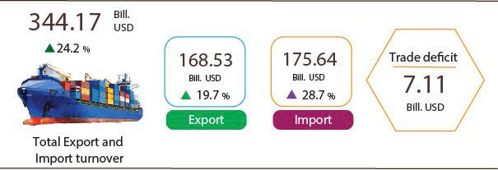

Export of goods
The export turnover of goods in March 2026 preliminarily reached 46.44 billion USD.
In April 2026, export turnover of goods amounted to 45.52 billion USD, decreasing by 2.0% over the previous month. Of which, the domestic economic sector reached 8.88 billion USD, down 1.2%; while the FDI sector (including crude oil) reached 36.64 billion USD, down 2.1%. Compared to the same period last year, the export turnover of goods in April increased by 21.0%, of which the domestic economic sector decreased by 4.2%, while the FDI sector (including crude oil) rose by 29.2%.
Overall, in four months of 2026, export turnover reached 168.53 billion USD, increasing by 19.7% over the same period last year. Of which, the domestic economic sector reached 33.65 billion USD, rose by 0,4%, accounting for 20.0% of total export turnover; the FDI sector (including crude oil) attained 134.88 billion USD, went up by 25.8%, accounting for 80.0%.
In four months of 2026, there were 24 export items with a value exceeding 1 billion USD, accounting for 89.1% of the total export turnover (including 7 items recorded export values of over 5 billion USD, accounting for 69.1%).
Table 4. Value of selected export products in four months of 2026
 | Value  (Mill. USD) | Growth rate Y-o-Y (%)
Products with a value of over 5 billion USD
Electronic goods, computers and their parts | 43,624 | 49.1
Phones all of kinds and their parts | 21,548 | 21.1
Machinery, instrument, accessory | 20,600 | 20.5
Textiles and sewing products | 11,963 | 1.6
Footwear | 7,320 | -3.8
Means of transport and spare parts | 6,110 | 13.2
Wood and wood products | 5,339 | -1.1

Regarding the structure of exported goods in four months of 2026, the group of manufactured products reached 151.5 billion USD, accounting for 89.9%; the group of agricultural and forestry products reached 12.68 billion USD, accounting for 7.5%; the group of fishery products attained 3.55 billion USD, accounting for 2.1%; and the group of fuels and minerals reached 0.8 billion USD, accounting for 0.5%.
Figure 12. Structure of exported goods
in four months of 2026
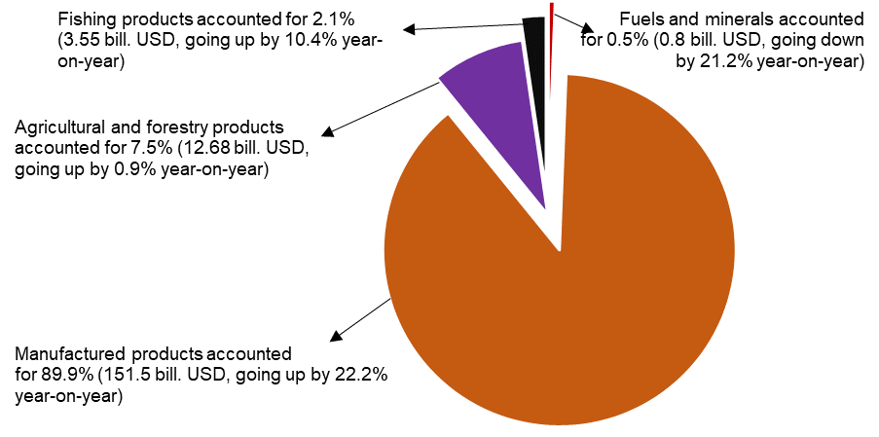
Import of goods
Import turnover of goods in March 2026 reached 47.11 billion USD.
Import turnover of goods in April 2026 reach 48.8 billion USD, a rise of 3.6% over the previous month. Of which, the domestic economic sector reached 13.8 billion USD, increasing by 2.6%; and the FDI sector reached 35.0 billion USD, going up 4.0%. Compared with the same period last year, the import turnover of goods in April increased by 32.5%, of which the domestic economic sector increased by 22.7%; and the FDI sector increased by 36.8%.
Overall, in four months of 2026, the import turnover of goods reached 175.64 billion USD, a year-on-year surge of 28.7%. Of which, the domestic economic sector reached 49.27 billion USD, an upturn of 20.4%; and the FDI sector reached 126.37 billion USD, an expansion of 32.3%.
In four months of 2026, there were 30 imported products with a value exceeding 1 billion USD, accounting for 87.4% of the total import turnover (including 2 imported products with the value of over 5 billion USD, accounting for 49.2%).
Table 5. Value of some imported goods in four months of 2026

 | Value  (Mill. USD) |  | Growth rate year-on-year (%)
Products with a value of over 5 billion USD
Electronic goods, computers and their parts | 65,266 |  | 52.3
Machine, equipment, tools and instruments | 21,100 |  | 20.2

Regarding the structure of imported goods in four months of 2026, the group of capital goods reached 165.37 billion USD, accounting for 94.2%, of which the group of machine, equipment, tools and instruments accounted for 54.8%; the group of fuels, raw materials accounted for 39.4%. The group of consumer goods reached 10.27 billion USD, accounting for 5.8%.
Figure 13. Structure of imported goods
in four months of 2026
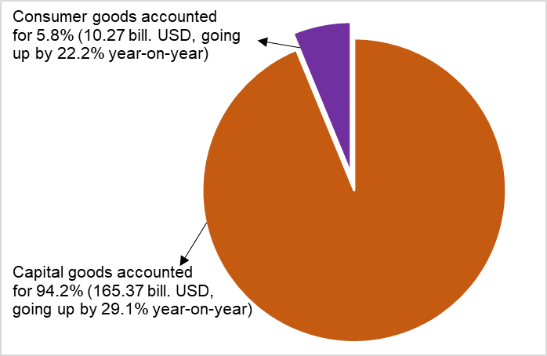
Regarding export and import markets of goods in four months of 2026, the United States was Viet Nam’s largest export market with a turnover of 53.9 billion USD. China remained Viet Nam’s largest import market with a turnover of 69.0 billion USD. In four months of 2026, the trade surplus to the United States and EU reached 46.9 billion USD and 14.2 billion USD, respectively, with the corresponding year-on-year surge of 24.4% and 6.7%; the trade surplus to Japan reached 0.5 billion USD, a downturn of 28.0%; the trade deficit to China, South Korea, ASEAN was 46.4 billion USD, 15.0 billion USD, 7.6 billion USD, respectively, gaining an equivalent expansion of 33.4%, 57.8%, and 44.3%.
Figure 14. Major commodity export and import markets
in four months of 2026
 |  | Export of goods | Import of goods
According to preliminary data, the trade balance of goods recorded a deficit of 0.68 billion USD in March, 3.83 billion USD in the Q1 2026 and 3.28 billion USD in April. Overall, in four months of 2026, the trade balance of goods posted a deficit of 7.11 billion USD (a surplus of 4.3 billion USD in the same period last year). Of which, the domestic economic sector recorded a trade deficit of 15.61 billion USD; while the FDI sector (including crude oil) recorded a trade surplus of 8.5 billion USD.
c) Consumer price index, gold and US dollar price index
The Consumer Price Index (CPI) in April witnessed a month-on-month increase of 0.84% as result of a rise in the prices of domestic gas in line with the prices of fuel global, as well as an expansion in the prices of eating out and construction materials resulting from the higher costs of raw material and transport. The CPI in April rose by 3.31%, 5.46% compared to that in December 2025 and the same period last year, respectively.
In general, the CPI in four months of 2026 saw a year-on-year increase of 3.99%; core inflation edged up 3.89%.
In the month-on-month increase of 0.84% in the CPI in April 2026, 10 groups of goods experienced an increase in the CPI but the CPI of transport group possessed a decrease.
(1) 10 groups of goods and services recorded an upturn in CPI, including
- The group of housing, electricity, water, fuel, and construction materials increased by 2.59% (contributing to an expansion of 0.59 percentage points in the overall CPI), focusing on a rise in the prices of the items as follows: Gas prices rocketed by 35.3% (contributing to a rise of 0.46 percentage points in the overall CPI); kerosene prices shot up 26.95%; the prices of environmental sanitation service; housing maintenance material; tap water services; household electricity; household electricity services; house rental soared by 4.28%; 4.11%; 1.24%; 1.06%; 0.84%; 0.79%, respectively. Of which, the price of house repair service jumped up 1.93%. In contrast, tap water prices decreased by 1.11% as the result of decreasing consumption.
- The group of beverages and tobacco accelerated by 0.85% due to rising costs of import, production, and distribution. Of which, the price of bottled, canned, and boxed energy drinks witnessed a month-on-month increase of 1.50%; the prices of carbonated soft drinks; cigarettes; alcohol and beer; and fruit juices climbed up 1.29%; 1.25%; 0.64%; and 0.45%, respectively.
- The group of household equipment and goods accelerated by 0.78% stemming from the rising costs of raw materials, labor, and transport. Of which, some items witnessed an increase in prices: the prices of household equipment repair; lighting fixtures and beds, wardrobes, tables, and chairs; glassware, ceramic and porcelain products; electric fans; electric rice cookers; soap and detergents; refrigerators; microwave, ovens, and induction cookers; air conditioners expanded by 1.40%; 0.99%; 0.97%; 0.79%; 0.75%; 0.72%; 0.62%; 0.47%; 0.33%, respectively. On the other hand, the hiring cost of a housekeeper declined by 0.11% due to reducing demand for cleaning and domestic work after the peak of Lunar New Year.
- The group of other goods and services grew by 0.64%, focusing on a rise of 1.04%; 0.77%; 0.72% in the CPI of funeral and wedding services; personal services; and personal items, respectively. In contrast, the price of jewelry fell by 4.11% in line with domestic gold price.
- The group of culture, entertainment, and tourism increased by 0.63%, focusing on items as follows: the prices of package tour went up 1.71% (an upturn of 1.78%; 1.25% in domestic tourism; outbound tourism, respectively); pets related services; sports services; both hotels, guesthouses, and children's toys; fitness equipment edged up 1.02%; 0.89%; 0.69%; 0.61%, respectively.
- The group of food and foodstuff service rose by 0.58% (contributing to an increase of 0.21 percentage point in the overall CPI), of which: Food; eating out added up 0.67%; 1.94%, respectively (contributing to an expansion of 0.18 percentage point); the CPI of foodstuff group unchanged.
- The group of garment, hat and footwear added up 0.52% due to rising costs of raw material, transport and labor. Of which, the CPI of footwear services; tailoring services; hats; fabrics of all kinds; other garments; ready-made clothes jumped up 1.20%; 1.19%; 0.74%; 0.62%; 0.61%; 0.45%, respectively due to rising costs of input.
- The group of information and communication accelerated by 0.17%, of which the price of feature phones; computers and its accessories; phone repair services; printers, projectors, and scanners; television and internet services expanded by 1.19%; 1.14%; 0.87%; 0.36%; 0.11%, respectively. In contrast, the price of audio equipment, and landline telephones reduced by 0.40%; 0.04%, respectively.
- The group of medicines and health care services climbed up 0.13%, mainly due to rising import costs of pharmaceutical raw materials, production and distribution. Of which, the prices of anti-allergy drugs and pain relief and fever reducing drugs both grew up 0.57%; respiratory drugs; hormones and drugs affecting the endocrine system; cardiovascular drugs; and anti-infective and antiparasitic drugs jumped up 0.46%; 0.43%; 0.42%; 0.33%, respectively.
- The education group accelerated by 0.08%, of which educational services added up 0.04% on account of the adjustments of tuition fee in some supplementary education centers. Besides, paper products; pens of all kinds; and stationery and other school supplies rose by 0.82%; 0.71%; 0.66%, respectively.
(2) The transport group reduced by 0.81% (contributing to a decrease of 0.08 percentage points in the overall CPI), mainly due to a fall of 3.19% in gasoline prices in line with world prices. In contrast, some transport goods and services witnessed an upturn as follows: The CPI of diesel oil rocketed by 18.55%; the CPI of public transport service spiked by 12.43%; the CPI of vehicle maintenance; spare parts; spare parts; car washing and tire pumping services; bicycle; new car; motorbike soared by 1.35%; 1.17%; 1.22%; 0.93%; 0.82%; 0.42%; 0.23%, respective.
d) Passenger and cargo transport
Transport activities in April 2026 continued to be dynamic, meeting the travel demand of domestic residents as well as international visitors to Viet Nam, and supporting production and the import and export of goods. Compared to the same period last year, passenger carried and passenger carried (passenger-kilometers) in April 2026 saw a year-on-year increase of 17.3% and 15.8%, respectively; freight transported and freight transported (ton-kilometers) recorded a year-on-year rise of 14.0% and 10.4%, respectively. Overall, in four months of 2026, passenger carried and passenger carried (passenger-kilometers) experienced a year-on-year rise of 15.0% and 12.7%, respectively; freight transported and freight transported (ton-kilometers) recorded a year-on-year increase of 14.2% and 10.2%, respectively.
Passenger carried in April 2026 was estimated at 509.5 million turns of passengers, a month-on-month increase of 5.6%, and passenger carried (passenger-kilometers) reached 28.4 billion passenger-kilometer, a month-on-month rise of 4.8%. Overall, in four months of 2026, the passenger carried was estimated at 2,102.3 million turns of passengers, a year-on-year increase of 15.0% and passenger carried (passenger-kilometers) reached 113.2 billion passenger-kilometer, a rise of 12.7%. Of which, domestic passenger carried was estimated at 2,095.4 million turns of passengers, a year-on-year increase of 15.0%, domestic passenger carried (passenger-kilometers) was 91.0 billion passenger-kilometer, a year-on-year upturn of 14.4%; oversea passenger carried was estimated at 6.9 million turns of passengers, a year-on-year expansion of 7.0%, and overseas passengers carried (passenger-kilometers) reached 22.2 billion passenger-kilometer, going up by 6.1%.

Table 6. Passenger carried in four months of 2026 by type of transport
 | Number of passengers |  |  | Year-on-year growth rate (%)
 | Carried  (Mill. Passengers) | Carried (passenger-kilometers)  (Bill. passenger-km) |  | Carried | Carried (passenger-kilometers)
Total | 2,102.3 | 113.2 |  | 15.0 | 12.7
Rail way | 16.3 | 1.1 |  | 11.6 | 4.1
Sea way | 4.0 | 0.3 |  | -13.9 | 0.4
Inland water way | 156.8 | 3.1 |  | 4.1 | 14.6
Road | 1,904.6 | 74.1 |  | 16.1 | 14.3
Airway | 20.6 | 34.6 |  | 11.3 | 9.7

Freight transported in April 2026 was estimated at 274.2 million tons, month-on-month increase of 1.4% and freight transported (ton-kilometers) reached 53.3 billion ton-kilometer, a month-on-month upturn of 2.3%. Overall, in four months of 2026, freight transported was estimated at 1,082.9 million tons, a year-on-year increase of 14.2% and freight transported (ton-kilometers) reached 208.2 billion ton-kilometer, a year-on-year increase of 10.2%. Of which, domestic freight transported was estimated at 1,063.4 million tons, an upturn of 14.2%, domestic freight transported (ton-kilometers) reached 121.3 billion ton-kilometer, up by 10.7%; overseas freight transported was estimated at 19.5 million tons, increasing by 14.7%, and overseas freight transported (ton-kilometers) was 86.9 billion ton-kilometer, up 9.3%.
Table 7. Freight transported in four months of 2026 by type of transport
 | Volume of freight |  |  | Year-on-year growth rate (%)
 | Transported  (Mill. tons) | Transported  (ton-kilometers)  (Bill. ton-km) |  | Transported | Transported (ton-kilometers)
Total | 1,082.9 | 208.2 |  | 14.2 | 10.2
Rail way | 1.6 | 1.3 |  | -6.8 | 1.6
Sea way | 52.2 | 112.0 |  | 8.3 | 8.3
Inland water way | 228.6 | 44.5 |  | 14.5 | 13.1
Road | 800.3 | 46.9 |  | 14.5 | 12.6
Airway | 0.2 | 3.5 |  | 2.6 | 6.4
đ) International visitors to Viet Nam
A stable and safe socio-political environment; increasingly open visa policies; more professional promotion and marketing activities; together with a diverse range of products aligned with trends and continuously improving service quality, have created an important foundation for attracting international visitors to Viet Nam.
In April 2026, international visitors to Viet Nam reached 2.03 million arrivals, a year-on-year increase of 22.8%. Overall, in four months of 2026, international visitors to Viet Nam amounted to 8.8 million arrivals, an increase of 14.6% over that in the same period last year, marking the highest level for four months on record. Of which, arrivals by airway reached 7.3 million arrivals, accounting for 82.5% of total international visitors to Viet Nam and rising by 10.1% year-on-year; arrivals by road reached 1.4 million arrivals, accounting for 15.5% and increasing by 47.6%; arrivals by seaway reached 174.3 thousand arrivals, accounting for 2.0% and rising by 10.1%.
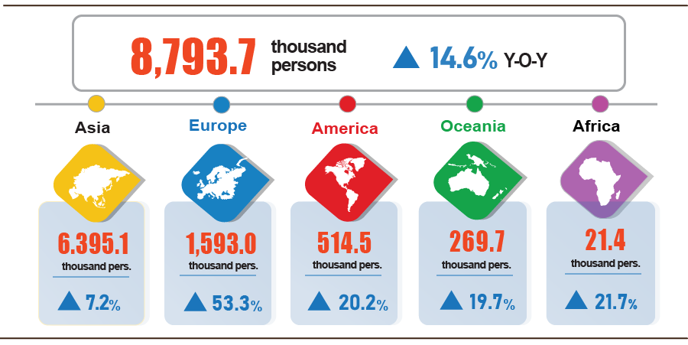
Figure 16. International visitors to Viet Nam in four months of 2026 by territory
7. Social situation
a) People's living conditions
According to preliminary Labour Force Survey results, 96.0% of households reported that their income in the month remained unchanged or increased compared to the same period last year (a month-on-month decrease of 0.6 percentage points and a year-on-year fall of 0.1 percentage points); 4.0% of households said that their income decreased or undetermined.
Among households reporting an increase in income, 68.6% attributed it to increased wages and salaries of household members; 35.3% reported growth in income from agriculture, forestry, and fishery activities; and 22.7% identified increased income from non-agricultural, forestry, and fishery production, business, and service activities.
Of the households with decreased income, 36.9% pointed to rising input costs for their production and business activities; 25.7% indicated a decline in the selling prices of products from household production and business activities; 21.9% noted that household members suffered from severe illness, injury, or death; 18.4% cited a reduction in the scale of their production and business activities; and 18.1% identified that a household member was temporarily out of work.
Regarding the impact of negative events on people’s living conditions in four months of 2026, households evaluated: 34.5% of households were impacted by rising prices of goods and services; 8.0% by natural disasters and climate change; 3.9% by epidemics in livestock or crops; 2.9% by human epidemics; 2.2% by household members suffering from severe illness, injury, or death; and 0.6% by fires or explosions.
In April, 19.0% of interviewed households received assistance from various sources. Specifically, the proportion of households receiving support from national programs and policies was 9.7%; from local programs and policies was 7.6%; from relatives and family members was 10.0%; from charitable activities of organizations or individuals was 2.7%; and from other sources was 0.1%.
Social security activities were implemented in a timely manner to support the people's lives. From the beginning of the year to April 25th, 2026, the Government provided 15.3 thousand tons of rice to the people, of which: nearly 9.1 thousand tons for hunger relief during the Lunar New Year for 604.6 thousand persons; 5.6 thousand tons for pre-harvest hunger relief for 372.9 thousand persons; and over 604 tons for natural disaster and flood relief for 40.3 thousand persons.
Regarding support for policy beneficiaries and national devotees on the occasion of the April 30th holiday, on April 22nd, 2026, the Prime Minister issued the Official Dispatch No. 431/TTg-KGVX on continuing to improve the welfare of national devotees on the 51st anniversary of the Southern Liberation and National Reunification Day (April 30th, 1975 - April 30th, 2026) and towards the 80th anniversary of Invalids and Martyrs Day (July 27th, 1947 - July 27th, 2027).
b) Epidemic, food poisoning
According to the report of the Ministry of Health, in the month (March 18th - April 17th, 2026), there were 6,408 cases of dengue fever (1 death); 11.8 thousand cases of hand, foot and mouth disease (3 deaths); 697 cases of rash fever suspected of measles; 25 cases of viral encephalitis; 05 cases of meningococcal meningitis (2 deaths); and 10 deaths from rabies. Overall, in four months of 2026, there were 45 thousand cases of dengue fever (5 deaths); 34.4 thousand cases of hand, foot and mouth disease (8 deaths); 3,127 cases of rash fever suspected of measles; 106 cases of viral encephalitis (1 death); 26 cases of meningococcal meningitis (4 deaths); and 20 deaths from rabies in the whole country.
As of April 17th, 2026, the total number of people living with HIV nationwide was 256.2 thousand persons; the number of deaths from HIV/AIDS was 118.3 thousand persons.
Regarding food poisoning, in April, there were 7 cases of poisoning, causing 349 persons poisoned. Overall, in fourth months of 2026 (from December 18th, 2025 to April 17th, 2026), there were 27 cases with 849 persons poisoned (3 deaths) nationwide.

c) Culture and sports
Regarding culture, in April, dynamic cultural activities were held nationwide to commemorate major national events, such as the Viet Nam ethnic groups ‘culture Day (April 19th); The Hung Kings Commemoration Day – Hung Temple Festival and the “Ancestral Land” Culture and Tourism Week in the Year of the Horse (Binh Ngo 2026) took place from April 17th to 26th in Phu Tho. To mark the Liberation of the South and National Reunification Day and International Workers’ Day, more than 20 cultural activities, exhibitions, and art performances were held in Ha Noi. Highlights included a series of traditional craft experience activities in the Old Quarter; exhibitions such as “Echoes of Lacquer Heritage” and “The flow of Vietnamese Lacquer – from heritage to contemporary”; as well as the event “Weaving new into old hues” held at the Ha Noi Museum; and large-scale artistic programmes such as “Symphony of the Nation” and “Echoes of the Fatherland”.

Regarding mass sport, in April, numerous dynamic sports activities took place nationwide, particularly in connection with a series of events celebrating the Liberation of the South and National Reunification Day (April 30th) and International Workers’ Day (May 1st), including marathon and half-marathon races; The 1st Ho Chi Minh City Sports Games in 2026… In addition, the online running movement (Online Run) continued to be strongly maintained on digital platforms, attracting people from all regions to participate in response to the special emulation campaign towards the 80th anniversary of the Sports sector’s traditional day.

Regarding elite sport, in April, several sports activities took place in a dynamic manner, including: the National Kickboxing Championship for Standout Teams from April 2nd to 11th, 2026 in Ha Noi; the National top shuttlecock Championship from April 18th to 23rd, 2026 in Hue, bringing together nearly 170 outstanding athletes from 10 provinces, cities and sectors nationwide; and the Ho Chi Minh City Television Cup Cycling Race (HTV Cup) from April 3rd – 30th, 2026, starting at Van Lang Park (Viet Tri, Phu Tho) and finishing at the Reunification Hall, Ho Chi Minh City.

d) Traffic accidents
In April (from March 15th to April 14th, 2026), there were 1,199 traffic accidents nationwide, causing 754 deaths and 682 injuries. Compared to the figures of March 2026, the number of traffic accidents, deaths and injuries saw an increase of 13.0%, 7.6% and 12.7%, respectively. Compared to the figures of the same period in 2025, the number of accidents, deaths, and injuries decreased by 24.1%, 14.2%, 35.4%, respectively.
Overall, in four months of 2026, there were 5,278 traffic accidents nationwide, causing 3,259 deaths and 3,118 injuries. Compared to the figures of the same period last year, the number of traffic accidents cases, deaths, and injuries decreased by 16.9%, 7.8%, and 26.2%, respectively. On average, in four months of 2026, there were 44 traffic accidents occurred a day, causing 27 deaths and 26 injuries.
đ) Disaster-induced loss
Damage caused by natural disasters in April was mainly due to the impacts of heavy rain, whirlwinds, and thunderstorms with lightning, causing 5 death and 16 injuries; damaged more than 6.4 thousand hectares of rice and other crops; collapsed, swept away, or damaged 1,993 houses; total property losses caused by natural disasters during the month amounted to 318.5 billion VND, nearly 7.4 times higher than the same period last year. Overall, in four months of 2026, natural disasters caused 6 death and 26 injuries; damaged more than 9.1 thousand hectares of rice and other crops; destroyed, swept away, or damaged 2,439 houses. Total property losses caused by natural disasters were estimated at 496.9 billion VND, 3.7 times higher than the same period in 2025.
e) Environmental protection and fire and explosion prevention
In April (from March 26th to April 23rd, 2026), authorities detected 853 environmental violations in 33 out of 34 localities, of which, 801 cases were addressed with a total fine of 21.2 billion VND, gaining a month-on-month increase of 1.1% and a year-on-year rise of 70.1%. Overall, in four months of 2026, the authorities detected 6,444 cases of environmental violations, of which, 5,633 cases were addressed with a total fine of nearly 108.7 billion VND, recording a year-on-year increase of 30.9%.
During the month (from March 15th to April 14th, 2026), 277 cases of fire and explosion occurred nationwide, causing 15 deaths and 15 injuries, with an estimated loss of 43.1 billion VND, nearly 3 times higher than the number of the previous month and experiencing a year-on-year decrease of 60.7%. Overall, in four months of 2026, there were 1,006 cases of fire and explosion nationwide, causing 41 deaths and 49 injuries, with an estimated loss of 280.7 billion VND, experiencing a year-on-year increase of 26.2%.

Recipients:  - General Secretary;  - President;  - Chairperson of the National Assembly;  - Prime Minister;  - Deputy Prime Ministers;  - Leaders of Ministry of Finance;  - Agencies under the Central Committee of the Party;  - Office of the President;  - Agencies under the National Assembly;  - Ministries and Ministerial-level Agencies, Government agency;  - The Supreme People’s Court of the Socialist Republic of Viet Nam;  - The Supreme People's Procuracy;  - Central mass organizations;  - Provinces and centrally governed cities;  - Vietnam Chamber of Commerce and Industry (VCCI);  - Units under the Ministry of Finance;  - News agencies and presses;  - Units under the National Statistics Office;  - Archives: Office Administration, Integrated Statistics and Foreign Affairs Department. | DIRECTOR GENERAL  Nguyen Thi Huong

Loclalities changed the land use purpose including: Can Tho with 10,600 hectares to other annual crops and 3,700 hectares to perennial crops. Dong Thap with 1,594 hectares to perennial crops and 533 hectares to other annual crops. An Giang with 1,803 hectares to aquaculture and 350 hectares to other annual crops. Bac Ninh reclaimed 800 hectares of rice land for airport construction; 938 hectares for industrial zones and transportation infrastructure; and over 650 hectares to perennial crops and 219 hectares to other annual crops. Ninh Binh with 2,700 hectares, while Ha Noi and Hung Yen each converted 1,300 hectares of rice land to non-agricultural land.
The producer price index for chicken increased by 4.17% in April, and chicken eggs rose by 8.36%, comparing to the same period last year.
Due to dry weather in some localities, causing the affects in reforestation progress and showing a decrease such as Phu Tho by 35.7%; Da Nang by 8.8%; and Tuyen Quang by 6.6%.
Figures released by the Ministry of Agriculture and Environment, from March 16th, 2026 to April 15th, 2026.
Figures released by provincial statistics reports: The price of raw pangasius in the Mekong River Delta fluctuated between 32,000 VND - 34,000 VND/kg, showing a y-o-y increase of 3,000 VND/kg.
https://vasep.com.vn/gia-thuy-san: As of mid-April, the price of whiteleg shrimp in the Mekong River Delta, remained at 120,000 VND - 150,000VND/kg, while smaller size from 50-60 shrimp/kg at 110,000 VND - 125,000 VND/kg. The price of tiger shrimp ranged from 170,000 VND - 220,000VND/kg.
The price of DO 0.05S-II diesel in April was 26,690 VND/liter, showing a decrease of 11,200 VND/liter comparing to the end of March.
The local month-on-month changes in IIP in April for the large-shared industrial sector provinces and municipalities were as follows: Da Nang up 44.2%; Vinh Long up 9.7%; Ho Chi Minh City up 8.2%; Quang Ngai up 4.2%; Dong Nai up 3.6%; Can Tho up 2.0%; Hai Phong up 1.3%; Bac Ninh up 0.5% and Quang Ninh down 4.1%.
The provinces and municipalities recorded a high year-on-year increase in IIP of the manufacturing for the first 4 months of 2026 were as follows: Ninh Binh (30.5%); Phu Tho (27.9%); Ha Tinh (24.2%); Nghe An (20.2%); Bac Ninh (19.3%). The provinces and municipalities recorded a high year-on-year increase in IIP of the electricity generation and distribution were as follows: Lai Chau (52.2%); Son La (50.1%); Ha Tinh (24.7%).
The provinces and municipalities recorded a slight year-on-year increase in IIP of the manufacturing for the first 4 months of 2026 were as follows: Lang Son (5.6%); Lao Cai (4.3%). The provinces and municipalities recorded decrease in IIP of the electricity generation and distribution for the first 4 months of 2026 were as follows: Ca Mau (2.3%); Quang Tri (1.8%); Lang Son (-4.4%). The provinces and municipalities recorded a year-on-year decrease in IIP of the mining and quarrying for the first 4 months of 2026 were as follows: Quang Ngai (-34.2%); Tuyen Quang (-16.8%); Ca Mau (-5.3%).
Of which, the additional registered capital of active enterprises in the four months of 2026 reached nearly 1.1 quadrillion VND (a -year-on-year decrease of 16.8%).
According to the report of the Foreign Investment Agency, Ministry of Finance, received on May 2nd, 2026.
Data received from the State Budget Department - Ministry of Finance on April 27th, 2026.
In the previous year, crude oil prices surged during the early months and included surcharges. This year, however, crude oil prices began to rise sharply in April 2026, driven by tensions in the Middle East that disrupted supply and pushed global crude oil prices upward. The average settlement price for crude oil in April was estimated at 105 USD per barrel (35 USD per barrel higher than the estimated price).
The value of export turnover was calculated at F.O.B price and import turnover was calculated at C.I.F price (including transportation and insurance costs of imported goods).
The estimated total value of exports and imports for April was provided by the Viet Nam Customs on 28th April 2026. The National Statistics Office estimated the export and import values of a number of key commodities in April based on the estimated total value provided by the Viet Nam Customs on 28th April 2026 and the preliminary data on export and import values of several key commodities up to 15th April 2026 supplied by the Viet Nam Customs.
The total export and import turnover of goods in four months of 2025 amounted to 277.21 billion USD, going up 15.7% year-on-year, of which exports reached 140.75 billion USD, increasing by 13.2%; imports reached 136.46 billion USD, increasing by 18.4%.
No change compared to the data provided by the Viet Nam Customs to the National Statistics Office on 03rd April 2026.
The same as the data sent by the Viet Nam Customs to the National Statistics Office of Viet Nam on April 3rd 2026.
No change compared to the March reporting period.
Of which, the CPI of household electricity and tap water in April 2026 reflected a one-month lag than other items because it is calculated basing on the revenue and consumption volume of March 2026.
Increasing costs of input costs particularly high prices of raw materials, fuel, and increasing costs of transport. Besides, growing demand for construction made the prices of materials such as sand, stone, cement, steel, and bricks rise.
Domestic rice prices rose mainly due to the market in the ending of the winter-spring crop season causing a fall in rice stocks and supply and the rising costs of transport and distribution. Besides, the prices of Vietnamese rice witnessed continuous uptrend in the export market. Therefore, the CPI of rice group increased by 0.64% (regular white rice; premium white rice; glutinous rice; brown rice jumped up 0.59%; 0.78%; 0.81%; 0.79%, respectively). The prices of some other food items also possessed an expansion, such as: wheat flour up 1.42%; white bread up 1.39%; instant noodles, instant pho/porridge up 1.29%; instant cereals up 1.08%; cassava up 1.07%; vermicelli, rice noodles, pho noodles up 0.75%; and other cereals up 0.68%.
Due to rising input costs, of which gas prices soared. Besides, the rising costs of labor, rent and operation, together with stricter regulations on sidewalk and street vending in some provinces made businesses adjust their selling prices to offset these costs. Of which, the CPI of eating out experienced a month-on-month upturn of 2.08%; drinking out and takeaway fast food edged up 0.94% and 1.97%, respectively.
Due to the impacts of the alternating increases and decreases in food groups, as follows: The CPI of pork; beef; fresh, dried, and processed vegetable; fresh, dried, and processed vegetable; egg of all kinds; fresh and processed fruit; milk, butter, and cheese; fish sauce and condiment; spices; confectionery; sugar and syrup; tea, coffee, and cocoa rose by 0.73%; 0.07%; 0.38%; 0.96%; 1.13%; 1.03%; 1.02%; 0.86%; 0.79%; 0.78%; and 0.73%, respectively.
Several routes in Ho Chi Minh City were temporarily suspended for maintenance, while vessel arrivals and departures were also affected by water current conditions.
According to a report from the Department of Border Gate, the Border Guard Command, the Ministry of National Defense, and the Immigration Department, the Ministry of Public Security.
The reporting period was from March 26th, 2026 to April 25th, 2026.
A household could select multiple reasons leading to increased income.
Including the following events: activities at the Viet Nam National Village for Ethnic Culture and Tourism from April 17th – 19th. In localities, events took place such as the First capital ethnic and religious Festival and the Binh Da Festival honouring Lac Long Quan, held in Ha Noi; and a thematic exhibition on ethnic costumes and jewellery of the Mekong Delta region, held in Can Tho.
Tay Ho Half Marathon 2026 took place in Ha Noi on April 12th, 2026; AirAsia Red Run Da Nang 2026 took place in Da Nang on April 26th, 2026; VnExpress Marathon Hue 2026 took place in Hue on April 19th, 2026.
According to a quick report from the Office of the Ministry of Public Security and the Viet Nam Maritime and Waterways Administration (Ministry of Construction) on April 23rd, 2026.
Compiled from reports of 34 Departments of Agriculture and Environment, covering the reporting period from March 22nd, 2026 to April 23rd, 2026.
According to data compiled by Provincial and centrally-governed cities Statistics Offices from the reports of Provincial Departments of Agriculture and Environment and Provincial Police Departments.
No environmental violation was detected in Khanh Hoa.
According to a quick report from the Ministry of Public Security dated April 23rd, 2026.

