MINISTRY OF FINANCE  NATIONAL STATISTICS OFFICE  ________________  No: 216/BC-CTK | SOCIALIST REPUBLIC OF VIET NAM  Independence-Freedom-Happiness  ______________________________________  Ha Noi, June 3rd, 2026

REPORT
SOCIO-ECONOMIC PERFORMANCE
IN MAY AND FIVE MONTHS OF 2026

1. 1. Agriculture, forestry, and fishing
Agricultural production in May focused primarily on harvesting spring rice and other crops nationwide, alongside cultivating autumn rice across the southern localities. Pig and poultry farming developed progressively toward farm-based and bio-secure production models. Wood production posted an upward trend driven by rising timber market prices; conversely, the area of newly planted forests contracted due to the reduction of available land for reforestation following the Typhoon Yagi in 2024, while forest fire prevention and protection tasks were strictly maintained. Aquaculture and shrimp production expanded significantly, supported by favorable marine capture fisheries conditions as the southern fishing season gathered momentum.
a) Agriculture
Spring rice
In 2026, the national cultivation area of spring rice reached 2,932.2 thousand hectares, representing a year-on-year decrease of 37.5 thousand hectares. This reduction stemmed from localities converting low-efficiency rice land to other crops and livestock options yielding higher economic value, or reallocating acreage to non-agricultural uses (including public infrastructure works, industrial zones, commercial and service land, etc.). The Northern localities cultivated 1,036.3 thousand hectares, posting a year-on-year decline of 14.1 thousand hectares, while the Southern localities cultivated 1,895.9 thousand hectares, registering a drop of 23.5 thousand hectares. Within the southern region, the Mekong River Delta reached 1,251.0 thousand hectares, down 14.4 thousand hectares over the same period last year.
As of May 20th, 2026, the harvested area of spring rice nationwide reached 2,218.6 thousand hectares, constituting 75.7% of the total planted area, matching the level recorded in the same period of 2025. Of this total, the northern localities harvested 362.0 thousand hectares, representing 34.9% of their planted area, equivalent to 108.1% of the figure from the corresponding period last year; this acceleration aimed to mitigate adverse weather impacts, specifically the risks of heavy rain, thunderstorms, and pest infestations induced by alternating sunny and rainy conditions. The Southern localities harvested 1,856.6 thousand hectares, making up 97.9% of their planted area, or 98.6% of the prior year's level. The Mekong River Delta essentially concluded its harvest with 1,247.3 thousand hectares, reflecting a year-on-year drop of 18.1 thousand hectares. The yield was estimated at 74.0 quintals/hectare, posting a year-on-year increase of 1.2 quintals/hectare, while total production reached an estimated 9.23 million tons, recording an expansion of 11.7 thousand tons.
Summer rice
As of May 20th, 2026, concurrently with the spring rice harvest, the southern localities had sown 826.0 thousand hectares of summer rice, equivalent to 78.7% of the cultivation level from the same period last year. Within this region, the Mekong River Delta accounted for 678.0 thousand hectares, matching 75.0% of the previous year's progress. The pace of summer rice sowing remained slower than the corresponding period last year, primarily due to the extended spring rice harvesting window in the South. Additionally, prolonged localized heatwaves, combined with high fertilizer and pesticide prices, weighed on farming sentiment and input investments. Several localities registered slower cultivation progress, including Dong Thap at 156.2 thousand hectares (equivalent to 76.6% of the same period last year), An Giang at 334.0 thousand hectares (matching 76.2%), and Vinh Long at 28.0 thousand hectares (constituting 80.1%).
In response to adverse summer weather conditions and localized drought risks, local authorities recommended that farmers synchronize sowing schedules to avoid pest peaks, implement water-saving irrigation techniques, and apply balanced fertilizer regimes-specifically reducing nitrogen inputs while increasing phosphorus, potassium, organic manure, and bio-fertilizers to optimize the growth and structural resilience of rice plants.
Annual crops
Parallel to rice cultivation, localities nationwide engaged in cultivating other annual crops. Among these, the planted areas for maize, peanuts, and vegetables registered year-on-year declines due to suppressed economic efficiency.
Figure 1. Cultivation of annual crops
(As of May 20th 2026) 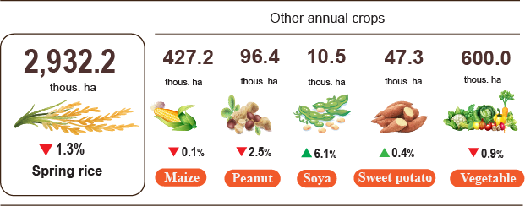
Livestock
Cattle and buffalo farming recorded a downward trend across various localities, constrained by low economic efficiency, contracting natural grazing acreages, depleted green fodder sources, and elevated animal feed prices. Certain provinces registered sharp contractions in buffalo number, led by Phu Tho with a year-on-year decline of 8.6%, followed by Cao Bang (-7.8%), Son La (-3.6%), Tuyen Quang (-3.0%), and Lao Cai (-2.1%). Cattle number similarly recorded drops in specific areas, with Phu Tho posting a year-on-year decrease of 4.9%, while Son La and Quang Tri both fell by 2.4%.
Conversely, pig farming maintained positive growth momentum as major diseases remained effectively controlled and live-weight farm-gate prices stayed highly favorable this month, encouraging commercial producers to scale up operations and accelerate herd repopulation. Localities dominated by large-scale corporate holdings and centralized enterprises utilizing proactive breed management and rigorous biosecurity protocols posted substantial gains in pig number; notably, Gia Lai and An Giang both registered a year-on-year growth rate of 7.5%, followed by Lam Dong (+6.9%), Thai Nguyen (+6.0%), Lang Son (+4.0%), Phu Tho (+3.7%), and Thanh Hoa (+3.6%).
Poultry farming likewise expanded, supported by short production cycles, rapid capital turnover, and relatively lower initial capital requirements compared to large livestock farming, rendering it highly viable for household enterprises. Large-scale, bio-secure chicken farming networks integrated with institutional buyers, schools, restaurant chains, supermarkets, and food-processing firms were consistently maintained, driving gains in overall production efficiency. Steady market demand alongside rigorous provincial vaccination initiatives supported poultry population growth across provinces, with Nghe An leading at a year-on-year expansion of 7.1%, followed by Thanh Hoa (+5.6%), Phu Tho (+3.8%), Bac Ninh (+3.7%), Dong Nai (+3.4%), Tay Ninh (+3.2%), Ninh Binh (+2.1%), and Hanoi (+1.6%). Nonetheless, a structural increase in egg-laying hen inventories led to a softening of domestic egg prices in May, which experienced a year-on-year drop of 0.6%. To safeguard farming margins when supply signaled potential market saturation, local authorities strengthened value-chain linkages, advanced processing capabilities, and stimulated domestic consumption and export channels.
Figure 2. Year-on-year growth rate of livestock and poultry number
at the end of May 2026
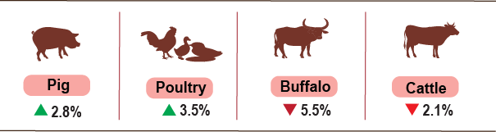
As of May 27th, 2026, no active classical swine fever outbreaks were recorded nationwide. However, localized disease occurrences persisted in several provinces, including avian influenza in Ninh Binh, Dien Bien, Thanh Hoa, Khanh Hoa, and An Giang; lumpy skin disease in Cao Bang and Quang Ngai; foot-and-mouth disease in Tuyen Quang; and African swine fever reported across 16 localities currently undergoing the mandatory 21-day quarantine protocol.
b) Forestry
Area of new concentrated planted forest nationwide in May was estimated at 32.9 thousand hectares, representing a year-on-year decline of 7.7%. This contraction occurred as localities prioritized the urgent restoration and replanting of forest areas severely damaged by the Typhoon Yagi in 2025, consequently limiting the allocation for entirely new plantings in 2026. Conversely, the number of scattered trees planted reached 8.2 million, recording a rise of 6.1%, while production of exploited wood reached 2,669.3 thousand cubic meters, posting an increase of 5.8% driven by escalating timber market values and intensified harvesting of mature commercial forests. Cumulatively for the first five months of 2026, the total area of new concentrated planted forest reached an estimated 112.1 thousand hectares, registering a year-on-year decrease of 3.1%; the volume of scattered trees planted reached 36.8 million, up 1.5%; and production of exploited wood reached 8,689.4 thousand cubic meters, recording a growth rate of 2.9%.
Total area of ​​forest damaged in May 2026 was estimated at 913.2 hectares, representing a year-on-year growth of 11.2%, of which, the area of chopped down forest reached 78.5 hectares, up 17.1%. Wildfire-impacted acreage reached 30.1 hectares, recording a reduction of 45.6%. Collectively, over the first five months of 2026, the cumulative damaged forest area stood at 296.2 hectares, posting a year-on-year decline of 50.9%; within this structure, cleared or damaged forest areas accounted for 252.3 hectares (down 45.9%), while fire-damaged areas constituted 43.9 hectares (down 68.1%).
c) Fishing
Total capture fisheries and aquaculture production in May 2026 reached an estimated 913.2 thousand tons, registering a year-on-year expansion of 4.3%. By commodity: fish production reached 636.4 thousand tons, up 3.1%; shrimp output stood at 140.0 thousand tons, rising by 6.5%; and other aquatic products constituted 136.8 thousand tons, recording a growth of 7.8%.
Aquaculture production within the month reached an estimated 543.9 thousand tons, posting a year-on-year increase of 6.6%. Out of this volume, fish production reached 350.6 thousand tons, expanding by 5.6%, while shrimp production made up 126.6 thousand tons, recording an increase of 6.9%.
Pangasius production in May registered a year-on-year expansion, driven by stable farm-gate prices and successful export market expansions across China, the European Union, ASEAN, and the Middle East, which collectively incentivized farmers to increase stocking densities. Total pangasius volume for the month reached an estimated 153.6 thousand tons, representing a year-on-year rise of 5.9%.
Similarly, commercial shrimp production in May recorded a year-on-year increase, supported by stable raw material prices and steady consumer demand, allowing the domestic supply of raw shrimp to fully satisfy processing and export requirements. White-leg shrimp production for May reached an estimated 88.0 thousand tons, posting a year-on-year expansion of 8.4%, while tiger shrimp production stood at 28.1 thousand tons, registering a rise of 5.2%.
Total capture fisheries production in May reached 369.3 thousand tons, representing a year-on-year growth of 1.0%. Within this sector, fish output reached 285.8 thousand tons, up 0.1%; shrimp caught stood at 13.4 thousand tons, expanding by 2.3%; and other aquatic products made up 70.1 thousand tons, accelerating by 4.6%. This favorable development was underpinned by excellent weather conditions, the peak phase of the southern marine capture season, and highly abundant marine stocks, all of which encouraged fishermen to intensify operations, upgrade vessel capacities, and optimize fishing gear to maximize offshore efficiency. Consequently, marine capture fisheries alone contributed 354.2 thousand tons, registering a year-on-year increase of 1.1%; out of this volume, fish accounted for 274.4 thousand tons (up 0.2%), shrimp reached 12.5 thousand tons (up 2.5%), and other aquatic products constituted 67.3 thousand tons (recording an increase of 4.8%).
Figure 3. Capture fisheries and aquaculture production
In 5 months of 2026 (Y-o-Y)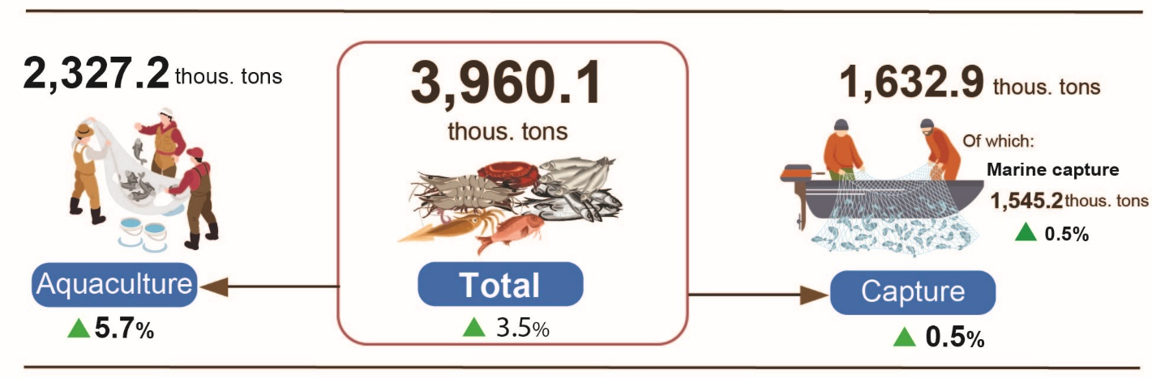
Generally, for the first five months of 2026, total fisheries production reached an estimated 3,960.1 thousand tons, demonstrating a year-on-year growth rate of 3.5%. Within the cumulative structure, fish production reached 2,852.4 thousand tons, up 2.7%; shrimp output stood at 509.7 thousand tons, rising by 6.8%; and other aquatic items reached 598.0 thousand tons, recording an increase of 4.4%.
2. Industrial production
Industrial production in May 2026 sustained its positive growth momentum. The Index of Industrial Production (IIP) for the month recorded an estimated expansion of 3.3% month-on-month and 8.8% year-on-year. Cumulatively, for the first five months of 2026, the IIP advanced by 9.1% over the corresponding period last year, marking the highest growth rate achieved during the first five months of the year across the past four years.
In May 2026, the overall IIP was estimated to grow by 3.3% month-on-month (MoM) and 8.8% year-on-year (YoY). Specifically, the manufacturing recorded a year-on-year increase of 9.0%; the water supply, sewerage, waste management and remediation activities grew by 8.7%; the electricity supply increased by 8.5% and the mining and quarrying rose by 6.0%.
Generally, in the first 5 months of 2026, the IIP was estimated to grow by 9.1% over the same period last year (the corresponding figure in 2025 was 8.8%). Specifically, the manufacturing grew by 9.5% (the corresponding figure in 2025 was 10.9%), contributing 7.4 percentage points to the overall growth; the mining and quarrying grew by 5.5% (4.1% decline in the same period of 2025), contributing 0.9 percentage points; the electricity supply rose by 7.6% (versus 4.2% in 2025), contributing 0.7 percentage points; the water supply, sewerage, waste management and remediation activities increased by 9.5% (versus 10.8% in 2025), contributing 0.1 percentage points.
In the first 5 months of 2026, the IIP of several key 2-digit activities experienced a year-on-year increase as follows: manufacture of basic metals (+20.2%); manufacture of motor vehicles (+18.0%); manufacture of chemicals and chemical products (+16.9%); manufacture of other non-metallic mineral products (+16.2%); manufacture of beverages (+15.1%); manufacture of furniture (+11.6%); manufacture of food products (+11.2%); manufacture of rubber and plastic products (+10.9); manufacture of paper and paper products (+10.7); manufacture of fabricated metal products (except machinery and equipment) (+9.6); manufacture of textiles (+9.3); manufacture of computer, electronic and optical products (+7.5%). Conversely, the IIP for some activities decreased as follows: mining of coal and lignite reduced by 4.5%; manufacture of other transport equipment reduced by 1.0%.
Table 1. Year-on-year IIP growth rate for several key industrial activities
in the first 5 months of the years 2022 - 2026
%
 | 2022 | 2023 | 2024 | 2025 | 2026
Mining of coal and lignite | 11.9 | -3.0 | -0.2 | 3.4 | -4.6
Manufacture of food products | 6.4 | 3.5 | 5.7 | 10.3 | 11.2
Manufacture of beverages | 9.8 | 5.4 | 0.2 | 0.6 | 15.1
Manufacture of textiles | 4.6 | -3.8 | 12.9 | 9.0 | 9.3
Manufacture of paper and paper products | 7.1 | -8.1 | 9.3 | 8.8 | 10.7
Manufacture of chemicals and chemical products | 3.5 | 3.5 | 20.4 | 6.4 | 16.9
Manufacture of rubber and plastic products | -12.3 | 6.8 | 27.9 | 16.4 | 10.9
Manufacture of other non-metallic mineral products | 6.3 | -5.0 | -3.2 | 11.6 | 16.2
Manufacture of basic metals | 3.1 | -6.1 | 12.7 | 9.6 | 20.2
Manufacture of fabricated metal products (except machinery and equipment) | 10.7 | 2.6 | 12.0 | 11.1 | 9.6
Manufacture of computer, electronic and optical products | 11.0 | -5.3 | 6.4 | 9.8 | 7.5
Manufacture of motor vehicles | 1.8 | -9.5 | 4.4 | 30.9 | 18.0
Manufacture of other transport equipment | 2.6 | -5.6 | -5.4 | 15.9 | -1.0
Manufacture of furniture | 4.7 | -3.7 | 19.9 | 10.8 | 11.6
The IIP in the first 5 months of 2026 experienced a year-on-year increase in all 34 provinces and municipalities. Several provinces saw a fairly high growth rate in the IIP thanks to the surge in the manufacturing and the electricity supply. Conversely, the IIP in several provinces and municipalities nudged up due to slow growth or decrease in the manufacturing, the mining and quarrying, and the electricity supply.
Figure 4. Year-on-year IIP growth rate for some localities
(in the first 4 months, 2026) (%)

Top of 10 localities by IIP growth rate  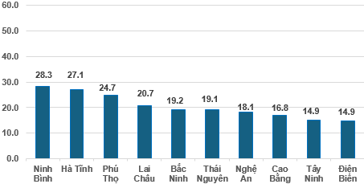 | Bottom of 10 localities by IIP growth rate  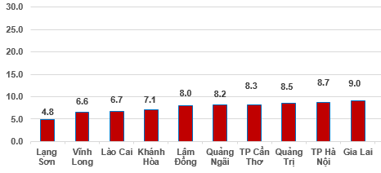
During the first four months of 2026, several key industrial products registered notable year-on-year increases, led by motorbike (+36.0%), automobiles (+26.7%), processed seafood (+21.6%), and rolled steel (+21.5%). Production of refined sugar and beer both climbed by 14.4%, while chemical paint expanded by 14.3%. On the other hand, several commodities posted output reductions, including NPK fertilizers (-6.8%), sodium glutamate (-6.0%), leather shoes and sandals (-5.7%), and coal (-1.1%).
Number of employees in industrial enterprises as of May 1st, 2026, expanded by 1.1% month-on-month and 3.4% year-on-year. By ownership structure, employees within state-owned enterprises edged up by 0.1% month-on-month and rose by 1.7% year-on-year; non-state enterprises recorded increases of 0.6% and 2.6%, respectively, while foreign-invested enterprises expanded by 1.5% month-on-month and 3.4% year-on-year. By kind of economic activity, the number of employees in the mining rose by 0.1% month-on-month but experienced a minor year-on-year contraction of 0.1%. The number of employees in the manufacturing advanced by 1.2% MoM and 3.5% YoY. The electricity, gas, steam, and air conditioning supply workforce expanded by 0.1% month-on-month and 3.0% YoY, while water supply, sewerage, waste management, and remediation activities recorded a month-on month increase of 0.2% and a year-on-year expansion of 2.8%.
3. Enterprise registration situation
In May 2026, the country recorded the establishment of over 17.0 thousand newly established enterprises with total registered capital exceeding280.9 trillion VND and registered employees of nearly 75.9 thousand employees. These figures represent a month-on-month decline of 16.5% in the number of enterprises, an increase of 13.8% in registered capital, and a decrease of 16.6% in registered employees. Compared to the corresponding period last year, the number of newly established enterprises and total registered capital expanded by 12.5% and 79.3%, respectively, whereas the registered employees contracted by 22.7%. The average registered capital per newly established enterprise in May reached 16.5 billion VND, marking a month-on-month increase of 36.4% and a year-on-year expansion of 59.3%. Additionally, nearly 9.1 thousand enterprises officially resumed operations during the month, representing a month-on-month increase of 3.9% and a year-on-year growth of 13.6%.
In May, there were 6,746 enterprises registered to temporarily suspend for a definite time, up 23.9% month-on-month and 13.9% year-on-year. Concurrently, 8,082 enterprises suspended operation waiting for dissolution procedures, recording increases of 50.0% MoM and 23.7% YoY. A further 3,831 enterprises completed procedures for dissolution, rising by 10.3% compared to the previous month and scaling up by 100.7% over the same period last year.
Overall, for the first five months of 2026, the nation recorded over 94.8 thousand newly registered enterprises with the total registered capital of nearly 1,066.3 trillion VND and total registered employee of 432.8 thousand employees. This represents a year-on-year surge of 42.1% in the number of enterprises, 64.8% in total capital, and 4.7% in the number of employees. The average registered capital per the newly established enterprise over this five-month stood at11.2 billion VND, up 16.0% year-on-year. Furthermore, nearly 47.8 thousand enterprises resumed operations (a 6.1% year-on-year increase), raising the cumulative total of newly established and resumed operation enterprises in the first five months of 2026 to over 142.6 thousand enterprises, a year-on-year expansion of 27.6%. On average, there were 28.5 thousand newly established and resumed operation enterprises per month.
By economic sector, in the five months of 2026, the number of newly registered enterprises in the agriculture, forestry and fishing sector; the industry and construction sector; and the services sector reached 978 enterprises (+56.0% Y-o-Y); 23.3 thousand enterprises (+52.7% Y-o-Y); and nearly 70.6 thousand enterprises (+38,7% Y-o-Y), respectively.
Figure 5. Enterprises registration situation in the five months of 2026
compared to the same period in 2025.

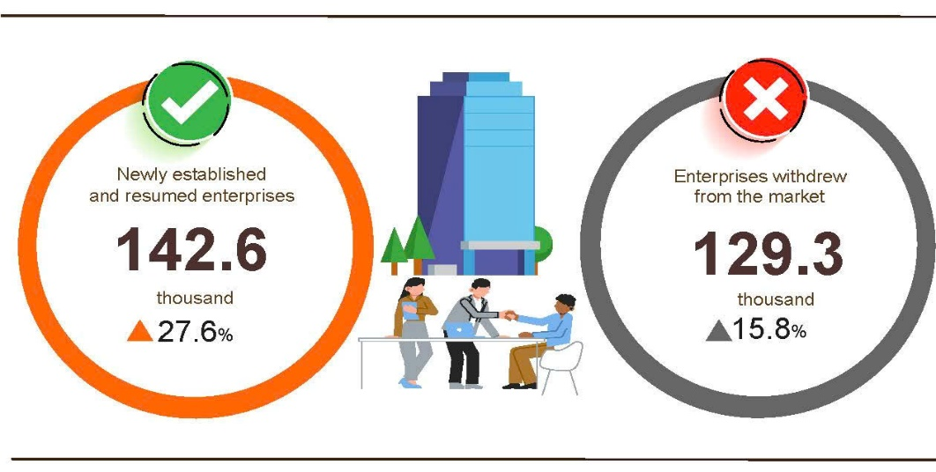
Overall, in the five months of 2026, the number of enterprises temporarily suspended for a definite time was 78.8 thousand enterprises, a year-on-year increase of 5.7%; 31.4 thousand enterprises suspended operation waiting for dissolution procedures, a year-on-year increase of 14.2%; and 19.0 thousand enterprises completed procedures for dissolution, a year-on-year increase of 99.1%. On average, 25.9 thousand enterprises withdrew from the market per month.
Table 2. Newly established and completely dissolved enterprises
in the five months of 2026 by kind of economic activity

 | Number of enterprises (Enterprises) |  | Year-on-year growth rate (%)
 | Newly established | Completely dissolved | Newly established | Completely dissolved
Wholesale and retail, repair of motor vehicle and motorcycle | 39,730 | 7,189 | 59.3 | 104.7
Manufacturing | 12,814 | 2,042 | 50.1 | 101.2
Construction | 9,107 | 1,352 | 53.2 | 98.5
Real estate business | 2,638 | 1,149 | 27.8 | 119.3
Transportation and storage | 6,088 | 708 | 69.8 | 93.4
Accommodation and food services | 4,287 | 912 | 95.0 | 80.6
Electricity, water and gas supply | 918 | 176 | 78.3 | 43.1
4. Investment
State budget investment in May was actively promoted by ministries, agencies, and localities, creating momentum for economic growth throughout 2026. Cumulatively, during the first five months of 2026, investment from the State budget reached an estimated 24.0% of the annual plan, representing an 11.2% expansion compared to the corresponding period last year. Disbursed foreign direct investment (FDI) in Viet Nam over the same five-month period stood at an estimated 9.75 billion USD, marking a 9.6% increase year-on-year.
In May alone, disbursed investment from the State budget reached nearly 65 trillion VND, growing by 10.2% year-on-year. This total comprised centrally-managed investment at nearly 10.2 trillion VND (up 17.4%) and locally-managed investment at 54.8 trillion VND (up 8.9%). Cumulatively, for the first five months of 2026, overall disbursed State budget investment reached an estimated 254.1 trillion VND, equivalent to 24.0% of the annual plan and representing an 11.2% year-on-year expansion (compared to 22.5% of the plan and a 21.1% growth rate recorded in the same period of 2025). The detailed performance was as below:
- Centrally-managed investment was estimated to reach 35.9 trillion VND, equivalent to 13.6% of the annual plan and an expansion of 8.9% year-on-year. Of which, investment managed by specific ministries witnessed divergent trends, such as Ministry of Construction: 16.5 trillion VND (down 18.7%); Ministry of Agriculture and Environment: 1.9 trillion VND (shrank by 59.9%); Ministry of Health: 401.6 billion VND (contracted by 52.5%); Ministry of Culture, Sports and Tourism: 244.1 billion VND (rose by 9.1%); Ministry of Education and Training: 211.4 billion VND (dropped by 54.6%); Ministry of Industry and Trade: 28.2 billion VND (decreased by 63.6%); Ministry of Science and Technology: 13.3 billion VND (slumped by 86.2%).
- Locally-managed investment was estimated at 218.2 trillion VND, equal to 27.5% of the annual plan and a growth of 11.6% year-on-year, including:
State budget investment at the provincial level reached 170.4 trillion VND, equivalent to 26.9% and a 9.0% upturn compared to 2025;
State budget investment at the commune level reached 47.8 trillion VND, equivalent to 29.6% and a 22.0% surge year-on-year.
The disbursed State budget investment in the first five months of 2026 in some provinces and centrally-run cities was as follows:
Figure 6. Disbursed investment from the State budget
in the first five months of 2026 in selected localities

Total inward foreign investment in Viet Nam as of May 31st, 2026, including newly registered capital, adjusting registered capital, and the value of capital contribution and purchasing shares by foreign investors reached 24.81 billion USD, a year-on-year increase of 34.9%.
Figure 7. Inward foreign investment in Viet Nam
in the first five months of 2022-2026 (Billion USD)

- In terms of newly registered capital: 1,576 projects were licensed with a registered capital of 14.84 billion USD, a 1.7% increase year-on-year in the number of projects and an upturn of 2.1 times in registered capital. Of which, the largest newly licensed FDI was the manufacturing and processing industry with 9.64 billion USD, accounting for 65.0% of the total newly registered capital; the electricity, gas, water, and air conditioning production and distribution reached 2.45 billion USD, making up 16.5%; and other activities was 2.75 billion USD, constituting 18.5%.
Among the 58 countries and territories with newly licensed investment projects in Viet Nam during the first five months of 2026, Singapore was the largest investor with 6.8 billion USD, comprising 45.9% of the total newly registered capital; followed by South Korea with 4.22 billion USD, equivalent to 28.4%; China with 1.79 billion USD, representing 12.1%; Japan with 712.6 million USD, accounting for 4.8%; Hong Kong Special Administrative Region (China) with 397.3 million USD, making up 2.7%; and the Netherlands with 380.3 million USD, constituting 2.6%.
- The adjusted registered capital: 415 turns of projects licensed from the previous years registered to adjust investment capital upwards by an additional 5.78 billion USD, a year-on-year decrease of 32.1%.
If including newly registered capital and adjusted registered capital of licensed projects in the previous years, the registered FDI in the processing and manufacturing industry reached 14.52 billion USD, equivalent to 70.4% of the total newly registered and increased capital; the electricity, gas, water, and air conditioning production and distribution reached 2.45 billion USD, comprising 11.9%; and other activities reached 3.65 billion USD, making up 17.7%.
- There were 1,164 turns of registered capital contributions and purchasing shares by foreign investors with a total value of 4.19 billion USD, a 46.7% surge year-on-year. Of which, 336 turns of capital contributions and purchasing shares increased the charter capital of enterprises with a value of 565.3 million USD, and 828 turns of foreign investors rebought domestic shares without increasing the charter capital with a value of 3.62 billion USD. The capital contributions and purchasing shares by foreign investors in the wholesale and retail trade and repair of motor vehicles and motorcycles reached 1.9 billion USD, accounting for 45.4% of the total capital contribution; the professional, scientific, and technical activities reached 1.16 billion USD, constituting 27.7%; and the other economic activities stood at 1.13 billion USD, representing 26.9%.
Total disbursed FDI in Viet Nam during the first five months of 2026 reached an estimated 9.75 billion USD, a year-on-year growth rate of 9.6%, setting the highest figure in the disbursed FDI in the first five-month window over the past five years. Sectoral deployment of this disbursed capital was led by the manufacturing at 8.06 billion USD (comprising 82.7% of the total disbursed FDI); followed by real estate activities at 716.5 million USD (representing 7.3%); and electricity, gas, hot water, steam, and air conditioning production and distribution reached at 356.6 million USD (accounting for 3.7%).
Figure 8. Disbursed foreign direct investment
in the first five months of 2022-2026 period (Billion USD)

Viet Nam’s outward investment activities during the first five months of 2026 included 85 projects granted new offshore investment certificates with a combined capital value of 760.8 million USD, a 2.8-fold increase over the corresponding period last year. Concurrently, 10 turns of projects adjusted their investment capital upwards by an additional 33.8 million USD, representing an 18.7% contraction.
In aggregate, total Viet Nam’s outward FDI from Viet Nam (encompassing both newly granted and adjusted capital) reached 794.6 million USD, expanding 2.5 times compared to the same period last year. By sector, the construction reached 178.8 million USD (constituting 22.5%); the electricity, gas, hot water, steam, and air conditioning production and distribution reached 163.8 million USD (comprising 20.6%); and transportation and storage reached 150.5 million USD (representing 18.9%).
In the first five months of 2026, 33 countries and territories received investment from Viet Nam, of which: Laos emerged as the leading recipient with 199.5 million USD (comprising 25.1% of total outward capital); followed by Kyrgyzstan with 149.9 million USD (representing 18.9%); the United Kingdom with 82.8 million USD (constituting 10.4%); Kazakhstan with 36.0 million USD (accounting for 4.5%); Cambodia with 32.9 million USD (making up 4.1%); the United States with 31.9 million USD (comprising 4.0%); and the British Virgin Islands with 30.1 million USD (representing 3.8%).
5. State budget revenue and expenditure
State budget revenue in the first five months of 2026 recorded an estimated expansion of 15.3% over the corresponding period last year. Concurrently, Sate budget expenditure grew by an estimated 3.1% year-on-year, successfully funding socio-economic development priorities, national defense, security, administrative operations, public debt service obligations, and timely social security disbursements to eligible beneficiaries in compliance with statutory regulations.
Figure 9. State budget revenue and expenditure in the first 5 months 2026
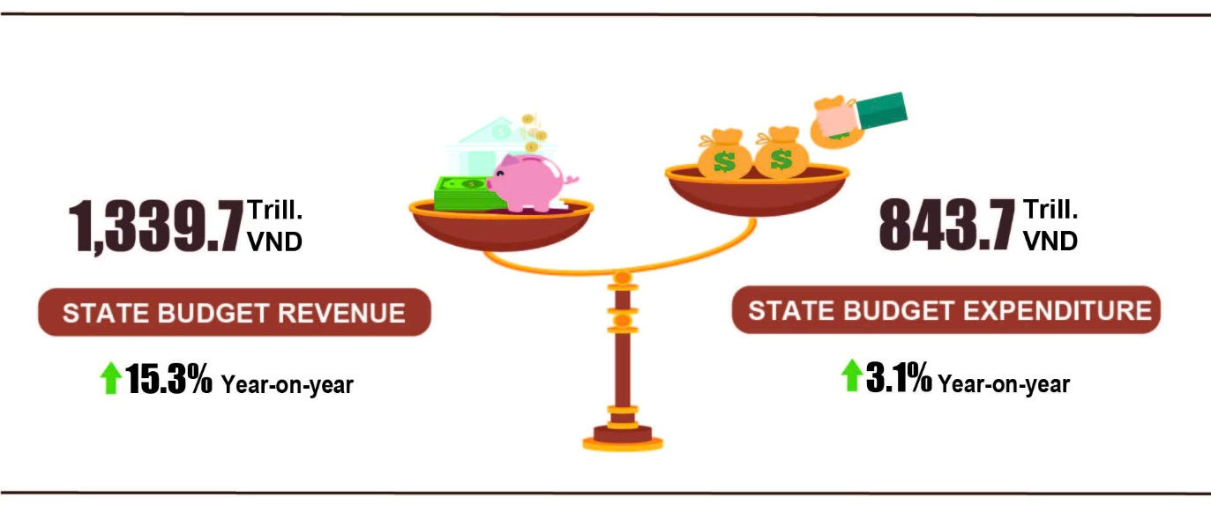
State budget revenue
Total state budget revenue in May 2026 was estimated at nearly 215.0 trillion VND. The accrued revenue in the first 5 months of 2026 reached 1,339.7 trillion VND, reaching 53.0% of the annual estimate (+15.3% YoY). In particular, selected revenue items were as follows:
- Domestic revenue in May 2026 was estimated at 173.8 trillion VND. The accrued revenue in the first five months of 2026 was 1,165.9 trillion VND, reaching 53.0% of the annual estimate (+15.6% YoY).
- Oil revenue in May 2026 was estimated at 5.6 trillion VND; the accrued revenue in the first five months of 2026 reached 23.4 trillion VND, reaching 54.5% of the annual estimate (+9.1% YoY).
- Revenue from budget balance of import-export activities in May 2026 was estimated at nearly 35.4 trillion VND; accrued revenue in the first five months of 2026 was estimated at 149.6 trillion VND, reaching 53.8% of the annual estimate (+14% YoY). This growth was driven by the sustained positive momentum in import-export activities during the first five months of 2026, alongside an increase in major imported commodities compared to the same period last year, which ultimately boosted state budget revenue.
State budget expenditure
Total state budget expenditure in May 2026 was estimated at 184.8 trillion VND. The accrued revenue in the first five months of 2026 was 843.7 trillion VND, reaching 26.7% of the annual estimate (+3.1% YoY). Specifically, recurrent expenditure in the first five months of 2026 was estimated at 586.0 trillion VND, equal to 32.4% of the annual estimate (+0.1% YoY); development investment expenditure gained 206.2 trillion VND, reaching 18.4% of the annual estimate (+11.8% YoY); interest payment was 50.4 trillion VND, reaching 41.6% of the annual estimate (+7.8% YoY).
6. Trade, prices, transport and tourism
a) Retail sales of goods and services
Commercial and service activities in May 2026 maintained a positive growth trajectory, with the retail sales of goods and services expanding by an estimated 11.8% year-on-year. For the first five months of 2026 cumulatively, overall retail sales of goods and services increased by 11.2% over the corresponding period last year. Within this structure, revenues from accommodation and food service activities climbed by 13.3%, while traveling services grew by 12.2%, reflecting a robust recovery in consumer demand and tourism activities.
The retail sales of goods and services at current prices in May 2026 were estimated at 647.1 trillion VND, a month-on-month increase of 0.5% and a year-on-year increase of 11.8%. Of which, several commodity groups continued to maintain an upward trend: timber and construction materials increased by 1.1% month-on-month and by 12.3% year-on-year, driven by favorable weather conditions, accelerated construction progress, and higher material prices during the peak season; garments rose slightly by 0.1% month-on-month and by 7.3% year-on-year, supported by increased demand for summer clothing; cultural and educational items grew by 0.9% month-on-month and by 5.9% year-on-year, reflecting a stronger demand for stationery, reference books for the exam season, as well as gifts and rewards for the end of the academic year. Some essential commodity groups showed signs of slowing compared to previous months: petroleum products declined by 1.4% month-on-month but increased by 17.1% year-on-year, as prices, although lower than in the previous month, remained higher than in the same period last year; food and foodstuff decreased by 0.9% month-on-month and rose by 7.7% year-on-year, reflecting market stabilization after holiday periods and increased supply from harvest seasons, which eased price pressures; household appliances and equipment edged down by 0.1% month-on-month and increased by 7.0% year-on-year, due to weakening demand following promotional campaigns during holidays and Tet, as well as the end of the early-season surge in purchases of cooling appliances. Accommodation and food service activities increased by 4.2% month-on-month and by 15.4% year-on-year; travelling services rose by 5.4% and by 15.4%, respectively; other services grew by 1.9% and by 10.8%.
Table 3. Retail sales of consumer goods and services at current prices
in the five months of 2026
Trillion VND
 | Estimate  for May  2026 | Estimate  5 months of  2026 | Year-on-Year  Growth rate (%)
 | Estimate  for May  2026 | Estimate  5 months of  2026 | May  2026 | 5 months of 2026
Total | 647.1 | 3,185.0 | 11.8 | 11.2
Retail sales of goods | 486.5 | 2,418.1 | 11.3 | 11.1
Accommodation and food services | 84.7 | 400.4 | 15.4 | 13.3
Travelling services | 8.9 | 40.6 | 15.4 | 12.2
Other services | 67.0 | 325.9 | 10.8 | 9.1
Generally, for the first five months of 2026, the retail sales of goods and services at current prices reached an estimated 3,185.0 trillion ND, marking an 11.2% expansion compared to the same period last year. Excluding the price factor, the growth rate stood at 6.1%, compared to a 7.2% increase documented during the corresponding five-month window in 2025.

Figure 10. Retail sales of goods and services at current prices
in the first five months of 2022-2026
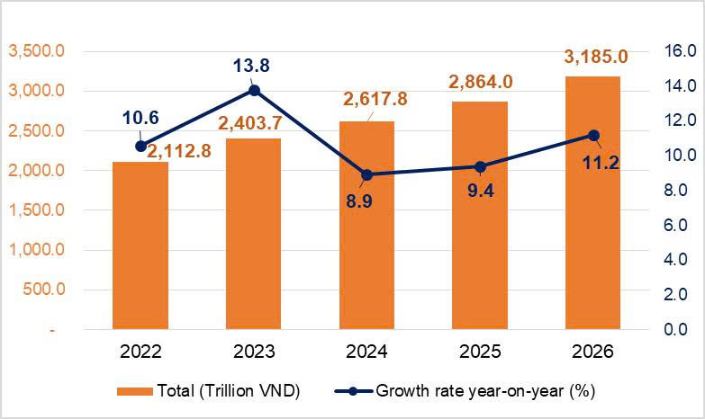
The retail sales of goods in five months of 2026 were estimated at 2,418.1 trillion VND, accounting for 75.9% of the total and increasing by 11.1% year-on-year. Of which, turnover from Petrolimex rose by 12.7% year-on-year; garments rose by 10.2%; food and foodstuffs increased by 9.6%; household appliances, tools and equipment increased by 7.5%; cultural and educational items increased by 5.6% and other services increased by 17.6%. Retail sales of goods in five months of 2026 of some localities saw a year-on-year increase including Quang Ninh (+12.9%); Da Nang (+12.7%); Dong Nai (+11.4%); Can Tho (+11.2%); Ha Noi (+11.1%); Ho Chi Minh City (+10.9%).
The turnover from accommodation and food service activities in the five months of 2026 were estimated at 400.4 trillion VND, accounting for 12.6% of the total turnover and increasing by 13.3% over the same period last year. In comparison to the same period last year, the turnover in five months of 2026 in some localities experienced an increase as follows: An Giang (+24.4%); Ninh Binh (+19.2%); Da Nang (+18.9%); Hue (+18.6%); Quang Ninh (+18.5%); Hai Phong (+14.6%); Can Tho (+13.1%); Ho Chi Minh City (+10.3%); Ha Noi (+9,2%).
The turnover of travelling in the five months of 2026 was estimated at 40.6 trillion VND, accounting for 1.3% of the total and a year-on-year growth of 12.2% supported by a combination of optimized visa policies, effective promotion and stimulus campaigns, and improving tourism service quality, which attracted both domestic and international visitors. Some localities recorded a high year-on-year increase in turnover in five months of 2026, including Khanh Hoa (+33.8%); Quang Ninh (+25.4%); Quang Ngai (+23.3%); Hue (+18.7%); Hai Phong (+15.6%); Ha Noi (+12.5%); Ho Chi Minh City (+8.2%).
The turnover of other services in the five months of 2026 was estimated at 325.9 trillion VND, accounting for 10.2% of the gross and increasing by 9.1% year-on-year. Specifically, the turnover increase in five months of 2026 in some localities was as follows: Hue (+28.2%); Quang Ninh (+25.2%); Bac Ninh (+19.3%); Ninh Binh (+17.3%); Ha Noi (+9.1%); Ho Cho Minh City (+5.7%).
b) Export and import of goods
In May, the total export and import turnover of goods reached 99.07 billion USD, a month-on-month increase of 3.2% and a year-on-year increase of 25.8%. Generally, in the five months of 2026, the total export and import turnover of goods reached 445.12 billion USD, going up 25.0% over that in the same period last year, of which exports increased by 19.5%; and imports increased by 30.8%.The trade balance of goods recorded a trade deficit of 13.80 billion USD.
Figure 11. Export and import of goods in the five months of 2026
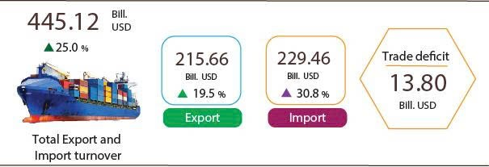
Export of goods
The export turnover of goods in April 2026 preliminarily reached 45.99 billion USD.
In May 2026, the export turnover of goods amounted to 46.93 billion USD, increasing by 2.1% over the previous month. Of which, the domestic economic sector reached 9.05 billion USD, going down 4.1%; while the FDI sector (including crude oil) reached 37.88 billion USD, going up 3.6%. Compared to the same period last year, the export turnover of goods in May increased by 18.0%, of which the domestic economic sector increased by 3.5%, the FDI sector (including crude oil) rose by 22.0%.
Overall, in the five months of 2026, the export turnover reached 215.66 billion USD, increasing by 19.5% over the same period last year. Of which, the domestic economic sector reached 43.5 billion USD, rose by 2.5%, accounting for 20.2% of the total export turnover; the FDI sector (including crude oil) attained 172.16 billion USD, went up by 24.7%, accounting for 79.8%.
In the five months of 2026, there were 26 export items with a value exceeding 1 billion USD, accounting for 90.7% of the total export turnover (including 7 items recorded export values of over 5 billion USD, accounting for 69.3%).

Table 4. Value of selected export products in the five months of 2026
 | Value  (Mill. USD) | Growth rate Y-o-Y (%)
Products with a value of over 5 billion USD
Electronic goods, computers and their parts | 56,187 | 46.2
Machinery, instrument, accessory | 26,971 | 22.1
Phones all of kinds and their parts | 26,370 | 17.7
Textiles and sewing products | 15,130 | 0.4
Footwear | 9,780 | 0.2
Means of transport and spare parts | 7,987 | 17.1
Wood and wood products | 7,020 | 2.9
Regarding the structure of exported goods in the five months of 2026, the group of manufactured products reached 193.71 billion USD, accounting for 89.8%; the group of agricultural and forestry products reached 15.79 billion USD, accounting for 7.3%; the group of fishery products attained 4.67 billion USD, accounting for 2.2%; and the group of fuels and minerals reached 1.49 billion USD, accounting for 0.7%.
Figure 12. Structure of exported goods
in the five months of 2026
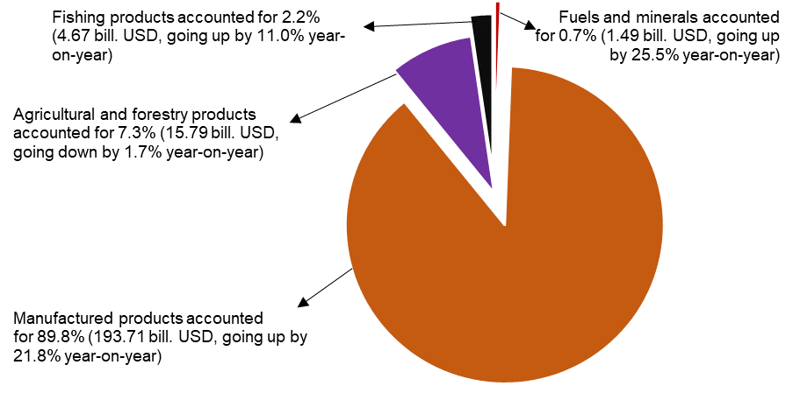
Import of goods
Import turnover of goods in April 2026 preliminarily reached 49.98 billion USD.
Import turnover of goods in May 2026 reach 52.14 billion USD, a rise of 4.3% over the previous month. Of which, the domestic economic sector reached 13.17 billion USD, decreasing by 10.8%; and the FDI sector reached 38.97 billion USD, increasing by 10.7%. Compared with the same period last year, the import turnover of goods in May increased by 33.8%, of which the domestic economic sector increased by 22.2%; and the FDI sector increased by 38.2%.
Overall, in the five months of 2026, the import turnover of goods reached 229.46 billion USD, a year-on-year surge of 30.8%, of which, the domestic economic sector reached 64.26 billion USD, an upturn of 22.7%; and the FDI sector reached 165.2 billion USD, an expansion of 34.3%.
In the five months of 2026, there were 36 imported products with their value exceeding 1 billion USD, accounting for 91.2% of the total import turnover (including 6 imported products with the value of over 5 billion USD, accounting for 60.7%).
Table 5. Value of some imported goods in five months of 2026
 | Value  (Mill. USD) |  | Growth rate year-on-year (%)
Products with a value of over 5 billion USD
Electronic goods, computers and their parts | 88,219 |  | 57.1
Machine, equipment, tools and instruments | 27,806 |  | 21.6
Fabrics | 6289 |  | -0.5
Other base metals | 5973 |  | 32.0
Plastics | 5643 |  | 9.0
Motor vehicles | 5443 |  | 36.0

Regarding the structure of imported goods in the five months of 2026, the group of capital goods reached 215.99 billion USD, accounting for 94.1%, of which the group of machine, equipment, tools and instruments accounted for 55.7%; the group of fuels, raw materials accounted for 38.4%. The group of consumer goods reached 13.47 billion USD, accounting for 5.9%.
Figure 13. Structure of imported goods
in five months of 2026
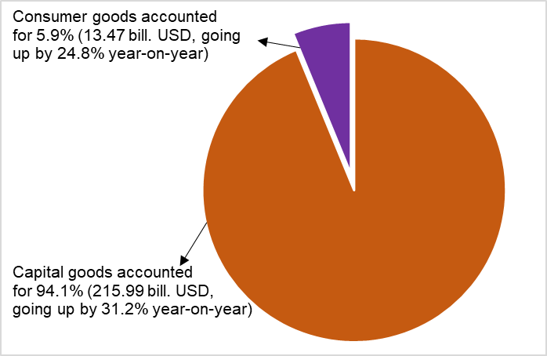

Figure 14. Major commodity export and import markets
in the five months of 2026
 |  | Export of goods | Import of goods
Regarding export and import markets of goods in the five months of 2026, the United States was Viet Nam’s largest export market with a turnover of 69.6 billion USD. China remained Viet Nam’s largest import market with a turnover of 92.6 billion USD. In the five months of 2026, the trade surplus to the United States and EU reached 60.4 billion USD and 18.1 billion USD, respectively, with the corresponding year-on-year surge of 21.1% and 11,3%; the trade surplus to Japan reached 0.8 billion USD, a downturn of 13.2%; the trade deficit to China, South Korea, ASEAN was 62.5 billion USD, 21.1 billion USD, 8.6 billion USD, respectively, gaining an equivalent expansion of 36.4%, 72.5% and 33.1%.
According to preliminary data, the trade balance of goods recorded a deficit of 3.99 billion USD in April; 8.59 billion USD for four months; and 5.21 billion USD in May. Overall, in the five months of 2026, the trade balance of goods posted a deficit of 13.80 billion USD (a surplus of 5.1 billion USD in the same period last year). Of which, the domestic economic sector recorded a trade deficit of 20.76 billion USD; while the FDI sector (including crude oil) recorded a trade surplus of 6.96 billion USD.
c) Consumer price index, gold and US dollar price index
The Consumer Price Index (CPI) in May experienced a month-on-month increase of 0.29% as result of a rise in the prices of electricity and water arising from high demand during hot weather, as well as an increase in the prices of construction material, house rental and gasoline. The CPI in May expanded by 3.61% and 5.60% compared to that in December 2025 and the same period last year, respectively.
In general, the CPI in the five months of 2026 witnessed a year-on-year upturn of 4.31%; core inflation soared by 4.04%.
Figure 15. Month-on-month CPI growth rate

In the month-on-month increase of 0.29% in the CPI in May, 10 groups of goods possessed an increase in their prices, while the CPI of food and foodstuff services saw a decrease.
(1) 10 groups of goods possessed an increase in their prices, including:
- The group of housing, electricity, water, fuel, and construction materials increased by 0.96% (contributing to a rise of 0.22 percentage points in the overall CPI), focusing on an expansion in the prices of the items as follows: house rental added up 0.71%, of which the prices of house repair service; housing maintenance material; household electricity; tap water jumped up 0.69%; 0.81%; 2.38%, 1.41% respectively. In contrast, a decrease of 1.50% in the gas prices in line with the world prices contributed to a decline of 0.02 percentage points in the overall CPI.
- The transport group accelerated by 0.83% (contributing to an increase of 0.08 percentage point in the overall CPI), mainly due to CPI of gasoline; spare parts; vehicle maintenance; driving license fees; road toll; self-drive car and motorbike rental services; parking services edged up 2.12%; 0.32%; 0.59%; 0.82%; 0.68%; 0.46%; and 0.07%, respectively. In contrast, some transport goods and services witnessed a reduction in their prices: the CPI of the diesel; public transport services fell by 16.42%; 1.47%, respectively.
- The group of culture, entertainment, and tourism climbed up 0.48%, focusing on items as follows: The prices of package tour expanded by 1.19% (a rise of 1.35%; 0.27% in domestic tourism; outbound tourism, respectively) due to rising costs of tour organization, especially costs of transport, accommodation, and tourism services; photography and printing; hotels and guesthouses; pet related services; sports services soared by 1.0%; 0.66%; 0.60%; 0.23%, respectively.
- The group of beverages and tobacco rose by 0.21% due to increasing costs of import, production, and distribution. Of which, the CPI of fruit juices possessed a month-on-month increase 0.44%; the CPI of bottled energy drinks; cigarettes; alcohol and beer of all kinds accelerated by 0.09%; 0.47%; and 0.18%, respectively.
- The group of household equipment and goods expanded by 0.17% due to increasing costs of raw material, labor, and transport. Of which, some items witnessed an increase in the prices: the prices of lighting fixtures; air conditioners; electric fans; household equipment repair; gas stoves; beds, wardrobes, tables, and chairs; glassware, ceramic and porcelain products; microwave, ovens, and induction cookers; soap and detergents; refrigerators; metal ware; wall and table clocks, mirrors jumped up 0.51%; 0.50%; 0.35%; 0.31%; 0.30%; 0.27%; 0.23%; 0.22%; 0.17%; 0.18%; 0.16%; 0.14%, respectively. In contrast, prices of bathroom water heaters; blenders and juicers; whisk dropped 0.46%; 0.45%; 0.24% because promotional programs offered by some manufacturers.
- The group of other goods and services increased by 0.14%, mainly as the result of a rise of 0.39% in the CPI of personal services and an expansion of 0.19% in funeral and wedding services. In contrast, the jewelry group fell by 2.58% in line with domestic gold price.
- The group of garment, hat and footwear soared by 0.13% due to rising costs of raw material, transport and labor. Of which, the CPI for footwear services; tailoring services; fabrics of all kinds; footwear; hats grew by 0.62%; 0.33%; 0.28%; 0.30%; 0.17%, respectively; both other garments and ready-made clothes jumped up 0.06%.
- The group of medicines and health care services added up 0.10% due to an upturn of 0.32% in the CPI of medicines, resulting from growing demand for drugs in hot weather. Of which, the CPI of pain relief and fever reducing drugs; respiratory drugs; hormones and drugs affecting the endocrine system; anti-allergy drugs; vitamin and mineral drugs; cardiovascular drugs; anti-infective and antiparasitic drugs edged up 0.64%; 0.42%; 0.39%; 0.38%; 0.34%; 0.33%; 0.31%, respectively.
- The group of information and communication accelerated by 0.04%, of which the prices of audio equipment; regular mobile phones; computers and accessories; phone repair services; printers, projectors, and scanners; television and internet services rose by 0.81%; 0.41%; 0.37%; 0.26%; 0.19%; 0.03%, respectively. In contrast, the prices of smartphone and tablet accessories reduced by 0.18%.
- The education group soared by 0.03%, mainly due to an expansion of 0.40%; 0.36%; 0.17% in the prices of pens; stationery and other school supplies; paper products, respectively
(2) The group of food and foodstuff service decreased by 0.14% (contributing to a reduction of 0.05 percentage point in the overall CPI), of which: food; foodstuff dropped 0.68%; 0.25%, respectively (contributing to a fall of 0.06 percentage points); while eating out added up 0.36%.
In general, the CPI in the five months of 2026 possessed a year-on-year surge of 4.31%, of which: Housing, electricity, water, fuel and construction materials witnessed the highest increase of 6.64% (contributing to a rise of 1.51 percentage points in the overall CPI); transport shot up 5.22% (contributing to a soar of 0.52 percentage points in the overall CPI); food and foodstuff expanded by 4.77% (contributing to an upturn of 1.71 percentage points in the overall CPI); other goods and services soared by 3.96%; beverages and tobacco jumped up 3.38% (contributing to an increase of 0.06 percentage points in the overall CPI); education climbed up 3.28% (contributing to a soar of 0.20 percentage points in the overall CPI); household equipment and goods grew by 2.53% (contributing to a rise of 0.13 percentage points in the overall CPI); culture, entertainment, and tourism went up 2.22% (contributing to expansion of 0.07 percentage points in the overall CPI); garment, hats, and footwear accelerated by 1.91% (contributing to a rise of 0.07 percentage points in the overall CPI); medicines and healthcare service edged up 0.99%; while information and communication decreased by 0.06%.
Core inflation in May saw a month-on-month increase of 0.34% and a year-on-year rise of 4.67%. On average, core inflation in the five months of 2026 possessed a year-on-year expansion of 4.04%, lower than a soar of 4.31% in the overall CPI due to significant fluctuations in the prices of gasoline, gas, and food, which contributed to an increase in the overall CPI, being the factors were excluded from the list of core inflation calculations.
Domestic gold prices fluctuated in line with the world gold prices. As of May 27th, 2026, the average price of the world gold in May was 4,619.18 USD/ounce, a month-on-month decrease of 2.40%. In May, the prices of world gold declined due to profit-taking of investors after a period of spite and a more stable market sentiment, causing reducing demand for safe-haven assets. The domestic gold price index in May witnessed a month-on-month fall of 4.11% as the result of business`s downward adjustments of gold price in line with the world gold prices. The gold price index recorded a year-on-year increase of 33.87%; a soar of 6.27% compared to that on December 2025; and the average gold price index in the five months of 2026 experienced a surge of 65.97%.
Domestic US dollar prices fluctuated in line with global prices. As of May 27, 2026, the average US dollar index in May reached 98.62 points on the international market, a slight month-on-month decrease of 0.01 points due to market expectations for US Federal Reserve (FED) interest rate cut in the future. The average domestic US dollar price on the free market was around 26,375 VND/USD. The US dollar price index in May saw a month-on-month expansion of 0.02% due to the growing domestic demand for foreign currency; a year-on-year upturn of 0.78%; a fall of 0.28% compared to that in December 2025; the average US dollar price index in the five months of 2026 climbed up 1.99%.
d) Passenger and cargo transport
Transport activities in May 2026 continued to be dynamic, meeting the travel demand of domestic residents as well as international visitors to Viet Nam, and supporting production and the import and export of goods. Compared to the same period last year, passenger carried and passenger carried (passenger-kilometers) in May 2026 saw a year-on-year increase of 17.8% and 13.9%, respectively; freight transported and freight transported (ton-kilometers) recorded a year-on-year rise of 13.8% and 15.7%, respectively. Overall, in five months of 2026, passenger carried and passenger carried (passenger-kilometers) experienced a year-on-year rise of 19.0% and 12.7%, respectively; freight transported and freight transported (ton-kilometers) recorded a year-on-year increase of 13.9% and 12.5%, respectively.
Passenger carried in May 2026 was estimated at 598.6 million turns of passengers, a month-on-month increase of 1.4%, and passenger carried (passenger-kilometers) reached 28.5 billion passenger-kilometer, a month-on-month rise of 1.5%. Overall, in five months of 2026, the passenger carried was estimated at 2,781.7 million turns of passengers, a year-on-year increase of 19.0% and passenger carried (passenger-kilometers) reached 141.4 billion passenger-kilometer, a rise of 12.7%. Of which, domestic passenger carried was estimated at 2,772.9 million turns of passengers, a year-on-year increase of 19.1%, domestic passenger carried (passenger-kilometers) was 113.4 billion passenger-kilometer, a year-on-year upturn of 13.6%; oversea passenger carried was estimated at 8.8 million turns of passengers, a year-on-year expansion of 9.6%, and overseas passengers carried (passenger-kilometers) reached 28.0 billion passenger-kilometer, going up by 9.2%.
Table 6. Passenger carried in five months of 2026 by type of transport
 | Number of passengers |  |  | Year-on-year growth rate (%)
 | Carried  (Mill. Passengers) | Carried (passenger-kilometers)  (Bill. passenger-km) |  | Carried | Carried (passenger-kilometers)
Total | 2,781.7 | 141.4 |  | 19.0 | 12.7
Rail way | 20.2 | 1.4 |  | 16.2 | 2.6
Maritime transport | 4.9 | 0.4 |  | -9.8 | 16.9
Inland water way | 194.7 | 4.3 |  | 6.3 | 23.2
Road | 2,537.3 | 94.6 |  | 20.4 | 16.3
Airway | 24.6 | 40.7 |  | 5.9 | 4.5

Freight transported in May 2026 was estimated at 275.8 million tons, month-on-month increase of 1.6% and freight transported (ton-kilometers) reached 58.5 billion ton-kilometer, a month-on-month upturn of 4.1%. Overall, in five months of 2026, freight transported was estimated at 1,355.9 million tons, a year-on-year increase of 13.9% and freight transported (ton-kilometers) reached 269.6 billion ton-kilometer, a year-on-year increase of 12.5%. Of which, domestic freight transported was estimated at 1,331.1 million tons, an upturn of 13.8%, domestic freight transported (ton-kilometers) reached 156.8 billion ton-kilometer, up by 14.6%; overseas freight transported was estimated at 24.8 million tons, increasing by 16.3%, and overseas freight transported (ton-kilometers) was 112.8 billion ton-kilometer, up 9.8%.
Table 7. Freight transported in five months of 2026 by type of transport
 | Volume of freight |  |  | Year-on-year growth rate (%)
 | Transported  (Mill. tons) | Transported  (ton-kilometers)  (Bill. ton-km) |  | Transported | Transported (ton-kilometers)
Total | 1,355.9 | 269.6 |  | 13.9 | 12.5
Rail way | 1.9 | 1.6 |  | -12.7 | 0.1
Maritime transport | 70.3 | 141.6 |  | 14.4 | 9.4
Inland water way | 281.1 | 60.9 |  | 12.3 | 18.0
Road | 1,002.4 | 61.4 |  | 14.3 | 15.9
Airway | 0.2 | 4.1 |  | 1.1 | 2.8
đ) International visitors to Viet Nam
A stable and safe socio-political environment; increasingly open visa policies; more professional promotion and marketing activities; together with a diverse range of products aligned with trends and continuously improving service quality, have created an important foundation for attracting international visitors to Viet Nam.
In May 2026, international visitors to Viet Nam reached 1.78 million arrivals, a year-on-year increase of 16.5%. Overall, in five months of 2026, international visitors to Viet Nam amounted to 10.6 million arrivals, an increase of 14.9% over that in the same period last year, marking the highest level for five months on record. Of which, arrivals by airway reached 8.7 million arrivals, accounting for 82.3% of total international visitors to Viet Nam and rising by 11.0% year-on-year; arrivals by road reached 1.7 million arrivals, accounting for 15.8% and increasing by 40.8%; arrivals by maritime transport reached 202.4 thousand arrivals, accounting for 1.9% and rising by 15.4%.
Figure 16. International visitors to Viet Nam in five months of 2026 by territory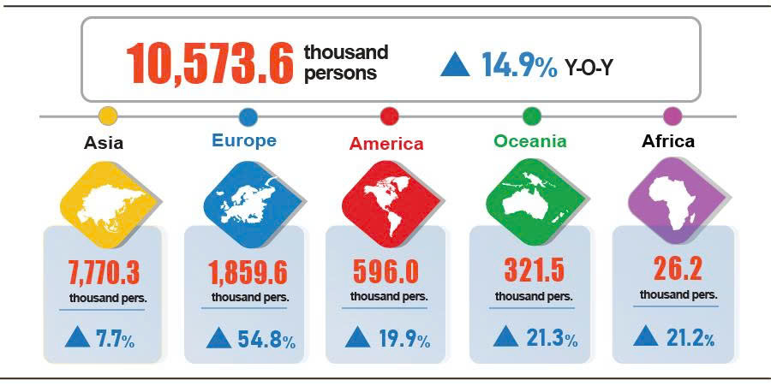
7. Social situation
a) People's living conditions
According to preliminary results of the Labour Force Survey, people's living conditions remained stable. The proportion of households reporting that their income in the month remained unchanged or increased compared to the same period last year was 96.5% (a month-on-month increase of 0.5 percentage points and a year-on-year fall of 0.6 percentage points); 3.5% of households said that their income decreased or undetermined.
Among households reporting an increase in income, 64.1% of households attributed it to increased wages and salaries of household members; 41.3% of households reported growth in income from agriculture, forestry, and fishery activities; and 21.5% of households identified increased income from non-farm production, business, and service activities.
Of the households with decreased income, 34.9% of households pointed to increase in input costs for their production and business activities; 27.3% of households indicated a decline in the selling prices of products from household production and business activities; 21.0% of households noted that household members suffered from severe illness, injury, or death; 19.6% of households cited a reduction in the scale of their production and business activities; and 17.6% of households identified that a household member was temporarily out of work.
Regarding the impact of negative events on people’s living conditions in the five months of 2026, households evaluated as follows: 35.3% of households were impacted by rising prices of goods and services; 7.7% of households were impacted by natural disasters and climate change; 3.9% of households were affected by epidemics in livestock or crops; 2.9% of households were affected by human epidemics; 2.2% of households with their household members were suffered from severe illness, injury, or death; and 0.5% of households were impacted by fires or explosions.
In May, 18.6% of interviewed households received assistance from various sources. Specifically, the proportion of households receiving support from national programs and policies was 9.3%; from local programs and policies was 7.3%; from relatives and family members was 10.1%; from charitable activities of organizations or individuals was 2.5%; and from other sources was 0.08%.
Social security activities were always prioritized and implemented by authorities at all levels to support the people's lives. In May, as of May 25th, 2026, the Government provided more than 1.0 thousand tons of rice to the people for the 2026 pre-harvest period. From the beginning of this year, the Government provided 16.3 thousand tons of rice to the people, of which: nearly 9.1 thousand tons for hunger relief during the Lunar New Year for 604.6 thousand persons; more than 6.6 thousand tons for pre-harvest hunger relief for 442.6 thousand persons; and over 604.0 tons for natural disaster and flood relief for 40.3 thousand persons.
b) Gratitude to national devotees
Towards the 80th anniversary of Invalids and Martyrs Day (July 27th, 1947 - July 27th, 2027), the “500-day-and-night campaign to accelerate the search, collection, and identification of martyrs’ remains” has been deployed from March 15th, 2026 to July 27th, 2027.
Immediately after the campaign was launched (April 2nd, 2026), under the drastic direction of the National Steering Committee, ministries, steering committees at all levels, agencies, units, and localities actively took initiative to get involved, focusing on implementing the set tasks and solutions, and achieved positive initial results. These included the issuance of the Government's Resolution on specific mechanisms and policies to remove difficulties in sampling, expert evaluation, and identification of information-lacking martyrs' remains using DNA testing; training, guiding, and issuing technical procedures, as well as digitizing information of martyrs' remains samples. At the same time, plans were developed for receiving, processing, and utilizing information sources; and pilot sampling of martyrs' remains for unidentified graves was organized, etc.
Up to now, the search and collection teams have found and collected 974 martyrs' remains, including 182 remains in Laos, 550 remains in Cambodia, and 242 remains domestically.
c) Epidemic, food poisoning
According to the report of the Ministry of Health, in the month (April 18th - May 17th, 2026), there were 5,407 cases of dengue fever; 10.5 thousand cases of hand, foot and mouth disease (1 deaths); 668 cases of rash fever suspected of measles; 25 cases of viral encephalitis; 4 cases of meningococcal meningitis; and 08 deaths from rabies. Overall, in five months of 2026, there were over 50.3 thousand cases of dengue fever (5 deaths); 44.9 thousand cases of hand, foot and mouth disease (9 deaths); 3,795 cases of rash fever suspected of measles; 131 cases of viral encephalitis (1 death); 30 cases of meningococcal meningitis (4 deaths); and 32 deaths from rabies in the whole country.
As of May 17th, 2026, the total number of people living with HIV nationwide was 256.6 thousand persons; the number of deaths from HIV/AIDS was 118.5 thousand persons.
Regarding food poisoning, in May, there were 9 cases of poisoning, causing 555 persons poisoned (2 deaths). Overall, in the five months of 2026 (from December 18th, 2025 to May 17th, 2026), there were 36 cases with 1,404 persons poisoned (5 deaths) nationwide.

d) Culture and sports
Regarding culture, in May 2026, dynamic cultural activities were held nationwide, including: the Sen Village Festival 2026, organized in Nghe An on May 19th; Ninh Binh Tourism Week 2026, held in Ninh Binh during the last ten days of May under the theme “Ninh Binh – A Heritage journey through the ages”; the Red Flamboyant Festival – Hai Phong 2026, held in Hai Phong on May 8th under the theme “Hai Phong – Convergence and Radiance”; and the programme commemorating the 72nd anniversary of Dien Bien Phu Victory Day, which included tribute ceremonies, incense offerings at the A1 National Martyrs’ Cemetery, visited to historical sites, and the reception of large numbers of tourists and veterans returning to the former battlefield.
Regarding elite sport, in May, sporting activities were held actively and achieved several notable accomplishments, including: the Viet Nam U17 national football team qualified for the FIFA U-17 World Cup Qatar 2026, which will be held in Qatar from November 19th to December 13th, 2026; the Viet Nam national Judo team secured first place overall at the 2026 Southeast Asian Judo Championships, held in Bac Ninh from May 19th to May 24th, 2026; the national Taekwondo team earned qualification for the Asian Games (ASIAD 20), to be held in Japan from September 19th to October 4th, 2026; the 2026 National Club Weightlifting Championships were held in Ninh Binh from May 16th to May 24th, 2026; the 2026 National Age Group Swimming and Diving Championships were held in Dong Thap from May 20th to May 30th, 2026; and the National Beach Volleyball Championship 2x2 was held in Da Nang from May 1st to May 9th, 2026, etc.

Regarding mass sport, in May, numerous dynamic sports activities took place nationwide, creating a dynamic atmosphere of physical training and sporting activities ranging from schools to semi-professional competitions. A highlight of the month was the opening of the National 7-a-Side Football Championship, scheduled to take place from May to July 2026. In addition to traditional sports such as badminton, Chinese chess, and air volleyball, the rapidly growing sport of Pickleball was officially included by many localities in their summer grassroots sports programmes and competitions. Notably, in commemoration of the birthday of President Ho Chi Minh (May 19th) and in response to the Month of Action for Children, many provinces and cities organized provincial-level school sports tournaments while launching nationwide swimming campaigns and drowning prevention initiatives for children. Furthermore, sporting events with significant social and humanitarian value, such as the National Championships for Athletics and Weightlifting for Persons with Disabilities, as well as the semi-professional Lion Championship martial arts competitions, provided opportunities for participants from all walks of life to excel and helped promote the spirit of “Physical Fitness for Building and Defending the Nation” across the country.

đ) Traffic accidents
In May (from April 15th to May 14th, 2026), there were 1,204 traffic accidents nationwide, causing 787 deaths and 644 injuries. Compared to the figures of April 2026, the number of traffic accidents and deaths saw an increase of 0.4% and 4.4%, respectively and the number of injuries experienced a decrease of 5.6%. Compared to the figures of the same period in 2025, the number of accidents, deaths, and injuries decreased by 22.9%, 11.7%, 39.8%, respectively.
Overall, in the five months of 2026, there were 6,482 traffic accidents nationwide, causing 4,046 deaths and 3,762 injuries. Compared to the figures of the same period last year, the number of traffic accidents cases, deaths, and injuries decreased by 18.1%, 8.6%, and 28.9%, respectively. On average, in the five months of 2026, there were 43 traffic accidents occurred a day, causing 27 deaths and 25 injuries.
e) Disaster-induced loss
Damage caused by natural disasters in May was mainly due to the impacts of heavy rain, whirlwinds, and thunderstorms with lightning, which made 12 persons died or missing and 24 others injured; damaged more than 24.7 thousand hectares of rice and other crops; collapsed, swept away, or damaged 2346 houses; total property losses caused by natural disasters during the month amounted to 342.4 billion VND, experiencing a year-on-year increase of 19.2%. Overall, in the five months of 2026, natural disasters made 18 persons died or missing and 47 others injured; damaged more than 35.1 thousand hectares of rice and other crops; destroyed, swept away, or damaged 6,115 houses. Total property losses caused by natural disasters were estimated at 924.1 billion VND, nearly 2.2 times higher than the same period in 2025.
g) Environmental protection and fire and explosion prevention
In May (from April 26th to May 23rd, 2026), authorities detected 1,154 environmental violations in 29 out of 34 localities, of which, 895 cases were addressed with a total fine of 20.1 billion VND, gaining a month-on-month decrease of 4.9% and a year-on-year rise of 23.3%. Overall, in the five months of 2026, the authorities detected 7,597 cases of environmental violations, of which, 6,528 cases were addressed with a total fine of nearly 128.9 billion VND, recording a year-on-year increase of 29.7%.
During the month (from April 15th to May 14th, 2026), 239 cases of fire and explosion occurred nationwide, causing 9 deaths and 12 injuries, with an estimated loss of 67.2 billion VND, experiencing a month-on-month increase of 55.8%, nearly 2.9 times higher than the number of the previous year. Overall, in the five months of 2026, there were 1,245 cases of fire and explosion nationwide, causing 50 deaths and 61 injuries, with an estimated loss of 347.9 billion VND, experiencing a year-on-year increase of 41.5%.
Recipients:  - General Secretary;  - President;  - Chairperson of the National Assembly;  - Prime Minister;  - Deputy Prime Ministers;  - Leaders of Ministry of Finance;  - Agencies under the Central Committee of the Party;  - Office of the President;  - Agencies under the National Assembly;  - Ministries and Ministerial-level Agencies, Government agency;  - The Supreme People’s Court of the Socialist Republic of Viet Nam;  - The Supreme People's Procuracy;  - Central mass organizations;  - Provinces and centrally governed cities;  - Vietnam Chamber of Commerce and Industry (VCCI);  - Units under the Ministry of Finance;  - News agencies and presses;  - Units under the National Statistics Office;  - Archives: Office Administration, Integrated Statistics and Foreign Affairs Department. | DIRECTOR GENERAL  Nguyen Thi Huong

The pork price index in May showed a rise of 0.33% (m-o-m).
The number of laying hens as of April 1st, 2026 showed a (y-o-y) of 10%.
Several localities experienced a (y-o-y) decrease in the area of ​​newly planted forests including Quang Ninh (-86.9%); Lang Son (-19.7%); and Tuyen Quang (-7.3%), respectively.
Several localities experienced a significant increase in wood production including Quang Ngai (+19.4%), Quang Tri (+18.6%), Da Nang (+ 9.1%), and Hue (+ 7.5%).
Figures released by Ministry of Agriculture and Environment as of May 15th, 2026.
Source: Compiled from provincial statistics reports: The price of raw pangasius fish in the Mekong Delta, weighing 0.7-1.0 kg/fish, remains at 32,000 VND/kg - 34,000 VND/kg, an increase of approximately 3,000 VND/kg compared to the same period in 2025.
Source: Compiled from provincial statistics reports: The price of whiteleg shrimp in the Mekong Delta ranges from 85,000 to 130,000 VND/kg for shrimp of 50-100 pieces/kg, while the price of tiger shrimp (30-40 pieces/kg) ranges from 140,000 to 175,000 VND/kg.
The year-on-year growth/decline rates of the industrial production index for the first five months of the year during the period 2022–2026: 8.1%; -2.0%; 7.1%; 8.8%; and 9.1%, respectively.
The local month-on-month changes in IIP in May for the large-shared industrial sector provinces and municipalities were as follows: Da Nang up 25.3%; Quang Ngai up 10.2%; Vinh Long up 4.4%; Can Tho up 4.2%; Dong Nai up 4.0%; Bac Ninh up 3.7%; Ho Chi Minh up 1.2%; Quang Ninh down 5.0% and Hai Phong down 2.0%.
Some key industrial sectors in certain localities experienced low growth, affecting the overall growth of the province and the country. Specifically, the electricity production and distribution sector in some localities declined or grew slowly, such as Ho Chi Minh City down 4.5%, Quang Ninh up 0.6%, Lam Dong up 2.7%, and Vinh Long up 3.9%. The mining sector saw declines in Quang Ngai ( 37.7%), Tay Ninh (36.0%), Gia Lai (4.5%), Quang Ninh (4.0%), and Lao Cai (2.1%). The processing and manufacturing sector in some localities recorded low growth below 10%, including Hanoi up 8.8%, Quang Ngai up 8.1%, Gia Lai up 8.0%, Khanh Hoa up 5.3%, and Lang Son up 2.4%.
The provinces and municipalities that recorded a high year-on-year increase in IIP of the manufacturing sector for the first five months of 2026 were as follows: Ninh Binh (28.7%); Ha Tinh (26.2%); Phu Tho (25.6%); Cao Bang (25.1%); Thai Nguyen (19.6%). The provinces and municipalities that recorded a high year-on-year increase in IIP of the electricity generation and distribution sector were as follows: Ha Tinh (36.8%); Lai Chau (22.5%); Nghe An (12.3%).
The provinces and municipalities that recorded a low year-on-year increase in IIP of the manufacturing sector for the first five months of 2026 were as follows: Khanh Hoa (5.3%); Lang Son (2.4%). The provinces and municipalities that recorded a low year-on-year increase in IIP of the electricity generation and distribution sector were as follows: Lang Son (3.3%); Can Tho (2.9%); Lam Dong (2.7%). The provinces and municipalities that recorded a year-on-year decrease in IIP of the mining sector were as follows: Can Tho (-38.0%); Quang Ngai (-37.7%); Gia Lai (-4.5%); Lao Cai (-2.1%).
According to the report of the Foreign Investment Agency, Ministry of Finance, received on June 2nd, 2026.
Data received from the State Budget Department - Ministry of Finance on May 31st, 2026.
Tax and fee relief measures remained in place throughout May to support businesses and individuals in navigating operational difficulties and to stimulate socio-economic development.
In the first five months of 2026, authorities enhanced revenue collection management and cracked down on smuggling and commercial fraud to ensure the timely remittance of emerging revenues into the state budget.
Within domestic revenue, collections from the three economic sectors (accounting for 46.4% of the domestic revenue budget) were estimated at 647.2 trillion VND (+37.5% YoY). Receipts from major tax categories, such as corporate income tax, value-added tax, and special consumption tax, all recorded sharp year-on-year growth. Conversely, revenues from housing and land saw slower progress, estimated at nearly 204.0 trillion VND, which accounted for approximately 15.2% of total state budget revenue (-4.5% YoY).
The value of export turnover was calculated at F.O.B price and import turnover was calculated at C.I.F price (including transportation and insurance costs of imported goods).
Preliminary data on exports and imports of goods in May 2026 provided by the Viet Nam Customs on 2nd June, 2026.
The total export and import turnover of goods in five months of 2025 amounted to 355.96 billion USD, going up 15.7% year-on-year, of which exports reached 180.53 billion USD, increasing by 14.2%; imports reached 175.43 billion USD, increasing by 17.4%.
This figure was 466 million USD higher than the data reported by the Viet Nam Customs to the National Statistics Office of Viet Nam on 28th April 2026.
This figure was 1.18 million USD, higher than the data reported by the Viet Nam Customs to the National Statistics Office of Viet Nam on 28th April 2026.
The reporting period for April was estimated to record a trade surplus of 3.28 billion USD.
Some commodities recorded high trade deficits: Electronic goods, computers and their parts posted a deficit of 32.0 billion USD; petroleum products, 4.3 billion USD; plastics materials, 4.1 billion USD; coal, 3.6 billion USD; crude oil, 2.9 billion USD; and chemicals, 2.7 billion USD.
The CPI of household electricity and tap water in May 2026 reflected a one-month lag than other items because it is calculated basing on the revenue and consumption volume of April 2026.
Domestic rice prices reduced mainly because the winter-spring rice crop is harvested, resulting in abundant supply. Therefore, the CPI of rice shrunk by 0.95% (a drop of 1.07%; 0.53%; 0.89%; 0.35% in regular white; premium white rice; glutinous; brown rice, respectively). In contrast, the prices of other food items experienced an increase: the prices of instant cereals; bread; other cereals; instant noodles, pho/porridge; corn flour; vermicelli, pho noodles, and rice noodles jumped up 0.64%; 0.49%; 0.43%; 0.36%; 0.31%; 0.22%, respectively.
The CPI of pork; fresh seafood; eggs of all kinds; poultry meat; beef; fresh and processed fruits fell by 0.82%; 0.63%; 0.44%; 0.42%; 0.14%; 1.41%, respectively. In contrast, some item groups witnessed a rise in prices: the CPI of fresh, dried and processed vegetables; milk, butter, and cheese; fish sauce and condiment; tea, coffee, and cocoa; confectionery and jam; and spices soared by 1.36%; 0.37%; 0.34%; 0.15%; 0.12%; and 0.05%, respectively.
Due to growing costs of input, labor, shop rental, and operation. Of which the CPI of eating out; drinking out; take awa y fast food jumped up 0.32%; 0.48%; and 0.52%, respectively.
The CPI after excluding the prices of fresh food, foodstuff, energy, and State-managed goods, which include healthcare and education services.
Several routes in Ho Chi Minh City were temporarily suspended for maintenance, while vessel arrivals and departures were also affected by water current conditions.
According to a report from the Department of Border Gate, the Border Guard Command, the Ministry of National Defense, and the Immigration Department, the Ministry of Public Security.
The reporting period was from April 26th, 2026 to May 25th, 2026.
A household could select multiple reasons.
Decision No. 27/QD-BCDQG dated March 22nd, 2026 of the National Steering Committee on the search, collection, and identification of martyrs' remains.
https://baochinhphu.vn/chien-dich-500-ngay-dem-tiep-tuc-hanh-trinh-dua-cac-liet-si-tro-ve-voi-dat-me-102260527083846605.htm (accessed at 9:30 AM, May 29th, 2026).
According to a quick report from the Office of the Ministry of Public Security and the Viet Nam Maritime and Waterways Administration (Ministry of Construction) on May 23rd, 2026.
Compiled from reports of 34 Departments of Agriculture and Environment, covering the reporting period from April 22nd, 2026 to May23rd, 2026.
According to data compiled by Provincial and centrally-governed cities Statistics Offices from the reports of Provincial Departments of Agriculture and Environment and Provincial Police Departments.
No environmental violation was detected in 5 provinces, including: Hung Yen, Thai Nguyen, Quang Ngai, Khanh Hoa, and Lam Dong.
According to a quick report from the Ministry of Public Security dated May 23rd, 2026.

