MINISTRY OF FINANCE  NATIONAL STATISTICS OFFICE  ________________  No.: 289/BC-CTK | SOCIALIST REPUBLIC OF VIET NAM  Independence-Freedom-Happiness  ______________________________________  Ha Noi, August 3rd, 2026

REPORT
SOCIO - ECONOMIC PERFORMANCE
IN JULY AND 7 MONTHS OF 2026
____________________

1. Agriculture, forestry and fishing
Agricultural, forestry, and fishery production in July maintained stable growth. Agricultural production focused on cultivating and tending of rice and other winter and summer-autumn crops. Pig and poultry farming stayed constant, shifting towards farm-based models and biosecurity standards. Forestry production continued to grow, with a notable growth in wood production thanks to the rising demand of raw materials for processing and export facilities. Aquaculture saw positive growth thanks to stable prices for raw pangasius and shrimp, alongside increased purchasing demand for processing and export enterprises; Capture fisheries expanded thanks to favorable weather and a downward trend in fuel prices.
a) Agriculture
Winter- rice
As of July 20th, 2026, localities nationwide cultivated 1,138.5 thousand hectares of winter-rice nationwide, a year-on-year decrease of 45.6 thousand hectares. Of which, the northern localities reached 806.9 thousand hectares (-25.4 thousand hectares), the southern localities reached 331.6 thousand hectares (-20.2 thousand hectares). The drop of winter-rice area was mainly due to localities converted portions of low-yield rice land to other annual crops, perennial crops, high-value aquaculture, or repurposing the land use for public infrastructure and industrial zones. Several localities experienced significant reduction of winter-rice area were as follows: Gia Lai (-9.8 thousand hectares), Lao Cai (-8.7 thousand hectares), Thanh Hoa (-4.2 thousand hectares), and Ca Mau (-2.1 thousand hectares).
Summer-Autumn rice
As of July 20th, 2026, localities nationwide cultivated 1,862.8 thousand hectares of summer-autumn rice, a year-on-year drop of 24.0 thousand hectares. Specifically, the northern localities reached 166.9 thousand hectares (-5.5 thousand hectares) and the southern localities reached 1,695.9 thousand hectares (-18.5 thousand hectares). The progress of the summer-autumn rice cultivation was recorded slower year-on-year due to late harvest of the spring crop, long lasting heatwaves in several localities, and limited irrigation water supplies, as the result, farmers shrank the cultivation area or delayed sowing. Several localities completed summer-autumn rice sowing, however, there was recorded with a year-on-year drop in cultivation area, of which, Dong Thap reached 231.6 thousand hectares (-12.3 thousand hectares); Vinh Long reached 104.8 thousand hectares (-3.3 thousand hectares); Can Tho reached 284.0 thousand hectares (-0.3 thousand hectares); and Ca Mau reached 94.2 thousand hectares (-0.1 thousand hectares).
So far, the early summer-autumn rice harvested area reached ​​356.2 thousand hectares, representing 19.1% of the total cultivation area. Of which some localities were recorded with harvested areas were as follows: An Giang reached 170 thousand hectares, accounting for 33.8%, Dong Thap reached 97.4 thousand hectares, accounting for 42.1%, Can Tho reached 44.2 thousand hectares, accounting for 15.6%, and Tay Ninh reached 35.3 thousand hectares, accounting for 13.3%. The remaining summer-autumn rice acreage was currently in the flowering and milky grain stages. However, this period often recorded with widespread rainfall-creating conditions conducive to the outbreak and spread of pests and diseases, localities were recommended to intensify field monitoring and guide farmers in proactive pest control measures to minimize damage and ensure crop yields.
Autumn-winter rice
As of July 20th, 2026, the southern localities cultivated 170.0 thousand hectares of autumn-winter rice, equal to 59.0% of the same period last year; of which An Giang reached 58.5 thousand hectares, equal to 55.9%, Can Tho reached 50.7 thousand hectares, equal to 39.1%, and Dong Thap reached 19.3 thousand hectares, equal to 73.2%. The sowing progress of the autumn-winter rice this year was recorded slower, year-on-year, mainly due to the late harvest of the summer-autumn rice.
Annual crops
Along with rice cultivation, localities nationwide cultivated other crops. However, the acreage of some primary annual crops saw a year-on-year drop due to low economic efficiency, farmers switched to crops and production models for higher economic value.
Figure 1. Cultivation area of annual crops
(As of July 20th 2026)
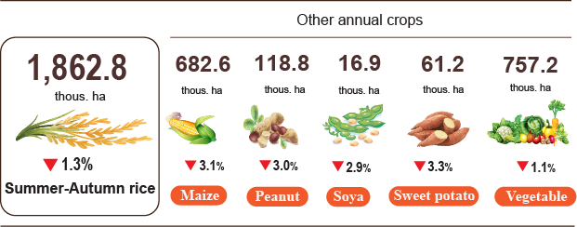
Livestock
Cattle and buffalo farming continued a downward trend due to low economic efficiency, shrinking natural grazing areas, reduced supply of green fodder, and high feed prices. Several localities experienced a year-on-year crash in the number of buffalo including Thanh Hoa (-8.4%), Phu Tho (-6.1%), Vinh Long (-6.0%), Dak Lak (-4.3%), Khanh Hoa (-3.2%), and Son La (-2.8%). Conversely, thanks to advantages of land availability, feed sources, and the development of commercial farm-based farming combined with breed improvement, confinement rearing, fattening, and the application of technical advances, number of castles in some localities showed year-on-year growth, with Dong Nai (+3.4%), Lam Dong (+3.0%), and Nghe An (+2.6%).
Pig farming witnessed stability in the month. Although live weight prices in some northern and central provinces showed a slight downward trend during the second half of July, after a period of remaining at high levels, however these prices still brought enough profit for farmers to maintain livestock production and repopulation. However, African swine fever outbreaks persisted in certain localities, primarily in small-scale, household-level farms; in these settings, limited biosecurity measures and inconsistent control of breeding stock, along with irregular cleaning and disinfection, caused the risk of disease emergence and transmission. Therefore, local authorities must strengthen disease surveillance, providing guidance on biosecurity practices, and manage the regeneration to mitigate the risk of outbreaks and ensure a stable market supply.
Poultry farming represented a positive rapid capital turnover growth in most localities, driven by short production cycles, and stable consumer demand for poultry meat and eggs. Several localities recorded a boom in poultry numbers, year-on-year, including Tay Ninh (+6.7%), Nghe An (+6.4%), Thanh Hoa (+4.6%), Dong Nai (+3.9%), Phu Tho (+3.8%), and Bac Ninh (+3.5%).
Figure 2. Year-on-year growth rate of livestock and poultry number
at the end of July 2026
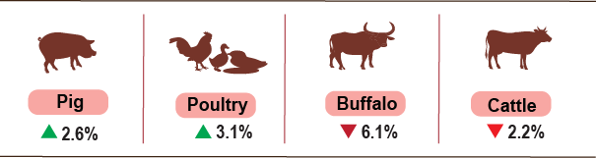
As of July 26th, 2026, the localities nationwide were recorded with no blue-ear disease and foot-and-mouth disease; lumpy skin disease persisted in Cao Bang, Ho Chi Minh City, and Dong Thap; avian influenza took place in 11 localities; and African swine fever persisted in 15 localities that have not yet passed the 21-days quarantine period.
b) Forestry
The area of newly planted forests nationwide in July was estimated to reach 14.6 thousand hectares, a year-on-year rise of 5.0%; the number of scattered forestry trees reached 6.5 million, (+3.2%); and wood production reached 2,387.1 thousand cubic meters, (+13.5%), driven by high demand for raw materials for processing and export facilities. Several localities recorded a bounce of wood production, year-on-year, with Gia Lai (+80.9%), Lang Son (+14.8%), Nghe An (+8.9%), and Quang Tri (+8.0%). Generally, in the seven months of 2026, the area of ​​newly planted concentrated forests was estimated to reach 159.8 thousand hectares, a year-on-year reduction of 3.1%, number of scattered forestry trees planted reached 57.9 million, (+2.4%); and wood production reached 14,181.9 thousand cubic meters (+6.1%).
The forest damaged area in July was 449.6 hectares, showing a year-on-year increase of 6.2 fold including 45.0 hectares of forest cut or destroyed (-23.4%), 404.6 hectares of forest fire, showing a 29.3 fold increase, caused by long lasting, widespread heatwaves and high temperatures in localities nationwide. Generally, in the seven months of 2026, total damaged forest area reached 845.4 hectares, a year-on-year decrease of 9.0%, of which the logging and deforestation area was 337.1 hectares (-46.6%), while the forest fire area was 508.3 hectares (+71.2%).
c) Fishing
Capture fisheries and aquaculture production in July was estimated to reach 918.9 thousand tones, a year-on-year leap of 4.3%, of which fish reached 603.1 thousand tones (+2.5%), shrimp reached 191.7 thousand tones (+7.3%), and other aquatic products reached 124.1 thousand tones (+8.4%).
Aquaculture production in the month was estimated at 586.8 thousand tones, a year-on-year jump of 6.1%, of which fish reached 340.5 thousand tones (+4.2%), shrimp reached 182.1 thousand tones (+7.4%), and other aquatic products reached 64.2 thousand tones (+13.0%). Generally, in the seven months of 2026, total aquaculture production was estimated at 3,579.9 thousand tones, a year-on-year growth of 5.8%, of which fish reached 2,324.5 thousand tones (+4.4%), shrimp reached 884.6 thousand tones (+8.0%), and other aquatic products reached 370.8 thousand tones (+9.8%).
Pangasius production in July saw a year-on-year upward trend thanks to the prices of commercial pangasius showed stability and sustained purchasing demand from export-oriented processing enterprises, those factors encouraged farmers to intensify culturing efforts and harvest ponds that reached maturity. pangasius production in July was estimated at 154.7 thousand tones, a year-on-year expansion of 3.9%. Generally, production in the seven months of 2026 reached 1,090.1 thousand tones, (+4.8%).
Shrimp production in July saw a year-on-year upward trend, driven by favorable weather for brackish-water shrimp farming, stable raw shrimp prices maintained high, and rising procurement demand of processing enterprises, those factors encouraged farmers to maintain production and harvest. White leg shrimp production in July was estimated at 142.8 thousand tones, a year-on-year increase of 7.8%, black tiger shrimp production reached 32.8 thousand tones, (+3.5%). Generally, in the seven months of 2026, white leg shrimp production reached 637.1 thousand tones, a year-on-year climb of 9.1%, and black tiger shrimp production was estimated at 200.4 thousand tones, (+4.2%).
The production of capture fisheries in July was estimated at 332.1 thousand tones, a year-on-year increase of 1.2%, of which fish reached 262.6 thousand tones (+0.5%), shrimp reached 9.6 thousand tones (+4.3%), and other aquatic products reached 59.9 thousand tones (+3.8%). The increase was driven by favorable weather and a downward trend in fuel prices, enabling fishermen to spend more days at sea and maintain fishing trip frequencies while improve operational efficiency. In the seven months of 2026, total captured fisheries production was estimated at 2,293.2 thousand tones, a year-on-year rise of 0.7%, of which fish reached 1,776.5 thousand tones (+0.4%), shrimp reached 81.2 thousand tones (+1.6%), and other aquatic products reached 435.5 thousand tones (+1.6%). Marine capture fisheries production in July was estimated at 325.9 thousand tones, a year-on-year growth of 1.2%, of which fish reached 258.1 thousand tones (+0.5%), shrimp reached 9.2 thousand tones (+3.4%), and other aquatic products reached 58.6 thousand tones (+3.9%). In the seven months of 2026, marine capture fisheries production was estimated at 2,193.0 thousand tones, a year-on-year increase of 0.7%, of which fish reached 1,702.9 thousand tones (+ 0.4%), shrimp reached 75.7 thousand tones (+1.7%), and other aquatic products reached 414.4 thousand tones (+1.7%).
Figure 3. Capture fisheries and aquaculture production in seven months of 2026
(Y-o-Y growth rate)
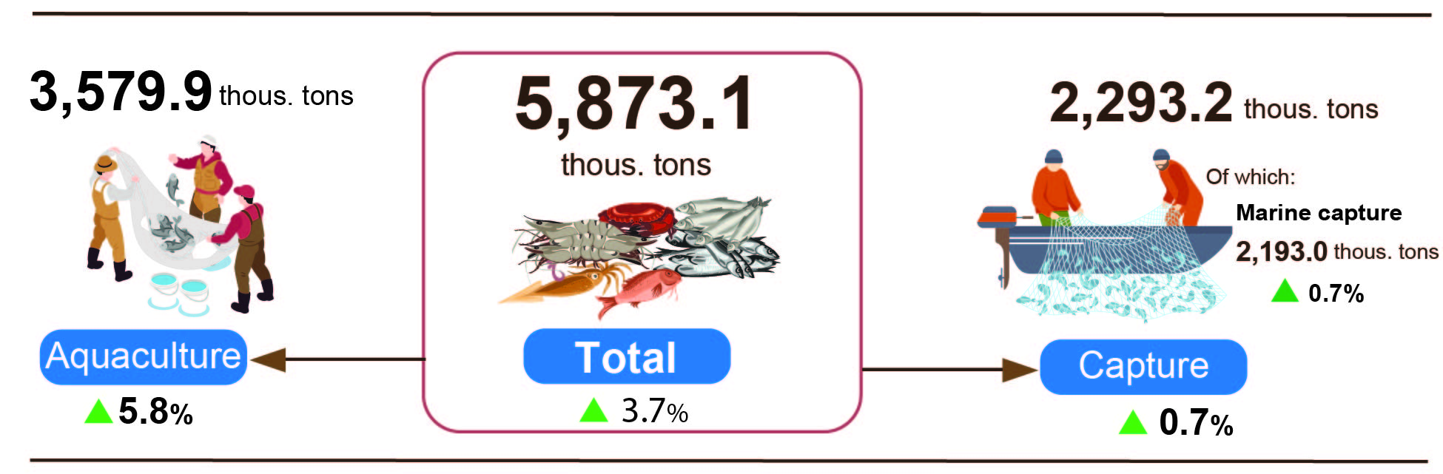
Generally, in the seven months of 2026, total fisheries production was estimated at 5,873.1 thousand tones, a year-on-year expansion of 3.7%, of which fish reached 4,101.0 thousand tones (+2.6%), shrimp reached 965.8 thousand tones (+7.4%), and other aquatic products reached 806.3 thousand tones (+5.2%).
2. Industrial production
Industrial production in July recorded positive growth, driven by the commissioning of new production capacities and the expansion of production and business activities. The Index of Industrial Production (IIP) for the month recorded an estimated expansion of 1.2% month-on-month and 14.5% year-on-year. Cumulatively, for the seven months of 2026, the IIP advanced by 11.4% over the corresponding period last year, marking the highest growth rate achieved during the seven months of the year across the past years.
In July 2026, the manufacturing recorded a year-on-year increase of 15.0%; the water supply, sewerage, waste management and remediation activities grew by 14.9%; the electricity supply increased by 12.5% and the mining and quarrying rose by 10.4%.
Generally, in the seven months of 2026, the manufacturing grew by 12.0% (the corresponding figure in 2025 was 10.1%), contributing 9.3 percentage points to the overall growth; the mining and quarrying grew by 6.6% (2.4% decline in the same period of 2025), contributing 1.0 percentage points; the electricity supply rose by 9.9% (versus 4.8% in 2025), contributing 0.9 percentage points; the water supply, sewerage, waste management and remediation activities increased by 10.0% (versus 10.1% in 2025), contributing 0.2 percentage points.
In the first 7 months of 2026, the IIP of several key 2-digit activities experienced a year-on-year increase as follows: manufacture of basic metals (+23.5%); manufacture of motor vehicles (+16.0%); manufacture of beverages (+15.7%); manufacture of other non-metallic mineral products (+13.5%); manufacture of other transport equipment (+13.5%); manufacture of furniture (+13.3%); manufacture of computer, electronic and optical products (+12.8%); manufacture of fabricated metal products (except machinery and equipment) (+12.8%); manufacture of chemicals and chemical products (+12.5%); manufacture of rubber and plastic products and manufacture of wood processing and products made from wood, bamboo and rattan (except furniture) (+12.2%) ; manufacture of products made from straw and plaiting materials (+12.2%); manufacture of food products (+11.2%); extraction of crude petroleum and natural gas (+10.3%). Conversely, the IIP for mining of hard coal and lignite decreased by 3.1%.
Table 1. Year-on-year IIP growth rate for several key industrial activities
in the 7 months of the years 2022 - 2026 (%)
 | 2022 | 2023 | 2024 | 2025 | 2026
Mining of hard coal and lignite | 7.3 | -2.2 | -2.1 | 3.7 | -3.1
Extraction of crude petroleum and natural gas | -1.6 | -1.0 | -12.5 | -7.5 | 10.3
Manufacture of food products | 7.1 | 4.5 | 6.9 | 10.0 | 11.2
Manufacture of beverages | 19.9 | 4.4 | 0.0 | 1.7 | 15.7
Manufacture of wood processing and products made from wood, bamboo and rattan (except furniture), as well as products made from straw and plaiting materials | 10.2 | -5.7 | 11.1 | 9.9 | 12.2
Manufacture of chemicals and chemical products | 3.7 | 5.1 | 17.1 | 7.0 | 12.5
Manufacture of rubber and plastic products | -8.0 | 8.1 | 29.2 | 17.0 | 12.2
Manufacture of other non-metallic mineral products | 6.3 | -4.8 | -1.7 | 14.4 | 13.5
Manufacture of basic metals | 0.0 | -1.7 | 12.3 | 10.6 | 23.5
Manufacture of fabricated metal products (except machinery and equipment) | 9.8 | 5.5 | 12.9 | 11.2 | 12.8
Manufacture of computer, electronic and optical products | 11.6 | -4.2 | 11.2 | 7.3 | 12.8
Manufacture of motor vehicles | 0.9 | -7.3 | 8.1 | 29.4 | 16.0
Manufacture of other transport equipment | -1.4 | -4.2 | 1.5 | 10.8 | 13.5
Manufacture of furniture | 4.3 | -1.2 | 21.0 | 12.9 | 13.3

The IIP in the 7 months of 2026 experienced a year-on-year increase in all 34 provinces and municipalities. Several provinces saw a fairly high growth rate in the IIP thanks to the surge in the manufacturing and the electricity supply. Conversely, the IIP in several provinces and municipalities nudged up due to slow growth or decrease in the manufacturing, the mining and quarrying, and the electricity supply.
Table 1. Year-on-year IIP growth rate for several key industrial activities
in the 7 months of the years 2022 - 2026
Top of 10 localities by IIP growth rate 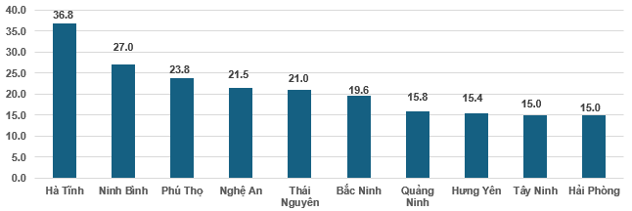 | Bottom of 10 localities by IIP growth rate  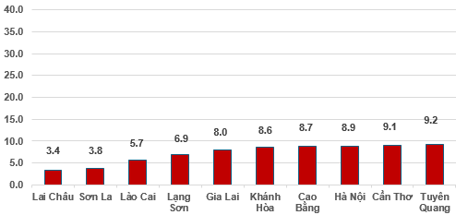
During the seven months of 2026, several key industrial products registered notable year-on-year increases, led by motorbike (+31.1%), laptop (+30.7%), rolled steel (+24.7%), and automobiles (+24.3%), processed seafood (+21.2%), refined sugar (+18.5), steel bar, angle bar (+16.8%), beer (+13.9%), crude oil (+12.7%). On the other hand, several commodities posted output reductions, including NPK fertilizers (-10.9%), sodium glutamate (-7.8%), leather shoes and sandals (-4.9%), and coal (-3.1%).
Number of employees in industrial enterprises as of July 1st, 2026, expanded by 1.1% month-on-month and 3.1% year-on-year. By kind of economic activity, the number of employees in the mining and quarrying rose by 0.1% month-on-month but experienced a year-on-year decrease of 1.3%. The number of employees in the manufacturing advanced by 1.1% month-on-month (MoM) and 3.3% year-on-year (YoY). The electricity, gas, steam, and air conditioning supply workforce remains no change MoM and increased by 1.4% YoY, while water supply, sewerage, waste management, and remediation activities recorded a month-on month increase of 0.1% and a year-on-year expansion of 3.7%.
3. Enterprise registration
In July, the country had over 14.2 thousand newly established enterprises with a registered capital of nearly 166.3 trillion VND and registered employees of 82.0 thousand employees, a month-on-month decrease of 15.5%, 41.9%, and 0.6% in the number of enterprises, in the registered capital, and in the number of employees, respectively. In comparison with the same period last year, in the number of enterprises showed a decrease of 13.9%, and in the number of registered capital and the number of employees expanded by 41.6%, and 3.8%, respectively. The average registered capital per newly established enterprise in July reached 11.7 billion VND (-31.3% MoM) and (+64.4% YoY). In addition, the country had over 10.1 thousand resumed operations enterprises (-25.5% MoM and -30.7% YoY).
In July, there were 8,723 enterprises registered to temporarily suspended for a definite time (+20.4% MoM and +18.8% YoY); 10,382 enterprises suspended operation waiting for dissolution procedures (+3.9% MoM and +136.8% YoY); 7,209 enterprises completed procedures for dissolution (+45.4% MoM and +269.9% YoY).
Overall, in the seven months of 2026, the whole country had over 125.9 thousand newly registered enterprises with a total registered capital of nearly 1,518.9 trillion VND and total registered employees of nearly 597.3 thousand persons, a year-on-year increase of 16.9%, 63.6% in the number of enterprises, in registered capital, respectively and a decrease of 10.9% in the number of employees. The average registered capital per newly established enterprise in the seven months of 2026 reached 12.1 billion VND (+39.9% YoY). The total registered capital added to the economy in the seven months of 2026 reached nearly 3.6 quadrillion VND (+7.3% YoY). In addition, the country had nearly 61.3 thousand resumed operation enterprises (-7.7% YoY), bringing the total number of newly established and resumed operation enterprises in the seven months of 2026 to nearly 187.2 thousand enterprises (+7.5% YoY). On average, there were 26.7 thousand newly established and resumed operation enterprises per month.
By economic sector, in the seven months of 2026, the number of newly registered enterprises in the agriculture, forestry and fishing sector; the industry and construction sector and the services sector reached 1,325 enterprises (+ 39.6% YoY); nearly 31.0 thousand enterprises (+31.4% YoY); 93.6 thousand enterprises (+12.5% YoY), respectively.
Figure 5. Enterprise registration in the seven months of 2026 (YoY growth rate)

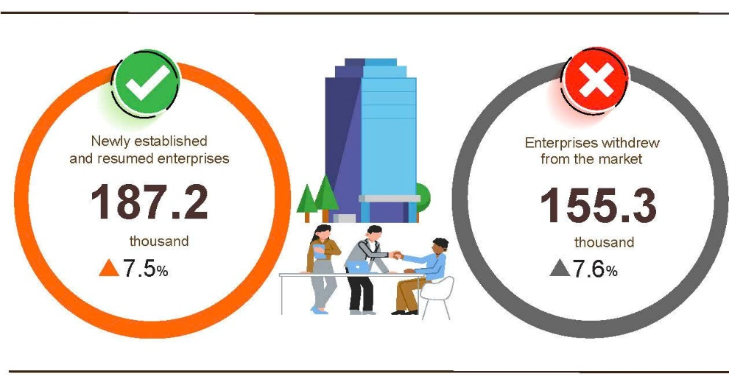

Overall, in the seven months of 2026, the number of enterprises temporarily suspending for a definite time was over 87.5 thousand enterprises (-1.2% YoY); over 36.6 thousand enterprises suspended operation waiting for dissolution procedures (-11.7% YoY); nearly 31.2 thousand enterprises completed procedures for dissolution (+118.7% YoY). On average, 22.2 thousand enterprises withdrew from the market per month.
Table 2. Newly established and completely dissolved enterprises in the seven months of 2026 by kind of economic activity

 | Number of enterprises (Enterprises) |  |  | YoY growth rate (%)
 | Newly established | Completely dissolved |  | Newly established | Completely dissolved
Wholesale and retail, repair of motor vehicle and motorcycle | 51,131 | 11,760 |  | 10.4 | 125.1
Manufacturing | 16,558 | 3,410 |  | 16.1 | 119.6
Construction | 12,433 | 2,303 |  | 51.8 | 128.5
Real estate business | 3,649 | 1,861 |  | 23.2 | 135.3
Transportation and storage | 8,477 | 1,213 |  | 43.6 | 117.4
Accommodation and food services | 5,615 | 1,482 |  | 46.9 | 103.6
Electricity, water and gas supply | 1,352 | 324 |  | 74.5 | 94.0
4. Investment
State budget investment in July was actively promoted by ministries, agencies, and localities, creating a momentum for economic growth throughout 2026. Cumulatively, during the seven months of 2026, disbursed investment from the state budget was estimated to reach 39.0% of the annual plan, representing an 18.4% expansion compared to the corresponding period last year. Disbursed foreign direct investment (FDI) in Viet Nam over the same seven-month period stood at an estimated 15.20 billion USD, making up a year-on-year increase of 11.8%.
In July alone, disbursed investment from the State budget reached 98.6 trillion VND (+25.9% YoY). This total comprised centrally- managed investment at 17.5 trillion VND (up 33.2%) and locally-managed at 81.0 trillion VND (up 24.5%). Cumulatively, for the seven months of 2026, overall disbursed State budget investment was estimated at 445.5 trillion VND, equivalent to 39.0% of the annual plan and a representing (+18.4% YoY) (the corresponding figure in 2025 were 37.0% of the plan and +24.7% YoY). Specifically:
- Centrally-managed investment was estimated to reach 67.7 trillion VND, representing 27.1% of the annual plan (+19.8% YoY). Of which, investment managed by specific ministries witnessed divergent trends, such as Ministry of Construction with 22.7 trillion VND (-30.0%); Ministry of Agriculture and Environment with 3.2 trillion VND (-58.7%); Ministry of Health with 599.3 billion VND (-56.2%); Ministry of Culture, Sports and Tourism with 378.4 billion VND (+6.2%); Ministry of Education and Training with 299.2 billion VND (-62.6%); and the Ministry of Industry and Trade with 41.1 billion VND (-65.2%).
- Locally-managed investment was estimated at 377.8 trillion VND, equal to 42.3% of the annual plan and a year-on-year increase of 18.2%, including:
State budget investment at the provincial level reached 299.8 trillion VND, equivalent to 42.2% and a 16.1% upturn compared to 2025;
State budget investment at the commune level reached 78.0 trillion VND, representing 42.8% and a year-on-year surge of 26.9%.
Disbursed investment from the State budget during the seven months of 2026 for a number of provinces and centrally-run cities was as follows:
Figure 6. Disbursed investment from the State budget
in the seven months of 2026 in selected localities

Total inward foreign investment in Viet Nam as of July 31st, 2026, including newly registered capital, adjusting registered capital, and the value of capital contribution and purchasing shares by foreign investors reached 38.06 billion USD, a year-on-year increase of 58.0%.
Figure 7. Inward foreign investment in Viet Nam
in the seven months of 2022-2026 (Billion USD)

- In terms of newly registered capital: 2,429 projects were licensed with a total registered capital of 21.05 billion USD; a 7 year-on-year increase of 8% in the number of projects and an upturn of 2.1 times in registered capital. Of which, the largest newly licensed FDI was the manufacturing with 11.58 billion USD, accounting for 55.0% of the total newly registered capital; the electricity, gas, steam, and air conditioning supply sector reached 3.13 billion USD, making up 14.9%; and other activities was 6.34 billion USD, constituting 30.1%.
Among the 69 countries and territories with newly licensed investment projects in Viet Nam during the seven months of 2026, Singapore was the largest investor with 7.5 billion USD, accounting for 35.6% of total newly registered capital; followed by South Korea with 5.61 billion USD, representing 26.7%; Hong Kong SAR (China) with 2.91 billion USD, comprising 13.8%; China with 1.73 billion USD, making up 8.3%; Japan with 1.37 billion USD, constituting 6.5%; and the Netherlands with 424.3 million USD, accounting 2.0%.
- Regarding the adjusting registered capital: 666 turns of projects licensed from previous years registered to adjust investment capital upward by an additional 10.43 billion USD, a year-on-year increase of 4.4%.
If including newly registered capital and adjusting registered capital of licensed projects in previous years, the registered FDI in the manufacturing reached 17.94 billion USD, equivalent to 57.0% of the total newly registered and additional capital; the real estate activities reached 5.23 billion USD, accounting for 16.6%; and other activities reached 8.31 billion USD, making up 26.4%.
- There were 1,815 turns of registered of capital contribution and purchasing shares by foreign investors with a total value of 6.58 billion USD, a year-on-year increase of 61.6%. Of which, 578 turns capital contribution and purchasing shares increased the charter capital of enterprises with a capital contribution value of 2.35 billion USD, and 1,237 foreign investors re-bought domestic shares without making the charter capital increase with a value of 4.23 billion USD. Among capital distribution and purchasing shares by foreign investors, the professional, scientific, and technical activities attracted 2.68 billion USD, accounting for 40.8% of the total contribution value; the wholesale and retail trade, and motor vehicles and motorcycles repair achieved 1.96 billion USD, accounting for 29.7%; and other activities reached 1.94 billion USD, representing 29.5%.
Total disbursed FDI in Viet Nam during the seven months of 2026 reached an estimated 15.20 billion USD (+11.8% YoY), setting the highest figure in the disbursed FDI in the seven-month period over the past five years. Sectoral deployment of this disbursed capital was led by the manufacturing at 12.55 billion USD (comprising 82.6% of the total disbursed FDI); followed by the real estate activities with 1.1 billion USD (representing 7.5%); and the electricity, gas, steam and air conditioning supply reached 549.3 million USD (accounting for 3.6%).

Figure 8. Disbursed foreign direct investment
in the seven months of 2022-2026 period (Billion USD)

Viet Nam's outward investment activities during the seven months of 2026, 106 projects were granted new investment certificates with a total combined capital value of 1.17 billion USD, a 2.9-fold increase over the corresponding period last year. Concurrently, 23 turns of projects adjusted their investment capital upwards an additional 1.19 billion USD, a 9.2-fold rise.
In aggregate, total Viet Nam's outward FDI from Viet Nam (comprising both newly registered and adjusted capital) reached 2.36 billion USD, expanding 4.5 times compared to the same period last year. By activity, the transportation and storage reached 601.7 million USD (constituting 25.5%); the electricity, gas, steam, and air conditioning supply reached 585.8 million USD (comprising 24.8%); agriculture, forestry, and fishing sector reached 487.4 million USD (representing 20.6%); and construction reached nearly 209 million USD (making up 8.8%).
In the seven months of 2026, 35 countries and territories received investment from Viet Nam; of which: Laos led with 638.3 million USD (accounting for 27.0% of total outward capital), followed by Cambodia with 449.9 million USD (representing 19.0%); Indonesia with 308.6 million USD (comprising 13.1%); India with 173.9 million USD (making up 7.4%); Philippines with 167.2 million USD (accounting for 7.1%); Kazakhstan with 149.9 million USD (representing 6.3%), and the United Kingdom with 82.8 million USD (comprising 3.5%).
5. State budget revenue and expenditure
State budget revenue in the seven months of 2026 was estimated to increase by 16.0% over the same period last year. State budget expenditure was estimated to increase by 7.7% over the previous year, ensuring the needs of socio-economic development, national defense, security, state management, payment of due debts, and timely payment to beneficiaries according to regulations.
Figure 9. State budget revenue and expenditure
in the 7 months of 2026
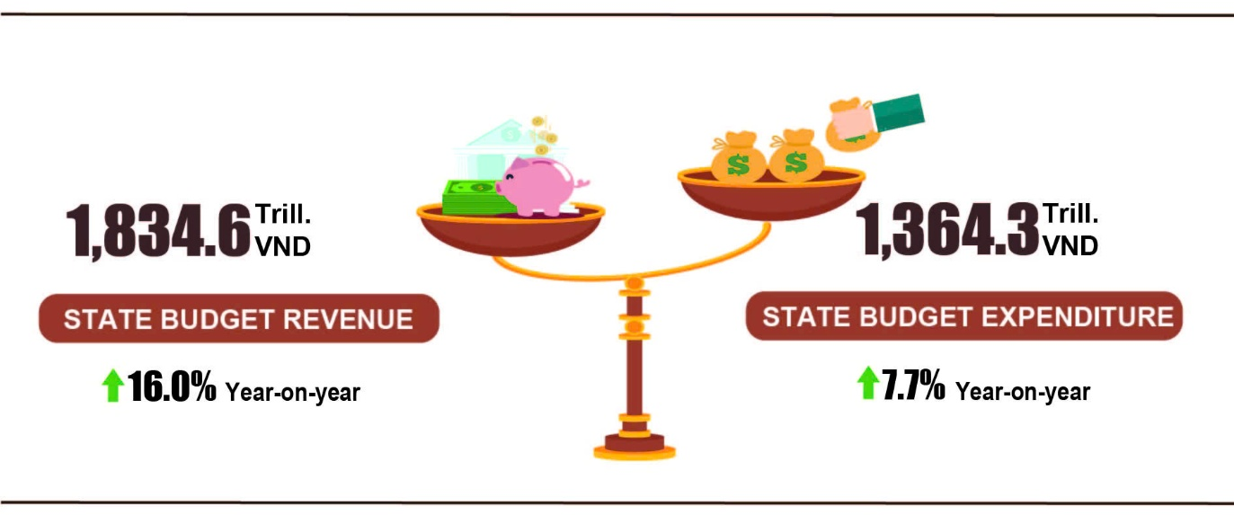
Total state budget revenue in July 2026 was estimated at 259.7 trillion VND. The total state budget revenue accumulated in the seven months of 2026 was estimated at 1,834.6 trillion VND, reaching 72.5% of the annual estimate and going up by 16.0% over the same period last year. In particular, selected revenue items were as follows:
- Domestic revenue in July 2026 was estimated at 228.3 trillion VND. The accrued revenue in the 7 months of 2026 was estimated at 1,587.5 trillion VND, reaching 72.2% of the annual estimate. This figure accounted for 86.5% of total state budget revenue, representing a year-on-year increase of 16.0%.
- Oil revenue in July 2026 was estimated at 6.1 trillion VND. The accrued revenue in the 7 months of 2026 was estimated at 37.3 trillion VND, reaching 86.6% of the annual estimate. This figure accounted for 2.0% of total state budget revenue, representing a year-on-year increase of 29.6%.
- Revenue from budget balance of import-export activities in July 2026 was estimated at 25.1 trillion VND. The accrued revenue in the 7 months of 2026 was estimated at 208.8 trillion VND, reaching 75.1% of the annual estimate. This figure accounted for 11.4% of total state budget revenue, representing a year-on-year increase of 13.7%.
Total state budget expenditure in July 2026 was estimated at 215.4 trillion VND. In the 7 months of 2026, total state budget expenditure reached an estimated 1,364.3 trillion VND, reaching 43.2% of the annual estimate and marking a year-on-year increase of 7.7%. The state budget expenditure fully covered public salaries, pensions, and social allowances, while effectively maintaining social safety net policies. Specifically: Recurrent expenditure reached 875.0 trillion VND, equivalent to 48.4% of the annual estimate, this figure accounted for 64.1% of total state budget expenditure (up 1.4% YoY). Expenditure on development investment was 418.9 trillion VND, equivalent to 37.4% of the annual estimate, this figure accounted for 30.7% of total state budget expenditure (up 23.7% YoY). Interest payment was 68.4 trillion VND, equivalent to 56.5% of the annual estimate, this figure accounted for 5.0% of total state budget expenditure (up 8.5% YoY).
6. Trade, prices, transport and tourism
a) Retail sales of goods and services
Trade and service activities in July continued to maintain their growth momentum, with the retail sales of goods and services estimated to be up 14.5% YoY. For the seven months of 2026 cumulatively, overall retail sales of goods and services rose by 13.1% over the corresponding period last year, indicating that service activities continued to sustain their growth momentum, contributing positively to the overall growth of the service sector.
The retail sales of goods and services at current prices in July 2026 were estimated at 669.1 trillion VND, (+0.9% MoM and +14.5% YoY).
Of which, retail sales revenue of most commodity groups tended to increase compared to the previous month and the same period last year, as follows: timber and construction materials (+1.8% MoM and +22.8% YoY); repair of motor vehicles, motorcycles, and motorbikes (+1.5% MoM and +13.6% YoY); household appliances, tools, and equipment (+1.3% MoM and +9.6% YoY); means of transport (excluding automobiles, including spare parts) (+1.0% MoM and +6.3% YoY); the groups of food and foodstuff, garments, automobiles of all types, and other fuels (excluding petrol and oil) each rose by 0.9% MoM, and by 12.7%, 12.4%, 1.5%, and 24.9% YoY, respectively. Notably, revenue from the gemstones, precious metals, and related products group declined by 1.6% month-on-month in July, affected by a "confidence shock" in the domestic gemstone market; however, for the seven months of 2026 cumulatively, revenue from this group still increased by 12.7% over the same period in 2025.
Accommodation and food service activities increased by 2.8% month-on-month and by 19.0% year-on-year; travelling services rose by 7.8% and by 24.3%, respectively; other goods and services groups decreased by 1.8% month-on-month but increased by 14.1% year-on-year.
Table 3. Gross retail sales of goods and services at current prices
in the seven months of 2026
Trillion VND
 | Estimate  for July  2026 | Estimate  7 months of 2026 | Year-on-Year  Growth rate (%)
 | Estimate  for July  2026 | Estimate  7 months of 2026 | July  2026 | 7 months of  2026
Total | 669.1 | 4,555.8 | 14.5 | 13.1
Retail sales of goods | 500.3 | 3,441.2 | 13.6 | 12.7
Accommodation and food services | 88.9 | 580.6 | 19.0 | 15.9
Travelling services | 9.5 | 59.3 | 24.3 | 16.3
Other services | 70.4 | 474.7 | 14.1 | 12.6

Generally, for the seven months of 2026, the retail sales of goods and services at current prices reached an estimated 4,555.8 trillion VND, marking a 13.1% increase compared to the same period last year. Excluding the price factor, the growth rate stood at 7.5% (compared to a 7.4% increase in 2025).
Figure 10. Retail sales of goods and services at current prices
in the seven months of 2022-2026

The retail sales of goods in the seven months of 2026 were estimated at 3,441.2 trillion VND, accounting for 75.5% of the total and increasing by 12.7% year-on-year. Of which, turnover from the gemstones, precious metals and related products group rose by 28.2%; other goods increased by 18.8%; timber and construction materials and petroleum products of all types both increased by 15.2%; other fuels (excluding petrol and oil) rose by 15.1%. Retail sales of goods in seven months of 2026 of some localities saw a year-on-year increase including Da Nang (+14.2%); Quang Ninh (+14.0%); Ha Noi and Can Tho (+12.9%); Dong Nai (+12.8%); Hai Phong (+12.6%); Ho Chi Minh City (+12.1%).
The turnover from accommodation and food service activities in the seven months of 2026 was estimated at 580.6 trillion VND, accounting for 12.7% of the total turnover and increasing by 15.9% over the same period last year. Turnover in seven months of 2026 compared to the same period last year in some localities saw a year-on-year increase including Quang Ninh and Khanh Hoa (+20.4%); Da Nang (+20.0%); Lam Dong (+19.3%); Hue (+19.2%); Thanh Hoa (+16.8%); Hai Phong (+15.8%); Ha Noi (+14.8%); Ho Chi Minh City (+14.4%); Can Tho (+13.0%).
The turnover of travelling in the seven months of 2026 was estimated at 59.3 trillion VND, accounting for 1.3% of the total and a year-on-year growth of 16.3%. Turnover in seven months of 2026 of some localities saw a year-on-year increase including Lam Dong (+39.6%); Khanh Hoa (+30.1%); Hue (+28.5%); Quang Ninh (+26.4%); Lao Cai (+21.0%); Ha Noi (+15.2%); Da Nang (+14.0%); Ho Chi Minh City (+13.9%).
The turnover of other services in the seven months of 2026 was estimated at 474.7 trillion VND, accounting for 10.4% of the gross and increasing by 12.6% year-on-year. Turnover in seven months of 2026 of some localities saw a year-on-year increase including Hue (+29.8%); Quang Ninh (+27.9%); Khanh Hoa (+23.2%); Gia Lai (+20.8%); Ninh Binh (+20.3%); Hai Phong, Nghe An, and Dong Nai (+16.7%); Ha Noi (+10.9%); Ho Chi Minh City (+9.3%).
b) Export and import of goods
In July, the total export and import turnover of goods reached 109.75 billion USD, a month-on-month increase of 5.3% and a year-on-year increase of 33.0%. Generally, in the seven months of 2026, the total export and import turnover of goods reached 659.58 billion USD, going up 28.1% over that in the same period last year, of which exports increased by 21.7%; and imports increased by 34.8%, reflecting the strong growth momentum of export and import activities. However, imports growing faster than exports resulted in a trade deficit of 20.52 billion USD, mainly due to the rising demand for imports of raw materials, machinery and goods serving production and investment.
Figure 11. Export and import of goods in the seven months of 2026
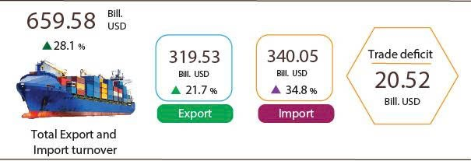
Export of goods
The export turnover of goods in July 2026 reached 53.08 billion USD, increasing by 4.5% over the previous month. Of which, the domestic economic sector reached 10.27 billion USD, going up 2.7%; while the FDI sector (including crude oil) reached 42.81 billion USD, going up 5.0%. Compared to the same period last year, the export turnover of goods in July increased by 25.0%, of which the domestic economic sector increasing by 14.0%, the FDI sector (including crude oil) expanding by 27.9%.
Overall, in the seven months of 2026, the export turnover reached 319.53 billion USD, increasing by 21.7% over the same period last year. Of which, the domestic economic sector reached 63.64 billion USD, rose by 5.8%, accounting for 19.9% of the total export turnover; the FDI sector (including crude oil) attained 255.89 billion USD, went up by 26.4%, accounting for 80.1%.
In the seven months of 2026, there were 31 export items with a value exceeding 1 billion USD, accounting for 93.0% of the total export turnover (including 7 items recorded export values of over 10 billion USD, accounting for 69.7%).
Table 4. Value of selected export products in the seven months of 2026
 | Value  (Mill. USD) | Growth rate Y-o-Y (%)
Products with a value of over 10 billion USD
Electronic goods, computers and their parts | 85,172 | 50.1
Machinery, instrument, accessory | 40,151 | 24.6
Phones all of kinds and their parts | 38,499 | 18.6
Textiles and sewing products | 22,863 | 1.1
Footwear | 14,185 | 0.7
Means of transport and spare parts | 11,629 | 16.3
Wood and wood products | 10,210 | 5.6
Regarding the structure of exported goods in the seven months of 2026, the group of manufactured products reached 287.91 billion USD, accounting for 90.1%; the group of agricultural and forestry products reached 22.79 billion USD, accounting for 7.1%; the group of fishery products attained 6.86 billion USD, accounting for 2.2%; and the group of fuels and minerals reached 1.97 billion USD, accounting for 0.6%.
Figure 12. Structure of exported goods
in the seven months of 2026
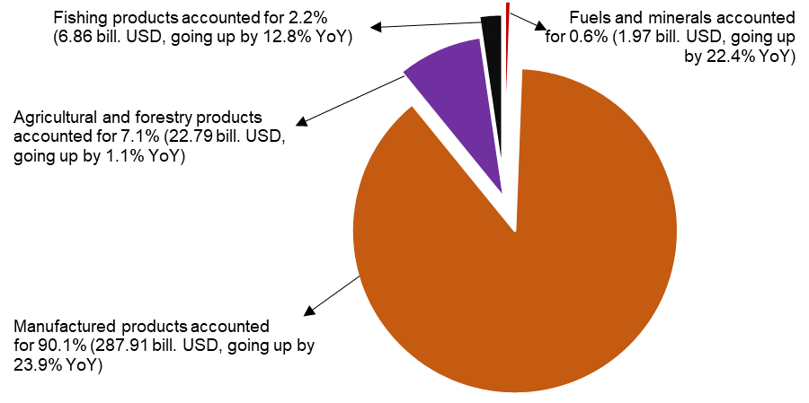
Import of goods
Import turnover of goods in July 2026 reached 56.67 billion USD, a rise of 6.1% over the previous month. Of which, the domestic economic sector reached 13.8 billion USD, decreasing by 2.8%; and the FDI sector reached 42.87 billion USD, increasing by 9.3%. Compared with the same period last year, the import turnover of goods in July increased by 41.4%, of which the domestic economic sector increased by 23.7%; and the FDI sector increased by 48.2%.
Overall, in the seven months of 2026, the import turnover of goods reached 340.05 billion USD, a year-on-year surge of 34.8%, of which, the domestic economic sector reached 92.14 billion USD, an upturn of 24.1%; and the FDI sector reached 247.91 billion USD, an expansion of 39.2%.
In the seven months of 2026, there were 40 imported products with their value exceeding 1 billion USD, accounting for 93.0% of the total import turnover (including 2 imported products with the value of over 10 billion USD, accounting for 52.0%).
Table 5. Value of some imported goods in the seven months of 2026
 | Value  (Mill. USD) |  | Growth rate year-on-year (%)
Products with a value of over 10 billion USD
Electronic goods, computers and their parts | 135,802 |  | 65.9
Machine, equipment, tools and instruments | 41,069 |  | 22.7

Regarding the structure of imported goods in the seven months of 2026, the group of capital goods reached 319.95 billion USD, accounting for 94.1%, of which the group of machine, equipment, tools and instruments accounted for 56.9%; the group of fuels, raw materials accounted for 37.2%. The group of consumer goods reached 20.1 billion USD, accounting for 5.9%.
Figure 13. Structure of imported goods
in the seven months of 2026
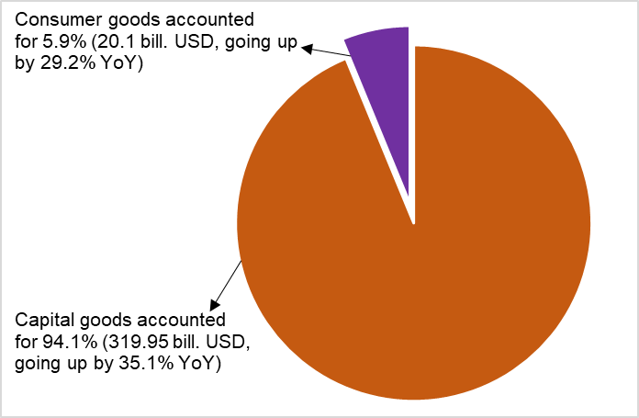
Regarding export and import markets of goods in the seven months of 2026, the United States was Viet Nam's largest export market with a turnover of 104.7 billion USD. China remained Viet Nam's largest import market with a turnover of 138.6 billion USD. In the seven months of 2026, the trade surplus to the United States and EU reached 91.4 billion USD and 26.6 billion USD, respectively, with the corresponding year-on-year surge of 22.6% and 19.9%; the trade surplus to Japan reached 1.5 billion USD, an upturn of 12.5%; the trade deficit to China, Korea Rep., ASEAN was 93.0 billion USD, 32.4 billion USD, 12.2 billion USD, respectively, gaining an equivalent expansion of 39.7%, 86.9% and 45.8%.
Figure 14. Major commodity export and import markets
in the seven months of 2026
 |  | Export of goods | Import of goods
According to preliminary data, the trade balance of goods recorded a deficit of 3.59 billion USD in July. Overall, in the seven months of 2026, the trade balance of goods posted a deficit of 20.52 billion USD (a surplus of 10.35 billion USD in the same period last year). Of which, the domestic economic sector recorded a trade deficit of 28.5 billion USD; while the FDI sector (including crude oil) recorded a trade surplus of 7.98 billion USD.
c) Consumer price index, gold and US dollar price index
The Consumer Price Index (CPI) in July witnessed a month-on-month decrease of 0.12%, mainly due to a decline in gasoline, oil prices which tracked shifting global fuel trends, a reduction in the prices of food and foodstuff thanks to abundant supply. The CPI in July saw an increase of 3.08% compared to December 2025 and a year-on-year rise of 4.45%.
In general, the CPI in the seven months of 2026 possessed a year-on-year expansion of 4.39%; core inflation experienced an upturn of 4.19%.
The CPI in July witnessed a MoM fall of 0.12%, of which 3 groups of goods and services recorded a price contraction and 8 groups of goods and services experienced price increases.
Figure 15. Month-on-month CPI growth rate (%)

- Three groups of goods and services recorded a decline in CPI:
(i) The transport group witnessed a MoM decrease of 2.02% (contributing to a decline of 0.20 percentage point in the overall CPI), mainly due to a fall of 4.35% in gasoline prices and a shrink of 9.18% in diesel prices, the impacts of adjustments to the prices of domestic fuel in line with world price fluctuations. Besides, the price of passenger transported by airway, road dropped 3.24%, and 0.26%, respectively; the prices of new and used car declined by 0.20% and 0.10% respectively. In contrast, the CPI of some commodity groups possessed a MoM increase: vehicle parts (+0.41%) due to increasing costs of component import; vehicle maintenance (+0.20%) due to rising costs of labor.
(ii) The group of food and foodstuff service experienced a shrink of 0.07% (contributing to a reduction of 0.03 percentage point in the overall CPI), including a decline of 0.50% in the CPI of food; a fall of 0.07% in foodstuff; whereas an upturn of 0.12% in eating out.
(iii) The group of housing, electricity, water, fuel, and construction materials witnessed a reduction of 0.07% (contributing to a downturn of 0.02 percentage point in the overall CPI), mainly due to a sharp plunge of 11.41% in the prices of cooking gas prices in line with the world prices; a contraction of 1.19% in kerosene price stemming from the impacts of price adjustments in the month. Conversely, the price of some services increased, including house rent (+0.41%); environmental sanitation services (+1.96%); household electricity (+1.55%), and tap water (+0.27%) due to increasing demand for electricity and water during hot weather.
- Eight groups of goods and services experienced an increase in CPI, including:
(i) The group of medicines and health care services jumped up 0.07% due to rising prices of some drugs resulting from increasing costs of transport and import. Specifically, the CPI showed an increase in anti-infection and non-steroidal pain relief and fever reducing drugs, gout and bone disease medications (+0.28%); respiratory drugs (+.21%); anti-parasitic drugs (+0.18%); anti-allergic and hypersensitive drugs (+0.16%); and outpatient medical examination and treatment services (+0.05%).
ii) The group of information and communication climbed up 0.10%, of which the prices of phone repair service (+0.86%); telecommunication services (+0.26%). In contrast, prices of smartphone and tablet accessories (-0.80%); feature phones (-0.27%); color televisions (-0.24%); and landline phones, smartphones, and tablets (-0.18%).
(iii) The group of household equipment and goods edged up 0.14% due to rising costs of raw material and labor, increasing demands for purchase of cooling equipment and items for summer tourism. Of which, prices of some items increase, for example other electric appliances and devices (+0.84%); electric lighting (+0.60%); beds, wardrobes, tables, and chairs (+0.32%); indoor textiles (+0.24%); glassware, ceramic and porcelain products (+0.20%); soap and detergents (+0.18%); and electric fans (+0.07%). In contrast, prices of items witnessed a decrease, including electric irons (-0.63%); washing machines (-0.46%); electric cookers (-0.38%); bathroom water heaters (-0.31%); and microwave ovens, ovens, and induction stoves (-0.13%).
(iv) The group of garment, hat and footwear accelerated by 0.16% due to rising cost of raw material and labor and increasing demands for purchase of items for summer tourism. Of which, the CPI of garments services expanded by 0.30%; footwear (+0.24%); ready-made clothes (+0.15%); and hats (+0.12%). In contrast, footwear services dropped 0.29%; fabrics off all kinds (-0.11%); and other clothes (-0.06%).
(v) The group of beverages and tobacco soared by 0.18% due to increasing costs of production and high demand for consumption during the hot weather. Of which, the prices mineral water added up 1.28%; carbonated soft drinks (+0.40%); bottled, canned, and boxed energy drinks (+0.27%); cigarettes (+0.22%); alcohol of all kinds (+0.20%); fruit juices (+0.02%); whereas the prices of beer slightly decreased by 0.02%.
(vi) The education group rose by 0.24%, mainly due to upward adjustment of tuition fees in some educational institutions and training centers. Besides, the price of pens of all kinds expanded by 0.66%; paper products (+0.54%); and stationery and other school supplies (+0.47%).
(vii) The group of culture, entertainment, and tourism jumped up 0.52%. Of which, package tours (+1.26%) (domestic tourism and outbound tourism soared by 1.39%; 0.48%, respectively) due to increasing demands for tourism during summer and raising costs of tour organization, especially costs of transport, accommodation, and tourism services; hotels and guesthouses accelerated by 0.40%; books, newspapers, and magazines of all kinds (+0.21%); and sports services (+0.17%). In contrast, the prices of children's toys shrunk by 0.13%; sports equipment (-0.10%); and cultural equipment (-0.03%).
(viii) The groups of other goods and services soared by 1.96%, mainly due to a surge of 7.90% in health insurance contributions in accordance with the adjustment of newly base salary. Besides, the price of haircut and hair washing services edged up 0.67%; personal care services (+0.60%)... In contrast, the price of jewelry decreased by 1.53% in line with the downward trend of domestic gold prices.
The average CPI in the seven months of 2026 witnessed a YoY increase of 4.39%, of which the housing, electricity, water, fuel, and construction materials experienced the highest surge of 6.72% (contributing to a soar of 1.53 percentage points in the overall CPI); transport (+5.01%) (contributing to a jump of 0.50 percentage points in the overall CPI); food and foodstuff services (+4.77%) (contributing to an expansion of 1.71 percentage points in the overall CPI); other goods and services (+4.25%) (contributing to an upturn of 0.15 percentage points in the overall CPI); beverages and tobacco (+3.60%) (contributing to a climb of 0.06 percentage points in the overall CPI); education (+3.35%) (contributing to a rise of 0.20 percentage points in the overall CPI); and household equipment and goods (+2.72%) (contributing to an increase of 0.14 percentage points in the overall CPI); culture, entertainment, and tourism (+2.58%) (contributing to growth of 0.08 percentage points in the overall CPI); garment, hats, and footwear (+2.0%) (contributing to an increase of 0.07 percentage points in the overall CPI); medicines and health care services (+1.06%); and information and communication (+0.03%).
Core inflation in July experienced a MoM increase of 0.33 and a YoY rise of 4.63%. On average, the core inflation in seven months of 2026 recorded a YoY expansion of 4.19%, lower than a surge of 4.39% in the overall CPI resulting from significant fluctuations in the prices of gasoline, gas, and food that caused an increase in the overall CPI, were excluded from the calculation of core inflation.
Domestic gold prices fluctuated in line with world gold prices. The average price of world gold in July (as of July 25, 2026) was 4,086 USD/ ounce, a MoM decline of 4.62%. The decline in world gold prices caused by US Federal Reserve’s (FED) continuous maintenance of the cautious monetary stance as well as the maintenance of strong US dollar, and profit-taking by investors after a period of the gold price’s spike. Domestic price index of gold in July saw a MoM decrease of 3.02%; a YoY spike of 19.15%; and a plummet of 5.66% compared to that in December 2025. The average gold price index in seven months of 2026 possessed a YoY shoot of 51.86%.
Domestic US dollar prices witnessed a slightly increase in line with international market prices. The US dollar continued to be supported by the FED continuous maintenance of its cautious monetary policy as well as the maintenance of high interest rates. Besides, the positive US economic indicators raised the expectations of FED implementation of loose monetary policy, leading to increasing demand for holding USD. The average US dollar prices in the international market in July (as of July 25, 2026) reached 100.81 points, a MoM rise of 0.76 points. Domestic US dollar price index in July possessed a MoM expansion of 0.18%; a YoY soar of 0.38%; and an expansion of 0.01% compared to that in December 2025. On average, the US dollar price index in seven months of 2026 experienced a YoY upturn of 1.55%.
d) Passenger and cargo transport
Transport activities in July 2026 continued to be dynamic, meeting the travel demand of domestic residents as well as international visitors to Viet Nam, while ensuring the efficient movement of goods, contributing to the promotion of trade, tourism, and economic growth. Compared to the same period last year, passenger carried and passenger carried (passenger-kilometers) in July 2026 saw a YoY increase of 16.9% and 13.5%, respectively; freight transported and freight transported (ton-kilometers) recorded a YoY rise of 17.0% and 16.1%, respectively.
Overall, in the seven months of 2026, passenger carried and passenger carried (passenger-kilometers) experienced a YoY rise of 18.0% and 12.4%, respectively; freight transported and freight transported (ton-kilometers) recorded a YoY increase of 14.9% and 12.3%, respectively.
Passenger carried in July 2026 was estimated at 620.7 million turns of passengers, a MoM increase of 3.1%, a YoY rise of 16.9%; and passenger carried (passenger-kilometers) reached 30.9 billion passenger-kilometer, a MoM rise of 5.0% and a YoY growth of 13.5%. Overall, in seven months of 2026, the passenger carried was estimated at 4,007.1 million turns of passengers, a YoY increase of 18.0% and passenger carried (passenger-kilometers) reached 201.6 billion passenger-kilometer, a rise of 12.4%. Of which, domestic passenger carried was estimated at 3,995.3 million turns of passengers, a YoY increase of 18.1%, domestic passenger carried (passenger-kilometers) was 164.4 billion passenger-kilometer, a YoY upturn of 14.7%; overseas passenger carried was estimated at 11.8 million turns of passengers, a YoY expansion of 4.2%, and overseas passengers carried (passenger-kilometers) reached 37.2 billion passenger-kilometer, going up by 3.2%.
Table 6. Passenger carried in the seven months of 2026 by type of transport
 | Number of passengers |  |  | YoY growth rate (%)
 | Carried  (Mill. Passengers) | Carried (passenger-kilometers)  (Bill. passenger-km) |  | Carried | Carried (passenger-kilometers)
Total | 4,007.1 | 201.6 |  | 18.0 | 12.4
Rail way | 28.7 | 2.2 |  | 22.5 | 1.6
Maritime transport | 7,8 | 0.7 |  | 1.9 | 19.9
Inland water way | 261.1 | 6.3 |  | 6.3 | 17.3
Road | 3,674.7 | 135.4 |  | 19.1 | 17.0
Airway | 34.8 | 57.0 |  | 3.4 | 2.6
Freight transported in July 2026 was estimated at 294.3 million tons,
a MoM increase of 0.9%, a YoY rise of 17.0%; and freight transported (ton-kilometers) reached 61.8 billion ton-kilometer, a MoM upturn of 2.5%, a YoY increase of 16.1%. Overall, in seven months of 2026, freight transported was estimated at 1,933.2 million tons, a YoY increase of 14.9% and freight transported (ton-kilometers) reached 387.6 billion ton-kilometer, a YoY increase of 12.3%. Of which, domestic freight transported was estimated at 1,899.2 million tons, an upturn of 14.9%, domestic freight transported (ton-kilometers) reached 219.0 billion ton-kilometer, up by 11.7%; overseas freight transported was estimated at 34.0 million tons, increasing by 16.6%, and overseas freight transported (ton-kilometers) was 168.6 billion ton-kilometer, up 13.0%.
Table 7. Freight transported in the seven months of 2026 by type of transport
 | Volume of freight |  |  | YoY growth rate (%)
 | Transported  (Mill. tons) | Transported  (ton-kilometers)  (Bill. ton-km) |  | Transported | Transported (ton-kilometers)
Total | 1,933.2 | 387.6 |  | 14.9 | 12.3
Rail way | 2.7 | 2.2 |  | -14.9 | -4.0
Maritime transport | 98.9 | 201.0 |  | 11.6 | 9.0
Inland water way | 391.4 | 88.1 |  | 12.2 | 16.5
Road | 1,439.9 | 90.3 |  | 15.9 | 17.1
Airway | 0.3 | 6.0 |  | 0.1 | 3.8
đ) International visitors to Viet Nam
Viet Nam continued to be an attractive destination for international tourists thanks to its favorable visa policies, intensified promotion and marketing efforts, and the diversification of tourism products and advantages in natural landscapes, rich culture, cuisine, and reasonable travel costs. As a result, the number of international visitors to Viet Nam in the seven months of 2026 reached 13.9 million arrivals, a YoY increase of 13.8%.
In July 2026, international visitors to Viet Nam reached an estimated 1.67 million arrivals, a MoM decrease of 0.7% but a YoY increase of 6.6%. Overall, in seven months of 2026, international visitors were estimated at 13.9 million arrivals, up 13.8% YoY. Of which, arrivals by airway reached 11.5 million arrivals, accounting for 82.8% of total international visitors to Viet Nam and rising by 10.7% YoY; arrivals by road reached 2.2 million arrivals, accounting for 15.7% and increasing by 33.6%; arrivals by seaway reached 210.9 thousand arrivals, accounting for 1.5% and rising by 14.7%.
Figure 16. International visitors to Viet Nam in the 7 months of 2026 by territory

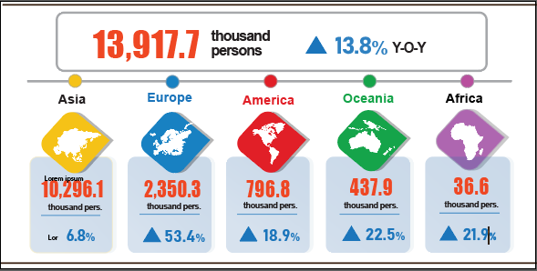
7. Social situation
In July, people’s living conditions remained stable, and attention to social security work, was paid and implemented in a timely and effective manner. On the occasion of the 79th anniversary of Invalids and Martyrs Day (July 27th, 1947 - July 27th, 2026), activities to visit, present gifts, and provide healthcare for wounded and sick soldiers, Heroic Vietnamese Mothers, martyrs' relatives, and national devotees were thoughtfully organized, reflecting the traditional virtue of “When drinking water, remember its source” and expressing gratitude to those who sacrificed and devoted themselves to the cause of national liberation and Fatherland protection.
a) People's living conditions
According to preliminary results of the Labour Force Survey, people's living conditions in July generally remained stable. The proportion of households reporting that their income in the month remained unchanged or increased compared to the same period last year was 96.7% (a decrease of 0.2 percentage points compared to the June reporting period and a year-on-year increase of 0.5 percentage points); 3.3% of households said that their income decreased or was undetermined.
Among households reporting an increase in income, 68.0% of households attributed it to increased wages and salaries of household members; 35.8% of households reported growth in income from agriculture, forestry, and fishery activities; and 21.3% of households identified increased income from non-farm production, business, and service activities.
Of the households with decreased income, 34.5% of households pointed to an increase in input costs for their production and business activities; 27.6% of households indicated a decline in the selling prices of products from household production and business activities; 25.6% of households noted that household members suffered from severe illness, injury, or death; 20.3% of households identified that a household member was temporarily out of work; and 19.9% of households cited a reduction in the scale of their production and business activities.
Regarding the impact of negative events on people’s living conditions in the seven months of 2026, households evaluated as follows: 35.9% of households were impacted by rising prices of goods and services; 7.6% of households were impacted by natural disasters and climate change; 3.7% of households were affected by epidemics in livestock or crops; 2.9% of households were affected by human epidemics; 2.1% of households were affected by household member suffering from severe illness, injury, or death; and 0.5% of households were impacted by fires or explosions.
In the seven months of this year, 18.5% of interviewed households received assistance from various sources. Specifically, the proportion of households receiving support from national programs and policies was 9.0%; from local programs and policies was 7.3%; from relatives and family members was 10.2%; from charitable activities of organizations or individuals was 2.2%; and from other sources was 0.07%.
Social security activities have always been prioritized and implemented by authorities at all levels. In July (as of July 26th, 2026), the Government provided over 283.2 tons of rice to the people for relief from natural disasters and floods. From the beginning of this year, the Government provided 18.1 thousand tons of rice to the people, of which: nearly 9.1 thousand tons for hunger relief during the Lunar New Year for 604.6 thousand persons; more than 8.2 thousand tons for pre-harvest hunger relief for 547.2 thousand persons; and over 887.4 tons for natural disaster and flood relief for 59.1 thousand persons.
b) Gratitude to national devotees
Towards the 80th anniversary of Invalids and Martyrs Day (July 27th, 1947 - July 27th, 2027), the “500-day-and-night campaign to accelerate the search, collection, and identification of martyrs’ remains” has been being drastically deployed by authorities at all levels, sectors, units, and localities. Over the past period, the campaign has focused on synchronously carrying out tasks of searching for and collecting martyrs' remains; collecting, storing, and evaluating DNA samples; building databases for information matching; as well as conducting mine and explosive clearance in areas with many war relics and suspected grave locations.
As of July 26th, 2026, forces have found and collected 1,491 martyrs' remains, including 467 remains domestically, 174 remains in Laos, and 850 remains in Cambodia. Particularly in Tuyen Quang, 5 mass graves containing about 23 martyrs' remains were discovered; in the Le Thi Rieng Park area (Ho Chi Minh City), 104 martyrs' remains along with 5 collective martyrs' remains (about 13 martyrs' remains) were found. Along with the collection work, localities and units organized 13 memorial and burial ceremonies for martyrs' remains, receiving and reinterring 735 martyrs' remains. In addition, units received, stored, and preserved 15,729 martyrs' remains samples from localities nationwide.
The campaign has accelerated DNA sampling and the construction of a large-scale DNA database to identify information-lacking martyrs' remains. Authorities conducted sampling for 80,882 martyrs' graves, of which 56,425 graves were eligible for sampling, reaching a rate of 69.76%. As a result, 250,000 relatives' samples were collected, of which 66,000 samples were analyzed and synchronized into the DNA database for information matching and verification.
c) Epidemic and food poisoning
According to the report of the Ministry of Health, in the month (June 18th – July 17th, 2026), there were 6,279 cases of dengue fever (1 death); 3,888 cases of hand, foot and mouth disease; 359 cases of rash fever with suspected measles, 24 cases of viral encephalitis, 6 deaths from rabies. Overall, from the beginning of the year to date, there were over 61.6 thousand cases of dengue fever (8 deaths); nearly 58.7 thousand cases of hand, foot and mouth disease (10 deaths); nearly 4,800 cases of rash fever suspected of measles; 178 cases of viral encephalitis (1 death); 31 cases of meningococcal meningitis (5 deaths); and 40 deaths from rabies in the whole country.
As of July 17th, 2026, the total number of people living with HIV nationwide was 257.2 thousand persons; the number of deaths from HIV/AIDS was 119.2 thousand persons.
Regarding food poisoning, in July, there were 8 cases of poisoning, causing 749 persons poisoned. Overall, in 7 months 2026 (from December 18th, 2025 to July 17th, 2026), there were 55 cases with 2,600 persons poisoned (7 deaths) nationwide.

d) Culture and sports
Regarding culture, in July, cultural activities focused on paying tribute to those who rendered meritorious service to the nation and promoting education on the country's revolutionary traditions in commemoration of the 79th anniversary of War Invalids and Martyrs' Day (July 27th, 1947 - July 27th, 2026), alongside numerous cultural and artistic events held nationwide. Many localities organized incense-offering ceremonies at martyrs' cemeteries, visited and presented gifts to people with meritorious service to the revolution, while also holding art performances, exhibitions, and communication activities promoting the traditions of "Never forget where you came from" and "Repaying those who have served the nation". A highlight was the "Guiding Stars" programme honouring fallen heroes and martyrs, which was held simultaneously at four venues on the evening of July 26th, 2026. The Ministry of Culture, Sports and Tourism organized a nationwide free film screening campaign from July 22nd to July 28th, 2026, together with various cultural programmes serving the public, contributing to the promotion of patriotism and the strengthening of national solidarity. In addition, numerous exhibitions and cultural and fine arts exchange activities were organized, contributing to the promotion of Vietnamese cultural values, the enhancement of international cultural cooperation, and the preservation and promotion of the country's cultural heritage and fine arts.
Regarding high-performance sports, in July, several major sporting events took place, including the 2026 Asian Dance Sport Championship, held in Ho Chi Minh City from July 8th to July 12th, 2026; the National Outstanding Junior and Youth Badminton Championships, held in Bac Ninh from July 13th to July 20th, 2026; and a long-term training camp of the Viet Nam national artistic gymnastics team in China from July 12th to September 5th, 2026, in preparation for the 20th Asian Games (ASIAD 20), scheduled to be held in Japan in September 2026.
Regarding mass sports, in July, numerous sporting events were organized for different groups of participants, notably the Ha Noi Summer Sports Games, held in Ha Noi from July 1st to August 7th, 2026; the National Swimming and Chess Championships for Persons with Disabilities, held in Ha Noi from July 4th to July 8th, 2026; and the National Outstanding Roller Sports Championships, held in Ha Noi from July 4th to July 5th, 2026.

đ) Traffic accidents
In July (from June 15th to July 14th, 2026), there were 1,167 traffic accidents nationwide, causing 700 deaths and 693 injuries. Compared to the figures of June 2026, the number of traffic accidents, deaths, and injuries decreased by 8.3%, 10.9%, and 7.2%, respectively. Compared to the figures of the same period in 2025, the number of accidents, deaths, and injuries decreased by 21.5%, 21.8%, and 27.1%, respectively.
In the seven months of 2026, there were 8,940 traffic accidents nationwide, causing 5,577 deaths and 5,179 injuries. Compared to the figures of the same period last year, the number of traffic accidents cases, deaths, and injuries decreased by 18.0%, 10.4%, and 27.9%, respectively. On average, during seven months of 2026, there were 42 traffic accidents occurred a day, causing 26 deaths and 24 injuries.
e) Disaster-induced loss
Natural disasters in July caused 16 deaths and missing persons, 11 injuries; damaged over 3,500 hectares of rice and crops; destroyed, swept away, or damaged 971 houses; total property losses caused by natural disasters in the month was 831.1 billion VND, a YoY decrease of 84.9%. Overall, in seven months of 2026, natural disasters caused 44 deaths and missing persons, 75 injuries; damaged 35.4 thousand hectares of rice and other crops; destroyed, swept away, or damaged more than 7.9 thousand houses. The total property losses caused by natural disasters were estimated at 1,936.1 billion VND, a YoY decrease of 73.7%.
g) Environmental protection and fire and explosion prevention
During the month (from June 26th to June 23rd, 2026), authorities detected 1,909 cases of environmental violations in 33 out of 34 localities, of which, 1,053 cases were addressed with a total fine of 21.5 billion VND, representing a MoM decrease of 37.2% and a YoY increase of 77.8%. Overall, in seven months of 2026, authorities detected 11,549 cases of environmental violations, of which, 8,877 cases were addressed with total fines of 166.1 billion VND, representing a YoY increase of 30.0%.
During the month (from June 15th to July 14th, 2026), 241 cases of fire and explosion occurred nationwide, causing 7 deaths and 13 injuries, with an estimated losses of 27.6 billion VND, a MoM decrease of 85.2% but a YoY increase of 48.9%. Overall, in seven months of 2026, there were 1,752 cases of fire and explosion nationwide, causing 60 deaths and 82 injuries, with estimated damages of 602.2 billion VND, 3 times higher than the same period last year.

Recipients:  - General Secretary;  - President;  - Chairperson of the National Assembly;  - Prime Minister;  - Deputy Prime Ministers;  - Leaders of Ministry of Finance;  - Agencies under the Central Committee of the Party;  - Office of the President;  - Agencies under the National Assembly;  - Ministries and Ministerial-level Agencies, Government agency;  - The Supreme People’s Court of the Socialist Republic of Viet Nam;  - The Supreme People's Procuracy;  - Central mass organizations;  - Provinces and centrally governed cities;  - Viet Nam Chamber of Commerce and Industry (VCCI);  - Units under the Ministry of Finance;  - News agencies and presses;  - Units under the National Statistics Office;  - Archives: Office Administration, Integrated Statistics and Foreign Affairs Department | DIRECTOR GENERAL  Nguyen Thi Huong

The repurposing of the land use of the winter-rice was as follows: 7.5 thousand hectares to aquaculture; 1.8 thousand hectares to perennial crops; 1.2 thousand hectares to other annual crops; and 6.7 thousand hectares to non-agricultural land.
Figures released by the Agriculture and Environment Newspaper. The live weight pig prices on July 27th, 2026: https://nongnghiepmoitruong.vn/gia-heo-hoi-hom-nay-27-7-2026-nhieu-noi-giam-them-1000-dong-d823243.html.
Localities recorded with a surge of afforestation progress, year-on-year including Ha Tinh (+136.6%), Tuyen Quang (+40.2%), Gia Lai (+34.9%), and Thai Nguyen (+23.9%).
Data from the Ministry of Agriculture and Environment, as of June 15th, 2026.
Localities recorded with a leap of forest fire area including Quang Tri (+367.6 ha), Ninh Binh (+116.6 ha), and Dak Lak (+15.0 ha).
Reported by provincial statistical reports, the price of commercial pangasius (sized 800g–1kg) in the Mekong River Delta ranged from 28,000 to 31,000 VND/kg.
Source: https://tepbac.com/gia-thuy-san In Mekong River Delta, the price of white leg shrimp (sizes ranging from 50 to 100 shrimp/kg) fluctuated between 85,000 and 130,000 VND/kg, while black tiger shrimp (sizes ranging from 30 to 40 shrimp/kg) ranging from 140,000 to 175,000 VND/kg.
The local month-on-month changes in IIP in July for the provinces and municipalities with large industrial production scales were as follows: Can Tho up 4.4%; Dong Nai up 1.8%; Ho Chi Minh City up 1.7%; Da Nang up 0.9%; Hai Phong down 0.8%; Bac Ninh down 3.0%; Quang Ninh down 7.5%; Quang Ngai down 8.7%; and Vinh Long down 11.6%.
The growth/decline rates of the IIP in the seven months of 2026 compared with the same period of the previous year during the 2019–2026 period were as follows: 9.4%; 2.6%; 7.6%; 8.6%; -0.8%; 8.5%; 8.4%; and 11.4%, respectively.
The localities with high growth in the manufacturing and processing industry IIP in the 7 months of 2026 compared with the same period of the previous year were as follows: Ha Tinh (+34.6%); Quang Ninh (+33.6%); Ninh Binh (+27.4%); Nghe An (+25.0%); Phu Tho (+24.7%); and Thai Nguyen (+21.4%). The localities with surge in the IIP of electricity supply were as follows: Ha Tinh (+54.0%); Phu Tho (+13.7%); and Bac Ninh (+11.8%).
The localities with low growth or a decline of IIP in the manufacturing in the 7 months of 2026 compared with the same period of the previous year were as follows: Lai Chau (+3.6%); Lang Son (+2.2%); and Son La (-0.3%). The localities with low growth in the IIP of electricity supply in the 7 months of 2026 compared with the same period of the previous year were as follows: Lai Chau (+3.3%) and Gia Lai (+3.0%). The localities with a decline in the mining industry IIP in the 7 months of 2026 compared with the same period of the previous year were as follows: Can Tho (-49.1%); Tuyen Quang (-6.8%); and Gia Lai (-4.3%).
According to the report of the Foreign Investment Agency, Ministry of Finance, received on August 1st, 2026.
Data received from the State Budget Department - Ministry of Finance on July 31st, 2026.
The 2026 target for the ratio of recurrent expenditure to total state budget expenditure was set at 57.3%.
The 2026 target for the ratio of development investment expenditure to total state budget expenditure was set at 35.5%.
The value of export turnover was calculated at F.O.B price and import turnover was calculated at C.I.F price (including transportation and insurance costs of imported goods).
Preliminary data on exports and imports of goods in July 2026 provided by the Viet Nam Customs on August, 2nd, 2026.
The total export and import turnover of goods in seven months of 2025 amounted to 514.95 billion USD, going up 16.4% year-on-year, of which exports reached 262.65 billion USD, increasing by 14.9%; imports reached 252.30 billion USD, increasing by 17.9%.
Some commodities recorded high trade deficits: Electronic goods, computers and their parts posted a deficit of 50.6 billion USD; petroleum products, 6.1 billion USD; plastics materials, 5.8 billion USD; coal, 5.5 billion USD; crude oil, 4.6 billion USD; chemicals, 3.6 billion USD, and chemical products, 3.4 billion USD.
Of which: Bicycle tires and inner tubes (+0.56%); other bicycle parts (+0.55%); motorcycle tires and inner tubes (+0.47%); other motorcycle parts (+0.45%); and car parts (+0.14%).
The CPI of rice decreased by 0.80% (premium white rice; glutinous rice; regular white rice; and cracked white rice declined by 0.88%; 0.84%; 0.78%; 0.34%, respectively). The prices of rice prices fell due to increasing domestic supply resulting from harvest season of summer-autumn rice crop, abundant global rice supply, and decreasing demand for rice import in some major markets. The CPI of some other food items experienced a MoM shrink: potatoes (-0.80%); vermicelli, Pho noodles, and rice noodles (-0.20%); and other grains (-0.09%). In contrast, prices of corn (+1.37%); cassava (+0.30%); and wheat flour (+0.27%).
The CPI of pork (-0.76%), fresh seafood (-0.18%), and poultry (-0.16%), mainly due to abundant supply; sugar and syrup (-0.15%). In contrast, the CPI of eggs and all kinds (+1.25%); confectionery (+0.63%); spices (+0.55%); milk, butter, and cheese (+0.32%); fresh, dried, and processed vegetables (+0.23%) ((kohlrabi (+5.57%); cabbage (+2.08%); potatoes (+1.26%)); fresh and processed fruits (+0.20%), mangoes (+3.15%); pineapples, dragon fruit, and papayas (+0.61%)); tea, coffee, and cocoa (+0.04%).
Due to increasing demand for consumption during the summer and rising costs of operation such as shop rental, electricity, and water. Of which takeaway fast food (+0.41%); drinking out (+0.31%); and eating out (+0.04%).
The CPI household electricity and tap water in July reflected a one-month lag than other items because it was calculated basing on the revenue and consumption volume of June 2026.
The CPI after excluding the prices of fresh food, foodstuff, energy, and State-managed goods, which included healthcare and education services.
The reporting period was from June 26th, 2026 to July 25th, 2026.
A household could select multiple reasons.
Out of more than 20.5 thousand households participating in the survey in July, 562 households (2.8%) reported a decrease in income compared to the same period last year. Of these, the primary reasons were an increase in input costs for household production and business activities (34.5%, equivalent to 194 households); a decline in the selling prices of products from household production and business activities (27.6%, equivalent to 155 households); a household member suffering from severe illness, injury, or death (25.6%, equivalent to 144 households); a household member temporarily being out of work (20.3%, equivalent to 114 households); and a reduction in the scale of household production and business activities (19.9%, equivalent to 112 households).
According to a quick report from the Office of the Ministry of Public Security and the Viet Nam Maritime and Waterways Administration (Ministry of Construction) on July 23rd, 2026.
Compiled from reports submitted by 34 Provincial Departments of Agriculture and Environment, reporting period from June 22nd to July 23rd, 2026
According to data compiled by Provincial and centrally-governed cities Statistics Offices from the reports of Provincial Departments of Agriculture and Environment and Provincial Police Departments.
No environmental violations were detected in July in Lam Dong.
According to a quick report from the Ministry of Public Security dated July 23rd, 2026.

