MINISTRY OF FINANCE  NATIONAL STATISTICS OFFICE  ________________  No.: 327/BC-CTK | SOCIALIST REPUBLIC OF VIET NAM  Independence-Freedom-Happiness  ______________________________________  Ha Noi, September 3rd, 2026

REPORT
SOCIO - ECONOMIC PERFORMANCE
IN AUGUST AND 8 MONTHS OF 2026

1. Agriculture, forestry and fishing
Agricultural, forestry, and fishery production in August maintained stable growth. Agricultural production focused on cultivating and tending of rice and other winter and summer-autumn crops. However, the cultivation area of rice and other crops witnessed a year-on-year decline due to land-use conversion and unfavorable weather. Pig and poultry farming showed positive growth. Wood production rose significantly, driven by increased demand for raw materials of processing facilities. Aquaculture maintained a positive trend, supported by intensified farming practices, the application of science, technology, and stable market demand.
a) Agriculture
Summer-Autumn rice
As of August 20th, 2026, localities nationwide cultivated 1,870.0 thousand hectares of summer-autumn rice, a year-on-year (YoY) drop of 29.1 thousand hectares. Specifically, the Northern localities reached 167.5 thousand hectares (-4.9 thousand hectares) and the Southern localities reached 1,702.5 thousand hectares (-24.2 thousand hectares). The cultivated area of summer-autumn rice showed a year-on-year drop as some localities converted parts of summer-autumn rice land to other crops of higher economic value or reclaimed land for public infrastructure projects. Additionally, prolonged heatwaves in several areas causing shortage of irrigation water, leaving some land areas unsuitable for cultivation.
As of August 20th, 2026, summer-autumn rice that reached maturity and was ready for harvesting nationwide reached 723.7 thousand hectares, representing 38.7% of the sown area and 77.5% compared to the same period last year. The harvesting progress of the autumn-winter rice this year was recorded slower year-on-year mainly due to localities adjusted crops calendar and delayed sowing period to proactively deal with drought and water shortages. Of which, An Giang harvested 240.5 thousand hectares, equal to 47.8% of the sown area and 64.9% YoY; Can Tho harvested 159.2 thousand hectares, equal to 56.1% and 86.6% YoY; and Dong Thap harvested 145.4 thousand hectares, equal to 62.7% and 78.2% YoY. Regarding the remaining summer-autumn rice area, localities needed to closely monitor weather situations, pest outbreaks while guiding farmers to take advantage of favorable weather to rapidly harvest ripe rice and minimized losses.
Winter rice
As of August 20th, 2026, localities nationwide cultivated 1,312.5 thousand hectares, a year-on-year decrease of 50.7 thousand hectares. Specifically, the Northern localities reached 938.5 thousand hectares (-38.2 thousand hectares), while the Southern localities reached 374.0 thousand hectares (-12.5 thousand hectares). The reduction in winter rice area was driven by the conversion of inefficient rice land to annual or perennial crops, high-value aquaculture, and for public infrastructure and industrial zones. Additionally, some areas could not be sown due to challenging production conditions.
Annual crops
Along with rice cultivation, localities nationwide cultivated other crops. However, the area of some primary annual crops saw a year-on-year drop due to prolonged sunny and heatwaves, which causing irrigation water shortages in southern localities, negatively affected to production condition resulting the farmer reduced their cultivation area.
Figure 1. Cultivation area of annual crops
(As of August 20th 2026)
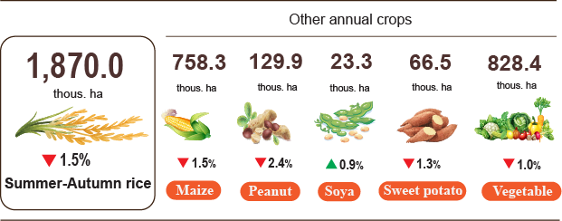
Livestock
Cattle and buffalo farming continued a downward trend due to low economic efficiency, shrinking natural grazing areas, reduced supply of green fodder, and high feed prices. Several localities experienced a year-on-year sharp decline in the number of buffalo including Thanh Hoa (-9.6% YoY), Tuyen Quang (-9.3% YoY), Quang Ngai (-8.7% YoY), Phu Tho (-7.0% YoY). Localities experienced significant declines in cattle numbers included Thanh Hoa (-8.5% YoY), Phu Tho (-5.6% YoY), Vinh Long (-5.1% YoY), Son La (-5% YoY), Dak Lak (-3.1% YoY), and Tay Ninh (-2.0% YoY). Conversely, localities that leveraged advantages in land availability and feed resources to develop commercial, farm-based livestock production incorporating breed improvement, confinement rearing, fattening, and the application of technical advancements, cattle numbers continued a month-on-month (MoM) growth, including: Dong Nai (+3.5% MoM), Lam Dong (+3.0% MoM), Nghe An (+2.5% MoM), and Da Nang (+1.2% MoM).
Pig farming achieved positive results. The corporate and large-scale farm sectors proactively prepared breeding stock and feed supplies, implementing closed-loop farming processes, and strengthening biosecurity measures. Several localities recorded a surge in pig numbers year-on-year, including: Cao Bang (+ 32.6% YoY), Gia Lai (+17.3% YoY), Phu Tho (+10.9% YoY), Quang Ngai (+ 6.8% YoY), Da Nang (+ 6.1% YoY), Ho Chi Minh City (+ 5.2% YoY), Lam Dong (+4.9% YoY), and Dong Nai (+4.4% YoY).
Poultry farming maintained positive growth, driven by the sector’s relatively strong adaptability to market fluctuations, short production cycles, rapid capital turnover, and stable consumer demand for meat and eggs. The development of closed-loop, enterprise-linked farm operations also enhanced disease control capabilities. However, the rising animal feed prices and fluctuating input costs impacted production efficiency, particularly for small-scale farmers.
Figure 2. Year-on-year growth rate of livestock and poultry number
at the end of August 2026
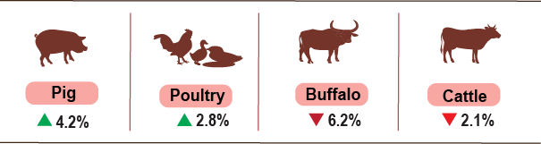
As of August 27th, 2026, the localities nationwide were recorded no outbreaks of blue-ear disease and foot-and-mouth disease; avian influenza persisted in Hung Yen, Ninh Binh, Cao Bang, Tuyen Quang, Dien Bien, Quang Ngai, Dong Nai, Dong Thap, and African swine fever persisted in 22 localities that have not yet passed the 21-days quarantine period.
b) Forestry
The area of newly planted forests nationwide in August was estimated to reach 21.3 thousand hectares, a year-on-year drop of 4.9%; the number of scattered forestry trees reached 6.0 million, (-4.8% YoY); The area of planted forests decreased during the month due to the implementation of local plans and hot weather in early August. Wood production reached 2,372.3 thousand cubic meters, (+4.4% YoY), driven by increasing demand for raw materials of wood processing facilities. Generally, in eight months of 2026, the area of newly planted concentrated forests was estimated to reach 180.8 thousand hectares, a year-on-year reduction of 3.4%, number of scattered forestry trees planted reached 63.9 million, (+1.6% YoY); and wood production reached 16,662.9 thousand cubic meters (+6.5% YoY).
The damaged forest area in august was 240.6 hectares, showing a 7.6-fold increase year-on-year including 37.4 hectares of forest cut or destroyed (+64.8% YoY), 203.2 hectares of forest fire, (+23.1-fold increase) caused by prolonged, widespread heatwaves and high temperatures across various localities. Additionally, violations of forest protection regulations resulting the increase in area of damaged forest. Generally, in eight months of 2026, the total area of damaged forest was estimated at 1,086.0 hectares, a year-on-year climb of 13.1%, of which, the logging and clearing area reached 374.5 hectares (-42.8% YoY), damaged area by forest fire was estimated at 711.5 hectares (+ 2.3-fold).
c) Fishing
Capture fisheries and aquaculture production in August were estimated to reach 991.3 thousand tones, a year-on-year growth of 4.4%, of which fish reached 680.4 thousand tones (+2.8% YoY), shrimp reached 176.2 thousand tones (+6.6% YoY), and other aquatic products reached 134.8 thousand tones (+9.4% YoY).
Aquaculture production in the month was estimated at 629.3 thousand tones, a year-on-year jump of 6.6%, of which fish reached 397.4 thousand tones (+4.9% YoY), shrimp reached 162.8 thousand tones (+7.0% YoY), and other aquatic products reached 69.1 thousand tones (+16.0% YoY). Generally, in the eight months of 2026, total aquaculture production was estimated at 4,253.9 thousand tons, a year-on-year growth of 6.0%, of which fish reached 2,716.6 thousand tones (+4.5% YoY), shrimp reached 1,097.4 thousand tones (+7.9% YoY), and other aquatic products reached 439.9 thousand tones (+10.7% YoY).
Pangasius production in August saw a year-on-year upward trend, thanks to the prices of commercial pangasius showed stability, ensuring supply for processing and export. Pangasius production in the month was estimated at 160.6 thousand tons, a year-on-year expansion of 4.5%. Generally, production in eight months of 2026 reached 1,250.7 thousand tons, (+4.8% YoY).
Shrimp production in the month witnessed a year-on-year upward trend driven by stable raw material prices and the adoption of high-tech, intensive, and super-intensive farming models that boosted yields, alongside consumption processing, and export saw a stability. In August, white leg shrimp production was estimated at 119.0 thousand tons, (+6.6% YoY), while black tiger shrimp production reached 29.8 thousand tons, (+4.9% YoY). In eight months of 2026, white leg shrimp production reached 806.0 thousand tons, a year-on-year surge of 8.7%, and black tiger shrimp production was estimated at 230.2 thousand tons, (+4.2% YoY).
The production of capture fisheries in August was estimated at 362.0 thousand tones, a year-on-year increase of 0.7%, of which fish reached 283.0 thousand tones (+0.1% YoY), shrimp reached 13.4 thousand tones (+2.1% YoY), and other aquatic products reached 65.7 thousand tones (+3.2% YoY). Marine capture fisheries remained stable despite complex weather conditions that impacted offshore capturing; Capture fisheries production showed a year-on-year upturn. Generally, in eight months of 2026, the capture fisheries production was estimated at 2,695.5 thousand tons, (+0.7% YoY), of which 2,099.7 thousand tons of fish (+0.4% YoY), 86.9 thousand tons of shrimp (+1.8% YoY), and 509.0 thousand tons of other aquatic products (+1.8% YoY). Marine capture fisheries in the month were estimated at 347.8 thousand tons, a year-on-year rise of 1.0%, including: 272.3 thousand tons of fish (+ 0.4% YoY), 12.5 thousand tons of shrimp (+2.2% YoY), and 62.9 thousand tons of other aquatic products (+3.5%). Generally, in eight months of 2026, marine capture fisheries production was estimated at 2,581.1 thousand tons, (+0.8% YoY), of which, 2,015.4 thousand tons of fish (+ 0.4% YoY), 80.5 thousand tons of shrimp (+1.8% YoY), and 485.1 thousand tons (+1.9% YoY).
Figure 3. Capture fisheries and aquaculture production in eight months of 2026
(YoY growth rate)
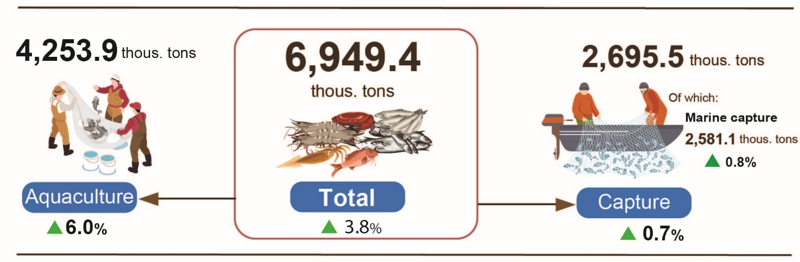
Generally, in the eight months of 2026, total fisheries production was estimated at 6,949.4 thousand tones, a year-on-year expansion of 3.8%, of which fish reached 4,816.3 thousand tones (+2.6% YoY), shrimp reached 1,184.2 thousand tones (+7.4% YoY), and other aquatic products reached 948.9 thousand tones (+5.8% YoY).
2. Industrial production
Industrial production in August continued to maintain positive growth momentum. The Index of Industrial Production (IIP) for the month recorded an estimated expansion of 1.5% month-on-month and 14.4% year-on-year. Cumulatively, for the eight months of 2026, the IIP advanced by 11.9% over the corresponding period last year, marking the highest growth rate achieved during the eight months of the year across the past years.
In August 2026, the manufacturing recorded a year-on-year increase of 14.6%; the mining and quarrying rose by 18.5%; the electricity supply increased by 11.8%; and the water supply, sewerage, waste management and remediation activities grew by 9.5%.
Generally, in the eight months of 2026, the manufacturing grew by 12.5% (the corresponding figure in 2025 was 10.0%), contributing 9.6 percentage points to the overall growth; the mining and quarrying grew by 8.1% (a 2.1% decline in the same period of 2025), contributing 1.3 percentage points; the electricity supply rose by 10.1% (versus 5.0% in 2025), contributing 0.9 percentage points; the water supply, sewerage, waste management and remediation activities increased by 9.4% (versus 8.8% in 2025), contributing 0.1 percentage points.
In the first 8 months of 2026, the IIP of several key 2-digit activities experienced a year-on-year increase as follows: manufacture of basic metals (+22.4% YoY); manufacture of beverages (+16.4% YoY); manufacture of motor vehicles (+15.9% YoY); manufacture of electrical equipment (+14.6% YoY); manufacture of computer, electronic and optical products (+13.9% YoY); manufacture of furniture (+12.7% YoY); manufacture of other non-metallic mineral products (+12.6% YoY); manufacture of rubber and plastic products (+12.3% YoY); manufacture of wood processing and products made from wood, bamboo and rattan (except furniture), as well as products made from straw and plaiting materials (+12.2% YoY); manufacture of chemicals and chemical products, and extraction of crude petroleum and natural gas both (+11.9% YoY); manufacture of food products (+11.6% YoY). Conversely, the IIP for manufacture of leather and related products saw a low growth of 3.6%, while mining of hard coal and lignite decreased by 1.8%.
Table 1. Year-on-year IIP growth rate for several key industrial activities
in the 8 months of the years 2022 - 2026 (%)
 | 2022 | 2023 | 2024 | 2025 | 2026
Mining of hard coal and lignite | 6,9 | -1,2 | -3,5 | 1,9 | -1,8
Extraction of crude petroleum and natural gas | -0,6 | -2,6 | -11,9 | -6,8 | 11,9
Manufacture of food products | 9,0 | 4,9 | 7,3 | 10,2 | 11,6
Manufacture of beverages | 27,3 | 4,0 | 0,2 | 2,7 | 16,4
Manufacture of leather and related products | 18,0 | -2,4 | 10,8 | 13,1 | 3,6
Manufacture of wood processing and products made from wood, bamboo and rattan (except furniture), as well as products made from straw and plaiting materials | 13,5 | -4,6 | 9,8 | 9,7 | 12,2
Manufacture of chemicals and chemical products | 4,8 | 5,2 | 16,5 | 7,3 | 11,9
Manufacture of rubber and plastic products | -6,6 | 8,5 | 29,3 | 17,0 | 12,3
Manufacture of other non-metallic mineral products | 7,2 | -4,3 | -1,0 | 14,7 | 12,6
Manufacture of basic metals | -1,2 | 0,6 | 12,3 | 10,5 | 22,4
Manufacture of computer, electronic and optical products | 11,0 | -3,2 | 9,5 | 8,0 | 13,9
Manufacture of electrical equipment | 16,9 | 2,1 | 10,5 | 5,1 | 14,6
Manufacture of motor vehicles | 3,9 | -6,6 | 11,2 | 27,2 | 15,9
Manufacture of furniture | 5,3 | 0,8 | 22,9 | 11,1 | 12,7

Figure 1. Year-on-year IIP growth rate for several key industrial activities
in the 8 months of the years 2022 - 2026
Top of 10 localities by IIP growth rate  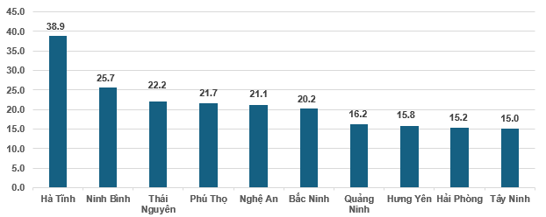 | Bottom of 10 localities by IIP growth rate  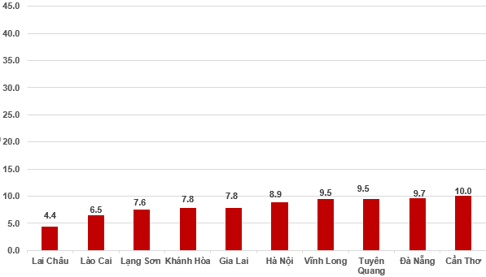
The IIP in the 8 months of 2026 experienced a year-on-year increase in all 34 provinces and municipalities. Several provinces saw a fairly high growth rate in the IIP thanks to the surge in the manufacturing and the electricity supply. Conversely, the IIP in several provinces and municipalities nudged up due to slow growth or decrease in the manufacturing, the mining and quarrying, and the electricity supply.
During the eight months of 2026, several key industrial products registered notable year-on-year increases, led by motorbike (+27.9% YoY), laptop (+25.7% YoY), automobiles (+24.0% YoY), rolled steel (+23.4% YoY), processed seafood (+21.4% YoY), refined sugar (+18.5% YoY), steel bar, angle bar (+15.2% YoY), beer (+14.4% YoY), and chemical paint (+12.2% YoY). On the other hand, several commodities posted output reductions, including NPK fertilizers (-8.6% YoY), sodium glutamate (-8.1% YoY), leather shoes and sandals (-4.2% YoY), and liquefied petroleum gas (LPG) (-3.2% YoY).
Number of employees in industrial enterprises as of August 1st, 2026, expanded by 1.0% month-on-month and 3.8% year-on-year. By kind of economic activity, the number of employees in the mining and quarrying fell by 0.1% month-on-month (MoM) and experienced a year-on-year decrease of 0.7%. The number of employees in the manufacturing advanced by 1.0% MoM and 4.0% YoY. The electricity, gas, steam, and air conditioning supply workforce remained unchanged MoM and increased by 1.9% YoY, while water supply, sewerage, waste management, and remediation activities recorded a month-on-month increase of 0.1% and a year-on-year expansion of 5.0%.
3. Enterprise registration
In August, the country had nearly 12.2 thousand newly established enterprises with a registered capital of nearly 189.4 trillion VND and registered employees of nearly 60.4 thousand employees, a month-on-month decrease of 14.4%, an increase of 13.9% in registered capital 13.9%, and a decrease of 26.4% in the number of enterprises, in the registered capital, and in the number of employees, respectively. In comparison with the same period last year, in the number of enterprises, in the number of registered capital and the number of employees showed a decrease of 40.5%, 41.9% and 43.5%, respectively. The average registered capital per newly established enterprise in August reached 15.6 billion VND (+33.2% MoM and -2.3% YoY). In addition, the country had nearly 9.5 thousand resumed operations enterprises (-6.5% MoM and -23.8% YoY).
In August, there were 5,322 enterprises registered to temporarily suspended for a definite time (-39% MoM and -18.5% YoY); 7,566 enterprises suspended operation waiting for dissolution procedures (-27.1% MoM and +10.1% YoY); 9,631 enterprises completed procedures for dissolution (+33.6% MoM and +151.2 YoY).
Overall, in the eight months of 2026, the whole country had nearly 138.1 thousand newly registered enterprises with a total registered capital of nearly 1,708.3 trillion VND and total registered employees of nearly 657.7 thousand persons, a year-on-year increase of 7.7%, 36.2% in the number of enterprises, in registered capital, respectively and a decrease of 15.4% in the number of employees. The average registered capital per newly established enterprise in the eight months of 2026 reached 12.4 billion VND (+26.4% YoY). The total registered capital added to the economy in the eight months of 2026 reached nearly 4.4 quadrillion VND (+5.7% YoY). In addition, the country had nearly 68.3 thousand resumed operation enterprises (-15.8% YoY), bringing the total number of newly established and resumed operation enterprises in the eight months of 2026 to nearly 206.4 thousand enterprises (-1.4% YoY). On average, there were 25.8 thousand newly established and resumed operation enterprises per month.
By economic sector, in the eight months of 2026, the number of newly registered enterprises in the agriculture, forestry and fishing sector; the industry and construction sector and the services sector reached 1,448 enterprises (+24.1% YoY); nearly 34.1 thousand enterprises (+19.8% YoY); 102.6 thousand enterprises (+4.1% YoY), respectively.
Figure 5. Enterprise registration in the eight months of 2026 (YoY growth rate)
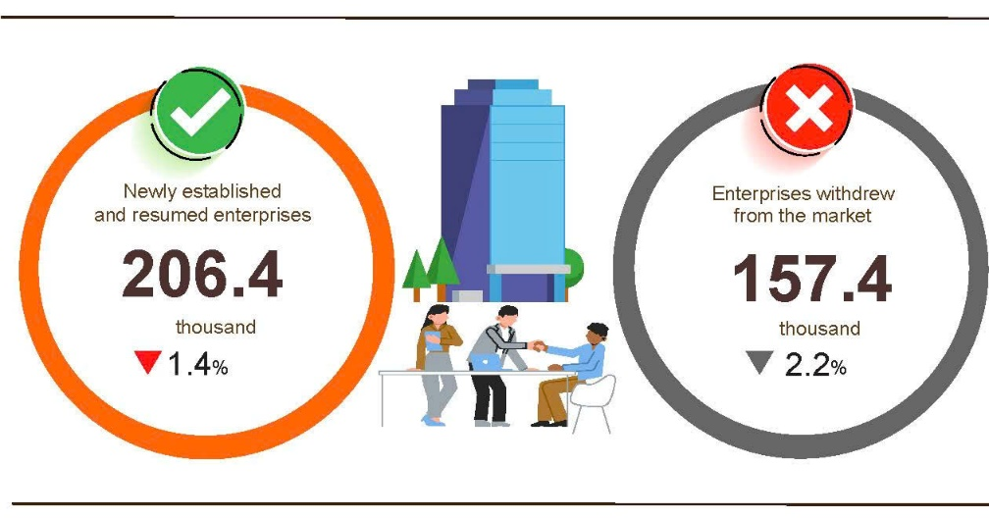
Overall, in the eight months of 2026, the number of enterprises temporarily suspending for a definite time was over 88.0 thousand enterprises (-7.3% YoY); nearly 28.6 thousand enterprises suspended operation waiting for dissolution procedures (-40.3% YoY); over 40.8 thousand enterprises completed procedures for dissolution (+125.5% YoY). On average, 19.7 thousand enterprises withdrew from the market per month.
Table 2. Newly established and completely dissolved enterprises in the eight months of 2026 by kind of economic activity

 | Number of enterprises (Enterprises) |  |  | YoY growth rate (%)
 | Newly established | Completely dissolved |  | Newly established | Completely dissolved
Wholesale and retail, repair of motor vehicle and motorcycle | 55,570 | 15,474 |  | 0,9 | 133,5
Manufacturing | 18,016 | 4,407 |  | 4,7 | 123,8
Construction | 13,746 | 3,095 |  | 40,1 | 141,6
Real estate business | 4,078 | 2,384 |  | 15,1 | 135,1
Transportation and storage | 9,408 | 1,629 |  | 29,4 | 135,4
Accommodation and food services | 6177 | 2,001 |  | 32,0 | 117,0
Electricity, water and gas supply | 1,546 | 440 |  | 60,2 | 100,9
4. Investment
State budget investment in August was actively promoted by ministries, agencies and localities contributing a boost to the economic growth. Overall, in during the first eight months of 2026, disbursed investment from the state budget was estimated at 50.5% of the annual plan, representing an 18.5% increase compared to the corresponding period last year. Disbursed foreign direct investment (FDI) in Viet Nam during the same eight-month period stood at an estimated 17.25 billion USD, making up a year-on-year increase of 12%.
In August alone, disbursed investment from the State budget reached 105.7 trillion VND (+24.1% YoY); this total comprised centrally-managed investment at 15.0 trillion VND (up 8.3%) and locally-managed at 90.7 trillion VND (up 27.2%). Cumulatively, for the eight months of 2026, overall disbursed State budget investment was estimated at 546.8 trillion VND, equivalent to 50.5% of the annual plan, representing an increase of +18.5% YoY (corresponding figure in 2025 were 45.3% of the plan and +26.4% YoY). Specifically:
- Centrally-managed investment was estimated to reach 75.9 trillion VND, representing 48.2% of the annual plan (+7.9% YoY). Of which, investment managed by specific ministries recorded decreased trends decreases such as: Ministry of Construction with 19.8 trillion VND (-49.3%); Ministry of Agriculture and Environment with 3.8 trillion VND (-59.3%); Ministry of Health with 739.7 billion VND (-56.4%); and Ministry of Education and Training with 549.1 billion VND (-44.9%).
- Locally-managed investment was estimated at 470.9 trillion VND, equivalent to 50.9% of the annual plan and a year-on-year increase of 20.4%, including:
State budget investment at provincial level reached 379.6 trillion VND, representing 52.0% and a year-on-year upturn of 19.6%;
State budget investment at commune level reached 91.3 trillion VND, equivalent to 46.9%, and a 24.1% increase compared to that in 2025.
Disbursed investment from the State budget during the eight months of 2026 witnessed a sharp increase across many provinces and centrally-run cities.
Figure 6. Disbursed investment from the State budget
in the eight months of 2026 in selected localities

Total inward foreign investment in Viet Nam as of August 31st, 2026, including newly registered capital, adjusting registered capital, and the value of capital contribution and purchasing shares by foreign investors reached 40.63 billion USD, a year-on-year increase of 55.4%.
Figure 7. Inward foreign investment in Viet Nam
In the eight months of 2022-2026 (Billion USD)

- In terms of newly registered capital: 2,771 projects were licensed with a total registered capital of 21.72 billion USD; a year-on-year increase of 9.4% in the number of projects and an upturn of 96.8% in registered capital. Of which, the largest newly licensed FDI was the manufacturing with 12.15 billion USD, accounting for 55.9% of the total newly registered capital; the electricity, gas, steam and air conditioning supply reached 3.13 billion USD (making up 14.4%); and other activities was 6.44 billion USD (constituting 29.7%).
Among the 73 countries and territories with newly licensed investment projects in Viet Nam during the eight months of 2026, Singapore was the largest investor with 7.62 billion USD, accounting for 35.1% of total newly registered capital; followed by South Korea with 5.67 billion USD, making up 26.1%; Hong Kong SAR (China) with 2.96 billion USD, comprising 13.6%; China with 1.93 billion USD, representing 8.9%; Japan with 1.42 billion USD, constituting 6.5%; and the Netherlands with 424.3 million USD, accounting for 2.0%.
- Regarding adjusting registered capital: 819 turns of projects licensed from previous years registered to adjust investment capital upward by a 12.21 billion USD, a year-on-year increase of 14.7%.
If including newly registered capital and adjusting registered capital of licensed projects in previous years, the registered FDI in the manufacturing reached 20.18 billion USD, accounting for 59.5% of the total newly registered and additional capital; the real estate activities reached 5.32 billion USD, accounting for 15.7%; and other activities reached 8.42 billion USD, making up 24.8%.
- There were 2,062 turns of the capital contributions and purchasing shares by foreign investors with a total value of 6.7 billion USD, a year-on-year increase of 50.1%. Of which, 652 turns of capital contributions and purchasing shares increased in the enterprises’ charter capital with a capital contribution value of 2.55 billion USD, and 1,410 foreign investors repurchased domestic shares without making the charter capital increase with a value of 4.15 billion USD. Among capital distribution and purchasing shares by foreign investors, the professional, scientific, and technical activities attracted 2.74 billion USD, accounting for 40.9% of the total contribution value; the wholesale and retail trade and motor vehicles and motorcycles repair achieved 2.01 billion USD, accounting for 30.0%; and other activities reached 1.95 billion USD, making up 29.1%.
Total disbursed FDI in Viet Nam in the eight months of 2026 was estimated at 17.25 billion USD (+12.0% YoY), setting the highest figure in the disbursed FDI for the eight-month period over the past five years. Specifically, the manufacturing reached 14.24 billion USD, accounting for 82.6% of the total disbursed FDI; the real estate activities reached 1.29 billion USD, making up 7.5%; and the electricity, gas, steam, and air conditioning supply reached 622.9 million USD, accounting for 3.6%.
Figure 8. Disbursed foreign direct investment
in the eight months of 2022-2026 period (Billion USD)

Viet Nam’s outward investment activities during the eight months of 2026, 113 projects were granted new investment certificates with a total combined capital value of 1.21 billion USD, a 2.8-fold increase over the corresponding period last year. Concurrently, 29 turns of projects adjusted their investment capital upwards an additional 1.41 billion USD, a 10.9-fold rise.
In aggregate, total Viet Nam’s outward FDI (comprising both newly registered and adjusted capital) reached 2.62 billion USD, expanding 4.7 times compared to the same period last year. By activity, the transportation and storage reached 601.7 million USD (comprising 23.0%); the electricity, gas, steam and air conditioning supply reached 585.8 million USD (making up 22.4%); the agriculture, forestry, and fishing sector reached 516.6 million USD, representing 19.7%; and the manufacturing reached 320.1 million USD, constituting 12.2%.
In the eight months of 2026, 35 countries and territories received investment from Viet Nam; of which: Lao PDR led with 667.5 million USD (accounting for 25.5% of total outward capital), followed by Cambodia with 486.5 million USD (representing 18.6%), India with 323.9 million USD (comprising 12.4%), Indonesia with 313.6 million USD (comprising 12.0%), the Philippines with 167.2 million USD (making up 6.4%), Kazakhstan with 149.9 million USD (accounting for 5.7%), and the UK with 82.8 million USD (making up 3.2%).
5. State budget revenue and expenditure
State budget revenue in the eight months of 2026 was estimated to increase by 16.0% over the same period last year. State budget expenditure was estimated to increase by 13.3% over the previous year, ensuring the needs of socio-economic development, national defense, security, state management, payment of due debts, and timely payment to beneficiaries according to regulations.
Figure 9. State budget revenue and expenditure in the 8 months of 2026
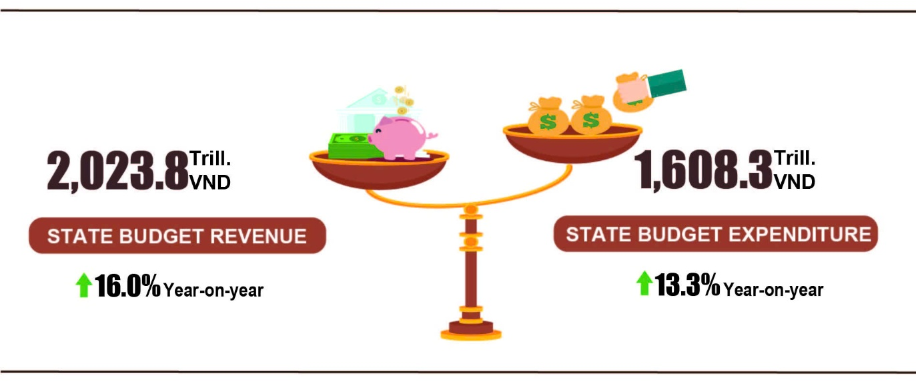
Total state budget revenue in August 2026 was estimated at 150.4 trillion VND. The total state budget revenue accumulated in the eight months of 2026 was estimated at 2,023.8 trillion VND, reaching 80.0% of the annual estimate and going up by 16.0% over the same period last year. In particular, selected revenue items were as follows:
- Domestic revenue in August 2026 was estimated at 130.3 trillion VND. The accrued revenue in the 8 months of 2026 was estimated at 1,752.9 trillion VND, reaching 79.7% of the annual estimate. This figure accounted for 86.6% of total state budget revenue, representing a year-on-year increase of 16.6%.
- Oil revenue in August 2026 was estimated at 5.8 trillion VND. The accrued revenue in the 8 months of 2026 was estimated at 43.6 trillion VND, reaching 101.5% of the annual estimate. This figure accounted for 2.2% of total state budget revenue, representing a 31 year-on-year increase of 5%.
- Revenue from budget balance of import-export activities in August 2026 was estimated at nearly 13.0 trillion VND. The accrued revenue in the 8 months of 2026 was estimated at 223.9 trillion VND, reaching 80.6% of the annual estimate. This figure accounted for 11.1% of total state budget revenue, representing a year-on-year increase of 7.9%.
Total state budget expenditure in August 2026 was estimated at 238.1 trillion VND. In the 8 months of 2026, total state budget expenditure reached an estimated 1,608.3 trillion VND, reaching 50.9% of the annual estimate and marking a year-on-year increase of 13.3%. The state budget expenditure fully covered requirements for socio-economic development, national defense, security, and state administration, as well as timely debt service obligations upon maturity. Furthermore, budget allocations ensured prompt disbursements of payroll and salary-related benefits to state beneficiaries, thereby contributing significantly to the effective execution of social welfare policies. Specifically: Recurrent expenditure reached 1,015.0 trillion VND, equivalent to 56.1% of the annual estimate, this figure accounted for 63.1% of total state budget expenditure (up 4.9% YoY). Expenditure on development investment was 514.6 trillion VND, equivalent to 45.9% of the annual estimate, this figure accounted for 32.0% of total state budget expenditure (up 35.4% YoY). Interest payment was 76.7 trillion VND, equivalent to 63.3% of the annual estimate, this figure accounted for 4.8% of total state budget expenditure (up 11.2% YoY).
6. Trade, prices, transport and tourism
a) Retail sales of goods and services
Trade and service activities in August continued to maintain their growth momentum. The retail sales of goods and services were estimated to rise by 1.6% MoM and by 14.9% YoY. For the eight months of 2026 cumulatively, overall retail sales of goods and services witnessed a year-on-year surge of 13.3%, reflecting that consumption demand and service activities continued to expand, contributing positively to the overall growth of the service sector.
The retail sales of goods and services at current prices in August 2026 were estimated at 679.8 trillion VND (+1.6% MoM and +14.9% YoY).
Retail sales revenue of most commodity groups in August tended to increase compared to that in the previous month and the same period last year, as follows: other fuels (excluding petrol and oil) (+2.2% MoM and +25.9% YoY); timber and construction materials (+1.8% MoM and +24.8% YoY); gemstones, precious metals and related products (+0.7% MoM and +19.2% YoY); the group of food and foodstuff (+2.0% MoM and +12.9% YoY); repair of motor vehicles, motorcycles and motorbikes (+2.7% MoM and +12.3% YoY); garments (+2.4% MoM and +11.9% YoY); household appliances, tools and equipment (+1.6% MoM and +9.2% YoY); means of transport (excluding automobiles, including spare parts) (+0.3% MoM and +4.3% YoY). However, the group of automobiles of all kinds experienced a MoM decline of 2.7% and a YoY reduction of 1.8%.
Accommodation and food service activities increased by 2.6% MoM and by 21.5% YoY, respectively; travelling services decreased by 6.9% MoM but rose by 19.2% YoY; other goods and services groups jumped up 1.5% MoM and 14.8% YoY, respectively.

Table 3. Gross retail sales of goods and services at current prices
in the eight months of 2026
Trillion VND
 | Estimate  for August  2026 | Estimate  for 8 months  2026 | Year-on-Year  Growth rate (%)
 | Estimate  for August  2026 | Estimate  for 8 months  2026 | August  2026 | 8 months  2026
Total | 679.8 | 5,235.5 | 14.9 | 13.3
Retail sales of goods | 507.4 | 3,947.6 | 13.8 | 12.8
Accommodation and food services | 90.5 | 670.3 | 21.5 | 16.4
Travelling services | 9.1 | 68.7 | 19.2 | 17.1
Other services | 72.8 | 548.9 | 14.8 | 13.2

Generally, for the eight months of 2026, the retail sales of goods and services at current prices were estimated at 5,235.5 trillion VND, a year-on-year shoot of 13.3%; excluding the price factor, the growth rate stood at 7.6% (compared to an increase of 7.5% in 2025).
Figure 10. Retail sales of goods and services at current prices in the eight months of the 2022–2026 period

The retail sales of goods in the eight months of 2026 were estimated at 3,947.6 trillion VND, accounting for 75.4% of the total and surging up 12.8% YoY. Of which, turnover from gemstones, precious metals and related products spiked by 28.1%; other goods shot up 19.2%; timber and construction materials surged up 16.5%; petrol and oil of all kinds soared by 15.2%; other fuels (excluding petrol and oil) rocketed by 16.4%. Retail sales of goods in the eight months of 2026 of some provinces saw a year-on-year increase including: Da Nang (+14.2%); Quang Ninh (+13.9%); Can Tho and Hai Phong (+13.1%); Ha Noi (+12.8%); and Ho Chi Minh City (+12.2%).
The turnover of accommodation and food service activities in the eight months of 2026 was estimated at 670.3 trillion VND, accounting for 12.8% of the total turnover and a year-on-year surge of 16.4%. Turnover in the eight months of 2026 compared to that in the same period last year in some localities saw a year-on-year upturn including: Da Nang (+21.4%); Khanh Hoa (+20.4%); Hue (+20.2%); Lam Dong (+19.5%); Thanh Hoa (+17.5%); Hai Phong (+16.8%); Can Tho (+16.5%); Ha Noi (+14.4%); Ho Chi Minh City (+13.9%); and Ca Mau (+13.2%).
The turnover of travelling in the eight months of 2026 was estimated at 68.7 trillion VND, making up 1.3% of the total turnover and a year-on-year shoot of 17.1%. Turnover in the eight months of 2026 of some provinces witnessed a year-on-year expansion including: Quang Ninh (+26.5%); An Giang (+21.8%); Ho Chi Minh City (+16.0%); Da Nang (+15.9%); and Ha Noi (+14.1%).
The turnover of other services in the eight months of 2026 was estimated at 548.9 trillion VND, comprising of 10.5% of the total turnover and a year-on-year soar of 13.2%. Turnover in the eight months of 2026 in some provinces experienced a year-on-year jump including: Quang Ninh (+29.6%); Hue (+28.2%); Da Nang (+20.9%); Ninh Binh (+21.0%); Ha Noi (+11.2%); and Ho Chi Minh City (+9.6%).
b) Export and import of goods
In August, the total export and import turnover of goods reached 109.7 billion USD, a month-on-month downturn of 0.1% and a year-on-year upturn of 31.7%. Generally, in the eight months of 2026, the total export and import turnover of goods achieved 770.14 billion USD, the highest eight-month figure on record, a year-on-year spike of 28.7%, of which exports and imports shot up 22.4% and 35.3%, respectively. The trade balance of goods recorded a trade deficit of 20.46 billion USD.
Figure 11. Export and import of goods in the eight months of 2026
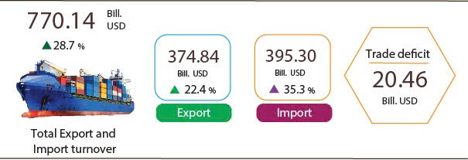
Export of goods
The export turnover of goods in August reached 54.79 billion USD, a month-on-month rise of 3.2%. Of which, the domestic economic sector attained 10.5 billion USD, a climb of 2.2%; while the FDI sector (including crude oil) achieved 44.29 billion USD, a soar of 3.4%. The export turnover of goods in August possessed a year-on-year shoot of 26.0%, of which the domestic economic sector and the FDI sector (including crude oil) surged up 14.1% and 29.2%, respectively.
Overall, the export turnover of goods in the eight months of 2026 obtained 374.84 billion USD, a year-on-year shoot of 22.4%. Of which, the domestic economic sector recorded 74.47 billion USD, an expansion of 7.4%, consisting of 19.9% of total export turnover; the FDI sector (including crude oil) reached 300.37 billion USD, an increase of 26.9%, accounting for 80.1%.
In the eight months of 2026, there were 33 export items with a value exceeding 1 billion USD, comprising of 93.6% of total export turnover (including 7 items recorded export values of over 10 billion USD, accounting for 70.0%).
Table 4. Value of some export goods in the eight months of 2026
 | Value  (Mill. USD) | Growth rate YoY (%)
Products with a value of over 10 billion USD
Electronic goods, computers and their parts | 101,059 | 51.1
Machinery, instrument, accessory | 47,289 | 26.4
Phones all of kinds and their parts | 45,590 | 19.4
Textiles and sewing products | 26.897 | 1.6
Footwear | 16,202 | 0.7
Means of transport and spare parts | 13,392 | 16.6
Wood and wood products | 11,807 | 6.0
Regarding the structure of exported goods in the eight months of 2026, the group of manufactured products reached 337.99 billion USD, accounting for 90.2%; the group of agricultural and forestry products achieved 26.65 billion USD, consisting of 7.1%; the group of fishery products attained 8.0 billion USD, comprising of 2.1%; and the group of fuels and minerals gained 2.2 billion USD, making up 0.6%.
Figure 12. Structure of exported goods in the eight months of 2026 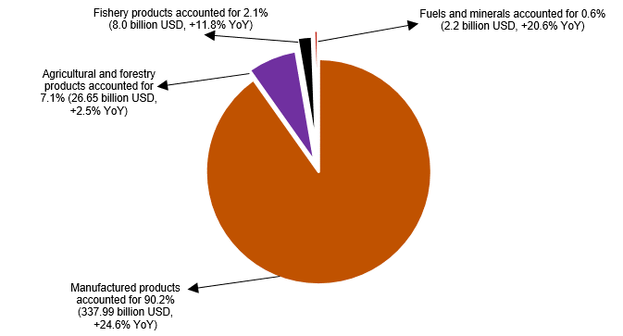
Import of goods
Import turnover of goods in August reached 54.91 billion USD, a MoM fall of 3.1%. Of which, the domestic economic sector achieved 12.82 billion USD, a reduction of 7.1%; the FDI sector gained 42.09 billion USD, a decline of 1.8%. Compared to that in the same period last year, the import turnover of goods in August witnessed a spike of 37.9%, of which the domestic economic sector and the FDI sector rocketed by 19.7% and 44.6%, respectively.
Overall, the import turnover of goods in the eight months of 2026 attained 395.3 billion USD, a YoY surge of by 35.3%, of which the domestic economic sector obtained 105.07 billion USD, a soar of 23.7%; the FDI sector recorded 290.23 billion USD, a shoot of 40.1%.
In the eight months of 2026, there were 43 imported products with their value exceeding 1 billion USD, accounting for 93.9% of total import turnover (including 3 imported products with the value of over 10 billion USD, consisting of 55.5%).
Table 5. Value of some imported goods in the eight months of 2026
 | Value  (Mill. USD) |  | Growth rate YoY (%)
Products with a value of over 10 billion USD
Electronic goods, computers and their parts | 161.630 |  | 68,3
Machinery, instrument, accessory | 47.400 |  | 22,1
Textiles | 10.165 |  | 2,5
Regarding the structure of imported goods in the eight months of 2026, the group of capital goods reached 372.04 billion USD, accounting for 94.1%, of which the group of machine, equipment, tools and instruments; the group of fuels, raw materials comprised of 57.6%; 36.5%, respectively. The group of consumer goods achieved 23.26 billion USD, making up 5.9%.
Figure 13. Structure of imported goods in the eight months of 2026 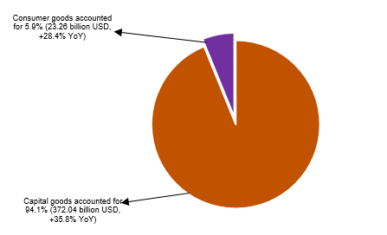
Figure 14. Major commodity export and import markets in the eight months of 2026
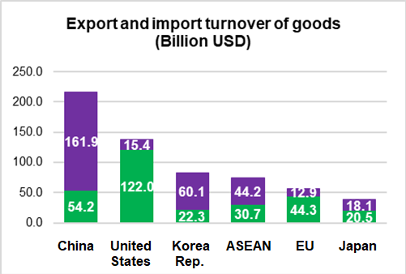 |  |  | 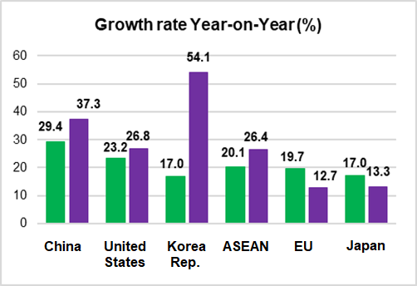
 |  | Export of goods | Import of goods
Regarding export and import markets of goods in the eight months of 2026, the United States was Viet Nam’s largest export market with a turnover of 122.0 billion USD. China remained Viet Nam’s largest import market with a turnover of 161.9 billion USD. In the eight months of 2026, the trade surplus to the United States reached 106.6 billion USD, a year-on-year increase of 22.7%; the trade surplus to the EU attained 31.4 billion USD, an expansion of 22.8%; the trade surplus to Japan gained 2.4 billion USD, a spike of 58.0%; the trade deficit to China was 107.7 billion USD, a shoot of 41.7%; the trade deficit to Republic of Korea was 37.8 billion USD, a spike of 89.4%; and the trade deficit to ASEAN was 13.5 billion USD, a surge of 43.4%.
According to preliminary data, the trade balance of goods recorded a deficit of 0.12 billion USD in August. Overall, in the eight months of 2026, the trade balance of goods posted a deficit of 20.46 billion USD (a surplus of 14.02 billion USD in the same period last year). Of which, the domestic economic sector recorded a trade deficit of 30.6 billion USD; while the FDI sector (including crude oil) recorded a trade surplus of 10.14 billion USD.
c) Consumer price index, gold and US dollar price index
The Consumer Price Index (CPI) in August witnessed a month-on-month increase of 0.47%, mainly due to upward adjustments to the prices of domestic petrol and oil in line with world fuel prices. The CPI in August saw a rise of 3.57% compared with that in December 2025 and recorded a year-on-year surge of 4.89%.
In general, the CPI in the eight months of 2026 possessed a year-on-year expansion of 4.45%; core inflation experienced an upturn of 4.24%.
The CPI in August possessed a month-on-month jump of 0.47%, of which 10 groups of goods and services recorded an increase in prices but 01 group of goods and services experienced a decline in prices.
Figure 15. Month-on-month CPI growth rate in August 2026 (%)

Ten groups of goods and services recorded an increase in the CPI, as follows:
(i) The group of culture, entertainment and tourism witnessed a month-on-month climb of 0.03%. Of which, the prices of books, newspapers and magazines of all kinds (+0.27%); domestic tourism (+0.20%); sports equipment and instruments (+0.19%); toys (+0.15%); and hotels (+0.06%). In contrast, fees for hiring sports venues reduced by 0.09%; outbound tourism (-0.24%); and cinema and music performances (-1.02%).
(ii) The group of medicines and health care services edged up 0.05% due to a slight increase in prices of some medicines resulting from rising costs of input material.
(iii) The group of information and communication experienced witnessed a month-on-month expansion of 0.08%. Of which, prices of feature mobile phones (+1.24%); landline phones (+0.53%); printers, projectors and scanners (+0.19%); phone repair (+0.18%); and telecommunication services (+0.11%). In contrast, prices of color televisions shrunk by 0.32%; smartphones and tablets accessories (-0.08%); and computers and its accessories (-0.03%).
(iv) The group of housing, electricity, water, fuel and construction materials witnessed a month-on-month upturn of 0.10%, mainly due to a rise of 0.07% in house rent; a jump of 4.63% in the price of kerosene; an expansion of 4.19% in the price of cooking gas; and an upturn of 0.03% in the prices of housing maintenance materials. In contrast, the prices of household electricity and tap water declined by 1.33% and 0.32%, respectively.
(v) The group of garment, hats and footwear experienced a month-on-month soar of 0.11% due to increasing demand for purchase in preparation for the new school year. Of which, prices of hats (+0.27%); fabrics of all kinds (+0.18%); footwear (+0.11%); ready-made clothes (+0.09%); footwear services (+0.65%); and garment services (+0.48%).
(vi) The group of beverages and tobacco edged up 0.12% due to higher demands for consumption and increasing costs of input material for production. Of which, prices of bottled, canned and boxed energy drinks (+0.52%); mineral water (+0.34%); cigarettes (+0.24%); alcohol of all kinds (+0.18%); fruit juices (+0.10%); and beer of all kinds (+0.06%). Whereas the prices of carbonated soft drinks fell by 0.14%.
(vii) The group of other goods and services possessed a month-on-month jump of 0.15%, of which: the prices of electric personal care appliances (+0.75%); watch and jewelry repair (+0.50%); personal care services (+0.49%); non-electric personal articles (+0.33%); wedding and funeral services (+0.21%); and haircut and hair-washing services (+0.19%). In contrast, the prices of jewelry decreased by 0.50%; handbags, suitcases and wallets (-0.44%); and administrative and legal services (-0.35%).
(viii) The group of household equipment and goods saw a month-on-month increase of 0.19%, mainly due to rising costs of raw materials, fuels and labor in production. Of which, prices of other consumer items; refrigerators, cooking utensils, glassware, ceramic and porcelain products; electric appliances and soap and detergents; beds, wardrobes, tables and chairs; metal, plastic and rubber household products; indoor textiles; household equipment repair services; and domestic services added up 0.33%; 0.27%; 0.20%; 0.13%; 0.07%; 0.05%; 0.34%; 0.18%, respectively. In contrast, prices of electric irons; wall mirrors; egg whisk; washing machines; bathroom water heaters reduced by 0.92%; 0.70%; 0.50%; 0.35%; and 0.10%, respectively.
(ix) The education group witnessed a month-on-month expansion of 0.47%, of which: prices of education services (+0.57%); paper products (+0.37%); pens of all kinds (+0.34%); stationery and other school supplies (+0.29%).
(x) The transport group saw a month-on-month jumped of 4.09% (contributing to an increase of 0.41 percentage point in the overall CPI), mainly due to the spike of 22.15% in the price index of diesel and the surge of 9.53% in the prices of gasoline as a result of the impacts of domestic adjustments to the prices of petrol and oil. Besides, the prices of spare parts (+0.11%); vehicle maintenance services (+0.40%); car-washing and tire-inflation services (+0.33%); and driving-license training fees (+0.37%). In contrast, prices of passenger transport by railway; by airway and by bus dropped by 9.86%; 0.81%; 0.29%, respectively; the prices of used automobiles (-0.63%); new automobiles (-0.50%); and motorbikes (-0.18%).
The group of food and foodstuff services experienced a month-on-month decline of 0.03% (contributing to a reduction of 0.01 percentage point in the overall CPI), of which: the CPI of foodstuff (-0.05%); food (-0.04%); and eating-out services (+0.01%).
The average CPI in the eight months of 2026 witnessed a year-on-year increase of 4.45%, of which the group of housing, electricity, water, fuel and construction materials experienced the highest surge of 6.71% (contributing to a rise of 1.52 percentage points in the overall CPI); transport (+5.38%) (contributing to a jump of 0.54 percentage point in the overall CPI); food and foodstuff services (+4.76%) (contributing to an expansion of 1.70 percentage points in the overall CPI); other goods and services (+4.46%) (contributing to an upturn of 0.16 percentage point in the overall CPI); beverages and tobacco (+3.67%) (contributing to a climb of 0.06 percentage point in the overall CPI); education (+3.42%) (contributing to a soar of 0.2 percentage point in the overall CPI); household equipment and goods (+2.79%) (contributing to an upturn of 0.14 percentage point in the overall CPI); culture, entertainment and tourism (+2.71%); garment, hats and footwear (+2.03%); medicines and health care services (+1.08%); and information and communication (+0.09%).
Core inflation in August witnessed a month-on-month rise of 0.11% and a year-on-year expansion of 4.55%. On average, core inflation in the eight months of 2026 recorded a year-on-year growth of 4.24%, lower than a surge of 4.45% in the overall CPI, resulting from significant fluctuations in the prices of gasoline, gas and food that led to a rise in the overall CPI, were excluded from the calculation of core inflation.
Domestic gold prices witnessed a fluctuation in the contrast direction of the world gold prices. The average price of world gold in August (as of 25 August 2026) was 4,377.25 USD per ounce, a month-on-month shoot of 7.22%. An expansion in the prices of world gold caused by the weak US dollar, a decline in US bond yields and a significant increase in investment flows into gold funds; as well as continuously geopolitical instability in Iran and the Middle East led to increasing demand for gold. Domestic price index of gold in August saw a month-on-month decrease of 0.65%; a year-on-year surge of 16.98%; and a shrink of 6.27% compared to that in December 2025. The average gold price index in the eight months of 2026 possessed a year-on-year spike of 46.98%.
Domestic US dollar prices saw a fluctuation in line with world prices. The average USD index on the international market in August (as of 25 August 2026) reached 99.65 points, a downturn of 1.17 points compared to that in July, stemming from the weak US dollar on the international market amid expectations of change in US monetary policy and a decline in US Treasury yields. The domestic US dollar price index in August experienced a month-on-month drop of 0.38%; a year-on-year shrink of 0.36%; and a fall of 0.38% compared to that in December 2025. The average US dollar price index in the eight months of 2026 possessed a year-on-year upturn of 1.31%.
d) Passenger and cargo transport
Transport activities in August 2026 maintained the growth momentum, meeting the travel demand of domestic residents as well as international visitors to Viet Nam, while ensuring the efficient movement of goods, contributing to the promotion of trade, tourism, and economic growth. In comparison to the same period last year, passenger carried and passenger carried (passenger-kilometers) in August 2026 saw a year-on-year increase of 17.9% and 16.0%, respectively; freight transported and freight transported (ton-kilometers) recorded a year-on-year rise of 17.6% and 17.3%, respectively.
Generally, in the eight months of 2026, passenger carried and passenger carried (passenger-kilometers) experienced a year-on-year rise of 18.6% and 13.1%, respectively; freight transported and freight transported (ton-kilometers) recorded a year-on-year increase of 16.7% and 12.9%, respectively.
Passenger carried in August 2026 was estimated at 658.6 million turns of passengers, a month-on-month increase of 2.5%, a year-on-year rise of 17.9%; and passenger carried (passenger-kilometers) reached 32.1 billion passenger-kilometer, a month-on-month rise of 1.8% and a year-on-year growth of 16.0%. Generally, in eight months of 2026, the passenger carried was estimated at 4,687.5 million turns of passengers, a year-on-year increase of 18.6% and passenger carried (passenger-kilometers) reached 234.3 billion passenger-kilometer, a rise of 13.1%. Of which, domestic passenger carried was estimated at 4,674.0 million turns of passengers, a year-on-year increase of 18.6%,and domestic passenger carried (passenger-kilometers) was 191.7 billion passenger-kilometer, a year-on-year upturn of 15.7%; overseas passenger carried was estimated at 13.5 million turns of passengers, a year-on-year expansion of 4.4%, and overseas passengers carried (passenger-kilometers) reached 42.6 billion passenger-kilometer, rising by 2.8%.
Table 6. Passenger carried in the eight months of 2026 by type of transport
 | Number of passengers |  |  | YoY growth rate (%)
 | Carried  (Mill. Passengers) | Carried (passenger-kilometers)  (Bill. passenger-km) |  | Carried | Carried (passenger-kilometers)
Total | 4,687.5 | 234.3 |  | 18.6 | 13.1
Rail way | 33.1 | 2.4 |  | 23.6 | -2.9
Maritime transport | 8.4 | 0.7 |  | -0.1 | 11.4
Inland water way | 297.6 | 7.3 |  | 7.5 | 15.5
Road | 4,307.2 | 157.9 |  | 19.6 | 18.0
Airway | 41.2 | 56.0 |  | 6.7 | 3.3
Freight transported in August 2026 was estimated at 324.0 million tons,
month-on-month increase of 0.6%, a year-on-year rise of 17.6%; and freight transported (ton-kilometers) reached 63.0 billion ton-kilometer, an upturn of 2.1% MoM, an increase of 17.3% YoY. Generally, in the eight months of 2026, freight transported was estimated at 2,285.1 million tons, a year-on-year increase of 16.7% and freight transported (ton-kilometers) reached 450.5 billion ton-kilometer, a year-on-year increase of 12.9%. Of which, domestic freight transported was estimated at 2,245.3 million tons, (+16.7%), domestic freight transported (ton-kilometers) reached 257.9 billion ton-kilometer, (+14.2%); overseas freight transported was estimated at 39.8 million tons, (+18.0%), and overseas freight transported (ton-kilometers) was 192.6 billion ton-kilometer, (+11.2%).
Table 7. Freight transported in the eight months of 2026 by type of transport
 | Volume of freight |  |  | YoY growth rate (%)
 | Transported  (Mill. tons) | Transported  (ton-kilometers)  (Bill. ton-km) |  | Transported | Transported (ton-kilometers)
Total | 2,285.1 | 450.5 |  | 16.7 | 12.9
Rail way | 3.0 | 2.5 |  | -16.6 | -6.8
Maritime transport | 112.0 | 228.4 |  | 10.7 | 8.8
Inland water way | 446.8 | 102.5 |  | 13.0 | 17.5
Road | 1,723.0 | 110.2 |  | 18.2 | 19.2
Airway | 0.3 | 6.9 |  | 1.5 | 4.0

đ) International visitors to Viet Nam
Tourism activity maintained its growth momentum during eight months of 2026. International tourist arrivals to Viet Nam reached 15.9 million, a year-on-year rise of 14.4%. These results were attributable to ensured security and social order, favorable visa policies, intensified promotion and marketing efforts, and diverse tourism products, alongside advantages such as natural landscapes, culture, cuisine, and reasonable travel costs.
In August 2026, international visitors to Viet Nam reached an estimated 1.99 million arrivals, a month-on-month decrease of 19.7% and a year-on-year increase of 18.4%. Generally, in eight months of 2026, international visitors were estimated at 15.9 million arrivals (+14.4% YoY) marking the highest figure for eight-month period in many years. Of which, arrivals by airway reached 13.2 million arrivals, accounting for 83.1% of total international visitors to Viet Nam, (+11.6% YoY); arrivals by road reached 2.5 million arrivals, accounting for 15.7% (+32.0% YoY); arrivals by seaway reached 220.6 thousand arrivals, accounting for 1.4% (+17.5% YoY).
Figure 16. International visitors to Viet Nam in eight months of 2026 by territory
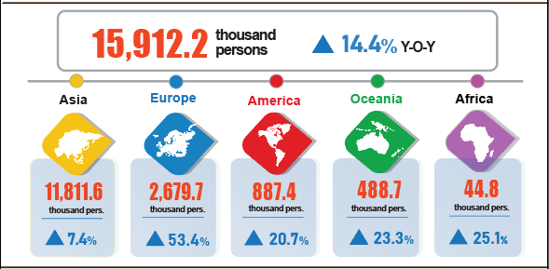
7. Social situation
In August, people’s living conditions remained stable, and social security policies continued to be actively deployed and implemented nationwide.
a) People's living conditions
According to preliminary results of the Labour Force Survey, people’s living conditions in August generally remained stable. The proportion of households reporting that their income in the month remained unchanged or increased compared to the same period last year was 96.5% (a decrease of 0.2 percentage points compared to the July reporting period and a year-on-year decrease of 0.1 percentage points); 3.5% of households reported that their income decreased or was undetermined.
Among households reporting an increase in income, 67.1% attributed it to increased wages and salaries of household members; 39.5% reported growth in income from agriculture, forestry, and fishery activities; and 21.0% identified increased income from non-farm production, business, and service activities.
Of the households with decreased income, 30.0% pointed to an increase in input costs for production and business activities; 27.9% indicated a decline in selling prices of products from household production and business activities; 20.5% noted that household members suffered from severe illness, injury, or death; 19.6% identified that household members were temporarily out of work; and 17.6% cited a reduction in the scale of their production and business activities.
Regarding the impact of negative events on living conditions in the eight months of 2026, interviewed households reported various disruptions: 36.0% experienced rising prices of goods and services; 7.6% suffered from natural disasters and climate change; 3.7% faced epidemics in livestock or crops; 2.9% were hit by human epidemics; 2.2% dealt with family members’ severe illness, injury, or death; and 0.5% suffered consequences from fires or explosions.
In the eight months of this year, 18.4% of interviewed households received assistance from various sources. Specifically, the proportion of households receiving support from national programs and policies was 9.0%; from local programs and policies was 7.2%; from charitable activities of organizations or individuals was 2.2%; from relatives and family members was 10.3%; and from other sources was 0.06%.
Social security activities have always been prioritized and implemented by authorities at all levels and sectors. From the beginning of the year to date (as of August 26th, 2026), the Government provided 18.1 thousand tons of rice to the people, of which: nearly 9.1 thousand tons for hunger relief during the Lunar New Year for 604.6 thousand persons; more than 8.2 thousand tons for pre-harvest hunger relief for 547.2 thousand persons; and over 887.4 tons for natural disaster and flood relief for 59.1 thousand persons.
b) Gratitude to national devotees
Towards the 80th anniversary of War Invalids and Martyrs Day (July 27th, 1947 - July 27th, 2027), the “500-day-and-night campaign to accelerate the search, collection, and identification of martyrs’ remains” has been drastically deployed by authorities at all levels and stakeholders. Over the past period, the campaign has focused on synchronously carrying out tasks of searching for and collecting martyrs' remains; collecting, storing, and analyzing DNA samples; building databases for information matching; as well as conducting mine and explosive clearance in areas with many war relics and suspected grave locations. Selected achievements as of August 22nd, 2026 were as follows:
Forces found and collected 1,863 martyrs’ remains, including 839 remains domestically, 174 remains in Lao PDR, and 850 remains in Cambodia. The campaign is mobilizing 32 search and collection teams with total personnel of 1,559 persons, including 13 teams performing domestic tasks and 19 teams working abroad (8 teams in Lao PDR and 11 teams in Cambodia). Units organized 16 memorial and burial ceremonies for martyrs’ remains, which included receiving 850 martyrs’ remains.
Authorities conducted sampling for 148,601 martyrs’ graves, reaching a rate of 69.8%. Of these, 102,689 graves were eligible for sampling, reaching 69.1%; 45,912 graves were not eligible for sampling. To date, 11 out of 34 provinces and cities completed sampling efforts. To carry out the task, 264 sampling teams with about 3,500 people were mobilized. DNA sampling of martyrs’ relatives was also accelerated. The total number of collected samples reached 265,761; of which 71,102 samples were analyzed and 66,909 samples were synchronized into the database. This constitutes an important data source for DNA analysis and matching, step-by-step identifying martyrs with missing information. Along with sampling in localities, the reception, storage, and preservation of martyrs' remains samples were carried out to ensure sample sources for forensic identification. As of August 22nd, 35,983 martyrs' remains samples from localities were received, stored, and preserved. Particularly, the Military Institute of Forensic Medicine received 27,169 martyrs’ remains samples from 16 out of 17 provinces and cities and performed forensic identification for 195 samples.
Mine and explosive clearance continued to be identified as a crucial task, directly ensuring safety for the search and collection of martyrs' remains. So far, functional forces cleared 11,793.6 out of 22,725 hectares, reaching 51.9% of the plan. Particularly in the core zone of Vi Xuyen/Tuyen Quang, 4,075.8 out of 4,460 hectares were cleared, reaching 91.39%. To execute this task, 360 mine clearance teams were mobilized, utilizing 1,311 detectors and specialized equipment, with a total of 5,183 participants.
c) Epidemic and food poisoning
According to the report of the Ministry of Health, in the month (July 18th - August 17th, 2026), there were over 16.7 thousand cases of dengue fever (2 deaths); 8,689 cases of hand, foot and mouth disease (1 death); 253 cases of rash fever with suspected measles; 32 cases of viral encephalitis, 2 cases of meningococcal meningitis; 6 deaths from rabies. Overall, from the beginning of the year to date, there were over 78.3 thousand cases of dengue fever (13 deaths); over 67.3 thousand cases of hand, foot and mouth disease (11 deaths); 5,005 cases of rash fever suspected of measles; 210 cases of viral encephalitis (1 death); 33 cases of meningococcal meningitis (5 deaths); and 46 deaths from rabies in the whole country.
As of August 17th, 2026, the total number of people living with HIV nationwide was 258 thousand persons; the number of deaths from HIV/AIDS was 119.6 thousand persons.
Regarding food poisoning, in August, there were 2 cases of poisoning, causing 140 persons poisoned. Overall, in 8 months 2026 (from December 18th, 2025 to August 17th, 2026), there were 57 cases with nearly 2,800 persons poisoned (7 deaths) nationwide.

d) Culture and sports
Regarding culture, in August, cultural activities were diverse and varied, focusing on communications and education on traditional values on the occasion of the 81st anniversary of the August Revolution and National Day (September 2nd), as well as exhibitions, artistic performances, festivals, cultural exchanges, and activities to preserve and promote the value of cultural heritage. Notable activities were held in various localities, including the exhibition “Heritage of Le Quy Don, a renowned cultural figure” in Hung Yen; the “ASEAN cultural colors 2026” programme in Ha Noi; the Hue Nam Palace Festival as part of Hue Festival 2026; an exhibition on the Temple of Literature – Quoc Tu Giam and the tradition of learning in Quang Ninh; the 2026 Viet Nam - Korea Festival in Da Nang; the “Fatherland in our hearts” programme in Ho Chi Minh City; and the exhibition “The South forever remembers Uncle Ho” in Gia Lai.
Regarding elite sports, sporting competitions were actively held both domestically and internationally, with notable events including the 7th Viet Nam young talents martial arts championships, held in Bac Ninh from August 23rd-26th, 2026; the 2026 National Elite Archery Championship, held in Hue from August 24th, 2026; and the 2026 National club swimming and diving championships, held in Hai Phong from August 24th-28th, 2026. In addition, Viet Nam’s sports continued to achieve notable results in the international arena. At the 24th ASEAN+ age-group chess championships, Viet Nam’s chess team won 121 gold medals, 37 silver medals and 85 bronze medals, ranking first overall; open-water swimming athletes won 11 gold medals at the 2026 Southeast Asian Championships; sport dancers won 2 gold medals; the women’s volleyball team finished runners-up in Leg 1 of the 2026 SEA V.Cup; and Viet Nam’s women’s Sepak Takraw team secured a gold medal in the doubles event at the 2026 King's Cup World Championship. At the 2026 ASEAN Hyundai Cup, the Viet Nam men’s national football team successfully defended its Southeast Asian championship title.
Regarding mass sports, the mass sports and physical exercise movement continued to develop widely across the country, in association with the organization of Sports and Physical exercise Congresses at all levels, promoting community sports and the movement “All people take exercises following the example of great Uncle Ho”. Numerous activities were organized in various localities, notably the 10th Cao Bang provincial sports and physical exercise congress; martial arts tournaments held in Thanh Hoa; Taekwondo and badminton tournaments held in various localities; the Ha Noi International Martial Arts Festival 2026; the 1st Dak Lak provincial sports and physical exercise congress; the 2026 National U20 Futsal Championship held in Ho Chi Minh City; the 1st Viet Nam ethnic minority women’s football tournament – VTV Cup held in Lao Cai; the 2026 Toyota Cup National U9 Football Tournament held in Quang Ngai; and the 2026 Phuc Thinh 3-Cushion Carom Super Cup.

đ) Traffic accidents
In August (from July 15th to August 14th, 2026), there were 1,280 traffic accidents nationwide, causing 805 deaths and 748 injuries. Compared to the figures of July 2026, the number of traffic accidents, deaths, and injuries increased by 9.5%, 14.7%, and 7.9%, respectively. Compared to the figures of the same period in 2025, the number of accidents, deaths, and injuries decreased by 11.4%, 2.7%, and 21.1%, respectively.
In eight months 2026, there were 12,347 traffic accidents nationwide, causing 7,048 deaths and 8,130 injuries. Compared to the figures of the same period last year, the number of traffic accidents cases, deaths, and injuries decreased by 17.2%, 9.4%, and 27.1%, respectively. On average, during eight months of 2026, there were 42 traffic accidents occurred a day, causing 26 deaths and 24 injuries.
e) Disaster-induced loss
Natural disasters in August, mainly caused by rainstorms, thunderstorms and lightning, caused 11 deaths and missing persons, 15 injuries; inundated and damaged more than 44.9 thousand hectares of rice and crops; destroyed, swept away, or damaged nearly 4.7 thousand houses; total property losses caused by natural disasters in the month were 737.1 billion VND, a year-on-year decrease of 91.7%. Overall, in eight months of 2026, natural disasters caused 50 deaths and missing persons, 91 injuries; damaged 80.4 thousand hectares of rice and crops; destroyed, swept away, or damaged 12.5 thousand houses. The total property losses caused by natural disasters were estimated at 2,681.9 billion VND, a year-on-year decrease of 83.5%.
g) Environmental protection and fire and explosion prevention
During the month (from July 26th to August 23rd, 2026), authorities detected 1,221 cases of environmental violations in 31 out of 34 localities, of which, 1,138 cases were addressed with total fines of 21.6 billion VND, representing a month-on-month increase of 0.3% and a year-on-year increase of 46.2%. Overall, in eight months of 2026, authorities detected 12,770 cases of environmental violations, of which, 10,015 cases were addressed with total fines of 187.7 billion VND, representing a year-on-year increase of 31.7%.
During the month (from July 15th to August 14th, 2026), 249 cases of fire and explosion occurred nationwide, causing 4 deaths and 12 injuries, with estimated losses of 16.4 billion VND, a decrease of 40.6% MoM and a decrease of 49.6% YoY. Overall, in eight months of 2026, there were 2,001 cases of fire and explosion nationwide, causing 64 deaths and 94 injuries, with estimated damages of 618.6 billion VND, nearly 3.2 times higher than the same period last year.
Recipients:  - General Secretary;  - President;  - Chairperson of the National Assembly;  - Prime Minister;  - Deputy Prime Ministers;  - Leaders of Ministry of Finance;  - Agencies under the Central Committee of the Party;  - Office of the President;  - Agencies under the National Assembly;  - Ministries and Ministerial-level Agencies, Government agency;  - The Supreme People’s Court of the Socialist Republic of Viet Nam;  - The Supreme People's Procuracy;  - Central mass organizations;  - Provinces and centrally governed cities;  - Viet Nam Chamber of Commerce and Industry (VCCI);  - Units under the Ministry of Finance;  - News agencies and presses;  - Units under the National Statistics Office;  - Archives: Office Administration, Integrated Statistics and Foreign Affairs Department. | DIRECTOR GENERAL  Nguyen Thi Huong

Dong Thap converted 1,237.3 hectares of rice land to annual crops and 5,189.2 hectares to perennial crops; Vinh Long converted 2,532.7 hectares of rice land to perennial crops.
Ha Tinh: 1,455 hectares; Quang Ngai: 127.3 hectares; Quang Tri: 110 hectares.
The conversion of land use purposes was as follows: 7.5 thousand hectares of winter rice land to aquaculture; 1.8 thousand hectares to perennial crops; 1.2 thousand hectares to other annual crops; and 6.7 thousand hectares to non-agricultural land.
The uncultivable area of winter rice was as follows: Thanh Hoa (-4.2) thousand hectares due to land located in low-lying areas prone to frequent flooding; Lao Cai and Gia Lai (-8.7) thousand and (-9.8) thousand hectares, respectively, as late harvests from the previous crop delayed crop calendar; and Ca Mau (-2.1) thousand hectares due to high tides affecting production conditions.
Localities recorded with a slump of new afforestation progress, YoY including Quang Ninh (-84.6%), Son La (70.8%), Ha Tinh (-64.1%), and Ca Mau (-30.2%).
Localities recorded a surge in wood production, YoY, including: Lang Son (+16.1%), Tuyen Quang (+11.8%), Nghe An (+11.6%), and Quang Tri ( +8.8%).
Figures released by Ministry of Agriculture and Environment as of August 15, 2026.
Localities recorded a leap of damaged forest areas including Gia Lai (+185 ha), Dak Lak (+18 ha), Da Nang (+14 ha), and Dien Bien (+6 ha).
Source: http://vasep.com.vn/gia-thuy-san and from local reports. The price of raw pangasius (weighing 0.7–1.1 kg/fish) in the Mekong River Delta remained at 29,000–30,000 VND/kg. Pangasius exports in seven months of 2026 reached 1.3 billion USD, a 10% increase year-on-year; China remained the largest market, with export turnover rising by 31%.
Source: http://vasep.com.vn/gia-thuy-san White leg shrimp price in the Mekong River Delta (sized 50–100 pieces/kg) ranged from 85,000 to 130,000 VND/kg, while black tiger shrimp price (sized 30–40 pieces/kg) ranged from 140,000 to 175,000 VND/kg. Shrimp exports in seven months of 2026 estimated at 2.8 billion USD, a year-on year climb of 13.5%.
The local month-on-month changes in IIP in August for the provinces and municipalities with large industrial production scales were as follows: Ho Chi Minh City up 4.3%; Can Tho up 4.2%; Dong Nai up 4.0%; Hai Phong up 3.9%; Bac Ninh up 2.9%; Da Nang up 2.8%; Vinh Long up 0.7%; Quang Ngai down 1.7%; and Quang Ninh down 2.8%.
The year-on-year changes in the industrial production index for the first eight months during the 2019–2026 period were 9.5%, 2.2%, 5.5%, 9.2%, -0.2%, 8.4%, 8.5%, and 11.9%, respectively
The localities with high growth in IIP of the manufacturing in the 8 months of 2026 compared with the same period of the previous year were as follows: Ha Tinh (+38.0%); Quang Ninh (+31.8%); Ninh Binh (+26.1%); Nghe An (+25.7%); Thai Nguyen (+22.6%); and Phu Tho (+22.1%). The localities with high growth in the IIP of electricity supply in the 8 months of 2026 compared with the same period of the previous year were as follows: Ha Tinh (+51.4%); Phu Tho (+18.7%); and Bac Ninh (+12.8%).
The localities with low growth in IIP of the manufacturing in the 8 months of 2026 compared with the same period of the previous year were as follows: Lang Son (+2.1%) and Lao Cai (+4.9%). The localities with low growth in the IIP of electricity supply in the 8 months of 2026 compared with the same period of the previous year were as follows: Gia Lai (+0.5%) and Lai Chau (+4.2%). The localities with a decline in the mining industry IIP in the 8 months of 2026 compared with the same period of the previous year were as follows: Can Tho (-48.9%); Da Nang (-46.0%); Tuyen Quang (-7.9%); and Gia Lai (-0.1%).
According to the report of the Foreign Investment Agency, Ministry of Finance, received on September 2nd, 2026.
As stated in Report Nº. 715/BC-BTC of the Ministry of Finance (Aug 28, 2026).
The 2026 target for the Ratio of recurrent expenditure to total state budget expenditure was set at 57.3%.
The 2026 target for the Ratio of development investment expenditure to total state budget expenditure was set at 35.5%.
The value of export turnover was calculated at F.O.B. price and import turnover was calculated at C.I.F. price (including transport and insurance costs of imported goods).
Preliminary data on exports and imports of goods in August were provided by the Viet Nam Customs on September 1st 2026.
The total export and import turnover of goods in the eight months of 2025 amounted to 598.25 billion USD, going up 16.4% YoY, of which exports reached 306.14 billion USD (+14.9%); imports reached 292.12 billion USD (+18.0%).
Some commodities recorded high trade deficits: electronic goods, computers and their parts posted a deficit of 60.6 billion USD; petroleum products (7.4 billion USD); plastics materials (6.7 billion USD); coal of all kinds (6.2 billion USD); crude oil (5.3 billion USD); chemical products (3.9 billion USD); and chemicals (3.9 billion USD).
Of which: the group of anti-allergic drugs and hypersensitive drugs (+0.26%); the group of hormones and endocrine drugs (+0.24%); the respiratory and cardiovascular drugs (+0.14%); anti-infection and non-steroidal pain relief and fever reducing drugs, gout and bone disease medications (+0.12%); anti-infective and anti-parasitic drugs (+0.05%); diagnostic services and emergency patient transport (+0.05%); and outpatient medical examination and treatment services (+0.01%).
The CPI of household electricity and tap-water in August reflected a one-month lag than other items because it was calculated basing on the revenue and consumption volume of July 2026.
The CPI of pork (-0.70%); poultry meat (-0.31%); and fresh aquatic products (-0.15%). In contrast, prices of fresh and processed fruit (+0.18%); eggs of all kinds (+2.09%); fresh, dried and processed vegetables (+0.10%); tea, coffee and cocoa (+0.51%); milk, butter and cheese (+0.43%); spices (+0.40%); sugar and syrup (+0.10%); and confectionery (+0.09%).
The CPI of rice possessed a reduction of 0.17% (regular white rice (-0.09%); premium white rice (-0.41%); glutinous rice (-0.30%); and brown white rice (-0.08%), mainly due to a decline in the prices of domestic rice in line with a downward trend of the export market in context of abundant global rice supply, stronger competition among exporting countries and decreasing demand for import in some major markets. Prices of vermicelli, Pho noodles, and rice noodles fell by 0.23%. In contrast, prices of potatoes rose by 1.08%; maize (+0.63%); bread (+0.52%); other grain (+0.33%); maize flour (+0.28%); instant noodles, pho and porridge (+0.27%); and vermicelli (+0.26%).
Of which, prices of takeaway fast food (+0.14%); drinking out (+0.10%); eating out (-0.02%).
The CPI after excluding the prices of fresh food, foodstuff, energy, and State-managed goods, which included health care and education services.
The reporting period was from July 26th, 2026 to August 25th, 2026.
A household could select multiple reasons.
Out of over 20.5 thousand households surveyed in August, 596 households (2.9%) reported a year-on-year drop in income. They attributed this primary reduction to: higher input costs for household production and business (30.0% or 179 households); lower selling prices for their goods and services (27.9% or 166 households); household members experiencing severe illness, injury, or death (20.5% or 122 households); temporary job suspension of household members (19.6% or 117 households); and scaled-back production and business operations (17.6% or 105 households).
An additional three deaths were recorded in May, June and July 2026.
According to a quick report from the Office of the Ministry of Public Security and the Viet Nam Maritime and Waterways Administration (Ministry of Construction) on August 23rd, 2026.
Compiled from reports submitted by 34 Provincial Departments of Agriculture and Environment, reporting period from July 22nd to August 23rd, 2026.
According to data compiled by Provincial and centrally-governed cities Statistics Offices from the reports of Provincial Departments of Agriculture and Environment and Provincial Police Departments.
No environmental violations were detected in August in 3 localities, namely Lang Son, Khanh Hoa and An Giang.
According to a flash report from the Ministry of Public Security dated August 23rd, 2026.

